Pituitary Tumors
Last updated: December 22, 2020
Differential Diagnosis of Sellar and Parasellar Tumors 1
PITUITARY ADENOMAS 1
Pathophysiology, Pathology, Etiology 2
Classification 2
Size 2
Hormonal secretion 2
Histology 2
Epidemiology 4
Clinical Features 4
1. Hormonal function control 4
2. Mass effect 4
Diagnosis 5
Skull X-ray 5
CT 5
MRI 6
Radionuclide studies 10
PET 10
SPECT 10
Angiography 10
Neuro-ophthalmological evaluation 10
Evaluation of pituitary function 11
Genetic testing 12
Complications 12
Treatment 12
Different Strategies 12
Medical therapy 13
Surgery 14
Postoperatively 14
Endocrinological follow-up 14
Ophthalmological follow-up 14
Imaging follow-up 14
Postop complications 14
Radiotherapy 15
Types 15
Indications 15
Methodology (SRS) 15
Preop 15
Outcomes 15
Complications 16
Chemotherapy 16
Algorithms according to Hormone 16
Prognosis 17
Natural history without treatment 17
Treatment of Recurrence / Residual Tumor 17
PITUITARY CARCINOMAS 17
EMPTY SELLA SYNDROME 17
Etiology 17
Clinical Features 17
Diagnosis 17
Treatment 18
PITUITARY APOPLEXY 18
Clinical Features 18
Diagnosis 18
Treatment 18
Hypophysitis 18
CRANIOPHARYNGIOMA 18
Epidemiology 18
Pathology 19
Grossly 19
Histology 19
Clinical Presentation 21
Diagnosis 21
Treatment 23
Surgery 23
Radiotherapy 24
Chemotherapy 24
Prognosis 24

Neurohypophysis is rare site of neoplasia:
  - infundibulomas are rare variants of pilocytic astrocytomas.
  - granular cell tumors (myoblastomas, choristomas) are rare tumors with uncertain cell origin.

Most pituitary tumors are adenomas!

Differential Diagnosis of Sellar and Parasellar Tumors
- Tumors:
- pituitary adenoma, pituitary carcinoma, craniopharyngioma
- meningioma, metastatic tumors*
- cranial nerves - optic glioma, CN5 schwannoma
- bone - chordoma, chondrosarcoma
- dermoid, epidermoid, teratoma, germ cell tumors (← treated with radiation)
*most commonly involve pituitary stalk
H: surgery with histological diagnosis.

- Not tumors: compression of sella due to hemorrhage, carotid aneurysm, empty sella, Rathke’s cleft cyst, tuber cinereum hamartoma, granulomas (e.g. tuberculosis, sarcoid), lymphocytic hypophysitis?
H: neuroradiological imaging.

- most common differential for nonsecreting adenoma is craniopharyngioma and empty sella.
- majority of (para)sellar tumors are benign.
benign ≠ innocent (optic apparatus, hypothalamus, hypophysis)

PITUITARY ADENOMAS
- neuroepithelial tumors of adenohypophysis.
hormonal syndromes → see p. 2738 >>

Pathophysiology, Pathology, Etiology

Guidelines on the Management of Patients with Nonfunctioning Pituitary Adenomas (CNS 2016):
molecular etiology and epidemiologic risk factors remain incompletely defined.

- putative tumor suppressor gene alterations:
- retinoblastoma gene
- multiple endocrine neoplasia type I (MEN-I) gene 11q13 (found in 3-4 %) – inherited pituitary adenoma!
- p53 deletions correlates with aggressive behavior.
- pituitary adenomas are not under hypothalamic control.
- alternative hypothesis: overstimulation (or deranged signaling) from hypothalamus → inappropriate pituitary growth.
- adenomas grow slowly; initially confined to sella turcica → may grow out of sella and compress / encase / destroy:
  - optic chiasm
  - cavernous sinus and internal carotids (lateral extension)
  - hypothalamus
  - surrounding bony structures (e.g. sphenoid sinus, clivus)
N.B. locally invasive adenomas nearly always are histologically benign! CNS metastases and, rarely, distant metastases can occur!
- often have small foci of hemorrhage or necrosis, but no mitotic activity.
N.B. pituitary adenomas never have calcifications!? (look at CT – if calcium is present, it is craniopharyngioma)?
Clinical characteristics of pituitary adenomas with radiological calcification. Toshihiro Ogiwara et al. Acta Neurochirurgica 2017 August 19
Pituitary adenoma presenting with calcification is relatively rare (5.6%), but should be kept in mind to avoid making a wrong preoperative diagnosis. As not all pituitary adenomas with calcification are hard tumors, preoperative radiological calcification should not affect decision-making regarding surgical indications (tumor resection is usually possible without any complications).

- adenomas lack discrete capsule, but presence of pseudocapsule facilitates surgical separation.

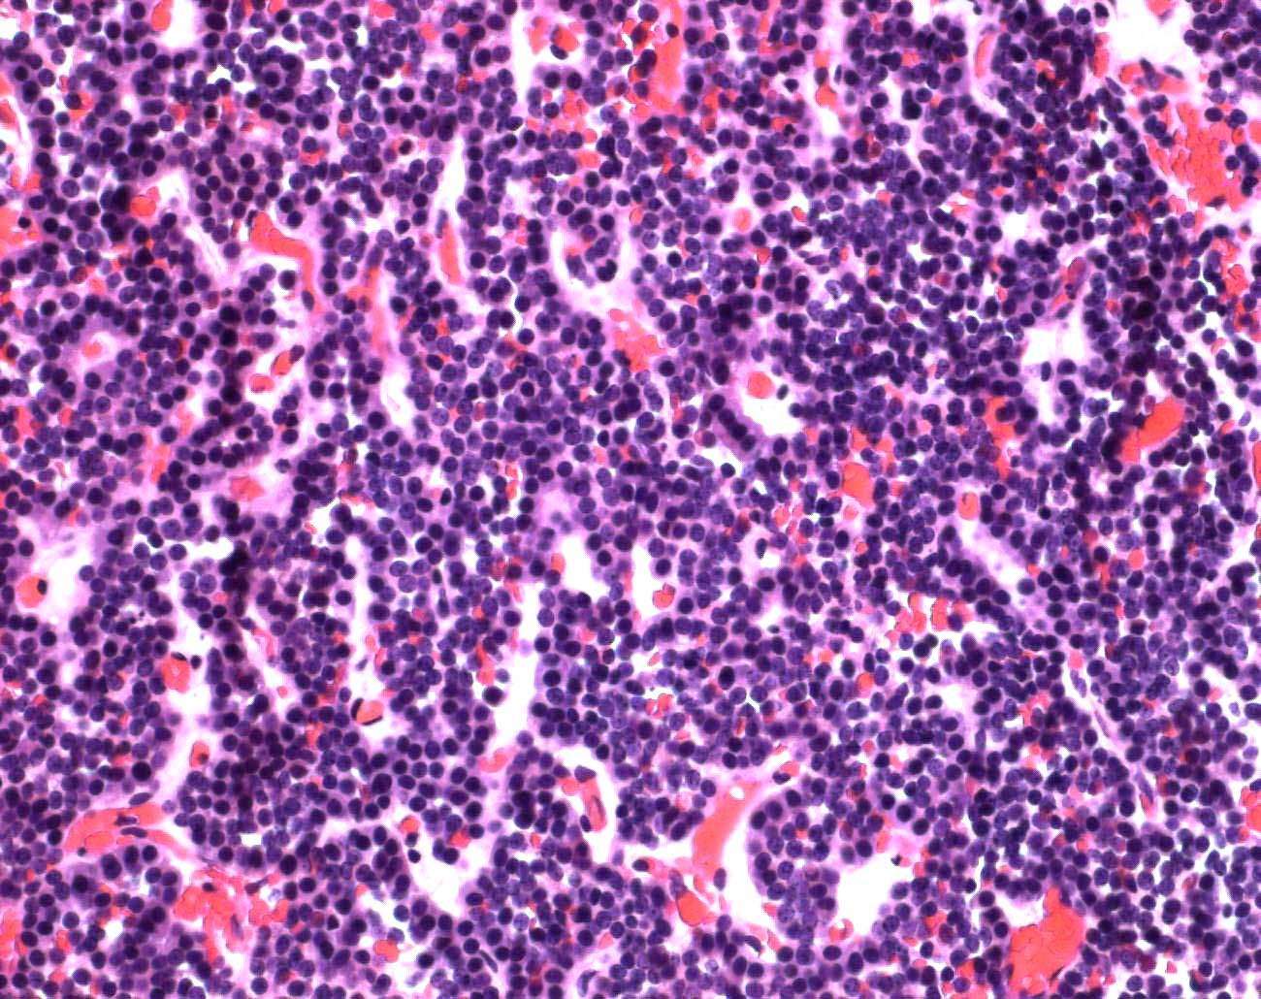

Classification
Size
< 1 cm in diameter – microadenomas
> 1 cm – macroadenomas.

Hormonal secretion
- nonsecretors, s. nonfunctioning pituitary adenomas (most common pituitary tumors!) – manifest when reach size of macroadenoma – mass effect (normal pituitary tissue destruction, pressure on optic chiasm, etc).
- some nonsecretors secrete α subunit of glycoprotein hormones (FSH, LH, TSH) – suggests origin as gonadotrophs.
- null cell adenomas demonstrate no evidence (clinical or immunohistochemical) of hormone secretion.

- hormone secretors (frequency: prolactin > GH > ACTH > gonadotropins > TSH) – manifest with specific endocrine syndromes. see p. 2738 >>
    - nonsecreting, prolactin-secreting in men*, gonadotropin-secreting, GH-secreting adenomas manifest late (as macroadenomas)!
*main symptom – impotence – men tend to present late for this symptom
    - other adenomas manifest early (still as microadenomas).
    - some tumors secrete multiple hormones (termed null tumors).
    - normally five pituitary cell types are regionally distributed:
lactotrophs and gonadotrophs – widely distributed;
somatotrophs – peripherally (two lateral wings of gland);
thyrotrophs – anteromedially;
corticotrophs – central median wedge.

Histology
- on routine staining:
- chromophilic cells (acidophilic or basophilic)
- chromophobic cells.
N.B. routine staining is meaningless - tumor can be difficult to differentiate from normal tissue or metastatic disease - immunohistochemical staining and electron microscopy are essential!
- typical normal acinar structure is lost – adenomas may contain follicular, trabecular, or cystic portions growing as diffuse sheet; cells are arranged in syncytial or sinusoidal pattern; monotonous appearance.
- nuclei with “salt and pepper” chromatin (s. endocrine chromatin).
- differentiation of hyperplasia from adenoma may be difficult.
- types of undifferentiated cell adenomas:
- nononcocytic (null)
- oncocytoma (s. oxyphil adenoma) - tumor contains buildup of mitochondria.

Adenoma - packeted arrangement of cells resembles that of anterior pituitary, together with prominent vascular network:
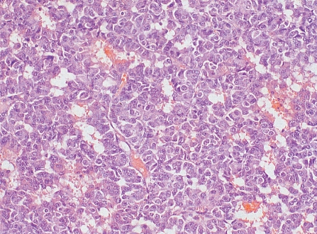

microadenoma:
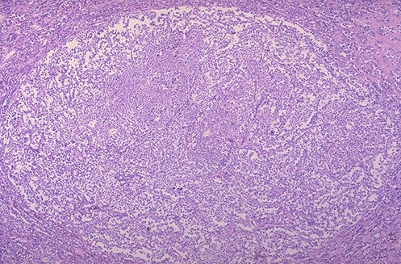
Source of picture: “WebPath - The Internet Pathology Laboratory for Medical Education” (by Edward C. Klatt, MD) >>

Photograph of microadenoma (0.9 cm in largest diameter) - incidental null cell adenoma found postmortem; tumor is well delineated and has compressed residual still functional adenohypophysis to crescent shape:
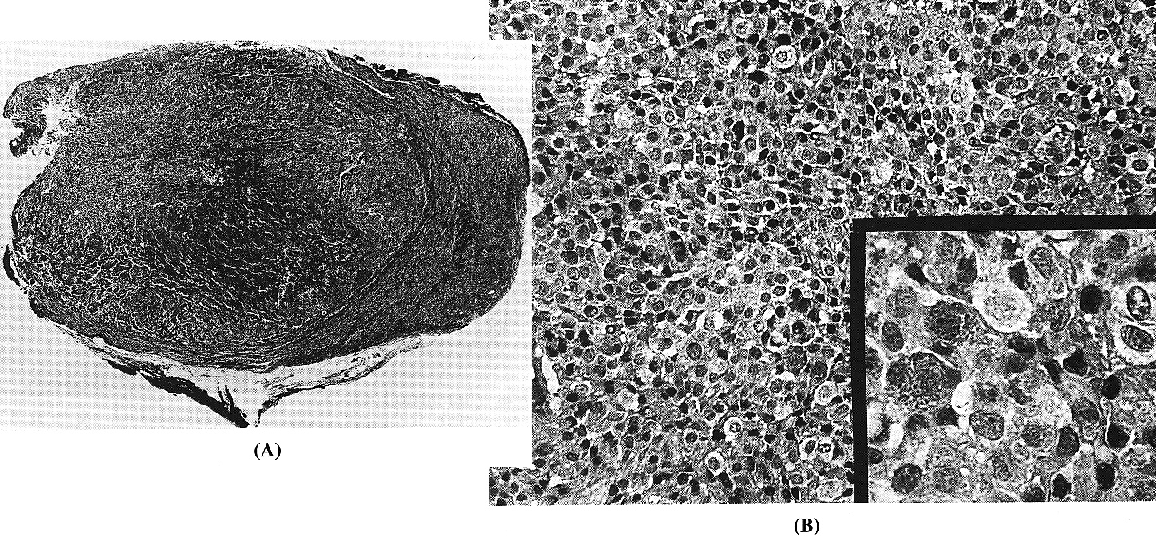
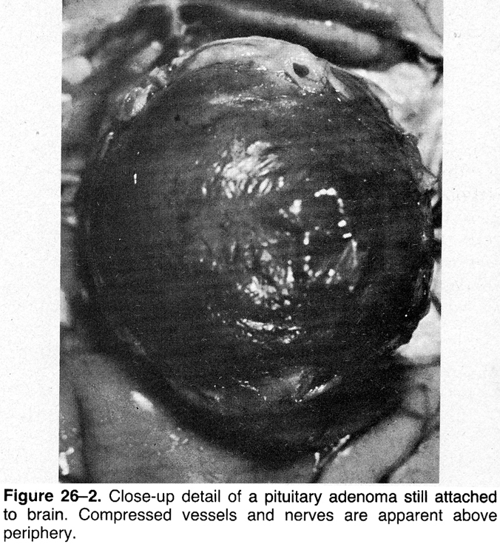

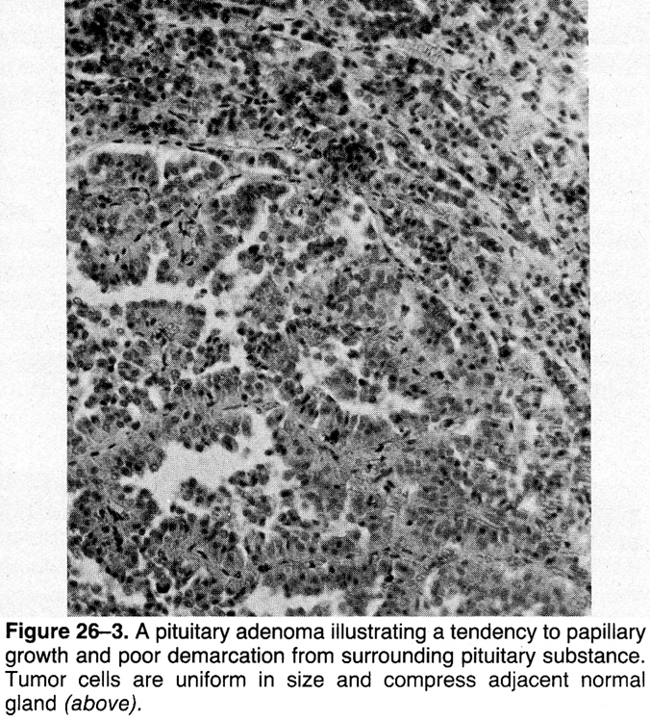

macroadenoma:
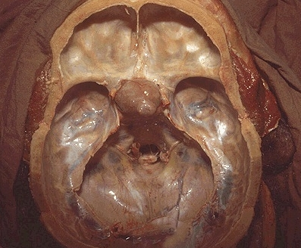
Source of picture: “WebPath - The Internet Pathology Laboratory for Medical Education” (by Edward C. Klatt, MD) >>

Epidemiology
The most common tumor in sella region (except craniopharyngiomas in childhood)

Guidelines on the Management of Patients with Nonfunctioning Pituitary Adenomas (CNS 2016):
From cancer registries prevalence is:
19-28 cases per 100,000 people
Meta-analysis of autopsy data and radiologic studies in healthy volunteers - pituitary adenomas are 700 times more common than registry data suggests:
pituitary adenomas are found in 14% of autopsies
pituitary adenomas are found in 23% of CT/MRI studies
Mean prevalence of 17%

- 4-20 % of all intracranial tumors.
- most occur in young adults (peak - 3rd-4th decades); children make 10% of all patients.
- men = women (clinically evident more often in young women); symptomatic prolactinomas and Cushing disease are found more frequently in women.

Clinical Features
Most pituitary adenomas can be detected while relatively small (microadenomas) - located in exquisitely sensitive area:
N.B. nonsecreting microadenomas are asymptomatic!

1. Hormonal function control
A) hormonal hypersecretion (most commonly prolactin!)
B) destruction of normal gland → hypopituitarism (partial in 37-85% patients with nonsecretory tumors, pan in 6-29% patients with nonsecretory tumors)
N.B. all macroadenomas eventually cause hypopituitarism.
- if hypopituitarism occurs, hormone loss is sequential: GH → gonadotropins → ACTH → TSH.
- primary pituitary tumors rarely* cause ADH deficiency (except when induced by hypophysectomy); diabetes insipidus is more common in craniopharyngiomas.
*7% of patients with NFPAs at the time of clinical presentation

2. Mass effect
- headache occurs in 20% (can be diffuse and nonpulsatile and may be mistaken for daily headaches; more often in females) – due to stretching of diaphragma sellae and adjacent dural structures; ICP is normal!
N.B. nonspecific headaches may be the only early symptoms, esp. in nonsecreting adenomas!
- it is still debatable if pituitary tumors can cause / exacerbate headaches, but pituitary surgery is associated with headache improvement or resolution in majority of patients (plus, pituitary surgery was not found to cause or worsen headaches)
Rizzoli P. et al “Headache in Patients With Pituitary Lesions: A Longitudinal Cohort Study” Neurosurgery: March 2016 - Volume 78 - Issue 3 - p 316–323

- crossing fibers in optic chiasm (superior bitemporal quadrantanopia → full bitemporal hemianopia - chief and earliest finding in most patients!)
- relationship of pituitary and optic chiasm:
    - chiasm directly above pituitary (80%).
    - chiasm anteriorly to pituitary (9%)
    - chiasm behind pituitary (11%).

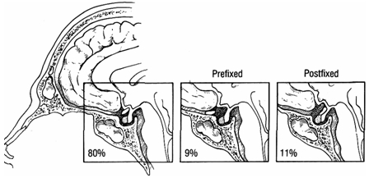

- further expansion compromises noncrossing fibers - affects lower and finally upper nasal quadrants.
- any pattern of visual loss is possible, e.g.:
- asymmetrical loss results from chiasm ischemia produced by vessel occlusion.
- unilateral mass located anterior to postfixed chiasm may produce central scotoma in one eye + upper outer quadrantanopia in contralateral eye (due to von Willebrand's knee - looping of crossing fibers in proximal segment of optic nerve opposite side of their retinal origin) – so called junctional scotoma
Any form of temporal field defect, even if monocular, can result from chiasmal compression
- some tumors affect only macular fibers → central hemianopic scotomas - may be missed on routine screening (so formal quantitative visual field testing is important in all cases!!!).
- other findings: optic disc atrophy (generally horizontal-oriented, i.e. bow-tie), dropout of nerve fiber layer in nasal retina, loss of central visual acuity, loss of color vision, visual field defects.
N.B. papilledema is exceptional (seen only in pituitary apoplexy).

- lateral extension into cavernous sinus → diplopia, ophthalmoplegias, and postganglionic Horner syndrome.

- hypothalamic compression (e.g. hyperprolactinemia*, diabetes insipidus, alterations in consciousness, memory, intake of food and water).
*if serum prolactin > 90-200 μg/L – prolactinoma is more likely!

- extension into sphenoid sinus → CSF rhinorrhea (≈ 0.5% cases) - cortical bone separating sella from sphenoid sinus is quite thin in normal individuals!; may occur as prolactinoma shrinks with medical treatment.

- compression of 3rd ventricle → obstructive hydrocephalus.

- basal forebrain abnormalities (personality changes, dementia, anosmia).

- temporal lobe seizures.

- pituitary adenomas may enlarge during pregnancy (esp. prolactinomas); sudden hypotension during delivery may cause ischemic stroke (apoplexy).

Diagnosis
N.B. pituitary adenomas almost never have calcifications!?

Guidelines on the Management of Patients with Nonfunctioning Pituitary Adenomas (CNS 2016)
      - high resolution MRI (Level II) is recommended as the standard for preoperative assessment but may be supplemented with CT* (Level III) and fluoroscopy (Level III).
*thin-cut CT for sphenoid septal anatomy; CTA for vascular anatomy; dual-energy CT to discriminate between pituitary adenomas and meningiomas with a sensitivity of 90.9% and specificity of 100%
      - while there are promising results suggesting the utility of MR spectroscopy, MR perfusion, PET, and SPECT to evaluate histology and characteristics, there is insufficient evidence to make formal recommendations.
      - while promising results are available pertaining to high-resolution MR and proton density imaging as tools of assessing cavernous sinus invasion, there is insufficient evidence to make a formal recommendation.
      - while promising results are available pertaining to perfusion and gradient echo imaging as tools for assessing tumor vascularity and hemorrhage, there is insufficient evidence to make a formal recommendation.

Skull X-ray
- limited use.
- macroadenomas balloon pituitary fossa → asymmetrical floor of pituitary fossa:
frontal projection - one side of fossa is deeper than other;
lateral projection - two more or less parallel lines that create impression of “double floor”.

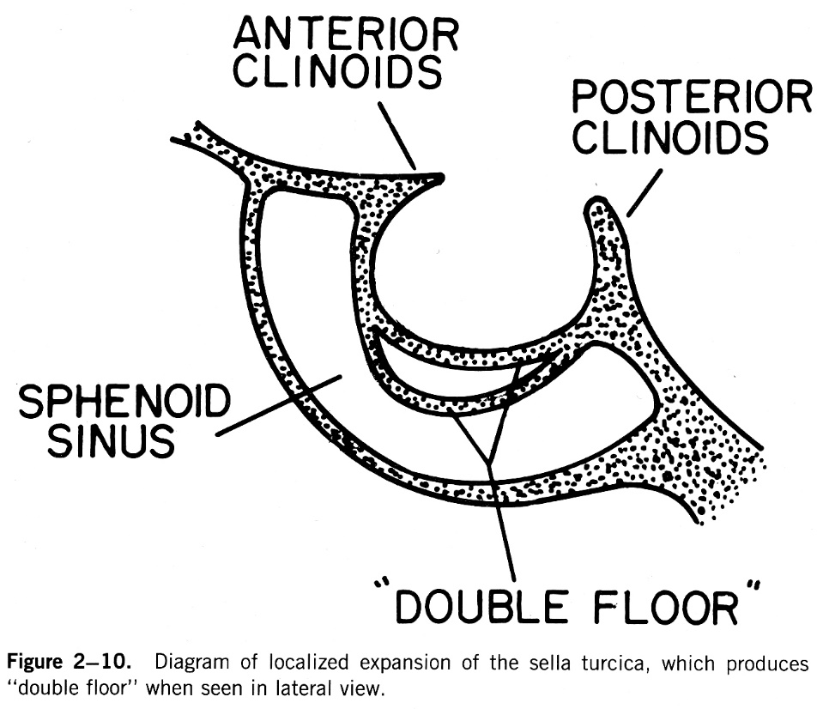

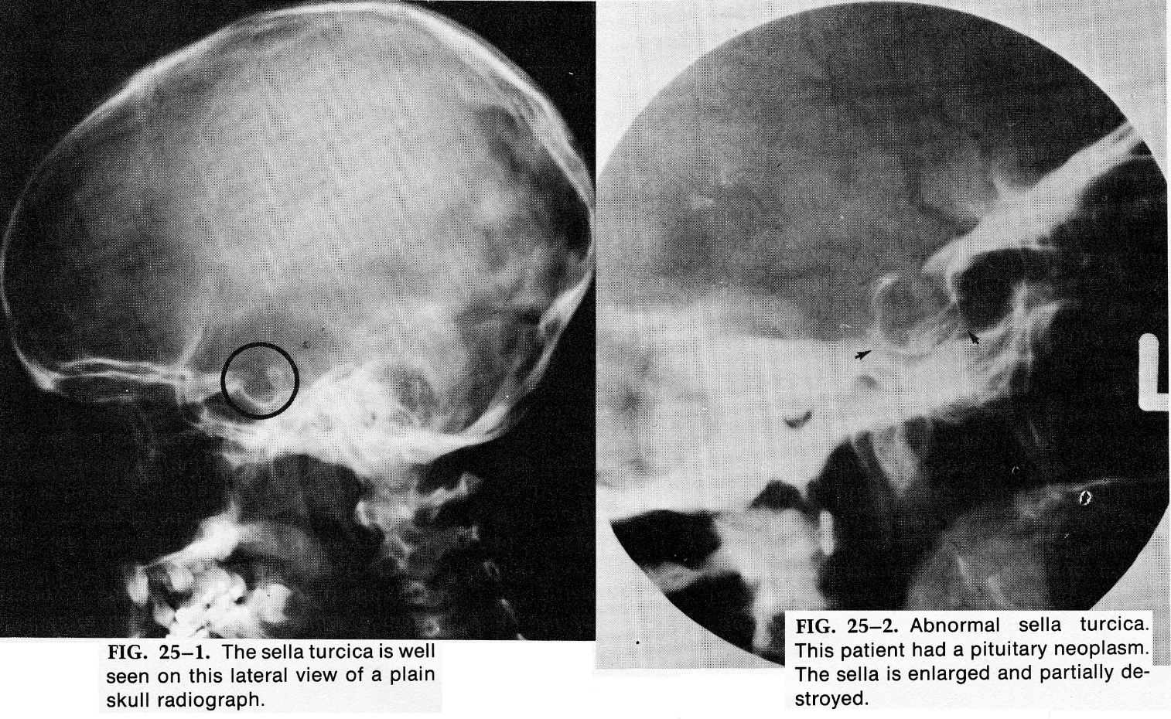

CT
(thin-section, direct coronal plane, with bone windows)
- macroadenomas are easily detected - hyperdense mass within enlarged pituitary fossa.
- may miss small microadenoma (appear as hypodense structures, vs. macroadenomas).

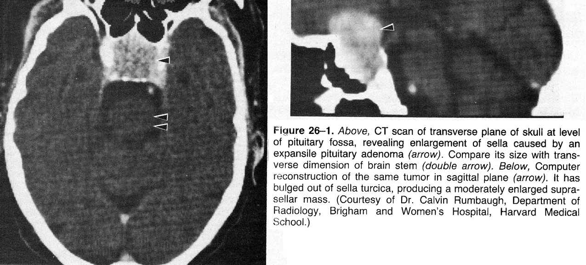

Dual-energy CT (utilizes high-frequency cycling of high/low voltages to improve the quality of the CT images) - can discriminates between pituitary adenomas and meningiomas with a sensitivity of 90.9% and specificity of 100%.

MRI
- gold standard, more sensitive method for tumor identification (esp. 1-mm cuts and magnified views through sella – pituitary protocol) - investigation of choice for microadenoma detection!!!

Normal neurohypophysis on T₁-MRI shows increased signal (representing neurosecretory granules in ADH-containing axons).

Normal adenohypophysis:
- isointense with grey matter on all MR sequences.
- circumventricular organ without an intact BBB - enhances homogeneously (punctate areas of heterogeneity - local variations in vascularity, microcyst formation, or granularity), strongly and rapidly (within 30 minutes of gadolinium infusion).

Normal pituitary gland size and configuration are highly variable (esp. in women of childbearing age or pubertal girls – normal hypertrophy of gonadotrophs).
N.B. great care must be exercised in diagnosis of microadenomas on MRI basis without associated evidence of hormonal abnormality.
- in neonatal period both anterior and posterior lobes are hyperintense and pituitary gland is bulbous in shape.
- during adolescence and puberty there is significant physiological hypertrophy (in girls upper surface is convex, giving gland almost spherical shape on sagittal views - do not mistake for mass).

Schematic diagram of MRI of normal pituitary fossa: pituitary is bordered laterally by cavernous sinus, which contains internal carotid artery and cranial nerves III, IV, V₁ , V₂ , and VI; optic chiasm lies immediately above pituitary gland.
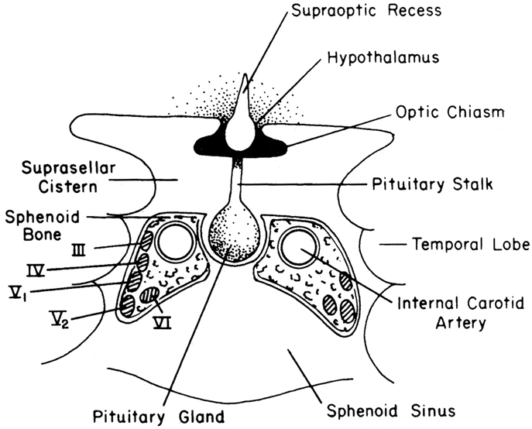

Source of picture: David C. Sabiston “Sabiston Textbook of Surgery: the Biological Basis of Modern Surgical Practice”, 15th ed. (1997); W.B. Saunders Company; ISBN-13: 978-0721658872 >>

Guidelines on the Management of Patients with Nonfunctioning Pituitary Adenomas (CNS 2016): discussions and recommendations(if any) are highlighted below.

Microadenomas:
- unenhanced MRI is not helpful - only some microadenomas have different signal intensity to normal gland.
- standard MRI protocol for investigation of microadenomas - 1-mm thick coronal T1 spin-echo sequences through pituitary gland before and after IV gadolinium;
- additional images in sagittal plane are performed in many centers;
- desirable to perform fat-saturated T1 sequence (fat-suppressed imaging) - eliminates high signal from fat in clivus and clinoid processes (could be mistaken for enhancement).
- adenomas always enhance less than normal pituitary gland (hypodense area also can represent ischemic stroke in tumor).
- normal pituitary gland is most often displaced superiorly and posteriorly by adenoma; displacement of normal pituitary in other directions can suggest other pathology!
- there is an association between the “bright stalk” and adenoma size:
- normal pituitary stalk is of relatively low intensity but can be bright when compressed by tumor.
- stalk compression/deviation or bright stalk are not always associated with elevated prolactin expected of stalk effect.
- accuracy can be increased by dynamic pituitary scans (series of rapid images with 10–15 s time intervals for about 3 min following gadolinium IV bolus) - differences in time course of enhancement between adenoma and adjacent normal gland – very useful in detecting microadenomas!
N.B. microadenomas enhance later and/or lesser than normal pituitary tissue!
- other indirect MRI signs:
- gland height↑ (normally < 10 mm)
- gland upper margin contour alteration from concave or straight to convex
- erosion of sella turcica floor adjacent to hypointensity area
- displacement of pituitary stalk (normally midline) away from hypointensity area.

Most macroadenomas enhance strongly and uniformly.
- surgeons can predict the consistency of adenoma from T2-MRI: the more hyperintense the adenoma, the softer the tumor.
- low-density areas within mass may represent cysts/necrosis/stroke; tumor which enhances only peripherally or not at all may be necrotic.
- if entire sellar contents are of low density, search for infundibulum - empty sella is much more likely diagnosis than completely cystic pituitary macroadenoma!
- hemorrhages appear as high-intensity areas (best – gradient echo [GE] imaging).
- suprasellar extension is easily demonstrated in both coronal and sagittal images.
- visual field loss is significantly correlated with the height of the chiasm and the tumor as well as optic nerve hyperintensity on T2 images but not with optic tract edema.
- it is more difficult to be sure about cavernous sinus invasion - no imaging technique can perfectly visualize the medial cavernous sinus wall
- displacement of cavernous ICA segment may occur without tumor invasion into cavernous sinus.
- abnormal signal intensity lateral to cavernous ICA segment, indicates invasion into cavernous sinus.
- 3 T vs 1.5 T yields superior sensitivity (83% versus 67%, respectively) and specificity (84% relative to 58%) in terms of correlation to surgical findings of cavernous sinus invasion.
- volumetric interpolated breath-hold examination (VIBE) sequence may offer superior image resolution of tumor invasion of the cavernous sinus (eliminates subtle patient motion related to respiratory effort)
- proton density weighted MR is highly sensitive and specific for predicting tumor invasion of the cavernous sinus.
- class III data suggests that multiple microcysts on T2, cavernous sinus invasion, lobulated appearance, and size > 40 mm are associated with silent corticotroph adenomas.
- Knosp criteria - the extent of parasellar extension relative to inter-carotid lines drawn through the intra-cavernous carotid on a coronal MRI; high Knosp grades are associated with increased likelihood of sinus invasion.
- normal pituitary between adenoma and the cavernous sinus (“rim sign” or “peri-arterial enhancement”) can exclude sinus invasion.
- asymmetric dural enhancement of tentorium along the posterior portion of the cavernous sinus is associated with increased likelihood of sinus invasion and thought to be related to venous congestion secondary to tumor mass.

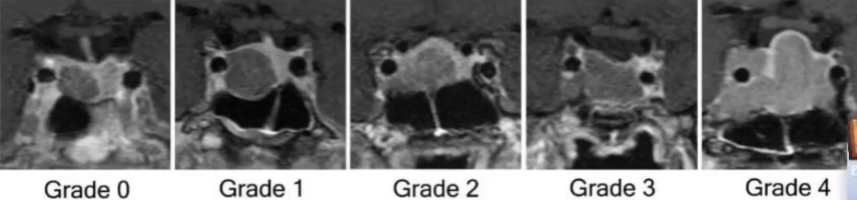
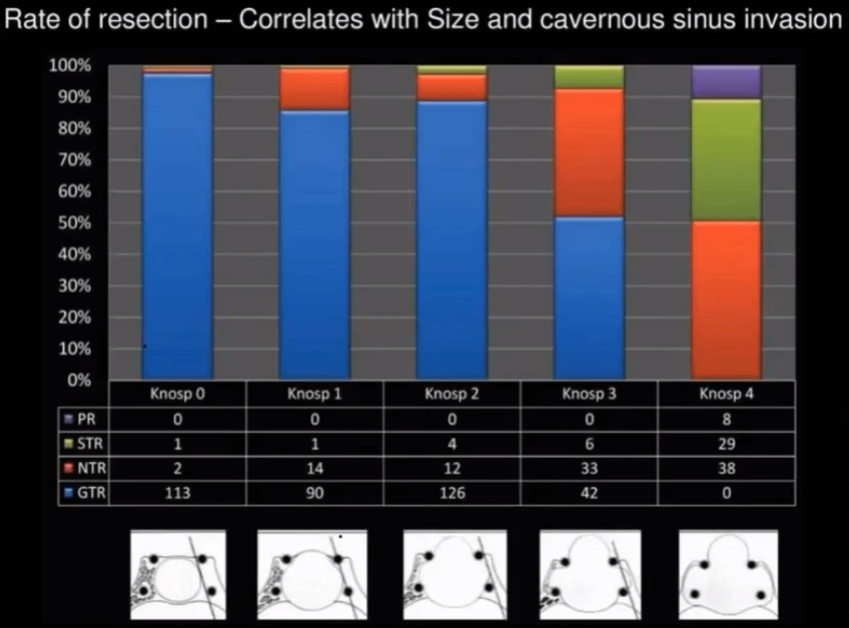

- bone invasion: magnetic susceptibility effects at the skull base (air vs bone) render normal fat-suppression techniques less effective, making it more difficult to assess involvement of the bony structures around the sella.
- signal intensity on MRI CISS sequences is associated with the firmness of tumor; DWI may also be helpful but results of studies are conflicting.
- MR perfusion studies provide information regarding tumor vascularity.

Differential diagnosis
MR spectroscopy
- technically challenging within small volumes such as the sella and is very sensitive to magnetic susceptibility effects due to the surrounding bone.
- pituitary adenomas often show a choline peak.
- both hypothalamic hamartomas and gliomas exhibit decreased N-acetyl aspartate (NAA), however, hamartomas are characterized by increased myoinositol while gliomas show increased choline accumulation.
- craniopharyngiomas and germinomas both show dominant lipid peaks.

T2-MRI (left) shows microadenoma; contrast (right) normally enhances pituitary; adenoma appears lighter:
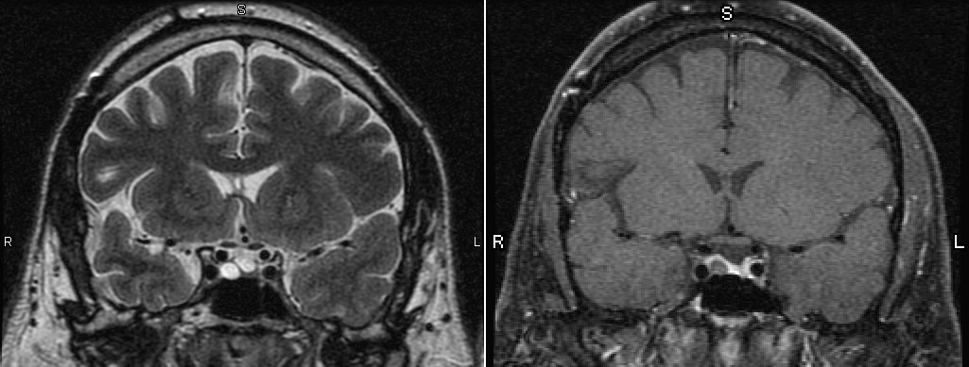

Contrast T1-MRI – macroadenoma: adenoma (A) enhances; tumor displaces carotid arteries laterally (black arrows); A1 segments of anterior cerebral arteries (white arrows) and chiasm (arrowheads) drape over mass.
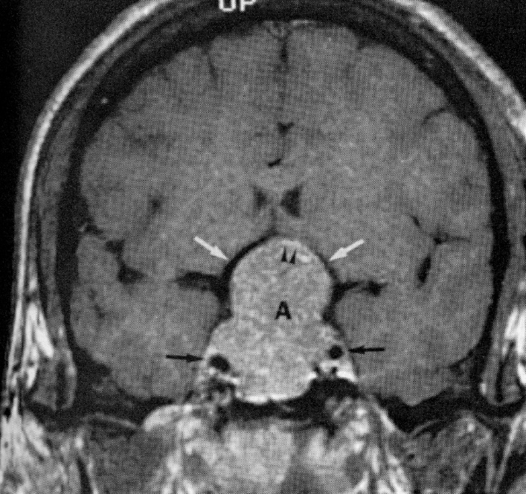

Contrast MRI - microadenoma (arrow):
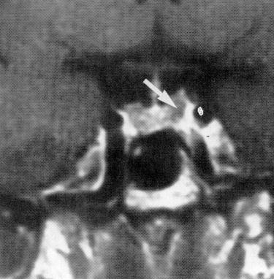
Source of picture: Martin D. Abeloff “Clinical Oncology”, 2nd ed. (2000); Churchill Livingstone, Inc.; ISBN-13: 9780443075452 >>

Contrast MRI - macroadenoma (tumor extends out of sella into hypothalamus):
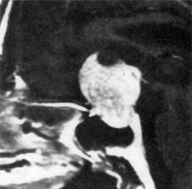
Source of picture: Martin D. Abeloff “Clinical Oncology”, 2nd ed. (2000); Churchill Livingstone, Inc.; ISBN-13: 9780443075452 >>

microadenoma - hypodense (arrows) 9 mm in diameter involving right side of pituitary fossa displacing gland and stalk to left:
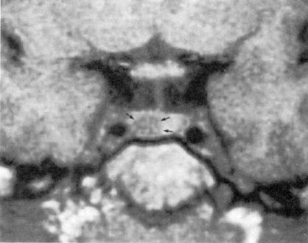
Source of picture: Vincent T. DeVita Jr. “Cancer: Principles and Practice of Oncology”, 5th ed. (1997); Lippincott Williams & Wilkins; ISBN-13: 978-0397584246 >>

microadenoma (prolactinoma) - hypodense lesion (arrowhead); slight depression of sella floor under tumour:
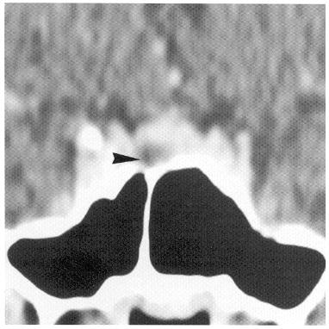
Source of picture: Ronald G. Grainger, David J. Allison “Grainger & Allison’s Diagnostic Radiology: A Textbook of Medical Imaging”, 4th ed. (2001); Churchill Livingstone, Inc.; ISBN-13: 978-0443064326 >>

Dynamic coronal T1-MRI;
- scan at 90 s following injection of gadolinium reveals microadenoma (arrowhead), which has enhanced to lesser degree than surrounding normal pituitary tissue.
- after 4 min enhancement is similar to rest of gland.
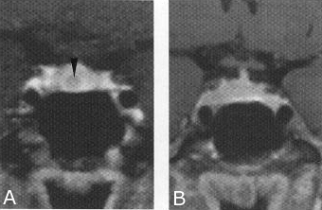
Source of picture: Ronald G. Grainger, David J. Allison “Grainger & Allison’s Diagnostic Radiology: A Textbook of Medical Imaging”, 4th ed. (2001); Churchill Livingstone, Inc.; ISBN-13: 978-0443064326 >>

Contrast T1-MRI: > 1 cm intrasellar mass; note tumor expansion into sphenoid sinus, extension into suprasellar cistern with partial compression of optic chiasm (arrows):
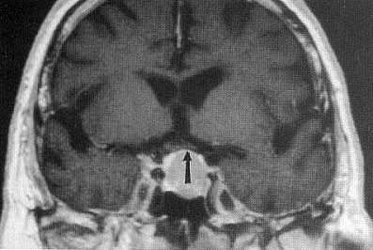
Source of picture: John H. Juhl “Paul and Juhl’s Essentials of Radiologic Imaging”, 7th ed. (1998); Lippincott Williams & Wilkins; ISBN-10: 0-397-58421-0 >>

Prolactin-secreting microadenoma: T1-MRI with contrast - hypodense lesion in left pituitary; upward convex margin of left lobe of gland, indicating focal expansion (arrow):
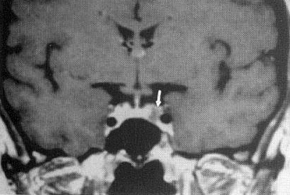
Source of picture: John H. Juhl “Paul and Juhl’s Essentials of Radiologic Imaging”, 7th ed. (1998); Lippincott Williams & Wilkins; ISBN-10: 0-397-58421-0 >>

macroadenoma (contrast T1-MRI) - invasion of left cavernous sinus - tumor (white arrow) surrounds left internal carotid artery and sinus appears expanded; normal enhancement of uninvolved right cavernous sinus although tumour encroaches under supraclinoid portion of right internal carotid artery (black arrowhead):
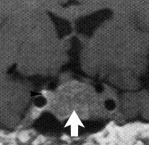
Source of picture: Ronald G. Grainger, David J. Allison “Grainger & Allison’s Diagnostic Radiology: A Textbook of Medical Imaging”, 4th ed. (2001); Churchill Livingstone, Inc.; ISBN-13: 978-0443064326 >>

Hemorrhagic macroadenoma (T1-MRI without contrast) - hyperintense intrasellar mass; fluid level within this lesion (arrow); pituitary fossa has been expanded; surgery revealed hemorrhagic fluid within macroadenoma:
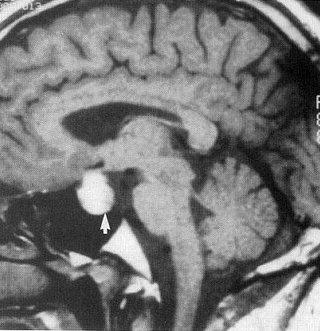
Source of picture: John H. Juhl “Paul and Juhl’s Essentials of Radiologic Imaging”, 7th ed. (1998); Lippincott Williams & Wilkins; ISBN-10: 0-397-58421-0 >>

GH-secreting macroadenoma with left cavernous sinus invasion (T1-MRI without contrast) - convex outward margin of left cavernous sinus (arrow); left internal carotid is elevated:
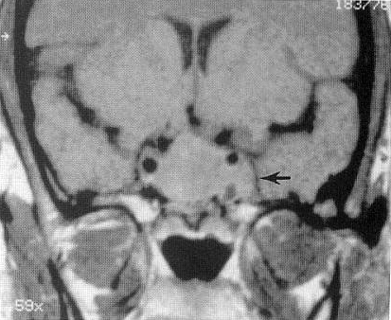
Source of picture: John H. Juhl “Paul and Juhl’s Essentials of Radiologic Imaging”, 7th ed. (1998); Lippincott Williams & Wilkins; ISBN-10: 0-397-58421-0 >>

MRI - hemorrhage into tumor (apoplexy):
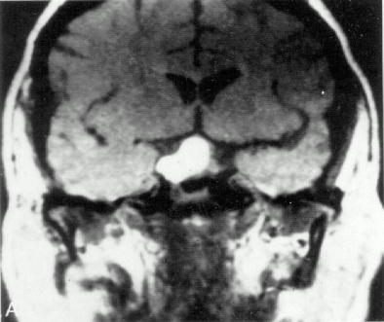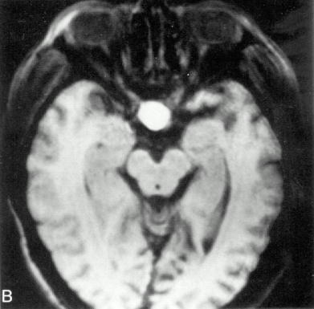

- CT with contrast - macroadenoma with suprasellar and parasellar extension.
- MRI with contrast following bromocriptine therapy shows marked decrease in tumor size such that infundibulum and optic chiasm are decompressed (arrow).
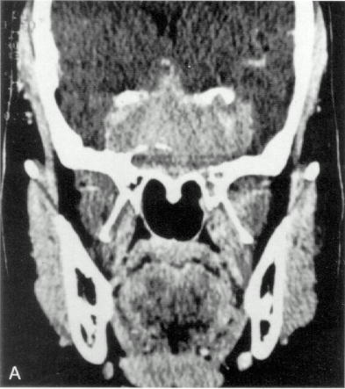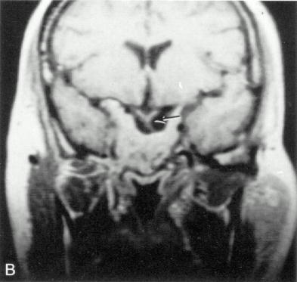

- MRI - macroadenoma filling sphenoid sinus and extending into 3rd ventricle floor.
- suprasellar component compressing optic chiasm (arrow).
- following gross total resection through extended frontal craniotomy - infundibulum is well decompressed (arrow).
- no residual tumor, optic chiasm and portion of infundibulum can be clearly seen (arrow).
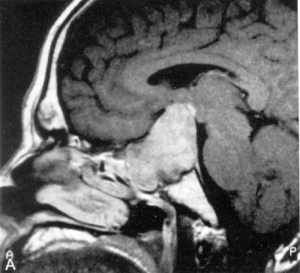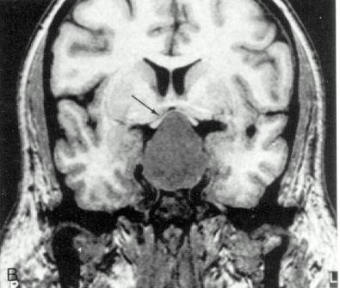
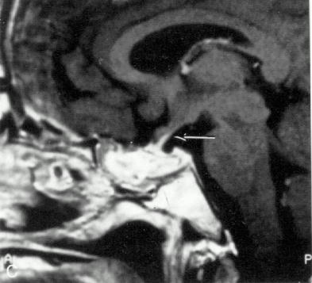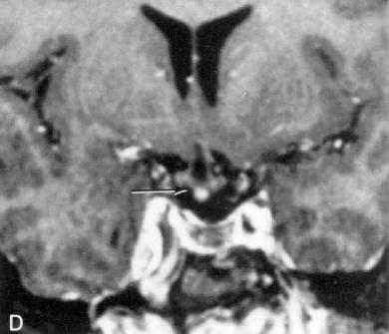

Radionuclide studies
- some GH-secreting adenomas (and some prolactinomas) express somatostatin receptors - ¹¹¹In octreotide uptake has place in:
  - evaluation of incomplete tumor resection due to involvement of adjacent structures.
  - identification which patients may respond to octreotide therapy.

PET
Guidelines on the Management of Patients with Nonfunctioning Pituitary Adenomas (CNS 2016): utility is limited and is not routinely used in standard practice.
- 18(F)-FDG PET detects pituitary adenomas with a sensitivity of 94%-100% and a sensitivity of 88%-100%
- [11C]-L-deprenyl PET may facilitate discrimination of meningiomas from adenomas.

SPECT
Guidelines on the Management of Patients with Nonfunctioning Pituitary Adenomas (CNS 2016): diagnostic utility remains unclear.
- SPECT using iodinated dopamine D2 antagonist S(-) iodobenzamide (IBZM) or similar compounds demonstrated that D2 receptors in pituitary adenomas can be visualized using SPECT
- Technetium-99m-hexakis-2-methyoxy-isobutyl-isonitrile SPECT can discriminate adenoma from normal pituitary gland.
- ^{99m}Tc(V)-DMSA is actively taken up by adenomas relative to other sellar/suprasellar lesions.
- radiolabeled somatostatin or dopamine can potentially differentiate hormone producing from nonfunctioning pituitary adenomas and identify patients who would benefit from pharmacotherapy, although the clinical feasibility of this is unclear.

Angiography
- to exclude aneurysm!!!! (lethal surgical cases described!!!)
- surgical planning

Neuro-ophthalmological evaluation
- accurate mapping of visual disturbances (important for every patient prior to surgery).
- in addition to formal ophthalmologic examination, tests of value include automated static perimetry and optical coherence tomography (OCT).
- often, patients with obvious chiasmal compression may not be aware of visual loss, discovered only on quantitative ophthalmic assessment.
- relative position of the chiasm may influence the incidence of visual field defects, with a decrease frequency of visual deficits occurring in patients with an anatomically prefixed optic chiasm

Guidelines on the Management of Patients with Nonfunctioning Pituitary Adenomas (CNS 2016)
Level III Recommendation:
- pretreatment evaluation by an ophthalmologist is recommended: asymptomatic visual deficits due to the ophthalmologist’s ability to quantitate psychophysical (acuity and visual fields), functional (quantitation of afferent pupillary defect and visual evoked potentials [VEP]), and anatomical (disc appearance and ocular coherence tomography [OCT]) assessment. When paired with postoperative evaluation, documents postoperative change.
- automated static perimetry is recommended for early detection of visual field deficits.
- visual evoked potentials may be used to assess the optic nerves in cases in which psychophysical areas, such as acuity and visual fields, cannot be assessed.
- older patients and patients with longer duration (over 4 months) of vision loss should be counseled regarding the reduced chance of postoperative vision improvement
- formal ophthalmologic examination, looking for optic nerve atrophy or optical coherence tomography (OCT) to measure both retinal nerve fiber layer (RNFL) thickness and the presence of damage to the ganglion cell layer is recommended to assess chances of postoperative vision improvement.
- anatomic assessment of the anterior visual pathways with optical coherence tomography documents previous damage, showing evidence of nerve fiber bundle thinning and evidence of ganglion cell dropout with segmentation analysis.

Evaluation of pituitary function
(sensitive radioimmunoassays) in all patients!
N.B. guard against cortisol insufficiency postoperatively.

All endocrine axes + prolactin should be checked in every patient!

Hormone | Laboratory Test
TSH | TSH, free T₄
LH/FSH | Male: testosterone
 | Female: estradiol, progesterone
ACTH | Morning ACTH
 | Fasting AM cortisol
 | 24-hour urine free cortisol
 | Dexamethasone suppression test
GH | Morning GH
 | Somatomedin-C
 | IGF-1 (reflects GH concentration over the preceding 24 hours)
Prolactin | Prolactin

High prevalence (37-85%) of hypopituitarism in patients with NFPAs.

- inferior petrosal sinus sampling is used to localize tumors not seen radiographically (e.g. many ACTH-secreting microadenomas are < 5 mm).
- central hypothyroidism is typically confirmed by the thyrotropin releasing hormone stimulation test, in which serum TSH is measured serially post-TRH at 20 and 60 minutes, with a normal response defined as the 20- minute TSH value being higher than the 60-minute TSH value. A flat response is seen in pituitary disease, and delayed response, with the 60-minute value higher than the 20-minute value, is seen in hypothalamic disease.

Guidelines on the Management of Patients with Nonfunctioning Pituitary Adenomas (CNS 2016):
- NFPA may present with hypopituitarism (37-85%, esp. GH deficiency) or pituitary stalk hyperprolactinemia (25-65%, with a mean level of 39 ng/mL and with a minority of patients exceeding a serum prolactin level of 200 ng/mL).
- level II recommendation: routine endocrine analysis of all anterior pituitary axes + prolactin to assess for hypopituitarism (prolactin and IGF-1 are also valuable to assess for hypersecretion states that might not be clinically suspected).
- no evidence supporting routine biomarker testing (e.g., alpha-subunit or chromogranin A) was available.

Although not widely used, chromogranin A (CGA) has also been assessed as a potential biomarker for NFPAs. In a prospective case-control study by Gussi et al, 3 of 27 patients with NFPAs had elevations of serum CGA at 576, 143, and 241 ng/mL, respectively. As the authors acknowledge, the low prevalence of CGA elevations in the NFPA population makes its utility as a sensitive biomarker less reliable.

Prolactin
- serum prolactin level is perhaps the most important laboratory level that dictates a given patient’s treatment course – the ability to distinguish between a prolactinoma (for which medical therapy represents first-line therapy in most patients) and an NFPA with hyperprolactinemia caused by the pituitary stalk effect (a surgically treated disease for most patients) is a critical one.
- nonsecreting tumors are commonly associated with slight elevations of serum prolactin (< 150*) – stalk syndrome (compression of pituitary stalk, interrupting dopaminergic fibers that inhibit prolactin release) - must be distinguished from prolactin-secreting tumors because bromocriptine has little or no effect on nonsecretory tumors.
*some studies indicate different thresholds beyond which stalk effect is unlikely:
> 94.3 ng/mL
> 85 ng/mL in the absence of renal failure or any prolactin-enhancing drugs + prolactin increment less than 30% following thyrotropin-releasing hormone.
Be vigilant to prescription / recreational drugs that interfere with normal pituitary function!
- hyperprolactinemia is seen in 25-65% of patients with histologically verified NFPAs, with a mean level of 39 ng/mL and with a minority of patients exceeding a serum prolactin level of 200 ng/mL
- be aware of hook effect (s. prozone effect) - type of interference which plagues certain immunoassays and nephelometric assays, resulting in false negatives or inaccurately low results – too much antigen (prolactin) interferes with results (H: diluting blood sample; modern labs do it automatically):

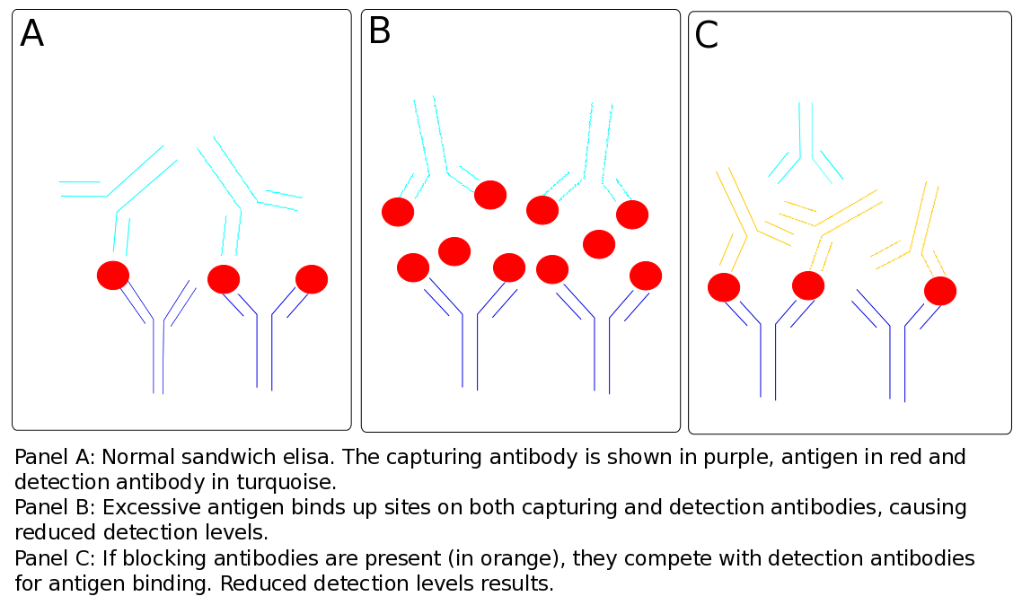
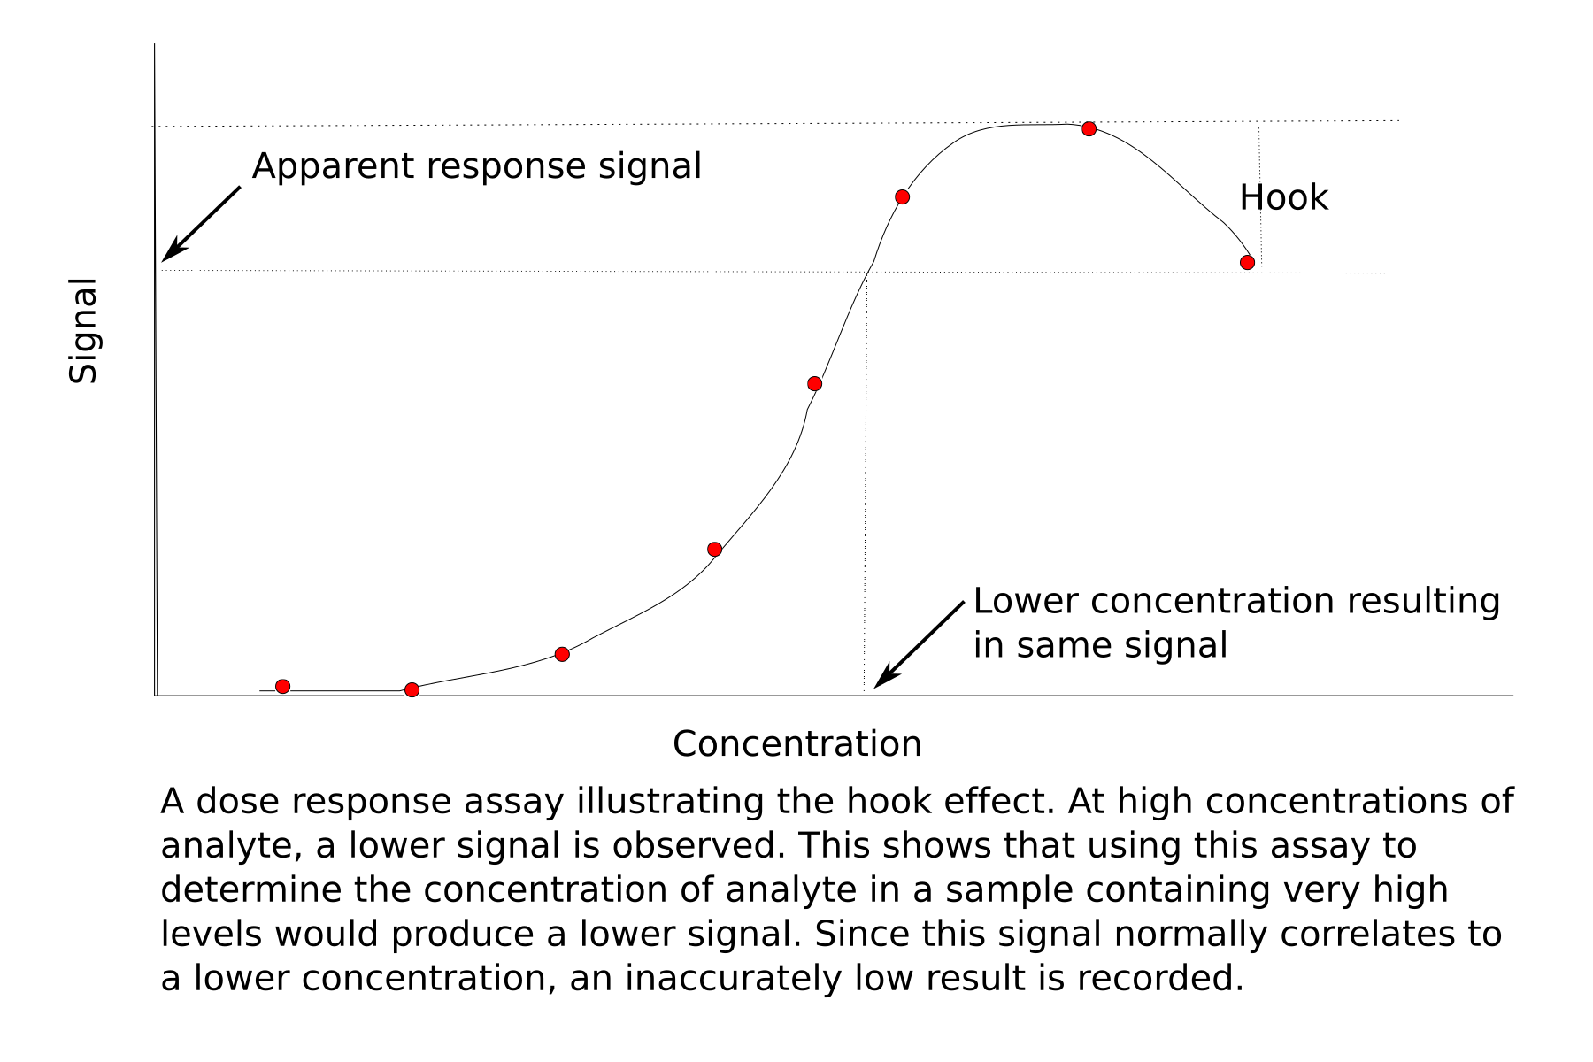

Genetic testing
Not indicated in sporadic cases.
- in 2012, Cazabat et al published their results from a prospective single-center observational study - 113 patients with presumed sporadic NFPAs underwent genetic screening for germline mutations in the AIP gene - only 1 patient (0.9%) had evidence of an AIP mutation.

Guidelines on the Management of Patients with Nonfunctioning Pituitary Adenomas (CNS 2016):
- no evidence supporting routine genetic testing was available.

Complications
  - Pituitary apoplexy - can be lethal!
  - Permanent visual loss, ophthalmoplegia, and other neurological complications.
  - CSF rhinorrhea – most commonly following favorable response of invasive prolactinomas to initiation of dopamine agonist therapy.
- possible mechanisms - decreased tumor volume (due to intrinsic infarction or hemorrhage), ongoing invasion, ICP increases
- treatment: surgical repair, preferentially via transsphenoidal approach

Treatment
Only surgical removal can produce cure!

Different Strategies
macroadenomas are treated surgically (except maybe prolactinomas)
microadenomas:
- prolactin-secreting - primary treatment is medical with dopamine agonists (role of imaging in hyperprolactinemia is mainly to exclude macroadenoma; precise localization of microadenoma is therefore less important - in some centers, imaging is restricted to unenhanced MRI).
- other secreting adenomas are treated surgically - adenoma localization by other means (petrosal venous sampling) is therefore important if MRI is unsuccessful.
- incidental asymptomatic adenomas require no intervention but should be followed periodically (endocrine examinations, visual field examinations, MRI) - onset of symptoms or MRI documentation of growth are indications for treatment.

Goals of treatment differ according to tumor functional activity:
- nonsecreting tumors → reduction of mass while maintaining pituitary function (although complete surgical resection is desired, radiosensitivity of these tumors invites subtotal surgical debulking followed by curative adjuvant radiation therapy).
- secreting tumors → aggressive normalization of hypersecretion while preserving normal pituitary function (usually by total surgical excision*, but some prolactinomas are better controlled medically).
*response to radiation therapy is slow and less predictable.

Guidelines on the Management of Patients with Nonfunctioning Pituitary Adenomas (CNS 2016)
Level III Recommendation: Surgical resection is recommended as the primary treatment of symptomatic* NFPAs.
There is insufficient evidence to make a recommendation for treatment vs. observation of asymptomatic NFPAs.
Primary medical therapy showed inconsistent tumor response rates using somatostatin analogues (12-40% response rate), dopamine agonist therapy (0-61% response rate), or combination therapy (60% response rate); > 20% patients required surgery as a result of progressive clinical symptoms.

*visual field deficit or visual loss, ophthalmoplegia, compression of the optic apparatus on MRI, endocrine dysfunction (incl. hypopituitarism or stalk effect causing hyperprolactinemia), pituitary apoplexy, refractory headaches not attributable to other headache syndromes, or other neurologic deficits related to compression from the tumor

Natural history with no treatment of asymptomatic NFPAs
Dekkers OM et al. The natural course of non-functioning pituitary macroadenomas. Eur. J. Endocrinol. 2007;156(2):217-224.
- 28 patients, mean follow-up was 118 months:
50% - radiologic evidence of tumor growth.
21% - required operation due to onset of visual field deficits.
29% - spontaneous reduction in tumor volume.
Arita K et al. Natural course of incidentally found nonfunctioning pituitary adenoma, with special reference to pituitary apoplexy during follow-up examination. J. Neurosurg. 2006;104(6):884-891
- 42 patients, F/U 4 years:
40% - tumor growth.
24% - became symptomatic (9.5% developed pituitary apoplexy over 5 years)
28.6% - underwent surgical intervention due to new symptoms or increasing tumor size.

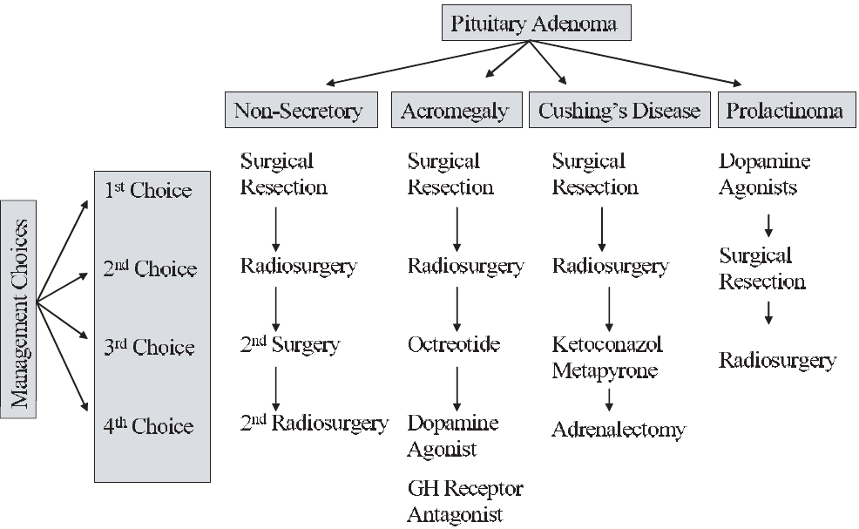

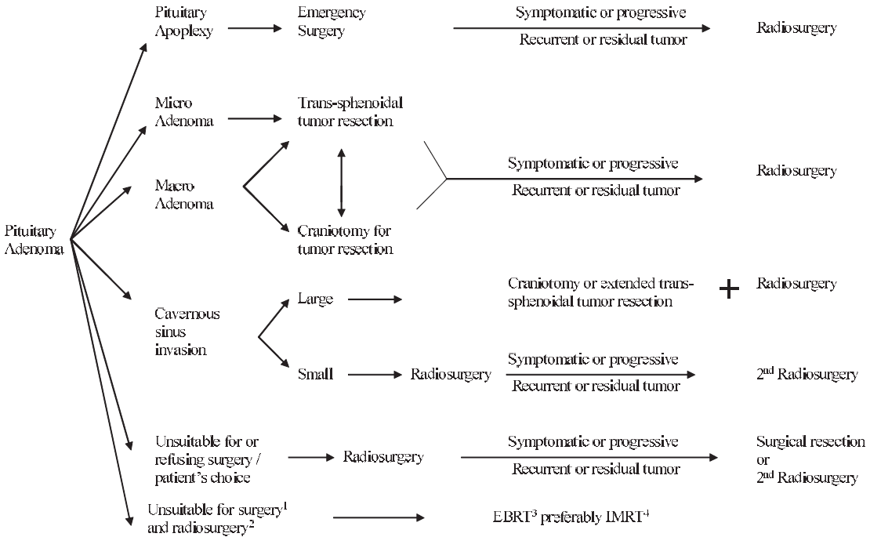

Medical therapy
further see p. 2738 >>
A. Inhibition of hypersecretion:
Prolactin hypersecretion → dopamine agonists (e.g. bromocriptine, cabergoline).
N.B. increase cabergoline dosing incrementally to avoid too precipitous shrinkage of mass → dura mater tear → CSF leak
ACTH hypersecretion → ketoconazole, pasireotide, cabergoline
GH hypersecretion → octreotide, dopamine agonists, pegvisomant (GH receptor antagonist)
- refinements in medical treatment may allow nonsurgical treatment for some microadenomas (esp. prolactinomas!!!) throughout life.
N.B. GH hypersecretion and ACTH hypersecretion are clear indications for surgery, even when mass is not important.
- some antisecretory medications can lead tumors to be denser and more fibrotic - technically more challenging to remove during microsurgery.
- bromocriptine, octreotide may confer relative radioresistance to tumors undergoing SRS.

B. Hormonal replacement most commonly includes thyroid and adrenal hormones.

Surgery
- best way to definitive diagnosis and is usually curative. See p. Op305 >>

See also craniopharyngioma aspects >>

Postoperatively
- surgery often improves vision (over hours ÷ years), relieves headache, etc. see below >>
- CSF leak prevention: HOB 30-45 all the time, no straws, no nose blowing, no straining, no sneezing with closed mouth for 1-2 weeks.
- nasal packs for 3 days; concomitantly abx (to prevent toxic shock syndrome – analogy with vaginal tampons) - Ancef / Keflex / Clindamycin, saline nasal spray every 2-3 hours while awake, phenylephrine nasal spray q6h PRN epistaxis
- monitor for DI: strict Is and Os, BMP and urine spec gravity QID and PRN; patient must have easy access to drinking water to auto-cope with high urinary output (if urinary output > 300 for 2 consecutive hours or Na persistently > 145 or patient cannot keep I&Os even H: DDAVP 1 mcg q12h IV PRN as it may be transient; Dr. Sahni gives DDAVP liberally; if DDAVP required for > 5 days, transition to scheduled 0.5 mcg q12hr subQ and then intranasal if ENT clears for that).
- hydrocortisone taper per endocrinology recs / rapidly if BP is OK: 100 mg q8h → 50 mg q8h → 25 mg q12h → 15-20 mg + 5-10 mg (discharge on this dose)
- if has lumbar drain – keep it clamped until nasal packs are out (if CSF leak - drain 10 cc/hr).
- some experts prescribe Augmentin for 14 days.

Endocrinological follow-up
- close monitoring of hormonal status (at least thyroid and adrenal function) at frequent intervals (at 3 and 6 mo, and yearly thereafter) - replacement hormonal therapy is usually required and adjustments continue even years later.
microadenomas often can be removed without damage to normal pituitary tissue!
Dr. Broaddus prefers endocrinology consult postop; Dr. Holloway – only if patient was not seen by endocrinologist preoperatively.

Guidelines on the Management of Patients with Nonfunctioning Pituitary Adenomas (CNS 2016)
Level III Recommendations
- postoperative serum sodium levels on the first 2 days and on days 7-8 is recommended to prevent symptomatic postoperative hyponatremia (insufficient evidence to make a recommendation on the detection and treatment of postoperative diabetes insipidus).
- evaluation of adrenal function on postop day 2, 6 weeks, and 12 months after surgery is recommended.
- perioperative corticosteroid supplementation is recommended for NFPA patients with preoperative or immediate postoperative (day 2) hypocortisolemia.
- postoperative endocrinologic follow-up in patients with normal pituitary function beyond 1 year is not recommended.
- indefinite endocrinologic follow-up is recommended in all patients after radiotherapy or with abnormal pituitary function after surgery.
Level Inconclusive Recommendations
- There is insufficient evidence to make a recommendation on the detection and treatment of postoperative diabetes insipidus (DI).
- There is insufficient evidence to make a recommendation regarding the frequency of endocrinologic follow-up evaluation after surgery or radiation therapy.

Ophthalmological follow-up
Guidelines on the Management of Patients with Nonfunctioning Pituitary Adenomas (CNS 2016)
Level III Recommendations
- ophthalmologic follow-up after surgical / radiation therapy for NFPAs is recommended (insufficient evidence to make a recommendation on the length of time for this surveillance and the frequency).

Imaging follow-up
- MRI same night* and at 3 months; then annually for 10 years – so recurrence can be detected early and, while small, can be treated with radiation, thus, avoiding redo surgery (Dr. Holloway).
*some surgeons (Dr. JRC, Holloway) skip immediate postop MRI (as it does not change anything, plus, blood and grafts in sella mask picture) but Dr. Broaddus does always want it

Guidelines on the Management of Patients with Nonfunctioning Pituitary Adenomas (CNS 2016)
Level III Recommendations
- MRI with fat suppression* is recommended for follow-up after surgical or radiation treatment.
- first radiologic study to evaluate the resection extent must be 3-4 months after surgery (insufficient evidence to make a recommendation regarding the timing of initial radiologic follow-up after radiation therapy); immediate postoperative radiographic studies may be misleading in determining the amount of tumor residual.
- radiologic surveillance has to be long-term (insufficient evidence to make a recommendation on the length of time of surveillance and its frequency).
- gross total resection of the NFPA requires radiologic surveillance less frequently than subtotal resection.

*to distinguish hemorrhage, fat graft, and the posterior lobe of the pituitary gland

Acromegaly
- potential for the recurrence of high IGF-1 many years after achieving control, sometimes with stable or absent tumor remnant, suggests the need for ongoing long-term monitoring of IGF-1 levels.
- no patients with a normal IGF-1 index had evidence of tumor growth - the vast majority of patients who have long-term normalization of IGF-1 and stable structural disease do not seem to require routine pituitary imaging - pituitary MRI could be reserved for patients who exhibit new elevated IGF-1 after some period of tumoral stability (prevents unnecessary exposure to gadolinium).

Postop complications
CSF leak (4.7%), meningitis (2.0%), visual deterioration (2.0%)

Trans-sphenoidal approach
- mortality < 1%
- major complications (stroke, visual loss, meningitis, CSF leak, cranial palsy) < 3.5%.
- permanent diabetes insipidus appears in 0.1% (microadenomas) or 1-5% (macroadenomas).
- olfactory dysfunction – depends on approach. see p. Op305 >>

Radiotherapy
Types
- Radiosurgery – historically, only if distance from optic chiasm is > 10 mm; modern approach – enough ≥ 1 mm from optic apparatus.
- Stereotactic fractionated – can radiate even if tumor contacts chiasm (max fraction dose is 1.9 Gy); delivers radiographic and functional outcomes similar to those seen with SRS but latency is longer with more frequent side effects (e.g. risk of hypopituitarism is significantly higher as compared to SRS).
- Conventional fractionated (45 Gy in 25 fractions of 1.8 Gy, calculated at 95% isodose line - provides long-term control in 75-90% cases).

Studies of radiation therapy as a primary treatment method have not shown superiority or equivalence to surgical resection of NFPAs.
General rule: radiotherapy is indicated when surgery is not an option.

Indications
(radiotherapy is normally adjunctive to surgery) – to control hypersecretion* and / or tumor mass:
  - residual tumor after subtotal resection (esp. widely invasive macroadenomas) - single session SRS provides growth control and long-term endocrine control that is superior to that of repeat resective surgery.
It is ok to hold off on radiation for residual tumor (only 25% will progress and only 17-21% will ever need treatment):
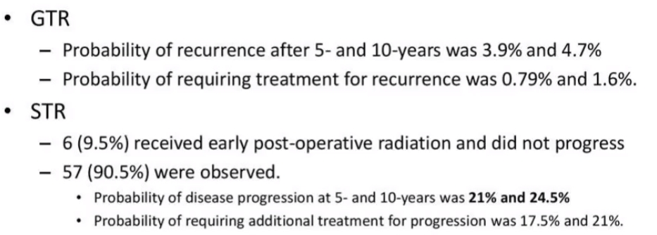
  - cavernous sinus invasion!!!
  - recurrence (if previously received adjuvant radiotherapy → reoperate; if previously did not receive radiotherapy → administer it now - single session SRS provides growth control and long-term endocrine control that is superior to that of repeat resective surgery)
  - not surgical candidates (but histologic confirmation is generally desired!)
  - not benefited from / intolerant to postsurgical medical intervention.
*Gamma knife is less effective than conventional radiotherapy (higher remission rates, no recurrences described) but Gamma knife carries lesser chances of panhypopituitarism

Benign tumor as a target for SRS
- Well circumscribed targets without infiltration
- Easily visualized with sharp delineation
- Slow growth rate makes high dose single fraction treatment desirable over fractionation (but late complications have time for expression)
- Goal of SRS: accurately deliver adequate radiation to the “target” with a minimal dose outside the prescribed area (i.e. provide the highest potential for growth control and normalization of hormone production + minimize the risk of cranial neuropathies)

Methodology (SRS)
Highly conformal dose plan is needed to spare the optic apparatus as well as any remaining normal pituitary gland!

Optic considerations – see p. Rx11 >>

Pituitary considerations – see p. Rx11 >>

Tumor control
Minimal tumor margin dose 12-16 Gy for nonfunctioning, 30-35 Gy for functioning.
- minimum margin dose of 12 Gy is generally considered a safe tumor control dose.
- doses of at least 15 Gy to ensure reliable and early tumor growth control may be prescribed when distance from the tumor margin to the optic apparatus allows.
N.B higher doses are needed for biochemical control (some investigators suggest up to 30–40 Gy to center, > 20 Gy to 50% margin isoline whenever possible for treating small volume secretory pituitary adenomas); SRS has better chances of biochemical control than fractionated XRT.

Cavernous sinus involvement
- microsurgery and SRS are often utilized in a planned staged manner: initial first stage extracavernous microsurgery to reduce the tumor volume and create space between the tumor and the optic apparatus, thus allowing safe delivery of the highest dose of SRS possible.

Preop
- bromocriptine, octreotide may confer relative radioresistance to tumors undergoing SRS - many clinicians suggest stopping these agents 4-6 weeks prior to SRS and restart 1 week after SRS.
- long acting drugs (e.g. slow release octreotide) should be discontinued 3–4 months prior to SRS.

Outcomes
Guidelines on the Management of Patients with Nonfunctioning Pituitary Adenomas (CNS 2016): assessment of the efficacy of radiation therapy in the primary treatment of NFPAs is sparse (the risk of tumor progression and radiation-induced hypopituitarism are major disincentives)
Gamma Knife results in published series:
decrease in tumor size | 38-85% (at 10years)
stable tumor size | 26.7-62%
increase in tumor size | 13.3%

Unlike surgical resection, which eliminates the tumor on subsequent neuroimaging, the neoplastic goal of SRS is permanent tumor control - a tumor, which has been enlarging, is made incapable of further tumor growth, and this control is confirmed through long-term neuroimaging follow-up.
- while permanent stabilization of tumor size is the desired goal, the majority of tumors will demonstrate varying degrees of tumor shrinkage over time.
- tumor growth control success: 94-95% cases at 5 yrs, 76-85% at 10 yrs.

Radiation therapy is less effective in controlling endocrine hypersecretion (although reported success in 29-82% of cases with SRS vs. 31-80% with surgery)
- normalization of hormone secretion requires time (median time to normal 1.09 yrs; cumulative normal 86 % after 3.4 yrs)
- normal vision can be achieved by irradiation alone in 2/3 patients (i.e. emergency radiotherapy is an option even with visual changes if surgery is not feasible).
- control rates: ACTH > GH > prolactin
- GH levels decrease only at rate of 10-30% per year (several years may be required for levels to normalize!).
Time to endocrinologic remission is 12-144 months
- ideal situation - small target volume sufficiently far from optic chiasm (to avoid radiation-induced optic neuropathy).

Complications
see also p. Rx11 >>
- hypopituitarism (risk 12-100% for fractionated XRT; 26% (0-39%) for SRS) may develop after years (largely correctable by hormone replacement therapy - patients treated for pituitary adenomas should be observed by endocrinologist for remainder of their lives); safe dose to gland is < 15 Gy, to stalk < 17 Gy.
- optic chiasm radiation injury (risk 1-2% for fractionated XRT, 4% risk for permanent cranial neuropathy with SRS; especially sensitive in acromegaly) → optic nerve neuropathy and ophthalmoplegia; optic structures should be decompressed before radiation therapy!
- temporal lobe injuries (infarctions, temporal epilepsy, cognitive dysfunctions) – due to radiation shifted away from optic apparatus
- radiation-induced brain tumor - risk is small (1.3% at 10 years and 1.9% at 20 years).
- cerebrovascular injury.
2)-4) complications do not occur with Gamma knife;

- with Gamma knife, only 38-60% tumors demonstrate shrinkage postop – SRS is not good for decompression.
- no dose limits to carotid artery (but avoid hotspots > 25 Gy on it).

Chemotherapy
- invasive pituitary adenomas may respond to temozolomide.

Algorithms according to Hormone
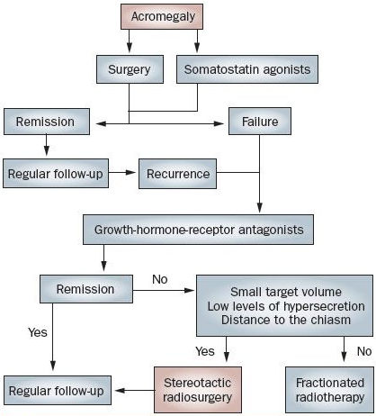

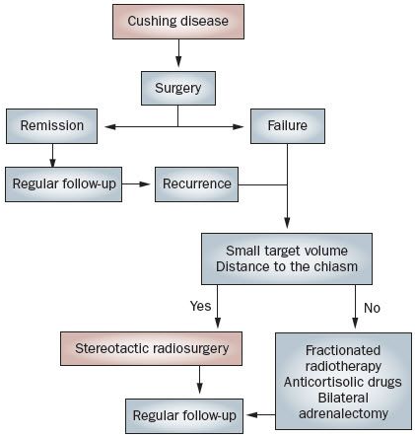
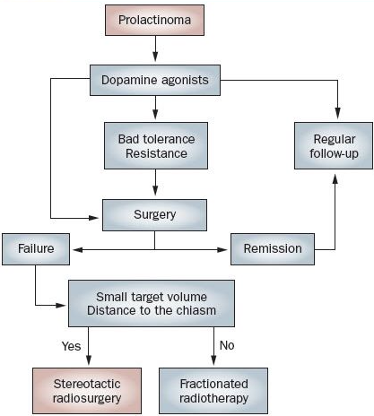

Prognosis
- very favorable prognosis (success of surgical intervention).
- recurrence is possible only if resection is incomplete.
- after surgery for NFPA: visual function improved in 75-91%, hypopituitarism improved in 35-50%, new hypopituitarism developed in 12% of patients.
    - Dekkers et al (2007) showed that visual acuity improved significantly within 3 months of transsphenoidal surgery; further improvement was seen 1 year postoperatively (the beneficial effects of tumor decompression can be seen in a delayed progressive fashion).

Natural history without treatment
See above >>

Treatment of Recurrence / Residual Tumor
- recurrence after initial resection is 44-75% within 10-years.
- OK to watch; if starts growing – linear growth – can calculate when will reach optic chiasm.

  - Surgery – 1st choice
  - Radiotherapy – fractionated (esp. if tumor touches optic chiasm) or SRS.
- invasive or imaging-negative functioning adenoma following failed resection → whole-sellar SRS can offer endocrine remission.

Guidelines on the Management of Patients with Nonfunctioning Pituitary Adenomas (CNS 2016) - adult patients with recurrent or residual NFPAs (recurrence after initial resection has been noted to be as high as 44%-75% within a 10-year period of time):
Level II Recommendations
- SRS (12-20 Gy) and radiotherapy (fractionated 45-54 Gy) are recommended to lower the risk of subsequent tumor progression (local tumor control ≥ 90% at 5 years).
- no or only small residual intrasellar tumor postoperatively - serial neuroimaging is recommended.
Level III Recommendations
- repeat resection is recommended for symptomatic recurrent / residual NFPAs; if repeat resection is too risky → SRS or radiation therapy
- assessment of NFPA proliferative index and ACTH staining (to identify silent corticotrophic adenomas) are recommended - risk of adenoma progression and the benefit of earlier adjuvant radiation.

PITUITARY CARCINOMAS
- extremely rare!
- despite highly invasive characteristics, rapid growth, and anaplastic features, histology is almost indistinguishable from adenoma - diagnosis confirmation needs distant metastases.

EMPTY SELLA SYNDROME
- arachnoid herniation through incomplete diaphragma sellae → globular sella enlargement with no discernible hypophysis (gland is flattened on sellar floor)

Etiology
- Primary (congenitally incompetent sellar diaphragm)
- Secondary – after:
- trans-sphenoidal surgery
- radiotherapy
- pituitary apoplexy
- involution of silent pituitary tumor
- benign intracranial hypertension

Clinical Features
- no endocrine / visual / neurologic disturbances (but hypopituitarism may be present).
Chiasm herniation inside sella does not cause visual field defects!
- typical patient - female (> 80%), obese (75%), hypertensive (30%) with benign intracranial hypertension (10%) and CSF rhinorrhea (10%).
- occasionally, patients have small coexisting secreting pituitary tumors.

Diagnosis
MRI - enlarged pituitary fossa filled with CSF; infundibulum is seen extending down posteriorly to lower part of fossa (thereby excluding cystic tumor).
- on plain radiography, cannot be distinguished from sellar enlargement by tumor.

Treatment
- no specific therapy is needed for empty sella alone.

PITUITARY APOPLEXY
- either hemorrhage or acute ischemia of pituitary gland (esp. macroadenomas - about 5% of their presentations; rarely into normal hypophysis) → hypothalamic, chiasmal, cavernous sinus, brainstem compression.
- provoking factors:
- reduced blood flow to gland (e.g. upper respiratory tract infection with frequent coughing and sneezing).
- sudden increment of blood flow
- stimulation of gland by endocrine mechanisms
- anticoagulation
- trauma.

Clinical Features
- sudden-onset:
- meningeal irritation - severe headache (87%), nausea-vomiting, stiff neck, fever.
- eye signs - partial ophthalmoplegia (45%), rapidly progressive visual loss (56%) in one or other eye.
- varying degrees of acute panhypopituitarism (73%) (e.g. vascular collapse ← deficient ACTH)
- altered consciousness (13%) because of hypothalamic compression.
May be fatal!

Diagnosis
CSF – hemorrhagic.
CT / MRI will differentiate from SAH.

Treatment
IV fluids + IV high-dose steroid replacement!
Conservative treatment for stable cases.

Indications for emergency surgical trans-sphenoidal decompression:
- rapidly deteriorating vision
- progression to coma!!!

Hypophysitis
(s. autoimmune hypophysitis)

Two main forms:

    - Lymphocytic (adeno)hypophysitis (s. lymphoid adenohypophysitis): the more commonly encountered form.
- autoimmune inflammation of the pituitary stalk with lymphocytic infiltrate; the antigens have not been identified.
- primarily in late pregnancy or early postpartum period.

    - Granulomatous hypophysitis: more aggressive, no gender bias, no association with pregnancy. May be autoimmune, but pathogenesis not definitely known.

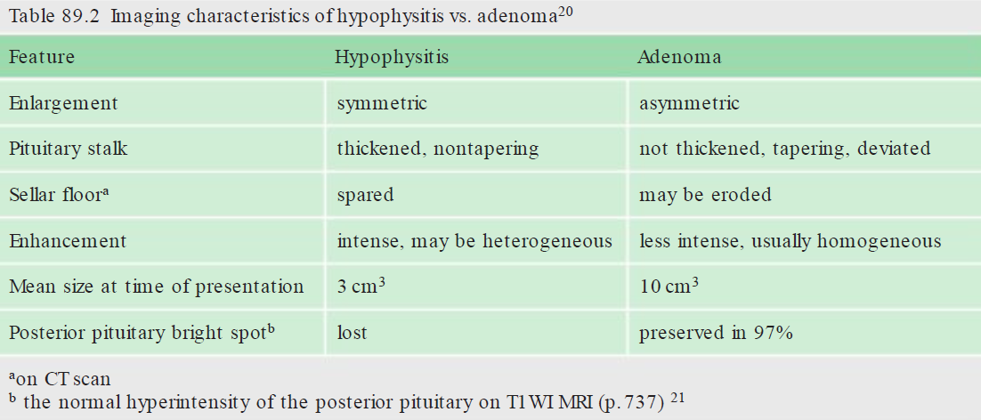

- often mimics a nonsecretory pituitary macroadenoma (enhancing sellar mass, with negative endocrine tests) - often undergo surgical resection instead of what may be more appropriate medical therapy (e.g. steroids, or discontinuing possible offending agents such as ipilimumab).

CRANIOPHARYNGIOMA
- slow-growing, extra-axial tumor.
Epidemiology
- 1-5% of all primary intracranial neoplasms
- 5-13% of all primary CNS tumors in children - 3rd most common tumor in childhood.
- incidence ≈ 0.13-2.0 per 100,000 per year.
- bimodal age distribution – first peak is in children 5-15 yrs; second peak at 50-74 years.
- median age at diagnosis is 8 years.
- unusual before age 2 years.
- male-to-female ratio is 1:1.
- no known risk factors.

- rare - 2%–5% of primary intracranial neoplasms (6-13% in children)

Pathology
Hypotheses of origin:
- Embryogenetic theory - embryonic nests of squamous epithelium along involuted hypophysiopharyngeal duct (i.e. congenital rests of Rathke's pouch stomodeal epithelium).
- Metaplastic theory – metaplasia of residual mature squamous epithelium (derived from stomodeum and normally part of adenohypophysis).

Grossly
- smooth, lobulated masses with solid and cystic components (90% are at least partially cystic).
- suprasellar location (arises in pituitary stalk and projects into 3rd ventricle and hypothalamus).
intrasellar + suprasellar (70%); only suprasellar (20%), purely intrasellar (10%).
- 80-90% are calcified (esp. in children).
- cysts filled with turbid, brownish-yellow, proteinaceous material that glitters and sparkles because of high content of floating cholesterol crystals (compared to machinery oil); cyst rupture into CSF → intense sterile chemical meningitis.
- several cytokines are elevated in cyst fluid when compared with CSF:
IL-1α and TNF-alpha are elevated but lower than 10-fold.
IL-6 is > 50,000 times more concentrated in cystic fluid than CSF.
- extend horizontally along path of least resistance in various directions - anteriorly into prechiasmatic cistern and subfrontal spaces; posteriorly into prepontine and interpeduncular cisterns, cerebellopontine angle, 3rd ventricle, posterior fossa, foramen magnum; laterally toward subtemporal spaces (can even reach sylvian fissure).
N.B. do not expand sella (unless they become very large) - differentiating feature from suprasellar pituitary macroadenomas!
- vascular supply from anterior circulation.

Histology
- well-differentiated tissue - two main histological types:
  - adamantinomatous form (in majority of children; embryogenetic origin) - resembles enamel pulp of developing teeth, composed of interspersed fibrous and necrotic tissue + multiloculated cysts;
- distinctive feature is peripheral palisading of basal epithelium layer, which encloses inner epithelium.
- inner epithelium may undergo hydropic vacuolization (“stellate reticulum”).
- areas of compactly arranged squamous cells contain keratin nodules ("wet" keratin* - hallmark of this tumor subtype).
*"wet" because of plump appearance of anuclear keratinocytes (vs. flat, flaky keratin with interspersed cell nuclei seen in epidermoid and dermoid cysts)
- "wet" keratin nodules frequently calcify.
- greater propensity to encase vessels and cranial nerves, invade brain and recur after surgery!!!

  - squamous papillary form (only in adults; metaplastic origin) – no complex heterogeneous architecture: less cystic stratified squamous epithelium and fibrovascular islands of connective tissue; does not form keratin nodules; does not calcify!

- craniopharyngiomas stimulate significant glial response (with profuse numbers of eosinophilic Rosenthal fibers* - densely compacted bundles of glial filaments in astrocytic cell processes) in contact areas with nervous elements - thick glial layer may encase tumor (pseudocapsule)**, but small epithelial “fingers” can extend into adjacent tissues through gliotic scar (“William Sweet finding”) - tight adherence to surrounding tissue can make complete resection difficult and hazardous; however, glial reaction is area to separate neoplasm from neural elements.
*Rosenthal fibers are characteristic feature of juvenile pilocytic astrocytomas - biopsy that samples only surrounding neuropil of craniopharyngioma may yield erroneous diagnosis!
**absent in 3rd vetricular portion

N.B. although histologically benign (do not undergo malignant degeneration), craniopharyngiomas may have malignant clinical course (location + adherence to critical structures with difficult removal + ability to recur).
- rarely undergo malignant degeneration

Adamantinomatous craniopharyngioma:
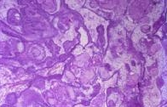 | Peripheral palisading of epithelium:  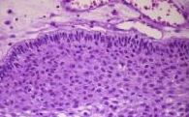
Inner epithelium with hydropic vacuolization (stellate reticulum):  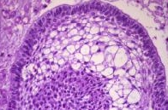 | "Wet" keratin nodule:  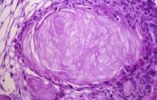
Calcified "wet" keratin nodule:
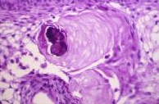

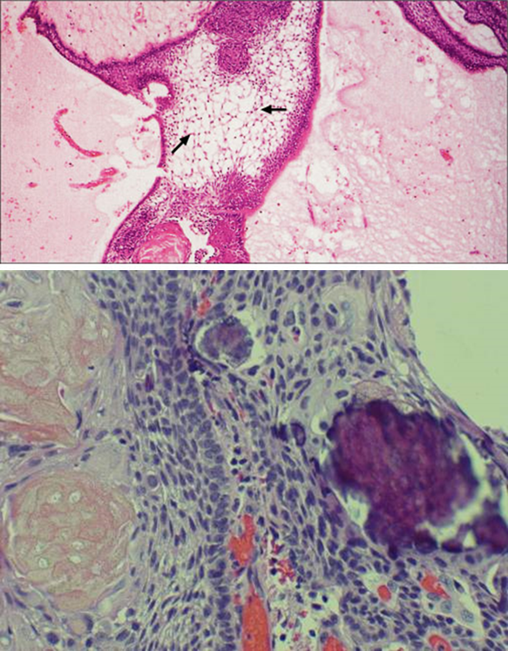

Papillary craniopharyngioma:
Only simple squamous epithelium:
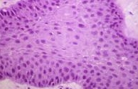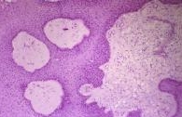

Rosenthal fibers in neuropils surrounding craniopharyngioma:
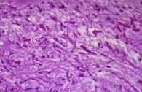

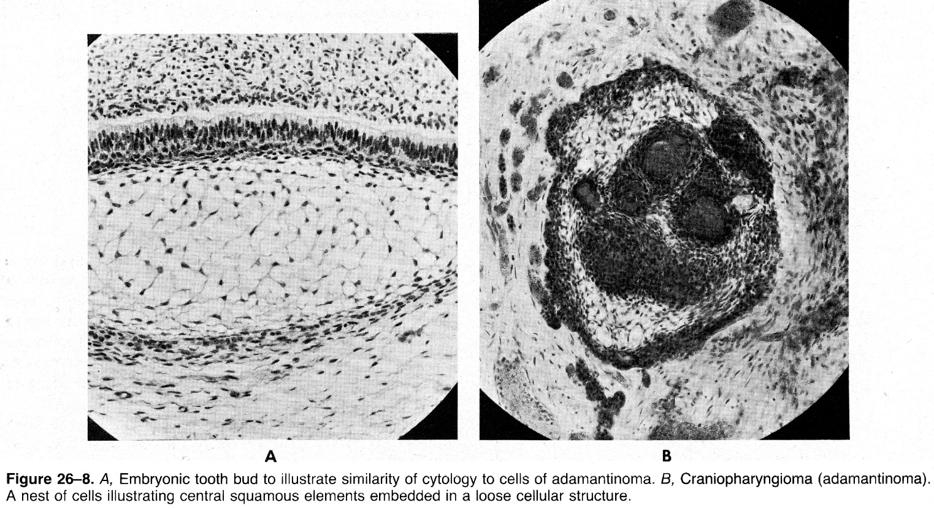

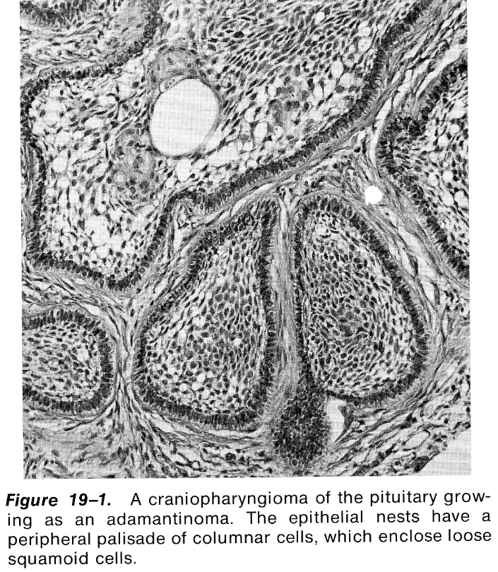

Typical epithelium showing basisquamous character with incarcerated keratin; note honeycombed character of epithelium in areas:
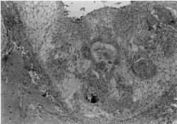
Source of picture: Philip A. Pizzo, David G. Poplack “Principles and Practice of Pediatric Oncology”, 3rd ed. (1997); Lippincott-Raven Publishers; ISBN 13: 9780397515615 >>

Basal cell layer (single rows of darker cuboidal cells) has given rise to larger squamous cell layer forming bulk of cellular parts; focally cells have further matured to occasional "keratin pearl" (e.g. in right upper part); microcystic cavities are scattered; macrocyst is seen in right upper corner, with "motor oil" content:
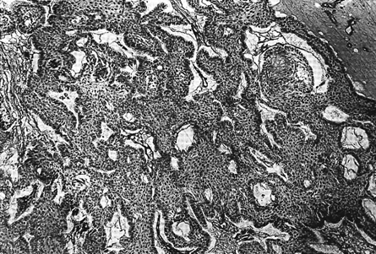

Clinical Presentation
- resembles pituitary adenomas, but most become symptomatic only after tumor have attained diameter of about 3 cm; symptom duration before diagnosis ≈ 1-2 yrs (i.e. chronic presentation).
- Increased ICP (related to hydrocephalus) – headaches (55-86%), vomiting, etc. – most commonly bring patient to clinical attention;
- superior tumor extension (obstruction of 3rd ventricle and foramen of Monro) → hydrocephalus in 50%.
- because of slow growth, papilledema is less common than optic pallor.
- Visual field defects (e.g. homonymous or bitemporal hemianopsia) of various degrees in 37-90%.
- Neuroendocrine deficits (66-90%) esp. GH, TSH and ADH deficits
- short stature and obesity are most common signs for pediatric endocrinological referral.
- in contrast to pituitary adenomas, prolactin abnormalities are seen in only 20% cases.
- 88-90% men complain of impotence, while 82% women complain of amenorrhea.

Diagnosis
Calcifications are present in the majority of pediatric tumors (up to 90%) and over half of adult lesions!

- Plain skull X-ray (valuable screening tool) – enlarged, distorted sella with suprasellar calcification.
- CT - partially cystic, low-density, contrast-enhancing (supra)sellar lesion with calcification.
- adult craniopharyngiomas often do not have calcifications – without biopsy difficult to differentiate from pituitary adenomas.
N.B. pituitary adenomas never have calcifications!
- MRI (best visualization!) - (supra)sellar tumor with solid and cystic components.
- cyst gives homogeneous high T2 signal and low T1 signal (cholesterol or blood products within cyst may give rise to high signal).
- solid portions and capsule show contrast enhancement.
CT is enough for diagnosis (calcifications), but tumor extension (e.g. hypothalamus invasion) is evaluated by MRI.
- Evaluation of hypothalamic-pituitary axis (esp. diabetes insipidus and hypoadrenalism – minimum evaluation in emergency cases)
  - before surgery, repeated postoperatively and periodically thereafter for at least 1 year (hormonal deficits often increase after surgery and may take several months to become fully apparent!).

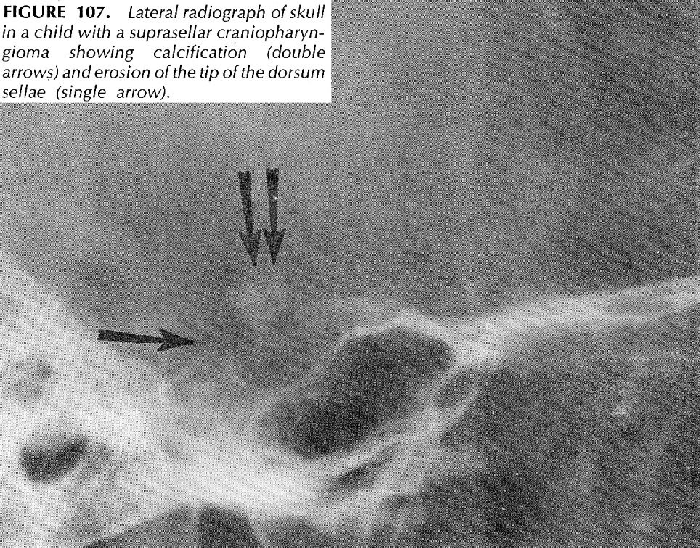

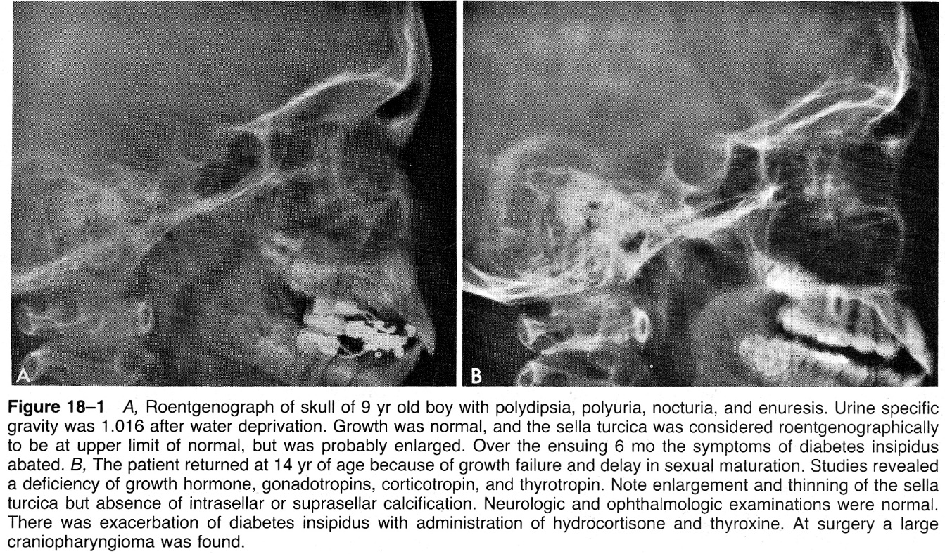

CT with contrast - partly calcified, partly cystic suprasellar lesion (note inhomogeneous enhancement of solid tumor components):
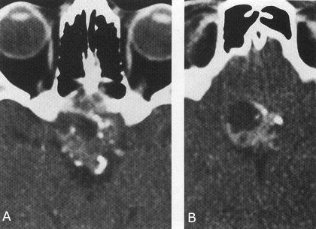
Source of picture: Ronald G. Grainger, David J. Allison “Grainger & Allison’s Diagnostic Radiology: A Textbook of Medical Imaging”, 4th ed. (2001); Churchill Livingstone, Inc.; ISBN-13: 978-0443064326 >>

MRI - cystic contrast-enhancing suprasellar mass extending upward, compressing hypothalamus:
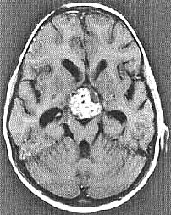
Source of picture: Christopher G. Goetz “Textbook of Clinical Neurology”, 1st ed. (1999); W.B. Saunders Company; ISBN 0-7216-6423-7 >>

Gadolinium-enhanced MRI:
A) very large suprasellar mass extending to hypothalamus & thalamus (enhancement is confined to superior portion).
B) tumor extends bilaterally.
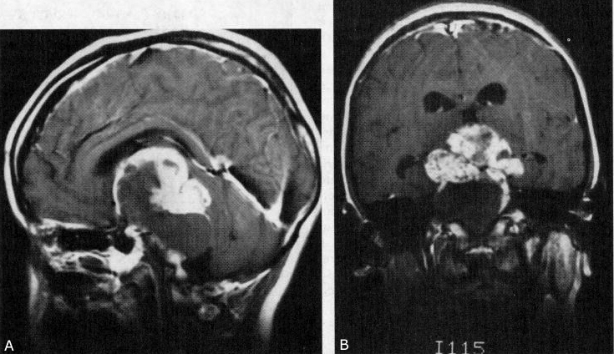
Source of picture: Martin D. Abeloff “Clinical Oncology”, 2nd ed. (2000); Churchill Livingstone, Inc.; ISBN-13: 9780443075452 >>

- CT without contrast: dense calcification within neoplasm wall (arrows); temporal horn dilation secondary to obstructive hydrocephalus.
- T1-MRI: large homogeneous suprasellar neoplasm expanding pituitary fossa and compressing 3rd ventricle.
- T1-MRI with contrast - enhancement of cyst wall; small amount of enhancement involving adjacent floor of 3rd ventricle; again temporal horn dilation.
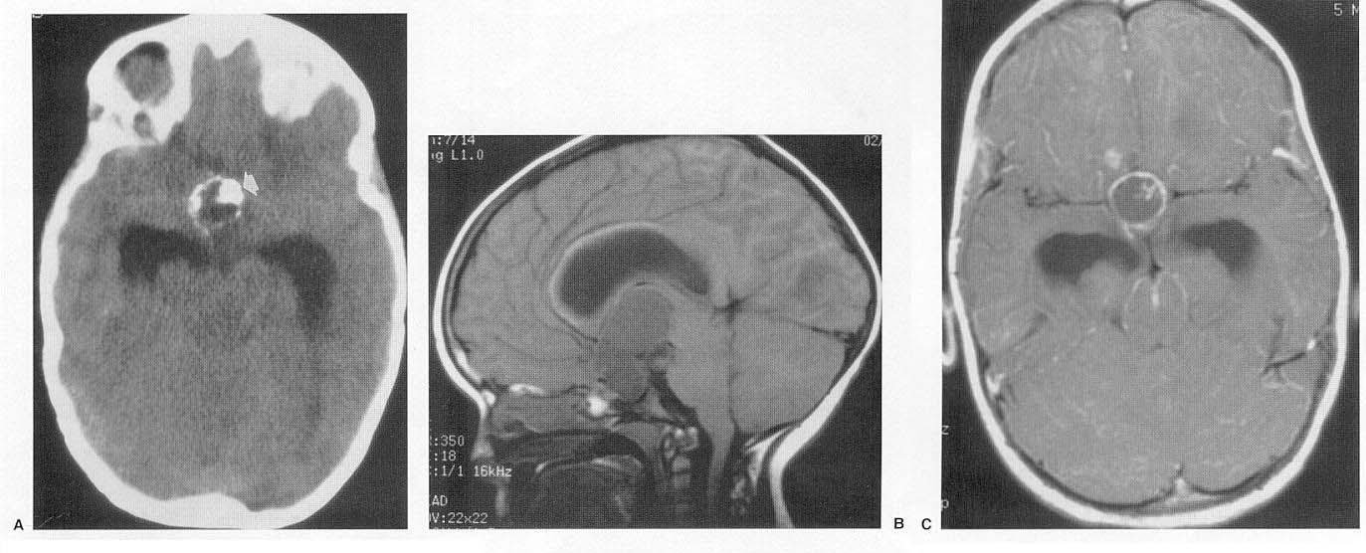

T1-MRI without contrast: large suprasellar neoplasm with two regions of high signal (arrows) - lipid material within cyst:
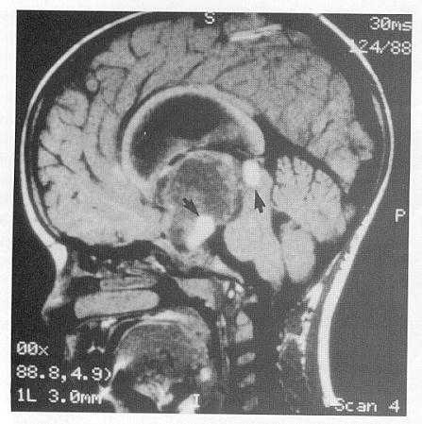

T2-MRI of mixed density tumor with foci of calcification (black):
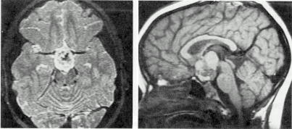

A) T2-MRI - large suprasellar mass (arrows) with cystic components.
B) T1-MRI - high signal in cystic portions; ACA and ACoA indent upper cyst surface (arrow).
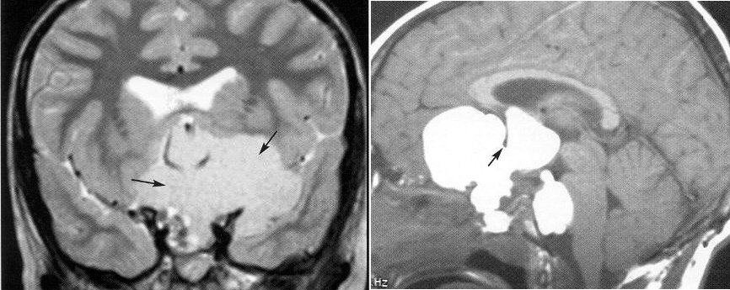

Treatment
Patient with suspected craniopharyngioma → surgery for cyst decompression and removal of accessible tumor:
- total resection may be attempted (using modern microsurgical techniques, 90% success rate); if successful – no further treatment is required, just serial neuroradiological follow-up
N.B. radical attempts are not warranted for densely adherent tumors!
- alternative – radiosurgery, intracavitary radiocolloids
- if tumor is subtotally resected:
- adjuvant radiotherapy
- serial neuroradiological follow-up

Surgery
http://www.neurosurgicalatlas.com/grand-rounds/technical-nuances-for-resection-of-craniopharyngiomas

See also pituitary adenoma aspects >>

Problems with craniopharyngiomas:
- proximity to vital neurovascular structures (highest morbidity – hypothalamic damage).
- difficult to cure - high recurrence rates - necessitate multimodality treatments (surgery, radiotherapy, radiosurgery, intracystic irradiation, local-intracystic/systemic chemotherapy*).
According to major literature studies, rate of recurrence ranges 0-53% in cases of total removal and 30-100% in cases of subtotal or partial removal.
*for craniopharyngiomas that have undergone malignant transformation
- current treatments focus on the relief of symptoms, avoidance of treatment-related morbidity, preservation of quality of life, and prevention of recurrence.
- main goal - complete excision (followed by irradiation in cases of residual tumor).
- recent studies have shown survival rates 83-93% at 10 years of follow-up

Preoperative corticosteroids are strongly recommended in all patients regardless of their preoperative status (if not already receiving due to ICP↑)
Hydrocortisone, 100 mg/m² i/v followed by 25 mg/m² q6h until maintenance steroids can be resumed postoperatively.
- fluid and electrolyte balance should be monitored closely (diabetes insipidus, syndrome of inappropriate ADH secretion, cerebral salt wasting are common in postoperative period!).
- vasopressin is not needed unless symptomatic deficit!

Modalities of surgical approaches:
- open – still “the standard”
- microscopic/endoscopic transsphenoidal
- endoscopic endonasal (EES)
- stereotactic cyst aspiration – for purely cystic tumors

Approach:
  - tumors located primarily in sella can be removed transsphenoidally (if sella is not enlarged, transsphenoidal approach is contraindicated); large cysts that enter sella can be drained and resected transsphenoidally;
  - subfrontal approach - for lesions that lie anterior to optic chiasm.
  - pterional approach - for lesions extending onto dorsum sella or into temporal fossa.
  - large cysts extending to 3rd ventricle roof can be approached through corpus callosum (interhemispheric).
  - orbitozygomatic approach

Extent of surgical removal (matter of intense debate):
  - total resection (survival times are longer and recurrences are fewer).
  - subtotal resection followed by local radiation (spares posterior pituitary function and permits more normal life).
- cysts should be tapped and tumor gradually mobilized.
- separate tumor from carotid arteries by sharp dissection; inflammatory tumor adhesion to surrounding vascular structures is most common cause of incomplete tumor removal (fusiform dilatations of large surrounding vessels are reported after attempts at radical dissection).
- tumor will separate from nervous tissue fairly readily, but there may be considerable difficulty exposing all lesion which extends high into 3rd ventricle - steady traction must be applied (N.B. tissue can be lost behind chiasm if tumor is released; tissue behind chiasm can be mobilized by dissecting through lamina terminalis).
- preserve pituitary stalk whenever possible!
- surgical mortality is now extremely low (< 5%, mostly from hypothalamic injury).

It is advisable to leave undisturbed tumor that is densely adherent to optic apparatus, anterior cerebral artery, or hypothalamus

Postoperative - similar to pituitary adenomas.
- aggressive removal nearly guarantees some injury to pituitary gland and stalk → diabetes insipidus + elements of hypopituitarism (→ replacement hormones and inhaled desmopressin spray for life!).
  - keep Pitressin administration at minimum during 1st week, when there is considerable variation in amount of Pitressin that patient releases.
  - later, if only small Pitressin doses are needed, it can be exchanged for chlorpropamide + hydrochlorothiazide combination.
- surgery improves affected vision!

Radiotherapy
- decreases recurrence rates and enhances survival in incomplete tumor resections and even in minimal surgeries (biopsies, cyst drainages).
- should start within 3 weeks of surgery.
- recommended regimens:
  - 54-55 Gy given in daily 1.8-Gy increments to local fields* only (using relatively small margins around tumor). *preoperative volume plus 1.5-cm margin
  - 11.5 Gy marginal dose (50% isodose) SRS - the only benign tumor that can completely disappear after SRS!!!
- for children < 3 yrs delay radiotherapy.

N.B. multiple comparisons strongly suggest that patients treated with subtotal resection + irradiation have less neuroendocrine dysfunction and fewer serious neurologic deficits than those who have had aggressive attempts at complete tumor resection (hypothalamic injury!!!)
- these patients also have better quality of life than patients treated with radical surgery alone.
- neuropsychologic function is preserved better in combined-therapy group despite known detrimental effect of radiation.
- because of morbidity of total resections, treatment with ³² P, ⁹⁰Y, ¹⁸⁶Re, ¹⁹⁸Au radiocolloids, IF-2α, bleomycin (intracavitary to large solitary cysts) and stereotactic radiosurgery (to 2-3 cm solid tumors) has increased.
N.B. if radiocolloid leaks → moyamoya-like disease!!!!

Chemotherapy
- no established role!
- intracystic bleomycin reduces cyst size and toughens and thickens cyst wall (→ safer surgery) – studies do not show the improved outcomes.
- anecdotal response to vincristine, BCNU, and procarbazine combination has been described in one patient.

Prognosis
Most important prognostic factor - extent of tumor resection (recurrences usually occur at primary site and within first year).
- tumor size is probably not independent variable, but rather is related to extent of resection.
- purely cystic lesions survive longer than solid or mixed lesions.
- excellent survival for patients < 20 yrs (99% at 5 yrs); vs. 38% at 5 years for those > 65 yrs.
- 10-year disease-free survivals:
> 70% if no visible calcification / tumor in postsurgical CT / MRI;
< 50% if incomplete resection without radiotherapy (50-75% recur within 2-5 years).

Survival rates:
Treatment | 5 yrs (%) | 10 yrs (%)
Total resection | 58-100 | 24-100
Subtotal resection | 37-71 | 31-52
Subtotal resection + radiation | 69-95

N.B. survival alone is inadequate measure of therapeutic efficacy - multitude of neuroendocrinologic, visual, and neuropsychologic problems must also be considered carefully:
- significant nonendocrine-related surgical morbidity and neurologic, visual-motor problems occur in 20% (in complete tumor resections);
- neuroendocrine deficit increase is common after aggressive surgery; permanent diabetes insipidus occurs in 68-75% adults and 80-93% children; replacement of ≥ 2 anterior pituitary hormones is necessary in 80-90% patients; obesity occurs in 50% patients.
some craniopharyngiomas express IGF-1 and/or sex hormone receptors → ↑recurrence in patients receiving growth hormone and/or sex hormone replacement.
- postsurgical declines in neuropsychologic status are seen in many patients.

Neuropsychological deficits represent major limiting factor of independent social functioning because ¹⁾ patients often can overcome minor neurological deficits and ²⁾ hormone-replacing therapies are widely available. Psychosocial impairment correlates directly with degree of hypothalamic injury sustained at time of surgery!

Female sex is independent predictor of increased cardiovascular, neurological, and psychosocial morbidity!

Bibliography for ch. “Neuro-Oncology” → follow this link >>

Viktor’s Notes℠ for the Neurosurgery Resident
Please visit website at www.NeurosurgeryResident.net

