Brain Metastases

Last updated: December 22, 2020

[Epidemiology 1](#_Toc52395072)

[Etiopathophysiology 2](#_Toc52395073)

[Sources in adults 2](#_Toc52395074)

[Sources in children 2](#_Toc52395075)

[Pathology 2](#_Toc52395076)

[Location 3](#_Toc52395077)

[Macroscopy 3](#_Toc52395078)

[Histopathology 3](#_Toc52395079)

[Immunohistochemistry 4](#_Toc52395080)

[Clinical Features 5](#_Toc52395081)

[Diagnosis 5](#_Toc52395082)

[Blood Studies 5](#_Toc52395083)

[Search for Systemic Cancer 5](#_Toc52395084)

[Imaging of neuraxis 5](#_Toc52395085)

[Contrast CT 5](#_Toc52395086)

[MRI with gadolinium 5](#_Toc52395087)

[PET 7](#_Toc52395088)

[CSF 7](#_Toc52395089)

[Biopsy 7](#_Toc52395090)

[Treatment 7](#_Toc52395091)

[Medical management 9](#_Toc52395092)

[Steroids 9](#_Toc52395093)

[AED 9](#_Toc52395094)

[Anticoagulation 9](#_Toc52395095)

[Evolution of modern treatment 10](#_Toc52395096)

[Surgery 10](#_Toc52395097)

[Surgery + WBRT vs. WBRT alone for solitary metastasis 11](#_Toc52395098)

[Radiotherapy 11](#_Toc52395099)

[Whole-brain radiation therapy (WBRT) 12](#_Toc52395100)

[Stereotactic Radiosurgery (SRS) 13](#_Toc52395101)

[SRS vs. WBRT 15](#_Toc52395102)

[WBRT ± SRS 15](#_Toc52395103)

[SRS ± WBRT 15](#_Toc52395104)

[SRS vs. WBRT vs. SRS + WBRT 16](#_Toc52395105)

[SRS vs. surgery 16](#_Toc52395106)

[Recurrence after SRS 16](#_Toc52395107)

[Laser (LITT) 16](#_Toc52395108)

[Chemotherapy 17](#_Toc52395109)

[Emerging Therapies 17](#_Toc52395110)

[Follow Up 17](#_Toc52395111)

[Prognosis 17](#_Toc52395112)

[Role of extracranial disease 17](#_Toc52395113)

[Role of treatment modality 17](#_Toc52395114)

[Role of number of metastases 18](#_Toc52395115)

[RPA / RTOG classification 18](#_Toc52395116)

[Specific metastases 19](#_Toc52395117)

[CNS melanoma 19](#_Toc52395118)

[Diagnosis 19](#_Toc52395119)

[Treatment & Prognosis 20](#_Toc52395120)

[Lung cancer 20](#_Toc52395121)

[Small cell 20](#_Toc52395122)

[Non-Small cell 20](#_Toc52395123)

[Breast Cancer 20](#_Toc52395124)

- tumors that originate outside CNS and spread secondarily to CNS via **hematogenous** route (metastasis) or by **direct invasion** from adjacent tissues (not considered metastases in strict sense because they remain in continuity with primary neoplasm).

Metastases from systemic cancer can affect:

1. brain (high blood flow - common site for metastases!)
2. spinal cord see [p. Onc50 >>](http://www.neurosurgeryresident.net/Onc.%20Oncology\Onc50.%20Intramedullary%20Spinal%20Tumors.pdf), [p. Onc54 >>](http://www.neurosurgeryresident.net/Onc.%20Oncology\Onc54.%20Intradural%20Extramedullary%20Spinal%20Tumors.pdf)
3. peripheral nerves see [p. Onc60 >>](http://www.neurosurgeryresident.net/Onc.%20Oncology\Onc60.%20Nerve%20Tumors%20(GENERAL).pdf)
4. meninges see [p. Onc34 >>](http://www.neurosurgeryresident.net/Onc.%20Oncology\Onc34.%20Neoplastic%20Meningitis.pdf)
5. skull see [p. Onc40 >>](http://www.neurosurgeryresident.net/Onc.%20Oncology\Onc40.%20Skull%20Tumors.pdf)
6. vertebrae see [p. Onc56 >>](http://www.neurosurgeryresident.net/Onc.%20Oncology\Onc56.%20Extradural%20Spinal%20Tumors,%20Vertebral%20Tumors.pdf)

Epidemiology

Metastatic tumors are most common mass lesions in brain! (> 50% of total brain tumors but only 6% of pediatric brain tumors)

* metastatic tumors are most common CNS neoplasms: 11\* / 100 000 population / year (probably underestimate due to underdiagnosis and inaccurate reporting)

\* < 1 at age < 25; > 30 at age > 60

* 60% patients are 50-70 yrs.
* **gender** lacks significant independent effect on occurrence of CNS metastasis (male ≈ female).
* autopsy:

**brain** metastases occur in 15-33% of patients who die of systemic cancer (30% adults, 6–10% children) - only 1/3 of these are diagnosed during life

**leptomeningeal** metastases 4–15% of solid tumors

**dural** metastases in 8–9%

**direct intracranial extension** from local primary tumors\* - rare

**spinal epidural** metastases\*\* in 5–10%

\*of head and neck (e.g. squamous cell carcinoma, esthesioneuroblastoma)

\*\*much more frequent than spinal leptomeningeal or intramedullary metastases

* 20% of cancer deaths.
* 15% systemic cancers present with neurologic symptoms! (esp. lung cancers)

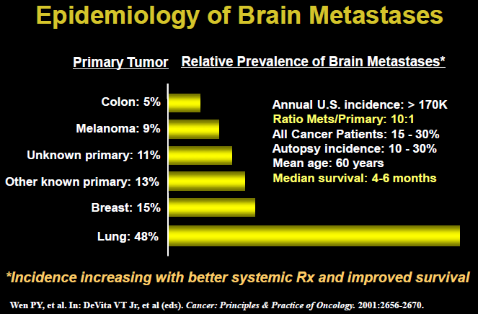

Etiopathophysiology

To establish metastatic colony, tumor cells must:

* 1. grow within primary site
  2. escape from primary tumor
  3. penetrate\* circulatory system (either as single cells or small tumor emboli)
  4. survive while circulating
  5. arrest in microvasculature of other organ
  6. extravasate\* into organ parenchyma;
     + most systemic treatments (e.g. chemotherapeutic agents, which may penetrate brain poorly) can transiently weaken BBB - allow systemic disease to be seeded in CNS.
  7. efficiently grow and compress (or invade) tissue at secondary site;
     + tumor cells modulate expression of fibronectin, collagen, laminin, and change type of integrin receptor on their surface and on surface of surrounding stromal cells → desegregation of stromal cells → permissive environment to expand and invade.

\*by producing proteolytic enzymes (metalloproteinases, cathepsins)

* 1. once in contact with CSF, cells may disseminate (“seed”) around CNS
* different tumors metastasize preferentially to different organs - cells with similar ***embryologic origins*** have similar growth constraints and express similar sets of adhesion molecules, such as vascular addressins expression on endothelial cells (e.g. melanoma cells are closely related to CNS cells - melanoma commonly metastasizes to brain).
* tumor cells can survive in environments of low oxygen tension; when tumor increases in volume by > 2-3 times, it induces ***angiogenesis*** (e.g. angiopoietin 2, vascular endothelial growth factor).

Sources in adults

- mainly hematogenous spread from systemic cancers (only few primary high-grade brain tumors metastasize to other parts of neuraxis):

Virtually all systemic cancers have capacity for brain metastasis!

* + - 1. **Lung** (35-50%)
         * *small-cell carcinomas* (20% lung cancers) account for 50% brain metastases from lung cancer.
         * in patients with newly diagnosed non-small cell lung cancer (NSCLC), 30-50% will develop brain metastases.
         * 80% lung cancer patients who survive > 2 yrs have brain metastases.
         * interval between diagnosis of primary lung cancer and brain metastases is ≈ 4 months.
         * prophylactic cranial irradiation reduces 2-year cumulative incidence of brain metastases in patients with small-cell carcinoma from 47 to 10%.
      2. **Breast** (13-20%) - main source of metastatic disease in women!
         * interval between diagnosis of primary breast cancer and brain metastasis is ≈ 3 years.
      3. **Melanoma** (9-11%) [*see below* >>](#CNS_melanoma)
      4. GU tract (7-11%) (21% **kidney**, 46% testes, 5% cervix, 5% ovary)
         * prostate carcinoma rarely metastasizes to brain! (but frequently to spine)
      5. Sarcoma (3-10%)
      6. GI tract (3-9%) (3% **colon**, 2% pancreatic)
      7. Head and neck cancer (6%)
      8. Neuroblastoma (5%)
      9. Lymphoma, mainly non-Hodgkin (1%)
* 10% cases have ***no identifiable primary source*** (most often adenocarcinomas or squamous cell carcinomas).
* 11% mass lesions in patients with cancer are ***not metastases***!
* **dural** metastases - from prostate, breast, lung, hematologic tumors.
* **leptomeningeal** metastasis - from lung and breast cancer, melanoma, hematopoietic tumors.

Propensity to spread to brain

Cumulative incidence of brain metastasis with interval after diagnosis of primary tumor:

|  |  |  |  |
| --- | --- | --- | --- |
| **Primary tumor site** | **< 1 month** | **< 1 year** | **< 5 years** |
| Lung | 7.8% | 14.8% | 16.3% |
| Renal | 1.7% | 5.2% | 9.8% |
| Melanoma | 0.7% | 4.0% | 7.4% |
| Breast | 0.4% | 1.0% | 5.0% |
| Colorectal | 0.1% | 0.6% | 1.2% |

Sources in children

leukemia > lymphomas > osteogenic sarcomas > rhabdomyosarcomas > Ewing sarcoma

* *germ-cell tumors* are common in adolescents and young adults aged 15-21 years.

Pathology

* number of tumors:

1 tumor – **single tumor** (25-50% cases)

N.B. up to 50% of patients have only 1 metastasis (but only 50% of those are surgical candidates in terms of extracranial disease)

2-3 tumors – **oligometastases**

4-8 tumors – **diffuse multifocal disease**

≥ 9 tumors – **miliary disease**

* very few are **solitary** (i.e. only metastasis detected in body).
* melanoma is most likely to be associated with multiple metastases than other tumor types.
* *bronchogenic carcinomas* tend to outgrow their blood supply and become ***necrotic***; *breast carcinoma* deposits may also cavitate but are more frequently ***solid***.
* in majority cases **edema** is substantial (for unclear reasons, some metastases produce almost no edema).
* **calcification** is unusual in untreated tumors (except for metastases from primary osseous tumors)
* some metastases *hemorrhage* spontaneously (esp. melanoma, renal cell carcinoma, choriocarcinoma).
* proliferation - variable and often higher than in primary neoplasm

Location

85% in **cerebrum** (metastases prefer anatomical arterial "watershed areas" and gray matter-white matter junction\*)

\**where end arteries penetrate into brain, narrow and branch into arterioles*

15-18% in **cerebellum** (esp. colorectal, renal, pelvic tumors)

3-5% in **brainstem**

* occasionally, metastatic CNS tumors seed along walls of ventricles or are located in pituitary gland, choroid plexus, or pre-existing lesion like meningioma.
* *cancer-cell trafficking may not be entirely random* - factors produced by stromal cells may guide final destination (e.g. retroperitoneal and pelvic cancers tend to metastasize to posterior fossa; breast cancer favors pituitary gland).
* metastatic cancers invade brain regions in proportion to both *tissue volume* and *blood flow* - highly vascularized areas (leptomeninges, ventricles, pituitary gland) receive disproportionately large number of cancers.

Macroscopy

- grossly circumscribed and rounded, grey white or tan masses with variable central necrosis and peritumoral edema.

* **adenocarcinomas** may contain collections of mucoid material.
* **haemorrhage** is relatively frequent in metastases of choriocarcinoma, melanoma, renal cell carcinoma.
* **melanoma** - brown to black colour.
* **leptomeningeal** metastasis - diffuse opacification of membranes, multiple nodules.
* **dural** metastases - localized plaques & nodules or diffuse lesions.
* **locally extending** primary neoplasms in head and neck - significant destruction of skull bones (in some cases, skull is penetrated by relatively subtle perivascular or perineural invasion without major bone destruction)

Histopathology

- diverse as in primary tumors from which they arise.

**Parenchymal metastases**

* most are histologically relatively well demarcated - expand by growth of groups of tumor cells in Virchow-Robin spaces (rather than by infiltration of single cells in neuropil) → destruction of neuroglial tissue and variety of reactive changes (gliosis, inflammation and florid microvascular proliferation).

small cell carcinomas of lung may show relatively diffuse (“pseudogliomatous”) infiltration in neuropil

* necrosis may be extensive, leaving recognizable tumor tissue only at periphery of lesion and around blood vessels.

**Leptomeningeal metastasis** - tumor cells dispersed in subarachnoid and Virchow-Robin spaces and may invade adjacent CNS parenchyma and nerve roots

**A**,**B** Intracerebral subcortical metastasis of small cell lung carcinoma.

**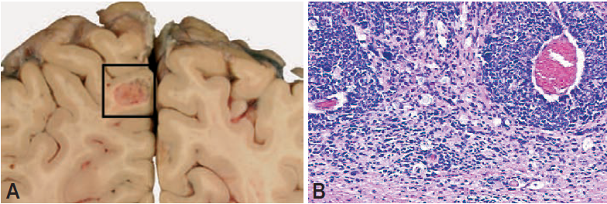**

[Source of picture: “WHO Classification of Tumours of the Central Nervous System” 4th ed (2007), ISBN-10: 9283224302, ISBN-13: 978-9283224303 >>](http://www.amazon.com/gp/product/9283224302)

**C**, **D** Extensive spread of small cell lung carcinoma cells along the walls of both lateral ventricles and the third ventricle. **D** Higher magnification of ventricular wall.

**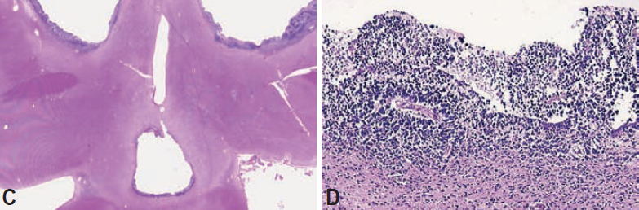**

[Source of picture: “WHO Classification of Tumours of the Central Nervous System” 4th ed (2007), ISBN-10: 9283224302, ISBN-13: 978-9283224303 >>](http://www.amazon.com/gp/product/9283224302)

**E**,**F** Intraventricular/choroid plexus metastasis of lung adenocarcinoma. Note the TTF1 staining of tumor cell nuclei (**F**).

**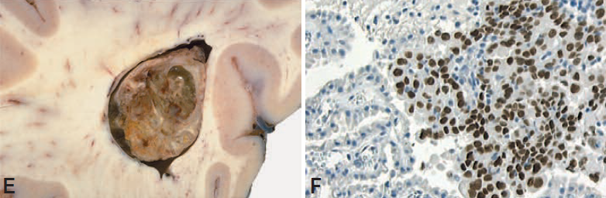**

[Source of picture: “WHO Classification of Tumours of the Central Nervous System” 4th ed (2007), ISBN-10: 9283224302, ISBN-13: 978-9283224303 >>](http://www.amazon.com/gp/product/9283224302)

**A** Leptomeningeal metastasis of non-Hodgkin lymphoma. **B** Dural metastasis of breast carcinoma.

**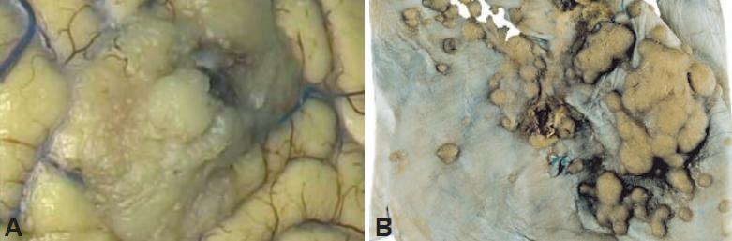**

[Source of picture: “WHO Classification of Tumours of the Central Nervous System” 4th ed (2007), ISBN-10: 9283224302, ISBN-13: 978-9283224303 >>](http://www.amazon.com/gp/product/9283224302)

Leptomeningeal metastasis of colon carcinoma (**A**,**B**). Note the perivascular infiltration of the cerebral cortex (**B**).

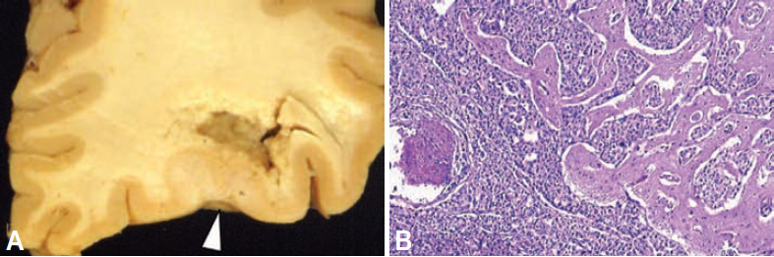

[Source of picture: “WHO Classification of Tumours of the Central Nervous System” 4th ed (2007), ISBN-10: 9283224302, ISBN-13: 978-9283224303 >>](http://www.amazon.com/gp/product/9283224302)

Intraspinal dural metastasis of lung adenocarcinoma (**C**,**D**).

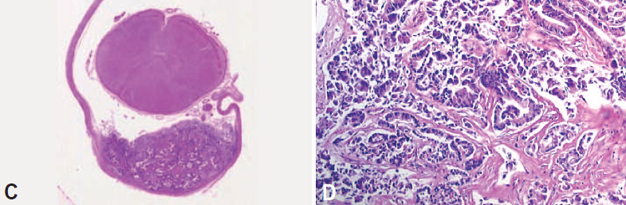

[Source of picture: “WHO Classification of Tumours of the Central Nervous System” 4th ed (2007), ISBN-10: 9283224302, ISBN-13: 978-9283224303 >>](http://www.amazon.com/gp/product/9283224302)

Metastasis from lung carcinoma:

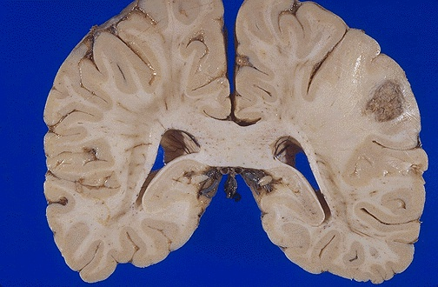

[Source of picture: “WebPath - The Internet Pathology Laboratory for Medical Education” (by Edward C. Klatt, MD) >>](http://library.med.utah.edu/WebPath/webpath.html" \t "_blank)

Immunohistochemistry

- similar to original tumors

Immunohistochemical analysis for indication of origin of common metastatic tumors of CNS:

CDX2, caudal type homeobox transcription factor 2; GCDFP, gross cystic disease fluid protein; RCCMa, renal cell carcinoma marker; TTF, thyroid transcription factor.

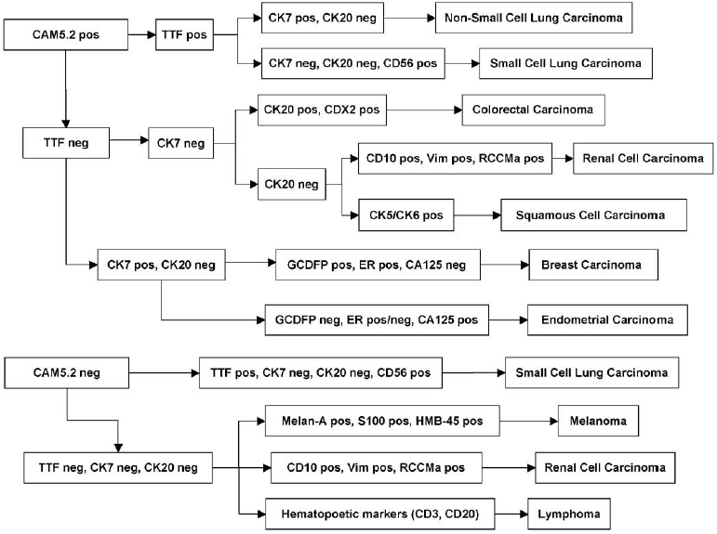

[Source of picture: “WHO Classification of Tumours of the Central Nervous System” 4th ed (2007), ISBN-10: 9283224302, ISBN-13: 978-9283224303 >>](http://www.amazon.com/gp/product/9283224302)

Clinical Features

1. Increased intracranial pressure: headache, altered mental status, nausea
2. Local effect: paresis, ataxia, visual complaints, sensory disturbances.

**Headache** (42-50%) and **seizures**\* (15-40%) are most common presenting symptoms!

\*new onset of seizures in patient > 35 years is highly suggestive! (but metastatic tumors are less likely to induce seizures than primary tumors)

* 10% present acutely with hemorrhage (most of are intramural hemorrhages), seizure, infarct.
* behavioral & cognitive dysfunction (35-75%); miliary metastases can produce progressive confusional state.
* motor dysfunction (30-60%).
* hydrocephalus is uncommon (in most cases, *carcinomatosis meningitis* is cause).
* **leptomeningeal** metastasis - multiple, varied neurological symptoms: headache, mental alteration, ataxia, *cranial nerve dysfunction and radiculopathy*.

Brain metastasis clinically presents in time frame related to primary tumor:

*precocious* (undetected primary);

*syn­chronous* (simultaneous primary);

*metachronous* (ante­cedent primary) - most common!

Diagnosis

Blood Studies

1. **CBC**
2. **Electrolyte** panel
3. **Coagulation** screen
4. **Liver** function panel
5. **Specific markers**:
   * CEA, PSA, CA125, CA153, AFP, HCG, LDH.
   * *anti-Yo antibody* in cerebellar degeneration;
   * *anti-Hu antibody* in limbic encephalopathy;
   * *anti-Ri antibody* in opsoclonus and ataxia.

*e.g. if no primary malignancy is found but anti-Yo is present in woman, prophylactic total abdominal hysterectomy/bilateral salpingo-oophorectomy is recommended*

Search for Systemic Cancer

1. **Stool guaiac**
2. **Gynecologic / pelvic examination** (incl. testicles)
3. **Skin and thyroid examination**.
4. **Chest radiography** - for any mass lesion in brain, specifically in patients without history of systemic cancer; if negative → **chest CT**; if negative → **CT of abdomen-pelvis**
5. **Mammogram**
6. **Whole-body FDG PET/CT**
7. **Bone scan**

* if primary tumor is not quickly revealed by careful evaluation, pathologic diagnosis of single brain tumor needs to be disclosed by resection or, if unresectable owing to its position, by biopsy.

Imaging of neuraxis

Neither methods are useful for differentiating metastasis from primary brain tumors!

Contrast CT

- many are invisible (isodense) → underestimation.

* some deposits are spontaneously dense (esp. malignant melanoma).

MRI with gadolinium

- gold standard

Brain and skull mts image review protocol:

**parenchymal** - gadolinium MPRAGE, FLAIR (not all mts enhance so FLAIR is even more sensitive, esp. for small mts)

**calvarial** - DWI (bright areas in the skull; vs. bone marrow abnormalities - will be diffuse signal along entire skull)

* circumscribed
* mild T1-hypointensity, T2-hyperintensity
* T1-MRI has highest sensitivity! (T2 may miss some lesions!!!)
* well-demarcated, approximately spherical lesions.
* may not always produce vasogenic edema.
* hypointense or isointense on T1, bright on T2.
* enhancement is variable: some enhance ***brightly and solidly*** (esp. small lesions), others are in ***ring configuration*** (esp. large lesions - core of necrosis).

N.B. administration of three times usual dose of gadolinium is more sensitive than standard protocol for detection of brain metastases!

* if MRI is normal → repeat with triple-dose gadolinium in 1 month.

Hemorrhagic metastases, melanomas - hyperintensity on non-contrast MRI or CT.

Leptomeningeal metastasis - focal or diffuse leptomeningeal **thickening** and **enhancement** (sometimes with dispersed **tumor nodules** in subarachnoid space); in addition, enhancement and enlargement of cranial nerves and communicating hydrocephalus.

Dural metastases - nodular masses or dural thickening along bone structures.

Metastasis of lung adenocarcinoma (three tumors, one in pineal gland):

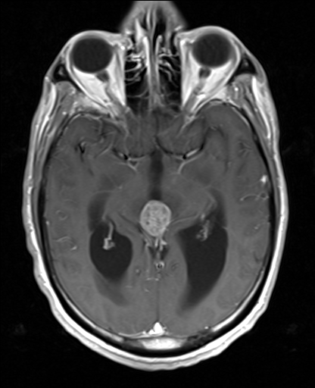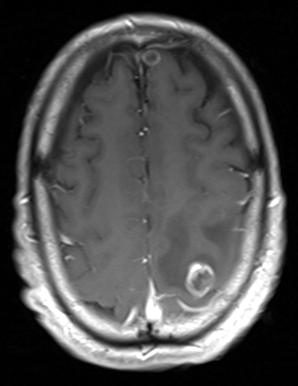

[Source of picture: Viktoras Palys, MD >>](mailto:vpalys@vcu.edu)

Adenocarcinoma in right frontal lobe:

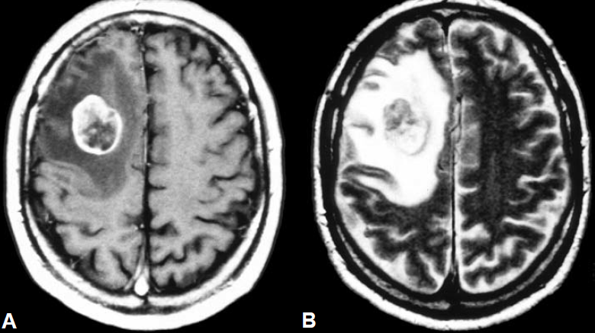

[Source of picture: “WHO Classification of Tumours of the Central Nervous System” 4th ed (2007), ISBN-10: 9283224302, ISBN-13: 978-9283224303 >>](http://www.amazon.com/gp/product/9283224302)

Miliary brain metastases of breast cancer:

A) nonenhanced MRI scan appears almost normal;

B) contrast-enhanced MRI shows > 20 separate metastatic lesions with no significant surrounding edema; patient was neurologically normal at time of this scan.  
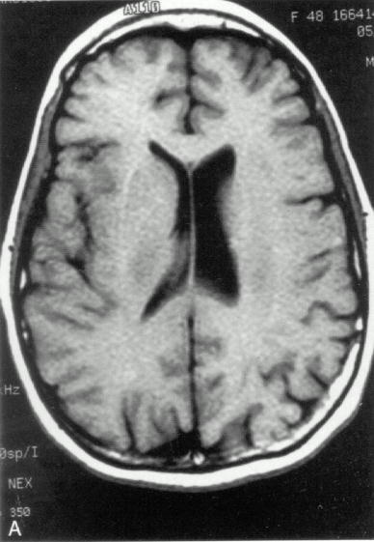 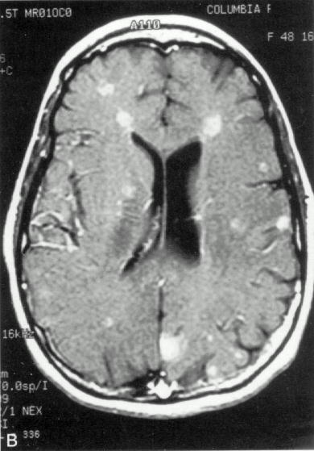

*A*. T2-MRI reveals two isodense masses - one in subependymal region and one near cortex (*arrows*).

*B*. Contrast T1-MRI reveals enhancement of two masses seen on T2 as well as third mass in left frontal lobe (*arrows*).

*C*. Contrast T1-MRI through pons reveals at least four other enhancing metastatic lesions.

Note absence of edema!

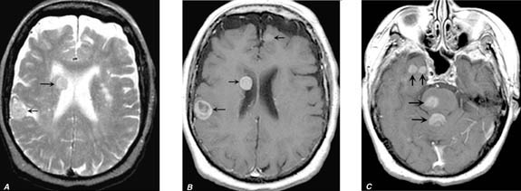

|  |  |
| --- | --- |
| MRI shows multiple metastatic tumors:  D:\Viktoro\Neuroscience\Onc. Oncology\00. Pictures\Brain metastases (MRI).jpg | Four metastases on T1-MRI - round and regular; one is irregular and exhibits central necrosis (*arrow*):  D:\Viktoro\Neuroscience\Onc. Oncology\00. Pictures\Brain mts (MRI) 2.jpg |

PET

* value of **fluoro-deoxyglucose** PET is highly questionable based on the limited sensitivity of FDG PET for brain tumors related to the physiologically high levels of glucose metabolism in healthy brain parenchyma - FDG PET has poor sensitivity (27%) for BM detection.
* increased expression of **amino acid transporters** in BM compared with healthy brain tissue renders radiolabeled amino acids suitable for PET imaging based on high tumor-to-background contrast:

**[18F]fluoroethyl)-L-tyrosine (FET) PET** – sensitivity 90% to depict larger (> 1 cm in diameter) BM; however, detection of lesions with < 1 cm diameter is considerably inferior to that of MRI.

CSF

- cytological examination in **leptomeningeal** metastases reveals malignant cells in initial CSF sample in 50%, 90% when CSF sampling is repeated in adequate volumes (10 mL).

Biopsy

Tissue diagnosis should be performed in cases of uncertain etiology!

N.B. always insist on biopsy of extracranial tumor (if known) – brain lesion may be radiosensitive!

* histological evaluation of specimens makes use of antibodies that are tumor / organ specific:

| **Histologic Stain** | **Tumor Specificity** |
| --- | --- |
| Keratin | Carcinomas |
| Mucicarmine (chromogranin) | Neuroendocrine tumors |
| HMB-45 | Melanoma |
| S-100 | Melanoma, sarcoma |
| CEA | Adenocarcinomas (colon, stomach, lung, breast, pancreas, uterus, ovary); thyroid medullary carcinoma, squamous carcinoma |
| Estrogen and progesterone receptors | Breast and uterus |
| Muscle-specific actin | Rhabdomyosarcomas |
| Alpha-fetoprotein, human chorionic gonadotropin | GU tumor |
| Placental alkaline phosphatase | Germ cell tumors |
| Prostatic acid phosphatase or prostate-specific antigen | Prostate carcinomas |
| Leukocytic common antigen, immunoglobulins, L26, UCHL 1, Leu-Ml, and CD30 | Lymphoma |

Treatment

Radiosurgery Practice Guideline for Metastatic Brain Tumors (Guideline Report #5-08, original guideline 2008):

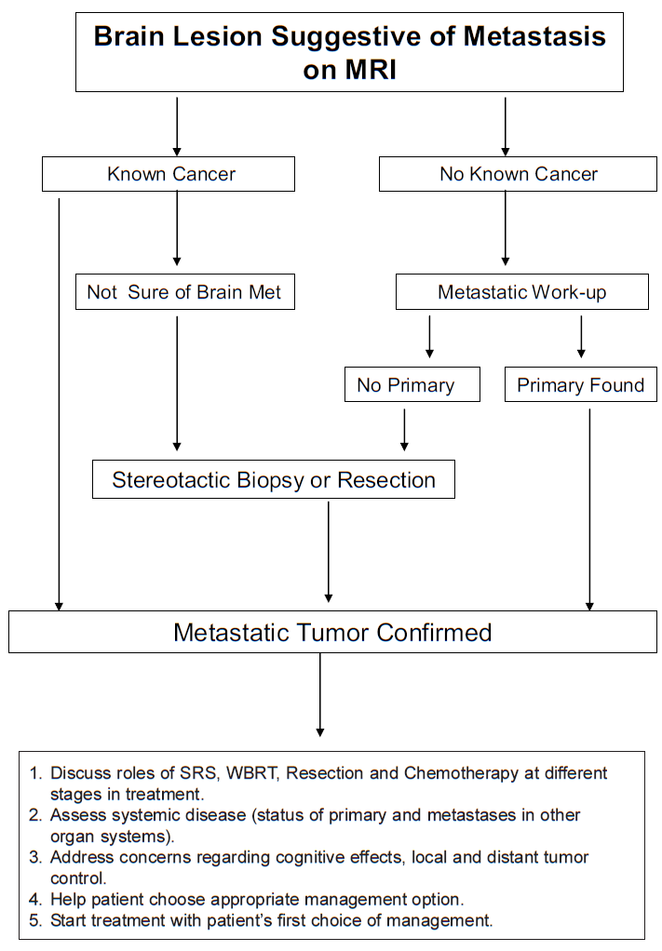

Radiosurgery Practice Guideline for Metastatic Brain Tumors (Guideline Report #5-08, original guideline 2008):

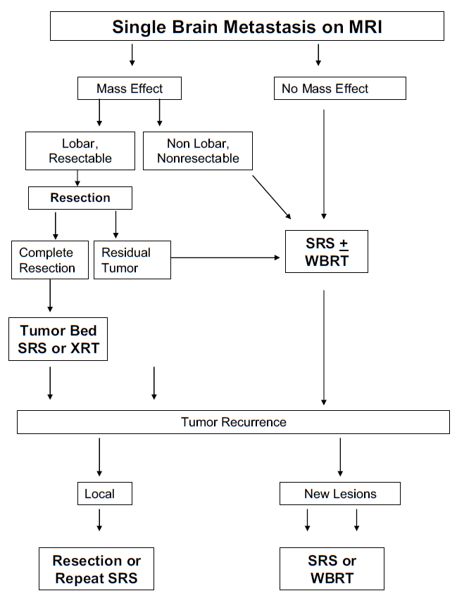

Radiosurgery Practice Guideline for Metastatic Brain Tumors (Guideline Report #5-08, original guideline 2008):

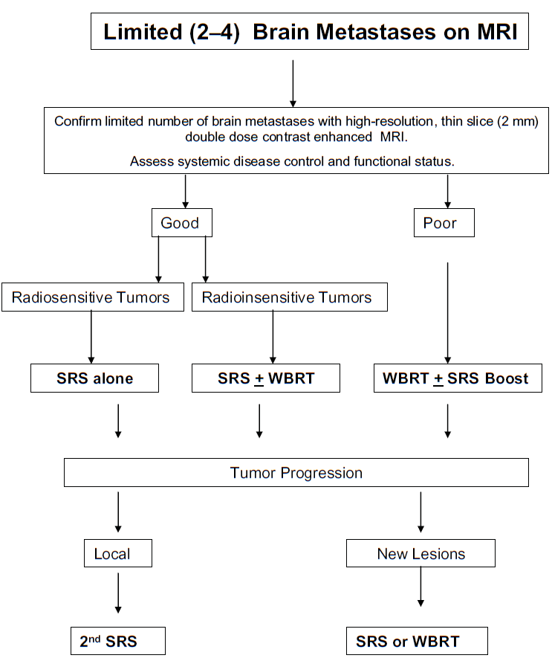

Radiosurgery Practice Guideline for Metastatic Brain Tumors (Guideline Report #5-08, original guideline 2008):

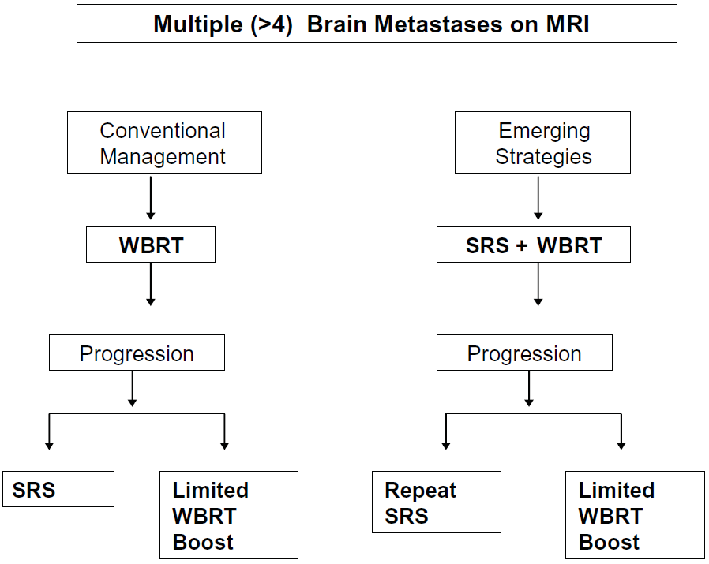

Medical management

For *incidentally* discovered brain metastasis *without significant mass effect or edema*, withholding steroids & antiepileptics is appropriate.

Steroids

CNS Systematic Review and Evidence-Based Guidelines for the Treatment of Adults With Metastatic Brain Tumors (2019)

Asymptomatic brain metastases without mass effect - ***insufficient evidence*** exists to make a recommendation.

Brain metastases with symptoms related to mass effect

***Level 3 recommendation***: corticosteroids are recommended to provide temporary relief of symptoms related to *increased ICP and edema*:

mild symptoms - starting dose of 4-8 mg/d of dexamethasone

moderate to severe symptoms - 16 mg/d of dexamethasone

***Level 3 recommendation***: dexamethasone is the best drug choice (minimal mineralocorticoid effect).

***Level 3 recommendation***: steroids should be tapered as rapidly as possible but no faster than clinically tolerated.

AED

* **seizure** prophylaxis (not necessary if no history of seizure; i.e. anticonvulsants must be administered only to patients at risk for seizure)
* anticonvulsants should be started (routinely) before radiation therapy / surgery.
* incidence of postoperative seizures – 18-24%
* most commonly used drugs are levetiracetam, phenytoin, carbamazepine, valproic acid.

CNS Systematic Review and Evidence-Based Guidelines for the Treatment of Adults With Metastatic Brain Tumors (2019)

***Level 3 recommendation***: prophylactic AEDs are not recommended for patients with brain metastases who did not undergo surgical resection and are otherwise seizure-free.

***Level 3 recommendation***: postcraniotomy AED use for seizure-free patients is not recommended.

Anticoagulation

Intracranial hemorrhage is frequently observed in patients with brain metastases but therapeutic anticoagulation does not increase the risk of intracranial hemorrhage!

Donato J “Intracranial hemorrhage in patients with brain metastases treated with therapeutic enoxaparin: a matched cohort study.” Blood. 2015 May 18

* matched, retrospective cohort study of 293 cancer patients with brain metastasis (104 with therapeutic enoxaparin and 189 controls)
* no differences in the cumulative incidence of intracranial hemorrhage at 1 year in the enoxaparin and control cohorts for measurable (19% vs 21%, Gray test P=0.97, HR 1.02 [90%CI 0.66-1.59]), significant (21% vs 22%, P=0.87), and total (44% vs 37%, P=0.13) intracranial hemorrhages.
* risk of intracranial hemorrhage was fourfold higher (adjusted HR 3.98, 90% CI 2.41-6.57, P<0.001) in melanoma or renal cell carcinoma (N=60) than lung cancer (N=153), but risk was not influenced by enoxaparin.

Evolution of modern treatment

* historical standard for the treatment of brain metastases was whole brain radiotherapy (WBRT), which was the subject of the initial Radiation Therapy Oncology Group (RTOG) randomized trials. Outcomes after WBRT for patients with brain metastases were poor, with median OS of only 3 to 4 mo for all patients. Several historical prognostic models that included factors such as age, extent of metastatic disease, performance status, and number of brain metastases found ranges of expected OS after WBRT of approximately 2 mo for the worst prognostic group and up to 7 to 11 mo for the most favorable prognostic group.
* in an effort to improve these outcomes, Patchell et al published a landmark randomized trial in 1990 investigating the role of surgical resection in addition to WBRT for patients with a single brain metastasis. This study demonstrated a significant improvement in OS with the addition of surgery prior to WBRT compared to WBRT alone (median OS 40 vs 15 wk, respectively, P < .01). The follow-up study randomized the same patient population with a single brain metastasis to surgical resection alone vs resection followed by WBRT.8 There was no difference in OS between the randomized arms (median OS 43 vs 48 weeks, respectively, P = .39). However, there were significantly lower rates of local cavity recurrence, distant brain failure, total intracranial failure, and neurological death in the surgery and WBRT arm.
* another major advancement in the treatment of brain metastases was the advent and propagation of stereotactic radiosurgery (SRS). The addition of SRS to WBRT compared with WBRT alone for patients with 1 to 3 brain metastases was found to have a significant improvement in local control and stabilization/improvement of performance status at 6 mo in the phase III RTOG 95-08 trial. The study was negative for the primary endpoint of OS in all patients, but patients with a single brain metastasis were found to have significantly improved OS with SRS boost after WBRT (median OS 6.5 vs 4.9 mo, P = .04). Due to the increasing awareness of the potential negative neurocognitive effects of WBRT and the lack of OS benefit with the addition of WBRT to surgery, several trials investigated SRS alone vs SRS and WBRT for patients with a limited number of brain metastases (defined as up to 3-4, depending on the trial). In terms of tumor control, all trials showed significantly worse local control, distant brain control, and total intracranial control with SRS alone, but with no detriment in OS with the omission of WBRT. Additionally, the proportion of patients experiencing neurocognitive decline was found to be significantly lower in the SRS alone arms at 3 to 4 mo post-treatment by approximately 25 to 30 absolute percentage points in the 2 trials that used a modern battery of neurocognitive assessments. There were also detrimental impacts on patient quality of life (QOL) associated with receipt of WBRT using validated QOL measures. For these reasons, SRS alone has become the preferred initial cranial radiation therapy (RT) treatment for patients with a limited number of brain metastases and good performance status.

Surgery

- metastasectomy.

Indications for surgical resection (in patient with good performance status):

1. solitary\* metastasis > 3 cm (lesions < 2 cm – better SRS unless tissue diagnosis is needed)
2. life-threatening strategically located metastasis\*\* (steroid-resistant neurological symptoms) despite other multiple cerebral metastases (symptomatic lesion is resected, for remaining lesions → radiotherapy)

\*i.e. no other sites of metastasis exist in body

\*\*e.g. cerebellar lesion with ventricular obstruction

1. need for tissue diagnosis

Requirements (if not met → XRT):

* 1. lesion in noneloquent area
  2. limited number of lesions
  3. limited and/or controlled systemic disease

N.B. extracranial metastases is important independent predictor of mortality (relative risk 2.3), i.e. most patients succumb to systemic cancer rather than intracranial lesion – may mask benefit of surgery!

* 1. Karnofsky score > 70 (able to function independently)
  2. life expectancy > 6 months
* patients that benefit from surgery most: KPS > 70, younger age, favorable RPA class, and lower Eastern Cooperative Oncology Group score, control of primary tumor, brain metastases diameter < 4 cm, and complete surgical resection.

Contraindications to surgery:

1. radiosensitive tumor (e.g. small-cell lung tumor, germ-cell tumor, lymphoma / leukemia / multiple myeloma, choriocarcinoma)

N.B. nonsmall cell lung metastases are mostly radioresistant – may benefit from surgery!

1. life expectancy < 3 months (WBRT indicated)
2. multiple lesions.
3. leptomeningeal disease.

* metastases are often sharply demarcated from surrounding normal brain - can be removed with minimal damage to functional nervous tissue.
* *piecemeal* vs. *en bloc* resection – results the same.
* **single brain metastasis**:

1. undiagnosed primary site → mandatory biopsy for a tissue diagnosis (even in unresectable locations)
2. potential extracranial source is identified → biopsy of extracranial lesion before the intracranial disease is addressed.
3. primary site unlikely to metastasize to brain (e.g. prostate carcinoma) → biopsy for a tissue diagnosis

* surgical resection alone has an expected 1 to 2-yr local recurrence (LR) rate of 47-59%, hence adjuvant XRT is generally recommended after surgical resection to minimize risk of cavity LR

N.B. ***surgery is followed by radiation*** – either **SRS** or **whole-brain radiation therapy (WBRT)**.

CNS Systematic Review and Evidence-Based Guidelines for the Treatment of Adults With Metastatic Brain Tumors (2019)

***Level 3 recommendation***: en bloc tumor resection, as opposed to *piecemeal* resection, is recommended to decrease the risk of postoperative leptomeningeal disease when resecting single brain metastases.

***Level 3 recommendation***: gross total resection is recommended over *subtotal* resection in recursive partitioning analysis class I patients to improve overall survival and prolong time to recurrence.

***Level 3 recommendation***: in multiple brain metastases, resection is recommended for lesions inducing *symptoms from mass effect* that *can be reached without inducing new neurological deficit* and who have *control of their systemic cancer*.

* otherwise, WBRT or SRS should both be considered as valid primary therapies.

Recurrent metastases

CNS Systematic Review and Evidence-Based Guidelines for the Treatment of Adults With Metastatic Brain Tumors (2019)

***Level 3 recommendation***: surgery is recommended for intracranial recurrence after initial surgery or SRS.

Surgery + WBRT vs. WBRT alone for solitary metastasis

Surgical resection of a solitary metastasis has survival benefit (but…)

– appropriate selection is necessary

– surgical morbidity must be low

Three class 1 evidence RTCs:

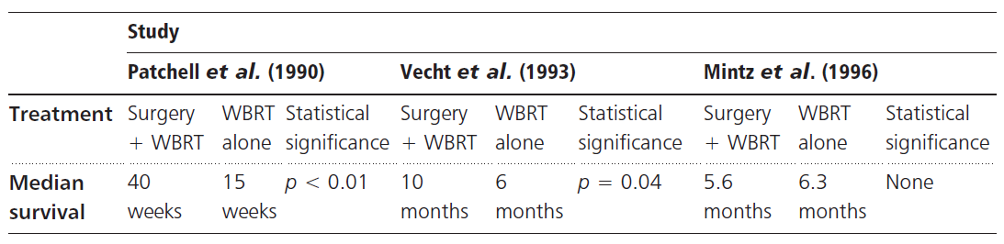

Patchell RA et al. “*A randomized trial of surgery in the treatment of single metastases to the brain*”. N Engl J Med 1990; 322:494-500.

Prospective randomized trial:

1. surgical removal followed by radiotherapy (surgical group) – 25 patients
2. needle biopsy and radiotherapy (radiation group) – 23 patients

Results:

* **recurrence** at the site of the original metastasis was less frequent in the surgical group (20% vs. 52%)
* **survival** was significantly longer in the surgical group (40 vs. 15 weeks)
* surgical group remained **functionally independent** longer (38 vs. 8 weeks)
* with death from neurological causes used as an endpoint, median survival was greater in the surgery group compared to the WBRT group (62 weeks versus 26 weeks, p < 0.0009).

Vecht CJ et al. “*Treatment of single brain metastasis: radiotherapy alone or combined with neurosurgery?*” Ann Neurol 1993;33:583-90

* excision plus radiotherapy vs. radiotherapy alone - 63 patients with single brain metastasis.
* combined treatment led to a longer survival (p = 0.04) and a longer functionally independent survival [FIS] (p = 0.06) in patients with stable extracranial disease.

N.B. patients with progressive extracranial cancer had a median overall survival of 5 months and a FIS of 2.5 months irrespective of given treatment.

Mintz AH et al. “*A Randomized Trial to Assess the Efficacy of Surgery in Addition to Radiotherapy in Patients with a Single Cerebral Metastasis*”. Cancer 1996; 78: 1470-6.

84 patients with single brain metastasis; arms:

1. surgery (gross resection ÷ lobectomy) → radiation (30 Gy to the whole brain in 10 fractions over 2 weeks; start no later than 4 weeks after surgery)
2. radiation alone

Results - the addition of surgery to radiation therapy did not improve the outcome:

1. No difference in survival (6.3 months in R; 5.6 months in S+R)

* most patients died within the first year
* risk ratio for mortality in S+R arm compared with R alone arm is 1.55.

1. No differences in 30-day mortality (9.8% in S+R; 7% in R)
2. No differences in morbidity
3. No differences in causes of death
4. No differences in quality of life (mean proportion of days with Karnofsky status ≥ 70%)

Critique:

* 73% of patients in study had extracranial metastases and/or uncontrollable primary disease.
* distribution of primaries not equal between groups: greater proportion of colorectal carcinomas in surgery group and breast carcinomas in WBRT group.

Radiotherapy

Radiotherapy always after resection (SRS and / or WBRT - any modality is good for survival benefit but justify use of it)!

Combining radiotherapies (WBRT + SRS or SRS + WBRT) improves CNS control but does not improve survival.

Cleveland clinic: SRS → 1-2 days later → surgery

* + SRS controls tumor seeding during surgery
  + SRS is easier to plan on preop MRI

Stereotactic Radiosurgery in the Management of Limited (1-4) Brain Metastases: Systematic Review and International Stereotactic Radiosurgery Society Practice 2017 Guideline

* there is ***no detriment*** to survival by withholding WBRT in the upfront management of brain metastases with SRS.
* while SRS on its own provides a high rate of local control (LC), WBRT may provide further increase in LC.
* WBRT does provide distant brain control with less need for salvage therapy.
* the addition of WBRT does affect neurocognitive function and quality of life more than SRS alone.
* for larger brain metastases, surgical resection should be considered, especially when factoring lower LC with single-session radiosurgery.
* there is emerging data showing good LC and/or decreased toxicity with multisession SRS.

CNS Systematic Review and Evidence-Based Guidelines for the Treatment of Adults With Metastatic Brain Tumors (2019)

***Level 1 recommendation***: Surgery + WBRT is recommended as first-line treatment for **single** brain metastases with favorable performance status and limited extracranial disease to extend overall survival, median survival, and local control.

***Level 1 recommendation***: Surgery + WBRT is superior treatment to WBRT alone for **single** brain metastases.

***Level 3 recommendation***: Surgery + SRS is recommended to provide survival benefit.

***Level 3 recommendation***: Surgery + SRS is recommended as an alternative to SRS alone to benefit overall survival.

***Level 3 recommendation***: multimodal treatments involving surgery (surgery + WBRT + SRS boost or surgery + WBRT) are recommended as alternatives to WBRT + SRS for providing overall survival and local control benefits.

Radiation Sensitizers

CNS Systematic Review and Evidence-Based Guidelines for the Treatment of Adults With Metastatic Brain Tumors (2019)

***Level 1 recommendation***: The use of temozolomide as a radiation sensitizer is not recommended in the setting of WBRT for **breast cancer** metastases.

***Level 1 recommendation***: The use of chloroquine as radiation sensitizer is not recommended in the setting of WBRT.

Whole-brain radiation therapy (WBRT)

– current mainstay of palliation\* – 30 Gy delivered in 10 fractions over 2 weeks (but all other WBRT regimens give similar outcomes and toxicity).

* + indicated for **irregular resection cavity**, **multiple lesions**, **older patients**, **low Karnofsky score**, **life expectancy < 3 months** (alternative opinion - patients with widespread systemic metastasis who are unlikely to survive more than few months are best treated with dexamethasone alone).
  + risk of neurocognitive decline (vs. SRS).

N.B. always aim for **hippocampus-sparing WBRT** (look for lesions in mesial temporal lobes)

* + small-cell lung tumor, germ-cell tumors, lymphoma, leukemia, and multiple myeloma are highly susceptible; other types of lung cancer and breast cancers are less sensitive; melanoma, sarcoma and renal-cell carcinoma are not sensitive at all.

\*use of WBRT has declined over the past 10 yr as the use of local and systemic therapies has evolved!

CNS Systematic Review and Evidence-Based Guidelines for the Treatment of Adults With Metastatic Brain Tumors (2019)

***Level 3 recommendation***: WBRT can be recommended to improve **progression-free survival** for **> 4 brain metastases**.

***Level 2 recommendation***: for patients with good performance (WHO performance status 0 to 2) and < 4 brain metastases – goal is minimizing neurocognitive toxicity, as opposed to maximizing progression-free survival and overall survival

* WBRT is not recommended (improves intracranial progression-free survival but not overall survival)
* local therapy (surgery or radiosurgery) without WBRT is recommended.

***Level 3 recommendation***: for patients with > 4 brain metastases, the addition of WBRT is not recommended unless metastases’ volume (> 7 cc), number (> 15), size, or location does not make them amenable to local therapy (surgical resection or SRS).

WHO / ECOG

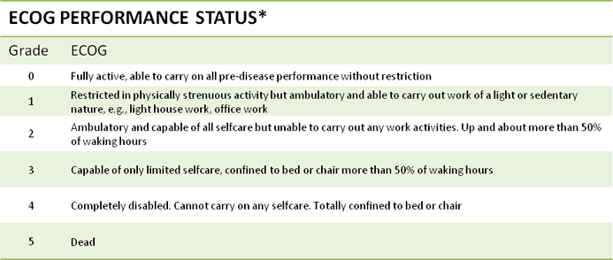

Adjuvant WBRT vs. observation - retrospective review from Mayo Clinic

Smalley SR. IJROBP 13:1611-1616, 1987

* 85 post-surgical patients: 34 received WBRT, 51 were observed.
* **subsequent brain relapse** 21% in WBRT group, 85% in observation group.
* **median survival**: 21 months in WBRT group vs. 11.5 months in observation group.

Adjuvant WBRT vs. observation for single brain metastases

Patchell RA et al. Postoperative radiotherapy in the treatment of single metastases to the brain: a randomized trial. JAMA 1998; 280 : 1485 – 1489

* surgery vs. surgery + WBRT; class I evidence.
* adults with completely resected single metastasis.
* post-operative WBRT reduces recurrence of brain metastases and reduces death from neurological causes:

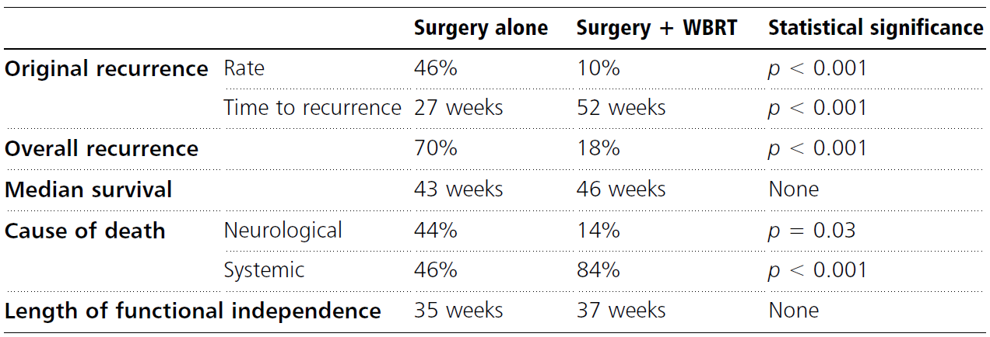

Treatment arms alter the mode of but not the time of death - is one cause of death more acceptable by another to patients and their families?

* + role of adjunctive WBRT ***after surgery for solitary lesion***, thus, is controversial; growing trend is to postpone WBRT until recurrence and to use fractionated stereotactic radiotherapy with radiosensitizers (e.g. gadolinium texaphyrin, RSR13).

Optimal methodology

CNS Systematic Review and Evidence-Based Guidelines for the Treatment of Adults With Metastatic Brain Tumors (2019)

***Level 1 recommendation***: standard WBRT dose/fractionation schedule (i.e. 30 Gy in 10 fractions or a biological equivalent dose [BED] of 39 Gy10) is recommended as altered dose/fractionation schedules do not result in significant differences in median survival or local control.

***Level 3 recommendation***: Due to concerns regarding neurocognitive effects, higher dose per fraction schedules (such as 20 Gy in 5 fractions) are recommended only for patients with poor performance status or short predicted survival.

Neurocognitive consequences

CNS Systematic Review and Evidence-Based Guidelines for the Treatment of Adults With Metastatic Brain Tumors (2019)

***Level 2 recommendation***: Due to neurocognitive toxicity, local therapy (surgery or SRS) without WBRT is recommended for ≤ 4 brain metastases amenable to local therapy in terms of size and location.

***Level 2 recommendation***: WBRT doses exceeding 30 Gy given in 10 fractions are not recommended - association of neurocognitive toxicity with increasing total dose and dose per fraction of WBRT.

***Level 2 recommendation***: if prophylactic cranial irradiation is given to prevent brain metastases (e.g. for **small cell lung cancer**), the recommended WBRT dose/fractionation regimen is 25 Gy in 10 fractions.

***Level 3 recommendation***: patients having WBRT should be offered 6 mos of memantine to potentially delay, lessen, or prevent the associated neurocognitive toxicity.

Tumor histopathology or molecular status

CNS Systematic Review and Evidence-Based Guidelines for the Treatment of Adults With Metastatic Brain Tumors (2019)

***Insufficient evidence*** to support the choice of any particular dose/fractionation regimen based on histopathology or molecular status.

Stereotactic Radiosurgery (SRS)

Favorable characteristics of brain metastases for SRS:

1. Radiographically distinct on MRI/CT
2. Pseudospherical shape
3. Displaces normal brain tissue
4. Minimal invasion of normal brain
5. Size at presentation ≤ 3 cm

Indications for Radiosurgery

1. Newly diagnosed single or multiple brain metastases without significant mass effect – i.e. ***alternative*** to surgery (esp. for 2-4 lesions with diameters < 3 cm)
2. Boost after WBRT for single or multiple brain metastases
3. Recurrent brain metastases after WBRT or surgery
4. ***Adjuvant*** to surgery:
   * 1. after gross total resection (to surgical bed with nice regular margins ± any other < 3 cm lesions) instead of WBRT
     2. residual tumor after resection

Contraindications for Radiosurgery: large volume tumors causing symptomatic mass effect on the brain.

1. **Stereotactic radiosurgery (SRS)** - another standard of care for limited number of lesions (number is undefined but maybe up to 8)
   * minimum doses to the margin typically range from 14–**24** Gy in a single session.
   * provides *excellent local control* (80-90%); failure usually occurs outside treatment volume, thus, inclusion of judicious **2-3-mm margin** beyond area of postoperative enhancement may be prudent (pioneered by Stanford group).

Current standard - ***do not include a brain margin*** (some centers include 1-2 mm of margin only to compensate for system inaccuracy).

* + patients may receive a single stress dose of **corticosteroids** at the conclusion of the SRS procedure.
  + for radioresistant tumors, necrotizing single fractions of radiosurgery work better than conventionally fractionated radiotherapy.
  + majority of treated brain metastases respond with ***volume reduction***;significant volume reductions (at either 6 or 12 weeks post-SRS) are strongly associated with prolonged local control, less corticosteroid use and stable neurological symptoms.
  + very little data are available on repeat SRS for recurrent brain metastases (but, in general, *same selection criteria / indications / contraindications* are used as for first time diagnosed brain mts).

CNS Systematic Review and Evidence-Based Guidelines for the Treatment of Adults With Metastatic Brain Tumors (2019)

***Level 3 recommendations***:

* SRS alone is recommended to improve median overall survival for patients with > 4 metastases having a cumulative volume < 7 cc.
* in terms of **overall survival**, SRS alone is equivalent to surgery + WBRT.
* SRS is an alternative to surgery in **solitary** metastases when surgery risk is high (and tumor volume and location are acceptable for employment of SRS).
* SRS should be considered for palliative care in the short term if this is consistent with the overall goals of the patient.
* after surgery for **solitary** brain metastasis, SRS should be used to decrease local recurrence rates.
* for **solitary** brain metastasis, SRS should be given to decrease the risk of local progression.
* for **2-4 metastases** having a cumulative volume < 7 mL, SRS is recommended for local tumor control, instead of WBRT.
* for **> 4 metastases** having a cumulative volume < 7 mL SRS alone is recommended to improve median overall survival.

1. **Fractionated stereotactic radiotherapy (fSRT)** - equally effective to radiosurgery.

Dose – depends on tumor size:

If can, use 24 Gy (unless close to brainstem or optic structures)

Best results are for tumors < 1 cm in diameter!

RTOG 90-05 (Shaw et al., 2000) examined the **maximum tolerated dose (MTD)** of single session SRS:

|  |  |
| --- | --- |
| **Tumor size** | **MTD (Gy, Tumor Margin)** |
| < 2.0 cm | 24\* |
| 2.0 – 3.0 cm | 18 |
| 3.1 – 4.0 cm | 15 |

\*investigators were afraid to give the higher dose

Cleveland clinic (Mohammadi et al. 2016) examined 1-year **local control rates** (by margin dose):

|  |  |
| --- | --- |
| **MTD (Gy, Tumor Margin)** | **Local control rate** |
| 24 | 85% (78 – 92%) |
| 18 | 49% (30 – 68%) |
| 15 | 45% (23 – 67%) |



Postoperative SRS

An early retrospective study from Stanford included 72 patients treated with postoperative SRS between 1998 and 2006. Most patients were treated to the contoured resection cavity without additional margin. An important finding was that cavity local control was significantly higher in patients with less conformal SRS plans. Conformality index (CI) is a measure of the compactness of the high-dose radiation given during SRS relative to the target volume and is calculated as the ratio: [volume of the prescription isodose line/volume of the target]. In order for the target to be completely encompassed by the prescription isodose line, CI necessarily must be ≥1. The larger the CI, the more volume is being radiated to the prescription dose relative to the volume of the target. The conclusion from this finding was that there was increased risk of marginal miss of the resection cavity in the postoperative SRS setting with more conformal SRS plans compared with less conformal plans as measured by the CI (likely due to difficulty contouring the postoperative cavity), and hence a 2-mm margin expansion on the cavity should be used. The ***Stanford group started systematically using a 2-mm margin*** and published a follow-up study comparing outcomes from a prospective group of patients treated with the 2-mm expansion compared with the historical control of patients treated without a margin.26 The use of a margin was found to have significantly improved local control without an increase of toxicity. The 1-yr cumulative incidence of cavity LR with and without the margin were 3% and 16%, respectively (P = .04), while the 1-yr toxicity rates with and without the margin were 3% and 8%, respectively (P = .27). These findings led to the adoption of an expansion (generally 1-2 mm) to the cavity as part of standard practice at most institutions in the postoperative SRS setting. The use of these margins does inherently and intentionally increase the volume of normal brain irradiated in order to overcome cavity delineation uncertainty.

* uncertainty of postsurgical cavity size (if SRS planning 4-5 weeks postop is done on immediate postop MRI): study from Dartmouth reported that about half of cavities (46.5%) were stable in size, defined as a change in volume of < 2 cm3, but about a quarter (23.3%) shrunk by > 2 cm3, and about the same proportion (30.2%) enlarged by > 2 cm3

Preoperative SRS

Due to the perceived drawbacks of postoperative SRS, namely the need for cavity margin expansion due to target delineation uncertainty, the variable postoperative clinical course and potential delay in administering postoperative SRS, and the theoretical risk of tumor spillage into CSF at the time of surgery (→ leptomeningeal disease (LMD)), investigators began to study the use of preoperative SRS as an alternative paradigm to maximize local control of the resection cavity and minimize neurocognitive detriment associated with WBRT.

Preoperative SRS treats the preoperative intact brain metastasis volume, which is well defined, readily identifiable on imaging, and does not require any margin expansion for target delineation uncertainty, i.e. the planning target volume (PTV) is the same as the gross tumor volume (GTV), with no added margin. Vs. the postoperative PTV will always include a larger volume of normal brain tissue since the target includes a 1- to 2-mm expansion of the cavity into normal brain → increasing risk of radiation necrosis.

Preoperative SRS is given prior to surgery, with the potential advantage of increased patient compliance given the variable postoperative clinical course for patients, the variable timing of postoperative SRS due to the need for healing and surgical recovery, and the requirement of a dedicated repeat MRI for postoperative SRS planning to account for cavity volume dynamics.

Preoperative SRS is delivered to an intact tumor with intact blood supply and oxygenation, while postoperative SRS is delivered to a more hypoxic postoperative bed. It is a described phenomenon in radiation oncology that lower doses of RT are required for tumor control when that tumor has an intact blood supply and is oxygenated. This is due to a mechanism of RT-induced DNA damage that ionizes oxygen molecules and generates oxygen-based free radicals that then damage nearby DNA which results in tumor kill. This effect can be quantified as the oxygen enhancement ratio, which is defined as the ratio of radiation doses during lack of oxygen compared to no lack of oxygen for the same biological effect. Based on this rationale, a ***20% dose reduction*** compared to standard maximum lesion diameter based SRS dosing derived from RTOG 90-05 was used in the preoperative SRS studies.

One of the potential issues with preoperative SRS is the possibility of subtotal resection after SRS. The published studies of preoperative SRS (which included patients treated through 2014 at a single institution) did not have any instances of subtotal resection and the gross total resection rate was 100%. The current consensus of practice from that institution in the case of subtotal resection would be to ***observe the residual disease*** given that it has been treated with a definitive though modestly reduced dose of SRS, reserving salvage local therapy for cases of progression (S. Burri, personal communication, October 27, 2017).

Another potential issue with preoperative SRS is the lack of pathologic confirmation of CNS disease prior to administering SRS, which is not the case in the postoperative setting. The risk of nonmetastatic disease in patients with suspected single brain metastases from trials conducted in the 1980s and 1990s ranged from 2% to 11%. There are not robust available data for the risk of nonmetastatic disease in patients with multiple brain lesions and/or in the modern era due to the fact that the vast majority of patients are treated with SRS alone without CNS pathologic confirmation. The rate of false-positive imaging results is recognized as comfortably low given the lack of CNS biopsy requirements on all recent SRS clinical trials and the adoption of SRS alone as the preferred treatment method for patients with a limited number of brain metastases.

SRS and immunotherapy: high dose per fraction RT is associated with increased surface tumor antigen expression and presentation of usually sequestered tumor antigens that could promote more robust responses in patients treated with immune checkpoint inhibitors. Additionally, there is also increasing evidence that patients treated with RT and immune checkpoint inhibitors may have improved outcomes compared with treatment with immune checkpoint inhibitors alone, as illustrated by a recent secondary analysis of a prospective trial of patients who did or did not receive RT prior to pembrolizumab treatment for advanced nonsmall cell lung cancer. Immunotherapy is also increasingly being shown to have effect across the blood brain barrier for brain metastases.

In this context, SRS in conjunction with immunotherapy has been associated with improved radiographic brain metastases response, improved OS, and reduced incidence of distant brain failure in retrospective studies. Preoperative SRS has the potential to induce changes in tumor antigen presentation and boost response to immunotherapy since the radiated tumor is still in place until surgical resection occurs.

Preoperative SRS vs Postoperative SRS

Retrospective bi-institutional study of 180 patients, of which 66 (36.7%) underwent preop SRS and 114 (63.3%) underwent postop SRS. Patient characteristics were well balanced between groups except for higher rates of performance status score of 0 (62.1% vs 28.9%, P < .001) and primary breast cancer (27.2% vs 10.5%, P = .01) for preop SRS. The preop SRS cohort also had lower median PTV margin (0 vs 2 mm, P < .001) and prescribed dose (14.5 vs 18 Gy, P < .001) due to the 20% dose reduction, but similar GTV volume (8.3 vs 9.2 mL, P = .85). The median imaging follow-up period was 24.6 mo for alive patients.

* no difference between groups for OS, cavity LR, or distant brain failure in the adjusted analysis.
* univariate 1-yr cumulative incidence of cavity LR was 15.9% vs 12.6% (P = .33) for preop vs postop SRS.
* preop SRS had a significantly lower cumulative incidence of LMD recurrence (P = .01) compared with postop SRS, with 1-yr rates of 3.2% vs 8.3% and 2-yr rates of 3.2% vs 16.6%, respectively. Postop SRS retained a significantly higher risk of LMD compared to preop in the adjusted analysis (HR: 4.03, 95% CI: 1.2-13.6, P = .02).
* Similar results were found for radiation necrosis and symptomatic radiation necrosis, with 1- and 2-yr cumulative incidence of symptomatic radiation necrosis of 14.6% vs 1.5% and 16.4% vs 4.9%, respectively (P = .01). Postop SRS retained a significantly higher risk of symptomatic radiation necrosis in the adjusted analysis (HR: 8.14, 95% CI: 2.16-30.74, P = .002).
* composite outcome (cavity LR, symptomatic radiation necrosis, and LMD relapse) as an indicator of overall toxicity and tumor control was also assessed: preop SRS had significantly lower rates of the composite endpoint compared with postop SRS, with 1-yr rates of 15.8% vs 31.8% and 2-yr rates of 27.9% vs 39.3%, respectively (P = .02). Postop SRS retained a significantly higher risk of the composite endpoint in the adjusted analysis (HR: 1.99, 95% CI: 1.16-3.42, P = .01).

SRS vs. WBRT

Among surveyed radiation oncologists (n = 711) who were given hypothetical scenarios, responses for the number of lesions requiring a switch from SRS to WBRT depended on physician characteristics:

* + ***CNS specialists*** were consistently more likely to treat more metastases with SRS - their "cutoff number" for making a switch from SRS to WBRT was significantly higher than that of non-CNS specialists (8.1 vs 5.1 among high-volume providers).
  + ***patient volume*** also played a role. CNS specialists who treated higher numbers of patients with brain metastases also reported a significantly higher cutoff number compared with those treating a lower volume of patients (8.1 in high-volume providers vs 5.6 in low-volume vs 4.1 in minimal-volume providers).

Dr. Lee (Department of Radiation Oncology at UCLA): "We have evidence to support SRS for 3 brain metastases, but what about 4 or 5? There is no clear evidence either way”.

SRS vs. WBRT for Brain Metastases - N107C - randomized trial conducted at 48 North American centers (194 patients with 1-4 brain mts, 59% from lungs):

* + SRS was as effective as WBRT in terms of overall survival (11.5 vs 11.8 months)
  + SRS provided better cognitive outcomes and better quality of life:
* median cognitive decline–free survival was 3.2 months for SRS and 2.8 months for WBRT (hazard ratio, 2.0; p < 0.0001) – effect of SRS on cognition is “modest” compared to WBRT.
* at 3 months following treatment, declines in QOL and physical well-being were significantly less pronounced after SRS than after WBRT (mean QOL change from baseline: -1.5 vs -7.0, P = 0.03; mean well-being change from baseline: -6.4 vs -20.2, P = .002); at 6 months, physical well-being remained significantly better for SRS patients than for WBRT patients (decline of -3.2 vs -15.1; P = .016).
  + WBRT was superior for the local control! (WBRT provided higher overall intracranial tumor control than SRS at 6 months (90.0% vs 74%) and 12 months (78.6% and 54.7%) (p < 0.0001).

“control vs cognition" – neither SRS or WBRT are superior; both are options

Dr. Brown (radiation oncologist at the Mayo Clinic in Rochester, MN): "There is no significant difference in survival whether a patient receives postoperative SRS or WBRT, and SRS avoids the well-known toxicities of WBRT. Furthermore, due to less time commitment and a quicker recovery after SRS, patients can restart systemic therapies more rapidly. SRS to the surgical cavity after resection of brain metastases should be considered a standard of care"

* big tumor going for emergency OR – postop better WBRT (to control tumor spillage).

WBRT ± SRS

CNS Systematic Review and Evidence-Based Guidelines for the Treatment of Adults With Metastatic Brain Tumors (2019)

***Level 1 recommendation***: In patients with 2 to 3 brain metastases not amenable to surgery, the addition of SRS to WBRT is not recommended to.

WBRT ± SRS for 1-3 metastases ≤ 4 cm (RTOG 9508 trial)

Andrews DW et al. Whole brain radiation therapy with or without stereotactic radiosurgery boost for patients with one to three brain metastases: phase III results of the RTOG 9508 randomised trial. Lancet 2004 ; 3 63 : 1655 – 1672

* class I evidence.
* WBRT total 37.5 Gy

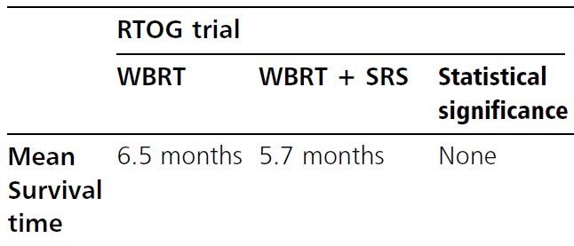

Conclusions:

1. SRS boost following WBRT is better than WBRT alone and should be a standard treatment for a single brain metastasis.
2. SRS boost following WBRT ***improves performance*** in all patients with ≤ 3 metastases and should be considered for all patients with 2-3 brain metastases.
3. No ***survival benefit*** with SRS boost.

Subgroup analysis: single brain metastasis - mean survival time in the WBRT + SRS group was 6.5 months vs 4.9 months in the WBRT-alone group (p < 0.04).

* similar results by the other trial: local brain control at one year ranged from 82–92% in the SRS boost arm vs. 0–71% in the WBRT alone arm; median survival was not statistically different between the two groups (7.5 months for WBRT alone vs. 11 months for WBRT and radiosurgery boost [p = 0.22]); survival was dependent on the extent of extracranial disease (p = 0.02).

Kondziolka D et al.: Stereotactic radiosurgery plus whole brain radiotherapy versus radiotherapy alone for patients with multiple brain metastases. Int J Radiat Oncol Biol Phys 45:427-434, 1999

SRS ± WBRT

CNS Systematic Review and Evidence-Based Guidelines for the Treatment of Adults With Metastatic Brain Tumors (2019)

***Level 2 recommendation***: WBRT can be added to SRS to improve local and distant control keeping in mind the potential for worsened neurocognitive outcomes + unlikely a significant impact on overall survival.

* newer WBRT delivery techniques using hippocampal avoidance may lessen the SRS advantage regarding neurocognition.

SRS ± WBRT for 1-4 metastases ≤ 3 cm (Japanese Radiation Oncology Study Group 99-1 trial)

Aoyama H et al. Stereotactic radiosurgery plus whole brain radiation therapy vs stereotactic radiosurgery alone for the treatment of brain metastases – a randomised controlled trial. JAMA 2006 ; 2 1 : 2483 – 2491

* class I evidence.
* WBRT total 30 Gy in 10 fractions.
* metastases with a maximum diameter of up to 2 cm were treated with SRS doses of 22–25 Gy and those > 2 cm were treated with 18–20 Gy.
* SRS dose was reduced by 30% when the treatment was combined with WBRT

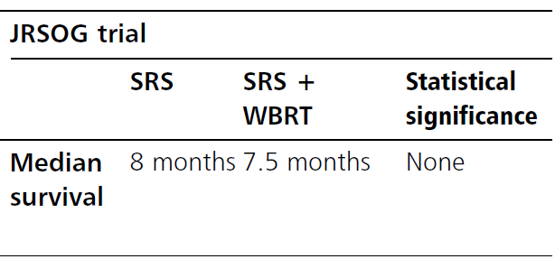

* recurrence rate at 12 months: 76.4% in the SRS group vs. 46.8% (p < 0.001) in SRS+WBRT group.
* median survival time was 7.5 months with WBRT + SRS and 8.0 months with SRS alone.

Conclusions:

1. WBRT boost following SRS does not improve ***survival***
2. WBRT boost reduces ***recurrence*** of brain metastases
3. patients with newly diagnosed brain metastases can be treated with up-front SRS alone, reserving WBRT for salvage.

SRS ± WBRT for 1-3 metastases

Chang EL, Wefel JS, Hess KR et al. Neurocognition in patients with brain metastases treated with radiosurgery or radiosurgery plus whole brain irradiation: a randomised controlled trial. Lancet Oncol . 2009;10(11):1037–1044.

* class I prospective randomized study
* withholding WBRT in favor of SRS alone was associated with improved ***neurocognition*** and increased ***survival***, but decreased *local and distant control*.

Radiosurgery Practice Guideline for Metastatic Brain Tumors (Guideline Report #5-08, original guideline 2008)

There is Level I and II-3 evidence that ***addition of WBRT to SRS*** for 1–3 newly diagnosed brain metastases does not improve survival, compared with ***SRS alone with WBRT reserved for salvage therapy***. There is Level I and II-1 and II-3 evidence: omission of WBRT results in decreased tumor control, both at the site of SRS and also in the remaining untreated brain.

American Society for Radiation Oncology (ASTRO) recommends *not routinely add adjuvant WBRT to SRS* for limited brain metastases (esp. from solid tumors) because for most of these patients SRS alone is sufficient and WBRT is associated with diminished cognitive function and worse patient-reported fatigue and quality of life.

SRS vs. WBRT vs. SRS + WBRT

* no survival difference: median survivals were 7 (SRS), 5 (SRS + WBRT), and 9 (WBRT) months.
* local brain control rate:

87% for Gamma Knife® SRS alone

91% for Gamma Knife® SRS + WBRT

62% for WBRT only

Chougule PB et al. Randomized treatment of brain metastasis with gamma knife radiosurgery, whole brain radiotherapy or both. Int J Radiat Oncol Biol Phys 48(Suppl 1):114, 2000

SRS vs. surgery

No prospective trials available

* both are excellent treatment options for solitary brain metastases

Recurrence after SRS

**Laser Interstitial Thermal Therapy (LITT)** has been used to treat recurrent brain metastasis after SRS.

**Repeat SRS** is another option although local control rate is lower (e.g. tumor control rate was 53.5% by In-Young Kim et al. 2018) than after primary SRS.

Laser (LITT)

* Dr. Danish – do not use LITT upfront, always do SRS first (vs. recurrent glioma – prefers LITT first and then SRS for LITT failure).
* risk factors for earlier local recurrence after LITT:
  + incompletely ablated lesions
  + recurrent lesions (as opposed to newly-diagnosed lesions)
  + larger lesions (> 6 cc)
  + dural-based lesions
  + no systemic therapy within 3 mos after LITT
  + LITT is able to disrupt BBB with peak of permeability in 1-2 wk after LITT, and resolved in 4-6 wk – therapeutic window for systemic therapy!

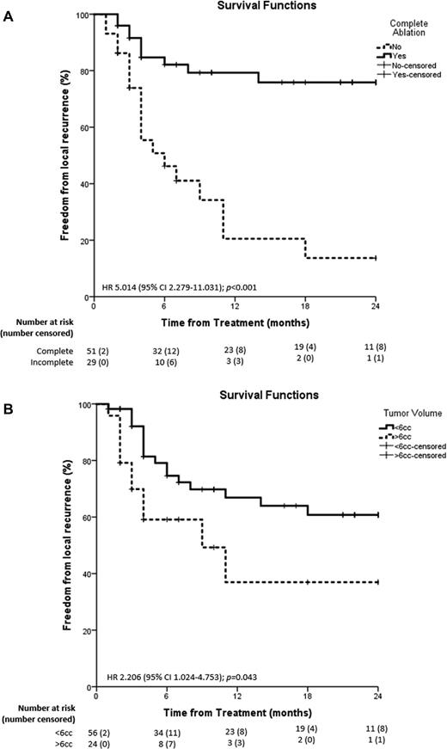 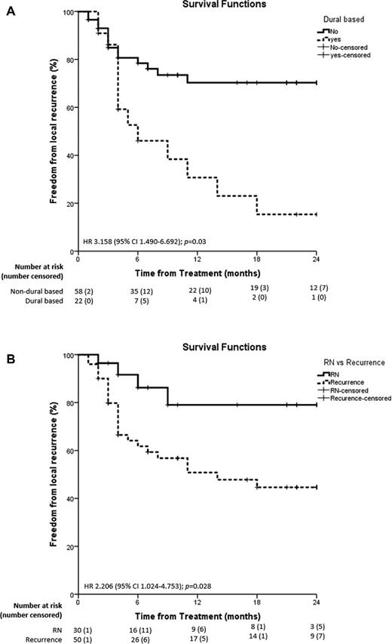

Chemotherapy

- depends on systemic disease, tumor type, and stage.

Most tumors that metastasize to brain are not chemosensitive! (most sensitive - *small cell lung cancer* and *seminomas*)

* development of brain metastases while patients are undergoing systemic chemotherapy indicates that the BBB makes the brain a sanctuary from many chemotherapeutic agents.
* chemotherapy role is limited to multiple brain metastases or active systemic cancer reasonably likely to respond to chemotherapy.
* in most cases, 2-3 agents are used in combination and in conjunction with whole-brain radiation therapy (WBRT).

CNS Systematic Review and Evidence-Based Guidelines for the Treatment of Adults With Metastatic Brain Tumors (2019)

See recommendations for specific cancers [>>](#SPECIFIC_METASTASES)

***Level 1 recommendation***: cytotoxic chemotherapy alone for brain metastases is not recommended as it has not been shown to increase overall survival.

***Level 1 recommendation***: chemotherapy following WBRT or SRS for brain metastases is not recommended.

***Insufficient evidence*** to make recommendations regarding vascular endothelial growth factor agents bevacizumab, sunitinib, and sorafenib for **solid tumor** **brain metastases**.

Emerging Therapies

CNS Systematic Review and Evidence-Based Guidelines for the Treatment of Adults With Metastatic Brain Tumors (2019)

There is ***insufficient evidence*** to make a recommendation regarding the use of high-intensity focused ultrasound (HIFU) or laser interstitial thermal therapy (LITT) or interstitial chemotherapy or brachytherapy or immune therapy

Follow Up

**MRI** every 2–3 months for one year, then every 3-4 months (less frequent beyond 2 years if both are present – no relapse before 2 years and tumor total volume < 5 mL)

Univ of Pittsburgh protocol: MRI every 3 mo for the first year of follow-up, every 4 mo for year 2, then every 6 mo thereafter, with limited consensus beyond 4 to 5 yr.

With SRS alone, risk of relapse within 1-2 years is 50-60% (if relapsed within 2 years and volume is > 5 cc, then relapse risk at > 2 years remains 50-60%)

Combining total SRS tumor volume ≥5 cc and failure during years 0 to 2, the 2 to 4-yr risk of intracranial failure if neither factor was present was 17%; either was 33%; and both was 66%

Prognosis

Unknown primary cancer - subgroup with widely divergent prognoses.

Factors associated with improved prognosis:

1. High Karnofsky score (> 70)
2. Age < 60 yrs
3. Number and location of CNS metastases (one brain metastasis - improved quality of life, survival benefit from surgical resection or radiosurgery).
4. Sensitivity of tumor to therapy
5. No systemic disease or systemic disease controlled
6. No systemic metastases within 1 year of diagnosis of primary lesion
7. Female patients

Role of extracranial disease

Most important factor for decision making – status of **extracranial disease**!

* activity of systemic disease and its propensity to be controlled represent in many studies a significant factor linked to survival.
* in many studies reporting the cause of death, systemic causes of death trump neurological causes of death.

Role of treatment modality

Median survival:

Surgical resection and WBRT - 36 months

Surgical resection - 22 months

SRS and WBRT - 16 months

SRS - 11 months

WBRT - 6 months

Untreated - 1 month (can be doubled by corticosteroids) (*Cairncross et al. 1980*)

Local recurrence rate of brain metastasis is relatively high:

85% after surgery without WBRT.

67% after radiation therapy + stereotactic radiosurgery.

Relapse rates beyond 2 yr following SRS alone for brain metastases - low in patients who do not suffer intracranial relapse within the first 2 yr and with low volume brain metastases, supporting a practice of less frequent screening beyond 2 yr

Gogineni et al. Long-Term Survivorship Following Stereotactic Radiosurgery Alone for Brain Metastases: Risk of Intracranial Failure and Implications for Surveillance and Counseling. Neurosurgery 83:203–209, 2018 DOI:10.1093/neuros/nyx376

* predictors of intracranial failure beyond 2 yr:

failure before 2 yr (HR = 2.2, 95% CI: 1.2-4.3, P = .01)

total tumor volume ≥ 5cc (HR= 2.3, 95% CI: 1.2-4.3, P = .01)

Role of number of metastases

* presence of **multiple** brain metastases per se is not an indicator of an adverse prognosis compared to a **single** brain metastasis.

RPA / RTOG classification

Radiation Therapy Oncology Group (RTOG) classes for predicting outcome in brain metastases (i.e. **recursive partitioning analysis (RPA) classification** on the basis of a retrospective study of 1200 patients treated with **whole brain radiotherapy**):

|  |  |  |  |  |
| --- | --- | --- | --- | --- |
| **Class** | **Karnofsky score** | **Systemic Disease** | **Median Survival (months) with WBRT** | **Adding SRS boost to WBRT** |
| 1  (age ≤ 65 yrs) | ≥ 70 | Controlled primary disease, no extracranial metastases | 7.1 (13.5 for single metastasis, 6.0 for multiple metastases) | 16.1 |
| 2  (age > 65 yrs) | ≥ 70 | Not group 1 or 3 | 4.2 (8.1 for single metastasis, 4.1 for multiple metastases) | 10.3 |
| 3 | < 70 |  | 2.3 | 8.7 |

Gaspar L et al. Recursive partitioning analysis (RPA) of prognostic factors in three radiation therapy oncology group (RTOG) brain metastases trials. In J Radiat Oncol Biol Phys 1997; 37 : 745 – 751 .

RPA classification has also been shown to have prognostic value in patients treated **surgically**.

Agboola O et al. Prognostic factors derived from recursive partition analysis (RPA) of radiation therapy oncology group (RTOG) brain metastasis trials applied to surgically resected and irradiated brain metastatic cases. Int J Radiation Oncology Biol Phys 1998; 42 : 155 – 159

Meta-analysis of five randomized RTOG studies (1960 patients) → less subjective, more quantitative, easier to use scale: *Sperduto P. Int J Radiat Oncol Biol Phys 70:510, 2008*

|  |  |  |  |
| --- | --- | --- | --- |
| **Points:** | **0** | **0.5** | **1.0** |
| Age | > 60 | 50-59 | < 50 |
| KPS | < 70 | 70-80 | 90-100 |
| Number of CNS  metastases | > 3 | 2-3 | 1 |
| Extracranial metastases | Present | - | None |

|  |  |
| --- | --- |
| **Total points** | **Median survival (mos)** |
| **3.5-4** | 11 |
| **3** | 6.9 |
| **1.5-2.5** | 3.8 |
| **0-1** | 2.6 |

Diagnosis Specific GPA (Median Survival):

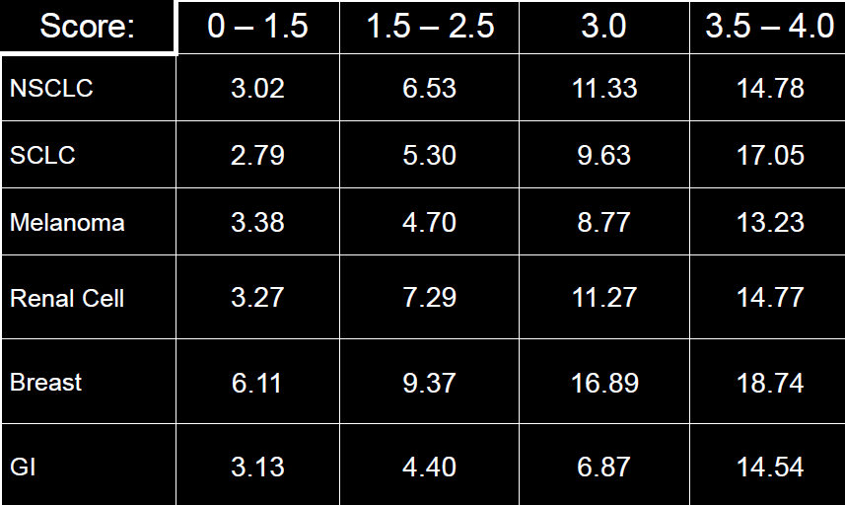

Nomogram for 6- and 12-month survival and median survival for RTOG brain metastases patients (BA, Breast and Adenocarcinoma; BO, Breast and Other; LA, Lung and Adenocarcinoma; LL, Lung and Large cell; LO, Lung and Other; LSM, Lung and Small cell; LSQ, Lung and Squamous cell; OA, Other and Adenocarcinoma; OG, Other and GI; OR, Other and Renal; OSQ, Other and Squamous cell; SMM, Skin-Melanoma; OO, Other and Other; PR, Partial Resection; CGTR, Complete/Gross total resection):

An external file that holds a picture, illustration, etc.
Object name is nos08702.jpg

Neuro Oncol. 2012 Jul;14(7):910-8. A nomogram for individualized estimation of survival among patients with brain metastasis. Barnholtz-Sloan JS et al.

Specific metastases

CNS melanoma

[see also p. 3005 >>](http://www.neurosurgeryresident.net/USMLE%202\Skin%20(2931-3030)\3005.%20Melanocytic%20Tumors%20(Nevi,%20Melanoma).pdf)

* 66-75% melanomas give brain metastasis! (melanocytes are derived from neural crest)

Melanoma is tumor type most prone to spread to brain! And does so with multiple brain metastases

* most often **multifocal**.
* unique tendency to hemorrhage!
* particularly prone to give ***pial implants***.

**Neurocutaneous melanosis** - *congenital giant hairy melanocytic nevi* with associated *leptomeningeal melanocytosis* (involving brain and/or spinal cord); leptomeningeal invasion can cause severe neurological compromise or death!

* *primary intracranial melanoma* can arise from meninges.

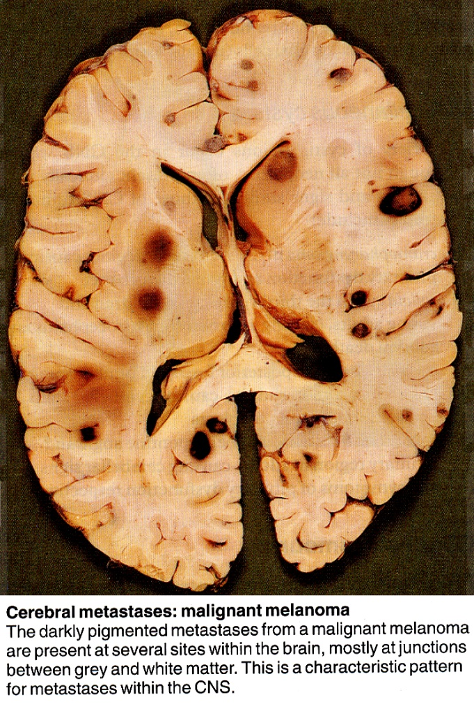

[Source of picture: James C.E. Underwood “General and Systematic Pathology” (1992); Churchill Livingstone; ISBN-13: 978-0443037122 >>](http://www.amazon.com/gp/product/0443068887)

Diagnosis

* **CT** – tends to be isodense or hyperdense; perilesional edema is usually present; pial implants appear (on contrast CT) as areas of nodular high density or as generalized enhancement along subarachnoid cisterns, fissures, and sulci.
* may appear ***hyperintense*** on **T1-MRI** and ***hypointense*** on **T2-MRI** (due to melanin).
* stereotactic **brain biopsy** is usually not necessary if primary is known and if imaging is compatible with melanoma.

T2-MRI - at least three foci of signal hypointensity in right hemisphere, largest in right posterior frontal cortex and others deeper in subcortical parietal region:

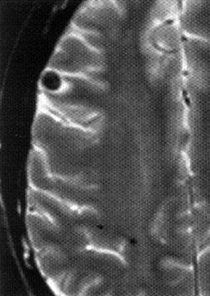

Noncontrast T1-MRI - high signal (melanin or hemorrhage); note extensive surrounding edema:

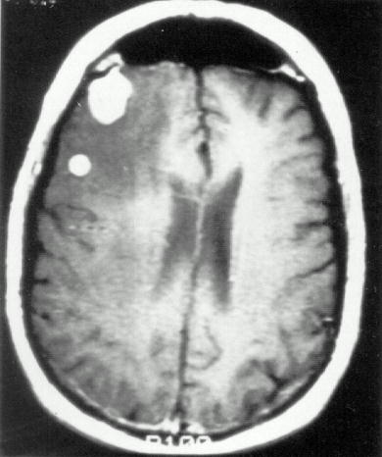

Treatment & Prognosis

*Poorly responsive to all treatments* - after melanoma is detected in brain, median survival is 3-4 months!

Melanoma that metastasizes to CNS is incurable

**1-3 lesions**:

1. surgical removal ± whole brain radiation
2. radiosurgery ± whole brain radiation

**Multiple metastases**:

1. whole brain radiation
2. chemotherapy:

dacarbazine – FDA approved for melanoma

fotemustine (marked myelosuppressive properties)

temozolomide

ipilimumab (Yervoy®) – 3-10 mg/kg IV once every 3 weeks → long-term survival similar to patients with advanced melanoma without brain metastases.

* fully human antibody that blocks CTLA-4 (cytotoxic T lymphocyte-associated antigen 4) → sustained active immune response.
* *steroids* act antagonistically (by suppressing immune response)
* while BRAF mutations are found in up to 66% of primary malignant melanomas, cerebral metastases harbor BRAF V600E mutations in 42%.
* BRAF inhibitors (BRAFi) vemurafenib and dabrafenib are FDA approved for melanomas that express V600E; control rates are better for dabrafenib (31%) compared to vemurafenib (16%), presumably based on the better penetration of BBB due to its smaller size and molecular structure

CNS Systematic Review and Evidence-Based Guidelines for the Treatment of Adults With Metastatic Brain Tumors (2019)

There is ***insufficient evidence*** to make recommendations regarding BRAF inhibitors (BRAFi) dabrafenib and vemurafenib for brain metastases due to **melanoma**

Lung cancer

Small cell

Treatment is whole brain radiation (even for single symptomatic\* metastasis)

Newer trend – chemotherapy with concurrent SRS – tumor tends to shrink very rapidly; WBRT reserved for failures.

\*e.g. over eloquent cortex; if symptomatic due to global mass effect and tumor is large → surgical debulking before radiation

CNS Systematic Review and Evidence-Based Guidelines for the Treatment of Adults With Metastatic Brain Tumors (2019)

***Level 2 recommendation***: SRS + chemotherapy is recommended to improve overall survival and progression free survival in lung adenocarcinoma patients.

Non-Small cell

CNS Systematic Review and Evidence-Based Guidelines for the Treatment of Adults With Metastatic Brain Tumors (2019)

There is ***insufficient evidence*** to make recommendations regarding epidermal growth factor receptor inhibitors erlotinib and gefitinib for brain metastasis due to **nonsmall cell lung cancer**

Breast Cancer

CNS Systematic Review and Evidence-Based Guidelines for the Treatment of Adults With Metastatic Brain Tumors (2019)

***Level 3 recommendation***: WBRT + temozolomide is recommended as a treatment for patients with triple negative breast cancer.

***Level 1 recommendation***: afatinib is not recommended for brain metastasis due to breast cancer.

***Insufficient evidence*** to make recommendations regarding HER2 agents trastuzumab and lapatinib for brain metastases due to **breast** **cancer**

Bibliography for ch. “Neuro-Oncology” → follow this [link >>](http://www.neurosurgeryresident.net/Onc.%20Oncology\Onc.%20Bibliography.pdf)

[Viktor’s Notes℠ for the Neurosurgery Resident](http://www.neurosurgeryresident.net/)

[Please visit website at www.NeurosurgeryResident.net](http://www.neurosurgeryresident.net)