Neoplastic Meningitis (s. Leptomeningeal Metastases, Leptomeningeal Carcinomatosis)

Last updated: April 12, 2019

Etiology 1

Pathology 1

Clinical Features 1

Diagnosis 1

Gadolinium-enhanced MRI 1

CSF 2

CSF Flow Studies 3

Meningeal Biopsy 3

Treatment 3

Surgery 3

Radiotherapy (craniospinal irradiation) 4

Chemotherapy 4

Intrathecal chemotherapy 4

Prognosis 5

NM - proliferation of neoplastic cells in ***subarachnoid space***.

NM - devastating, late-stage complication of cancer.

N.B. “meningitis” is misnomer - inflammatory response may not be present!

* may occur at ***any stage in neoplastic disease*** - either as presenting sign or as late complication (frequently associated with cancer relapse elsewhere in body; usually close correlation between NM and osseous metastases).
* incidence increasing (earlier detection, patients live longer).
* it is unknown why NM does not develop in some patients with extensive systemic metastases.

Etiology

* 1. 4-8% patients with any **systemic solid tumors** (hematogenously):
     1. breast adenocarcinoma (10-41%) Most patients with NM have *breast cancer*!
     2. small cell lung carcinoma (24-70%)
     3. GI tract tumors (2-20%)
     4. melanoma (2-15%)
        + carcinomas of head / neck / skull / vertebrae can spread to meninges:

1. retrograde growth along adventitia of blood vessels or perineurium of spinal and cranial nerve roots.
2. direct extension from parameningeal structures
   1. 5-15% patients with **hematologic** **malignancies** (hematogenously): diffuse large B-cell lymphoma and Burkitt's lymphoma, ALL → *lymphomatous meningitis, leukemic meningitis*
   2. **Primary**\* or **metastatic** **CNS tumors** (direct meningeal seeding via CSF) → *leptomeningeal* *gliomatosis*. [see p. Onc1 >>](http://www.neurosurgeryresident.net/Onc.%20Oncology\Onc1.%20Brain%20Tumors%20(GENERAL).pdf)

*< 2% patients with primary CNS tumors (esp. medulloblastoma, ependymoma, pineoblastoma, primitive neuroectodermal tumors, primary CNS lymphoma)

* 1-8% of patients with cancer develop NM (in 25% such patients systemic cancer is under control).
* in 1-7% patients, primary tumor is unknown.

Pathology

* CSF circulation is effective conduit for dissemination.
* disseminates to surfaces of brain, spinal cord, nerve roots, and ventricular ependymal surfaces.
* multifocal or diffuse infiltration of leptomeninges (in sheetlike fashion) along surface of brain / spinal cord ("sugar coating").
* tumor masses may extend into Virchow-Robin spaces.
* NM causes partial BBB disruption once tumor size has increased enough to stimulate growth of its own vasculature.
* NM may coexist with parenchymal CNS metastases.

Clinical Features

- subacute meningitis (but patient is afebrile with preserved consciousness):

Mutifocal neurological symptoms!

Classical vignette: **CN3 palsy + foot drop**

1. Meningeal irritation: classic **nuchal rigidity** (< 20% patients), **back pain**.
2. CSF flow obstruction → **ICP↑**, **hydrocephalus**.
3. Local tumor infiltration → **focal deficits**, **multiple cranial nerve palsies** (94%), **radiculopathies**, **myelopathy** (e.g. lower extremity weakness or numbness due to cerebellar or cauda equina involvement).

Mechanisms:

1. edema
2. alterations in nervous tissue metabolism* → **seizures**, **encephalopathy** (AMS, headache, behavior changes).
3. occlusion of blood vessels (as they cross subarachnoid) → **microinfarcts**.

*competition for glucose between malignant cells and neurons

* *rapidly progress*\* at alarming rate despite treatment efforts → neurological + systemic decline.

*possible exception - breast cancer

Diagnosis

Gadolinium-enhanced MRI

1. **Enhancing deposits** (patchy finely nodular or linear):
2. nerve roots – appear as thickening of nerve roots (especially evident in cauda equina, even in absence of clinical symptoms)
3. leptomeningeal - extending into sulci, cisterns, periependymal regions, and following convolutions of brain (usually follows positive CSF cytologic findings by 6 months)
4. **Matting** of nerve roots of cauda equina
5. **Indirect signs** - communicating hydrocephalus, bilateral transependymal edema, effacement of convexity sulci.
   * 60% scans appear normal (high-resolution MRI is necessary in spine).
   * *dural carcinomatosis* (common in carcinoma of breast) - focal curvilinear or diffuse contrast enhancement closely applied to inner table of skull, which does not follow convolutions of gyri.
   * differential of meningeal enhancement: infections, previous SAH, previous LP or intrathecal chemotherapy, prior neurosurgical procedures (e.g. placement of intraventricular reservoir), chronic CSF leak.

N.B. in patient with high KPS score and active systemic cancer in whom neuroimaging strongly suggests NM, some physicians justify treatment even if CSF cytology is negative.

A, Patchy nerve root enhancement, matting of nerve roots of cauda equina, and nodular deposits (*arrows*) in acute lymphocytic leukemia.

B, Linear, continuous enhancement of pia-arachnoid surrounding conus medullaris (*arrows*) in metastatic melanoma.



[Source of picture: H. Richard Winn “Youmans Neurological Surgery”, 6th ed. (2011); Saunders; ISBN-13: 978-1416053163 >>](http://www.amazon.com/gp/product/1416053166)

Carcinomatous spinal meningitis (postcontrast MRI) - diffuse pial enhancement along cord surface (*arrows*):

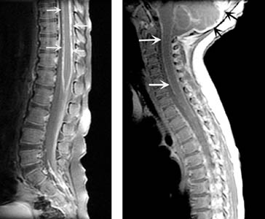

Dural metastasis from breast carcinoma (postcontrast T1-MRI): heterogenously enhancing mass with irregular surface that arises from dura over right cerebral convexity; it displaces underlying brain and causes considerable low signal edema within it; dural ‘tail’ extending away from tumor (*arrowhead*):

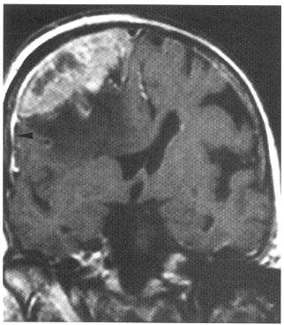

Marked enhancement of leptomeninges in cerebral sulci and superficial folia of superior cerebellum (*arrows*):



[Source of picture: H. Richard Winn “Youmans Neurological Surgery”, 6th ed. (2011); Saunders; ISBN-13: 978-1416053163 >>](http://www.amazon.com/gp/product/1416053166)

CSF

< 5% have completely normal CSF profiles

*Normal CSF does not exclude diagnosis!*

Definitive diagnosis - malignant cells in CSF; sensitivity depends:

1. **lumbar or cisternal** CSF (more reliable than intraventricular CSF)
2. **second specimen** increase sensitivity from 50-60% to 80%

15% *false-negatives* after 3 high-volume LPs (5% after 6 LPs)

1. CSF from **location nearest** to area of greatest involvement
2. CSF sample **volume** > 10.5 mL (however, most cytopathologists prefer serial samples obtained on different dates rather than single large-volume specimen)

Periodic **CSF examinations** - most useful test!!!

Most sensitive indicator - elevated protein (> 45 mg/dL in 80-90% patients)

* **normal CSF protein** reading is relatively strong (but not absolute) evidence against diagnosis.
* high elevations (500-1200 mg/dL) - either advanced NM or partial / complete blockage of CSF flow from cephalad locations.

Other:

* lumbar CSF pressure > 15 cmH2O (30-57% patients).
* glucose↓ normal ÷ ↓↓↓ (< 40 mg/dl in 31-55% cases) - due to abnormal glucose transport; tumor cells also use much glucose.
* reactive lymphocytes↑ (65%) → *false-positive* CSF (difficult to distinguish from malignant lymphomatous cells)
* xanthochromia from leptomeningeal bleeding (most likely in NM from melanoma)
* if gene rearrangements in particular malignancy are known → fluorescent in situ hybridization (FISH), flow cytometry, PCR.
* biochemical markers (poor sensitivity and specificity; levels decline with successful therapy):

CEA – adenocarcinomas;

α-fetoprotein, β-hCG – testicular cancers;

5-hydroxyindoleacetic acid (5-HIAA) – carcinoid tumors;

immunoglobulins – multiple myeloma;

LDH isoenzyme-5 – breast or lung tumors;

glial fibrillary acidic protein (GFAP) – gliomas.

CSF Flow Studies

* assessed by **nuclear medicine** (111In-diethylenetriamine pentaacetic acid or 99Tc-labeled albumin).
* partial or total CSF flow blockage is identified in 30-70% patients - outcome is poorer.
* should be done before initiating treatment – to identify CSF flow blockage:
  + to prevent accumulation of high concentrations of administered drug in areas of CSF loculation
  + to identify areas that would not receive adequate drug concentration beyond areas of blockage.
* CSF blocks can be opened with focal radiation therapy.

Meningeal Biopsy

* indication - patient with high clinical suspicion of NM but repetitively negative CSF cytology.
* most patients are not appropriate candidates (poor performance status and comorbid conditions).
* *sensitivity* and *specificity* are low when there is no target on MRI.

Malignant cells in CSF:

*A.* Isolated large cells with increased nuclear-to-cytoplasm ratio and fine clumps of cytoplasmic pigment (malignant melanoma).

*B.* Clump of cohesive cells of primitive neuroectodermal tumor and extensive meningeal seeding.

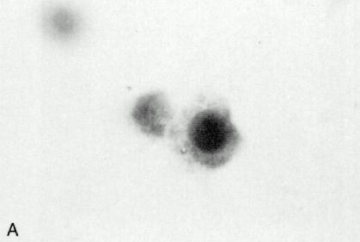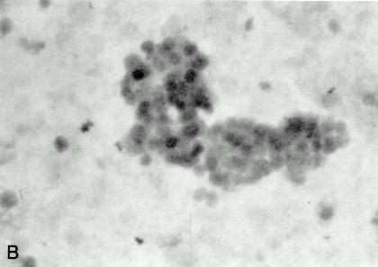

Myelogram and autopsy specimen from same patient - intradural filling defects in myelogram (A) that correspond to tumor nodules (*arrows*) on multiple nerve roots and thoracic spinal cord in pathologic specimen (B):

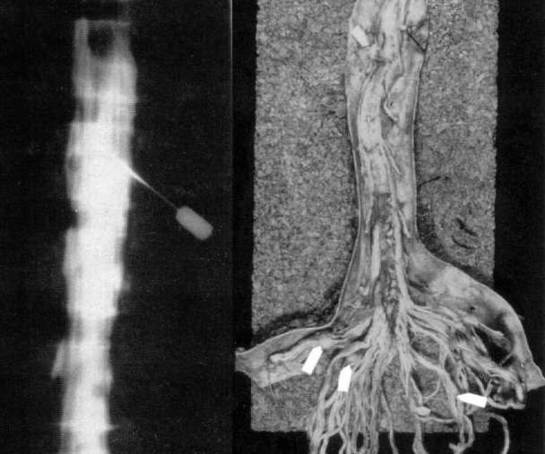

Treatment

- entire neuraxis must be treated, as tumor cells are disseminated widely by CSF flow.

* treatment increases patient's quality of life by extending time to neurological progression.
* *fixed focal neurologic deficits* (e.g. cranial-nerve palsies) do not improve, but *encephalopathies* can improve dramatically with treatment.

Treat systemic cancer, as patient is likely to die from that

Surgery

1. Placement of **intraventricular reservoirs** (e.g., Ommaya) for CSF access.

N.B. clinical studies have not shown statistically significant improvement in overall survival when comparing intraventricular vs. intralumbar drug administration (exception - childhood ALL).

1. **Ventriculoperitoneal shunting** for hydrocephalus or if symptomatic increased ICP does not improve with steroids

* questionable benefit in patients with end-stage disease.
* potential dissemination of malignant cells to abdomen.
* ineffective drug delivery to CSF (siphoning of administered drug from intraventricular reservoir; H: in-line on-off or programmable valves*).

* temporary closure of shunt valves has not yet been shown in clinical studies to sustain therapeutic levels of drug in CSF or to improve survival.

1. **Meningeal biopsy**.

Radiotherapy (craniospinal irradiation)

Indications:

1. focal RT to areas of ***bulky disease*** (nodules > 5 mm) - radiation treats areas such as *nerve-root sleeves*, *Virchow-Robin spaces*, and *interior of bulky lesions* that chemotherapy does not reach
2. focal RT to ***symptomatic sites*** often provides palliative benefit
3. patients with medulloblastoma or pineoblastoma who are considered poor risks for surgery
4. salvage therapy in patients for whom initial therapy for leukemic meningitis has failed.

* dosages range from 20 Gy in 1 week to 30 Gy over 3-4 weeks.

*lymphomatous and leukemic meningitis - 30 Gy over 10 doses*

* because CSI encompasses much of bone marrow, resulting hematologic toxicity may affect ability to provide substantial cytotoxic chemotherapy in future regimens.
* toxicity of intrathecal or high-dose systemic methotrexate is increased after whole-brain RT (H: administer MTX before RT)

Chemotherapy

- for younger patients with **high KPS scores** and **controlled systemic disease**

* many patients are too ill for aggressive therapy → supportive or hospice care.
* penetration (CSF concentration/systemic blood concentration):

thiotepa (90%)

topotecan (30%)

temozolomide (30%) - produced responses in NM accompanying malignant gliomas

cytarabine (ara-C; 20-28%)

MTX (3%)

Intrathecal chemotherapy

* chemotherapy treats *subclinical leptomeningeal deposits* and *tumor cells floating in CSF*, preventing further seeding.
* administered after radiotherapy.
* some studies show that IT treatment provides no differences in outcome.

N.B. for most neoplasms, survival has not yet been shown to be superior after intrathecal treatment.

Disadvantages and limitations:

1. more neurologic toxicity (than systemic chemo)
2. inadequate penetration of CNS parenchymal surfaces → limited efficacy in gross lesions (> 5 mm diameter)
3. limited efficacy in blocked CSF pathways (CSF compartmentalization)

*CSF flow abnormalities* are common (70% patients have ventricular outlet obstructions, abnormal spinal canal flow, or impaired flow over cortical convexities - these can be reversed with radiotherapy) - ***CSF-flow study*** is recommended for all patients at initiation of intrathecal chemotherapy; if obstruction is noted → defer therapy (whole neuraxis radiotherapy is reasonable alternative).

1. short half-life and cell cycle specificity (only 55% of CSF tumor cells cycle in 10-day span; half-life of most IT agents is only minutes - few hours)
2. some agents are not converted to active metabolites within CSF

e.g. triethylenephosphoramide (TEPA), active metabolite of thiotepa, is not measurable in CSF after IT administration.

Preferred route - implanted subcutaneous reservoir (e.g. Ommaya device) and ventricular catheter (rather than LP):

1. intraventricular injection is easy and ensures entry into CSF.
2. when injected into ventricle, drug follows normal CSF flow and thus reaches all parts of CSF space.
3. repetitive LPs are arduous and painful.
4. 10-15% of LPs do not deliver all of drug intended to reach subarachnoid space.

Drugs:

methotrexate (MTX) – first line! (FDA approved for lymphomatous and leukemic meningitis)

* because meningeal infiltration interferes with drug clearance, CSF concentrations can be unpredictable (maintain concentration near 10-6 M)
* can cause acute **arachnoiditis** (self-limiting and resolves within 24-72 hrs); **transverse myelitis** is rare idiosyncratic reaction (begins 30 min ÷ 48 h after intrathecal treatment)

N.B. combination of MTX and cranial irradiation may cause *necrotizing leukoencephalopathy*. [see p. Rx11 >>](http://www.neurosurgeryresident.net/Rx.%20Treatment%20Modalities\Rx11.%20Radiotherapy.pdf)

cytarabine (cytosine arabinoside, Ara-C) – second-line agent; not effective for solid tumors but effective (FDA approved) in *leukemic / lymphomatous meningitis*; available in liposome-encapsulated form (DepoCyt) - administered q2weeks (rather than 2-3 times / week).

thiotepa – third-line agent; cleared from CSF within minutes with less neurologic toxicity than MTX.

* other drugs reported in IT use (not approved by FDA): mafosfamide, etoposide, rituximab, interferon alfa, topotecan.

**Randomized Clinical Trials of Intrathecal Chemotherapy for Neoplastic Meningitis**

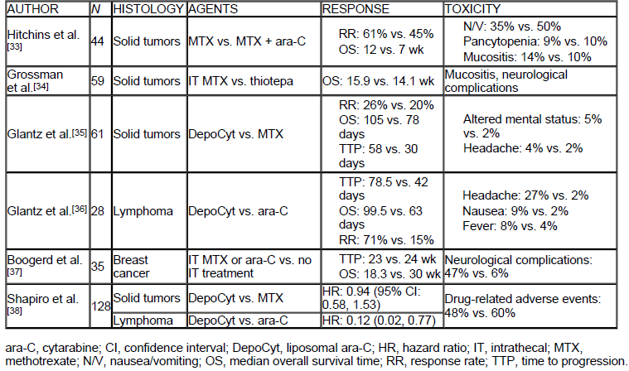

**Selected Phase I and II Studies of Treatment of Neoplastic Meningitis**

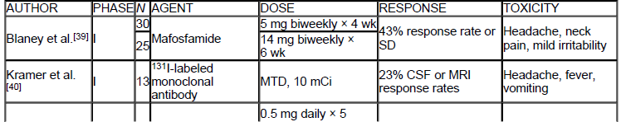

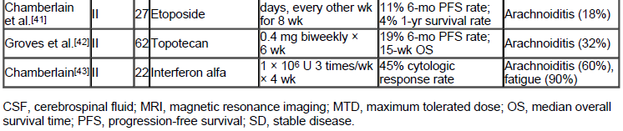

Prognosis

* average survival time – 3.5-6 months
* *without therapy* → death due to progressive neurologic dysfunction in 4-6 weeks
* *with therapy*, most patients die from systemic cancer complications rather than neurologic complications
* treatment to date has not had significant effect on survival.

Exception - *leukemic / lymphomatous meningitis* (esp. ALL) - can be eradicated completely from CNS!

* favorable prognostic factors:

1. young age
2. Karnofsky Performance Scale (KPS) score > 70
3. long duration of symptoms
4. controlled systemic disease
5. lack of encephalopathy or cranial nerve deficits
6. low CSF protein levels
7. **breast cancer** (11-25% alive at 1 year, 6% - at 2 years).
8. hematologic malignancies - curable
9. lack of bulky leptomeningeal deposits

* median survival:

7 months for NM from breast cancers

4 months for NM from small-cell lung carcinomas

3.6 months for NM from melanomas.

Bibliography for ch. “Neuro-Oncology” → follow this [link >>](http://www.neurosurgeryresident.net/Onc.%20Oncology\Onc.%20Bibliography.pdf)

[Viktor’s Notes℠ for the Neurosurgery Resident](http://www.neurosurgeryresident.net/)

[Please visit website at www.NeurosurgeryResident.net](http://www.neurosurgeryresident.net)