Skull Tumors
Last updated: December 22, 2020
Pathology 1
Epidemiology 2
Clinical Features 2
Diagnosis 2
Differential diagnosis 4
Treatment 4
Prognosis 4
Special Types 5
Chondrosarcoma 5
Fibrous Dysplasia 5
Solitary Plasmacytoma / Multiple Myeloma 7
Tumors of Vertebrae → see p. Onc56 >>
General Features of Bone, Cartilage, Soft Tissue Tumors → see p. 1197-1198 >>

Pathology
- Bone forming tumors:
  - osteoma (most common primary tumors of calvaria) - growths of mature dense lamellar cortical bone (outer or inner table); typical appearance - nidus of osteoid tissue in background of osteoblastic connective tissue, which is enclosed completely by reactive bone.
  - osteoid osteoma
  - ossifying fibroma - fibrous spindle cells with varying amounts of woven bone; tumor periphery is composed of mature lamellar bone.
  - osteoblastoma - fibrous stroma with irregular osteoid deposition.
  - osteosarcoma (second most frequent malignant skull tumor after multiple myeloma) - malignant spindle cell stroma, which directly produces osteoid or immature bone (osteoblastic, chondroblastic, or fibroplastic form); association with prior radiation exposure, Paget disease, fibrous dysplasia, chronic osteomyelitis.
- Cartilage forming tumors:
  - chondromas (enchondroma, juxtacortical chondroma, osteochondroma) - mature hyaline cartilage; arise from cartilaginous portion of bones formed by enchondral ossification (skull base and paranasal sinuses).
  - chondromyxoid fibroma - chondroid and myxoid differentiation with lobular growth.
  - chondroblastomas - immature cartilage cells.
  - chondrosarcoma (third most common malignant skull tumor); often associated with abnormalities of chromosomes 10 and 22; low-grade type (myxochondrosarcoma) - chondroid and immature cartilage deposition in areas of myxomatous change and cystic degeneration; high-grade type (mesenchymal chondrosarcoma) - absence of cartilage lobules and presence of fibrosarcomatous areas (groups of chondromatous cells lose their usual lobulation and begin to spindle out); both types are vimentin positive.
- Connective tissue tumors:
  - desmoplastic fibroma (very rare!) - fibrous connective tissue origin marked by collagen formation.
  - fibrosarcoma - varying amounts of collagen production and absence of bone, osteoid, or cartilage; medullary subtype has better prognosis than periosteal subtype.
- Histiocytic tumors (very rare!):
  - giant cell granuloma - giant cells around hemorrhagic foci, numerous spindle-shaped fibroblastic cells, and new bone formation; tumor cells are smaller than those of giant cell tumor of bone, whereas stromal cells and giant cells resemble each other.
  - nonossifying fibroma - fibroblast proliferation with multinucleated giant cells.
  - xanthoma - foamy xanthomatous cells.
  - Ewing sarcoma - uniform, densely packed small cells with indistinct cytoplasmic borders and many mitotic figures; stain strongly with PAS.
  - giant cell tumor (osteoclastoma) - well-vascularized tissue mass of plump, spindle, or ovoid stroma cells together with uniformly dispersed, numerous, large, multinucleated giant cells.
- Tumors of blood or blood vessel origin:
  - eosinophilic granuloma (common) - mononuclear histiocytes* mixed with eosinophils; giant cells and areas of hemorrhage or necrosis may be observed.
*histiocytes stain positive for protein S-100; on electron microscopy, Birbeck granules (that characterize Langerhans or X cells) are noted
  - hemangioma (10% of benign skull tumors) - non progressive brownish red lesions under skull periosteum; microscopically - capillary, cavernous, or venous blood vessels.
  - lymphangioma (rare) - consist of lymph vessels.
  - angiosarcoma (hemangiopericytoma or hemangioendothelioma) - irregular anastomosing vascular channels lined by one or more layers of atypical endothelial cells and pericytes, which have anaplastic immature appearance.
- Tumors of neuroepithelial origin: esthesioneuroblastoma
- Tumors of squamous cell origin: squamous cell carcinoma (nasal sinuses and temporal bone)
- Tumors of apocrine gland origin (salivary, lacrimal glands); propensity for perineural spread.
- Metastases (skull is common site!); dura is effective barrier - brain invasion is rare!
- Other types:
  - fibrous dysplasia – see below
  - Paget disease - initially increased osteoclastic activity (bone resorption) → increased osteoblastic activity (bone formation).
  - epidermoid & dermoid tumors (one of most common benign skull lesions in children) see p. Onc30 >>
  - aneurysmal bone cysts - large vascular spaces (lack endothelial lining) separated by trabeculae of connective tissue and bone; locally aggressive lesions - continue to expand until treated.
  - intraosseous meningiomas
  - multiple myeloma - widespread osteolytic bone destruction by dense tumor cells that look like plasma cells clustered in close aggregates.

- 19% are benign and 81% - malignant.
- features of benign tumor:
- single, small, grossly round / oval lesion
- peripheral sclerosis
- intralesional calcifications
- peripheral bone vascularity
- malignant transformation (to osteosarcoma, chondrosarcoma, or fibrosarcoma) - in 2% Paget disease and 0.5% fibrous dysplasia cases.
- lesion location is of little differential diagnostic value, but certain tendencies exist:
lesions of developmental origin - strong midline propensity;
osteomas - paranasal sinuses, frontal bone;
ossifying fibromas - frontotemporal region;
eosinophilic granuloma, ossifying meningioma - frontoparietal area;
Paget disease - skull base, usually multicentric.
cartilage tumors - skull base;
giant cell granuloma - sphenoid, temporal, and ethmoid areas;
hemangiomas (more common in vertebral column): globular variety - skull base; sessile type - frontotemporal region;
epidermoids and dermoids - cerebellopontine angle, parasellar region, calvaria (dermoids prefer midline).

Hyperostoses - local overgrowth of skull bones:
- induced by intracranial meningiomas
- nonneoplastic
- hyperostoses may involve either outer or inner tables;
  - outer table involvement is insignificant except for possible disfigurement.
  - hyperostoses of inner table rarely grow enough to compress intracranial contents.
Hyperostosis frontalis interna - asymptomatic symmetric hyperostosis of inner table of frontal bone - common incidental finding in women > 40 yrs; diploe and external table are not affected; differentiate from en plaque meningioma.

Epidemiology
- account for ≈ 1% of all bone tumors.
- most manifest in young adults! (except intraosseous meningioma, Paget disease, multiple myeloma, squamous cell carcinoma - affect older adults).

Clinical Features
  - Enlarging skull mass ± pain / tenderness (due to periosteal involvement).
- osteoid osteoma - nocturnal local tenderness relieved by NSAIDs.
- rapidly growing mass - aneurysmal bone cyst, chondroblastoma, chondromyxoid fibroma, desmoplastic fibroma, giant cell granuloma or malignant tumor.
- malignant tumors without pain - multiple myeloma, osteosarcoma.

  - Cranial nerve deficits (if tumor involves skull base), e.g. visual and hearing loss.

  - Dural erosion, direct brain compression.

  - Recurrent sinusitis, CSF rhinorrhea
- if tumor obstructs sinus ostium → mucocele (encapsulated, thick fluid collection); mucocele may erode through base of skull to compress intracranial structures.

  - Subdural collections - associated with malignant tumors invading dura (esp. metastatic).

Syndromes
Gardner syndrome:
- multiple osteomas of skull, sinus, mandible
- soft tissue fibromas of skin
- colon polyps
McCune-Albright syndrome - postzygotic mutation (spontaneous mutation) of GNAS1gene - involved in G-protein signaling - mutation prevents downregulation of cAMP signaling
- polyostotic fibrous dysplasia
- "autonomous production" of hormones - precocious puberty, hyperthyroidism, Cushing syndrome
- unilateral hyperpigmented skin macules (“café-au-lait”) - jagged "coast of Maine" borders, and tendency to respect midline and follow developmental lines of Blaschko
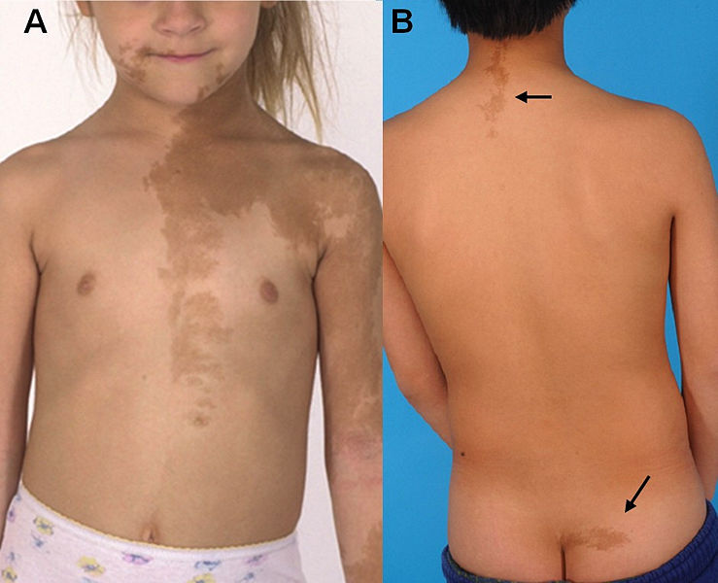

Hand-Schüller-Christian disease:
- diabetes insipidus
- exophthalmos
- bone lesions
Ollier syndrome - multiple enchondromas.
Maffucci syndrome:
- enchondromas
- dyschondroplasia
- cavernous hemangiomas of soft tissues / viscera

Diagnosis
Plain skull radiography with special projections, CT (extent of intracranial extension):
- radiolucent (osteolytic) – most tumors (benign and malignant)
- radiopaque (osteoblastic) – osteoma, ossifying fibroma, intraosseous meningioma, sclerotic form of fibrous dysplasia, later stages of Paget disease, some metastases (e.g. prostate, breast, bladder, hypernephroma).

- malignant tumors - irregular poorly defined borders, no periosteal reaction.

osteoma – condensation of cortical bone (circumscribed homogeneous bone density) which may project external to skull (exostosis) or towards cranial cavity (enostosis); arises from outer table without involvement of diploë (spongy osteoma may be radiolucent; osteoid osteomas - radiolucent nidus with surrounding dense sclerosis).
Osteoma of skull vault (lateral X-ray): extracranial nature of lesion is suggested by its very well defined border (tangential view clearly showed that only outer table was affected):
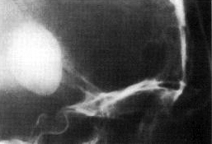
ossifying fibroma - initial lesion is radiolucent, but progressively becomes radiopaque, with sharp margins and dilated vascular channels.
intraosseous meningioma - irregular bone deposition on inner and outer tables, usually in vicinity of coronal suture.
osteoblastoma - well-demarcated nonenhancing lytic lesion with smooth calcified margins.
chondroma - well circumscribed lytic lesion eroding surrounding bone; stippled calcification helps to distinguish from metastasis or chordoma.
chondroblastoma - well-demarcated osteolytic area with varying degrees of calcification.
chondromyxoid fibroma - radiolucent with tissue calcification.
desmoplastic fibroma - well-defined lytic and expansile lesions with typical soap bubble appearance; causes thinning of overlying cortex without periosteal reaction.
giant cell granuloma - radiolucent, well demarcated, multiloculated, with expansion and thinning of bone cortex; CT - isodense lesion, which may erode overlying cortical bone.
nonossifying fibroma, xanthoma - radiolucent with sclerotic margins and bony trabeculae with soap bubble appearance.
eosinophilic granuloma - radiolucent, oval, well-demarcated lesion without sclerosis; appearance of punched-out defect or doughnut-shaped lesion that involves both inner and outer table; CT - soft tissue mass within area of bony destruction (central density may also be present).
hemangioma - well-defined nonenhancing lytic lesion with characteristic honeycomb or trabecular appearance; 33% show peripheral sclerosis; 10-15% show classic "sunburst" or "spoke wheel" pattern (spicules radiate from central point); intralesional calcifications are common; prominent vascular groove may be seen in vicinity (external carotid arteriography sometimes shows blush); diploe is expanded, but inner table is preserved!
Hemangioma of skull vault (A - lateral radiograph; B - CT, bone window) - well defined lucency in parietal bone has typical ‘spoke wheel’ appearance (due to prominent vascular impressions):
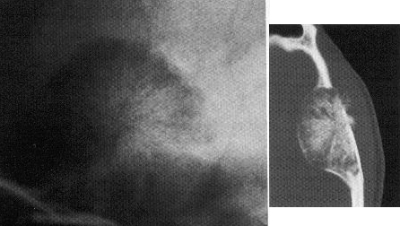
lymphangioma - cystic bone defect.
aneurysmal bone cyst - well-demarcated lesion that arises from diploë (expands both inner and outer tables); CT - multiloculated expansile lesion with characteristic fluid level.
epidermoid / dermoid - round lytic lesion arising within diploë; may expand inner and outer tables away from each other; sharp dense sclerotic borders that involve all three layers of bone; CT - hypodense nonenhancing lesion with irregular borders.
fibrous dysplasia – see below
Paget disease – expansion of skull base by thickened abnormal bone: sharply demarcated lytic lesions (osteoporosis circumscripta) → enlarged, coarsened trabeculae, thickening of cortex, and nonhomogeneous patchy densities (resemble cotton wool) with varying degrees of bone formation and no clear edges → sclerotic-lytic appearance (can be confused with fibrous dysplasia, but occurs in older age).
osteosarcoma – osteolytic soft-tissue extension; may have calcification; typical (but not frequent) appearance is sun-ray picture.
A. Noncontrast CT - calcified mass within medial right parietal-occipital lobes with massive extracranial soft tissue swelling.
B. CT bone window - thinning and erosive changes of calvarium with several large areas of calcification and ossification within extracranial soft tissues in right parietal-occipital region.
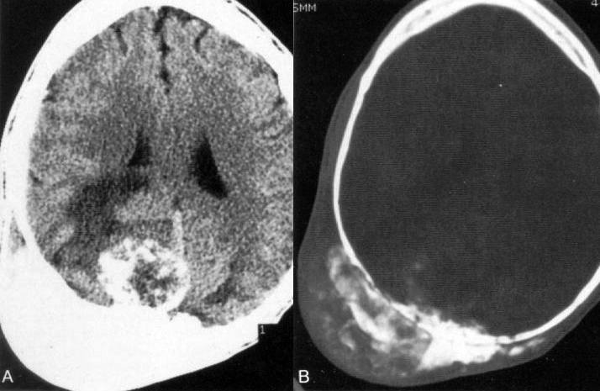

chondrosarcoma - no reliable radiological features (lytic and sclerotic changes within poorly defined margins).
fibrosarcoma - lytic lesion with thinning and widening of cortex.
Ewing sarcoma - typical onion skin appearance (laminated periosteal changes); CT - isodense mass surrounded by hypodense area and hyperostosis, contrast enhancing.
angiosarcoma - destructive lesion with cortical erosion and reactive ossification; CT - heterogeneous enhancement with focal necrosis.
plasmocytoma/multiple myeloma - multiple lytic lesions that involve both inner and outer tables, as well as diploë from which they arise; CT - hyperdense, homogeneous enhancing lesions.
giant cell tumors - involve sphenoid bone and commonly erode sellar region; CT -hyperdense, contrast-enhancing masses.
metastatic neoplasms:
    - osteoblastic - sclerosis and thickening (e.g. prostate, breast, bladder, hypernephroma).
    - osteoclastic - bone destruction and lucency (e.g. lung, uterus, GI tract, thyroid, melanoma, neuroblastoma).
    - combined (sclerotic and lytic) lesions - prostate, breast.
Metastases from breast carcinoma (lateral plain skull film) - numerous irregular lytic defects in cranial vault associated with large vascular grooves:
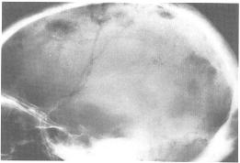

MRI - hypointense on T1, hyperintense on T2.
- some degree of contrast enhancement is common.

Brain and skull mts image review protocol:
parenchymal - gadolinium MPRAGE, FLAIR (not all mts enhance so FLAIR is even more sensitive, esp. for small mts)
calvarial - DWI (bright areas in the skull; vs. bone marrow abnormalities - will be diffuse signal along entire skull)

Bone scanning with Tc-99m – “hot” area of increased radioisotope uptake (osteomas, ossifying fibromas, osteoblastomas, all malignant tumors).

Arteriography - high vascularity (tumors of vascular origin, multiple myeloma); not helpful in diagnosis of other tumors.

Biopsy - paramount importance!

Differential diagnosis
- Encephalocele, meningoencephalocele
- Venous lakes of skull, pacchionian depression
- Fractures, surgical defects
- Osteomyelitis, tuberculosis, sarcoidosis, syphilis
- Hyperparathyroidism, osteoporosis, congenital hemolytic anemia

Treatment
No treatment is required for asymptomatic benign lesions unless diagnostic concerns exist!

- Pain control (aspirin or NSAIDs for osteoid osteoma)

- Surgical excision:
  - benign tumors – for symptomatic relief, cosmetic reasons, or cranial nerve decompression.
  - malignant tumors – treatment of choice for cure (except multiple myeloma); if other means cannot control tumor expansion, surgery is still option in metastatic disease!
- complete en bloc resection is preferred (with extensive margins for malignant tumors).
- preoperative embolization is recommended for angiosarcomas (to reduce intraoperative blood loss).
- unresectable lesions → curettage, Gamma Knife and CyberKnife.

- Radiotherapy - for some partially resected benign lesions with high recurrence rates (ossifying fibroma, hemangioma, aneurysmal bone cyst).
Radiosurgery is primary treatment for secondary osteosarcoma (esp. in elderly patients), multiple myeloma (if chemotherapy fails).
- not indicated for angiosarcoma and fibrosarcoma; use in chondrosarcoma controversial.

- Chemotherapy (combinations including cisplatin, cyclophosphamide, carmustine, lomustine) – for osteosarcomas, fibrosarcomas, multiple myeloma (first choice of treatment); efficacy in chondrosarcoma unknown.

Prognosis
Recurrence rates:
Aneurysmal bone cyst - 40-50%
Desmoplastic fibroma - 20-30%
Giant cell granuloma - 12-16%

5-yrs survival (cure):
Osteosarcoma 20-50%
Chondrosarcoma 10-year survival 30-80%
Fibrosarcoma 10-year survival 40%
Ewing sarcoma 40-65%.
Angiosarcoma 50%

Special Types
Chondrosarcoma
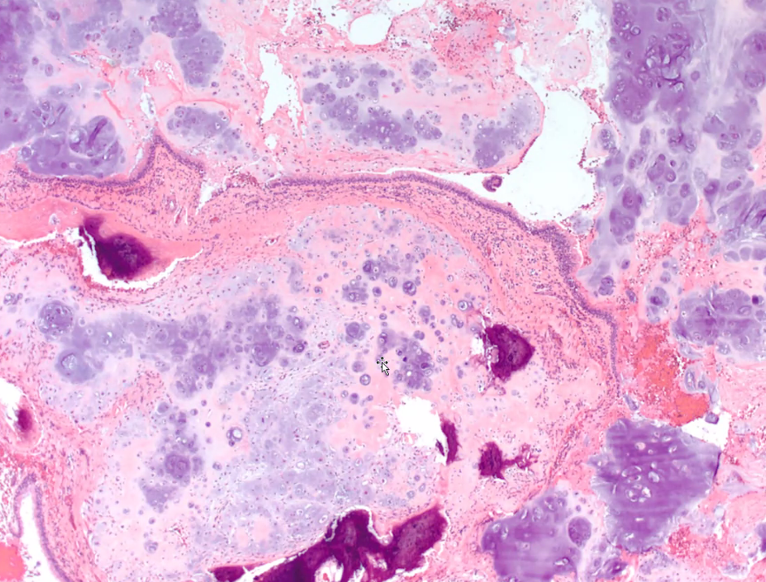

Fibrous Dysplasia
Benign FIBROUS LESIONS of bone:
- fibrous dysplasia
- osteofibrous dysplasia (ossifying fibroma)
- nonossifying fibroma

Pathology
- skeletal dysplasia - developmental anomaly (not true neoplasm) - normal bone formation arrested at woven stage → lamellar bone is not formed → typical overgrowth of fibrous tissue among woven bone; portions of the bone are replaced by fibrous connective tissue and poorly formed trabecular bone.
- process originates in the medullary cavity.
- may occur in single (70-80%) or multiple (20-30%) bones (monostotic and polyostotic fibrous dysplasia)
Polyostotic form is part of McCune-Albright syndrome see above
- any bone but is most common in proximal femur, tibia, ribs, and skull.

Characteristic thin, irregular (Chinese character-like) bony trabeculae and fibrotic marrow space:
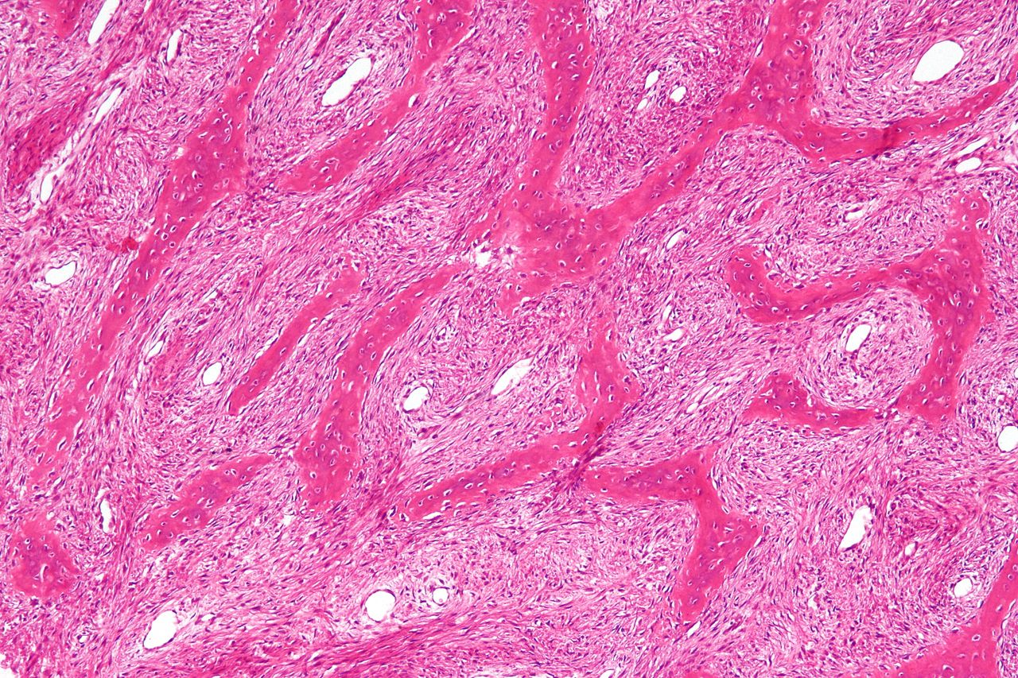

Etiology
- postzygotic (nonhereditary) mutation in guanine nucleotide stimulatory protein (GNAS1) gene.

Clinical features
- most commonly presents in the teens or 20s.
- most are asymptomatic
- may cause painful swelling, repeated pathologic fractures or severe bone deformity (e.g. "shepherd's crook" varus deformity of the proximal femur).

Mauricio Saravia, a Uruguayan artist:

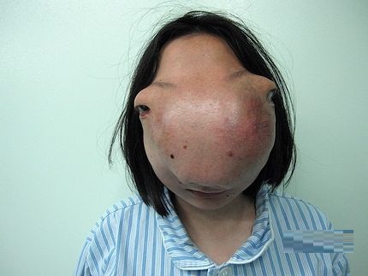

Imaging
Plain radiographs - lytic lesion with a "ground glass" appearance, bone expansion, endosteal erosion, periosteal reaction usually is absent (unless there is a pathologic fracture).

CT - “ground glass” - skull lucency with patches of increased density; multilobulated intradiploic lesion (can be confused with Paget disease, but occurs in younger age group); 3 different forms:
cystic form - involves mainly outer table;
sclerotic form - characterized by bone thickening;
mixed form - manifests after third decade.
Fibrous dysplasia of orbit and ethmoid sinus (CT with bone windows):
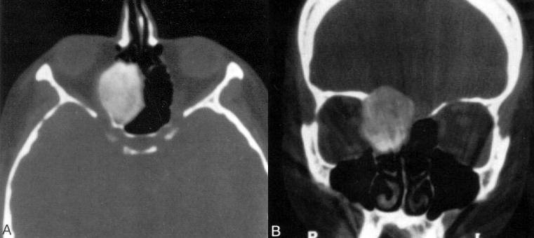

Fibrous dysplasia of left temporal bone (large arrowheads) and sphenoid bone (small arrowheads) - expansion and sclerosis:
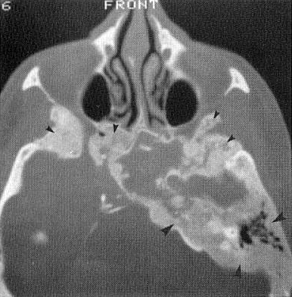

Fibrous dysplasia of the right zygomatic bone:
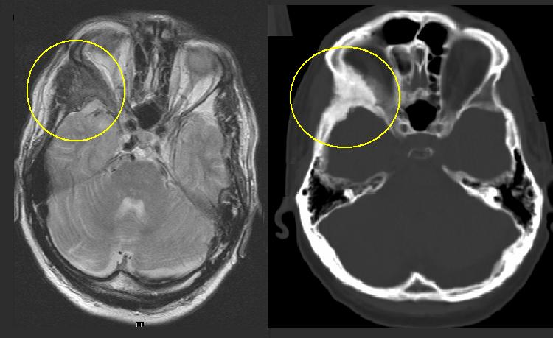

Differential diagnosis
- Nonossifying fibroma
- Unicameral bone cyst
- Aneurysmal bone cyst
- Chondromyxoid fibroma

Treatment
Symptomatic patients:
- bisphosphonate therapy
- curettage, bone grafting, and stabilization.
    - autograft should not be used because it will be resorbed.

Prognosis
- deformity of fibrous dysplasia progresses with skeletal growth → static after growth ceases (may be reactivated with pregnancy)
- often recurs after curettage and bone grafting.
- 0.5% fibrous dysplasia cases undergo malignant transformation (to osteosarcoma, chondrosarcoma, or fibrosarcoma).

Solitary Plasmacytoma / Multiple Myeloma
Plasmacytoma
– solitary benign neoplasm of monoclonal plasma cells.

Multiple Myeloma
– disseminated malignant form of plasmacytoma, potentially fatal.

- more often found in the vertebral column, thoracic cage, and long bones; involvement of the cranial vault is not infrequent.
    - involvement of the skull base is a strong positive predictor for progression from solitary plasmacytoma to multiple myeloma.
- plasmacytoma affects patients in the late 5th decade; vs. MM occurs in the late 6th decade.

Pathology
- smooth and lobulated but can cause irregular destruction of the involved bone
- made up of abnormal plasma cells that produce monoclonal immunoglobulins.
- widespread osteolytic bone destruction by dense tumor cells that look like plasma cells clustered in close aggregates.
- plasmacytomas may be of low (plasmacytic), intermediate, or high (plasmablastic) grade based on histologic findings.
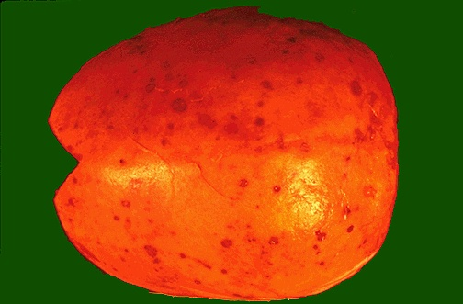

Clinical Features
- cranial neuropathies may be caused by mass effect or direct infiltration with myelomatous cells.
- involvement of the orbit may result in exophthalmos or ophthalmoparesis.
- headaches of increased intracranial pressure.
- intradural extension may give rise to seizures.

Diagnosis
It is essential to perform both CT and MRI.
- thorough evaluation to exclude multiple myeloma (particularly if the lesion is at the skull base) - bone marrow evaluation, a skeletal survey, a bone scan, and serum and urine protein electrophoresis.

Plain radiography and CT
- multiple myeloma - well-defined lytic lesions involving the diploë and cortical bone, without a sclerotic border.
- isodense to hyperdense on CT
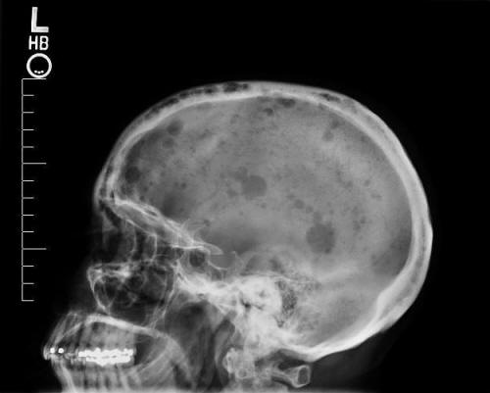
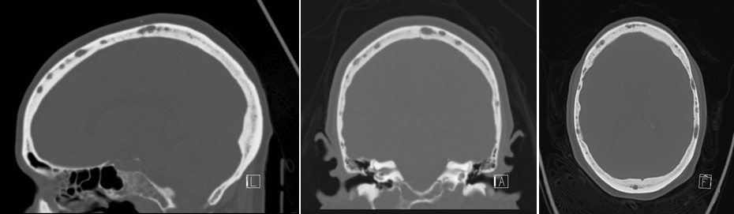
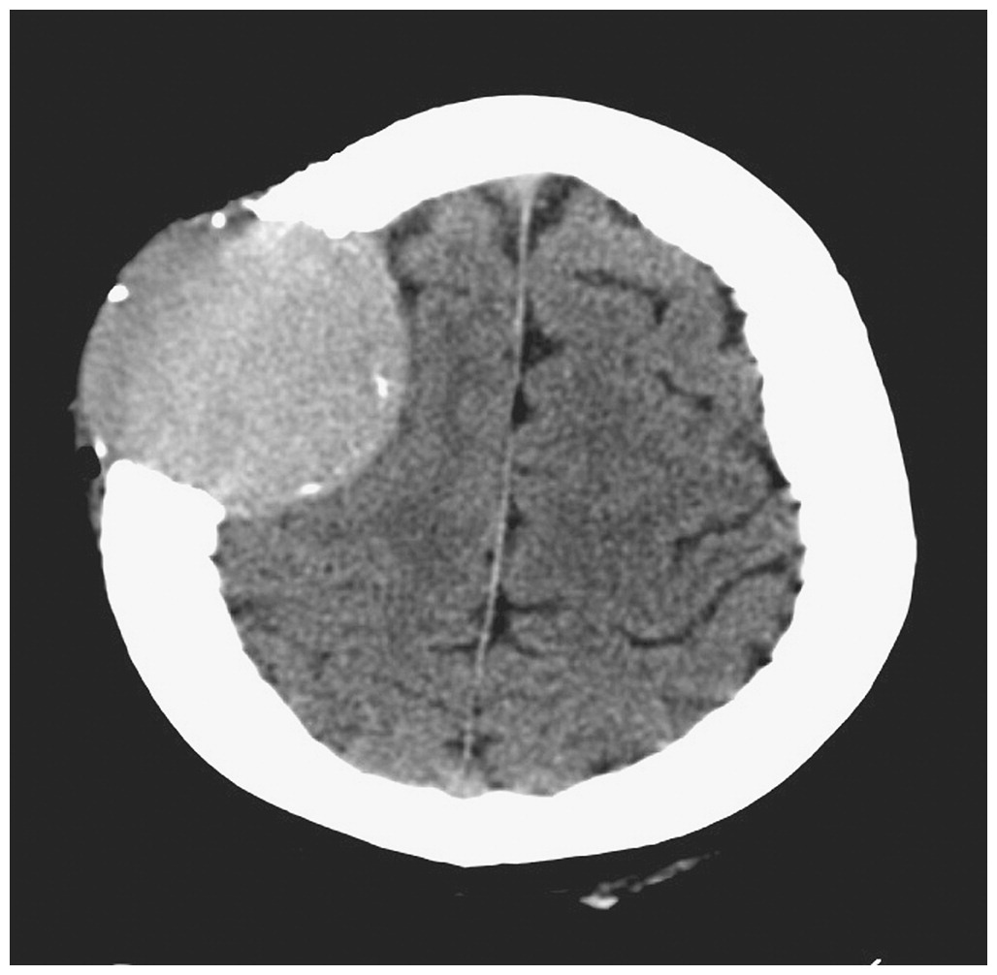

MRI
- isointense to hyperintense on T1, markedly hypointense on T2.
- DWI: plasmacytomas - restriction, whereas multiple myeloma - increased diffusion.
- avid contrast enhancement.
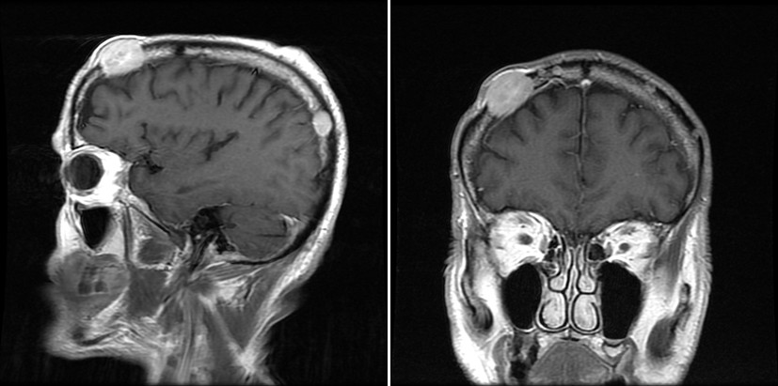

Radioisotope bone scanning
- “cold” lesion.
- relatively high false-negative rate.

Angiography - tumor blush from ECA branch feeders.

Treatment
Solitary plasmacytomas → surgical resection → irradiation (plasmacytoma is a radiosensitive lesion).
- tumors are often quite vascular - significant blood loss should be anticipated (preoperative embolization may be helpful).
- indications for radiotherapy alone (after biopsy):
    - prohibitive medical comorbid conditions
    - lesions of the skull base

Multiple myeloma - not treated by surgical resection
- chemotherapy with C-VAD (cyclophosphamide, vincristine, Adriamycin, and dexamethasone), along with stem cell transplantation and palliative irradiation, forms the mainstay of treatment.
- median survival - 3 years (several months to 10 years).

Bibliography for ch. “Neuro-Oncology” → follow this link >>

Viktor’s Notes℠ for the Neurosurgery Resident
Please visit website at www.NeurosurgeryResident.net

