Intramedullary Spinal Tumors
Last updated: December 22, 2020
Pathology 1
Location 1
Etiology 1
Clinical Features 2
Diagnosis 2
Imaging 2
Lumbar puncture 2
Biopsy 3
Treatment 3
Surgery 3
Procedure 3
Postoperative 3
Follow-up 3
Radiotherapy 3
Chemotherapy 3
Prognosis 4
Specific Tumor Types 4
Ependymoma 4
Astrocytoma 7
Oligodendroglioma 9
Developmental tumors [dermoid, epidermoid, teratoma] 9
Hemangioblastoma 9
Lipoma 10
Subependymoma 10
Ganglioglioma 10
Intramedullary schwannoma 10
Neurofibroma 10
Metastases 10
Melanoma 10

Incidence of spinal tumors ≈ 15-20% of intracranial tumors

Spinal tumors:
extradural – 55%
intradural extramedullary – 40%
intramedullary – 5-10%
- in children, 50% intradural lesions are extramedullary, 50% - intramedullary.

Intramedullary tumors:
- 5-10% of all spinal tumors.
- 2-4% of brain tumors (6-10% of pediatric brain tumors)
- intramedullary tumors are more common in children, extramedullary tumors - in adults.
- 5% neurofibromatosis patients develop multiple spinal cord tumors.

CNS tumors:
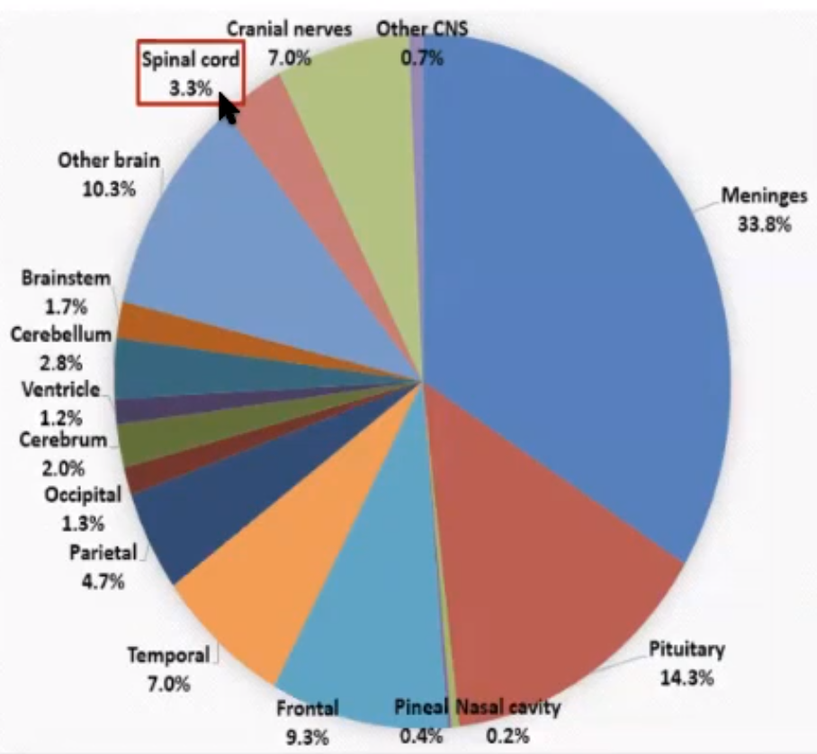

Pathology
- < 15-20% are malignant, > 90% are benign - subject to potential resection.
- extend over many spinal cord segments* - signs and symptoms are more variable (than those of extramedullary tumors). *holocord tumors are sometimes seen in children
- 70% are associated with cysts (may produce own symptoms of spinal dysfunction):
- intratumoral cysts (wall consists of tumor)
- peritumoral or capping cysts - cone-shaped glial-lined cavities extend above and below tumor for limited number of spinal segments.
- syringomyelia (most frequent with hemangioblastoma) - indistinguishable from other forms of syringomyelia.
- leptomeningeal dissemination (drop metastases) occurs in 58% of high-grade (malignant) tumors; uncommon in low-grade tumors.

Location
- anywhere from cervicomedullary junction to filum terminale.
- 50% in thoracic cord (because of relative length of this area), 30% in lumbosacral cord.

Etiology
Strikingly different from brain tumors!
- Ependymoma (56-70% in adults; only 30% in children)
- Astrocytoma (29%; in children 40-70%, 90% at age < 1 yo): pilocytic astrocytoma, other low-grade astrocytomas, anaplastic astrocytoma, glioblastoma
- Hemangioblastoma (3-5%)
- Oligodendroglioma (3%)
- Developmental tumors (3%):
  - dermoid
  - epidermoid
  - teratoma
- Lipoma (2%)
- Others (4%):
  - subependymoma
  - ganglioglioma
  - intramedullary schwannoma
  - neurofibroma
  - metastases (unusual, < 2%) – most commonly from small cell lung carcinoma

- astrocytomas and ependymomas are more common in patients with neurofibromatosis type 2.

Conus tumors:
    - myxopapillary ependymoma
    - ganglioglioma

Clinical Features
Progressive myelopathy (mimics syringomyelia) - Central Cord Syndrome see p. Spin1 >>
In most instances, clinical presentation does not indicate if tumor is extradural or intradural

- slow-growing nature - symptoms precede diagnosis by ≈ 2 years (vs. extramedullary tumors – shorter period).
- neurologic manifestations commonly begin unilaterally (full-blown Brown-Sequard syndrome is rare), becoming bilateral when tumor is quite large.
- dull, aching neck / back pain (from level of lesion; local or radiating) often is earliest symptom!
- characteristically at night when patient is supine (related to venous outflow disturbance and/or decrease of endogenous glucocorticoids); may be increased by Valsalva (coughing or sneezing).
- pain is usually less prominent than of extramedullary tumor.
- myelopathy with progressive paraparesis predominates early (LMN* → UMN);
N.B. kids may manifest as dextroscoliosis or torticollis.
*at tumor level - aid in localization
- dissociated sensory loss with sacral sparing, sphincter dysfunction, trophic changes.
- hydrocephalus (15%, esp. in malignant tumors) – due to increased CSF viscosity from elevated protein content.

Diagnosis
Imaging
Some tumors occur in multiple areas - image entire neuraxis (e.g. hemangioblastoma).
Plain X-rays - insensitive and nonspecific:
- spinal canal widening (around slowly expanding tumor)
- posterior scalloping of vertebral bodies (on lateral radiographs)
- medial erosion of pedicles → widening of interpedicular distance (on AP radiographs)
- kyphoscoliosis, dextroscoliosis (in children)

Contrast-enhanced MRI - very sensitive for tumors!
- fusiform enlargement of spinal cord over several levels (vs. inflammatory lesions - normal or minimal increase in cord size).
- most tumors are isointense or slightly hypointense.
- great majority of gliomas enhance at least partially (vs. brain gliomas).
- tumor-associated syrinx may be seen.

CT myelography - used when MRI is not available:
- multisegmental smooth spinal cord widening (± exophytic outgrowth) → narrowed subarachnoid space on both sides of cord.
- block of contrast flow (50-90%)
- enlarged vessels on cord surface (80% hemangioblastomas, 10% ependymomas).

Spinal angiography - only if hemangioblastoma is suggested. see below

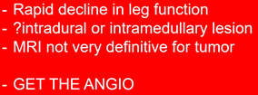

Intramedullary glioma (AP cervical myelogram) - diffuse widening of cervical cord, bilateral effacement of cerebrospinal fluid space (arrowheads):  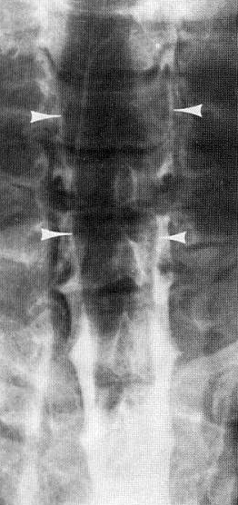 | Teratoma of spinal cord - well delineated on T1-MRI without contrast - high-intensity component of tumor (arrows) is fat:  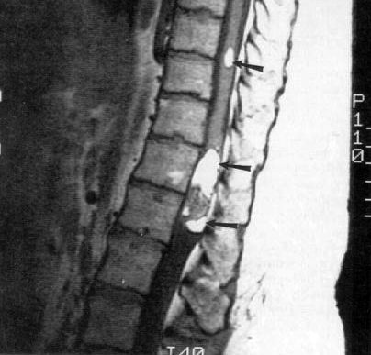

Lumbar puncture
- not indicated! (unless patient is being evaluated for leptomeningeal spread)
Should not be first test performed - in complete spinal block [relative contraindication to LP], LP may precipitate disastrous shift in intrathecal contents.
CSF in spinal block - protein↑↑↑ (Froin syndrome), xanthochromia (due to high protein content).

Biopsy
- essential prior to nonsurgical treatment! (biopsy is dangerous - look for non-CNS biopsy site first!)

Treatment
Remains controversial.

- in selected situations, watchful waiting can be considered (e.g. high surgical risk and/or mild neurologic dysfunction).
- high-dose steroid (dexamethasone, 50 mg IV→ 10 mg q6h) may improve neurologic function transiently.

Surgery
Surgical extirpation is treatment of choice for benign tumors! (cures have been reported only after complete surgical resections); no aggressive surgery for high-grade tumors!

Total removal with preservation of neurologic function!

Neurological deficits preop correlate with poor outcome postop – do not delay surgery!

Procedure
- see p. Op260 >>

Postoperative
- ICU for 24-48 hours.
- flat for 1-3 days (esp. lower thoracic – lumbar tumors).
- cervical tumors → continued mechanical ventilation in immediate postoperative period.
- prophylaxis for deep vein thrombosis.
- patience - majority of patients have increased deficit* during immediate postoperative period (edema from surgical manipulation, blood flow alteration) - typically transient and most return to baseline within 3-6 months.
- short course of tapering steroids may be used to help offset any cord injury → rapid steroid tapering (steroids inhibit wound healing - predispose to CSF leakage).
- hematoma is recognized by immediate progressive deterioration of nervous function → MRI / CT confirmation → urgent reexploration
*typically, temporary sensory disturbances due to posterior column retraction.
- ambulation is recommended after 1-3 days of bedrest in flat.
- CSF leakage* should be treated aggressively - suture closure, collodion, lumbar drainage, reoperation for closure. *frequently as poor healing of incision
- new-onset urinary retention may require prolonged bladder catheterization.
- bowel stimulation regimen may be necessary for new abnormalities.
- early physical / occupational therapy.
- MRI day after surgery (completeness of resection); residual tumor:
- repeat resection (for ependymoma)
- radiotherapy (for astrocytoma)
- watchful waiting (e.g. developmental tumors, lipomas - prolonged survival despite residual tumor).

Postsurgical pain:
Somatic (acute) pain - results from manipulation of nerve roots (e.g. ligation of dorsal nerve root due to bleeding from radicular vessel; better approach - sharp incision of nerve roots with focal cauterization of any bleeding). H: steroids are very helpful.
Central (chronic) pain - results from resection of intramedullary tumors: gnawing, sometimes burning, persistent pain; can be triggered by light touch and may extend well beyond area of stimulation; does not respond well to drugs or stimulators.

Follow-up
(serial neurologic examinations and MRI)
- consider, in select cases, maintaining the patient in prone position to avoid pial-dural scarring.
- tumor recurrence → image entire neuraxis (even benign ependymomas may change their growth characteristics and produce seeding) → repeat surgery (for ependymomas) or offer radiotherapy (for astrocytomas).

Radiotherapy
- primary treatment for:
    - malignant lesions (e.g. anaplastic astrocytomas, glioblastomas – surgical tumor removal has no value - survival is < 2 years).
    - inoperable tumors
- may be useful for:
    - residual tumor after surgery (e.g. most astrocytomas)
    - recurrent tumor (repeat surgery is first choice!)
- poor efficacy – ependymomas (surgically excised ependymomas need not undergo subsequent radiotherapy!).
- dose – 50 Gy in daily 1.5-2 Gy fractions - this dose is not curative (some report doses > 50 Gy reduce local failure rates);
- higher doses can be used for lesions involving only cauda equina or if irreversible complete transverse myelopathy already has occurred.
- margin 2-3 cm or two vertebral bodies above and below lesion.
- most important adverse effects:
    - acute and delayed myelopathy
    - diminished skeletal growth in young children
    - increased difficulty with subsequent surgical tumor removal (important if radiotherapy does not control growth of lesion).
- SRS may have role (esp. for malignant tumors); consider laser ablation – disconnection procedure – disconnects cord from tumor so radiation becomes possible.
Although similar symptomatic control may be achieved over short term when compared with surgical resection, recurrence and malignant tumor transformation have been observed after radiotherapy!
- advent of proton beam.

Chemotherapy
- experimental.
- indicated for malignant tumors.

Prognosis
5-year survival (for benign or low-grade neoplasms) > 90% (much longer than intracranial tumors!)
- astrocytomas that recur do so within 3 years; recurrence of ependymomas may be delayed for as long as 19 years! (never stop follow-up MRIs)

Prognostic factors:
- Histology (aggressive tumors have poor prognosis despite treatment - radical surgery can lead to severe neurologic impairment).
Tumor histology is the most important predictor of neurological outcome because it predicts resectability and recurrence!
Karikari at al. “Impact of Tumor Histology on Resectability and Neurological Outcome in Primary Intramedullary Spinal Cord Tumors: A Single-Center Experience With 102 Patients” Neurosurgery: March 2015 - Volume 76 - Issue - p S4–S13
Gross total resection was achieved in:
ependymomas - 90.9%
hemangioblastoma - 91.7%
astrocytomas - 14.3% (all those were pilocytic astrocytomas; none of the grade II, III, or IV astrocytic tumors had GTR)
At mean follow-up of 41.8 months, recurrences were observed:
ependymoma - 7.3 % cases
hemangioblastoma - no recurrences
astrocytoma - 47.6% cases
At time of last follow-up, neurological status was:
ependymoma - 20% patients improved, 69% remained the same, 10.9% worsened.
hemangioblastoma - 8.3% improved, 91.7% remained the same. No patient worsened!
astrocytoma - 4.8% improved, 47.6% remained the same, 47.6% worsened.
- Preoperative deficit - those with advanced neurologic compromise generally have no worthwhile improvement (need for early intervention and close follow-up!).
- Completeness of resection
Historically, intraoperative tumor resection has been based on whether plane dissection can be identified, which is often dependent on tumor histology: ependymomas typically demonstrate clear tumor and spinal cord interface, whereas astrocytomas exhibit more infiltrative pathology.
- Age > 60 yrs is negative prognostic factor.
- Lesion location (higher morbidity is associated with surgery of upper thoracic and conus lesions).
- Size of lesion - tumors spanning several levels may produce corkscrew growth pattern (requires extensive dissection of spinal cord in order to expose tumor).
- Arachnoid scarring, cord atrophy - negative prognostic factors for ependymomas.
There is a potential for late scarring of pia to dura with a tension injury to the spinal cord and loss of function.
- Syrinx - suggests noninfiltrative lesion (better prognosis).

Motor and autonomic functions continue to improved up to 24 mos postop (sensory function plateaus at 6-9 months):
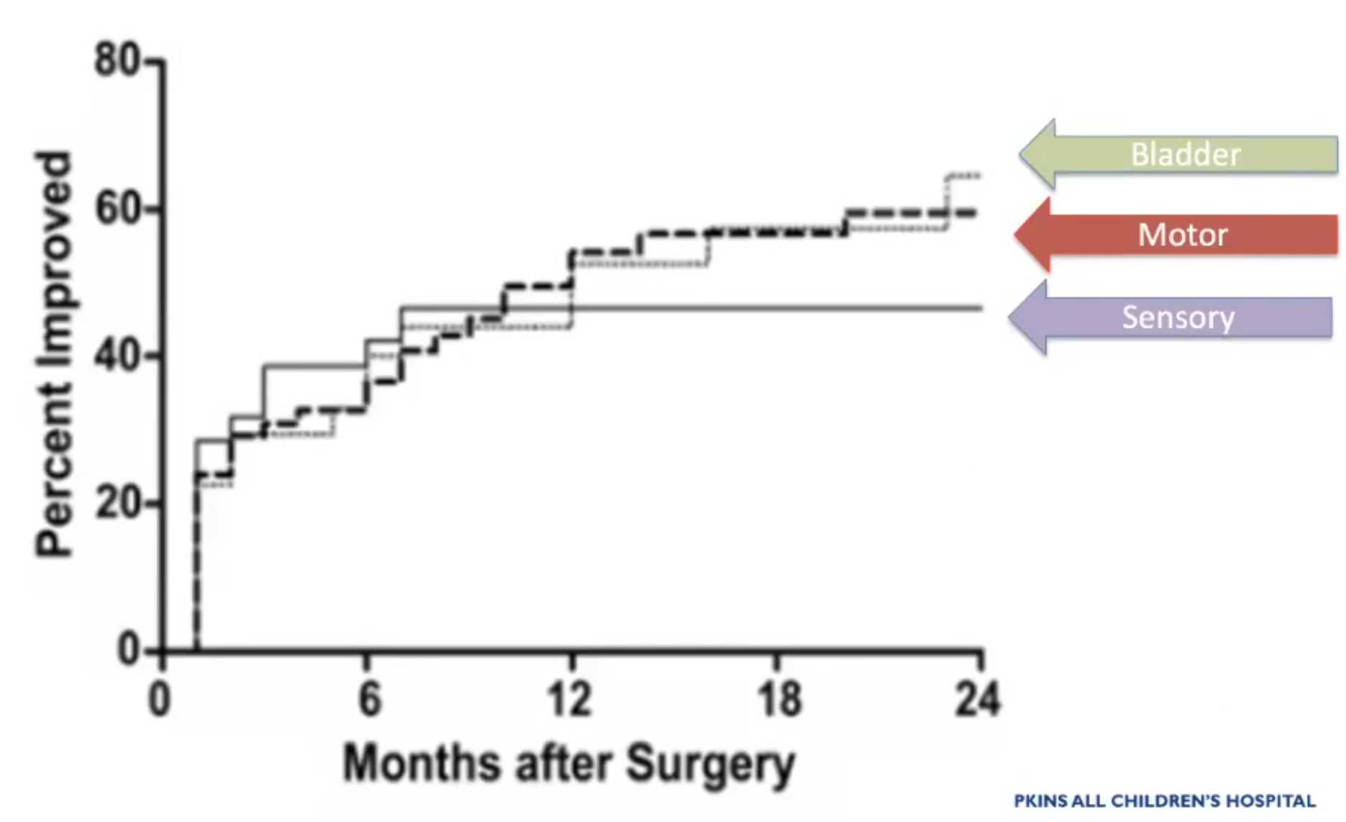

Specific Tumor Types
Ependymoma
- arise from ependymal cells lining central canal. see p. Onc14 >>
- 56% in conus medullaris (myxopapillary ependymoma - Alcian blue stain for mucin).
- characteristically hypovascular, cystic degeneration with hemorrhage at margins (“hemosiderin cap” on MRI), well circumscribed, noninfiltrative (cord compression rather than infiltration; complete resection → prolonged survival).
- mean age at presentation - 43 years (myxopapillary variant - 21 yrs but reported in 3 month-old to 86 year-old).
- pregnancy or trauma may precipitate Fincher's syndrome (acute subarachnoid hemorrhage with sciatica).
- slow growth - likely to result in bony remodeling.
- treatment:
- clear cleavage plane - complete excision is possible!
- chemotherapy has no role.
- radiotherapy has role:
Tsai “Outcomes after surgery and radiotherapy for spinal myxopapillary ependymoma: update of the MD Anderson cancer center experience.” Neurosurgery. 2014 Sep;75(3):205-14
- postoperative radiotherapy after resection of myxopapillary ependymoma was associated with improved progression-free survival and local control.
- myxopapillary ependymoma is grade I (potentially curable) but big tumors may seed CSF space – try to resect en bloc (transect filum, remove without entering capsule) + adjuvant panspinal radiation (current techniques help to spare bone marrow; chemotherapy has no established role).

Hemosiderin cap, edema:
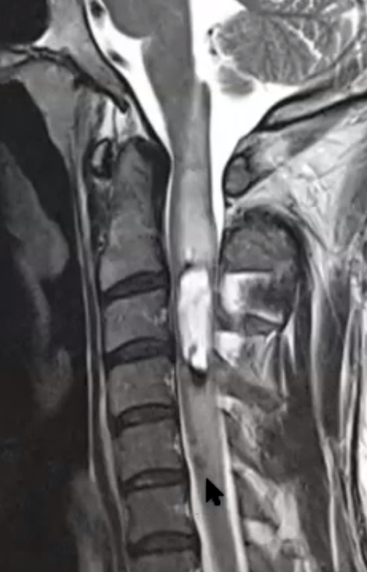

Ependymoma of distal spinal cord (A – T2; B – contrast T1) - large, fusiform, intramedullary enhancing tumor associated with extensive proximal syrinx:  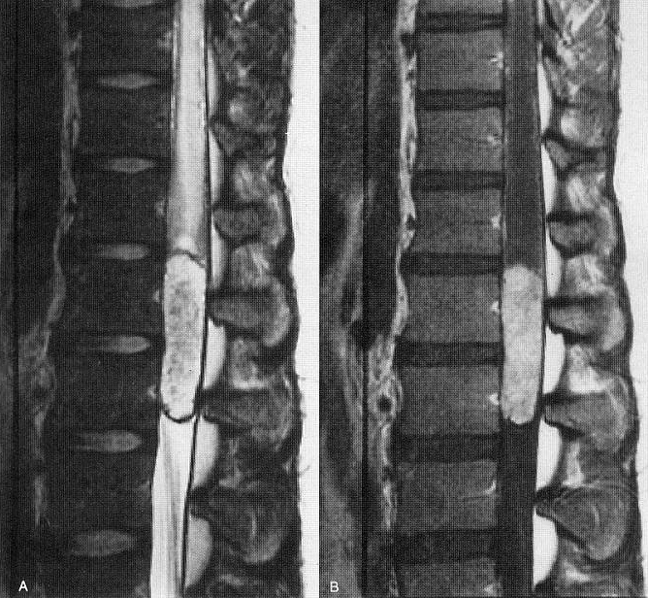 | Contrast T1-MRI - ependymoma with small capping cyst (arrow):  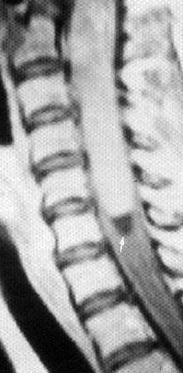

Myxopapillary ependymoma (MRI) - lobulated mass extending down from L4 level:
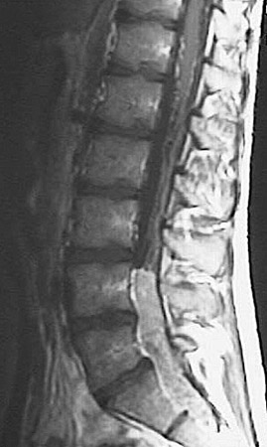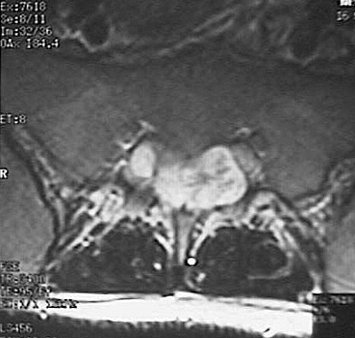
Source of picture: “WebPath - The Internet Pathology Laboratory for Medical Education” (by Edward C. Klatt, MD) >>

A. Operative photograph - myelotomy exposes dorsal surface of tumor; note clear demarcation of tumor from surrounding spinal cord.
B. Tumor specimen that has been completely removed.
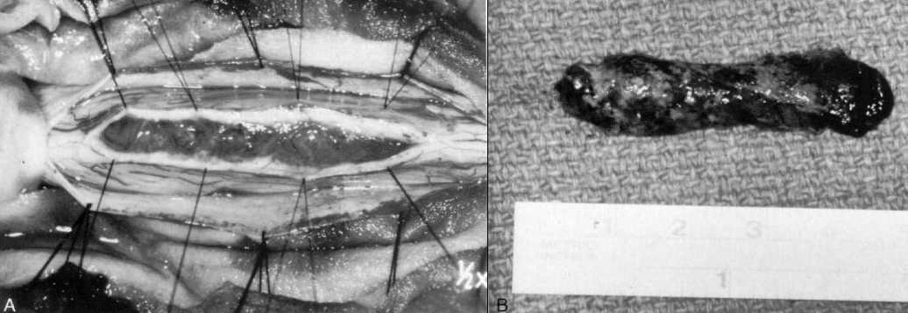

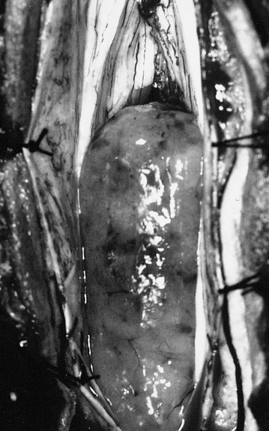

Myxopapillary ependymoma - cells around papillations that have myxoid connective tissue core:
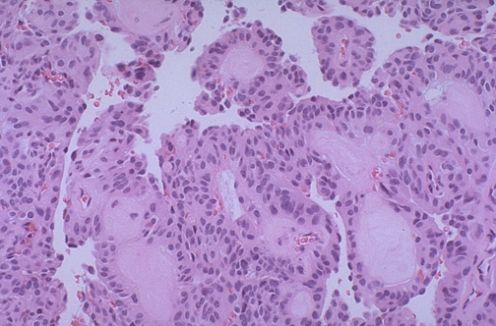
Source of picture: “WebPath - The Internet Pathology Laboratory for Medical Education” (by Edward C. Klatt, MD) >>

Myxopapillary ependymoma - streaming vessels with arrangements of tumor cells around them; cytoplasmic round vacuoles are filled with mucinous contents:
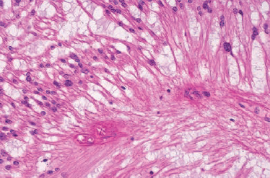
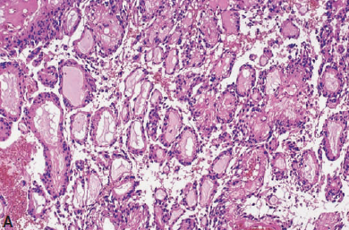
Source of picture: “WHO Classification of Tumours of the Central Nervous System” 4th ed (2007), ISBN-10: 9283224302, ISBN-13: 978-9283224303 >>

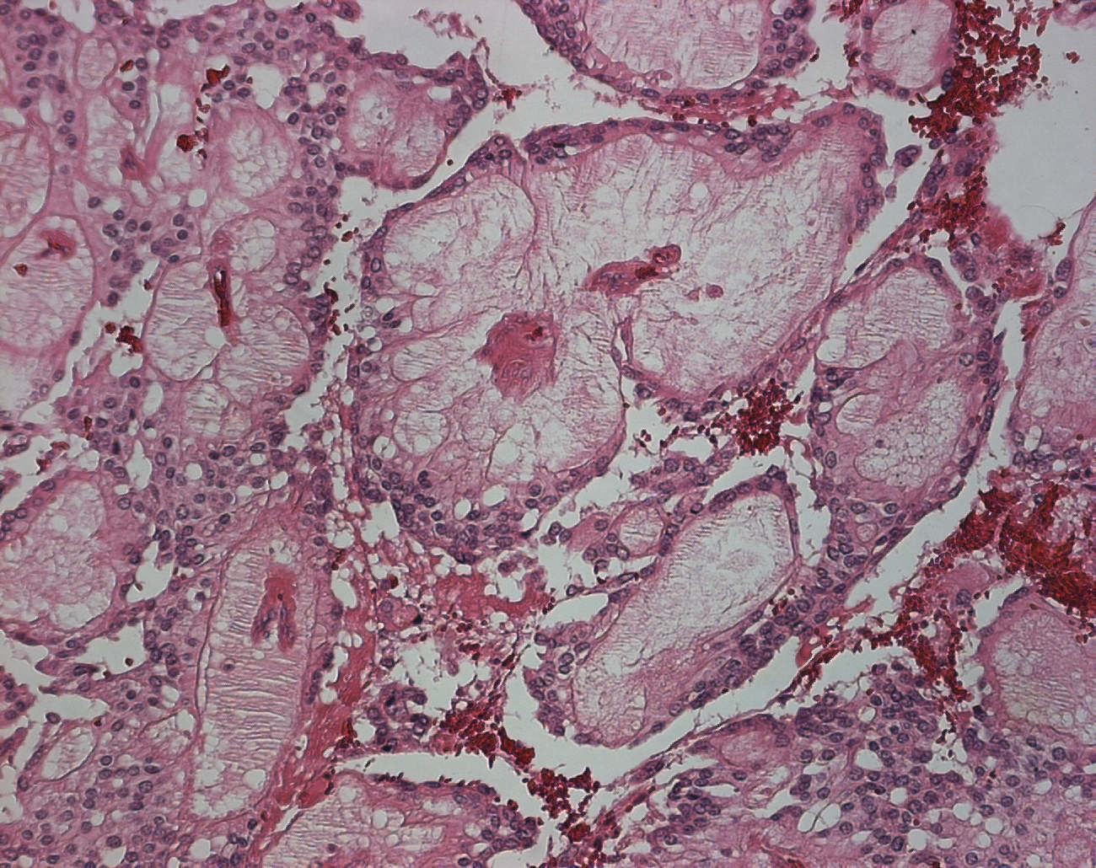

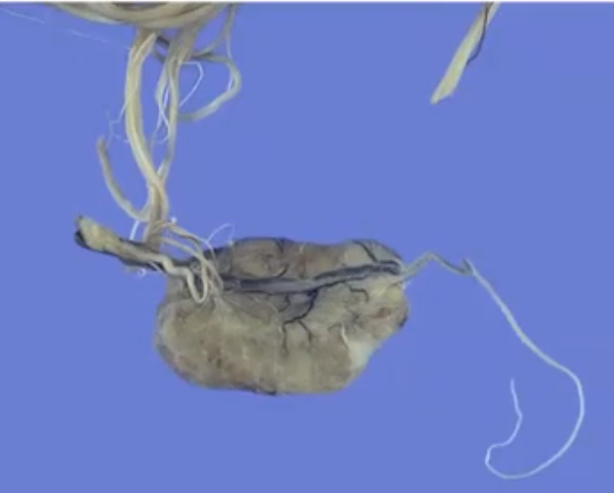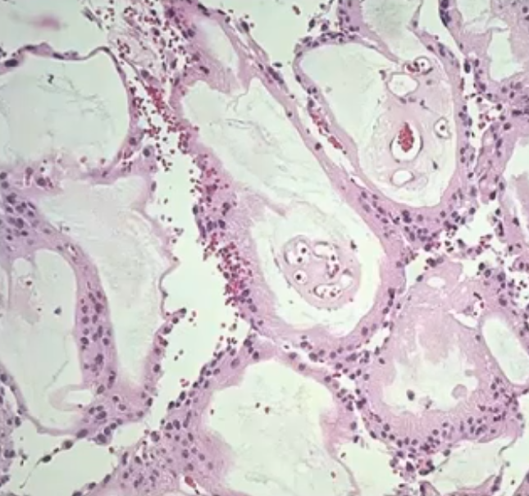

Astrocytoma
- more common in children (most common intramedullary tumor in pediatric age group!)
- average length - 7 vertebral-body segments.
- sometimes associated with microcysts or syrinxes.
- less hemosiderin, more peritumoral edema, more heterogenous enhancement (cf. ependymoma).
- pilocytic astrocytoma is well differentiated with definable surgical plane – possible to remove surgically.
- other low-grade astrocytomas - infiltrative and impossible to remove grossly (but residual tumor often has indolent course).
- anaplastic astrocytoma, glioblastoma are rare (< 10-20%); may seed CSF; surgery does not improve course! - death within 2 years.
Currently, no satisfactory modality is available for malignant astrocytomas!

A. T1-MRI - expansion of upper cervical cord (arrows) by mass lesion in cervicomedullary junction.
B. T2-MRI - high-signal-intensity intramedullary mass expanding upper cervical cord (arrows).
C. Contrast T1-MRI - irregular peripheral enhancement (arrows).
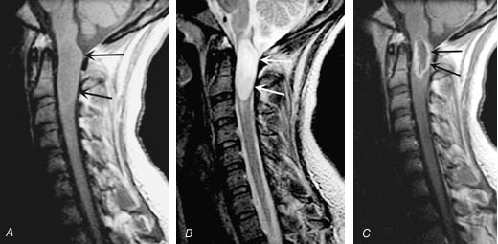

A. T1-MRI - large cyst in lower cervical cord and smaller cyst extending up into medulla; intervening spinal cord is slightly enlarged but demonstrates no signal abnormality.
B. Contrast T1-MRI - enhancing tumor at C2-3 level.
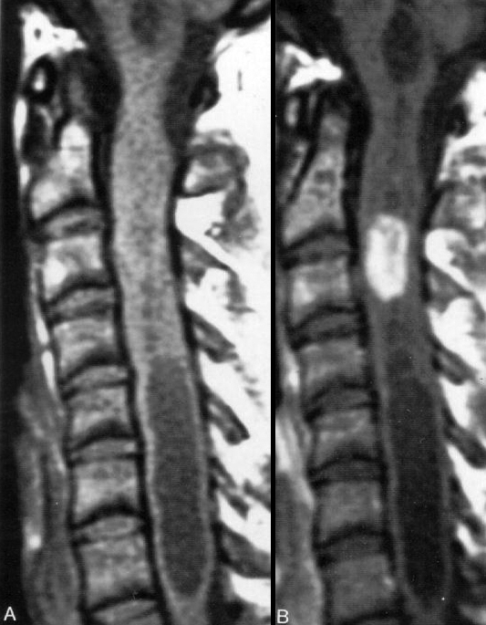

High-grade astrocytoma (contrast T1-MRI) - complex solid and cystic tumor of distal spinal cord with areas of intense enhancement; slight expansion of bony spinal canal:
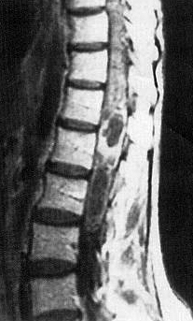

Glioblastoma (T1-MRI) - marked cord expansion by irregular mixed signal mass containing areas of recent hemorrhage (arrow):
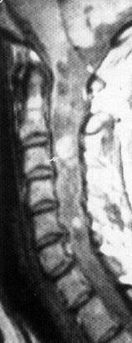

T1-MRI - anaplastic astrocytoma of upper thoracic cord (arrow); note cystic change:
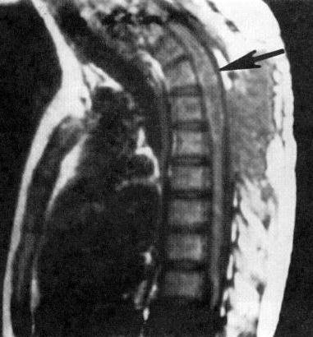

Pilocytic astrocytoma (contrast T1-MRI):
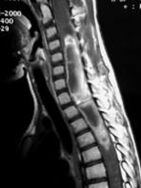

GBM – rare appearance (looks more benign on MRI):
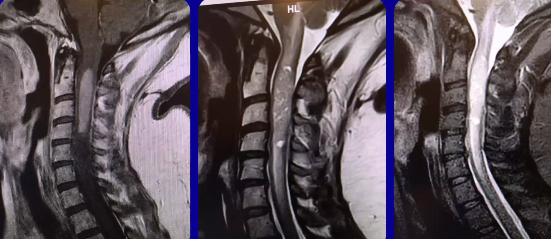

Oligodendroglioma

Developmental tumors [dermoid, epidermoid, teratoma]
(3%) - slow-growing neoplasms with lumbar predominance (esp. conus medullaris).
- can be associated with spinal dysraphism and dermal sinus tract.
- epidermoid may also be acquired – due to lumbar puncture with needle without stylet.
- dense capsule may preclude complete removal (tumor debris may cause early recurrence).
- avoid operative spilling of irritating (epi)dermoid content (→ inflammation, arachnoiditis, adhesions).

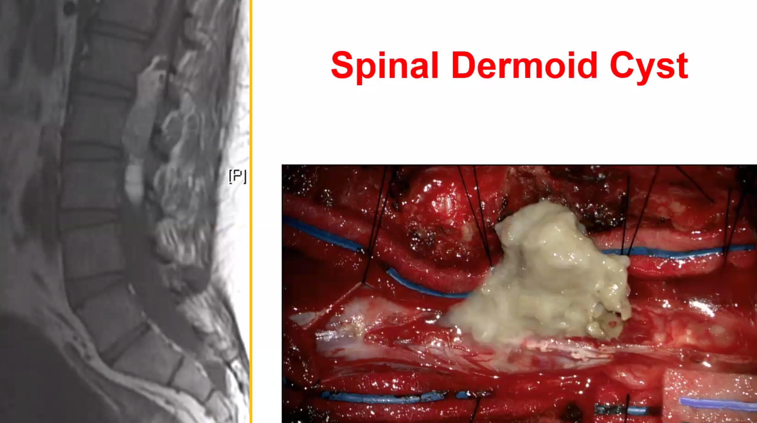

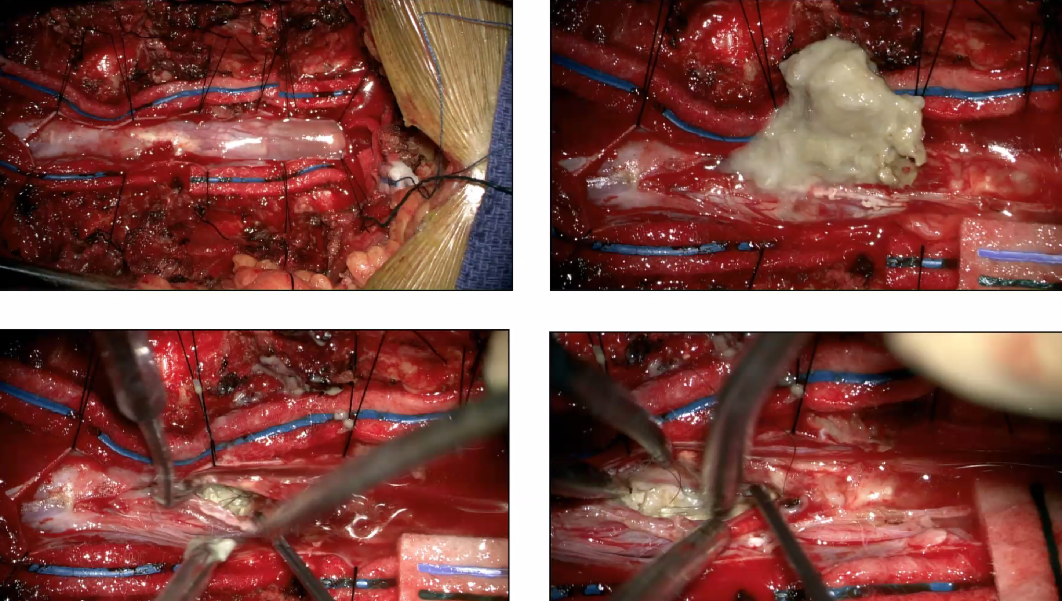

Teratoma
http://www.medscape.com/viewarticle/772262?src=mp

Hemangioblastoma
also for general features see p. Onc24 >>
- mean age at presentation – 4th decade.
- associated with von Hippel-Lindau disease in 30-80% cases.
- cyst with tumor nodule (50-70%).
- 20% may occur in multiple locations!
- SAH is classic presentation!
- nearly always involve posterior columns – simplified surgical approach.
- enhances strongly with MRI contrast.
- angiography often provides definitive diagnosis (but usually is not necessary preliminary to operative treatment):
  - homogeneous, well-circumscribed dense capillary blush
  - one or two supplying arteries are slightly enlarged
  - enlarged (or normal sized) draining veins opacify only little earlier than normal.

Treatment
- can be cured by surgical excision: see p. Op260 >>
- surgical principles similar to those used in treating AVMs - feeding arteries are coagulated, and tumor is dissected and removed en bloc (do not remove in piecemeal fashion - significant bleeding may ensue!).
- neuromonitoring has low value – surgery should be guided by tissue plane and tumor has to come out!
- LINAC radiation therapy has also been proposed as a treatment modality, with a great deal of success.
- bevacizumab – case report described its use in a patient with a surgically unresectable cervical cord hemangioblastoma, showing significant tumor regression and clinical improvement.

Contrast MRI - enhancing hemangioblastoma in conus medullaris:
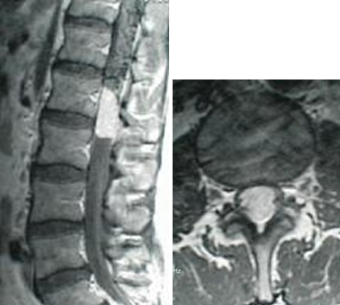

Lipoma
- not true neoplasm!
- often associated with spinal dysraphism and cutaneous abnormalities (nevi, dimples, hyperpigmentation, hypertrichosis, capillary angiomas, midline hairy patches, subcutaneous lipomas)
- presents in first 3 decades of life (when fat is being deposited).
- T1 – very hyperintense signal, T2 – hypointense (?) signal.
- loss of total body fat may be necessary to reduce tumor mass.
- fibrous adhesions to cord, no distinct cleavage plane make total removal difficult.
N.B. removal is not goal of surgery (CO₂ laser is particularly useful).

Subependymoma

Ganglioglioma

Intramedullary schwannoma

Neurofibroma
Dilated neuroforamen:
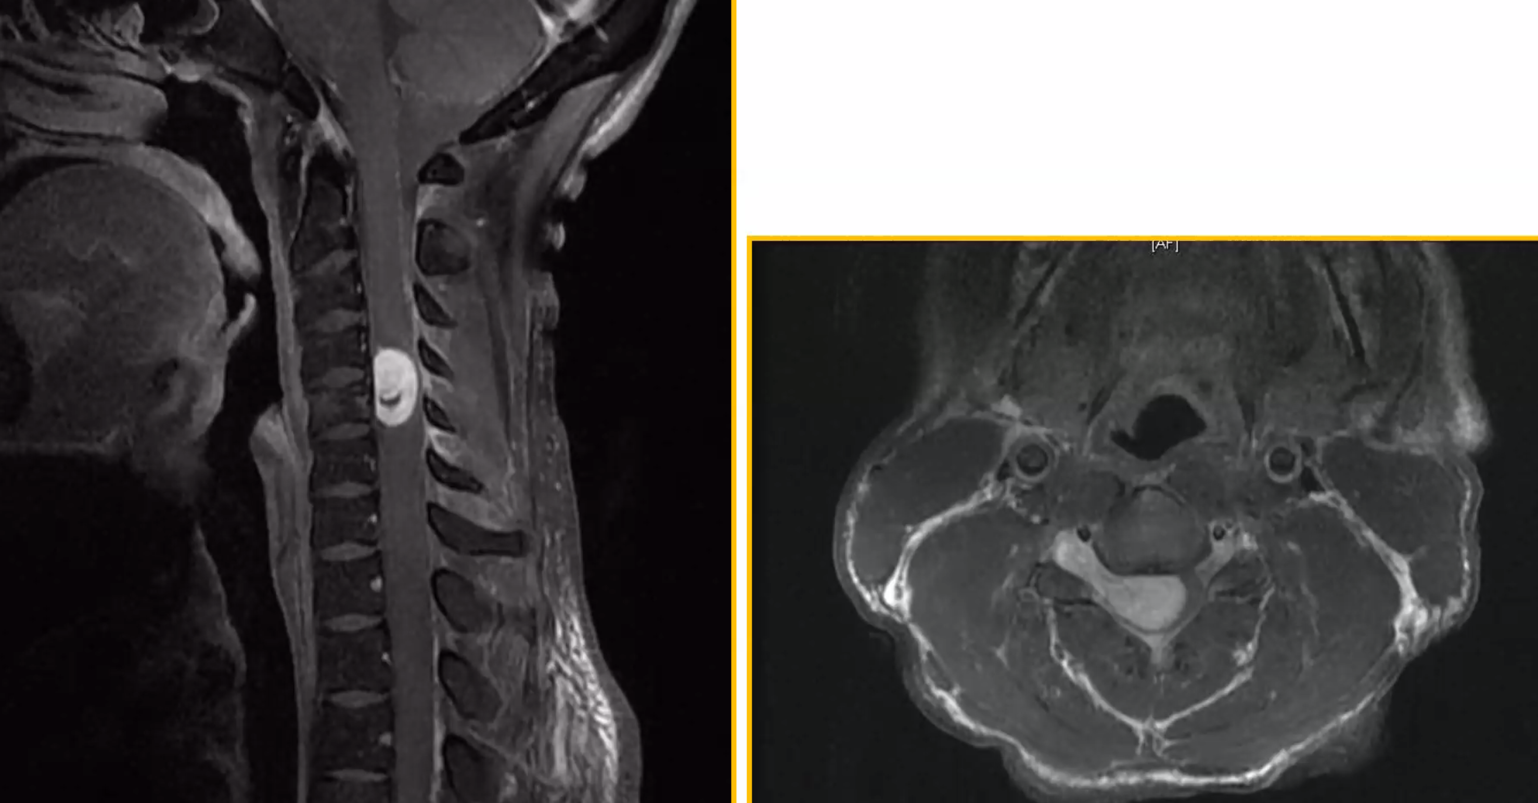

Metastases
(unusual)
- 61% have multiple CNS metastases.
- myelogram may be normal (42%).
- most common sources - lung cancer, breast cancer.
- surgery is recommended for solitary metastasis and limited cancer (can be completely resected through definitive cleavage plane).

Melanoma
Metastatic melanoma (cues [to differentiate from nerve sheath tumor] – hyperintense on T1, nondilated neuroforamen):
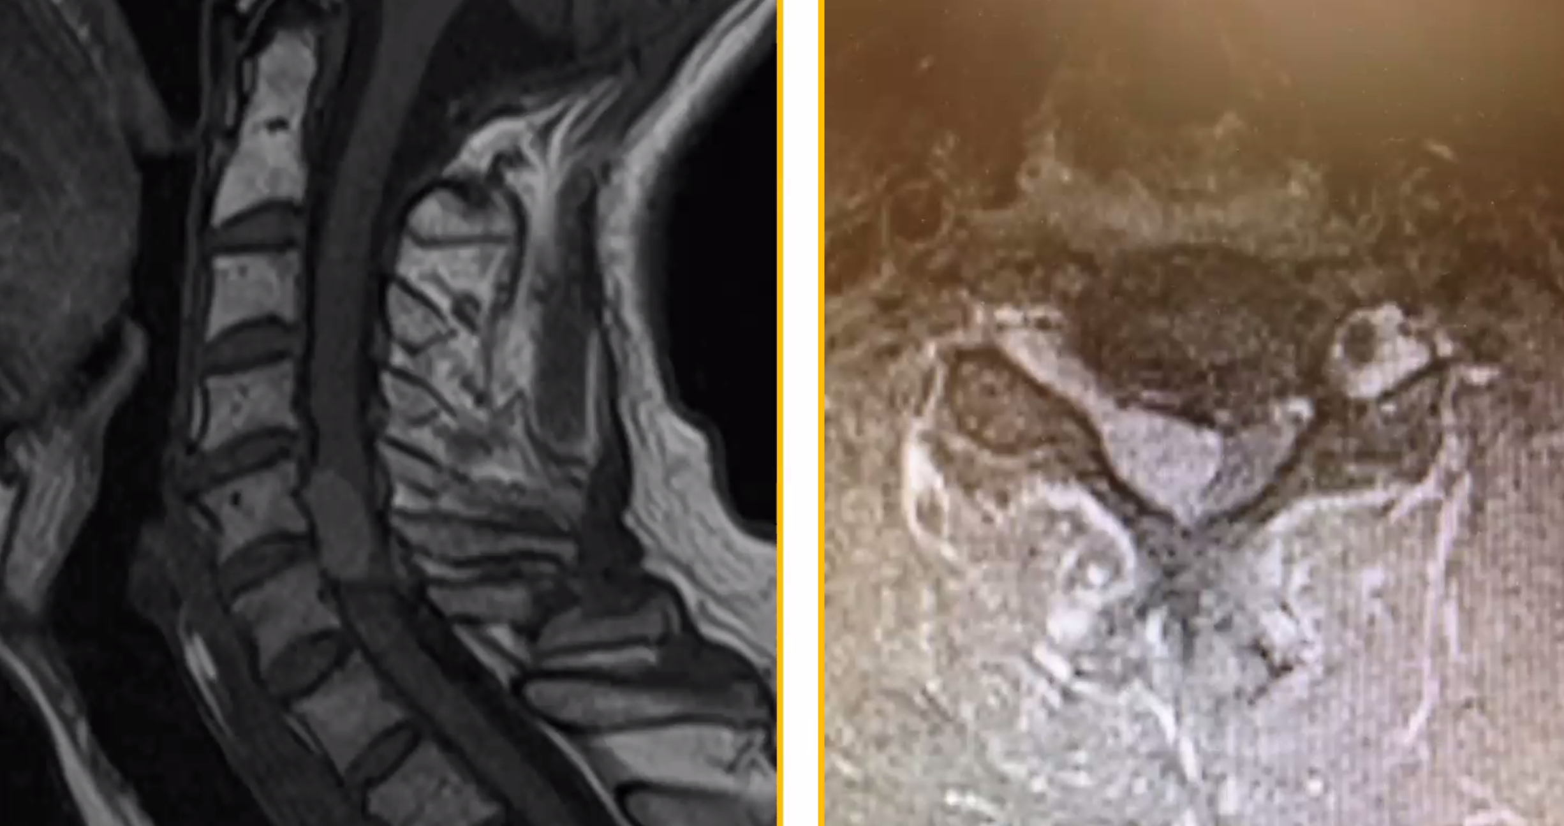

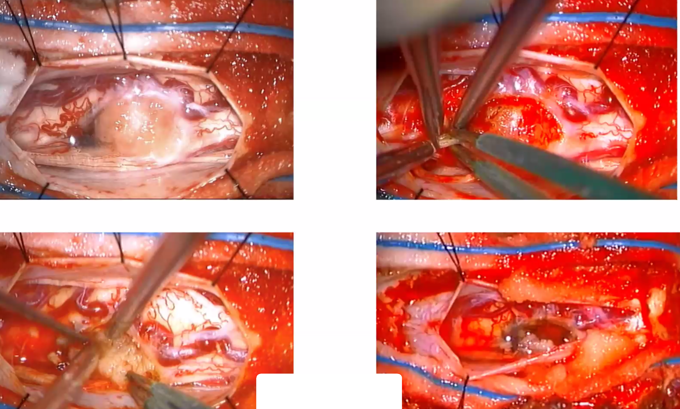

Bibliography for ch. “Neuro-Oncology” → follow this link >>

Viktor’s Notes℠ for the Neurosurgery Resident
Please visit website at www.NeurosurgeryResident.net

