Extradural Spinal Tumors, Vertebral Tumors
Last updated: January 16, 2021
Pathology, Epidemiology 1
Metastases 2
Primary Vertebral Tumors 2
Clinical Features 2
Diagnosis 3
Serum 3
Imaging 3
Biopsy 3
Differential Diagnosis 5
Treatment - Philosophy 5
NOMS decision making factors 5
Spinal cord compression 6
Bilsky classification - epidural spinal cord compression (ESCC) scoring 6
Treatment 7
Benign tumors 9
Metastases, Malignant Tumors 9
Spinal instability neoplastic score (SINS) 10
Treatment - Staging & Surgery 11
Primary spinal tumors 11
En Bloc resection 13
Metastatic spinal tumors 14
Treatment - Thermal ablation 15
Treatment - Percutaneous vertebroplasty 15
Treatment - Radiotherapy 15
Metastases 15
Treatment - SRS 16
Metastases 16
Separation Surgery (SS) 16
Prognosis 16
Metastatic Tumors 16
Follow-up 17
Specific Tumor Types (Primary) 17
Enostosis (Bone Island) 17
Osteoid osteoma 17
Osteoblastoma 18
Osteosarcoma (osteogenic sarcoma) 18
Giant cell tumor (osteoclastoma) 20
Osteochondroma (solitary osteocartilaginous exostosis) 21
Chordoma 22
Chondrosarcoma 22
Aneurysmal bone cyst 23
Ewing sarcoma 23
Eosinophilic granuloma 24
Hemangioma 24
Melanoma 24
Angiolipoma 24
Meningioma 25
Specific Tumor Types (Metastases) 25
Solid Tumors 25
Non-small cell lung cancer 25
Renal cell carcinoma 25
Hematological Tumors 25
Multiple myeloma 25
Solitary plasmacytoma 25
Lymphoma 26
Chordoma → see p. Onc42 >>
Tumors of Skull → see p. Onc40 >>
General Features of Bone, Cartilage, Soft Tissue Tumors → see p. 1197-1198 >>

Pathology, Epidemiology
- usually involve only few spinal segments.
- occasionally, tumor extends through intervertebral foramina, lying partially within and partially outside of spinal canal (“dumbbell” or “hourglass” tumor).
- epidural mass lesion can produce damage to spinal cord:
    - mechanical distortion → demyelination, axonal destruction.
    - vascular compromise → venous congestion and vasogenic edema → ischemia, myelin loss.
- vast majority of metastases affecting spinal cord expand from vertebral body or paravertebral tissues into epidural space.

Common distribution of spine lesions:
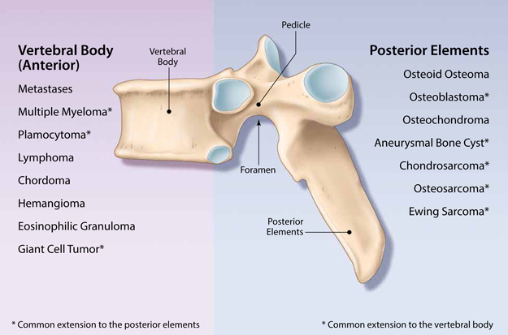

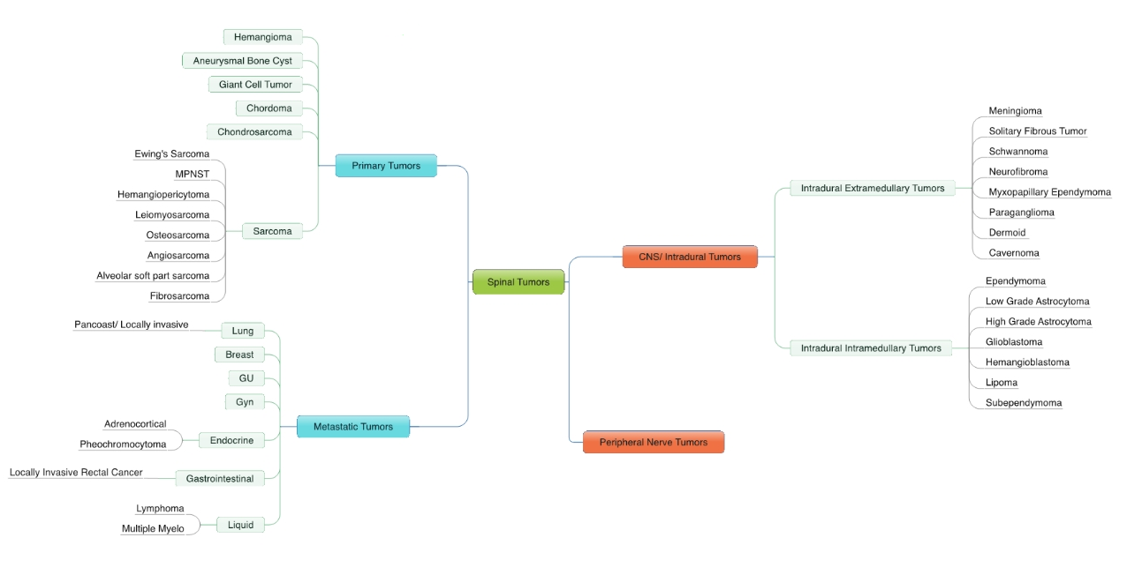

Metastases
pathology → see p. 1198 (9) >>
85% cases of epidural spinal cord compression arise from vertebral metastases! 10-15% - from tumors* spreading through intervertebral foramina.
*typically lymphoma or renal cell cancers
- spine is 3rd most common site for metastasis (after lung and liver):
- 94-98% - epidural and/or vertebrae
  - isolated epidural involvement is particularly common in lymphoma and renal cell carcinoma.
- 5-6% - intradural extramedullary
- 0.5-1% - intramedullary
- 90% of all cancer patients have spinal metastasis at time of death (only 5-30% of these patients are symptomatic)!
- why metastases favor vertebrae:
  - large volume of blood that slowly courses through bidirectional venous channels (Batson plexus) in epidural space.
  - rich concentration of growth factors in bone marrow.
- most common tumors with predilection to metastasize to vertebrae:
  - prostate
  - breast
  - lung
  - renal cell
  - gastric
- primary sources for spinal metastases:
  - lung – 15-31%
  - breast – 22-24%
  - gi tract – 9%
  - prostate – 8-10%
  - lymphoma – 6-10%
  - multiple myeloma
  - melanoma – 4%
  - unknown – 2%
  - kidney – 1%
  - others – 13%
- spread from primary tumors:
    - arterial route
    - retrograde spread through Batson plexus (during Valsalva maneuver)
    - direct invasion through intervertebral foramina
- vertebral body is often involved first in metastasis;
posterior elements are affected only one-fifth to one-seventh as often as vertebral bodies.
- 70% symptomatic lesions are found in thoracic region (small diameter of canal); 20% - lumbosacral, 10% - cervical.
exceptions - prostate and ovarian cancers - metastases favor sacral and lumbar vertebrae (spread through Batson's plexus)
- > 50% cases have several levels of involvement (in 10-38% sites are noncontiguous).

Primary Vertebral Tumors
(3-25 times less common than metastatic tumors!)
about specific tumor features see below
- Bone producing tumors
  - osteoid osteoma
  - osteoblastoma
  - osteosarcoma (osteogenic sarcoma)

- Cartilage producing tumors
  - osteochondroma.
  - chondrosarcoma.

- Lymphoproliferative tumors – most common primary vertebral tumors!
  - multiple myeloma, plasmacytoma
  - lymphoma

- Tumor of notochordal origin – chordoma. see p. Onc42 >>

- Round cell tumor - Ewing sarcoma.

Clinical Features
- in course of hours, days or weeks:

      - Most frequent initial symptom - gradually worsening constant focal back pain, unresponsive to rest (and may actually be most severe when recumbent at night* forcing some patients to sleep in sitting position); exacerbated by Valsalva maneuver; percussion tenderness; movement such as turning over in bed or rising from lying position may be painful; later – radicular pain may develop;
*vs. degenerative joint disease – pain may improve with recumbent position
N.B. neoplastic disease often presents with back pain indistinguishable from benign causes!
- bone pain - bony destruction (stretching of periosteum), pathologic fractures (vertebral collapse → mechanical instability).
- neuropathic pain (root / meningeal irritation).

      - Neurologic complications - myelopathy & radiculopathy - Extramedullary Cord / Root Compression. see p. Spin1 >>
  - pain typically precedes signs of cord compression by weeks ÷ months, but once cord compression occurs, it is always rapidly progressive (paraplegia may develop in hours or even minutes).
  - radiculopathy may appear before myelopathy.

      - Constitutional symptoms (in malignant disease), hypercalcemia (polyuria, pre-renal failure).

Best predictors of spinal level of abnormality:
- focal pain
- percussive tenderness
- nerve root signs
- LMN signs.

Diagnosis
Serum
- ESR↑, anemia
- hypercalcemia, alkaline phosphatase↑ - neoplastic bone processes.
- serum (or urine) electrophoresis - multiple myeloma, plasmacytoma.

Imaging
Plain X-ray of entire spine - what tumor is doing to bone and what bone is doing to tumor.
N.B. 50% of vertebral cancellous bone mass needs to be destroyed before it becomes evident on plain X-rays!
- osteoblastic (osteosclerotic) changes:
        - prostate cancer
        - Hodgkin disease
        - osteomas
        - sarcomas
        - occasionally - breast cancer, lymphoma, hemangioma
- signs - pedicular erosion (enlarged intervertebral foramen), paraspinal soft tissue shadow, vertebral collapse, kyphoscoliosis.
- “owl-eye” erosion of pedicles in AP view of lumbar spine (“missing” pedicle) - characteristic of metastatic disease!
- intervertebral space is usually not involved by tumors (if disk space is obliterated, infection is more likely).
- epidural disease cannot be confirmed or excluded by plain X-ray!
Vertebral body collapse is highly specific indicator of epidural disease!
epidural disease is found in 87% cases with > 50% collapse of vertebra, 31% cases with pedicle erosion without major vertebral collapse, 7% cases with tumor limited to vertebral body without collapse

MRI of entire spine (sensitivity > 95%): on emergency basis if cord compression is present; radiculopathy without myelopathy - safe to defer imaging for 24-48 h.
- vertebral metastases are T1 hypointense (relative to normal bone marrow); gadolinium contrast enhancement "normalizes" tumor appearance by increasing its intensity to that of normal bone marrow.
- contrast-enhanced fat-suppressed T1-MRI and especially STIR-sequence provide exquisite sensitivity for pathology within vertebral bodies.
- super bright STIR – suspect vascular tumor (hemangioma, angiosarcoma, etc)
- in contrast to infection, vertebral metastases do not cross disk space!

CT delineates primary bone tumors better than MRI or plain X-ray.

Myelography – tumor displaces cord with narrowing of both ipsilateral and contralateral subarachnoid spaces.
(vs. intradural extramedullary tumor – cord displacement with widening ipsilateral subarachnoid space while narrowing contralateral space).
- contrast outlines gentle curve around lesion.
- ‘push’ technique may be necessary to overcome partial blocks.
- acute postmyelography decompensation may occur with compressive lesions → emergency decompressive laminectomy.
- emergency myelography is still used if MRI is not available.

Bone scans (technetium-99m) are positive in 60% vertebral metastases but are not specific.

Spinal preoperative angiography:
- localizing artery of Adamkiewicz
- delineation & embolization of vascular tumors (e.g. metastatic renal cell carcinoma, hemangioma, hemangioblastoma, aneurysmal bone cyst, multiple myeloma)

Biopsy
(open or percutaneous image-guided) - ultimate way to make diagnosis (unnecessary in patients with known preexisting cancer).
- biopsy tract should be placed in line with future incision site (can be excised with specimen en bloc; interventional radiologist may place a skin stitch at biopsy entry and take photo).
- most appropriate biopsy technique - transpedicular approach (as opposed to open surgical biopsy, which would otherwise contaminate other planes).
- biopsy should not be performed when suspected tumor is chordoma (or other aggressive primary spine tumor that spreads via direct extension).
- meticulous hemostasis (blood can dissect soft tissue planes and contaminate adjacent compartments); drain must be placed to prevent hematoma (drain should exit skin in line with incision).

N.B. CSF removal (lumbar puncture) in presence of spinal tumor may worsen cord compression!

Thoracic vertebral metastasis (T1-MRI): normally bright signal of fatty marrow completely replaced by tumor of intermediate signal intensity; tumor extension into spinal canal with compression of spinal cord.
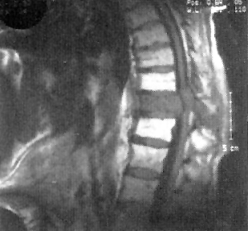

Metastases of renal carcinoma:
A. T1-MRI - multiple levels of spinal involvement; L₂ vertebra (arrow) is collapsed with epidural extension.
B. CT - degree of bone destruction at L₂ level; note retropulsion of bone fragments into epidural space (arrow):
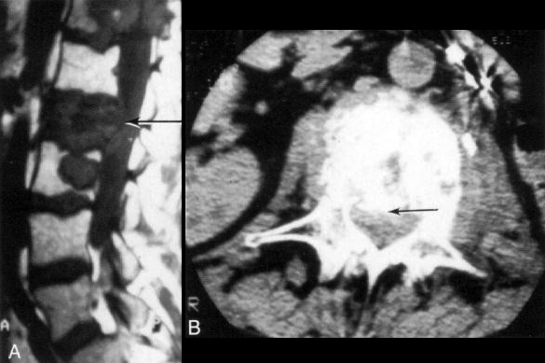

Liposarcoma metastatic to L4 and L5:

A. T1-MRI – low-signal-intensity marrow in L4 and L5 bodies and ventral epidural soft-tissue mass of similar signal intensity at L5.

B. FSE-STIR – tumor is much more conspicuous; L3-L4 and L4-L5 discs are degenerated, but inversion recovery image clearly excludes disc as source of epidural soft-tissue mass; additional sacral metastases.
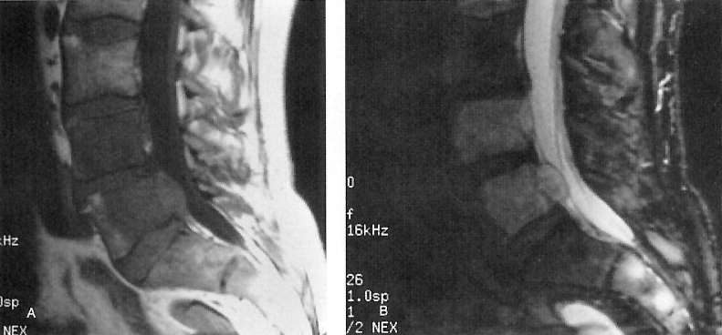

Epidural spinal cord compression due to metastatic breast carcinoma:
A (T1-MRI), B (T2-MRI) - compression fracture of T2 vertebral body with posterior displacement and compression of upper thoracic spinal cord; low-intensity bone marrow signal in A signifies replacement by tumor.
C (T1-MRI through T2 vertebral body) - soft tissue mass (arrow) extending posteriorly and laterally from vertebral body into epidural space.
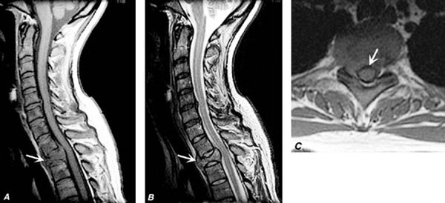

Metastases from prostate cancer (radioisotope bone scan) - increased radiotracer uptake throughout skeleton, particularly in cervical spine:  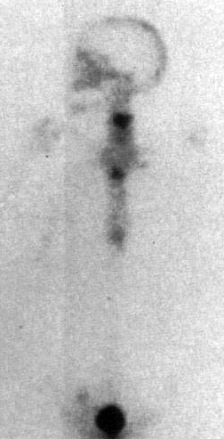 | Multiple areas of increased uptake (darker foci):  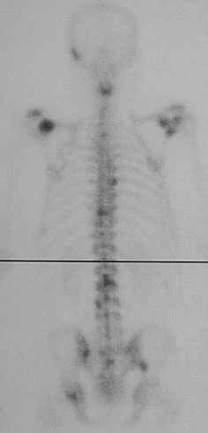

Extradural lymphoma (CT myelogram): anterior and rightward displacement of cord and contrast-enhanced cerebrospinal fluid space (arrowhead) caused by posterolateral epidural soft-tissue mass (arrow):
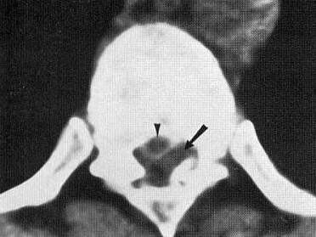

Metastatic breast carcinoma (MRI) - three contiguous thoracic vertebral segments with vertebral marrow replacement, compression fracture, spinal angulation, and epidural spinal cord compression:
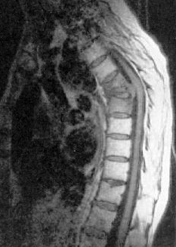

Differential Diagnosis
- Herniated disc material or degenerative spinal stenosis - most common cause of epidural mass!
- Epidural abscess / hematoma
- Epidural lipomatosis

Treatment - Philosophy
Surgical decision-making for oligometastases is based on two features:
- Neurological symptoms, s. cord compression – ESCC score >>
- Spine stability (concept fundamentally different from traumatic spine injuries) – SINS score >>

± Intractable pain – however, it is good indication for either radiotherapy or thermal ablation >> with vertebral augmentation >>
- radiotherapy controls pain well (in > 80% patients) but it takes days ÷ weeks
- radiotherapy has 25-40% risk of compression fracture development

If surgery is considered, last question remains – can patient tolerate surgery? – various prognostic scores >>

Palliation - functional purpose (decompression of the neural element, stabilization of the spine) ± partial tumor removal as intermediary procedure.

NOMS decision making factors
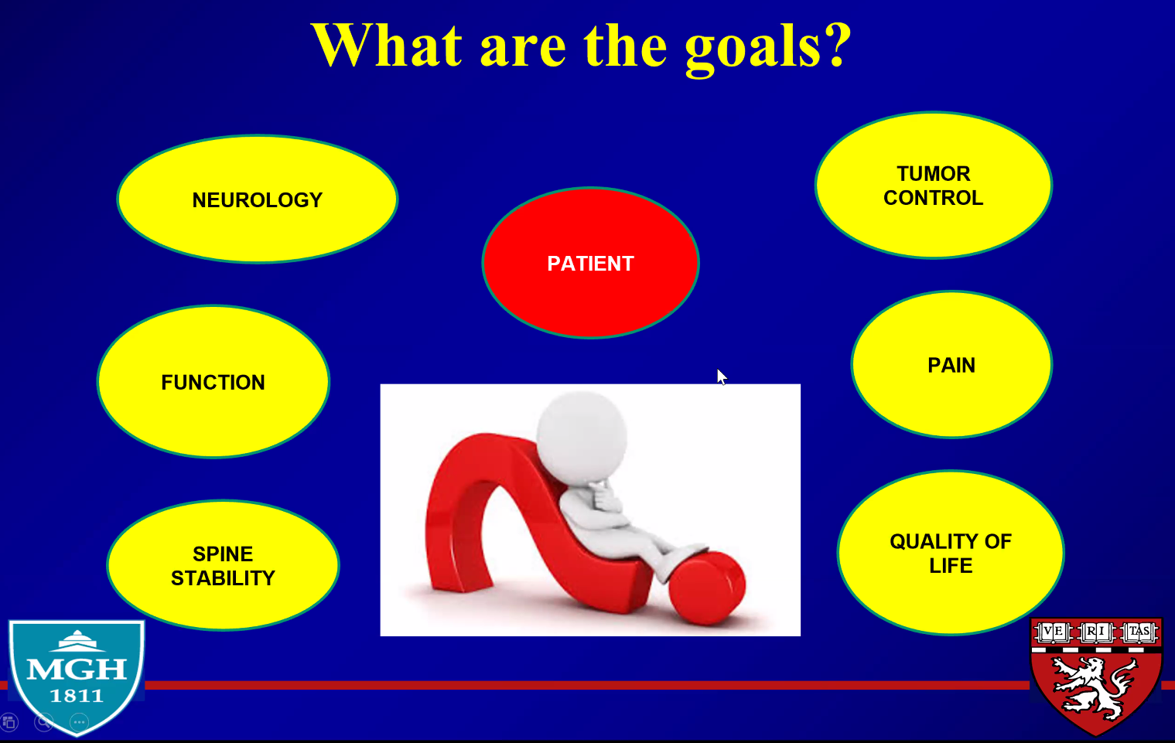

NOMS, neurologic (N), oncologic (O), mechanical (M), and systemic (S) disease flowchart:
Neurologic category takes into consideration radiographic findings such as epidural spinal cord compression, as well as clinical findings such as myelopathy – ESCC score >>
Oncologic category accounts for tumor histology - sensitivity to radiation and whether
the patient has received radiation to this area before.
Mechanical instability accounts for spinal instability and fractures – SINS score >>
Systemic disease considers the patient’s overall metastatic disease burden – survival, overall prognosis.
N.B. oncologists very often cannot predict life expectancy (as many patients with spine mts were excluded from trials so nobody knows how they will fare); more important is to discuss and see patient’s perspective for treatment goals!
May add – genotyping and molecular profiling of primary tumor.
ESCC, epidural spinal cord compression; IGRT, image-guided radiation therapy; MM, multiple
myeloma; NSCL Ca, Non–small-cell lung cancer; RCC, renal cell carcinoma; ROI, region of interest.
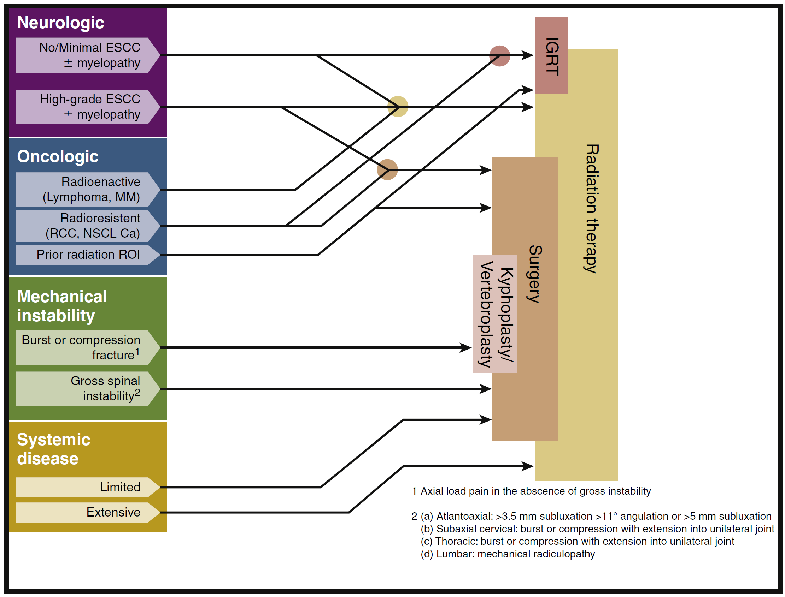
Laufer et al. 2013

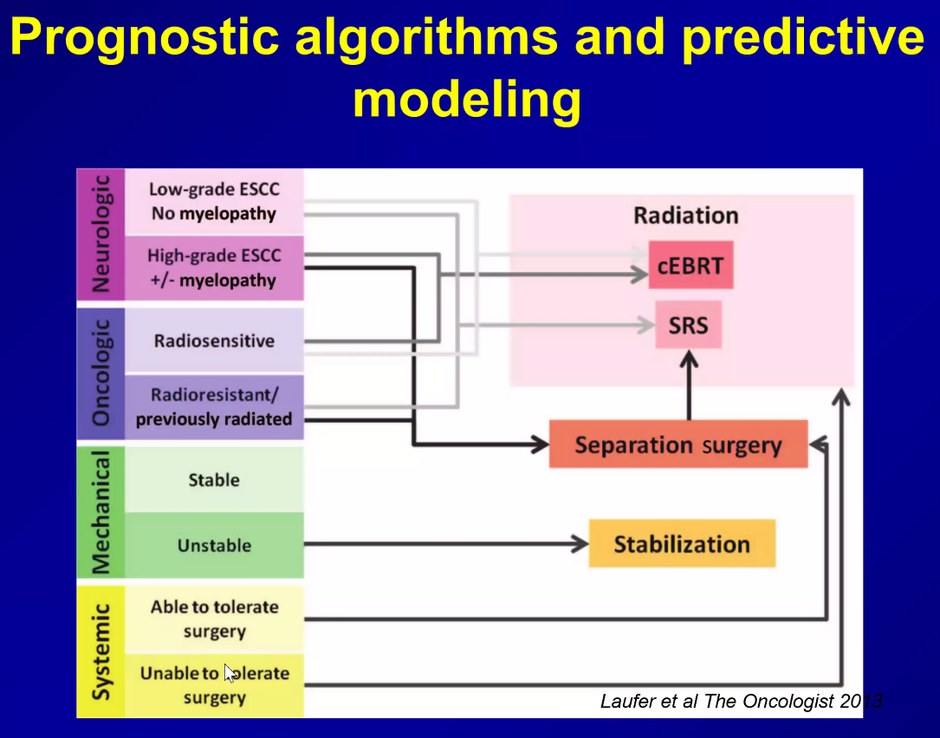

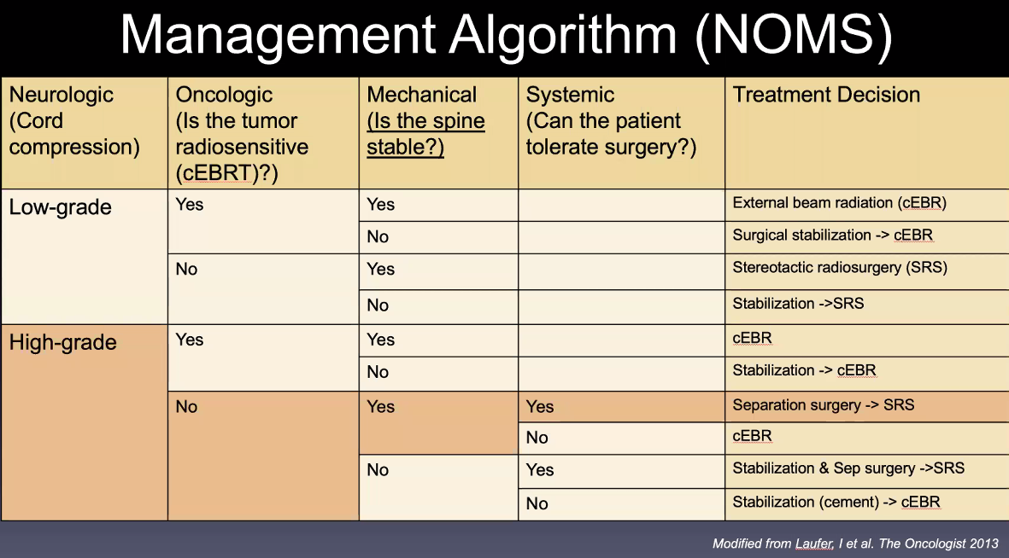

Spinal cord compression
Etiology, clinical features, diagnosis – see p. Spin1 >>
Bilsky classification - epidural spinal cord compression (ESCC) scoring
- 6-point system:
Low grade:
(A) Grade 0 - bone-only disease.
(B) Grade 1a - epidural impingement, without deformation of the thecal sac.
(C) Grade 1b - deformation of the thecal sac, without spinal cord abutment.
(D) Grade 1c - deformation of the thecal sac with cord abutment, but without cord compression.
High grade – cord compression:
(E) Grade 2 - spinal cord compression, but with CSF visible around the cord.
(F) Grade 3 - spinal cord compression, no CSF visible around the cord.
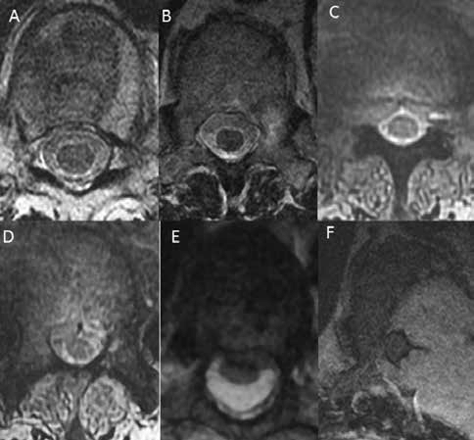

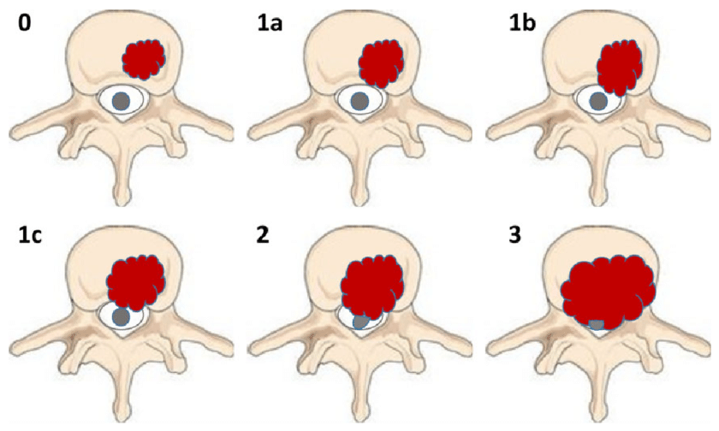
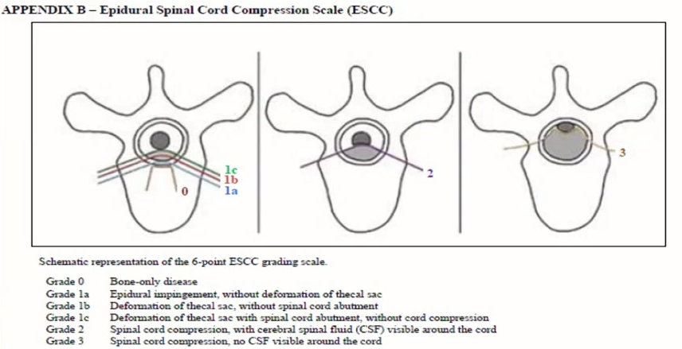
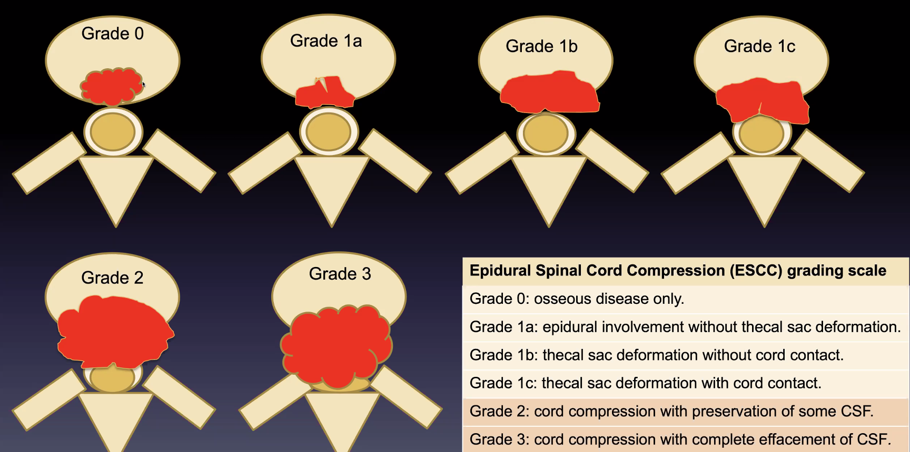

Grades 2-3 require separation surgery before radiation!

Treatment
Spinal cord compression is emergency! (therapy will not reverse fixed paralysis of > 48 h duration)
Cord compression results in edema, venous congestion, and demyelination. If the compression is of short duration, the effects are reversible; remyelination and recovery of function is possible. However, with prolonged compression, secondary vascular injury occurs with infarction of the spinal cord - no meaningful recovery is possible.
- Steroids (dexamethasone 10-100 mg IV → 4-24 mg q6h or methylprednisolone in Bracken protocol) – standard of treatment: give immediately prior to imaging study if clinical suspicion is strong (may help to preserve spinal cord function!)
  - steroid is continued until radiotherapy is completed.

High-dose dexamethasone vs. no steroids for metastatic spinal cord compression treated with radiotherapy
Sorensen PS , Helwig-Larson S , Mouridesen H Hansen HH . Effect of high-dose dexamethasone in carcinomatous metastatic spinal cord compression treated with radiotherapy: a randomized trial. Eur J Cancer 1994; 3 0A : 22 – 27
- 57 patients, class II evidence.
- exclusion: lymphoma; surgical decompression; meningeal carcinomatosis.
- dexamethasone 96 mg IV bolus → 96 mg PO for 3 days.
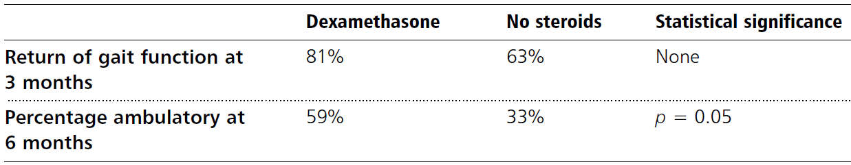
- steroids improve chances of ambulation.
- no difference in survival between the two groups.
- 11% of those receiving steroids experienced side effects.

- Emergency radiotherapy (combined with high-dose steroids): 30 Gy in 10 fractions.
  - immediate salutary effect of radiotherapy may be seen in 24-48 h, at best.

- If effective chemotherapy is available, it should be used with radiotherapy.

- If cannot rule out infection, start antibiotics.

- Indications for surgical decompression:
          - cord compression worsens despite radiotherapy.
          - maximum tolerated dose of radiotherapy has been delivered previously to site.
          - bony compression (e.g. vertebral fracture) contributes to cord compression.
  - approach must be tailored to anatomical site of compression within spinal canal (e.g. indiscriminate use of laminectomy* in all patients → frequent surgical failures; anterior approach is now used for many cases of vertebral body lesions). see p. Op220 >>

*N.B. laminectomy (removal of posterior elements) might be harmful in anterior compression cases:
- does not remove tumour - does not result in immediate decompression.
- can cause destabilization because often only the posterior elements are intact and removal of these elements causes instability.

Decompressive surgery + radiotherapy vs. radiotherapy alone for metastatic spinal cord compression – class I evidence.
Patchell RA, Tibbs PA, Regine WF, Payne R , Saris S, Kryscio RJ, Mohiuddin M, Young B. Direct decompressive surgical resection in the treatment of spinal cord compression caused by metastatic cancer: a randomised trial. Lancet 2005; 3 66 : 643 – 648 .
  - randomised, multi-institutional, non-blinded trial:
50 patients - surgery + XRT
51 patients - XRT alone patients
  - exclusions: paraplegia > 48 h, radiosensitive tumor (lymphomas, leukemia, multiple myeloma, germ cell tumor), only cauda equina compression, > 1 areas of compression, expected survival < 3 months.
  - steroids: all patients were given 100 mg dexamethasone immediately, then 24 mg q6h until the start of radiotherapy or surgery.
  - surgery: protocol did not specify operative techniques or fixation devices, however, the aim of surgery was to provide immediate direct circumferential decompression of the spinal cord:
        - cervical anteriorly-located tumours - anterior approach.
        - thoracic and lumbar anteriorly-located tumours - approach was through a transversectomy or anterior approach.
        - laterally-located tumours - lateral approach.
        - posteriorly-located tumours - laminectomy was done and any other posterior elements involved were removed.
        - stabilization was performed if spinal instability was present (methyl methacrylate, metallic rods, bone grafting, or other fixation devices).
  - radiotherapy given in 10 fractions of 3 Gy (encompassed one vertebral body above and below the visible lesion); timing:
        - in radiation group, radiotherapy was started within 24 h after randomization.
        - surgical patients were operated on within 24 h after randomization and received radiotherapy within 14 days of surgery.
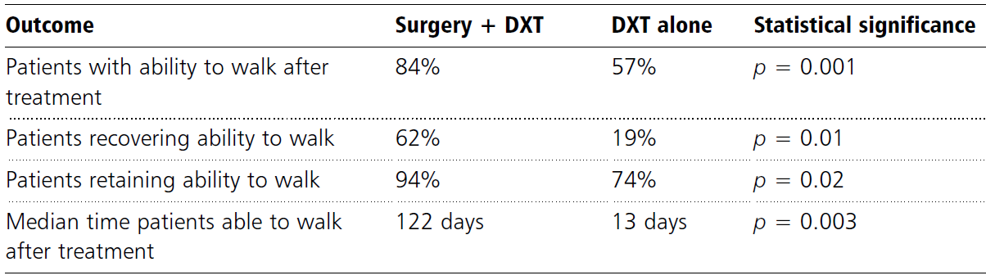
  - significantly more patients in the surgery group than in the radiotherapy group were able to walk after treatment (odds ratio 6.2 [95% CI 2.0–19.8] p=0.001) and retained ambulation significantly longer (122 vs. 13 days).
  - surgery allows most patients to remain ambulatory for the remainder of their lives (leads to increased survival), whereas patients treated with radiation alone spend a substantial proportion of their remaining time paraplegic.
  - surgical patients also did significantly better in all secondary outcomes (continence, functional scores, muscle strength, less opioid and steroid use, survival time).
  - surgery did not result in prolonged hospitalization - the median hospital stay was 10 days in both the surgery group (IQR 2–51 days) and the radiation group (0–41 days; p=0.86).

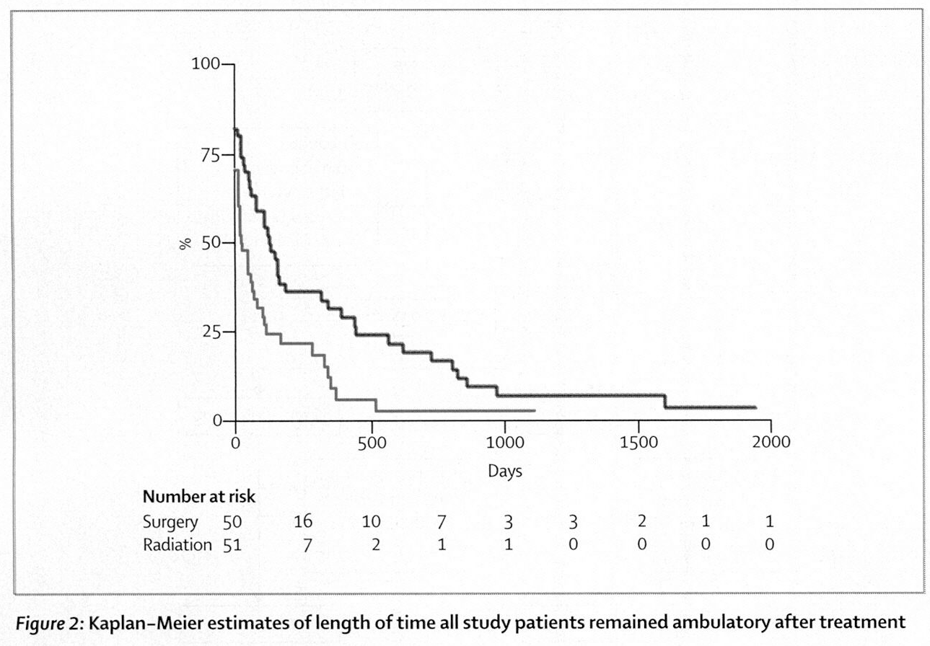
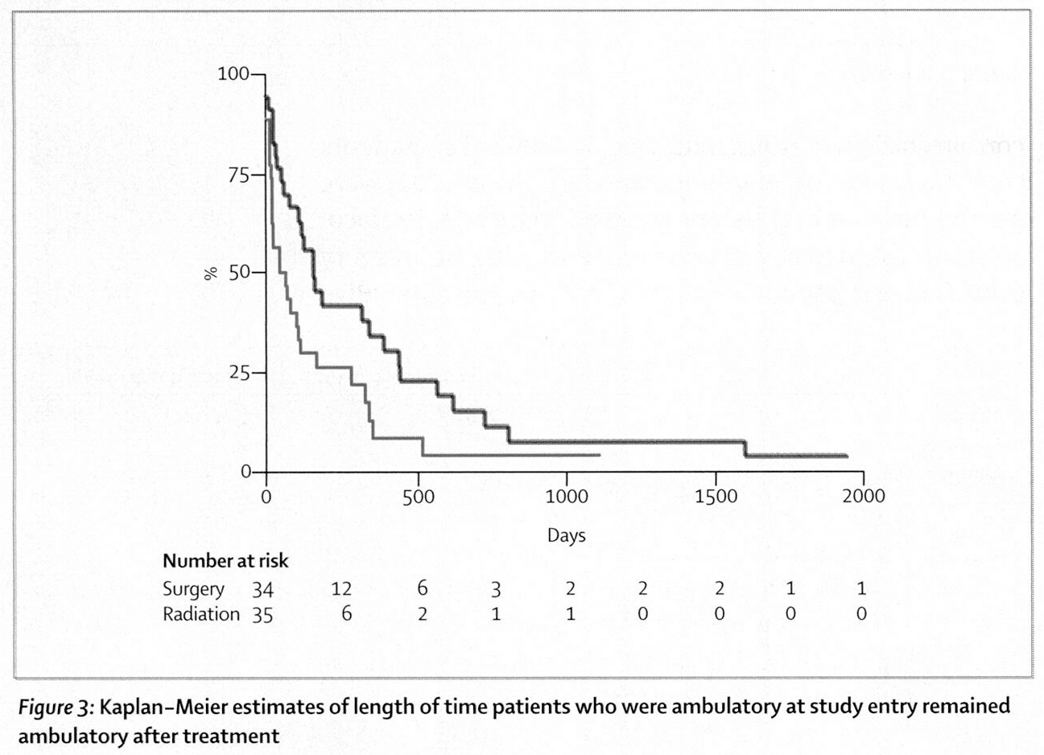

Critique – study used conventional XRT (e.g. renal cell carcinoma is radioresistant); modern radiotherapy (SRS) is much more powerful.

Benign tumors
Based on WBB staging see above >>

Metastases, Malignant Tumors
Primary spinal tumors - based on WBB staging see above >>

Metastatic spinal tumors - based on:
Tokuhashi score see above >>
Tomita score see above >>
No treatment increases life expectancy in spinal metastasis! (metastatic disease is incurable)

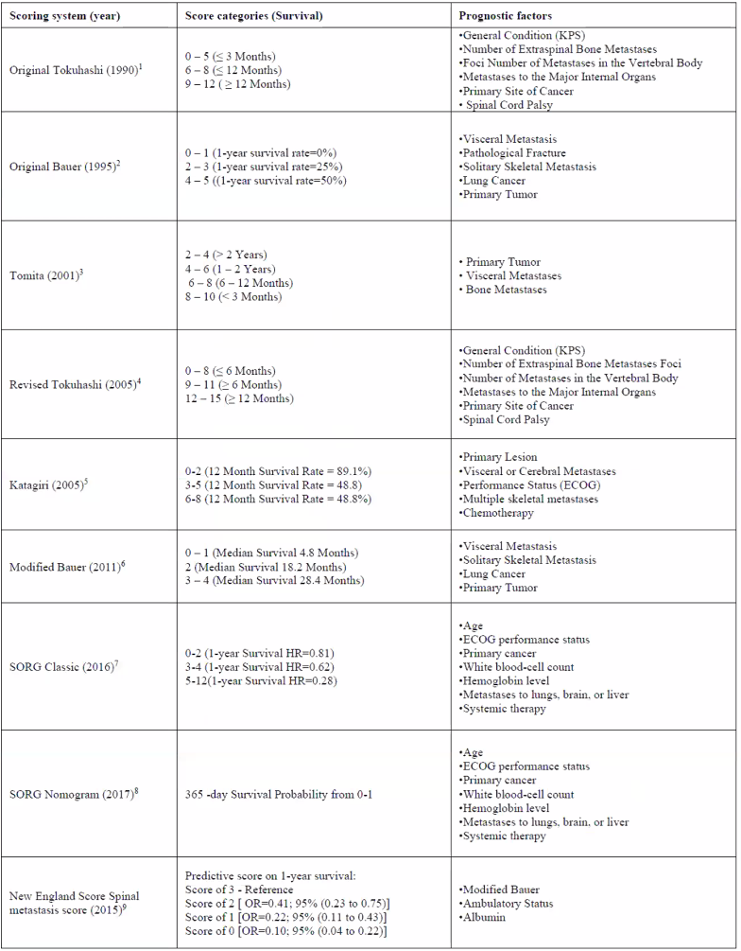

- Bone pain control:
- NSAIDs
- steroids (dexamethasone 10 mg loading dose → 4 mg q6h).
- spinal orthotics and physiotherapy
- irradiation (for bone pain due to stretching of periosteum).
- percutaneous vertebroplasty (injection of acrylic surgical cement) >>

- Neuropathic pain control: antiepileptics (e.g. gabapentin), tricyclic antidepressants, lidocaine patch, opioids.
  - neurosurgical ablations (rhizotomy, spinothalamic tractotomy, cordotomy) are not commonly used in spinal metastases.

- Hypercalcemia: rehydration, steroid, bisphosphonate (inhibits osteoclast function).

- Control of local disease:
- radiotherapy (procedure of choice in most patients!) – improves neurologic function, pain.
  - there is no standardized treatment – either conventional XRT >> or SRS >>
  - indications - SOSG recommendations:
XRT is indicated for spinal metastases in the absence of instability, prior radiation, high-grade cord compression, and radio-resistant histology (strong recommendation, moderate-quality evidence)
SRS should be considered over XRT in the setting of oligometastatic disease and/or radio-resistant histology when no relative contraindications exist (strong recommendation, low-quality evidence).
- local control rate of solitary met with SRS is similar to en bloc resection (e.g. solitary renal metastases: 6-13% vs. 7.5%), thus, Bilsky et all have been advocating for SRS as a first line of treatment when there is no epidural compression* and thus as a way of avoiding the morbidity of an en bloc resection.
*separation surgery may help here >>

- thermal ablation+cement >>
- early radical* surgical resection (spondylectomy) → stereotactic radiotherapy.
*goal is often palliative (rather than curative) in malignant lesions - pain relief, improved mobility
  - indications for surgery:
- single lesion
- radiotherapy-resistant tumor (e.g. melanoma)
- spinal instability (SINS scale ≥ 7 points) >>
- cord compression (with bone or disk fragments)
- progressive neurologic deterioration
- previous radiation exposure
- uncertain diagnosis (that requires tissue diagnosis)
- life expectancy > 3 (or 6) months.
< 3 months – only palliative pain control measures
  - tumor in posterior epidural space or posterior bony elements is best treated by posterior decompression (laminectomy); laminectomy is not good solution for anteriorly based lesions (posterior decompression may further destabilize spine so at least add short segment instrumentation).
  - anterior approaches:
- cervicomedullary junction - transoral or transcervical retro-parapharyngeal approach
- lower in neck - anterolateral cervical approach.
- thoracic - thoracotomy
- lumbar - retroperitoneal approach.
  - incomplete lesion removal results in early recurrence - every attempt should be made to perform the procedure definitively during the first operation - surgical team must be very comfortable with a variety of ventral and dorsal approaches to the spine.
  - some vascularized tumors may need embolization preoperatively to decrease intraoperative blood loss (usually liters of blood loss); for benign tumors use CellSaver.
  - if spinal instability has resulted from the tumor or the surgical treatment of the tumor, it is necessary to supplement the surgical procedure with instrumentation.
N.B. immediate stabilization is often important for quality of life (due to life expectancy, arthrodesis / fusion is not important – no role for biologics; if long term survival is a goal – autografts are the best)
- over time, instrumentation constructs fatigue, loosen, and fail unless bony fusion ensues; in the case of malignant disease, the limited life expectancy of the patient may, in fact, make bony fusion unnecessary.
- titanium implants should be standard for spine tumor reconstruction; carbon fiber have been adopted to lessen artifact on imaging - readily show tumor recurrence, as well as osseointegration of bone graft, on imaging.
- anterior stabilization is achieved with polymethylmethacrylate (PMMA) or hardware.

Game changes in spinal metastases treatment (in historical order)
      - Decompressive surgery
      - SRS
      - Separation surgery

Spinal instability neoplastic score (SINS)
- helps to assess tumor related instability of the vertebral column - useful in guiding the mobilization or operative management of patients with neoplastic spinal disease.
CG Fisher et al. A Novel Classification System for Spinal Instability in Neoplastic Disease An Evidence-Based Approach and Expert Consensus From the Spine Oncology Study Group. SPINE 2010, Volume 35, Number 22, pp E1221–E1229
- Pain:
mechanical pain* (pain with movement or spinal loading or upright position [postural] or pain improves with recumbency): 3 points
*differentiates from other types of pain not indicative of instability, such as pain associated with periosteal stretching or nerve root/spinal cord compression – worsen with recumbency (venous congestion), improve with steroids (edema)
occasional pain but not mechanical: 1 point
painless lesion: 0 points
- Bone lesion (on CT):
lytic: 2 points
mixed: 1 points
blastic (sclerotic): 0 points
- Location:
junctional (occiput-C2, C7-T2, T11-L1, L5-S1): 3 points
mobile spine (C3-C6, L2-L4): 2 points
semirigid (T3-T10): 1 point
rigid (S2-S5): 0 points
- Radiographic spinal alignment:
subluxation/translation: 4 points
de novo deformity (kyphosis/scoliosis): 2 points
normal alignment: 0 points
- Vertebral body collapse (anterior and middle columns):
> 50% collapse: 3 points
< 50% collapse: 2 points
no collapse with > 50% vertebral body involved: 1 point
none of the above: 0 points
- Posterior spinal element involvement (pedicles, facets, and/or costovertebral joints):
bilateral: 3 points
unilateral: 1 point
none of the above: 0 points

1 (pain) is the only feature that need to ask patient; other features (2-6) are radiological.

- low bone mineral density (in unaffected spine) should also be considered as strong risk factor for instability.
- in the case of multiple spine lesions, stability scores are not summed.
- previous laminectomies or other surgical procedures and previous radiation therapy (including radiosurgery) may also influence the fracture risk.
- body weight and activity level may also influence spinal loading and impending instability.

Treatment and prognosis:
score 0-6: stable → radiotherapy / thermal ablation+cement
score 7-12: potentially unstable (warrant surgical consultation) → surgery, radiotherapy / thermal ablation+cement
score 13-18: unstable (warrant surgical consultation to assess for instability prior to proceeding with any planned radiation treatment) → surgery → radiotherapy

N.B. tumor radiosensitivity does not affect decision making (i.e. radiosensitive tumor with SINS ≥ 13 needs operative stabilizations (vs. more favorable SINS → brace + radiotherapy)

Treatment - Staging & Surgery
Metastatic tumors – high likelihood of distant metastases – surgery goal is palliation through intralesional resection (plus, adjuvant therapy options are often available).
vs.
Primary tumors – low likelihood of distant metastases – surgery goal is cure through en bloc resection (plus, adjuvant therapy options* are limited) – especially true for chordomas, chondrosarcomas.
*adjuvant treatments are advancing rapidly (experts do less and less of en bloc resections!) – all primary tumors should be presented to multidisciplinary tumor board

En bloc resections are morbid, therefore, preop work up is important to define the strategy:
- Panspine MRI
- Chest-abdomen-pelvis CT
- PET / bone scan (not all tumors appear “hot”)
- Biopsy – not all primary tumors need aggressive resection (e.g. tumor radiologically appearing as osteosarcoma could be hemangioma!)
N.B. biopsy is important step in primary tumors!
N.B. choose biopsy tract so it is resectable within definitive surgical approach!

Do not forget the role of preoperative embolization in vascular tumors!
- experts use TXA; avoid CellSaver.

Primary spinal tumors
Weinstein, Boriani, Biagini (WBB) Surgical Staging System
Boriani S, Weinstein IN, Biagini R. Spine Update. Primary Bone Tumors of the Spine: Terminology and Surgical Staging. Spine 22(9):1036-1044, 1997
- surgical terminology and strategy guidance.
- particularly suited to the thoracolumbar spine (may not be easily extrapolated to the cervical spine - the anatomy of the vertebral artery, the sympathetic chain, the thyroid and parathyroid glands, and the arterial anatomy complicate the techniques of surgical resection).
- requires CT, MRI, and angiography (if performed)
- vertebra (in axial plane) is divided in clock-face fashion into 12 equal segments and 5 layers from superficial to deep:
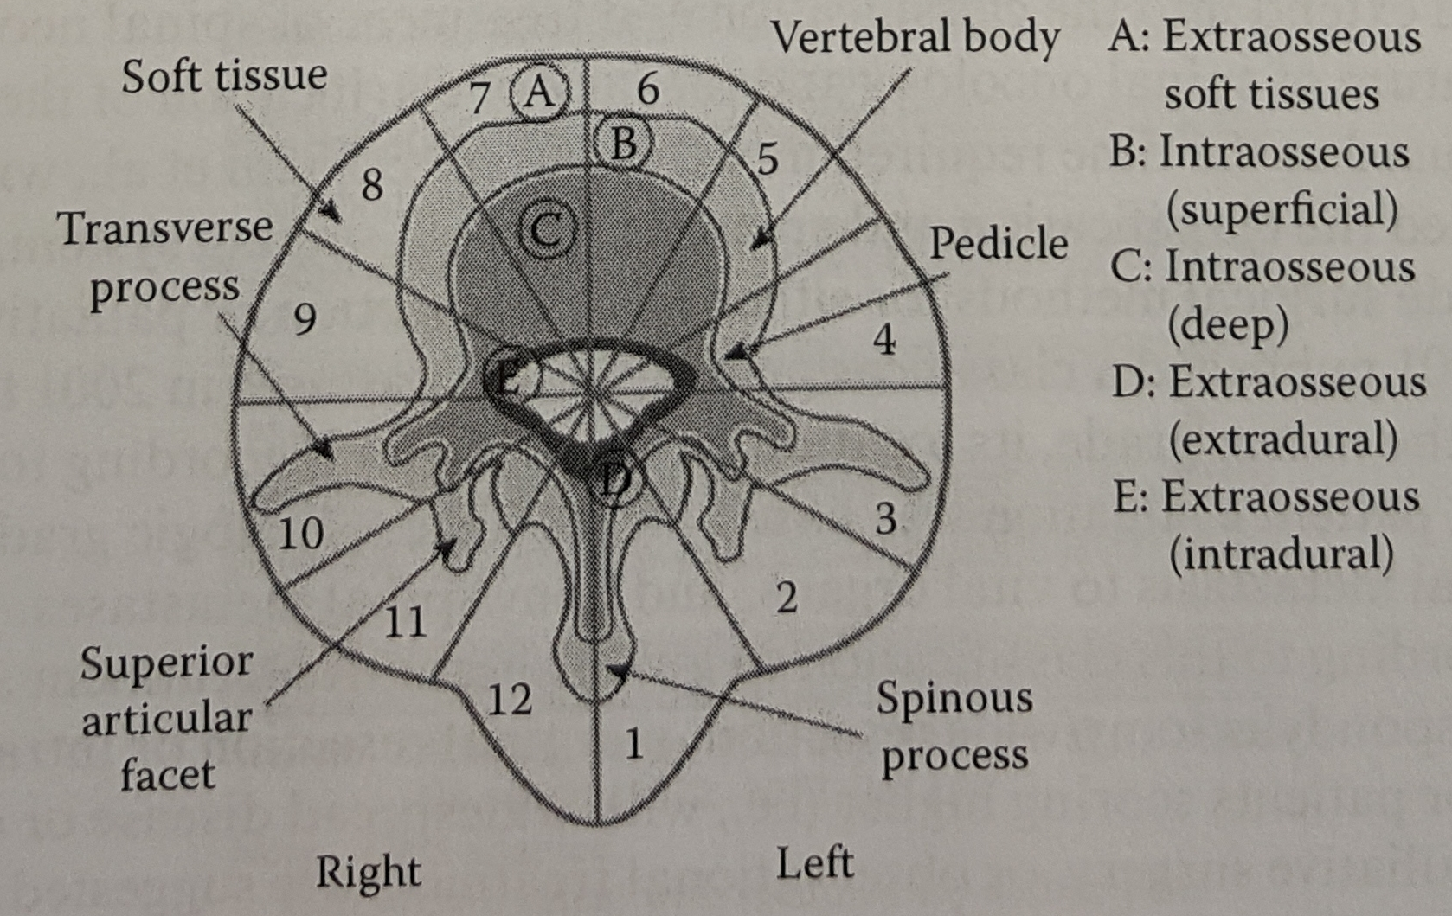
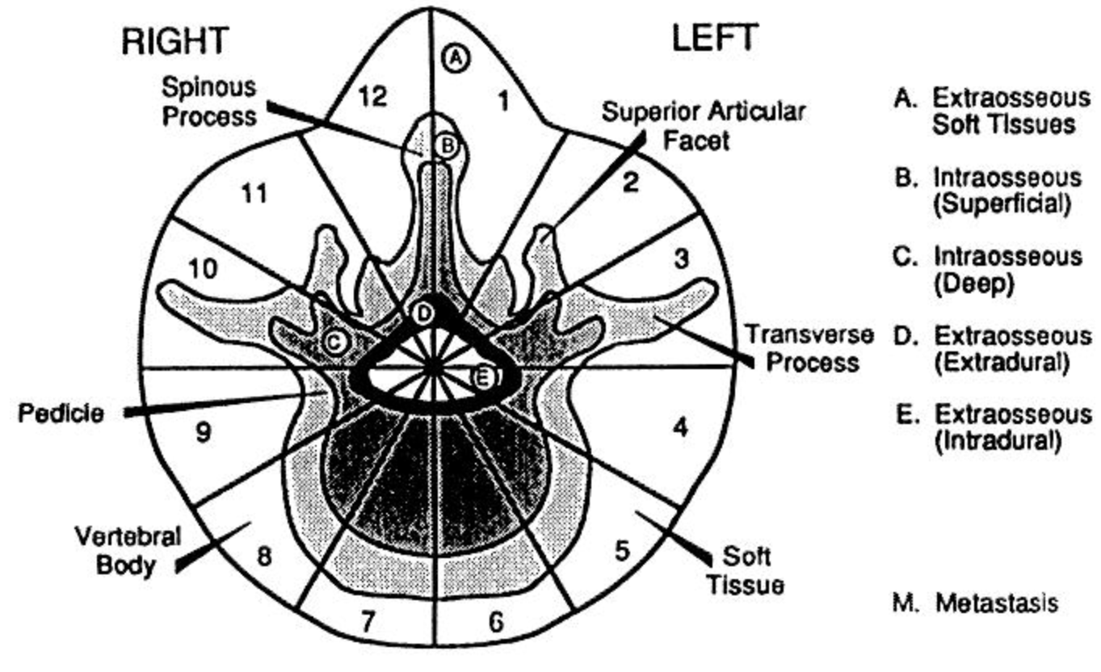

- longitudinal extent of the tumor is described by numbering the involved segments.
- system limitations – SRS, minimally invasive trans-psoas or oblique lateral approaches were not available and were not included.

Terminology
"Curettage" - the piecemeal removal of the tumor. As such, it is always an intralesional procedure.
"En bloc" - an attempt to remove the whole tumor in one piece, together with a layer of healthy tissue. The specimen then must be submitted to careful gross and histologic studies to further define the procedure as "intralesional," "marginal," or "wide." The term "intralesional" is appropriate if the surgeon has cut within the tumor mass; "marginal" is appropriate if the surgeon has dissected along the pseudocapsule, the layer of reactive tissue around the tumor; and "wide" is appropriate if separation has occurred outside the pseudocapsule, removing the tumor with a continuous shell of healthy tissue. The wide en bloc procedure can be called "excision" or "resection." Both of these terms are too widely used and interchanged for them to be separated. However, the authors of the present report prefer to define resection as "en bloc excision." To avoid confusion and to compare results, it is essential to distinguish the longer, more difficult, and risky removal of the whole tumor in one piece (en bloc) from a simple intralesional procedure, even though this sometimes may mean the piecemeal removal of the whole vertebra.
"Radical resection" - the en bloc removal of the tumor and the whole compartment of tumor origin. It is obvious that this can be possible for a tumor arising in the scapula (scapulectomy) or in the tibia (above knee amputation), but it is absolutely impossible for a spine tumor. Even if the spinal cord is sectioned above and below, the epidural space represents a compartment extending from the skull to the coccyx.
"Palliation" - a surgical procedure performed with a functional purpose (cord decompression, fracture stabilization), with or without partial or piecemeal removal of the tumor. In general its purpose includes helping to establish the diagnosis, the control of pain, and possibly an improvement in function.
In isolation the terms "vertebrectomy" or "spondylectomy" (removal of all the elements of the vertebra) and "corpectomy" or "somectomy" (removal of the vertebral body) have no oncologic meaning unless they are accompanied by an appropriate descriptor (e.g. intralesional) as defined above.

Three major methods for performing en bloc excisions in the thoracolumbar spine:
- Vertebrectomy - performed for lesions largely confined to the vertebral body (4-8 or 5-9 zones). En bloc tumor excision of the vertebral body can be performed with appropriate "margins" if the tumor is confined to zones 4 to 8 or 5 to 9 (Figure 4A), which means that it is centrally located and that at least one pedicle is free from tumor. The procedure can be performed in two stages (Figure 4B) or in one stage. The posterior approach (with patient in the prone position) involves excision of the posterior elements, which enables the anulus fibrosus and the posterior longitudinal ligament to be sectioned. It also allows careful hemostasis of the epidural venous plexus to be achieved and posterior stabilization to be performed. The anterior approach (transpleural thoracotomy, retroperitoneal abdominal, or thoracoabdominal approach) allows the ligature of segmental vessels (at the lesional level, above and below), proximal and distal discectomies (or the section by chisel through the neighboring vertebrae according to the preoperative planning), the en bloc removal of the vertebral body (Figures 1, 5A, and 5B), and anterior reconstruction.22 The main advantages of performing the vertebrectomy through a bilateral approach are that ligation of the segmental vessels is made easier and that it permits dissection of the tumor from the anterior elements entirely under direct vision, thus achieving a better margin when the tumor has expanded anteriorly.
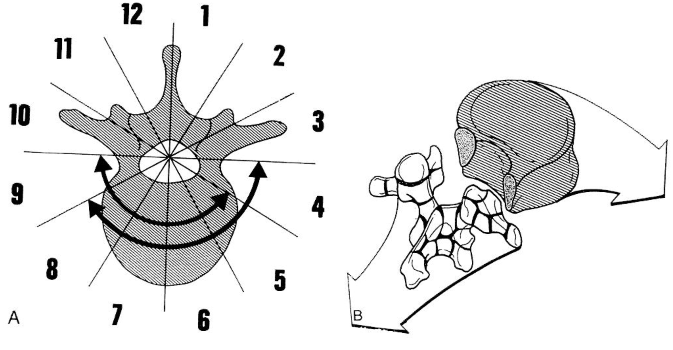
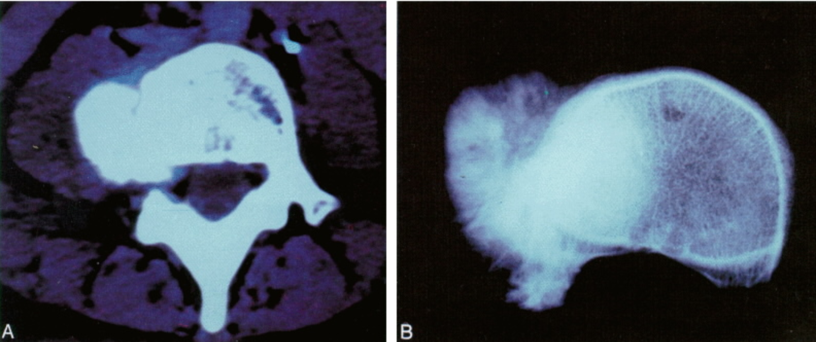

- Sagittal resection - this approach is most appropriate when the tumor occupies zones 3 to 5 (or 8 to 10), which means that it arises and develops eccentrically within the body, the pedicle, or the transverse process (Figure 6A). En bloc excision of more than one level can be performed and may include, if necessary, one or more ribs. A combined anterior and posterior approach allows 300 degrees of the circumference of the thoracic and lumbar vertebrae to be viewed (Figure 6B). The first step is the same as in vertebrectomy. The posterior healthy structures are removed (Figures 6B and 7A), including the pedicle to make room for the dural displacement. The nerve root or roots of the affected segment are ligated, if necessary. Then the patient is placed in a lateral decubitus position. In the thoracic spine, the midline posterior incision is combined with an oblique thoracotomy incision on the rib of the affected level, producing a T-shaped incision. In the lumbar spine and at the thoracolumbar junction, a classic retroperitoneal (abdominal or thoracoabdominal) approach is performed. The vertebra is cut by chisel or osteotome far from the tumor (at least one zone is free from tumor) after protecting the major vessels (isolated by the anterior approach), obtaining an en bloc excision (Figure 7B).
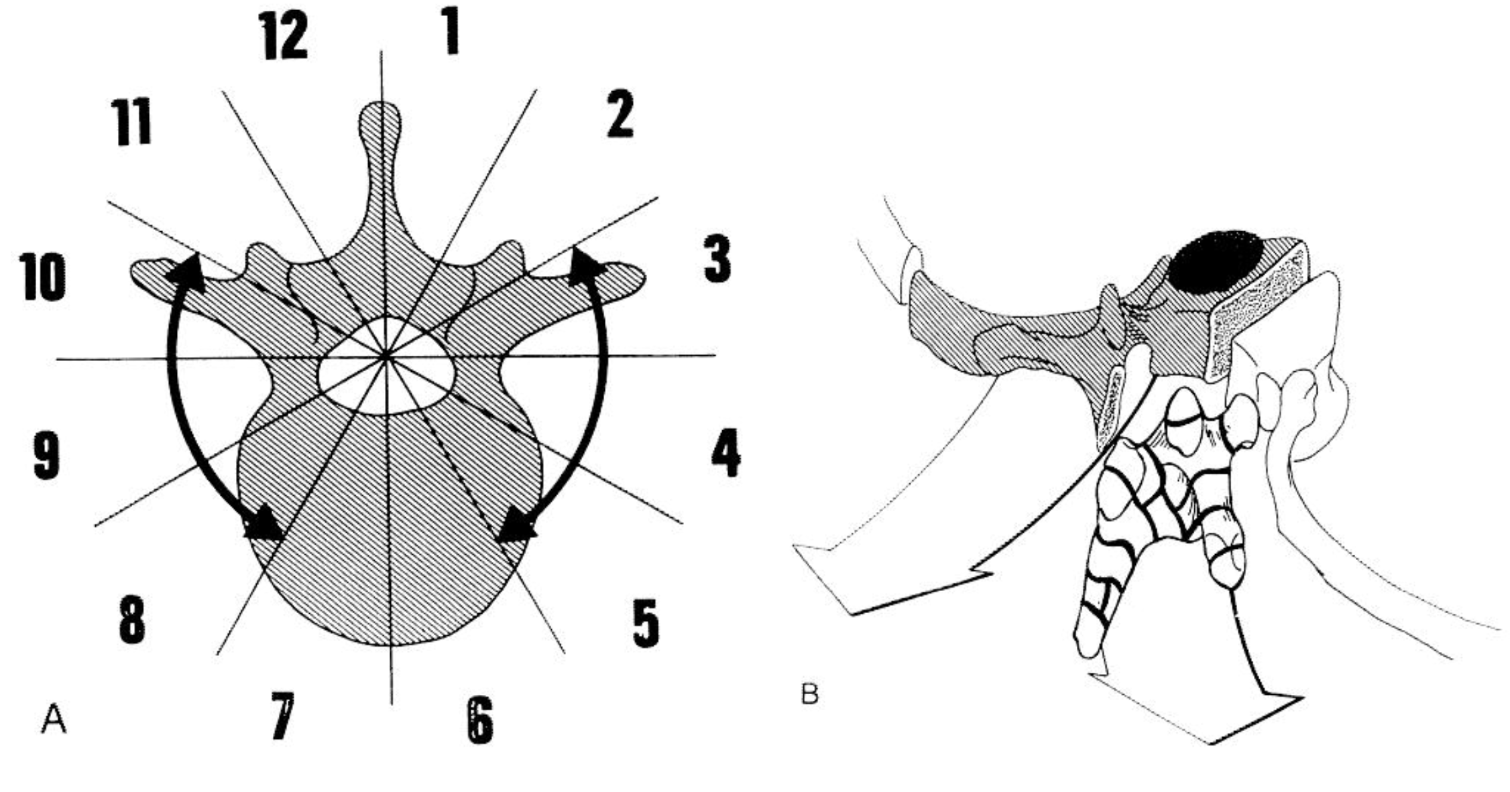
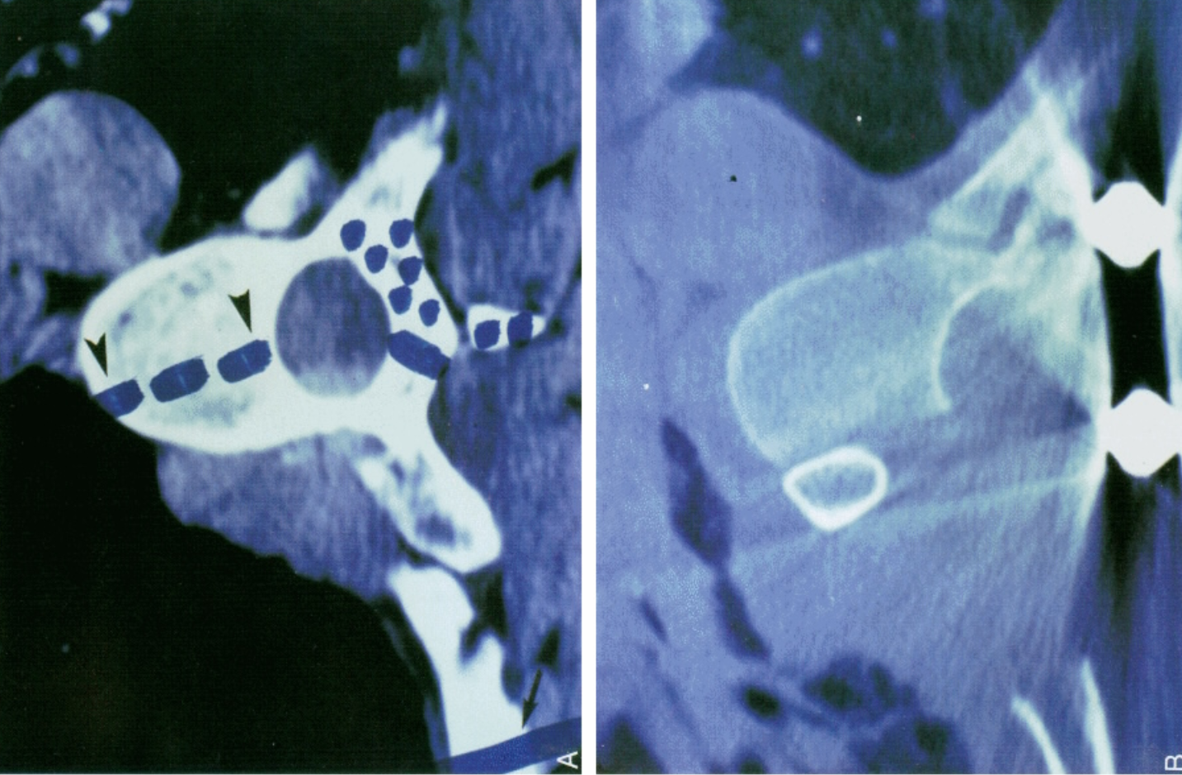

- Resection of the posterior arch - When the tumor is located between the zones 10 and 3, en bloc excision can be performed by a posterior approach (Figures 8A, 8B, 9A, and 9B).4 To achieve this result, a wide laminectomy must expose the dural sac above and below the tumor. Lateral dissection must expose the pedicles, which are sectioned by osteotome or Gigli saw (Figures 8B and 9B).
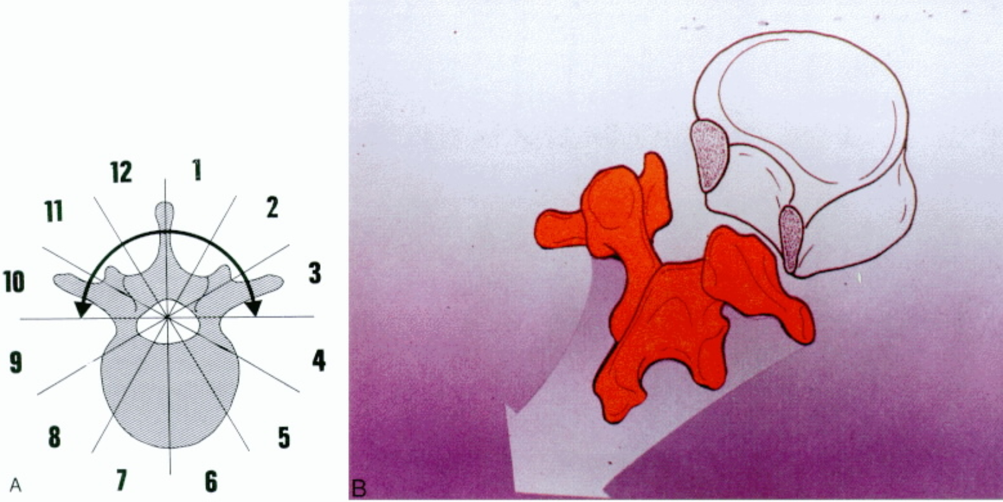
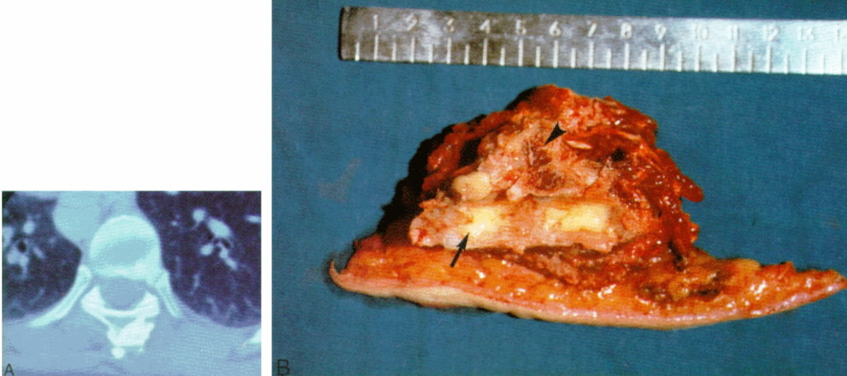

Benign tumors:
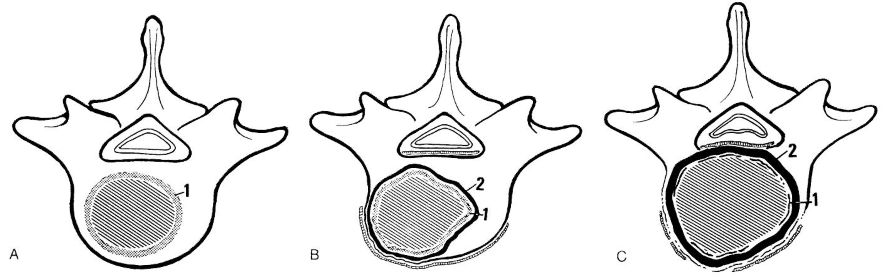
(a) Stage 1 - tumor is inactive and contained within its capsule (1).
(b) Stage 2 - tumor is growing, and the capsule (1) is thin and bordered by pseudocapsule of reactive tissue (2).
(c) Stage 3 - aggressiveness is evident by the wide reaction of healthy tissue (2), and the capsule (1) is very thin and discontinued.

Sl lesions - observation (unless palliation is needed for decompression or stabilization).
S2 lesions - intralesional curettage ± adjuvant therapy.
S3 lesions (aggressive behavior including invasion of the surrounding compartments):
- intralesional curettage + adjuvant therapy (despite a high risk of recurrence)
- marginal en bloc excision

Malignant tumors:
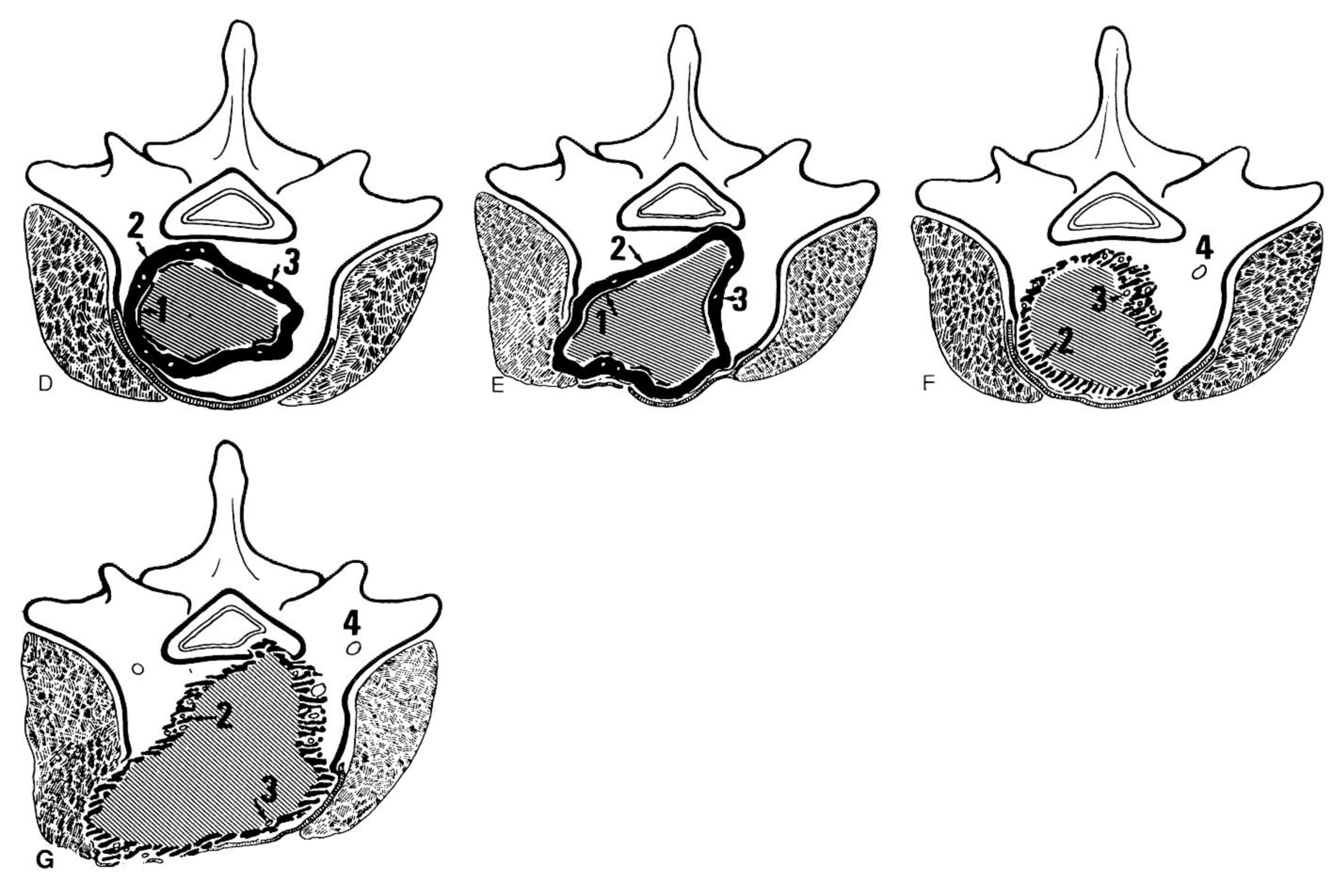

(d) Stage IA - capsule, if any, is very thin (1), and the pseudocapsule (2) is wide and containing an island of tumor (3).
(e) Stage IB – same as IA but tumoral mass is growing outside the compartment of occurrence.
(f) Stage IIA - pseudocapsule (2) is infiltrated by tumor (3), and the island of tumor can be found far from the main tumoral mass - skip metastasis (4).
(g) Stage IIB - pseudocapsule is growing outside the vertebra; island of tumor can be found far from the main tumoral mass - skip metastasis (4).
Stages IIIA and IIIB - the same lesions as IIA and IIB, but with distant metastasis.

Lower-grade malignancies (Stage IA and IB):
- marginal resection + adjuvant therapy
- en-bloc excision
Higher-grade malignancies (Stage IIA and IIB) - wide resection + adjuvant therapy (radical margins are not achievable in the spine due to the flowing tissue plane of the epidural space).

En Bloc resection
Yamazaki T, McLoughlin GS, Patel S, Rhines LD, Fourney DR. Feasibility and safety of en bloc resection for primary spine tumors: A systematic review by the Spine Oncology Study Group. Spine (Phila Pa 1976). 2009; 34(22 Suppl): S31-S38.

Best chance of disease-free survival!
- high risk of complications.
- ok to use Cell Saver (but only for en bloc resections) - use leukocyte-trap.
- both open biopsy (as opposed to CT-guided biopsy) and previously attempted intralesional resection are associated with decreased likelihood of achieving acceptable margins and decreased disease-free survival, and are therefore strongly discouraged.

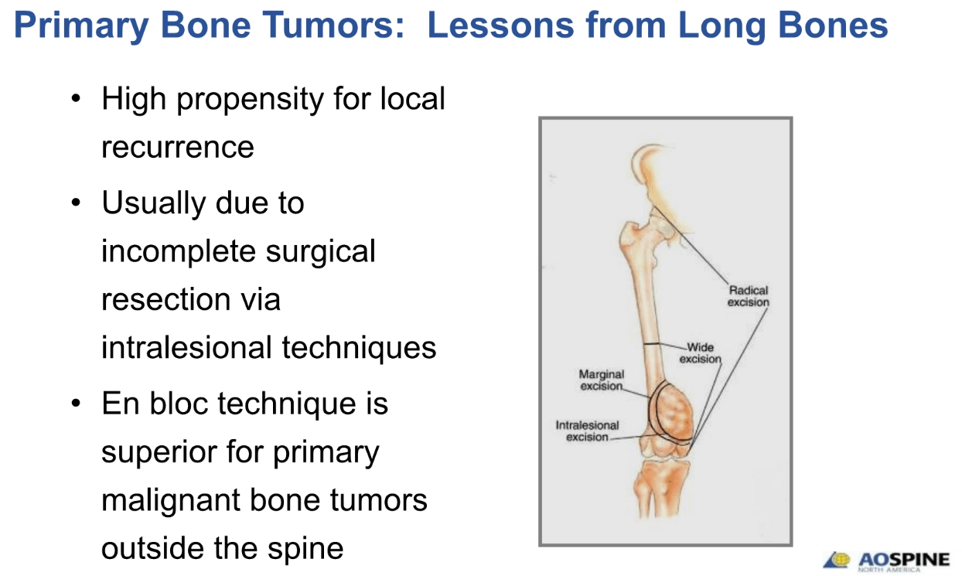

Metastatic spinal tumors
Practically, spondylectomy is very rarely indicated (as opposed to primary vertebral tumors); corpectomy with cage support can be done if needed for structural support in solitary metastasis.
N.B. hematological tumors (lymphoma, multiple myeloma) – treatment is medical; surgery indications are rare:
    - acute neurological deficit
    - augmentation for intractable pain

Revised Tokuhashi score
Tokuhashi Y, Matsuzaki H, Oda H, et al. A Revised Scoring System for the Preoperative Evaluation of Metastatic Spine Tumor Prognosis. Spine 30(19):2186- 2191, 2005
- prognostic and surgical strategy guidance for metastatic spinal tumors.
- multiple myeloma and lymphoma are excluded.
- original scoring system (1990) was based on six parameters: general condition, number of extraspinal bone metastases, number of metastases in the vertebral body, metastases to major internal organs, site of the primary cancer, and the severity of palsy.
- Tokuhashi score underwent revision in 2005:
      - to assign greater weight to the primary cancer in the overall score.
      - application of the score to conservatively managed patients (the original scoring system only evaluated surgically treated patients).

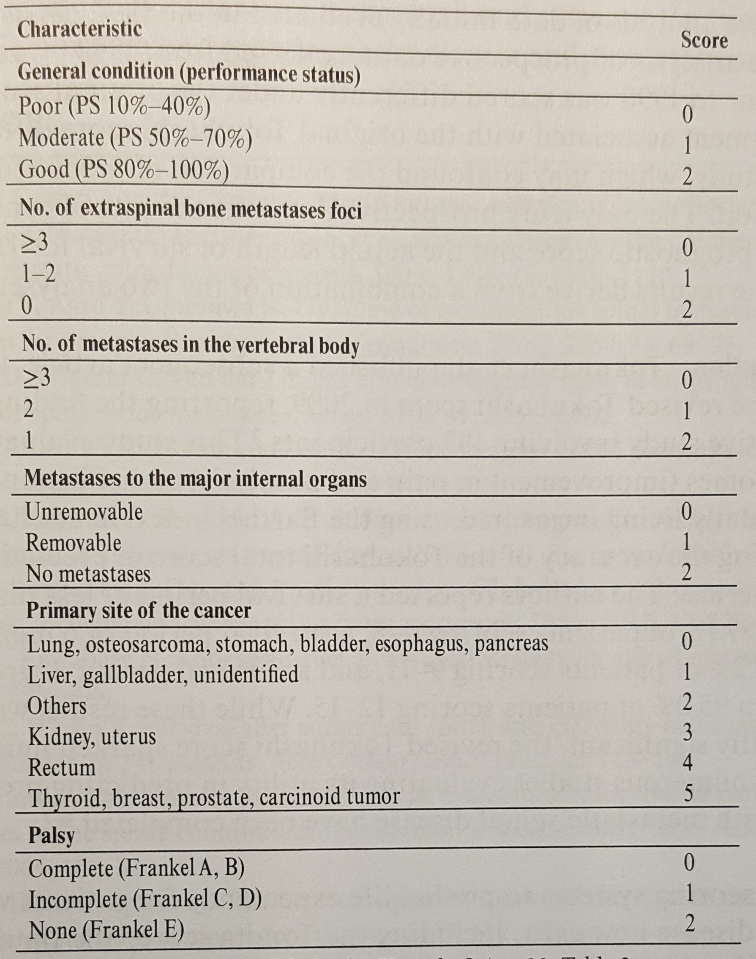

Predicted prognosis:
Total Score | Prognosis | Treatment strategy
0-8 | 87% patients lived ≤ 6 mos | conservative treatment
9-11 | 87% patients lived ≥ 6 mos | palliative surgical procedures (stabilization ± laminectomy); except score of 9-11 with a single spinal lesion and no metastases to major organs → excisional surgery (tumor excision with stabilization).
12-15 | 95% patients lived ≥ 1 yr | excisional surgery

N.B. Zoccali et al. determined that the accuracy of the revised Tokuhashi score has statistically significant decrease over time for patients with an expected survival of < 12 months, likely secondary to evolving modern treatments.

As an alternative to these rigid classification-based approaches, Paton et al. published a
principle-based decision framework called LMNOP (addresses clinical factors and is adaptable to changes in technology):
(L) location of disease (anterior/posterior columns, spinal level)
(M) mechanical instability by SINS score
(N) neurology
(O) oncology (histopathological diagnosis)
(P) patient fitness, patient wishes, prognosis (largely dependent on tumor type), and response to prior therapy.

Tomita score
Tomita K, Kawahara N, Kobayashi T, Yoshida A Murakami H, Akamaru T. Surgical Strategy for Spinal Metastases. Spine 26(3):298-306, 2001
- prognostic and surgical strategy guidance for metastatic spinal tumors.

Three factors:
    - malignant grade of the primary tumor (as determined by tissue of origin): (1) slow growth, (2) moderate growth, (3) rapid growth
    - visceral metastases to vital organs: (1) none, (2) present but treatable, (3) present untreatable
    - bone metastases: (1) isolated to the spine or (2) not isolated to the pine

Total Score | Prognosis | Treatment strategy
2-3 | 49.9 months (range 18-84 months) | wide or marginal excision
4-5 | 23.5 months (range 7-57 months) | intralesional excision ± marginal excision when possible
6-7 | 15.0 months (range  5-33 months) | palliative decompression and stabilization
8-10 | 5.9 months (range 1-14 months) | nonoperative palliative care

Limitations: no report on impact of radiotherapy and chemotherapy on patient survival; comorbidities are not included in decision making.

Sarcopenic index (frailty) - psoas muscle area at the L4 level / L4 vertebral body area.
Zakaria HM et al. Sarcopenia Predicts Overall Survival in Patients with Lung, Breast, Prostate, or Myeloma Spine Metastases Undergoing Stereotactic Body Radiation Therapy (SBRT), Independent of Histology. Neurosurgery 86:705–716, 2020 DOI:10.1093/neuros/nyz216
- sarcopenia predicts overall survival in lung cancer, breast cancer, prostate cancer, and multiple myeloma metastases to the spine, independent of tumor histology and after multivariate analysis accounting for demographic, oncologic, functional, and therapeutic factors.
- provides an objective, simple, and effective way to assess longevity.
- can be used to help with surgical decision making in patients with the same burden of disease, as patients with small psoas sizes are at higher risk of death.

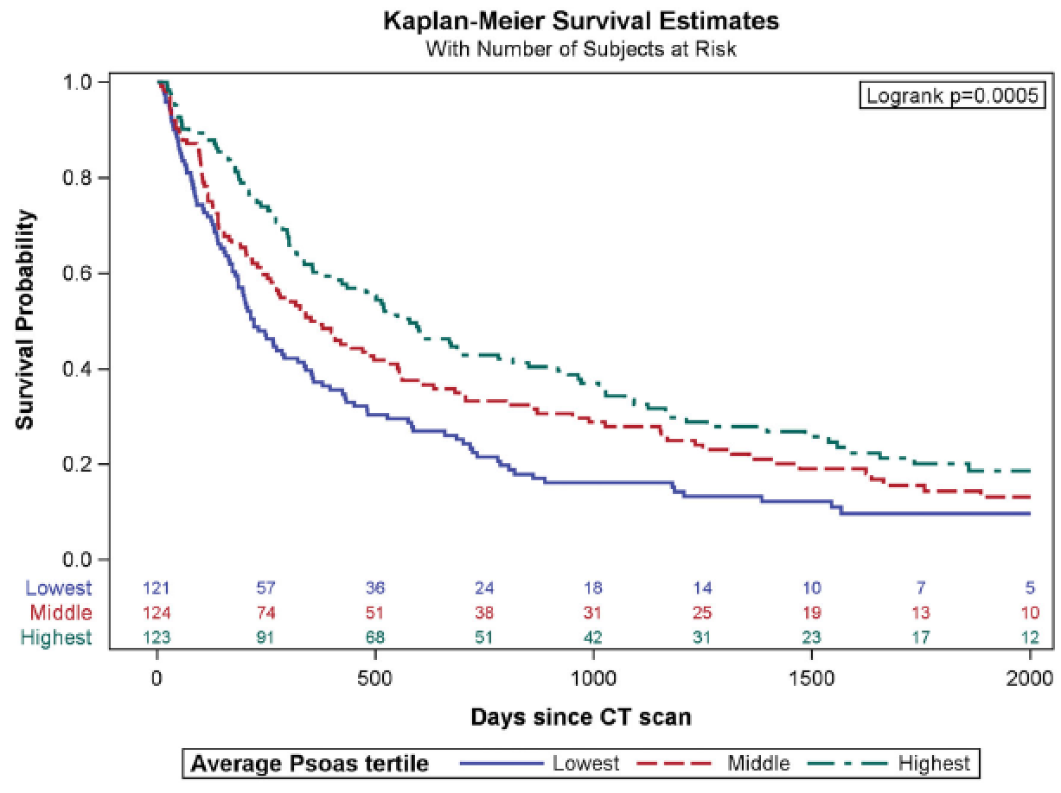

Treatment - Thermal ablation
- RF or microwave (better for osteoblastic tumors) probe – treats the tumor itself! (and still does not preclude other treatment modalities).
- main indication – pain control when radiotherapy is not an option (radioresistant tumor, previous XRT, etc).
- for weight bearing bones (such as spine) need to proceed with vertebroplasty or else vertebra will collapse in 3 months.
- curved probe
- cord protection: thermocouple insertion into epidural space, saline injection into epidural space, SSEP / MEP.

Treatment - Percutaneous vertebroplasty
(injection of acrylic surgical cement) for more see p. TrS9 >>
Weill A1, Chiras J, Simon JM, Rose M, Sola-Martinez T, Enkaoua E. Spinal metastases: indications for and results of percutaneous injection of acrylic surgical cement. Radiology. 1996 Apr;199(1):241-7.
- vertebroplasty was performed for analgesia in 29 procedures, stabilization of the vertebral column in 5 procedures, and both in 6 procedures.
- 72% clear pain improvement; 21% moderate pain improvement; 6% no improvement; improvement was stable in 73% of patients at 6 months.
- in the procedure performed for stabilization, no displacement of treated vertebrae was observed (mean follow-up, 13 months).
- 3 patients had transient radiculopathy due to cement extrusion, and 2 patients had transient difficulty in swallowing.

Treatment - Radiotherapy
- done > 2 weeks after surgery (ideally, at least 2 weeks; in rare cases with ongoing cord compromise – within 5 days).

Metastases
Indications >>

Methodology
- 30 Gy in 10-15 daily fractions.
- traditional treatment plan is to include 2 vertebral bodies above and 2 below lesion.
- studies failed to demonstrate that dose fractionation schedule has an impact on ambulation; some data suggests that a longer course (> 1 week) offers better motor function score compared to a shorter course (< 1 week), however, a shorter course may still be indicated for patients with a limited life expectancy.

Outcomes
- 60-80% of ambulatory patients remain ambulatory.
- 19-33% of nonambulatory patients regain ability to walk.
- 50-70% of patients demonstrate pain improvement (vs. 85-100% with SRS)
- 61-89% of patients achieve local control defined as the absence of recurrent cord compression.
- tumor histology represents an important prognostic factor:
favorable histologies - lymphoma, myeloma, seminoma, breast cancer, and prostate cancer;
unfavorable histologies - sarcomas, melanomas, renal cell carcinomas, gastrointestinal carcinoma, and non-small cell lung cancer (NSCLC).
- XRT appears to be safe (1 case of radiation myelopathy has been described).

Treatment - SRS
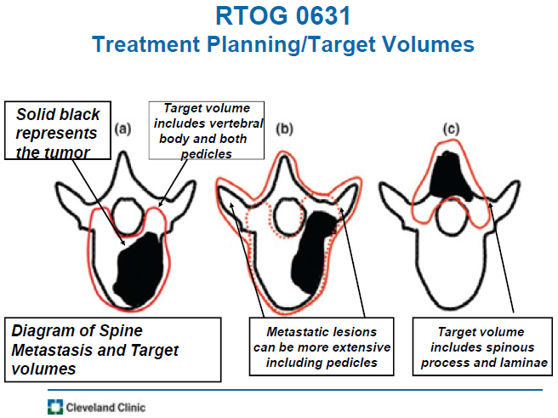

Metastases
Indications >>
- SRS is used as a primary treatment, as a re-irradiation procedure, or as an adjuvant to surgery.

Outcomes
- 85-100% of patients demonstrated pain improvement (vs. 50-70% with XRT), even with radio-resistant histologies.
- in the setting of progressive neurologic deficit where surgery was contraindicated, 57-92% of the patient experienced neurologic improvement.
- 75-100% of patients achieve local control defined as the absence of recurrent cord compression.
- progression occurring at adjacent levels is rare.
- progression at the epidural space has been described.

Complications
- radiation myelopathy has been reported.
- vertebral compression fractures (VCFs) have been documented as a late complication (11-39%);
- most of these fractures occur within 4 months.
- risk factors: lytic lesion, malalignment, ≥ 20 Gy per fraction.
- prophylaxis: pre-SRS cement augmentation (N.B. nearly half of these fractures remain asymptomatic and therefore do not require treatment).

Separation Surgery (SS)
- separating cord away from SRS target, i.e. downgrading epidural disease - converting high-grade epidural disease (deformation of the spinal cord with or without persistence of visible CSF) into low-grade, i.e. restoring CSF cuff around the cord. see Bilsky classification >>
N.B. separation surgery is for ventral disease! (for dorsal disease, complete tumor removal is recommended)
- posterior approach just to decompress cord; can be done with laser (LITT).
- SRS is done 2-3 weeks after SS (at least 2 weeks, in rare cases with ongoing cord compromise – within 5 days).

Studies
Laufer I, Bilsky MH, et al. Local disease control for spinal metastases following "separation surgery" and adjuvant hypofractionated or high-dose single-fraction stereotactic radiosurgery: outcome analysis in 186 patients. J Neurosurg Spine. 2013 Mar;18(3):207-14. doi: 10.3171/2012.11.SPINE12111. Epub 2013 Jan 22.
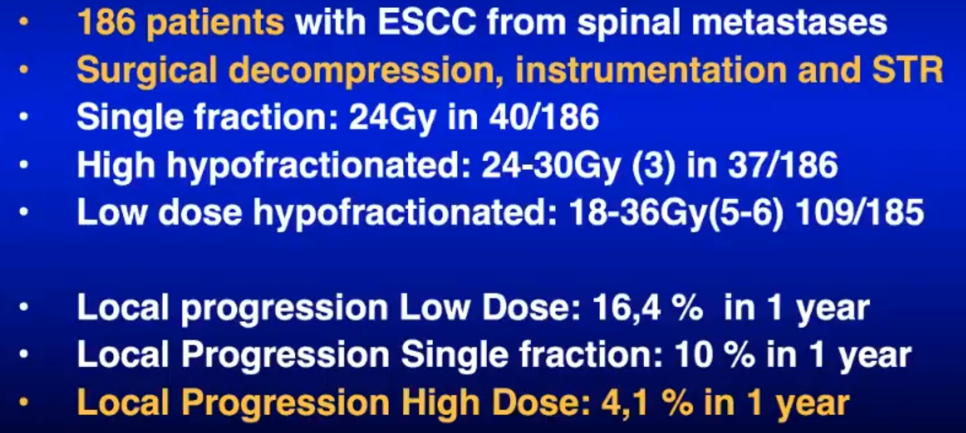

Prognosis
Metastatic Tumors
30-day postoperative mortality – 8.5%
median survival – 10 months

Tokuhashi score see above >>
Tomita score see above >>

Harvard web application to prognosticate 30-day postoperative mortality in spinal metastases: https://sorg-apps.shinyapps.io/spinemets/

90-Day and 1-Year Postoperative Mortality
Aditya V. Karhade et al. Predicting 90-Day and 1-Year Mortality in Spinal Metastatic Disease: Development and Internal Validation. Neurosurgery 85:E671–E681, 2019
  - 732 patients: 90-d and 1-yr mortality rates of 181 (25.1%) and 385 (54.3%), respectively.
  - albumin, primary tumor histology, and performance status were the 3 most important predictors of 90-d mortality.
https://sorg-apps.shinyapps.io/spinemetssurvival/

Pretreatment neurological status is one of most important prognostic factor affecting outcome (importance of early diagnosis!!!)
  - rapidly progressing deficits carry worse prognosis (than slowly evolving ones).
  - loss of bowel / bladder function is usually irreversible.

Follow-up
- patients get radiotherapy, ideally, > 2 weeks postop (earliest, 5 days) to prevent dehiscence.
- PET scans to monitor status of spinal disease for recurrence.

Specific Tumor Types (Primary)
about analogous tumors in skull → see p. Onc40 >>

Enostosis (Bone Island)
– mass of proliferating bone tissue within bone (i.e. calcified medullary defects of lamellar compact bone with haversian systems found within cancellous portion of bone): represent either hamartomatous lesions or failure of osteoclastic activity during bone remodeling.
Not a tumor!
Osteopoikilosis - rare inherited benign condition characterized by multiple benign enostoses; importance is predominantly in correct diagnosis so that it is not mistaken for pathology.
- one of most common spine lesions (found in 14% autopsies).
- most frequent in thoracic and lumbar spine.
- remain stable (some may slowly increase in size).
- discovered incidentally:
- X-ray, CT – circular or oblong osteoblastic lesions with spiculated margin; abrupt transition from normal to sclerotic bone; sclerotic bone lesion can be diagnosed as a bone metastasis versus bone island if its mean attenuation is < 885 HU and maximum attenuation is < 1060 HU with a 95% sensitivity and a 96% specificity for both values.
- bone scan – normal (vs. osteoblastic metastases!).
- MRI – low signal intensity with normal surrounding intensity.
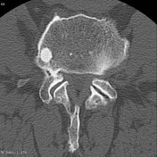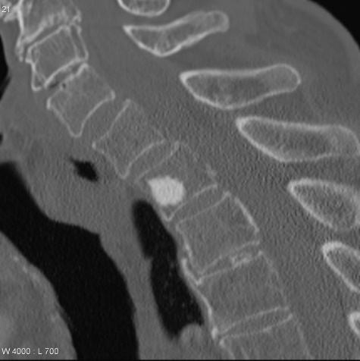
- considered one of the skeletal “don’t touch” lesions; if exhibits diameter increase > 25% in 6 months → biopsy.

Osteoid osteoma
- histologically identical to osteoblastoma* - microscopic well-organized trabecular bone with vascular fibrous connective tissue stroma surrounded by reactive cortical bone.
*but behaviorally very different – osteoid osteoma is locally self-limited.
- diameter < 1.5 cm (vs. osteoblastoma - typically > 2.0 cm).
- only 10% of body osteoid osteomas involve axial skeleton.
- 59% spinal osteoid osteomas are found in lumbar region.
- 75% occur in posterior elements (pedicles, facets, laminae), 18% - in transverse and spinous processes, 7% - in vertebral body.
- present in children 10-20 years.
- actively symptomatic - painful scoliosis (60%), radicular pain, muscular atrophy.
N.B. nocturnal pain is classically relieved with NSAIDs or salicylates!
- X-ray - round or oval radiolucent nidus, with surrounding rim of sclerotic bone (classic area of central calcification may be obscured by complex spinal architecture).
- bone scan - marked increased uptake by nidus (central lucent nidus is "cold" and sclerotic rim "hot") - allows confirmation of complete removal intraoperatively (with radioactive counter).
- CT (criterion standard for radiographic diagnosis) - well-defined low attenuation nidus with or without central calcification surrounded by area of sclerosis.
- MRI - vividly enhanced nidus.
- treatment – complete nidus resection (open surgery or percutaneous CT-guided resection or percutaneous radiofrequency ablation); scoliosis resolves spontaneously with time.

CT of thoracic vertebra:
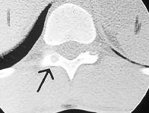

OO in long bones:
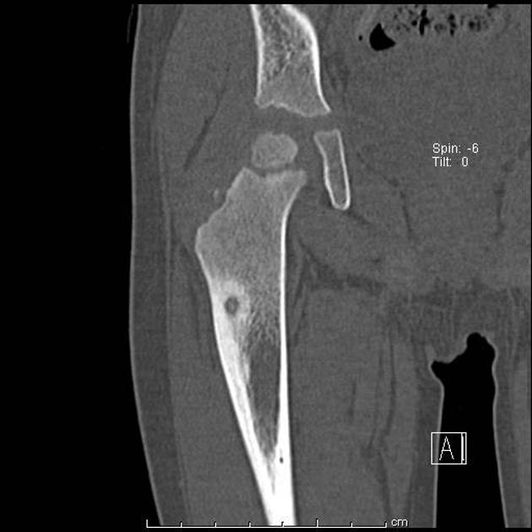
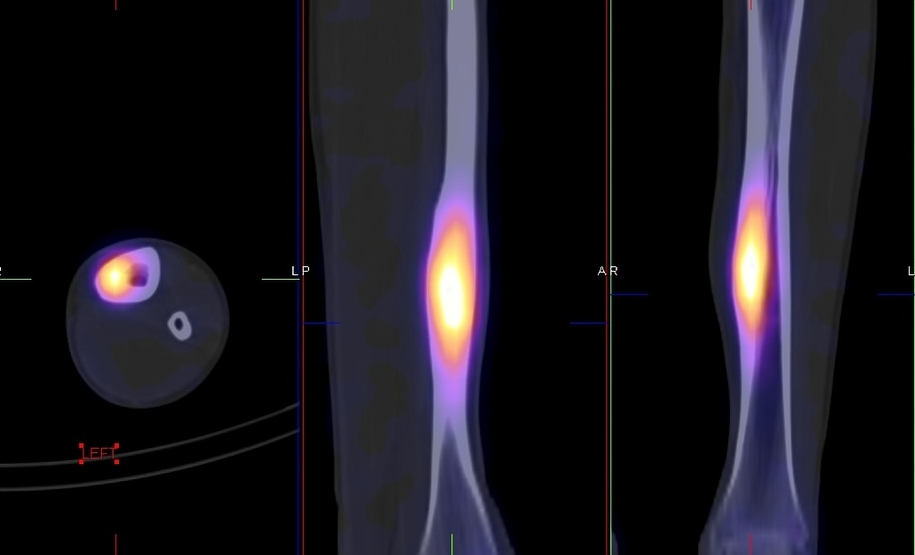

Osteoblastoma
- histologically similar (but not so well organized) as osteoid osteoma* - expansile lesion with interconnecting trabecular bone and fibrovascular stroma, multiple small calcifications and peripheral scalloped and sclerotic rim.
*but behaviorally very different – osteoblastoma is locally aggressive (bone destruction, infiltration of surrounding tissue)
Histology at low and high magnification:
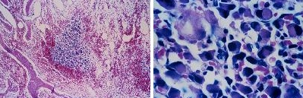
- 10-15% have aneurysmal bone cyst component.
- can attain considerable size, typically > 1.5-2.0 cm. (vs. osteoid osteoma).
- 35% of all body osteoblastomas occur in spine.
- equal distribution throughout spinal column.
- 55% cases involve posterior spinal elements; 42% - vertebral bodies.
- 2-3rd decade of life (i.e. peak incidence below 30 years).
- 2:1 male-to-female predominance.
- dull aching pains (neither nocturnal nor relieved by aspirin), local scoliosis, spinal stiffness; if tumor is large enough → encroaching on spinal cord!
- X-ray: central radiolucent area surrounded by sclerotic rim.
- CT - areas of mineralization, expansile bone remodeling, and sclerosis or thin osseous shell at its margins.
- MRI (nonspecific enhancement).
- bone scan - marked radionucleotide uptake.
- treatment of choice - wide local resection with spine stabilization; both anterior and posterior procedures may be required for total removal.
- not radiosensitive + irradiation may cause malignant transformation.
- 10-20% recurrence rate.

Osteoblastoma in posterior elements of C3 and C4 (X-ray, MRI):
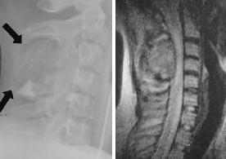

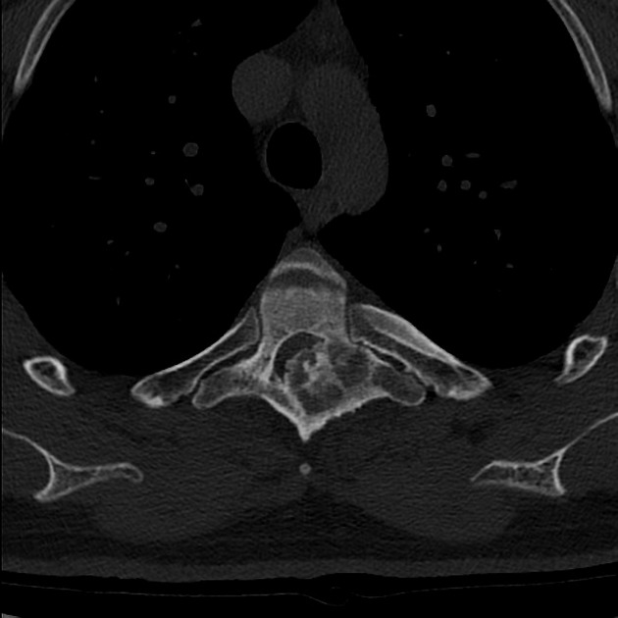

Osteosarcoma (osteogenic sarcoma)
- most common sarcoma of the spine (3-15% of all primary tumors of the spine)
- 0.6-3.2% of all body osteosarcomas occur in spine (50% represent metastases);
- most common in lumbosacral segments.
- eccentric involvement of vertebral body with extension into posterior elements is common.
- median age of presentation - 40 years; slight male predominance.
- the most common primary malignant bone tumor in the pediatric population (one of the lowest survival rates among pediatric cancers).
- risk factors: Paget's disease (Paget patients make up as much as 50% of the patients), previous irradiation.

Pathology, Histology
- firm and calcified and consist mostly of sarcomatous connective tissue that forms osteoid tissue or bone.
- blastic malignant spindle cells produce osteoid matrix.
- conventional osteosarcomas - three subtypes based on the matrix produced: osteoblastic (55%), fibroblastic (23%), and chondroblastic (22%).
- telangiectatic osteosarcomas are a separate classification of osteosarcoma that more closely resembles an ABC (in addition to the production of an osteoid matrix, there are also numerous blood-filled sinusoids).
- small-cell osteosarcoma - small cells with hyperchromatic nuclei positive for CD99; sometimes confused for a Ewing sarcoma, but can be distinguished by the presence of an osteoid matrix.
- epitheloid osteosarcoma - sometimes mistaken for a carcinoma, but the presence of an osteoid matrix leads to a correct diagnosis.

Clinical features
- pain and palpable mass; neurologic symptoms are found in 70-80% patients.
- location: more common in the thoracic spine and sacrum; typically arise in the posterior elements.

Diagnosis
- X-ray, CT - osteolytic or osteoblastic changes - densely mineralized matrix (“ivory vertebrae”); loss of vertebral height with sparing of adjacent disc.
- MRI – if large amount of mineralized matrix is present, lesion may appear with low signal intensity on all sequences.

Treatment - Spine Oncology Study Group recommends:
Sciubba D, Okuno S, Dekutoski M, Gokaslan Z: Ewing and osteogenic sarcoma: evidence for multidisciplinary management. Spine 34:S58–S68, 2009.
- all patients with osteosarcoma of the spine must be treated with neoadjuvant chemotherapy.
- high-dose methotrexate and doxorubicin in combination with a variety of other agents (cisplatin, ifosfamide, bleomycin, actinomycin D, and alfa-interferon).
- osteogenic sarcoma is unique* tumor showing good results with chemotherapy: a prospective randomized trial demonstrated 3-year event-free survival rates of 71% and 78% for patients treated with either cisplatin, doxorubicin, and methotrexate vs. muramyl tetrapeptide following resection, respectively.
*another is chordoma (sensitive to tyrosine kinase inhibitors)
- surgical resection should be attempted when it is felt a complete resection can be achieved - associated with an improvement in survival and local control.
- emergency decompression followed by more radical resection is also possible.
- postoperative radiation should be considered to improve survival.
- e.g. conventional external photon beam irradiation (median tumor dose 45 Gy).
- radiation as the primary treatment modality produces poor results.

Prognosis - poor (in old series - median survival of 10 months from diagnosis; Cooperative Osteosarcoma Study Group (COSS) reported median survival of 23 months; now long term survivors are reported).
- poor prognostic factors: metastases (p = .004), large tumors (> 10 cm) (p = .010), and sacral tumors (p = .048).

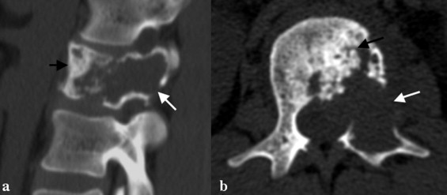

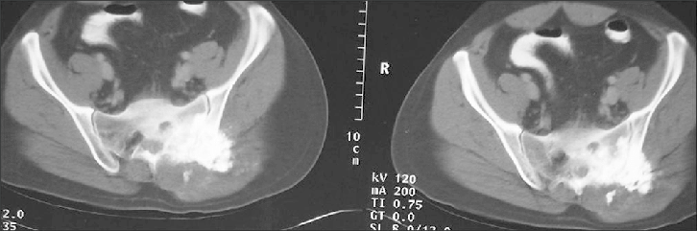

Chondroblastic osteosarcoma – T2 MRI (20 yo M patient underwent thoracic laminectomy; resistant to chemotherapy; eventually developed paraplegia – not operative candidate):
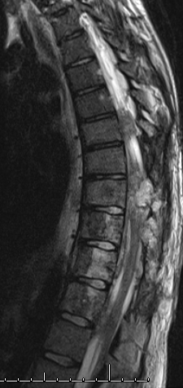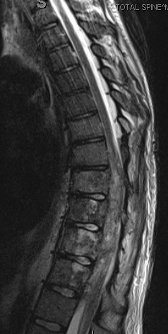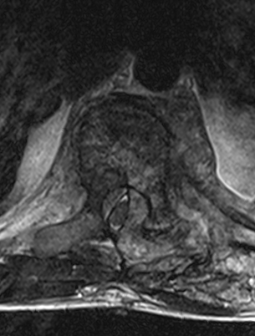
Source of pictures: Viktoras Palys, MD >>

Giant cell tumor (osteoclastoma)
- benign highly vascular (5% malignant - related to previous irradiation), but locally aggressive.
- multinucleated giant cells with fibrous stroma consisting of mononuclear cells; no active matrix production.
- 7% of all GCTs in body (spine is 4th most common site).
- most occur in sacrum, thoracic spine.
- occur in 3-5th decades of life; more common in women.
- can dramatically increase during pregnancy (hormonal influences).
- pain with neurologic impingement.
- X-ray - large osteolytic expansile lesions – “soap bubbles” (in sacrum - destruction of sacral foraminal lines, can extend past sacroiliac joints bilaterally).
- bone scan - diffuse radionucleotide uptake with areas of central photopenia and increased peripheral uptake.
- angiography - hypervascular lesions.
- CT - soft tissue attenuation with well-defined margins and thin rim of sclerotic bone.
- MRI - heterogeneous low-to-intermediate signal intensity (on both T1 and T2).
- treatment: (arterial embolization +) complete resection (better en bloc) or curettage; radiation reserved for surgically inaccessible tumors (another effective option - denosumab).
- recurrence rates 40-60%.

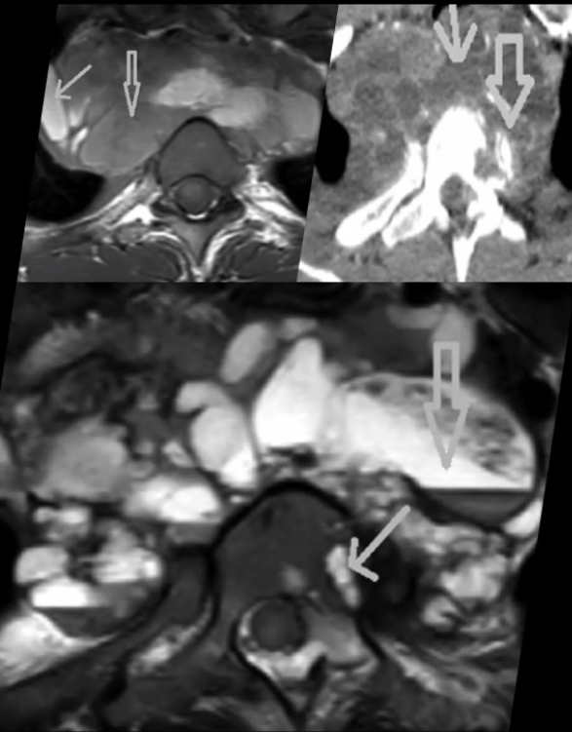

Contrast T1-MRI - C2 is replaced by tumor and large extraosseous mass is compressing spinal cord:
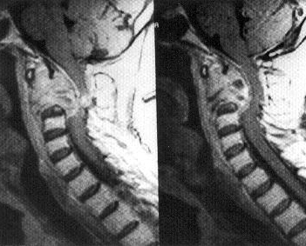
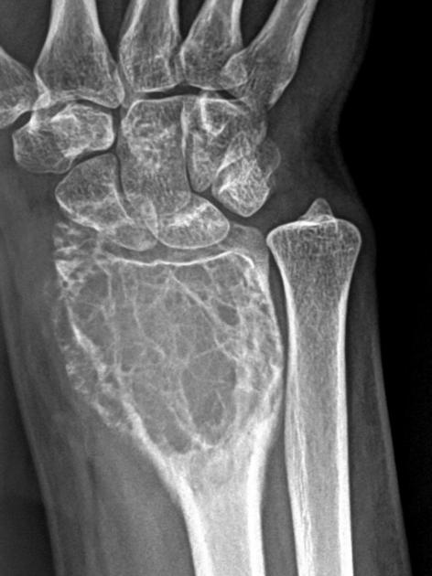

Osteochondroma (solitary osteocartilaginous exostosis)
- etiology - trapping of physeal cartilage outside growth plate during skeletal development.
- 7-9% patients with multiple hereditary exostoses (MHE) have multiple spinal lesions.
- pathology - benign lesion – pedicle of normal bone (protruding from cortex) with proliferating cartilaginous cap (bone is normal, but abnormal growth occurs at and as result of cartilage cap; continuity of lesion with marrow and cortex of underlying bone is present); may be sessile or pedunculated; typically do not increase in size after skeletal maturity occurs (growth after skeletal maturity, especially when accompanied by pain and bony destruction on imaging should prompt concern for malignant transformation).
- 4% of all solitary spine tumors.
- more common in cervical spine (esp. C2).
- posterior elements usually are involved.
- typically in males < 30 years (younger in MHE).
- neurologic deficits are more frequent in MHE (77% vs. 34%).
- X-ray (normal in 15%) - round bony exostosis with radiolucent cartilaginous cap protruding posteriorly from spinous process.
- CT - study of choice: calcified mass, often attached to a bony surface via a bony pedicle; typically no bony destruction unless malignant transformation has occurred (a rare finding).
- T1-MRI - central area of high signal intensity represents marrow (intermediate intensity on T2); cortex of exostosis - low signal intensity; hyaline cartilage cap - low signal intensity (high intensity on T2); post-contrast enhancement usually spares the cartilaginous cap; if cartilage cap is > 2 cm - suspect malignant transformation to chondrosarcoma (very rarely, osteosarcoma).
- treatment: complete surgical resection without radiation is curative.

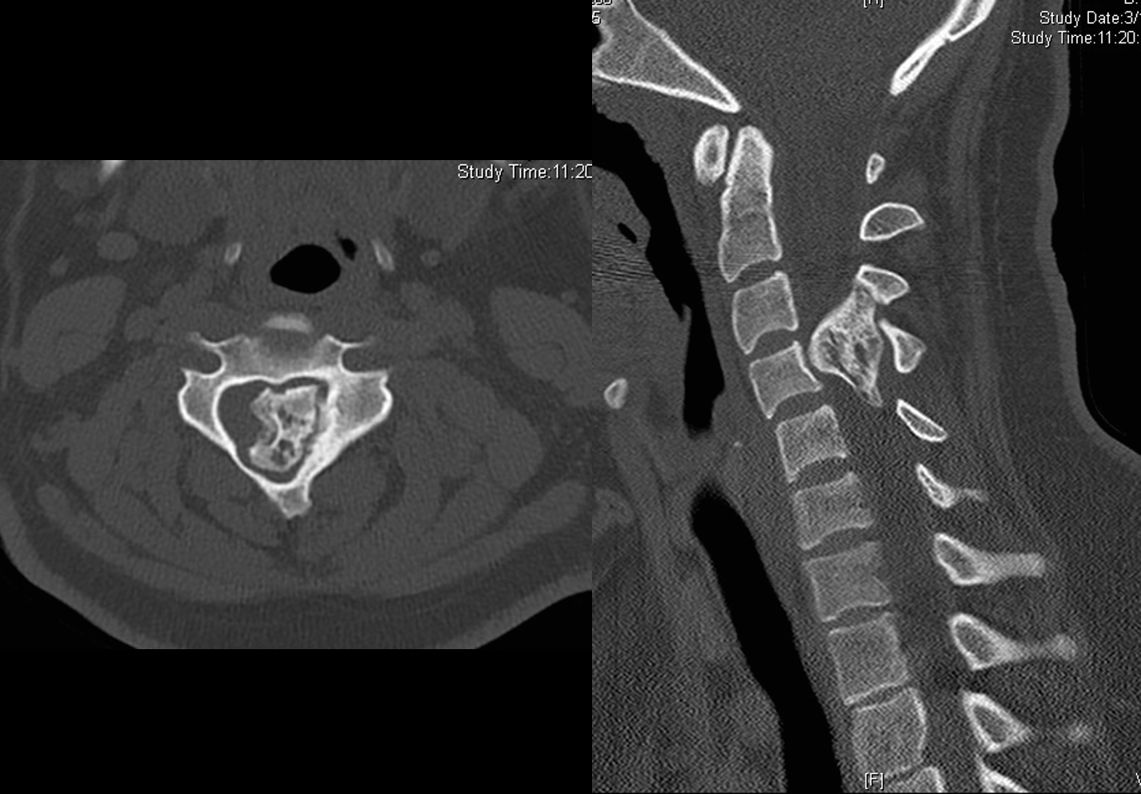
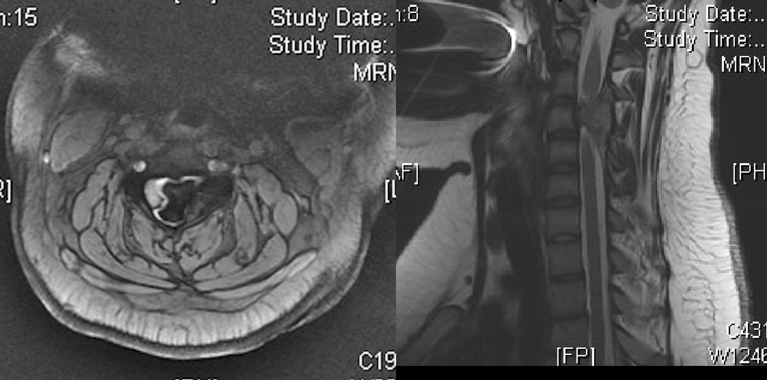
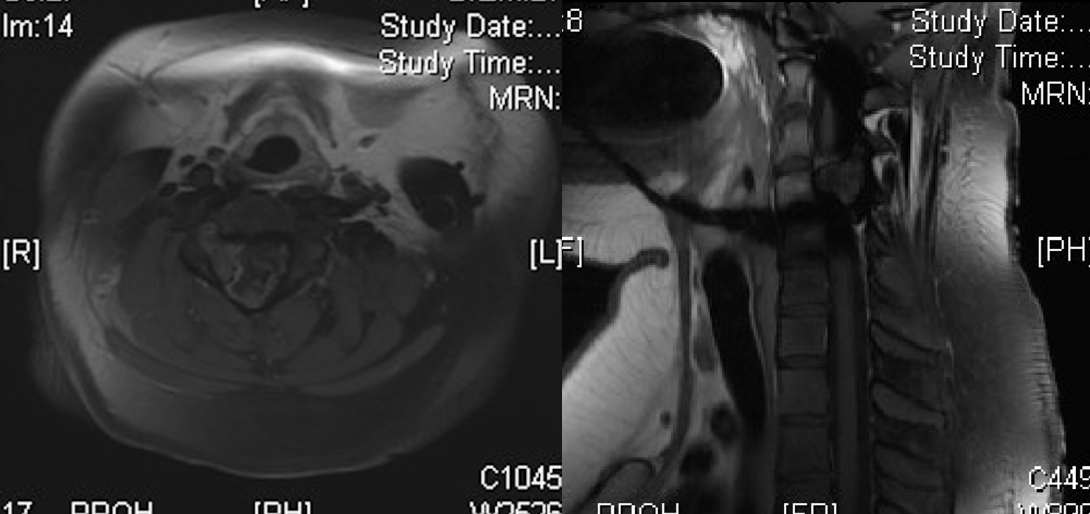

Chordoma

Chondrosarcoma
- malignant (but low-grade) cartilage producing tumors (round cellular stroma in chondroid matrix).
- lungs are most frequent sites of metastasis.

Histology at 40 times magnification:
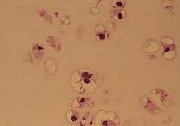

- second most common nonlymphoproliferative tumor of spine (7-12% of all spine tumors); spine is primary site in 3-12% of all body chondrosarcomas.
- thoracic spine is most common site.
- typically involve vertebral bodies.
- 35% tumors involve adjacent vertebral levels (by extension through disc).
- men : women = 2-4 : 1.
- mean age of presentation - 45 years.
- pain is frequent and constant finding.
- X-ray - bone destruction; mineralization in soft tissue component of lesion; characteristic chondroid matrix in form of rings and arcs (70%).
- tumors that arise from malignant transformation of osteochondromas are observed as thickening of cartilaginous cap.
- bone scan - intense heterogeneous uptake.
- angiography - very vascular tumor.
- treatment: en bloc surgical resection (vertebral corpectomy and strut bone grafting sometimes may be necessary for complete excision).
- adjunctive chemoradiotherapy is controversial and limited (so surgery is the only chance!).
- if wide marginal resection cannot be achieved → tumor recurrence and death in 74% cases.
- mean survival - 5.9 years.

X-ray, CT, MRI of same patient:
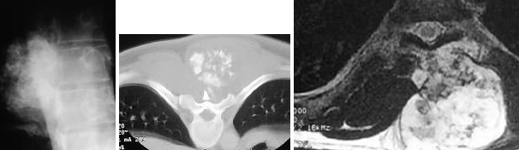

Recurrent chondrosarcoma of C4 (A - T1; B - T2-MRI): large mixed signal mass invading spinal canal; previous laminectomy:
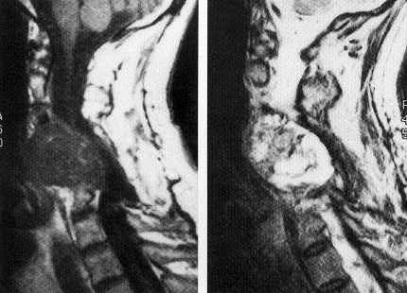

Aneurysmal bone cyst
- etiology:
Primary ABC (65-95%) - result from micro-trauma to bone with local circulatory disturbance.
Secondary ABC - result from underlying neoplasms (giant cell tumors, osteoblastomas, chondroblastomas, osteosarcomas) - neoplasms produce venous obstruction and possible arteriovenous malformations and set stage for ABC formation.
- macro - expansile (locally aggressive) area of bone remodeling, septations within mass, thin outer periosteal rim of bone.
- micro - multiloculated blood-filled cystic spaces not lined by endothelium (i.e. not vascular channels):
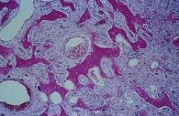
- may extend into adjacent vertebrae, discs, ribs, and paravertebral soft tissues.
- typically affect young patients (80% < 20 years).
- 10-30% of all body ABCs occur in spine;
- thoracic and lumbar spine are affected most commonly.
- predilection for posterior elements; 75% extend into vertebral body.
- painful scoliosis; 60% cause neurologic deficits.
- X-ray - honeycomb trabeculated pattern with eggshell-thin cortical margin.
- bone scan - peripheral uptake↑ with central "cold area" (“doughnut” sign).
- angiography - hypervascular mass (multiple vascular "lakes").
- CT / MRI - cystic lesion with internal septations and lakes containing fluid levels (visualized on MRI); enhancement of periosteal rim and septations but not cystic spaces.
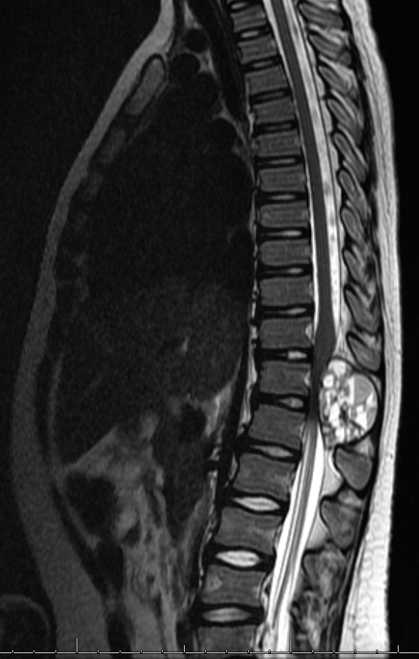
Picture source: VCU
- treatment - embolization + radiation (or postoperative) → complete resection.
- recurrence rate ≥ 20-30%.

Ewing sarcoma
- etiology - 11;12 chromosomal translocation.
- malignant round cell tumor (large sheet of homogenous small, round, blue cells divided by septa; abundant collagen); areas of osteonecrosis are found.
- most common nonlymphoproliferative primary malignant tumor of spine in children.
- 3-10% of all body Ewing sarcomas occur in spine (most commonly metastatic foci than primary lesions).
- most commonly sacrococcygeal region.
- centered primarily in vertebral body.
- patients 10-20 years.
- X-ray - permeative bone lysis, osseous expansion; diffuse sclerosis (69%) is associated with osteonecrosis.
- treatment - radiation & chemotherapy - almost 100% local control with 86% long-term survival rate (but sacral tumors have 62% local control and only 25% long-term survival rate - because of tendency for delayed clinical presentation and larger tumor size).

Eosinophilic granuloma
- one end of spectrum of systemic diseases, including Letterer-Siwe and Hand-Schiller-Christian disease.
- micro - bone is infiltrated and destroyed by histiocytes and eosinophils.
- most common benign bone tumor of children.
- vertebral involvement occurs in 10-15% cases.
- frequently in thoracic spine.
- peak incidence 5-10 years.
- acute onset of chest or back pain, focal sprain, torticollis, kyphoscoliosis, and, rarely, neurological compromise.
- X-ray - classic “vertebra plana” (symmetrically flattened and thinned vertebral body).
- treatment: curettage → low-dose radiotherapy; multiregimen chemotherapy for systemic eosinophilic granulomas.

Hemangioma
- benign tumor of newly formed blood vessels within vertebral body and arch.
- most common benign bone tumor (9-13% autopsies).
- in 33% cases, multiple vertebra are involved.
- confined to vertebral bodies but can extend into neural arches.
- usually* do not produce symptoms - usually discovered incidentally.
*pathologic vertebral fractures or epidural extension can occur - most frequently in thoracic region of teenaged girls.
- X-ray - coarse vertical striations or trabeculae ("corduroy cloth" impression).
- CT - dilated vascular spaces are easily seen (characteristic spotted appearance).
- MRI - bright high-intensity signals (on both T1 and T2).
- angiography - vascular lacunae and multiple feeding vessels (readily amenable to embolization).
- treatment - low-dose radiotherapy and external bracing;
- asymptomatic hemangiomas are left untreated.
- vertebroplasty
- spinal cord compression → vertebrectomy and spine stabilization (preoperative embolization* of tumor feeders is recommended).
*percutaneously puncturing vertebral body and injecting acrylic within it (vertebroplasty).

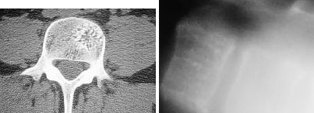

Capillary angioma of T8 involving vertebral body, transverse process and epidural space (A – T2-MRI, B – contrast T1-MRI):
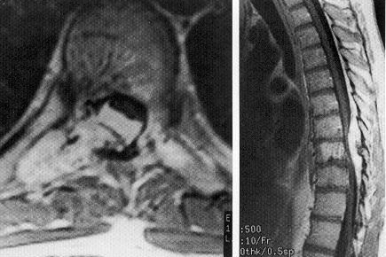

Melanoma
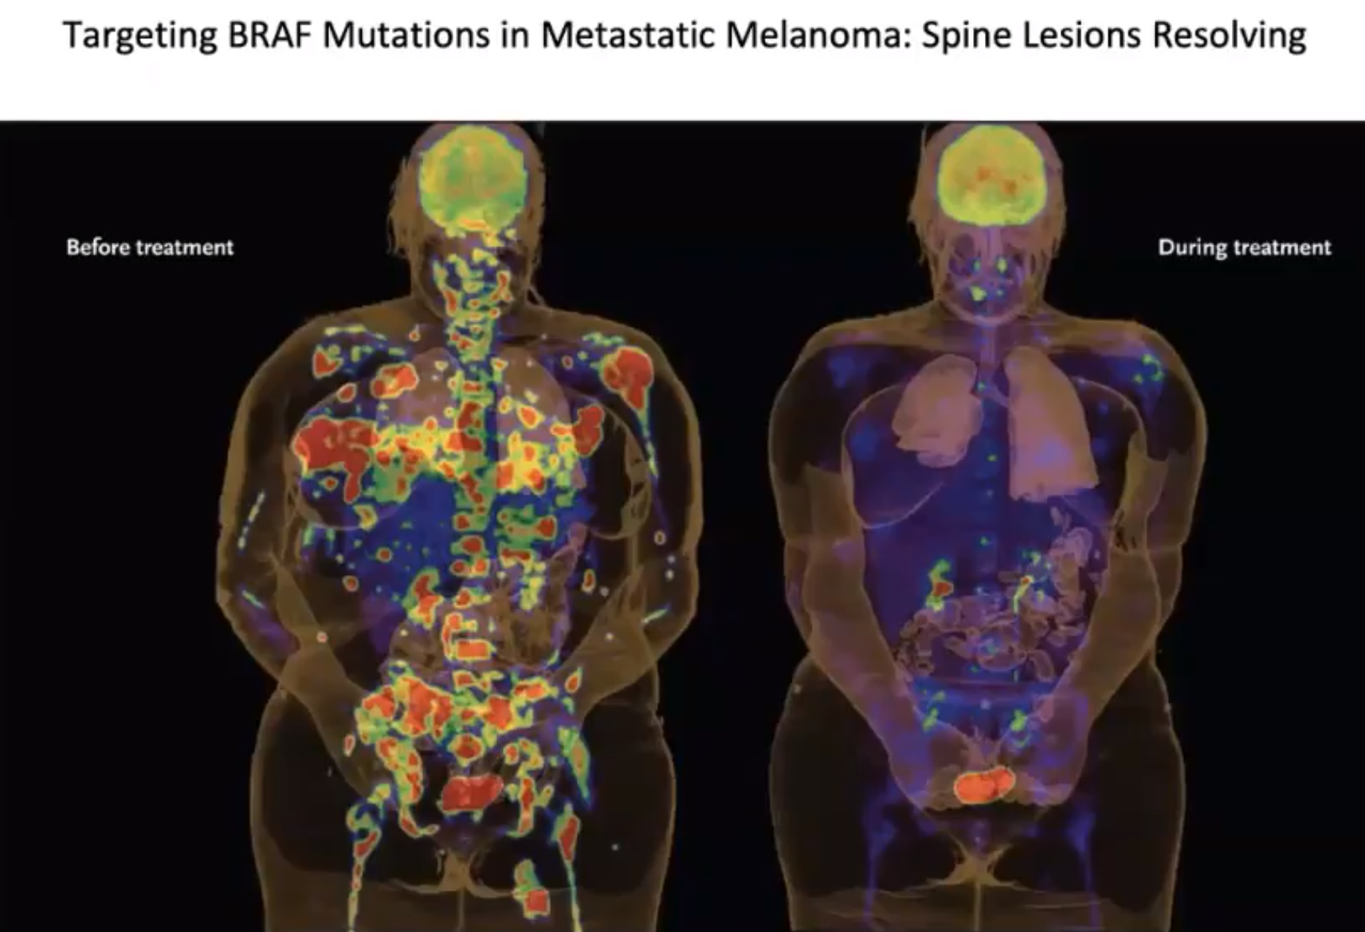

Angiolipoma
- very rare congenital vascular tumor.
- mature lipocytes and angiomatous proliferation, with or without other mesenchymal elements (e.g. muscles, cartilage).
- predominantly in thoracic spine.
- commonly, multiple, cystic, and encapsulated; less commonly, infiltrate entire vertebral body and epidural space.
- X-ray - coarse trabecular pattern (as hemangioma).
- MRI - high-signal intensity in vertebral body, consistent with fatty infiltration.
- treatment: total excision (anterior vertebrectomy or posterior laminectomy).
- angiolipomas do not undergo malignant transformation - no role for radiotherapy.

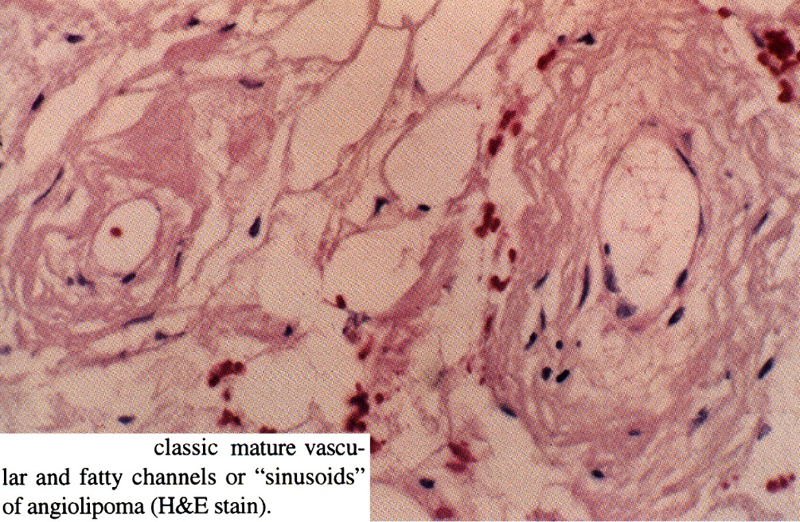
Source of picture: Frank H. Netter “Clinical Symposia”; Ciba Pharmaceutical Company; Saunders >>

Meningioma
- can be intradural and / or extradural.

Specific Tumor Types (Metastases)
Solid Tumors
Non-small cell lung cancer
- patient prognostic heterogeneity based on gene mutations (e.g. EGFR+ patients respond well to systemic therapy)

Renal cell carcinoma
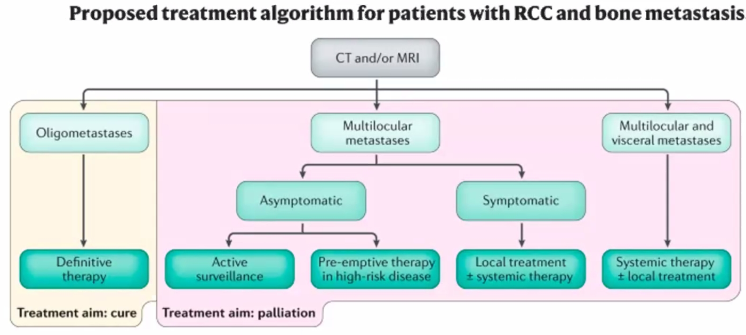

Hematological Tumors
N.B. hematological tumors (lymphoma, multiple myeloma) – treatment is medical; surgery indications are rare:
- acute neurological deficit
- augmentation for intractable pain

Multiple myeloma
- systemic disease with areas of local bone destruction (diffuse multifocal involvement of hematopoietic bone marrow); spine gets involved in 30-50% MM cases (esp. thoracic spine).
- malignant plasma cells produce abnormal quantities of immunoglobulins.
- most common primary malignancy of spine!
Multiple myeloma and solitary plasmacytoma account for 45% of all malignant bone tumors
- peak incidence in 6-8th decade.
- very soft vascular tumor (near-fluid consistency).

Clinical Feature
- back pain that might be relieved by recumbency (different than other metastases).

Diagnosis
- blood - total protein↑ with albumin↓, hypercalcemia, ESR↑;
- Bence Jones monoclonal antibody protein in urine.
- serum / urine protein electrophoresis.
- bone scan – in 33% cases, uptake may be decreased ("cold" spots); skeletal survey with plain X-rays / CT is more helpful* for detecting occult lesions – multiple round, "punched-out" or "moth-eaten" appearances (osteolysis without sclerotic edges) with pathological fractures involving anterior column
- compared with metastases, posterior elements are involved less frequently.
*MRI is even more sensitive!

Treatment - radiation to affected spine & chemotherapy
- MM is radiosensitive – radiotherapy can be used if cord compression is due to epidural disease.
- radiation can affect genetic markers – important for chemotherapy selection – bet to avoid radiotherapy if possible.
- vertebral augmentation is a good option for pain without neurological deficits (soft tumor allows impressive cement filling with good pain relief).
- indications for surgery:
- cord compression is due to bone/ligaments or deformity (as a result of destruction by tumor).
- rapid progression of symptoms is best managed with surgery because the effects of radiation can initially be associated with swelling
- high SINS score (→ adjuvant radiotherapy once healing of surgical site has been obtained).
- 5-yr survival – 18-30%.

Solitary plasmacytoma
- solitary lesion that usually affects vertebral body.
- self-limited, but up to 50% dedifferentiate into multiple myeloma (monitor for 20 years following original diagnosis).
- patients younger (males > females) than in multiple myeloma.
- X-ray - single lytic lesion (may need biopsy for definitive diagnosis)
- treatment: radiation 35-50 Gy and bracing (if pathologic fracture / neurological compromise → surgical vertebrectomy and stabilization → adjuvant radiotherapy).
- 5-year survival > 60%.

Lymphoma
- tends to spread in epidural space, through foramina (but not destroying the bone).
- biopsy only.

Bibliography for ch. “Neuro-Oncology” → follow this link >>

Viktor’s Notes℠ for the Neurosurgery Resident
Please visit website at www.NeurosurgeryResident.net

