Nerve Tumors
Last updated: December 22, 2020
Classification 1
Specific Tumor Types 1
Schwannoma (s. Neurilemoma, Neurinoma) 1
Pathology 1
Etiology 4
Clinical Features 4
Diagnosis 4
Staging 4
Treatment 4
Neurofibroma 5
Pathology 5
Clinical Features, Diagnosis, Treatment 5
Schwannoma vs. Neurofibroma 5
Malignant peripheral nerve sheath tumor (s. malignant schwannoma, neurofibrosarcoma, neurosarcoma) 6
Peripheral Nerve Metastases 7
Lipofibromatosis of median nerve 8

Schwannoma of Cranial Nerves → see p. Onc62 >>
Nerve tumors of Posterior Mediastinum → see p. 2159 >>

Classification
I. Neoplasms of nerve sheath origin:
A. Benign:
- Schwannoma
- Neurofibroma
B. Malignant:
- Malignant schwannoma
- Nerve sheath fibrosarcoma

II. Neoplasms of nerve cell (neural crest) origin:
- Neuroblastoma  - Ganglioneuroma  - Pheochromocytoma | see p. Onc20 >>  see p. Onc20 >>  see p. 2741 >>

III. Metastases to peripheral nerves

IV. Neoplasms of non-neural origin:
- Lipofibromatosis of median nerve
- Intraneural lipoma, hemangioma, ganglion

V. Nonneoplasms:
- Traumatic neuroma  - Compressive neuroma (Morton's neuroma) | see p. PN7 >>  see p. PN5 >>

  - most are benign.
  - can arise on any nerve trunk or twig (many PNS tumors are subcutaneous)

Specific Tumor Types
Schwannoma (s. Neurilemoma, Neurinoma)
Neurinoma is obsolete term
- most common neurogenic tumor! (exact prevalence unknown)
Schwannoma of Cranial Nerves → see p. Onc62 >>
Pathology
  - benign tumor of Schwann cells (derived from neural crest, stain positively for S-100*).
*acidic protein commonly found in supporting cells of central and peripheral nervous system - important diagnostic tool!
  - usually solitary, typically limited to one nerve fascicle or bundle.
  - grows eccentrically in nerve sheath (nerve fibers displaced peripherally*) - tumor is relatively easy to dissect free. *although axons may become entrapped in capsule

Compress, rather than invade, parent nerve

  - well-defined, fibrous capsule (vs. neurofibroma), frequently with overlying vessels.
  - in very large masses, degenerative cysts, hemorrhage, or dystrophic calcification may be present.
  - slow growing.
  - malignant degeneration is extremely rare (primary malignant tumors of Schwann cells are histologically distinct).
  - histologically – alternating 2 distinct regions:
Antoni A areas – compact cellular regions with spindle Schwann cells (positive for S-100 protein, twisted nuclei, indistinct cytoplasmic borders) in many intersecting bundles; cells may palisade around eosinophilic Verocay bodies (tight, discrete aggregate of spindle-shaped, palisaded nuclei with central “nuclear-free” fibrillary area, representing collection of cytoplasmic processes of tumorous Schwann cells); little stromal matrix.
Antoni B areas – much less cellular (spindle or oval Schwann cells arranged haphazardly in loose meshwork); background of myxomatous loose connective tissue with microcystic changes.
  - electron microscopy – all Schwann cell surface is coated with basal lamina; basal lamina lies in stacks between cells along with typical and long-spacing collagen fibrils with 130-nm periodicity (Luse body).

Four major forms:
- Conventional (common, solitary) form
- Cellular form – locally aggressive hypercellular mass of spindle-shaped cells forming intertwining fascicles and cords; characteristic mild-to-moderate cytologic atypia and low mitotic rate (5 mitoses per 20 high-powered fields); most commonly as tumor of mediastinum, retroperitoneum, and deep soft tissue.
- Plexiform form (5%) – multinodular growth pattern of predominantly Antoni A tissue in dermis and subcutis.
- Ancient form – entirely composed of Antoni B tissue with degenerative changes (cystic with calcification) and cytologic atypia (but mitotic figures are rare).

Location (any part of PNS) - in order of decreasing frequency:
- head & neck (50% of all schwannomas) – 2-10% of intracranial tumors (almost exclusively on sensory nerves CN8 > CN5 > CN9 > CN10) see p. Onc62 >>
N.B. CN1 and CN2 are myelinated by oligodendroglia!
- flexor surfaces of upper and lower extremities (esp. near elbow, wrist, and knee - peroneal and ulnar nerves).
- trunk - spinal roots (tumors often have dumbbell shape), sympathetic nerves (posterior mediastinum and retroperitoneum).

Schematic illustration :  Top - solid lesion arises within nerve composed of single fascicle.  Middle - Schwann cell proliferation within epineurium and peripherally displaced nerve fibers, resulting in nodular eccentric growth; no capsule is formed.  Bottom - larger tumor eventually becomes separated from surrounding fascicles by capsule formed from perineurium and epineurium; occasional axons are present: | 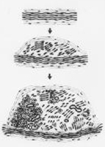 | Verocay body:  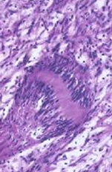

Cut surface of intradermal plexiform (nodular) variety - area of nodularity is clearly discernible:
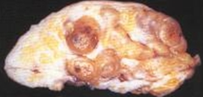

Low-power photomicrograph of dermal plexiform neurilemoma:
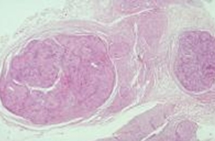

Uniformly positive anti–S-100 protein immunostaining:
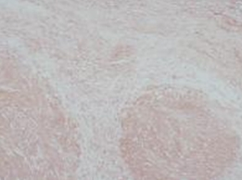

Large neurilemoma (5 cm in diameter) showing irregularly lobulated and secondary degenerative changes, i.e. partly cystic with calcification (so-called ancient change); hemorrhage and opaque creamy-yellow areas of tumor are also seen:
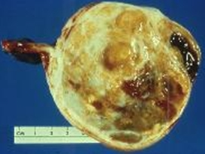

Electron micrograph of Luse body (typical collagen fibrils, 130-nm periodicity) and adjacent basement substance:
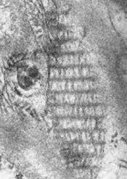

Cellular areas (Antoni A), including Verocay bodies (far right), as well as looser, myxoid regions (Antoni B):
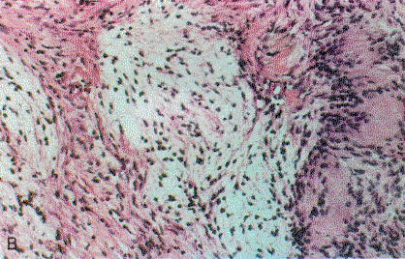

Cut surface of schwannoma (similar to that of many mesenchymal neoplasms, with "fish flesh" soft tan):
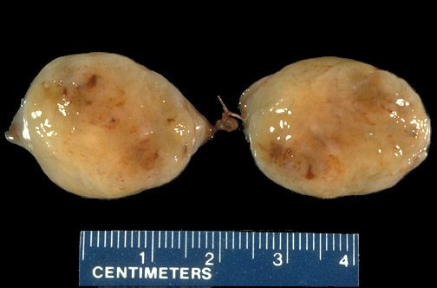
Source of picture: “WebPath - The Internet Pathology Laboratory for Medical Education” (by Edward C. Klatt, MD) >>

Schwannoma removed from surface of peripheral nerve:
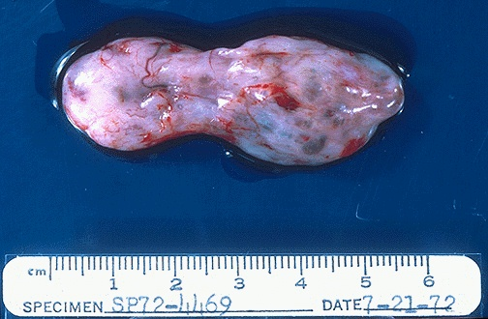
Source of picture: “WebPath - The Internet Pathology Laboratory for Medical Education” (by Edward C. Klatt, MD) >>

Left - "Antoni A" pattern with palisading nuclei surrounding pink areas (Verocay bodies).
Right - "Antoni B" pattern with looser stroma, fewer cells, and myxoid change:
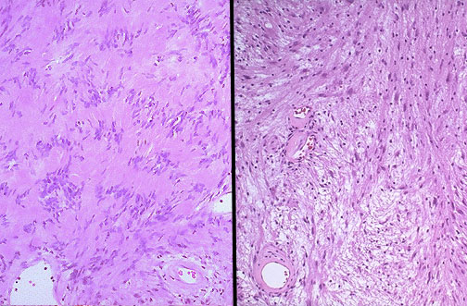
Source of picture: “WebPath - The Internet Pathology Laboratory for Medical Education” (by Edward C. Klatt, MD) >>

Verocay bodies:
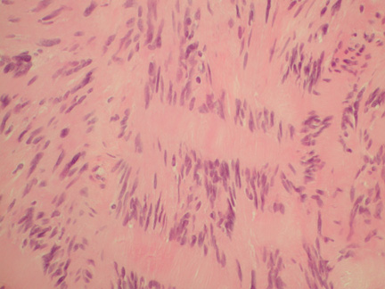

Schwannoma at higher magnification - spindle cells (like most neoplasms of mesenchymal origin), but cells are fairly uniform + plenty of pink cytoplasm:
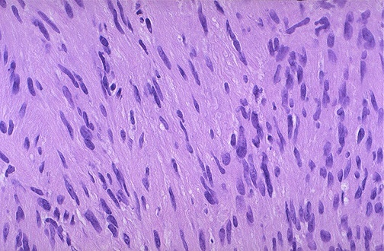
Source of picture: “WebPath - The Internet Pathology Laboratory for Medical Education” (by Edward C. Klatt, MD) >>

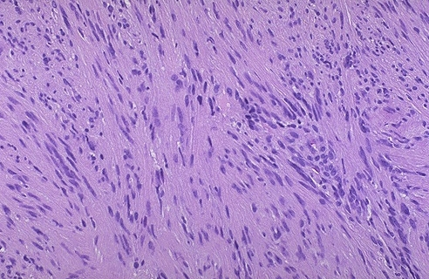
Source of picture: “WebPath - The Internet Pathology Laboratory for Medical Education” (by Edward C. Klatt, MD) >>

Etiology
  - most schwannomas have chromosome 22 aberrations - alteration or loss of NF2 gene (22q12) product (Merlin) is postulated to be involved in schwannoma formation.
  - rare schwannomas are associated with genetic syndromes:
Carney complex - autosomal dominant disorder:
          - psammomatous melanotic schwannoma (10% are malignant) - melanin deposition + concentric calcified bodies (psammoma bodies).
          - lentigines (melanocytes are also of neural crest origin)
          - cardiac myxomas
          - endocrine overactivity.
Neurofibromatosis type 2 (cranial or spinal root schwannomas)
Neurilemmomatosis - autosomal dominant variant of NF2 (characterized by multiple subcutaneous schwannomas).

Clinical Features
- vague symptoms (average interval before diagnosis ≈ 5.0-5.5 years) affect persons of any age (most commonly 20-50 yrs), females > males:
  - cosmetic deformity - slow-growing smooth-surfaced subcutaneous mass (< 10 cm), sometimes with purplish skin discoloration.
    - most are nontender.
    - mass is mobile in transverse plane and tethered along nerve axis.
    - waxing and waning of tumor size may be noted (fluctuations in amount of cystic change).
  - neurologic symptoms (late; more severe in tumors associated with NF-2) - compressive neuropathy:
pain constant burning but might be intermittent depending on anatomical location!
spinal roots – may compress spinal cord.
sciatic nerve – mimic discogenic low-back pain.
limb nerves – mild, localized pain and paresthesia.
tumors in compartments – compartment syndromes (thoracic outlet syndrome [C7 nerve root], carpal tunnel syndrome, tarsal tunnel syndrome)

Diagnosis
  - plain X-ray - only for intraosseous lesion (rare) - benign-appearing, well-circumscribed lesion (if involves sacrum - massive bony destruction may be present).
  - CT - hypodense to isodense; prominent enhancement*; intratumoral calcification is rare.
  - MRI - sharply circumscribed round or oval mass; hypointense on T1, hyperintense on T2; prominent enhancement*.
*uniform in smaller tumors but frequently heterogeneous in larger lesions (cystic changes).
  - PET – if uptake is high, suspect malignant peripheral nerve sheath tumor.
  - biopsy may be needed (esp. for bone lesions or large soft-tissue lesions); excruciating pain triggered by insertion of needle is clue in diagnosis of nerve tumors!

Staging
- Enneking system:
Grade 1 lesions – inactive
Grade 2 lesions – deform surrounding tissues but are not destructive or locally aggressive.
Grade 3 lesions – locally aggressive (may invade local tissues) but no metastatic potential.

Treatment
      - Resection – lesion is excised marginally, and nerve fibers are spared.
      - Stereotactic radiosurgery – for small intracranial schwannomas.
      - If resection would lead to significant functional deficit (unusual case):
        - observation.
        - interlesional resection.

  - most common complication is initial neurapraxia (can be permanent!).
  - recurrence is unlikely (incomplete excision - capable of slow recurrence).
Higher recurrent rates:
          - intraspinal, sacral, intracranial tumors
          - plexiform form
          - tumors in association with NF2

Neurofibroma
Pathology
  - benign tumor of Schwann cells, fibroblasts, perineurial cells, and frequently nerve fibers;
    - extensive amounts of collagen with axons dispersed throughout tumor (nerve fibers run through tumor – “shredded carrots”) - excision impossible without sacrificing nerve.
    - immunoreactivity for S-100 protein is observed in only portion of cells (vs. uniform reactivity in all cells throughout schwannoma).
    - like schwannomas, neurofibromas grow as Schwann cells in tissue cultures, identifying common cellular type.
  - tend to be multiple (suspect neurofibromatosis-1).
  - fusiform growth in endoneurium - difficult to dissect.
  - lack thick collagenous capsule (vs. schwannomas) - surrounded by variably thickened perineurium and epineurium.
  - lack Antoni type A and B patterns and Verocay bodies typical of schwannomas.
  - firm and lobulated (never cystic).
  - 13-15% undergo malignant degeneration to sarcoma.

“Shredded carrots”:
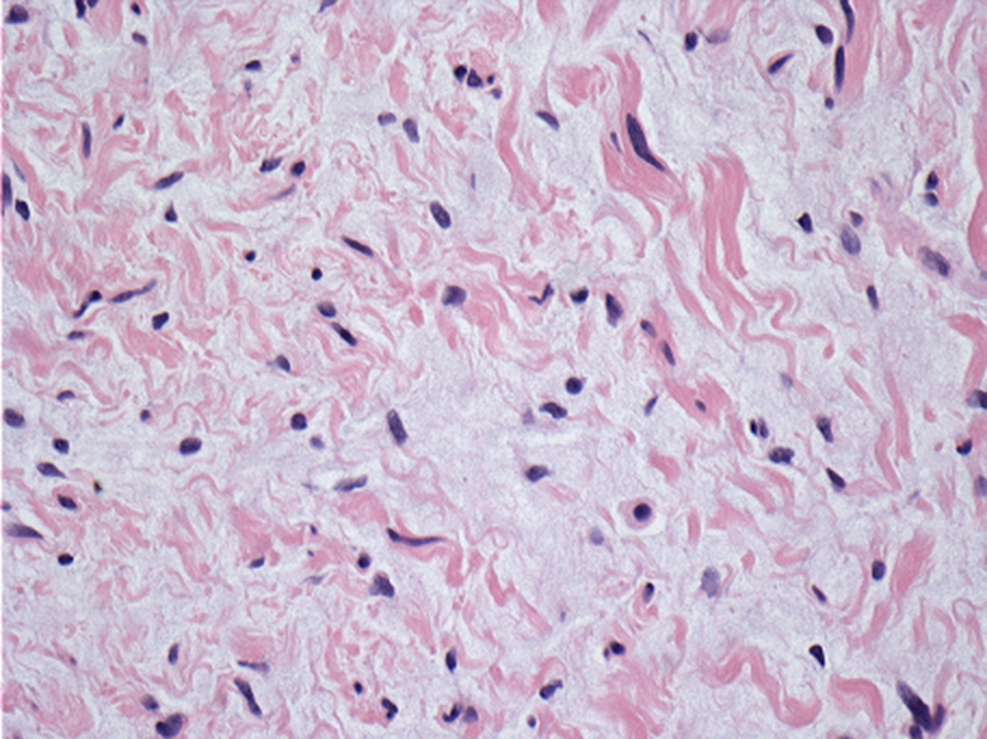

Special Type – Plexiform Neurofibroma (anomaly rather than true neoplasm):
            - considered by some to occur only in neurofibromatosis-1.
            - large nerve trunk is most common site.
            - frequently multiple.
            - loose, myxoid background with low cellularity.
            - proximal and distal extremes of tumor have poorly defined margins (tumor fingers and individual cells insert themselves between nerve fibers).
            - significant potential for malignant transformation.

Clinical Features, Diagnosis, Treatment
- see “Schwannoma”
  - skin lesions are evident as nodules (± overlying hyperpigmentation); may grow large and become pedunculated.
  - neurofibromas may start grow faster after incomplete resections (attempt radiotherapy first!)

Extraspinal neurofibroma (T2-MRI) - huge tumor in left posterior triangle without spinal involvement (P = posterior):
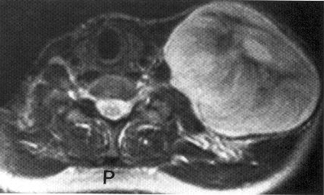

Schwannoma vs. Neurofibroma
  - principal cell type of both tumors - Schwann cell; neurofibromas also incorporate fibroblasts, and frequently nerve fibers as well.
  - MRI distinction between two types is usually difficult!

Schwannoma | Neurofibroma
Schwann cell | Schwann cell, fibroblasts, perineurial cells ± nerve fibers
solitary (multiple in NF2) | multiple
grows eccentrically in nerve sheath - easy to dissect | fusiform growth in endoneurium - difficult to dissect
thick collagenous capsule | no collagenous capsule
Antoni type A and B patterns and Verocay bodies | -
malignant degeneration is extremely rare | 13-15% undergo malignant degeneration

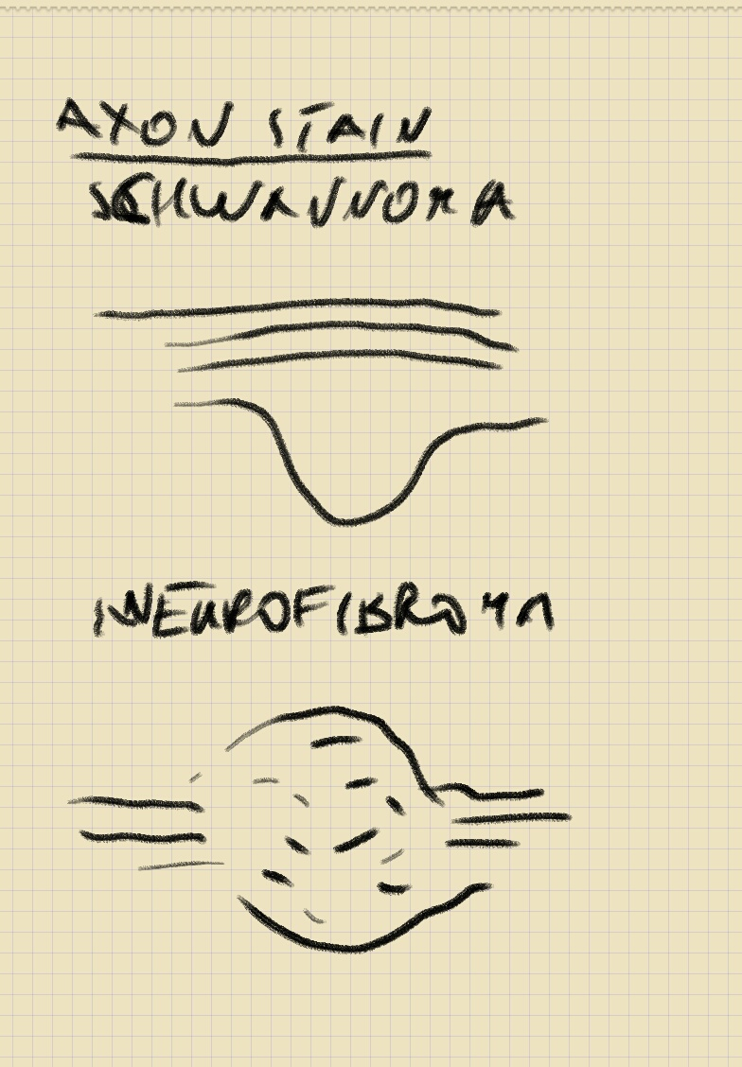
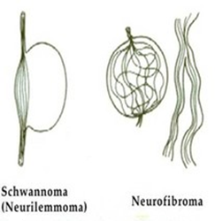
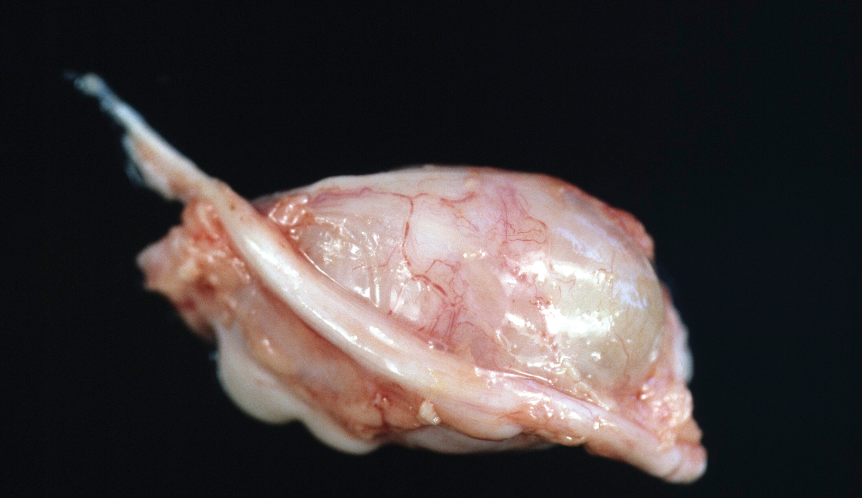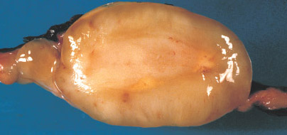

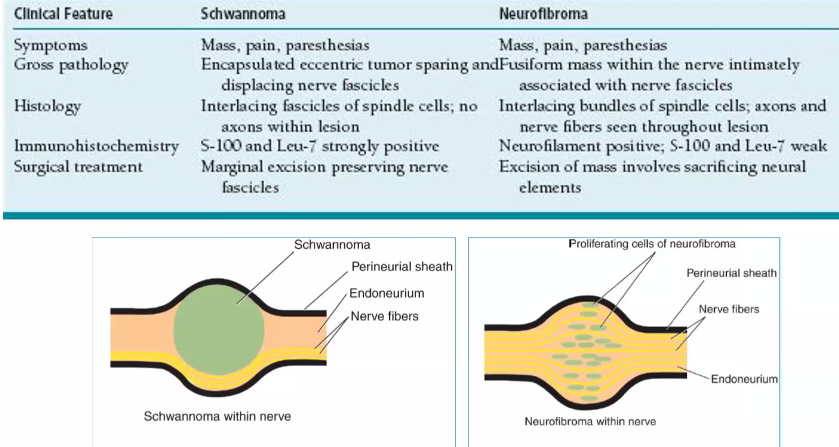

Malignant peripheral nerve sheath tumor (s. malignant schwannoma, neurofibrosarcoma, neurosarcoma)
- highly malignant sarcoma.
- ½ cases are diagnosed in people with type 1 neurofibromatosis (their lifetime risk is 8-15% with 35% cases at age < 20 years) – as transformation of pre-existing neurofibroma
- etiology: do not arise from malignant degeneration of schwannomas!
- de novo
- transformation of plexiform neurofibroma
- previous radiotherapy
- mutations in chromatin-modifying gene SUZ12 are found only in MPNST but not in benign neurofibromas.
- histology:
- immunoreactive for S-100
- poorly defined tumor mass with infiltration along axis of parent nerve, invasion of adjacent tissues.
- locally invasive → multiple recurrences, eventual metastatic spread.
- mitoses, necrosis, and extreme nuclear anaplasia are common.
- typical initial signs - pain or enlargement of mass.
- treatment is surgical resection with wide margins
- chemotherapy (e.g. high-dose doxorubicin) and often radiotherapy are done as adjuvant and/or neoadjuvant treatment but responses are poor.
- frequently fatal
- reduce life expectancy significantly in NF1 patients - mean survival 30.5 months
- 5-year survival only 20%

Malignant peripheral nerve sheath tumour with typical herringbone pattern. H&E stain.
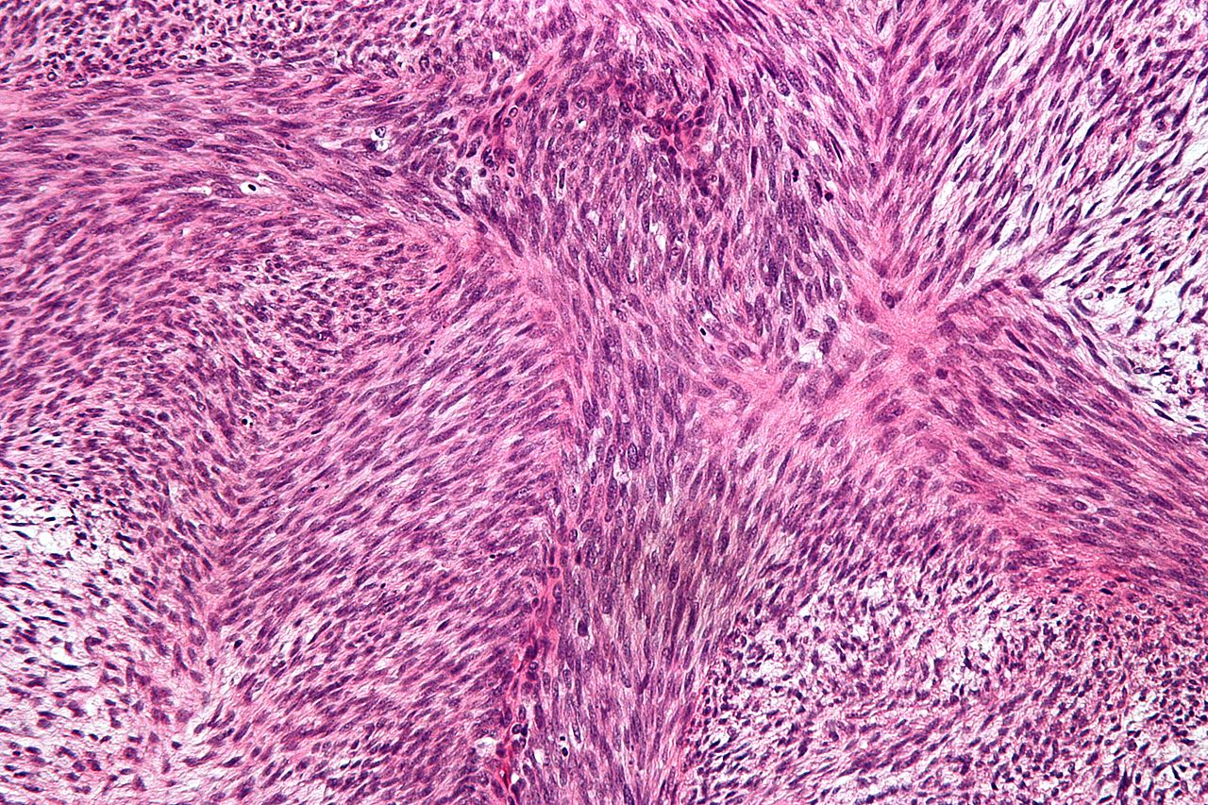
Source of picture: Wikipedia >>

Malignant triton tumor - MPNST with rhabdomyoblastomatous component; highly characteristic for NF1.
  - name "triton" is used in reference to observation of supernumerary limbs containing bone and muscle growing backs of tritons after implantation of sciatic nerve into soft tissues of back.

A. Spindle cell component with brisk mitotic activity. B. Rhabdomyosarcomatous component
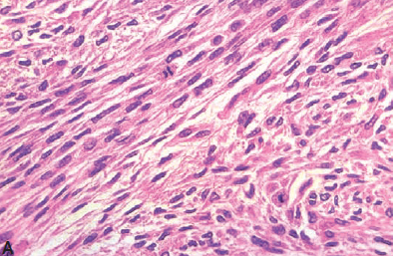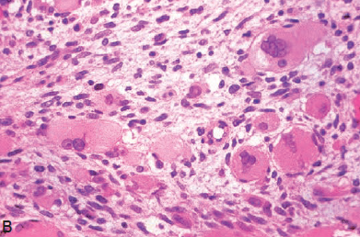
Source of picture: “WHO Classification of Tumours of the Central Nervous System” 4th ed (2007), ISBN-10: 9283224302, ISBN-13: 978-9283224303 >>

Peripheral Nerve Metastases
Cancer can affect peripheral nerves:
- compression (e.g. compression of brachial plexus by Pancoast's tumor; skull metastases may compress cranial nerve as it passes through skull foramen).
- direct invasion - from hematogenous spread or by direct extension from surrounding structures.
epineurium provides effective barrier to invasion by solid tumors, but certain tumors have special propensity to invade and spread along peripheral nerves
  - complications of therapy (radiation fibrosis, chemotherapy-induced neuropathy) can mimic peripheral nerve metastases.
  - CT / MRI - discrete tumors or areas of enhancement; surgical exploration is sometimes required for diagnosis.
  - control of pain (frequently severe and unrelenting) is priority:
- analgesics
- anesthetic blocks
- systemic chemotherapy
- focal radiation

Branches of peripheral nerve invaded by nests of malignant cells (→ unrelenting pain):
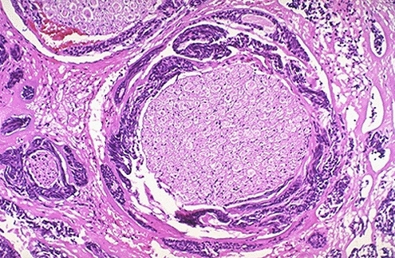

Lipofibromatosis of median nerve
  - soft mass in palm during childhood or early adulthood
  - H: microsurgical neurolysis (carpal tunnel release - only temporary relief).

Bibliography for ch. “Neuro-Oncology” → follow this link >>

Viktor’s Notes℠ for the Neurosurgery Resident
Please visit website at www.NeurosurgeryResident.net

