Schwannomas of Cranial Nerves

Last updated: January 18, 2020

[Cerebellopontine Angle Tumors 1](#_Toc25649890)

[Surgical Anatomy of Cerebellopontine Angle 1](#_Toc25649891)

[Vascular structures within cerebellopontine angle 1](#_Toc25649892)

[Nerves 2](#_Toc25649893)

[Internal auditory canal 2](#_Toc25649894)

[Temporal bone 2](#_Toc25649895)

[Vestibular Schwannoma (s. Acoustic Neuroma) 2](#_Toc25649896)

[Epidemiology 2](#_Toc25649897)

[Pathology 2](#_Toc25649898)

[Clinical Features 3](#_Toc25649899)

[Diagnosis 4](#_Toc25649900)

[Audiologic assessment 4](#_Toc25649901)

[Vestibular testing 4](#_Toc25649902)

[Imaging 4](#_Toc25649903)

[Treatment Algorithm 6](#_Toc25649904)

[Treatment - Surgery 7](#_Toc25649905)

[Approach 7](#_Toc25649906)

[Preoperative 8](#_Toc25649907)

[Intra-operative monitoring 8](#_Toc25649908)

[Translabyrinthine approach 9](#_Toc25649909)

[Retrosigmoid approach 9](#_Toc25649910)

[Middle cranial fossa approach 11](#_Toc25649911)

[Tumor resection 12](#_Toc25649912)

[Postoperative 12](#_Toc25649913)

[Complications 12](#_Toc25649914)

[Outcomes 13](#_Toc25649915)

[Treatment - Stereotactic Radiotherapy 13](#_Toc25649916)

[Fractionated 13](#_Toc25649917)

[SRS 13](#_Toc25649918)

[Indications 13](#_Toc25649919)

[Methodology 13](#_Toc25649920)

[Steroids 14](#_Toc25649921)

[Follow Up 14](#_Toc25649922)

[Results 14](#_Toc25649923)

[SRS after Failed Microsurgery 16](#_Toc25649924)

[Microsurgery after Failed SRS 16](#_Toc25649925)

[Repeat SRS 16](#_Toc25649926)

[Case discussions 16](#_Toc25649927)

[Treatment - Medications 16](#_Toc25649928)

[Prognosis 16](#_Toc25649929)

[Natural History 16](#_Toc25649930)

[Facial Schwannoma 17](#_Toc25649931)

[Clinical features 17](#_Toc25649932)

[Diagnosis 17](#_Toc25649933)

[Differential Diagnosis 18](#_Toc25649934)

[Treatment 18](#_Toc25649935)

[Trigeminal Schwannoma 18](#_Toc25649936)

[Hypoglossal Schwannoma 18](#_Toc25649937)

Cerebellopontine Angle Tumors

1. *Vestibular schwannoma* (80%)
2. *Meningioma* (20%)
3. Other rare cases:
4. *epidermoids* (!!!)
5. *other schwannoma*s - *trigeminal* (< 8% of intracranial schwannomas), *facial nerve* (extremely rare)
6. *vascular tumor*
7. *lipoma*
8. *metastases*.

Clinically - Cerebellopontine Angle Syndrome. [see p. CN7 >>](http://www.neurosurgeryresident.net/CN.%20Cranial%20Neuropathies\CN7.%20Facial%20Nerve%20Disorders.pdf#Cerebellopontine_angle_syndrome)

Surgical Anatomy of Cerebellopontine Angle

* cerebellopontine angle is space filled with CSF:

***medial boundary*** - brain stem;

***roof*** and ***posterior boundary*** - cerebellum;

***lateral boundary*** - posterior surface of temporal bone;

***floor*** - formed by lower cranial nerves (IX-XI).

* flocculus of cerebellum may lie within cerebellopontine angle and may be closely associated with CN7 and CN8 as they cross cerebellopontine angle to enter internal auditory canal.
* CN7 arises 2-3 mm anterior to root entry zone of CN8.
* foramen of Luschka is located just inferior and posterior to root entry zones of CN7 and CN8; tuft of choroid plexus can frequently be observed extruding from it.
* inferior and bit anterior to foramen of Luschka is olive, and just posterior to olive lie rootlets of origin for CN9-11.
* CN12 exits brain stem through series of small rootlets anterior to olive.

Vascular structures within cerebellopontine angle

**Arteries**

* most important vascular structure is AICA; it arises most commonly as single trunk from basilar artery but can arise as 2 separate branches. In rare cases, it originates as branch of PICA. As AICA moves from anterior to posterior, it first follows ventral surface of brain stem, but within cerebellopontine angle it takes long loop laterally to porus acusticus. In 15-20% of cases, AICA actually passes into lumen of internal auditory canal before turning back on itself toward posterior surface of brain stem. AICA can thus be divided into 3 different segments - premeatal, meatal, postmeatal.
* main branch of AICA passes over cranial nerves VII and VIII in only 10% cases; remainder of time, it either passes below VII and VIII cranial nerves or, in 25-50% of individuals, actually passes between them.
* three branches that regularly arise from meatal segment of AICA:

1. small perforating arteries supply blood to brain stem.
2. subarcuate artery passes through subarcuate fossa into posterior surface of temporal bone.
3. internal auditory artery (labyrinthine artery).

* CN7 and CN8 receive blood supply from small branches of AICA.

Two **veins** must be kept in mind during surgical procedures on cerebellopontine angle:

1. Petrosal vein (of Dandy) brings venous blood from cerebellum and lateral brain stem to greater petrosal sinus. It is encountered in area of CN5 anterior to porus acusticus. The petrosal vein often carries enough venous blood that its obstruction can lead to venous infarction and cerebellar edema.
2. Vein of Labbé (anatomy is quite variable) carries returning venous blood from inferior and lateral surface of temporal lobe; enters superior petrosal or transverse sinus between torcular and point at which greater petrosal sinus joins transverse sinus.

Nerves

**Facial nerve** leaves brain stem anterior to foramen of Luschka.

* as it leaves brain stem, fibers are sheathed in oligodendroglia. Within few millimeters of leaving brain stem, however, nerve loses oligodendroglia and becomes ensheathed by Schwann cells. It passes directly across cerebellopontine angle for about 2.0 cm, accompanied by CN8. It consistently enters internal auditory canal by crossing anterior superior margin of porus acusticus.

**Vestibulocochlear nerve** arises from brain stem slightly posterior to CN7.

* CN8 remains sheathed in oligodendroglia for approximately 15 mm (almost to point at which it passes into internal auditory canal). It has *longest oligodendroglial investment of any peripheral nerve*. The junction between oligodendroglia and Schwann cells thus occurs just medial to porus acusticus. Because acoustic neuromas arise from Schwann cells, they arise most commonly within most lateral portions of cerebellopontine angle or internal auditory canal.

**Nervus intermedius (nerve of Wrisberg)** leaves brain stem together with CN8.

* at some point within cerebellopontine angle, nervus intermedius crosses over to become associated with CN7. It may do so as several separate rootlets. At what point nervus intermedius crosses to become associated with CN7 is considerably variable (in 22% individuals, it is adherent to CN8 for ≥ 14 mm). As CN8 and CN7 reach porus acusticus they pass into it together with nervus intermedius and, sometimes, loop of AICA.

Internal auditory canal

* ≈ 8.5 mm (5.5-10.5 mm) in length, lined with dura, and filled with CSF.
* medial end (porus acusticus) is oval in shape.
* lateral end (fundus or lamina cribrosa) is complicated structure - divided into superior and inferior half by bony transverse crest:

1. upper half is further subdivided into anterior and posterior segment by vertical bony crest, often referred to as Bill’s Bar after William House, who popularized its importance as surgical landmark. The vertical crest separates macula cribrosa superior, series of very small openings through which terminal fibers of vestibular nerve pass in order to reach cupula of superior semicircular canal, from meatal foramen, which marks point at which CN7 leaves internal auditory canal and enters its labyrinthine segment. Because most lateral portion of internal auditory canal is 4-5 mm deep to geniculate ganglion, labyrinthine segment of CN7 must take fairly vertically oriented course upward to reach it. The labyrinthine segment may be less than millimeter wide as it passes between cochlea and anterior end of superior semicircular canal.
2. inferior portion of fundus is single oval-shaped space, ***anterior portion*** of which is occupied by rounded depression (tractus spiralis foraminosus) filled with small openings to accommodate terminal branches of cochlear nerve. The ***posterior portion*** is filled with macula crista inferior through which pass terminal ends of inferior vestibular nerve.

Temporal bone

* laterally, irregular superior surface of temporal bone transitions relatively smoothly to temporal squama.
* free edge of tentorium and greater petrosal sinus attach to medial edge of superior surface of temporal bone.
* arcuate eminence represents most superior portion of superior semicircular canal, which often rises slightly higher than plane of superior surface of temporal bone. It is often difficult to identify, especially in well-pneumatized temporal bones.
* geniculate ganglion generally lies within substance of temporal bone just medial to and few millimeters anterior to head of malleus. The geniculate ganglion may be sitting right on surface of temporal bone with no bony covering, or alternatively, it may lie several millimeters beneath superior surface of bone. The head of malleus is generally easy to identify if thin bone of tegmen is removed so as to enter into middle ear space from above. In difficult surgical situations, head of malleus can be used to identify geniculate ganglion. The geniculate ganglion gives off greater superficial petrosal nerve, which courses anteriorly and erupts through superior surface of temporal bone at facial hiatus.
* facial hiatus is 4-8 mm anterior to geniculate ganglion. The greater superficial petrosal nerve can be identified in this area. It can then be followed retrograde to geniculate ganglion.
* centimeter or so lateral to greater superficial petrosal nerve lies foramen spinosum, through which middle meningeal artery and associated veins pass. A few millimeters anterior and lateral to foramen spinosum is foramen ovale, which accommodates third (mandibular) division of CN5. The horizontal portion of carotid canal courses through anterior temporal bone medial to foramen spinosum and foramen ovale.
* cochlea cannot be identified from surface appearance of superior temporal bone. It lies just anterior to labyrinthine segment of facial nerve but is deep to geniculate ganglion.

Vestibular Schwannoma (s. Acoustic Neuroma)

- benign intracranial extra-axial tumor that arises from Schwann cell sheath investing either vestibular or cochlear nerve.

N.B. it is schwannoma (not neuroma)

Epidemiology

* incidence 0.7-1.0 cases per 100,000 population.
* 7% of all intracranial tumors.
* patients are 40-60 years of age.
* 95% are **sporadic**. 5% are **associated with NF2**.
* bilateral tumors are pathognomonic for **neurofibromatosis-II** (tumors occur earlier).

Pathology

about *schwannoma* → [see p. Onc60 >>](http://www.neurosurgeryresident.net/Onc.%20Oncology\Onc60.%20Nerve%20Tumors%20(GENERAL).pdf)

* **vestibular** division : auditory division = 3-20 : 1
* tumor originates at point where nerve acquires its reticulin and Schwann cell investment (in internal auditory foramen\* → local erosion of internal auditory meatus).

\*angle between cerebellum and pons

* *grow slowly* (2 mm/year) - can grow to substantial size before clinical symptoms (neurostructures accommodate to compression).
* once tumor has grown sufficiently large, it continues growth by ***eroding bone*** or by spilling out ***into cerebellopontine angle*** (angle is relatively empty - tumors can continue to grow until 3-4 cm in size before they come in contact with important structures).

CNS Systematic Review and Evidence-Based Guidelines for Vestibular Schwannomas (2017)

***Level 3 recommendation***:

What is the prognostic significance of KI-67 labeling index, proliferating cell nuclear antigen labeling index, degree of vascular endothelial growth factor expression, Antoni A vs B histologic patterns, mitotic figures, or other light microscopic features - ***no*** ***recommendation*** can be made due to a lack of adequate data.

Acoustic neuroma with displaced facial and cochlear nerves (nerves we are trying to preserve):  
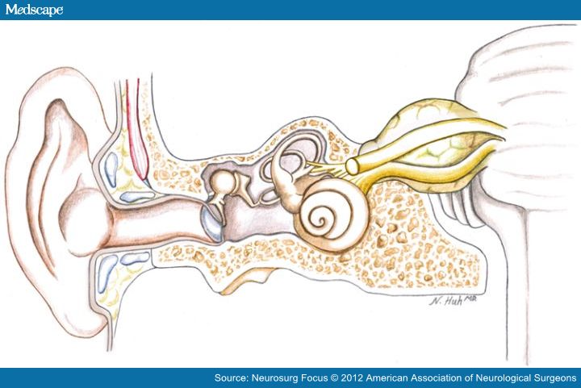

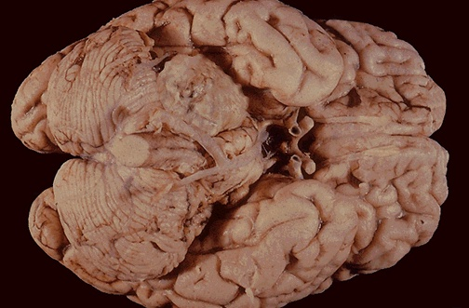

[Source of picture: “WebPath - The Internet Pathology Laboratory for Medical Education” (by Edward C. Klatt, MD) >>](http://library.med.utah.edu/WebPath/webpath.html" \t "_blank)

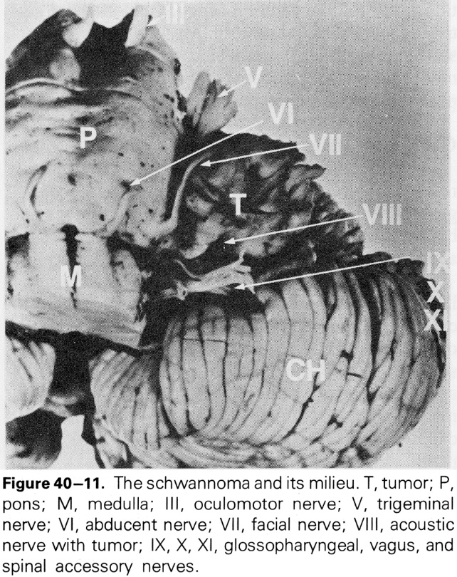

Clinical Features

Clinical stages: otologic → neurologic → neurosurgical

N.B. many small tumors never become clinically apparent!

1. Early symptoms - ipsilateral **neural hearing loss & tinnitus**.

* hearing loss is in ***speech frequencies*** (earliest complaint - difficulties hearing conversations on telephone).
* 3-5% patients have *normal hearing* at time of diagnosis.
* mechanisms of hearing loss:
  1. *direct injury* to cochlear nerve → progressive hearing loss (85-95%)
  2. interruption of cochlear *blood supply* (labyrinthine artery compression by tumor) → sudden and fluctuating hearing losses (5-15%) - may improve spontaneously or in response to steroids!
  3. *secretion of toxic substances* by tumor cells (e.g. TNF-α)

N.B. *any asymmetric sensorineural hearing loss* requires that acoustic neuroma be ruled out!;

*unilateral tinnitus alone* is sufficient reason to evaluate for acoustic tumor!

1. **Dizziness & unsteadiness**

N.B. tumor grows slowly - central compensatory mechanisms can prevent or minimize vertigo - *true vertigo is rare*!!!

* patients should be cautioned about underwater activities because of increased risks for disorientation!

1. **Compression of cranial nerves** as tumor grows large, it projects from ***internal auditory canal*** into ***cerebellopontine angle***.

* **CN5** and later **CN7** are affected – test corneal reflex!

N.B. *facial weakness is rare* (only 5-10% patients!\*) vs. *hypesthesia of posterior external auditory canal* (skin served by n. intermedius of CN7) is early sign – it is speculated that sensory fibers are more susceptible to pressure than motor axons

\*facial weakness associated with small or medium-size tumor should raise suspicion that it is not acoustic neuroma!

* patients often are unaware of facial hypoesthesia.
* less often, **CN9** and **CN10** are affected.

1. **Compression of neuraxis**

* large tumor (≥ 4.0 cm) begins to compress **cerebellum** and **pons** → ataxia, hydrocephalus.

Diagnosis

Audiologic assessment

*differentiation from sensory hearing loss* - [see p. Ear32 >>](http://www.neurosurgeryresident.net/Ear.%20Otology\Ear32.%20Hearing%20Loss,%20Deafness.pdf)

1. **Audiometry** (to all patients to establish baseline) – *severe impairment of speech discrimination*, absent recruitment, marked tone decay (pathologic adaptation).
2. **Acoustic reflex testing** - acoustic reflex decay.
3. **BAER** (detects tumor before CT, but misses tumors in patients with excellent hearing) - increased latency of 3rd waveform, absence of waveforms, etc. [see p. Ear30 >>](http://www.neurosurgeryresident.net/Ear.%20Otology\Ear30.%20Instrumental%20Auditory%20Examinations.pdf)

N.B. in modern neuroimaging era, audiologic testing is no longer used for diagnosis, but provides pretreatment baseline!

CNS Systematic Review and Evidence-Based Guidelines for Vestibular Schwannomas (2017)

***Level 3 recommendation***:

Screening MRI (for vestibular schwannomas) is recommended for adults with asymmetric audiogram:

* 1. ≥ 10 dB of interaural difference at ≥ 2 contiguous frequencies
  2. ≥ 15 dB at 1 frequency

N.B. selectively screening patients with **≥ 15 dB of interaural difference at 3000 Hz** alone may minimize the incidence of negative MRIs.

CNS Systematic Review and Evidence-Based Guidelines for Vestibular Schwannomas (2017)

***Level 3 recommendation***:

Screening MRI (for vestibular schwannomas) is recommended for adults with asymmetric tinnitus (either purely unilateral tinnitus or bilateral tinnitus with subjective asymmetry) - this practice is low yielding in terms of vestibular schwannoma diagnosis (< 1%).

N.B. asymmetric tinnitus is a relatively unreliable screening tool for VS.

CNS Systematic Review and Evidence-Based Guidelines for Vestibular Schwannomas (2017)

***Level 3 recommendation***:

Screening MRI (for vestibular schwannomas) is recommended for adults with sudden sensorineural hearing loss - this practice is low yielding in terms of vestibular schwannoma diagnosis (< 3%).

N.B. SSHL is better screening tool than tinnitus.

AAO-HNS (American Academy of Otolaryngology- Head and Neck Surgery hearing classification) classes and GR (Gardner-Robertson hearing classification) grades of hearing:

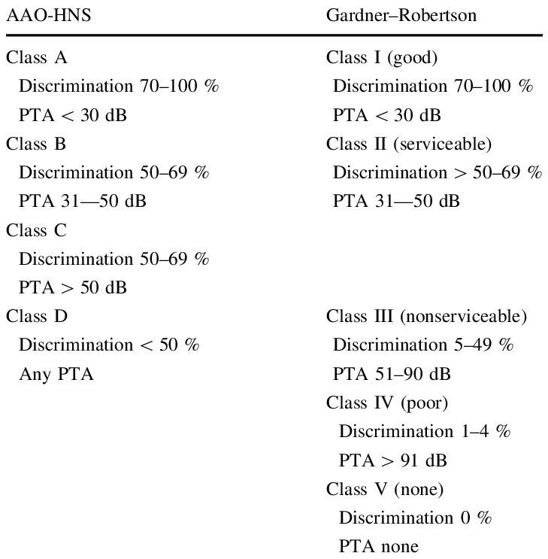

Vestibular testing

**Caloric testing** - marked *vestibular hypoactivity* (canal paresis).

Imaging

CNS Systematic Review and Evidence-Based Guidelines for Vestibular Schwannomas (2017)

***Initial Preoperative Evaluation - Level 3 recommendation***:

* high-resolution T2 plus contrast-enhanced T1 MRI.
* standard T1, T2, FLAIR, and DWI sequences obtained in axial, coronal, and sagittal plane may be used for detection of vestibular schwannomas.
* adults with proven or suspected vestibular schwannomas by imaging - T2-weighted MRI (CISS/FIESTA or DTI) may be used to augment visualization of the facial nerve course as part of preoperative evaluation.
* adults with ***cystic vestibular schwannomas*** should be counseled that their tumors may more often be associated with *rapid growth*, *lower rates of complete resection*, and *facial nerve outcomes that may be inferior in the immediate postoperative period* but similar to noncystic schwannomas over time.
* ***degree of lateral internal auditory canal involvement*** by tumor adversely affects facial nerve and hearing outcomes.

CNS Systematic Review and Evidence-Based Guidelines for Vestibular Schwannomas (2017)

***Surveillance*** (for growth of a vestibular schwannoma) ***- Level 3 recommendation*** – either:

1. postcontrast 3D T1 MPRAGE (magnetization prepared rapid acquisition gradient echo).
2. high-resolution T2 (including constructive interference in steady state [CISS] or fast imaging employing steady-state acquisition [FIESTA] sequences).

* MRIs should be obtained annually for 5 yr, with interval lengthening thereafter with tumor stability.

CNS Systematic Review and Evidence-Based Guidelines for Vestibular Schwannomas (2017)

***Postoperative Evaluation - Level 2 recommendation***: postcontrast 3-D T1 MPRAGE - ***nodular enhancement*** considered suspicious for recurrence.

* for gross total resection - postoperative MRI to document the surgical impression may occur as late as 1 yr after surgery.
* for near-total / subtotal resection - more frequent surveillance scans are suggested; annual MRI scans may be reasonable for 5 yr. Imaging followup should be adjusted accordingly for continued surveillance if any change in nodular enhancement is demonstrated.

CNS Systematic Review and Evidence-Based Guidelines for Vestibular Schwannomas (2017)

***Vestibular schwannomas associated with*** ***NF2*** - ***Level 3 recommendation*** - should be imaged similar to sporadic schwannomas with the following caveats:

1. More frequent imaging may be adopted - because of a more variable growth rate, then annual imaging may ensue once the growth rate is established.
2. In patients with bilateral vestibular schwannomas, growth rate may increase after resection of the contralateral tumor - more frequent imaging may be indicated, based on the nonoperated tumor’s historical rate of growth.
3. Careful consideration should be given to whether contrast is necessary in followup studies or if high-resolution T2 (CISS or FIESTA) MRI may be adequate instead.
4. **X-ray** – *enlarged internal auditory canal* (“trumpet-shaped”).
5. **MRI** with gadolinium enhancement – definitive diagnostic test!!!

* tumor has *intense enhancement*!
* can demonstrate 1-2 mm tumors (CT may miss tumors < 1-1.5 cm).
* if MRI is contraindicated but suspicion is high → **air-contrast cisternography** (high sensitivity - can detect relatively small intracanalicular tumors).

1. **Gas CT cisternography** (injected intrathecal gas is maneuvered to outline CN8) can demonstrate small tumors within IAC that are typically missed on routine CT; invasive and less sensitive than MRI.

**Koos grading**:

**stage I** – small intracanalicular tumor

**stage II** – small tumor with protrusion into cerebellopontine angle and no contact with brainstem

**stage III** – tumor occupying cerebellopontine cistern with no brainstem displacement

**stage IV** – large tumor with brainstem and cranial nerve displacement

Classification depending on location and brainstem compression:

Type A — intracanalicular.

Type B — cerebellopontine angle.

Type C — compressing brainstem.

Type D — deviation of fourth ventricle.



MRI - mass impinging upon cerebellum from cerebellopontine angle:

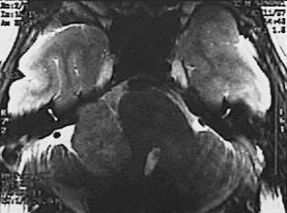

[Source of pictures: “WebPath - The Internet Pathology Laboratory for Medical Education” (by Edward C. Klatt, MD) >>](http://library.med.utah.edu/WebPath/webpath.html" \t "_blank)

Magnified view:

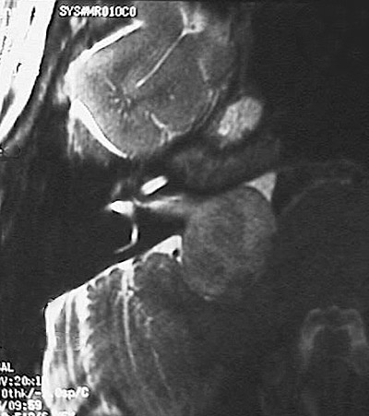

|  |  |
| --- | --- |
| Contrast MRI - tumor in right internal auditory canal (*arrow*):  D:\Viktoro\Neuroscience\Onc. Oncology\00. Pictures\Acoustic Neuroma (MRI 2).jpg  High resolution T2-MRI - small soft-tissue mass (*arrow*) in right internal auditory meatus, which is only minimally expanded; normal 7th and 8th nerves on left are clearly demonstrated:  D:\Viktoro\Neuroscience\Onc. Oncology\00. Pictures\Acoustic Neuroma (MRI 3).jpg | Contrast T1-MRI - mass in left internal auditory canal (canal is expanded secondary to neoplasm):  D:\Viktoro\Neuroscience\Onc. Oncology\00. Pictures\Acoustic Neuroma (MRI 4).jpg  Contrast T1-MRI - small tumor within internal auditory canal:  D:\Viktoro\Neuroscience\Onc. Oncology\00. Pictures\Acoustic Neuroma (MRI 5).jpg |

Treatment Algorithm

* 1. **surgical** excision – mainstay of treatment (esp. for larger tumors! ← may require adjuvant radiotherapy); most cost effective for patients < 45 yrs (vs. > 45 yrs – SRS)

Dade Lunsford: surgery only for symptomatic mass effect on brainstem!

CNS Systematic Review and Evidence-Based Guidelines for Vestibular Schwannomas (2017)

***Small intracanalicular tumors (< 1.5 cm) - insufficient data*** to support a firm recommendation that surgery be the primary treatment.

***Small intracanalicular tumors (< 1.5 cm)*** and ***good preoperative hearing - Level 3 recommendation***:

hearing preservation surgery via the **middle fossa** or the **retrosigmoid** approach may be attempted.

***Patients with NF2 - insufficient evidence*** that surgical resection should be the initial treatment.

There is ***insufficient evidence*** that a ***multidisciplinary team*** (neurosurgeon + neurotologist) provides superior outcomes\* compared to either subspecialist working alone.

\* complete resection and facial/vestibulocochlear nerve preservation

Does a subtotal surgical resection of a VS followed by stereotactic radiosurgery (SRS) to the residual tumor provide comparable hearing and FN preservation to patients who undergo a complete surgical resection?

There is ***insufficient evidence*** if ***subtotal resection followed by SRS*** provides comparable hearing and CN7 preservation vs. ***complete surgical resection***.

There is ***insufficient evidence*** to support either ***surgical resection*** or ***SRS*** for treatment of preoperative balance problems.

***Level 3 recommendation***: surgical resection may be used to better relieve trigeminal neuralgia than SRS.

***Level 3 recommendation***: microsurgical resection after SRS - increased likelihood of a subtotal resection and decreased CN7 function.

* 1. stereotactic **radiotherapy** – better (than surgery) preservation of CN5, CN7, hearing

N.B. **radiosurgery** is still *not a hearing preservation approach* (patient is counseled that likelihood of hearing loss is similar to continued observation).

Indications and CNS guidelines [>>](#SRS_indications)

* 1. careful serial **observation** (15-40% ultimately require therapeutic intervention):

[see above for MRI requirements (sequences and timing) >>](#Surveillance_MRI)

* + 1. ***short life expectancy*** (elderly patients, severe medical conditions)
    2. ***small tumors*** (esp. if hearing is good)
    3. tumor on ***side of only hearing ear*** or only seeing eye

N.B. during observation period, most (> 70%) patients who are initially eligible for hearing conservation surgery lose their eligibility!

Dade Lunsford: in 4.4 yrs tumor volume doubles – observation only for elderly.

CNS Systematic Review and Evidence-Based Guidelines for Vestibular Schwannomas (2017)

Patients with ***NF2 without surgical options:***

***Level 3 recommendation***: bevacizumab is recommended in order to radiographically reduce the size or prolong tumor stability, to improve hearing or prolong time to hearing loss.

* bevacizumab has made the most progress and appears to be a viable treatment option for patients with NF2 and growing tumors or loss of hearing. In these patients, bevacizumab recovers some useful hearing function and results in tumor reduction; however, the effect is ultimately lost with time succumbing to the natural tendency of the tumor to grow.

***Level 3 recommendation***: Lapatinib may be considered.

* dual [tyrosine kinase inhibitor](https://en.wikipedia.org/wiki/Tyrosine_kinase_inhibitor) which interrupts the HER2/neu and epidermal growth factor receptor (EGFR) pathways

***Level 3 recommendation***: Erlotinib is not recommended.

***Level 3 recommendation***: Everolimus is not recommended

***Any patient*** undergoing observation - ***Level 3 recommendation***: aspirin may be considered (to augment inflammatory response)

|  |  |  |
| --- | --- | --- |
| Treatment | **Hearing preservation** | **CN7 preservation** |
| Gamma knife | 85% | 90-100% |
| Surgery | lower |  |

* data demonstrates that consistent and durable hearing preservation in sporadic VSs remains an elusive goal. Most patients eventually develop nonserviceable hearing as a result of disease or treatment.
* auditory brainstem implants (ABI) are used successfully in hearing loss secondary to vestibular schwannomas.

Radiosurgery Practice Guideline for Vestibular Schwannomas (Guideline Report #4-06, original guideline 2006):

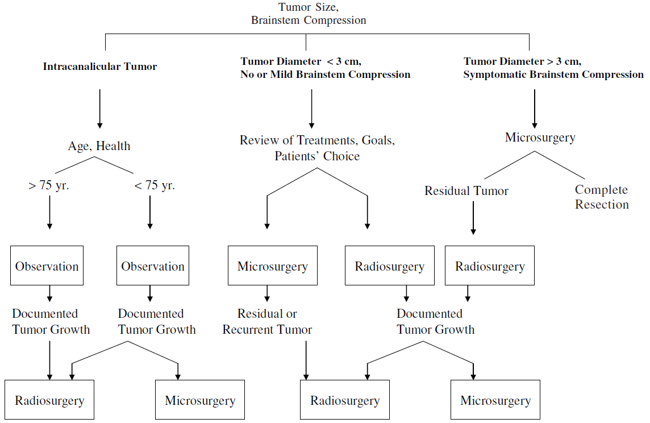

Algorithm for management of incidental VS

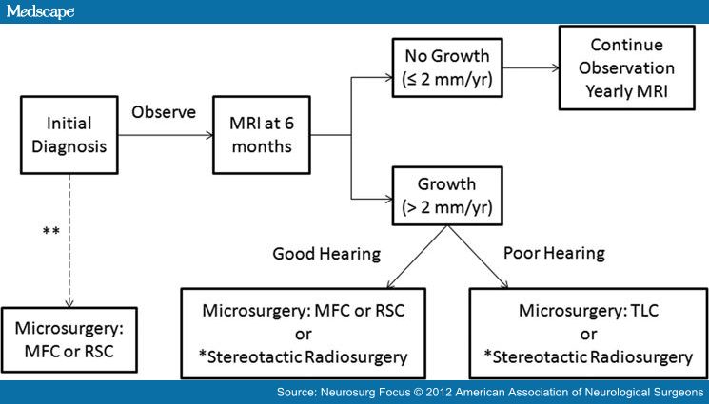

MFC = middle fossa craniotomy

RSC = retrosigmoid craniotomy

TLC = translabyrinthine craniotomy.

\*radiosurgery can be considered in elderly, in poor general medical condition

\*\*microsurgical resection can be considered without prior observation, with purpose of preserving good hearing (i.e. patients wishing to preclude future hearing loss are particularly appropriate candidates for this approach).

* studies indicate that growth usually occurs within first 5 years of observation, but monitoring MRIs beyond this time period is necessary because these tumors can continue to grow slowly and/or unpredictably over time
* observation for tumors > 1.5–2 cm is not recommended (higher probability for growth).
* for small tumors – SRS is better than surgery (except maybe to control vertigo); SRS may be used even for > 4 cm tumors if minimally symptomatic (KOOS grade 4) but recommend debulking first.

Treatment - Surgery

[see MRI features important for surgery planning and outcomes >>](#Preoperative_MRI)

Approach

**Main approaches**:

* + 1. ***retrosigmoid (suboccipital)*** approach - for small tumors with minimal extension into IAC (less than ½ of proximal IAC with predominantly CPA component) when patient desires hearing preservation
    2. ***translabyrinthine*** approach
    3. ***middle cranial fossa*** approach - for small intrameatal tumors ≤ 1.5 cm
* subtotal resection → adjuvant radiotherapy. *see below*
* *facial nerve function* preservation is the most important goal; fortunately CN7 is in continuity at end of most resections (any postoperative paresis tends to be temporary).
* if facial nerve is divided during surgery, it is sutured together (or nerve graft is placed between stumps).
* facial paralysis with no recovery within few months → surgical reinnervation (another cranial nerve, usually branch of CN11, is joined to *facial nerve* peripherally).
* tumor blood supply is from dura of porus acusticus.
* CN7 is usually anteriorly to tumor (so nerve is hidden).

**Approach selection**

* 1. patient has no useful hearing\*:

1. ***translabyrinthine*** approach (preferred)
2. ***retrosigmoid*** approach (for tumors with significant inferior extension)

\*50/50 rule - individuals with pure-tone average > 50 dB and speech discrimination < 50% do not have useful or salvageable hearing; other surgeons use 30/70 rule.

* 1. patient has useful hearing:

1. ***retrosigmoid*** approach (for tumors that have significant volume medial to porus acusticus).
2. ***middle cranial fossa*** approach (for tumor within lateral portion of internal acoustic canal, esp. small intracanalicular tumors).
   * + normal preoperative BAER favors hearing conservation.
     + abnormal electronystagmography favors hearing conservation (ENG tests horizontal semicircular canal, which is innervated by superior vestibular nerve; normal ENG = superior vestibular nerve is normal - tumor must have originated from inferior vestibular nerve, which is directly adjacent to cochlear nerve).
     + tumor diameter ≥ 1.5-2.0 cm - hearing is difficult to conserve.
   1. anatomic variations that make ***translabyrinthine*** approach difficult / impossible:

* high-riding jugular bulb (above level of inferior internal auditory canal).
* anteriorly placed sigmoid sinus (distance between sigmoid sinus and external auditory canal few millimeters or less - limited space within which surgeon has to operate).
* reduced / absent flow in contralateral sinus (injury to remaining sinus → catastrophic venous infarction).
* contracted sclerotic mastoid (little room for tumor removal + often associated with suppurative otitis media).

CNS Systematic Review and Evidence-Based Guidelines for Vestibular Schwannomas (2017)

What ***surgical approaches*** are best for complete resection and facial nerve preservation when:

1. serviceable hearing is present - ***insufficient evidence*** to support the superiority of either the **middle fossa** or the **retrosigmoid** approach.
2. serviceable hearing is not present - ***insufficient evidence*** to support the superiority of either the **retrosigmoid** approach or **translabyrinthine** approach.

CNS Systematic Review and Evidence-Based Guidelines for Vestibular Schwannomas (2017)

***Size of tumor - Level 3 recommendation***: Patients with larger tumor size should be counseled about the greater than average risk of loss of serviceable hearing.

CNS Systematic Review and Evidence-Based Guidelines for Vestibular Schwannomas (2017)

***Endoscopic assistance*** - ***Level 3 recommendation***: surgeon may choose it in order to aid in visualization.

Radiosurgery Practice Guideline for Vestibular Schwannomas (Guideline Report #4-06, original guideline 2006)

**Preservation of facial function** continues to improve. However, facial nerve outcomes vary according to tumor size and operator experience. When tumors are smaller than 1.5 cm, good facial nerve function can be expected (House-Brackmann grades I–II) in more than 90% of patients at Centers of Excellence. Only 3.2–6.7% of patients with this size tumor have poor outcomes (House- Brackmann grades III–IV). In addition to tumor size, preoperative electrophysiologic testing can help predict postoperative outcome, although this testing is not commonly used. The overall facial nerve preservation rate is 80%. However, facial nerve function (grades I and II) can be preserved in only 40–50% of patients with large (>4 cm diameter) tumors. Injuries of the nervus intermedius are underestimated because this nerve is rarely assessed preoperatively.

The ability to **preserve hearing** has increased substantially over the last couple of decades. Depending on criteria used for successful hearing conservation, hearing preservation has been reported in 30–80% of patients considered eligible for hearing preservation surgery. Meta-analysis performed by Gardner and Robinson showed an overall average success rate of about 33%. Delayed hearing deterioration may occur after surgery in 30–50% of patients who originally had successful hearing preservation. In various studies, serviceable hearing preservation rates of 8–57% using the retrosigmoid approach and 32–68% using the middle fossa approach have been reported.

**Tinnitus** becomes worse in 6–20% of individuals after tumor removal. In the majority of individuals, tinnitus remains unchanged. Approximately 25–60% of patients experience a decrease in tinnitus. Of patients without preoperative tinnitus, 30–50% developed it in the immediate postoperative period.

Preoperative

CNS Systematic Review and Evidence-Based Guidelines for Vestibular Schwannomas (2017)

***Level 3 recommendation***: perioperative nimodipine (or with the addition of hydroxyethyl starch) should be considered to improve postoperative facial nerve outcomes and may improve hearing outcomes.

***Level 3 recommendation***: preoperative vestibular rehabilitation is recommended to aid in postoperative mobility after surgery.

***Level 3 recommendation***: preoperative gentamicin ablation of the vestibular apparatus should be considered to improve postoperative mobility after surgery.

Intra-operative monitoring

of facial and vestibulocochlear nerve → dramatic reduction in morbidity.

facial nerve – EMG

vestibulocochlear nerve – BAEPs, ECOG, and direct CNAPs.

**Facial nerve**

CNS Systematic Review and Evidence-Based Guidelines for Vestibular Schwannomas (2017)

***Level 3 recommendation***: intraoperative facial nerve monitoring must be routinely utilized during surgery to improve long-term facial nerve function.

***Level 3 recommendation***: intraoperative facial nerve monitoring can be used to accurately predict favorable long-term facial nerve function after surgery.

* the presence of favorable testing reliably portends a good long-term facial nerve outcome.
* the absence of favorable testing in the setting of an anatomically intact facial nerve does not reliably predict poor long-term function (cannot be used to direct decision-making regarding the need for early reinnervation procedures).

N.B. poor intraoperative EMG electrical response of the anatomically intact facial nerve should not be used as a reliable predictor of poor long-term facial nerve function

**CN8**

CNS Systematic Review and Evidence-Based Guidelines for Vestibular Schwannomas (2017)

Patients with ***measurable preoperative hearing and tumors < 1.5 cm*** - ***Level 3 recommendation***: intraoperative eighth cranial nerve monitoring should be used during surgery when hearing preservation is attempted. ***Insufficient evidence*** if direct monitoring of the eighth cranial nerve is superior to far-field auditory brain stem responses.

* Level 3 evidence supports the use of intraoperative cochlear nerve monitoring in hearing preservation VS surgery. The most common method employed was auditory brainstem response. The presence or characteristics of Wave I and V, as well as the cochlear compound action potential (CAP), were the most useful parameters discussed. The biggest challenge with neuromonitoring of the cochlear nerve involves the technical aspects and delayed feedback. Auditory brainstem response is plagued by delay issues due to the data averaging that is required to assess changes in function. To circumvent this, direct cochlear nerve monitoring has been used instead. The technical requirements and challenges of performing direct cochlear nerve monitoring, however, were made apparent in various reports. They range from the inability to place electrodes at the nerve root exit zone prior to tumor resection, to the difficulty in keeping the probes in place throughout the duration of surgery or securing the probe without causing iatrogenic damage to the nerve. Finally, factors such as the presence of excess cerebrospinal fluid or blood, the stimulation voltage used to elicit responses, or the interference of electrocautery stimuli have all been reported to alter responses and the interpretation of results.

Translabyrinthine approach

AANS video: <http://www.neurosurgicalatlas.com/grand-rounds/resection-of-acoustic-neuromas-translabyrinthine-approach>

**Advantages**

1. *best view* of lateral brain stem facing acoustic tumor.
2. fundus and lateral end of internal auditory canal are *completely exposed*; CN7 can be identified at location where it is undistorted by tumor
3. *cerebellum retraction* is almost never necessary.
4. ↓*incidence of CSF leak*.
5. *allows restoration of CN7 continuity* (if CN7 has been divided or sacrificed) by rerouting CN7 and performing primary anastomosis (interposition graft can sometimes be avoided).

The translabyrinthine approach provides the best view of the lateral brain stem facing the vestibular schwannoma. • Retraction of the cerebellum is not needed. • The fundus and lateral end of the internal auditory canal are completely exposed; the facial nerve can be identified at a location where it is undistorted by tumor growth and compressed into the labyrinthine segment, decreasing the risk of delayed postoperative facial nerve palsy. • Possible opening of the tentorium in case of an extra large tumor that may extend upward. • Safe control of the lateral surface of the pons. Improved surgical comfort. • No need for a seated or lateral positioning of the patient.

**Disadvantages**

1. complete *hearing sacrifice* is unavoidable.
2. *worse visualization* (comparing with retrosigmoid approach) of inferior portions of cerebellopontine angle, cranial nerves, temporal bone anterior to porus acusticus.
3. *fat graft* (from abdomen) is required.
4. *sigmoid sinus* is more vulnerable to injury (bleeding is difficult to control).
5. high jugular bulb or anteriorly placed sigmoid sinus can substantially compromise space available for tumor removal.

Hearing sacrifice is complete and unavoidable. • The inferior portions of the cerebellopontine angle and cranial nerves are not as well visualized as they are in the retrosigmoid approach. The temporal bone anterior to the porus acousticus is also less well visualized. • A tissue graft (fat, fascia, homograft or synthetic dura) is required. Some surgeons prefer hydroxyapatite cement. • The sigmoid sinus may be more vulnerable to injury. • Need to extend the approach in case of contract mastoid or high jugular bulb position. • The third portion of the facial nerve may be vulnerable to injury during the approach. • The approach requires additional time.

**Operative details**

* small **incision** behind ear.
* petrous bone is gradually removed with high-speed drill until facial nerve is identified and exposed to point where it can be separated from tumor and protected.

Bone that must be removed is indicated in yellow (tumor is in orange):

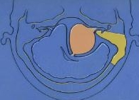

* dura of posterior fossa is seen easily - can be opened to access to intradural component of tumor.
* large bone and dural defects are closed by autogenous free fat graft.

**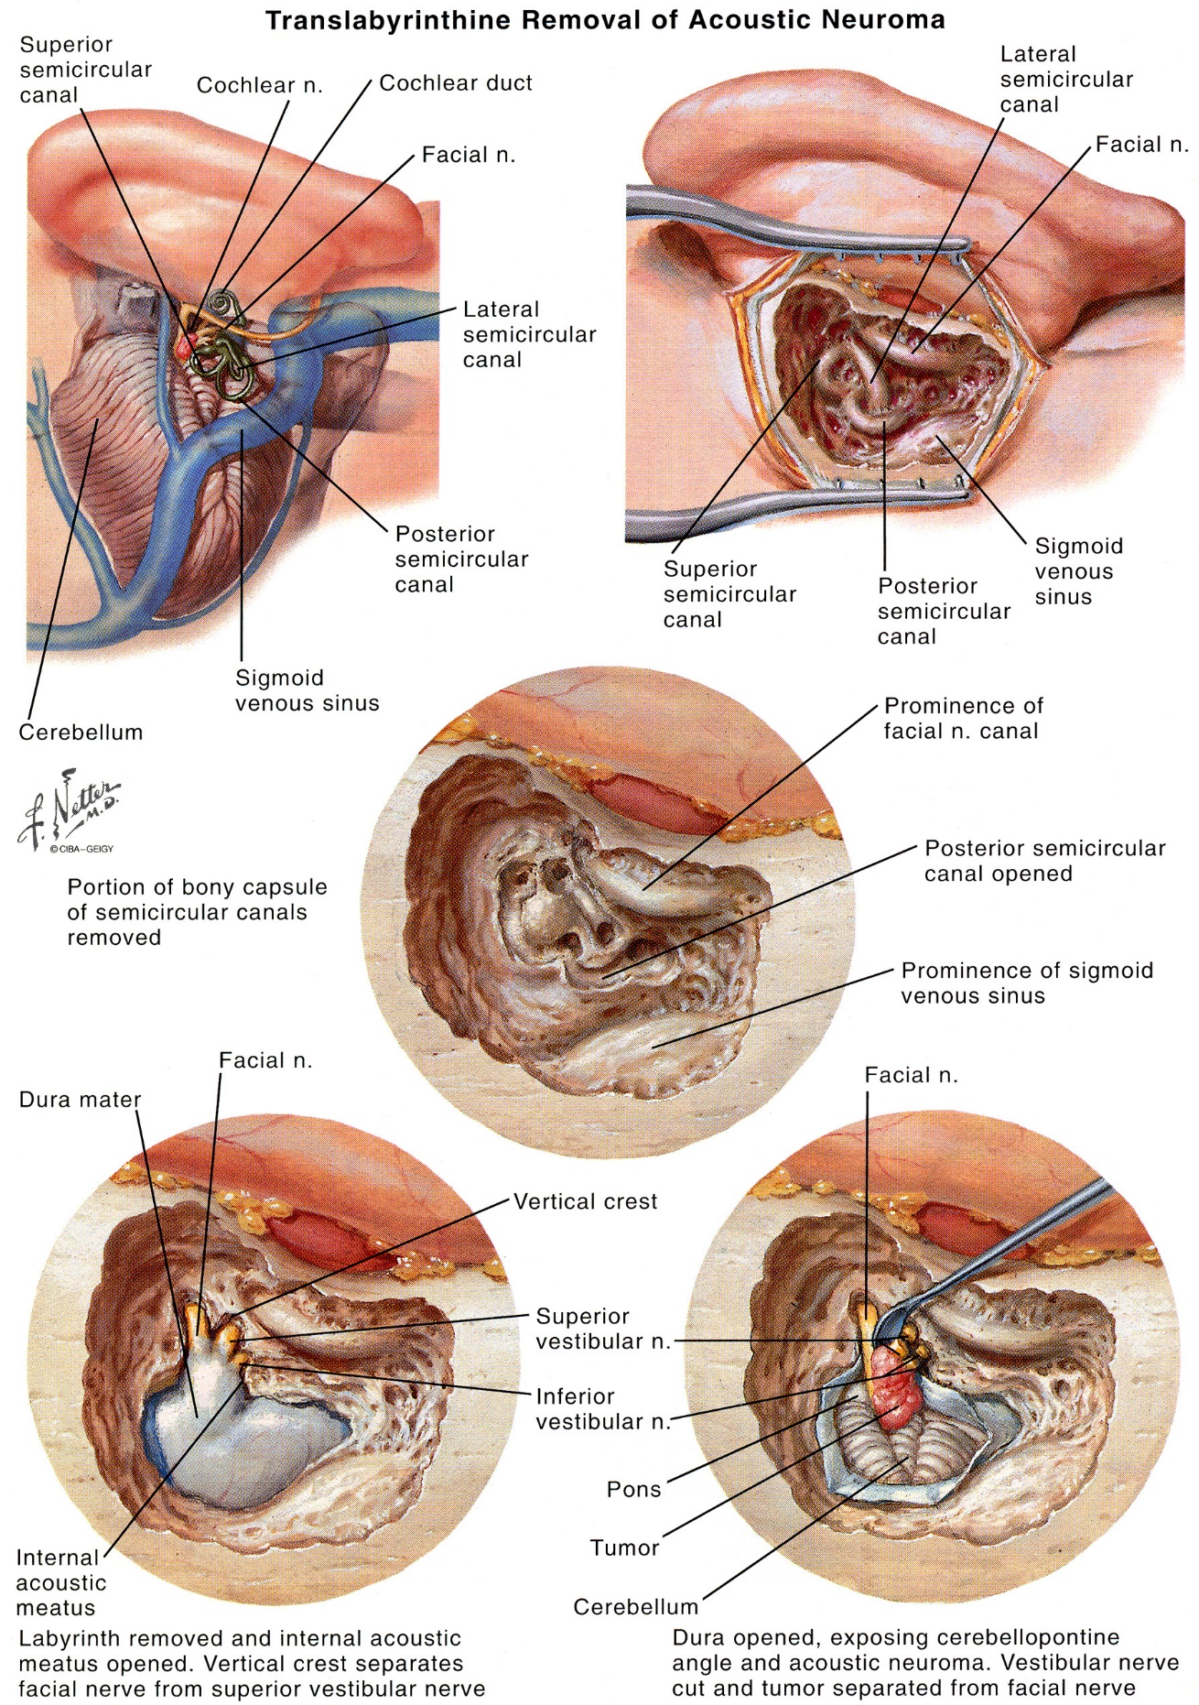**

[Source of picture: Frank H. Netter “Clinical Symposia”; Ciba Pharmaceutical Company; Saunders >>](http://www.amazon.com/gp/product/1933247401)

Retrosigmoid approach

AANS video: <http://www.neurosurgicalatlas.com/grand-rounds/resection-of-acoustic-neuromas-retromastoid-and-middle-fossa-approaches>

If need to get to IAC fundus, look for location of common crus on MRI – if too medial, it won’t be ableto reach fundus (need translab approach or SRS):

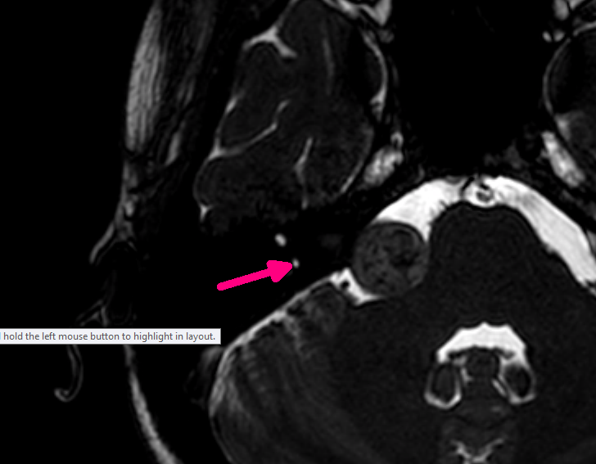

**Advantages**

* 1. *can be applied to all acoustic tumors*\* - for operations that sacrifice hearing and operations that attempt to conserve hearing (even for relatively large tumors).

\*except - small tumors in far-lateral portion of internal auditory canal.

* 1. *best wide-field (panoramic) visualization of posterior fossa* - especially helpful when displacement of nerves is not predictable.
  2. *labyrinth destruction is avoided*.

The retrosigmoid approach provides the best widefield visualization of the posterior fossa. The time needed for tumor exposure is short. The inferior portions of the cerebellopontine angle and the posterior surface of the temporal bone anterior to the porus acousticus are more clearly observed than in the translabyrinthine approach. Panoramic visualization is especially helpful when displacement of nerves is not predictable, as occurs commonly with meningiomas. • Hearing conservation surgery can be attempted even for relatively large tumors through the retrosigmoid approach. Destruction of the labyrinth is not required as part of the retrosigmoid approach.

**Disadvantages**

1. highest incidence of tumor *recurrence / persistence*.
2. may require *cerebellar retraction or resection* (→ edema, hematoma, infarction).
3. ↑incidence of *CSF leak*
4. severe protracted postoperative *headache* – can be diminished with intraoperative steps:
   * avoid contaminating CSF and subarachnoid space with bone dust;
   * bone flap is replaced and any residual bony defect is eliminated with methylmethacrylate or hydroxyapatite (eliminates direct attachment of posterior cervical musculature to dura).
5. tumor is between surgeon and CN7

The retrosigmoid approach may require cerebellar retraction or resection, which can lead to the development of postoperative edema, hematoma, infarction and bleeding. • The retrosigmoid approach is associated with a greater likelihood of protracted postoperative headache. • The highest incidence of tumor recurrence or incomplete resection occurs with retrosigmoid approaches due to poor control of the fundus of the internal auditory canal. • It may be difficult to perform a facial-to-facial nerve graft repair from this approach.

**Operative details**

- operation that fully exploits surgeon's microsurgical skill.

* **monitoring** – bilateral BAER, ipsilateral facial nerve EMG
* **patient position**:
  + - 1. supine + turn head toward contralateral shoulder
      2. true lateral (park-bench) position (Dr. Broaddus) - permits occiput to be rotated little bit more superiorly - slightly more direct view of internal auditory canal).
* **retromastoid craniotomy** → see p. Op300 [>>](HTTP://WWW.NEUROSURGERYRESIDENT.NET/Op.%20Operative%20Techniques/300-399.%20Cranial/Op300.%20Craniotomies.pdf)

Bone that must be removed is indicated in yellow (tumor is in orange):

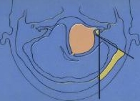

* dura is opened in T-shape, arachnoid incised, and cerebellum is retracted medially to expose cerebellopontine angle (cerebellum frequently falls away from posterior surface of temporal bone; hyperventilation, steroids, and intraoperative mannitol reduce ICP → easy surgical exposure with limited amount of retraction. Nonetheless, gentle cerebellar retraction is frequently necessary).
* drill off posterior wall of IAC (endolymphatic sac is the landmark how posteriorly we can drill).
* once adequate exposure has been obtained, tumor is clearly visualized along with brain stem and lower cranial nerves. However, cranial nerves VII and VIII are rarely observed because they are almost always pushed forward and lie across anterior surface of tumor, which cannot be visualized.
* debulking of tumor is next step and must be carefully performed so as to maintain anterior portions of capsule if injury to cranial nerve VII and/or VIII is to be avoided; incise tumor capsule longitudinally (along long axis of CN7-8) and debulk with pituitary rongeur.
* once tumor has been substantially debulked, posterior wall of internal auditory canal is removed:
  + - * dissect dura from posterior surface of petrous bone
      * high-speed drill (irrigating drill, diamond drill bit)
      * *bone dust* should be prevented from entering subarachnoid space during this phase of procedure. One probable cause for severe and intractable postoperative headache is spillage of bone dust into subarachnoid space during tumor removal. Carefully place Surgicel, pieces of Gelfoam, Telfa pads, and/or cottonoid strips around operative site so that bone dust from drilling adheres to them and is removed as they are removed.
      * great care must be taken to ***avoid injuring labyrinth*** while removing posterior wall of internal auditory canal. Portions of labyrinth quite commonly are medial to lateral end of internal auditory canal. Although no single anatomic landmark is completely reliable for prevention of injury to labyrinth, singular nerve and its canal, vestibular aqueduct, and cochlear aqueduct are all used as important surgical landmarks. Careful measurements taken from preoperative CT scans can provide useful information during drilling of posterior canal wall.
      * length of internal auditory canal varies considerably from individual to individual, and knowing exactly how much posterior canal wall needs to be removed to adequately expose tumor can help limit inadvertent injury to labyrinth. Blind extraction of tumor from internal auditory canal without removing posterior wall prevents significant risks of injury to facial and/or auditory nerve (if hearing is to be saved) while at same time increasing chances of leaving tumor at fundus. Use of intraoperative angled endoscopes has been of considerable help in performing this phase of operation.
* once internal auditory canal is exposed, dura is opened and tumor is removed from it. Although never proven, dissection from medial to lateral is thought to be less traumatic to both cochlear nerve and to vascular supply of inner ear. The vestibular nerves are generally sacrificed, and unless hearing is to be preserved, cochlear nerve is sacrificed as well. Eventually, surgeon is left with anterior portions of capsule adhered to brain stem and cranial nerve VII. As tumor capsule is carefully removed from brain stem, root entry zone of cranial nerve VII can be identified. The capsule is then carefully removed from facial nerve with as little trauma as possible.
* facial nerve monitor is great help in this portion of dissection. Variety of techniques has been used to monitor cochlear nerve when hearing preservation is desired. The most commonly used method is intraoperative ABR audiometry, but it has number of disadvantages. Most importantly, it requires summing large number of repetitions in order to extract response from background noise. Consequently, delay occurs between surgical manipulations and ABR changes. Direct cochlear nerve monitoring offers advantage of real-time feedback, but fully satisfactory method of placing and securing electrode still is lacking.
* once tumor removal is complete and hemostasis is absolute, ***dura is closed and craniotomy defect is repaired*** → see p. Op300 [>>](HTTP://WWW.NEUROSURGERYRESIDENT.NET/Op.%20Operative%20Techniques/300-399.%20Cranial/Op300.%20Craniotomies.pdf)

Middle cranial fossa approach

AANS video: <http://www.neurosurgicalatlas.com/grand-rounds/resection-of-acoustic-neuromas-retromastoid-and-middle-fossa-approaches>

**Advantages**

1. *fully exposes lateral third of internal auditory canal* without sacrificing hearing (some surgeons reach tumors that extend 0.5-1.0 cm into cerebellopontine angle)

N.B. better hearing preservation than retrosigmoid!

1. *extradural*.

It is the only procedure that fully exposes the lateral third of the internal auditory canal without sacrificing hearing.

**Disadvantages**

1. *CN7* is in way during tumor removal (CN7 courses across anterior superior portion of tumor) - temporary postoperative paresis is more common.
2. *temporal lobe* must be retracted → temporal lobe injury (especially troublesome with dominant side).
3. risk of *dural laceration* in elderly patients.
4. very *limited exposure of posterior fossa*; also may leave *tumor laterally*.
5. technically *difficult*.
6. postoperative *trismus* (related to manipulation and/or injury to temporalis muscle).

The facial nerve generally courses along the anterior superior portion of the tumor. Depending on whether the tumor is of superior or inferior vestibular nerve origin, the facial nerve may have to be dissected and displaced to obtain access to the tumor. This may make the nerve more vulnerable to injury during tumor removal. • The risk of dural laceration becomes increasingly more likely as patients become older. The dura mater in elderly patients is thin and more friable. This becomes especially noticeable beyond the seventh decade of life. • The approach provides only limited exposure of the posterior fossa but can be extended by an additional anterior petrosectomy following the Kawase procedure. • The operation is technically challenging. • Some patients incur postoperative trismus related to manipulation and/or injury to the temporalis muscle. • The temporal lobe must be retracted, which on rare occasion leads to temporal lobe injury. • The great superficial petrosal nerve may be injured during the elevation of the temporal dura.

**Operative details**

* **position**: *head must be in true lateral position*. In young individuals with supple neck, this can often be accomplished by turning head to side with patient in supine position. But if neck mobility is limited or concern exists that forced head turning will limit posterior fossa circulation or aggravate cervical spine disorders, then true lateral (park-bench) position should be used.
* exposure must be centered over vertically oriented line that passes ≈ 1 cm anterior to external auditory meatus. This is most easily accomplished through linear incision. A posteriorly based U-shaped or curvilinear S-shaped incision can be used if concern exists about scar contracture. Depending upon incision used, temporalis muscle is incised or reflected inferiorly. A temporal craniotomy (approximately 3 cm by 3 cm) is performed with its base at root of zygoma. The dura is elevated up from floor of middle cranial fossa, and osmotic diuretics, head elevation, hyperventilation, and steroids are used to limit cerebral edema.

Bone that must be removed is indicated in yellow (tumor is in orange):

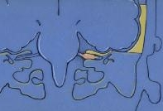

* dura of temporal lobe is then elevated off superior surface of temporal bone. The anterior extent of such elevation is usually foramen spinosum, but middle meningeal artery can be divided between clips and elevation continued anteriorly to foramen ovale if additional exposure is desired. Dural elevation should proceed from posterior to anterior to avoid injury to exposed greater superficial petrosal nerve or geniculate ganglion. Bleeding from veins associated with middle meningeal artery is often quite brisk but can generally be controlled with Surgicel packing. Medial dissection continues to free edge of temporal bone.
* superior petrosal sinus is attached to posterior surface of temporal bone but not always at its superior edge. Care must be taken to avoid injuring it. If inadvertent injury occurs, bleeding can generally be controlled with intraluminal Surgicel packing, electrocautery, or hemoclips. When extended middle cranial fossa approach is employed (for tumors that extend centimeter or more outside porus acusticus into cerebellopontine angle), superior petrosal sinus is deliberately divided between clips and tentorium is opened.
* drill IAC from medial (where it is wide) to lateral (nerves are compacted and easiest to injury)
* when it can be detected easily, arcuate eminence is extremely helpful landmark. Careful drilling can often identify blue line of superior canal within it. Because most difficult exposure to achieve during middle fossa surgery is lateral posterior end of internal auditory canal, perform dissection as close to superior semicircular canal as possible. The greater superficial petrosal nerve is generally easy to visualize and can be followed retrograde to geniculate ganglion. It lies ≈ 1.0 cm directly medial to foramen spinosum. Once area of geniculate is identified, small diamond burrs are used to completely expose it. If greater superficial petrosal nerve cannot be located and no other landmarks are available, middle ear space can be entered from above and head of malleus intercranial identified. The geniculate ganglion lies approximately 2-3 mm anterior and medial to head of malleus.
* once geniculate ganglion has been completely exposed, labyrinthine portion of nerve can be identified and followed medially and inferiorly into internal auditory canal. Remember that labyrinthine portion of nerve takes markedly vertical course as it moves from lateral geniculate ganglion to proximal fundus of internal auditory canal, which lies 5 or more millimeters deep to geniculate ganglion. Some surgeons prefer to identify internal auditory canal medially. Once medial end of canal is completely identified, they follow canal laterally to fundus of internal auditory canal.
* internal auditory canal should be skeletonized approximately 270°. The most difficult area to expose is point at which superior vestibular nerve penetrates labyrinthine bone to innervate ampulla. However, exposure in this area is critical if anatomy of lateral end of internal auditory canal is to be well visualized. If this area can be well visualized, then tumor removal is generally both successful and relatively straightforward. Larger tumors frequently have facial nerve splayed out over anterior superior portions of tumor. Tumor removal begins, as with other approaches, by carefully debulking. Once tumor is well debulked, enough room is created within internal auditory canal to carefully remove tumor capsule from inferior surface of facial nerve. Again, care must be taken to avoid torsion or twisting of nerve during tumor removal.
* once tumor has been completely removed, integrity of facial nerve is tested using intraoperative facial nerve monitor. Presumably, monitor has been in use throughout case. If facial nerve can be stimulated with low stimulus intensities, chances of good postoperative facial nerve function increase.
* fat is packed into internal auditory canal after using bone wax to fill obvious air cells to prevent postoperative CSF leak. The facial nerve monitor generally alerts physician if fat is being packed in so tightly that integrity of facial nerve is being compromised.
* retractors are removed, and temporal lobe is allowed to reexpand.

Tumor resection

* may leave 1 mm “tumor carpet” on CN7 to avoid nerve injury.
* if tumor extends to IAC (impacted tumor) – CN7 is compressed and high risk of injury.
* CN8 fibers fan out into modiolus – it takes very minimal force to disrupt those fibers – no lateral-to-medial motion while resection, i.e. all sweeping motions must be very gentle medial-to-lateral.
* if need only to debulk tumor (so get off brainstem to allow radiation) – high risk of bleeding

Postoperative

* ICU overnight (rapid intervention if ICP increases or bleeding occur).
* ***vestibular rehabilitation*** begins on first postoperative day and continues twice daily throughout hospital stay.
* palliative treatment for ***persistent vertigo*** after vestibular schwannoma removal - transtympanic gentamicin injection to kill remaining vestibular input so brain will no longer receive weird signals from malfunctioning vestibular apparatus.
* discharge on 3-4th postoperative day.

**Subtotal resection** – wait 1.5-3 mos, then SRS

**Follow-up MRI** (completeness of tumor removal) within 3-6 months → at 5 years → at 10 years (if all are normal, further imaging is performed only if clinical circumstances require it).

[see above for MRI requirements >>](#Postoperative_MRI)

N.B. distinguishing tumor recurrence from postoperative inflammation (both are MRI enhancing) can be quite difficult: recurrences tend to be globular while inflammatory enhancement tends to be linear.

* recurrence rate is ≤ 5-10% (vast majority of recurrences follow *suboccipital removal* - tumor left in lateral end of internal auditory canal where intraoperative visualization is so difficult).

Complications

* 1. Injury to AICA (occurs very rarely).
     + - AICA may be loosely attached to tumor capsule, but separating it from tumor is generally fairly easy.
       - sacrificing AICA itself has variable consequences (can lead to devastating neurologic injury or death).
       - AICA branches most vulnerable to injury - *labyrinthine artery*\* (failure to conserve hearing) and *branches to facial nerve* (postoperative facial nerve weakness).

\*may be very intimately associated with tumor (esp. larger tumors).

* 1. Occlusion of sigmoid sinus
     + - if contralateral venous outflow is patent and communication through torcular is good, complete occlusion may go entirely unnoticed.
       - occlusion of dominant sinus can result in catastrophic ICP↑, venous infarction, and even death.
  2. Occlusion of petrosal vein of Dandy (single large outflow tract in some patients; series of several large veins in others) → edema, temporal lobe or brain stem infarction.
  3. Occlusion of vein of Labbé → severe edema (→ brain herniation) and temporal lobe infarction;
     + - vein of Labbé is not directly in field during acoustic tumor surgery, but injury to superior petrosal sinus may result in vein obliteration.
  4. Hemorrhage into posterior fossa → brainstem compression → death within minutes.

Rapid neurologic deterioration in first 24 postoperative hours → suspect posterior fossa hemorrhage:

* *if time permits*, rapid unenhanced CT while operating room is prepared.
* *if deterioration is rapid*, forgo CT and take patient directly back to operating theatre.
* *if deterioration is very rapid* (with loss of consciousness, decerebrate posturing, and signs of imminent death), open wound at bedside (posterior fossa decompression) prior to emergent translocation to operating room.
  1. Injury to cerebellum (incidence dramatically diminished in recent decades) → edema → obstruction of 4th ventricle, brainstem compression.
     + - ***rotating shaft of surgeon's burr*** is often culprit (surgeons usually look past shaft to head of burr to control bone removal; shaft is often outside surgical field of view).
       - other causes - compression and retraction, alteration of arterial inflow, venous engorgement.
       - treatment - osmotic diuretics, hyperventilation, steroids (resection of involved cerebellar hemisphere part may be required).
  2. Postoperative facial paralysis (sometimes unavoidable). [about management - see p. CN7 >>](http://www.neurosurgeryresident.net/CN.%20Cranial%20Neuropathies\CN7.%20Facial%20Nerve%20Disorders.pdf)
     + - ***prophylactic perioperative steroids*** are widely used (but unequivocal evidence for effectiveness is lacking).
       - tumor < 1.5 cm - good facial nerve function can be expected (House-Brackmann grade I-II) in > 90% of patients.
       - patients with poor facial nerve function (House-Brackmann V-VI) at time of discharge have 25% chance of recovery of normal function.
       - 10-30% cases have **onset delayed** for few hours ÷ week (vasospasm, vascular injury, traction, nerve edema, stretching, even viral reactivation have been proposed):
* risk factors for delayed facial palsy: gross total tumor resection, retrosigmoid approach
* vast majority make complete and total recoveries within 1 month! (steroids, antivirals make no difference in recovery).
  1. Transient abnormality of CSF resorption → mild transient postoperative hydrocephalus.
  2. Bacterial meningitis → immediate LP (after CT has excluded significant hydrocephalus - could lead to herniation) → **antibiotics** immediately.
  3. Aseptic meningitis; **corticosteroids** are extremely helpful.
  4. CSF leak through: [about management – see p. S64 >>](http://www.neurosurgeryresident.net/S.%20Symptoms,%20Signs,%20Syndromes\S50-64.%20Intracranial%20pressure,%20brain%20edema,%20herniation,%20hydrocephaly\S64.%20CSF%20Leaks.pdf)

1. wound
2. eustachian tube.
   1. Severe postoperative headache *- see retrosigmoid approach (disadvantages)*

H: high-dose NSAIDs, aggressive manipulative physical therapy.

* 1. Tinnitus worsening (6-20% patients)
  2. Vertigo – improves over several days; it is predicted if patient never had in a history the episode of severe vertigo (if patient had it in the past and it went away, it most likely means that vestibular system is already nonviable); prophylaxis – never leave one division of vestibular nerve intact (i.e. if superior division got damaged, then cut also inferior division).

Outcomes

Radiosurgery Practice Guideline (2006) – outcomes by surgery approach [>>](#Surgery_outcomes_per_SRS_guidelines)

CNS Systematic Review and Evidence-Based Guidelines for Vestibular Schwannomas (2017)

***The overall probability of maintaining serviceable hearing following microsurgical resection of small to medium-sized sporadic vestibular schwannomas - Level 3 recommendation***:

moderately low probability (> 25-50%) of hearing preservation immediately following surgery, at 2 yr, at 5 yr, and at 10 yr.

***Subset of patients with*** AAO-HNS (American Academy of Otolaryngology- Head and Neck Surgery hearing classification) class A or GR (Gardner-Robertson hearing classification) grade I hearing at baseline ***- Level 3 recommendation:***

moderately high probability (> 50-75%) of hearing preservation immediately following surgery, at 2 yr, at 5 yr.

moderately low probability (> 25%-50%) of hearing preservation at 10 yrs.



The most consistent ***prognostic features*** associated with maintenance of serviceable hearing ***- Level 3 recommendation***:

* 1. good preoperative word recognition
  2. pure tone thresholds with variable cut-points
  3. smaller tumor size commonly less than 1 cm
  4. presence of a distal internal auditory canal cerebrospinal fluid fundal cap.

Age and sex are not strong predictors of hearing preservation outcome.

Treatment - Stereotactic Radiotherapy

N.B. acoustic neuromas are *not treated* with traditional **external beam radiotherapy** because they are *radioresistant* and because of *proximity with brain stem*.

Fractionated

* better hearing preservation (than single-session SRS)
* fewer cranial nerve complications!!!???
* Dade Lunsford: fractionation is not advantageous.
* for LINAC, dose is divided into 3–5 sessions, typically prescribed to the 80% isodose line, using a total mean dose ranging up to 17 Gy.

SRS

Benign tumor as a target for SRS – see [p. Onc26 >>](Onc26.%20Pituitary%20Tumors,%20Apoplexy,%20Empty%20Sella.pdf#SRS_target_principles)

* + can be performed using the Gamma Knife®, modified LINACs or the proton beam.

CNS Systematic Review and Evidence-Based Guidelines for Vestibular Schwannomas (2017)

There are ***no studies*** that compare radiosurgery equipment: Gamma Knife vs LINAC vs proton beam.

Indications

N.B. *brainstem compression* is not improved by radiation – use surgery instead!

1. new / residual / recurrent tumor
2. intracanalicular tumors and small to medium size tumors without brainstem compression\* and without signs of hydrocephalus (if hydrocephalus is present in old or infirm patients, a shunting procedure should be considered in addition to SRS).
3. older patients (conservative treatment may be indicated because of slow growth)
4. other significant medical problems
5. only-hearing ear
6. bilateral tumors (treat larger tumor when symptoms absolutely require)

\*Koos IV tumors should be offered microsurgery as first management.

CNS Systematic Review and Evidence-Based Guidelines for Vestibular Schwannomas (2017)

Intracanalicular small tumors (< 2 cm) without evidence of radiographic progression and no tinnitus ***- Level 3 recommendation***: observation is recommended - does not have a negative impact on tumor growth or hearing preservation compared to SRS.

Methodology

CNS Systematic Review and Evidence-Based Guidelines for Vestibular Schwannomas (2017)

***Dose - Level 3 recommendation***: there is no difference in radiographic control using different doses - it is recommended that for single fraction SRS < 13 Gy be used to facilitate hearing preservation and minimize new onset or worsening of preexisting cranial nerve deficits.

***Number of fractions*** - ***no recommendations***: there is no difference in radiographic control and clinical outcome using single or multiple fractions.

13 (12-18) Gy to 50% or other isodose line that conforms to the tumor margin (historically, 16-20 Gy)

* + lower radiosurgery doses may be a better for patients with bilateral NF2 vestibular schwannomas or patients with contra-lateral deafness from other causes, for whom hearing preservation may be more critical.

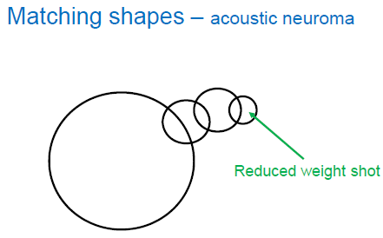

* + complete coverage of the tumor and preservation of brainstem, facial, cochlear and trigeminal nerve function is given priority during dose planning.

N.B. success depends upon high conformality to the tumor margin!

* + planning includes outlining of tumor volume, use of multiple isocenters, beam weighting and use of plug patterns.
  + combination of small beam diameter (4- and 8-mm) collimators; for large tumors, 16 mm collimators are also used.
  + series of 4 mm isocenters are used to create a tapered isodose plan to conform to the intracanalicular portion of the tumor.
  + facial-cochlear nerve complex generally courses along the anterior margin and anterior-inferior side of the tumor - the dose plan should by highly conformal in this region.
  + treatment isodose, maximum dose and dose to the margin are jointly decided by a neurosurgeon, radiation oncologist, medical physicist and, in some centers, a neurotologist after considering the goal of radiosurgery in an individual patient and the tolerance of the surrounding structures.
  + the ***fall off on cochlea, semicircular canal and brainstem*** are checked to keep them below tolerance level.

Steroids

* + there is no consensus on the use of corticosteroids on the day of radiosurgery.
  + some do not use steroids at all before, during or after radiosurgery.
  + some give IV 40 mg of methylprednisolone at the onset or conclusion of the procedure.
    - Cleveland Clinic: 1 dose of methylprednisone at the end of procedure; Rx of Medrol Dosepak PRN (if patient develops symptoms)
  + at other centers, 6 mg of dexamethasone is given immediately before dose delivery and is repeated every three hours for the duration of the treatment.

Follow Up

CNS Systematic Review and Evidence-Based Guidelines for Vestibular Schwannomas (2017)

***Level 3 recommendation***: follow-up imaging should be obtained at intervals after SRS to detect recurrence. ***No recommendations*** can be given regarding the interval of these studies.

***Progression of tumor after SRS*** - ***Level 3 recommendation***: SRS can be safely and effectively performed as a retreatment.

***Level 3 recommendation***: patients should be informed that there is minimal risk of malignant transformation of vestibular schwannomas after SRS.

***NF2*** - ***Level 3 recommendation***: SRS is a treatment option for tumors that are enlarging and/or causing hearing loss.

* + **MRI** at 6 months, 12 months, and 2, 4, 8 and 16 years.
    - *little change* is detected over first 6 months.
    - during initial 12 months, tumor may exhibit *initial edema*, but this declines over time (H: steroids or ventriculoperitoneal shunting).
    - by 12 months, follow-up MRI shows loss of central tumor enhancement (indicates favorable response).
    - 4-6% of tumors show pseudoprogression (tumor swelling) for 6-12 months – face may twitch – it is temporary.
    - by 2 years, partial involution of tumor is noted.
    - stereotactic radiation could completely eradicate tumor, but in most patients, residual tumor is noted on MRI (remains stable for long periods = local control).
  + all patients who have some preserved hearing are advised to obtain **audiological tests** (PTA and SDS) near the time of their MRI followups.

Results

Recent reports suggest a tumor control rate of 93–100% after SRS; pre-radiosurgery hearing can be preserved in 60–70% of patients (higher preservation rates for smaller tumors); facial and trigeminal nerve function can be preserved in > 95% of patients.

Multiple meta-analyses reveal that from the patients’ perspective, SRS provides a more desirable outcome than microsurgery!

CNS Systematic Review and Evidence-Based Guidelines for Vestibular Schwannomas (2017)

***Overall probability of maintaining serviceable hearing following SRS - Level 3 recommendation:***

moderately high probability (> 50-75%) of hearing preservation at 2 and 5 yrs

moderately low probability (> 25%-50%) of hearing preservation at 10 yrs.

***Subset of patients with*** AAO-HNS (American Academy of Otolaryngology- Head and Neck Surgery hearing classification) class A or GR (Gardner-Robertson hearing classification) grade I hearing at baseline ***- Level 3 recommendation:***

high probability (> 75-100%) of hearing preservation at 2 yrs

moderately high probability (> 50-75%) of hearing preservation at 5 yrs

moderately low probability (> 25%-50%) of hearing preservation at 10 yrs.



CNS Systematic Review and Evidence-Based Guidelines for Vestibular Schwannomas (2017)

***The most consistent prognostic features associated with maintenance of serviceable hearing - Level 3 recommendation:***

1. good preoperative word recognition
2. pure tone thresholds with variable cut-points
3. smaller tumor size
4. marginal tumor dose ≤ 12 Gy
5. cochlear dose ≤ 4 Gy.

Age and sex are not strong predictors of hearing preservation outcome.

Dade Lunsford:

* + **tumor control**:
* 98% at 6 years (6% of tumors initially increased 1-2 mm during the first 6-12 months and lost central enhancement, thereafter regressing);
* 95% at 10 years;
* at 10 -15 yrs: 73 % reduction in tumor volume, 25.5% no further change, 3 % delayed resection, 0.8 % required management of hydrocephalus.
  + 6-year actuarial rates for **preservation** (12-13 Gy):
* facial nerve function > 99%
* trigeminal nerve function 95.6 ± 1.8%
* useful hearing 78.6 ± 5.1%
  + 13 Gy tumor margin dose → 0% risk of new facial weakness and 3.1% risk of facial numbness (5-year actuarial rates); margin dose of > 14 Gy → 2.5% risk of new onset facial weakness and a 3.9% risk of facial numbness (5-year actuarial rates).
  + prior to 1991, tumor margin dose was 18-20 Gy preserving: 79 % facial function at 5 yrs, 73 % trigeminal function at 5 yrs.
  + unlike microsurgery, immediate *hearing loss* is uncommon after SRS; if hearing impairment is noted, it occurs gradually over 6 to 24 months.

N.B. unlike the solitary sporadic tumors that tend to displace the cochlear nerve, *tumors associated with NF2 tend to form nodular clusters that engulf or even infiltrate the cochlear nerve* – microsurgical resection is difficult but preservation of serviceable hearing in NF2 is an attainable goal with modern SRS.

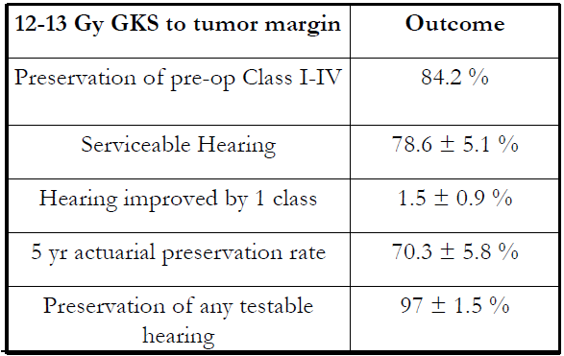

Lunsford et al. 2005

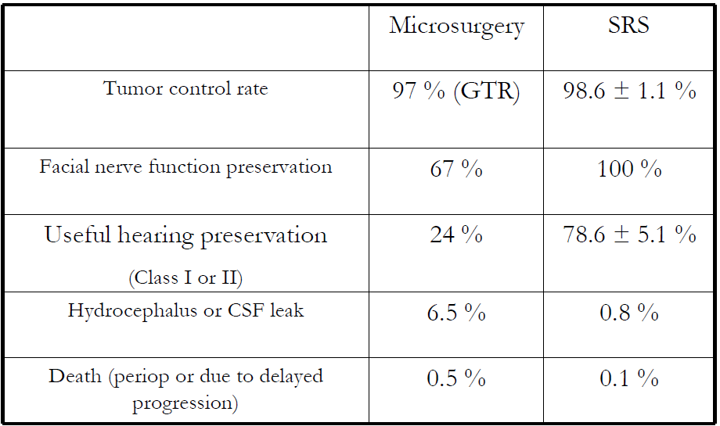

Survey of patients:

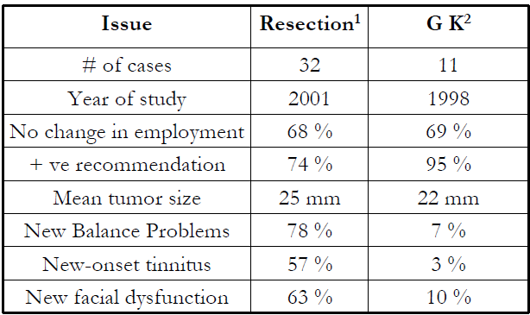

N.B. radiation *does not preserve hearing significantly better* than properly conducted surgery!

Dade Lunsford: SRS has better hearing preservation for patients < 60 yo; incidental tumor – OK to watch a little bit but counsel for early SRS.

* + SRS *does not improve tinnitus, balance, hearing*.
  + tumor size: SRS may be used even for > 4 cm tumors if minimally symptomatic (KOOS grade 4);

Iorio-Morin et al. Safety and Efficacy of Gamma Knife Radiosurgery for the Management of Koos Grade 4 Vestibular Schwannomas. Neurosurgery: April 2016 - Volume 78 - Issue 4 - p 521–530

Tumor control rates 95% and 92% at 2 and 10 years, respectively; serviceable hearing preservation rates 89% and 49% at 2 and 5 years, respectively; facial nerve preservation 100%

* + *cystic tumors* respond well to SRS (myth busted).
  + radiosurgical treatment carries 0.1-0.01% risk of *malignant transformation*.

SRS after Failed Microsurgery

* + achieves tumor control rate 93-94%

Microsurgery after Failed SRS

* + wait at least 6 months after SRS to document continuous tumor growth.
  + microsurgical resection is generally\* more difficult after radiation (significant adhesions between CN7 and tumor → facial nerve injury).

\*Dade Lunsford and several other experts: surgery is not more difficult after SRS

Repeat SRS

* + SRS can be repeated if first SRS failed (usually repeat SRS is fractionated).
  + can be delivered safely without an increased risk of complications as compared to the initial treatment.

Christian Iorio-Morin et al. Repeat Stereotactic Radiosurgery for Progressive or Recurrent Vestibular Schwannomas. Neurosurgery, Volume 85, Issue 4, October 2019, Pages 535–542,

Case discussions

38 yo female with preserved hearing and CN7 function; tumor is growing:

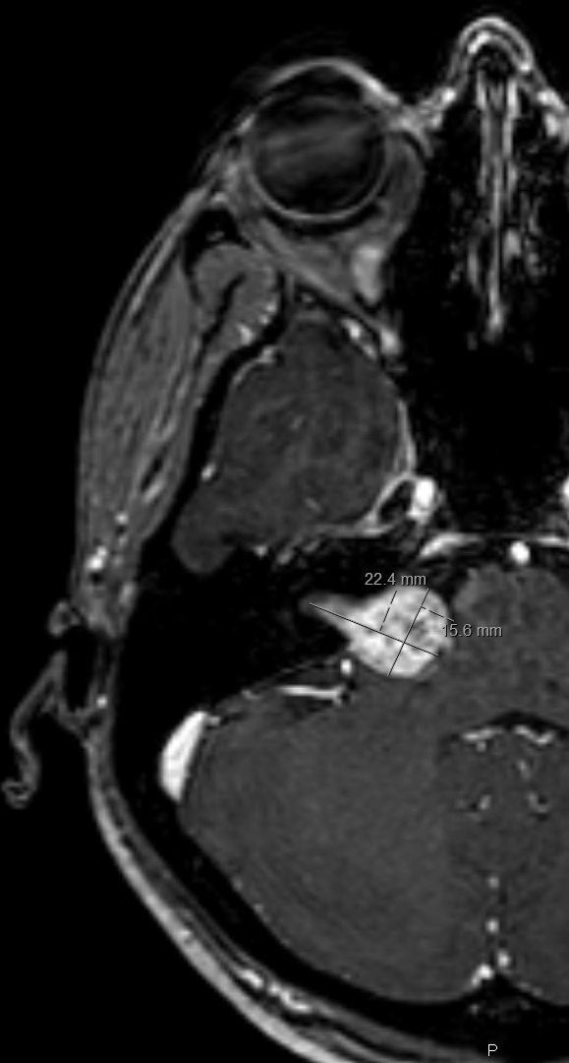

* + SRS is better option (vs. microsurgery) – risk of CN7 injury 0.2% (vs. 15-20%), better hearing preservation.

Treatment - Medications

* + there are currently no pharmacologic treatments approved by FDA.
  + only drug that has shown promise is clinical trials is bevacizumab, but it works in about 50% of patients.

Prognosis

Natural History

* + mean tumor growth 1-2 mm/year for “stable” tumors (2/3 of all tumors); 50% of patients will maintain hearing during observation for approximately 5 years
  + mean tumor growth 2–4 mm/year for those tumors that “grow”

N.B. some tumors may exhibit exceptional growth that exceeds 18 mm/year!

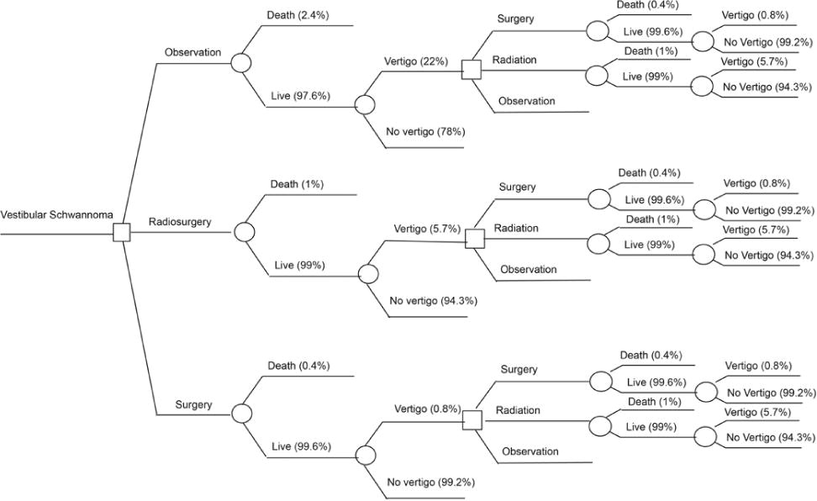

CNS Systematic Review and Evidence-Based Guidelines for Vestibular Schwannomas (2017)

***The overall probability of maintaining serviceable hearing with conservative observation of vestibular schwannomas - Level 3 recommendation:***

high probability (> 75-100%) of hearing preservation at 2 yr

moderately high probability (> 50-75%) of hearing preservation at 5 yr

moderately low probability (> 25-50%) of hearing preservation at 10 yr.

***Subset of patients with*** AAO-HNS (American Academy of Otolaryngology- Head and Neck Surgery hearing classification) class A or GR (Gardner-Robertson hearing classification) grade I hearing at baseline ***- Level 3 recommendation:***

high probability (> 75-100%) of hearing preservation at 2 yrs

moderately high probability (> 50-75%) of hearing preservation at 5 yrs

insufficient data on hearing preservation at 10 yrs.

The most consistent ***prognostic features*** associated with maintenance of serviceable hearing ***- Level 3 recommendation:***

1. good preoperative word recognition
2. pure tone thresholds with variable cut-points
3. nongrowth of the tumor.

Tumor size at the time of diagnosis, age, and sex do not predict future development of nonserviceable hearing during observation.

Facial Schwannoma

* uncommon lesion (≈ 1.2% of temporal bone tumors; 0.9% of schwannomas of cerebellopontine angle).
* 5% CN7 palsies are caused by facial nerve tumors.
* identified along entire course of CN7 (intratemporal much more common than intracranial).
* small percentage display unusual **multicentricity** (multiple discrete intraneural connections – “string of pearls”).
* grow at slower rate than acoustic neuroma.
* tend to grow *longitudinally* (along lumen of fallopian canal) - may prolapse into middle ear and out of stylomastoid foramen.
* ***otic capsule erosion*** is present in 30% patients.
* 50% fibers must degenerate before clinical signs of palsy are detected.

Clinical features

- slowly progressive (> 3 weeks) **CN7 dysfunction** (paresis, often preceded by facial twitching).

* small tumor can become symptomatic if it arises within narrow bony canal (e.g. labyrinthine segment), while more proximal tumor within cerebellopontine angle can become quite large before causing symptoms.
* classic presentation - *recurrent increasingly severe acute paralytic episodes* with partial / complete recovery.
* other possible symptoms: N.B. hearing loss is found in 69% patients!
  + **conductive hearing loss** (impinging upon stapes and oval window - tumors in horizontal segment).
  + **sensorineural hearing loss** (cochlear invasion - tumors proximal to geniculate ganglion, in labyrinthine segment).
  + **vertigo** (from labyrinthine fistula).

Diagnosis

**Otologic exam**

* otoscopy - mass behind drum (29%).
* pure tone audiogram.
* stapedial reflexes (not always reliable indicators of distal CN7 function).
* serial electroneuronography – important for surgery timing. *see below*
* CN7 action potential (valid method for assessing CN7 function waveform) – frequently no dysfunction (*CN7 schwannomas* are extremely slow growing).

**High-resolution, thin-cut CT** of temporal bone is superior to MRI!

**MRI** – small tumors; hypointense on T1 / hyperintense on T2; marked enhancement.

* ***enhancing enlargement along large segment of facial nerve*** is highly suggestive!
* radiographically distinguishing between *intracanalicular CN7 tumor* and *vestibular schwannoma* is often impossible.

**Biopsy** usually results in facial paralysis; pathologic diagnosis is made only intraoperatively.

**Photography** of resting and dynamic facial nerve function (serial assessment of deteriorating facial nerve + postoperative comparison)

Axial CT - large, circumscribed, osteolytic area in labyrinthine segment of facial nerve canal just anterior to cochlear capsule (*small arrowheads*); bone changes appear to be more expansile than destructive; adjacent old surgical defect (*large arrowhead*):

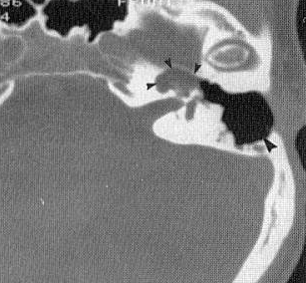

Differential Diagnosis

1. Hemangioma of temporal bone
2. Malignant schwannoma
3. Meningioma (e.g. intrinsic to geniculate ganglion and in intratemporal segment of facial nerve)
4. Middle ear carcinoma
5. Hematogenous metastasis
6. Direct spread of neoplastic disease into temporal bone via facial nerve (e.g. parotid mucoepidermoid carcinoma, squamous cell skin carcinoma)

Treatment

- primarily **surgical**.

Approach:

* 1. no useful hearing and tumor in internal acoustic canal → ***translabyrinthine*** or ***transpetrosal*** approach.
  2. useful hearing is present → hearing-sparing approach (e.g. ***middle fossa*** approach).
  3. residual / recurrent intracanalicular tumor → ***translabyrinthine*** approach is preferred (allows complete tumor removal).

Nerve repair:

1. smaller tumors – primary anastomosis.
2. larger tumors – interposition (cable) graft - *greater auricular* or *sural* nerve.

N.B. best expected functional result rarely exceeds House-Brackmann grade III paresis!

When to remove? **early removal**:

advantages - tumor is completely resected, least likelihood of injuring adjacent structures, maximum number of surviving healthy neurons for grafting nerve.

disadvantage - patient has good nerve function, and tumor removal nearly always destroys residual nerve function + grafting transected nerve never results in facial function better than House-Brackmann grade III/VI.

Many surgeons delay surgery until CN7 function has deteriorated beyond grade III/IV.

* surgical intervention is initiated once CN7 function has deteriorated to point in which expected result would be nearly equivalent to current CN7 function (documented with electroneuronography).
* intervention should not be delayed past point where motor endplates have atrophied.

Trigeminal Schwannoma

* usually arise from **root** or **ganglion**; less commonly, proximal division of CN5.
* occupy *middle fossa*; 50% extend into *posterior fossa* (may occupy both *middle* and *posterior* fossa - dumbbell shape).
* clinical features:

1. numbness in trigeminal distribution (≈ 100%)
2. trigeminal neuralgia (not common).
3. mild weakness of mastication (< 50%).
4. *extension into cavernous sinus* → oculomotor dysfunction (CN6 palsy may precede CN5 dysfunction!).
5. *extension into posterior fossa* → CN7 & CN8 dysfunction, cerebellar and pyramidal tract signs.

* **CT with bone windows** - erosion of petrous apex, foramen ovale, or foramen rotundum.
* treatment - ***surgical resection*** via subtemporal, frontal, or suboccipital approaches (cure or long-term control).

A. Coronal contrast T1-MRI - trigeminal tumor that has extended through foramen ovale *(arrowhead).*

B. Coronal CT with bone windows - widening of foramen ovale by tumor *(arrowhead).*

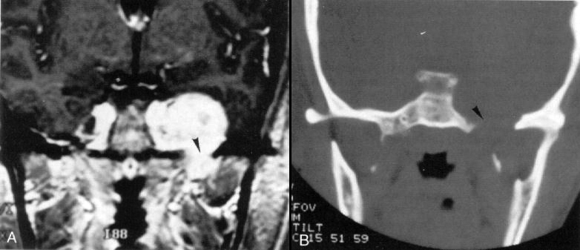

Hypoglossal Schwannoma

Contrast T1-MRI:

Axial image (A) - lobulated, enhancing tumor causes expansion of right hypoglossal canal (*arrow* indicates normal-sized left hypoglossal canal); tumor has large cystic intracranial component which compresses medulla oblongata (*arrowheads*), and smaller solid extracranial component.

Coronal image (B) - wasting and high signal of right side of tongue (*arrowheads*) indicates atrophy and fatty replacement.

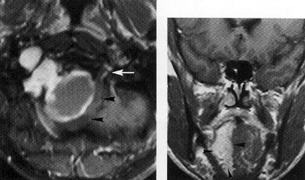

Bibliography for ch. “Neuro-Oncology” → follow this [link >>](http://www.neurosurgeryresident.net/Onc.%20Oncology\Onc.%20Bibliography.pdf)

[Viktor’s Notes℠ for the Neurosurgery Resident](http://www.neurosurgeryresident.net/)

[Please visit website at www.NeurosurgeryResident.net](http://www.neurosurgeryresident.net)