Paragangliomas
Last updated: April 12, 2019
Genetics 1
Epidemiology 1
Clinical features 1
Diagnosis 1
Staging 2
Treatment 2
Glomus Jugulare Tumor, Glomus Tympanicum Tumor 2
Pathology 2
Clinical Features 2
Diagnosis 2
Treatment 3
Follow-up, Prognosis 4

Paragangliomas - rare neuroendocrine neoplasms derived from paraganglia.

Paraganglia (s. chromaffin bodies) – small (< 1.5 mm) roundish bodies in diffuse neuroendocrine system (formerly called APUD):
- glomus intravagale – minute collection of chemoreceptor cells on auricular branch of vagus nerve, in proximity to ganglion vagale inferior (nodosum).
- glomus jugulare – minute collection of chemoreceptor cells in adventitia of jugular bulb (within jugular foramen of temporal bone).
- glomus tympanicum – on tympanic (Jacobson) nerve (on promontory of middle ear).
- carotid body (s. glomus caroticum) – chemoreceptor (O₂, CO₂, H⁺) innervated by CN9.
- glomus pulmonale – structure similar to carotid body, found in relation to pulmonary artery.
- paraaortic bodies (s. glomera aortica, organs of Zuckerkandl) – chemoreceptors (O₂, CO₂, H⁺) innervated by CN10.
- coccygeal body (s. glomus coccygeum) ?

Term “glomus” mistakenly was attached to these organs when their origin was believed to be similar to true glomus (arteriovenous) complexes, and although now recognized as inaccurate, nomenclature has persisted.

Paraganglia derive from neural crest in close association with autonomic nervous system:
  - sympathetic paragangliomas are composed of clusters of epithelioid (chief) chromaffin cells and usually secrete catecholamines (symptoms similar to pheochromocytoma) and are located in the sympathetic paravertebral ganglia.
Pheochromocytoma – paraganglioma of adrenal medulla.
  - parasympathetic (nonchromaffin) paragangliomas are nonfunctional and located along the glossopharyngeal and vagal nerves in the neck and at the base of the skull (carotid body, jugulotympanic and vagal paraganglia, and rarely, laryngeal paraganglia);
Chemodectoma – paraganglioma of chemoreceptors – only in carotid body.
N.B. majority of paragangliomas arising within the skull base and neck region are not associated with catecholamine secretion!

- highly vascular tumors that are typically associated with blood vessels (carotid artery, jugular bulb) and neural structures.
- malignant paragangliomas (metastatic behavior) are rare (15-35%; skull base and neck paragangliomas are usually benign).

Genetics
- one-third to one-half are associated with an inherited syndrome - linked to mutations in the genes encoding different subunits of the succinate dehydrogenase (SDH) enzyme complex – paraganglioma syndromes 1-5 (PGL1-5) – 70% patients are women with multiple paragangliomas.
N.B. genetic screening is advised for all patients diagnosed with a paraganglioma.
- susceptibility to paragangliomas is established component of four genetic syndromes:
- multiple endocrine neoplasia types 2A and 2B (MEN2)
- neurofibromatosis type 1 (NF1)
- von Hippel Lindau (VHL)
- Carney-Stratakis dyad - gastrointestinal stromal tumors (GISTs) and paragangliomas.

Epidemiology
- combined estimated annual incidence of pheochromocytoma/paraganglioma is ≈ 0.8 per 100,000 person years.
- persons exposed to chronic hypoxia due to dwelling at high altitude have a higher prevalence of paraganglioma as compared to those living at sea level.

Clinical features
- most paragangliomas are diagnosed in the 3-5 decades.
- four types of presentation:
- mass effect
- catecholamine hypersecretion: paroxysmal hypertension associated with episodic headache, sweating, and tachycardia/palpitations; additional symptoms - tremor, pallor, dyspnea, generalized weakness, panic attack-type symptoms, chronic constipation
- asymptomatic as an incidental finding on radiographic imaging
- asymptomatic found on screening of a proven mutation carrier

Carotid body paragangliomas are the most common paragangliomas of the skull base and neck (60); 80-90% are nonfunctional, and symptoms result from painless mass effect → dysphagia, deficits of cranial nerves VII, IX, X, XI and XII, hoarseness, Horner's syndrome.
- non-tender mass in the lateral neck that is more freely movable in the horizontal plane than vertically - Fontaine’s sign.
- tumor may be pulsatile.

Diagnosis
- biochemical testing (urinary and/or plasma fractionated metanephrines and catecholamines) is indicated for all paragangliomas, even if clinically non-functional.
- imaging: US, CT (homogeneous mass with intense enhancement and delayed washout), MRI (classic "salt and pepper" reflecting hypervascular signal voids), angiography, radioisotope imaging (metaiodobenzylguanidine (MIBG) or somatostatin receptor scintigraphy (SRS, indium-111-pentreotide scintigraphy, Octreoscan), FDG-PET
- biopsy (incisional or by fine needle aspiration) can cause severe hypertension from catecholamine crisis.
- genetic testing: patient with skull-base or neck paraganglioma - test for mutations in SDHD, SDHC, SDHB, SDHAF2, and SDHA.

Staging
Carotid body paragangliomas - Shamblin criteria:
●Class I tumors are localized with splaying of the carotid bifurcation but little attachment to the carotid vessels
●Class II tumors partially surround the carotid vessels
●Class III tumors intimately surround the carotids

Jugulotympanic paragangliomas - Fisch and Glasscock/Jackson staging systems

Treatment
Surgery
- adrenergic blockade (phenoxybenzamine is the preferred drug) is started 10-14 days before surgery; start high-sodium diet (>5000 mg daily) because of the catecholamine-induced volume contraction → orthostasis associated with alpha-adrenergic blockade.
N.B. beta-adrenergic blocker should never be started first - blockade of vasodilatory peripheral beta-adrenergic receptors with unopposed alpha-adrenergic receptor stimulation can lead to a further elevation in blood pressure
- embolization of the tumor's main arterial supply within 48 hours of surgery may help to reduce tumor size, bleeding; typical indication - tumor >3 cm
- complete surgical resection is the only curative treatment option.
- palliative surgery may be performed to reduce hypersecretory state
- malignant skull base and neck paragangliomas - metastases are most frequently found to the cervical lymph nodes – recommend selective lymph node dissection (selective ipsilateral neck dissection of regions IIa, IIB, and III) at the time of primary tumor resection.
- postoperatively be aware of baroreflex failure syndrome.

External beam radiation therapy, arterial embolization, stereotactic radiotherapy - may provide long-term disease control for patients in poor medical condition.

Glomus Jugulare Tumor, Glomus Tympanicum Tumor
- benign, slow-growing but locally invasive, encapsulated, highly vascular tumor of chief cells of glomus jugulare / tympanicum (i.e. nonchromaffin paraganglioma, s. chemodectoma).

- rare - incidence is 1 case per 1.3 million people.
- most common tumor of middle ear (second to vestibular schwannoma as most common tumor of temporal bone).
- predominantly women (3-6 : 1) 40-70 years (6 months – 88 years).
- most are sporadic.
- rarely - familial with autosomal dominant inheritance and incomplete penetrance; genomic imprinting - only children of males possessing disease gene (11q23) develop tumors.

Pathology
- histology - resembles normal paraganglia - clusters of chief cells (termed “zellballen” = Germ. “cell balls”) in highly vascular stroma; pattern is enhanced on silver staining (useful diagnostically); sustentacular cells and axons, seen in normal paraganglion, rarely appear in tumor.
- macro - reddish purple vascular lobulated mass.
- more common on left side.
- multicentric in 3-10% sporadic cases and in 25-50% familial cases.
- expands within temporal bone via pathways of least resistance (air cells, sigmoid and inferior petrosal sinuses, skull base foramina, eustachian tube); tumor tends to obstruct internal jugular vein.
- also erodes bone in lobular fashion (but often spares ossicular chain) - region of jugular fossa and posteroinferior petrous bone → mastoid and adjacent occipital bone.
Significant intracranial and extracranial extension may occur!
- 4% cases metastasize (lung, lymph nodes, liver, vertebrae, ribs, spleen).
- 1-4% tumors produce clinically significant levels of catecholamines (norepinephrine or dopamine) - mimicking pheochromocytoma.

Fisch classification (tumor extension to surrounding structures):
Type A tumor - limited to middle ear cleft (glomus tympanicum)
Type B tumor - limited to tympanomastoid area with no infralabyrinthine compartment involvement
Type C tumor - involving infralabyrinthine compartment of temporal bone and extending into petrous apex
Type C1 tumor - limited involvement of vertical portion of carotid canal
Type C2 tumor - invading vertical portion of carotid canal
Type C3 tumor - invasion of horizontal portion of carotid canal
Type D1 tumor - intracranial extension < 2 cm in diameter
Type D2 tumor - intracranial extension > 2 cm in diameter

Clinical Features
- insidious onset (significant delay in diagnosis):
- loud pulsatile tinnitus (76%; tumor is vascular!) + earache – features differentiating from vestibular schwannoma!
Significant ear pain is uncommon!
- conductive hearing loss (52%; inhibited ossicular mobility).
- middle ear mass, ear fullness (18%), bruit; erosion laterally through drum → otorrhea, external canal bleeding (7%) - mimics friable bleeding polyp.
- erosion laterally to inner ear → sensorineural hearing loss (5%), vertigo (9%), CN7 palsy.
- pathognomonic for glomus jugulare tumor - jugular foramen syndrome (CN9-11 paresis; nerves are situated medial to jugular bulb); lags ≈ 1 year after initial symptoms.
- in 1-4% cases, leading symptoms are pheochromocytoma-like (hypertension, tachycardia); also, somatostatin, VIP, calcitonin, neuron-specific enolase may be produced by tumor (carcinoid-like symptoms).
- intracranial extension → cerebellar / brainstem symptoms, dural sinus involvement, hydrocephalus, ICP↑.

Diagnosis
Otoscopy - characteristic, pulsatile, reddish-blue tumor behind tympanic membrane (tip of iceberg).
Brown sign - pulsatile purple-red middle ear mass that blanches with positive pneumatic otoscopy - distinguishing sign (often of little clinical value).
Audiology - mixed conductive and sensorineural hearing loss.
Plain X-ray - enlargement of lateral jugular foramen and fossa.
CT with thin sections - extent of bone destruction.
Contrast MRI (reflects highly vascular nature) - characteristic soft tissue intensity intermixed with high-intensity signals and signal voids (“salt & pepper” appearance); bright enhancement.
- some advocate that imaging be carried down to carotid bifurcation - to determine if multiple tumors exist; plus, glomus tumors are fed by ascending pharyngeal artery – enlarged artery on vascular imaging is pathognomonic for glomus tumors!)
Just before surgery (to allow embolization in one session) - carotid arteriography with cross-compression or trial balloon occlusion;
- blood supply is via ascending pharyngeal artery from ECA and branches from petrous portion of ICA.
- for tumors with large intracranial extension → vertebral arteriography (to exclude arterial feeders from posterior circulation).
Biopsy is likely to cause significant hemorrhage!

Glomus jugulare tumor (axial CT bone-window at foramen magnum level) - right jugular foramen (open large arrow) is smoothly rounded and densely corticated, but left is enlarged (small black arrows) and bone surrounding it appears ‘moth-eaten’:
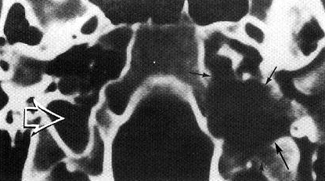

Glomus tympanicum tumor (coronal CT) - soft-tissue mass (arrowhead) along cochlear promontory (p) and hypotympanum; note that carotid artery (c) is just inferomedial to mass:
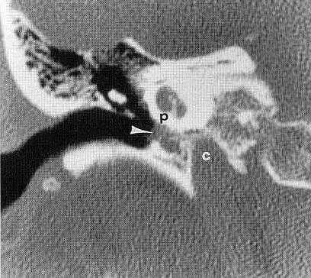

Glomus jugulare tumor (contrast T1-MRI) - marked enhancement with flow voids, representing large veins (arrows):
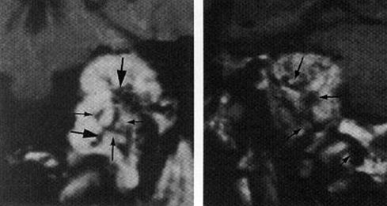

Glomus jugulare tumor:
A: Coronal CT - expansion of jugular fossa (small arrowheads indicate lateral wall) and destruction of petrous apex (large arrowhead).
B: Digital subtraction external carotid angiogram (AP projection) - pronounced tumor vascularity (arrowheads).
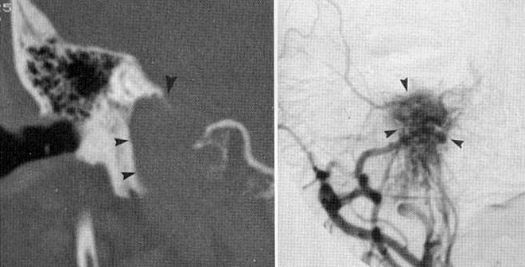

Glomus jugulare tumor (angiography):
A) Lateral projection, injection of occipital artery, arterial phase - large, extremely vascular mass fed by posterior auricular (small arrow) and occipital (large arrow) arteries.
B) Lateral projection after particulate embolization of anterior feeding vessel (posterior auricular artery) (arrow indicates catheter within artery) - bulk of mass no longer stains.
C) Following embolization of occipital artery - very striking further reduction in vascularity (arrow = catheter; arrowheads = emboli in occipital artery):
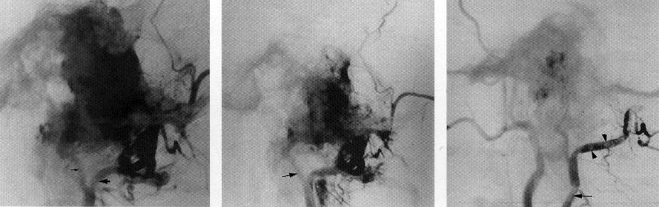

Treatment
Some cases require no treatment! (e.g. elderly patient with small tumor that grows slowly)

Drug therapy:
- α- and β-blockers for tumors secreting catecholamines* (esp. for 2-3 weeks before embolization and/or surgery - to avoid potentially lethal BP lability and arrhythmias).
* ≥ 3 times reference range
- Octreotide – for growth control of somatostatin receptor–positive tumors.
- Etoposide, cisplatin – for metastases.

Surgery – treatment of choice!
- preoperative embolization (immediately after the diagnostic angiogram).
- routine intraoperative monitoring (EEGs, SSEPs).
- sigmoid sinus above and jugular vein below are ligated, and segment between them excised with attached tumor;
- temporarily occlude transverse or sigmoid sinus (with EEG monitoring) to determine whether vein bypass should be performed for total resection.
- approach:
Fisch type A tumor – transmeatal or perimeatal approach.
Fisch type B tumor – extended posterior tympanotomy.
Fisch type C tumor – standard combined transmastoid-infratemporal or transtemporal-infratemporal approach with or without ICA trapping, preceded by ECA or superselective embolization.
Large Fisch type D tumor – combined otologic and neurosurgical approach (infratemporal approach with skull base resection and posterior fossa exploration).
- partial resection → radiation.

Classic fractionated radiotherapy or SRS – both are successful in long-term control of tumor growth (esp. with doses ≥ 40 Gy):
  - adjuvant after subtotal resections.
  - sole treatment modality for symptomatic elderly / infirm patients with extensive or growing tumors.
- dose of 45 Gy in 5 weeks is recommended; Cleveland Clinic uses 14-16 Gy (SRS).
- paragangliomas are radiosensitive* but not radiocurable!
*paragangliomas used to be nonsurgical tumors

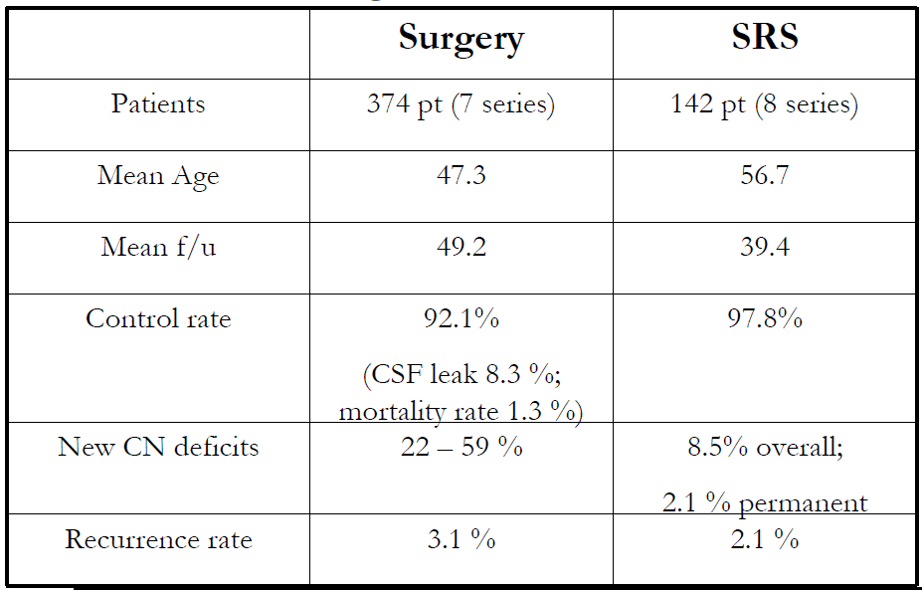

Sheehan J, Tanaka S, Link M, et al “Gamma Knife surgery for the management of glomus tumors: a multicenter study: Clinical article”
Dose median was 30 Gy (14-50 Gy) with 10-18 Gy to tumor margin → progression free survival of 98% at 1 year, 90% at 3 years and 88% at 5 years.

Follow-up, Prognosis
Radiologic (± endocrinologic) monitoring for tumor growth / regrowth every 6 months for 2 years → every 2 years.
Survival at 20-yrs - 94% (77% are symptom free).
Prognosis is excellent!

Bibliography for ch. “Neuro-Oncology” → follow this link >>

Viktor’s Notes℠ for the Neurosurgery Resident
Please visit website at www.NeurosurgeryResident.net

