Other CSF Sampling Procedures
Last updated: December 20, 2020
Cisternal (s. suboccipital) Puncture 1
Complications 1
Lateral Cervical (C1-2) Puncture 1
Ventricular Puncture 2
External Ventricular Drainage (EVD) → see p. Op6 >>

Indicated when lumbar puncture cannot be done.

Cisternal (s. suboccipital) Puncture
- puncture to cisterna magna
- neck is shaved from external occipital protuberance to mastoid process laterally.
- patient in lateral decubitus position (sitting position can be used).
  - neck is flexed to chest.
  - pillow under head (to keep neck and vertebral axis in same plane).
- patient is cleaned and anesthetized similar to LP.
- spinal needle is placed in midline halfway between C₂ spinous process and inferior occiput.
- needle is angled cephalad through subcutaneous tissue until it comes in contact with bony occiput.
- needle is then withdrawn and subsequently advanced at less acute angle with horizontal plane of cervical spine.
- this is repeated until dural "pop" is felt.
N.B. stylet is removed frequently so that dura is not punctured unknowingly!
- CSF is removed in usual manner.
- contrast material may be injected into cisterna magna (to identify rostral extent of obstructing lesion identified by lumbar myelography).

Complications
- brain stem puncture (vomiting, apnea).
- upper cervical cord damage.
- cisterna magna hematoma.
- dural veins are less extensive - bloody taps are less common.
- subarachnoid pressure is lower and dural tear can heal faster - low-pressure headaches are less common.

Lateral Cervical (C1-2) Puncture
- puncture in C₁₋₂ interspace from posterolateral approach:
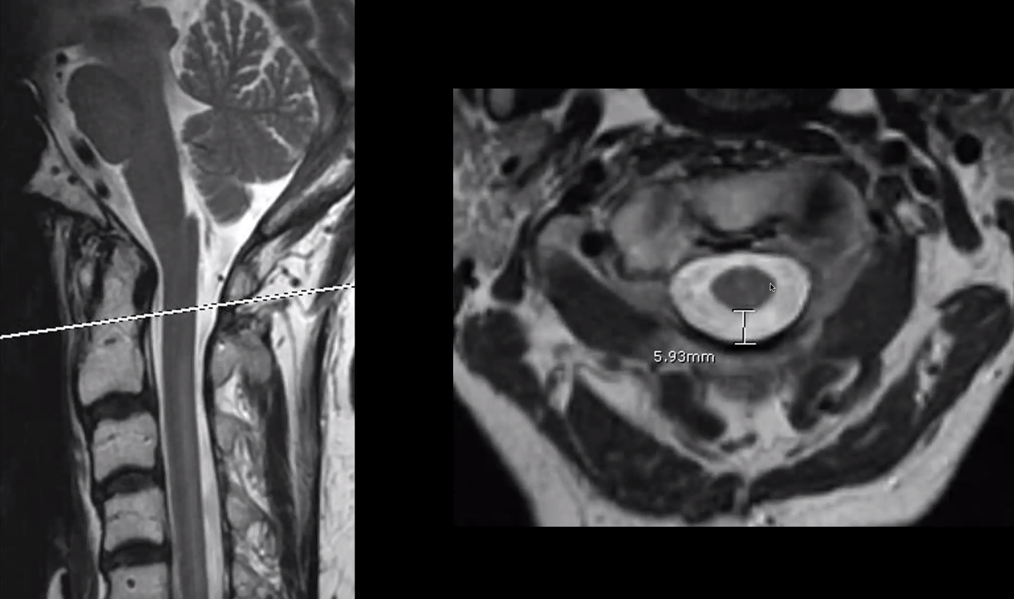
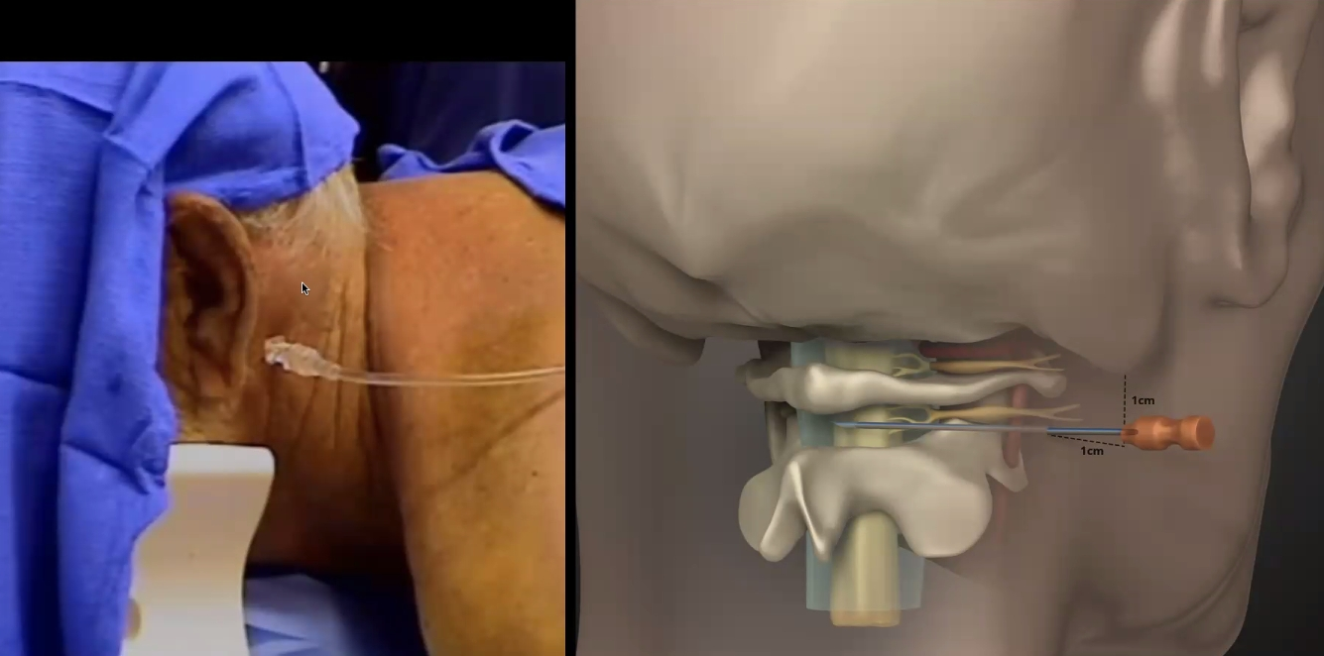

- Fluoroscopic guidance:
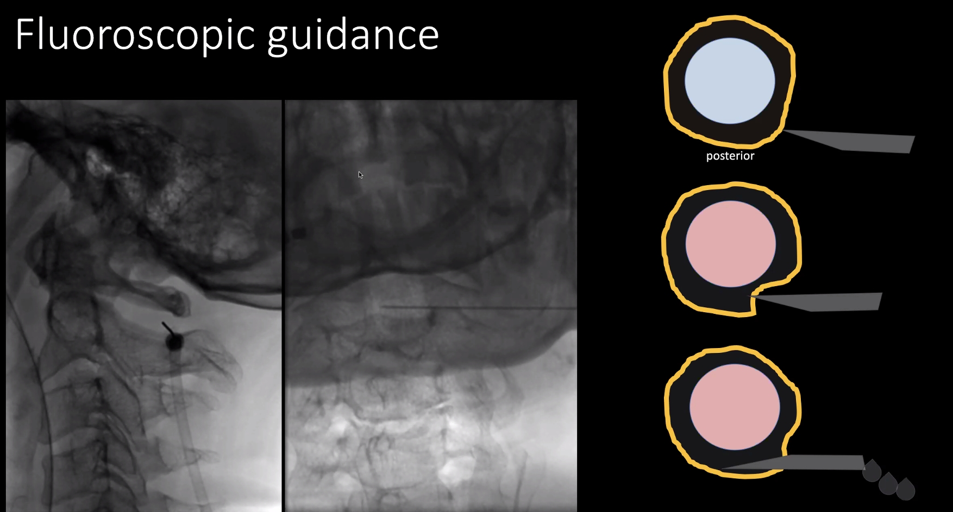

- CT-guidance:
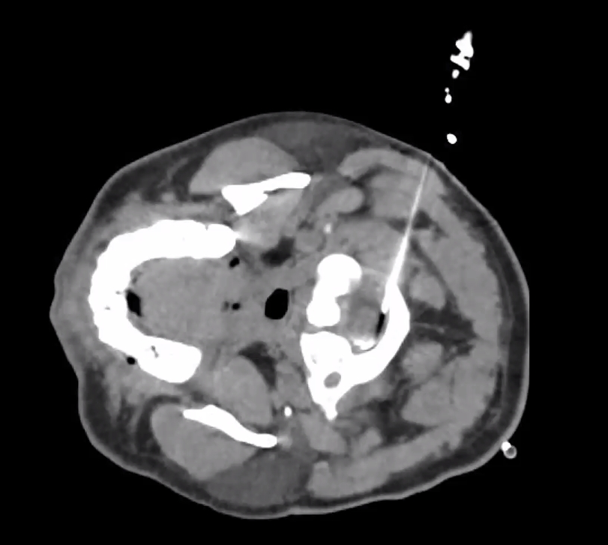

- prone or supine position, fully sterilized and anesthetized.
- 20-22G spinal needle is inserted perpendicular to neck and parallel to bed under lateral fluoroscopy.
- point for insertion: 5-10 mm inferior and up to 5 mm anterior or posterior to tip of mastoid process.
- physician advances needle slowly and frequently removes stylet to check for fluid return.
  - if needle goes too deeply and encounters paraspinous muscles, it is probably too deep posteriorly and should be repositioned more anteriorly.
  - if bone is encountered, more dorsal placement is needed.
- pressure and fluid samples are collected, as in other sites.
- contraindications: lesion at foramen magnum (e.g. cerebellar ectopia), unreduced atlanto-axial subluxation.
- complications: cervical cord damage, vertebral artery injury, anomalous PICA injury

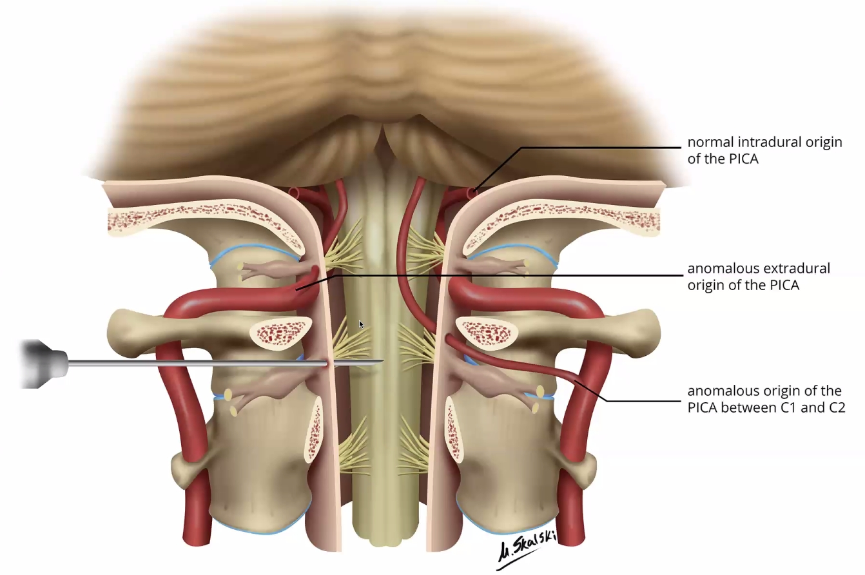

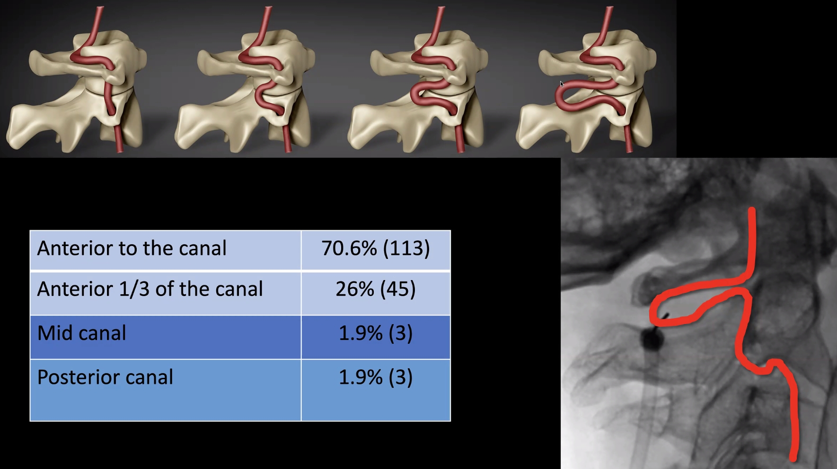

Ventricular Puncture
- similar to subdural tap: see p. TrH13 >>
- 23-25G ventricular needle with stylet (or AngioCath with automatically retractable needle) is placed in lateral border of anterior fontanel and is directed toward inner canthus of ipsilateral eye.
- needle is advanced slowly, and stylet is removed frequently to determine presence of CSF.
- ventricle is usually encountered ≈ 4 cm from skin surface.
- aspirate 10 mL/kg of CSF.

Viktor’s Notes℠ for the Neurosurgery Resident
Please visit website at www.NeurosurgeryResident.net

