Spinal Tumor Surgery (techniques)
Last updated: February 16, 2023
Extramedullary Tumors 1
Intramedullary Tumors 1
Preoperative 1
Procedure 1
Monitoring 1
Approach 1
Dura 2
Cord 2
Tumor 3
Spine stabilization 4
Closure 4
Special situations 4
Holocord tumors 4
Postoperative, Prognosis 4

Extramedullary Tumors
C1-2 nerve sheath tumor – see p. Op210 >>

Intramedullary Tumors
References to check
"Intradural Intramedullary Tumor: What Dictates Treatment? General Principles of Spinal Cord Surgery" by Dr. Jean-Paul Wolinsky, Northwestern University Feinberg School of Medicine, Chicago, IL. Presented at the LSRS 13th Annual Meeting. >>

Surgical extirpation is treatment of choice for benign tumors! (cures have been reported only after complete surgical resections)

Total removal with preservation of neurologic function!

Preoperative
- steroids in perioperative period (start at least 24 h prior to surgery; begin tapering 3-5 days after surgery).
- baseline urodynamic studies!
- do preop VA balloon occlusion test if anticipate vertebral artery sacrifice; if VA is nondominant, one may consider sacrificing (e.g. coiling) VA preop.

Procedure
These are high-risk operations that require special expertise in spine and microsurgical techniques.
- it is sometimes recommended to have two surgeons in this operation (or an experienced assistant).

Monitoring
Monitor spinal cord function using intraoperative electrophysiology (real-time feedback regarding possible ischemia or retraction injury):
- somatosensory-evoked potentials (SSEP)
- motor-evoked potentials (MEP)
- D-waves
- EMG (extremity muscles, anus + bulbocavernosus reflex*)
- spinal cord is sensitive to decreased perfusion - avoid hypotension (keep MAP > 85), use TIVA!
*for conus tumors
EMG, bulbocavernosus reflex – “lost or retained”
SSEP, MEP, D-wave – decrease by 50%

See p. D25 >> (including protocol for intraop spinal cord injury)
Epidural recording for D-wave correlates with expected outcome. see p. D25 >>

Approach
- depending on tumor location – either laminectomy (posterior approach) or corpectomy (anterior approach);

Posterior approach
- patient under general anesthesia (TIVA – to allow monitoring) in prone position.
- depending on tumor location – either laminectomy* (posterior approach) or corpectomy (anterior approach)
- if tumor spans several spinal levels → wide laminectomy (laminoplasty* in children and select adults);
*removing all laminae as single unit en bloc with footplate (“lobster tail”) → at the end place back and suture to the facet/pars with silk sutures (drill bone holes with C bit) - to protect spinal cord, to lessen risk of subsequent spinal deformity;
Dr. Jallo does laminoplasty for all adults (esp. true for kids) – “it does not prevent deformity but it helps with epidural scar and less CSF leaks”
- laminectomy should be of sufficient size to allow visualization of healthy cord above and below neoplasm.
- when using a posterior approach for ventral and lateral lesions, the spinal cord can be released by cutting the dentate ligament (± dorsal rootles) bilaterally at the level of the lesion, above and below - this maneuver will help rotating the cord to gain further access to the lesion.
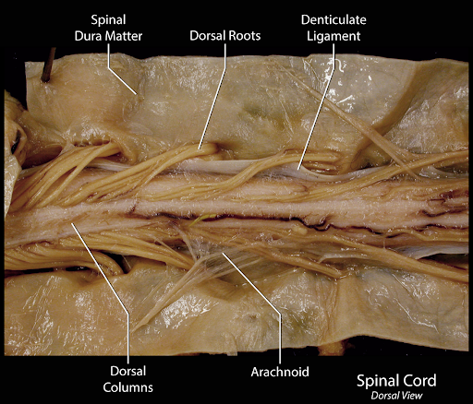

Dura
- prior to dural opening, tumor is localized with intraoperative ultrasound or spinal stereotaxy (esp. in thoracic spine where level localization is often unreliable).
N.B. use US to determine dural opening extent.
- perfect hemostasis before opening dura (epidural bleeding only tends to get worse once dura is opened); wax bone edges then lay 0.5x3 patties along gutters to absorb blood ooze.
- open dura under microscopic magnification
- midline durotomy extending above and below the level of the lesion as confirmed by intraoperative ultrasound.
- be mindful of potential adhesions of the spinal cord or vascular structures to the undersurface of the dura – operating on previously resected or radiated tumors may present a special challenge - err on the conservative side so as not to compromise spinal cord function.
- place 4-0 silk tuck-ups to retain dura open.

Cord
Under microscope, linear* midline** myelotomy at thinnest area between tumor and spinal cord.
*to spare vertically running white matter tracts.
**between the sensory fibers
- eccentric lesions may be approached through posterior intermediate sulcus or dorsal root entry zone (posterolateral sulcus):
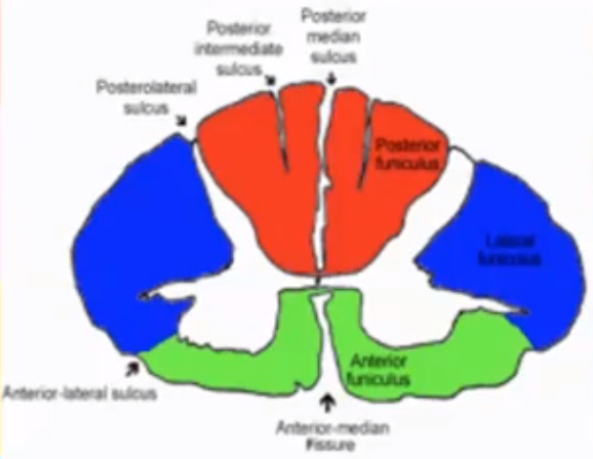

- dorsal midline must be studied carefully to identify the median raphe so that injury to the posterior columns is avoided.
- pattern of the dorsal roots can help with this identification.
- visualize the adjacent normal cord and follow midline raphe across the tumor (some tumors may be growing further in one hemicord than the other and may actually rotate or shift the dorsal midline); dorsal median vein is another landmark.
- electrical mapping of the posterior columns is also helpful - stimulate with bipolar fork where it is safe to cut.
- if tumor has exophytic component, this is initial area of approach (pia mater is opened directly over tumor), i.e. debulk any exophytic component prior to addressing tumor located within parenchyma.
- dorsal vasculature is saved by dissecting it from the pia and rotating it to one side of the spinal cord.
- blood vessels crossing the dorsal midline or penetrating into the dorsal midline are coagulated with fine bipolar forceps on the lowest coagulation setting – do it in strict midline! Dr. Jallo cautions to minimize coagulation until cord is opened.
- use #11 blade
- Dr. Nader recommends double-edge razor blade - sharper than most scalpels.
- Dr. Jallo uses 16G needle:
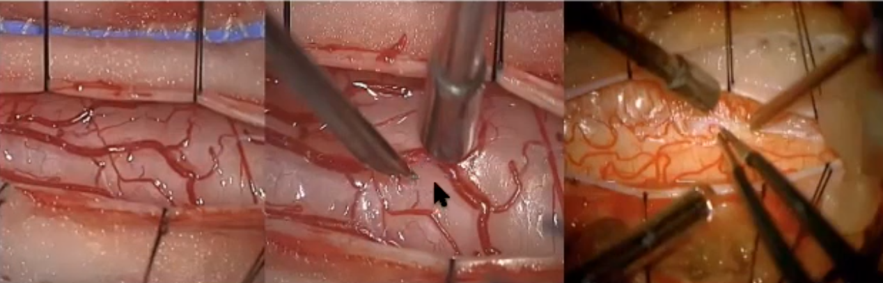
- exposure is opened until full extent of lesion can be visualized (ultrasonography may help to define tumor extent).
- dissect pia and place 5-0 or 7-0 Prolene stitches (to keep myelotomy open) suturing edge of pia* to edge of dura (may place vascular Weck clips instead of tying knots).
*Dr. Jallo recommends no pial stitches (so cord can relax in areas where surgeon is not working); he uses plated bayonets to spread the cord:
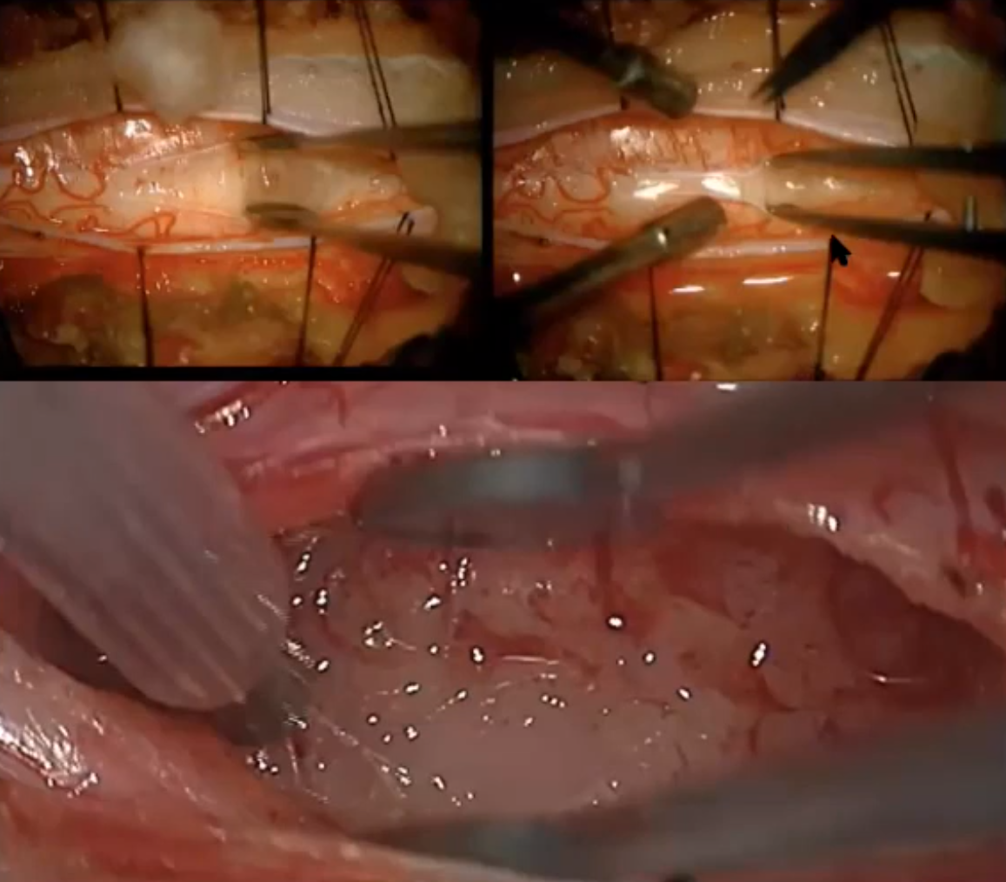
- traction on the cord should be avoided and kept to a minimum at all times.

Tumor
- for vascular tumors (e.g. hemangioblastoma) first need to control* feeders – bipolar them first, then resect tumor.
*some experts recommend intraop ICG angiography to find feeding vessels
- try to find cleavage plane to dissect* tumor around.
- nonvascular tumors can be removed in piecemeal fashion (vascular tumors – en bloc).
*Rhoton dissectors >>, Beaver blade, sharp canal knives, microbipolar cautery, and Fukushima microsuctions - use #6 Rhoton dissector to sweep the border along with very gentle traction on the tumor with a fine-toothed forceps
- send to frozen pathology for confirmation – if pathologist is not sure of diagnosis, better stop and come back for a second operation rather than to hurt the patient.
N.B. wait for frozen pathology before proceeding with resection (astrocytoma – do not do aggressive resection!)
- predictors of GTR - histology, tumor edema, no motor deficits.

McCabe Canal Knife:
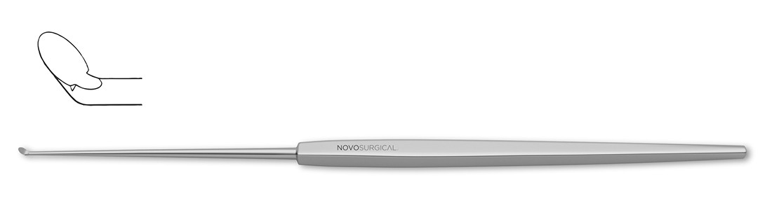

- defining the plane of dissection between the tumor and the cord can be difficult (preoperative T2-weighted MRI must be thoroughly studied to identify the cyst-tumor junction that can be used to begin the dissection between tumor and spinal cord).
- upon entering lesion, send biopsy for histopathology.
- tumors tend to be avascular and may have true capsule (or definable plane).
- if ill-defined plane is present, risk-to-benefit ratio for aggressive removal is not clear (e.g. developmental tumors can be quite adherent to spinal cord).
- for biopsy-proven high-grade* lesions, only biopsy and dural patch graft (to enlarge space for spinal cord) may be alternate approach to attempted resection.
*rapid progression even after aggressive resections

ependymomas have plane – easy to dissect; blood supply to the ependymoma arises from the branches of the anterior spinal artery penetrating through the ventral median raphe - these vessels are coagulated and divided as they are encountered on the ventral surface of the tumor.
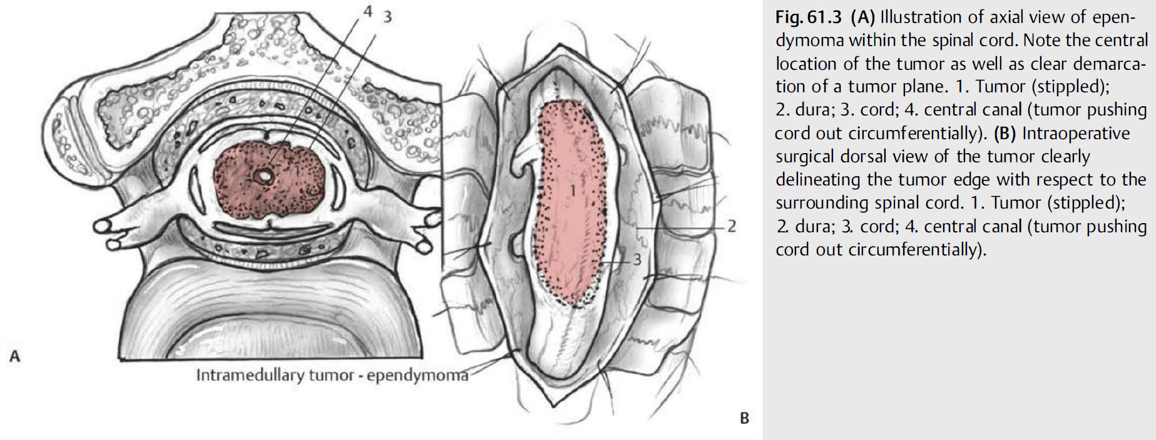

astrocytomas do not have plane (tumor cells infiltrating among axons of the spinal cord – debulk, i.e. resection is limited to the portion of the tumor that can be clearly defined as distinct from normal cord; in cases of cord compression, where the astrocytoma needs to be debulked, portions of the tumor can be resected, which are usually discolored (i.e., gray or yellow) relative to the whiteness of the spinal cord (consistency tends to be different as well, and discerning this can require some tactile feedback gained by the experience of the tumor neurosurgeon); if uncertainty arises during resection, further very tiny tissue specimens may be sent to pathology for spinal cord versus tumor differentiation.
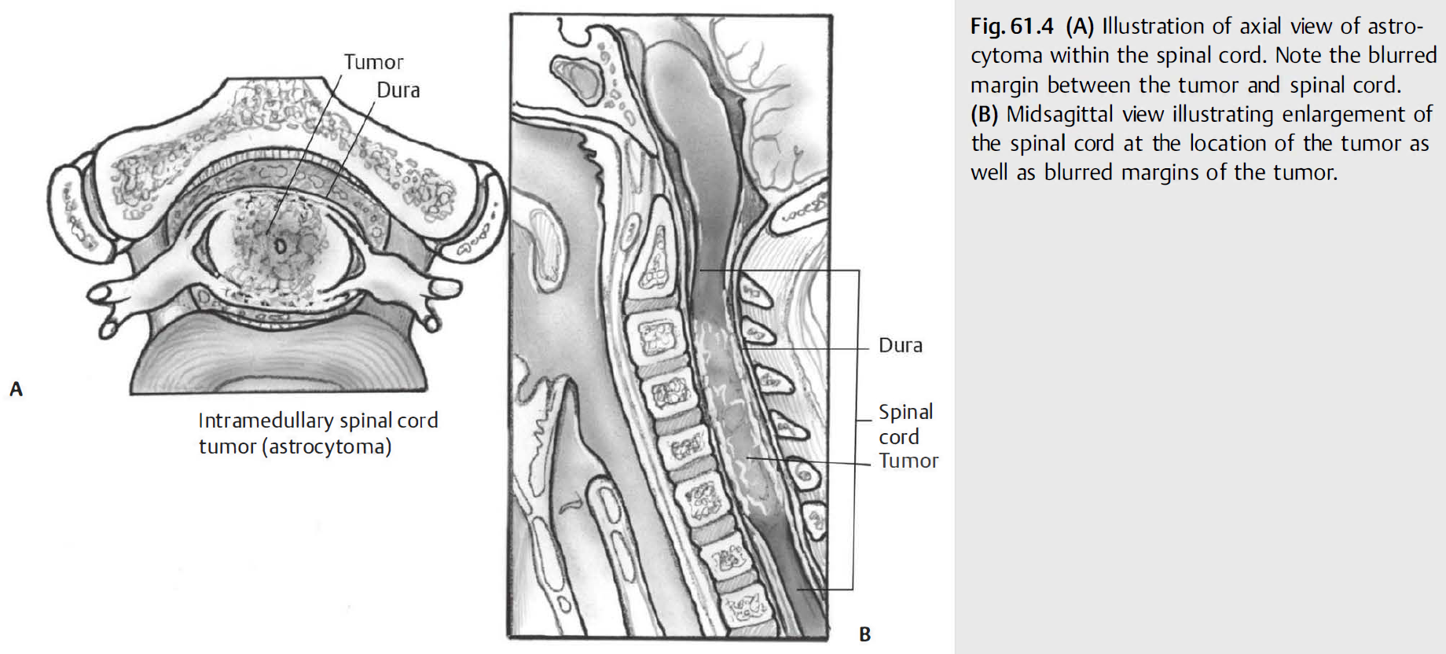
- if frozen section shows tumor to be malignant → surgery is aborted (→ radiotherapy).

N.B. extent of resection must be based on combination of presence of plane-of-dissection and intraoperative monitoring data; plus, surgeon’s experience and patient’s wishes!!!

- debulking instruments: NICO Myriad side-cutting dissector, Cavitron ultrasonic surgical aspirator (CUSA), fine-tipped contact laser (CO₂, KTP).
- any cysts/syringes encountered should be drained, septations divided (spinal cord pulsations demonstrating adequate decompression are monitored).
- for hemostasis use irrigating bipolar cautery (e.g. MALIS), irrigation and absorbable gelatin sponge with thrombin.
- any vessels en passage should be spared.
- when operating on tumors of conus medullaris, filum terminale should probably also be removed.

Spine stabilization
- Dr. Jallo avoids it during original surgery to avoid hardware artefacts on MRI.

Closure
- defect in neural tissue does not need to be closed (Dr. Spetzler); alternative - approximate myelotomy edges with Prolene (but leave gaps – to prevent intramedullary hematoma).
- watertight dural closure (may use dural grafting*) to minimize CSF leak.
*esp. if unable to totally resect tumor – duraplasty gives room and time
- irrigate intradurally – leave no blood.
- simple running 4-0 silk / 5-0 Prolene suture (ideally, Hemo-Seal (HS-7) needle)
- Valsalva maneuver → layers of Surgicel + DuraSeal / Tisseel / Adherus
- epidural drain may be left in place (but risk of infection or CSF tracking along drain); H: place drain above muscles (to avoid pulling CSF).
- consider instrumentation to prevent postoperative kyphosis.

Special situations
Holocord tumors
- typically, low grade tumors.
- Dr. Jallo operates on upper end of tumor (to decompress arm area) and then chemoradiation for the rest of tumor.

Postoperative, Prognosis
- see p. Onc50 >>
Check postop PVR → catheterize PRN
Bladder function – preop and postop!

Viktor’s Notes℠ for the Neurosurgery Resident
Please visit website at www.NeurosurgeryResident.net

