Cranioplasty
Last updated: January 16, 2021
Timing 1
Advantages of early replacement 1
Planning 2
Imaging 2
Bone flap 2
CT protocol for custom flap 3
Preop 3
Technique 4
Postop 4
Complications 4

References:
H. Richard Winn “Youmans Neurological Surgery” 6th ed. (2011), ch. 338

Timing
- previous infection – 6 months should pass after all infection has cleared.
- no previous infection – after brain edema subsided (usually > 6 weeks; skull edges ossify – less risk of autologous bone flap resorption);
- TBI edema subsides fast; MCA stroke edema persists longer.
- “R. Chestnut protocol” – at least 6 months before cranioplasty.
- cranioplasty can be performed at around 34 days after DC for TBI (pros: ventriculomegaly occurred less frequently, 6-month GOS score was better in the early cranioplasty group)
How early can we perform cranioplasty for traumatic brain injury after decompressive craniectomy? A retrospective multi-center study. Na Rae Yang et al. World Neurosurgery 2017 October 31

Timing of Cranioplasty in Military Penetrating Injuries
- incidence of postcranioplasty complication was greatly increased (56%) among patients who had a complication (e.g., infection or CSF leak) during initial care + complications increased among patients whose cranioplasty was performed less than 1 year after injury (20%) versus more than 1 year after injury (4%); in cases without initial complications, there did not appear to be any difference in infection rate as a function of timing of cranioplasty.
Rish BL, Dillon JD, Meirowsky AM, et al. Cranioplasty: a review of 1030 cases of penetrating head injury. Neurosurgery. 1979;4:381– 385

Advantages of early replacement
- Reduced incidence of scalp contraction (which can contribute to wound dehiscence)
- Reduced temporalis atrophy (which can contribute to temporomandibular joint complaints and cosmetic asymmetry)
- Resolution of the syndrome of the trephined.
- Early replacement before the development of severe encephalomalacia eliminates the potential dead space under the flap postoperatively (risk for EDH, pneumocephalus, and fluid collections).
- Provides cerebral protection during the phases when patients are most at risk - starting to walk again but are still likely to experience imbalance, incoordination, and orthostatic hypotension.
- Lower risk of developing hydrocephalus – but only in TBI patients!
Davide Nasi, Mauro Dobran. Can early cranioplasty reduce the incidence of hydrocephalus after decompressive craniectomy? A meta-analysis. Surg Neurol Int . 2020 May 2;11:94.
- there is study that showed postoperative hydrocephalus rates were significant higher in the early (< 3 mos) cranioplasty group [RR=2.67, 95%CI (1.24, 5.73), p<0.05]
Hao Xu. Early cranioplasty vs. late cranioplasty for the treatment of cranial defect: A systematic review. Clin Neurol Neurosurg . 2015 Sep;136:33-40. doi: 10.1016/j.clineuro.2015.05.031. Epub 2015 May 29.
- Cranioplasty, regardless of timing, is associated with significant neurological improvement; postcranioplasty neurological outcome is significantly improved in the early cohort (< 90 days) and has greater magnitude of change.
JG Malcolm et al. Early Cranioplasty is Associated with Greater Neurological Improvement: A Systematic Review and Meta-Analysis. Neurosurgery. 2018 Mar 1;82(3):278-288.
- Early cranioplasty can reduce the duration of operation.
Hao Xu. Early cranioplasty vs. late cranioplasty for the treatment of cranial defect: A systematic review. Clin Neurol Neurosurg . 2015 Sep;136:33-40. doi: 10.1016/j.clineuro.2015.05.031. Epub 2015 May 29.

Planning
Imaging
- CT – make sure brain has room to go back into skull (sometimes, brain bulges due to low atmospheric pressure).
- Check if CTA was ever done (for pseudoaneurysms).

Bone flap
Native bone flap (always check if available; uncommon in military victims):
- stored frozen (theories that too much freezing destroys substances and transplanted flap is rapidly resorbed) – thaw and soak in Betadine solution.
- stored implanted in abdominal wall – high chances that autoresorption happened.

Synthetic alternatives (advantage of filling in the temporal craniectomy defect and providing a strut for the temporalis muscle, which often results in better cosmesis):
- Methylmethacrylate (e.g. DePuy) – mix well powder with solvent, apply on defect and mold (Dr. Broaddus - place layer of cotton to prevent heat transfer to brain), pour water when starts to get hot, trim with drill when solid, fix to skull with plates and screws.

- Medpor (Stryker – they also give sterile real skull model – can be used intraop for bone edge dissection whenever skull defect is of difficult shape)
N.B. Medpor cannot be flashed if becomes unsterile (therefore, Stryker ships two identical sterile implants packed separately)
- PEEK (polyetheretherketone) – custom skull flaps are made by: see p. Op140 >>

- PEKK (polyetherketoneketone) – claims of less bacterial adhesion and encapsulation.

- PMMA – porous, hydrophilic.

- Titanium

Custom made flap better fills bone voids!

Companies often price their implants based on size:
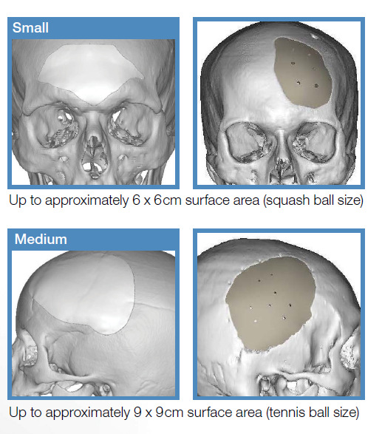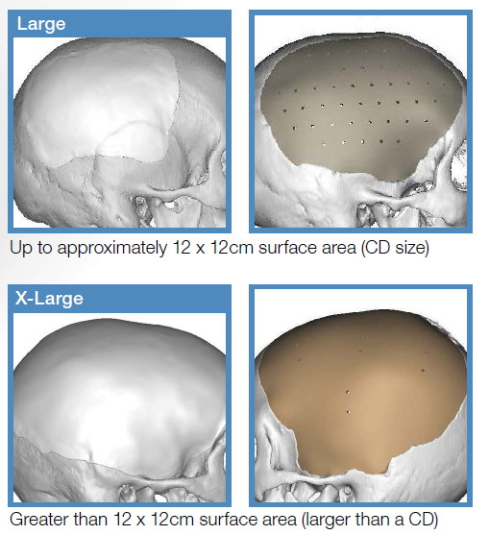

PEEK vs. Titanium
Rosinski et al. A Retrospective Comparative Analysis of Titanium Mesh and Custom Implants for Cranioplasty. Neurosurgery January 86:E15–E22, 2020
PEEK - infection rates are higher (27% vs. 0%); importantly, none of the patients who received
custom implants and developed cranioplasty infection had a craniectomy for osteomyelitis or epidural abscess.
Titanium mesh – worse cosmesis and postsurgical discomfort - can be managed nonsurgically; one of the most common complications in the titanium group, CSF leak (11.1%), did not occur in the PEEK group.

CT protocol for custom flap
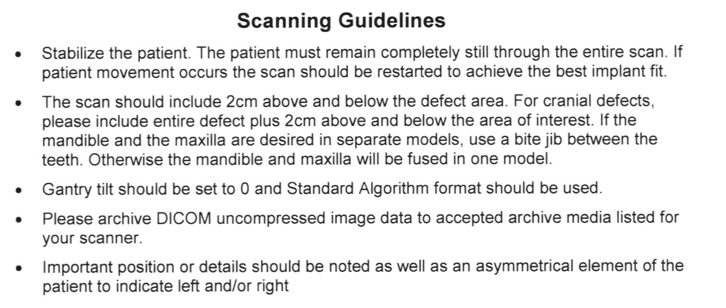

Preop
- always use Foley (in case patient needs mannitol intraop!); may not for Dr. Graham.
- may load with AED for 7 days.

Technique
- use sharp dissection with Metzenbaum scissors (insert scissors underneath and along incision between scalp flap and bone → cut with knife)
- use bipolar cautery for hemostasis (Bovie worsens incision healing, plus, transmits too much heat to the underlying brain – increased risk of postop seizures).
- dissect temporalis muscle from dura (risk of durotomies and bleeds a lot; Dr. Collins believes it decreases postoperative headaches from muscle pulling on dura).
- there is frequently a ridge of scar tissue at the perimeter of the bone flap that may be shrunken back with bipolar cautery or excised – gives extra mL of room to fit bone flap in.
- unintentional durotomies repaired with 4-0 silk running sutures.
- may tack dura to bone flap centrally with sutures.
- may cover dura with Surgicel.
- fix flap to skull edges with plates and screws.
- advance flap anteriorly-superiorly for cosmetic reasons (may need to drill off the sphenoid wing ridge on the bone flap for better accomodation).
- avoid plates on the path of legs of glasses
- smoothen bone edges with drill to improve contour.
- Dr. JRC uses HydroSet
- fix temporalis muscle to new flap with sutures, screws (must go through muscle fascia).
- leave drain over flap (subgaleal) on suction.
- use running vertical mattress for skin closure (e.g. 3-0 Monocryl) – scar edges tend to invert so mattress helps to keep skin edges aligned.

Difficulty closing scalp without tension: perform partial* thickness galeal incisions in # fashion – helps to stretch scalp.
*partial - to avoid damaging galeal vessels

Postop
- regular floor or ICU.

Complications
- Infection (15-20%) – no matter what type of bone flap is used (autologous stored in abdomen vs. synthetic vs. autologous frozen).
N.B. cranioplasty is the neurosurgical procedure with the highest infection rates!
- some experts culture autologous bone flap before reimplantation.
- some experts soak autologous bone flap in the Betadine before reimplantation.

- Cerebral swelling

- Resorption of the autologous bone flap; risk is increased: kids, irradiated contaminated bone flaps, fragmented bone flaps, abdominal bone flap storage.

Vilcinis “Neurotraumatologija” 1999
KAUKOLĖS KAULŲ DEFEKTAI IR JŲ PLASTIKA
Kaukolės kaulų defektai lieka po įspaustinių, skeveldrinių lūžių šalinimo, šautinių, durtinių sužalojimų, dekompresinių kraniektomijų, osteomielito.
Indikacijos kranioplastikai yra kosmetinės, apsauginės, o taip pat dėl trepanacijos sukeltų nemalonių pojūčių. Išvaizdos pagerinimas gali turėti įtakos ir psichosocialinei adaptacijai. Pakartotinų traumų apsauga ypač svarbi kariams, policijos, pramonės, darbuotojams, sportininkams, ligoniams sergantiems epilepsija. Trepanaciniam sindromui būdingi veržiantys, pulsuojantys galvos skausmai, ypač keičiantis aplinkai: atmosferos slėgiui, temperatūrai (netoleruoja saulės, karščio). Be to šie ligoniai jaučia svaigimą, nuovargį, nemigą, negalėjimą susikoncentruoti, nerimą, depresiją. Tokie simptomai galimi ir be kaukolės kaulų defekto po smegenų sukrėtimo ir tai vadinama “postkomociniu” ar “potrauminiu” sindromu. Esant plačiam kaukolės defektui po dekompresijos tiesioginis atmosferos slėgis sąlygoja pusrutulio kolapsą ir gali sąlygoti neurologinį pablogėjimą. Gi po kranioplastikos šiems ligoniams neretai pagerėja neurologinė būklė.
Kranioplastiką rekomenduojama atlikti išnykus intrakranijinės hipertenzijos požymiams, nes ankstyva operacija gali pagerinti neurologinių simptomų atsistatymą. Tai siejama su smegenų kraujotakos pagerėjimu po kranioplastikos. Operacija atidedama po infekcinių komplikacijų - paprastai 6 mėn.
Reikalavimai kranioplastikos medžiagoms:
- lengvai modeliuojama, priderinant prie kaukolės formos
- lengvai sterilizuojama
- stiprumas, atitiktų kaulo
- lengvo svorio
- pralaidi rentgeno spinduliams ir nejautri magnetiniame lauke
- pigi
Optimalu panaudoti to paties žmogaus kaulą, pvz., išsaugant, konservuojant kaulinį lopą. pašalintą, atliekant dekompresiją, panaudojant greta esančio kaukolės kaulo išorinę plokštelę ar šonkaulį, klubakaulio sparno fragmentą. Šio kaulo prigijimą blogina: bloga jo fiksacija prie defekto kraštų, kietojo dangalo pakeitimas fascia lata ar lavono dangalu, defekto kaulinių kraštų užvaškavimas, plonas, menkai vaskuliarizuotas skalpas.
Ieškota optimalios aloplastinės medžiagos. Dar prieš 3000 metų prieš mūsų erą Peru rastos auksinės ir sidabrinės plokštelės, savo dydžiu atitinkančios trepanacines kaukolės angas. Vėliau buvo naudojamas tantalas, nerūdijantis plienas, titanas, cirkonis, aliuminis. Jų nepatogumas, kad yra geri temperatūros laidininkai, apsunkina rentgenologinius tyrimus.
1940 m. Kleinschmidt pasiūlė kranioplastikai naudoti metylmetakrylatą, kuris greitai tapo labai populiarus ir iki šiol naudojamas. Operacijos metu sumaišomi polimero milteliai su monomero tirpikliu, masė gerai išmaišoma, kad tirpiklio perteklius išgaruotų, nes jis veikia citotoksiškai. Defekto sritis užliejama šia mase, kad gerai priglustų prie kaulo defekto kraštų. Modeliavimui skirta apie 5 min, o po 15 minučių įvyksta egzoterminė polimerizacija ir plokštelė sukietėja. Tada ji fiksuojama prie kaukolės kaulų kraštų. Protokrilo ir kitų aloplastinių medžiagų nerekomenduojama naudoti kai yra pažeistas kaktinis antis - prieš tai būtina atlikti jo plastiką.
Paskutiniu metu kranioplastikai pradėtos naudoti keraminės medžiagos - trikalcio fosfatas, hidroksiapatitas, kurioms būdinga osteogenezės stimuliacija, t.y. jos palaipsniui rezorbuojasi ir sukaulėja.

Viktor’s Notes℠ for the Neurosurgery Resident
Please visit website at www.NeurosurgeryResident.net

