Cerebrovascular Surgery (techniques)
Last updated: April 12, 2020
Vessel intraop visualization 1
Sylvian Fissure splitting 1
Anatomic Triangles, CSF cisterns 3
Vascular anastomosis, Bypass 6
Indications 6
Technique 6
Postoperatively 7
Aneurysm Clipping 7
AVM 7
Postop 7
Carotid Endarterectomy 7
Booking 7
Instruments 8
Positioning 8
Anesthesia 8
Monitoring 8
Approach 8
Endarterectomy 11
Closure 12
Postop 13
Follow-up 13
Complications 13
EDAS (encephaloduroarteriosynangiosis) 13
Optional: parietal bur holes 14
Microvascular decompression (MVD, Jannetta procedure) 14
Indications 15
Patient counselling 15
Procedure 15
Postoperatively 16
Outcomes 16
Trigeminal Neuralgia 16
Hemifacial Spasm 17
Neuroangiography – see p. D61 >>

Vessel intraop visualization
IC green
Yellow 560 – nicely shows filling of tiniest perforators.

Sylvian Fissure splitting
- opening dura and cutting arachnoid adhesions along middle fossa floor frees inferior temporal lobe:
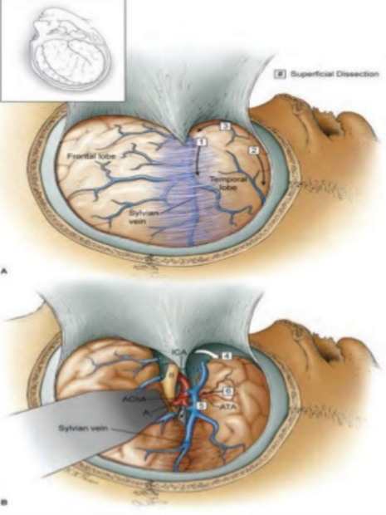

- using two micro pick-ups tear arachnoid apart in avascular spot → work with low power suction and Rhoton dissectors / microscissors.
- try to preserve all crossing vessels (Dr. JRC) / it is fine to take if needed (Dr. Rivet).
- It should never be necessary to take a vessel crossing the fissure because these can always be separated to one lobe or another through careful dissection (i.e. one vessel trunk gives branches either to temporal or frontal lobe but not to both).
- divide temporopolar vein – untethers anterior temporal lobe:
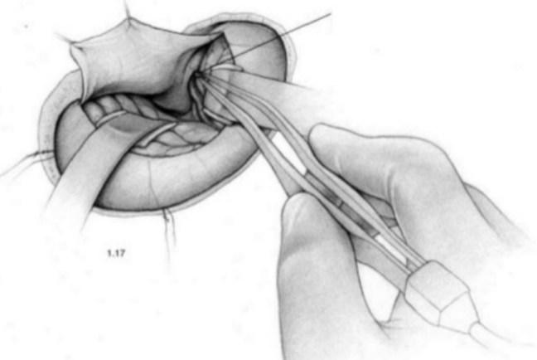

- open carotid cistern:
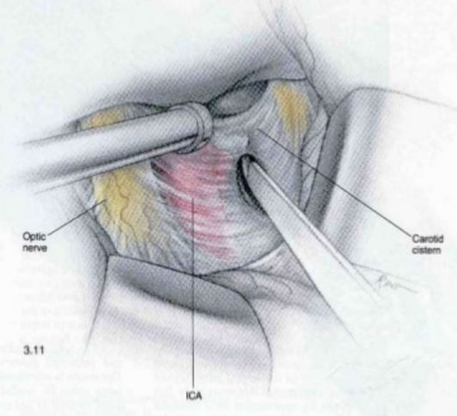

Anatomic Triangles, CSF cisterns
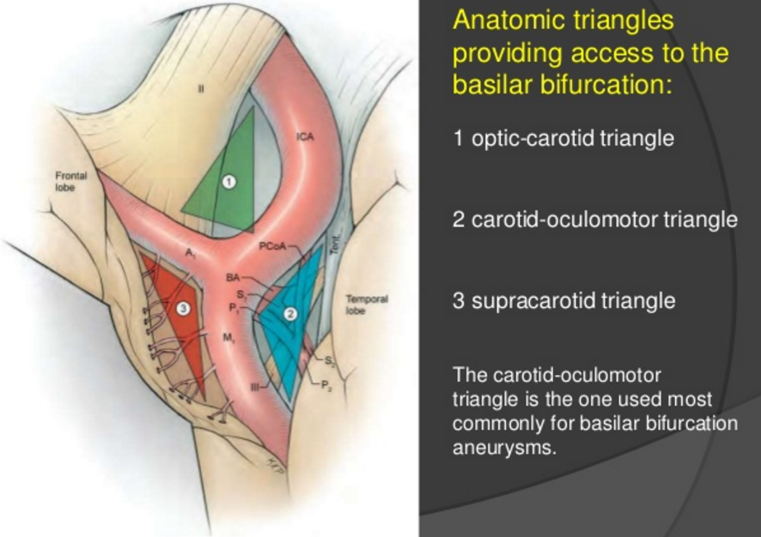

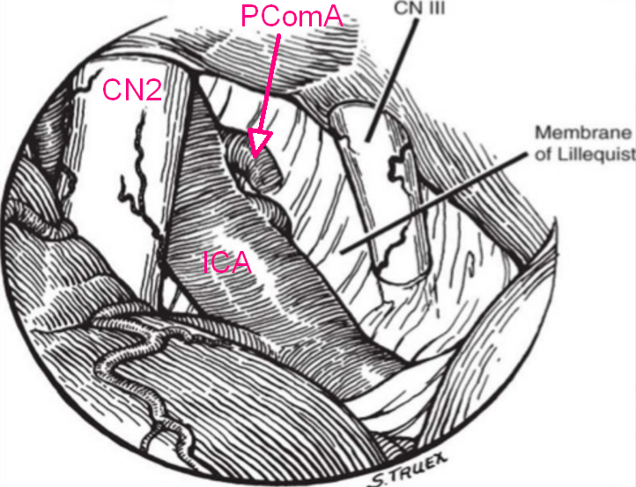

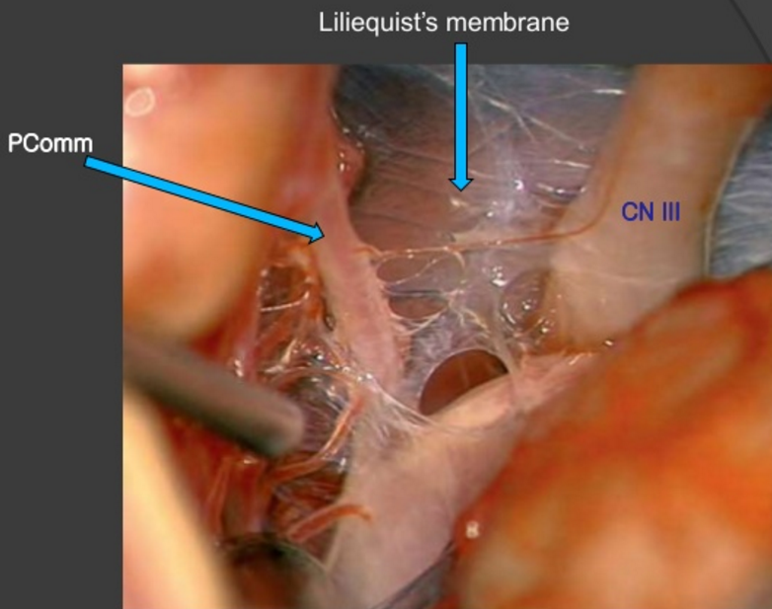

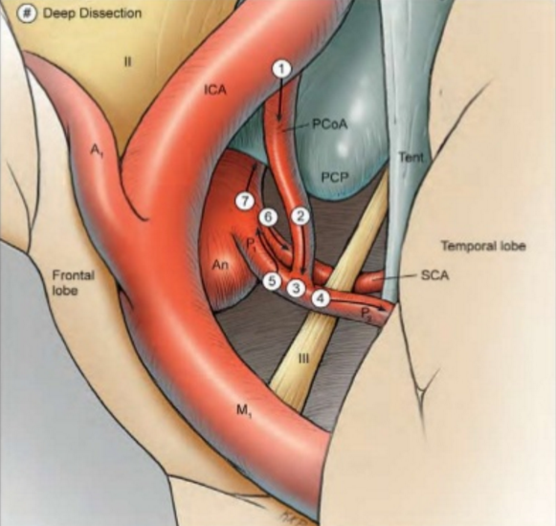

Vascular anastomosis, Bypass
Fukushima bypass (obsolete) – petrous ICA to supraclinoid ICA.

Indications
- moyamoya (Dr. Lawton always prefers direct revascularization over EDAS)
- atherosclerotic occlusion
- aneurysms (in Dr. Lawton’s experience, 4% of aneurysms need bypass)

Technique
- no need for systemic anticoagulation, only heparin irrigation
- smallest sutureable vessel – 0.7 mm diameter.
- crossclamp time:
M1, A1 – 5-10 minutes (due to nonforgiving perforators)
Distal – up to 30 minutes
- peel off 1 cm of connective tissue cuff from vessel wall to allow suturing.
- arteriotomy with the tip of 27G needle, then continue with microPotz type scissors.
- never crush endothelium with forceps (may put two prongs of forceps into vessel lumen to facilitate needle passage)
- strategy to increase vessel diameter in end-to-side anastomosis: cut vessel end 60 degree obliquely, plus, make longitudinal cut in vessel wall (“fishmouthing”).
- arteriotomy for side anastomosis – 3 times vessel diameter.
- use highest microscope magnification; zoom out for knot tying.
- 10-0 Prolene (9-0 if anastomosis under some tension), enough three throws for the knot.
- Dr. Lawton uses running sutures (adjusts and tightens suture line at the end of suturing), others use interrupted sutures.
- make two anchoring stitches at each end of arteriotomy (for fishmouth, first stitch at the heel) – aligns vessel walls for nice stitching.
- remove crossclamps – is leak bleeds, wrap with hemostatic agent and wait (“2 minutes law”) – majority will seal off; most common leak site – very first stitches next to anchoring stitch, so make them more closely spaced.
- thrombosis after anastomosis is done – make proximal arteriotomy and retrieve thrombus.

Postoperatively
aspirin for life

Aneurysm Clipping
See also p. Vas25 >>
All clips since 2008 are MRI-compatible (at VCU - titanium Aesculap Yasargil clips).

Approach:
ICA terminus, MCA – pterional crani; supine with head rotation:
PComA – 45 degrees
AComA – 60 degrees
BA bifurcation - subtemporal, lateral supraorbital, modified presigmoid

AVM
Postop
SBP goal < 110-120
Keppra for 7 days

Carotid Endarterectomy
Carotid anatomy – see p. A205 >>
Preoperative evaluation – see p. Vas7 >>

Booking
EEG (Dr. JRC – also SSEP)
Angiographic table
Handheld Doppler

Instruments
Silastic vascular loops and umbilical tapes
DeBakey vascular clamps
Rhoton dissector # 7
Penfield # 4
6-0 Prolene
Intraoperative Doppler

Positioning
- supine on angiographic table
- operating table should be horizontal without head elevation.
- head on gel donut.
- head is turned 15-20 degrees to opposite side to provide access.
- may place rolled towel under shoulders (to exaggerate neck extension).
- gentle preparation of operative site (risk of dislodging fragments from fragile carotid plaque).

Anesthesia
        - Local anesthesia (cervical plexus block) - allows direct evaluation of neurologic status - enables operation without routine shunt, which is technical nuisance and may pose increased risk (if neurologic deterioration occurs → shunting); technically more difficult, stressful for surgeon.
        - General anesthesia - improved airway control and patient comfort + protective effects of some general anesthetics on cerebral circulation; requires shunting? see below
N.B. no superiority of either approach!

Monitoring
EEG (Dr. JRC – also SSEP)

Approach
- incision – longitudinal along medial border of sternocleidomastoid; some authors postulate that transverse skin incision leads to increased risk of CN injuries which is not true (3% with transverse, 5% with longitudinal).
Dr. JRC – 10 blade for skin, then Metz + bipolar (no Bovie)
- dissect to visualize carotid sheath.
- dissect CCA, ECA, and ICA.
- facial vein may be ligated to provide access to superior ICA.
- vagus and hypoglossal nerves are identified and preserved.
- avoid traction over angle of mandible - to protect mandibular branch of CN7.
- ansa cervicalis (descendens hypoglossi) may be transected to improve exposure of ICA and avoid traction on hypoglossal nerve.
- with identification of carotid bifurcation, 0.1-0.3 mL of 1% lidocaine without epinephrine is instilled near region of carotid sinus nerve - to prevent bradycardia and hypotension.
- complete exposure of carotid → place Silastic vascular loops around CCA, ICA, ECA (in event shunting will be needed).

From Vas7:
Incision & dissection
  - 10 cm vertical incision along anterior border of sternocleidomastoid muscle.
      - begins 1-2 fingerbreadths above sternal notch.
      - ends at level of mastoid process.
      - oblique incision in skin fold over carotid bifurcation.
  - plane of dissection is anteromedial to sternocleidomastoid, beginning inferiorly and proceeding superiorly.
  - in upper midportion of incision, transverse cervical nerve (skin innervation medial to incision and along lower jaw) is divided.
  - medial border of sternocleidomastoid muscle is dissected and retracted posteriorly to expose carotid sheath.

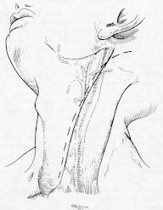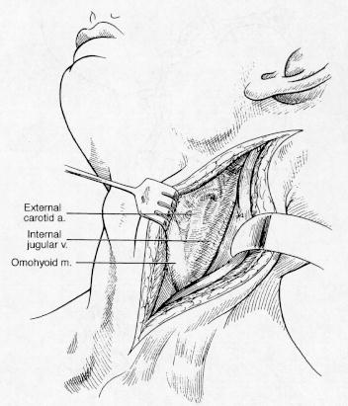

  - carotid sheath is opened along anterior and medial border of internal jugular vein.
N.B. keep dissection along anterior border of this vein to avoid injury to spinal accessory nerve in superior portion of wound.
  - internal jugular vein branches coursing anteriorly are ligated and divided throughout extent of incision; facial vein (branch of internal jugular vein) marks site of carotid bifurcation.
  - after dividing facial vein, internal jugular vein is retracted posteriorly to expose carotid bifurcation.
  - CCA (distal 3-5 cm), ICA & ECA (proximal 2-3 cm) are exposed and mobilized with minimal dissection and manipulation of carotid bulb;
      - CCA is dissected with sharp technique in periadventitial plane to prevent injury to vagus nerve (found lateral and posterior to CCA).
      - on occasion, vagus nerve can be found anteriorly on CCA (for this reason, dissection should proceed along medial border of CCA to prevent injury to this nerve).

major danger is embolization produced by excessive manipulation of carotid bifurcation - be intensely aware of fragile nature of atherosclerotic plaque – use "no touch" technique

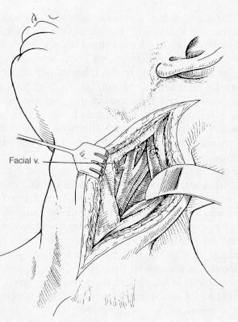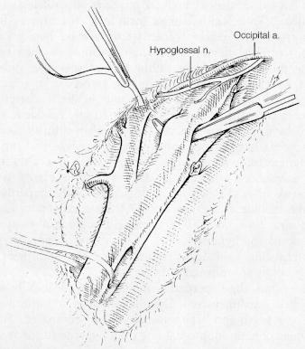

High carotid bifurcations
- location of carotid bifurcation is determined preoperatively (duplex ultrasonography or arteriography).
- anterior mandible subluxation can extend exposure.
most commonly favored technique for mandibular subluxation - circummandibular/transnasal wiring manipulations that fix mandible in subluxed anterior location for duration of operation.
- accompanied by sectioning of posterior belly of digastric muscle ± styloidectomy.

Clamping
Sequence of clamping “ICE” – ICA, CCA, ECA → check for shunt need.
Sequence of unclamping “reverse ICE” – ECA, CCA, ICA → ICA back washout (to remove debris and prevent intraoperative stroke).

shunt
- reestablishment of some blood flow + serves as stent for arteriotomy closure.
Shunt use may be:
- routine (esp. patients with prior infarcts and/or contralateral carotid occlusion).
- selective – use monitoring to assess need for shunt:
  - EEG (focal or hemispheric slowing in cortical electrical activity → shunt)
  - neurologic status during temporary carotid occlusion in awake patient under local anesthesia (altered consciousness → shunt)
  - somatosensory evoked potential monitoring
  - “stump pressure” (i.e. ICA backpressure; if < 50 mmHg → shunt)
  - isotopic regional CBF measurements
  - transcranial Doppler monitoring
  - intra-arterial CCA-to-ICA shunt:
- internal straight
- external looped.
  - soak shunt in heparinized saline solution before use.
  - proximal and distal vascular control with Rummel tourniquets (large tourniquet is placed around CCA, and small tourniquets are placed around ECA and ICA); some prefer fine vascular clamps.
N.B. apply these constricting devices on normal artery - avoid plaque at bifurcation!
  - prior to application of tourniquets / clamps, patient is IV heparinized 100-150 U/kg.
  - order of placement:
- place shunt into ICA first → allow to backbleed freely → insert into CCA.
- place shunt into CCA first → allow to bleed slightly (any embolic material is flushed) → place into ICA.
N.B. place shunt in areas free of gross atherosclerotic debris!

Endarterectomy
- 5000-11000 units of heparin IV - ACT has to be > 300 seconds. (Dr. Simon likes > 250)
- clamp in order: ICA → CCA → ECA.
- may place temporary clip on superior thyroid artery.
- ask anesthesiologist to slightly increase BP (e.g. with phenylephrine) when common carotid artery is crossclamped.
- watch EEG for 2 minutes for changes; if drop of amplitudes > 50% of > 4 Hz waves (and increase > 50% of theta waves) → increase BP → place shunt.
- keeping MAP ≥20% above baseline during cross-clamp of carotid may be associated with lower risk of postop early cognitive dysfunction (subtler form of neurologic injury than stroke).
- open ICA with No. 11 blade all the way into CCA.
- dissect plaque circumferentially using Rhoton 7 and Penfield 4 dissectors.
- irrigate with heparinized saline several times during plaque removal.
- at the end, all edges of carotid intima have to be smooth.

From Vas7:
Endarterectomy
  - arteriotomy with 11 scalpel blade begins in CCA (at site below plaque) and extends into ICA.
  - angled Potts scissors are used to incise artery through plaque into normal ICA.
  - it is important to extend arteriotomy above and below gross intimal disease.
  - plaque is carefully dissected from arterial wall using blunt dissector (such as Penfield instrument).
  - when normal intima is reached in CCA, intima is sharply dissected and transected so as to allow no loose flap.
      - in some cases, entire common carotid artery has eccentric thickening, necessitating leaving small shelf of plaque.
      - endarterectomy proceeds proximally as far as possible to reach vessel portion where plaque is minimal, and resulting shelf is small at point where endarterectomy ends (on occasion, this requires endarterectomy in CCA to level of clavicle).
  - at bifurcation, plaque is peeled from below upward to ECA where it is carefully dissected from ECA by everting proximal 2-3 cm of ECA.
      - as this process proceeds up ECA, it is wise to release occluded Rummel tourniquet temporarily to allow plaque to be carefully removed.
      - it is important to leave ECA patent and free of gross disease; if there is any uncertainty, it may be necessary to fashion separate arteriotomy on ECA, remove ECA plaque, and patch arteriotomy with vein or prosthetic material.
  - subsequently, plaque is peeled out of ICA, and it will usually peel out quite smoothly distally.
      - if distal intima remains thickened and infiltrated with plaque, it is necessary to remove this to point of normal intima.
      - if there is any question about distal intimal flap being loose, it should be tacked down with 6-0 double-arm polypropylene sutures proceeding from within artery to outer wall where suture is tied (suture should be placed vertically rather than horizontally to avoid constricting lumen) - most important moment to success of operation!
      - it is critical to completely visualize distal end-point and transition area between endarterectomy site and normal intima - most important aspect is to obtain smooth, tapering endpoint on ICA.
- when shunt is in place, longer arteriotomy is required to ensure adequate visualization of distal end-point.
- intimal flap dissection along intraluminal course of carotid may require permanent ligation or excision & graft interposition.

Closure
- close with 6-0 Prolene sutures - starting from both ends and finally securing 2 edges together.
- during closure, keep irrigating with heparinized saline.
- prior to securing last stitch, backflow from CCA to avoid any piece of plaque going to brain; prior to securing the last stitch, bulb-tip needle is inserted into lumen and irrigated with heparinized saline.
- remove clamps in reverse order: ECA → CCA → ICA.
- also remove temporary clip from superior thyroid artery.
- check with handheld Doppler flow distally in ICA. (not with Dr. Simon).
- suture line is reinforced with layers of Surgicel.
- close in anatomic layers.
- supermeticulous hemostasis.
- leave drain.
- skin closed with 4-0 Vicryl in interrupted fashion with inverted knots / staples (Dr. Simon).

From Vas7:
Closure (Artery Reconstruction)
- preferable – vein or prosthetic patch closure
N.B. perioperative stroke and restenosis outcomes are better with saphenous vein than with Dacron and polytetrafluoroethylene.
advantages - increased lumen size → delayed recurrent stenosis (esp. for females);
disadvantages - operative time↑, patch rupture, false aneurysm formation (→ thromboembolism), infection (of prosthetic patch).

- primary closure – only if arteriotomy does not extend above bulb (i.e. nonextensive disease); 5 mm external diameter is lower limit acceptable for primary closure*; transition area with pronounced shelf of intima should be covered with vein patch if shelf cannot be removed.
*thus vein patch closure is recommended for all women

  - just before completing closure, shunt is removed, all vessels are allowed to flush, and closure is completed.
  - external and common carotid arteries are opened first, and then ICA is opened (to minimize air or particulate embolization).
  - arterial wall is palpated to determine thrill (indicates loose intimal flap or some obstructive intraluminal mass); if thrill is present → arteriogram; if clot / debris is inside lumen → vessel must be reopened and all debris removed.
  - many surgeons routinely insonate with Doppler probe - should hear unimpeded diastolic flow in internal carotid artery; irregular and high-pitched flow may indicate stenosis or other problems → intraoperative arteriogram.
  - heparin reversal with protamine* is subject to wide practice variations; some surgeons stress nonreversal of heparin, or waiting at least 20 minutes to reverse heparin.
*0.5-1 mg protamine sulfate for every 100 U of heparin

Carotid artery exposed prior to carotid endarterectomy (coil present in ICA):  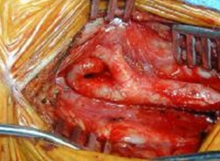 | Carotid artery prior to closure (tapered endpoint and smooth appearance of lumen):  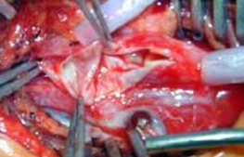
Dissection of plaque (black arrow); bypass shunt (yellow arrow) allows blood to flow around operative site (bloodless surgical field without cross-clamping of carotid artery): | 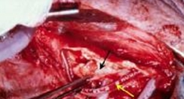

Postop
  - 24-hour admission for most patients (incl. 2-4 hours in postanesthetic recovery room)
indications for ICU observation - preoperative hypertension, MI, arrhythmia, recent stroke, chronic renal failure.
  - CBC, electrolytes, ECG.
  - maintain BP < 130 mmHg – to prevent reperfusion syndrome!; extubate deep; patient is not leaving OR until BP parameters are met.
  - continue aspirin.

Follow-up
See p. Vas7 >>

Complications
See p. Vas7 >>

EDAS (encephaloduroarteriosynangiosis)

  - neuromonitoring with SSEP and EEG.
  - Foley catheter, arterial line
  - Keppra for 7 days.
  - Mayfield skull clamp and turn head to opposite side with shoulder bump underneath the ipsilateral shoulder.
  - using Doppler, STA is outlined on scalp – incision along it (might be slightly away from it to avoid damage).
  - local anesthesia with 1% lidocaine without epinephrine.
  - skin opened with 15-blade and further dissection carried with tenotomy scissors – long segment of STA is dissected along posterior division; dissect anterior division as well to have enough slack on artery to suture down to arachnoid; leave soft tissue cuff around artery trunk.
  - temporalis fascia and muscle opened parallel and underneath STA.
  - 2 burr holes created, 1 superiorly and 1 inferiorly → bone flap turned with a footplate.
  - operative microscope
  - dura opened in cruciate fashion:
- Dr. JRC - dural leaflets inverted and packed underneath bone edge.
- Dr. Rivet – skeletonize dura into internal visceral and external pericranial leaflets (internal is inverted and folded underneath bone; external will be placed above brain at the end of case)
  - note arachnoid layer with fragile neovascularity.
  - Dr. JRC - STA is sutured to arachnoid with 8-0 nylon interrupted stitches; then open arachnoid in 4 different spots around artery
  - Dr. Rivet – open arachnoid in different spots; STA is sutured to dural pericranial leaflets using 4-0 silk, thus, that artery is freely laying on brain.
  - hemostasis with Gelfoam.
  - bone flap is flattened with M8 bit to prevent compression of STA.
  - bone flap is fixated to skull with two small quadrangular plates and small screws.
  - temporalis fascia closed with 2-0 Vicryl.
  - galea closed with inverted 2-0 Vicryl stitches.
  - skin closed with staples.
  - postop NSICU, no imaging.

Optional: parietal bur holes
  - linear incision down to bone.
  - 6 burr holes.
  - dura opened in cruciate fashion at each burr hole.
  - try to invert dural leaflets.
  - standard closure.

Microvascular decompression (MVD, Jannetta procedure)
Operative video:
Technical Nuances of Microvascular Decompression of the Posterior Fossa Cranial Nerves >>
Microvascular Decompression Surgery for Trigeminal Neuralgia >>
Endoscopic Microvascular Decompression for Trigeminal Neuralgia at Penn Medicine >>
http://www.neurosurgicalatlas.com/grand-rounds/mvd-for-trigeminal-neuralgia-and-hemifacial-spasm-pearls-and-pitfalls
http://www.neurosurgicalatlas.com/grand-rounds/trigeminal-neuralgia
MVD for Hemifacial Spasm: Craniotomy and Vascular Decompression:
https://www.neurosurgicalatlas.com/cases/mvd-for-hemifacial-spasm-craniotomy-and-vascular-decompression

Indications
- vascular compression syndromes:
- trigeminal neuralgia – see p. CN5 >>
- CN9 neuralgia
- hemifacial spasm
- torticollis

Patient counselling
I discussed with Ms. XXX the option of microvascular decompression. I would give her about a 70% chance of success with a 30% chance of immediate failure along with a delayed risk. This is based on some of her atypical features. Her one of main goals is to be able to get off of some of her medication. I explained that we do like to keep the medication for some time after surgery that I think is a reasonable goal. I would recommend MVD because of her age. Explained that the destructive procedures all wear off over time, but she could consider the Gamma Knife or glycerol if she preferred to have the noninvasive route, but they will need to be repeated at some point, and eventually will not be able to be repeated again because of the growing risk of anesthesia dolorosa. I have explained her that what we would expect to find at surgery is an artery against the nerve and if we did not, then our chances of success with surgery greatly diminished. If that were to be the case, we would cause a mild lesion of the nerve just as we would with 1 of the destructive procedures, but that it would not last. I explained the risk of infection, CSF leak, diplopia, hearing loss, facial asymmetry as well as stroke, heart attack, death. Also about the need for physical therapy for neck spasms after the surgery, possible need for an LP to rule out chemical meningitis versus bacterial meningitis. She has a job in a deli with bending and lifting. So I told her she would have to have a leave of absence for 1 month. She would like to have the procedure done during her vacation so as to minimize her time off from work.

Procedure
- retrosigmoid craniotomy – see p. Op300 >>
- consider mannitol
- cerebellum is retracted inferomedially with Greenberg retractor (and Telfa underneath).
- open arachnoid membrane.
- trigeminal nerve is identified (may need to coagulate and divide petrosal vein; not necessary for facial nerve)
- look for abnormal contact between blood vessels (SCA* or AICA, superior petrosal vein) and nerve
*SCA is the commonest vessel causing compression (75%)
- vessel is mobilized, translocated anteriorly to nerve; Janetta: at surgery compressing arteries are separated from the nerve but compressing veins are cauterized and cut (venous compression was seen in 68 %)
- vessel is separated from nerve with shredded Teflon pad wrapped circumferentially around nerve at entry zone (or polyvinyl alcohol foam)
Dr. JDDay: place lots of nonshredded Teflon blocks (in shingled manner – wall nerve off the vessel)
- Dr. Broaddus – Teflon should hold vessel away and not to contact nerve!
- if potentials deteriorate → lessen cerebellar retraction (Dr. JDDay uses no retractors; retracts with sucker shaft).
- if no pathologic vascular compression had been identified, perform partial rhizotomy.
- anesthetist performs Valsalva maneuver - surgeon watches nerve and implant under microscope to be sure that there is no implant movement; Dr. JDDay: forceful saline spray to make sure implant does not move.

AICA and trigeminal nerve in direct contact:
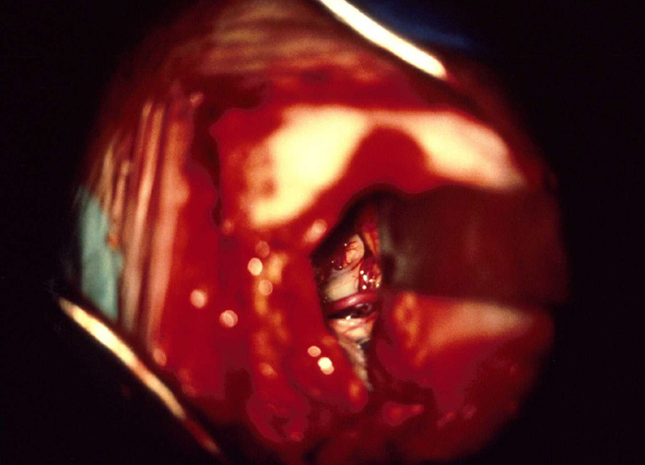

The most vociferous opponent of Janetta’s theory of microvascular compression at the REZ was Adams in Oxford who presented anatomical, clinical, neuropathological, and neurophysiological findings that he proposed supported the hypothesis that trauma to the nerve during dissection and subsequent ‘decompensation’ of the nerve were more likely to explain the efficacy of MVD (Adams, 1989).

Postoperatively
- 20% patients develop chemical meningitis from Teflon at 2 weeks postop; H: steroids.

Outcomes
Trigeminal Neuralgia
MVD vs. Gamma Knife – see p. CN5 >>
- success rate 73-80%
- facial numbness - 5.5% of patients followed over a 10-yr period
- facial dysesthesia (5.3-5.7%)
- minor hearing impairment (2.7%) and dizziness (1.8%).
otovestibular testing is performed in all patients prior to surgery because hearing loss is occasional complication of MVD.
- pain relief is longer than after rhizotomy (even may be cured!); pain recurrence rate - 3.5-4% per year.
Risk factors for recurrence: lack of immediate post-operative relief, female sex, venous compression, and pre-operative symptoms of > 8 years duration
Factors that favor the success: typical trigeminal pain, objective evidence of vascular compression, short history prior to surgery, no previously failed procedure.

Predictors of pain freedom after MVD on meta-analysis:
- disease duration ≤ 5 yr (OR=2.06, 95% CI=1.08- 3.95)
- demyelination after a certain disease duration may be severe enough to induce an irreversible central sensitization even after decompression
- arterial compression over venous or other (OR = 3.35, 95% CI = 1.91-5.88)
- superior cerebellar artery involvement (OR = 2.02, 95% CI = 1.02-4.03)
- type 1 pain Burchiel classification (OR = 2.49, 95% CI = 1.32-4.67).

Relief of pain: complete relief (excellent outcome) defined as ≥ 98 % pain relief without need for medication; partial relief (good outcome) defined as 75 % reduction in pain; failure (poor outcome) defined as recurrence of > 25 % of pre-operative pain or need for a further surgical procedure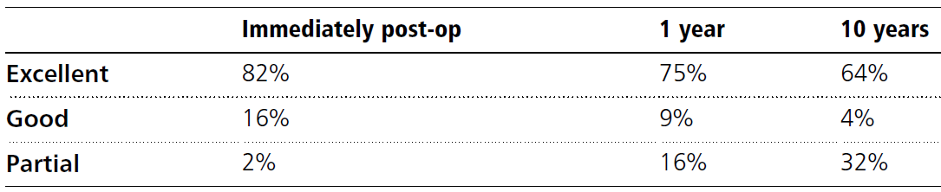
Recurrence rates were < 2 % at 5 years and < 1 % at 10 years
Barker FG , Janetta PJ , Bissonette DJ , PAC , Larkins MV , Jho HD . The long-term outcome of microvascular decompression for trigeminal neuralgia . N Engl J Med 1996; 334 : 1077 – 1083.

Hemifacial Spasm
10% recurrence in first 2 years, then 1% / yr

Viktor’s Notes℠ for the Neurosurgery Resident
Please visit website at www.NeurosurgeryResident.net

