General Principles of Operative Neurosurgery
Last updated: April 12, 2020
Neuroanesthesia 1
Blood Pressure 1
Jugular venous pressure 1
Ventilation 1
Hematocrit 1
Temperature 1
Blood glucose level 1
Cerebral metabolic rate of oxygen (CMRO₂) 1
Anesthetics 1
Inhalational 1
Halogenated agents 2
Intravenous 2
Opioids 2
Neuromuscular Blockers 2
Medications 2
Antibiotics 2
Standard 2
Allergy to penicillins 3
Local Anesthetics 3
Mannitol 3
Steroids 3
AED 3
Patient’s Position 3
Skull clamps 4
Prep 4
Hemostasis 4
Preoperative Assesment 4
Hematological Resuscitation 4
Hemostasis 4
Electrical hemostasis 4
Mechanical hemostasis 4
Systemic hemostasis 4
Chemical Hemostasis 4
Intraoperative electrophysiologic monitoring – see p. D25 >>
Neuronavigation – see p. Op30 >>
Principles of craniotomies (incl. incision, closure) – see p. Op300 >>
Surgical site infection (SSI) prophylaxis – p. Op120 >>

Surgical risk calculator (based on ACS NSQIP database):
https://riskcalculator.facs.org/RiskCalculator/PatientInfo.jsp

Neuroanesthesia
Blood Pressure
- determines CPP.
- may need to be manipulated:
- reduced - when working on aneurysm
- increased - to enhance collateral circulation during cross clamping
- arterial line is most accurate; for intracranial procedures, arterial line should be calibrated at external auditory meatus to most closely reflect intracranial blood pressure.
- only vasopressor which reduces CSF production (→ ICP↓) is norepinephrine.

Jugular venous pressure
- influences ICP

Ventilation
- goal - end tidal CO₂ (ETC0₂) 25-30 mmHg with correlating PaC0₂ of 30-35 mmHg.

N.B. Keep pCO₂ low for cranial procedures but use with care for stereotactic procedures to minimize shift of intracranial contents!!!

Hematocrit
Low Hct - improved blood rheology but decreased oxygen carrying capacity.

Temperature
- mild hypothermia provides some protection against ischemia.
Each 1° C drop → cerebral metabolic rate of oxygen (CMRO₂) drops by 7%

Blood glucose level
- hyperglycemia exacerbates ischemic deficits.

Cerebral metabolic rate of oxygen (CMRO₂)
- reduced with certain neuro-protective agents and by hypothermia.

Anesthetics
Inhalational
general principles – see p. 3905 >>
- most reduce cerebral metabolism (except nitrous oxide) by suppressing neuronal activity.
- disturb cerebral autoregulation and cause cerebral vasodilatation → CBV↑ → ICP↑.
- if administration > 2 hrs → CSF volume↑ → ICP↑.
- most agents increase CO₂ reactivity of cerebral blood vessels → affect intra-operative EP monitoring.

Nitrous Oxide (N₂O s. “laughing gas”)
- major component of general anesthesia - minimally influences respiration & hemodynamics.
- low blood & tissue solubility - rapid induction and emergence.
- due to movement speed, N₂O may retard oxygen uptake after N₂O anesthesia termination → diffusion hypoxia (H: 100% O₂).
N.B. at least 20% oxygen always must be co-administered!
- potent analgesic but weak general anesthetic! no respiratory depression, no muscle relaxation!
  - provides only partial anesthesia (MAC - 104%) - no sufficient potency to be used alone (used in combination with potent volatile agents - permits lower dose of them).
  - 80% N₂O cannot produce surgical anesthesia (add opioids for analgesia, thiopental for narcosis, neuromuscular blocker for muscle relaxation).
  - 30% N₂O + O₂ is useful analgesia in dental surgery.
- potent vasodilator → CBF↑↑↑
- minimally increases cerebral metabolism
- least c/v effects, least hepatotoxicity – safest inhalational anesthetic!!!
- high incidence of postoperative nausea & vomiting.
- most important clinical problem - nitrous oxide is 34 times more soluble than nitrogen and diffuses into closed gas spaces faster than nitrogen diffuses out → nitrous oxide increases volume / pressure in these spaces;
nitrous oxide is contraindicated in presence of closed gas spaces:
- pneumocephalus - may convert to "tension pneumocephalus" (prevention: filling cavity with fluid + turning off N₂O ≥ 10 minutes prior to dural closure)
- pneumothorax, pulmonary cysts
- small bowel obstruction
- middle ear blockage
- retinal surgery (intraocular gas bubble is created).
- in chronic abuse may cause leukopenia.

Halogenated agents
- all suppress EEG activity (except enflurane) - some degree of cerebral protection.

isoflurane general aspects see p. 3905 >>
- can produce isoelectric EEG without metabolic toxicity - improves neurologic outcome in cases of incomplete global ischemia (although in experimental studies on rats, amount of tissue injury was greater than with thiopental).

desflurane general aspects see p. 3905 >>
- cerebral vasodilator (increases CBF and ICP) but decreases CMRO (compensatory vasoconstriction).

sevoflurane general aspects see p. 3905 >>
- mildly increases CBP and ICP, and reduces CMRO.

Enflurane general aspects see p. 3905 >>
- induces epileptiform EEG changes (relatively contraindicated in seizure disorders).

Intravenous
Barbiturates
- see p. S50 >>

Ketamine
- see p. Rx3 >>

Propofol
- see p. Rx3 >>

Midazolam (Versed®)
- see p. Rx3 >>

Etomidate
- see p. Rx3 >>

Dexmedetomidine (Precedex®)
- see p. Rx3 >>

Opioids
- see p. 3905 >>

Neuromuscular Blockers
- see p. 3905 >>

Medications
Antibiotics
See also – p. Op120 >>

N.B. if operating for suspected infection – skip antibiotics until cultures are sent!
- antibiotic prophylaxis not indicated for EVD insertion or drains.
- intraoperative redosing - to ensure adequate serum and tissue concentrations if:
- procedure duration exceeds 2 half-lives of antibiotic
- excessive blood loss during the procedure
- postoperatively (order 1st dose now) – for 24 hours.

Standard
Cefazolin (Ancef®)
Parameter | Manufacturer’s labeling | American Society of Health-System Pharmacists, Infectious Diseases Society of America, Surgical Infection Society, Society for Healthcare Epidemiology of America (ASHP/IDSA/SIS/SHEA)
Dose | 1 g IV or IM | 2 g IV (1 g if patient < 60 kg; 3 g if patient > 120 kg; 30 mg/kg for kids)
Initiate | 30-60 minutes prior to surgery | within 60 minutes prior to surgical incision
Re-dose intraop  (T½ 1.2-2.2 hrs) | 0.5-1 g after 2 hours | in 3-4 hours
Postoperatively | 0.5-1 g every 6-8 hrs for 24 hrs

Allergy to penicillins
Type I Hypersensitivity (i.e. anaphylaxis) only!
- type 1 reactions occur 30–60 minutes after administration.
- cephalosporins and carbapenems can safely be used in patients with an allergic reaction to penicillins that is not type 1 reaction (e.g. anaphylaxis, urticaria, bronchospasm) or exfoliative dermatitis (Stevens-Johnson syndrome, toxic epidermal necrolysis).

Vancomycin
Parameter | Value
Dose | 15 mg/kg (e.g. 1 g) IV; same for kids
Initiate | within 120 minutes of incision*
Re-dose intraoperatively  (T½ 4-11 hrs) | after 6-8 hours
Postoperatively | 1 g every 12 hrs 2 doses
*The Society of Thoracic Surgeons recommends over 60 minutes with completion within 1 hour of skin incision!
- for patients colonized with MRSA, single 15 mg/kg preoperative dose may be added to other recommended agents.

Clindamycin
- 600 mg (20 mg/kg for kids) IV 30-60 minutes before procedure with no follow-up dose needed.

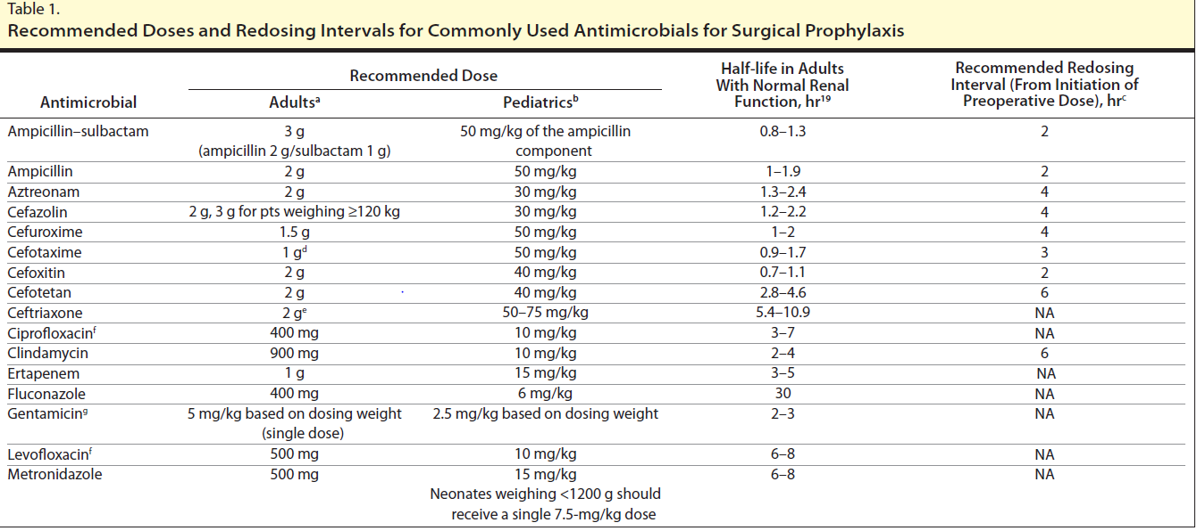
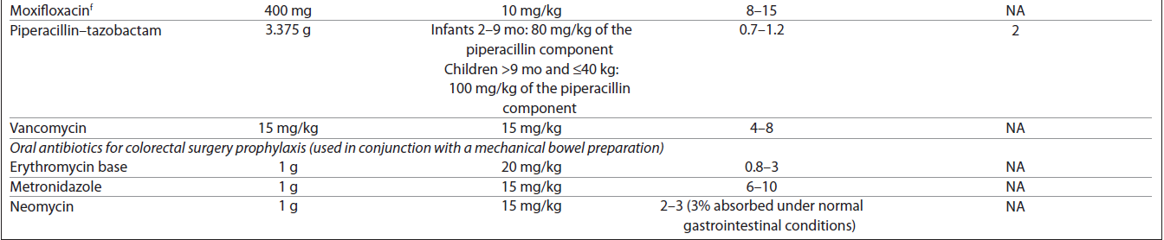

Local Anesthetics
Pharmacology - see p. 2229 >>
- for craniotomies:
  - inject local anesthetic with epinephrine after prepping but before going to scrub arms – gives time for epinephrine to work (excellent hemostasis).
  - inject in two layers (skin, under pericranium) – excellent hemostasis!

Mannitol
- 1 g/kg bolus.
- timing:
- when Foley is in, before even incision (Dr. Broaddus) – maximum action starts after 30 minutes and lasts several hours.
- at start of bone work (Dr. Ritter, Dr. Rivet) – mannitol increases bleeding due to hypoviscosity effect.

Steroids
Dexamethasone.
- Dr. Broaddus – steroids are best when given before insult!

AED
– if cerebral cortex will be involved (either cut or retracted excessively); continue 7 days postop.
Doses – see p. Rx0 >>

Patient’s Position
Watch this at first opportunity:
http://www.neurosurgicalatlas.com/grand-rounds/Patient-Positioning-for-Intracranial-Surgery-A-Guide-for-Residents-an-Fe

- supine patient position is adequate for lesions anterior to and within the central lobule; consider using the lateral position if the lesion is situated just posterior to the lobule (alternatively, the supine position can be employed with the ipsilateral shoulder highly elevated on a bulky gelrest).
- ¾ = park bench
- head lowering (Trendelenburg) - increases arterial blood flow, but also increases ICP by impairing venous outflow.
- prone position + excessive fluids:
- facial edema (risk factor for posterior ischemic optic neuropathy with blindness)
- airway edema (no cuff leak – unable to extubate)
- abdominal volume is made pendulous between bars – decreased spinal venous epidural bleeding but also kidney perfusion↓ (decreased UO).
- during procedure, patient's position may change and be unnoticed due to draping.
- Dr. Broaddus likes to avoid any rotations (of head or bed) – everything must be in perpendicular planes – helps with spatial orientation even without navigation.

Skull clamps
- see p. Op140 >>

N.B. after application of skull clamp, the only allowed patient torso movement is Trendelenburg / Reverse Trendelenburg or Left / Right rotation.
No flexing of torso after pin application – causes stress on pins and neck!

Prep
- no hair clip (Dr. Ritter, Dr. Broaddus) or minimal clip (Dr. Holloway).
- chlorhexidine sponge (general cleaning)* → isopropyl alcohol gauze (degreasing) → mark** skin incision (this way marking stays well as opposed to marking before chlorhexidine sponge) → ChloraPrep x2 (3 minutes apart)***
*Dr. Ritter - not needed if done chlorhexidine towels at home
**no per Dr. Ritter – child’s parents do not like it.
***chlorhexidine is contraindicated at age < 2 months (use Betadine)

Hemostasis

- brain is vascular organ; 15-20% of cardiac output is distributed to brain.
- much of neurosurgical training is focused on how to avoid and stop bleeding:
- stay in midline
- stay on bone (“bone is home” – subperiosteal dissection)
- avoiding bleeding is easier that stopping it.

Preoperative Assesment
- History (personal and familial) - bleeding / clotting problems.
- Laboratory studies:
    - coags (PT/INR, aPTT)
    - CBC (WBC, Hb, platelet count)
    - BMP (Bun & creatinine)
    - UA
    - LFT?

Hematological Resuscitation
- Normalize temperature (patient’s and fluids)
- Correct platelets – goal > 100 (< 50 is absolute contraindication to neurosurgery)
- Correct ionized calcium
- Correct INR – goal < 1.4
- Correct DIC and/or low fibrinogen (< 150) with cryoprecipitate.
- rapid correction in life-threatening circumstances - use Factor VII
- Involve anesthesia, hematology (massive transfusion protocol team)

Hemostasis
- obtain proximal and distal control of major vessels early.
- avoid and control bleeding in potential spaces:
- epidural: tack-ups along craniotomy perimeter, tenting sutures (in middle of craniotomy flap)
- epidural veins of spine

Electrical hemostasis
- see p. Op140 >>
- Bipolar; irrigation is important!
- Monopolar

Mechanical hemostasis
a. Finger pressure
b. Elevation to control venous bleeding
c. Skin clips: Raney vs. Michel
d. Warm water
e. Coton (understand why there are so many sizes and shapes of “cottonoids”)
f. Contact Agents: surgical flow seal, Oxycel, gel foam, etc., bone wax, thrombin, fibrin glue, peroxide, etc.

Systemic hemostasis
Tranexamic ACID (TXA) - synthetic analogue of lysine – inhibits activation of plasminogen to plasmin, slowing the degradation of fibrin.
- 10 mg/kg at the start of surgery → 5 mg/kg/hour for 24 hours after surgery.
- used in craniosynostosis and spine surgery.
- risk of thromboembolic complications.

Chemical Hemostasis
- see p. Op140 >>

Viktor’s Notes℠ for the Neurosurgery Resident
Please visit website at www.NeurosurgeryResident.net

