General Principles of Perioperative Neurosurgery
Last updated: December 20, 2020
Morbidity, Mortality 1
Imaging 2
Anticoagulants / Reversal 2
Antiaggregants / Reversal 2
Diabetes 3
Antihypertensives 3
Sedation 3
Seizure prophylaxis 3
Nausea And Vomiting 3
Feeding 3
Stomach protection 3
Alcohol 3
Cardiovascular and Pulmonary 3
Minimally Invasive Hemodynamic Monitoring 3
Vigileo monitor 3
Postoperative Pain 4
DVT prophylaxis 4
Infection Prophylaxis 4
ICP control – see p. S50 >>

Morbidity, Mortality
Clavien-Dindo classification (validated for neurosurgery patients):
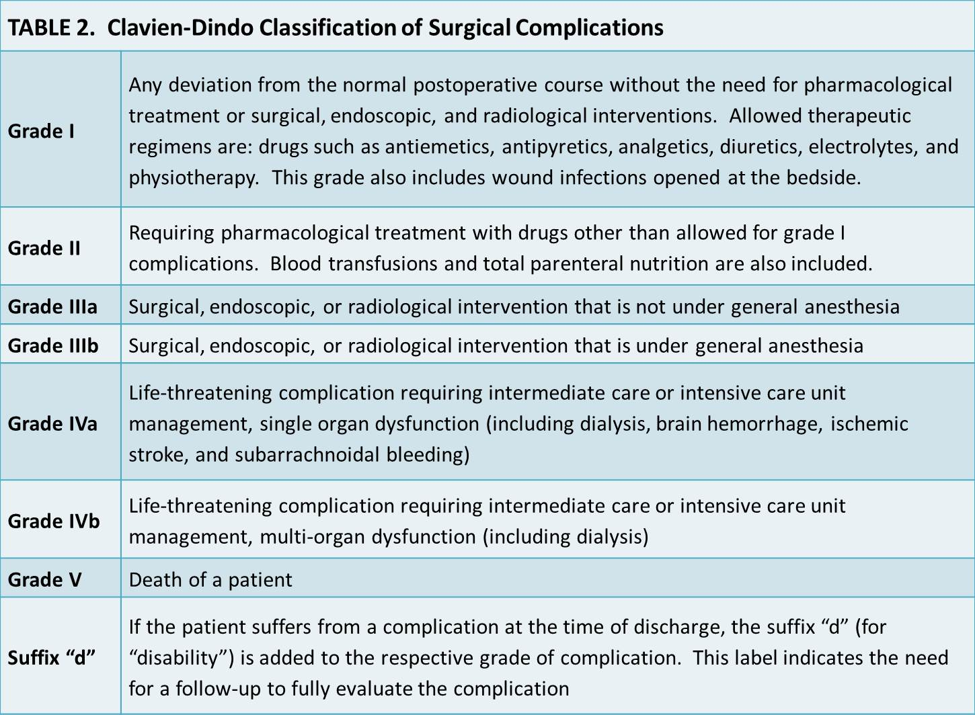

Within 30 days:
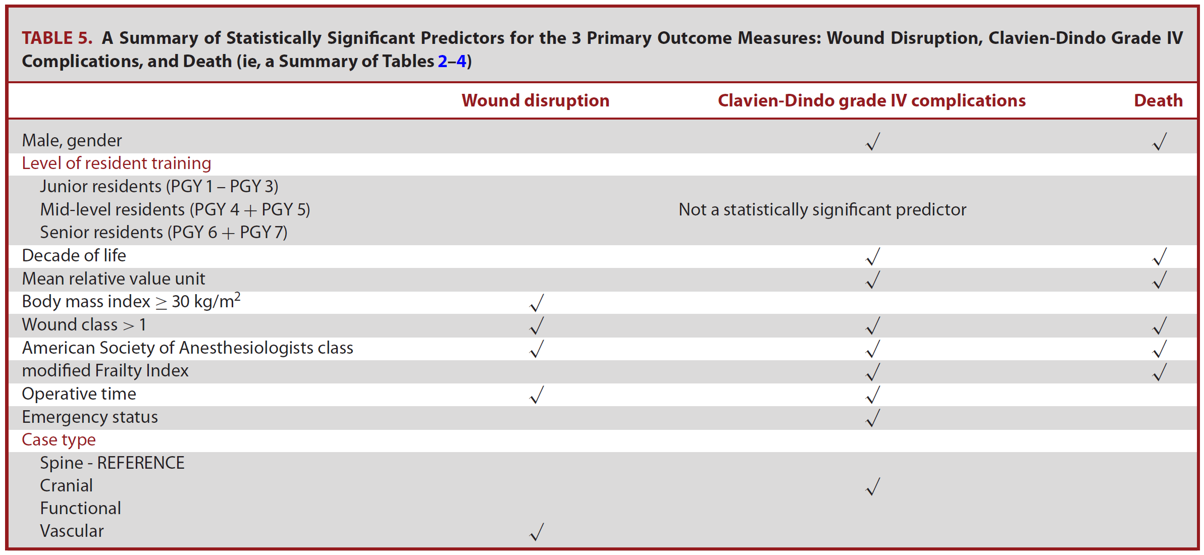
Macki M et al. The Impact of Different Postgraduate Year Training in Neurosurgery Residency on 30-Day Postoperative Outcomes. Neurosurgery 84:778–787, 2019 DOI:10.1093/neuros/nyy277

Wound disruption (within 30 days):
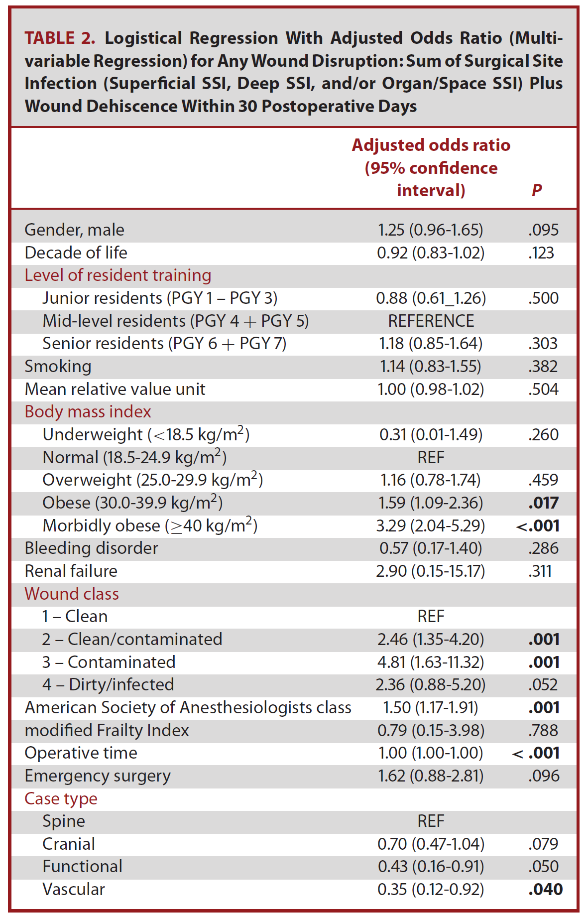
Macki M et al. The Impact of Different Postgraduate Year Training in Neurosurgery Residency on 30-Day Postoperative Outcomes. Neurosurgery 84:778–787, 2019 DOI:10.1093/neuros/nyy277

Clavien-Dindo Grade IV* complication (within 30 days):
*end-organ dysfunction, necessitating intermediate or intensive care unit management
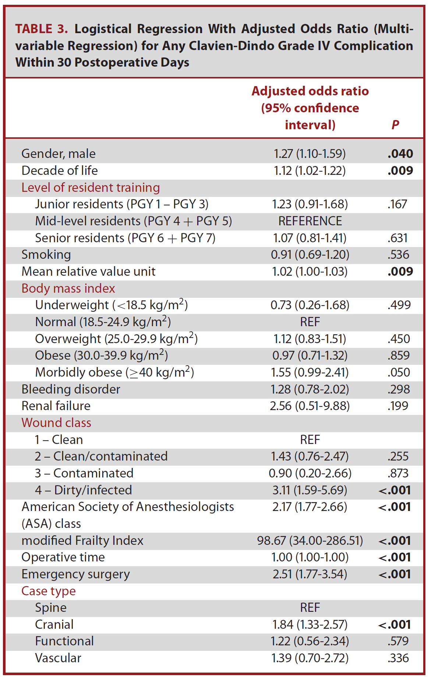
Macki M et al. The Impact of Different Postgraduate Year Training in Neurosurgery Residency on 30-Day Postoperative Outcomes. Neurosurgery 84:778–787, 2019 DOI:10.1093/neuros/nyy277

Death (within 30 days):
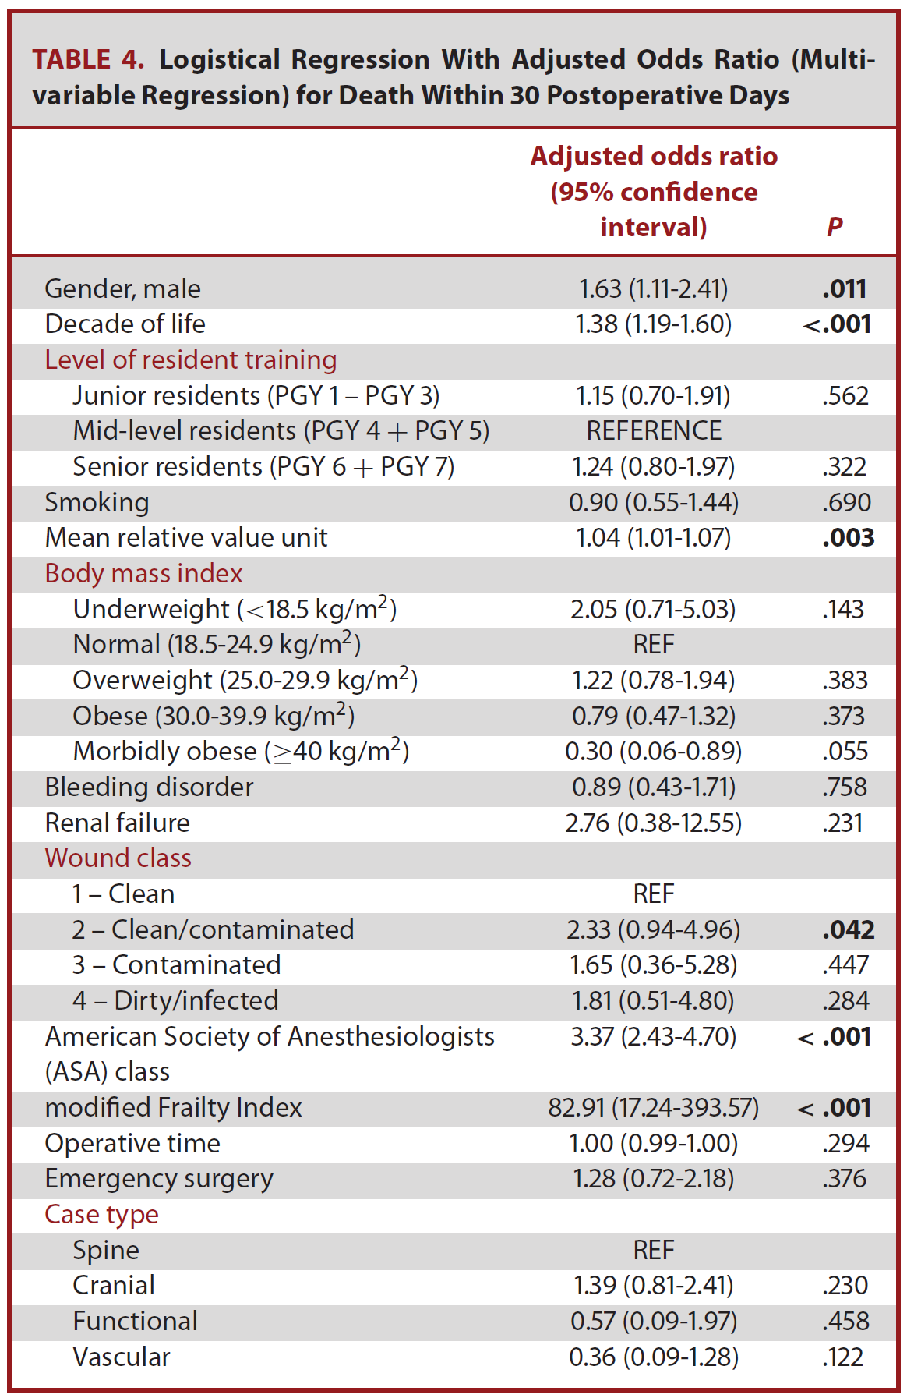
Macki M et al. The Impact of Different Postgraduate Year Training in Neurosurgery Residency on 30-Day Postoperative Outcomes. Neurosurgery 84:778–787, 2019 DOI:10.1093/neuros/nyy277

Imaging
- repeat head CT if neurological status changes.
- routinely repeat plain head CT after 6 hours (or earlier if neuro status changes) for TBI with hemorrhage in observation; some prefer to document stable CT 24 hours apart.

Anticoagulants / Reversal
Doses and reversal strategies – see p. Rx0 >>

Antiaggregants / Reversal
Doses and reversal strategies – see p. Rx0 >>

Platelet function testing
- Plavix: VerifyNow P2Y12 (if result < 40% or > 194 – no platelet inhibition; patient maybe nonresponding to Plavix → reload with 300-600 mg of Plavix)
- Aspirin:
- VerifyNow Aspirin Test (result < 550 Aspirin Reaction Units = platelet disfunction consistent with aspirin)
- PFA-100 test - performed with the Collagen/Epinephrine membrane; normal Col/Epi closure time (< 188 seconds) excludes the presence of a significant platelet function defect. If >188 seconds, the Col/ADP test is automatically performed:
  - normal Col/ADP (< 108 seconds) = aspirin-induced platelet dysfunction
  - prolonged Col/ADP (> 108 seconds) = hematocrit < 0.28, platelet count < 100, significant platelet function defect (von Willebrand disease, other inherited/acquired platelet dysfunction)

- aspirin:
ASA in brain tumor resection. Cessation of ASA in patients with cardiovascular disease is associated with a known increased risk of thrombotic events, especially in patients with coronary stents.
Of the 452 patients analyzed, there were no statistical differences detected between the groups (stopped ASA preop or continued uninterrupted) for outcomes including bleeding complications, need for reoperation, or thrombotic complications.
CONCLUSIONS: In this analysis, perioperative low dose ASA use was not associated with increased risk of perioperative complications.
Rahman M “Effects of Perioperative Acetyl Salicylic Acid on Clinical Outcomes in Patients Undergoing Craniotomy for Brain Tumor.” World Neurosurg. 2015 Jul;84(1):41-7.

Diabetes
- metformin should be held 48 hours before any surgery, and should not be restarted post-op until patient has fully recovered and is eating and drinking normally
N.B. especially important in angiography – risk of lactic acidosis - hold metformin 48 hours after angiography.

Antihypertensives
Doses – see p. Rx0 >>

- β-blockers – continue periop!

Sedation
Doses – see p. Rx0 >>

- in intubated patients who are sufficiently alert to experience discomfort from endotracheal tube, low doses of short-acting anesthetics such as propofol or dexmedetomidine can be used to avoid marked hypertension, anxiety, or dyssynchrony with ventilator.

Seizure prophylaxis
Doses – see p. Rx0 >>

- phenytoin / fosphenytoin (check serum level after 3rd dose; goal 1-2; reload if needed)
- levetiracetam
- for 7 days, then stop (unless documented seizures or paralyzed – continue until TOF 4/4 and no seizure activity noted).

Nausea And Vomiting
Doses – see p. Rx0 >>

- post-operative nausea and vomiting may:
- adversely affect ICP
- may negatively impact recent cervical surgical procedures

Feeding
Dobbhoff tube – see p. 2209 >>

Stomach protection
- PPI
- H2-blockers – risk of thrombocytopenia

Alcohol
- if signs of alcohol abuse: CIWA scale with phenobarbital PRN, thiamine 100 mg IV STAT, “goody“ bag IV, substance abuse consult.

Cardiovascular and Pulmonary
- keep normotensive (SBP goal 100-160 mmHg); exceptions:
- ischemic stroke
- IPH
- SAH
- keep euvolemic (esp. avoid hypotension).
- goal pO2 > 100 mmHg, SaO2 > 90-93%, pCO2 35-40 mmHg.

Minimally Invasive Hemodynamic Monitoring
Vigileo monitor
- volemia monitoring in mechanically ventilated patients without arrhythmias.
- requires central line and A-line.

Goals:
CO (cardiac output) > 3
SV (stroke volume) > 70
SVV (stroke volume variation) < 10
- intrathoracic pressure changes due to ventilation – it is reflected in systolic BP; in normovolemia that fluctuation should be < 10

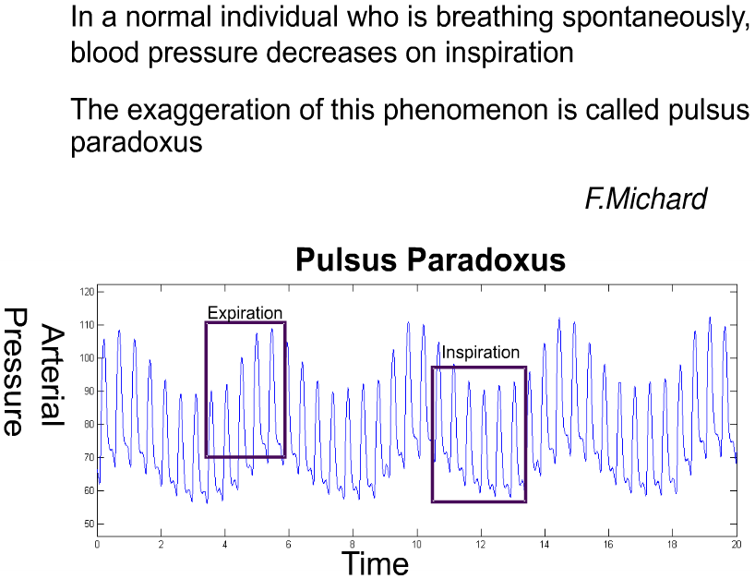

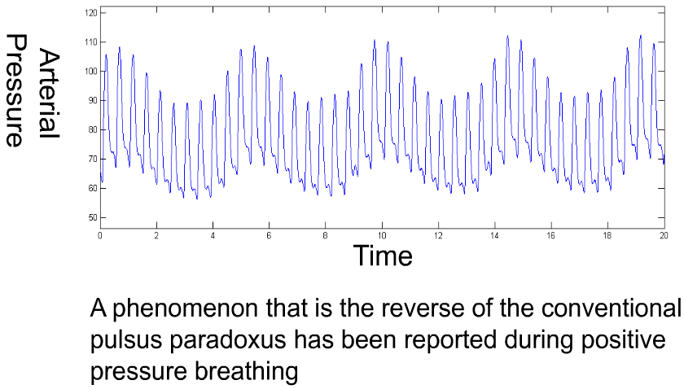

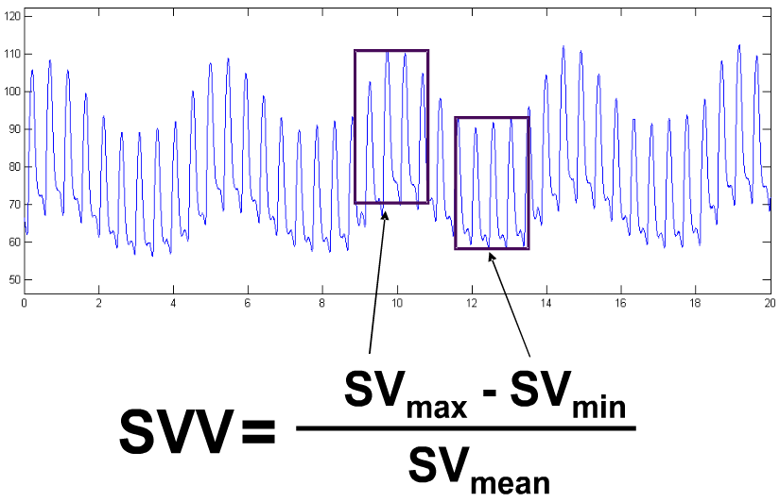

Postoperative Pain
- ketorolac (Toradol) - safe for postoperative pain management in pediatric population - there is no association between ketorolac use and clinically or radiographically significant hemorrhage.
Marlin Dustin Richardson, Nicholas O. Palmeri, Sarah A. Williams, Michelle R. Torok, Brent R. O’Neill, Michael H. Handler, and Todd C. Hankinson “Routine perioperative ketorolac administration is not associated with hemorrhage in pediatric neurosurgery patients” Journal of Neurosurgery: Pediatrics, Jan 2016 / Vol. 17 / No. 1 : Pages 107-115
- avoid NSAIDs where bone fusion is needed.

DVT prophylaxis
- SCD
- prophylactic heparin (some delay until 24 hours postop or TBI)
- heparin 5000 units subQ q8h (head problems); if < 60 kg use q12h
- enoxaparin 30 mg subQ q12h (sci, trauma with long bone fx)
- enoxaparin 40 mg subQ daily (ischemic stroke); if morbidly obese use 40mg q12h

Infection Prophylaxis
Doses – see p. Rx0 >>
Intraoperative antibitotics – see p. Op100 >>
Spine aspects – see p. Op220 >>
Skull fractures (incl. triple abx) – see p. TrH5 >>

﻿CDC 2017 guidelines for SSI prevention. JAMA Surg. Published online May 3, 2017:

Advise patients to shower or bathe (full body) with soap (antimicrobial or nonantimicrobial) or an antiseptic agent on at least the night before the operative day. (Category IB–strong recommendation; accepted practice.)
- randomized controlled trial evidence suggested uncertain trade-offs between the benefits and harms regarding the optimal timing of the preoperative shower or bath, the total number of soap or antiseptic agent applications, or the use of chlorhexidine gluconate washcloths for the prevention of SSI.

Perform intraoperative skin preparation with an alcohol-based antiseptic agent unless contraindicated. (Category IA–strong recommendation; high-quality evidence.)
- application of a microbial sealant immediately after intraoperative skin preparation is not necessary for the prevention of SSI. (Category II–weak recommendation; low-quality evidence suggesting a trade-off between clinical benefits and harms.)
- the use of plastic adhesive drapes with or without antimicrobial properties is not necessary for the prevention of SSI. (Category II–weak recommendation; high to moderate–quality evidence suggesting a trade-off between clinical benefits and harms.)
- randomized controlled trial evidence was insufficient to evaluate the trade-offs between the benefits and harms of repeat application of antiseptic agents to the patient’s skin immediately before closing the surgical incision for the prevention of SSI.
- randomized controlled trial evidence suggested uncertain trade-offs between the benefits and harms regarding antimicrobial dressings applied to surgical incisions after primary closure in the operating room for the prevention of SSI.

The search did not identify randomized controlled trials that evaluated soaking prosthetic devices in antiseptic solutions before implantation for the prevention of SSI.

Antimicrobial prophylaxis should be administered only when indicated based on published clinical practice guidelines and timed such that a bactericidal concentration of the agents is established in the serum and tissues when the incision is made. (Category IB–strong recommendation; accepted practice.)
- no further refinement of timing can be made for preoperative antimicrobial agents based on clinical outcomes. (No recommendation/unresolved issue.)
- literature search did not identify randomized controlled trials that evaluated the benefits and harms of weight-adjusted parenteral antimicrobial prophylaxis dosing and its effect on the risk of SSI.
- search did not identify sufficient randomized controlled trial evidence to evaluate the benefits and harms of intraoperative redosing of parenteral prophylactic antimicrobial agents for the prevention of SSI.
- for clean and clean-contaminated procedures, additional prophylactic antimicrobial agent doses should not be administered after the surgical incision is closed in the operating room, even in the presence of a drain. (Category IA–strong recommendation; high-quality evidence.)

Consider intraoperative irrigation of deep or subcutaneous tissues with aqueous iodophor solution for the prevention of SSI. Intraperitoneal lavage with aqueous iodophor solution in contaminated or dirty abdominal procedures is not necessary. (Category II–weak recommendation; moderate-quality evidence suggesting a trade-off between clinical benefits and harms.)
- do not apply topical antimicrobial agents (i.e. ointments, solutions, or powders) to the surgical incision for the prevention of SSI. (Category IB–strong recommendation; low-quality evidence.)
- randomized controlled trial evidence suggested uncertain trade-offs between the benefits and harms regarding intraoperative antimicrobial irrigation (eg, intra-abdominal, deep, or subcutaneous tissues) for the prevention of SSI.

During surgery, glycemic control should be implemented - target levels < 200 mg/dL in all patients, with and without diabetes. (Category IA–strong recommendation; high to moderate–quality evidence.)
- search did not identify randomized controlled trials that evaluated the optimal hemoglobin A1C target levels for the prevention of SSI in patients with and without diabetes.

Maintain perioperative normothermia. (Category IA–strong recommendation; high to moderate–quality evidence.)

Increased fraction of inspired oxygen should be administered during surgery and after extubation in the immediate postoperative period for patients with normal pulmonary function undergoing general anesthesia with endotracheal intubation.
- randomized controlled trial evidence suggested uncertain trade-offs between the benefits and harms regarding the administration of increased fraction of inspired oxygen (FiO2) via endotracheal intubation during only the intraoperative period in patients with normal pulmonary function undergoing general anesthesia for the prevention of SSI.
- to optimize tissue oxygen delivery, maintain perioperative normothermia and adequate volume replacement. (Category IA–strong recommendation; moderate-quality evidence).
- randomized controlled trial evidence suggested uncertain trade-offs between the benefits and harms regarding the administration of increased FiO₂ via face mask during the perioperative period in patients with normal pulmonary function undergoing general anesthesia without endotracheal intubation or neuraxial anesthesia (ie, spinal, epidural, or local nerve blocks) for the prevention of SSI.
- randomized controlled trial evidence suggested uncertain trade-offs between the benefits and harms regarding the administration of increased FiO₂ via face mask or nasal cannula during only the postoperative period in patients with normal pulmonary function for the prevention of SSI. (No recommendation/unresolved issue).
- the search did not identify randomized controlled trials that evaluated the optimal target level, duration, and delivery method of FiO₂ for the prevention of SSI.

Do not withhold transfusion of necessary blood products from surgical patients as a means to prevent SSI. (Category IB–strong recommendation; accepted practice).

Application of autologous platelet-rich plasma is not necessary for the prevention of SSI. (Category II–weak recommendation).

Consider the use of triclosan-coated sutures for the prevention of SSI. (Category II–weak recommendation).

Available evidence suggested uncertain trade-offs between the benefits and harms of systemic corticosteroid or other immunosuppressive therapies on the risk of SSI in prosthetic joint arthroplasty.

Viktor’s Notes℠ for the Neurosurgery Resident
Please visit website at www.NeurosurgeryResident.net

