Surgical Instruments, Materials
Last updated: April 12, 2020
Needles 1
Hemo-Seal (HS-7) 1
Hemostatic Materials 2
Surgicel (Ethicon) 2
Gelfoam (Pfizer) 2
Liquid FIBRIN 2
Liquid THROMBIN 2
LeGoo gel 2
Raplixa 2
Antibacterial Materials 2
TYRX™ Absorbable Antibacterial Envelope (Medtronic) 2
Electrosurgery (Electrocoagulation) 3
PEAK PlasmaBlade (Medtronic) 3
Nonstick bipolar 4
Skin substitutes / Allografts 4
SurgiMend (TEI Biosciences) 4
AlloDerm (LifeCell) 4
Bone Substitutes / Allografts 4
HydroSet (Stryker) 4
Polyetheretherketone (PEEK) 5
Polyetherketoneketone (PEKK) 5
Demineralized bone matrix (DBM) 5
MagniFuse (Medtronic) 5
Grafton (Medtronic) 5
AcuPac (Acuity Surgical) 6
ViviGen (DePuy Synthes) 6
Bone Growth Stimulators 7
OrthoFix 7
Recombinant human bone morphogenetic protein (rhBMP) 7
Dural Sealants 7
Chemical 7
Dura Seal (Confluent Surgical) 7
Adherus (Severn Healthcare Technologies, HyperBranch Medical Technology) 7
BioGlue (Cryolife) 8
Fibrin 8
Tisseel (Baxter International) 8
EVICEL (Johnson and Johnson Wound Management, Ethicon) 8
Dural Substitutes 8
SepraFilm 8
DuraGen (Integra LifeSciences Corporation) 8
Suturable DuraGen (Integra LifeSciences Corporation) 8
Synthecel 8
Dura-Guard (Synovis Surgical Innovations, St. Paul, MN) 8
DuraForm (Codman) 8
Head Holders 8
Mayfield INFINITY pediatric head holder 9
Integra radiolucent Mayfield 9
Pins 9
Doro 9
Pediatric pins 9
Cranial Plating 10
CRANIOPLASTIC kit (Codman) 10
RapidFlap (Biomet Microfixation) 10
Drills 10
Drill Bits 10
Perforators 10
Rongeurs 10
Retractors 10
General 10
Cranial - Scalp Flap retractors 12
Cranial – Brain retractors 12
Greenberg 12
Vycor retractor 12
NICO BrainPath retractor 12
Budde® Halo Retractor 13
CNS parenchyma protectors 13
BICOL Collagen Sponge (Codman) 13
Probes, Dissectors 13
CNS parenchyma ablators 13
CUSA (Integra) 13
Myriad (NICO) 14
Tables and Frames 15
Axis table 15
Wilson frame 15
Gel Chest Rolls 15
Exoscopes 15
Ventricular Endoscopes 15
Flexible 15
Rigid 15
NeuroPen (Medtronic PS Medical) 15
Little Lotta (Karl Storz ) 15
Paediscope (Aesculap ) 16
Headlights 16
Microscopes 16
OPMI Pentero 900 (Zeiss) 16
Intraoperative Imaging (X-ray) 16
Fluoroscopy 16
Intraoperative Imaging (CT) 16
CereTom (NeuroLogica) 17
O-arm (Medtronic) 17
BodyTom (NeuroLogica Corporation) 17
Robots 17
Neuronavigation (incl. frameless and frame-based systems) – see p. Op30 >>
Chemonavigation (5-ALA, fluorescein) – see p. Op340 >>
Valves for CSF shunts – see p. Op10 >>
EVD hardware – see p. Op6 >>
Cranioplasty - see p. Op330 >>
Biopsy needles – see p. Op310 >>
LITT lasers – see p. Op345 >>

Needles
Hemo-Seal (HS-7)
Needle smaller than suture – perfect for dural closure as created dural hole is smaller than suture!

Hemostatic Materials
Avitene Flour MCH (Davol, Inc., a subsidiary of C.R. Bard, Inc., Warwick, RI)
SurgiFoam
FloSeal
Gelfoam paste

Surgicel (Ethicon)
- absorbable hemostatic oxidized regenerated cellulose; very acidic (so also bactericidal).

Gelfoam (Pfizer)
- absorbable compressed gelatin sponge, Inc., NY, NY)
- water-insoluble, nonelastic, porous, pliable.
- made from purified porcine skin, gelatin granules and water.
- may be cut without fraying.
- able to absorb and hold within its interstices, many times its weight of blood and other fluids (e.g. capable of absorbing up to 45 times its weight of whole blood).
- hemostatic properties are not fully understood, but appears to be more physical (than the result of altering the blood clotting mechanism); although not necessary, GELFOAM can be used either with or without thrombin to obtain hemostasis.
- use of suction applied over the pledget of cotton or gauze to draw blood into the GELFOAM is unnecessary, as GELFOAM will draw up sufficient blood by capillary action.
- it has been demonstrated that fragments of another hemostatic agent, microfibrillar collagen, pass through the 40μ transfusion filters of blood scavenging systems. GELFOAM should not be used in conjunction with autologous blood salvage circuits since the safety of this use has not been evaluated in controlled clinical trials.
- absorption (when not used in excessive amounts) - absorbed completely, with little tissue reaction, in soft tissues within 4-6 weeks; when applied to bleeding nasal, rectal, or vaginal mucosa, it liquefies within 2-5 days.
- side effects: foreign body reactions, "encapsulation" of fluid and hematoma; in laminectomy operations, multiple neurologic events were reported (cauda equina syndrome, spinal stenosis, meningitis, arachnoiditis).

Liquid FIBRIN
- contain fibrinogen and thrombin - sprayed / dripped on small, oozing blood vessels → forms fibrin covering that stops bleeding.
- FDA approved for: liver, vascular, general surgery - to stop oozing and minor bleeding from capillaries ÷ small veins when bleeding control by standard surgical techniques is ineffective / impractical.
- FDA-approved products:
- Crosseal®
- Evicel®
- Artiss® (FDA approved for attaching skin grafts onto burn patients):
  - contains lower concentration of thrombin (allows more time to position skin grafts before graft begins to adhere).
  - contains aprotinin (delays break down of blood clots).

Liquid THROMBIN
Evithrom®
- applied to bleeding surface.
- may be used in conjunction with absorbable gelatin sponge.
- thrombin is toxic to raw brain parenchyma (e.g. on Gelfoam) – causes brain edema (vs. OK if applied on intact pial surface).

Warning: risk of air or gas embolism after application of products using air- or gas-pressurized sprayers – when used at higher than recommended pressure or at distance too close to surface of bleeding site; H: use recommended ranges of pressure and distance

LeGoo gel
- manufactured by PluroMed Inc, Woburn, Massachusetts.
- October 4, 2011 FDA approved to temporarily stop blood flow during vascular and cardiovascular surgery without using clamps or elastic loops, which can damage blood vessels.
- approved for temporarily stopping blood flow in blood vessels below neck that are ≤ 4 mm in diameter.
- contraindicated for use on vessels supplying blood to the brain.
- LeGoo is a water-soluble, temperature-sensitive gel that is liquid at room temperature. When injected into a blood vessel, LeGoo forms a gel plug that molds to the shape of the blood vessel and stops blood flow for up to 15 minutes - suturing can be performed directly through the gel.
- upon completion, LeGoo is dissolved by applying ice directly to the vessel; diluted material will not re-gel once it is dissolved: it passes through the microcirculation and is excreted in urine.
- studies have shown that LeGoo is “biocompatible and non-toxic”.

Raplixa
- spray-dried fibrin sealant (contains purified human plasma-derived fibrinogen and thrombin)
- FDA approved to control bleeding from small blood vessels during surgery; approved for use in conjunction with an absorbable gelatin sponge.
- manufactured by ProFibrix BV, a subsidiary of The Medicines Company.
- dried powders can be combined into a single vial - no need to combine fibrinogen and thrombin before use and allows product to be stored at room temperature

Antibacterial Materials
TYRX™ Absorbable Antibacterial Envelope (Medtronic)
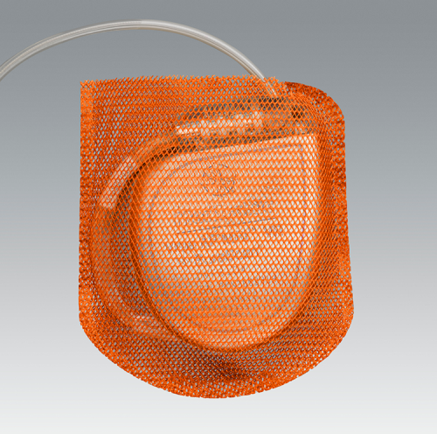
- fully absorbable in approximately 9 weeks.
- available for cardiac implantable electronic devices (CIEDs), including ICDs and pacemakers.
- contains two powerful antibiotics — minocycline and rifampin - minimum inhibitory concentration (MIC) in the tissue is reached within 2 hours of implantation and maintained for a minimum of 7 days.
- envelope reduces device migration, erosion, or Twiddler Syndrome.

TYRX™ Medium (PM) Absorbable Antibacterial Envelope size: 2.5” (6.3 cm) x 2.7” (6.9 cm)
TYRX™ Large (ICD) Absorbable Antibacterial Envelope size: 3.0” (7.6 cm) x 3.35” (8.5 cm)

Electrosurgery (Electrocoagulation)
Colorado-tipped Bovie

PEAK PlasmaBlade (Medtronic)
- history - PEAK PlasmaBlade System’s pulsed plasma-mediated discharges and electrode insulation techniques were originally invented and developed by Daniel Palanker and his team at the Hansen Experimental Physics Laboratory and Department of Ophthalmology at Stanford University. PEAK PlasmaBlade technology was developed further by PEAK Surgical for commercial purposes and acquired by Medtronic in 2011.
- compatible with any neurosurgical procedure (any leads, batteries, devices).

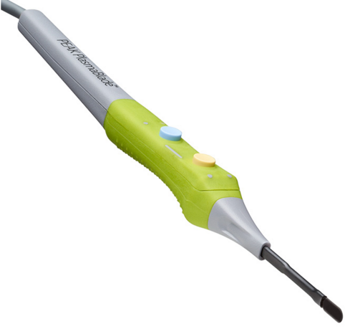

- connects to PULSAR® II Generator - supplies pulsed* plasma RF energy:
*most RF-based surgical equipment use continuous voltage waveforms
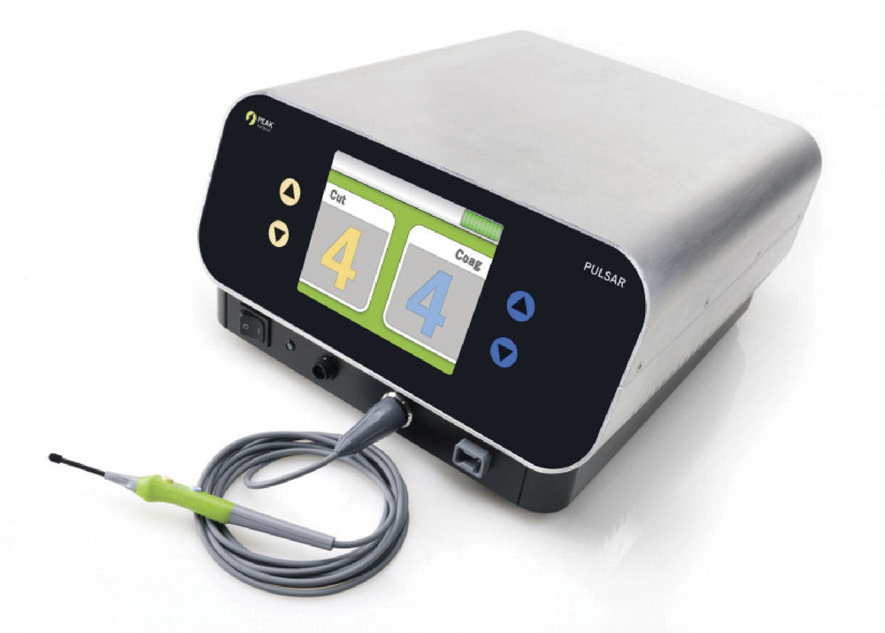

- may be used to cut and coagulate soft tissue (default setting: 6 for cut and 6-7 for coag):
- maintains cutting effectiveness and hemostatic ability even when submerged in liquefied tissue or blood.
- bleeding control of traditional electrosurgery without extensive collateral tissue damage - operates at significantly lower temperatures than traditional electrosurgical technology (40 – 170°C vs. 200 – 350°C).
N.B. melting point of polyurethane insulation (PU55D) is between 185 – 225°C.
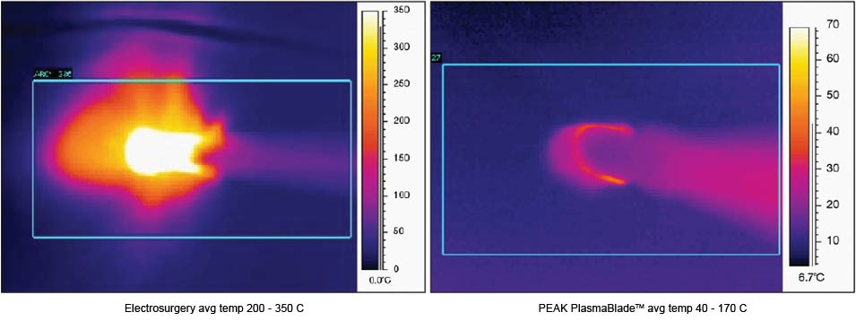

- equivalence to scalpel in healed incision strength, inflammatory cell counts and healed scar.
- Loh SA, Carlson GA, Chang EI, Huang E, Palanker D, Gurtner GC. Comparative healing of surgical incisions created by the PEAK PlasmaBlade, conventional electrosurgery, and a scalpel. Plast Reconstr Surg. 2009;124(6):1849-1859.
- Ruidiaz ME, Messmer D, Atmodjo DY, et al. Comparative healing of human cutaneous surgical incisions created by the PEAK PlasmaBlade, conventional electrosurgery, and a standard scalpel. Plast Reconstr Surg. 2011;128(1):104-111.
- Chang EI, Carlson GA, Vose JG, Huang EJ, Yang GP. Comparative healing of rat fascia following incision with three surgical instruments. J Surg Res.2011;167(1):47-54.

- selection of devices:
- PEAK PlasmaBlade 4.0 – cuts through all types of soft tissue, including skin, fat and muscle
- PEAK PlasmaBlade 3.0S – integrated suction with telescoping shaft for extended reach of up to 15 cm
- PEAK PlasmaBlade Needle – fine needlepoint tip for ultra-precise surgical procedures

Nonstick bipolar
- for coagulating brain/cord vessels (bipolar tips do not stick to parenchyma)

- ISOCOOL® Bipolar Forceps (DePuy)
https://www.depuysynthes.com/hcp/codman-neuro/products/qs/ISOCOOL-Bipolar-Forceps
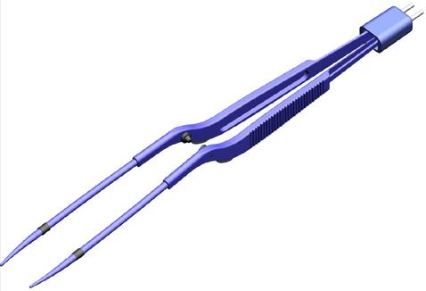

- SPETZLER™ MALIS® Nonstick Forceps – have irrigating port; also version – DUAL IRRIGATING – irrigates on both sides.

Skin substitutes / Allografts
SurgiMend (TEI Biosciences)
- acellular collagen matrix for soft tissue reconstruction.
- derived from fetal and neonatal bovine dermis.
- 1.0, 2.0, 3.0 & 4.0 mm thicknesses and sizes up to 25 cm x 40 cm
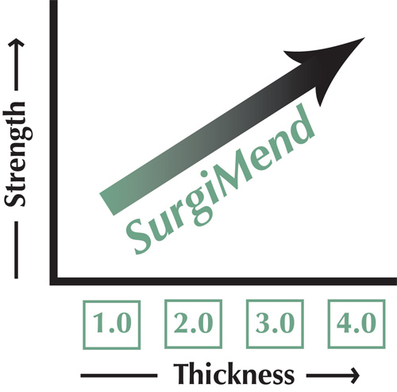

- contains three times more Type III collagen than other acellular dermal matrices (Type III collagen mediates tissue healing while inhibiting scarring).
- does not elicit acute or chronic foreign body inflammatory response that leads to the implant’s degeneration
- free of contaminants, artificial chemical crosslinks, and denatured proteins
- pure collagen; no added preservatives

AlloDerm (LifeCell)
- acellular dermal matrix
- derived from donated human skin tissue.

Bone Substitutes / Allografts
HydroSet (Stryker)
Injectable HA Bone Substitute (calcium phosphate cement)

Polyetheretherketone (PEEK)
- custom-made implants for repair of large cranial defects

Polyetherketoneketone (PEKK)
- custom-made implants for repair of large cranial defects

Demineralized bone matrix (DBM)
- main criticism against use of DBM is wide variability in DBM processing → uneven proportions of osteo-inductive substance.

MagniFuse (Medtronic)
Brochure >>
5, 10, 20, 25 cm lengths.

Grafton (Medtronic)
- fiber-based demineralized bone matrix (DBM).

Indications - bone grafting procedures in combination with autologous bone or other forms of allograft bone, or alone as a bone graft.

Contraindications - infection at the transplantation site, treatment of spinal insufficiency fractures.

PREFORMED FIBER TECHNOLOGY

GRAFTON FLEX
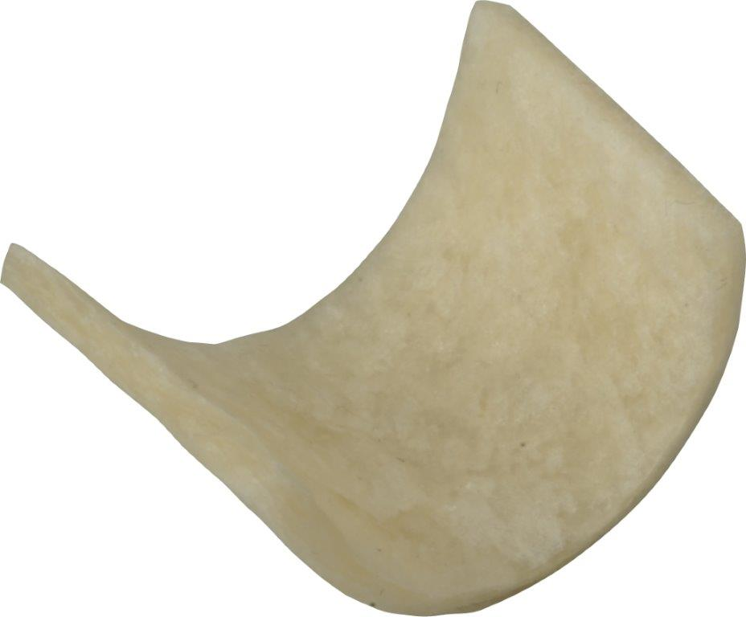

GRAFTON MATRIX
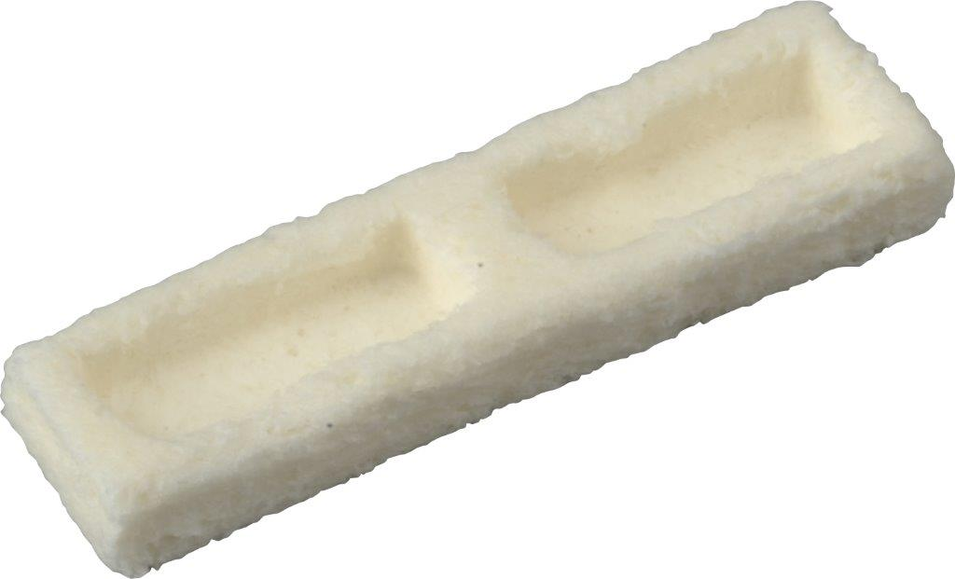

GRAFTON STRIPS
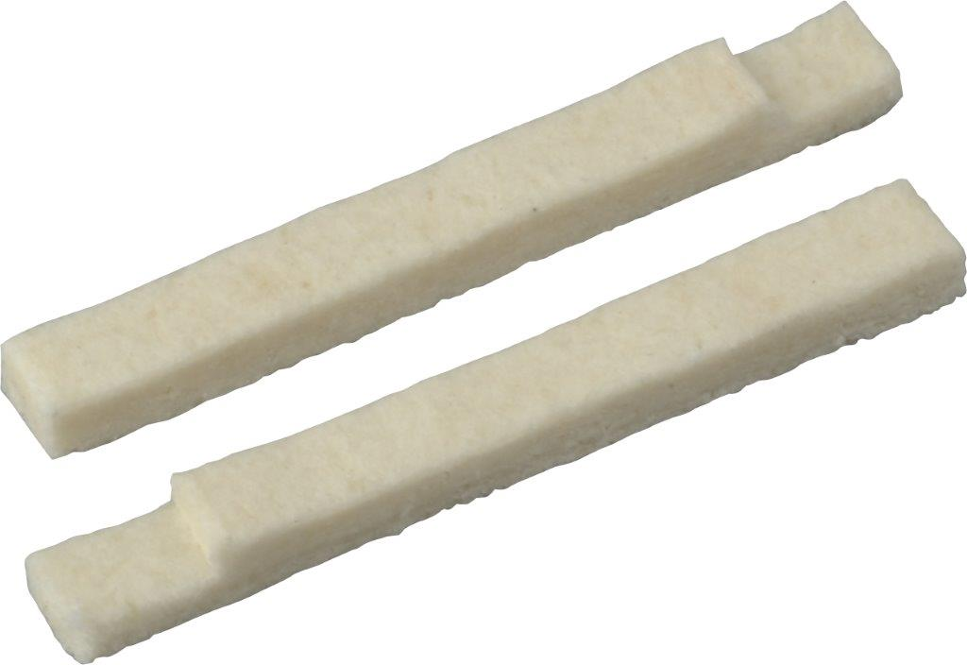

GRAFTON DBM DBF
- demineralized cortical fibers: moldable and may be hydrated with either blood or BMA and can be combined with allograft or autograft for use in spinal fusion procedures, as well as any bone void where fusion is desired.
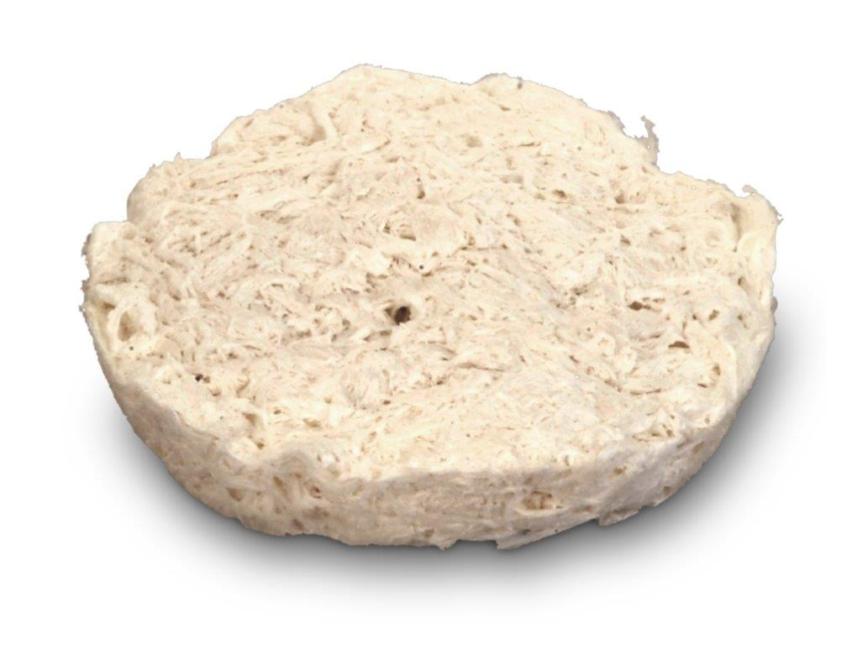

FIBER TECHNOLOGY

GRAFTON CRUNCH DBM
- mixture of demineralized bone fibers and demineralized cortical bone chips
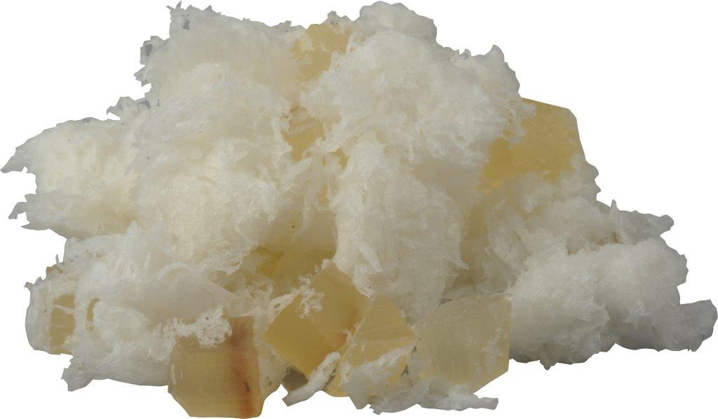

GRAFTON PUTTY
- demineralized bone fibers and can be mixed with either allograft or autograft bone
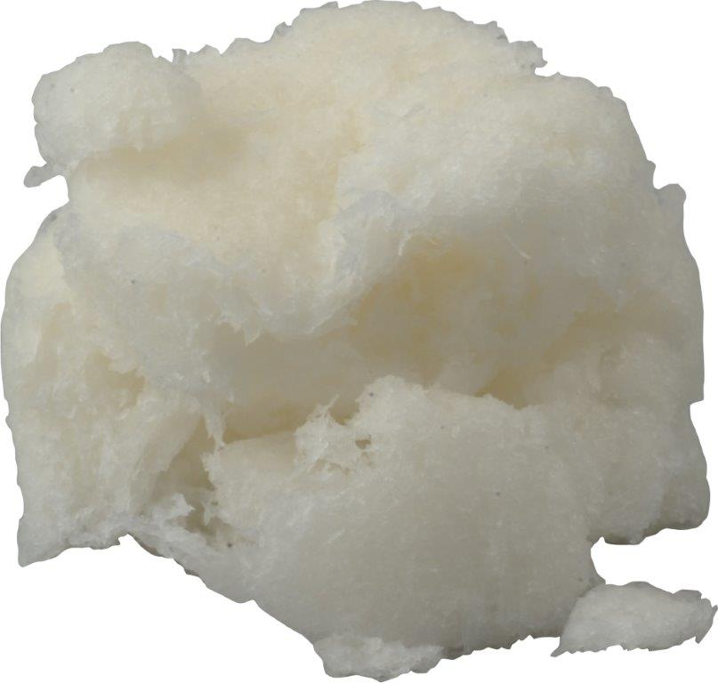

GRAFTON ORTHOBLEND—LARGE / SMALL
- demineralized bone fibers with cancellous chips or crushed cancellous chips:
LG Chip Size: 2mm–10mm.
SM Chip Size: 0.1mm–4mm.
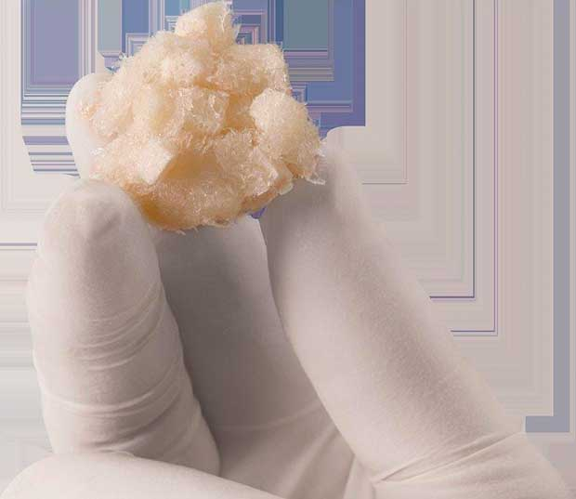

INJECTABLE (NON-FIBER)

GRAFTON PASTE
- moldable and can be mixed with allograft or autograft bone
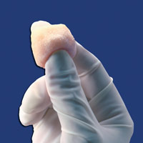

GRAFTON GEL
- can be injected percutaneously and can be mixed with cancellous chips.
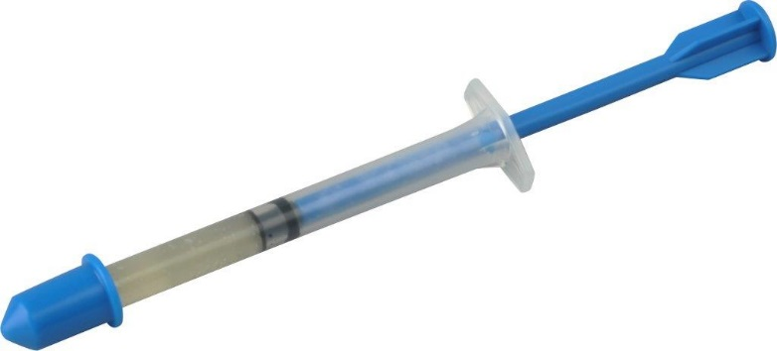

AcuPac (Acuity Surgical)
- human allograft - pre-milled cancellous bone product combined with demineralized cortical fibers.
- comes frozen
- 2.5, 10, 25, 50, 100 mL

ViviGen (DePuy Synthes)
- cellular bone matrix comprised of cryopreserved human viable* cortical cancellous bone matrix and demineralized bone (DMB).
*has live cells – kept in freezer; it takes 5 mins to thaw – but implant within 2 hours to keep cells alive.
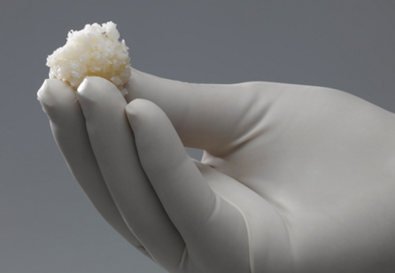

- arrives in cryopreservative solution containing Dimethyl Sulfoxide (DMSO) and Human Serum Albumin (HSA):
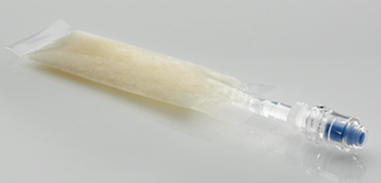

“ViviGen Formable” – has putty consistence for malleability.

- can be combined with any other grafts and/or BMP (but may not need BMP – graft already has differentiated cells – cost savings of avoiding BMP).

Bone Growth Stimulators
Allogeneic morphogenetic protein (OsteoAMP®)

OrthoFix
In cervical surgery – see p. Op210 >>

Recombinant human bone morphogenetic protein (rhBMP)
- members of the transforming growth factor-beta superfamily, discovered in the mid-60s.
FDA has approved clinical use of 2 types of rhBMPs:
- rhBMP-7 (OP1 Olympus Corporation, Tokyo 163- 0914, Japan) in recalcitrant long bone nonunions and posterolateral lumbar arthrodesis revisions
- rhBMP-2 for spinal fusion procedures with the LT-CAGE Lumbar Tapered Fusion Device (Medtronic Sofamor Danek, Dublin, Ireland) through the anterior approach in patients with degenerative disc disease (DDD) at 1 level from L4–S1, and later for repair of symptomatic, posterolateral lumbar spine pseudarthrosis. The off-label use of rhBMP-2 has been shown to be effective in achieving high fusion rates in the lumbar spine.
- use of rhBMP-2 is limited for 2 main reasons: high costs and association with complications (hyperostosis and inflammation, de novo cancer when used at doses above 40 mg)
- don’t use with DuraGen as it will bind some BMP!
- BMP may contribute to some interbody graft subsidence.

Dural Sealants
Chemical
Dura Seal (Confluent Surgical)
- synthetic absorbable sealant
- FDA approved for intracranial and spinal application
- composed of two solutions:
- polyethylene glycol (PEG) ester (“blue”)
- trilysine amine (“white”)
- when mixed together, precursors cross link to form hydrogel sealant.
- use within 1 hour of preparation
- may swell up to 50% of its size in any dimension - do not apply to confined bony structures where nerves are present; two deaths are reported in literature.
- absorbed in 4-8 weeks

Adherus (Severn Healthcare Technologies, HyperBranch Medical Technology)
- fully synthetic absorbable sealant
- FDA approved
- composed of two solutions:
- polyethylene glycol (PEG) ester
- polyethylenimine (PEI)
- polymerization occurs within approximately one second of application.
- may swell up to 46% of its size - do not apply to confined bony structures where nerves are present.
- absorbed over approximately 90 days.

Adherus AutoSpray is a sterile, single-use, battery operated device with internal system components that provide air flow to aid in delivery of Adherus Dural Sealant and allow delivery to be paused without clogging!
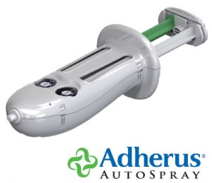

BioGlue (Cryolife)
- classified by the manufacturer as neurotoxic.

Fibrin
Tisseel (Baxter International)
- completely resorbed in 10-14 days.
- oxidized cellulose-containing preparations can reduce the efficacy of TISSEEL and should not be used as carrier materials

EVICEL (Johnson and Johnson Wound Management, Ethicon)

Dural Substitutes
SepraFilm

DuraGen (Integra LifeSciences Corporation)
- onlay dural regeneration matrix
- handles like normal soft tissue, easily conforming to complex surfaces of exposed neural tissue
- designed to remain in place during active healing
- demonstrates effective protection against CSF leakage with sutureless closure
- fully resorbed and replaced by native tissue with complete dural closure
- suturing is not required, but tensionless stay sutures may be used if desired

Suturable DuraGen (Integra LifeSciences Corporation)
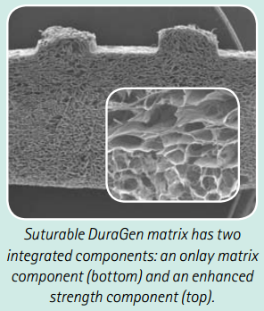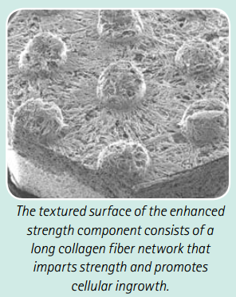

- proven effectiveness against CSF leakage.
- fully resorbed and replaced by native tissue with complete dural closure.
- no reported encapsulation

Synthecel
- cellulose (Synthes – DePuy)
- sutureable

Dura-Guard (Synovis Surgical Innovations, St. Paul, MN)
– bovine pericardium cross-linked with glutaraldehyde.
- rinse surgical gloves to remove glove powder prior to touching the patch.
- immerse and agitate Dura-Guard for ≥ 3 minutes in 500 ml of sterile saline (0.9% NaCl) – to prevent sterile inflammatory reaction!
- do not pour storage solution into sterile saline.
- 500 ml rinse solution may contain one of following antibiotics: ampicillin & gentamicin, bacitracin, cefazolin, cefotaxime, neomycin, vancomycin - Dura‑Guard is not adversely affected by treatment with these antibiotics listed.
- keep patch immersed in sterile saline until ready to use.
PATCH MUST REMAIN MOIST AT ALL TIMES
- visually examine both sides of patch - if one side appears smoother, implant so smoother surface faces neural tissue.
- when implanting by suture, suture bites should be taken 2-3 mm from graft edge.

DuraForm (Codman)
https://www.depuysynthes.com/hcp/codman-neuro/products/qs/DURAFORM-Dural-Graft-Implant

- collagen- based biocompatible dural substitute >>

Head Holders
About application principles – see p. Op100 >>

Mayfield INFINITY pediatric head holder
- has integrated skull clamp and horseshoe headrest – adjustable height so head weight is distributed between pins (mainly serve as motion stabilizers) and head rest.
- multiple, quick-change, snap-in rocker arm options - to match the stabilization points to the size of the patient’s head:
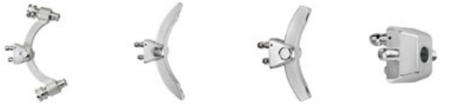

- uses lower (max. 18 lbs vs 80 lbs for adults) torque screw:
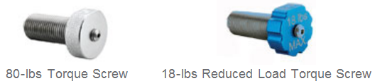

Integra radiolucent Mayfield
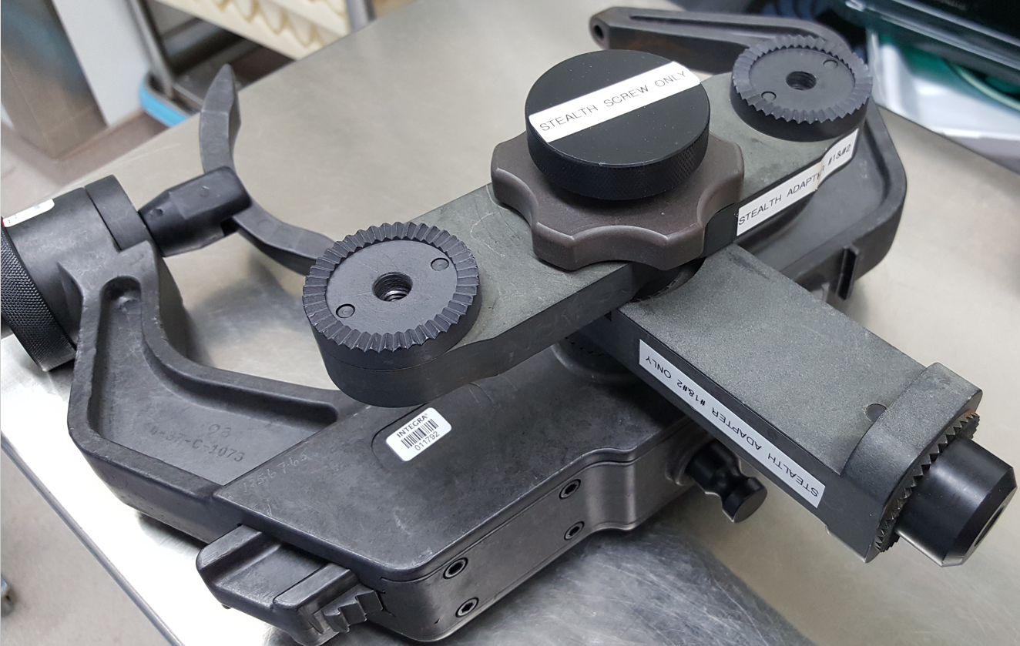
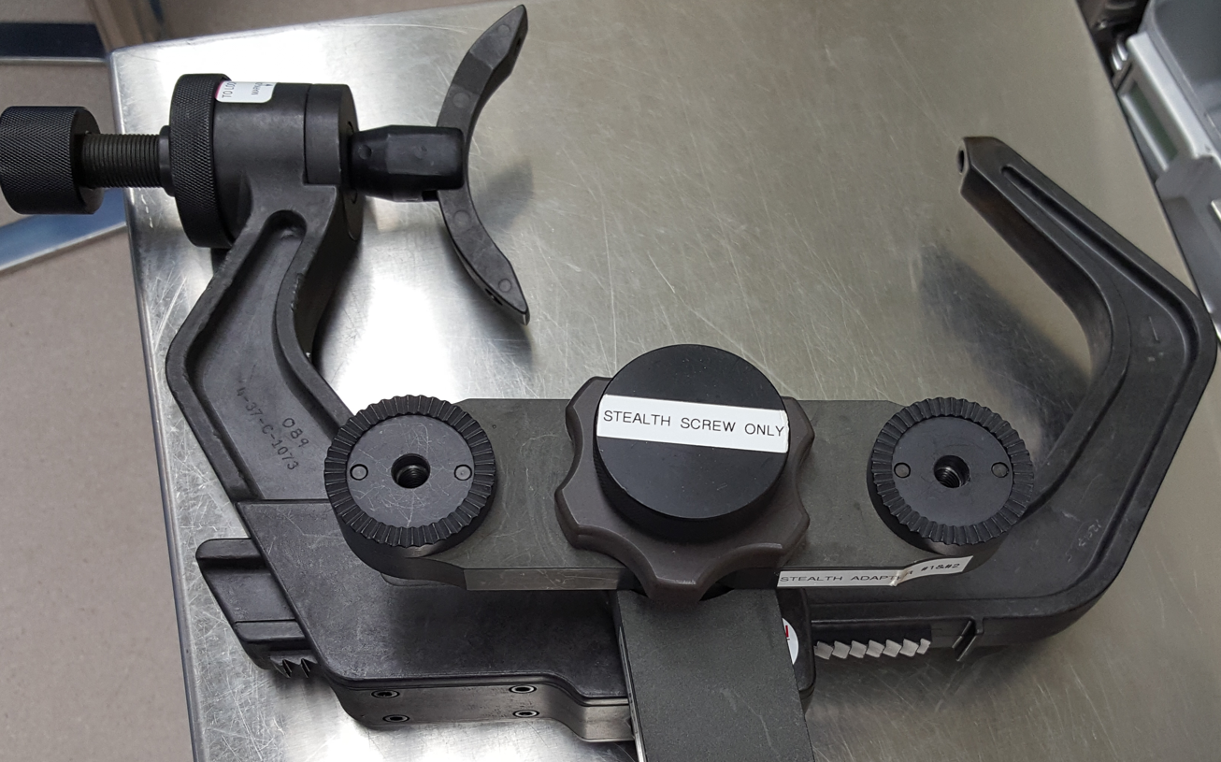
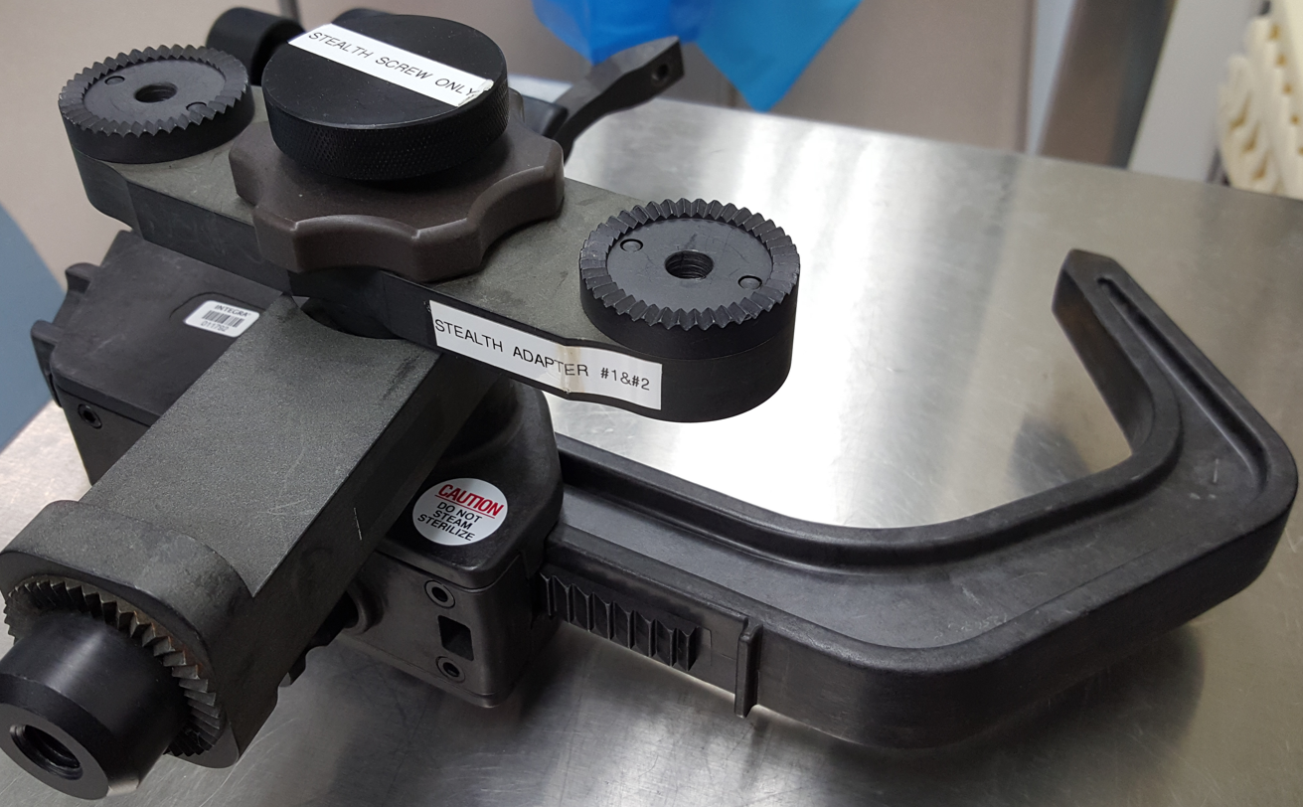

Pins
Doro
- radiolucent

Pediatric pins
- have low profile not to perforate skull; suitable for kids ≤ 3 years (for older patients with thicker scalp, pin rim will press and necrose skin).

Cranial Plating
Leibinger/Stryker cranial plating system
Stryker low profile skull plating system
Leibinger titanium cranial mesh:
blue – thinner
golden – thicker
- cut mesh using template
- mold mesh with molding forceps

CRANIOPLASTIC kit (Codman)
- resinous material for repairing cranial defects >>

RapidFlap (Biomet Microfixation)
https://issuu.com/daltonagency/docs/biomet_microfixation__rapidflap_
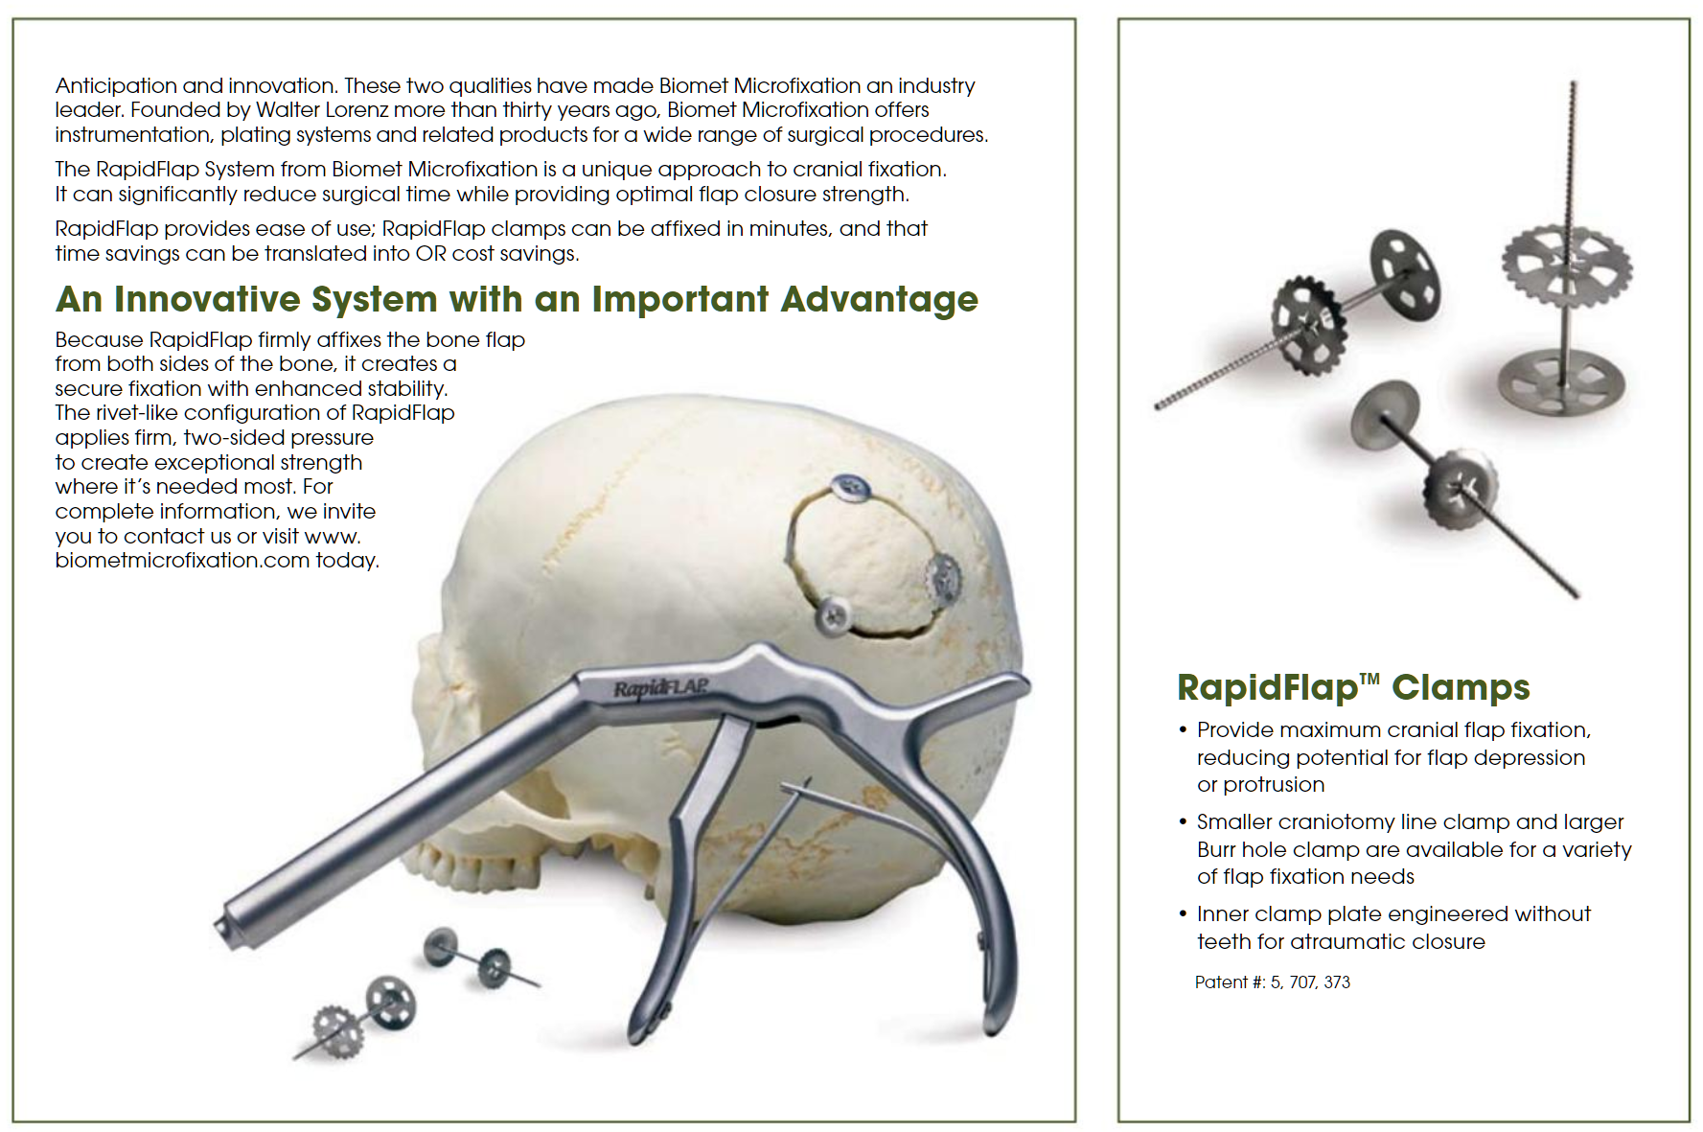

Drills
high-speed Midas Rex drill with an Acorn bit

Drill Bits
Perforators
Acra-Cut >>

Codman >>

Available in three sizes (outer collar / inner core):
9/6 mm
11/8 mm
14/11 mm
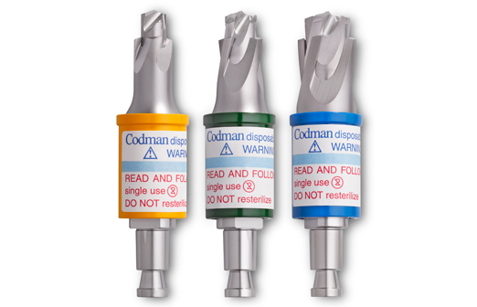

Rongeurs
Kerrison rongeur
Leksell rongeur
Lempert rongeur (≈ small Leksell)
Blakesley forceps:
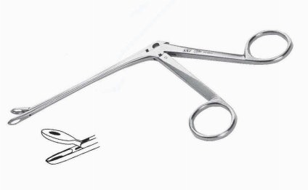

Retractors
General
Adson Cerebellar retractor:
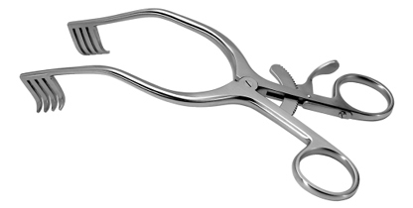

Gelpi retractor:

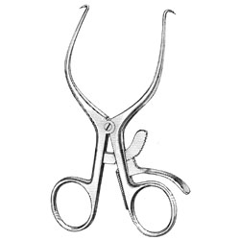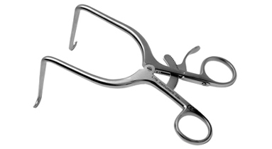

Williams retractor:
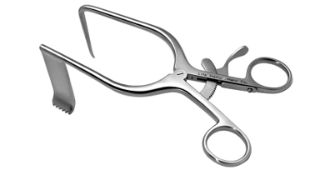

McCulloch retractor:
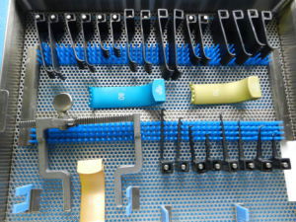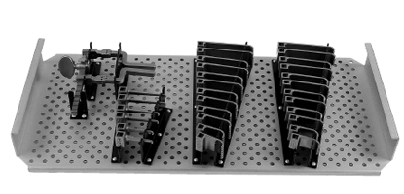

Meyerding retractor:
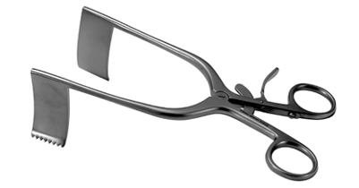

Adson Beckman retractor:
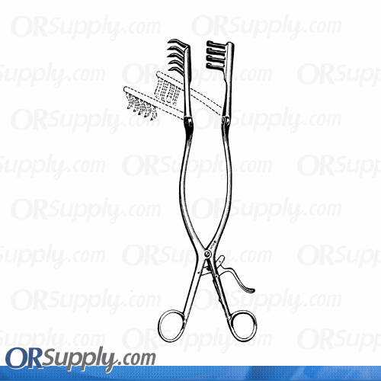

Taylor retractor
– spike sits on lateral side of facet or pars, hook is held by assistant or weight is attached on sterile rope – used for lumbar spine exposure in morbidly obese patients.

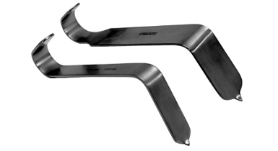

Hohmann retractor
Mathieu retractor
Weitlaner retractor
Deaver retractor
Love nerve root retractor

Cranial - Scalp Flap retractors
Hooks and Greenberg retractor – for scalp flap retraction

Yasargil (Leyla) bar - to hold back scalp flap

Cranial – Brain retractors
Greenberg

Vycor retractor

NICO BrainPath retractor
“Atraumatic Access to the Subcortical Space” - see brochure >>
- very similar to Vycor; “Shepard’s hook” holder attaches to Greenberg
- comes in 3 lengths: 50, 60, 75 mm
- has 13.5 mm diameter:
  - does not disrupt white matter
  - unable to use microscope (for binocular vision, channel must be at least 22 mm); thus, use exoscope on Mitaka arm (or Synaptive robot – aligns exoscope – BrainPath may have attached navigation balls)

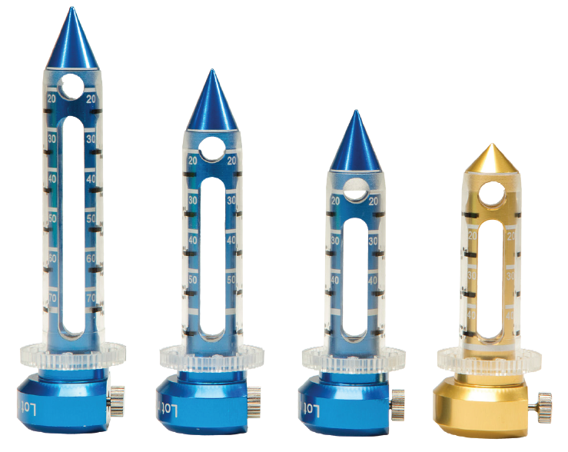
- do not use mannitol – brain turgor stabilizes retractor and pushed lesion into retractor’s lumen.
- very limited dural opening – cruciate incision (each limb 1 cm)
- incise arachnoid over sulcus; push BrainPath (with regular Stealth probe inside obturator) through sulcus towards target, remove obturator.

Budde® Halo Retractor
- attaches to MAYFIELD® Skull Clamps or to the side rails of the OR table to provide a sturdy platform for retraction and a ready support or hand rest for the surgeon.

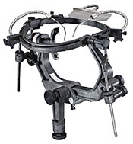

CNS parenchyma protectors
BICOL Collagen Sponge (Codman)
- for use in procedures requiring prolonged retraction and exposure of the brain.
- application and manipulation of the wetted material is facilitated by its surface textures:
- one surface is very smooth so that once moistened it slides over the brain and readily conforms to the area to be protected.
- the opposite surface has sufficient grain to provide friction to a retractor blade for manipulation.

Probes, Dissectors
Woodson (“dental”) probe:
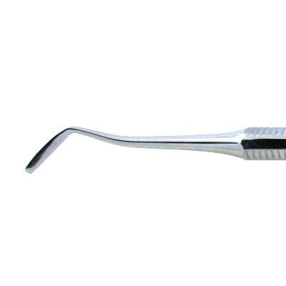

CNS parenchyma ablators
CUSA (Integra)
Brochures >> and >>

Settings
Aspiration 10-20%
Irrigation 80%
Amplitude ≥ 50%
Tissue selectivity – use Standard (++++ uses less longest pauses – spares blood vessels, e.g. when working next to carotid)

Tips
Angled tip is less powerful than Straight

Integra CUSA® ShearTip™ - efficient fibrous tissue removal:
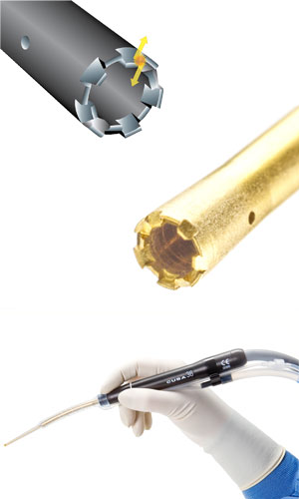

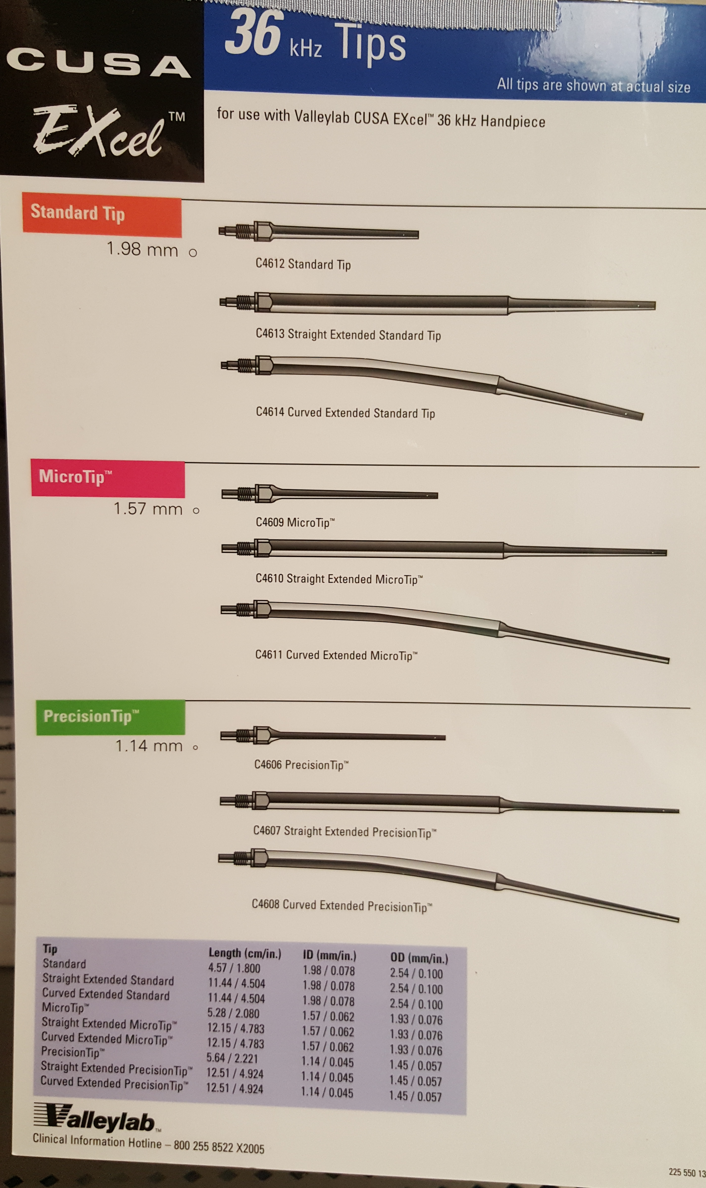

Myriad (NICO)
Side-Cutting Aspiration Device – see brochure >> and >>
- side mouth cutting (oscillating guillotine) and aspiration aperture:
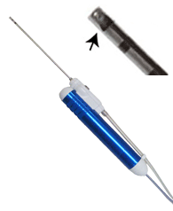
- can work through tubular retractors; special version can work through rigid endoscope (when working inside ventricles, decrease suction power to 50%)
- does not generate heat
- has tissue collection filter – can send for pathology!
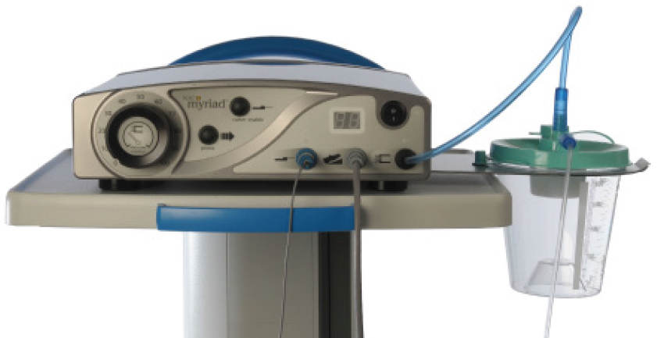

Tables and Frames
Axis table
- top of chest bar – 2 fingerbreadths below sternal notch.
- iliac crest at the border of top 1/3 and lower 2/3 of leg pad.
- patient position on the table imitates standing position – do not flex legs at hips or knees!!!
- lets abdomen to hang – decreased epidural venous bleeding.

Wilson frame
- radiolucent version exists.
- cranked up is good for lumbar discectomies
- deflated can be used:
- for posterior cervical fusions
- for lumbar fusions (Dr. Graham) but only for thin persons (place paddings under head and under legs so patient is basically flat)

Gel Chest Rolls
- can be placed in transverse position (Dr. Graham uses for thoracolumbar trauma)

Exoscopes
- so far only monocular (advantage – can look down narrow* BrainPath retractor)
*13 mm diameter (microscopes need at least 22 mm to see stereoscopic)
- straight or 90º angled (not in surgeon’s way)
- two brands:
- Synaptive (can be coupled with robot that moves camera along BrainPath axis)
- Storz VITOM

Ventricular Endoscopes
Ventricular endoscopy technique – see p. Op10 >>

Flexible
Karl Storz – keep on Mitaka arm

Rigid
Channeloscope

NeuroPen (Medtronic PS Medical)
- low resolution, semirigid, disposable.
- 1.2 mm diameter – used as stylet for ventricular catheter placement (make slit in catheter distal end so endoscope can be advanced through tip once placed inside ventricle).

Little Lotta (Karl Storz )
– large diameter; see >>
UAMS has Lotta
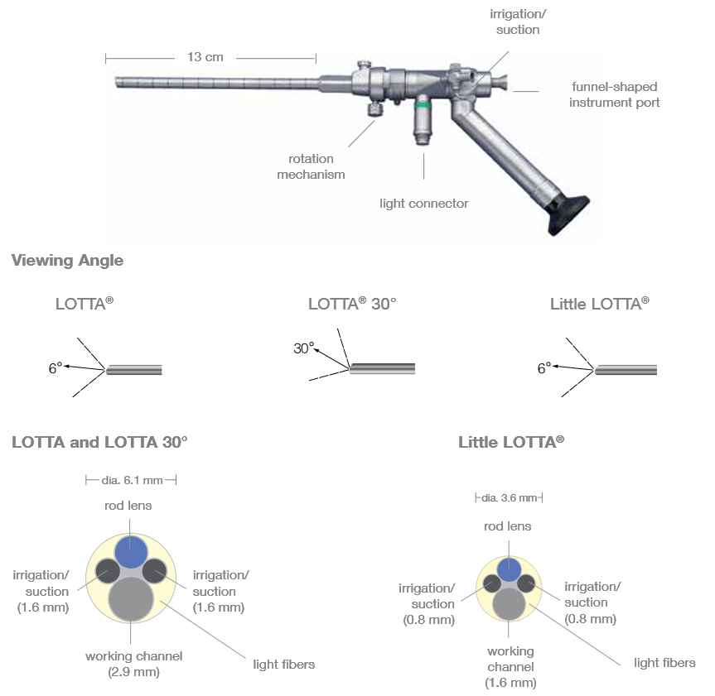

Paediscope (Aesculap )
– small diameter (for small ventricles); 30,000 pixel fiber optic, Outer diameter: 3.0 mm Working channel: 1.2 mm (for flexible instruments for pediatric patient, 1.0 mm outer diameter), Integrated irrigation and overflow channels: 0.8 mm:
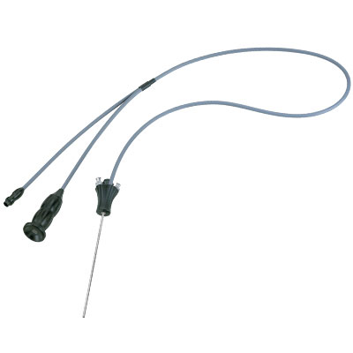

Headlights
 | Integra | Storz | Wolf | ACMI | Olympus
Price
Contact | 311 Enterprise Drive, Plainsboro, NJ 08536  800-997-4868
Strength | 350+ lumens guaranteed after 20 min burn in on highest setting
Hours of LED operation | 25,000+
Perks | Audible battery life notifications

Microscopes
OPMI Pentero 900 (Zeiss)
See >>

Intraoperative Imaging (X-ray)
Fluoroscopy
- if need to see more segments of anatomy, keep receiver closer to patient (also helps to decrease scattered radiation); if emitter is closer to patient, then receiver receives divergent beams and zoomed image.

Intraoperative Imaging (CT)
Types of intraoperative CTs:
- fan beam CT (FBCT) - the same technology employed for diagnostic imaging in radiology suites.
- flat panel cone beam CT (CBCT) - typically portable and increasingly common in the OR environment but inferior soft tissue resolution (e.g. it cannot rule out a small bleed).

CereTom (NeuroLogica)
- small portable FBCT device.
- average dose is 1.7 mSv.
- small bore makes it difficult to use during the procedure itself but can be used to obtain the registration scan and to check final hardware position prior to leaving the OR.

O-arm (Medtronic)
O-arm in spine surgery – see p. Op220 >>
Standard mode (0.48-0.6 mSv or 17.36 mGy) - about 75% of typical stereotactic head CT exposure
High-definition mode (25.7 mGy)
Enhanced mode (2.2 mSv or 64.2 mGy – same as regular CT 2-4 mSv – so limit its use!)

Max. dose for one patient in one procedure – 151.0 mGy

- O-arm is portable CBCT device.
- it is composed of a gantry that opens and encloses around a patient.
- it acquires 391 flat-plate fluoroscopy images (30 × 40-cm field of view) as it rotates around the patient → recreates 3D image set (512 × 512 × 192) that has the appearance of a thin-cut CT with bone windows.
- O-arm can be used as a very accurate registration modality; Dr. Holloway et al (2013) showed:
- measurement error of O-arm is 0.69 mm (SD 0.33) in standard mode and 0.61 mm (0.31) in enhanced mode; maximum measurement error in the study was 1.9 mm.
- using bone fiducials for DBS surgery, intraoperative O-arm registration led to the final DBS placement accuracy of 2.04 ± 0.80 mm vs. with preoperative CT registration it was 2.16 ± 0.92 mm.
- images do not contain soft tissue information like a typical CT - soft tissue resolution of O-arm is insufficient to detect small hemorrhages.

BodyTom (NeuroLogica Corporation)

Robots
– see p. Op40 >>

Viktor’s Notes℠ for the Neurosurgery Resident
Please visit website at www.NeurosurgeryResident.net

