Hereditary Neuropathies
Last updated: April 17, 2019
Hereditary Sensory and Motor Neuropathies (HSMN) 1
Epidemiology 1
Classification 1
Genetics 2
Diagnosis 2
Treatment 2
HSMN I (s. Charcot-Marie-Tooth disease 1, peroneal muscular atrophy) 2
Genetics 2
Clinical Features 2
Diagnosis 3
Prognosis 3
Hereditary neuropathy with liability to pressure palsies (s. HNPP, tomaculous neuropathy) 3
Genetics 3
Clinical Features 3
Diagnosis 3
HSMN II (s. Charcot-Marie-Tooth disease 2) 4
Genetics 4
Clinical Features 4
Diagnosis 4
Prognosis 4
HSMN III (s. Dejerine-Sottas disease) 4
Genetics 4
Clinical Features 4
Diagnosis 4
CMT 4 4
Hereditary Sensory and Autonomic Neuropathies (HSAN) 4
HSAN I (hereditary sensory radicular neuropathy) 4
HSAN II (congenital sensory neuropathy) 4
HSAN III (familial dysautonomia, Riley-Day syndrome) 5
Pathology, Pathophysiology 5
Clinical Features 5
Diagnosis 5
Treatment 5
HSAN IV (familial sensory neuropathy with anhydrosis, congenital insensitivity to pain) 5
HSAN V (congenital sensory neuropathy with selective loss of small myelinated fibers) 6
Hereditary Sensory Neuropathies (HSN) 6
Other Hereditary Neuropathies 6
Giant Axonal Neuropathy 6
Familial Amyloid Polyneuropathy (FAP) 6
Pathogenesis 6
Epidemiology 6
Clinical Features 6
Diagnosis 7
Treatment 7

- Hereditary sensory and motor (Charcot-Marie-Tooth) neuropathies ≈ 90% of all hereditary neuropathies! (more common than myasthenia gravis!)
- Hereditary sensory and autonomic neuropathies
- Neuropathy with leukodystrophy:
  - Metachromatic leukodystrophies (infantile, juvenile, adult)
  - Multiple sulfatase deficiency
  - Krabbe disease
  - Adrenoleukodystrophy, adrenoleukoneuropathy
  - Cockayne syndrome
  - Pelizaeus-Merzbacher disease
- Friedreich ataxia
- Giant axonal neuropathy
- Acute intermittent porphyria
- Familial amyloidotic polyneuropathy
- Abetalipoproteinemia (Bassen-Kornzweig disease)
- Analphalipoproteinemia (Tangier disease)
- Fabry disease
- Joseph disease
- Lafora body disease; polyglucosan body disease
- Leber hereditary optic neuropathy
- Hereditary ataxias

Onset of neuropathic dysfunction is insidious, and progression is indolent, occurring over years or decades (except porphyric neuropathies).

Hereditary Sensory and Motor Neuropathies (HSMN)
- peripheral neuropathies that affect either autonomic, sensory, motor fibers, or combination thereof.

Epidemiology
prevalence 4.7-40 per 100,000.
incidence - 1 in 25,000 persons.

Classification
HSMN I (s. Charcot-Marie-Tooth disease 1) – hypertrophic demyelinating neuropathies – most common HSMN!

HNPP (hereditary neuropathy with liability to pressure palsies, s. tomaculous neuropathy) – severely hypertrophic demyelinating neuropathy.

HSMN II (s. Charcot-Marie-Tooth disease 2) – axonal neuropathies.

HSMN III (s. Dejerine-Sottas disease) – severe hypertrophic demyelinating neuropathies with onset in infancy.

Genetics
Disorder | Inheritance | Gene | Product
CMT 1A | AD | Duplication (gene dosage effect) at 17p11.2-12 | PMP22 (peripheral myelin protein 22)
HNPP (hereditary neuropathy with liability to pressure palsies) | AD | Deletion at 17p11.2
Dejerine-Sottas syndrome A | AD | Point mutation at 17p11.2
Dejerine-Sottas syndrome B | AD | Point mutation at 1q22.3 | PO (myelin protein zero)
CMT 1B | AD | 1q22.3
CMT 1C | AD | ?
CMT 1 (X-linked) | X-linked | Xq13.1 | Connexin 32
CMT 2A | AD | 1p36-P35 | ?
CMT 2B | AD | 3q | ?
CMT 4A | AR | 8q13 | ?
CMT 4B | AR | 1q231 | ?
CMT 4C | AR | 5q23-33 | ?
Peripheral myelin protein 22 (PMP22) - present in compact myelin of PNS.
- Schwann cells can modulate axon caliber, neurofilament density within axoplasm, etc.
- abnormal expression of PMP22 → both neuronal and Schwann cell alterations.
- PMP22 is implicated in trembler mouse.

Myelin protein zero (P0) - major component of PNS myelin.
- major role - compaction of myelin (holding opposing membranes together).
- analog in CNS is proteolipid protein (PLP).

Connexin 32 - gap junction protein (gap junctions are at Ranvier nodes and Schmidt-Lanterman incisures - intracellular gap junctions between folds in Schwann cell cytoplasm).

Diagnosis
Always search for affected family members – facilitates diagnosis!
- genetic confirmation (available only for CMT 1A, X-linked CMT, HNPP, Dejerine-Sottas syndrome).
- nerve conduction studies: Family members should be examined!
- demyelinating features - slowed nerve conduction velocities (extent of velocity reduction is no longer accepted criterion for diagnosing type of CMT).
- axon-loss features - low amplitude evoked potentials (normal conduction velocities!)
- sural nerve biopsy (important for excluding other depositions of metabolic products):
In demyelinating CMT forms:
  - increase in epineurium and perineurium collagen.
  - ↓number of myelinated fibers (correlates with severity of disease), segmental demyelination.
  - numerous onion bulbs*
*cause macroscopic nerve enlargement
In axon-loss CMT forms: wallerian degeneration.
- EMG and muscle biopsy are not usually required for diagnosis; serum CK is normal.
- CSF protein may be elevated, but no cells appear in CSF.

Treatment
No cure or effective treatment available.
- orthoses, surgical correction of joint deformities and scoliosis, physical therapy.
- stabilization of ankle is primary concern:
early stages - stiff boots that extend to midcalf
later stages - lightweight plastic splints worn inside socks.
complete foot drop - external short leg braces or surgical fusion of ankle.

HSMN I (s. Charcot-Marie-Tooth disease 1, peroneal muscular atrophy)
– hypertrophic* demyelinating neuropathies (+ sclerosis in spinal posterior column, particularly upper fasciculus gracilis).
*due to episodes of remyelination

- CMT type 1A – most common form (50-60% of all CMT cases).
- CMT type 1B – rare form (< 2% of all CMT cases).
- X-linked CMT (10%) – affects males (carrier females may have mild, variable clinical disease).

Genetics
- see above >>

Clinical Features
Wide intrafamilial variability! (affected family members may have no symptoms and minimal neurologic findings but may still show severe reduction of nerve conduction velocity)
- clinical presentations of CMT 1A and 1B are similar, although they are distinguishable.
- CMT 1A may have milder clinical course than 1B.
- age of onset ranges childhood ÷ early adulthood (2-3rd decades); may be earlier in X-linked CMT.
- progression is slow.
- cranial nerves are generally spared, intelligence is normal.

- Symmetrical insidious weakness & atrophy of intrinsic foot & peroneal muscles (footdrop, steppage gait).  N.B. muscle atrophy is sign of axon-loss neuropathies!  - patients report frequent ankle sprains.  - later may be involved - calf ("champagne-bottle" legs; “stork” legs), thigh, intrinsic hand muscles.  - cramps & fasciculations after exercise.  - reflexes disappear: ankle → patellar → arm.  - Careful examination reveals sensory abnormalities in all modalities in stocking-glove pattern (esp. elevated vibratory thresholds in toes).  - Skeletal abnormalities (≈ 60% patients) reflecting long-standing muscle imbalance - pes cavus, hammer (claw) toes, scoliosis.  N.B. high pedal arches or hammer toes may be only signs in less affected family members!  - Cool anhidrotic skin over distal leg.  - Enlargement & hardening of nerves (≈ 25% patients); especially:  - ulnar nerve at elbow;  - greater auricular nerve running from posterior margin of sternocleidomastoid muscle to base of ear. | marked wasting of calf and intrinsic foot muscles:  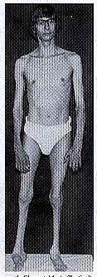
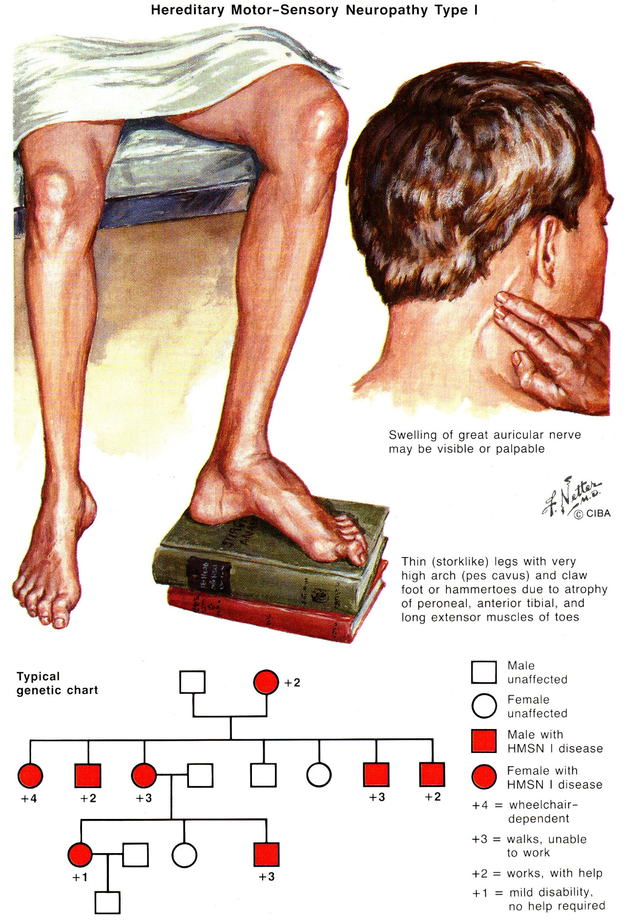

Diagnosis
- see above >>

Prognosis
- life expectancy is not reduced and patients remain ambulatory throughout their lives.

Roussy-Levy disease
- combination of HMSN I and Friedreich ataxia; autosomal dominant inheritance, gene locus has not been identified.

Hereditary neuropathy with liability to pressure palsies (s. HNPP, tomaculous neuropathy)
– demyelinating neuropathy.

Genetics
- see above >>

Clinical Features
- age of onset - 2-3rd decades.
- recurring sensory and motor nerve palsies brought on by mild pressure or trauma to nerve (insult from which normal person would quickly recover results in residual nerve damage that may take days ÷ months to resolve).
- most commonly affected - ulnar, median, peroneal nerves, brachial plexus.

Diagnosis
- see above >>
- nerve conduction velocities are slow even between attacks!; conduction block is possible (vs. HSMN I).
- myelin on nerve biopsy (teased nerve fibers and electron microscopy) has sausage-like appearance (Lat. tomacula - sausage);
it is normal in nerves with increasing age, so evaluation may require quantitative study (morphometry).

HSMN II (s. Charcot-Marie-Tooth disease 2)
– axonal neuropathies:
  - no histologic evidence of demyelination
  - normal conduction velocities!
  - no hypertrophic nerves!

Genetics
- see above >>

Clinical Features
- onset – 3-5th decades of life (later than CMT 1).
- ≈ CMT 1.

Diagnosis
- see above >>

Prognosis
≈ CMT 1.

HSMN III (s. Dejerine-Sottas disease)
– severe hypertrophic demyelinating neuropathies.

Genetics
- see above >>

Clinical Features
- more malignant than HSMN I & II:
- onset in infancy (1st decade).
- progressive generalized (trunk and limb!!!) muscle weakness (children may never walk!)
- severe sensory loss, limb ataxia.
- marked hypertrophy of peripheral nerves (palpably enlarged at early age).
- may be mentally retarded.

Diagnosis
- see above >>
Marked onion bulbs with hypomyelination!

CMT 4
CMT 4A – demyelinating neuropathy with onset in 1st decade.

Hereditary Sensory and Autonomic Neuropathies (HSAN)
- primary sensory & autonomic neurons:
- fail to develop
- undergo system atrophy and degeneration.

Two large divisions:
HSAN I - progressive disorder with onset in ≥ 2nd decade with primarily lower extremities affected.
HSAN II-V - static congenital disorders that are generalized.

Prominent sensory loss and dysautonomia
Common feature among all types is insensitivity to pain!
- dysautonomia is mild in HSAN I-II but prominent in HSAN III.
- sensory loss may be profound → mutilating deformities of hands and feet (sensory neurogenic arthropathy, mutilating acropathy).
- there may be weakness, skeletal changes similar to HSMN.

Type | Inheritance
HSAN I | Primarily AD, gene at 9q22.1-q22.3  (AR and X-linked pedigrees have been identified)
HSAN II | AR
HSAN III | AR, almost exclusively Ashkenazi Jews  (gene on D9S58, 9q31-33 - unknown gene product)
HSAN IV | AR, rare
HSAN V | < 10 cases reported

HSAN I (hereditary sensory radicular neuropathy)
- slowly progressive disorder with onset in ≥ 2nd decade with primarily lower extremities affected.
- predominantly sensory neuropathy (dysautonomia very mild – loss of sweating in legs).
- chronic axonal degeneration (mostly myelinated fibers) with myelin remodeling.
- does not seem to decrease lifespan.
  - insensitivity to pain in feet → plantar ulcers, recurring paronychia, stress foot fractures, recurrent cellulitis, resorption of foot bones → pedal deformity & mutilations.
  - spontaneous feet pain (burning or aching), worsened with weight bearing, decreased at night; or disabling lancinating pain in deep tissues of feet, legs, or shoulder.

Proper foot care!!! - regular inspections, soaked daily + petrolatum lotion (to seal in moisture), proper shoes, aggressive treatment of ulcers, etc.

HSAN II (congenital sensory neuropathy)
- generalized predominantly sensory (in all modalities) neuropathy, presenting in infancy.

- axonal degeneration (profound loss of myelinated fibers in cutaneous nerves, esp. sural); degenerative process begins in utero or in infancy.  - mutilations are more severe than in HSAN I:  - begin earlier when patients cannot understand problem and cooperate.  - hands are also seriously affected.  - loss of sweating over acral parts (but no postural hypotension).  - no prominent muscle weakness.  - nerve conduction studies - no sensory nerve action potentials elicitable in ulnar, median, sural nerves.  N.B. conduction velocities of motor fibers of same nerves are normal!  - provide adequate educational opportunities to develop intellectual potential in spite of severe physical handicaps. | destruction of tongue tissue due to insensitivity to pain:  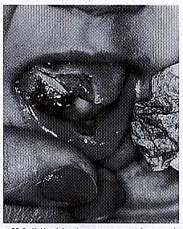

HSAN III (familial dysautonomia, Riley-Day syndrome)
- almost exclusively Ashkenazi Jews (carrier state is estimated to be 1%).

Pathology, Pathophysiology
- pathophysiologic findings:
    - decreased levels of dopamine-β-hydroxylase (decreased synthesis of noradrenaline from dopamine)
    - increased levels of β unit of nerve growth factor (NGF).
- postmortem studies (vary widely):
      - no nervous system lesions at all
      - extensive damage:
- CNS (esp. cortex, brain stem reticular formation, long tracts of cord);
- peripheral nerves - axonal degeneration mostly in unmyelinated fibers (↓↓↓number* of unmyelinated fibers of cutaneous nerves), loss of ganglion cells (sensory and autonomic).
*nerve conduction velocities are within normal range
Clinical Features
lack of fungiform papillae on tongue (→ hypogeusia) - highly distinctive feature!!!
Prominent dysautonomia!!!
- presents at birth* (frequently low birth weight and breech presentation): muscle hypotonia, absent tendon reflexes, absent corneal reflexes, poor Moro response, poor cry, inability to suck.
*vs. Shy-Drager syndrome
- progresses: failure to thrive, unexplained fevers (40% with seizures), lack of tearing (→ corneal abrasions), cold hands & feet, erythematous skin blotching, difficulty in swallowing* with regurgitation + hypersalivation → aspirations → pneumonia.
*some infants require tube-feeding
- breath-holding spells followed by syncope are common in first 5 yr.
- 40% patients experience seizures (during hyperpyrexia, breath-holding spells).
- after age 3 yrs dysautonomic crises begin - cyclic vomiting, diaphoresis, hypertension, tachycardia, thermal instability irritability, self-mutilation, negativistic behavior.
- markedly elevated serum norepinephrine (causes hypertension) and dopamine (causes vomiting) levels.
- prominent gastric distention may occur, hematemesis may complicate pernicious vomiting.
- decreased pain sensation (→ Charcot's joints; newly erupting teeth cause tongue ulcerations).
- ataxia (proprioceptive), intolerance for general anesthetics.
- possible GI abnormalities: megaesophagus, pylorospasm, gastric ulcer, jejunal distention, megacolon.
- 50% patients develop kyphosis, scoliosis.
- in adolescence: vomiting and dysautonomic crises tend to decrease; delayed puberty; complaints center on decreased exercise tolerance, poor general coordination, emotional difficulties, and postural hypotension.
- IQ is frequently ≥ 20 points below unaffected siblings.
- abnormal responses to altered atmospheric air (hypercapnia and hypoxia do not produce expected increases in ventilatory effort): drowning has occurred, because air hunger did not develop under water; coma has occurred in high altitudes.
- 20% adult patients have ischemic-type glomerulosclerosis.
- most patients do not survive to adulthood (oldest surviving patient in one series was 38 years old).

Diagnosis
    - absence of fungiform papillae on tongue
    - absent deep tendon reflexes
    - intradermal injection of histamine → no pain, no normal flare.
    - absence of overflow tearing with crying (normal until 2-3 mo of age!)
    - conjunctival instillation to one eye of 2.5% methacholine or 0.0625% pilocarpine → miosis, restored tearing.
N.B. pupillary responses to light and accommodation appear normal!
Supersensitivity to cholinergic and adrenergic agents
- exaggerated pressor response to IV norepinephrine.
      - urinary ratio vanillylmandelic acid / homovanillic acid ↓.
      - prenatal diagnosis is possible.

Treatment
- Ranitidine
- Diazepam, chlorpromazine (for crises)
- Methylcellulose eye drops
- Gastrostomy, fundoplication

HSAN IV (familial sensory neuropathy with anhydrosis, congenital insensitivity to pain)
      - selective loss of small myelinated axons with almost complete absence of unmyelinated fibers.
      - similar to HSAN II, with addition of anhydrosis (episodes of fever related to environment rather than infection).
      - mild mental retardation.

HSAN V (congenital sensory neuropathy with selective loss of small myelinated fibers)
- congenital insensitivity to pain.
- normal strength and tendon reflexes in extremities.

Hereditary Sensory Neuropathies (HSN)
- age at onset – 1-3rd decades.
- selective involvement of dorsal root ganglia neurons (neuronopathy).
- frequent distal mutilations (hands and feet).

HSN-I
- autosomal dominant inheritance (gene unknown); some families have sensorineural deafness.

HSN-II
- autosomal recessive inheritance (gene unknown); may be less severe than HSN-I.

Other Hereditary Neuropathies
Giant Axonal Neuropathy
- disorder of neurofilament synthesis or organization.
- autosomal recessive inheritance, but high proportion of spontaneous cases.
- pathology – intermediate (10 nm) filament masses in variety of cell types.
- onset in early childhood (1st decade):
  - characteristically abnormal tight curly black-reddish hair.
  - slowly progressive motor & sensory neuropathy.
  - slowly progressive encephalopathy with Rosenthal fibers - intellectual impairment, optic atrophy, cerebellar ataxia and nystagmus, corticospinal disturbance.
- death usually in adolescence.
- diagnosis:
- mildly reduced conduction velocities and action potentials.
- nerve biopsy - axonal loss with massive focal axonal enlargements (neurofilament accumulations); myelin sheath intact.
- management - supportive.

Familial Amyloid Polyneuropathy (FAP)
- amyloid (glycoprotein with fibrillar β sheet structure) may be derived from variety of precursor proteins.
- in amyloidosis, extracellular amyloid deposition occurs in variety of organs. see p. 1589 (1-6) >>
- in amyloid neuropathy, extracellular amyloid deposition in peripheral nerves predominates.

Amyloid neuropathy:
acquired - Ig-derived amyloid (AL). see p. 1589 (1-6) >>
hereditary (familial amyloid polyneuropathy) – amyloid (AF) derived from serum proteins:
- transthyretin (TTR) – produced in liver, involved in transport of thyroid hormones and vitamin A (gene maps to 18q11.2-q12.1).
- apolipoprotein A1
- gelsolin.

FAP type |  | Clinical Phenotype | Amyloid Precursor | Common Mutation
FAP 1 | (Portuguese) | Lower limb neuropathy | Transthyretin | Met 30 (plus others)
 | (Irish/Appalachian) |  |  | Ala 60
FAP 2 (Indiana) |  | Upper limb neuropathy | Transthyretin | Ser 84, His 58 plus others
FAP 3 (Iowa) |  | Lower limb neuropathy  Nephropathy  Gastric ulcers | Apolipoprotein A1 | Arg 26
FAP 4 (Finnish) |  | Cranial neuropathy  Corneal dystrophy | Gelsolin | Asp 187, Tyr 187

- all are autosomal dominant conditions with reduced penetrance.

Pathogenesis
FAP 1 - axonal loss (unmyelinated and small myelinated fibers → large fibers).
- segmental demyelination is also evident (due to compressive effect of amyloid deposits).
- hypothesis - neuropathy results from generalized metabolic disorder (amyloid deposition is only secondary event).
- amyloid may have diffuse or patchy distribution.
- amyloid deposition may be present only in proximal nerves and absent in distal nerves.
- patterns of amyloid deposition (CNS is spared!):
  - in connective tissue of peripheral nerves (→ compressive damage).
  - in endoneurial tissue (→ nerve ischemia).
  - in vasa nervorum (may alter vascular permeability → endoneurial edema → compressive damage).

Epidemiology
FAP 1 (Portuguese) - most common FAP - 500 Portuguese families.
FAP 4 - 200 Finnish families.
Other FAP - single families.

Clinical Features
FAP 1
- age of onset varies with ethnic origin:
FAP 1 (Portuguese) - twenties ÷ late fifties;
FAP 1 (Irish-Appalachian) - sixth and seventh decades.
- onset: painful dysesthesia with attacks of stabbing pain in lower limbs + autonomic dysfunction + loss of pain and temperature sensation → foot ulcers, Charcot joints, etc.
- slowly progresses - eventually involves all nerve fiber types and all sensory modalities + motor & autonomic fibers.
- later may become involved - upper limbs (carpel tunnel syndrome may occur), heart, kidneys.
- death from sepsis and systemic disease occurs 7-15 years from onset.

FAP 2
- onset - middle life: upper limbs (e.g. bilateral carpal tunnel syndrome – due to amyloid deposition) and vitreous opacities.
- may spread to lower limbs; autonomic neuropathy can occur.
- individuals may survive as long as 35 years with some disability.

FAP 3
≈ FAP l:
- upper and lower extremities are affected (no associated carpal tunnel syndrome).
- peripheral neuropathy can be severe.
- peptic ulceration.
- renal, liver, adrenal glands, testes involvement also occurs.
- peripheral neuropathy becomes disabling over 10 years; death (renal failure) - over 20-year period.

FAP 4
- asymptomatic corneal lattice dystrophy begins in thirties.
- progressive cranial neuropathy (principally CN7, although CN5, CN12, and CN8 may also be involved).
- mild generalized sensory & autonomic neuropathy.
- facial skin: thickened → atrophic.

Diagnosis
Search for monoclonal antibodies (urine and serum) - to exclude acquired amyloidosis.
Electrophysiology - axonal neuropathy (in early stages when only small-diameter fibers are involved, sensory nerve action potentials may be preserved!).
- sensory and motor conduction velocities are usually normal.
Biopsy - amyloid deposition (staining with Congo red, and characteristic green birefringence with polarizing filters).
Immunohistochemistry - to characterize amyloid nature (e.g. TTR antibody immunohistochemistry).
DNA analysis - for common TTR mutations (sequencing of entire TTR gene may be justified in absence of one of common mutations).

Treatment
- supportive.
- plasma exchange - in hope of removing circulating amyloid protein (usually not successful).
- liver transplantation (> 90% TTR is synthesized in liver).

Bibliography for ch. “Peripheral Neuropathies” → follow this link >>

Viktor’s Notes℠ for the Neurosurgery Resident
Please visit website at www.NeurosurgeryResident.net

