Child Maltreatment (Abuse and Neglect)
Last updated: April 21, 2019
Physical Abuse 1
Corporal punishment 2
History 2
Physical examination 2
Evaluation 3
Treatment 3
Sexual Abuse 8
Clinical Features 8
Sequelae 8
Evaluation 8
Management 10
Emotional (Psychological) Abuse 10
Clinical Features 10
Neglect 10
Etiology 10
Clinical Features 10
Failure to Thrive 11
Clinical Features 11
Etiology 11
Evaluation 11
Treatment 11
Female Genital Mutilation 11

Child maltreatment - behavior toward child that is outside norms of conduct and entails substantial risk of causing physical or emotional harm.
- highest rate – age from birth to 3 yr; boys ≈ girls.
- it is unusual for child abuse to begin after age of 6 years (exception - sexual abuse).
- four types:
- physical abuse ≈ 18.6%
- sexual abuse ≈ 9.9%
- emotional (psychologic) abuse ≈ 6.5%
- neglect, including medical neglect ≈ 60.2% (causes 1/3 of fatalities due to maltreatment!)
- many children were victims of multiple types of maltreatment.
- > 80% perpetrators are parents (i.e. not babysitters or other persons outside family); 58% perpetrators are women; most perpetrators are lonely, socially isolated, but do not have serious psychiatric pathology.
- parents who are not overtly abusive may be silently participating in abuse by failing to protect child from abusive parent.
e.g. mother who is physically present in home, yet is "unaware" of years of ongoing step-father-daughter incest.
- occur across spectrum of socioeconomic groups.
- often associated with physical injuries, delayed growth and development, mental problems (incl. violent or suicidal behavior).
- development may be precocious - expectation that child function as "parent" (role reversal) causes some children to develop quickly;
- development may be retarded if abuse is severe or enduring.
- diagnosis - history and physical examination.
- management:
- treatment of any injuries and urgent physical and mental conditions
- steps to keep child safe (e.g. hospitalization, foster care).
- psychotherapy for child and parents (parents may also benefit from parent training classes).
- documentation & reporting to appropriate state agencies
N.B. abuse by family member must be reported to child protection agency; abuse by person outside family must be reported to police & child protection agency.
  - professionals in contact with children (physicians, nurses, teachers, day care workers, police) are by law mandated reporting suspected* child abuse / neglect in all U.S. states.
*reasonable suspicion is enough (not necessary to find proofs!)
  - members of general public are encouraged, but not mandated, to report suspected abuse.
  - any person who makes report in good faith is immune from criminal and civil liability.
  - health professionals should, but are not required to, tell parents that report is being made pursuant to law and that they will be contacted, interviewed, and possibly visited at their home.

Ecological model of human development and interaction - child functions within family (microsystem), family functions within community (exosystem), various communities linked together by set of sociocultural values that influence them (macrosystem), and all of these systems operate over time (chronosystem).

Physical Abuse
- maltreatment in which child sustains inflicted / nonaccidental physical injury at hands of caregiver.
Münchhausen syndrome by proxy → see p. Psy37 >>
- focus is more on effect of injury on child and less on perceived intention of caregiver (e.g. folk healing practices may cause appearance of nonaccidental injury to child).
- 25% cases of child abuse include physical abuse; males ≈ females (boys are at higher risk for serious injury); no racial predilection.
- most common injuries:
- skin (burns ≈ 9-10%, bruises ≈ 40%)
- skeleton (fractures ≈ 30%)
- CNS (intracranial hematoma, shaken baby syndrome) ≈ 24% - major cause of death in child abuse! see p. TrH20 >>
Inflicted acute head trauma should be in differential diagnosis of every lethargic infant!
- circumstances that lead to physically abusive actions:
- caregiver's angry and uncontrolled disciplinary response to actual / perceived misconduct of child;
- caregiver's psychological impairment, which causes resentment and rejection of child by caregiver and perception of child as different and provocative;
- child left in care of abusive baby-sitter;
- caregiver's use of substances (e.g. alcohol) that disinhibit behavior;
- caregiver's entanglement in domestic violence situation (30-59% mothers of abused children are victims of domestic violence); intervening on behalf of victimized parent (typically child's mother) is effective child-abuse prevention strategy!

Ecological viewpoint (see above for ecological model) - caregiver, child, and environment contribute to placing child at risk for injury:
Caregiver has personal developmental history (e.g. abused / neglected in childhood), personality style (e.g. poor impulse control), psychological functioning (e.g. in some cases abuse occurs while parent is psychotic), and coping strategies; caregiver possesses expectations of child, and level of ability to nurture child's development.
Child may have certain characteristics that make providing care more complex (e.g. irritable, demanding, hyperactive, poor bonding with caregiver*, medical fragility, various special needs).
N.B. any child needs safe, nurturing parenting regardless of any characteristics that he or she may possess.
*e.g. prematures (abuse risk increased 3-fold!!!), stepchildren
Environment may contain stressors that make caregiving less than ideal and may overextend coping abilities of caregiver (particularly when emotional support of relatives, friends, neighbors, or peers is unavailable).

Corporal punishment
- discipline method that uses physical force as behavioral modifier (severe corporal punishment constitutes physical abuse, but this may be culturally defined).
- corporal punishment is nearly universal; 90% US families report having used spanking as means of discipline at some time.
- caregivers frequently express remorse and agitation while punishing their children.
- if misconduct continues even after corporal punishment is applied, caregiver then may become angry and frustrated and reapply physical force (angry caregiver may lose control and injure child).
- spanking is least effective method for decreasing undesired behavior in children.
- better alternatives to spanking:
    - time out
    - removal of privileges
    - expressions of parental disappointment
    - grounding (angl. draudimas eiti pas draugus).

History
Basic questions:
- what was date and time of injury and when was it first noted?
- where did injury occur?
- who witnessed injury?
- what was happening prior to injury?
- what did child do after injury?
- what did caregiver do after injury?
- how long after injury did caregiver wait until seeking care for child?

Following histories raise concerns for possible physical abuse:
- inconsistent details that change over time are offered.
- caregivers give implausible details not congruent with trauma observed on examination.
- caregivers describe minor trauma, but child displays major injury on examination.
- no history of trauma is offered (so called "magical injuries").
- injury is described as self-inflicted and is not compatible with age or developmental abilities of child.
- caregivers demonstrate significant delay in seeking treatment for child.
- serious injury is blamed on younger sibling/playmate.
- caregiver frequently changes health care facilities, pediatricians, or emergency departments.

Physical examination
- thorough head-to-toe examination is essential - to find other areas of either current or previous injury.

Indicators that should raise suspicion:
- injury pattern inconsistent with history provided
- multiple injuries / multiple types of injuries
- injuries at various stages of healing
- poor hygiene

Fractures that raise high degree of suspicion:
- metaphyseal corner fractures
- multiple, bilateral, differently aged posterior rib and scapular fractures
- multiple / complex skull fractures
- spinous process fractures
- spiral fractures in nonwalking infants
- immature skeleton is less dense porous bone, periosteum is thicker and more easily elevated off → compression injury, bending and buckling injuries (green stick and buckle injuries).
- child's joint capsule and ligaments are strong and relatively more resistant to stress than bone and cartilage → less joint dislocations in childhood.
- bone healing is more rapid in children (important in evaluation of physical abuse).

Burn patterns that raise high degree of suspicion:
- classic forced immersion burn pattern (sharp stocking and glove demarcation, sparing of flexed protected areas).
- patterned burns.
- cigarette burns.
- splash / spill burn patterns not consistent with history or developmental level .
- localized burns to genitals, buttocks, and perineum (especially at toilet training stage).

Bruising patterns that raise high degree of suspicion:
- multiple areas of body beyond bony prominences
- bruises at many stages of healing
- bruises in nonambulatory child
- markings resembling objects, grab marks, slap marks, human bites, loop marks.
- patchy alopecia - differentiated from tinea capitis by: lack of skin involvement, broken hairs of varying lengths, no fungi on hair surface.
- head and neck petechiae with subconjunctival hemorrhages – due to choking.
Bruises on back, buttocks, and back of legs are extremely rare from falls!

Time Since Injury | Appearance of area
0-2 days | swollen and tender
0-5 days | red or blue in color
5-7 days | green in color
7-10 days | yellow in color
10-14 days | brown in color
2-4 weeks | discoloration gone

Evaluation
For children < 2 years, skeletal survey is recommended (generally not helpful for those > 5 yr):
- AP views of humeri, forearms, hands, femurs, lower legs, feet, chest/ribs, pelvis.
N.B. subperiosteal elevations in long bones may be only sign!
- lateral view of axial skeleton.
- AP and lateral views of skull.
- disorders causing multiple fractures include osteogenesis imperfecta and congenital syphilis.
- depending on history / physical examination, other diagnostic tests may be indicated:
- radionuclide bone scanning
- CT of head / chest
- ophthalmologic exam
- meticulous documentation is essential (incl. charts, photos, detailed descriptions).

Treatment
- Physicians are mandated to report suspicions to proper governmental authorities in all 50 states:
    - child protective services (CPS) agency - performs investigations of suspected cases.
    - law enforcement officials
N.B. physician participates in evaluation of abuse but does not have responsibility to prove that it has occurred or to determine identity of abuser (law enforcement and court system have these responsibilities); reporting physician has immunity from criminal and civil liability!
- Details of caregiving environment - determine psychosocial supports needed to keep child safe (periodic contact with child and family ÷ removal of child from home with termination of parental rights).
- Consider hospitalization (to ensure child safety) even if not indicated medically.

- without effective intervention, 25% children will be repeatedly abused, and 5% will be killed.

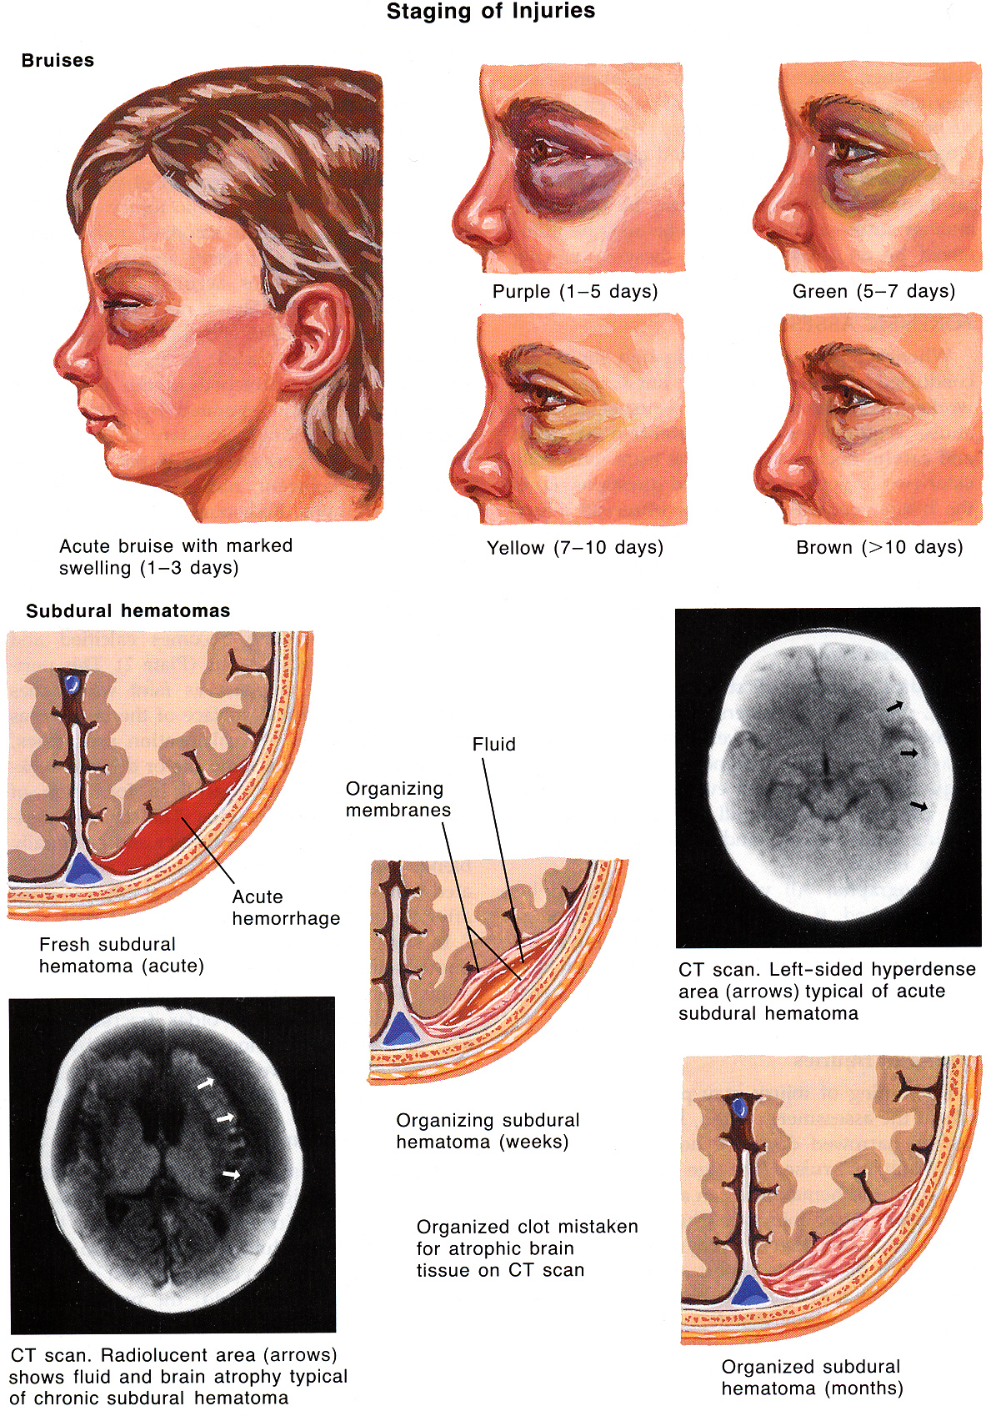
Source of picture: Frank H. Netter “Clinical Symposia”; Ciba Pharmaceutical Company; Saunders >>

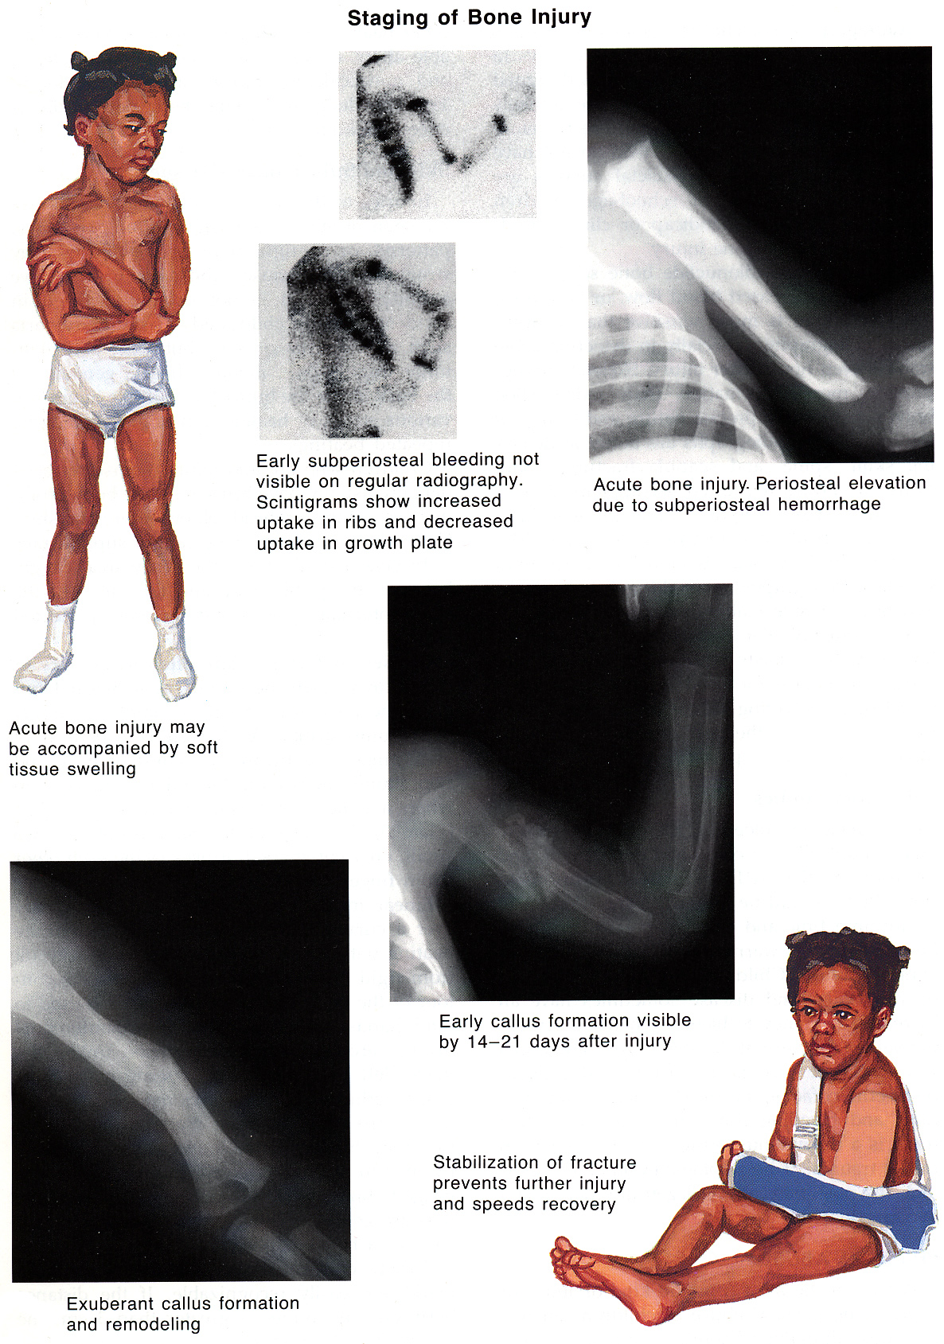
Source of picture: Frank H. Netter “Clinical Symposia”; Ciba Pharmaceutical Company; Saunders >>

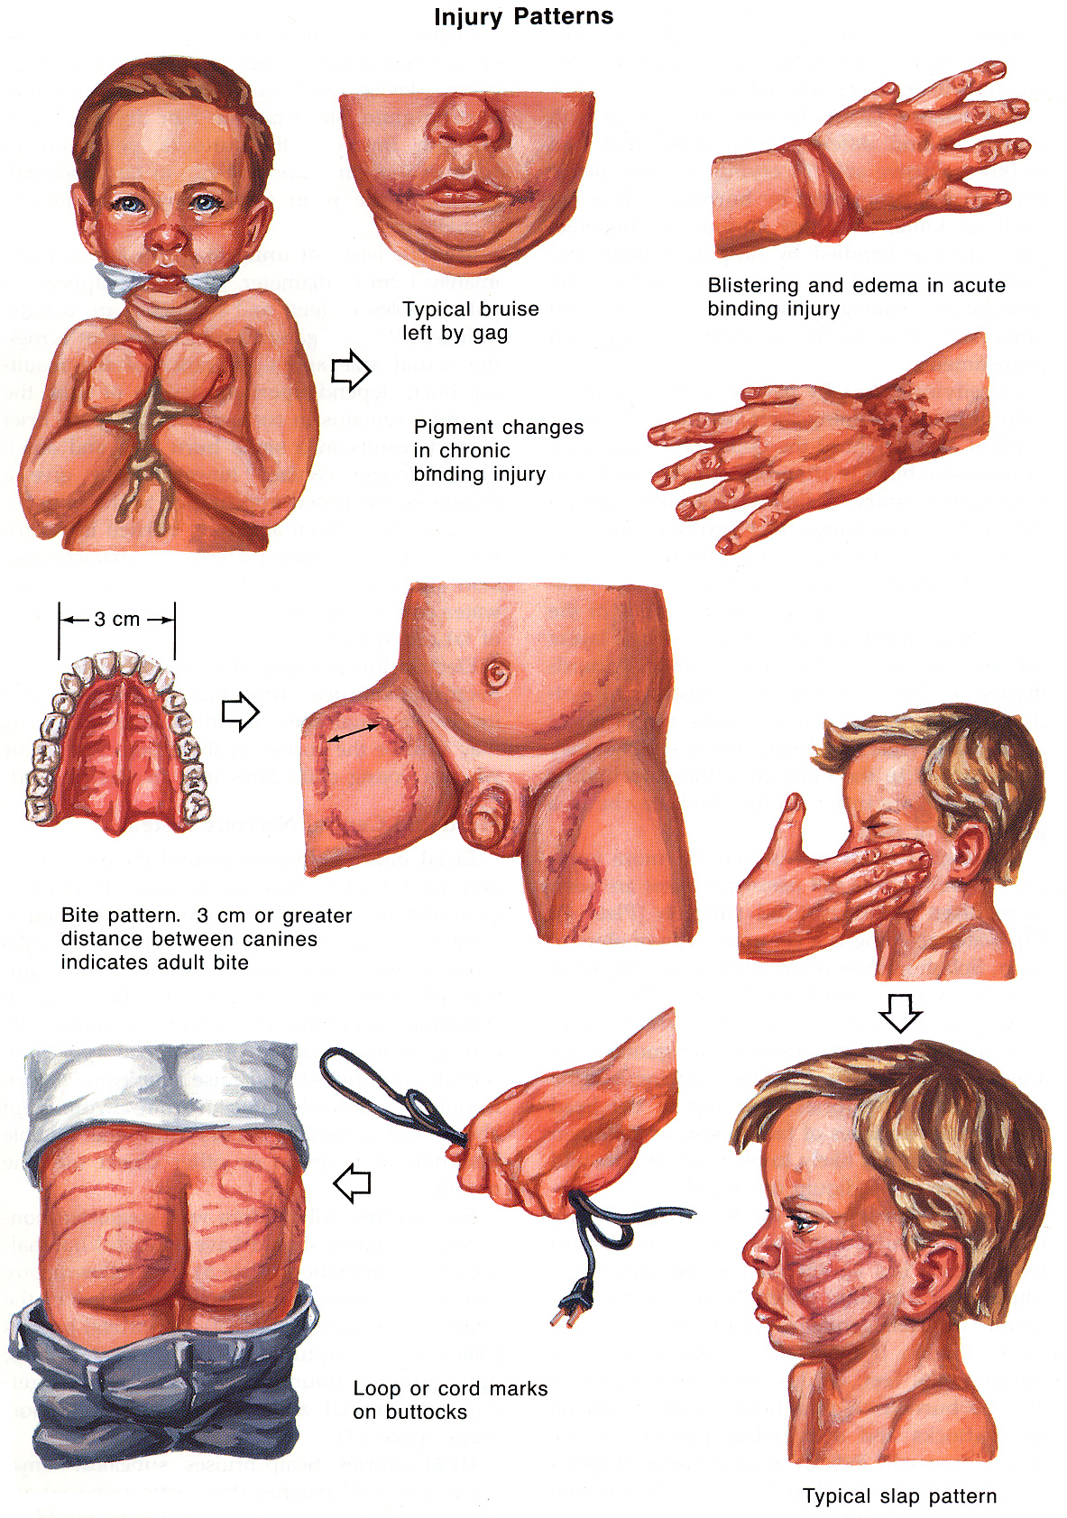
Source of picture: Frank H. Netter “Clinical Symposia”; Ciba Pharmaceutical Company; Saunders >>

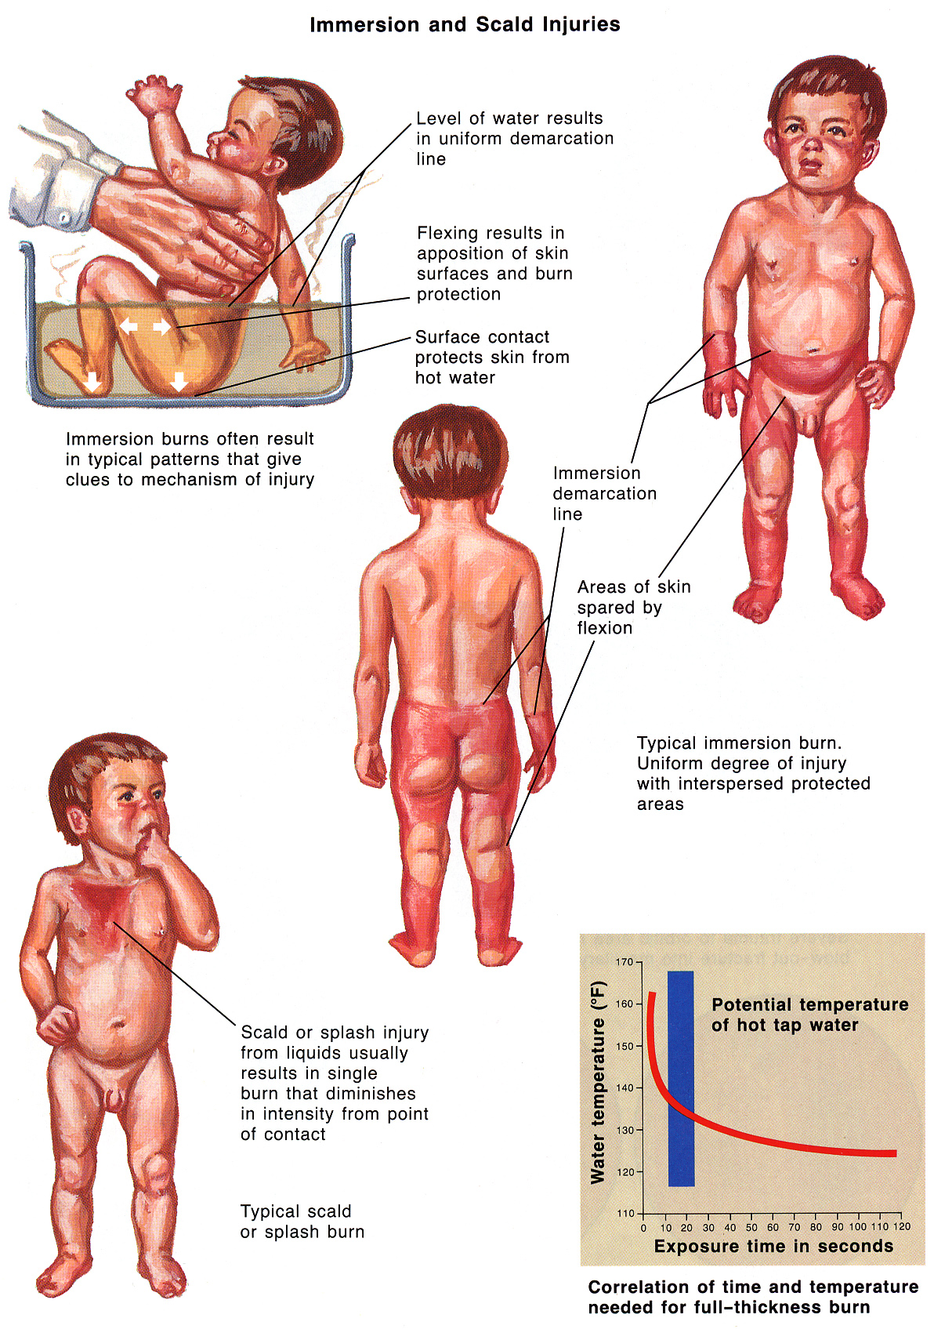
Source of picture: Frank H. Netter “Clinical Symposia”; Ciba Pharmaceutical Company; Saunders >>

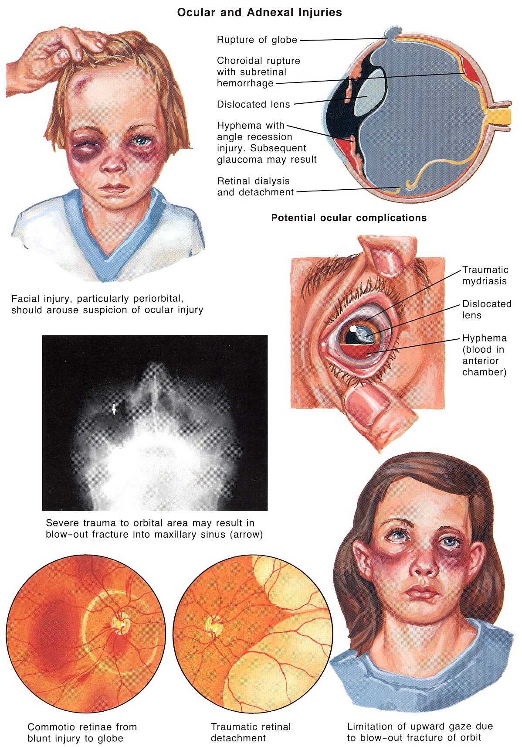
Source of picture: Frank H. Netter “Clinical Symposia”; Ciba Pharmaceutical Company; Saunders >>

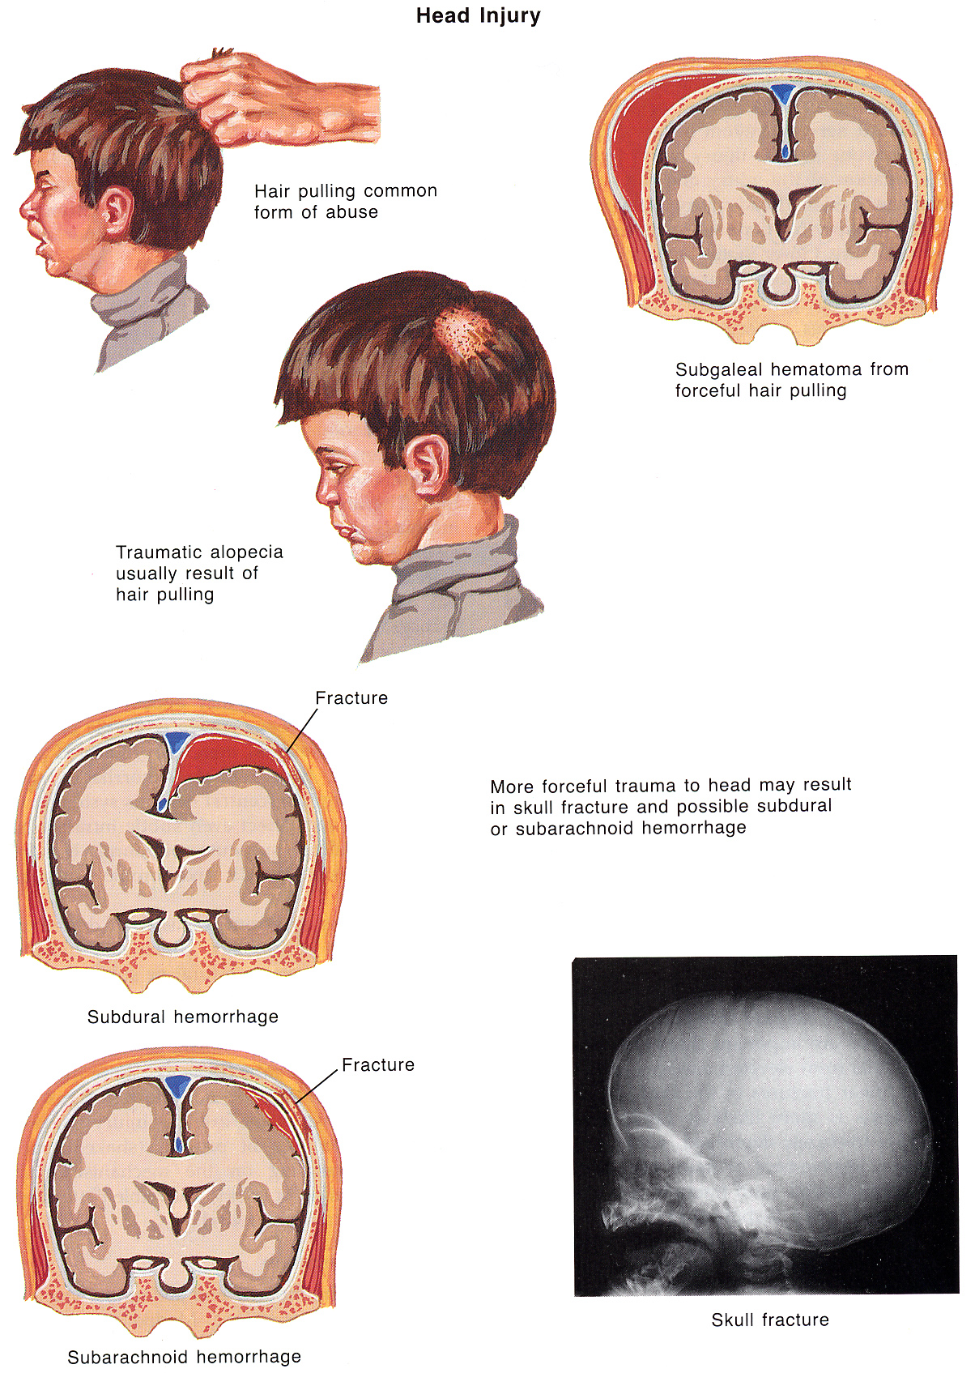
Source of picture: Frank H. Netter “Clinical Symposia”; Ciba Pharmaceutical Company; Saunders >>

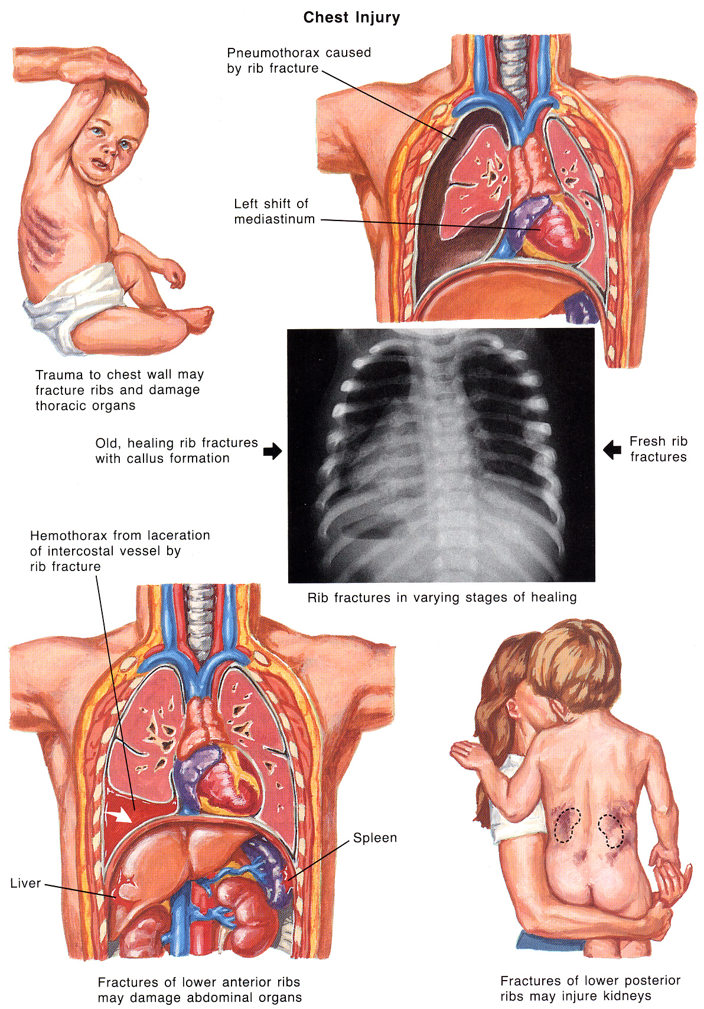
Source of picture: Frank H. Netter “Clinical Symposia”; Ciba Pharmaceutical Company; Saunders >>

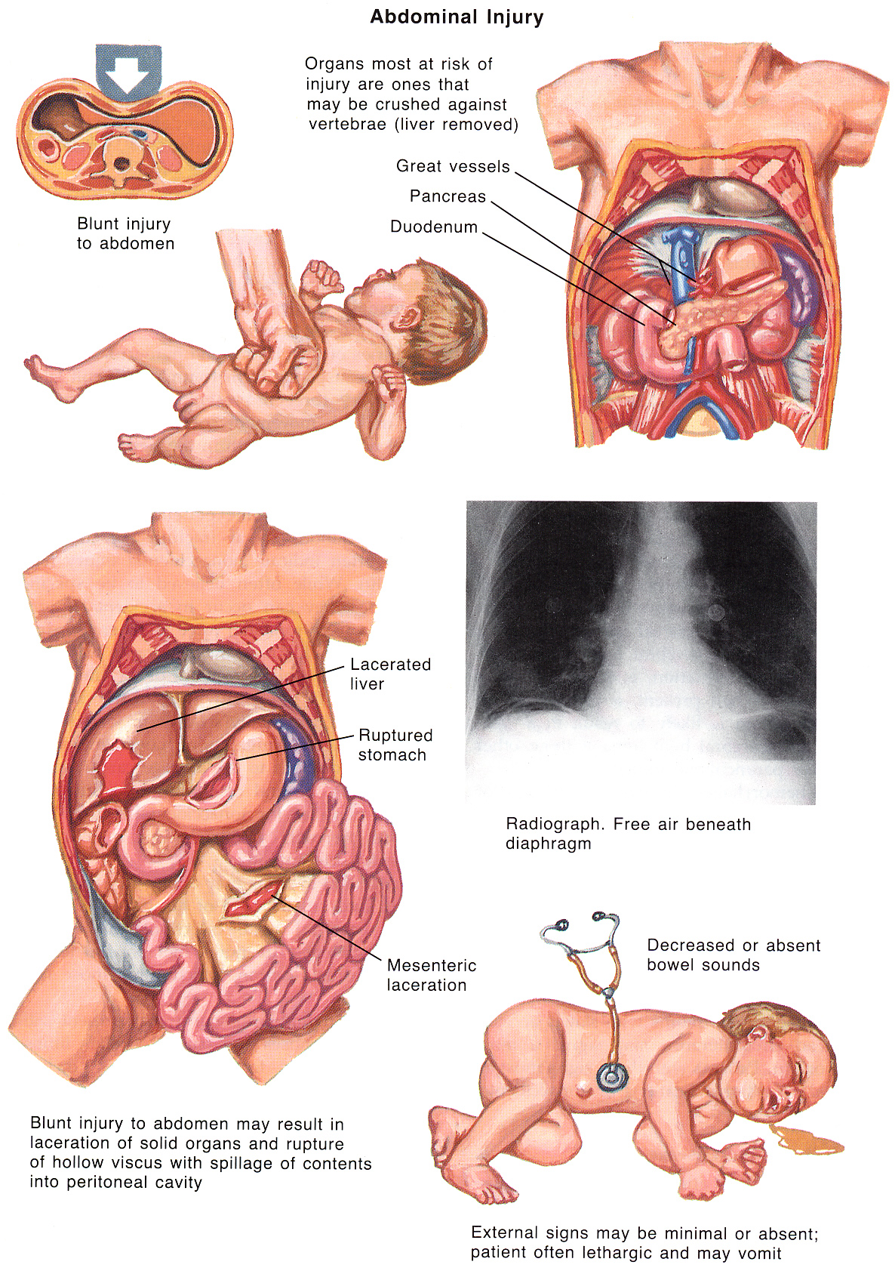
Source of picture: Frank H. Netter “Clinical Symposia”; Ciba Pharmaceutical Company; Saunders >>

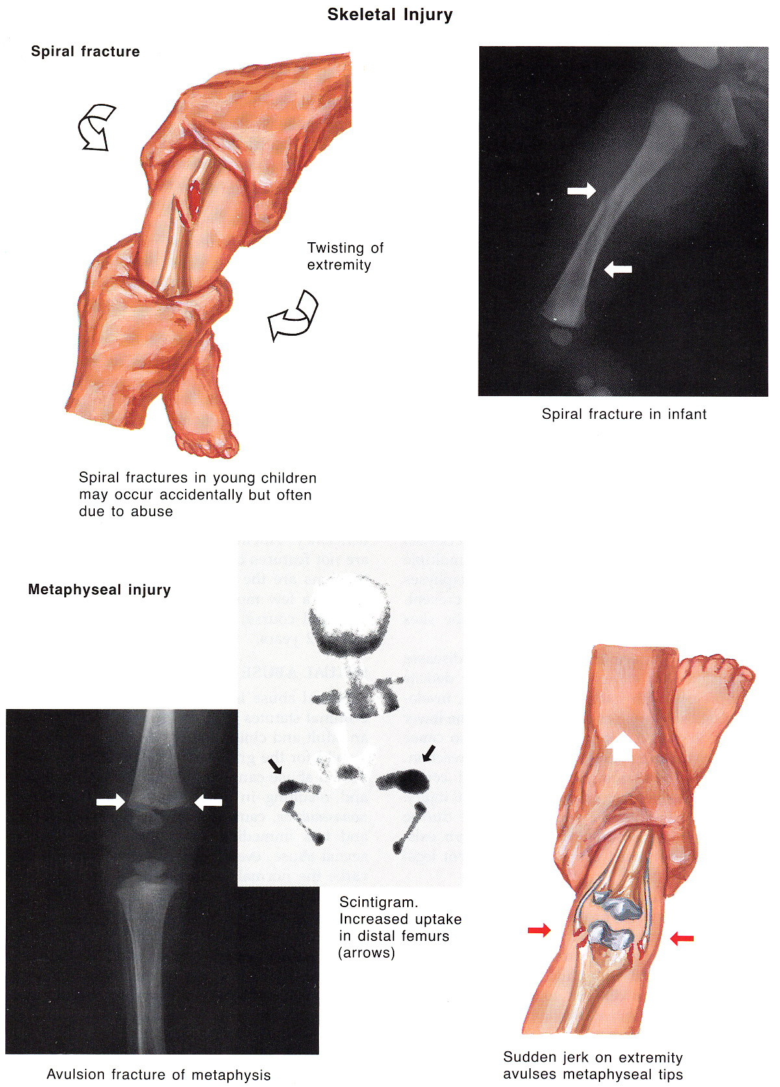
Source of picture: Frank H. Netter “Clinical Symposia”; Ciba Pharmaceutical Company; Saunders >>

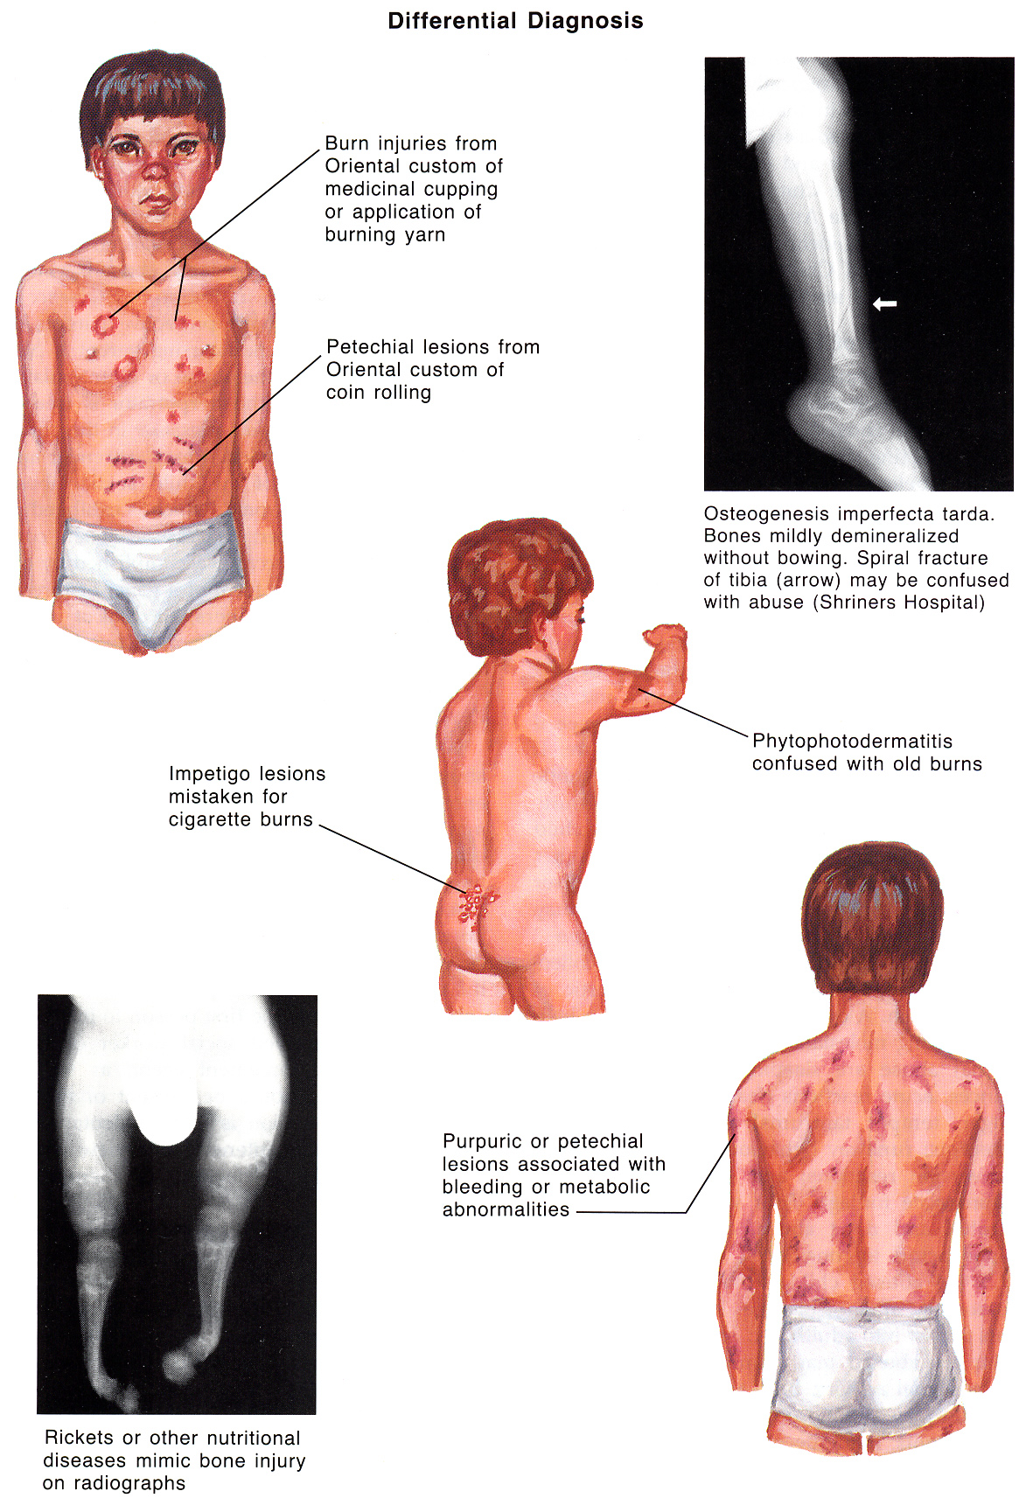
Source of picture: Frank H. Netter “Clinical Symposia”; Ciba Pharmaceutical Company; Saunders >>

Sexual Abuse
about rape, incest, molestation → see p. 2632 >>
- use of children in sexual activities (i.e. action with child that is done for sexual gratification of adult or significantly older child).
- because of children immaturity, they cannot understand or give informed consent.

Contact activities - sexualized kissing, fondling, masturbation, digital / object penetration of vagina / anus, oral-genital, genital-genital, anal-genital contact.
Noncontact activities - exhibitionism, inappropriate observation of child (e.g. while child is dressing, using toilet, bathing), production or viewing of pornography, involvement of children in prostitution.

Sexual abuse does not include sexual play, in which children close in age (typically < 4 yrs apart) view or touch each other's genital area without force or coercion.

- frequent absence of physical coercion (→ no physical signs left!)
- lifetime prevalence: 1 girl from 5, 1 boy from 10.
- in most cases abused children are victims of someone they know.
- risk of sexual abuse is increased in children who have several caregivers or caregiver with several sex partners.

Clinical Features
- frequently, nonspecific behavioral changes are presenting symptoms:
- abrupt or extreme changes in behavior
- sexualized behaviors
- phobias
- symptoms of depression, sleep disturbances
- poor school performance, truancy [angl. pamokų praleidinėjimas]
- aggressiveness or withdrawal (running away).

Physical signs of sexual abuse (but there is extensive list of differential diagnosis for each sign):
- Difficulty in walking / sitting
- Anogenital bruising / redness / bleeding / discharge
- Perioral injuries
- STD of any sort in child < 12 yr

Sequelae
No universal short-term or long-term impact of sexual abuse has been identified!
  - Psychological disorders: depression, eating disorders, anxiety disorders, substance abuse, somatization, posttraumatic stress disorder (PTSD), dissociative disorders, psychosexual dysfunction in adulthood, interpersonal problems (difficulties with issues of control, anger, shame, trust, dependency, and vulnerability).
  - Medical sequelae: functional GI disorders (e.g. irritable bowel syndrome, dyspepsia, chronic abdominal pain), gynecologic disorders (e.g. chronic pelvic pain, genital or anal tears), STDs, pregnancy.
- American Academy of Pediatrics (AAP) views nonvertically transmitted gonorrhea, syphilis, chlamydia, and HIV as diagnostic of sexual abuse in prepubertal child!;
T. vaginalis is highly suggestive of sexual abuse;
nonvertically transmitted condyloma acuminata and herpes with no clear history of autoinoculation also are suggestive of sexual abuse.

Evaluation
Interview - first speak alone with caregiver and then alone with child (most valuable component of medical evaluation!).
- first step in healing process for child who is sexually traumatized.
- rely on nonleading questions as much as possible.
yes-or-no questions (“Did daddy do this?” “Did he touch you here?”) can easily sculpt untrue history in young children!
- begin with nonthreatening topics such as favorite activities, school subjects, and personal interests.
- once rapport has been established, ask children why they have come to doctor's office.
- encourage children to use their own words for body parts.
- use drawings to help children describe where they may have been touched and with what they were touched.
- permit children to sit where they want to sit, slowing down pace of interview if it starts to go too fast, permitting time for play breaks.
- meticulous documentation! (may be considered as evidence in subsequent legal proceedings).
- consider videotaping or at least audiotaping interview (may be admissible evidence in some jurisdictions).
- after child interview concludes, caregiver is invited back in room to help facilitate transition to physical examination.

Physical examination see p. Exam11 >>
> 75% physical examinations are without definitive findings of sexual abuse!:
      - physical force often is not major component (vs. in adult sexual assaults).
      - presentation is frequently delayed.
      - genital mucous membranes heal rapidly, often without obvious scarring.
- after appropriate discussion, leave room and allow child to prepare for examination by suitable disrobing and putting on gown with caregiver's assistance.
- size of hymenal orifice is variable, depending on state of relaxation of child, position of child, and examiner technique (measurement of hymenal orifice has limited utility in evaluation).
- proper attention to modesty is necessary; use quiet room with adequate privacy; use gowns and drapes as appropriate.
- internal examinations and instruments are almost never necessary in prepubertal cases (otherwise, arrange examination under anesthesia).

If suspected abuse occurred recently (within 72 hours):
- examination with magnifying light source with camera (such as specially equipped colposcope).
- collect forensic evidence via rape kit; cultures for STDs are not part of rape kit and should be handled separately.
- place clothing in paper bag (not in plastic - may seal in moisture and lead to evidence degradation).
- hair samples and swabs of body fluids are obtained for legal evidence.

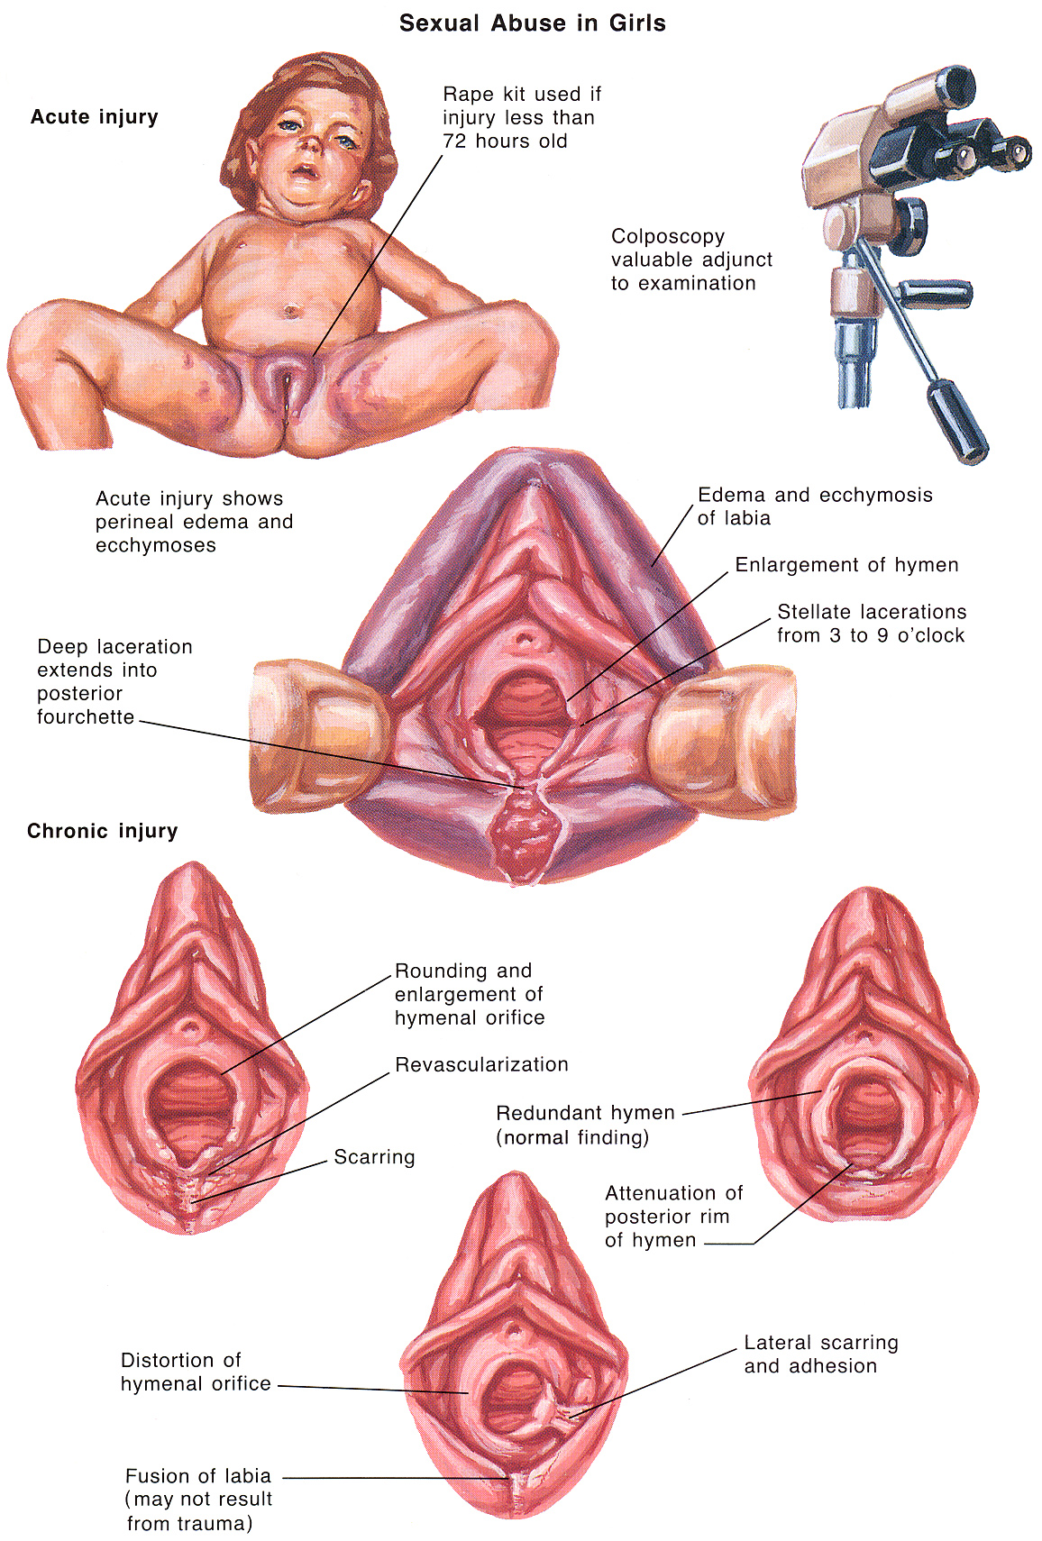
Source of picture: Frank H. Netter “Clinical Symposia”; Ciba Pharmaceutical Company; Saunders >>

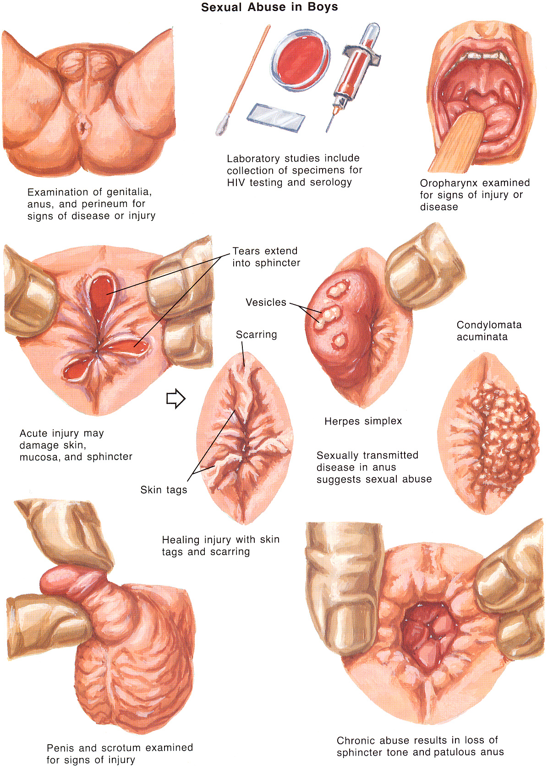
Source of picture: Frank H. Netter “Clinical Symposia”; Ciba Pharmaceutical Company; Saunders >>

Management
Health care providers are mandated reporters (to appropriate CPS agency) in all 50 states!
Emotional support for psychosocial crisis in which child and family now find themselves; mental health consultation for acute stress reaction and, later, PTSD (psychic trauma in young children has significant effect!).
STD prophylaxis – not indicated for asymptomatic prepubertal children (risk for STD is low); for teenagers – as for adults. see p. 2632 >>

Emotional (Psychological) Abuse
- infliction of emotional harm through use of words or actions:
    - berating [angl. keikimas] - by yelling or screaming.
    - spurning [angl. atstūmimas] - by belittling [angl. sumenkinimas] child's abilities and achievements.
    - intimidating and terrorizing with threats.
    - exploiting or corrupting by encouraging deviant or criminal behavior.
    - emotional neglect. see below

Clinical Features
- may lead to growth, behavioral, and developmental impairments (often misdiagnosed as mental retardation or physical illness):
- blunt emotional expressiveness and decrease interest in environment
- failure to thrive
- emotional effect usually becomes obvious at school age.
- children may be insecure, anxious, distrustful, superficial in interpersonal relationships, passive, and overly concerned with pleasing adults.

Neglect
- failure to provide for or meet child's basic physical, emotional, educational, and medical needs.
Neglect differs from abuse in that it usually occurs without intent to harm.
        - Emotional neglect - failure to provide affection or love or other kinds of emotional support, i.e. emotional deprivation when words or actions are omitted or withheld (e.g. ignoring or rejecting child or isolating him from interaction with other children or adults).
        - Physical neglect - failure to provide adequate food, clothing, shelter, supervision, and protection from potential harm.
        - Educational neglect - failure to enroll child in school, ensure attendance at school, or provide home schooling.
        - Medical neglect - failure to ensure appropriate preventive care (such as vaccines) or needed treatment for injuries / disorders.

Etiology
- often occurs in impoverished families in which parents also have mental disorders (typically depression or schizophrenia), drug (esp. cocaine-using mothers) or alcohol abuse, or limited intellectual capacity.
- desertion by father who is unable / unwilling to assert controlling influence in family may precipitate neglect.

Clinical Features
- malnutrition, fatigue, lack of hygiene or appropriate clothing, failure to thrive (up to stunted growth and death from starvation or exposure).

Failure to Thrive
- child fails to gain or maintain weight at age-appropriate norms (3rd percentile for age group is considered threshold).

Clinical Features
- failure to grow in height sometimes accompanies this; failure of head circumference growth occurs only in very severe long-standing cases.
- characteristic emotional - behavioral constellation (reactive attachment disorder of infancy or early childhood) - disturbed and developmentally inappropriate social relatedness: social unresponsiveness, withdrawal and inhibition, excessive interpersonal familiarity and lack of appropriate social boundaries.

Etiology
- inadequate nutrition:
Nonorganic (environmental / psychosocial) failure to thrive (related to aberrant caregiving, i.e. psychosocial causality; responds to provision of adequate nutritional and emotional needs of patient).
Early infancy (< 8-9 months) - child is inactive and relies on parental feeding - failure to thrive indicates “poor parenting” (e.g. lack of synchrony between hunger in parent and child; parent may misinterpret certain cues from infant and miss other cues altogether; general lack of money to provide food).
Late infancy - failure to thrive may be secondary to anaclitic depression, poor parenting, or childhood psychosis.
Toddler stage - negativism associated with "terrible twos" can also apply to eating (children refuse to eat in service of autonomy).
- premature infants who have intensive care needs at home are at greater risk for neglect / abuse.

Organic failure to thrive (e.g. juvenile-onset diabetes mellitus, malabsorption syndromes, inborn error of metabolism, formula intolerance or allergy, congenital heart defect, etc).

Most significant pitfall - focus on simply medical differential diagnosis and disregard of complex psychosocial factors that can affect pediatric growth!

Evaluation
- To detect organic cause and / or signs of abuse.
- Growth chart - age plotted against weight, height, and head size.
- Nutritional evaluation and diet history;
  - dietary details
  - caregivers' knowledge
  - observed feeding behaviors
  - elimination pattern
- Psychosocial evaluation of family and child in context of family (e.g. disturbance in bonding / attachment may be obvious); in-home assessment is important!

Treatment
- underlying medical disorders must be treated.
- first try outpatient high-calorie diet with close supervision.
          - diet must be individualized according to age and nutritional status; adequate calories for catch-up growth (150-200% of normal caloric requirement); severe cases of malnutrition (esp. with neurodevelopmental delay) → gastrostomy feeding tube.
- consult early:
- nutritionist
- behavioral-developmental pediatrician
- oromotor skill therapists (to assess oromotor feeding skills).
- social workers
- psychologists, psychiatrists
- parent-child interactions should be evaluated carefully.
  - parent education!!! (teach parents to recognize and respond to cues of child).
  - provide home visitation services.
  - when parental neglect is present, child protective agencies must be involved.
  - it may be necessary to hospitalize child to determine whether he can gain weight in new environment; placement in foster home may be needed as last step.

N.B. simply increasing patient's energy intake may not cause growth to occur if underlying comorbid psychosocial pathology is not addressed as well!!!

Female Genital Mutilation
- deeply ingrained as part of some cultures in northern or central Africa: women who experience sexual pleasure are considered impossible to control, are shunned, and cannot be married.
- average age of girls who undergo mutilation is 7 yrs.
- mutilation is done without anesthesia.
- types:
    - partial clitoral excision.
    - infibulation - removal of clitoris and labia, followed by suturing of remaining tissue closed except for 1- to 2-cm opening for menses and urine; legs are bound together for weeks afterward; infibulated females are cut open on their wedding night.
- sequelae – bleeding, infection (including tetanus, recurrent UTI or gynecologic infection), scarring, severe psychologic sequelae.
- incidence decreasing (influence of religious leaders who have spoken out against practice and growing opposition in some communities).

Bibliography for ch. “Pediatrics” → follow this link >>

Viktor’s Notes℠ for the Neurosurgery Resident
Please visit website at www.NeurosurgeryResident.net

