Sturge-Weber syndrome

(Encephalotrigeminal Angiomatosis)
Last updated: April 17, 2019
Pathophysiology 1
Etiology 1
Epidemiology 1
Pathology, Clinical Features 1
Roach Scale classification 2
Diagnosis 2
Treatment 3

Sturge-Weber syndrome - congenital sporadic phacomatosis with capillary venous angiomas in leptomeninges, skin of face, eye.

Pathophysiology
- residual embryonal blood vessels with secondary effects on surrounding brain tissue.
    - normally, in 6th week vascular plexus develops around cephalic portion of neural tube, under ectoderm destined to become facial skin; vascular plexus regresses around 9th week of gestation.
    - failure of normal regression → angiomata.
    - neurologic dysfunction results from secondary effects:
      - "vascular steal" around angioma → hypoxia, ischemia
      - venous occlusion, thrombosis, infarction.
    - secondary effects are aggravated by recurrent seizures (even when short) → progressive dystrophic calcification*, gliosis, atrophy → neurologic deterioration, seizures↑.
Although leptomeningeal angioma is static anatomic lesion, syndrome has progressive nature!
*N.B. calcifications are located primarily in cerebral substance rather than in vessel walls

Etiology
- no recognizable genetic contribution; somatic mutations affecting:
        - structure blood vessels (vessel circumference decreased, while vessel density increased)
        - innervation of blood vessels (malformed vessels innervated only by noradrenergic sympathetic fibers)
        - expression of extracellular matrix (fibronectin↓) and vasoactive molecules (endothelin-1 expression↑ in malformed vessels).

Epidemiology
incidence - 1 per 50,000

Pathology, Clinical Features
All lesions (if unilateral) tend to be ipsilateral!

No increased propensity for cancer!!!

- Leptomeningeal angiomas
  - unilateral (85%) > bilateral (15%).
  - most common in parietal and occipital regions.
  - ipsilateral features - cerebral hemiatrophy, hemihypertrophy of skull and sinuses, enlarged choroid plexus, abnormal myelination.
  - cortical veins are either absent or replaced by few enlarged cortical veins.
  - neurologic manifestations:
- seizures (72-93%) - typically focal; may be intractable; 75% before age of 1 year, 95% begin before 5 years.
- focal deficits (esp. hemiparesis [25-56%], homonymous hemianopsia [44%]) - may be transient ("strokelike episodes"), but otherwise slowly progressive.
- vascular headaches ("symptomatic migraine") (44-77%)
- developmental disorders (50-75%) (developmental delay, learning disorders, mental retardation) - more common when angiomas are bilateral.
N.B. major intracranial hemorrhage is rare!

- Cutaneous angioma (“port-wine stain” s. nevus flammeus) (87%) in skin of face.
N.B. most patients with facial port-wine stains do not have SWS!
N.B. presence of port-wine stain implies neither presence nor severity of intracranial leptomeningeal angiomatosis (only 8% of facial port-wine stains have this association)
  - typically in V₁ and V₂ distributions of CN5.
CNS is not affected if port-wine stain does not involve V₁ area!
  - unilateral (49-86%; ipsilateral to CNS lesion) > bilateral (14-51%).
  - presents at birth – suspicion of diagnosis in neonate!
  - can be progressive (light pink macule → dark red or purple nodular lesion).

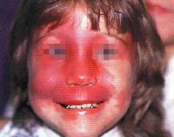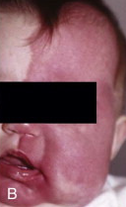
Source of picture: H. Richard Winn “Youmans Neurological Surgery”, 6th ed. (2011); Saunders; ISBN-13: 978-1416053163 >>

- Glaucoma (30-71%) → buphthalmos (hydrophthalmia) → blindness.
N.B. glaucoma typically occurs only when port-wine stain involves eyelids!;
if port-wine stain is unilateral, glaucoma is ipsilateral!
  - causes: mechanical angle obstruction, episcleral venous pressure↑, secretion↑ of aqueous fluid (by choroidal hemangioma or ciliary body).
  - may be present at birth but can develop at any age.

- Eye hemangiomas – choroidal (40%), conjunctival, episcleral.

Roach Scale classification
Type I - both facial and leptomeningeal angiomas; may have glaucoma.
Type II - facial angioma alone (no CNS involvement); may have glaucoma.
Type III - isolated leptomeningeal angiomas; usually no glaucoma.

Diagnosis
Structural versus functional mismatch (functional neuroimaging demonstrates greater area of involvement than structural neuroimaging) - especially important when considering epilepsy surgery!

Skull x-ray – pathognomonic subcortical “tram-track” calcifications in gyriform pattern (late finding – usually in patients > 2 yrs) - paired parallel lines that follow cerebral convolutions.
N.B. calcification in ipsilateral* outer cortex rather than of blood vessels or white matter!
*ipsilateral to port wine stain
- underlying ipsilateral cerebral atrophy → ipsilateral skull-table and orbital thickening, elevation of sphenoid wing and petrous ridge, enlarged ipsilateral paranasal sinuses and mastoid air cells.

“Tram-track” calcifications:
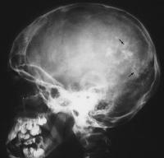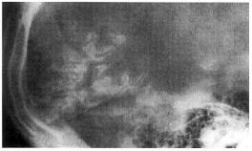

Smaller hemicranium on affected side:
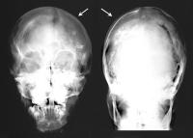

Angiography – does not show angioma! (or early capillary blush)
- lack of superficial cortical veins → nonfilling of dural sinuses (with absence of cortical veins, venous drainage occurs via enlarged tortuous transcortical veins into deep venous system).

CT:
- “tram-track” calcifications under angioma (in infants and even neonates)
- adjacent cortical atrophy.
Shrunken cerebral lobe with calcified cortex
- enlarged ipsilateral choroid plexus & enlarged draining transcortical draining veins.
- BBB breakdown (during seizures).

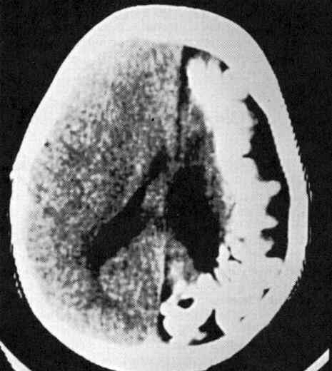

CT - left hemiatrophy of cerebral cortex and typical gyral calcification:
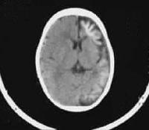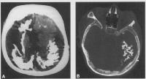

MRI:
- T2 - hyperintense leptomeningeal thickening and enhancement.
- gadolinium enhancement of angioma (appears as enhancement of subarachnoid space, medium covering cortical gyri and filling sulci) – early diagnosis!
N.B. enhancement is difficult to assess on CT in presence of calcification!
- adjacent cortical atrophy, accelerated / delayed myelination around angioma.
- enlarged ipsilateral choroid plexus (size correlates with angioma extent) & enlarged draining transcortical draining veins.
- progressive sinovenous occlusion → lack of superficial cortical veins (on MRV).

Contrast T1-MRI - right cerebral atrophy, enhancing right occipital cortex, enlarged right choroid plexus:  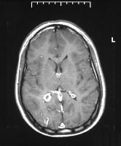 | Contrast T1-MRI - intense pial enhancement and subjacent cerebral atrophy:  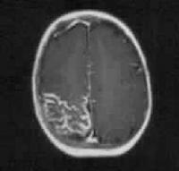
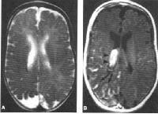

SPECT: hyperperfusion (in infancy, before first seizures) → classic hypoperfusion of involved hemisphere (after 1 year of age, even in those without epilepsy).
- steal phenomenon (during seizures).

PET – hypometabolism.

EEG – marked voltage attenuation in region of angioma; background suppression (74%); polymorphic delta activity; epileptiform discharges in remainder of cortex (22%).

Biopsy – typically not performed.

Treatment
    - Seizure control improves neurologic outcome!
N.B. epilepsy surgery should not be delayed (ideally – during infancy)!
controversy regarding optimal timing of surgery: early surgery might preempt cognitive deficits from chronic, intractable epilepsy vs. early surgery might subject some patients to surgery risks.
      - complete seizure control is achieved in 10-50% patients; refractory seizures occur in 11-83%.
      - epileptogenic region is located in cortex adjacent to angioma.
      - localize area of seizure onset preoperatively by video EEG, ECOG, functional neuroimaging (e.g. ischemic regions may act as epileptogenic foci that may not be detected by CT / MRI).
        - Focal cortical resection – when epileptogenic region is smaller and more localized.
        - Hemispherectomy (anatomical hemispherectomy or functional hemispherectomy or hemidecortication) – for extensive, unilateral epileptogenic region; hemispherectomy is more successful if done during infancy!
        - Corpus callosotomy – for bilateral disease (intractable atonic or tonic seizures leading to secondary injury).
        - Vagus nerve stimulation (VNS) – for those who are not candidates for other surgical procedures.

    - Prophylactic daily low-dose aspirin - for headaches, stroke-like events (may be result of progressive venous thrombosis).
N.B. varicella and yearly influenza immunizations (varicella / influenza + aspirin → Reye syndrome)
    - Cosmetic laser therapy ASAP for port-wine stain (earlier treatment - fewer laser flashes needed to remove lesion).
    - IOP control

Bibliography for ch. “Phakomatoses” → follow this link >>

Viktor’s Notes℠ for the Neurosurgery Resident
Please visit website at www.NeurosurgeryResident.net

