Substance-related Disorders
Last updated: April 24, 2019
Substance use disorders 1
Substance dependence 2
Substance abuse 3
Substance-induced disorders 3
Complications of Substance Use 3
Diagnosis 5
Principles of Treatment 5
Specific Substances 6
Opioids 6
Intoxication 6
Diagnosis 6
Treatment 6
Withdrawal 7
Treatment 7
Complications 7
Treatment of dependence 9
Detoxification (controlled withdrawal) 9
Maintenance with continued opioid use 9
Maintenance of abstinence 9
Pregnancy 10
Nicotine 10
Withdrawal features 10
Complications 10
Smoking Cessation 10
Other Kinds of Tobacco 11
Amphetamines 11
Withdrawal 12
Treatment 12
Complications 12
Cocaine 12
Withdrawal 12
Treatment 12
Cannabis (Marijuana, Hashish, Ganja, Bhang) 12
Sedatives, Hypnotics, Anxiolytics 13
Intoxication 13
Treatment 13
Withdrawal 13
Treatment 13
Hallucinogens (Psychotomimetics, Psychedelics) 14
Intoxication 14
Treatment 14
Withdrawal 14
Ketamine (“K”, Special K) 14
Intoxication 14
Gamma Hydroxybutyrate (GHB, “G”) 15
Intoxication 15
Inhalants 15
Volatile Solvents 15
Intoxication 15
Withdrawal 15
Volatile Nitrites 15
Methylxanthines 15
Intoxication 15
Withdrawal 16
Alcohol → see p. Psy21 >>
Anticholinergics → see p. A35 >>

Substance-related Disorders - disorders related to use of psychoactive substances.

DSM-IV categorizes 13 types of substances:
- Alcohol*
- Amphetamines
- Caffeine
- Cannabis*
- Cocaine
- Hallucinogens, Phencyclidine
- Inhalants
- Nicotine*
- Opioids
- Sedatives, hypnotics, anxiolytics
- Polysubstance
- Other (e.g. digitalis, amyl nitrite)
*most commonly used substances (regardless of economic or ethnic background).
  - all of these substances are associated with dependence and abuse, except – are not abused:
caffeine – produces only physical dependence;
nicotine – produces only dependence.
  - legal status of substance (licit vs. illicit) has little to do with potential harmfulness.

Controlled substances are divided into 5 schedules:
Schedule I substances - high potential for abuse, no accredited medical use, and lack of accepted safety; drugs can be used only under government-approved research conditions.
Schedule II-IV substances - prescriptions must bear physician's federal Drug Enforcement Administration (DEA) license number.
Schedule V substances - least likely to be abused; some drugs do not require prescription.

Substance use disorders
- pathologic use of substance: Physiology of dependence → see p. A139 >>
- Substance abuse
- Substance dependence

Lifetime prevalence - 13% for alcohol, 6% for other substances.
  - initiation of use (alcohol and cigarettes) increases for younger teens.
  - males > females (except amphetamines, barbiturates, tranquilizers - females use as much as or slightly more than men).
  - tobacco use predicts abuse of other substances.
In general, "soft" drugs (like marijuana) seem to break down psychological barrier to using "hard" drugs!

Stages of substance use: use → abuse → dependence
Stages | Description
Stage 1:  Experimentation | Usually starts with peer pressure.  Few if any behavioral changes.  User struggles between euphoria achieved and associated guilt.
Stage 2:  To relieve stress | Use is more than occasional and in nonsocial situations.  Supply of substance is maintained, peer group develops around substance abuse.  Mood swings, decline in school performance.
Stage 3:  Regular abuse | Becomes involved with drug-oriented culture (most, if not all, peers use drugs).  Chronic behavioral problems (may include problems with law).  Depression when not using drugs.  Must raise money to support habit.
Stage 4:  Dependence | Drug is used to prevent depression.  May drop out of school and become involved in destructive family dynamics.  Physical changes (weight loss, fatigue, blackouts, chronic cough).

  - 60-90% adolescents experiment to some extent with drugs.

Substance dependence
DSM-IV-TR criteria for substance dependence:
Maladaptive pattern of substance use leading to clinically significant impairment or distress, as manifested by ≥ 3 of following (occurring together at any time in same year):
- Tolerance - defined as:
- requirement for increased amounts of substance to achieve same effect, or
- decreased effect with continued use of same amount of substance.
- Withdrawal (abstinence) - defined as:
- typical withdrawal syndrome for substance (refer to Criteria A and B of criteria sets for Withdrawal from specific substances), or
- substance (or closely related compound) is taken to relieve or avoid withdrawal symptoms.
- Substance is taken in greater amounts or for longer time than was originally intended.
- Unsuccessful attempts or wishes to cut down on or control substance use.
- Significant amounts of time spent in activities necessary to obtain (e.g. visiting multiple doctors or driving long distances) or use (e.g. chain-smoking) substance or recover from its effects.
- Giving up important social, occupational, or recreational activities because of substance use.
- Continued use of substance despite knowledge that it is causing or aggravating physical or mental problems.
e.g. cocaine use despite recognition of cocaine-induced depression; continued drinking despite recognition that ulcer was made worse by alcohol consumption.

Physiologic (s. Physical) Dependence - presence of either tolerance or withdrawal.
  - drugs that cause strong physical dependence: heroin, alcohol, cocaine (?).

Psychic Dependence (s. Addiction) - overwhelming involvement with seeking (craving) and using substance and high tendency toward relapse after substance withdrawal (i.e. quantitative description of degree to which substance use pervades individual's life).
  - addiction may develop to any substance (even to placebo!!!).
  - drugs that cause chiefly psychologic dependence: marijuana (? physiologic dependence may also occur), amphetamine, hallucinogens.
  - drugs that cause psychologic dependence have following effects:
    - reduced anxiety and tension
    - elation, euphoria, or other mood changes pleasurable to user
    - feelings of increased mental and physical ability
    - altered sensory perception
    - changes in behavior.

Psychic and physical dependence can coexist or occur alone!
- individual may develop tolerance and undergo withdrawal without being addicted; that is, individual's life is not organized around finding and using drug.
e.g. patients physically dependent on narcotics, tranquilizers, or sedatives during treatment of prolonged illness or insomnia but who do not experience intrusion of drug use into many aspects of their lives.
- it may be possible to be addicted without being physically dependent.

Potential for dependence:
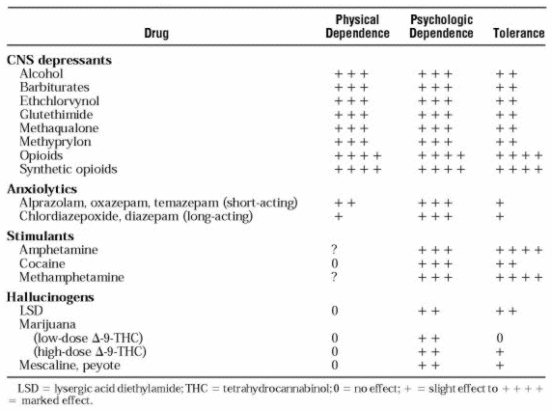

Relative potential for dependence:

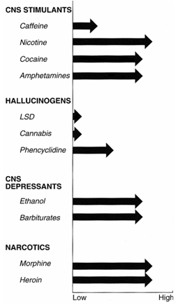

Substance abuse
- fewer and different consequences than substance dependence.

DSM-IV-TR criteria for substance abuse:
Maladaptive pattern of substance use if one of following four problems has occurred over 12-month period, and if patient does not meet criteria for substance dependence:
- Failure to fulfill major role obligations.
- Recurrent use of substance in situations in which it is hazardous (e.g. while driving).
- Recurrent legal problems resulting from substance use.
- Continued use of substance despite social or interpersonal problems caused by substance.
e.g. arguments with spouse about substance use, getting into fights when drunk.

N.B. drug abuse is definable only in terms of societal disapproval!
- some label all illegal substance use in underaged adolescents as misuse (chronic abuse causes arrest of psychosocial development).

Recreational drug use has increasingly become part of Western culture, although in general, it is not sanctioned by society.
- some users apparently are unharmed - use drugs episodically in relatively small doses, precluding clinical toxicity and development of tolerance and physical dependence.
- many recreational drugs (e.g. crude opium, alcohol, marijuana, caffeine, hallucinogenic mushrooms, coca leaf) are “natural” (i.e. close to plant origin); they contain mixture of relatively low concentrations of psychoactive compounds and are not isolated psychoactive chemicals.
- recreational drugs are most often taken orally or inhaled.
- recreational use is often accompanied by ritualization, with set of observed rules, and is seldom practiced alone.
- most recreational drugs are psychostimulants or hallucinogens designed to induce “high” or altered consciousness rather than to relieve mental distress.

Substance-induced disorders
- physical and mental syndromes caused by intoxication or withdrawal:

  - Substance intoxication - reversible, substance-specific syndrome related to recent ingestion of substance.

  - Substance withdrawal - substance-specific, physiologically determined syndromes that appear after:
- abrupt withdrawal
- decrease in dosage.
- syndrome causes significant distress or functional impairment.
- syndrome may be mild ÷ life-threatening.
- blood levels are often zero in abstinence syndromes.

  - Substance-induced delirium; only nicotine does not cause delirium.

  - Substance-withdrawal delirium - caused by withdrawal of alcohol, sedative-hypnotics, anxiolytics.

  - Substance-induced persisting dementia - caused by intoxication or withdrawal; dementia persists after intoxication or withdrawal has cleared.

  - Substance-induced, persisting amnestic disorder - impairment of recall of previously learned material or of ability to learn new information with use of alcohol, sedative-hypnotics, anxiolytics; memory disorder persists after intoxication or withdrawal has resolved.

  - Substance-induced psychotic disorder - hallucinations or delusions caused by alcohol, amphetamines, cannabis, cocaine, hallucinogens, inhalants, opioids, phencyclidine, sedatives; according to DSM-IV, this diagnosis cannot be based on hallucinations if patient realizes that they are caused by substance.

  - Substance-induced mood disorder - depressed or manic mood that develops within 1 month of using alcohol, amphetamines, cocaine, hallucinogens, inhalants, opioids, phencyclidine, sedatives, anxiolytics.

  - Substance-induced anxiety disorder - generalized anxiety, panic attacks, obsessions, or compulsions that develop within 1 month of substance use or withdrawal.

  - Substance-induced sexual dysfunction - develops within 1 month of substance intoxication; alcohol, amphetamines, cocaine, opioids, medications (e.g. reserpine, SSRI, MAOI).

  - Substance-induced sleep disorder - develops within 1 month of substance use or withdrawal; alcohol, amphetamines, caffeine, cocaine, opioids, sedatives, anxiolytics, hypnotics.

Complications of Substance Use
- result from:
- specific drug actions (e.g. fatal overdose due to fluctuations in purity of available compounds).
- contaminants of illicit preparations (e.g. anaphylactic reactions, hypersensitivity reactions → granulomata in lungs).
- unsanitary parenteral drug administration (e.g. infections).
- patient's lifestyle or intoxicated behavior (e.g. STD, homicides, suicides, smoking-related fires).

Trauma - may be consequence of drug's acute effects (e.g. automobile and other accidents during marijuana intoxication; violence in psychostimulant users; self-mutilation during hallucinogen psychosis).
- trauma among users of illicit drugs is most often result of illegal activities necessary to distribute and procure them.
- suicide and death are more common than in general population

Infection
- parenteral users of any drug are subject to array of infections (hepatitis, cellulitis, pyogenic myositis, endocarditis, tetanus, botulism [at injection sites or, among cocaine users, in nasal sinuses], malaria [heroin users from endemic areas], HIV) → multiple parenchymal and subcutaneous abscesses, mycotic aneurysms.
  - lumbar vertebral osteomyelitis is most common musculoskeletal complication.
  - repeated antigenic stimulation from infections or from daily parenteral injection of foreign substances → hypergammaglobulinemia (e.g. present in 90% heroin addicts).
- substance use increases promiscuity → STD (esp. female drug abusers engaging in prostitution to obtain narcotic).
- heroin and cocaine are themselves immunosuppressants (heroin users were subject to unusual fungal infections before AIDS epidemic).

Seizures
- feature of withdrawal from sedatives.
- feature of intoxication with methaqualone and glutethimide.
- opioids lower seizure threshold.
- seizures can occur in repeated cocaine users without overdose (due to "kindling"); amphetamine and other psychostimulants are less epileptogenic than cocaine, but seizures have occurred with OTC anorectic phenylpropanolamine.
- marijuana is protective for development of new-onset seizures.

Stroke
- ethanol and tobacco abuse increase risk for ischemic and hemorrhagic stroke.
- parenteral drug use → stroke through systemic complications (hepatitis, endocarditis, AIDS) or embolism of foreign particulate material.
- heroin → nephropathy → hypertension, uremia, bleeding.
- amphetamine → acute hypertension → intracerebral hemorrhage; also cerebral vasculitis → occlusive stroke.
- cocaine → acute hypertension and direct cerebral vasoconstriction → ischemic and hemorrhagic* stroke. *e.g. hemorrhage during reperfusion.
- LSD and phencyclidine are vasoconstrictive → occlusive and hemorrhagic strokes.

Altered Mentation
- dementia – due to ethanol abuse, malnutrition, head trauma, infection (e.g. HIV encephalopathy).
- cerebral atrophy and irregularly decreased cerebral blood flow have been reported in chronic cocaine users.
- sedatives can cause "reversible dementia" in elderly, and delayed learning in small children.
- gasoline sniffers → lead encephalopathy; toluene sniffers → white matter lesions with dementia.
- evidence is against chronic mental abnormalities secondary to opioids, marijuana, or hallucinogens.
- controversy exists over whether psychostimulants predispose to depression or phencyclidine to schizophrenia.

Fetal Effects
- effects of illicit drugs on intrauterine development are difficult to separate from damage secondary to ethanol, tobacco, malnutrition, and inadequate prenatal care.
- evaluate home situation (if newborn will be safely cared for after discharge).
- opioids freely cross placental barrier → small for gestational age, at risk for respiratory distress, physically dependent newborn; cognitively impaired later in life.
N.B. opioids do not cause malformations!
- pregnant addicts should enter methadone maintenance (abstinence is better for fetus, but abstinent mothers often revert to heroin use and withdraw from prenatal care).
- withdrawal late in 3rd trimester may precipitate early labor (pregnant women seen near term are best be stabilized with methadone).
- methadone concentration in breast milk is minimal (may nurse newborn without causing any apparent clinical problems).

Newborn opioid withdrawal (occurs within 72 h after delivery) - tremors, high-pitched cry, jitters, hypertonicity, vomiting, diarrhea, sweating, seizures, tachypnea that produces respiratory alkalosis; treatment: swaddling and frequent feedings (to reduce restlessness), for severe symptoms:
  - tincture of opium (contains 10 mg morphine/mL) - dilute 25-fold with water and give 2 drops/kg PO q 4-6 h as needed → taper over several days or weeks.
  - phenobarbital 5-7 mg/kg/day PO or IM in 3 divided doses.

- cocaine → abruptio placentae, birth weight↓, congenital anomalies (due to vascular disruption), microcephaly, tremor, perinatal stroke, developmental delay. see p. A35 >>
- marijuana → birth weight and length↓.
- nicotine → low birth weight, perinatal mortality, SIDS, asthma.

Miscellaneous Effects
- chronic cocaine → dystonia and chorea; cocaine can precipitate symptoms in Tourette syndrome.
- heroin, amphetamine, cocaine, phencyclidine → rhabdomyolysis and renal failure.
- marijuana inhibits LH and FSH → reversible impotence and sterility in men and menstrual irregularity in women.
- smokers of "heroin pyrolysate" → dementia, ataxia, quadriparesis, blindness, and death; autopsies show spongiform changes in white matter.
- nitrous oxide sniffers → myeloneuropathy.
- sniffers of glue containing n-hexane → severe sensorimotor polyneuropathy.
- toluene sniffers → cerebellar white matter changes → ataxia.

Diagnosis
Detailed information should be sought during routine examinations, particularly:
- academic and behavioral problems in previously well-adjusted youngsters
- families with history of substance abuse.

History:
  - Determine substance use patterns at school, in neighborhood, by peers, and by family members before asking about adolescent's experience.
  - Determine level of dysfunction: school absences/failure, intoxication, relationship with family, problems with law.
  - Determine degree of depression, potential suicidal ideation.

Physical examination
- weight loss
- skin and mucous membrane changes
- compromise in lung function
- changes in mood and affect.

Laboratory studies - urine or blood tests! (drug will not be detectable in patient who is experiencing withdrawal syndrome)
- liver function
- pulmonary function.

Subcutaneous hemorrhage in antecubital fossa (evidence that this was injection site for drugs):
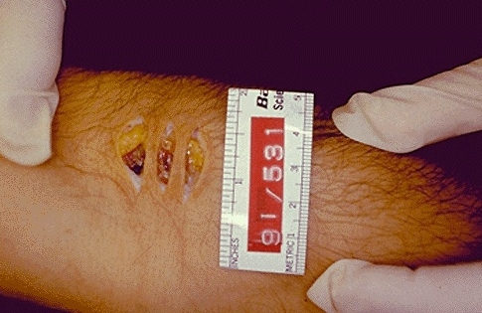

White circular and irregular scars from "skin popping" (subcutaneous injection of drugs):
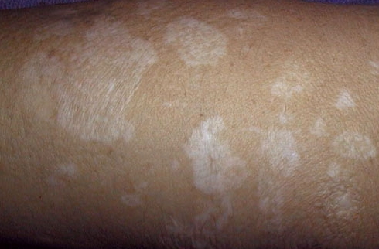

Principles of Treatment
Many substance abusers do not realize or do not admit that they have problem!

Those in third (regular abuse) and fourth (dependence) stages may require hospitalization or placement in residential rehabilitation facility.

I. Safe detoxification; it is impossible to address causes of substance abuse / dependence while patient continues to use substance; alcohol / sedative-hypnotics withdrawal risks delirium and seizures.
First goal of treatment is to withdraw substance!

II. Complete abstinence
- there may be few individuals who can use substances in moderation after successful treatment (but it is impossible to identify them).

III. Avoid other substances associated with dependence / abuse
- not infrequently, people who have been dependent on substance ask to be treated with benzodiazepines or related compounds for anxiety or insomnia; this request is dangerous:
  - introduces another substance.
  - taking pill for rapid relief of dysphoria reinforces association between drug taking and feeling better → increasing tendency to go back to drug of choice for same result.
  - some reports suggest that benzodiazepines increase risk of alcoholism relapse.

IV. Evaluate and treat other psychiatric co-morbidity
- anxiety, mood, personality disorders can be caused by substance itself - most clinicians do not treat accompanying psychiatric disorders until patient has period of abstinence.

V. Involve family
- family members may encourage use of substance in patient;
- family may ignore or overlook sexual abuse of one child by focusing attention on another child's problem with drugs or alcohol.
- spouse also may be drug-dependent.
- family can be important allies in insisting that patient deal with problem.

VI. Unscheduled toxicology screens - essential in identifying relapse and noncompliance.

VII. Self-help groups (peer support groups) provide credibility and encouragement from individuals who have had similar problems and who are adept at dealing with common resistances to treatment.
- 12-step programs have been developed for most substances (e.g. AA for alcoholics).

VIII. Sanctioned treatment
- when patient is forced to remain in therapy by legal sanction (e.g. threatened loss of driver's license or professional license for relapse), outcome is better than when patient is free to withdraw from therapy at any time.

IX. Contingency contracting - patient agrees in advance that therapist will notify employer or licensing body if relapse occurs; patient may leave letter with therapist outlining problem, which is to be mailed if urine screen is positive or patient does not keep appointment; some patients deposit sum of money with therapist (certain amount is then paid back to patient for each week of abstinence).

X. Change of peer group
- for many patients (esp. adolescents) substance use is encouraged by peers.
- help patient to find different peer group in which substance use is not prerequisite to social support.

Specific Substances
Opioids
Opioid receptors, endogenous opioids → see p. A4b >>
Opioid substances → see p. S20 >>

- opioids can be ingested, smoked, insufflated, IV injected.
- street preparations are often adulterated with quinine, procaine, lidocaine, lactose, mannitol and are contaminated with bacteria, viruses, fungi.
- after period of decreased use, narcotic use is undergoing resurgence in middle class groups.
- 2-3% adults 18-25 yrs have tried heroin at some time in their lives.
- heroin is most commonly used recreational opioid
- until advent of crack cocaine, heroin was most common illicit drug used in many metropolitan USA areas.
- death rate is 2-20 times higher.
- personality and behavior prior to drug use predict behavior while using opioids (many narcotic abusers lead antisocial lifestyle that persists until drug is withdrawn).
- narcotic abuse develops - most commonly when adolescent / young adult is engaged in experimental or recreational drug use;
  - only very small percentage of narcotic users becomes dependent in course of medical treatment (when receive narcotics from physician); but dependence on prescription analgesic opioids (morphine, oxycodone) is increasing; therapeutic doses taken regularly over 2-3 days can lead to some tolerance → mild withdrawal (scarcely noticed as flu-like).
N.B. patients with chronic pain requiring long-term use should not be labeled addicts! (although they have some problems with physical dependence)
  - rate of narcotic addiction is ≈ 5 times higher in health care personnel than in any other group of individuals with comparable education and socioeconomic class.
- epidemic transmission - heroin abuse tends to be transmitted in epidemic fashion among individuals who know each other.
  - these epidemics begin slowly, peak rapidly, and then decline quickly when all susceptible individuals within given group have been exposed (completely abate after 5 to 6 years).
  - new addicts then tend to expose their friends in other circles → third generation of abusers.
- susceptibility to heroin addiction varies in different populations (highest risk - young African American men; lower risk – women).
- 50% individuals who abuse narcotics become physically dependent.
- dependence is initiated by someone known to individual who is already addicted (drug "pushers" actually cause few new cases of dependence, although they obviously are major source of drug).
- drug cultures - when cultural norms support heroin use, and relatively pure preparations are available, large percentage of users become dependent.
  - removal of peer group support, removal of easy availability of drugs, and, possibly, removal of major environmental stresses end drug abuse.
  - most individuals who become dependent have psychological predisposition to abuse and tend to remain in peer groups that encourage substance use.
Relapse is likely when individual returns to environment in which drugs are available and friends and colleagues condone abuse!
- psychiatric illness is present in 50-87% dependent people (most commonly - depression, anxiety states, borderline and antisocial personality disorders).
  - individuals from disorganized social backgrounds are also more susceptible to narcotic dependence.

Typical heroin addict – male 25-35 yrs living in city and member of minority group (esp. black or Hispanic).

Intoxication
Mild ÷ moderate intoxication:
- Analgesia
- Euphoria, dreamlike pleasant drowsiness → apathy and lethargy, mental clouding, no loss of consciousness
- Impaired attention and memory
- Illusions, visual hallucinations
- Nausea and vomiting can occur
- Mouth dryness, pruritus, flushed warm skin (cutaneous vasodilation)
- Miosis, constipation, hypothermia, postural hypotension
- Dysarthria
- Decreased respiratory rate and depth

- parenteral heroin "hit" lasts for about minute (it is often compared to orgasm).

Severe intoxication:
- Respiratory depression (may recur up to 24 hours after apparent recovery from overdose; up to 72 hours for methadone) – cause of death!
- Hypotension
- Pulmonary edema (noncardiogenic)
- Depressed reflexes
- Coma
- Seizures (with propoxyphene or meperidine)

- death after very small drug amounts may be due to adulterants (e.g. quinine causes cardiac conduction abnormalities and ventricular fibrillation; combination of heroin + ethanol + quinine might synergize to cause sudden death).

Diagnosis
- morphine glucuronide in urine specimen (heroin is biotransformed to morphine, conjugated with glucuronide, and excreted).

Treatment
- naloxone 2 mg IV* is initially administered to reverse coma and apnea!!! (severe pulmonary edema is usually not responsive to naloxone)
*often IM or SC because of bad veins of these patients
  - 1-4 mg increments can be repeated q 2-3 min (up to total 20 mg).
  - overdosage may precipitate severe abstinence (physical soft restraints should be applied before antagonist is given - some patients become agitated, delirious, and combative) – use lower doses for known long-term addicts.
  - if opioid is taken in combination with cocaine / amphetamine - paranoid psychosis can be unmasked by naloxone.
  - if opioid is taken in combination with barbiturates / ethanol - coma does not respond to naloxone.
- supportive care (hospitalize and observe for at least 24 h): mechanical ventilation, etc.
  - naloxone does not treat pulmonary edema; H: PEEP, loop diuretics, vasodilators.

Withdrawal
- self-limited, not life-threatening (but extremely uncomfortable)!!! - CNS hyperactivity:
- Dysphoria, anxiety, craving for drug
- Restlessness, irritability, insomnia
- Lacrimation, rhinorrhea, perspiration, piloerection*, diarrhea
- Nausea, muscle aches, tremors, hot and cold flashes
- Mydriasis, hypertension
- Violent yawning, resting respiratory rate > 16 breaths/min
*hence name “cold turkey” for withdrawal
- syndrome severity increases with size of opioid dose and duration of dependence.
- symptoms appear 4-10 hours after cessation, symptoms peak at 48-72 hours and disappear in 7-10 days (minor effects may persist up to 6 mo).
withdrawal of methadone (long half-life) develops more slowly and is overtly less severe (although users may describe it as worse).
- opioids induce cross-tolerance - abusers can substitute one for another.

Treatment
- withdrawal effects are lessened by methadone substitution – give sufficient dose to suppress abstinence (maximum 20-50 mg/d) → dose is decreased by 10%-20% every day, every few days.
N.B. any physician may prescribe methadone for pain, but use of methadone to detoxify narcotics addict (as well as methadone maintenance to prevent relapse) violates federal law in any setting other than federally approved site for treatment of narcotic addiction.
- clonidine 0.1-0.3 mg ×3/d for 2 weeks can halt almost all signs of opioid withdrawal → taper dose (to avoid rebound hypertension, restlessness, insomnia, irritability).

Lofexidine (BritLofex) - tablets 0.2mg (titrate according to patient response) – used for detoxification to decrease withdrawal symptoms.
- mechanism of action – selective α₂-agonist with high affinity for 2A receptor subtypes (vs. clonidine - non-selective α₂-agonist) - less anti-hypertensive activity.

Complications
see also above >> (incl. newborn opioid withdrawal)
- injection of crushed oral tablets suspended in water and passed through cigarette filter → cerebral hemorrhages, cerebral vasculitides, pulmonary granulomas.
- pulverized meperidine tablets → seizures and fundal hemorrhages.
- chronic heroin → myelopathy (acute paraparesis, sensory loss, urinary retention shortly after drug administration) - vascular etiology (hypotension, embolism of foreign objects, direct toxic effects.
- supraclavicular injections → anterior spinal artery syndrome.
- repeated jugular vein injections → vocal cord paralysis, cervical infection.
- mononeuropathies and polyneuropathies (can present as Guillain-Barré syndrome), painful brachial and lumbosacral plexopathies.
- heroin adulteration with:
chloroquine → headache, confusion, visual disturbances, spongiform encephalopathy.
quinine → toxic amblyopia.
- opioids lower seizure threshold (heroin use is risk factor for new-onset seizures).
- infections are common cause of morbidity in heroin users (esp. Staphylococcus aureus and Pseudomonas); tetanus and botulism have occurred in parenteral heroin abusers.
- heroin snorting → nasal septum may be perforated.
  - because heroin potency has recently increased, more users are snorting and smoking.
- many heroin addicts begin with subcutaneous injections (“skin popping”) and may return to this mode when extensive scarring makes veins inaccessible; as addicts become more desperate, cutaneous ulcers in unlikely sites may be found.
- meperidine analog contaminated with methyl-phenyl-tetrahydropyridine (MPTP), metabolite of which is toxic to neurons in substantia nigra → severe irreversible parkinsonism.

Talc granulomatosis of lungs (polarized light) - bright white collections of polarizable talc* crystals centered around vascular spaces (patient with long history of IV drug use):
*used to dilute injected drug
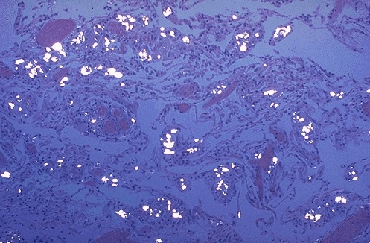

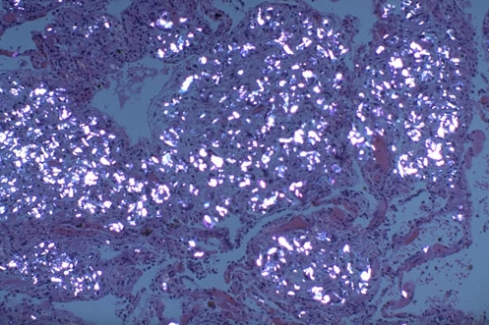
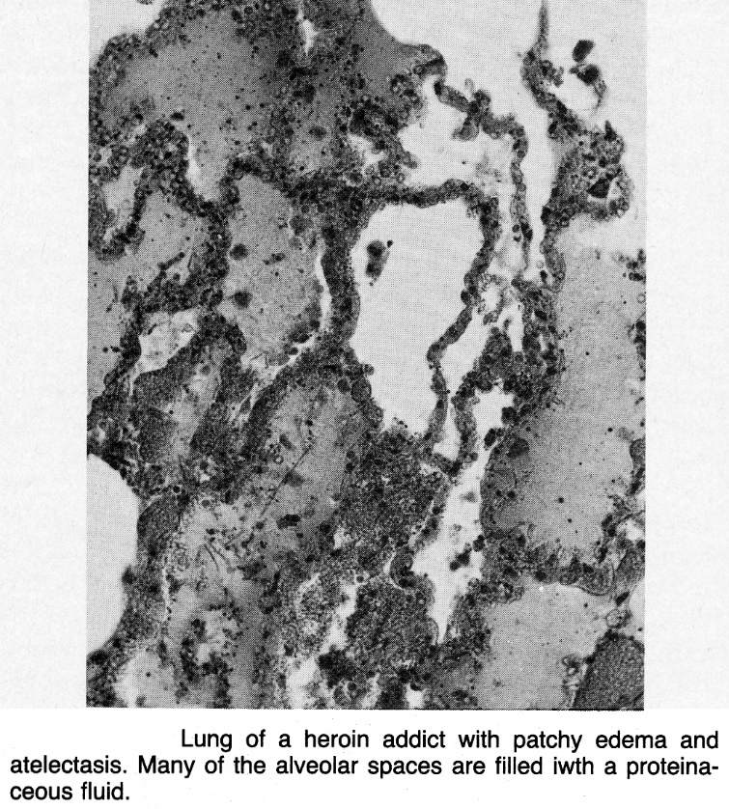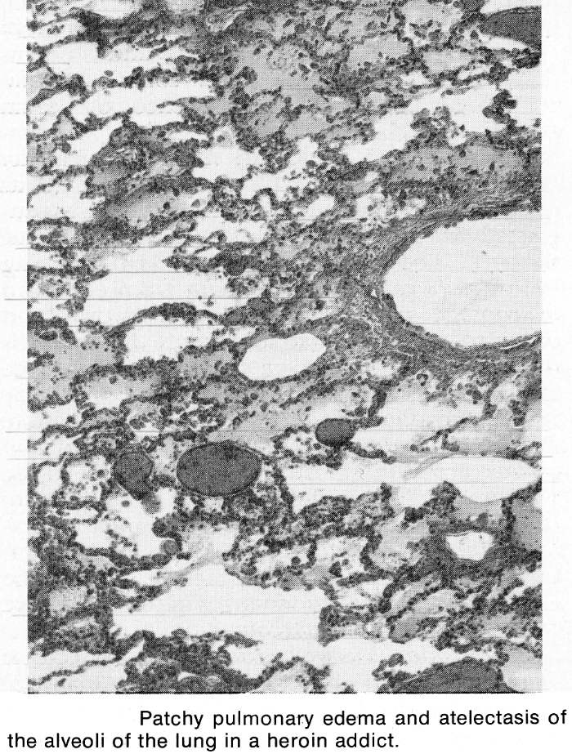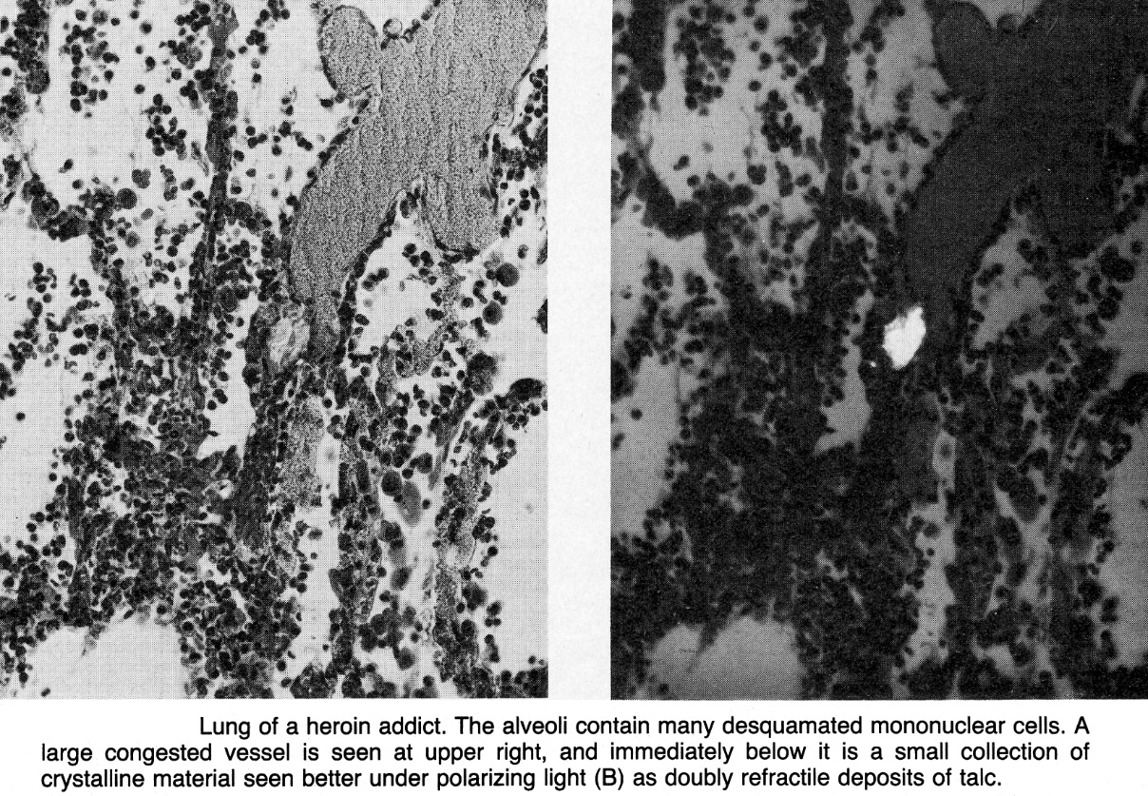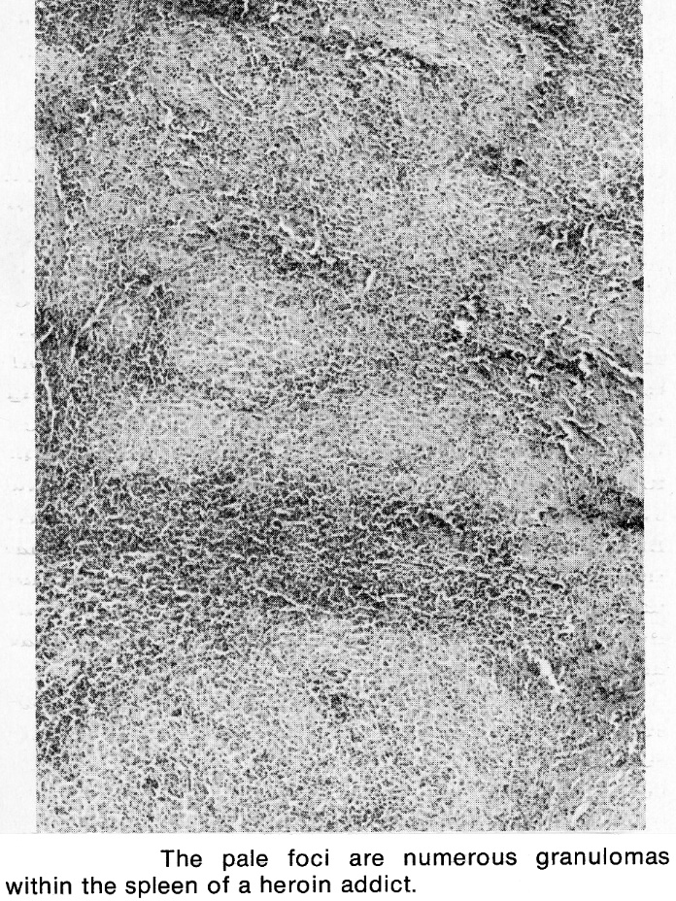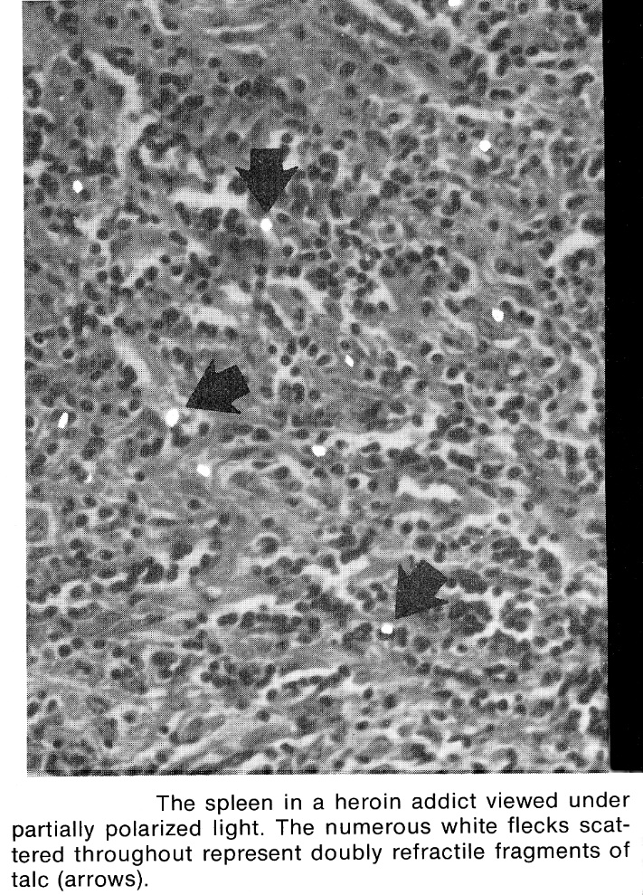

Heroin nephropathy - focal scarring of glomerulus:
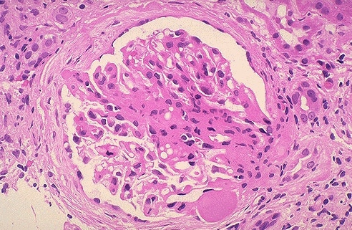

Talc granulomatosis of liver (talcum powder collects in mononuclear phagocyte system and lungs):
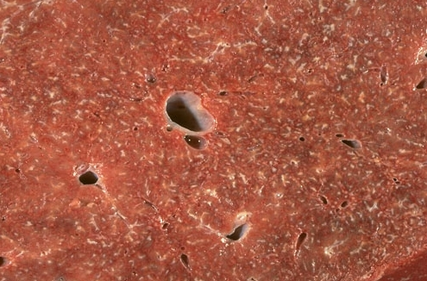

Treatment of dependence
Administration of opioids for pain for addicts in medical setting
- do not permit fears of addiction to interfere with administration of appropriate doses of narcotics to patients in pain.
- addicts require higher doses than other patients.
- narcotics should be administered on set schedule rather than as needed (prevents patients from becoming preoccupied with pain).
- do not detoxify during acute physical illness!
- do not write outpatient prescriptions for suspicious complaints or those with high abuse potential, as indicated by:
    - losing prescriptions or running out of medication early
    - requests for specific drug
    - history of abuse (alcohol or other drugs)
    - physician shopping
    - claims that physician who originally wrote prescription is unavailable
    - threats when narcotics are not prescribed
    - dishonesty with physician.

Detoxification (controlled withdrawal)
Low-grade opioid dependence (as may occur in people who have used opioid analgesics for long time) can be treated by reducing opioid dose slowly, by substituting weak opioid (e.g. propoxyphene), or by using benzodiazepines (not cross-tolerant to opioids) in decreasing doses.

Seriously addicted patients – psychosocial counselling sessions plus partial agonist:
A. Preferred method - methadone 15-80 mg/day - long half-life and less profound sedation and euphoria.
- methadone prevents severe (but not necessarily all) symptoms of withdrawal.
- doses ≥ 25 mg can produce unconsciousness if person has not developed tolerance.
- can only be carried out by federally approved program (in most cases, physician should refer addicts to specialized treatment centers).
- very gradual withdrawal from methadone is attempted when patient seems ready.
- most addicts note some abstinence symptoms when dosage is reduced below 20 mg/day (H: reduction in dosage by as little as 1 mg/week below this level may be necessary for detoxification of long-term methadone users).
- clonidine may help withdraw from methadone.
- withdrawal for addicts coming from methadone maintenance program may be particularly difficult - their doses may be as high as 100 mg /day (H: reduce dose to 60 mg /day over several weeks before attempting complete detoxification).
B. Modern method - buprenorphine-naloxone (Suboxone® tablets) 14 mg/day, tapered to day 14.
- recent studies show that extended therapy (up to 24 mg/day for 9 weeks, then tapered to week 12) gives even better results.

Maintenance with continued opioid use
AIDS epidemic has provoked harm-reduction movement - services that reduce harm of drug use without requiring cessation:
N.B. not all drug abuse treatment programs are abstinence-oriented!

        - Providing clean needles and syringes.

        - Easy access to maintenance opioids (enabling addicts to be socially productive):
- methadone
- buprenorphine (Subutex®) 8- or 16-mg tablet once/day (becomes preferred over methadone) - blocks receptors, thereby interfering with illicit use of heroin; can be prescribed at doctor's office instead of at treatment clinic!
Suboxone® tablets (buprenorphine + naloxone)
- L-α-acetylmethadol s. LAAM, levomethadyl acetate (Orlaam®) – discontinued!!!
long-acting preparation (suppresses narcotic withdrawal for 72 hours) - less frequent administration is necessary (100 mg 3 times/wk is comparable to methadone 80 mg once/day); QT interval abnormalities have been found - use is therefore discontinued!

Indication to qualify for opioid maintenance - clear-cut signs of addiction (e.g. history of ≥ 3 opioid injections/day, intoxication, fresh needle tracks, medical or psychosocial consequences of abuse).
- if patient has strong psychosocial supports and is highly motivated to discontinue drug use, patient can be withdrawn from opioids immediately using methadone.
- if supports are weak or motivation is uncertain, period of methadone maintenance is instituted while motivation, social supports, and relationship with treatment team are strengthened.
- periodic unscheduled urine and blood screens to assess compliance; persistent noncompliance (i.e. continued self-administration of narcotics) results in dismissal.
Opioid maintenance is most suitable for long term (e.g. > 2 yrs) opioid users!

Maintenance of abstinence
Naltrexone (50 mg once/day or 350 mg/wk in 2 or 3 divided doses) - used in manner analogous to disulfiram to precipitate withdrawal when narcotics are used (so many opioid addicts will not voluntarily consume it).

Therapeutic communities play important role.
- residency is usually 15 months.
- initial dropout rates are extremely high.
- confrontation by fellow addicts of lying and rationalization of drug use has more credibility to addict than therapies that are administered by professionals.
- if outpatient therapy is unsuccessful, residential treatment is necessary.

Pregnancy
- it is better to continue opioid use than to attempt quitting while pregnant (alternating between intoxication and withdrawal can result in unstable intrauterine environment → miscarriage, premature labour, placental abruption or stillbirth)
- consider methadone maintenance - dosages are monitored and controlled; if methadone maintenance is not an option - continue substance use in safest manner.

Nicotine
Pharmacology, intoxication → see p. A35 >>

- worldwide, cigarette smoking is major preventable cause of disease, 2nd-leading cause of death (1 of every 5 deaths).
½ of all smokers die prematurely of disease directly caused by smoking, losing 10-14 yr of life (7 min/cigarette)!!!
- cigarette manufacturers have publicly denied that nicotine is addictive drug – this misinformation led to false belief that nicotine use is habit and not addiction.
- average age at first use is 14.5 years (smoking prevention must start early!).
- prevalence (decreasing in USA) ≈ 25% (28% men and 24% women; vs. in 1965 - 52% and 34%).
- highest in blacks, blue-collar workers, less-educated persons, persons in lower socioeconomic strata.
- other risk factors: smoking parents / peers, schizophrenia, major depression.
- smoking is more prevalent in developing countries.
- tax increase is single most important intervention by governments to curb tobacco consumption!

- physical dependence develops rapidly and is severe (nicotine is highly addictive drug); nicotine is not abused!
Teenager who smokes as few as 4 cigarettes might develop lifelong addiction!
- nicotine has paradoxical dual action - CNS stimulant and CNS sedativa. see p. A35 >>
Nicotine acts on brain reward mechanisms: indirectly - through endogenous opioid activity; directly - through activation of mesolimbic dopaminergic pathways.
- lifetime history of major depression is more than twice as common in people who smoke; depression interferes with smoking cessation.

DSM-IV-TR criteria for nicotine use disorder: any 3 of following within 1-year time span:
- Tolerance (decreased effect and increasing dose to obtain same effect).
- Withdrawal after cessation
- Smoking more than usual
- Persistent desire to smoke despite efforts to decrease intake
- Extensive time spent smoking or purchasing tobacco
- Postponing work, social, or recreational events in order to smoke
- Continuing to smoke despite health hazards

Withdrawal features
- Depression (mostly mild, sometimes major), irritability, anxiety, insomnia, difficulty concentrating, impatience.
- Headache
- Increased appetite / hunger (→ average weight gain of 4-5 kg), GI pain, digestive disturbances
- Decreased heart rate
- start within few hours of last cigarette, peak in first few days (worst in 1st wk) but eventually disappear within month.
- nicotine does not cause withdrawal delirium.
- exacerbation of ulcerative colitis often soon after quitting.

Complications
- people smoke to feed nicotine addiction but simultaneously inhale hundreds of carcinogens, noxious gases (e.g. CO), and chemical additives → smoking harms nearly every organ in body:
  - Cancer (esp. lung, esophageal, oropharyngeal, laryngeal, stomach, bladder, kidney, pancreatic, cervical, anal).
  - Chronic lung disease - chronic obstructive pulmonary disease (COPD), emphysema, bronchitis → productive cough, chest pain, decrease in performance endurance.
  - Atherosclerotic cardiovascular disease (CAD, stroke, aortic aneurysm), peripheral vascular disease.
  - Fetal - low birth weight, perinatal mortality, SIDS, asthma.
  - Periodontitis → tooth loss.
  - Smoking-related fires

N.B. concentrations of toxins and carcinogens are higher in sidestream smoke; secondhand smoke significantly increases risk of same neoplastic, respiratory, and cardiovascular diseases! (H: ban smoking in public and work places)

Smoking Cessation
Success rates are 20-30%
- Physician counseling - health professional can contribute powerfully to motivate patients to attempt and sustain cessation by offering encouragement, advice, and assistance.
- counseling begins with 5 A's:
  - ask at every visit if patient smokes and document response;
  - advise to quit in clear, strong language;
  - assess smoker's willingness to quit within next 30 days;
    - establish quit date, preferably within 2 wk.
    - stress that total abstinence is better than reduction.
  - assist those willing to make quit attempt with brief counseling and medications;
  - arrange follow-up, preferably within 1st wk of quit date.
- patient should develop social support among family and friends for their quit attempt.
- alcohol use is associated with relapse - alcohol restriction or abstinence should be discussed!
- quitting is more difficult with another smoker in household - encourage housemates to quit together!
- 40 states in US have telephone quitlines.
- for those nonwilling to quit, set realistic goals that fall short of total smoking cessation - temporary abstinence, reduction in consumption.

- Behavioral therapy, group therapy, hypnosis and acupuncture (no different from placebo).

- Nicotine replacement – makes easier to abstain from tobacco (but is not stand-alone measure, i.e. effective only when combined with behavioral program); dosing schedule is graduated decrease over 8 weeks (studies show that results even better if over 24 weeks);
  - transdermal patch (highest compliance) - delivers nicotine at relatively steady rate; smokers who use ≥ 10 cigarettes per day should use 21-mg/day patch for first 6 weeks → 14-mg/day for 2 weeks → 7-mg dose for final 2 weeks;
    - transdermal patch works by preventing severe withdrawal;
    - for breakthrough cravings provoked by situational stimuli (very high risk of relapse) acute therapies may be added (gum, nasal spray, inhaler)!!!!!!
  - chewing gum (nicotine polacrilex available in doses 2 mg [for smokers of 1–24 cigarettes/day] and 4 mg [≥ 25 cigarettes/day]) - 50% of nicotine in gum is absorbed (closely approximates time course of plasma nicotine levels observed after cigarette smoking, but peak level is ≈ ½ of peak level with smoking); use piece of gum every 1-2 hours for first 6 weeks → one piece every 2-4 hours for 3 weeks → one piece every 4-8 hours for 3 weeks;
    - may cause jaw soreness, mild burning sensation in mouth and throat.
    - acidic beverages (soda, coffee, beer) interfere with buccal absorption.
  - lozenge (available in 2- and 4-mg formulations) should not be chewed; amount of nicotine absorbed per lozenge is higher than that delivered by gum.
  - vapor inhaler satisfies behavioral aspects (hand-to-mouth ritual); nicotine is not delivered to bronchi or lungs, but rather it is deposited and absorbed in mouth, like nicotine gum.
  - nasal spray – most rapid nicotine delivery! (acute craving relief)
  - sublingual tablet held under tongue - use for at least 12 weeks → gradually taper.

- cigarette delivers 1.2-2.9 mg of nicotine (typical one pack-per-day smoker absorbs 20-40 mg nicotine / day → plasma concentration 23-35 ng/mL).  - for some smokers, withdrawing from smoking completely may be difficult - NRT may be used indefinitely (clearly safer than cigarette-delivered nicotine with its numerous toxins).  - NRT delays but does not prevent weight gain.  - NRT contraindicated in:  - pregnancy (category X or D); except chewing gum (category B)!  - within 2 wk of MI, serious angina, serious arrhythmias.  - avoid NRT in patients who smoked < 10 cigarettes/day (nicotine toxicity is possible + lacking evidence of benefit).  - using NRT + continuing to smoke risks nicotine toxicity! | 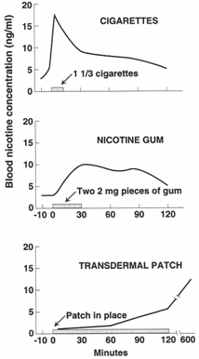

- Varenicline (Chantix™) – high affinity and selectivity at α4β2 neuronal nicotinic acetylcholine receptors → agonist activity* to ease withdrawal symptoms while simultaneously preventing nicotine binding;
    - initiate 1 wk before date chosen to stop smoking.
    - continue treatment for 12 wk; if successfully stopped smoking at end of 12 wk, additional 12-wk course is recommended.
    - may worsen current psychiatric illnesses / cause old psychiatric illnesses to reoccur; may even increase risk of suicide!
*significantly lower than nicotine

- Bupropion SR (Zyban) - first-line therapy - doubled rates of cessation; may be used in combinations (e.g. with nicotine transdermal patch); also effective when nicotine replacement therapy fails.
    - some evidence suggests bupropion SR is more effective than nicotine replacement.

- Second-line therapies:
- nortriptyline - potential efficacy for smoking cessation in smokers even without history of major depression.
- clonidine - doubled rates of cessation in resistant cases.

- encourage low-calorie diet and exercise regimen to prevent weight gain!!!
- 2 days ÷ 6 weeks after abstinence severe major depressive episodes may occur; H: SSRI, nortriptyline.
- long-term follow-up is recommended (high risk for relapse!!! - relapse during first year after achieving smoking cessation occurs in 50%).
    - changes in CNS (neurone genetics, cell structure, cell function) induced by smoking do not reverse with pharmacological therapy.
- verify successful cessation by measuring cotinine or CO levels.

Other Kinds of Tobacco
Cigarette smoking is most harmful form of tobacco use!
- Exclusive pipe smoking is relatively rare in US (< 1% of people ≥ 12 yr).

- 5.4% of persons > 12 yr smoke cigars.

- Using smokeless tobacco (chewing tobacco and snuff) is male-oriented activity (3.3% of persons ≥ 12 yr use smokeless tobacco); toxicity varies by brand - cardiovascular disease, oral disorders (e.g. cancers, gum recession, gingivitis, periodontitis), teratogenicity.

- smoking cessation is accomplished similarly as that for cigarette smokers (success rates are higher among smokeless tobacco users).

Amphetamines
Pharmacology, intoxication → see p. A35 >>
- all amphetamine analogs produce very similar signs and symptoms (also similar to cocaine, but rush is prolonged).
- during 1980s and 1990s, most of amphetamines were replaced by cocaine.
- recently, methamphetamine (METH, Ice) and methylenedioxymethamphetamine (MDMA, Ecstasy) have undergone major resurgence among adolescents and young people.
    - MDMA (taken as pills) is used frequently at "raves", because it also has hallucinogen properties (accentuates physical sensation); energizes but to far lesser extent than other amphetamines.
    - METH (injectable) is easily manufactured illicitly - chief type of amphetamine abuse in North America.
- repeated amphetamine use induces only psychological dependence (and death of large numbers of serotonergic neurons).

Withdrawal
- psychological and behavioral manifestations (not as severe as with other substances): depression, fatigue, increased sleep, nightmares (due to REM rebound), increased appetite, decreased memory or poor concentration.
- objective signs are few, but EEG changes are considered by some to fulfill physical criteria for physical dependence.

Treatment
- Antidepressants (e.g. bupropion, venlafaxine, desipramine) - for withdrawal depression.
- Hospitalization - if patient is suicidal.

Complications
- acute hypertension → intracranial hemorrhage (intracerebral, intraventricular, SAH).
- cerebral vasculitis* → occlusive stroke (angiography shows occlusions & beadings).
*affecting either medium-sized arteries (resembling polyarteritis nodosa) or smaller arteries and veins (resembling hypersensitivity angiitis)
methamphetamine use can cause necrotizing cerebral angiitis!
- ecstasy causes severe damage to serotonergic neurons in nonhuman primates.
- heart may suffer severe stress → ischemic myocardial changes (made worse by concomitant ethanol use):
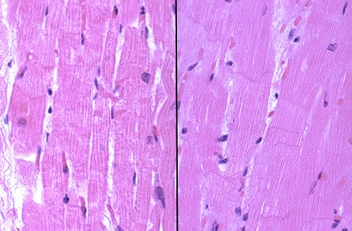

Cocaine
Pharmacology, intoxication → see p. A35 >>
- extremely serious public health problem (1/4 of young adults have used cocaine; white males > blacks, Hispanics).
- as amphetamines, cocaine produces only psychological dependence (addiction).

Withdrawal
Tolerance to cocaine occurs, and withdrawal from heavy use is characterized by somnolence, increased appetite, and depression ("cocaine blues").

Treatment
- medications that enhance dopaminergic transmission in reward centers:
  - Imipramine, desipramine (!!!), maprotiline, bupropion, venlafaxine - reduce craving.
  - Amantadine - decreases craving in first few weeks after withdrawal; also useful in long-term.
  - Bromocriptine.
- extremely expensive inpatient therapy is available.

Cannabis (Marijuana, Hashish, Ganja, Bhang)
Pharmacology → see p. A4b >>

- marijuana is one of most commonly abused drugs (was used 3000 BC) - used more frequently than alcohol by certain adolescent populations!
- most commonly used episodically without evidence of social or psychologic dysfunction.
- cannabis is "gateway drug" in adolescents - reduces threshold for using more dangerous substances.
- can be smoked, eaten, or taken intravenously; potency varies greatly.
- urine tests remain positive for days or weeks.
- traditional thought: marijuana does not cause physical dependence, only mild tolerance and mild psychologic dependence!
N.B. abusers regularly experience craving for drug and prolonged mild withdrawal dysphoria (reduced by restarting drug) ≈ benzodiazepine withdrawal
NMS Psychiatry states: “contrary to popular wisdom, physical dependence on marijuana may occur with withdrawal on discontinuation”
- complications of long-term high-dose abuse: (very few!!!)
- amotivational syndrome (apathy and cognitive impairment) - may persist after discontinuation.
- fetal effect - fetal weight↓ (small effect); no congenital anomalies!
- cannabis inhibits LH and FSH → reversible impotence and sterility in men and menstrual irregularity in women
- large airway changes (episodes of acute bronchitis, wheezing, coughing, increased phlegm).
  - even daily smokers do not develop obstructive airway disease.
  - lung cancer has not been reported if smoke only marijuana (less smoke is inhaled + smoke contains fewer carcinogenic substances).
- treatment of dependence: 5HT₃ antagonists - may reduce craving and "highs" that reinforce marijuana use.

Sedatives, Hypnotics, Anxiolytics
- Benzodiazepines (most commonly abused: diazepam, lorazepam, alprazolam). see p. Rx1 >>
- Barbiturates - particularly prone to pathologic use! see p. Rx2 >>
- Drugs related to barbiturates: ethchlorvynol, glutethimide, propanediols (e.g. meprobamate), methyprylon, paraldehyde.
- Chloral compounds (e.g. chloral hydrate).

Drug automatism - patient forgets that drug has already been taken and continues to take more pills, usually in effort to get to sleep.
- abuse and dependence are created / encouraged in everyday medical practice more often than for opioids.

Barbiturate abuse patterns:
- chronic abuse in 30-50 yrs old individuals (of middle ÷ upper class) who obtain drug from their unsuspecting physicians.
- episodic abuse in teenagers who ingest drug to produce high.
- IV abuse in illegal drug addicts who run low on money supply (barbiturates are less expensive than other drugs).

Intoxication
≈ ethanol intoxication

Mild-to-moderate intoxication:
- Euphoria
- Hypalgesia (increased pain threshold)
- Increased seizure threshold
- Sedation, psychomotor impairment
- Paradoxical excitement in:
    - susceptible individuals
    - elderly persons
    - children
    - people with pre-existing neurological impairment
- Fine lateral-gaze nystagmus, dysarthria, ataxia
- Postural hypotension.

- tolerances develops irregularly and incompletely - considerable behavioral, mood, and cognitive disturbances persist, even in regular users.

Severe intoxication:
- Nystagmus on forward gaze, marked ataxia with falling
- Deep sleep → stupor → coma
- Respiratory depression
- Depressed reflexes
- Decreased cardiac output, hypotension
- Bullous skin lesions and necrosis of sweat glands
- Hypothermia

- death from barbiturate overdose is possible; death from benzodiazepine overdose alone is rare (e.g. respiratory depression is much milder with benzodiazepines).

Treatment
- emesis (if ingestion has occurred within 30 minutes and gag reflex is intact) or gastric lavage + cathartic agent.
- forced diuresis with maximal urine alkalinization / hemodialysis
- respiratory support
- maintain BP with dopamine
- prevent loss of body heat
- flumazenil for benzodiazepine intoxication. see p. Rx1 >>

Withdrawal
≈ ethanol withdrawal
- syndromes vary in time of onset, duration, and severity (difficult to predict for individual).
- can be life-threatening! esp. barbiturates (similar to delirium tremens); less severe for benzodiazepines
- extent of physical dependence is related to dose and duration of use.
e.g. pentobarbital 200 mg/d taken for many months may not induce significant tolerance, but 300 mg/d for > 3 mo or 500-600 mg/d for 1 mo may induce withdrawal when drug is stopped.
- fear of withdrawal symptoms leads to continued drug use and inability to function without drug.
e.g. it seems to patient that he cannot sleep without drug, but continued drug use serves only to prevent withdrawal and suppress REM rebound (escalating doses often are needed to accomplish this result).
- short-acting compounds: symptoms begin within 12-24 hours, peak at 4-7 days, and last ≈ 1 week;
long-acting compounds: symptoms begin later (4-10 days after discontinuation) and reach peak more slowly (around 7th day).
- many people who misuse sedatives are heavy alcohol users - delayed sedative withdrawal may complicate alcohol withdrawal!

- Anxiety and agitation.
- Weakness and tremulousness, hyperreflexia (e.g. clonic blink reflex).
- Fever, diaphoresis → dehydration.
- Delirium with frightening visual and auditory hallucinations.
- Seizures (75% patients who were taking pentobarbital ≥ 800 mg/d).
- Orthostatic hypotension → cardiovascular collapse.

Treatment
- treatment is less effective if initiated after appearance of delirium.
- all CNS depressants (alcohol, barbiturates, benzodiazepines, etc) produce some cross-tolerance - known compound (e.g. pentobarbital or phenobarbital) is substituted for offending substance to suppress abstinence syndrome and is then gradually withdrawn. also see p. Psy21 >>
- assess tolerance (amounts to suppress withdrawal) - observe results of administering 200 mg pentobarbital or 60-100 mg phenobarbital when patient no longer appears to be intoxicated (usually within 12-16 hours after discontinuation of offending substance):
- becomes severely intoxicated or falls asleep - tolerance does not exist - patient does not need further treatment.
- develops moderate symptoms (e.g. dysarthria, nystagmus, ataxia without sleepiness) - moderate tolerance - patient requires 200-300 mg pentobarbital or 60-90 mg phenobarbital per day.
- absence of symptoms - significant tolerance – use 600-1000 mg pentobarbital or 180-300 mg phenobarbital daily (divided every 6 hours).
- once patient is stabilized, dose is decreased by 10% every 1-2 days;
  - reappearance of abstinence indicates that dose needs to be reduced more gradually.
  - unexpected intoxication indicates barbiturate accumulation and need for faster dosage reduction.
  - reestablishment of CNS stability requires about 30 days.
- if patient is also taking antidepressants (esp. tricyclics), antidepressant should not be abruptly stopped, but reduced over 3-4 days.
- benzodiazepines also can be used to suppress withdrawal from any cross-reacting CNS depressant, but standardized protocols (with exception of alcohol withdrawal*) have not been established. *see p. Psy21 >>
- maternal abuse may cause neonatal withdrawal (jitteriness, irritability, fussiness) beginning 7-10 days postpartum; H: sedation with phenobarbital 5-7 mg/kg/d PO or IM in 3 divided doses → tapered over few days ÷ weeks.

Hallucinogens (Psychotomimetics, Psychedelics)
- agonists at presynaptic 5-HT₂ receptors:
Lysergic acid diethylamide (LSD) - most commonly abused hallucinogen in USA; most powerful hallucinogen (produces symptoms at 25-50 µg doses).
- made from lysergic acid found in fungus, ergot, which can grow on grains.
- readily absorbable after oral administration; effects peak at 2-4 hours and may last for several hours.
Psilocybin (mushrooms)*
Mescaline (peyote cactus)*
2,5-Dimethoxy-4-methylamphetamine (STP, DOM)
dimethyl-tryptamine (DMT)
*used in religious ceremonies by Native Americans

Phencyclidine (PCP, "angel dust") inhibits reuptake of dopamine, 5-HT, and norepinephrine (so considered separately from hallucinogens); can be injected, snorted, smoked (sprinkled on smoking material), or eaten.

- ecstasy, marijuana also have hallucinogenic properties.

Intoxication
- altered perceptual state reminiscent of dreams.
- state is accompanied by bright, colorful changes in environment and by plasticity of constantly changing shapes and color.
- drug interferes with rational thought - individual is incapable of normal decision making.

      - Activation of sympathetic nervous system - mydriasis, tachycardia, BP↑, piloerection, fever.
      - Clear sensorium + perceptual distortions (illusions), hallucinations with brilliant colors and alterations in shapes, distortion of time sense, depersonalization, paranoia.
      - Inappropriate affect (euphoria, intensive arousal, severe anxiety-panic, or even intense depression) – called “bad trip”.

- little effect on brainstem and spinal cord - no toxic fatalities have been reported with hallucinogen use; most fatalities occur from actions while in intoxicates state (e.g. driving).
- hallucinogens are not apparent on routine “drugs of abuse” screens.

PCP intoxication also can cause:
    - Euphoria → hyperactivity, bizarre violent behavior (impulsiveness with assaultiveness) to any environmental stimulation (including attempts at reassurance).
    - Hyperacusis, hyperreflexia, horizontal, rotatory and vertical nystagmus, ataxia, dysarthria
    - Dissociative anesthesia (“lost sense of self” - insensitivity to pain, without loss of consciousness) - PCP is ketamine analog (PCP was initially developed as anesthetic, but use discontinued due to postoperative psychosis).
    - Higher doses produce withdrawn catatonic state, muscular rigidity (→ rhabdomyolysis), feeling of limb numbness.
    - In increased dosage: anesthesia, stupor, coma (eyes may remain open!), seizures, death (unusual)
Excessive salivation distinguishes PCP from cocaine / amphetamine, which produce dry mouth
- high PCP doses produce long-lasting psychotic / cognitive changes in susceptible individuals.

Treatment
          - most patients have stable vital signs - reassurance in quiet setting ("talking patient down") is usually enough.
          - neuroleptics (e.g. haloperidol) quickly abort syndrome; alternative – IV or oral diazepam.

PCP intoxication:
- risk of violence* - patients generally should be left alone in quiet area (or use restraints).
*H: IV diazepam (neuroleptics can induce neuroleptic malignant syndrome)
- PCP coma → enhance PCP clearance by urine acidification, prolonged gastric lavage, activated charcoal; antihypertensives, anticonvulsants.

Withdrawal
- does not produce significant abstinence syndrome! (significant tolerance* and mild psychologic dependence have occurred, but withdrawal is rare).
*with cross-tolerance to other hallucinogens

Flashbacks (s. hallucinogen persisting perception disorder) – for long-term users: brief reexperiences of hallucinogenic state* years after substance discontinuation.
*flashes of color, geometric pseudohallucinations, fleeting perceptions in peripheral visual fields
- may be precipitated by marijuana, antihistamines, SSRIs, alcohol, barbiturates or by stress or fatigue or can occur without apparent reason.
- flashbacks tend to subside within 6 to 12 months.
- mechanism – overstimulation of previously sensitized (by hallucinogens) serotonin receptors by medications that increase synaptic serotonin availability [e.g. SSRIs].
- treatment - reassurance (that symptoms will subside) + benzodiazepine.

Ketamine (“K”, Special K)
- generally snorted.

Intoxication
lower doses - giddy euphoria → bursts of anxiety or mood lability.
middle doses - withdrawn state (disassociation).
high doses - severe disassociation (“K-hole”) with ataxia, dysarthria, muscular hypertonicity, and myoclonic jerks.
very high doses - coma and severe hypertension; death is unusual.
- c/v status is usually unaffected.
- acute effects fade after 30 min.

Treatment - nonstimulatory environment.

Gamma Hydroxybutyrate (GHB, “G”)
- taken by mouth.

Intoxication
- relaxation, fatigue, disinhibition - resemble alcohol or ketamine but last longer and are far more dangerous - can lead to respiratory depression and death (esp. when combined with alcohol – most deaths have occurred!!!!!).
- most people recover rapidly (effects may not fade for 1-2 h).
- treatment - mechanical ventilator.

Inhalants
Volatile Solvents
- chemical diversity (aliphatic hydrocarbons such as n-hexane, aromatic hydrocarbons such as toluene, halogenated hydro carbons such as trichloroethylene, nitrous oxide from whipped cream dispensers):
- Gasoline
- Glue
- Paint thinner, solvents
- Spray paints
- Lighter fluid
- Fire-extinguishing agents
- Marker pens
- sniffing ("huffing") inhalants is increasingly severe problem among children and adolescents (up to 10% USA adolescents); most users stop solvent use by end of adolescence.

Intoxication
- temporary stimulation before depressing CNS (desired subjective effects are similar to ethanol).
- Dizziness, euphoric dreamy high, assaultiveness → illusions, hallucinations, delusions → depressed reflexes, psychomotor retardation, apathy, impaired judgment → confusion, altered states of consciousness, delirium → short period of sleep.
- Nystagmus, ataxia, dysarthria, tremor
- Muscular weakness, blurred vision.

- intoxicated state may last minutes ÷ > 1 h; death most often results from respiratory arrest, arrhythmias, asphyxia (due to airway occlusion or aspiration).
- chronic use may result in brain damage (dementia), neuropathies, hepatic & renal failure (carbon tetrachloride), nasal and bronchial irritation, oral squamous carcinoma!!!
- gasoline sniffers → lead encephalopathy.
- toluene sniffers → cerebral & cerebellar white matter changes → dementia, ataxia.
- sniffers of glue containing n-hexane → severe sensorimotor polyneuropathy.
- nitrous oxide sniffers → myeloneuropathy indistinguishable from cobalamin deficiency (but anemia is absent, and serum vitamin B₁₂ levels are normal); mechanism - inactivation of cobalamin-dependent enzymes (methionine synthetase and methylmalonyl-CoA mutase).
- there is no antidote or specific treatment! (respiratory and cardiac monitoring)

Withdrawal
- partial tolerance and psychologic dependence develop with frequent use, but withdrawal does not occur!

Volatile Nitrites
- poppers (as amyl, butyl, or isobutyl nitrite), sold as Locker Room and Rush or in "room odorizers".
- inhaled to enhance sexual pleasure (particularly among urban male homosexuals).
- vasodilation, with brief hypotension, dizziness, and flushing, followed by reflex tachycardia.
- no significant hazard (dangerous when combined with drugs for erectile enhancement → severe hypotension and death).

Methylxanthines
- psychomotor stimulants:
- caffeine - most widely consumed stimulant in world! - found in beverages (coffee, tea, cocoa, cola), chocolate, and OTC drugs (sold as stimulants).
- theobromine found in cocoa
- theophylline found in tea, also used as drug
- aminophylline – used as drug

- mechanism of action:
- inhibition of phosphodiesterase → increase in cAMP and cGMP.
- blockade of adenosine receptors.
- well absorbed orally, metabolized in liver, excreted in urine.
- long-term use → tolerance and psychological dependence; by other authors - only physical dependence.
- physical dependence is not well documented

Intoxication
- CNS stimulation (with cortex being most sensitive):
100-200 mg of caffeine (1-2 cups of coffee) → fatigue↓, arousal, vigilance (learning / memory / performance↑) - often subtle and difficult to detect;
1.5 g of caffeine (12-15 cups of coffee) → restlessness, anxiety-agitation, insomnia, rambling speech & thoughts, tremor, increased awareness of environment / hyperesthesia (ringing in ears and giddiness), hyperventilation (theophylline is used in apnea of prematurity);
2-5 g of caffeine - spinal cord stimulation → reflex excitability↑, tremulous extremities, tense muscles, muscle twitching, convulsions (esp. theophylline), rhabdomyolysis.
- Cardiac stimulation (positive inotropic and chronotropic effects - can be harmful to patients with angina pectoris) → tachycardia, flushing.
10 g of caffeine (lethal dose) → tachyarrhythmias.
- Diuresis
- Smooth muscle relaxation (e.g. bronchioles – useful in asthma).
- GI stimulation: nausea-vomiting, HCl secretion↑ (avoid in peptic ulcers).

- caffeine clearly alters sleep patterns; if taken within 1 hour of attempted sleep, it increases sleep latency, decreases total sleep time (stage 3 & 4↓, stage 2↑), worsens subjective sleep quality.

Treatment
- gastric lavage, activated charcoal, whole-bowel irrigation, hemodialysis or charcoal hemoperfusion (preferable for theophylline intoxication)
- agitation, seizures – benzodiazepines
- arrhythmias – β-blockers (for supraventricular), lidocaine (for ventricular).
- vomiting – metoclopramide, ondansetron.

Withdrawal
- those who routinely consumed > 600 mg of caffeine (6 cups of coffee) per day and then suddenly stop: drowsiness, headaches, fatigue, decreased performance, depression; H: gradual reduction of intake.

Bibliography for ch. “Psychiatry” → follow this link >>

Viktor’s Notes℠ for the Neurosurgery Resident
Please visit website at www.NeurosurgeryResident.net

