Barbiturates
Last updated: April 21, 2019
Mechanism of action 1
Pharmacologic Actions 1
Pharmacokinetics 1
Therapeutic uses 1
Adverse effects 1
Barbiturate Overdose 1

Mechanism of action
- At low doses - potentiation of GABA action on Cl⁻ channel; barbiturates presumably bind to picrotoxin binding site.
N.B. barbiturates do not bind to benzodiazepine receptors!
- At higher doses - interference with Na⁺ and K⁺ transport across cell membranes → generalized inhibition of polysynaptic transmission in all CNS areas (esp. mesencephalic ARAS).
N.B. barbiturates are less selective than benzodiazepines!

Pharmacologic Actions
- nonspecific generalized CNS depression in dose-dependent fashion: sedation → hypnosis → anesthesia → coma → death.
  - respiratory depression (barbiturates suppress respiration at various levels – CNS and chemoreceptor) up to death.
  - vasomotor medullary center depression occurs only at toxic doses.
  - phenobarbital has specific anticonvulsant activity different from nonspecific CNS depression. see p. E3 >>
  - in anesthetic doses, barbiturates significantly decrease CNS O₂ utilization.
No analgesic properties (al low doses, even exacerbate pain!); anxiolytic properties much lower than of benzodiazepines!

Pharmacokinetics
- absorbed orally.
- distributed widely throughout body; all barbiturates redistribute*: brain → splanchnic areas → skeletal muscle → adipose tissue.
*cause of short duration of action of (ultra-)short-acting derivatives!!!
- higher lipid solubility → more rapid onset & shorter duration of action, higher potency.
- metabolized in liver; inactive metabolites excreted in urine.
- duration of action is very important clinically - determines therapeutic use:

long-acting barbiturates (T_{1/2} – 1-2 days) – used as antiepileptics.
phenobarbital - duration of action greater than day. see p. E3 >>
barbital

short-acting barbiturates (T_{1/2} – 2-8 hours) – used rarely as sedative-hypnotics or anxiolytics.
pentobarbital – used to induce therapeutic coma in refractory status epilepticus.
secobarbital
amobarbital
hexobarbital
butabarbital

ultra short-acting barbiturates (T_{1/2} – 20 minutes) – used for anesthesia induction.
thiopental - acts within seconds; duration of action ≈ 30 minutes.

Therapeutic uses
    - Intravenous anesthesia induction - ultra-short-acting barbiturates (thiopental).

    - Anticonvulsant - long-acting barbiturates (phenobarbital): see p. E3 >>
      - status epilepticus in children
      - eclampsia
      - young children with recurrent febrile seizures (phenobarbital is drug of choice).

    - Mild sedatives (to relieve anxiety, insomnia) - short-acting barbiturates (were formerly mainstay, but now have been largely replaced by benzodiazepines).
- barbiturates decrease amount of REM sleep (as do benzodiazepines); after drug discontinuance - rebound of REM sleep (usually in form of nightmares).

    - Producing therapeutic barbiturate coma for CNS protection (via reduction of O₂ utilization).

    - Kernicterus treatment in neonates (via P-450 induction).

Adverse effects
- CNS depression (drowsiness, impaired concentration, mental and physical sluggishness).
- Drug hangover (residual CNS depression) - feeling of tiredness (± nausea and dizziness) for many hours after patient awakes.
- High potential for physical dependence & addiction (abrupt withdrawal → severe tremors, anxiety, weakness, restlessness, nausea & vomiting, grand mal seizures, delirium with vivid hallucinations, cardiac arrest).
Withdrawal is much more severe than opiate withdrawal and can result in death!!!
- P-450 microsomal enzyme induction:
- diminished action of drugs that are dependent on P-450 metabolism (incl. quickly developing tolerance to barbiturate itself!!!).
- increased porphyrin synthesis (barbiturates are contraindicated in acute intermittent porphyria).
- Narrow therapeutic index → frequent overdoses.

Barbiturate Overdose
- leading cause of death among drug overdoses.
- metabolic coma with severe respiratory & cardiovascular depression. also see p. Psy23 >>
- short-acting preparations are more lethal at lower doses.
- patient who survives acute episode may develop bronchopneumonia, renal tubular acidosis, cutaneous “barbiturate blisters” (due to porphyrin↑):
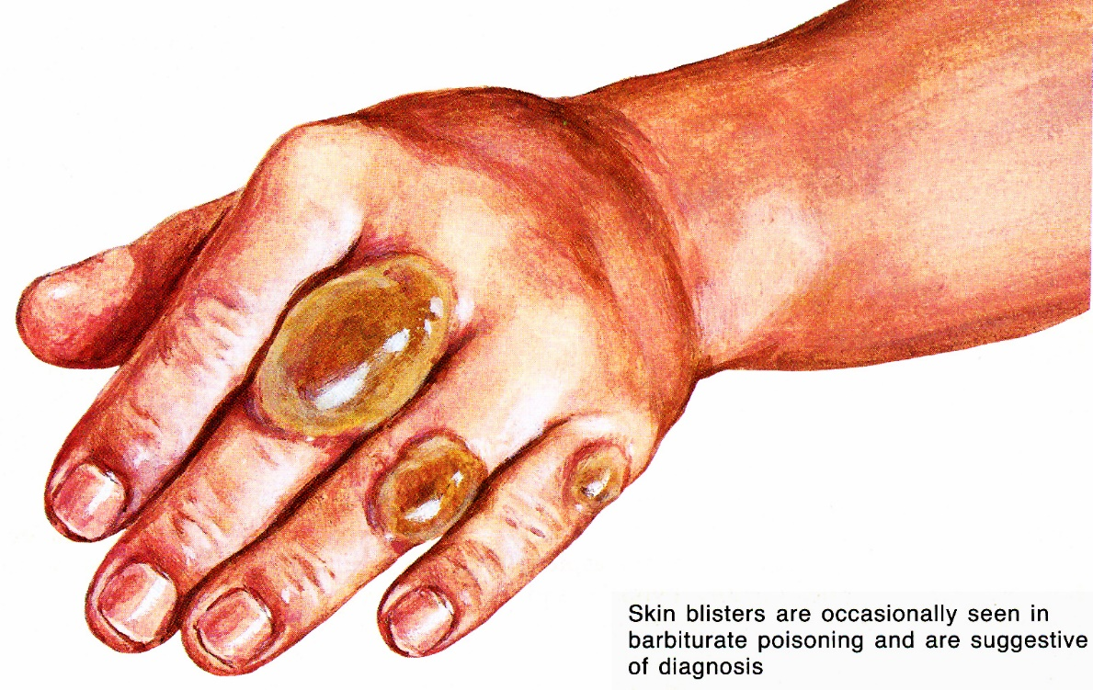
Source of picture: Frank H. Netter “Clinical Symposia”; Ciba Pharmaceutical Company; Saunders >>

- treatment: no specific antidotes!
- artificial respiration + cardiovascular support
- stomach purging
- urine alkalinization (barbiturates are acidic)
- hemodialysis – most effective treatment!!!

Bibliography for “Barbiturates” → follow this link >>

Viktor’s Notes℠ for the Neurosurgery Resident
Please visit website at www.NeurosurgeryResident.net

