Other Dementias
Last updated: May 8, 2019
Diffuse Lewy Body Disease 1
Pathogenesis, Pathophysiology, Pathology 1
Clinical Features 2
Management 3
Vascular Dementia 3
Causes and Types 3
Pathology 3
Clinical Features 4
Diagnosis 5
Treatment 6

Diffuse Lewy Body Disease
Pathogenesis, Pathophysiology, Pathology
Lewy bodies - intracytoplasmic, single or multiple, eosinophilic, round-elongated inclusions that have dense core surrounded by pale halo.
- composed of fine 7-8 nm straight filaments (densely packed in core but loose at rim); immunocytochemically - neurofilament antigens, α-synuclein, ubiquitin.

Dementing disorders associated with Lewy bodies can be categorized into three groups:
- Parkinson disease without cortical Lewy bodies or AD changes (Lewy bodies only in substantia nigra)
- Parkinson disease with cortical Lewy bodies (diffuse Lewy bodies disease, DLBD)
- Alzheimer disease with cortical Lewy bodies (Lewy body variant of AD, LBV – 15-30% of all AD cases).
Lewy body-related pathology is the second most common dementia histopathology behind AD!
i.e. Lewy bodies are found in 15-25% degenerative dementias.

- Lewy bodies, if present in cortex, are invariably also present in brain stem:
  - Lewy bodies in brain stem (easily seen on hematoxylin-eosin sections) - reside in substantia nigra, locus caeruleus, and raphe nuclei.
  - cortical Lewy bodies often lack surrounding halo and are more difficult to visualize (unless immunostains for ubiquitin are used); maximal numbers in cingulate gyrus, insular cortex, parahippocampal gyrus.

Lewy bodies:
H & E stain | immunoperoxidase stain for ubiquitin
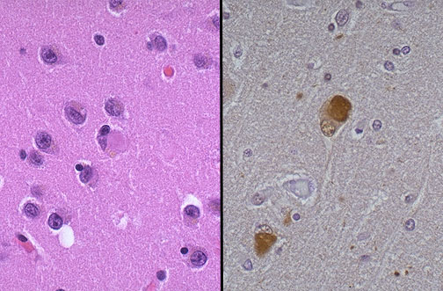
Source of picture: “WebPath - The Internet Pathology Laboratory for Medical Education” (by Edward C. Klatt, MD) >>

- brain is normal ÷ slightly atrophic.
- neurotransmitter deficits mostly involve cholinergic and dopaminergic systems;
nucleus basalis atrophy and cholinergic deficiency (LBV > DLBD) are more severe than in AD!

N.B. relationships among DLBD, AD, and Parkinson disease are debated because there is evidence to support all points of view.

Clinical Features
- mean age of DLBD onset is 57 years.
- male to female ratio 1.7:1.
- death ensues after 10-15 years.

mixed (cortical-subcortical) dementia
moderate÷severe dementia + mild÷moderate parkinsonism.
- literature is divided on whether parkinsonian or cognitive symptoms present first.
- dementia:
- multifactorial nature (presence and frequency of cortical Lewy bodies may be contributor);
- prominent visual hallucinations, paranoid delusions, illusions, and behavioral dyscontrol are characteristic clinical features;
- frequent fluctuations of behavior, cognitive ability, and level of alertness (episodic confusion and lucid intervals suggesting delirium).
- absence of severe aphasia, agnosia, apraxia.
- parkinsonism reflects basal ganglia & nigral degeneration; subcortical degenerative changes → psychomotor slowing; i.e. bradykinesia > resting tremor.
- repeated unexplained falls occur early!

Management
Whether treatment is necessary at all, and if so, what symptoms warrant treatment?

Treatment of dementia (may exacerbate parkinsonian syndrome!!!) – as in AD:
- acetylcholinesterase inhibitors serve as 1st-line therapy for neuropsychiatric as well as cognitive symptoms.
- patients are very sensitive to neuroleptic medications (exaggerated adverse responses to standard doses) - use most selective neuroleptics (risperidone, clozapine).

Treatment of parkinsonian syndrome (with levodopa) may exacerbate neuropsychiatric disorder.

Nonpharmacological aspects of caregiving are similar to AD.

Vascular Dementia
- 2nd most common dementia of elderly in USA (but No.1 in Asia!)

Causes and Types
- brain injury from cerebrovascular disease:
  - multiple cortical infarcts (multiple ischemic lesions in cerebral cortex* cumulatively result in loss of enough neurons** to produce dementia) - multi-infarct dementia
*not necessarily in eloquent locations
**usually destroying at least 100 ml of brain volume
N.B. many use "multi-infarct dementia" interchangeably with “vascular dementia”.
  - occlusive disease of small penetrating cerebral arterioles [microangiopathy] → multiple bilateral lacunar infarcts (small infarctions in deep hemispheric white matter) resulting in état lacunaire (Binswanger disease, s. subcortical arteriosclerotic encephalopathy)
  - strategically placed single infarct (may cause specific cognitive deficit, aphasia, amnesia, but rarely causes dementia)
  - cerebral hypoperfusion (chronic, reversible) - most experts reject such mechanism.
  - amyloid angiopathy (not associated with dementia, but predisposes older persons to hemorrhagic lobar stroke).

Pathology
Multiple remote cystic infarcts in various locations over several years:
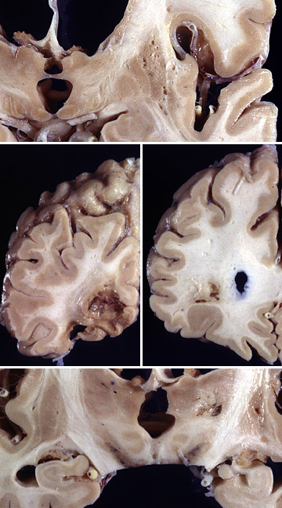
Source of picture: “WebPath - The Internet Pathology Laboratory for Medical Education” (by Edward C. Klatt, MD) >>

Clinical Features
Clinical features vary, but few generalizations are applicable (when compared with Alzheimer's disease):
- men > women
- often have risk factors (hypertension, diabetes, hyperlipidemia, cigarette smoking).
- history of transient ischemic attacks
- earlier age of onset (< 75 yrs)
- onset may be abrupt
- stepwise deterioration!!! (episodes of sudden neurologic deterioration)
- focal neurologic signs (limb rigidity, spasticity, hyperreflexia, extensor plantar responses, gait disturbance)
- pseudobulbar palsy (emotional lability, dysarthria, dysphagia).
- memory disturbance is of retrieval type - able to register information but difficulty spontaneously recalling it - categorical clues or multiple choices help.
- shorter survival (after mental status changes onset).

Clinical subtypes:
Cortical syndrome (multi-infarct dementia) - abrupt onset of cognitive failure, focal sensorimotor signs, severe aphasia (when present).

Subcortical syndrome (Binswanger disease):
- dementia of subtle onset and slow progression (vs. multi-infarct dementia)  - bilateral pyramidal signs (lateralizing motor signs are uncommon).  - gait imbalance (with marche a petit pas)  - "frontal" abulic behavior, mildly impaired memory.  - pseudobulbar signs, urinary incontinence.  - associated (but not always) with severe hypertension and systemic vascular disease. | multiple areas of abnormal high signal intensity in periventricular white matter, corona radiata and lentiform nuclei (arrows). 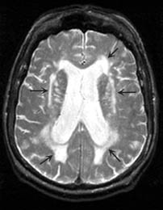

Diagnosis
- brain imaging (provides supporting, but not diagnostic, evidence):
  - focal infarctions in strategic cortical locations.
  - Binswanger disease - ischemic periventricular white matter changes, sparing cortex and basal nuclei.

Treatment
- by stroke prevention strategies:
- antihypertensives
- cigarette cessation
- blood cholesterol reduction
- anticoagulants / antiplatelet therapy (aspirin, clopidogrel, ticlopidine).

Bibliography see p. S11

Viktor’s Notes℠ for the Neurosurgery Resident
Please visit website at www.NeurosurgeryResident.net

