Pain
Last updated: December 19, 2020
Anatomy - Physiology 2
Sense organs for pain 2
Pain Types 4
Time 4
Etiopathophysiology 5
Location 6
Deep Pain 6
Muscle Pain 6
Visceral Pain 6
Referred Pain 7
Central Inhibition & Counterirritants 7
Endogenous Analgetics 8
Opioids 8
Epibatidine 8
Cannabinoids 9
Nociceptin & nocistatin 9
Pain Evaluation 9
Instrumental examinations 9
Pain Treatment Principles 10
Noninvasive Pain Treatment 10
Drugs 10
Physical therapy 12
Transcutaneous Electrical Nerve Stimulation (TENS) 13
Psychotherapy 13
Invasive Pain Treatment 13
Sympathetic blocks 13
Intrathecal Infusions 14
Neuromodulation / Electrical Stimulation 15
Transcutaneous electrical nerve stimulation (TENS) 15
Spinal cord (dorsal columns) stimulation (SCS) 15
Deep brain stimulation (DBS) 15
Epidural motor cortex stimulation 17
Motor cortex stimulation 17
Neuroablative Procedures 18
Classification 18
Peripheral 19
Sympathectomy 19
Neurectomy 19
Rhizotomy 20
Ganglionectomy 20
Intrathecal alcohol 23
Spinal 23
Drez (Dorsal Root Entry Zone) Myelotomy 24
(Anterolateral) Cordotomy 26
Commissural (s. midline) Myelotomy 33
Trigeminal Tractotomy / Nucleotomy 36
Cranial 40
Mesencephalic Tractotomy 40
Thalamotomy 40
Hypophysectomy 41
Stereotactic Frontolimbic Disconnections 41
Experimental 41
Chronic Neuropathic Pain Syndromes 41
Sensitization of C-Polymodal Nociceptors 42
Triple Cold Syndrome 42
Central Post-Stroke syndrome (s. Thalamic Pain syndrome, Déjérine-Roussy syndrome) 42
Pain Asymbolia 43
Phantom Limb Pain 43
Occipital Neuralgia 43
Post-Herpetic Neuralgia 43
Pain of Spinal Cord Injury 44
Pain of Brachial Plexus Avulsion 46
Cancer and Terminal Pain 46
Complex regional pain syndromes 47
Budapest Criteria 47
Reflex sympathetic dystrophy 47
Causalgia 48
(Psychogenic) Pain disorder → see p. Psy37 >>
CN5 deafferentation pain → see p. CN5 >>

Pain - complex subjective sensation reflecting real / potential tissue damage and affective response to it.
Pain is “felt” by thalamus, but cortex has important role in localization and interpretation.

Anatomy - Physiology
Sense organs for pain
- naked nerve endings (see p. A17 >) found in almost every tissue.
N.B. pain receptors are specific (i.e. pain is not produced by overstimulation of other receptors!).
- adequate stimulus for pain receptors is not as specific as that for others – pain receptors can be stimulated by variety of strong stimuli (thermal, electrical, mechanical, chemical).
- it has been suggested that pain is chemically mediated (painful stimuli liberate chemical agent that stimulates nerve endings) – responsible chemical agent may be:
  - ATP
  - histamine, bradykinin
  - unidentified endogenous ligand for capsaicin receptor.
    - capsaicin is component responsible for burning pain produced by hot chili peppers.
    - capsaicin receptor is nonselective ion channel - permits flow of Na⁺ and Ca²⁺ into nociceptive neurons, producing depolarization.
    - also activated by warmth (may be warmth receptor).

Nociceptor types
C-polymodal nociceptors (CPNs) - convey via C fibers, respond to variety of noxious stimuli (i.e. mechanical, thermal, chemical).
- receptive field in skin ≈ 1 cm².
- thresholds are well below level at which actual tissue damage occurs.
- responsible for neurogenic inflammation: CPN excitation → axonal reflex → release of algogenic substances from nociceptive terminals (e.g. substance P) → local vasodilatation (skin reddening – “flare reaction”) that spreads some centimeters; area of hyperalgesia also widens beyond site of injury (secondary hyperalgesia).

Aδ nociceptors - convey via Aδ fibers, respond mainly to mechanical stimulation.
- smaller, punctiform receptive field.
- higher thresholds than CPNs.

Silent nociceptors, s. mechanically insensitive afferents (recently discovered) - convey via C fibers, activated only during inflammation.
- without inflammatory changes, they do not respond even to very high noxious stimulation.
- present in viscera (viscera are completely insensitive in normal noninjured, noninflamed tissue).

Pain impulses are transmitted to CNS by two fiber systems:
  - Small myelinated Aδ fibers (2-5 μm in diameter, conduct at 12-30 m/s);
- transmit fast* mild pain - “bright”, sharp, localized (small receptive fields of nociceptors);
- terminate primarily in laminas I and V of dorsal horn;
- use glutamate as transmitter (acts on NMDA receptors);
- evoke withdrawal reflex and sympathetic discharge (BP↑, etc).
  - Unmyelinated C fibers (0.4-1.2 μm in diameter, conduct at 0.5-2 m/s) - found in lateral division of dorsal roots;
- transmit slow* severe pain - dull, intense, diffuse, burning, unpleasant (due to collaterals to reticular formation → limbic system);
- terminate in laminas I and II (substantia gelatinosa) of dorsal horn;
- use substance P as transmitter (acts on neurokinin receptors);
- evoke autonomic responses (nausea, sweating, BP↓, generalized muscle tone↓)
*farther from brain stimulus is applied, greater temporal separation of two components

Dorsal horns
- nociceptive afferents have their cell bodies in dorsal root ganglion and synapse centrally with second-order neurons in dorsal horns.
- pain fibers are located more laterally in root.
- before contacting second-order neurons, axons divide into descending and ascending branches that run few segments (in Lissauer tract - separates dorsal horn from cord surface) giving off collaterals to superficial layers of dorsal horn.
Synapses on dorsal horn neurons are sites of considerable plasticity - pain impulses can be "gated" i.e. augmented or inhibited (dorsal horn has been called “gate”):
  - descending serotonergic pathways from brainstem RF (raphe nuclei) can inhibit pain transmission.
  - stimulation of large-diameter afferent touch fibers (from area from which pain is being initiated)* reduces pain.
*collateral branches of these fibers enter substantia gelatinosa and presynaptically inhibit pain transmission from dorsal root pain fibers to spinothalamic neurons.
pain can be relieved by transcutaneous electrical nerve stimulation (TENS), which stimulates predominantly large-caliber afferent fibers.
  - transient nociceptive input → expansion of receptive areas of dorsal horn neurons to include low-threshold mechanoreceptors (mechanical stimulation is percepted as pain).

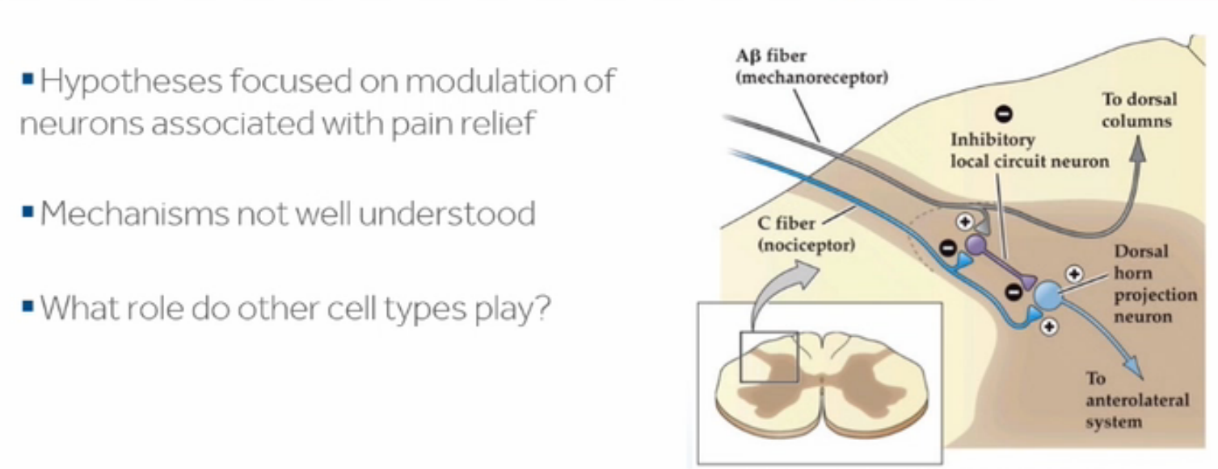

Central pathways (from dorsal horn neurons):
- some axons end in spinal cord / brain stem.
- most axons enter fast anterolateral system see p. A49 (1) >>
many fibers also enter spinoreticular, spinomesencephalic, spinocervical tracts - end in reticular system (which projects to midline and intralaminar nonspecific projection nuclei of thalamus – ARAS activation), hypothalamus, periaqueductal gray (area concerned with pain inhibition).
- projections end in ventral posterior nuclei of thalamus (mainly ventral posterior lateral nucleus; ventral posterior medial nucleus receives input from nociceptive neurons in trigeminal nuclei).
- pain activates contralateral cortical areas SI, SII, cingulate gyrus, mediofrontal cortex, insular cortex, cerebellum.
anticipation of pain (vs. pain itself) activates mediofrontal cortex, insular cortex, and cerebellum.

Physiologic significance
- painful stimuli initiate potent withdrawal & avoidance responses.
N.B. pain sensation purpose is not to inform brain about stimulus quality, but to indicate that stimulus is physically damaging (so receptors are called nociceptors).
- pain is useful sensation only if it leads to stimulus removal! (loss of pain sensation → painless, repetitive traumatic lesions).
- pain is unique among sensations - has "built-in" unpleasant affect.
- pain was called by Sherrington "physical adjunct of imperative protective reflex".
N.B. sensory stimuli can be perceived without cerebral cortex (this is especially true for pain) - cortical areas are concerned with discriminative, exact, meaningful interpretation of pain and some of its emotional components, but perception alone does not require cortex!

Pain Types
Time
Acute pain (lasts or is anticipated to last < 1 month) - essential biologic signal.
- associated with sympathetic nervous system hyperactivity (e.g. tachycardia, ↑respiratory rate and BP, diaphoresis, dilated pupils) and anxiety.

Chronic pain - has no adaptive biologic role.
  - pain persisting > 1 mo beyond usual healing period of tissue injury.
  - pain persisting / recurring for > 3-6 mo.
  - pain associated with tissue injury that is expected to continue or progress.
- associated with vegetative signs (e.g. lassitude, sleep disturbance, ↓appetite, weight loss, ↓libido, constipation) and depression.

According to pathologic substrate:
Somatogenic pain (nociceptive or neuropathic).
Psychogenic pain.

Etiopathophysiology
Nociceptive pain - result of activity in normal pain receptors (no primary dysfunction of nervous system) - indicates disorder in any other system or organ; diagnosis & treatment involve different medical specialties.
- after anything more than minor injury, postinjury pain persists while injury heals.

Inflammatory pain - spontaneous pain and hypersensitivity to pain in response to tissue damage and inflammation.
- alterations in nociceptive terminals can occur as result of local tissue damage and inflammation.
- bradykinin, prostaglandins, and nerve growth factor sensitize nociceptor terminal so it becomes hypersensitive to subsequent stimuli without producing direct nociceptive activation.
- COX-2 is induced by inflammatory mediators – NSAIDs have no effect on nociceptive or immediate inflammatory pain.

Neuropathic pain - spontaneous pain and hypersensitivity to pain - results of dysfunction of nervous system (i.e. “positive” sensory phenomenon); treatment involves neurological team.
- if nerves are damaged, neuropathic pain may persist and become strange burning, tingling, or electric shock-like*, excruciating even after injury heals; usually in area of sensory loss; very difficult condition to treat (resistant to analgesics).
*generation of ectopic impulses in nociceptive pathways
- neuropathic pain is chronic or recurrent (exception - acute burning pain of herpes zoster).

Central pain augmentation (s. dysfunctional, functional, or undetermined pain)
- no neurologic deficit or peripheral abnormality can be found.
- pain is due to abnormal responsiveness of nervous system causing heightened sensitivity to sensory mechanisms, thus amplifying pain symptoms.
- examples: fibromyalgia, migraine, irritable bowel syndrome.

Mechanisms of hyperalgesia, allodynia & neuropathic pain:
- ↑sensitivity of peripheral pain receptors (due to local release of sensitizing substances).
- damaged fibers become highly mechanosensitive and fire spontaneously without stimulation.
- after nerve injuries electrical impulses may spread abnormally from sympathetic fiber to afferent fiber (ephaptic conduction s. “artificial synapses”).
- denervated spinal neurons become spontaneously active.
- ↑release of substance P (→ increased transmission at dorsal horn “gates”) – due to:
  - increased activity of presynaptic NMDA receptors.
  - gene switch → some Aβ fibers (from mechanoreceptors) start to produce substance P.

hyperalgesia - stimuli that would normally cause only minor pain produce exaggerated response.
allodynia - normally innocuous stimuli (such as touch) cause pain.
- due to sensitizing inflammatory mediators (bradykinin, prostaglandins, leukotrienes).
- in clinical practice, hyperalgesia and allodynia always coexist (term “hyperalgesia” is used to refer to both) – perceived as tenderness, soreness.
- hyperalgesia can be elicited by mechanical and thermal stimuli:
Dynamic mechanical hyperalgesia - induced by light skin stroking.
Static mechanical hyperalgesia - induced by sustained light pressure (e.g. pinching).

Location
Deep Pain
- from periosteum and ligaments.
- poorly localized, nauseating, frequently associated with sweating and changes in blood pressure.
- initiates reflex contraction of nearby skeletal muscles (steadily contracting muscles become ischemic → ischemia stimulates pain receptors → more spasm).

Muscle Pain
- during adequate blood supply, pain does not result.
- if blood supply is occluded, muscle contraction soon causes pain; pain persists after contraction until blood flow is reestablished.
- mechanism – muscle contraction releases chemical agent (Lewis "P factor")* that causes pain; when blood supply is restored, agent is washed out or metabolized.
*P factor identity is not settled (could be K⁺).
- clinical examples: angina pectoris, intermittent claudication.

Visceral Pain
- poorly localized, can be very severe (!), associated with autonomic symptoms (e.g. nausea, vomiting, hypotension, sweating) – unpleasant.
- often radiates or is referred to other areas.
- receptors for pain (and other sensory modalities) in viscera are similar to those in skin, but there are marked differences in their distribution:
- no proprioceptors in viscera;
- few temperature and touch receptors;
- nociceptors are more sparsely distributed (than in somatic structures) - visceral pain is poorly localized!
- adequate stimuli:
- distention (hollow viscera) → pain that waxes and wanes (intestinal colic).
- spasm / constriction (hollow viscera) → cramping pain
- traction on mesentery
- afferent fibers reach CNS via sympathetic / parasympathetic pathways (see A30 (1) p.)
some substance P-containing afferents make connections via collaterals to postganglionic sympathetic neurons in collateral sympathetic ganglia (reflex visceral control independent of CNS).
- in CNS, visceral sensation travels along same pathways as somatic sensation; cortical receiving areas for visceral sensation are intermixed with somatic receiving areas.

Classic signs of inflammation in abdominal viscus:
- visceral pain
- tenderness – form of hyperalgesia (relatively minor stimuli cause severe pain).
- autonomic changes - due to activation of visceral reflexes.
- reflex contraction of nearby skeletal muscle (e.g. rigid abdominal wall) - most marked when inflammatory processes involve peritoneum; protects underlying inflamed structures from inadvertent trauma ("guarding").

Referred Pain
- visceral pain felt not in viscus but in some somatic structure (may be considerable distance away).
[dif. projected pain – due to direct stimulation of nociceptive pathways]
- deep somatic pain may also be referred, but superficial somatic pain is not.
- when visceral pain is both local and referred, it seems to spread (radiate).
- clinically important examples:
- cardiac pain referred to inner aspect of left arm.
- pain in shoulder tip caused by irritation of central diaphragm portion.
- pain in testicle due to ureter distention.
N.B. sites of reference are not stereotyped - unusual reference sites occur with considerable frequency (e.g. cardiac pain may be purely abdominal).
- dermatomal rule - pain is referred to structure that developed from the same embryonic segment or dermatome as structure in which pain originates.
(e.g. during embryonic development, diaphragm migrates from level of 3-4th cervical segments, the same location at which afferents from shoulder tip enter).
- referred pain is possible only in segments where visceral pain transmission is via sympathetic pathways (so visceral pain cannot be referred into C₁₋₈ and L₃-S₁ dermatomes – do not have ramus communicans albus!)
- experience plays important role:
- in patients who have had previous abdominal surgery, pain of abdominal disease is frequently referred to surgical scars.
- pain originating in maxillary sinus is referred to nearby teeth, but in patients with history of traumatic dental work such pain is regularly referred to previously traumatized teeth (true even when teeth are considerable distance away from sinus).
- mechanisms of referred pain:
- Convergence: there are more sensory fibers in peripheral nerves than axons in spinothalamic tracts – due to convergence of peripheral sensory fibers on spinothalamic neurons (somatic and visceral afferents converge on the same spinothalamic neurons); since somatic pain is much more common than visceral pain, brain has "learned" that activity in given pathway is caused by pain stimulus in particular somatic area.  - Facilitation: collaterals from visceral afferents end on dorsal horn neurons receiving pain impulses from somatic structures; activity in visceral afferents produces EPSPs (increased excitability - minor activity in somatic afferents could cause continuous pain). | 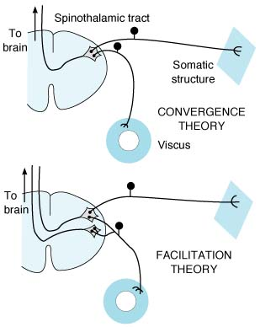
N.B. both convergence and facilitation play role!
If convergence alone were explanation for referred pain, local anesthesia of somatic area of reference should have no effect on pain, whereas if facilitation effects were responsible, pain should disappear. Effects of local anesthesia vary: severe pain is usually unaffected, but mild pain may be completely abolished.

Central Inhibition & Counterirritants
- soldiers wounded in battle may feel no pain until battle is over (stress analgesia - mediated by endogenous opioids, prevented by naloxone).
- touching / shaking injured area decreases pain of injury.
- electric vibrator at pain site gives some relief.
- acupuncture (it is possible to perform major surgery with acupuncture as only type of anesthesia):
- at location distant from pain site (acts by releasing endorphins).
- at pain site (acts as counterirritant).
- skin stimulation (e.g. mustard plaster, hot bottle) over area of visceral inflammation produces some relief.

Endogenous Analgetics
Opioids
see also p. S21 >>
- relieve pain (esp. effective when given intrathecally).
- opioid receptors are produced in dorsal root ganglion cells and migrate both peripherally and centrally along axons.
Sites at which opioids act to produce analgesia:
- peripherally, at injury site – mainly δ receptors binding enkephalins; inflammation causes opioid production by immune cells.
- dorsal horn "gate" – mainly κ receptors; opioids act in substantia gelatinosa presynaptically to decrease substance P release (enkephalin-secreting interneurons).  - rostral sites in brain stem RF (afferents from frontal cortex, hypothalamus) – mainly μ receptors: activation of periaqueductal gray (midbrain) → raphe magnus nucleus (rostral medulla) → descending serotonergic fibers → inhibition at dorsal horn “gate” (mechanism by which serotonin inhibits transmission in dorsal horn is unsettled – may be direct inhibition or via activation of enkephalin interneurons).  - additional descending pathways arise from other brainstem nuclei (locus ceruleus, dorsal raphe nucleus, nucleus reticularis gigantocellularis).  - neurotransmitters utilized by these systems include endorphins, serotonin, norepinephrine (rationale for use of opioids, serotonin agonists, serotonin & norepinephrine reuptake inhibitors). | 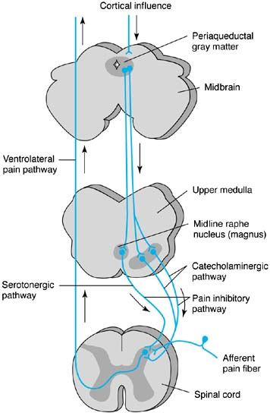

Epibatidine
- cholinergic agonist (first isolated from frog skin) - potent nonaddictive nonopioid analgesic.
- more potent synthetic congeners have been developed.
- effects are blocked by cholinergic blocking drugs.
- nicotine also has analgesic effects.

Cannabinoids
(anandamide, palmitoylethanolamide) see p. A4b >>

Nociceptin & nocistatin
- nociceptin (structurally resembles dynorphin-17):
  - acts at orphan receptor, ORL₁ (opioid-like receptor 1), that did not bind any of opioids with high affinity.
  - causes hyperalgesia rather than analgesia.
  - present in many CNS areas (incl. hypothalamus, brain stem, dorsal horn).
- nociceptin precursor protein also contains nocistatin that antagonizes nociceptin effects.

Pain Evaluation
- distribution: radicular, peripheral nerve, plexus; radiating (referred) vs. projected.
- quality: sharp / burning, spontaneous / stimulus-induced (allodynia, hyperalgesia).
- intensity (0 “no pain” ÷ 10 "the worst pain one can imagine")
- autonomic symptoms (sweating, trophic alterations, skin temperature changes).
- psychologic comorbidities (with emphasis on depression and anxiety); ask if litigation is ongoing or financial compensation for injury will be sought!

- organic cause should always be sought!!! - pain is managed best by removing underlying cause.
- pain and suffering should be distinguished (esp. in cancer patient - suffering may be due as much to loss of function and fear of impending death as to pain).

Instrumental examinations
- Imaging studies (MRI, CT)

- Electrophysiologic studies (of peripheral somatosensory pathways)
  - nerve conduction studies & needle electromyography evaluate motor and large-caliber afferent fibers, leaving unexplored small-caliber afferents; conventional electrophysiological studies are unable to explore pathophysiological substrate of positive sensory phenomena.
N.B. normal nerve conduction study does not necessarily rule out peripheral nerve lesion as cause of pain; abnormal study does not necessarily imply that peripheral nerve lesion is cause of symptoms.
  - microneurography (using intraneural microelectrode) - explores small- and large-caliber afferent fibers including pathophysiological substrate of positive sensory phenomena; procedure is mainly experimental, time consuming, high incidence of false-negative results.
  - Quantitative Somatosensory Thermotest (QST) - routine clinical evaluation of small-caliber afferent pathways: ramp of ascending or descending stimulating temperature is applied to skin through thermostimulator, patient signals his / her threshold for cold, warm, cold pain, and heat pain sensations;
determined thresholds are result of whole afferent pathways (PNS + CNS) - so abnormal pattern does not have precise localizing diagnostic value; nevertheless, certain abnormal patterns are characteristic of some clinical syndromes.

- Skin thermography (specific indications – peripheral nerve lesions: reflex sympathetic dystrophy, focal autonomic neuropathies, focal nerve injuries):
skin temperature↑ - vasomotor sympathetic denervation, neurogenic inflammation (antidromic discharge in C nociceptors via axonal reflex).
skin temperature↓ - reflex increase in sympathetic vasomotor tone (in response to pain), sympathetic denervation supersensitivity.

- Somatosensory evoked potentials (electrophysiological study of central somatosensory pathways);
- explores only large-caliber afferent lemniscal pathway;
- recent development of CO₂ laser somatosensory evoked potentials - exploration of small-caliber spinothalamic pathway.

- Nerve & muscle biopsies
- electron microscopy is essential for evaluation of unmyelinated fibers.

Pain Treatment Principles
postoperative pain management – see p. 3905 >>
It is important to differentiate between nociceptive and neuropathic pain.
Neuropathic pain responds poorly to narcotics and to ablative procedures (exceptions - trigeminal rhizotomy, DREZ lesioning).

N.B. for analgesic orders, it is better instead of PRN to use “ATC unless refused” order
ATC – around the clock; PRN – as needed

Noninvasive Pain Treatment
Drugs
All pain can be relieved by appropriately potent drug at sufficient dosage, although this treatment may also produce sedation or confusion!
- Tricyclic antidepressants (amitriptyline, nortriptyline, desipramine)
- most effective drugs in ongoing burning pain (e.g. in diabetic polyneuropathy, post-herpetic neuralgia).
- analgesic effect is related to blockade of serotonin and norepinephrine reuptake (in periaqueductal gray).
- analgesic effect is not related to antidepressive activity; they do not reduce pain threshold in normal skin.

- IV. Selective Serotonin-Norepinephrine Reuptake Inhibitors (SNRIs)
Duloxetine (Cymbalta) - FDA approved for chronic musculoskeletal pain (including discomfort from osteoarthritis and chronic lower back pain), diabetic peripheral neuropathy, fibromyalgia. see p. Psy15 >>

- Anticonvulsants (gabapentin*, pregabalin**, phenytoin, carbamazepine, lamotrigine)
see p. E3 >>
*first choice **second choice
- particularly useful for lancinating pain (ectopic impulse generation at peripheral or central levels): trigeminal neuralgia, entrapment / traumatic neuropathies.
- mechanism of action - membrane-stabilizing effect.

- Topical local anesthetic preparations, e.g. EMLA cream (eutectic mixture of local anesthetics - 2.5% lidocaine and 2.5% prilocaine), tetracaine in liposomes (penetrates stratum corneum).
- extensively used in post-herpetic neuralgia.
- mechanism of action - inhibition of sodium entry into cell (regenerating nerve endings develop dense concentrations of sodium channels).
- local anesthetics have been also tried orally (e.g. mexiletine).

- Opioids – indicated for: opioid dosage guidelines see p. S21 >>
  - acute severe pain
  - chronic cancer pain
  - chronic noncancerous pain – only after careful patient selection (ideally, by pain management specialists)!
N.B. although physical (pharmacological) dependence occurs in virtually all patients treated for chronic pain with opioids for long time, addiction (psychologic dependence) is extremely rare without history of substance abuse.
- mechanism of action – pain impulse transmission↓.
- most appropriate for moderate ÷ moderately severe chronic noncancerous pain is long-acting opioid or opioid combination drug; immediate-release opioid treatment is useful for breakthrough pain.
Butrans® - FDA approved once-weekly buprenorphine transdermal system for moderate to severe chronic pain in patients requiring continuous, around-the-clock opioid analgesic for an extended period; patches will be available in 5, 10, and 20 μg/hour strengths
- tramadol, tapentadol – advantageous dual action medications (opioid agonist + norepinephrine serotonin reuptake inhibitors), FDA approved for pain treatment. see p. S21 >>

- NMDA-receptor antagonists (e.g. ketamine in subanesthetic doses); works at spinal cord C afferents; main drawback - mental side effects.

- Topical capsaicin (extracted from hot pepper, Solanaceae family) - after long-term skin application produces hypalgesia.
- mechanism of action - depletion of substance P.
- used in painful diabetic neuropathy, post-herpetic neuralgia.
- main drawbacks - intense burning pain, mechanical hyperalgesia during first weeks of application.

- NSAIDs (aspirin, indomethacin, diclofenac, benzydamine, ketorolac*).
- effective for mild ÷ moderate pain; may be combined with opioids.
- used in trauma & inflammation.
- mechanism of action - blockade of receptors of inflammatory mediators, stabilization of neuronal membranes, inhibition of prostaglandin synthesis.
*has oral, IM, IV and intranasal forms
- Corticosteroids (dexamethasone) are effective adjuncts for pain due to malignant infiltration of neural structures.

- Muscle relaxants are effective adjuncts for pain with muscle spasms
N.B. avoid carisoprodol (Soma) – converted into benzodiazepines – addictive potential!

- Botulinum toxin - adjunct for treatment of piriformis syndrome.

Physical therapy
- to minimize pathologic immobilization that seems to underlie many cases of progressive disability (trophic changes, disuse atrophy, ankylosis)!
- Heat - temporary relief in subacute and chronic traumatic and inflammatory disorders; heat increases blood flow and extensibility of connective tissue; heat application may be superficial or deep; contraindications: cancer, hemorrhagic disorders, advanced heart disorder, peripheral vascular disease, impaired skin sensation (esp. to temperature and pain), significant hepatic or renal insufficiency.
- infrared heat - applied with lamp, for 20 min/day;
- hot packs - cotton cloth containers filled with silicate gel; they are boiled in water or warmed in microwave oven, then applied to skin; wrapping packs in several layers of towels helps protect from burns.
- paraffin bath - affected area is immersed in (usually small joints), or painted (usually large joints) with melted wax heated to 49° C; heat is retained by wrapping with towels for 20 min.
- hydrotherapy - used to enhance wound healing - agitated warm water stimulates blood flow and débrides wounds; often given in Hubbard tank (large industrial whirlpool) with water heated to 35.5-37.7° C; total immersion in water heated to 37.7-40° C relaxes muscles and relieves pain; particularly useful with range-of-motion exercises.
- diathermy (local therapeutic heating of tissues):
Short wave diathermy - uses oscillating high-frequency electromagnetic fields applied with capacitor plates or inductive coil applicators; rarely very effective; additional contraindications: nonremovable prostheses, pacemakers, electrophysiologic braces.
Short wave diathermy cannot be used if patients have metal implants in or near area to be treated.
Microwave diathermy - uses microwaves; simpler to apply, output can be adjusted more accurately, more comfortable; provides deeper heat without undue heating of skin (microwaves are selectively absorbed in tissues with high water content, e.g. muscles); contraindications – see short wave diathermy.
Ultrasound diathermy - uses high-frequency sound waves to penetrate deep (4-10 cm) into tissue; effects are thermal, mechanical, chemical, and biologic; should not be applied to ischemic tissue, anesthetized areas, or over eyes, brain, spinal cord, ears, heart, reproductive organs, brachial plexus, healing bones.

- Cold (e.g. ice bag, cold pack, volatile fluids, soaking extremities in cool tap water) – for acute pain (esp. traumatic, inflammatory).
- choice between heat and cold therapies is often empiric (when heat does not work, cold is applied); for acute pain, cold seems to be better than heat (cold is used during first few hours or day).
- cold induces some local anesthesia.
- cold should not be applied over poorly perfused areas.

- Orthotic devices

- Mechanotherapy:
- cervical traction (for chronic neck pain); vertical traction (with patients in sitting position) is more effective than horizontal traction (with patients lying in bed); motorized intermittent rhythmic traction with 7.5-10 kg is most effective; for best results, traction should be applied with patient's neck flexed 15-20° (hyperextension may increase nerve root compression in intervertebral foramina).
- massage - mobilizes contracted tissues, relieves pain, reduces swelling and induration; do not use to treat infections or thrombophlebitis.

- Acupuncture (for chronic pain, for stroke victims to enhance rehabilitation) – thin needles inserted through skin at specific body sites, frequently far from site of pain; used with other treatments.

Transcutaneous Electrical Nerve Stimulation (TENS)
- uses low current at low-frequency oscillation; gentle tingling sensation without increased muscle tension.
- 20 min ÷ few hours may be applied several times daily.
- covered by most insurances.
- totally free of side effects*, and virtually nothing is lost if it is ineffective (allow adequate trial of several weeks!).
*TENS may cause arrhythmia; should not be applied over eyes

Psychotherapy
- pain-modification techniques (guided mental imagery, hypnosis, relaxation).
CBT (cognitive behavioral therapy) has high value in chronic pain management!
- treatment of depression, anxiety.

Invasive Pain Treatment
- Neuromodulation procedures (activate intrinsic modulating systems):
  - chronic intrathecal infusions
  - electrical stimulation (mainly for neuropathic pain)
- Neuroablative procedures (mainly for nociceptive pain)

Sympathetic blocks
(of different kinds) - traditionally used in belief that sympathetic system maintains pain; recently challenged on basis of placebo-controlled trials.
  - blocks of stellate ganglion - for upper extremity.
  - blocks of lumbar chain - for lower extremity.
- main indication - complex regional pain syndromes (reflex sympathetic dystrophy, causalgia).
- if blocks improve pain but only temporarily, many clinicians recommend sympathectomy.

Intrathecal Infusions
See p. Op240 >>

Drugs
- Morphine
- Bupivacaine (off-label use for this drug)
- Clonidine (off-label use for this drug)
- Ziconotide

ziconotide (Prialt®) - N-type calcium channel blocker.
- binds to N-type calcium channels located on primary nociceptive (A-δ and C) afferent nerves in superficial layers (Rexed laminae I and II) of dorsal horn → blockade of neurotransmitter release in primary afferent nerve terminals → antinociception.
- does not bind to opioid receptors (does not potentiate morphine-induced respiratory depression!), pharmacological effects are not blocked by opioid antagonists.
- administered as intrathecal infusion
- FDA indicated for severe chronic pain when intrathecal therapy is warranted + when refractory to other treatment (such as systemic analgesics, adjunctive therapies or intrathecal morphine).
- molecule - 25 amino acid peptide - completely degraded by endopeptidases and exopeptidases widely located throughout body (metabolic interactions with other drugs thus unlikely).
- CSF clearance approximates adult human CSF turnover rate (0.3–0.4 mL/min); terminal half-life in CSF after intrathecal administration ≈ 4.6 hours.
- severe psychiatric and neurological symptoms may occur:
    - cognitive adverse events (reversible within 2 weeks after drug discontinuation): confusion (33%), memory impairment (22%), speech disorder (14%), aphasia (12%), thinking abnormal (8%), amnesia (1%).
    - acute psychiatric disturbances: hallucinations (12%), paranoid reactions (3%), hostility (2%), delirium (2%), psychosis (1%), manic reactions (0.4%).
    - unresponsiveness or stupor (2%).
- contraindication - pre-existing psychosis; all other patients should be frequently monitored for cognitive impairment, hallucinations, changes in mood or consciousness.
- therapy can be discontinued abruptly without withdrawal effects.
no known antidote to ziconotide!

intrathecal (intraventricular / intraspinal) morphine
- indicated in narcotic-responsive pain that is not adequately controlled, usually due to side effects, by systemic opioids.
- effective for nociceptive pain in any anatomic distribution.
Intraspinal morphine:
  - hyperbaric solution (7% dextrose) - for pain in lower trunk, pelvis, legs.
  - isotonic solution (0,9% saline) - for analgesia up through caudal cervical segments.
Intraventricular morphine - for cervicofacial pain, diffuse pain.
- main advantage - pain control with micro quantities of morphine - avoids systemic side effects.
- use test injections first; neither analgesia nor side effects develop until there is some degree of receptor saturation (after 30-45 min) - patients should be observed overnight.
- after single intraspinal injection - serum levels of morphine are negligible, onset of action is 5-10 minutes, effect lasts 10-30 hours.
vs. epidural administration - slower onset (1 hour), greater redistribution into epidural vasculature (higher serum levels), but limited CSF redistribution (more regionalized effect!).
- doses vary (trend to double or triple dose over patient life span); “drug holiday” may slow tolerance development.
- contraindications:
- significant side effects on test injection.
- high risk of infection or hemorrhage.
- patient's inability to comprehend need for periodic refilling (or lack of available local medical resources for refilling).
- history of prolonged use of high-dose opiates (tolerance may develop rapidly).

Neuromodulation / Electrical Stimulation
- procedures are reversible!
N.B. patients can stimulate themselves as needed, but pain relief diminishes with time (stimulation tolerance)!

Transcutaneous electrical nerve stimulation (TENS)
See above >>

Spinal cord (dorsal columns) stimulation (SCS)
See p. Op240 >>

Deep brain stimulation (DBS)
– for affective component of pain.

History
- the earliest use of DBS was in the treatment of pain (not movement disorders!), predating the discovery of dorsal column stimulation and even the “gate control” theory of pain by more than a decade.
- although early success was seen in small case series, the structured clinical trials that followed were marred by low patient enrollment, high attrition and poor overall efficacy1, which led to the FDA conferring “off-label” status for the use of DBS for chronic pain.

Targets and indications
In the 1950s, Heath and Mickle observed that septal stimulation alleviated intractable pain related to cancer or rheumatoid arthritis.
Stimulation of descending endorphin system (↑release of β-endorphin) – most effective for nociceptive pain (DBS produces a sensation of warmth).
- target in periventricular gray (PVG) - within several millimeters of wall of 3rd ventricle and slightly anterior to posterior commissure.
- periaqueductal gray (PAG) stimulation produces similar pain relief but also may cause oscillopsia or severe anxiety.
- particularly susceptible to tolerance, with the need for higher stimulation parameters over time to achieve the same therapeutic effect.

Stimulation of ascending lemniscal system (exact mechanism of pain relief unknown) – most effective for neuropathic pain (DBS produces paresthesia overlapping the painful area)
- target in somatosensory ventrocaudal (Vc) thalamic nucleus (VPM-VPL) or in sensory portion (posterior third of posterior limb) of internal capsule.

Patient with a previous left middle cerebral artery infarction and central post-stroke pain - electrodes targeting both the thalamus (VPL) and PVG will be implanted in the same patient, contralateral to the side of pain:
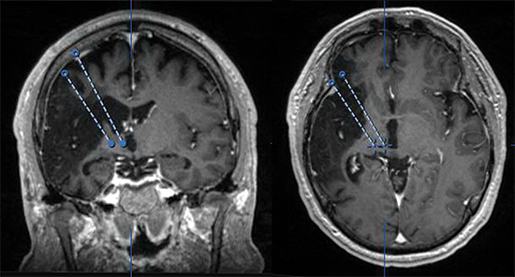

Oxford group’s recommends first implantation of the PAG/PVG and testing for intraoperative improvement (pleasant warmth—a sensation of warmth or analgesia in the painful body area); if this is not detected, they move on to the sensory thalamus.

For affective component of chronic pain – target in anterior cingulate cortex (ACC) 20 mm posterior to anterior tip of frontal horns of lateral ventricles; position contacts mostly in white matter, cingulum bundle, with deepest contact in corpus callosum:
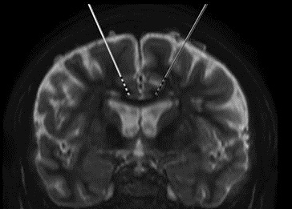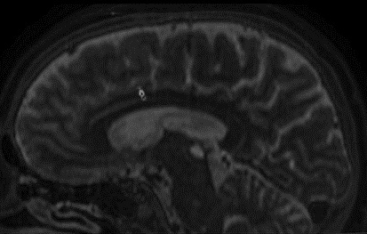
- ACC is involved in processing affective component of pain.
- patients not always describe decrease in their pain intensity; patients describe feeling as if their pain was separate from them physically and said that they did not think about it anymore (although they could still sense it) → improved quality of life.
- there is a latency period until clinical improvement is observed, compared to the “immediate” effects or either sensory thalamus or PAG/PVG stimulation.
- complications – risk of inducing epilepsy.

Outcomes
- poststroke pain: 40-50% pain relief with PAG/PVG and/or VPM/VPL DBS (trend to higher improvement among the patients who had suffered cortical vs subcortical strokes); longer F/U results are more disappointing.
- phantom limb pain: one of the largest series that has been published is from Oxford and included 9 patients: 8 patients (89%) improved with a mean follow-up of 31.9 mo.
- brachial plexus injury pain: significantly worse outcomes compared to those treated for phantom limb pain.

Epidural motor cortex stimulation
- pain relief same as thalamic Vc DBS

Motor cortex stimulation
- improves quality of life in patients with chronic refractory neuropathic pain.
- additional factors other than a simple analgesic effect may contribute to these results.

Neuroablative Procedures
Classification
- Peripheral:
  - Neuroma resection
  - Neurectomy
  - Sympathectomy
  - Ganglionectomy
  - Rhizotomy
  - Intrathecal alcohol

- Spinal:
  - Cordotomy
  - Midline myelotomy
  - DREZ myelotomy
  - Trigeminal tractotomy

- Cranial:
- Mesencephalic tractotomy
- Thalamotomy
- Hypophysectomy
- Cingulotomy

- there are no absolute criteria for surgical intervention timing - final consideration of surgery should occur only when all attempts at conservative management have failed.
- many unsatisfactory outcomes of surgery result from failure to take account of behavioral component (some patients feel better when physician acknowledges their severe pain without necessarily curing it; for a few, acknowledgment is even more important than cure!).
N.B. in chronic neuropathic pain syndromes it is necessary that patients undergo psychological evaluation, including Minnesota Multiphasic Personality Inventory (MMPI), and that evaluating psychologist address issue of appropriateness of medical or surgical management. Patients with significant psychological factors involved in chronic pain behavior are better off!

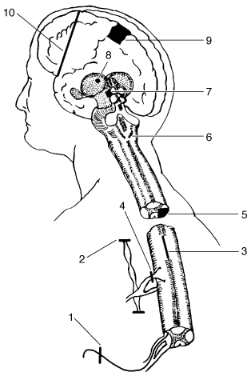 | - Nerve section  - Sympathectomy  - Myelotomy  - Posterior rhizotomy  - Anterolateral cordotomy  - Medullary tractotomy  - Mesencephalic tractotomy  - Thalamotomy  - Cingulate gyrectomy  - Prefrontal lobotomy

Peripheral
Sympathectomy
- indication - sympathetically mediated pain, pain of peripheral vascular occlusive disease (e.g. Raynaud's phenomenon), postamputation pain of digits, pain of chronic pancreatitis (celiac plexus ablation).
- endoscopic approach.
- for upper extremity pain → sympathectomy of T₂₋₃ ; preserve T₁ to avoid Horner’s syndrome;
for lower extremity pain → sympathectomy of L₁₋₂ (complete denervation may require section up to T₁₁ ganglion).

Neurectomy
- most peripheral nerves are mixed, reducing value of transection unless motor loss is acceptable.
notable exception - superficial branch of dorsal interosseous nerve in forearm - purely sensory nerve - best treated by transection rather than attempted repair following injury.
- main indication - painful neuromas (but these often recur*).
*procedures to prevent this recurrence - separating two nerve ends, burying nerve in muscle, burying nerve in bone, covering nerve with Silastic.
- ablation of infraorbital, supraorbital, or mental nerves - treatment of trigeminal neuralgia (benefit is often temporary).
- denervation of facet joints in spine - to relieve chronic low back pain (controversial).

Rhizotomy
- ablation of sensory root:
- Trigeminal rhizotomy – see Trigeminal Neuralgia
- Posterior rhizotomy:
- indications remain elusive (majority of large series are disappointing):
- most common indication - pain following unsuccessful disc procedures.
- cancer pain involving limited dermatomal region.
- postherpetic neuralgia
- postthoracotomy pain.
- preoperative series of selective root blocks (but pain relief does not guarantee equally successful surgical outcome!).
- at least three roots must be taken.
N.B. sacrifice of > 2 sensory roots in extremity can lead to loss of function, in spite of preserved motor capacity!
- if S₂ is preserved on one side, bladder control should be possible.
- preserving C₆ or C₇, or C₅ and C₈, is recommended to avoid upper extremity proprioceptive difficulties.
- in lower extremity, L₂, L₃, or L₄ should be preserved.
- approach:
  - open procedure (intradurally or extradurally)
  - percutaneous procedure (RF coagulation or injections).
- technically simple, but accurate localization is imperative (use stimulation!).
- avoid vascular injury - blood supply to cord enters along roots.

Ganglionectomy
Removes pain transmitting neurons (which DREZ may not achieve)

Trigeminal - historical

Cervical
Easy for C2 (for intractable occipital neuralgia); other levels need facetectomies:

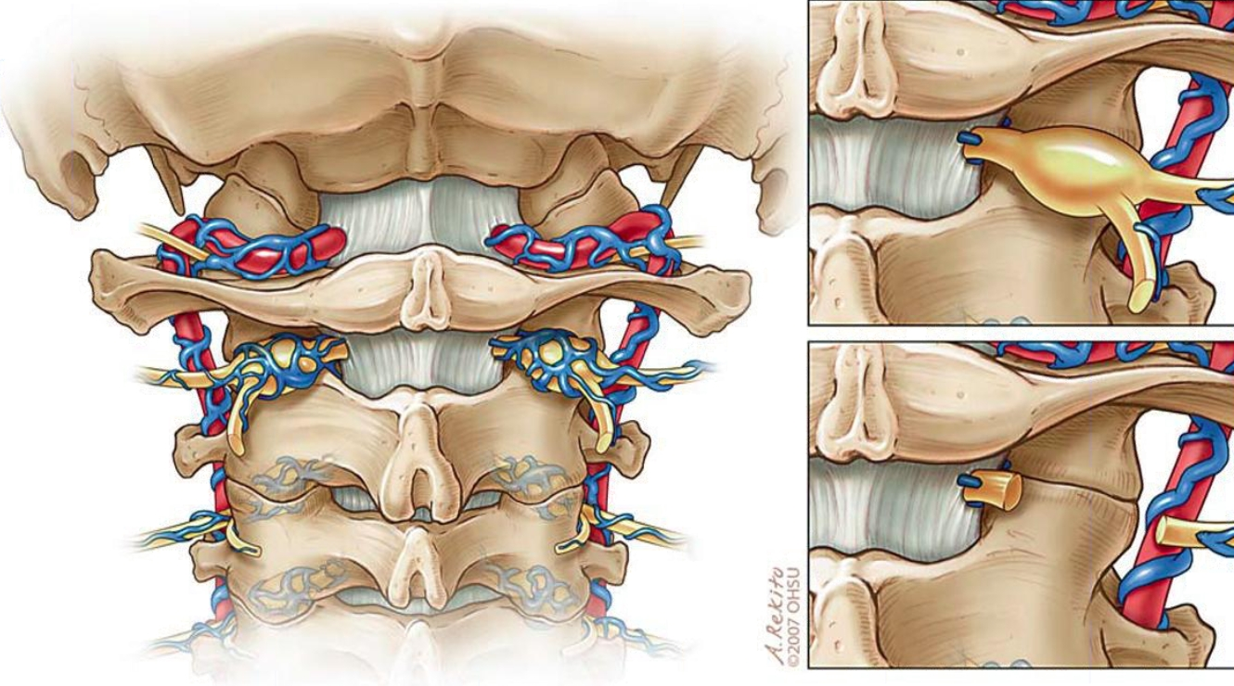
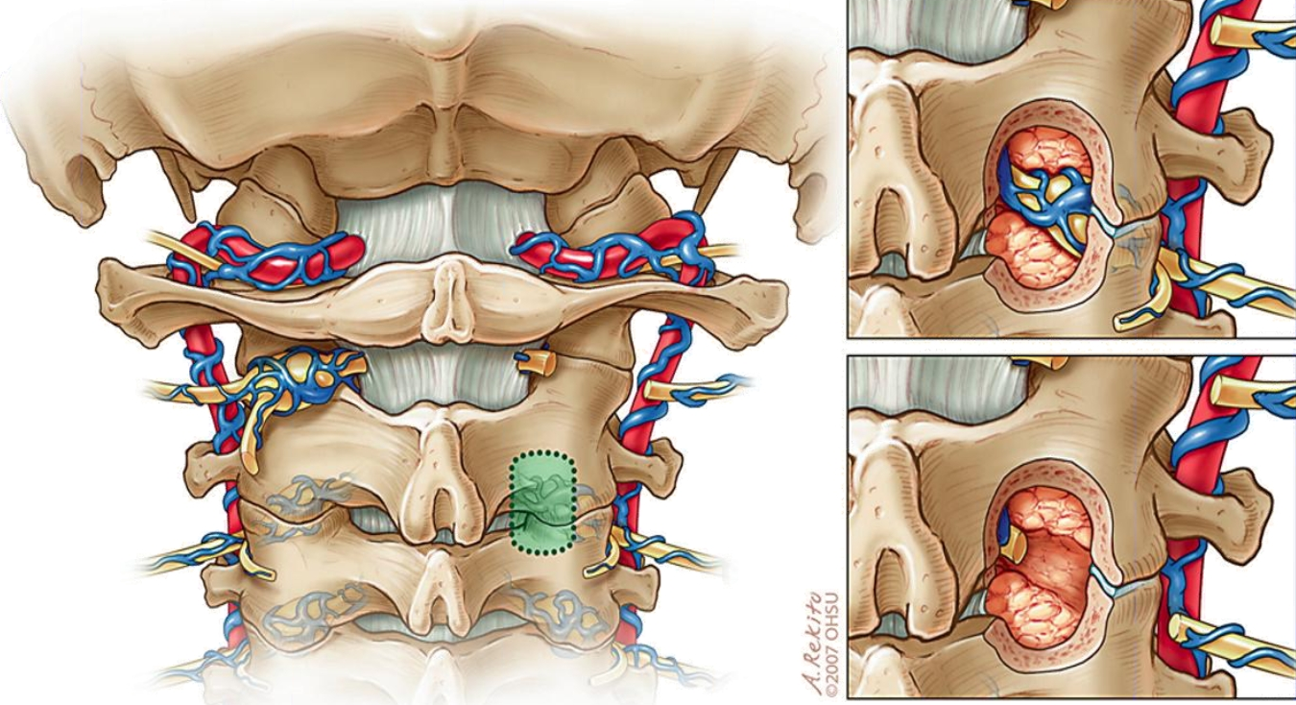

Thoracic – better than rhizotomy due to some sensory fibers entering via ventral roots:
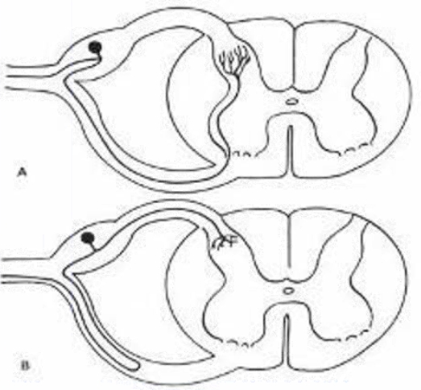

- preop do test block injections.
- extradural exposure
- 3-level surgery (1 level above and 1 level below affected level)
- cut / clip inside foramen

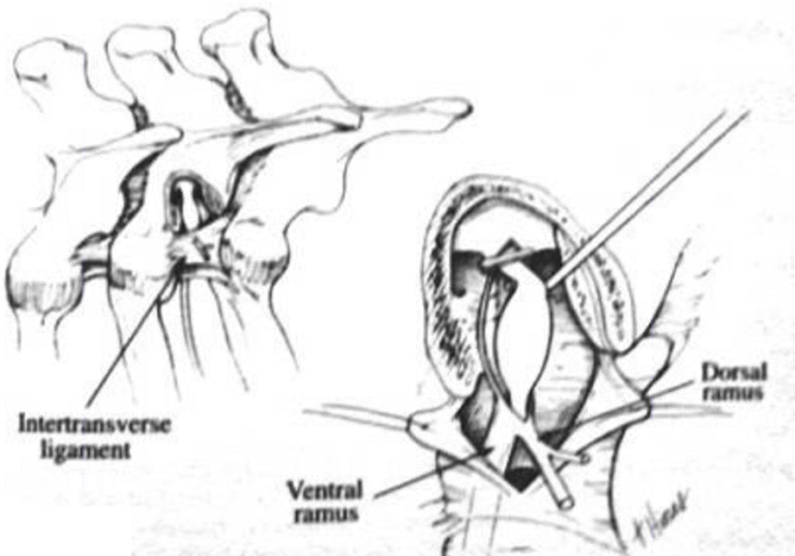
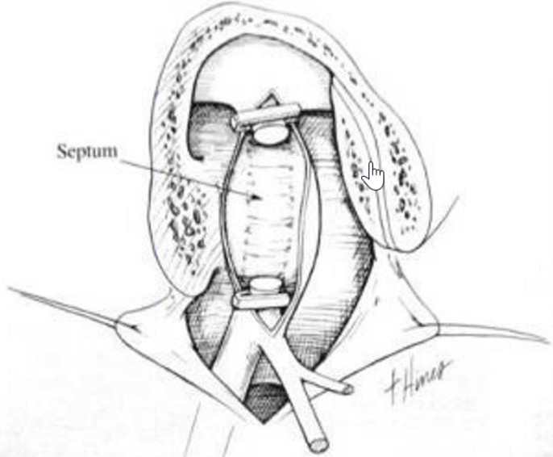

Intrathecal alcohol
– for pain confined to 1-2 unilateral segments.
- absolute alcohol is instantaneously neurolytic.
- absolute alcohol is hypobaric – patient lies in decubitus position (painful side up), slightly prone (irrigation of posterior roots) on table with Trendelenburg controls.
- draw 1 cm³ alcohol into tuberculin syringe before lumbar puncture.
- after needle penetrates dura, it is rotated several times (to allow arachnoid membrane to move away from needle tip – to avoid subdural injection); needle advanced several more millimeters and rotated few times again; with needle bevel pointing toward root, injection is begun (only after good CSF flow is assured) in 0.1-mm increments.
- initial 0.1 cm³ injection: if stinging, burning pain anywhere other than at pain site, he / she is instructed to cough (to break up small alcohol volume) and is then repositioned immediately.
e.g. if patient undergoing S₁ rhizolysis complains of pain in left L₅ distribution → cough → reposition with head in Trendelenburg position.
- after injection of 0.2 - 0.3 cm³ both stinging injection pain and cancer pain should begin to subside (≈ 0.5 cm³ will give satisfactory block).
N.B. patient cooperation is imperative!
- relief lasts up to 6 months (less in cancer extension).

Spinal
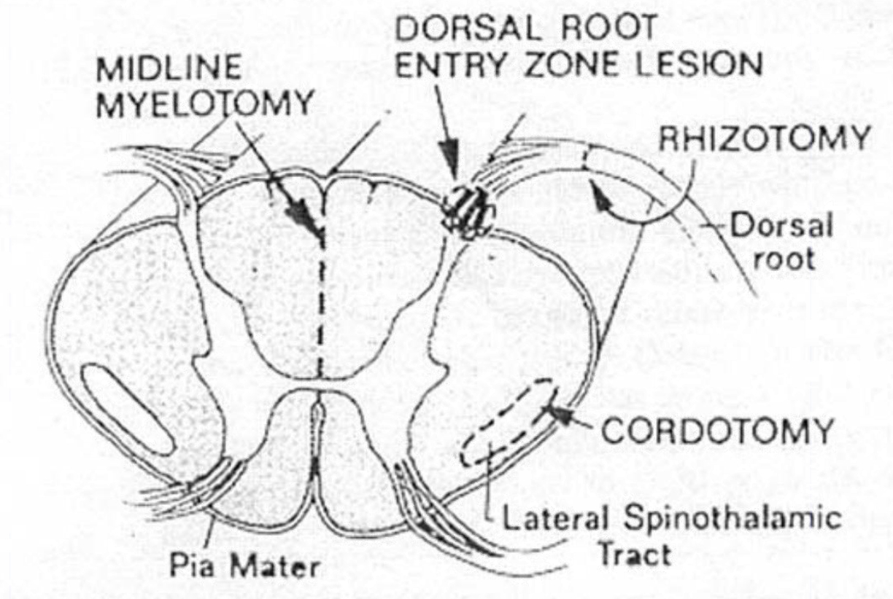
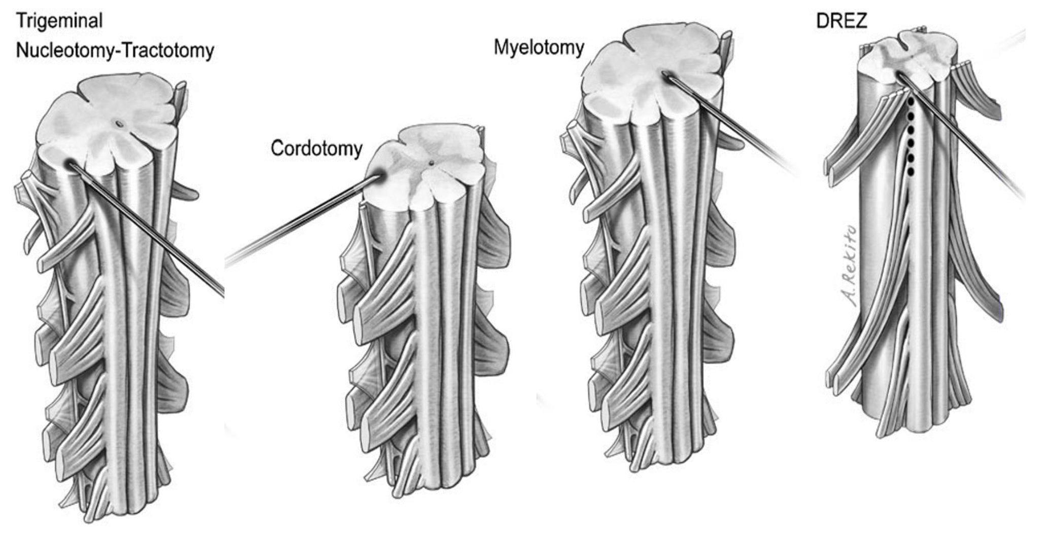

Monitoring
    - Awake patient
    - SSEP, MEP – to avoid complications (not to guide effect)

Drez (Dorsal Root Entry Zone) Myelotomy
- indications (effective in deafferentation pain!; initially was developed to treat spasticity):
- brachial plexus avulsion pain - segments involved are lesioned. see also p. PN7 >>
DREZ myelotomy is only effective procedure!
- spinal cord injury (postparaplegia) end-zone pain - two segments rostral and one segment caudal to level of transection are lesioned.
- phantom limb pain - segments involved with pain as well as one segment rostral and caudal are lesioned.
- only selected cases of postherpetic neuralgia (best results in superficial burning, itching pain with hyperalgesia, and absence of sensory deficits) – but indication is poor.
- DREZ anatomy:
- dorsal rootlets, Lissauer’s tract, and the dorsal horn together constitute the DREZ.
- the mean angle is 30 degrees at C6, 26 degrees at T4, 37 degrees at T12, and 36 degrees at L3
- afferent nociceptive fibers, before entering the dorsal horn, bifurcate rostrocaudally or trifurcate rostrocaudal laterally to run for a few segments in a thin Lissauer’s tract of small axons capping the dorsal horn and giving off branches into the gray matter at different levels.
- Lissauer’s tract has the important assignment of modulating the signals transmitting from afferent nociceptive fibers.
- lateral part of Lissauer’s tract contains the propriospinal fibers; therefore, destruction of the medial (or lateral?) part of Lissauer’s tract should result in decreased excitability of nociceptive fibers.
- mechanism of action:
- DREZ operations were introduced after the demonstration of increased electrical activity in the dorsal horn of the spinal cord and brainstem in patients with CNS deafferentation (e.g. brachial plexus avulsion); nociceptive axonal endings terminate in Rexed levels 1 to 2 and 5 - neurons in these areas begin to fire in a manner similar to those contained in an epileptogenic area after deafferentation; thus, DREZotomy aims to destroy these hyperactive areas to eliminate central pain.
- originally designed to destroy superficial layers of posterior horn; recent evidence suggests - should destroy Lissauer tract and layers I to V.
- mechanism of destruction (RF current, laser, incision and microbipolar coagulation) is not as important as accuracy & completeness of destruction.
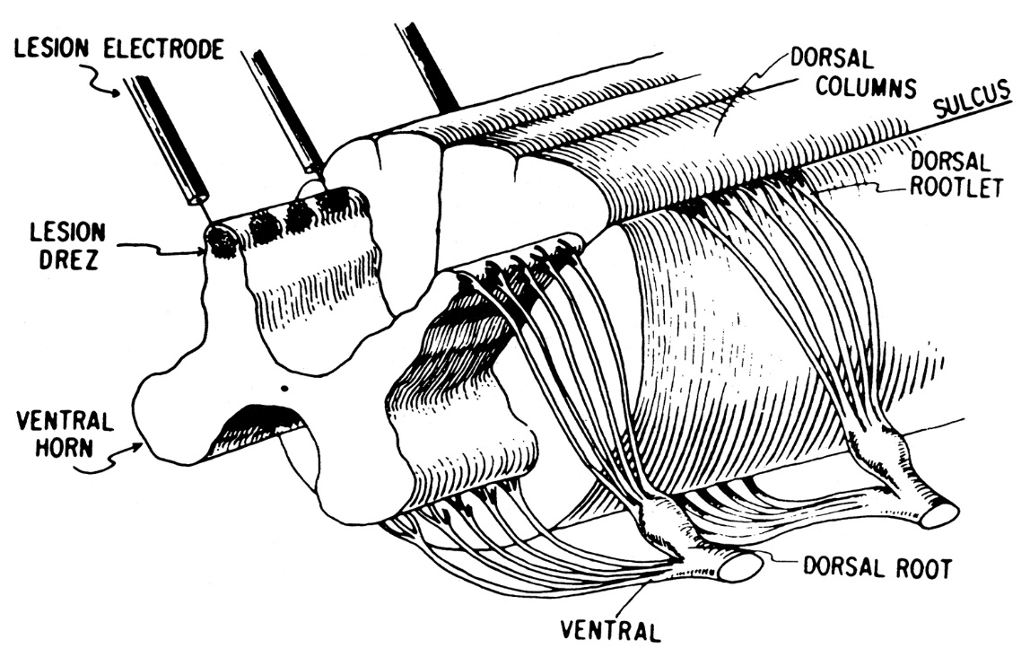

- technique:
- expose one level above and one level below the avulsed roots for proper identification of normal dorsal roots and DREZ in anatomical place above and below the area affected by avulsion healed by scarring and even cord rotation.
- cervical hemi-laminectomy (sometimes a complete cervical laminectomy is needed due to extensive scarring at the affected site and for proper anatomical verification of DREZ comparing to the contralateral normal side).
- midline durotomy.
- RF lesions are started using DREZ kit with the electrode at 30 degrees oblique of the coronal plane; lesions are made 1 mm apart with 75ºC for 15 seconds per lesion.

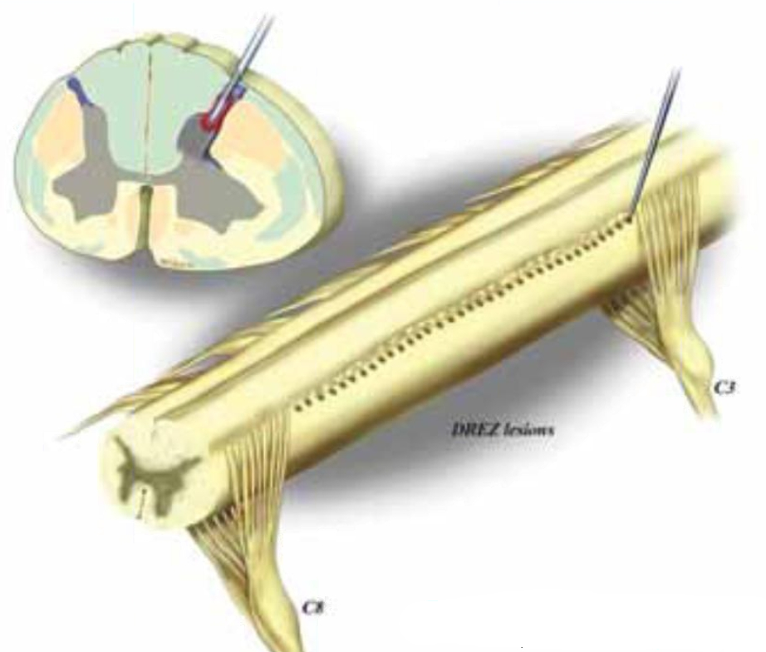

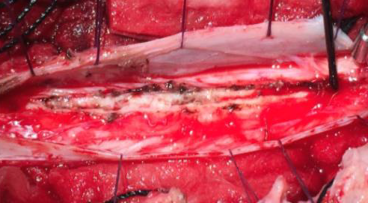

- complications
- temporary ipsilateral ataxia - probably due to involvement of dorsal spinocerebellar tract.
Intraoperative monitoring could limit thermal effects on the long tract.
- temporary hemiparesis
- CSF leak.
- outcomes:
  - cervical root avulsions - results are better for complete avulsions than for incomplete.
  - BPA – 60-80% improvement in most series
  - SCI – 50-67%
  - postherpetic neuralgia – 25%

Nucleus caudalis DREZ coagulation - extension of DREZ lesioning to trigeminal nucleus caudalis (subserves pain-temperature-crude touch from V, VII, IX, and X cranial nerves).
- El-Naggar/Nashold electrode.
- most significant risk is ataxia (injury to spinocerebellar tract, which overlies nucleus caudalis).

(Anterolateral) Cordotomy
- interruption of nociceptive pathways in anterolateral column (spinothalamic tract)
- for contralateral multisegmental pain.

Preoperative rule out:
- deafferentation pain (→ worsening of already intractable pain).
- any pain on opposite side (H: bilateral high thoracic cordotomy or commissural myelotomy).

Relative contraindications:
- respiratory compromise (esp. in high cervical cordotomy).
voluntary respiration control - lateral corticospinal tracts (spared).
involuntary respiration control – in anterolateral quadrant immediately medial to cervical spinothalamic fibers – can be severed in bilateral high* cervical cordotomy (→ fatal sleep apnea [Ondine's curse]); failure to respond to CO₂ challenge with hyperventilation may predict this complication preoperatively.
*bilateral cordotomy – only for below C5
- preexisting bowel / bladder dysfunction (ascending pathways for sensation of bladder fullness are located in anterolateral quadrant, just medial to sacral spinothalamic fibers).
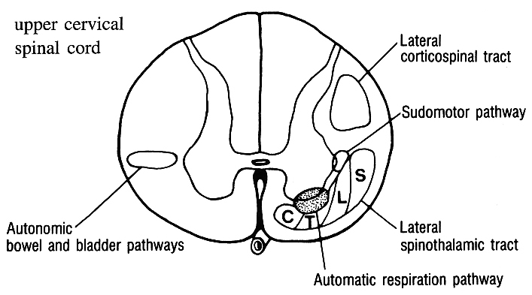
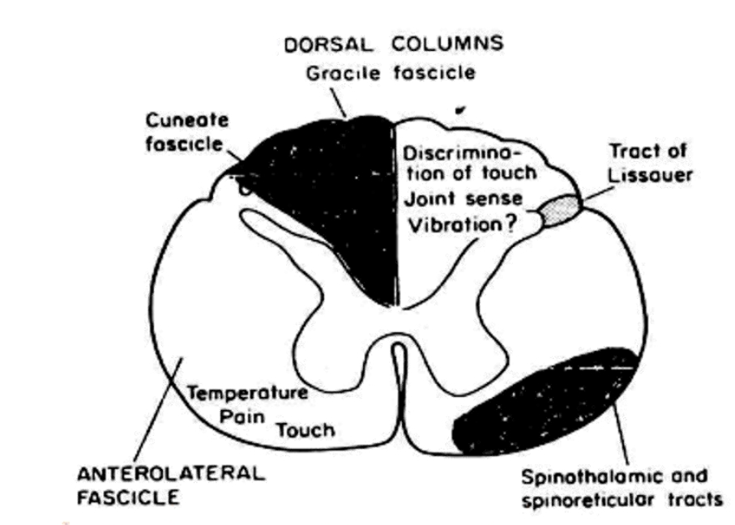

Outcome
- pain relief is immediate but pain recurs in ≈ 12 months (cordotomy is reserved for patients with limited life expectancy).

N.B. thermanalgesia level will descend variable number of segments within 2-3 weeks after surgery! + months to years later, some pain-temperature sensation can recur – due to:
- further central short-circuiting of pain transmission [reverberating circuits].
- collateral pain pathways.
- denervation hypersensitivity in pain centers.

Techniques:
  - open
  - percutaneous (RF)
  - endoscopic

Technique – open thoracic
– for pain caudal to T₈.
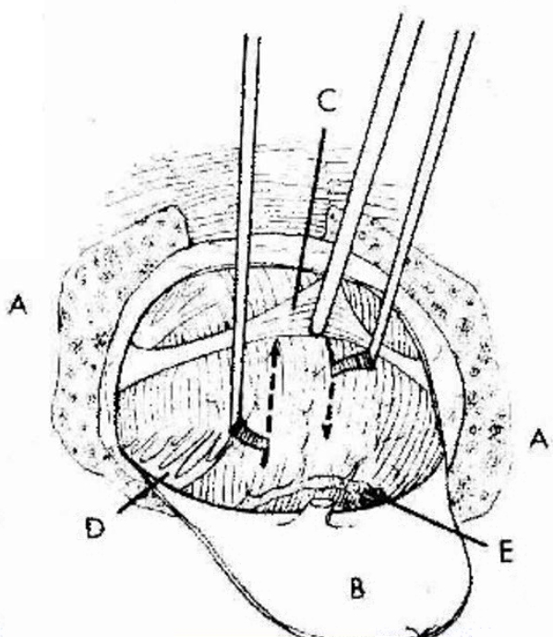

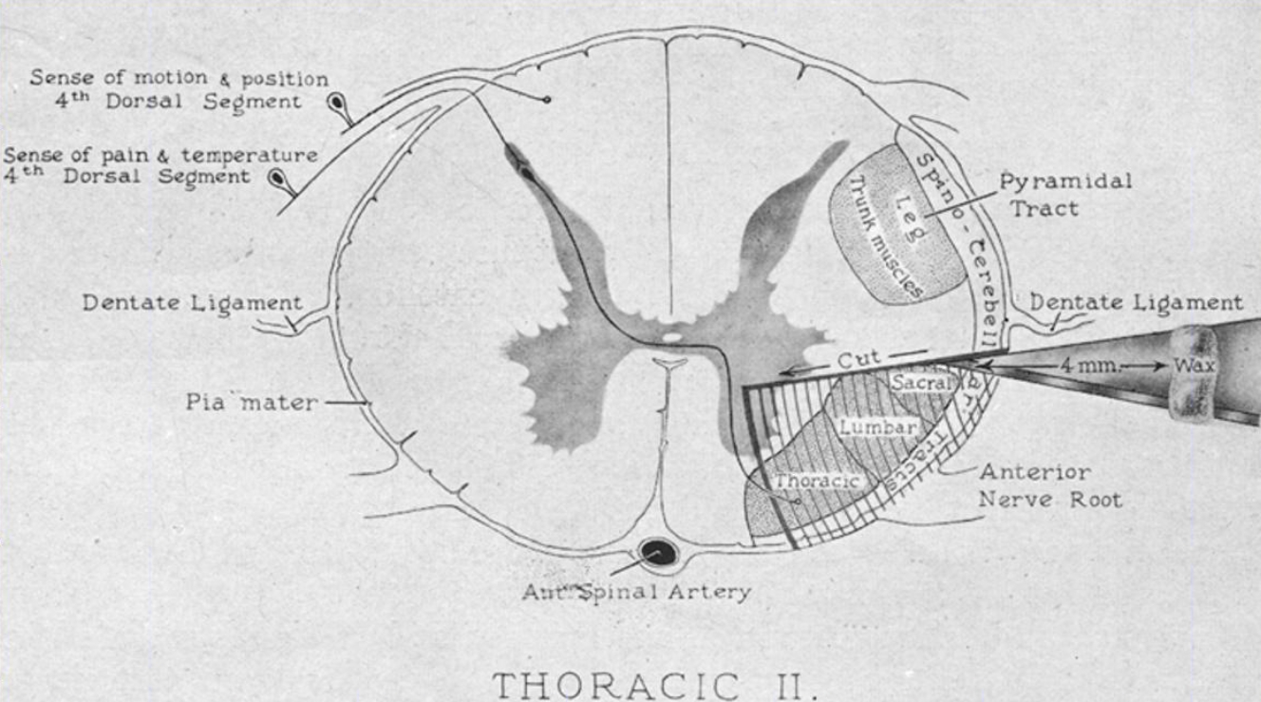

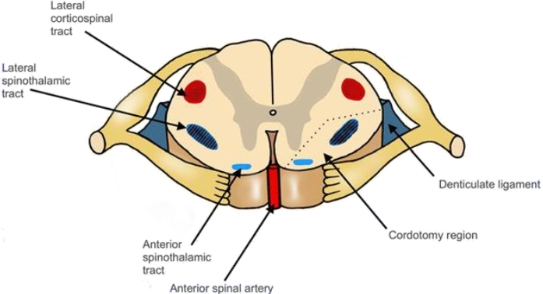

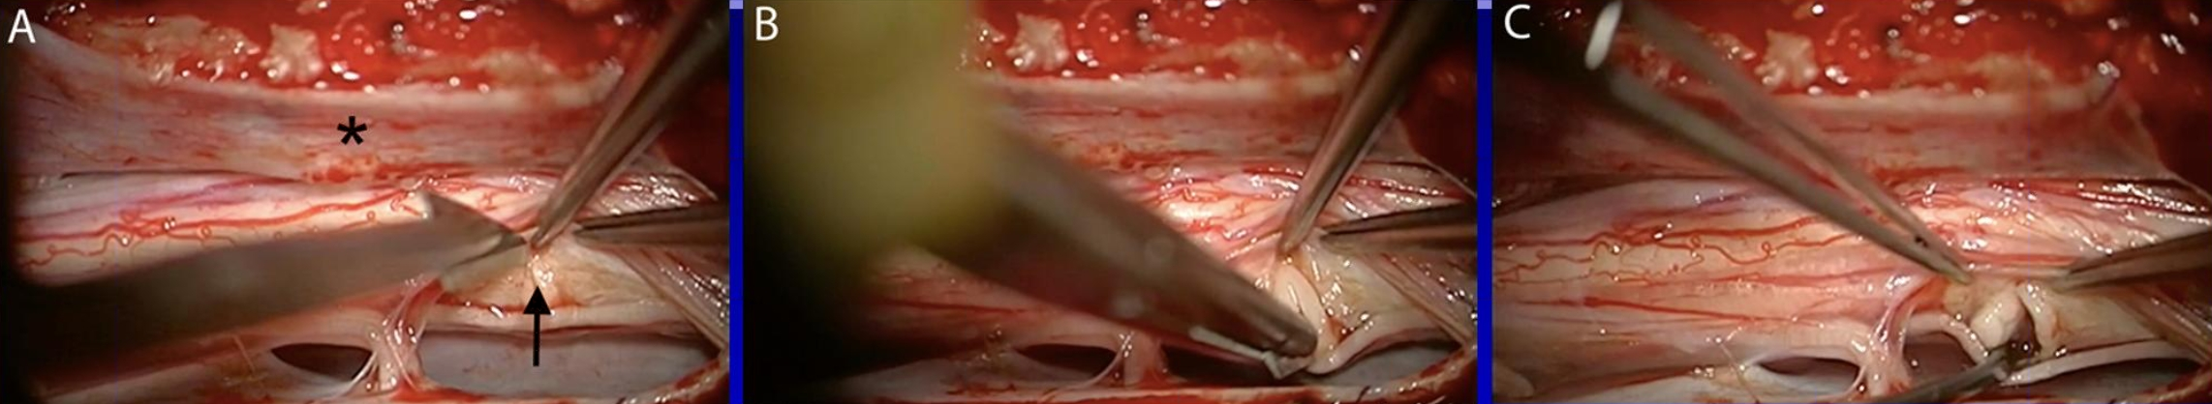

- general anesthesia (disadvantage - cannot locate lateral spinothalamic tract with intraoperative stimulation).
- T₂₋₃ laminectomy (for bilateral cordotomy, T₂₋₄ laminectomy - cuts are performed with one as far rostral and other as far caudal as possible).
- dentate ligament is cut and retracted posteriorly and medially.
- after measuring half cord width (usually no more than 5 mm), equal length of No. 11 blade is grasped by needle holder.
- blade is inserted at dentate ligament level and then drawn anteriorly.
- dental mirror is held anterior to assure that blade tip avoids anterior spinal artery as cut is completed anteriorly.
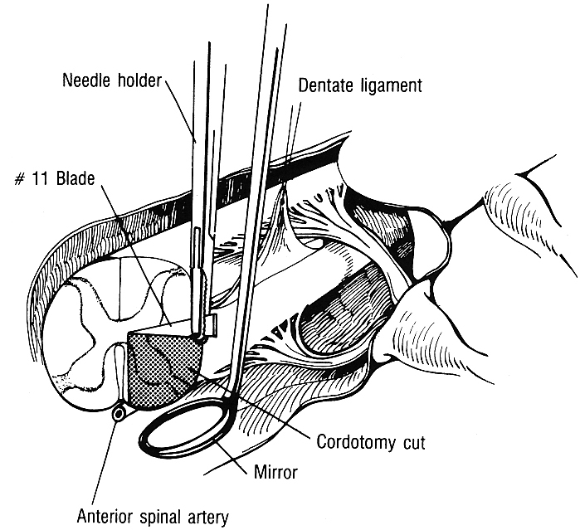

Technique - High cervical percutaneous CT-guided RF cordotomy (Kanpolat 2009)
- supine awake, local anesthesia with sedation – procedure is painless
- rigid head fixation in stereotactic device, supine
- 9-cm thin-walled 18-gauge needle is inserted and guided (with lateral fluoroscopy or CT guidance) to C₁₋₂ interspace:
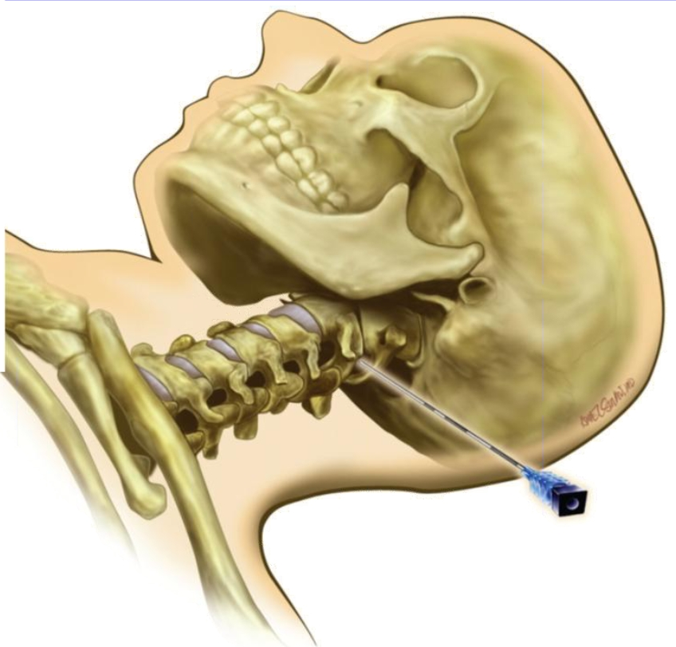
- when guide needle penetrates dura, anesthesiologist gives enough IV Pentothal to provide brief general anesthesia.
- once CSF flow is established, outline (with myelogram!!! – cord deviates!!!) anterior margin of dentate ligament (marks cord equator).
- needle is slowly advanced and intermittently checked for cessation of CSF flow, which indicates that it is contacting cord.
- electrodes: Mullan-Portney, thermocoupled Levin.
- cordotomy electrode passes through guide needle and enters cord* slightly anterior to dentate ligament (*rapid change of impedance 500 → 1000 ohms).
- physiological testing:
2-5 Hz stimulation: contraction of ipsilateral nuchal muscles - electrode is too anterior; contraction of ipsilateral leg muscles - electrode is too posterior; in either case electrode should be repositioned.
when no motor response is obtained → 50-100 Hz stimulation (warm or cool thermal sensation or, less likely, pain or paresthesias on entire contralateral body side - proper electrode position!).
- lesioning: start at 42.5-44°C; patient is checked continuously for development of contralateral thermanalgesia or for ipsilateral paresis (lesion extension into corticospinal tract → stop immediately; attempt again another day); if only hypalgesia is obtained, lesion temperature is increased 5°C until targeted painful region becomes analgesic to strong pinprick by 22G needle.

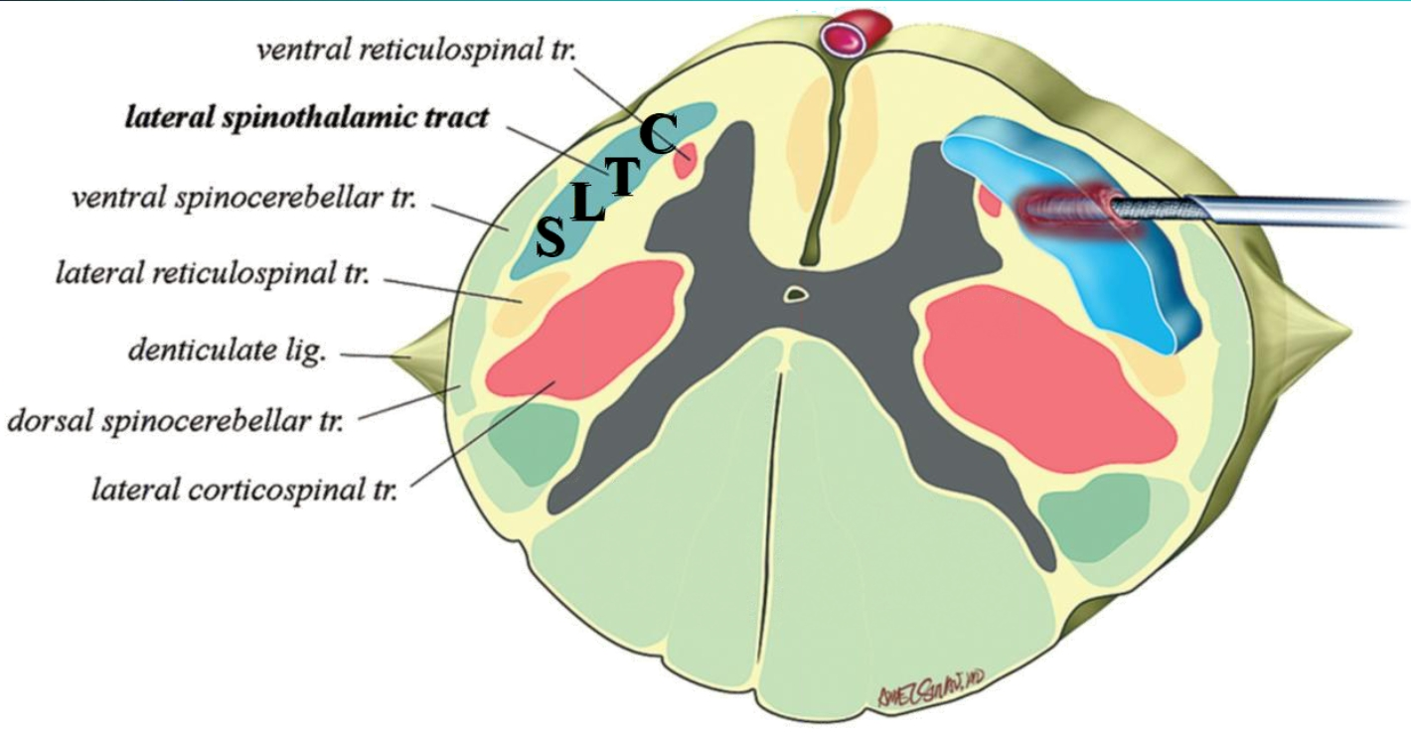

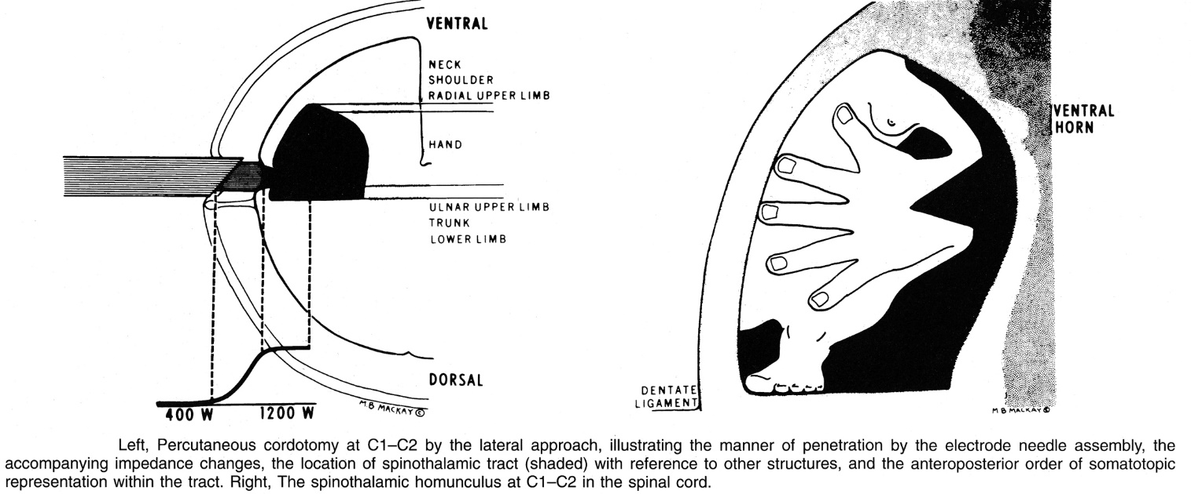
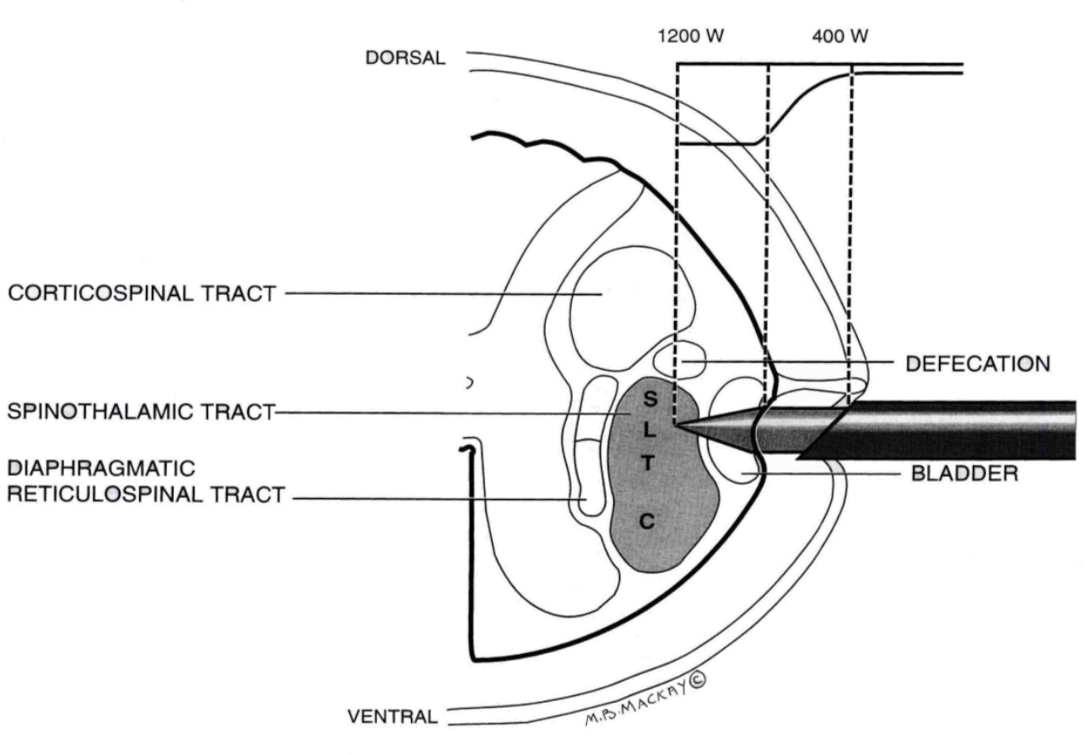

- complications – muscle weakness, temporary fatigue, dysesthesias (15%; may be severe and spread to encompass entire newly analgesic region), respiratory failure, urinary dysfunction, increased or new pain
N.B. increased pain occurs in most patients experiencing bilateral pain after unilateral cordotomy; new pain occurs in most patients in whom original pain on both sides was relieved by bilateral cordotomy.
    - target pain is always relieved but new mirror pain* occurs in 6-73% of patients after unilateral cordotomy (referred pain mechanism). *may be as severe as the original dominant pain
    - ½ of patients after bilateral cordotomy exhibit new pain cephalad to region rendered analgesic by cordotomy but such postoperative pain is weaker and better controlled than original pain

CT-guided (Kanpolat)
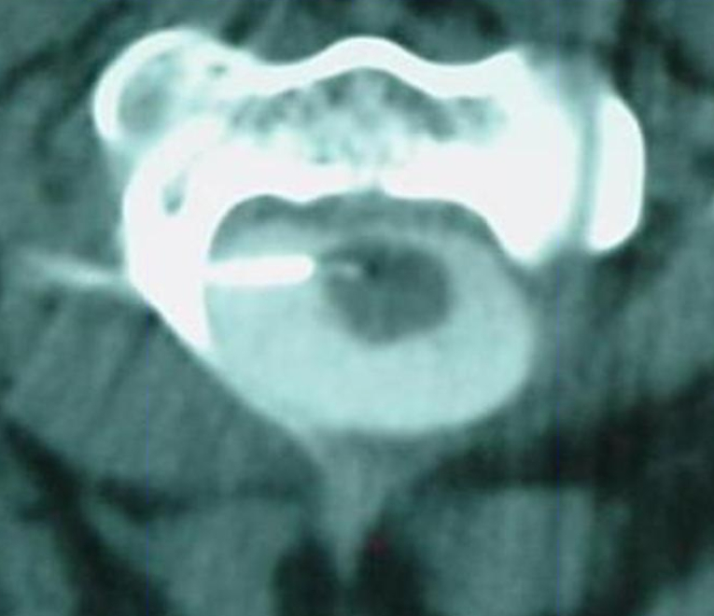
- case series (n = 207): VAS 8 → 1, KPS 45 → 70

Technique - endoscopic
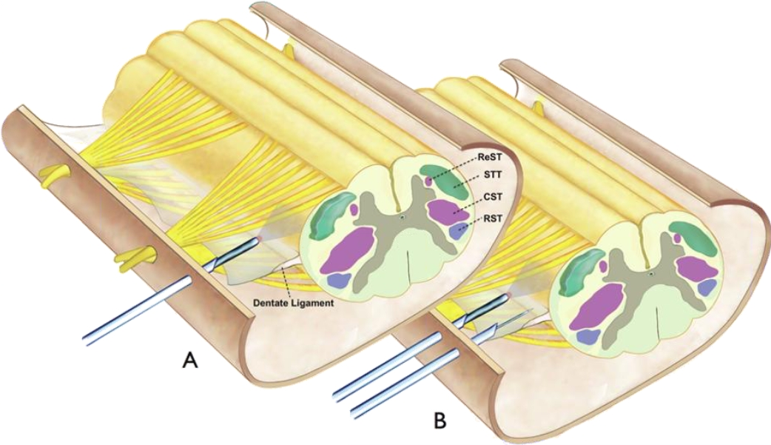

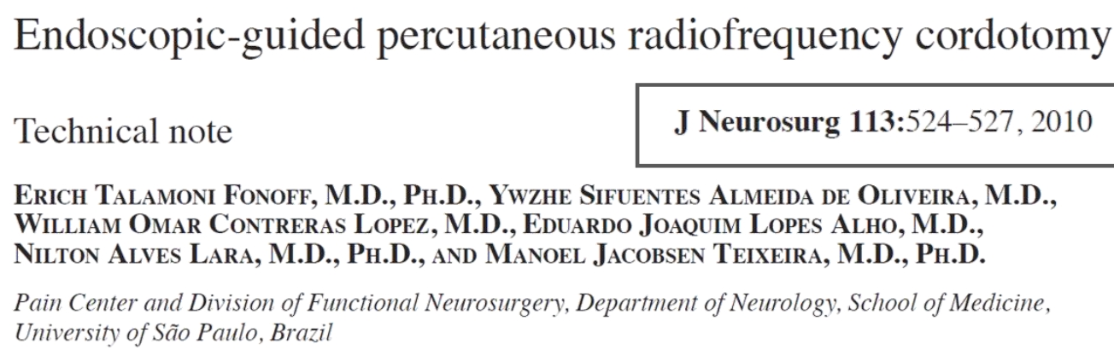

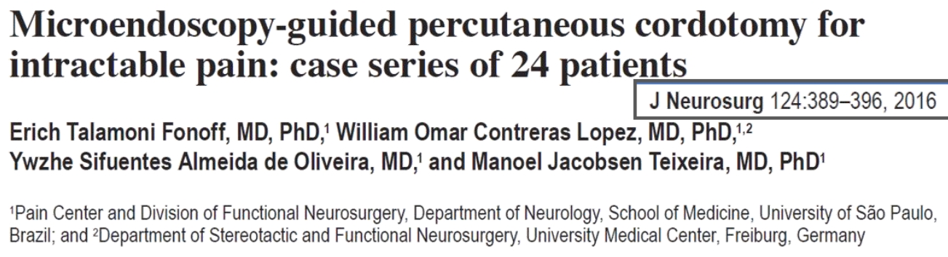

Commissural (s. midline) Myelotomy
- for bilateral pain below neck (alternative to bilateral cordotomy).
- splitting spinal cord in midline sagittal plane (at and above level of pain).
- mechanism - destruction of central ascending nonspecific multisynaptic pathway (extralemniscal system) in central grey commissure / decussating fibers.
- main indication – visceral cancer pain.
- also effective for deafferentation pain!

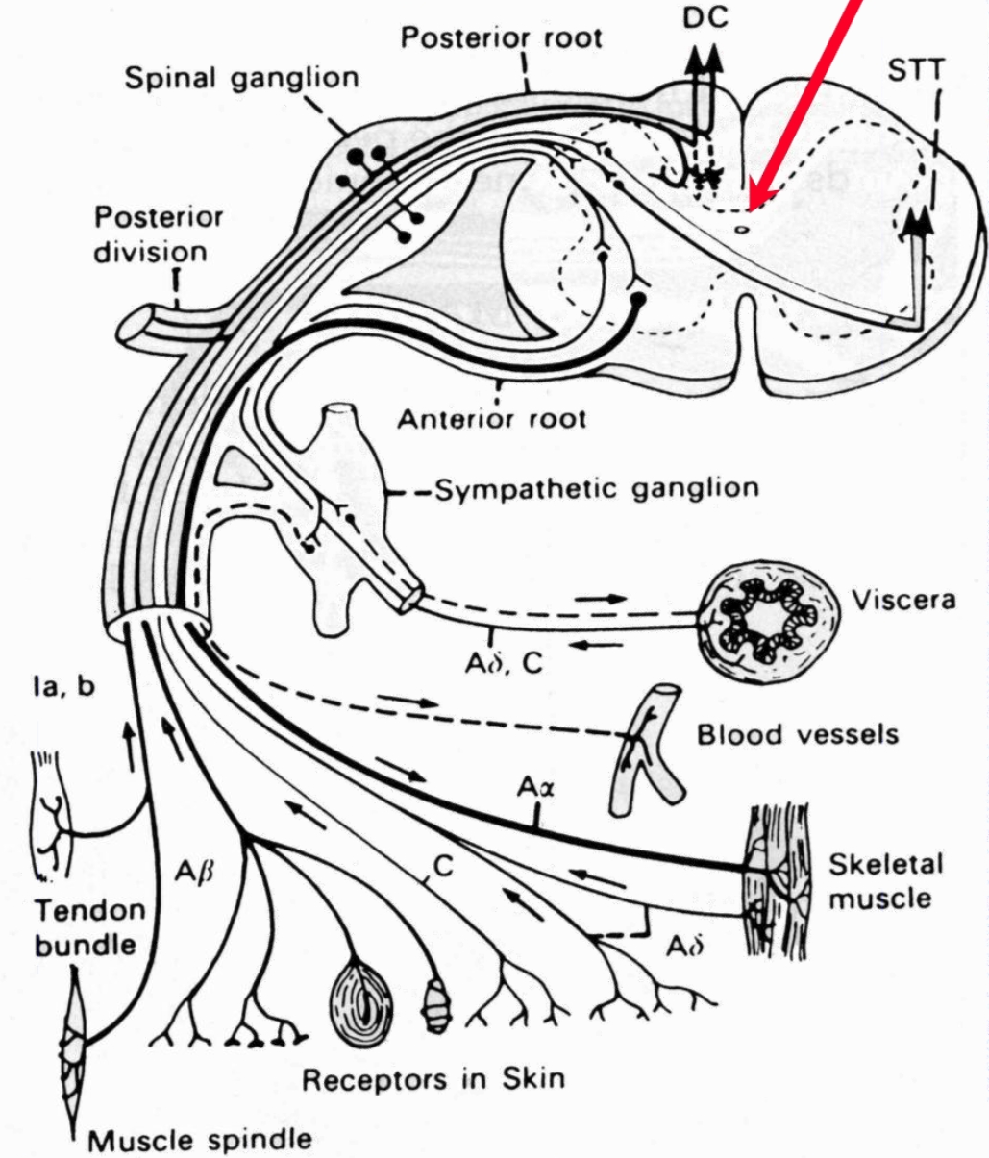

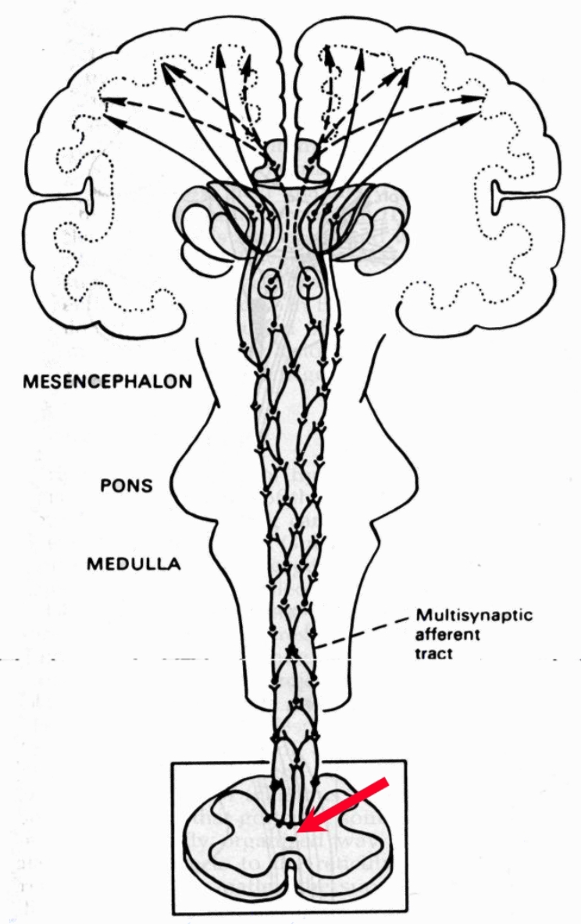

Old procedure (until 1968): general anesthesia, multilevel laminectomy, longitudinal incision (full thickness) with blade in midsagittal plane - all cord segments involved in pain transmission + next three rostral segments.

Modern procedure - CT-guided cervical commissural myelotomy
- local anesthesia.
- head well flexed in stereotactic apparatus.
- guide needle is introduced posteriorly in midline through occiput-C₁ interspace (under fluoroscopic guidance).
- 50 Hz 1.0 volt stimulation is carried out as electrode is advanced - symmetrical paresthesias should be obtained in legs & perineum → both arms.
- after arm responses are no longer obtained, electrode is advanced another 2 mm.
- radiofrequency coagulation until significant hypalgesia / analgesia occurs (or unwanted neurologic deficit).
- no weakness, sphincter disturbances, or respiratory dysfunction has been reported.
- outcome – case series (Sindou 1990): n = 114, 80% initial pain relief, < 50% long-term pain relief (usually, pain relief for months – years).

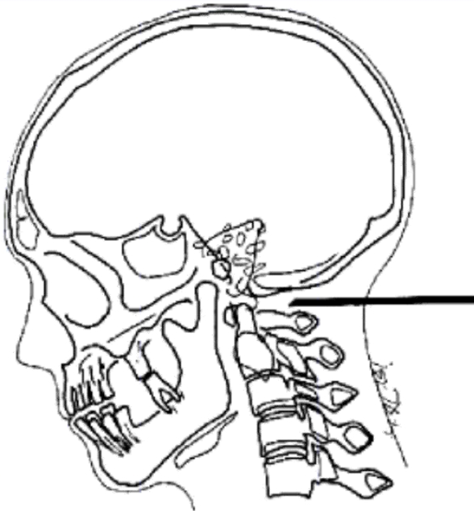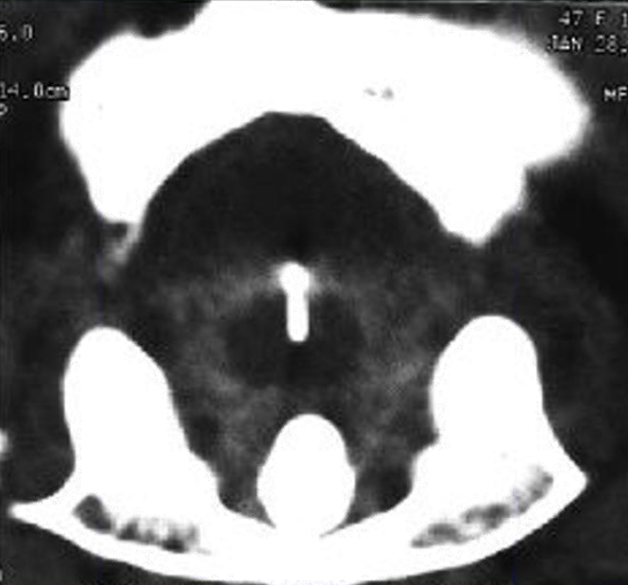

References
Aditya Vedantam et al. Limited Midline Myelotomy for Intractable Visceral Pain: Surgical Techniques and Outcomes

Trigeminal Tractotomy / Nucleotomy
Only for ipsilateral oncological pain!
Second indication – CN5 deafferentation pain.

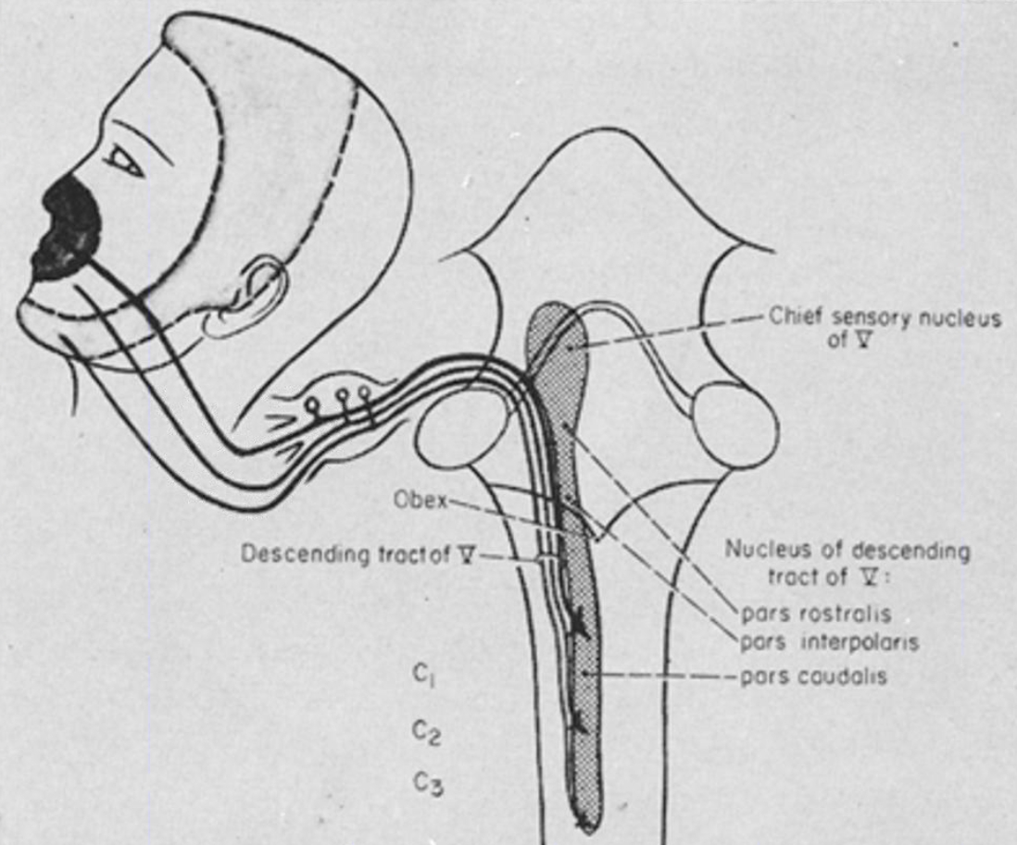

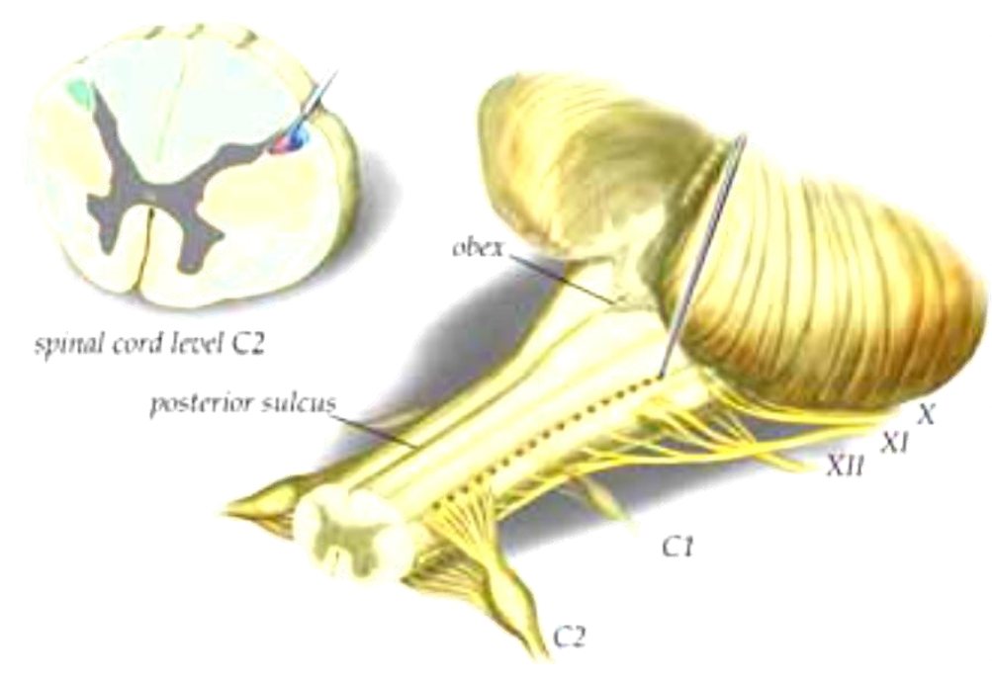

- initial description – Sjoqvist
- modern – Kanpolat (2008): awake, prone, occiput-C1 approach, CT-guided
N.B. procedure is painful!
- knife vs. RF vs. focused ultrasound
- 1-2 RF lesions.
- aim to lesion more lateral → arm ataxia but avoids anesthesia.

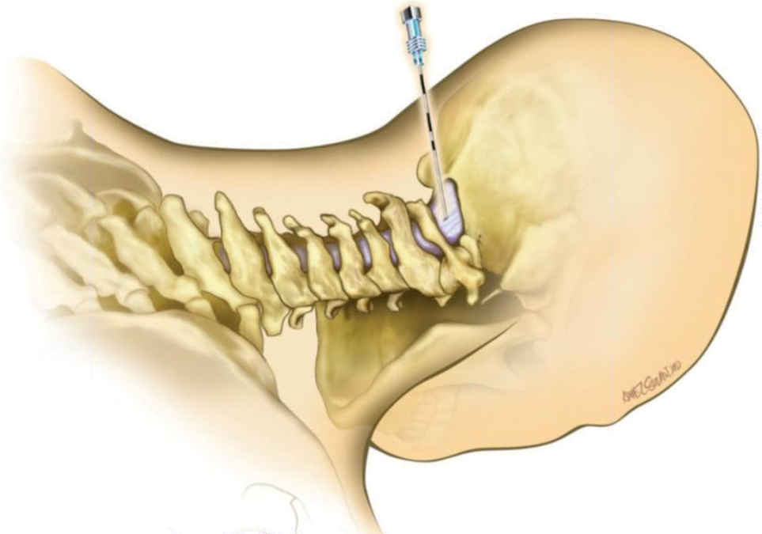
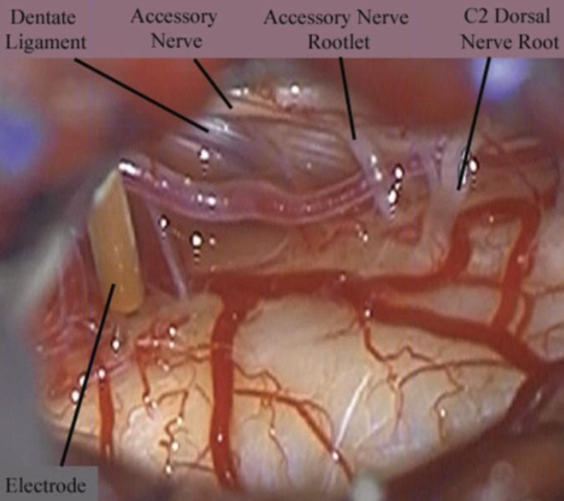

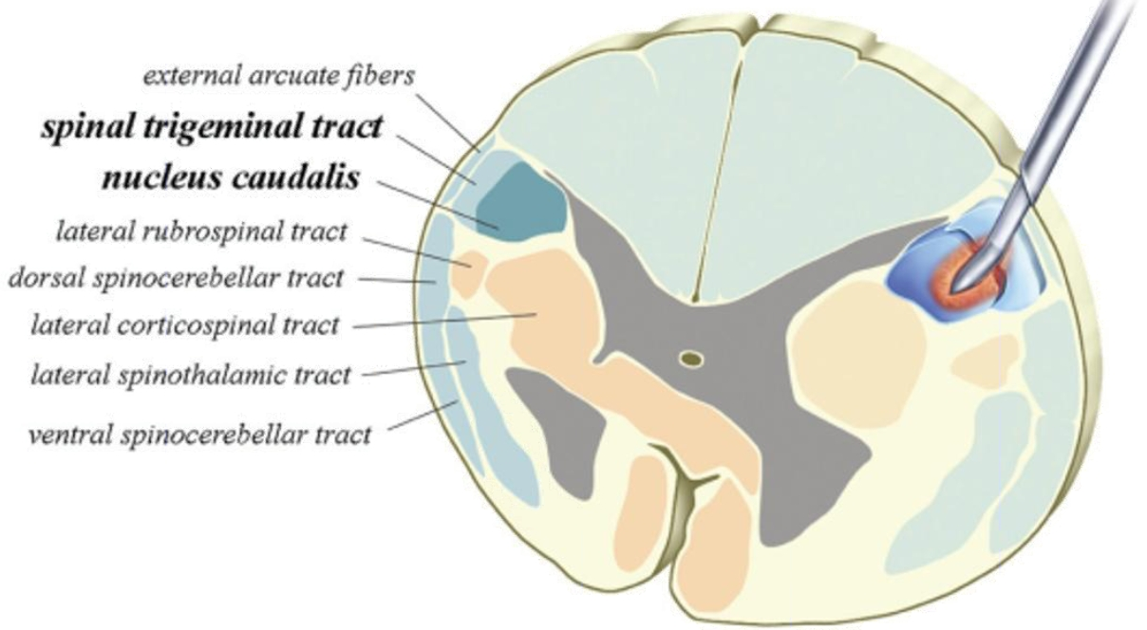
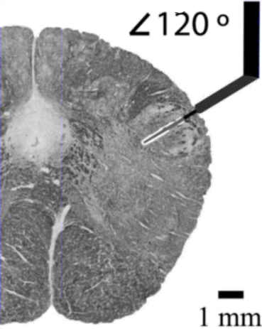
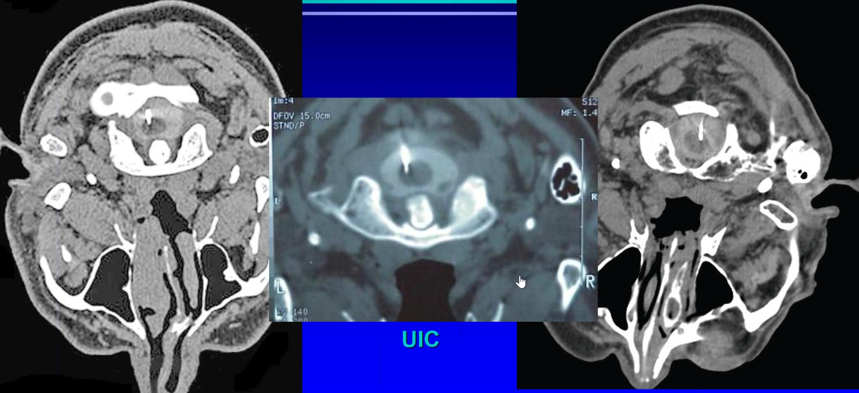

Outcomes
- pain relief immediate.
- case series (Kanpolat 2008): n = 66, VAS 8 → 1, KPS 60 → 70
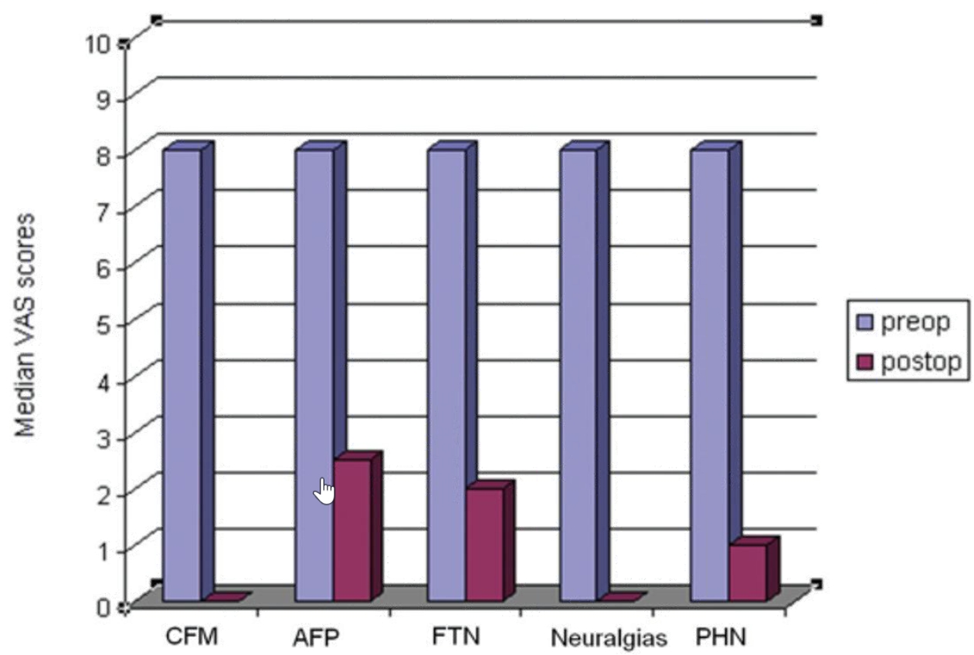

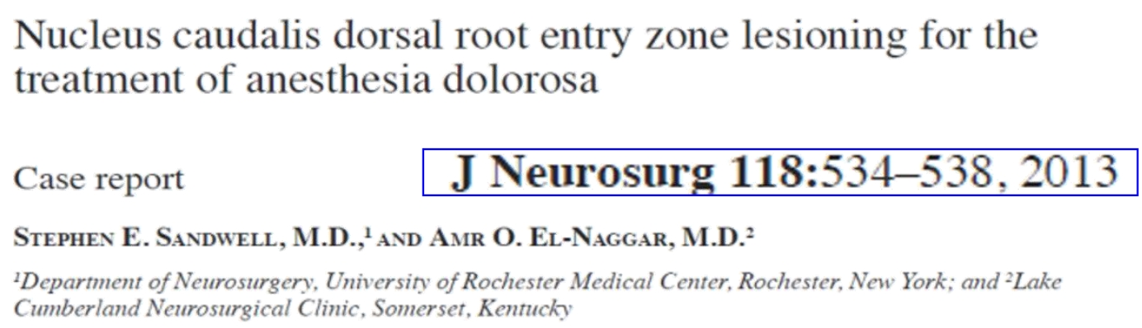

Cranial

Mesencephalic Tractotomy
- destruction of spinothalamic tract at midbrain level, just below superior colliculus.
- at this level, tracts from face and body are close to each other (face represented more medially).
- if lesion includes adjacent periaqueductal gray (paleospinothalamic pathway) → reduction in emotional suffering.
- indications:
  - face pain (when trigeminal rhizotomy can't be performed)
  - face pain also involving ear, oropharynx, neck, shoulder.
- stereotactic, MRI-guided, computer-assisted technique.
- target is 5 mm posterior and inferior to superior aqueduct and 9 mm lateral to midline.
- when electrode is properly positioned, stimulation produces contralateral thermal sensation; if too medial (near medial lemniscus) contralateral paresthesias / electric shock sensations are reported.
- lesioning is begun at 50°C for 60-90 sec; patient is repeatedly checked for evidence of position sense loss; loss of upward gaze and at least temporary diplopia are expected.
- lesioning is increased in 5° increments until side effects or contralateral thermanalgesia occur.
- 4 mm lesion will usually suffice.
- complications - permanent ocular palsies (< 10%) are easily compensated with eye patching.
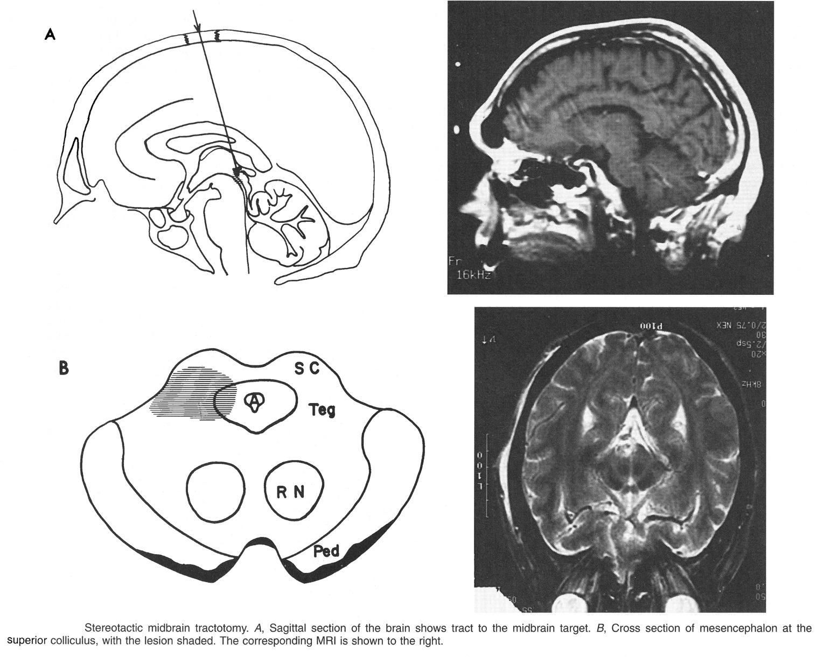

Thalamotomy
- indications ≈ mesencephalic tractotomy.
- stereotactic, image-guided, computer-assisted technique or SRS (120-180 Gy in 1-3 isocenters – treatment effect delayed).
A. Lesioning medial thalamus (intralaminar nucleus, parafascicular nucleus, centromedian nucleus) - receives input from brain stem RF (slower-conducting multisynaptic pain pathway - transmits poorly localized pain) - widespread pain relief without demonstrable analgesia.
- target - located posteriorly 9/10 of total distance from anterior to posterior commissure, 4 mm above intercommissural line, 9 mm lateral to midline; localization can be verified by:
  - high-threshold stimulation → vibrating sensation in contralateral arm.
  - more accurate method - low-amplitude stimulation, exploring with side-extruding electrode to find junction of centromedian and ventralis posteromedialis nuclei, after which location of centromedian nucleus can be inferred.
B. Lesioning posteromedial thalamus & pulvinar
C. Lesioning dorsomedial & anterior thalamic nuclei, which project to frontal and limbic lobes (effect ≈ cingulotomy).

Hypophysectomy
- performed by craniotomy or percutaneous techniques or SRS (160 Gy delivered to pituitary gland).
- leads to complete pain relief in > 70-80% of cases for opioid refractory nociceptive or mixed cancer pain.

Stereotactic Frontolimbic Disconnections
- allay severe anxiety (suffering) that accompany chronic pain - patients report that they feel pain but that it "doesn't bother" them.
- little long-term personality alteration - avoid in sociopathic / hysteroid individuals (procedure may abolish what little social inhibition they possess).
- no loss of intellect (even IQ increase).
- does not alter pain threshold - will not be particularly effective for stoic patients who display little suffering.
- performed bilaterally.

- Cingulate gyrectomy, cingulotomy (lesioning white matter deep to cingulate gyrus).
- Subcaudate capsulotomy (lesioning inferior medial frontal lobe).
- Frontothalamic tractotomy
- Prefrontal lobotomy - cutting deep connections between frontal lobes and rest of brain.
N.B. prefrontal lobotomy causes extensive personality changes! - rarely performed today!

Experimental
Adrenal medulla transplantation into subarachnoid space and periaqueductal gray.

Chronic Neuropathic Pain Syndromes
Pain in thorax / abdomen almost always implies visceral disorder.
Headache – see p. S24 >>
Neck, low back pain – see p. Spin19 >>
Psychogenic pain – see p. Psy37 >>
- only small minority of acute pains evolve into severe, unremitting, and disabling chronic pain (e.g. 2-5% traumatic peripheral nerve injuries persist as severe neuropathic pain, 10% acute herpes zoster becomes post-herpetic neuralgia).
- two broad categories of neuropathic pain:
- deafferentation pain (due to partial or complete interruption of peripheral or central afferent neural activity); e.g. postherpetic neuralgia, central pain (after CNS injury), phantom limb pain.
- sympathetically maintained pain (dependent on efferent sympathetic activity).
- neuropathic pain may involve predominantly peripheral processes; e.g. neuroma, radiculopathy from discogenic disease.
- psychologic factors cannot be ignored in chronic pain problems;
  - debilitating, demoralizing effect of chronic pain, attendant depression;
  - tendency to guard painful limb or joint from even tactile stimulation (hyperpathia, s. "pain behavior" - grunting, panting, moaning, muscle tensing during examination or even on simple direct observation).
- pain syndromes often include other positive sensory phenomena (paresthesia, dysesthesia).
see p. S22 >>

Sensitization of C-Polymodal Nociceptors
- burning pain & mechanical hyperalgesia (increased by heat and relieved by cold).
- skin is red and hyperthermic (neurogenic inflammation).
- QST shows heat hyperalgesia (+ warm hypesthesia).
- can be seen in many syndromes.
- can be induced experimentally after injection of capsaicin.

Triple Cold Syndrome
- burning pain (increased by cold and relieved by heat).
- skin is cold and pale (sympathetic denervation supersensitivity).
- QST shows cold hyperalgesia (+ cold hypesthesia), paradoxical hot burning sensation.
- lesion of small myelinated fibers with relative sparing of unmyelinated fibers (cold hyperalgesia is due to central release of C-nociceptive input, which is normally inhibited by cold-specific Aδ fibers).
- can be seen in many syndromes; in elderly, may occur without apparent cause.

Central Post-Stroke syndrome (s. Thalamic Pain syndrome, Déjérine-Roussy syndrome)
- damage to posterior thalamic nuclei (usually infarct of thalamogeniculate branch of posterior cerebral artery) – described by Dejerine and Roussy in 1906.
- lesions in hemispheres (particularly parietal lobule), brain stem (≈ 8% stroke patients have CPSS)
All patients have lesion in spinothalamic pathway!
- contralateral severe loss of all sensory modalities → after few weeks ÷ months → attacks of prolonged, severe, lancinating, extremely unpleasant pain* in contralateral body half that are spontaneous (or occur in response to trivial stimuli).
*"flesh is being torn from my limbs" or "bathed in acid"
- also mechanical & thermal (particularly cold) hyperalgesia.
- no autonomic or trophic changes!
- pain is usually resistant to all kinds of treatment: amitriptyline.

Pain Asymbolia
- dissociation between primary pain sensation and emotive & motor withdrawal responses.
- cortical lesions involving parietal and parietal-occipital lobes (esp. on dominant side); mechanism - interruption of connections between sensory cortices and limbic system.
- patient can identify pin pricking him but reports that it does not hurt (pain hemiagnosia).
- may be associated with fully developed Gerstmann syndrome, left hypersensitive sensory reaction to even light touch.

Phantom Limb Pain
- pain (in addition to other sensations) felt in amputated limb (not in stump!)
- can be severe and difficult to control.
- some experts think it is more likely to occur if patient had painful condition before amputation or if pain was not adequately controlled intraoperatively and postoperatively.
- treatment – simultaneous exercise of amputated and contralateral limbs, stump massage / finger percussion / mechanical devices (e.g. vibrator) / ultrasound, drugs (e.g. gabapentin), DREZ lesioning.
N.B. stump pain does not respond to DREZ lesioning! (H: spinal cord stimulation)

Occipital Neuralgia
Options:
- Injections
- Stimulation
- C2 ganglionectomy

Post-Herpetic Neuralgia
- pain persistence after new lesions have ceased and skin healing is complete (i.e. pain for ≥ 1 month after skin healing).
- incidence ≈ 10-75% (risk factor - age↑; i.e. develops almost exclusively in persons > 50 yrs).
- possible mechanism - persistent sensitization of nociceptors (central mechanism has also been proposed).

Three components of discomfort:
  - constant, deep, aching, bruised, burning sensation – 100%.
  - allodynia evoked by wearing clothing or by gentle touch – 90%.
  - spontaneous, recurrent, lancinating, shooting, electric shock-like pain - tends to fade over initial year.
- area of pain and allodynia may cover much larger band of skin than dermatome of viral reactivation.
- elderly are more susceptible (slower inflammation resolution, greater tissue destruction, enhanced susceptibility to permanent neural injury).

Prophylaxis – prednisone at onset of herpes zoster in immunocompetent patients or patients > 60 yrs.
N.B. not recommended for HIV-positive patients.
- carbamazepine is less effective than prednisolone in preventing postherpetic neuralgia following acute herpes zoster.

General feature - resistance to therapy;
- if pain has persisted for ≥ 1 year, spontaneous remission is very unlikely.
- proved efficacy:
- capsaicin cream (not recommended due to burning sensation)
- local anesthetic patches (topical lidocaine, prilocaine cream)
Lidoderm® (transdermal lidocaine patch) – FDA approved
- tricyclic antidepressants started at low dose at bedtime (e.g. amitriptyline, desipramine) - it takes several weeks to achieve maximum benefit!
- anticonvulsants (gabapentin, carbamazepine) can reduce lancinating component of neuropathic pain.
- oral opioids.

Minority are refractory to all currently available medications; surgical options:
  - spinal cord or deep brain stimulation
N.B. try neuromodulation options first!
  - intrathecal medication pumps
  - neurolytic nerve blocks
  - ablative procedures (DREZ lesioning is not very effective).

Pain of Spinal Cord Injury
- 65-85% of all SCI patients will experience pain, and 1/3 of these patients will experience severe/ excruciating pain.
- fundamental problem is that pain after SCI is often complex and multifactorial.
- pain of SCI is central neuropathic type; it can be:
  - spontaneous
  - evocable

Bryce-Ragnarsson SCI pain taxonomy
Tier I – location (pain at, above or below the level of injury)
Tier II – type (nociceptive or neuropathic)
Tier III – subtypes.

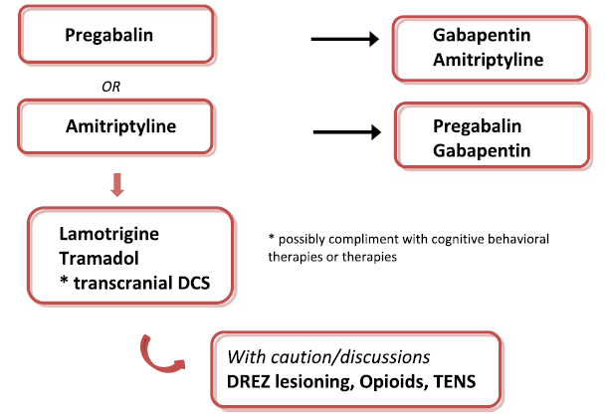

Antiepileptics:
pregabalin – first line treatment, FDA approved (2012) for SCI pain.
gabapentin
- older generations – lamotrigine (historic first line treatment), topiramate (may induce paresthesias).

Tricyclics: amitriptyline – best medication! Secondary amine tricyclics (nortriptyline and desipramine) cause less sedation and fewer anticholinergic effects compared to amitriptyline, but they have not been studied in SCI patients.

Opioids (methadone, tramadol) – evidence is sparse and controversial; last resort.

Cannabinoids
- continues to remain unproven as a reliable analgesic for pain following SCI.
- one study comparing dronabinol against an active placebo (diphenhydramine) found no significant difference in relief of below-level pain.
- another study using a cannabinoid analog showed significant improvements in pain, although those with SCI were small (n=3).

Intrathecal pumps – insufficient evidence.
- clonidine, opioids, ziconotide.

Transcranial direct current stimulation (tDCS), transcranial electrical stimulation (TES), transcranial magnetic stimulation (TMS) – evidence is weak and conflicting.

Behavioral therapy/psychological therapy - may be of use in alleviating psychological distress associated with pain.

- End-zone pain (evocable pain) - may be triggered by local nonpainful stimuli.
  - located at level of SCI, i.e. in variable portions of dermatomes immediately caudal to level of sensory loss.
  - constant (aching or burning) or paroxysmal (cramping, lasting up to 5 min).
  - treatment - DREZ lesioning, nerve blocks – only for patients with complete SCI (patients with incomplete SCI have a high risk of losing preserved function below the level of injury).
- Nonevokable pain - not evoked by nonpainful stimuli.
  - more diffuse and nondermatomal in distribution.
  - constant, burning, most intense in saddle area.
  - treatment: (responds poorly to DREZ lesioning)
shooting pain - cordotomy or cordectomy (excision of damaged cord area).
burning pain - thalamic or spinal cord stimulation (data is limited)
Some develop delayed-onset pain due to posttraumatic syrinx. H: syrinx shunting.

N.B. any procedure involving the spine always carries a small risk of further iatrogenic neurologic injury from the procedure itself.

Pain of Brachial Plexus Avulsion
See also p. PN7 >>
DREZ myelotomy is the most effective procedure

Cancer and Terminal Pain
N.B. most cancer pain syndromes have prominent nociceptive component but may also include neuropathic pain (nerve damage by tumor or its treatment) and psychogenic pain (related to loss of function and fear of disease progression).
- severe pain affects ½ of dying cancer patients, half of whom never obtain adequate relief.
- severe pain is also prevalent in patients dying of organ system failure and dementia.
- pain persists not because it cannot be well controlled but because patients, families, and physicians have misconceptions about pain and drugs (esp. opioids).
- commonly used drugs in terminal patients (oral administration, incl. opioids, is most convenient; alternatives: rectally, parenterally):
mild pain - aspirin, acetaminophen, NSAIDs;
moderate pain – codeine, oxycodone, dihydrocodeine, dextropropoxyphene;
severe pain – hydromorphone, morphine, diamorphine, buprenorphine (sublingual), fentanyl.
N.B. use drugs on non-prn (noncontingent) schedule (avoid pain reoccurrence!)
Pharmacologic dependence may result but causes no problems in dying patients except need to avoid inadvertent withdrawal!
- when stable opioid dose becomes inadequate → increase dose 1.5-2.0 times (respiratory depression does not occur unless dose is >> twice previously tolerated dose).
- adjunctive measures (help decrease opioid doses):
corticosteroids – decrease pain of inflammation and swelling.
tricyclic antidepressants, anticonvulsants – in neuropathic pain.
benzodiazepines – if pain is worsened by anxiety.
regional nerve blocks, indwelling epidural / intrathecal catheters – for regional pain.
pain-modification techniques (guided mental imagery, hypnosis, relaxation).
- surgical treatment:
malignant diffuse visceral pain → cervical midline myelotomy;
diffuse body pain from metastatic disease → cingulotomy, SRS hypophysectomy, opioid intraventricular infusion

Complex regional pain syndromes
- complex regional pain syndrome type I (reflex sympathetic dystrophy) – without evidence of nerve injury (cause may be minor trauma, arthritis, bone fractures); in 25% cases precipitant cause is not identified; pain is not confined to distribution of single peripheral nerve.
- complex regional pain syndrome type II (causalgia) – caused by apparent traumatic nerve lesion; pain develops in territory of affected nerve.
- historically, sympathetic nervous system has been involved in pathogenesis of both conditions (sympathetically maintained pain); early sympathectomy may cause relief; recent placebo-controlled sympathetic blocks have questioned this concept.
- CRPS is syndrome (not independent disease entity) - reversible cause (usually orthopedic) can occasionally be found!

Budapest Criteria
- criteria for better discrimination between CRPS and neuropathic painful conditions; in order to make a clinical diagnosis of CRPS, the following four criteria must be met:

S. No | Criteria | Categories
 |  | Sensory | Vasomotor | Sudomotor/Edema | Motor/Trophic
1 | Continuing pain, disproportionate to any inciting event | -- | -- | -- | --
2 | Symptoms: Must report at least one symptom in three of the four categories shown to the right | Hyperesthesia; Allodynia | Temperature asymmetry; Changes in skin color; Skin color asymmetry | Edema; Sweating changes; Sweating asymmetry | Decreased range of motion; Motor dysfunction; Trophic changes (hair, nails, skin)
3 | Signs: At the time of evaluation, must have at least one sign in two or more of the categories shown to the right | Hyperalgesia (pinprick); Allodynia (light touch or temperature); Deep somatic pressure; Joint movement | Skin temperature asymmetry (>1°C); Changes in skin color; Skin color asymmetry | Edema; Sweating changes; Sweating asymmetry | Decreased range of motion; Motor dysfunction (weakness, tremor, dystonia); Trophic changes (Hair, nails, sin)
4 | No other diagnosis can better explain the patient’s signs and symptoms | -- | -- | -- | --

Reflex sympathetic dystrophy
- pathophysiology – see causalgia (below)
- females account for 70% patients.
- usually in extremity.
- causalgia + signs of sympathetic overactivity:
- edema
- vasomotor abnormality: warm, red, dry skin → cool, pale, cyanotic, hyperhidrotic skin.
- increased hair growth, thickened nails → hair lost, nails break, thin & shiny skin.
- dystrophy / atrophy of subcutaneous tissue, muscles, bone: immobility of joints → osteoporosis (Sudeck atrophy).
- overall, treatment outcomes are disappointing!!!
- treatment is directed at sympathetic activity suppression:
- α-adrenergic blockade (α₁-blockers are more effective than α₂-agents); e.g. phenoxybenzamine.
- regional sympathetic blocks (e.g. guanethidine blocks).
- sympathectomy (response rates range 12-97%).
- always consider other treatment methods (physiotherapy, other drugs, TENS, etc), because response cannot be predicted unless tried.
- dorsal root ganglion stimulation, e.g. Axium™ Neurostimulator System (St. Jude Medical) ACCURATE study

shoulder-hand syndrome: inflammatory shoulder arthritis → painful hand swelling with local vascular changes, and atrophy of muscle and bone.

Causalgia
- spontaneous, disabling, constant burning pain* long after seemingly trivial traumatic injuries.
*[G. kausis, burning, + algos, pain]
- caused by partial injury of mixed peripheral nerve (esp. median, sciatic, tibial) or brachial plexus;
partially damaged sympathetic fibers directly activate sensory fibers (that lost their coverings) - ephaptic conduction (“artificial synapses” - periphery has been short-circuited): sympathetic discharge brings on diffuse persistent pain
"vicious cycle" of sympathetic stimulation → pain → more sympathetic stimulation
N.B. causalgia does not occur when nerve is completely severed!
- lesions are usually above elbow or below knee (median or tibial nerves); arms are more often involved than legs; pain most often involves hand.
- often accompanied by hyperalgesia, allodynia, reflex sympathetic dystrophy (red glossy skin, sweating in affected area, abnormalities of hair & nails, fixed joints).
- pain may resolve early in clinical course only to return weeks or months later.
- pain is exacerbated by movement of associated joint (though no objective signs of arthritis are seen); immobilization provides some relief.

Treatment
- soaking affected part in water.
- phenoxybenzamine (α-adrenoblocker) often provides some relief.
- selective sympathetic blockade* almost invariably abolishes (or greatly reduces) pain - some investigators require this feature as diagnostic criterion before surgical sympathectomy (alternative – positive response to regional infusion of guanethidine)!
*e.g. stellate ganglion block in median nerve injury
- early, aggressive treatment → cure is possible!
- if causalgia involves upper extremity, lower half of stellate ganglion and upper 2-3 thoracic ganglia are removed.
- if untreated, disorder sometimes is progressive (involves more proximal parts and, rarely, homologous parts of other side, or other body parts) – result from inappropriate immobilization, from patient's desire to protect painful area.
- strong psychogenic component is suspected in some cases but is difficult to prove.
Although sympathetic block alleviates pain, injection of placebo has similar effects, and sympathectomy rarely produces permanent relief.
- IV regional ketorolac and lidocaine - randomized, double-blinded, crossover study: only short-term pain reduction in CRPS involving lower extremity.

Clinical course of complex regional pain syndromes:
  - symptoms usually begin within first few days following injury; course is in stages (each lasts ≈ 3-6 months).
Stage I ("acute" stage) – pain seems more severe than usually caused by initial injury.
- affected area protection, often with pronounced reluctance to mobilize it, is early and obvious feature!
- edema, erythema, warmth, increased hair and nail growth may be apparent.
- subtle bony changes on radiographs.

Stage II ("dystrophic" stage) (3 to 6 months after injury)
- edema → induration, cool hyperhidrotic skin, livedo reticularis, cyanosis.
- hair loss and ridged, cracked, brittle nails.
- diffuse osteoporosis, periarticular demineralization (MRI is most sensitive).

Stage III ("atrophic" stage) - proximal pain spread and irreversible tissue damage.
- skin is thin & shiny, wasted digits, Dupuytren's contractures, ankylosis.

N.B. recognizing patient in stage II-III is not difficult, but by this point nearly all will suffer long-term dysfunction even with aggressive treatment!

Bibliography
NMS Neuroanatomy 1998, Physiology 2001
Ganong “Review of Medical Physiology”, 2002 (chapter 7)
McPhee, Lingappa, Ganong “LANGE Pathophysiology of Disease”, 2002
Goetz “Textbook of Clinical Neurology”, 1st ed., 1999 (333-349, 1053-1054 p.)
Rowland “Merritt's Textbook of Neurology”, 9th ed., 1995 (27-30, 486-488 p.)
Goldman “Cecil Textbook of Medicine”, 21st ed., 2000 (2072-2073 p.)
“The Merck Manual”, 17th ed., 1999 (ch. 167, 294)
“Stedman’s Medical Dictionary”, 27th ed., 2000
Marshall B. Allen, Ross H. Miller “Essentials of Neurosurgery: a guide to clinical practice”, 1995 (477-495 p.); Publisher: McGraw-Hill, Inc.; ISBN-10: 0070011168; ISBN-13: 978-0070011168
“Oxford Handbook of Clinical Medicine” 1994 (90, 766-767 p.)
“Oxford Handbook of Clinical Specialties” 1995 (442 p.)
“Harrison's Principles of Internal Medicine”, 1998
“Sabiston Textbook of Surgery”, 16th ed., 2001 (283-284, 1543-1544 p.)
“Sabiston Textbook of Surgery”, 15th ed., 1997 (1381-1387 p.)

Viktor’s Notes℠ for the Neurosurgery Resident
Please visit website at www.NeurosurgeryResident.net

