Migraine
Last updated: May 8, 2019
Pathophysiology 1
Epidemiology 4
Clinical Features 5
Female Aspects 9
Diagnostic Criteria For Migraine 10
Clinical Subtypes 10
Complicated migraine 10
Basilar migraine 10
Confusional migraine 11
Hemiplegic migraine 11
Ophthalmoplegic migraine 11
Retinal migraine 11
Abdominal migraine (s. cyclic vomiting syndrome) 12
Carotidynia (s. facial migraine) 12
Migrainous accompaniments (s. migraine equivalents) 12
Transformed migraine 12
Malignant migraine 13
Differential Diagnosis 13
Evaluation 13
Management 14
Cerena transcranial magnetic stimulator (eNeura Therapeutics) 14
Peripheral Nerve Blocks 14
Selective 5-HT₁ agonists - triptans 14
Calcitonin-gene-related peptide (CGRP) antagonists 16
5-HT₁ agonists - Ergot alkaloids 16
Abortive treatment principles 18
Rebound headache 20
Pregnancy & breastfeeding 21
Prophylaxis 21
Nonpharmacologic 21
Pharmacologic 23
Prognosis 25

Galen's hemicrania → low Latin hemigranea → migranea → French migraine

Migraine is 2nd most common primary headache disorder!
Migraine is still underdiagnosed and undertreated!

Pathophysiology
Exact pathophysiology unknown!

Traditional vascular theory (already obsolete)
- intracranial vasoconstriction → aura.
- painful reactive extracranial vasodilation → headache.
- arguments against this theory:
  - theory cannot explain prodromal features.
  - theory cannot explain reason some antimigraine drugs have no effect on cerebral vasculature.
  - not been substantiated by cerebral blood flow (CBF) studies.

Comprehensive neurovascular theory (completely replaced vascular theory).
- hypothalamic and limbic system disturbances → prodromal symptoms.
- neuronal dysfunction → aura and headache.
- vascular changes are only secondary (rather than cause of attack)!!!

classic migraine
  - aura is caused by cortical spreading depression (CSD) of Leão - slowly moving (2-3 mm per minute) potassium-liberating depression of cortical activity preceded by wave front of increased metabolic activity.
  - blood vessels in CSD area simultaneously dilate then constriction (because CSD reduces metabolism) - wave of decreased CBF spreads (2-3 mm/min) forward from occipital cortex, preceding aura and persisting into headache phase.
  - decrease in CBF averages 25-30% (too little to explain symptoms) and progresses anteriorly in wave-like fashion independent of topography of cerebral arteries!
  - hypoperfusion wave persists for 4-6 hours, follows convolutions of cortex, and does not cross central or lateral sulcus but progresses to frontal lobe via insula.
  - subcortical perfusion is normal.
  - contralateral neurologic symptoms appear during temporoparietal hypoperfusion (focal ischemia, however, does not appear necessary for focal symptoms to occur).
  - increased CBF occurs after headache begins, and continues until headache subsides.
N.B. hyperperfusion begins after headache onset!
  - CSD directly excites nucleus caudalis and trigeminovascular afferents (by promoting release of nociceptive substances from neocortex into interstitial space → direct firing of nociceptive stimulus).
  - activated trigeminal system stimulates cranial vessels to dilate (final common pathway to throbbing headache is dilatation of blood vessels).

common migraine - no change in CBF!!!

central midbrain region may be migraine generator – causes cortical events; main responsible structure may be serotonergic neurons of dorsal raphe:
- dorsal raphe contains highest concentration of serotonin receptors in CNS (mainly 5-HT_{1A} but 5-HT_{1D} receptors are also present).
- electrical stimulation near dorsal raphe can result in migraine-like headaches.
- projections from dorsal raphe terminate on cerebral arteries and alter cerebral blood flow.
- dorsal raphe also projects to visual processing neurons (lateral geniculate body, superior colliculus, retina, visual cortex).
- dorsal raphe cells stop firing during deep sleep (sleep ameliorates migraine).

nucleus caudalis trigeminalis (pain processing center for head and face region) is activated - due to cortical spreading depression or biochemical dysfunction.
- imbalance between facilitation and inhibition to nucleus caudalis trigeminalis may render it more sensitive to nonpainful stimuli that are misinterpreted as painful - may explain increased propensity to head pain (such as so-called ice-pick headache) even during migraine-free periods.
Migraine may be considered hereditary perturbation of central inhibitory mechanisms.

Serotonin (5-HT)
- stimulation of midbrain serotonergic cells → increased CBF.
- reserpine (CNS 5-HT-depleting agent) can precipitate migraine headaches.
- sleep (reduces CNS 5-HT neuronal firing) is well-established method of aborting migraine attacks.
- plasma [5-HT] decreases during migraine attack, and urinary excretion of 5-hydroxyindoleacetic acid (main 5-HT metabolite) increases.
- inhibitory 5-HT_{1B/1D} receptors decrease release of 5-HT, norepinephrine, acetylcholine, and substance P; inhibitory 5-HT_{1B/1D} heteroreceptor, located on trigeminal nerve terminals, blocks neurogenic inflammation.
- abortive drugs (dihydroergotamine, sumatriptan) are high affinity 5-HT_{1B/1D} agonists.
- many prophylactic drugs are 5-HT₂ antagonists.

Migraine mechanism can be partitioned into three phases:
  - Brain stem generation (pharmacologic data converge on serotonin receptors).
  - “Vasomotor activation” - arteries within and outside brain contract or dilate.
  - Trigeminal-vascular system activation: stimulation of trigeminal nerve → release of vasoactive neuropeptides (substance P, calcitonin gene-related peptide, neurokinin A) at sensory C-fibers of trigeminal nerve on blood vessels → dilatation, plasma extravasation, and sterile neurogenic inflammation (soft-tissue swelling and tenderness of blood vessels).
- activation of any of three phases is sufficient for headache production.
- one phase may dominate in individual's migrainous syndrome.

Dopaminergic hypersensitivity theory
- prodromal symptoms (yawning, irritability, nausea, vomiting) can be attributed to dopaminergic stimulation.
- dopamine antagonists (e.g. prochlorperazine) completely relieve 75% migraine attacks.

Magnesium deficiency theory
- magnesium deficiency in brain triggers chain of events, starting with platelet aggregation and glutamate release → release of 5-HT.

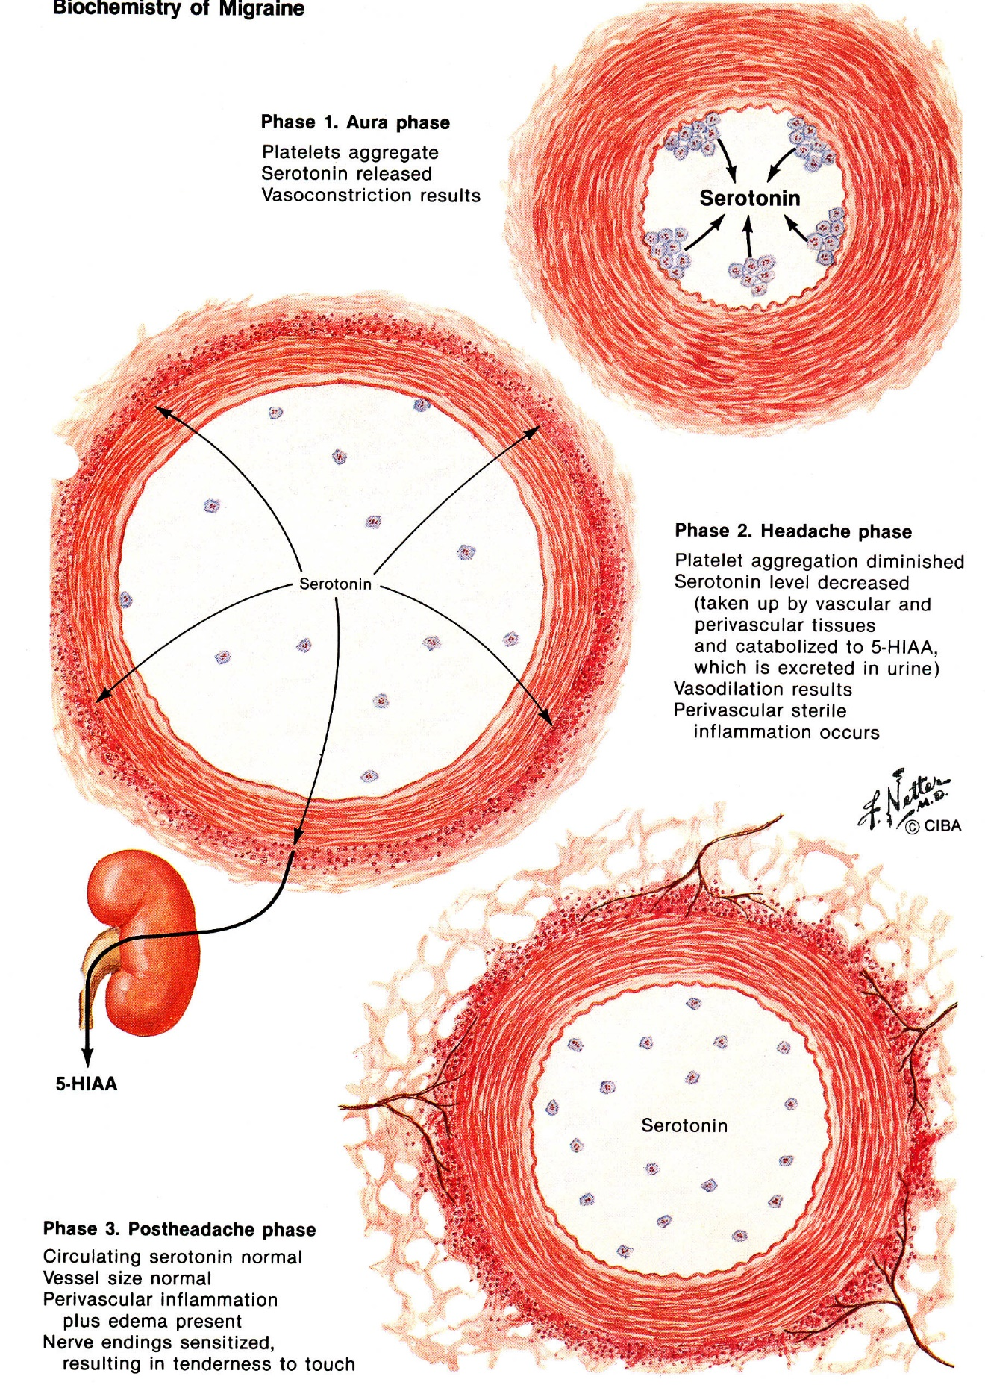

Epidemiology
Prevalence
- ≈ 12% (≈ 18% postpubertal* women, ≈ 6% men, ≈ 4% children).
*estrogens are significant trigger!
- prevalence highest in third-fifth decades.
- prevalence lower among African Americans and Asian Americans than among whites.

Economical aspects
- afflicts population during most productive years of life - begins in first three decades (youngest patient reported to develop migraine was 1 yr of age).
- economic impact is enormous (absenteeism, decreased productivity, cost of diagnostic tests and treatment, etc).
- migraine is more prevalent in lower socioeconomic class - burden of migraine renders patients less able to compete effectively in society, school, and workplace ("downward socioeconomic drift").

Genetics
- 70% migraineurs have family history; relatives of migraineurs have 3-4 times higher risk than controls.
- according to twin studies, 40-50% of susceptibility to migraine is genetically based.
- segregational analysis has failed to identify any single mendelian pattern of transmission (except familial hemiplegic migraine).

Migraine and affective disorders have bidirectional influence
(underlying CNS abnormality, perhaps serotonergic disturbances, predispose patients to develop one or both disorders; i.e. neither one can be said to cause other, but susceptibility to both is due to third, shared etiologic factor.)
  - migraineurs have 4.5-fold risk of major depression, 6-fold risk of manic episodes, 3-fold risk of anxiety disorder, 6-fold risk of panic disorder.
  - depressed patients develop migraine at 3 times rate of nondepressed patients.
  - co-morbid occurrence of disorders may tip balance in favor of one treatment that can beneficially affect both disorders (e.g. tricyclic antidepressant, vs. β-blockers which may aggravate depression).

Epilepsy, stroke, mitral valve prolapse are more common in migraineurs.

Clinical Features
Benign syndrome of recurring headache and/or neurologic dysfunction.
Migraine falls into two categories:
- migraine without aura (common migraine) - 85% patients.
- migraine with aura (classic migraine) - 15% patients.
Migraine without aura is more common than migraine with aura!

Migraine attack can be divided into 4 phases:
- prodrome
- aura
- headache
- postdrome

N.B. although most migraineurs experience more than one phase, no phase is obligatory for diagnosis (e.g. migraine with aura may occur with or without headache), exception - migraine without aura requires headache for diagnosis.

Prodrome (60% patients) - occurs hours or days before headache; includes following features:
  - psychological – depression, drowsiness, euphoria, hyperactivity, talkativeness, irritability, restlessness.
  - neurological – photophobia, phonophobia, hyperosmia, dysphasia, difficulty concentrating, yawning.
  - constitutional & autonomic – stiff neck, cold feelings, sluggishness, food cravings, anorexia, diarrhea / constipation, thirst, urination, fluid retention.

Aura - focal neurological symptoms (positive or negative phenomena) that precede or accompany attack.
- aura symptoms develop over 5-20 minutes and last < 60 minutes (aura > 1 hour - complicated migraine).
- headache, when present, occurs within 60 minutes of end of aura; most patients do not feel well* during this period (from aura end to headache onset).
*variety of cognitive or emotional symptoms.
N.B. aura begins maximum 2 hours before headache!
- aura is not with every headache, but when it occurs it is stereotyped from attack to attack.
- as patients age, aura may occur without subsequent headache (late-life migraine equivalents).

  - Most frequently (≈ 64%) occurring aura is visual in nature!
    - most common - elementary visual disturbances (incl. scotomata, photopsia, phosphenes, specks, geometrical forms, shimmering, undulations);
- dysfunction of occipital lobe neurons - present in both eyes and often in hemifield distribution.
- may occur singly or number in hundreds.
- more likely to occur during (than before) headache.
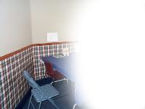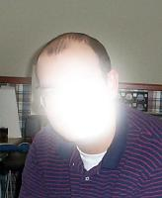

    - most characteristic (nearly diagnostic of migraine!) - complicated hallucinations

teichopsia, s. fortification spectrum (G. teichos - wall) - pathognomonic scintillating scotoma of migraine (occurs in 10% cases) - begins as small paracentral scotoma that slowly expands into “C” shape; luminous angles appear at enlarging outer edge and become colored as scintillating scotoma expands and moves toward periphery of involved hemifield; resembles fortifications of walled medieval town; eventually disappears over horizon of peripheral vision; entire process consumes 20-25 minutes; never occurs during headache phase; mechanism of teichopsia is entirely neurogenic (vs. vasogenic) due to dorsal raphe system activation! | 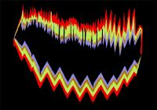

    - visual distortions (speculated to represent some of Lewis Carroll's descriptions in Alice's Adventures in Wonderland) - complex disorder of visual perception - metamorphopsia, micropsia, macropsia, zoom vision (opening up or closing down in size of objects), mosaic vision (fracture of image into facets); more common in children.

  - Paresthesias - second most common aura (≈ 40%)!
    - typically progress over 10-20 minutes (slower than spread of sensory symptoms of TIA).
    - cheiro-oral - start in hand, migrate up arm, and then extend to involve face, lips, and tongue.
    - can become bilateral and may be followed by numbness and loss of positional sense (negative phenomena).
    - often associated with visual aura.

  - Motor symptoms (18%) - usually associated with sensory symptoms; unilateral sense of heaviness of limbs (true weakness is rare).

  - Cognitive, psychic symptoms (17-20%) - difficulties in perception and use of body; speech and language disturbances; states of double or multiple consciousness associated with deja vu or jamais vu; elaborate dreamy, nightmarish, trancelike, or delirious states.

Headache
    - headache itself is similar in all types of migraine.
    - attack occurs during awake state, although it may have already started upon awakening and less commonly may awaken patient at night.
    - unilateral (60%), localized in frontotemporal and ocular area.
- side affected in each episode may be different; may be bilateral at onset or start on one side and become generalized.
- if headache is always on 1 side, structural (vascular) lesion needs to be excluded by neuroimaging!!!
    - gradually builds up over 1-2 hours*, progressing posteriorly and becoming diffuse; pain peaks and then subsides.
* some have abrupt onset ("crash" migraine similar to "thunderclap" headache).
    - throbbing (in 85% cases).
    - moderate ÷ marked severity*, aggravated by routine physical activity.
* ≥ 5 points (on 0 to 10 scale)
Any severe headache (regardless of cause) is likely to be throbbing and associated with vomiting and scalp tenderness!
    - lasts 4-72 hours (2-48 hours in children).
status migrainosus – attack lasting > 72 hours (despite treatment); headache-free periods of < 4 hours (sleep not included) may occur; usually associated with prolonged analgesic use; often with pernicious nausea, vomiting, dehydration, and despair.
    - frequency of attacks is extremely variable (few in lifetime ÷ several per week); average 1-3 headaches per month.
    - invariably accompanied by other features - nausea (80-90%), vomiting (30-50%), sensory hyperexcitability (photophobia, phonophobia, osmophobia → seek dark, quiet room), blurred vision, nasal stuffiness, diarrhea, polyuria, pallor, sweating, localized edema of scalp / face, scalp tenderness, prominence of vein or artery in temple, neck stiffness and tenderness, impairment of concentration and mood, lightheadedness (not true vertigo), pale, cold and moist extremities.
N.B. for children vomiting and abdominal symptoms may be much more prominent than headache!!!
    - well-known stereotyped activators (triggers):
Most patients find that many triggers affect their susceptibility to headache.
- cycling estrogen, especially fall in estrogen levels (before menstrual period, after childbirth, during pill-free week of oral contraceptive use, interrupted dosing regimen of hormone replacement therapy).
- changes in sleep patterns.
- certain foods - red wine, aged cheese, citrus fruits, chocolate, hunger.
N.B. association of diet and migraine is usually overstated - common practice of handing patients long lists of foods they should avoid is to be condemned!
- stress
- bright lights or glare, odors.
    - well-known deactivators - sleep, late pregnancy, exhilaration, vomiting.

Postdrome - patient may feel tired and weak, "washed out," irritable, listless, impaired concentration, scalp tenderness, mood changes.
    - some feel unusually refreshed or euphoric, whereas others note depression and malaise.

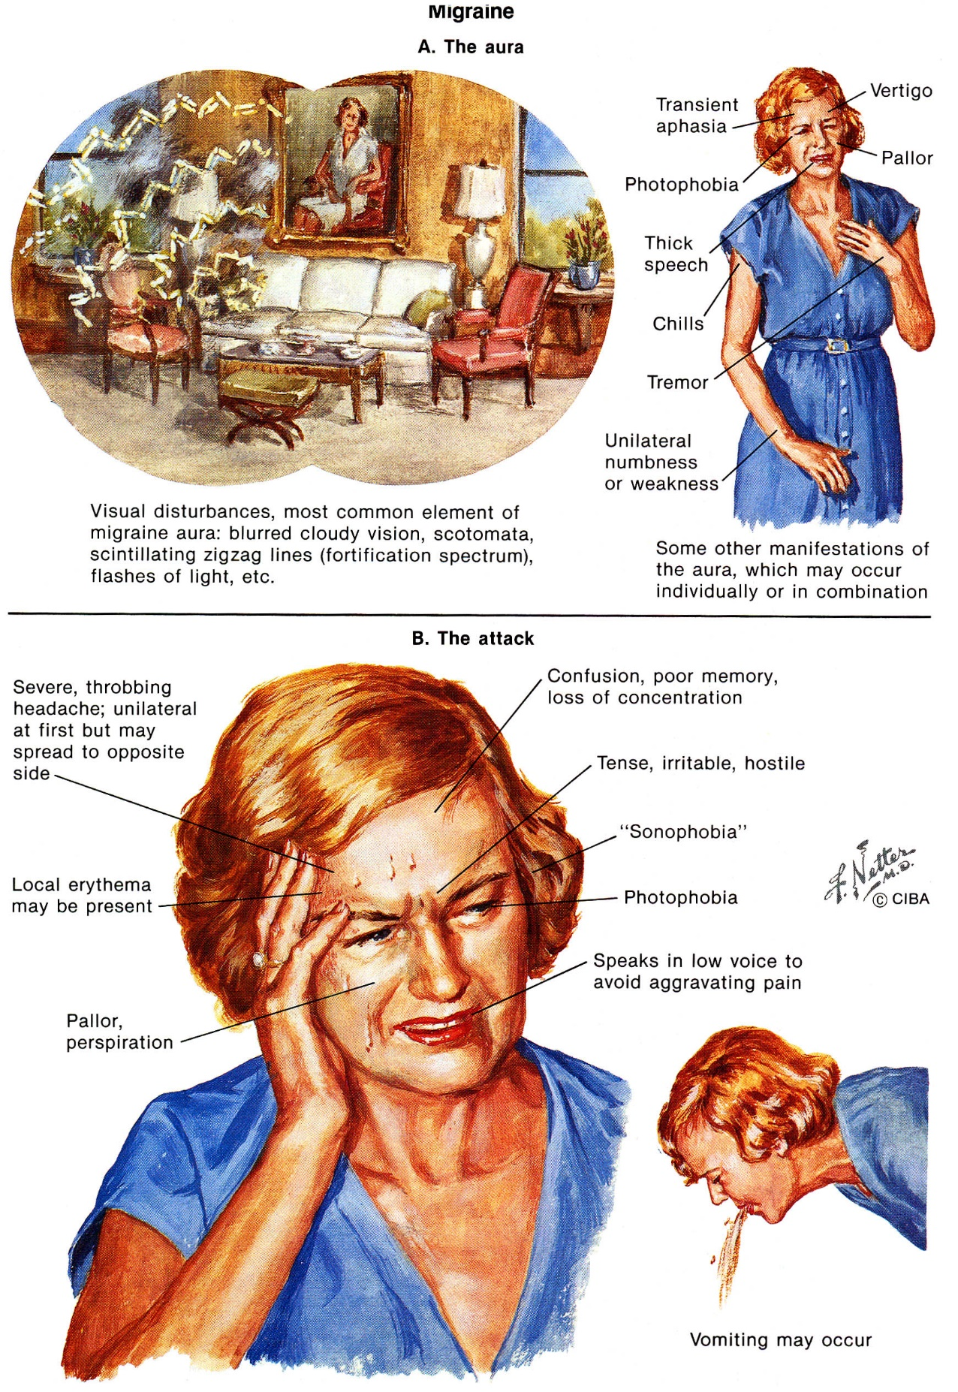

Female Aspects
pregnancy:
  - migraine (esp. migraine with aura) may worsen during first trimester.
  - 60% experience clear improvement during later pregnancy (pathognomonic for migraine).
  - headache occurs frequently in postpartum period.
  - pregnancy complications not increased, birth defects not increased.
- frequent definite relationship between attacks and menstrual period.
- many women experience improvement with natural (but not surgical) menopause.

Diagnostic Criteria For Migraine
N.B. criteria have high specificity but low sensitivity - experienced clinicians often make presumptive diagnosis based on fewer criteria and proceed with treatment!

Migraine with Aura (Classic Migraine) - at least 2 attacks having ≥ 3 of following 4 characteristics:
- One or more fully reversible aura symptoms.
- At least one aura symptom over > 4 minutes or ≥ 2 symptoms occurring in succession.
- No single aura symptom lasts > 60 minutes.
- Headache follows aura with free interval < 60 minutes (headache may also begin before or simultaneously with aura).

Migraine Without Aura (no focal neurologic symptoms precede headache) - at least 5 attacks of episodic headache lasting 4-72 hours (untreated or unsuccessfully treated) with:
≥ 2 of following characteristics:
- Unilateral
- Pulsating
- Moderate or severe intensity (inhibits or prohibits daily activities)
- Aggravation by walking stairs or similar routine physical activity
+
At least one of following:
- Nausea and/or vomiting
- Photophobia and phonophobia

For Both Disorders
  - history, physical and neurological examinations, appropriate investigations must adequately exclude secondary disorders.
  - if secondary condition co-exists, migraine is considered primary only if original migraine onset did not occur in close temporal relation with other disorder.

Clinical Subtypes
Complicated migraine
- migraine with dramatic focal neurologic features
- persisting neurologic disorder after migraine attack – i.e. aura of 1 hour ÷ 1 week duration + normal neuroimaging (if > 1 week or abnormal neuroimaging, migrainous infarction is likely).

Basilar migraine
(previously called "basilar artery migraine")
    - visual aura (up to total blindness) → brain stem signs (ataxia, vertigo, nystagmus, tinnitus, diplopia, nausea and vomiting, dysarthria, bilateral distal and perioral paresthesia, change in level of consciousness and cognition) persist ≈ 30 minutes → throbbing occipital headache.
    - altered sensorium may persist for up to 5 days (may superficially resemble psychotic reactions).
    - full recovery is rule.
    - affects all age groups.
    - clear female predominance (originally believed to be disorder of adolescent girls).
    - high-resolution MRI and MRA probably are indicated in all patients.
    - triptans contraindicated!

Confusional migraine
- more common in boys.
    - headache accompanied by inattention, distractibility, difficulty maintaining speech and other motor activities.

Hemiplegic migraine
- sporadic form
- familial form - autosomal dominant with genetic heterogeneity:
  - 50% cases - point mutations in CACNL1A4 gene (α1-subunit of brain-specific P/Q-type calcium channel that is coupled to neurotransmitter release) on 19p13; clinical distinction - cerebellar atrophy.
  - mutations in 1q31.

    - typically begins in childhood → ceases with adulthood.
    - attacks are frequently precipitated by minor head injury.
    - hemiplegia (± hemisensory loss) may be part of aura (lasts < 1 hour) or may continue through headache phase (and last for days or weeks thereafter).
    - affected side may vary from attack to attack.
    - changes in consciousness (confusion ÷ coma) occur in 23% patients (esp. children).
    - prophylactic acetazolamide is recommended.
    - triptans contraindicated!

Ophthalmoplegic migraine
- migrainous unilateral periorbital pain accompanied by vomiting for 1-4 days → CN3 palsy (with ptosis, dilated pupil).
- CN4 and CN6 may be rarely involved.
- ophthalmoplegia duration varies (hours ÷ 2 months); some ophthalmoparesis may remain.
- many cases fit criteria for Tolosa-Hunt syndrome: (1) steady, gnawing, boring, eye pain; (2) involvement of nerves of cavernous sinus; (3) symptoms lasting days ÷ weeks; (4) spontaneous remission, with recurrent attacks after months or years; (5) CT or MRI limiting disorder to cavernous sinus; (6) steroid responsiveness.
- usually begins in childhood (vs. Tolosa-Hunt syndrome – in adulthood).
- another diagnostic possibility - intracranial aneurysm compressing CN3.
Neuroimaging / angiography are necessary for ophthalmoplegic migraine diagnosis (i.e. diagnosis of exclusion)!

Retinal migraine
- vasospasm of choroidal or retinal arteries → retinal and optic nerve ischemia - presents with monocular blindness (amaurosis fugax lasting 3-30 minutes).
- episodes are limited to same eye in > 90% patients.
- ophthalmoscopy - optic disc pallor, papilledema, narrowing of retinal vessels, retinal hemorrhages.

Abdominal migraine (s. cyclic vomiting syndrome)
- migraine equivalent - periodic abdominal pain, violent and sometimes prolonged vomiting not accompanied by headache.
- exclusively in childhood; onset typically prior to 10 years (mean age 3.5 years).
- antiemetic drugs are not effective (selective 5-HT₃ antagonist ondansetron may be efficacious).

Carotidynia (s. facial migraine)
  - pain located at jaw or neck; continuous, deep, dull, aching, and becomes throbbing episodically; often superimposed sharp, ice pick-like jabs.
  - soft tissue swelling, tenderness and prominent pulsations of ipsilateral cervical carotid artery.
N.B. 50% traditional migraineurs with frequent attacks have carotid tenderness at several points on side most often involved during hemicranial migraine attacks.
- many patients also report throbbing ipsilateral headache (concurrent as well as between carotidynia attacks).
- attacks occur one to several times per week
- attacks last several minutes ÷ hours.
- most common among older patients (incidence peaking in 4-6th decades).
- dental trauma is common precipitant.
- indomethacin is often effective.

Migrainous accompaniments (s. migraine equivalents)
- focal neurologic symptoms without headache or vomiting (i.e. aura without headache).
- accepted as migraine only after full investigation and prolonged follow-up; occasional headaches in association with same symptoms confirm migraine diagnosis for episodes without headache.
- more common in patients 40-70 years (may occur for first time after age 45) - late-life migrainous accompaniments.
- attacks last 1 minute ÷ 72 hours.
- scintillating scotoma (even isolated) is diagnostic of migraine, whereas other episodic neurological symptoms (paresthesias, aphasia, sensory and motor symptoms) need more careful evaluation.
- can easily be confused with TIA.
Criteria for late-life migrainous accompaniments:
  - scintillations (or other visual display), paresthesias, aphasia, dysarthria, paralysis
  - build-up of scintillations
  - march of paresthesias
  - progression from one accompaniment to another, often with delay
  - ≥ 2 similar attacks
  - headache in 50% attacks
  - episodes last 15-25 minutes
  - characteristic mid-life "flurry" of attacks
  - generally benign course
  - normal angiography (no thrombosis, embolism, dissection)
  - excluded epilepsy, polycythemia, thrombocythemia, thrombotic thrombocytopenia

Transformed migraine
- past history of episodic migraine* → many years of analgesic overuse → chronic daily headaches that persist for months.
*90% without aura; typically beginning in teens or twenties.
    - most patients are women.
    - headaches grow less severe and more frequent, but associated symptoms (photophobia, phonophobia, nausea) become less frequent and less severe!!!
    - daily headaches resemble chronic TTH with mild ÷ moderate pain but with photophobia, phonophobia, GI features - in past, this was called mixed tension-vascular headache.
    - other migraine features (unilaterality, aggravation by menstruation) may persist.
    - full-blown migraine attacks (meet all of IHS criteria for migraine except duration) superimposed on background of less severe headaches often occur.
    - most patients overuse symptomatic medication; stopping overused medication → frequently distinct headache improvement.
    - 80% patients have depression (depression often lifts when pattern of medication overuse and daily headache is interrupted).

Malignant migraine
- Migraine which turns out to be MELAS. see Met5 p.
- Migraine in maternal relatives of patients with oxidative phosphorylation diseases and who are unresponsive to usual prophylactic medications
Migraine is frequently seen in maternal relatives of patients with diseases of oxidative phosphorylation!
- Migraine patients who develop strokes (intense vasoconstriction → thrombosis)
- relative risk of stroke (particularly in migraine with aura) is increased only slightly; patients with prolonged auras (complicated migraine) may benefit from prophylactic neuroprotective calcium channel blockers or platelet inhibition with low-dose aspirin (if prior strokes → warfarin).
- when vasoconstriction abates, blood flow to region is augmented → reperfusion can cause hemorrhage into infarcted tissue.

Differential Diagnosis
Disorders that may have migraine-like headaches as symptom:
- Other primary headache disorders
- Cerebrovascular disorders (infarction, TIA, venous thrombosis, vasculitis, carotid or vertebral dissection) should be included in differentiation of migraine.
- Structural brain abnormalities (tumors, infections, vascular malformations) - headaches may be thought of as secondary migraine.
- Cerebral autosomal dominant arteriopathy with subcortical infarcts and leukoencephalopathy (CADASIL)
- Mitochondrial encephalopathy with lactic acidosis and strokelike spells (MELAS)
- Ornithine transcarbamylase deficiency
- Raeder paratrigeminal syndrome.
- Sinusitis, glaucoma
- Aura of migraine may lead directly to partial seizure (migralepsy).

Evaluation
Full neurologic examination should be done on first visit!
± MIDAS (Migraine Disability Assessment scale)
Normal neurological examination + headaches that fit IHS criteria of migraine → brain imaging not required; diagnosis is clinical!
- indications for neuroimaging:
  - abnormal neurological examination, persistent neurological deficit
  - atypical history, clinical presentation
  - worst headache of patient's life
  - sudden unexplained change in frequency or major characteristics of headache
  - progressive or new chronic daily headaches
    - EEG is usually normal (focal or generalized slowing may be found, especially during or immediately after migrainous attack).
    - routine blood tests and ECG - before initiating therapy for migraine.
    - cerebral blood flow studies:
during aura: bilateral decrease in occipital cortex → spreads anteriorly to temporal and parietal lobes.

Management
    - prophylactic drugs are 5-HT₂ antagonists, whereas abortive agents are 5-HT₁ agonists.
    - migraine can be aborted if therapy is initiated at onset of symptoms (during aura or at first hint of pain without aura).

Cerena transcranial magnetic stimulator (eNeura Therapeutics)
- FDA approved device to relieve pain caused by migraine headache with aura
    - used by prescription after onset of pain.
    - using both hands, patient holds device to back of head and, pressing button, releases pulse of magnetic energy that stimulates occipital cortex, stopping or reducing pain associated with this type of migraine.
    - 38% of patients were pain-free 2 hours after using device (vs 17% of controls); after 24 hours, nearly 34% of treated patients were pain-free (vs 10% of controls).
    - does not relief other associated symptoms (incl. sensitivity to light or sound and nausea).
    - dosage - not to exceed 1 treatment in 24 hours.

Peripheral Nerve Blocks
See p. S24 >>

Selective 5-HT₁ agonists - triptans

Mechanism of action
- potent full agonists at 5-HT_{1B/D} receptors (less potent at 5-HT_{1A} receptors).
- inhibit neuropeptide release (such as substance P) in periphery.
- block pain transmission in trigeminal pathways (inhibiting protein C-fos release from trigeminal nucleus caudalis).
- induce cranial vessel constriction (5-HT_{1D} receptors are found on small, peripheral nerves that innervate intracranial vasculature).

No of triptans offers safety advantage over others when used in pharmacologically equivalent doses; main differences between triptans are pharmacokinetic.
- all triptans constrict coronary arteries in vivo.
- overuse of triptans has not been associated with rebound headache.
- combining different triptans can be done but is discouraged (can be confusing for some patients).
- combination of triptans and ergotamines should be avoided (24 hours interval between these medications is necessary) - may increase vasospastic reactions.
- combination of triptans and SSRI (selective serotonin reuptake inhibitor) may cause life-threatening serotonin syndrome. see p. Psy15

N.B. triptans by blocking c-fos expression (by action on 5-HT₁ receptors) decrease headaches with diverse pathogenesis (e.g. meningovascular irritation) - response to 5-HT₁ agonists is not diagnostic of migraine headache!

Contraindications:
- uncontrolled hypertension
- coronary artery disease
- age >65 y
- ergot alkaloid in preceding 24 hours.
- stroke of any type
- peripheral vascular disease
- hemiplegic or basilar migraine

Sumatriptan (Imitrex)
    - rapidly aborts (or markedly reduces) migraine headaches and all complex of migrainous symptoms* in 80% patients. *decreases nausea and vomiting!
    - indications - moderately severe ÷ severe migraine headaches; also effective in cluster headaches.
    - administered: Doses should be separated by at least 2 hours!
- gold standard against which other drugs are judged - 6 mg s/c (efficacy – 82% at 20 min); max 12 mg/d.
- 5 and 20 mg intranasally (efficacy – 62% at 2 h) – not popular (prolonged and unpleasant bitter taste); max 40 mg/d.
- 25-100 mg orally (efficacy – 60-70% at 4 h); max 300 mg/d.
    - short duration of action (T_{1/2} - 2 hours) - headache commonly recurs within 24-48 hours after single dose; second dose is effective in aborting headache.
    - few side effects – due to vasoconstriction; e.g. chest or neck pain (serious cardiac side effects uncommon).
    - sumatriptan does not cross intact BBB.

2nd-generation triptans (all in only oral formulations):
Zolmitriptan (Zomig)
- improved efficacy (over oral sumatriptan) - 62% at 2 h and 75-78% within 4 h.
    - activity at 5-HT_{1A} receptor → nausea.
    - available in 2.5-mg and 5-mg tablets.
    - dose can be repeated every 2 hours; max 10 mg/d.

Naratriptan (Amerge, Naramig)
- efficacy is significantly lower (than all other oral triptans), but long T_{1/2} (6 hours) - no need to redose - useful for slow to start but prolonged headaches (efficacy 49-67% at 24 h).
- available in 1-mg and 2.5-mg tablets; may be repeated after 4 h.
- high oral bioavailability (more consistent response).

Rizatriptan (Maxalt)
- fast acting - efficacy 71% at 2 h.
- available in 5-mg and 10-mg disintegrating tablets (disintegrating wafer) - convenience for patients who cannot swallow pills or do not have access to water.
- can be repeated every 2 hours; max 30 mg/d.
- T_{1/2} = 2-3 h.
- interacts with propranolol (but no other β-blocker) - propranolol increases [rizatriptan] by 70% - rizatriptan dose must be halved.

Almotriptan (Axert)
- T_{1/2} = 3-4 h.
- 6.25 and 12.5 mg tablets; max 25 mg/d.

Frovatriptan (Frova)
- very long T_{1/2} (26-30 h).
- dosage - 2.5 mg once at attack onset.
Eletriptan (Relpax)
- onset within 1 h.
- T_{1/2} = 18 h.
- dosage - 20-40 mg at onset of migraine; may repeat once after 2 h; max 80 mg/d.
- additional contraindications - severe hepatic impairment; potent CYP450 3A4 inhibitors (ketoconazole, itraconazole, nefazodone, troleandomycin, clarithromycin, ritonavir, nelfinavir) within 72 h.

Calcitonin-gene-related peptide (CGRP) antagonists
erenumab (Aimovig) – FDA approved for the prevention of migraine in adult patients; once-monthly self-injectable fully human monoclonal antibody.

5-HT₁ agonists - Ergot alkaloids
- high affinity but low selectivity for 5-HT₁ receptors (more potent at 5-HT_{1A} receptors, but less potent at 5-HT_{1D} - vs. triptans).
- also stimulate D receptors (CNS stimulation – confusion, anxiety).
- produce α-adrenergic blockade → strong vasoconstriction (BP↑, vascular insufficiency), uterine contractions (abortion).
Ergot overdose treatment - nitroprusside

Contraindications:
- complicated migraine (i.e. neurologic deficits)
- pregnancy (fetal vasoconstriction & abortifacient potential!!!), breastfeeding
- coronary artery disease; peripheral vascular disease; thrombophlebitis; severe hypertension; bradycardia; age > 60 yrs.

Ergotamine (Cafatine, Cafergot, Cafetrate)
- past drug of choice for abortive treatment.
- effective in 50% patients (most effective when administered during prodrome!!!).
- GI absorption is variable (can be increased by caffeine!!!).
- administered (subnauseating dose should be determined for individual patient - dose that provokes nausea may intensify head pain!):
  - orally (1 mg q30min; max 6 mg per attack)
  - nasally (2-3 mg; max 6 mg per attack)
  - sublingually (1-2 mg q30min; max 6 mg per attack)
  - rectally (1-2 mg q30min; max 4 mg per attack)
- side effects - diarrhea, nausea, vomiting; prolonged use → significant rebound headache*, dependency, gangrene.
*H: limited use to twice weekly.
Dihydroergotamine (DHE-45)
- derivative of ergotamine - less toxic, fewer side effects; only parenteral!
- weaker arterial constrictor, less uterine effects, less emetic, longer acting - less likely to produce drug-rebound headache.
- efficacy ≈ sumatriptan (72% at 1 h).
- administered:
  - intranasally (1 mg q15min; max 2 mg).
  - i/m, s/c (0.5-1 mg q1h; max 3 mg).
  - i/v (0,25-1 mg q8h; max 2 mg) ± metoclopramide or prochlorperazine - excellent choice for status migrainosus.

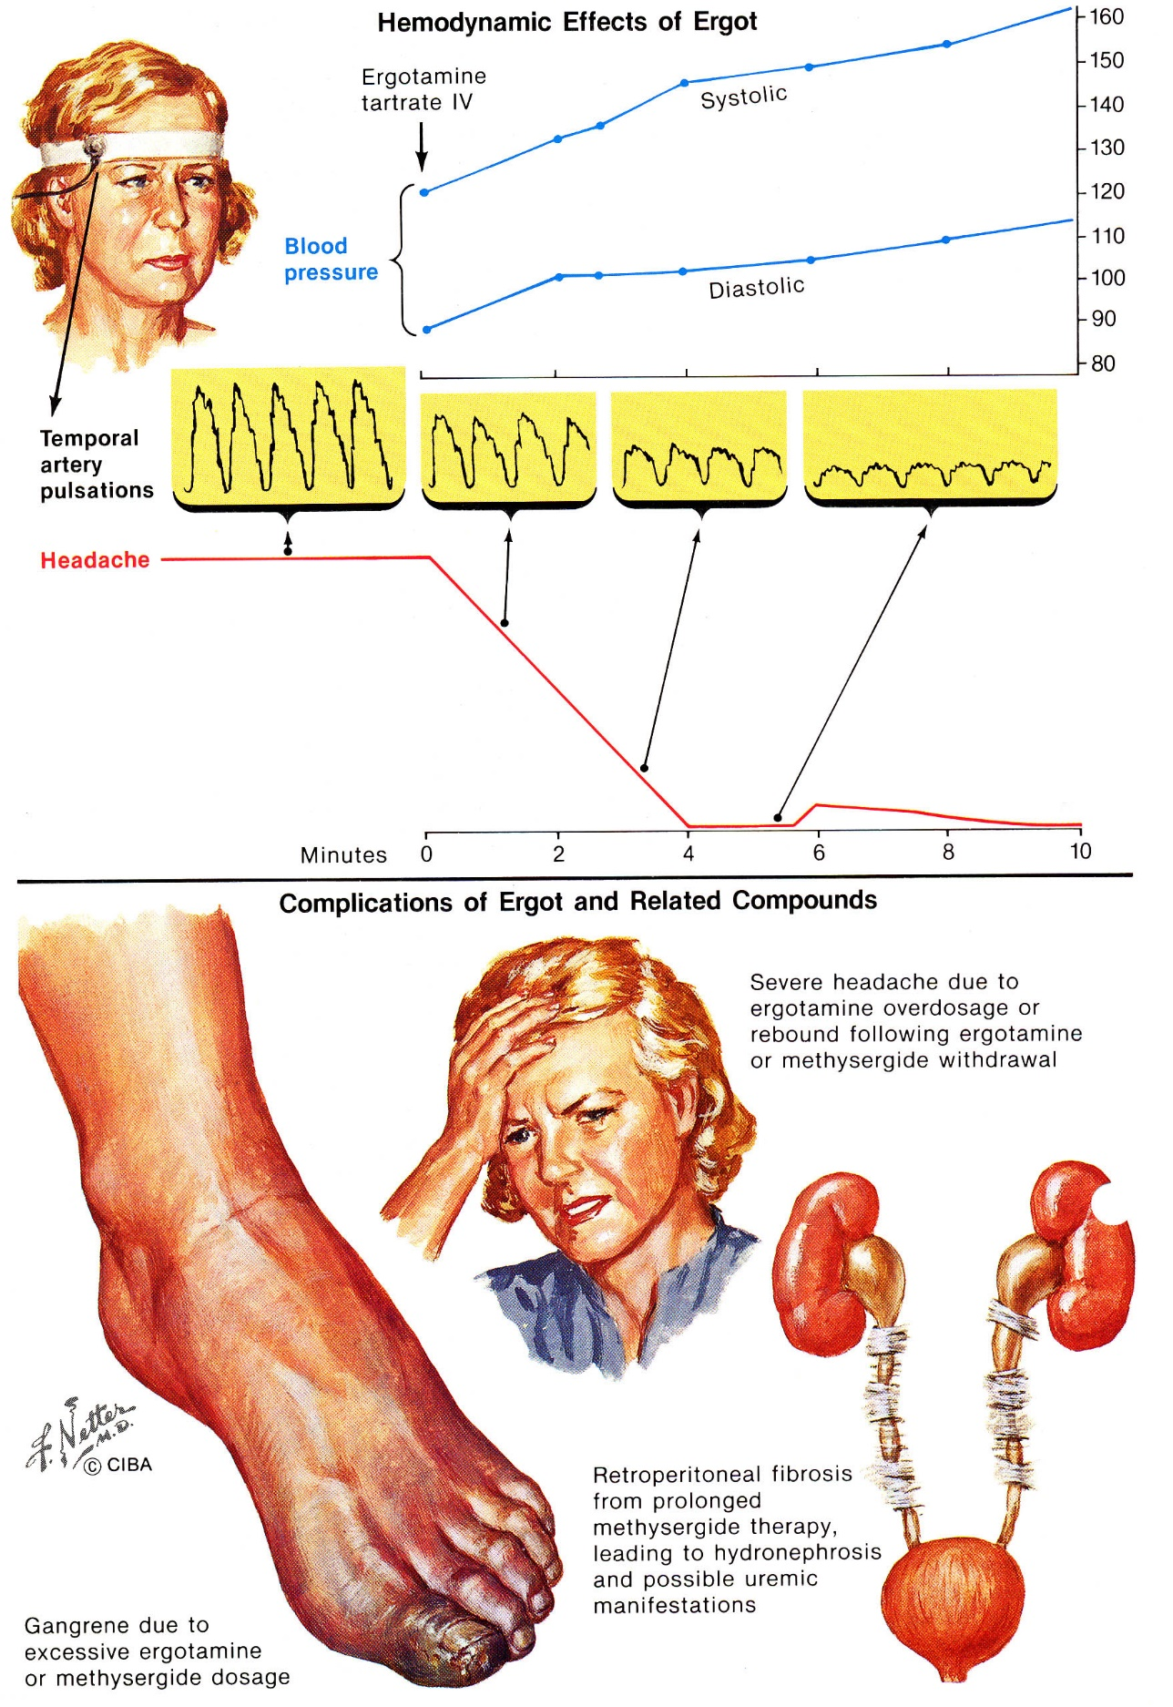

Abortive treatment principles
Nearly all patients with migraine headaches use medications to treat acute pain.
Opioids are not recommended!
Sooner treatment is begun, more effective it will be!
Nonpharmacologic treatments alone have no effect!
- abortive medications (incl. OTC) must be limited to 2-3 days/week to prevent rebound headache.
- adequate dose of whichever agent is chosen should be used at onset of attack; if additional medication is requested in 30-60 min (because symptoms have returned or have not abated), initial dosage should be increased for subsequent attacks.
- reduced GI motility (gastric stasis) → impaired drug absorption (even in absence of nausea) during attacks!; delayed absorption is related to attack severity but not to duration – if oral agents fail:
  - nausea → parenteral administration.
  - no nausea → add prokinetic (metoclopramide or cisapride).

N.B. doctors often give antiemetics before analgesics to prevent vomiting and increase resorption.

Mild attacks
Analgesics & NSAIDs are first-line:
- aspirin (1000 mg) ± combined with metoclopramide (10 mg, to combat nausea) – efficacy ≈ 50 mg sumatriptan
- acetaminophen
- ibuprofen
- naproxen
- propoxyphene
- ketorolac – may be effective in severe attacks.
- adjunctive medications (included in combination preparations to improve efficacy) – caffeine, butalbital (barbiturate of intermediate duration of action), dichloralphenazone (mild sedative), isometheptene (mild vasoconstrictor).
e.g. Fiorinal® (butalbital + aspirin or acetaminophen)
- antiemetics may be needed.

Moderate severity attacks - oral migraine-specific medications:
- triptans e.g. Treximet® (sumatriptan + naproxen)
- ergot alkaloids
Do not combine ergots with triptans!
Do not administer vasoconstrictors (ergots or triptans) to patients with known complicated migraine!!!
- managed care organizations advocate economically driven "step care" approach (patients are required to fail therapy with simple analgesics, nonspecific analgesics, and semispecific drugs before being allowed to use relatively expensive triptans).
- headache experts encourage "stratified care" (individual patient's headache frequency, severity, and other factors are considered in decision about treatment).
- many clinicians believe that patient-administered triptans & ergots have best efficacy-to-adverse-effect ratio of all acute-treatment medications and are most cost effective (fewer emergency visits).

Severe attacks – add parenteral medications (e.g. DHE q8h with IV metoclopramide).
Inpatient treatment is indicated in:
  - Status migrainosus, severe rebound headache, intractable headache that has failed to respond to outpatient treatment.
  - Significant co-morbidities

- triptans (e.g. sumatriptan SC)
- aspirin IV
- neuroleptics – chlorpromazine, prochlorperazine, thiothixene, droperidol – effective against nausea & vomiting.
- corticosteroids – dexamethasone, prednisone.
- narcotic analgesics – butorphanol, hydromorphone, oxycodone, meperidine, morphine – use only for infrequent, severe attacks when other treatments are contraindicated.
- lidocaine 4% (1 mg intranasally)
- diphenhydramine IV

  - rehydration may be necessary.

Status migrainosus
- dihydroergotamine IV
- corticosteroids

Treatment according to time required for head pain to reach peak after first being perceived by patient:
> 3 hours – oral medications:
- ergotamine
- isometheptene
- Fiorinal
1-3 hours:
- nasal dihydroergotamine
- ergotamine suppository
- oral sumatriptan
< 1 hour:
- sumatriptan s/c
- s/c or i/m dihydroergotamine
- nasal butorphanol

Rebound headache
- perpetuation of head pain secondary to overuse of symptomatic medication; i.e. occurs in primary headache disorder when patient uses immediate relief medications very frequently and excessively.
- no major difference among various analgesics.
- doses and duration of analgesic overuse are not defined; abortive medications > 2 days/week is often cited.
- pathogenesis not understood (defective 5-HT uptake caused by analgesic overuse?).
- clinical features:
  - headache occurs (near) daily (i.e. transformed migraine).
  - headache varies in intensity, type, severity, and location from time to time.
  - threshold for pain low (slight physical or intellectual effort bring on headaches).
  - headache accompanied by asthenia, GI symptoms, restlessness, anxiety, irritability, memory problems, difficulty in intellectual concentration, depression.
  - drug-dependent rhythmicity of headaches.
  - tolerance to analgesics over period of time.
  - withdrawal symptoms if taken off medications abruptly.
  - spontaneous headache improvement on discontinuing medications.
  - concomitant prophylactic medications relatively ineffective while patient is consuming excessive amounts of immediate relief medications.
- detoxification therapy:
- inpatient discontinuation of all headache-related medications (by headache specialist experienced in protocols).
- clonidine 0.1 mg patch - to decrease withdrawal in patients dependent on codeine or morphine-based medications.
N.B. never use narcotics for any chronic headache condition!
- start preventative medications in conjunction with detoxification.
  - daily amitriptyline (30-100 mg) or nortriptyline (40-120 mg) - act independently of antidepressant effects!
  - for recalcitrant cases - valproate (500-2,000 mg) or phenelzine (45-90 mg).

Pregnancy & breastfeeding
- acetaminophen (± metoclopramide) is first choice.
- very severe attacks - IV fluids, prochlorperazine, or narcotics.
- ergot alkaloid and triptans should be avoided completely!!!

Prophylaxis
Nonpharmacologic
Migraine is chronic disorder that requires lifestyle change at some level:
- encourage patients to use daily diary to document headaches
- avoid trigger factors
- keep regular patterns - exercise, meal, sleep.
- biofeedback techniques - thermal biofeedback combined with relaxation therapy, EMG biofeedback, cognitive-behavioral therapy.

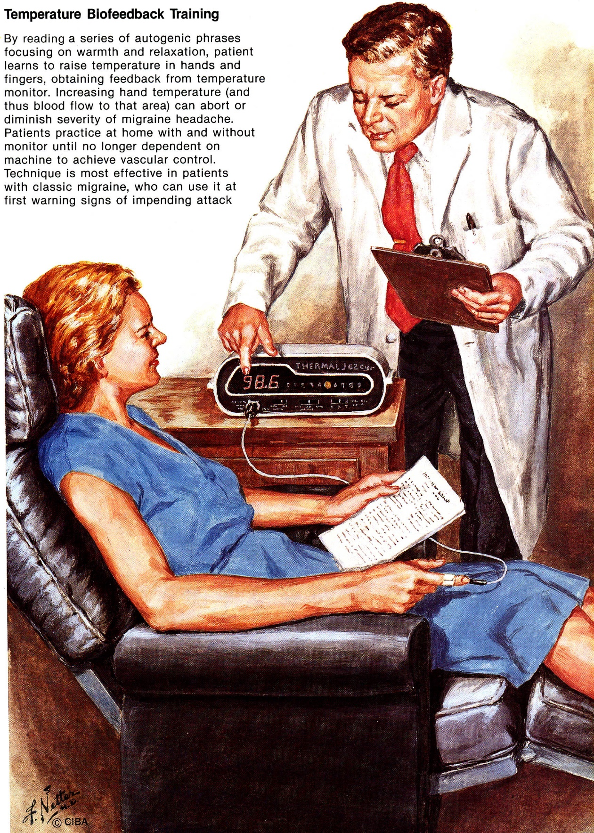

Onabotulinumtoxin A – FDA approved for prophylaxis in chronic migraine
http://cme.medscape.com/viewarticle/731020?src=cmemp&uac=121060BZ

Feverfew (Tanacetum parthenium, s. Chrysanthemum parthenium, Pyrethrum parthenium) - traditional medicinal herb found in many old gardens.  - active ingredients - parthenolide and tanetin.  - inhibit release of serotonin and prostaglandins → inflammation of blood vessels↓.  - capsules / tablets contain at least 205 μg parthenolide.  - might take 4-6 weeks before becomes effective - not a remedy for acute migraine attacks.  Evidence that it prevents migraine is limited!  - contraindicated in pregnancy.  - adverse effects: GI distress, mouth ulcers, antiplatelet. | 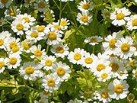

MigreLief® (formerly MigreHealth and MigreLieve) - patented combination of 3 natural ingredients:
Magnesium (citrate and oxide)
Riboflavin
Puracol™ Feverfew (proprietary extract + whole leaf)
- designed to provide benefits within 90 day build up period → continue daily use if you notice benefits.
- can be used with migraine prescription medicines or by itself.

Pharmacologic
- indicated if:
- severe* attacks occur ≥ 2 times / month. *produce disability for > 3 days
- acute treatment is required > 2 times / week.
- complicated migraine
- attacks occur in predictable pattern.
- abortive drug treatment is ineffective / intolerable / contraindicated.

(*FDA approved for migraine prophylaxis):
- Antagonists of calcitonin gene-related peptide (CGRP) - antibody injection given every 2 weeks; entirely new class of drugs for the prevention of migraine - as effective as traditional preventive medication in both episodic and chronic migraine; work very quickly - it is possible to know whether the drug works within 4 weeks, and they have a very good side-effect profile.

- β-Blockers
  - propranolol* – drug of choice
  - nadolol – second choice
  - timolol*
  - metoprolol
  - atenolol

- Calcium Channel Blockers
  - flunarizine - best-documented efficacy!
  - verapamil
  - diltiazem
  - nifedipine

- Serotonin Antagonists
  - methysergide* (Sansert®) - ergot alkaloid - 5-HT₂ antagonist - antagonizes peripheral actions of serotonin (e.g. inhibits serotonin vasoconstriction).
    - 2 mg/d (increase up to 12 mg/d).
    - prophylaxis effective in 60% cases (esp. in classic migraine).
    - adverse effects are common (used as second-line): nausea, abdominal pain, appetite stimulation, insomnia, nervousness, fluid retention, limb claudication.
    - continuous administration should not exceed 6 months (retroperitoneal-pleural-pericardial fibrosis, cardiac valvular fibrosis and related conditions have occurred with uninterrupted use); risk of fibrotic complication is ≈ 1:1500 and reverses after drug is stopped.
H: allow 3-4-wk drug-free interval after each 6-mo course + yearly pelvis & abdomen imaging and cardiac auscultation.
    - contraindications - peripheral vascular disease, chronic pulmonary disease, hypertension, deep vein thrombosis, active peptic ulcer.
  - cyproheptadine - 5-HT₂ antagonist; also blocks H₁ receptors.
    - used traditionally for:
      - pediatric migraine prevention.
      - pruritic dermatoses.
    - 2 mg/d (increase up to 32 mg/d).
  - pizotifen (esp. in combination with sumatriptan) - not available in USA.

- Anticonvulsants
  - valproate* - only drug proven to prevent migraine! (has been shown to reduce migraine frequency by 50%).
  - topiramate – safe and effective!
  - gabapentin

- Antidepressants (efficacy independent of antidepressant effect) - not recommended as first choice in migraine prophylaxis!
  - tricyclic - amitriptyline, nortriptyline, protriptyline, doxepin, imipramine
  - MAO inhibitor - phenelzine
  - SSRI - fluoxetine, sertraline, paroxetine

- NSAIDs (risk of adverse effects, particularly gastropathy or nephropathy!)
  - naproxen - efficacy similar to propranolol
  - tolfenamic acid
  - aspirin
  - ketoprofen

- Other
  - BOTOX® - injections to scalp and temple every 2-3 months; ineffective by American Academy of Neurology report!
  - riboflavin (alteration of neuronal oxidative metabolism)
  - magnesium (reducing neuronal hyperexcitability)
  - candesartan - as effective as propranolol in preventing migraine headaches!

- majority of preventive medications have modest efficacies (therapeutic gains < 50% when compared to placebo).
- many patients experience relief of headaches at low doses - drugs should be started at low dose.
- latency can be quite prolonged (time needed to down-regulate serotonin receptors):
  - 6-8 weeks are necessary to judge effect of particular dose (headache diaries aid in evaluation).
  - prophylaxis should not be considered failure until it has been given at maximum tolerable dose for at least 30 days (for β-blockers – 60 days).
- monotherapy is preferable, but drug combinations can work synergistically.
- if taken at time of attack, prophylactic agents are usually ineffective.
- when headaches have been controlled for 6 months, attempts can be made to taper and discontinue therapy.
- patients should be monitored for abortive medication overuse.

Drug selection:
First line:
High efficacy – β-blockers, tricyclic antidepressants, valproate.
Low efficacy – verapamil, NSAIDs, SSRIs.
Second line:
High efficacy – methysergide, flunarizine, MAOIs.
Unproven efficacy – cyproheptadine, gabapentin, lamotrigine.

According to comorbid conditions / migraine features:
Hypertension, angina, stress – β-blockers.
Prolonged aura, basilar migraine, hemiplegic migraine – verapamil.
Depression, sleep disorders, underweight – antidepressants.
Epilepsy, mania – valproate.
Woman of childbearing age – avoid valproate.
Perimenstrual migraine – NSAIDs, acetazolamide (start 1-2 days before expected onset of headache and continued for its expected duration).

Prognosis
Prognosis is generally good - usually improves (and may disappear) after age 50 yrs.
- natural history of transformed migraine is less certain – despite aggressive treatment, many continue to have lower intensity chronic daily headache or frequent episodic migraine.
- although migraine is not itself life-threatening, many of treatments for it can be:
  - addiction to nonspecific barbiturate or narcotic medications;
  - gastric bleeding from NSAID overuse;
  - end-stage renal disease from analgesic nephropathy.

Bibliography see p. S24 >>

Viktor’s Notes℠ for the Neurosurgery Resident
Please visit website at www.NeurosurgeryResident.net

