Cluster Headache and Chronic Paroxysmal Hemicrania
Last updated: May 8, 2019
Cluster Headache 1
Pathophysiology 1
Epidemiology 1
Clinical Features 2
Differential Diagnosis 3
Evaluation 4
Abortive therapy 4
Preventive therapy 4
Prognosis 5
Chronic Paroxysmal Hemicrania 5
Hemicrania continua 6

Cluster Headache
Old synonyms - Raeder syndrome, Horton cephalalgia, histamine cephalalgia, sphenopalatine neuralgia.
Pathophysiology
- not fully determined.

Theories
- circadian pacemaker alterations (due to hypothalamic dysfunction).
  - attacks increase following beginning and end of daylight savings time.
  - there is loss of circadian rhythm (for blood pressure, temperature, hormones - prolactin, melatonin, cortisol, beta endorphins).
  - recently, functional neuroimaging have identified posterior hypothalamic grey matter as key area for basic defect.
  - pain is generated at pericarotid / cavernous sinus complex.
- neurogenic inflammation
- carotid body chemoreceptor dysfunction
- central parasympathetic & sympathetic imbalance
- increased responsiveness to histamine.

Epidemiology
Prevalence 0.01-1.5% (≈ 0.3%)
- higher in men (male : female ≈ 6-8:1) and in blacks.
- family history is rare.

Onset - any age (generally - in late twenties).
- ≈ 10% patients develop cluster in their sixties.

Peptic ulcer disease is only known associated medical disorder.
- strong associations with smoking, alcohol use, and previous head / face trauma.
- certain personality and physical characteristics have been associated with cluster headache (e.g. tall and rugged-looking body, leonine facial appearance, multifurrowed and thickened skin with prominent folds, broad chin, vertical forehead creases, nasal telangiectasias).

Clinical Features
  - Episodic cluster headache - remission periods lasting ≥ 14 days (usually 6 months ÷ 2 years).
  - Chronic cluster headache (≈ 10%) - no remissions or remissions last < 14 days; headache is occurring for > 1 year.

Either type may transform into other! (in 4-13% patients, episodic CH transforms into chronic CH)

Multiple episodes of headache:
- pain begins without warning.
- severe – pain rapidly increases (within 5-15 minutes) to excruciating levels.
- short-lived – if left untreated, attacks usually last 30-90 minutes (15-180 minutes).
- strictly unilateral*, periorbital (orbital / supraorbital / temporal) – distribution of 1st or 2nd divisions of trigeminal nerve. *usually affects same side in subsequent months
- may radiate to forehead, temples, jaws, nostrils, ears, neck, or shoulder.
- pain is deep, constant (not throbbing), boring, piercing, burning, explosive.
- at least one symptom of unilateral (ipsilateral) autonomic dysfunction:
  - conjunctival injection (“red eye”)
  - lacrimation
  - miosis
  - ptosis
  - eyelid edema
  - nasal congestion
  - rhinorrhea
  - facial sweating
- in variant of cluster headache, full Horner's syndrome can be seen.
- patients feel agitated or restless with need to isolate themselves and move around (most sufferers assume upright position to relieve discomfort!); patients have been known to become violent or bang their heads against wall.
- GI symptoms uncommon.

Attack frequency varies (8 attacks per day ÷ 1 attack every 2 days).
Periodicity is hallmark of cluster headache! - attributed to hypothalamic (particularly suprachiasmatic nuclei) hormonal influences
    - attacks often occur at same time each day ("alarm clock headache"); onset is nocturnal in 50% cases (may awaken patients from sleep).
    - attacks occur in cluster periods that last 1 week ÷ 1 year (usually 1-3 months) separated by periods of headache-free remission.
    - cluster episodes often appear at characteristic times of year (particularly around vernal and autumnal equinoxes).
    - attacks may cease during pregnancy (but attacks seldom correlate with menses).

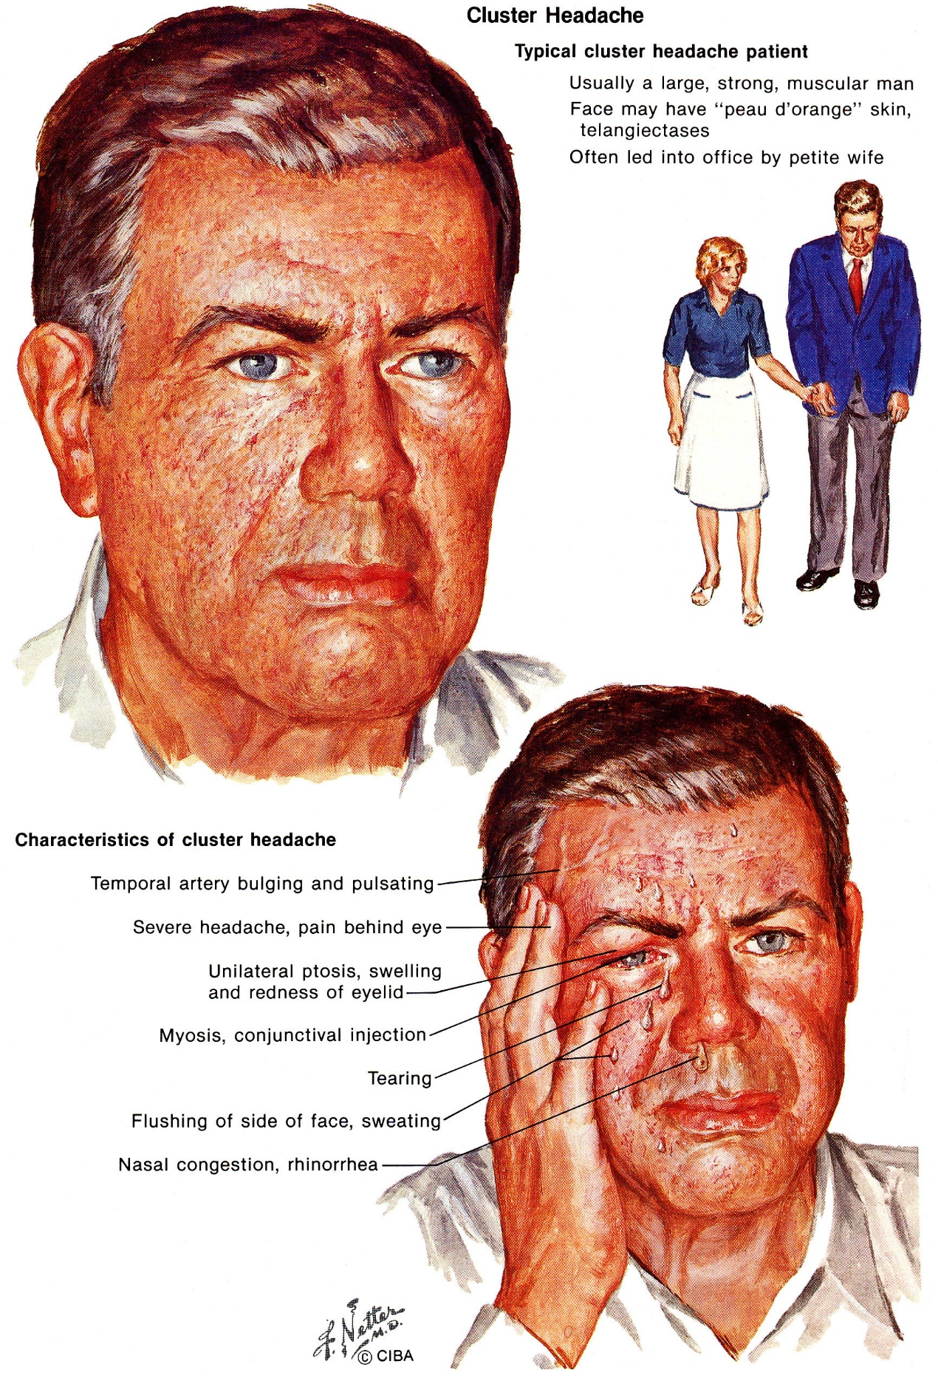

Differential Diagnosis
      - Secondary cluster-like headache (due to structural lesions near cavernous sinuses).
      - Chronic paroxysmal hemicrania
      - Migraine
      - Trigeminal neuralgia
      - Temporal arteritis
      - Raeder paratrigeminal syndrome - pain is constant (no distinct attacks)
      - Tolosa-Hunt syndrome
      - Sinusitis
      - Glaucoma

Evaluation
        - strictly clinical diagnosis - careful history is all that is needed.
        - MRI is justified only in atypical cases or abnormal neurological examination (except when abnormality is Horner's syndrome!).

Abortive therapy
Oral preparations are not recommended - absorbed too slowly.

- Inhaled high-flow oxygen (12 L/min 100% by mask for full 15 minutes following headache onset) - treatment of first choice (70-80% effective); postulated mechanism – O₂ is vasoconstrictor and increases serotonin synthesis.
- Parenteral sumatriptan 6 mg s/c
- Parenteral DHE
- Topical (intranasal) local anesthetics (2-4% lidocaine) - to most caudal aspect of inferior nasal turbinate (patient in supine position) - can deliver sphenopalatine ganglion block - remarkably effective!
- Parenteral narcotics
- Sphenopalatine ganglion stimulation with implantable system
- at 15 minutes following stimulation, 55% of treatment group had pain relief compared with 6% in sham treatment group (P < .0001); pain relief was maintained to 90 minutes (50% pain relief for treatment group vs 13% for sham). http://www.medscape.com/viewarticle/807281

Preventive therapy
- required for almost all patients!:
- attacks are too short and too severe to treat with only abortive medication;
- prophylactic treatment is most effective among all primary headache disorders! (except chronic CH - notoriously resistant to standard prophylactic agents)
- avoid alcohol and nitroglycerin.
Alcohol provokes attacks in 70% patients but has no effect when cluster bout remits (“on-off vulnerability to alcohol” - pathognomonic of cluster headache!!!).
- Peripheral Nerve Blocks see p. S24 >>

In order of preference (begin early in cluster period and continue until headache-free for at least 2 weeks):
  - ergotamine (orally 2 mg × 2/d) - classic treatment - most effective when given 1-2 hours before expected attack (for patients with single nocturnal episode, 1 mg suppository at bedtime may be all that is necessary)
Educate regarding early symptoms of ergotism (limb claudication) when ergotamine is used daily (H: weekly limit of 14 mg).
  - verapamil
  - methysergide (no longer available in USA)
  - lithium (300 mg bid or tid titrated according to serum lithium level) – esp. useful in chronic cluster headache!
  - prednisone (10-day course, beginning at 60 mg/d for 7 days and rapidly tapering); long-term use not recommended.
  - divalproex
  - capsaicin drops to ipsilateral nostril - induces substance P release (principal mediator of pain); after repeated applications, depletes neuron of substance P.
  - indomethacin

N.B. propranolol and amitriptyline are largely ineffective!
- new approach: in refractory CCH + low risk for anticoagulant-related hemorrhagic complications, low-intensity anticoagulation with warfarin (to achieve INR 1.5–1.9) is associated with significantly higher incidence of remission lasting ≥ 4 weeks, as well as significantly less impact of headache on patients' quality of life as compared to placebo.

Surgical therapy:
- new promising approach - DBS into posterior inferior hypothalamus.
- surgical intervention (for strictly unilateral chronic cluster) - ablation of sensory input of trigeminal nerve and autonomic pathways (e.g. percutaneous RF trigeminal gangliorhizolysis, rhizotomy) - effective in 75%.
- SRS – methodology as for trigeminal neuralgia but results not as good (no sustained pain relief beyond 2 years F/U); some authors tried to add 8 mm shot to sphenopalatine ganglion (Pollock BE & Kondziolka D. J Neurosurg 87:450-453, 1997).

Prognosis
- chronic headache that may last for patient's life.
- drug therapy may convert from chronic to episodic cluster.
- prolonged, spontaneous remissions have been described in up to 12% patients.

Chronic Paroxysmal Hemicrania
- as cluster headache (2% prevalence of cluster headache) with following differences:
- dramatic response to indomethacin – diagnostic criterion!
- women > men (7:1)
- shorter headache duration ≈ 13 (5-30) minutes.
- headaches occur ≈ 5-11 times/day.
- 10% attacks may be triggered by flexing / rotating / pressing upper portion of neck.
- typically, no remissions! (rarely, episodic paroxysmal hemicrania with remissions lasting weeks or months).
- MRI / CT should be undertaken to exclude symptomatic causes.
- treatment of choice - indomethacin (up to 200 mg/d); aspirin may also be beneficial, but relief is usually not complete.
- prognosis - may last indefinitely (with frequently reduced indomethacin requirement); spontaneous cures have been described.

Hemicrania continua
- exclusively 1-sided, constant moderate ÷ severe headache exquisitely responsive to indomethacin.

Bibliography see p. S24 >>

Viktor’s Notes℠ for the Neurosurgery Resident
Please visit website at www.NeurosurgeryResident.net

