Brain Death
Last updated: December 19, 2020
Criteria for Brain Death 1
Apnea Test (s. apnea challenge) 5
Ancillary Studies 6
Care of organ donor 9
Organ donation after cardiac death 11
Pediatric aspects 12

Diagnosing brain death must never be rushed or take priority over the needs of the patient or the family

Brain Death (BD) or Death by Neurological Criteria (DNC) – permanent loss of brain function* (cerebrum nor brain stem nor cerebellum)
(i.e. no clinical detection at bedside).**

*vs. brain activity (such as laboratory detection of cellular-level neuronal and neuroendocrine activity) is compatible with brain death, e.g. osmolar control - some patients develop diabetes insipidus only after clinical signs of brain death (i.e. diabetes insipidus is not required for BD diagnosis).

**vs. Vegetative State - brain stem is intact.

It is suggested that the terms whole brain death and brainstem death should be abandoned and replaced with BD/DNC

- the only spontaneous activity is cardiovascular (apnea persists in presence of hypercarbia sufficient for respiratory drive); pulse rate is invariant and unresponsive to atropine!
- the only reflexes present are spinal; muscles show generalized flaccidity and no movement (except spinal reflexes to pain).
N.B. presence of seizures is not compatible with BD diagnosis!
N.B. presence of any face / tongue movement is not compatible with BD diagnosis!
N.B. complex-spontaneous motor movements and false-positive triggering of ventilator may occur in patients who are brain dead!

- BD rarely lasts more than few days (always followed by circulatory collapse* even if ventilatory support is continued); mean = 4 days.
*progressive hypotension that becomes increasingly unresponsive to catecholamines
- recovery has never been reported!
- in USA, BD = legal death (i.e. death by brain criteria*)
*vs. somatic criteria (irreversible cessation of cardiopulmonary function)

Somatic death precludes function of brain. The opposite is true as well, so death of organism can be determined on basis of brain death.

There is no explicit reason to make diagnosis of brain death except when organ transplantation or difficult resource-allocation (intensive care) issues are involved. ethical issues – see p. 4667 >>

Criteria for Brain Death
although some details may be dictated by local law, standard criteria are established by President's Commission report of 1981.
Clinical examination is performed by one or two different physicians (for children - attending physicians)
1. | Coma, unresponsive to stimuli (incl. painful) above foramen magnum.
2. | Permissive diagnosis - structural disease or irreversible metabolic disturbance
3. | - Body temperature > 36°C (wait at least 24 hr after rewarming from hypothermia, then perform imaging - should demonstrate brain edema, brainstem herniation).  - Systemic circulation may be intact (in adults: SBP > 100, MAP > 60)  - Serum electrolytes must be WNL + no known endocrine disturbances + absence of drug intoxication (incl. ethanol, sedatives, potentially anesthetizing or paralyzing* drugs**).  metabolic disturbances should be corrected!  *present train of four or deep tendon reflexes  **tox screen (alcohol blood level must be 80mg/dL), serially measuring drug levels to ensure they do not exceed the therapeutic range (pentobarbital level should be < 10), or allowing 5 elimination half-lives to pass (assuming normal hepatic and kidney function),
4. | Adults  known structural cause – at least 6 hours observation (absent brain function)  others (incl. anoxic-ischemic brain damage) – at least 24 hours observation
Children
< 7 days of age or prematures – BD diagnosis inappropriate (i.e. wait until age 7 days)
7 ÷ 30 days – observation at least 24 hours
older children – observation at least 12 hours (24 hours if anoxic-ischemic brain damage)
Child's brain is more resilient - more difficult determination of BD!
5. | Absence of cephalic reflexes, incl. pupillary, corneal, oculocephalic, oculovestibular (caloric), gag, sucking, swallowing, cough, stereotyped posturing.  Decorticate or decerebrate posturing is not compatible with BD diagnosis!  Purely spinal reflexes may be present (incl. tendon reflexes, plantar responses, limb flexion to noxious stimuli, tonic neck reflexes).
6. | Apnea off ventilator (with ongoing oxygenation) for duration sufficient to produce hypercarbic respiratory drive (usually 10-20 min to achieve Paco₂ ≥ 60 mmHg).
7. | Optional confirmatory studies:  - EEG - isoelectric for 30 minutes at maximal gain.  - Absent brain stem evoked responses.  - Absent cerebral circulation demonstrated by radiographic / radioisotope / MR angiography.

- assessment of BD after cardiopulmonary resuscitation must be deferred for 24 hours; if there are concerns or inconsistencies in the examination with other severe acute brain injuries, clinicians must be cautious and not rush.
- when death results from criminal assault, or there is possibility of litigation regarding death, extra care must be taken and legal counsel may be advisable before making determination of brain death.
- interventions to decrease intracranial pressure (hyperosmolar therapy, ventricular drainage, and decompressive craniectomy) should be applied when clinically indicated during therapeutic phases of care vs. if these types of interventions are not indicated for the treatment of devastating brain injury, they should not be performed simply for the purpose of demonstrating irreversibility of the clinical state.

First stage - demonstrate deep unresponsive coma with apnea* and no response to painful central stimuli (peripheral stimuli may elicit spinal reflex movements and may confuse family).
*always first check if patient is triggering the ventilator = “breathing over the vent” (i.e. real f > set ventilator f)
- test motor responses of the face and limbs:
- apply deep pressure to all of the following: i. the condyles at the level of the temporomandibular joints ii. the supraorbital notch bilaterally iii. the sternal notch iv. all 4 extremities, both proximally and distally.
- insert a cotton swab on a stick in each nostril to perform “nasal tickle” testing.
- response consistent with BD/DNC:
- noxious stimuli should not produce grimacing, facial muscle movement, or a motor response of the limbs other than spinally mediated reflexes.
- noxious stimuli above the foramen magnum should not produce any movement in the face or body.
- noxious stimuli below the foramen magnum should not produce any movement in the face but may elicit spinally mediated peripheral motor reflexes.
- spinal cord mediated motor reflexes (flexor/extensor plantar responses, triple flexion response, flexor withdrawal, muscle stretch reflexes, abdominal and cremasteric reflexes, tonic-neck reflexes, isolated jerks of the upper extremities, unilateral extension-pronation movements, asymmetric ophisthotonic posturing of trunk, undulating toe flexion, myoclonus, respiratory-like movements, quadriceps contraction) can be compatible with brain death, and may occasionally consist of complex movements, including bringing one or both arms up to face, leg movements mimicking periodic leg movement, or sitting up ("Lazarus" sign) especially with hypoxemia (thought to be due to spinal cord ischemia stimulating surviving motor neurons in upper cervical cord).
N.B. if complex integrated motor movements occur, it is recommended that confirmatory testing be performed prior to pronouncement of brain death

Second stage - demonstrate permissive diagnosis; i.e. there must be diagnosis adequate to explain death of brain (including brain stem!).
  - this need not be etiological diagnosis (e.g. massive intracerebral hemorrhage qualifies as permissive diagnosis, even if etiology of hemorrhage is unknown).
  - this does not require demonstration of anatomical lesion (e.g. history of prolonged anoxia would suffice).
  - this requires documentation of irreversibility.
Exclusion criteria (irreversibility and BD cannot be determined): ¹sedative drugs, ²hypothermia (< 36°C), ³shock (MAP < 60 or SBP < 100), ⁴neuromuscular blockade.
  - below 32.2°C (90° F), pupils may be fixed and dilated, respirations may be difficult to detect, and recovery is possible!
  - shock (SBP < 90 mmHg) and anoxia can produce lethargy.
  - immediately post-resuscitation: shock or anoxia may cause fixed and dilated pupils; atropine may cause slight dilatation but not unreactivity
N.B. neuromuscular blockage (e.g. for intubation) does not affect pupils because iris lacks nicotinic receptors
  - should be no evidence of remediable exogenous or endogenous intoxication, including drug or metabolic (barbiturates, benzodiazepines, meprobamate, methaqualone, trichloroethylene, paralytics, hepatic encephalopathy, hyperosmolar coma ... ).
N.B. for patients coming out of pentobarbital coma, wait until level < 10 mcg/mL
  - pseudocholinesterase deficiency (prevalence 1/3000) can cause succinylcholine to last up to 8 hours (instead of 5 mins); H: twitch monitor can rule-out NMB (place electrodes immediately behind eye or across zygomatic arch)

Third stage - demonstrate no detectable function above level foramen magnum:
midbrain – absent pupillary light reflex (most easily assessed by bright light of ophthalmoscope); unreactive pupils may be either at midposition (as they will be in death) or dilated (in setting of dopamine infusion); pupils should not be constricted!
pons:
- absent corneal reflex - eye closing to corneal (not scleral!) stimulation – touch the cornea of both eyes with a cotton swab on a stick at the external border of the iris, applying light pressure.
- no inducible eye movements:
- absent doll’s eyes (contraindicated if C-spine not cleared)
OR
- absent oculovestibular reflex (cold water calorics): instill 60-100 ml ice water into one ear (do not do if TM perforated*) with HOB at 30° - wait at least 1 minute for response, and 5 min before testing the opposite side.
Brain death is excluded if any extra-ocular movement is noted!
*test is valid, just a risk of infection
medulla:
- absent oropharyngeal (gag) reflex to stimulation of bilateral posterior pharynx
- absent cough reflex, i.e. no cough response to deep tracheal (at least level of carina) suctioning
- apnea test (last test to perform! - elevating PaCO₂, increases ICP which could precipitate herniation and vasomotor instability)

Fourth stage - period of observation with sequential testing; recommended observation periods during which time the patient fulfills criteria of clinical brain death before the patient may be pronounced dead:
N.B. there is insufficient evidence to determine minimally acceptable observation period to ensure that neurologic functions have ceased irreversibly!
  - well established overwhelming brain damage from an irreversible condition (e.g. massive intracerebral hemorrhage), some experts will pronounce death following a single valid brain death exam in conjunction with a clinical confirmatory test.
  - well established irreversible condition and clinical confirmatory tests are used: 6 hours.
  - well established irreversible condition and no clinical confirmatory tests are used: 12 hours
  - if diagnosis is uncertain and no clinical confirmatory tests: 12-24 hours
  - if anoxic injury is cause of brain death: 24 hours (may be shortened if cessation of CBF is demonstrated)

- when BD criteria are met, it is legal time of death – artificial ventilation and blood pressure support are no longer an option (unless organ harvesting is intended).
  - if BD patient is maintained on mechanical ventilation, brain gradually undergoes autolytic process.
  - removal of ventilator results in terminal rhythms (most often complete heart block without ventricular response, junctional rhythms, or ventricular tachycardia).
  - purely spinal motor movements may occur in moments of terminal apnea: back arching, neck turning, leg stiffening, upper extremity flexion.

N.B. BD diagnosis is made primarily by clinical methods!

Apnea Test (s. apnea challenge)
- observing brain stem response to hypercapnia without producing hypoxemia.
N.B. hypoxia depresses neuronal metabolism, it does not stimulate the central chemoreceptors to trigger respiration in adults
Because there is concern that apnea testing may elevate ICP, it is recommended that apnea test be conducted last.
- although acidosis, rather than hypercapnia, is real afferent trigger for ventilation, Paco₂ ≥ 60 mmHg (50 mmHg in United Kingdom) is usually endpoint for this test; pH goal < 7.30
Additional requirement for children or patients with pe-existing hypercarbia Paco₂ ≥ 20 mmHg above the baseline
- A-line is convenient to have.
- in order to prevent hypoxemia (→ arrhythmias, MI):
- preapneic oxygenation (10-15 minutes of 100% O₂ ventilation) is required before starting test; also adjust ventilator to bring Paco₂ to 40 mmHg (to shorten test time and thus reduce risk of hypoxemia).
- during the test - supplemental oxygen by diffusion:
  - 100% O2 flow administered at 6* L/min through either pediatric oxygen cannula or 14 F tracheal suction catheter (with side port covered with adhesive tape) passed to estimated level of carina
*N.B. too high flow may wash out CO₂ and it might be difficult to achieve Paco₂ ≥ 60 mmHg
  - continuous positive airway pressure (CPAP) with 10 cmH₂O pressure - does not provide ventilation, so it does not interfere with observation for spontaneous respirations.
N.B. some patients with cardiorespiratory dysfunction still may not tolerate ≈ 10 minutes of apnea (necessary to raise Paco₂ to 60 mmHg) without becoming hypoxemic & hypotensive → take blood gases sample and stop apnea test → perform confirmatory test (see below) instead.
- in absence of ventilation, Paco₂ passively rises 3 mmHg/min;
- although it may be possible to predict this point by following trend in end-tidal CO₂ (PetCO₂) measurements, there is enough discrepancy between arterial blood Paco₂ and PetCO2 to indicate use of arterial measurement.
- starting from normocapnia, average time to reach Paco₂ 60 mmHg is 6 minutes (sometimes as long as 12 minutes may be necessary) – usually blood for gases is sent at 10 minutes.
- visual observation is standard method for detecting respiratory movement; this may be supplemented by airway pressure monitoring.
- test is aborted prematurely if:
- patient breathes - incompatible with brain death
- significant hypotension occurs
- if O₂ saturation drops below 80-85% (on pulse oximeter)
- significant cardiac arrhythmias occur
- if apnea test cannot be safely completed (e.g. high cervical cord injury), ancillary study should be performed. see below
- Paco₂ 60 mmHg will adequately stimulate ventilatory drive within 120 seconds in functioning brain;
- if patient remains apneic ≥ 2 minutes despite Paco₂ 60 mmHg, diagnosis of apnea is confirmed.
- any respiratory movement negates diagnosis of apnea.
- not valid with severe COPD or CHF

Ancillary Studies
Indicated if:
- patient is unable to tolerate apnea test.
- some portion of examination cannot be performed (e.g. face too swollen to examine eyes, slowly cleared barbiturates present in blood).
- confounding conditions cannot be resolved.
- uncertainty regarding interpretation of possible spinally mediated movements.
- usually indicated only for potential organ donors, because there is no requirement that death be diagnosed in order to withdraw supportive measures, but at times may be helpful for patient's family (it is commonly accepted that respirator can be disconnected from brain-dead patient, but problems may arise because of inadequate explanation and preparation of family by physician).

EEG
– electrocerebral silence (ECS)

EEG is not used routinely!!!! (if performed as an ancillary test, EEG should be used in conjunction
with somatosensory and brainstem auditory evoked potentials given the limitations of EEG).

example – EEG in brain-dead patient following attempted resuscitation after cardiopulmonary arrest:
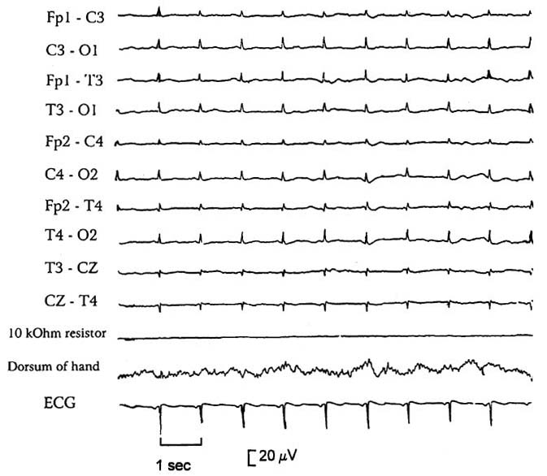
N.B. EEG is prone to false-positive (e.g. artifacts that cannot be distinguished from cerebral activity with certainty) and false-negative (due to hypothermia, shock or hypnosedative drug intoxication) results.

- residual EEG activity (alpha coma-like activity, low-voltage fast waves, sleep-like slowing with spindle activity) may persist for some days following brain death.
- some guidelines require EEG confirmation of brain death in children < 1 yr of age.
- EEG does not detect brainstem activity.
- ECS does exclude reversible coma - at least 6 hours observation is recommended in conjunction with ECS.
- definition of ECS on EEG: no electrical activity > 2 µV with the following requirements:
- recording from scalp or referential electrode pairs ≥ 10 cm apart
- 8 scalp electrodes and ear lobe reference electrodes
- inter-electrode resistance < 10,000 ohms (or impedance < 6,000 ohms) but over 100 ohms
- sensitivity of 2 µV/mm
- time constants 0.3-0.4 sec for part of recording
- no response to stimuli (pain, noise, light)
- record > 30 mins
- repeat EEG in doubtful cases
- qualified technologist and electroencephalographer with ICU EEG experience
- telephone transmission not permissible

Evoked Responses
  - BAER - absent (apart from wave I and early part of wave II, which are generated peripherally);
- in many patients with suspected BD, however, all BAER components (incl. wave I) are absent - not possible to exclude other causes (such as technical factors of deafness) for absent response.

  - Bilateral absence of all somatosensory evoked responses later than N13-N14 is supportive of brain death.

Tests of cerebral perfusion
- most definitive confirmatory tests!!! (in some countries, used as indication for terminating life-support).
- blood does not flow intracranially above foramen magnum* (static column of contrast medium)
*absence of intracranial flow at level of carotid bifurcation or circle of Willis; filling of superior sagittal sinus may occur in delayed fashion
- some conditions may mimic this pattern: arterial dissection, embolic / arteritic occlusion just beyond ophthalmic artery, severe catheter-induced spasm, subintimal injection.

- Conventional contrast four-vessel digital subtraction angiography – only test with 100% sensitivity and specificity - reference standard of ancillary testing!

- Cerebral Radionuclide Angiogram (CRAG)
- can be performed at the bedside with a general purpose scintillation camera with low energy collimator.
- may not detect minimal blood flow to the brain, especially brainstem, therefore 6 hours observation in conjunction with CRAG is recommended unless there is a clear etiology of overwhelming brain injury (e.g. massive hemorrhage or GSW).
- indications:
- where complicating conditions are present, e.g. hypothermia, hypotension (shock), drug intoxication, severe facial trauma where ocular findings may be difficult or confusing
- severe COPD or CHF where apnea testing may not be valid
- to shorten observation period, especially when organ donation is a possibility
- technique:
- scintillation camera is positioned for an AP head and neck view
- inject 20-30 mCi of 99mTc-labeled serum albumin or pertechnetate in a volume of 0.5-1.5 ml into a proximal IV port, or a central line, followed by a 30 ml NS flush
- perform serial dynamic images at 2 second intervals for 60 seconds, then obtain static images with 400,000 counts in AP and then lateral views at 5, 15 & 30 minutes after injection
- if a study needs to be repeated because of a previous non-diagnostic study or a previous exam incompatible with brain death, a period of 12 hours should lapse.
- findings:
- no uptake in brain parenchyma = "hollow skull phenomenon":
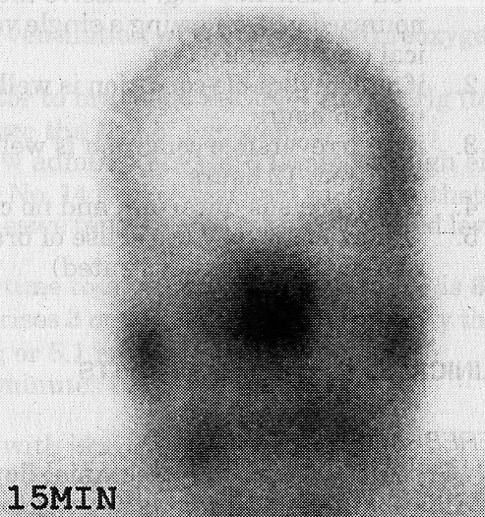
- termination of carotid circulation at skull base, and lack of uptake in ACA and MCA distributions (absent "candelabra effect").
- there may be delayed or faint visualization of dural venous sinuses even with brain death due to connections between extracranial circulation and venous system.

- In some areas, transcranial Doppler blood flow velocity measurements are considered adequate.
- small peaks in early systole without diastolic flow or reverberating flow (indicative of significantly increased ICP).
- initial absence of doppler signals cannot be used as criteria for brain death since 10% of patients do not have temporal insonation windows.

Atropine
- in brain death, 1 amp of atropine (1 mg) IV should not affect heart rate due to absence of vagal tone (normal response to atropine of increased heart rate rules out brain death, but absence of response is not helpful since some conditions such as Guillain-Barre may blunt response).
- systemic atropine in usual doses causes slight pupillary dilatation, but does not eliminate reaction to light (therefore, to eliminate uncertainty, examine pupils before giving atropine).

Care of organ donor
- once brain death occurs, cardiovascular instability eventually ensues, generally within 3-5 days - management with pressors is required.
- fluid and electrolyte imbalances from loss of hypothalamic regulation must be normalized.
- in some instances a beating-heart cadaver can be maintained for months

Hypotension and urinary output control:
- Control hypotension through volume expansion whenever possible (after brain death, ADH production ceases, producing diabetes insipidus with high urine output, thus copious fluid administration is anticipated (> 250-500 ml/hr is common). Most centers prefer AVOIDING exogenous ADH (risk of renal shutdown)
- start with D5 - 1/4 NS + 20 mEq KCI/L (replaces free water) “replace urine cc for cc plus 100 cc/hr maintenance”
- use colloid (FFP, albumin) if unable to maintain BP by replacement.
- Vasopressors if still hypotensive:
- start with low dose dopamine, increase up to 10 µg/kg/min, add dobutamine if still hypotensive at this dosage
- If UO is still > 300 ml/hr after above measures, use ADH analog
N.B. aqueous vasopressin (Pitressin®) is preferred over DDAVP to avoid renal shutdown!
- Thyroglobulin IV converts some cells from anaerobic to aerobic metabolism - may help stave off cardiovascular collapse.

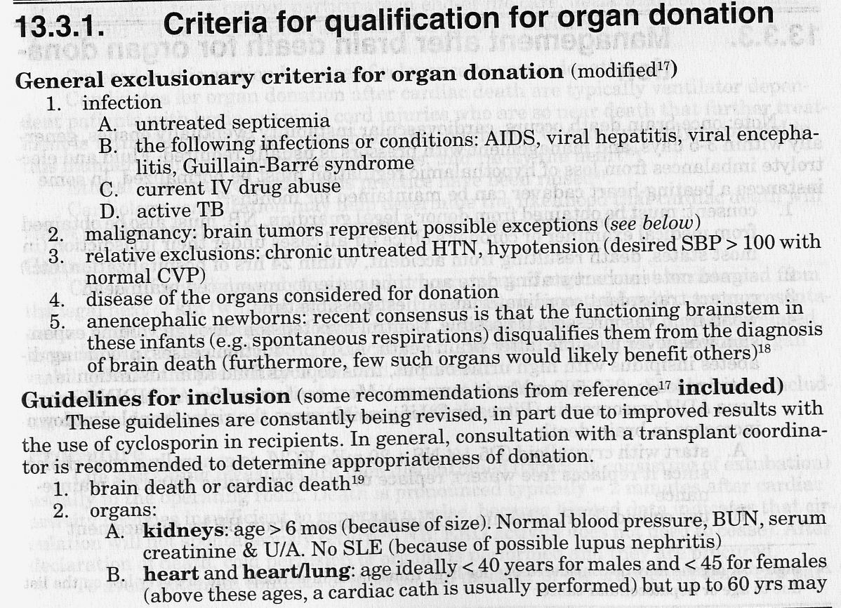
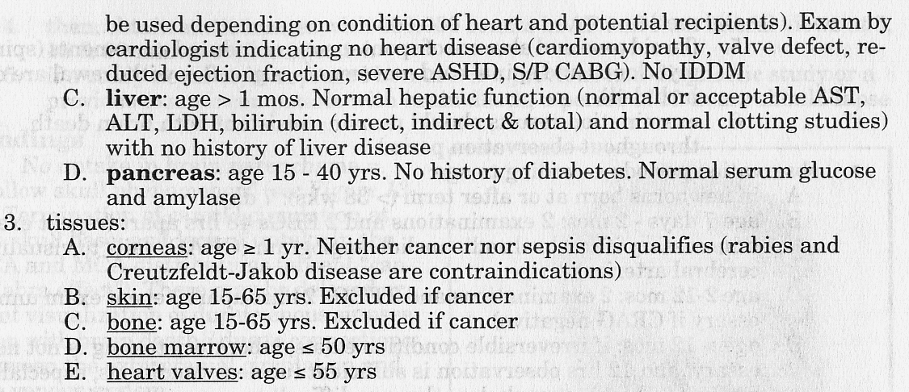

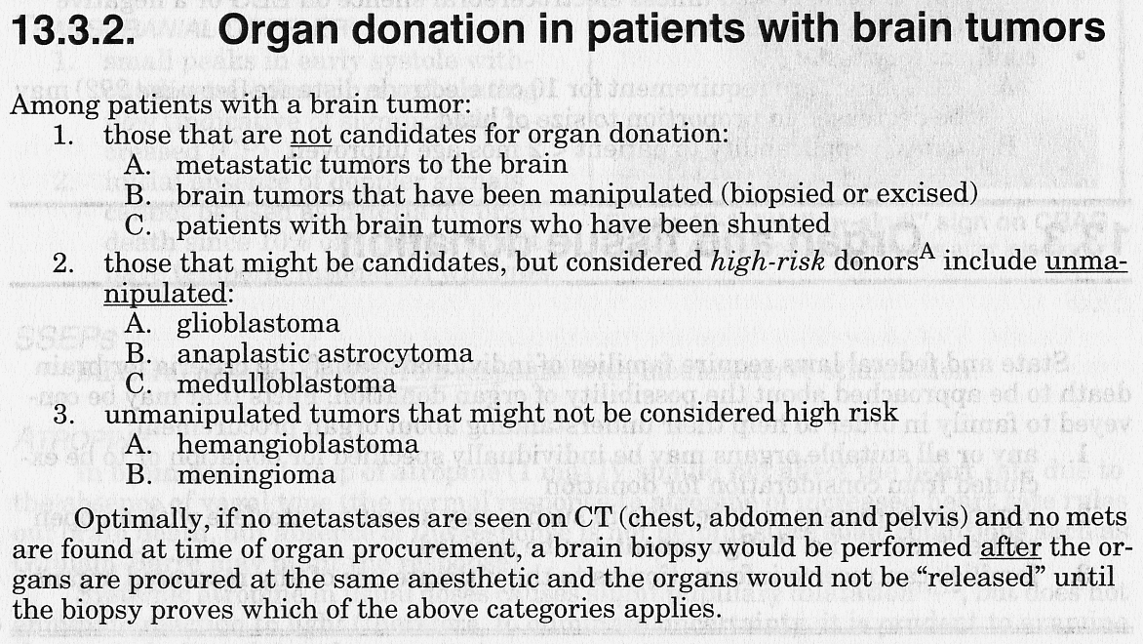

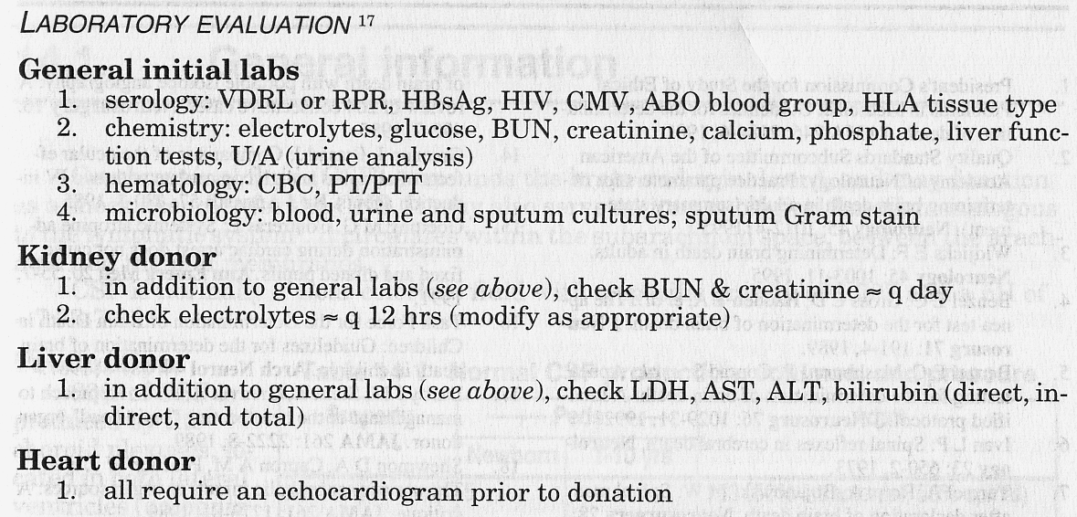

Organ donation after cardiac death
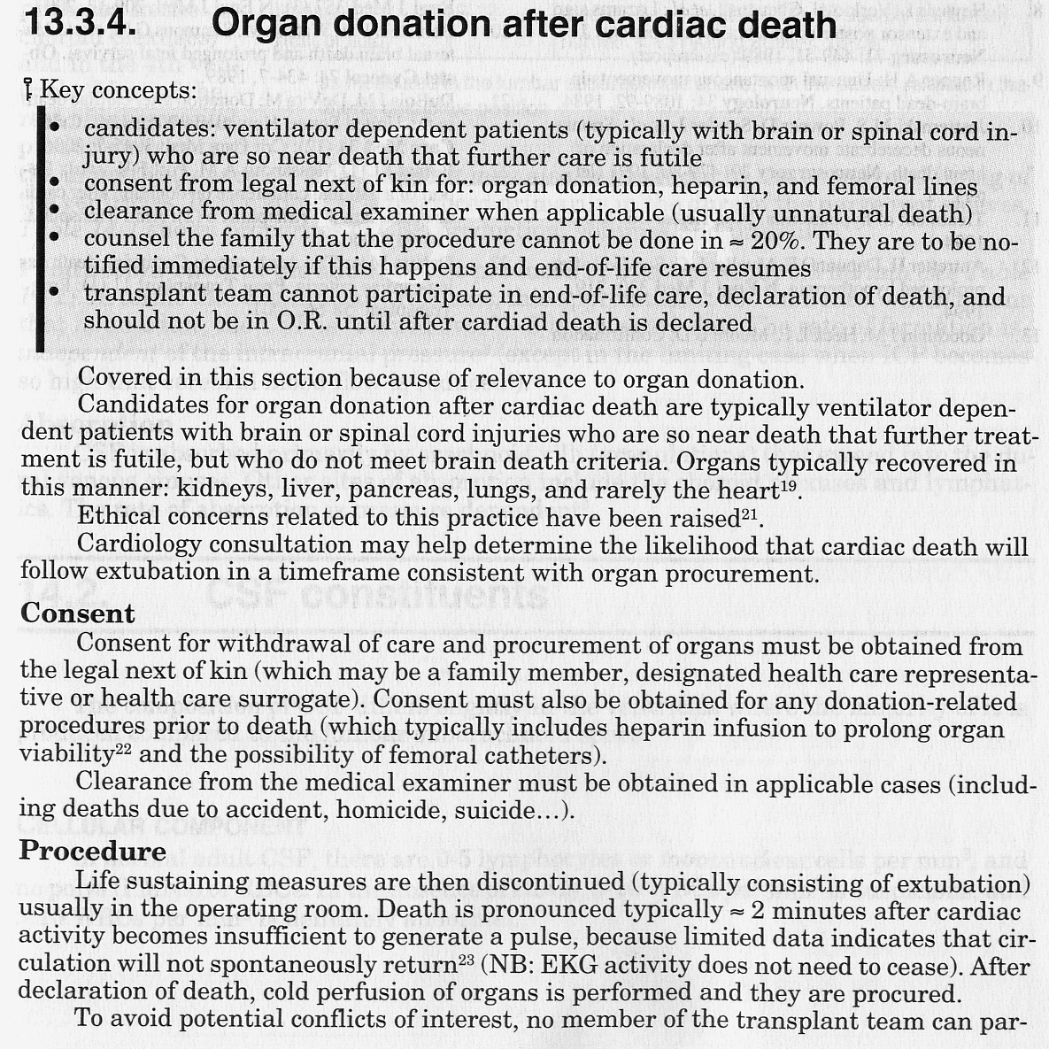
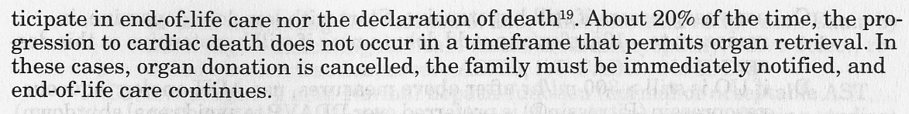

Pediatric aspects
Guidelines for the Determination of Pediatric Brain Death – see p. S34a >>

- minimal applicable age - newborns > 36 weeks gestation.
- minimum 2 examinations.
- include the sucking and rooting reflexes.

Bibliography
Mark S. Greenberg “Handbook of Neurosurgery” 7th ed. (2010); Publisher: Thieme Medical Publishers; ISBN-13: 978-1604063264 (chapter 13) >>
Goetz “Textbook of Clinical Neurology”, 1st ed., 1999 (13-15 p.)
Rowland “Merritt's Textbook of Neurology”, 9th ed., 1995 (26 p.)
Goldman “Cecil Textbook of Medicine”, 21st ed., 2000 (2027-2028 p.)
“Harrison's Principles of Internal Medicine”, 1998, ch. 24
Behrman “Nelson Textbook of Pediatrics”, 15th ed., 1996 (1718-1719 p.)
“The Merck Manual”, 17th ed., 1999 (ch. 170)
NMS Medicine 2000, Pediatrics 2000, Physiology 2001

Viktor’s Notes℠ for the Neurosurgery Resident
Please visit website at www.NeurosurgeryResident.net

