Cerebral Edema
Last updated: May 8, 2019
Etiopathophysiology 1
Pathology 2
Clinical Features 3
Diagnosis 4
Treatment 4

Etiopathophysiology
brain edema - brain volume↑ due to increase in extravascular brain water.
- it is general reaction to insults.

N.B. differentiate from brain engorgement - brain volume↑ due to increase in intravascular volume (e.g. obstruction of cerebral veins, arterial vasodilatation).

 | Cerebral Edema
 | Vasogenic | Cytotoxic | Hydrocephalic  (s. interstitial)
Pathogenesis | Capillary permeability↑ | Cellular swelling | Intraventricular fluid↑
Location | White matter | Gray & white matter | Ventricular, white matter (periventricular)
Edema fluid | Plasma filtrate | Intracellular H₂O & Na | CSF
Extracellular fluid volume | ↑ | ↓ | ↑
Contrast enhancement | + | - | -

Vasogenic edema - increased capillary permeability to macromolecules = BBB disruption (widening of tight junctions + increase in pinocytotic vesicles).
- etiology (most common type of edema!):
  - tumor
  - abscess, meningitis, encephalitis
  - stroke (ischemia, infarction, hemorrhage)
  - trauma (diffuse BBB disruption up to several hours after trauma - window of opportunity to administer cerebral protective drugs that would not penetrate intact BBB)
  - lead encephalopathy.
- accumulates preferentially in white matter and can become very widespread.
- exception is corpus callosum (so tightly bundled that there is little extracellular space - edema does not spread readily).
- paucity of brain lymphatics impairs resorption of excess fluid.
- eventually resolves (edema fluid is reabsorbed into vascular space or ventricular system).
- BBB disruption causes CT/MRI contrast enhancement, CSF protein↑.

Cytotoxic edema - swelling of cells (neurons, glia, endothelial) due to membrane pump failure.
- etiology:
- decreased energy supply to brain cells (e.g. ischemia, hypoxia, trauma) → increased intracellular osmoles (Na⁺, lactate, H⁺) → rapid water entry into cells.
- even after short ischemia, brain may respond to reperfusion with severe brain edema.
- plasma osmolality↓:
  - osmotic disequilibrium syndromes (in hemodialysis, diabetic ketoacidosis) - excessive intracellular solutes (organic acids in uremia; glucose & ketone bodies in diabetic ketoacidosis) result in excessive cellular hydration when plasma osmolality is rapidly reduced with therapy.
  - acute dilutional hyponatremia
  - inappropriate secretion of ADH
- acute hepatic encephalopathy, Reye's syndrome.
- accumulates in white & grey matter.
- extracellular fluid volume is compensatory reduced!

Conditions associated with generalized edema have elements of both vasogenic and cytotoxic edema.
- both vasogenic and cytotoxic edema occur in setting of trauma!
- acute hypoxia causes cytotoxic edema, which is followed by vasogenic edema as infarction develops.

Interstitial (s. hydrocephalic) edema (best characterized in obstructive hydrocephalus) - CSF movement across ventricular walls.
- accumulates in periventricular white matter (esp. at angles of lateral ventricles).
- volume of periventricular white matter is reduced! (after successful CSF shunting, edema is reduced, and thickness of mantle is restored)

mechanisms by which edema alters neuronal function:
- ICP↑
- Increased distances for nutrient diffusion (e.g. O₂).
- Lipid peroxidation in membranes

Pathology
- edematous brain is softer and appears to "overfill" cranial vault.
- gyri are flattened, intervening sulci are narrowed.
- ventricular cavities are compressed.
- as brain expands, herniation may occur. see p. S54 >>

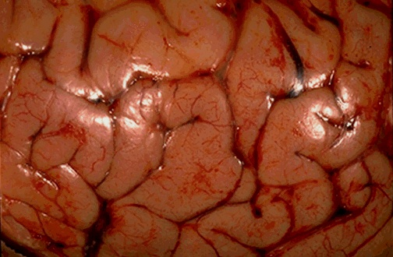
Source of picture: “WebPath - The Internet Pathology Laboratory for Medical Education” (by Edward C. Klatt, MD) >>

Multiple small metastases causing cerebral edema seen at right which obscures structures:
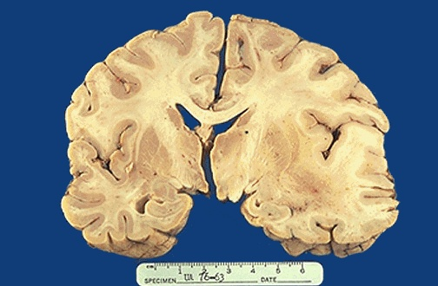
Source of picture: “WebPath - The Internet Pathology Laboratory for Medical Education” (by Edward C. Klatt, MD) >>

Clinical Features
- intracranial hypertension:
- Generalized brain dysfunction (disturbances of consciousness, etc) – due to diffuse edema.
- Focal neurologic deficits – due to focal edema, brain herniation.
N.B. in brain tumor, clinical signs are often caused more by surrounding edema than by tumor mass itself (so deficits maybe reversible with steroids)!

  - rate of edema formation is directly proportional to severity of neurologic deficits.
  - in chronic hydrocephalus interstitial edema manifestations are usually minor (in advanced cases - dementia and gait disorder become prominent) - CSF accumulation in extracellular space is much better tolerated than is presence of plasma in extracellular space (as in vasogenic edema).

Diagnosis
Neuroimaging (MRI better than CT):
  - decreased density of brain parenchyma (water content↑) – T1-MRI and CT signal↓, T2-MRI signal↑.
- blurring or loss of visible distinction between gray matter and white matter.
N.B. vasogenic edema spreads along white matter tracts - no grey matter involvement with preserved grey-white junction (vs. cytotoxic edema)
  - mass effect:
- diffuse edema: loss of definition of cortical sulci → bilateral compromise of ventricles → effacement of basal cisterns.
- focal edema - focal mass effect.
- MRI / CT with contrast → brain parenchymal enhancement in vasogenic edema (BBB disruption!); no enhancement in cytotoxic edema.

CSF - protein↑ in vasogenic edema (BBB disruption!); normal in cytotoxic edema.

EEG:
- vasogenic edema – slowing.
- interstitial edema – normal.

Treatment
  - Intensive care - patent airway, avoidance of hypoxia, maintenance of BP.
N.B. avoid salt-free fluids IV!
  - Surgery - excision / decompression of intracranial mass lesions, shunting procedures.

  - Pathogenetic treatment:
Cytotoxic edema - augment CPP + increase intravascular osmolality.
Vasogenic edema – decrease hydrostatic pressure in capillaries + decrease BBB permeability.

    - glucocorticoids (dexamethasone 10 mg IV or IM loading → 4 mg q6h maintenance; pediatric dose 1-2 mg/kg loading → 0.25 mg/kg qid maintenance) - direct effect on endothelial cell function – decreased BBB permeability – for vasogenic edema (around tumor, abscess, radiotherapy field).
Glucocorticoids dramatically and rapidly (in hours) reduce focal and general signs of brain edema around tumors!
- usual complications of steroid therapy are expected (esp. gastric hemorrhage - all patients receiving steroids for more than few hours should receive ranitidine or PPI!).
- not useful in cytotoxic edema (e.g. no efficacy in TBI, stroke).
- conflicting reports about efficacy in acute bacterial or tuberculous meningitis (e.g. steroids reduce deafness in infants with bacterial meningitis).

    - osmotherapy (mannitol) – for cytotoxic edema.
- effect is short-lived (solute reaches equilibrium concentration in brain after delay of only few hours).
- parts of brain most likely to “shrink” are normal areas (e.g. regions of vasogenic edema with increased capillary permeability do not shrink*).
*even develop rebound edema following mannitol use because solute accumulates in edematous tissue.
- no rationale for long-term use - brain adapts to hyperosmolality with increase in intracellular osmolality.

    - drugs that reduce CSF formation (acetazolamide, furosemide) – for interstitial edema.

Bibliography see p. S50 >>

Viktor’s Notes℠ for the Neurosurgery Resident
Please visit website at www.NeurosurgeryResident.net

