CSF Leaks
Last updated: December 19, 2020
Etiology 1
Clinical Features 1
Diagnosis 1
Complications 2
Prophylaxis 3
Treatment 3

Etiology
CSF leaks occur if dura is violated:
- surgery (esp. if CSF is contaminated with blood, bone dust, and necrotic debris → inflammatory & mechanical interference at arachnoid villi → CSF pressure↑).
- tumor invasion (e.g. pituitary tumor erosion)
- trauma (esp. basal skull fractures – thin & tightly adherent dura).
- fracture of ethmoid or sphenoid bone or orbital plate of frontal bone → rhinorrhea (nasoliquorrhea) - CSF leak through cribriform plate or adjacent sinus.
- fracture of temporal bone → otorrhea (otoliquorrhea).

Predisposing factor - ICP↑.

Clinical Features
- watery discharge from nose, ear canal, wound.
- starts within 48 hours after dural breach.
N.B. after TBI, nasal mucosa may be swollen – rhinorrhea is delayed (do not confuse with posttraumatic rhinitis)
- rhinorrhea – salty taste in mouth.
- point of external leakage is poor guide to site of fistula (e.g. CSF may enter ear but leave nose via Eustachian tube).
- orthostatic headache

Diagnosis
Differentiation from local bleeding without CSF leak:
- ring (halo) test - drop of nasal discharge is placed on piece of filter paper* – CSF (less dense than blood) migrates further on paper than blood – CSF is seen as large transparent ring surrounding central blood clot.
*but may be seen spontaneously on pillow
- pure bleeding usually stops in 1-2 days.

Differentiation from nasal secretions:
- CSF rhinorrhea is clear fluid, tends to be profuse (particularly when bending forward in morning)
- glucose concentration: in CSF ≥ 30 mg/dl (in lacrimal secretions / nasal mucus < 5 mg/dl); e.g. CSF tests positive for glucose using Dextrostix.
- chloride concentration: CSF > lacrimal secretions / nasal mucus.
- β2-transferrin assay (present in CSF) - most accurate diagnostic test for CSF!
- occult / intermittent CSF rhinorrhea – ENT may see nasal mucosal maceration.
- injection of radionuclide (e.g. ^{99m}Tc DTPA) into CSF → tampons are placed in each nostril → assessment of uptake by tampons - CSF rhinorrhea is diagnosed when tampon is impregnated with at least twice radioactivity of control tampon in opposite nostril (in presence of intact septum).
Fistulės vietai nustatyti anksčiau buvo naudojamos dažo medžiagos į CSF (methylene blue*, fluorescein, fenolsulfonftaleinas, indigokarminas), tačiau jos veikia toksiškai ir šiuo metu nebenaudojamos.
*may be lethal intrathecally!

X-ray, CT bone window – fluid in paranasal sinuses, skull fracture.

If there is CSF leak but fracture site is not evident (important before attempted surgical repair) → at time when patient is actively leaking fluid, perform:
    - overpressure radionuclide cisternography (with ^{99m}Tc DTPA) - can demonstrate leak into nasal cavity or ear, but fails to delineate fistula site!
Radionuclide cisternogram - anterior fossa CSF fistula:
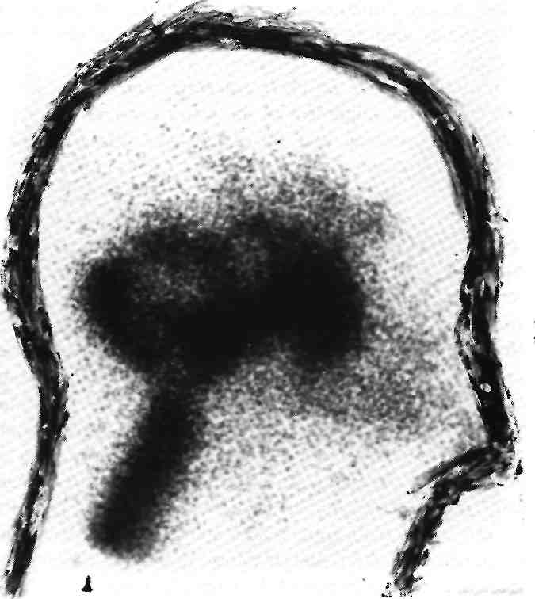

    - overpressure CT cisternography (with metrizamide) - instillation (via LP) of water-soluble contrast into CSF → temporarily occlude both jugular veins for 4-5 min to encourage active leakage → CT in coronal plane with patient placed prone* → contrast medium in sinuses or nasal cavity.
*leaking is likely to be maximal in this position
N.B. site of intermittent leaks is rarely delineated, but most such leaks resolve spontaneously!

MRI with intrathecal gadolinium (CT is less sensitive – bone and intrathecal contrast look the same and obscure each other).

Complications
- poor wound healing
- severe headaches (intracranial hypotension)
- recurrent bacterial meningitis!!! (esp. Streptococcus pneumoniae)
rhinorrhea > otorrhea
Kai likvorėja išnyksta per 7 dienas meningito rizika – 11-20%, o tęsiantis ilgiau - net 88%.

Prophylaxis
      - "oversew" - sew stitches closer together in tissues immediately overlying surgical site.
      - vascularized pericranial flaps to repair holes in dura (e.g. temporalis muscle flaps, trapezius muscle flaps, free radial forearm flaps, free rectus abdominis muscle flaps).
      - dural sealants – see p. Op140 >>
      - prophylactic temporary CSF diversion (EVD, lumbar drain) – drain for 3 days, then clamp for 24 hrs (if no leak – D/C drain).

Treatment
  - Bed rest with head elevation ≥ 45°, avoid Valsalva (laxatives); if CSF leak is lumbar – keep patient flat.
N.B. leak may be only temporarily closed with brain and then recur!
  - CSF production decreasing agents (e.g. acetazolamide) - controversial
  - Pressure dressing (does not work for posterior fossa) and wound resuturing if CSF leaks externally (but CSF may find alternate means of egress, e.g. via rhinorrhea).
  - Local antibiotics (e.g. into ear canal); prophylactic systemic antibiotics are started after 7th day of CSF leak (many cases arrest spontaneously within 7 days).
N.B. routine prophylactic antibiotics lead to selection of resistant organisms → drug-resistant meningitis.

If CSF leak still persists for > 12-48 hours → reduce CSF pressure by:
- multiple lumbar punctures*
- continuous / intermittent drainage via lumbar drain* (at the end, clamp drain for 24 hrs – if no leak, remove drain).
- permanent diversion by indwelling shunt (in case of coexisting hydrocephalus).
*remove 50-400 mL in any given 24-hour period (e.g. 10 mL/h)

Progressive diminution of level of consciousness (during CSF drainage) - possibility of pneumocephalus!

rhinorrhea is less likely (80%) to arrest spontaneously than otorrhea (95%)

Some surgeons observe drainage for 2 days, others use as many as two 5-day trials of continuous lumbar drainage; if unsuccessful → operation: craniotomy with reapproximation of torn dura, suturing fascia / pericranium / muscle autografts to reinforce closure.
  - skull base dura is thin and difficult to repair (esp. dura overlying cribriform plate - olfactory nerves travel through it).
Geriau yra užsiūti kietojo dangalo defektą ekstraduraliai, tačiau defektą lengviau surasti intraduraliai.

If everything fails – place VP shunt.
  - if there is no external CSF leak, may observe CSFomas (pseudomeningoceles) – many disappear over several months.

Bibliography see p. S50 >>

Viktor’s Notes℠ for the Neurosurgery Resident
Please visit website at www.NeurosurgeryResident.net

