Neurosarcoidosis
Last updated: May 8, 2019
Etiopathophysiology 1
Pathology 1
Clinical Features 1
Diagnosis 1
Laboratory 1
Imaging 1
Treatment 2
Prognosis 2
Sarcoidosis In General → see p. 2150-2150 (3) >>

Neurosarcoidosis – part of systemic granulomatous disease.
- commonly involved organs: lungs, skin, lymph nodes, bones, eyes, muscles, parotid glands.
- incidence of sarcoidosis is 3-50 cases/100,000 population.
- 5% sarcoidosis patients have CNS involvement.
- 1-3% neurosarcoidosis patients have no systemic manifestations.

Etiopathophysiology
- cause is unknown.
- exaggerated cellular immune response.

Pathology
- primarily involves leptomeninges (parenchymal invasion also often occurs) - adhesive arachnoiditis with nodule formation (nodules have predilection for posterior fossa), meningitis or meningoencephalitis - at the base of the brain (basal meningitis) and in the subependymal region of the third ventricle.
- noncaseating granulomas with lymphocytic infiltrates; Langhans giant cells may or may not be present.

Clinical Features
- Diabetes insipidus (hypothalamic involvement) - most common neurologic manifestation!
- Multiple cranial nerve palsies (esp. facial diplegia)
- Intracranial hypertension - common
- Hydrocephalus - from adhesive basal arachnoiditis
- Seizures occur in 15%
- Peripheral neuropathy
- Myopathy
- Low grade fever

- median age of onset of neurologic symptoms - 44 years.

Diagnosis
Laboratory
- Mild leukocytosis and eosinophilia.
- ↑Angiotensin-converting enzyme (ACE) in serum:
- in 83% of patients with active pulmonary sarcoidosis, but in only 11 % with inactive disease
- in 55% of cases with neurosarcoidosis
- CSF (similar to any subacute meningitis): elevated pressure, mild pleocytosis (10-200 cells) mostly lymphocytes, elevated protein (up to 2,000 mg), mild hypoglycorrhachia (15-40 mg/dl).

Imaging
CXR
Characteristic findings of sarcoidosis (hilar adenopathy, mediastinal lymph nodes).

FLAIR-MRI
- gadolinium enhancement of leptomeninges and/or optic nerve
- lesions may be solitary or multiple
- lesions may be located intra- or extraparenchymal, periventricular, in basal cisterns.
- hydrocephalus may occur.

Gallium Scan
- with ⁶⁷Ga citrate:
- Panda sign: uptake in lacrimal glands, parotid glands & nasopharynx (normal). Not specific for sarcoidosis.
- Lambda distribution: uptake in hilar lymph nodes.
- Leopard man sign: diffuse dappled pattern due to uptake in soft tissues, skin, muscles, mediastinum, and lacrimal glands

Biopsy
- in uncertain cases.
- biopsy should include all layers of meninges and cerebral cortex.
- cultures and stains for fungus and acid-fast bacteria (TB) should be performed in addition.

Diffuse cerebral neurosarcoidosis mimicking gliomatosis cerebri:
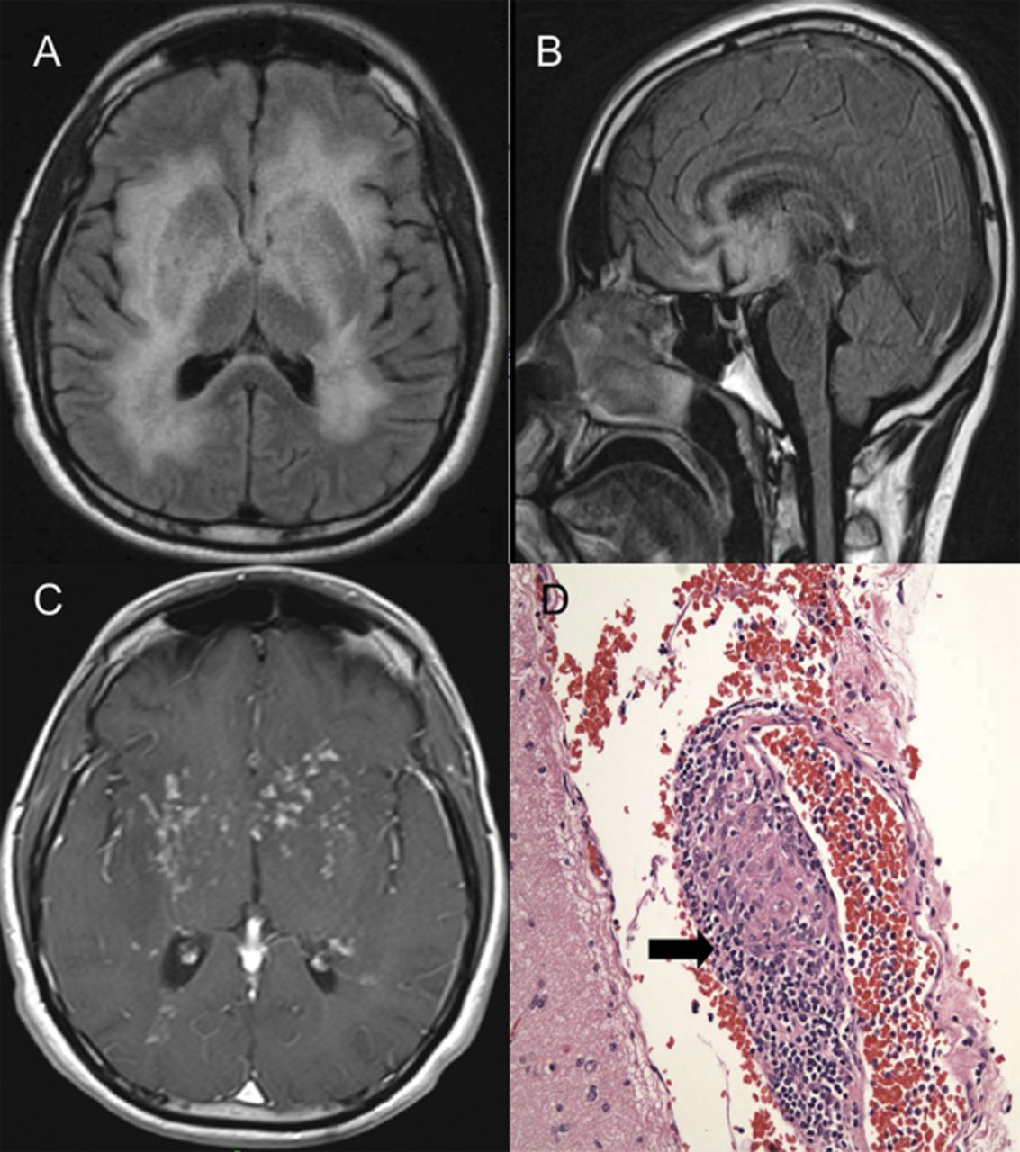

Treatment
Corticosteroids - beneficial for systemic as well as neurologic involvement.
- initiated with prednisone 60 mg PO qd in adults, and tapered based on response.
- cyclosporine may allow a reduction in steroid dosage in refractory cases.

Treatment for unresponsive cases: methotrexate, cytoxan, cyclophosphamide, azathioprine, low dose XRT.

Prognosis
- benign disease.
- peripheral and cranial nerve palsies recover slowly.

Bibliography for “Neurosarcoidosis”:
Mark S. Greenberg “Handbook of Neurosurgery” 7th ed. (2010); Publisher: Thieme Medical Publishers; ISBN-10: 1604063262 ISBN-13: 978-1604063264 >>

Viktor’s Notes℠ for the Neurosurgery Resident
Please visit website at www.NeurosurgeryResident.net

