Axial Pain

Last updated: December 19, 2020

Back Pain (Lumbago) 1

Epidemiology 1

Etiopathophysiology 1

Clinical Features 1

Diagnosis 2

Treatment 2

Philosophy 2

Back Exercises 3

Back Hygiene 5

Sitting 5

When Using Computer 5

Standing 5

Lifting 5

Neck Pain 6

Pathophysiology 6

Differential 6

Treatment 6

Surgery 6

Back Pain (Lumbago)

Epidemiology

#### Back pain is ubiquitous - lifetime prevalence approaches 80% (prevalence increases with advancing age).

* 1% of U.S. population is chronically disabled because of back pain.

Etiopathophysiology

Most causes are benign!

1. **Degenerative disorders** (disk protrusion, spondylosis, spinal stenosis, scoliosis, spondylolysis, spondylolisthesis)
2. **Injury** (fracture, subluxation, ligamentous sprain, muscular strain, whiplash injury)
3. **Inflammatory disease** (ankylosing spondylitis, RA, psoriatic arthropathy, arachnoiditis)
4. **Metabolic** (Paget's disease, osteoporosis)
5. **Tumors** (bone/neural, metastatic, multiple myeloma)
6. **Infections** (herpes zoster, disk infections, epi- or subdural abscess, meningitis, osteomyelitis)
7. ***Referred pain*** (abdominal / pelvic viscera, retroperitoneal processes)
8. ***Psychogenic pain*** (chronic anxiety states, depression, conversion reaction, psychosis, litigation-related, malingering, chronic pain syndrome, substance abuse)

N.B. any chronic low back pain is colored by psychologic factors! (sometimes psychosocial factors are more important than anatomic causes)

Back pain patients:

96% have mechanical back pain

4% have inflammatory back pain

Clinical Features

**Musculoskeletal pain**

1. **Back pain** is nonradiating; if it radiates it is usually not below knees* ≈ imitates radiculopathic pain (but not burning and not in dermatomal, rather in sclerotomal pattern).

*usually due to hamstring tightness; sacroiliitis / hip disease pain can also radiate but not below knees

1. **Restricted** **range of motion** (esp. forward flexion, ± lateral flexion & rotation; backward extension is normal)- by pain or muscle spasm.
2. ± Localized **tenderness** over spinous process (suggests vertebral involvement by tumor or infection)
3. **Flattening of lumbar lordosis** with asymmetry in appearance of paraspinal muscles – due to muscle spasm.
4. **Trigger points** may be present (define certain myofascial pain syndromes).
5. **Absence of neurological deficits**

* positive *Lhermitte's sign* - suspect spinal cord compression.
  + in absence of injury or any significant neurologic findings, detailed investigation is usually unrewarding.

Mechanism:

1. ***irritation of nerve endings*** at sites of injury / inflammation (e.g. herniated disc irritating annulus fibrosus & posterior longitudinal ligament)
2. ***spasm of paraspinal muscles***.

Paraspinal muscles are pain-sensitive and are probably most common source of neck or back pain!

Pain occurs:

* 1. typically - after ***unaccustomed exercise***\* (esp. when previous conditioned state is lost due to weakened abdominal muscles).

*e.g. lifting heavy object or trying to perform activity that requires use of back muscles that have not been used for some time

* 1. occasionally - ***spontaneously*** (often on awakening in morning).

|  |  |  |
| --- | --- | --- |
|  | Pain is **exacerbated** by | Pain is **relieved** by |
| “Mechanical” back pain | movement | rest at recumbency |
| Inflammatory back pain | rest | stretching or activity |

Local pain that ***does not vary*** with changes in position suggests **tumor**, **infection**, **fracture**, or **referred pain**

* spinal stenosis pain is worse with walking and bending backward and relieved by bending forward!
* ***marked stiffness of all movements*** may be indicative of ankylosing spondylitis.

Oncologic pain

* constant unremitting, in atypical or multiple sites.
* unrelated to activity or posture!

N.B. pain of**vertebral metastases** is often aggravated by **recumbency** (may be relieved by sitting up)!

**Referred pain**

- arises from ***deep structures*** (pelvic or abdominal viscera) and is felt at distant site **within same spinal segment** (i.e. pain is usually described as abdominal or pelvic as well as spinal)

* deep aching quality.
* local signs (pain with spine palpation*, paraspinal muscle spasm) are absent.

*sometimes tenderness at site of referral.

* pain not affected by position of spine!!! (but aggravated by abdominal / pelvic palpation)

**Radicular pain** [see p. PN1 >>](http://www.neurosurgeryresident.net/PN.%20Peripheral%20Neuropathies\PN1.%20GENERAL%20-%20Peripheral%20Neuropathies.pdf#Radiculopathy)

Examination should include maneuvers that stretch different nerve roots!

Quickest screening for radiculopathy:

knee-jerk (L4)

great toe dorsiflexion (L5)

ankle-jerk (S1).

Diagnosis

Most episodes of acute (< 1-3 month duration) back / neck pain are self-limited and ***do not require imaging***!

American College of Radiology recommendation – do not obtain lumbar spine radiographs for acute low-back pain unless fracture, malignancy, or infection are suspected.

* many asymptomatic middle-aged ÷ elderly subjects have MRI abnormalities of spine, and clinical relevance of any structural abnormalities may therefore be uncertain.
* 85% patients with low back pain cannot be given definitive diagnosis!
* malingering is best diagnosed by close observation of patient outside medical setting by someone other than physician.

**“Red-flag” diagnostic approach** - certain historical & clinical clues are elicited to assess ***probability of serious disease*** – to distinguish *patients needing additional tests* (X-ray → MRI/CT) from those *who may benefit from 6-week trial of conservative care* (or at least not be harmed by such trial):

**Red flags** - symptoms & signs rarely encountered in benign forms of back pain:

1. **History**
2. new back pain in young patient (< 20 yrs)
3. new back pain in older patient (> 50 yrs)

N.B. most benign back pains initially present in younger patients!

1. significant trauma (→ fracture)
2. steroid use (→ osteoporotic collapse)
3. cancer (→ metastatic disease)
4. unintended weight loss (→ cancer)
5. disorder with predilection for infection / hemorrhage
6. metabolic bone disorder
7. **Present complaint**
8. pain that *worsens at night* or that is *not relieved by any position*
9. *thoracic* pain (dissecting aneurysm)
10. bilateral radiculopathy
11. perianal numbness / paresthesia
12. change in bladder or bowel function
13. writhing pain
14. significant lower limb weakness not explainable by pain
15. progressive neurologic deficit
16. **Physical examination & laboratory findings**
17. pulsatile abdominal mass (or enlarged aorta shadow on lumbar radiograph)
18. fever
19. neurologic deficit not explained by monoradiculopathy

N.B. monoradiculopathy is common presentation of benign disease (e.g. disk herniation, lateral recess stenosis).

1. localized tenderness over spine
2. ESR↑ (most important laboratory test!) – metastases, infection
3. WBC count↑
4. **Lack of symptom pattern compatible with benign disease**
5. **Lack of response to conservative measures**

Indications for imaging:

1. Red flags
2. Neurologic deficits
3. Pain in uncommon sites (e.g. lower thoracic region)
4. Children
5. Risk factors for fracture (trauma, steroid use, osteoporosis)

Also consider **HLA-B27** testing but know its limits!

Choice of tests:

Motor deficits --> MR

Cancer or Infection:

known --> MR with contrast

suspected --> ESR, CRP, XR (if any positive -- MR with contrast)

Risk of compression FX --> XR (if patient will need treatment - also MR)

Treatment

Philosophy

Caring for patient is exactly that: caring.

Prudent clinician must realize that **psychosocial aspect** of back pain is as important if not more important than looking for **biological cause** of pain!

Most acute cases are short lived and respond to symptomatic measures!

* + - if imaging reveals structural lesion (+ symptoms do not improve / worsen on 4 weeks of conservative treatment), surgical treatment may be necessary.
    - **preoperative psychological assessment** - to exclude patients with *marked psychological impairment* (high risk for poor surgical outcome).

N.B. beware **pseudo-concordance** – imaging finding and unrelated back pain!

Differentiate **chronic pain syndrome** vs. **mechanical back pain**

**mechanical back pain** – features:

1. Deep and agonizing pain
2. Worsened by loading
3. Improved by unloading

Treatment for mechanical back pain – consider **surgery**:

**chronic pain syndrome** (vs.) – features:

1. Chronic pain (> 3 months)
2. 24/7 pain
3. Non-restorative sleep
4. Low energy level
5. Inactivity
6. Opioids

Treatment for chronic pain syndrome – **lifestyle changes**:

1. Core strengthening exercises
2. Flexibility exercises
3. Smoking cessation
4. Weight loss

Questionnaire

|  |  |  |
| --- | --- | --- |
|  | True | False |
| My pain is 24/7 |  |  |
| I have low energy most days |  |  |
| Most of the times I do not get restful sleep |  |  |
| I spend more than 12 hours a day resting and / or sleeping |  |  |
| My pain causes me a great deal of suffering |  |  |
| I have pain in two or more parts of my body |  |  |
| My pain is present when I lay in bed |  |  |
| My pain does not worsen when I stand up |  |  |

If most answers are “True” – do not operate!

Reality:

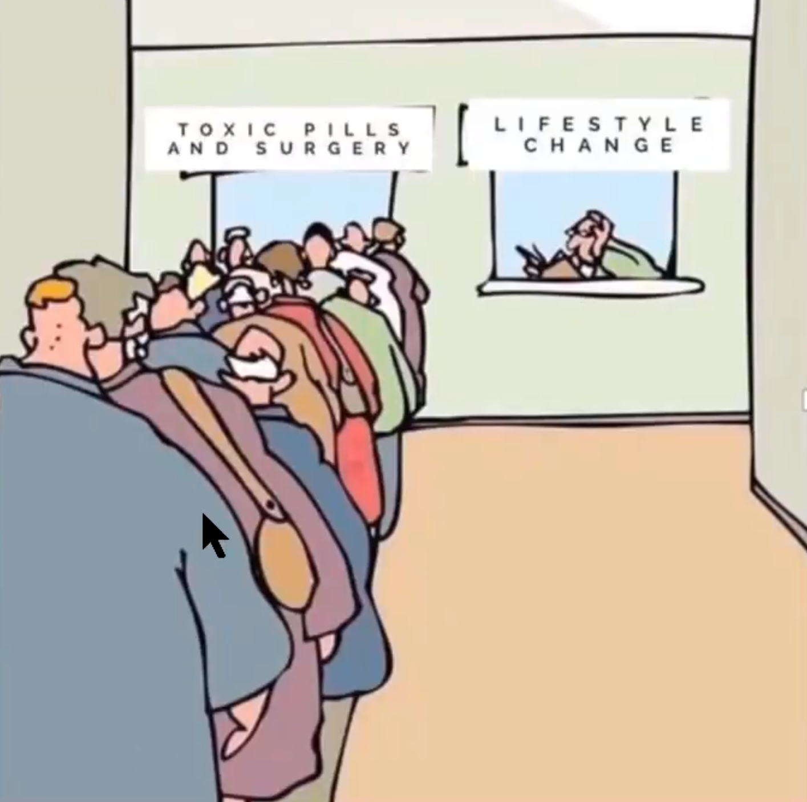

MRC spine stabilization trial – surgical stabilization vs. intensive rehab for chronic LBP.

Fairbank J , Frost H , Wilson-MacDonald J , Yu LM , Barker K , Collins R and for the Spine Stabilisation Trial Group . Randomised controlled trial to compare surgical stabilisation of the lumbar spine with an intensive rehabilitation programme for patients with chronic low back pain: the MRC spine stabilisation trial. B MJ 2005 ; 3 30 : 1233 – 1240

* + - class I evidence (349 patients in 15 centers in UK).
    - inclusion: clinician and patient uncertainty* regarding which treatment option is best (; ≥ 12 months of chronic lower back pain; age 18–55 years.

* ‘certainty’ may have excluded the best surgical candidates

* + - exclusions: previous stabilization surgery; significant co-morbidities; pregnancy; psychiatric disease.
    - choice of surgical method of stabilization was left to the discretion of the operating surgeon.
    - small but statistically significant effect of surgery in improving ODI scores: –4.1 (p = 0.045); no difference in any of the other outcome measures.

There is no clear evidence for the benefit of surgery over rehabilitation in the treatment of chronic low back pain.

Benefit of surgery is small compared to the cost and risks of surgery → emphasized requirement for comprehensive rehabilitation services.

**Musculoskeletal pain**

* + - **immobilization & bed rest** (no agreement of optimal duration – 1-3 days is usually adequate) → *increasing mobilization*.
      * back pain: hips and knees flexed relieve muscle spasm.
      * neck pain: ***soft*** ***cervical collars***\* limit neck movements (spontaneous and reflex) that exacerbate pain (use collar for ≤ 4 days – risk of neck muscle weakness); ***cervical pillow*** (or towel rolled up) placed under neck when reclining or sleeping.

*often worn in reverse to allow for neck flexion

* + - **physical therapy** (extent of any benefit is unclear); little evidence that traction, ultrasound, diathermy, acupuncture, or manipulation is helpful.
      * ***manipulation*** may help pain caused by muscle spasm alone but may aggravate arthritic joint or further rupture disk.
      * ***diathermy*** (deep heat) may reduce muscle spasm and pain after acute stage.
    - **NSAIDs** - usually sufficient to relieve pain; in severe cases – **narcotics**.
    - **muscle relaxants** (relieve painful muscle spasm) for 2-3 days (methocarbamol 1-2 g qid; carisoprodol 350 mg tid or qid; cyclobenzaprine 10 mg tid or qid; diazepam 10 mg tid).
    - injection of steroid combined with local anesthetic:
      * 1. ***epidural*** - may occasionally produce short-term pain relief in acute low back pain with radiculopathy.
        2. ***tender point*** - for myofascial or fibromyalgia syndrome.
        3. ***facet joints***.
    - in chronic pain, **tricyclic antidepressants** are often helpful; **cognitive behavioral therapy (CBT)** is especially effective!

*Guidelines recommend that patients with chronic low back pain remain active!!!*

* + - exercises to strengthen paraspinal and abdominal muscles! + lumbosacral stretching exercises, weight reduction.

N.B. exaggerated lumbar lordosis increases stress on muscles and ligaments that support back!

Treatment for back pain *starts*, *ends*, and *restarts* with back exercises! Medications are not as effective as exercises!

Back Exercises

Tell patient to repeat each of following exercises two times day.

Rotate from one exercise to other. Do one set of exercises and then rotate to another exercise and do set.

Do not exercise past point of pain. Pain means stop!

1. **Standing hamstring stretch**: Place heel of your leg on stool or other object about 2 ft high. Keep your leg fully extended and lean forward. You will feel back of your leg begin to stretch (your hamstring muscles). Remember to keep leg straight and not bent and do not bend back. Hold stretch for 15 s. Repeat five times alternating with each leg.



[Source of picture: Edward J. Shahady “Primary Care of Musculoskeletal Problems in the Outpatient Setting” (2006); Springer; ISBN-13: 978-0387306469 >>](http://www.amazon.com/gp/product/0387306463)

2. **Lying down hamstring stretch**: Lie on your back and raise each leg straight (fully extended) until you feel same stretch in back of your leg. Bend your toes toward you to increase stretch. Hold stretch for 15 s. Repeat five times alternating with each leg.



[Source of picture: Edward J. Shahady “Primary Care of Musculoskeletal Problems in the Outpatient Setting” (2006); Springer; ISBN-13: 978-0387306469 >>](http://www.amazon.com/gp/product/0387306463)

3. **Pelvic tilt**: Lie on your back with your knees bent about 45° and feet flat on floor. Tighten your abdominal muscles and push your lower back into floor. Hold this position for 5 s. Do three sets of 10.



[Source of picture: Edward J. Shahady “Primary Care of Musculoskeletal Problems in the Outpatient Setting” (2006); Springer; ISBN-13: 978-0387306469 >>](http://www.amazon.com/gp/product/0387306463)

4. **Partial curl**: Lie on your back with your knees bent 45° and your feet on floor. Tighten your stomach muscles and flatten your back against floor. Place your chin onto your chest. Some individuals find that they need to support their neck with their hands clasped behind neck to decrease discomfort. Start curl by moving upper body toward your knees until your shoulders clear floor. Hold this position for 5 s. Exhale with curl and inhale as you return to starting position. Initially repeat 25 times and then build up to 50 at each setting.



[Source of picture: Edward J. Shahady “Primary Care of Musculoskeletal Problems in the Outpatient Setting” (2006); Springer; ISBN-13: 978-0387306469 >>](http://www.amazon.com/gp/product/0387306463)

5. **Knee to chest stretch**: Lie on your back with your legs straight out in front of you. Slowly bend one knee and bring it toward you. Clasp both hands around knee and pull it toward your chest. Hold this position for 15 s and return to starting position. Repeat process on other knee, then do both knees together, Repeat each one three times.



[Source of picture: Edward J. Shahady “Primary Care of Musculoskeletal Problems in the Outpatient Setting” (2006); Springer; ISBN-13: 978-0387306469 >>](http://www.amazon.com/gp/product/0387306463)

6. **Sacroiliac joint stretch**: Lie on your back with your knees bent to 45° and feet on floor. Place ankle of one leg on knee of other and gradually externally rotate that leg until you feel stretch in your back. Repeat with each leg and hold each external rotation for 15 s. Do each side 5 to 10 times.



[Source of picture: Edward J. Shahady “Primary Care of Musculoskeletal Problems in the Outpatient Setting” (2006); Springer; ISBN-13: 978-0387306469 >>](http://www.amazon.com/gp/product/0387306463)

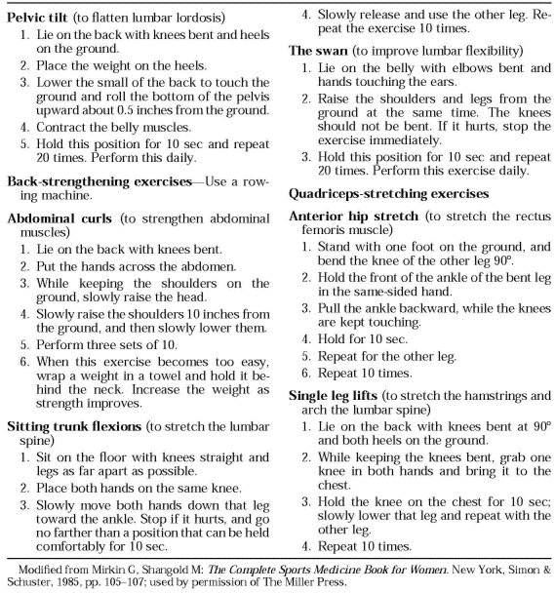

Back Hygiene

Sitting

* head up not tilted forward or back.
* thighs parallel to floor; knees bent to 90° and never higher than hips.
* feet should be flat on floor.
* make sure chair has good lumbar (lower back) support; for additional support, use small pillow or rolled-up towel.
* keep about 3 in. of space between back of your knee and edge of your seat.

When Using Computer

* keep keyboard and monitor directly in front of you and monitor should be at eye level.
* bend elbows at 90° angle and place wrists in neutral position, not tilted up or down when using keyboard.
* use wrist rests for extra support.
* avoid sitting for > 1 h at time → get up and walk or stand for 1-2 min; stretch your back and neck during break.

Standing

* have place to rest your foot that is 6 in. high; alternate each foot periodically.
* if working while standing, keep work surface near waist level.

Lifting

Push or slide heavy objects rather than lift them!

* stand as close as possible to item you will be lifting.
* place one foot slightly in front of other.
* bend your knees and squat down.
* lift object by pushing up with your legs and buttocks.
* when retuning object to floor reverse procedure.

Neck Pain

Always keep in mind the possibility of spondyloarthropathies or of a severe process, such as tumor, trauma, infection, or rare vascular causes (e.g. vertebral artery dissection)

Pathophysiology

- multifactorial

DISCO-genic pain

* cervical disc is dorsally innervated by a sinuvertebral nerve plexus and ventrally innervated by the cervical sympathetic trunk; disc degeneration may stimulate these nerves and generate mechanical pain.

FACET-generated pain

The distribution of pain elicited after stimulation of the facet joints in normal subjects:



Bogduk N: The anatomy and pathophysiology of neck pain. Phys Med Rehab Clin N Am 14:455–472, 2003 (17).

Differential

Mechanical neck pain is bilateral (vs. C3-4 radiculopathies – pain may be unilateral).

Treatment

Surgery

**Cervical spondylosis with primarily axial neck pain** (without radicular symptoms or myelopathy) meeting all criteria:

1. failed to respond to ***extensive nonoperative treatment***.
2. positive cervical ***discography*** (confirm a specific level as the pain source and, potentially, which levels to fuse) – only positive discs should be considered for surgical management, max. 1-2 discs.
3. ***MRI*** confirmation of spondylosis and no other causes.
4. cleared ***psychological testing***.

* treatment of choice - **ACDF** (good results in appropriately chosen patients).

Bibliography for ch. “Spinal Disorders” → follow this [link >>](http://www.neurosurgeryresident.net/Spin.%20Spinal%20Disorders\Spin.%20Bibliography.pdf)

[Viktor’s Notes℠ for the Neurosurgery Resident](http://www.neurosurgeryresident.net/)

[Please visit website at www.NeurosurgeryResident.net](http://www.neurosurgeryresident.net)