Syringomyelia
Synonyms: syringomyelus, hydrosyringomyelia, syringohydromyelia, myelosyringosis, Morvan's disease
Last updated: April 22, 2019
Epidemiology 1
Pathology 1
Etiology 1
Pathogenesis 1
Clinical Features 1
Syringobulbia 2
Diagnosis 2
Differential diagnosis 4
Treatment 4

Posttraumatic syrinx → see p. TrS5 >>

Epidemiology
- exact incidence unknown but it is rare.
- more frequent in men.

Pathology
- longitudinal (tubular) cavitation in central spinal cord.
Hydromyelia - simple cystic expansion of central canal of cord.
Syrinx - pathologic tube-shaped cavity in CNS parenchyma (outside central canal).
- syrinx is lined by dense, gliogenous tissue and surrounded by dense glial fibril wall.
- syrinx may communicate with central canal (fluid within syrinx is similar to, if not identical with CSF).
- most common starting location - base of posterior horn in cervical cord.
  - syrinx may be limited to cervical cord or may extend length of neuraxis.
- transverse diameter varies from segment to segment (usually maximal in cervical and lumbosacral enlargements).
- syrinx slowly enlarges (due to hydrodynamic forces) to involve much of both gray and white matter (at times, only narrow rim of parenchyma is left).
- if syrinx is long, it may have septations but usually (but not always) all cavities communicate.

Etiology
- Congenital
- familial cases have been described.
- rarely occurs in isolation; usually associated with other anomalies:
- Arnold-Chiari malformation (60-90%)!!!
- platybasia
- atresia of Magendie foramen
- Dandy-Walker syndrome
- vascular malformations.

- Syringomyelia may also be late* consequence of spinal trauma:
*up to 20 years after trauma
  - ex vacuo after absorption of intramedullary hematoma
  - flexion-extension injury
  - cord ischemia due to hypotension
  - birth trauma

- Tumors - syrinx may cap rostral or caudal pole of intramedullary (rarely, extramedullary) tumor (e.g. low grade astrocytomas).

- Chronic adhesive arachnoiditis (tuberculosis, post-traumatic, post-surgery) → impaired CSF circulation.

Pathogenesis
Communicating* syringomyelia (s. hydromyelia) – most cases of syringomyelia!
*syrinx is part of ventricular system
- hydrodynamic Gardner's theory: occluded exit foramina of fourth ventricle (e.g. by developmental defect in rhombic roof) + CSF pulsations directed downward → dilatation of central canal ± hydrocephalus.
- Williams theory: ball-valve effect of cerebellar tonsils in Arnold-Chiari malformation (central canal spinal constriction at level of foramen magnum) → during Valsalva maneuver CSF may pass caudad through narrowed canal → syrinx formation; foramen magnum decompression usually results in syrinx resolution.

Noncommunicating syringomyelia
- extension of CSF under pressure along Virchow-Robin spaces
- cystic degeneration of intramedullary tumor
- ischemia in anterior spinal artery insufficiency.
- resorption of intramedullary hematoma (hematomyelia)
- cord contusion / compression → microcystic cavitation.
- obliterated original communication with ventricular system.

Clinical Features
Manifests in 3-4th decade (mean age at onset ≈ 30 years) - chronic, slowly progressive central cord syndrome. see p. Spin1 >>
- usually located in cervical ÷ upper thoracic segments (rarely, syrinx develops in lumbar cord either in association with or independent of cervical syrinx).

Damage to decussating spinothalamic fibers → segmental loss of pain and temperature sensations (analgesia with thermoanesthesia):
- bilateral, frequently asymmetrical.
- over shoulders (“cape” distribution) or across shoulders and upper torso, front and back in shawl-like distribution (en cuirasse).
- deep and aching chronic pain (≈ 30%) in impaired segments.
- complications - painless hand ulcers, burns, and whitlows.

Damage to anterior horns → segmental LMN signs (areflexia, weakness, atrophy, fasciculations):
- intrinsic hand muscles are often affected first → striking early hand atrophy - claw-hand deformity (main en griffe).
- ascends to forearms, and ultimately affects shoulder girdle.
- complications:
  - thoracic scoliosis (thoracic LMN innervating paraspinal musculature).
  - neurogenic arthropathies (Charcot joints) in shoulder, elbow, wrist.
Classic vignette: cervical syrinx → Charcot shoulder
As syrinx size increases, other spinal structures can be involved. see p. Spin1 >>
- dorsal columns
- corticospinal pathways → spastic leg weakness.
- intermediolateral columns; e.g. hands may develop remarkable subcutaneous edema and hyperhidrosis (main succulente).
- spontaneous arrests for several years are not uncommon.
- violent cough or sneeze may produce hemorrhage into syrinx.

Syringobulbia
Syrinx may expand into brainstem - into medulla oblongata or even into pons:
N.B. only 10% syringes extend above C₂
- CN9-12 may be involved (bulbar palsy), usually asymmetrically.
- nuclear involvement of CN5 → facial pain and thermal hypesthesia in onion skin pattern.
- nystagmus is not rare.
- rarely, syrinx extends into centrum semiovale (syringocephalus).

Diagnosis
CSF - few abnormalities (CSF pressure may be elevated, cell count rarely > 10/mm³, mild elevation of CSF protein).

MRI - diagnostic procedure of choice! (syringomyelia, and its cause, are shown well)
N.B. no correlation between clinical severity and size of syrinx relative to remaining cord substance!
- signal intensity of cyst ≈ CSF.
- cyst margins often irregular (may demonstrate periodic folds or septations - result from turbulent flow within cavity).
- further MRI evaluation:
  - brain (hydrocephalus?)
  - craniovertebral junction (Arnold-Chiari malformation?).
N.B. if syringomyelia occurs without Arnold-Chiari malformation or prior spinal cord injury → complete spinal MRI with gadolinium (to rule out intramedullary tumor).

MRI-T2: syringobulbia due to cervicothoracic pilocytic astrocytoma in 4 yo female:
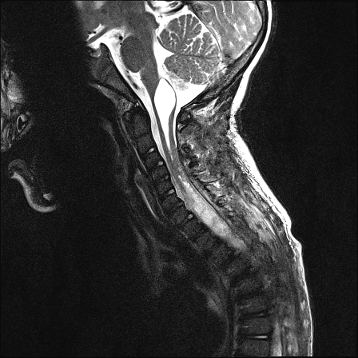
Source of picture: Viktoras Palys, MD >>

MRI-T1: large syrinx + associated Arnold-Chiari malformation (cerebellar tonsillar herniation below foramen magnum):
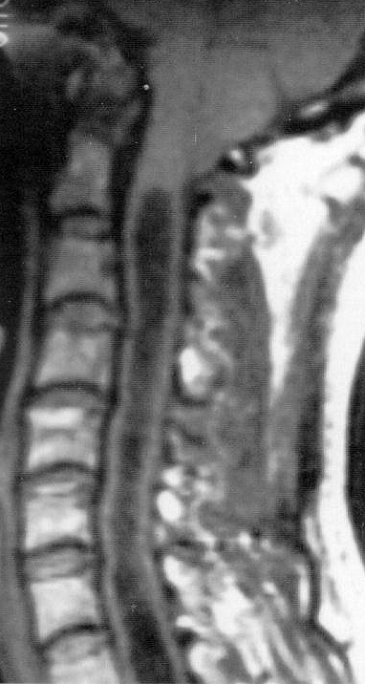

MRI: dilated central spinal canal + pointed cerebellar tonsils (Chiari I malformation):
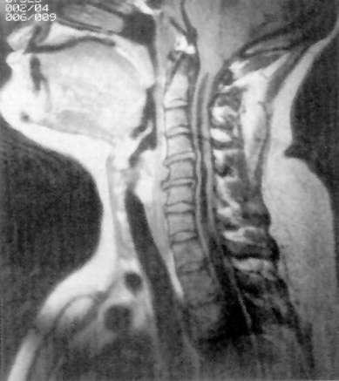

MRI (syringomyelia + Chiari malformation):
A. MRI-T1: descent of cerebellar tonsils and vermis below level of foramen magnum (black arrows); CSF collection dilates central canal (white arrows).
B. MRI-T2: high-signal-intensity syringomyelia (white arrows) expanding cervical cord with signal intensity equivalent to CSF.
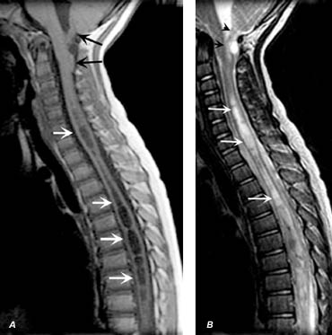

T1-MRI (syringohydromyelia + Chiari I malformation): cerebellar tonsils (upper thick black arrow) lie below neural arch of C1, and distended syrinx (white and black arrows) extends from C2 to T2:
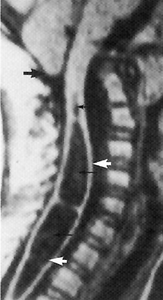

Myelography followed by delayed CT.
- spinal cord is:
enlarged (fusiform expansion) in 80%;
normal in 10%;
small (flattened in sagittal plane) in 10%.
- rotating patient from prone to supine position → considerable changes in cord size and shape.
- contrast medium enters all intramedullary cavities (most likely 6–12 h after myelography).

Patient prone (A) and supine (B) - fluctuation in cyst size (low radiodensity) with posture.
(C) patient supine 8 h after myelogram - contrast penetration and retention in syrinx cavity (arrow).
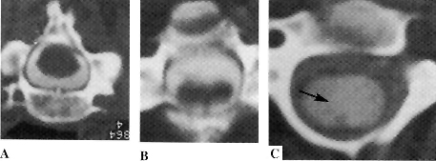
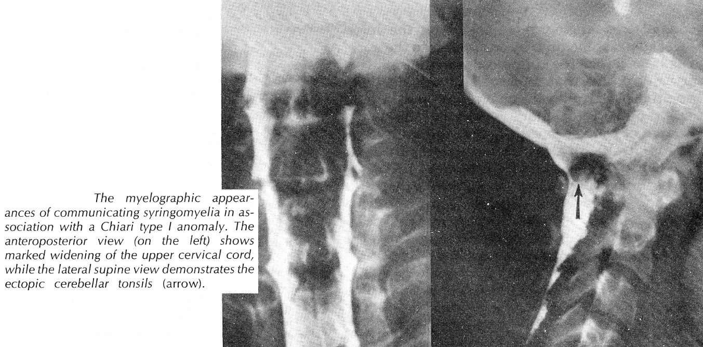

Differential diagnosis
- all easily excluded with MRI:
- intramedullary tumors.
- ALS
- MS
- cervical spondylosis
- anomalies of craniovertebral junction

Treatment
Incidental syrinx (i.e. asymptomatic and no neurologic deficit) with no identified etiology → observation with MRI at 2-3 year intervals (if the size remains stable).

Symptomatic / enlarging syrinx → surgery.

  - First choice - correction of abnormal CSF dynamics:
      - tumor: mass removal → syrinx resolution.
      - Arnold-Chiari malformation:
        - hydrocephalus is present → ventriculoperitoneal shunting.
        - no hydrocephalus (or ineffective ventriculoperitoneal shunt) → posterior fossa decompression, ± simultaneous syrinx shunting.

  - Second choice - drainage of syrinx cavity when etiology cannot be easily addressed (e.g. in arachnoiditis, post-traumatic syrinx): see p. Op230 >>
    - temporary – percutaneous needle aspiration (can be repeated) or open syringotomy.
    - permanent – various shunts (syringopleural, syringoperitoneal, syringo-subarachnoid).

Bibliography for ch. “Spinal Disorders” → follow this link >>

Viktor’s Notes℠ for the Neurosurgery Resident
Please visit website at www.NeurosurgeryResident.net

