Transverse Myelopathy
Last updated: April 22, 2019
Etiology 1
Idiopathic acute transverse myelitis 1
Etiology 1
Clinical Features 1
Diagnosis 1
Treatment 1
Surfer's Myelopathy 2

Transverse Myelopathy - syndrome of spinal cord segment damage across greater part of sectional area.

Etiology
- Trauma - most frequent cause of complete lesions.

- Demyelinating & inflammatory processes (transverse myelitis) - most commonly incomplete lesions (although there is evidence of involvement of entire cross-section of cord):
- MS, neuromyelitis optica
- infection – enteroviruses (esp. poliomyelitis*, enterovirus 70-71), herpesviruses (HSV-2**, VZV***, EBV, CMV), mumps, measles, mycoplasma, acute meningovascular syphilis, HIV, HTLV-I.
*prototypical acute infectious myelitis
**recurrent sacral myelitis in association with outbreaks of genital herpes
***most common cause of acute viral myelitis
- collagenoses - SLE (!), Sjögren's syndrome, Behçet's disease.
- sarcoidosis (subacute transverse myelopathy with severe cord swelling).

- Spinal cord ischemia - complete or incomplete lesion (e.g. anterior 2/3 anterior spinal artery syndrome).

- Hemorrhage into spinal cord.

- Intraparenchymal abscess.

- Idiopathic acute transverse myelitis

Idiopathic acute transverse myelitis
Etiology
- frequently after nonspecific viral infection – direct viral invasion into cord or autoimmune mechanisms.
Pathology - inflammatory demyelination which involves several segments (usually thoracic).
- may progress to necrosis and cavitation.

Clinical Features
- lost all motor & sensory functions below level of transverse myelopathy.
N.B. sensory & motor findings tend to be symmetric (vs. MS – asymmetric)!
  - onset – (sub)acute back pain, ascending leg weakness, paresthesias below level of lesion, sphincter dysfunction.
- pathological process may be acute - initially produces spinal shock, but hyperreflexia soon supervenes; persistent areflexic paralysis indicates necrosis over multiple spinal segments (differentiate from Guillain-Barré syndrome).
  - common additional features:
    - band of disagreeable dysesthesia above uppermost border of sensory loss.
    - radicular pain at lesion level.
    - tender (on percussion) spinous processes - in epidural abscess, vertebral metastasis.
  - spontaneous complete recovery (over weeks ÷ months) occurs in 60% cases.

Diagnosis
CT / MRI - mild fusiform swelling in affected region.  - diffuse / multifocal abnormal bright signal on T2-MRI.  - contrast enhancement (BBB disruption) in acute cases.  - brain MRI for all cases - to assess for of MS.  CSF:  - normal  - pleocytosis (up to several hundred mononuclears; in severe acute cases, PMNs may be present), protein normal or mildly elevated. | T2-MRI: mild expansion of upper spinal cord and signal change (white) within it:  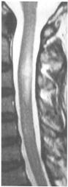

Most important differentiation (must be done rapidly with MRI!) - compressive myelopathy:
- spinal or epidural abscess / hematoma
- tumor, especially metastatic (may present acutely even though tumor has been present for weeks or longer)
- herniated intervertebral disk (central herniation may cause acute compression without local pain).

Treatment
Corticosteroids (e.g. IV methylprednisolone 500 mg q 12 hours for 3 days → tapering with prednisone) - reduce edema and lead to earlier function restitution.
- indications – idiopathic (postinfectious) transverse myelopathy, MS, cord compression.

Surfer's Myelopathy
Freedman, Brett A “Surfer's Myelopathy: A Rare Form of Spinal Cord Infarction in Novice Surfers: A Systematic Review” Neurosurgery: May 2016 - Volume 78 - Issue 5 - p 602–611

- rare (64 cases reported), acute, atraumatic thoracic/conus medullaris myelopathy that occurs in young, healthy, novice surfers who have no pre-existent spinal disease.
- most definitive support is for a vascular cause (angiogram may show the absence of radicular artery and no artery of Adamkiewicz).
- altered venous return that occurs from lying prone for prolonged periods of time on a surfboard can contribute to vascular insufficiency.
- occlusion by embolus or vasospasm induced by prolonged hyperextension; there have been no reported cases of a similar acute myelopathy in novice or elite butterfly stroke swimmers, who repetitively and violently hyperextend their flexible trunks for brief periods of time, often while performing a Valsalva maneuver; therefore, it is more likely that prolonged hyperextension plays the putative role.
- clinically start with back pain and rapidly progress to complete / incomplete myelopathy.
- diagnosis: T2 signal in the central cord within 24-72 hours; gadolinium enhancement and DWI are not helpful; at follow up – cord atrophy at involved levels.
- treatment - patients receiving steroids improved 55% of the time; optional – lumbar drain.
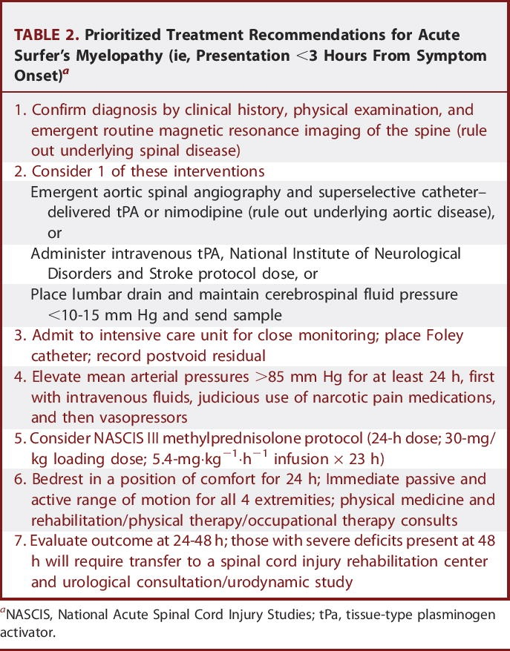
- prognosis:
- incomplete cases improve within 24 hours of onset
- no improvement has been reported for ASIA A cases (>50% of reported cases)
- overall neurological recovery rate - 42%;

Bibliography for ch. “Spinal Disorders” → follow this link >>

Viktor’s Notes℠ for the Neurosurgery Resident
Please visit website at www.NeurosurgeryResident.net

