Subdural Hematoma

Last updated: January 7, 2022

[Epidemiology 1](#_Toc91708653)

[Etiology 1](#_Toc91708654)

[Pathology, Pathogenesis 1](#_Toc91708655)

[Location 1](#_Toc91708656)

[Classification 1](#_Toc91708657)

[Clinical Features 3](#_Toc91708658)

[Diagnosis 4](#_Toc91708659)

[Recurrent SDH workup 8](#_Toc91708660)

[Treatment 9](#_Toc91708661)

[Conservative Management 9](#_Toc91708662)

[Chronic SDH 9](#_Toc91708663)

[Hematoma Evacuation 10](#_Toc91708664)

[Acute SDH 10](#_Toc91708665)

[Chronic SDH 11](#_Toc91708666)

[Prognosis 11](#_Toc91708667)

[Acute SDH 11](#_Toc91708668)

[Chronic SDH 11](#_Toc91708669)

[SDH in infants 11](#_Toc91708670)

[Newborns 11](#_Toc91708671)

[Older infants 11](#_Toc91708672)

[Subdural Tap 12](#_Toc91708673)

**SDH** – (rapidly clotting) blood collection in plane between dura and arachnoid.

Epidemiology

* men : women = 3:1
* most patients > 70 yrs.
* more common than EDH.

Etiology

1. **Vigorous head motion** (acceleration-deceleration injury\*) – may be trivial!
2. **Spontaneous** (30% of chronic SDH, i.e. intrinsic susceptibility – prone to recur)
   1. ***coagulopathies***
   2. ***(occult) CSF leak / CSF shunts*** causing ventricular decompression (→ stretching of bridging veins) and low ICP (intracranial venous congestion – seen on MRI as abnormal meningeal enhancement)
   3. ***intracerebral hemorrhage***, ***ruptured intracranial aneurysm*** (blood may dissect into subdural space, esp. PComA → convexital SDH; distal ACA → parafalcine SDH)
   4. intermittent bleeding from ***dural AVF*** (recurrent subdural hematomas)
   5. bleeding from ***intracranial tumors***

\*e.g. falls & assaults (≈ 72% SDH cases!), vehicular trauma (only ≈ 24% - automobile absorbs some of energy - so deceleration rate is less!), shaken baby syndrome

SDH is not usually associated with skull fractures\*; direct impact is not necessary!

\*if skull fracture is present, it is commonly contralateral to SDH

Pathology, Pathogenesis

- movement of brain relative to skull → rupture (via shearing mechanism) of **bridging veins** (cross subdural space - run from cortical surface to dural sinus; commonly found along sagittal sinus and around anterior tip of temporal lobe).

* + rarely, bleeding source may be **cortical artery** (hematoma looks more like EDH – lens shaped) or oozing **brain laceration**.

N.B. bleeding is most commonly venous (vs. EDH - arterial)

* as hematoma expands in subdural space, it raises ICP (→ global ischemia) and compresses brain (→ regional ischemia → herniation).
* **brain atrophy** (e.g. elderly, chronic alcoholism, dementia) predisposes to SDH even after minor trauma - brain has additional space for movement, bridging veins are stretched, atrophic brain cannot tamponade beginning hematoma; SDH may reach > 100 mL before becoming symptomatic!

Location

* + 1. along ***cerebral convexities*** - most common! (most often frontotemporal).
    2. along ***interhemispheric fissure*** and ***tentorium***\* (often associated with shaken baby syndrome). \*i.e. between occipital lobe and tentorium
    3. ***posterior fossa*** (< 1%) - cerebellum undergoes little movement; most SDHs here are result of parenchymal cerebellar injury – posterior fossa SDHs have highest mortality!
* subdural space (unlike epidural space) is *not confined by cranial sutures* and has *no adhesions* – SDH rapidly spreads along entire hemisphere and into hemispheric fissure, limited only by dural reflections at midline / tentorium.
* **bilateral SDHs** (≈ 10%) are more common in *infants* - adhesions in subdural space are absent at birth and develop with aging.

Classification

**Acute SDH** manifests during first 72 hours; most common type of traumatic intracranial hematoma (5-30% of severe head injuries; ≈ 1% of mild head injuries)

* + commonly (> 50%) associated with *extensive primary brain injury*!!! (vs. EDH) - diffuse parenchymal injury, contusions, lacerations, intracerebral hematomas - play major role in outcome!!!
  + more common in elderly and in infants (both have larger subarachnoid space - allows for more movement between brain and dura).

SDH is more common in very young and elderly (vs. EDH)

average age of trauma patient without acute SDH - 26 years;

average age of patient with acute SDH - 41 years.

* + mortality:

simple SDH (if no other brain injury) ≈ 20%;

complicated SDH (e.g. with contusions) ≈ 60%.

GCS 12-15 ≈ 0%;

GCS 3-5 ≈ 76%.

**Subacute SDH** manifests when 3-20 days old (surgical literature favors > 3 days; radiological literature favors > 7 days).

**Chronic SDH** manifests when > 14-20 days old

* + most common after age 50 with apparently insignificant head trauma.
  + most are derived from ***subdural hygroma***; minority develop from ***untreated acute SDH***.
  + commonly associated with **cerebral atrophy**.
  + risk factors for chronic SDH - elderly with cerebral atrophy, chronic alcoholism, epilepsy, bleeding disorders, arachnoid cysts, cardiovascular disease (hypertension, arteriosclerosis).
  + 8.7-32% are *bilateral*.
  + mortality ≈ 5-10%.
  + **small SDHs** often spontaneously resorb; **larger SDHs** liquefy (in ≈ 1 week) and form encapsulating vascular membranes (fibroblasts grow from dural surface and form thicker outer membrane by about 7 days, and thinner inner membrane after 2-3 weeks), rarely calcifies.
* *blood* in chronic SDH has liquid consistency, typically resembling crank case oil (can be drained through burr holes!).
* *membrane consists* of many fragile capillaries, intact and lysed RBCs, hemosiderin-laden macrophages, and granulation tissue.
* *organized hematoma is firmly* *attached* by fibrous tissue to dura and is not at all adherent to arachnoid (arachnoid does not contribute to membrane formation).
  + at some point, critical mass is reached (hematoma assumes ***biconvex*** shape and becomes ***symptomatic***):
    1. bleeding into chronic SDH (*small recurrent hemorrhages from thin-walled vessels within membrane* due to repeated minor trauma); up to 45% chronic SDHs rebleed; risk of rebleeding is greatest in first few months.
    2. *osmotic swelling* – due to blood break down and increased protein content (draws water osmotically across subdural membrane → clot enlargement).

Dura has been reflected above to reveal bridging veins:

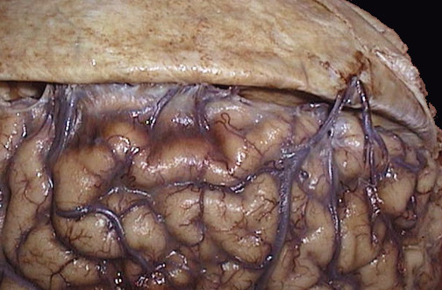

[Source of picture: “WebPath - The Internet Pathology Laboratory for Medical Education” (by Edward C. Klatt, MD) >>](http://library.med.utah.edu/WebPath/webpath.html" \t "_blank)

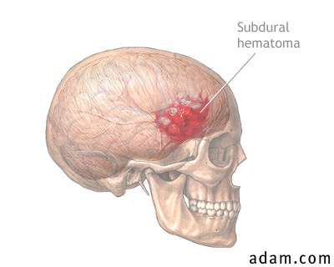

Dura has been reflected back (with small portion visible at lower right) to reveal subdural hematoma:

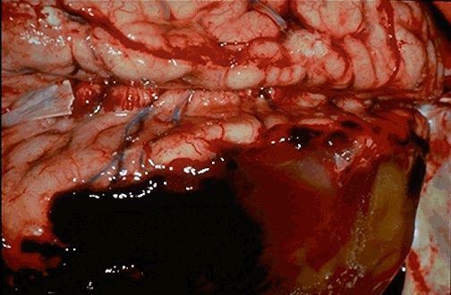

[Source of picture: “WebPath - The Internet Pathology Laboratory for Medical Education” (by Edward C. Klatt, MD) >>](http://library.med.utah.edu/WebPath/webpath.html" \t "_blank)

Here is bilateral chronic subdural hematoma; blood clots are brown to tan because of organization:

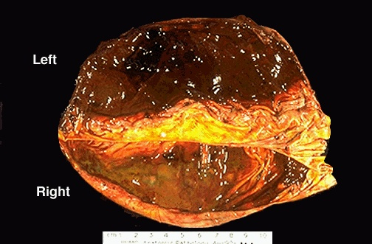

[Source of picture: “WebPath - The Internet Pathology Laboratory for Medical Education” (by Edward C. Klatt, MD) >>](http://library.med.utah.edu/WebPath/webpath.html" \t "_blank)

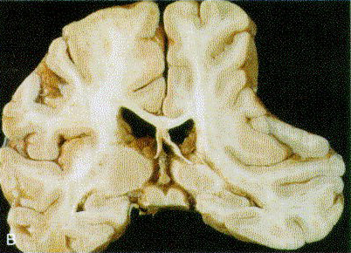

[Source of picture: Ramzi S. Cotran “Robbins Pathologic Basis of Disease”, 6th ed. (1999); W. B. Saunders Company; ISBN-13: 978-0721673356 >>](http://www.amazon.com/gp/product/0721601871)

Clinical Features

1. **Clinically silent**.
2. **Brain compression** (slow venous bleeding enables large hematomas to form before clinical signs appear) - can progress rapidly or slowly.

Most **acute SDHs** manifest within 48 hours.

* + ≈ 50% patients are unconscious from time of injury; ***(semi)lucid interval*** is observed in 30-70% cases.
  + there may be **focal signs**\* (due to prolonged brain tissue compression under hematoma), but often clinical manifestations are nonlocalizing (due to **ICP**↑); later, **brain herniation** may develop.

\*deficits are soft (not as profound as in other hematomas); hemianesthesia, hemianopsia are seldom observed (anatomic structures are deep and not easily compressed)

In pre-CT era, **chronic SDHs** earned label "great imitator" because of variable course and presentation (sometimes mistaken for dementia, stroke, or brain tumor!).

* + in 25-50% cases, there is no clear history of head trauma.
  + signs or symptoms fluctuate in ≈ 24% cases (mimic TIAs).
  + **headache** (90%), mild **hemiparesis** (45-58%), **confusion** (56%), **drowsiness** (40-50%), **personality changes**, **papilledema**, **gait dysfunction**, **seizures** are most common presenting features.

N.B. after hematomas have exerted pressure on brain for long time (perhaps year or more), removing them does little to improve cognitive function.

Nonepileptic, Stereotypical, and Intermittent Symptoms (NESIS)

* + NESIS clinically manifests as symptoms lasting > 5 minutes, dysphasia, preserved awareness, lack of positive symptomatology (such as clonic movements), lack of response to AEDs.
  + possible pathophysiology – ***cortical spreading depression or depolarization (CSD)*** (phenomenon similar to seen in SAH-associated vasospasm, stroke, TBI) – first described in animals in 1940 by Leão.
  + EEG is negative for ictal or epileptiform discharges\*; EEG most commonly shows focal or generalized slowing.

\*N.B. scalp EEG has only 70% sensitivity to detect ictal or epileptiform discharges.

* + differentiation from seizures is difficult without EEG; some clinical features are helpful:

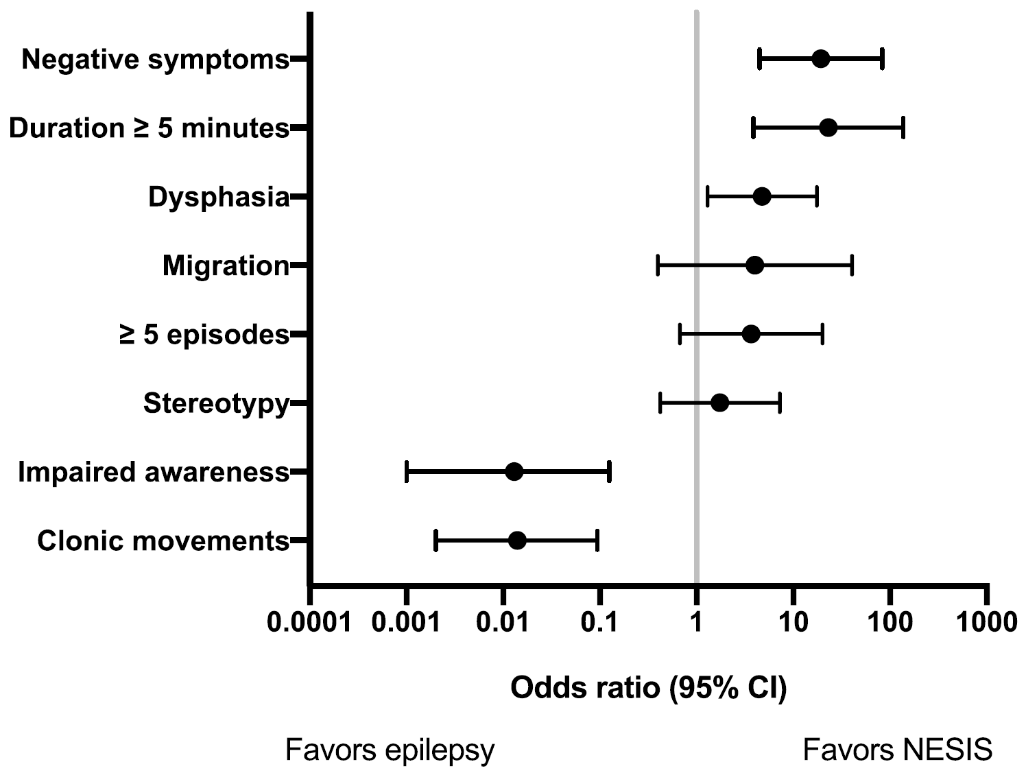

**Proposed Scoring System for the Diagnosis of NESIS (before EEG)**

(sensitivity of 96.6%, specificity of 100%)

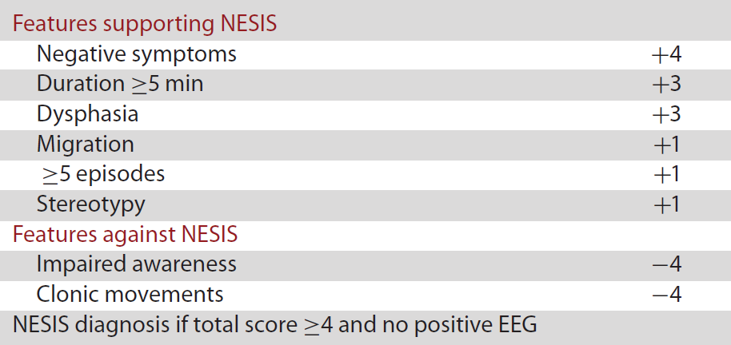

* + outcomes and mortality are better compared to patients with confirmed epilepsy.
  + treatment
    - CSD in human models have shown potential response to lamotrigine and topiramate;
    - for patients in whom epilepsy is still considered a possibility, topiramate could be an interesting first-line option, as it would address both seizures and CSD.
  + GENESIS trial (Generating Evidence on NESIS) is on the way.

Diagnosis

**Hemostasis** (PT, aPTT, platelet count)

**LP** (absolutely contraindicated) – xanthochromia, variable number of RBCs.

**Noncontrast CT** - crescentic collection over hemispheric convexity without extension into depths of sulci; can cross suture lines and continue along falx and tentorium (do not cross midline!):

N.B. blood pressure is less and space is less restricted (vs. EDH) → crescentic shape.

**Acute SDH** – ***hyperdense***\* (40-90 HU); rarely, can appear isodense:

* 1. low hematocrit (anemia)
  2. hyperacute clot (< 1 h old)
     + small hematomas may not be depicted because attenuation similar to adjacent inner table of skull (H: wider CT window and level, e.g. 240 and 80 HU).

**Subacute SDH** – ***isodense***\*; important signs - effacement of cortical sulci, displacement of gray matter–white matter junction (‘buckling’); membranes are not vascularized.

* + - better visualization - **MRI** (high signal on T1) or **contrast-enhanced CT** (opacification of cortical vessels - definition of brain margins).

**Chronic SDH** – ***hypodense***\* (15-30 HU, i.e. isodense to CSF); vascularized membranes enhance with contrast.

\*compared to brain.

Rule of thumb: blood remains ***denser*** than brain for 1 week, and is ***less dense*** after 3 weeks.

* underlying brain is flattened (***mass effect***), and subarachnoid space is often clear.

***absent midline shift*** - suspect contralateral mass (e.g. ≈ 20% chronic SDHs are bilateral); useful sign – ventricular frontal horns lie closer together (‘rabbit’s ear’ configuration).

***excessive midline shift*** - suspect underlying cerebral edema.

* in **interhemispheric SDH**, falx cerebri appears thickened and irregular.
  + interhemispheric SDH may *mimic SAH* (subarachnoid blood clears after several days; SDH remains wedge-shaped, smooth-bordered, hyperattenuating lesion).
  + interhemispheric SDH may *spread onto tentorium* → characteristic ‘comma shape’ on axial CT.
* **posterior fossa SDH** does not cross midline or extend above tentorium (vs. EDH).
* **temporal** and **tentorial SDHs** are better detected on coronal MRI (than on axial CT).
* *rebleeding* into **subacute / chronic SDH** makes hematoma *biconvex* and *heterogeneous* density (mixed old and fresh blood, sedimentation levels) – in general, looks like EDH with heterogeneous density.

Size of extra-axial hematoma is more important factor than whether blood is epidural or subdural in location!

Suspect child abuse! (esp. if posterior interhemispheric & tentorial SDHs)

* *osmotic swelling* of **chronic SDH** makes hematoma *biconvex* and *water* density – in general, looks like EDH with water density.

**MRI** is most sensitive imaging test! (esp. in subacute and chronic phase) but CT is usually enough. further see [p. D51 >>](http://www.neurosurgeryresident.net/D.%20Diagnostics\D45-59.%20Neuroimaging%20(X-ray,%20CT,%20MRI,%20PET,%20MRS)\D51.%20MRI.pdf#HEMORRHAGE_ON_MRI)

* **chronic SDH** - high signal on T1; *membranes* have low signal intensities (on T1 and T2).

Absence of clear history of trauma → **angiography** (search for ruptured aneurysm or dural AV fistula).

* angiographic signs of SDH – *avascular zone* between skull and brain with away dislocation of major vessels.

**T1 & T2-MRI** - bilateral subacute SDHs (increased signal intensity; areas of intermediate intensity represent more acute hemorrhage into subacute collections):

*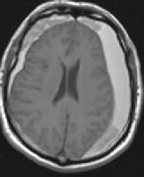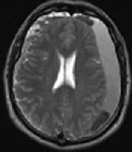*

Skull fracture with adjacent, small acute SDH (window and level values are widened over standard values to aid detection):

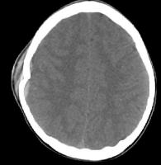

**MRI** - subacute SDH with extension into anterior interhemispheric cistern (note that sutures do not contain spread):

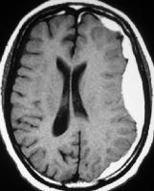

SDH with adjacent SAH due to ruptured MCA aneurysm:

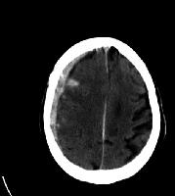

SDH due to ruptured right PComA aneurysm:

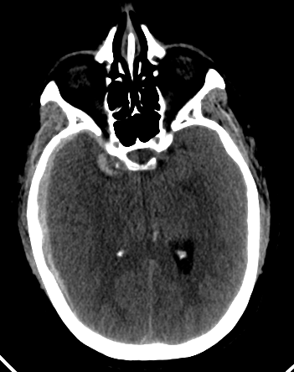

Right frontal subacute SDH; note displaced gray matter–white matter junction, and midline shift:

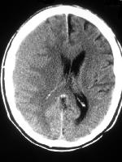

Subacute-on-chronic SDH with blood-fluid level (acute hemorrhage into chronic collection):

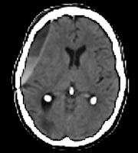

Acute-on-chronic SDH:

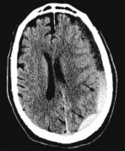

[Source of picture: H. Richard Winn “Youmans Neurological Surgery”, 6th ed. (2011); Saunders; ISBN-13: 978-1416053163 >>](http://www.amazon.com/gp/product/1416053166)

Subacute SDH - less dense than brain but denser than CSF; it is denser posteriorly; midline displacement is greater than would be expected from size of lesion - suggests extensive underlying swelling; contralateral (left) ventricle is dilated:

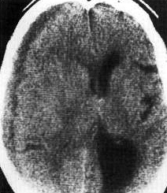

Bilateral SDHs, right greater in size than left:

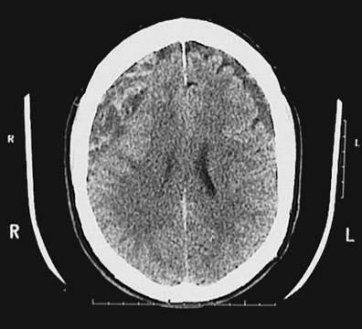

[Source of picture: “WebPath - The Internet Pathology Laboratory for Medical Education” (by Edward C. Klatt, MD) >>](http://library.med.utah.edu/WebPath/webpath.html)

Acute SDH:

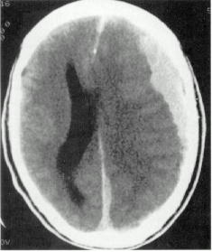

MRI - bilateral SDHs (*arrows*) with suboccipital extension:

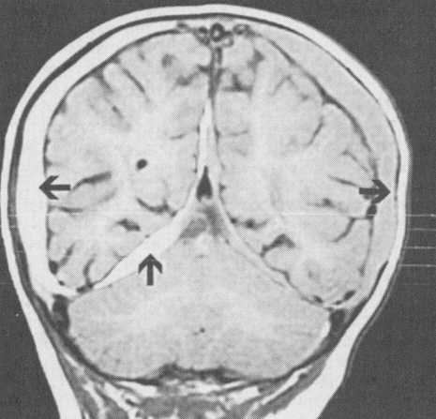

Interhemispheric acute SDH:

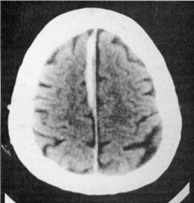

Bilateral chronic SDHs; midline shift is absent:

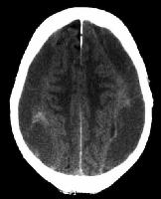

Chronic SDH with no mass effect:

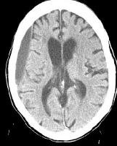

Bilateral acute-on-chronic SDHs:

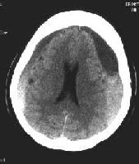

Acute SDH extending over entire left hemisphere; sedimentation level is seen (patient has clotting dysfunction):

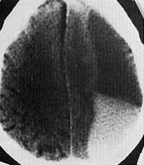

[Source of picture: “WebPath - The Internet Pathology Laboratory for Medical Education” (by Edward C. Klatt, MD) >>](http://library.med.utah.edu/WebPath/webpath.html" \t "_blank)

Subacute SDHs:

A) Noncontrast CT inward displacement of gray-white matter junction of left cerebral hemisphere; small sedimentation level is apparent in posterior portion.

B) Contrast CT at same level as A - good visualization of lateral margin of left cerebral hemisphere (opacified cortical veins):

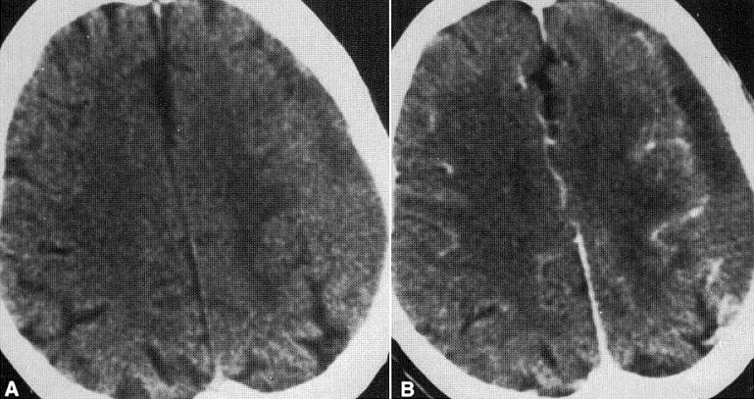

Acute and subacute SDHs:

A. T1-MRI - large fluid collections (*white arrows*) consistent with large subacute SDHs.

B. T2-MRI - hyperintense signal (*white arrows*) representing subacute blood and hypointense signal (*black arrows*) representing more recent hematoma.

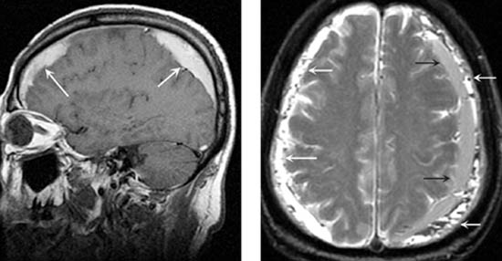

Calcified SDHs:

A. In *frontal view*, bilateral shell-like calcifications form cast of cerebral hemispheres.

B. In *lateral view*, outer calcified membranes are near bony skull, and inner membranes are separated from outer by relatively clear zones.

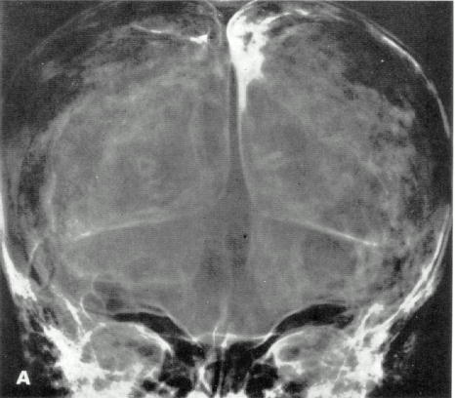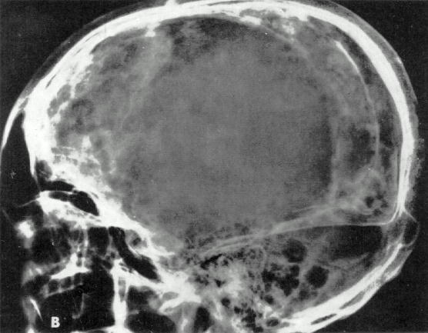

Recurrent SDH workup

1. MRI + DWI, CTA – for ***vascular abnormalities***
2. MRI of spine – for ***occult CSF leak***

Treatment

In all cases, hematoma *complete resolution* should be documented (conservatively treated acute SDH can evolve into chronic SDH).

Conservative Management

* surgical drainage is not required in many cases (acute SDH may disappear spontaneously, but may evolve into subacute or chronic lesion!) - managed with serial CT and close neurological observation in a neurosurgical ICU and then as outpatient.
* **seizure prophylaxis** and other measures → see [p. TrH1 >>](http://www.neurosurgeryresident.net/TrH.%20Head%20trauma\TrH1.%20Head%20Injury%20(GENERAL).pdf)
* monitor coagulation parameters!
* **platelet transfusion** for patient on ASA/Plavix – probably no effect!

“Reversal of Antiplatelet Therapy May Not Benefit TBI” Congress of Neurological Surgeons (CNS) 2013 Annual Meeting. Abstract #164 and #195. Presented October 22, 2013. [>>](http://www.medscape.com/viewarticle/813420)

Chronic SDH

* *chronic SDH growth is due to the highly friable nature of the vascularized membrane* that forms after initial injury.
  + - 1. Chronic SDH can be treated with tranexamic acid (TXA) 650-750 mg PO daily for 30 days without concomitant surgery; tranexamic acid might simultaneously inhibit fibrinolytic and inflammatory (kinin-kallikrein) systems, which might consequently resolve cSDH; some experts administer it postop (after bur hole washout)

J Neurosurg. 2013 Aug;119(2):332-7. doi: 10.3171/2013.3.JNS122162. Epub 2013 May 3.

Nonsurgical treatment of chronic subdural hematoma with tranexamic acid.

Kageyama H, Toyooka T, Tsuzuki N, Oka K.

* + - 1. Dr. Okonkwo (UPMC) gives Medrol Dosepak; Dr. Day (UAMS) gives dexamethasone 2 mg q8hrs for 2 weeks, then tapers based on repeat CT findings.

Dex-CSDH Trial

P.J. Hutchinson et al. for the British Neurosurgical Trainee Research Collaborative and Dex-CSDH Trial Collaborators. Trial of Dexamethasone for Chronic Subdural Hematoma. N Engl J Med 2020;383:2616-27. DOI: 10.1056/NEJMoa2020473

* multicenter (23 sites), randomized, placebo-controlled trial in the United Kingdom
* adults with **symptomatic chronic SDH**:
* mean age 74 years
* symptoms: headache, gait disturbance, confusion or cognitive decline, limb weakness, speech disturbance, decreased consciousness, and seizures.
* exclusions: glucocorticoids are contraindicated, receiving (or had been receiving within 1 month before screening) glucocorticoids on a regular basis, cerebrospinal fluid shunt, severe lactose intolerance, psychotic disorders, acute SDH.
* **94% underwent surgery during index admission** (decision to operate was made by the treating clinician) – trial was *unable to statistically explore dexamethasone role as an alternative to surgery*!
* groups were similar (e.g. 60% in both groups had a score of 1-3 on the modified Rankin scale at admission, 94% in both groups had GCS 13-15).
* 1:1 ratio: **dexamethasone** (375 → 341 patients\*) vs. **placebo** (373 → 339 patients\*).

**Oral dexamethasone** 2-week tapering course started within 72 hrs of admission: 8 mg bid on days 1 to 3 → 6 mg bid on days 4 to 6 → 4 mg bid on days 7 to 9 → 2 mg bid on days 10 to 12 → 2 mg once daily on days 13 and 14.

\*some withdrew consent, some were lost for F/U.

Outcomes

* primary outcome - score of 0-3 (favorable outcome) on the modified Rankin scale at 6 months after randomization; favorable outcome was reported:

83.9% patients in dexamethasone group

90.3% patients in placebo group

difference, −6.4 percentage points [95% confidence interval, −11.4 to −1.4] in favor of the placebo group (p = 0.01);

odds ratio for a favorable outcome with dexamethasone was 0.55 (95% CI, 0.33 to 0.91) in favor of the placebo group (P = 0.02).

* adverse events: more in the dexamethasone group than in the placebo group.

Adverse events of special interest: hyperglycemia leading to treatment or discontinuation of the trial regimen, new-onset diabetes, hyperosmolar hyperglycemic state, new-onset psychosis, peptic ulceration / GI bleeding, upper GI side effects.

* repeat surgery for recurrence was performed:

1.7% patients in dexamethasone group

7.1% patients in placebo group.

* follow-up imaging was not mandated (trial outcomes did not include imaging results to address the possible effect of dexamethasone on the size of chronic subdural hematomas).

|  |  |  |
| --- | --- | --- |
| **Outcome** | **Dexamethasone** | **Placebo** |
| Favorable outcome | 83.9% | 90.3% |
| Favorable outcome in never operated patients | 82% | 100% |
| Adverse events | 10.9% | 3.2% |
| Any infection | 6.4% | 1.1% |
| Repeat surgery | 1.7% | 7.1% |

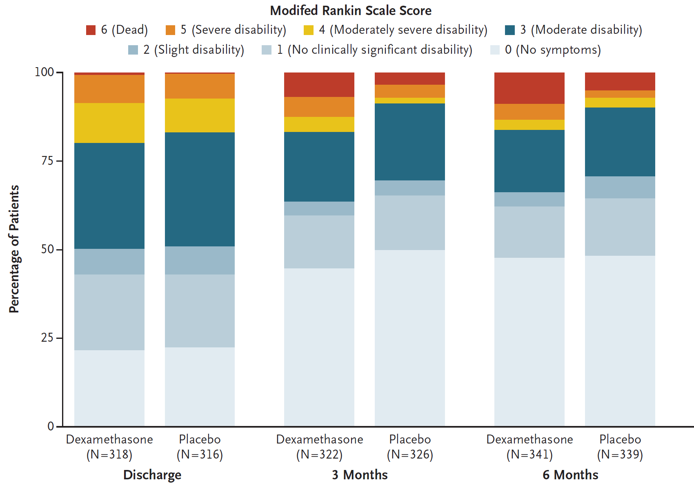

* + - 1. Proposed treatment for recurrent (or new in high risk patients – elderly on anticoagulation) symptomatic SDH - **middle meningeal artery (MMA) embolization** with the goal of eliminating the arterial supply to this vascularized membrane.
* use PVA particles - able to travel distally within the MMA vasculature and cover a broad anatomic area, limiting the chance of new collaterals forming distally (vs. liquid embolics such as Onyx or nBCA glue provide more of a “stump” embolization proximally).
  + - 1. EG-1964 (Edge Therapeutics, Inc.) - polymer-based filament that contains aprotinin - pancreatic trypsin inhibitor.
* indicated to prevent rebleeding and reduce the need for blood transfusions following cardiac bypass surgery
* IV administration has serious thrombotic side effects
* EG-1964 delivers sustained dose of aprotinin over 21-28 days directly to site of SDH

Hematoma Evacuation

Acute SDH

Guidelines “Surgical management of acute subdural hematomas” in Neurosurgery. 2006 Mar;58(3 Suppl):S16-24

* indications for ASAP\* surgery: also see [p. TrH1 >>](http://www.neurosurgeryresident.net/TrH.%20Head%20trauma\TrH1.%20Head%20Injury%20(GENERAL).pdf#Indications_for_surgery)

1. acute SDH with a thickness > 10 mm, regardless of the GCS score
2. midline shift > 5 mm, regardless of the GCS score.
3. GCS < 9 and GCS decreased between the time of injury and hospital admission by ≥ 2 points
4. GCS < 9 and asymmetric or fixed and dilated pupils
5. GCS < 9 and ICP > 20 mm Hg

* acute SDH in coma (GCS < 9) → ICP monitoring.
* surgical evacuation of an acute SDH should be performed using a craniotomy ± bone flap removal and duraplasty. see [p. Op320 >>](HTTP://WWW.NEUROSURGERYRESIDENT.NET/Op.%20Operative%20Techniques/300-399.%20Cranial/Op320.%20Cranial%20Trauma%20procedures.pdf#Acute_SDH)

\*delay for 4 hours is a benchmark of neurosurgical care:

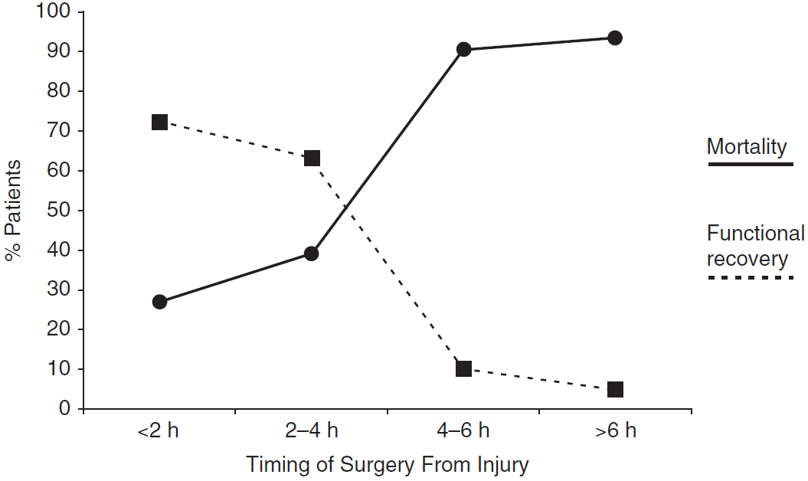

Seelig et al. (1981)

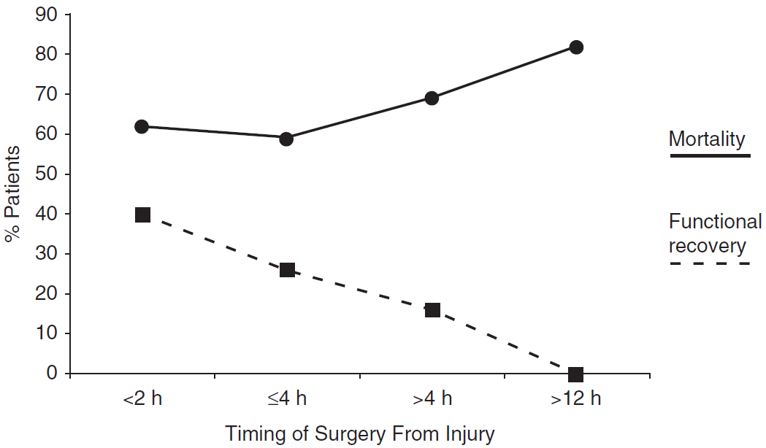

Wilberger et al. (1991)

Wilberger et al. (1991) study also revealed that the appropriate strategies ***to prevent secondary brain injury*** may be more important than the timing of surgery in determining outcome (i.e. an increased focus on how to ***manage ICP during the interval between injury and surgery***).

* after evacuation of traumatic SDH, place EVD, esp. if preop GCS was ≤ 8.

Chronic SDH

* any *coagulopathy* must be reversed ASAP.
* must be surgically evacuated if symptomatic\* (+ significant mass effect on imaging):

\*except mild headaches

1. **Burr hole craniostomy (“burr hole washout”)** – procedure of choice. [see p. Op320 >>](HTTP://WWW.NEUROSURGERYRESIDENT.NET/Op.%20Operative%20Techniques/300-399.%20Cranial/Op320.%20Cranial%20Trauma%20procedures.pdf#BURR_HOLE_WASHOUT)

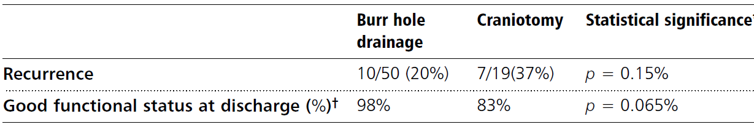

Svien HJ and Gelety JE . On the surgical management of encapsulated subdural hematoma. J Neurosurgery 1964 ; 2 1 : 172 – 177 .

Meta-analyses have confirmed findings of the paper by Svien and Gelety (Weigel et al., 2003; Lega et al., 2009; Mondorf et al., 2009)

1. **Twist drill craniostomy** – at bedside for very sick patient. [see p. Op320 >>](HTTP://WWW.NEUROSURGERYRESIDENT.NET/Op.%20Operative%20Techniques/300-399.%20Cranial/Op320.%20Cranial%20Trauma%20procedures.pdf#BURR_HOLE_WASHOUT)
2. **Craniotomy** – indicated for:
3. **multilocular** / **calcified** SDHs.
4. burr hole / twist drill **drainage failures**.

N.B. some experts advocate craniotomy as first choice for cSDH but studies show that all results (complications, dispo, recurrences requiring reoperation\*, mortality) are worse than with BHWO.

\*24% (vs. 6-7% for BHWO)

Postoperatively [see p. Op320 >>](HTTP://WWW.NEUROSURGERYRESIDENT.NET/Op.%20Operative%20Techniques/300-399.%20Cranial/Op320.%20Cranial%20Trauma%20procedures.pdf#Postop_BHWO)

Prognosis

Acute SDH

Most important prognostic factors:

1. Concomitant primary brain injury
2. GCS score
3. Age (esp. > 40 yrs).
4. Time from trauma to surgical evacuation of hematoma (esp. > 4 hours)

Chronic SDH

After surgical evacuation, subdural hematoma recurs in 10-20% patients.

Chronic SDH increases mortality 17-fold at 1 year.

SDH in infants

Newborns

* SDH was once considered ***most common intracranial birth injury*** (but now ↓ with improved obstetric care).
* in majority of cases, bleeding is bilateral and located over dorsolateral surfaces of frontal and parietal lobes.
* clinically: seizures, pallor, tense anterior fontanel, rapidly enlarging head, hypotonia, poor Moro reflex.
* may be abnormal at birth (no spontaneous respiration, severe hypotension, seizures, retinal hemorrhage).
* initial manifestation may be generalized seizures within first 6 months of life.
* acute cases may progress to herniation.
* diagnosis – **ultrasound**, **CT**, **funduscopy** (50% show retinal or subhyaloid hemorrhages).
* if SDH interfered with brain growth, skull vault may be thick, with paucity of convolutional impressions, and hypertrophy of air cells and paranasal sinuses.
* calcification streaks / plaques, often parallel to vault, may be visible in capsule of chronic SDH.
* treatment – evacuation through **craniotomy**.

Ultrasound - left echogenic acute subdural hematoma (H), associated with right subarachnoid anechogenic effusion (E). Falx cerebri (*arrow*) remains straight:

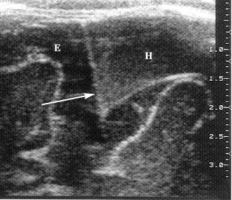

Older infants

* SDH is most common intracranial lesion in children < 2 years:

1. ***shaken baby syndrome***!!! (chronic SDH in infants who do not yet walk)

[see p. TrH20 >>](http://www.neurosurgeryresident.net/TrH.%20Head%20trauma\TrH20.%20Head%20Injury%20(PEDIATRIC).pdf#Shaken_Baby_syndrome)

1. complication of shunt procedures
2. bleeding disorders.

* clinically: macrocrania (symmetrical or asymmetrical), tense anterior fontanel, lethargy / irritability, seizures, poor feeding, vomiting, failure to thrive.
* diagnosis – **CT**, diagnostic **subdural tap** (should be done bilaterally, even if positive on one side).
* treatment – repeated daily **subdural taps** monitored by CT, head circumference measurements.
* resorption of hematoma must occur over weeks ÷ months.
* if > 10 taps are done (symptoms persist after 2 wk of daily drainage) → surgical treatment (e.g. ***subdural-peritoneal shunting*** or ***subdural-subgaleal shunting*** for 6 months; historically – *subtemporal craniectomy* – to let fluid drain into pterygoid fossa).
* removal of membranes was once thought to be important to avoid brain growth restriction, but this no longer seems necessary.
* 25% have some psychomotor retardation.



Subdural Tap

* anterior fontanelle becomes effectively closed between 9 and 18 months.
* equipment - sterile prep and drape, gloves, razor, blunt short-beveled spinal needle with stylet (20 G, 1½ or 2½ inch), manometer, CSF collection tubes, and local anesthesia (if desired).
* scalp is shaved anterior to ears (over lateral margins of anterior fontanelle).
* restrain infant by bundling him in sheet; supine, head firmly held by attendant (avoid excessive neck flexion).
* raise skin wheal of *local anesthetic* at puncture site.
* **insert needle** through skin at extreme lateral limit of anterior fontanelle where it meets coronal suture (i.e. at least 2-3 cm from midline - to prevent sagittal sinus injury).
* use **zigzag puncture** to prevent later fluid leakage (puncture dislocated skin at right angle, then aim needle laterally).
* dura is entered with sudden "popping" sensation.
* cerebral cortex is ≈ 1.5 cm from skin surface (***attachment of hemostat*** 5-7 mm from beveled end of needle should provide adequate safeguard).
* remove stylet - subdural fluid is *allowed to drain spontaneously* (fluid is never aspirated - risk of drawing pial vessels into point of needle).
* only 10-20 mL of subdural fluid should be removed from each side at one time (removing larger amounts may precipitate rebleeding or shock).
* if pial vessel is punctured, bleeding will usually cease spontaneously.
* pressure is measured with manometer.
* specimens are collected for Gram staining, culture, cells, glucose, and protein.
* remove needle → apply pressure → firm sterile dressing → place in sitting position (to prevent leakage).
* repeat on opposite side.
* *continued leakage* from puncture site → apply **collodion-impregnated cotton fluff** over puncture wound + **elevate head** 20-30°.

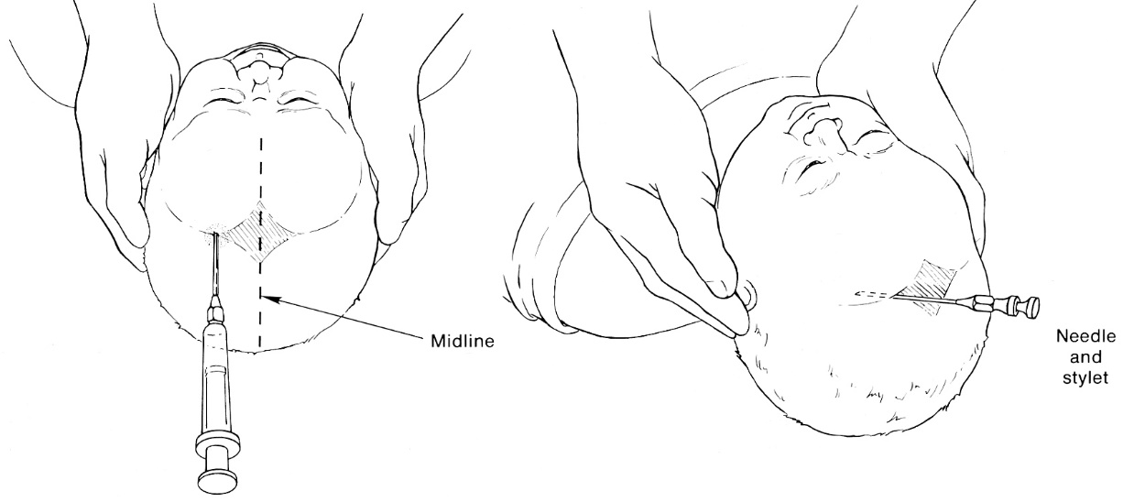

Bibliography for ch. “Head Trauma” → follow this [link >>](http://www.neurosurgeryresident.net/TrH.%20Head%20trauma\TrH.%20Bibliography.pdf)

[Viktor’s Notes℠ for the Neurosurgery Resident](http://www.neurosurgeryresident.net/)

[Please visit website at www.NeurosurgeryResident.net](http://www.neurosurgeryresident.net)