Spinal Trauma
Last updated: December 19, 2020
Epidemiology 1
Modern trends 2
Etiopathophysiology, Pathology 2
Vertebral Column 2
Regional aspects 2
Stability and spinal cord injury 2
Incidence of spinal cord injury 3
Predisposing Factors to spinal cord injury 3
SCI 3
Primary SCI 3
Pathology in Stages 4
Degrees of SCI 4
Secondary SCI 4
Ischemia 4
Biochemical Cascade 4
Wave of apoptosis 4
Experimental Therapies 5
Neuroprotective Agents 5
Cell-based therapies 5
Clinical Features 6
History 6
Physical examination 6
Classification (VCT) 7
Scales (SCI) 7
ASIA 7
International Spinal Cord Injury Basic Pain Data Set 8
Prehospital management 8
Airway 9
Hypotension correction 9
Spine Immobilization 9
Transportation 11
Diagnosis & Strategies for Immobilization 12
SCI without radiographic abnormalities (SCIWORA) 12
Cervical Spine 12
Awake asymptomatic ADULT patients 13
Awake asymptomatic PEDIATRIC patients 13
Awake patient + neck pain or tenderness 13
Obtunded / unevaluable patient 13
Diagnostic Modalities 13
X-ray 13
Cervical Spine 13
Thoracic Spine 14
CT 14
CTA 14
MRI 14
CT myelography 14
Bone Scans 14
Somatosensory evoked potentials 14
Complications 15
Posttraumatic syrinx (s. traumatic syringomyelia) 15
Treatment 16
Spinal Cord Perfusion Pressure 16
Neuroprotection 16
Steroids 16
GM-1 ganglioside (Sygen) 17
Naloxone, thyrotropin release hormone, tirilazad 18
Minocycline 18
Riluzole 18
Hypothermia 18
Cardiovascular care 18
Respiratory care 18
Thromboembolia 18
Thoracolumbar SCI 18
Cervical SCI 19
General Measures 19
Surgery 19
Spinal canal Decompression 19
Timing of surgical intervention 19
Expansile Duraplasty 20
Penetrating Wounds 20
Definitive Spine Reduction & Stabilization 20
Cervical VCT 20
tongs application 20
halo application 21
External cervical immobilization devices 21
Thoracolumbar VCT 22
Prognosis 23
Rehabilitation 24
Associated Injuries 24
Pediatric Aspects 24
Neonatal SCI 24
Specific Vertebral and Ligamentous Injuries (incl. Pathologic Fractures) → see p. TrS9 >>

VCT – vertebral column trauma.
SCI – spinal cord injury.

SCI is devastating in both socioeconomic and psychological aspects (intensive initial hospital care, long-term rehabilitation, lifelong care).

Epidemiology
VCT causes ≈ 6% traumatic hospitalizations
SCI causes ≈ 1% traumatic hospitalizations.

incidence 10.4-83 per million (15,000 new cases of SCI per year in the United States and Canada)
Mostly young and otherwise healthy (peak 20-24 yrs; 50% are < 23 yrs; 65% are < 35 yrs).
- male-to-female ratio – 3-20:1
- incidence highest during summer weekends.
- incidence is rising among blacks.
- quadriplegia occurs in 54.1 % of cases, with complete SCI occurring in 55.6 %
Second wave – elderly (females ≈ males, but males are less numerous in elderly populations)

prevalence 721-906/1,000,000.

The most common etiology of SCI: motor vehicle collisions, followed by falls, gunshot wounds, and diving.

Modern trends
- average age at time of injury has climbed substantially over the last five decades, from the age of 29 in the 1970s to the age of 42 currently (2017).
- pediatric SCI for those 15-years-old or younger are rare (3.5%), while injuries in retirees are on the rise, particularly due to falls.

Etiopathophysiology, Pathology
Vertebral Column
Causes (most commonly indirect severe force applied to vertebral column → sudden flexion, hyperextension, vertebral compression, or rotation):
    - motor vehicle accidents 30-50% (declining)
    - violence 5-29% (increasing)
    - falls 17-21% (esp. in elderly)
    - recreational activities 7-16% (esp. diving)
    - birth trauma (esp. cervical spine – breech delivery, “shaken baby”)

Evolutional aspects:
      - prehistoric humans suffered little spinal injury - semierect posture, with shoulders hunched well forward, combined with well-developed posterior cervical muscles that extended head against pull of gravity, protected cervical spine against day-to-day trauma.
      - in evolution, people assumed upright posture (so that hands could be used more effectively), shoulders dropped away from newly elevated head and previously hypertrophied paraspinous muscles atrophied - this provided head with tremendous range of motion but decidedly diminished protection of spine.

Spinal cord injury is characterized by biphasic pathophysiology:
- primary injury – mechanical
- secondary injury (can be more detrimental than primary injury) – ischemia, biochemical cascades, inflammation, apoptosis.

Regional aspects
Vertebral trauma:
50% - cervical (30% occur at C₂, 50% occur at C₆₋₇)
50% - thoracic ÷ sacral (60-70% occur in T₁₂-L₂)
N.B. trauma most often affects junctions between fixed and mobile segments

Cervical segment (very mobile segment that joins two large body masses – head with trunk) – closed spinal injuries by hyperextension or flexion, etc.
- 42% cervical fractures are unstable
- 39% cervical fractures give neurologic deficit.
- 4-8% patients with head injury have concomitant cervical spine injury.
- cervical region is the most frequently injured spine segment in vehicular crashes, especially when shoulder and lap belt restraints are not worn.
- falls are the most common (70%) cause in elderly

Thoracic spine (longest segment) – high percentage of missile injuries
- T₁₋₁₀ region has high stability (stabilizing effects of rib cage, almost-vertical orientation of articulating processes, shingle-like oblique arrangement of spinous processes) - significant force is required to cause fracture / dislocation.
- laminae are also protective – broad, sloping, overlapping.
- thoracic spinal canal is narrow, cord has poor vascular supply – vertebral injuries have high incidence of SCI (90% dislocations above T₁₀ result in complete paraplegia!!!)

Thoracolumbar union (rigid thoracic area transitions to mobile lumbar spine) – closed spinal injuries by vertical compression with flexion (→ compression fractures with anterior wedging), or rotation (→ fracture dislocations), etc.
- lower mechanical stability - no stabilizing effect of rib cage (T₁₁₋₁₂ region has false ribs), spinous processes are more horizontal, disc height↑.
- injuries to T₁₁-L₁ can result in significant paralysis (conus medullaris).

Mid ÷ low lumbar spine - injuries are more forgiving - roots of cauda equina are smaller, more flexible, and more resistant to injury (as they are PNS) compared with conus medullaris (as it is CNS).

Stability and spinal cord injury
Holdsworth’s concept:
anterior column (80% of vertical strength) - vertebral bodies and intervertebral disks - held in alignment by anterior & posterior longitudinal ligaments.
posterior column - articulating facets (provide remaining 20% of vertical strength), pedicles, transverse processes, laminae, spinous processes - held in alignment by nuchal ligament complex (supraspinous, interspinous, infraspinous ligaments), capsular ligaments, ligamentum flavum.

If both columns are traumatically disrupted at one level (spine moves as two separate pieces) - mechanically unstable injury - great risk of vertebral canal misalignment (→ spinal cord injury) from even slight motion.
If only one column is disrupted (other column resists further movement) - likelihood of spinal cord injury resulting from normal motion depends on integrity of ligaments supporting involved column.
- failure of any one of columns may involve compression effect (failure of vertical strength) or failure of ligamentous strength (incapability to oppose distraction).
- spinal canal compromise is more frequent when anterior column is involved.
- any degree of subluxation must be treated as potentially unstable!!! (ligamentous disruption allows cord compression at moment of impact, but vertebral bodies return closer to their original stations afterward).

mechanically stable - fragments are not likely to move and cause neural damage when spine is physiologically loaded.

N.B. mechanically stable injuries may be neurologically unstable - result in spinal cord damage from:
- fracture fragments (bone splintering)
- herniated intervertebral disks
- epidural hematoma
- spinal cord vascular compromise:
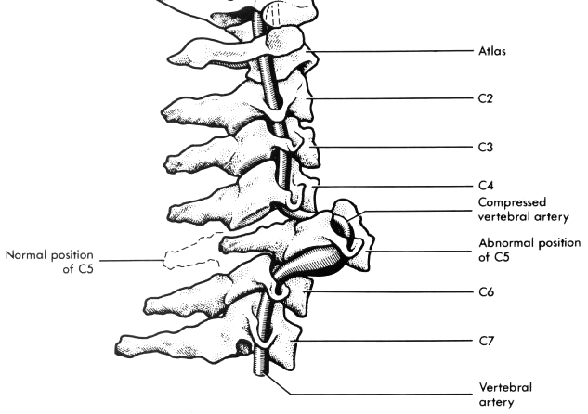

Denis (1983) divided anterior column of Holdsworth into two segments:  anterior segment - anterior halves of vertebral bodies with intervening disks, anterior longitudinal ligament.  middle segment - posterior halves of vertebral bodies and their intervertebral disks, posterior longitudinal ligament.  Injuries involving 2 or 3 columns are unstable! | 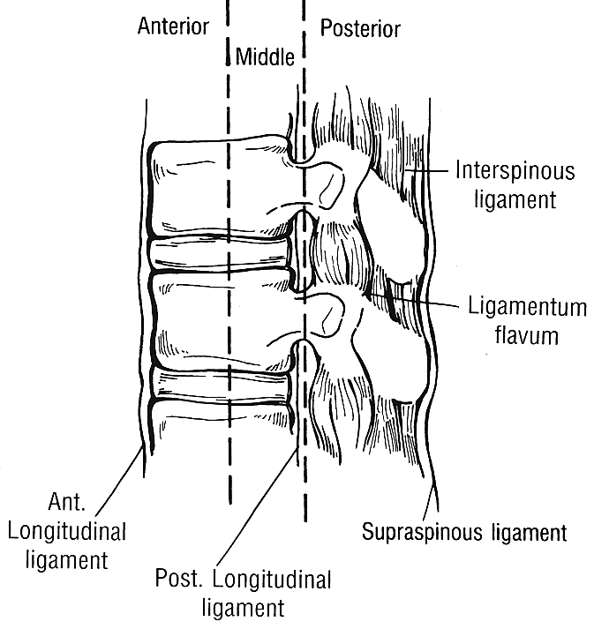

Incidence of spinal cord injury
Overall, only 10-15% VCTs result in neurologic deficits.
Type of injury | Percent with neurologic deficit
Fracture of vertebral body | 3
Fracture of posterior element | 19
Fracture of posterior elements and vertebral body | 11
Dislocation only | 17
Dislocation + fracture of posterior elements | 27
Dislocation + fracture of vertebral body | 56
Dislocation + fracture of posterior elements and vertebral body | 61

Predisposing Factors to spinal cord injury
- preexisting vertebral column pathology (may allow SCI even without fracture or dislocation!!!):
    - instability of apophyseal joints (e.g. rheumatoid arthritis).
    - atlantoaxial instability (e.g. Down syndrome*, rheumatoid arthritis) → severe SCI after minor injury. *laxity of transverse ligaments
    - decreased spinal canal - spondylosis (elderly predisposition to cervical SCI**), spinal stenosis, ligamentum flavum hypertrophy.
**forcible cervical extension → cord compression between arthritically enlarged anterior vertebral ridge and posteriorly located hypertrophic ligamentum flavum:
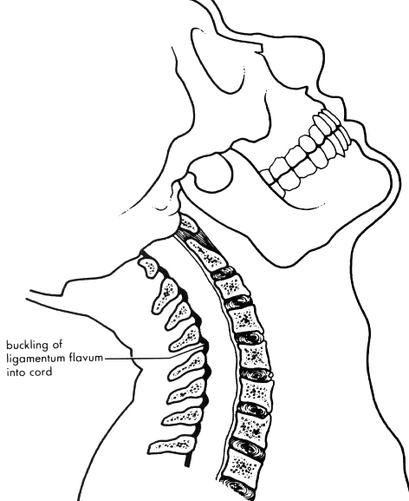

SCI
Primary SCI
- immediate neurologic deficit due to structural damage (via traction / compression / laceration) of spinal cord.
VCT and SCI most often coexist, yet either can occur in isolation.

- Direct injury to spinal cord (rare) - bypassed protection afforded by vertebrae: bullets / missiles, stabbing with sharp object.

- Indirect injury to spinal cord - result of forces acting on vertebral column leading to:
- VCT (fractures, dislocations).
N.B. VCT need not be mechanically unstable to damage spinal cord (but not immobilized mechanically unstable VCT may lead to cord injury later!)
- hyperflexion / hyperextension of vertebral column, esp. if spinal stenosis is present (e.g. 37% cervical SCIs show no vertebral column injury);
- violent neck hyperextension (e.g. pedestrian struck from rear by vehicle) may avulse pons from medulla, or medulla from cervical cord → instantaneous death.
- spinal cord is damaged by misalignment of vertebral canal, bone fragments (bone splintering), herniation of disc material, infolding of ligaments.

  - it requires little direct force to cause significant injury to exposed spinal cord (spinal cord is much more vulnerable than cauda equina);
1-gm weight dropped from height of only 10 cm onto monkey's surgically exposed spinal cord results in permanent neurologic dysfunction.

Pathology in Stages
  - microhemorrhages*, exudation & massive swelling in central gray matter occur within minutes** → progress over next few hours (extend from gray matter to white matter, progress longitudinally and taper several segments above & below level of injury; small hemorrhages may coalesce into hematomyelia) → cord fills whole spinal canal at injury level → intradural pressure↑ → secondary ischemia.
*rupture of small venules
**macroscopically cord looks swollen, reddish, and soft
- subarachnoid hemorrhage is rare, and any extradural hemorrhages are small.
- hematomyelia is limited to central gray matter (LMN dysfunction); eventually absorbed, leaving centrally placed, smooth-walled cyst.
  - within several weeks – edema subsides, hemorrhages are absorbed, acute exudate is replaced by macrophages (most prominent cell being lipid phagocyte); axons undergo wallerian degeneration.
  - reparative stage may persist for up to 2 years → glial scar, fibrosis, syrinx-like cavitation (in place of necrotic – hemorrhagic areas).
  - in ≥ 5 years after injury, cord becomes shrunken (replaced by fibrous tissue); progressive proliferation of acellular connective tissue → chronic adhesive arachnoiditis.

Degrees of SCI
- concussion / stretching (much less common than in brain) → brief neurologic dysfunction with recovery in minutes or hours (e.g. syndrome of neurapraxia after athletic injury - dramatic, although transient, neurological deficits including quadriplegia).
- contusion (hemorrhagic softening) → permanent neurologic dysfunction; surrounding compressed tissue suffers prolonged neurologic dysfunction.
- laceration / crushing → permanent neurologic dysfunction.
- hemisection / transection* → permanent neurologic dysfunction.
*it is extremely rare for primary injury to transect spinal cord.
  - ≈ 10% of remaining cross-sectional area of spinal cord is enough to support locomotion.

Secondary SCI
- neurologic deficit progresses over many hours due to ischemic / hypoxic / toxic damage to spinal cord – may eventually culminate in permanent neurological deficits – very important aspect in treatment! (even when complete transverse myelopathy is evident immediately after impact, it may be reversible)
  - gray matter necrosis is evident within 4 h; at 8 hours necrosis becomes global (paralysis below level of lesion becomes irreversible).

Ischemia
- very prominent feature of post-SCI events.

    - Blood vessel damage (leads to ischemia):
      - loss of autoregulation (significant reduction in spinal cord blood flow within 2 hours of injury).
      - cord compression by epidural hematoma.
      - vascular compression (e.g. by dislocated vertebra) → thrombosis.

    - Spinal shock causes systemic hypotension → ischemia exacerbation.

Biochemical Cascade
Primary SCI initiates complex autodestructive progressive biochemical cascade, involving free radical-induced lipid peroxidation (destruction of membranes) → progressive edema & ischemia.

- Massive release of glutamate (key element in excitotoxicity) leads to overstimulation of neighbor neurons → intracellular calcium & sodium↑, extracellular potassium↑ → production of free radicals → death of healthy neurons and oligodendrocytes (AMPA glutamate receptors play major role in oligodendrocyte damage).

- Neuroinflammation

Wave of apoptosis
- further affects oligodendrocytes up to 4 segments from trauma site days ÷ weeks after initial trauma (syringomyelia may develop as outcome).
  - even after severe contusive SCI, axons survive in the subpial rim of white matter, but show dysfunctional conduction (because of changes in axonal K⁺ channel expression and distribution).

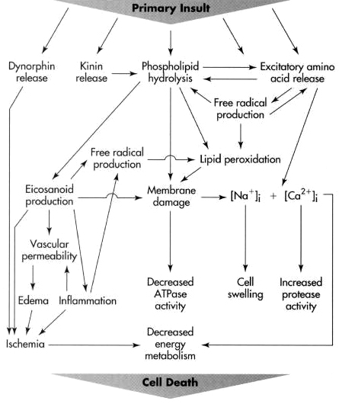

Key subacute event is demyelination (post-traumatic degeneration of white matter) – due to:
  - oligodendrocyte loss (death and limited renewal)
  - ↓ myelin gene expression.

Experimental Therapies
Neuroprotective Agents
- Riluzole – targets excitotoxicity. see p. Spin21 >>
- BA-210 (Cethrin®) - Rho antagonist; promotes neuroregeneration and neuroprotection.
- Minocycline – anti-inflammatory drug.
- Anti-Nogo; Nogo-A is myelin-associated neurite outgrowth inhibitory protein limiting recovery and plasticity after CNS injury.
- VEGF – stimulates angiogenesis and limits apoptosis.

Cell-based therapies
- primarily target myelin repair by restoration of oligodendrocyte population.
Spontaneous remyelination is limited!

    - other mechanisms - neuroprotection, trophic factor release, immunomodulation, axon regeneration

A. Endogenous precursor cells within adult spinal cord - do not promote remyelination (even after infusion of exogenous growth factors)

B. Cell replacement therapy - potential cell types:
- embryonic stem cells (ESCs) – ethical issues!!!
N.B. pluripotential stem cells should not be used – potentially oncogenic under trophic factor stimulation.
- adult brain-derived neural precursor cells (NPCs) or neural stem cells (NSC)* – extensive capacity for self-renewal and multipotency in vitro!
    - NPCs reside in forebrain (subventricular zone) and spinal cord for life.
    - NPCs can be isolated in vitro in the presence of growth factors → formation of clonally derived free-floating colonies (neurospheres).
    - NSC human transplantation has been reported to improve electromyography and electrophysiology.
- mononuclear progenitor cell (MNC)* - either the bone marrow or blood or umbilical cord; reports of consistent improvements in ASIA grade.
- Schwann cells (SC)* - from autologous sural nerve
- olfactory ensheathing cells (OEC)* - from autologous olfactory mucosa
- mesenchymal stem cells (MSC)* - from bone marrow, umbilical cord, adipose tissue
- skin-derived precursor cells
- oligodendrocyte precursor cell (OPC)*

*cells used in published (up to Sept 2020) human trials

Ectopic growth remains a major concern - finite space within the spinal canal and the potential for cord compression (may take up to 8 yr to manifest).
Rehabilitation after transplantation may be essential for efficacy!

Cell delivery:
- intramedullary - injection directly into the spinal cord lesion epicenter (e.g. using biomaterial matrices, notably NeuroRegen Scaffold™ and RMx Biomatrix™)
- intrathecally – can be done repeatedly.
- intravenous administration.

Trials (Sept 2020 data)
  - still no approved therapies!
  - most trials remain ongoing or not completed – 96% of registered trials are either phase I, phase II, or nested phase I/II designs.
  - number of completed trials linked to publications on clinicaltrials.gov is low at 28%
  - quality of trials remains highly variable.
  - majority of trials that are registered as completed are yet to generate any accompanying peer-reviewed publications.
  - methodological and regulatory inconsistencies must be overcome - multinational consortia are needed.

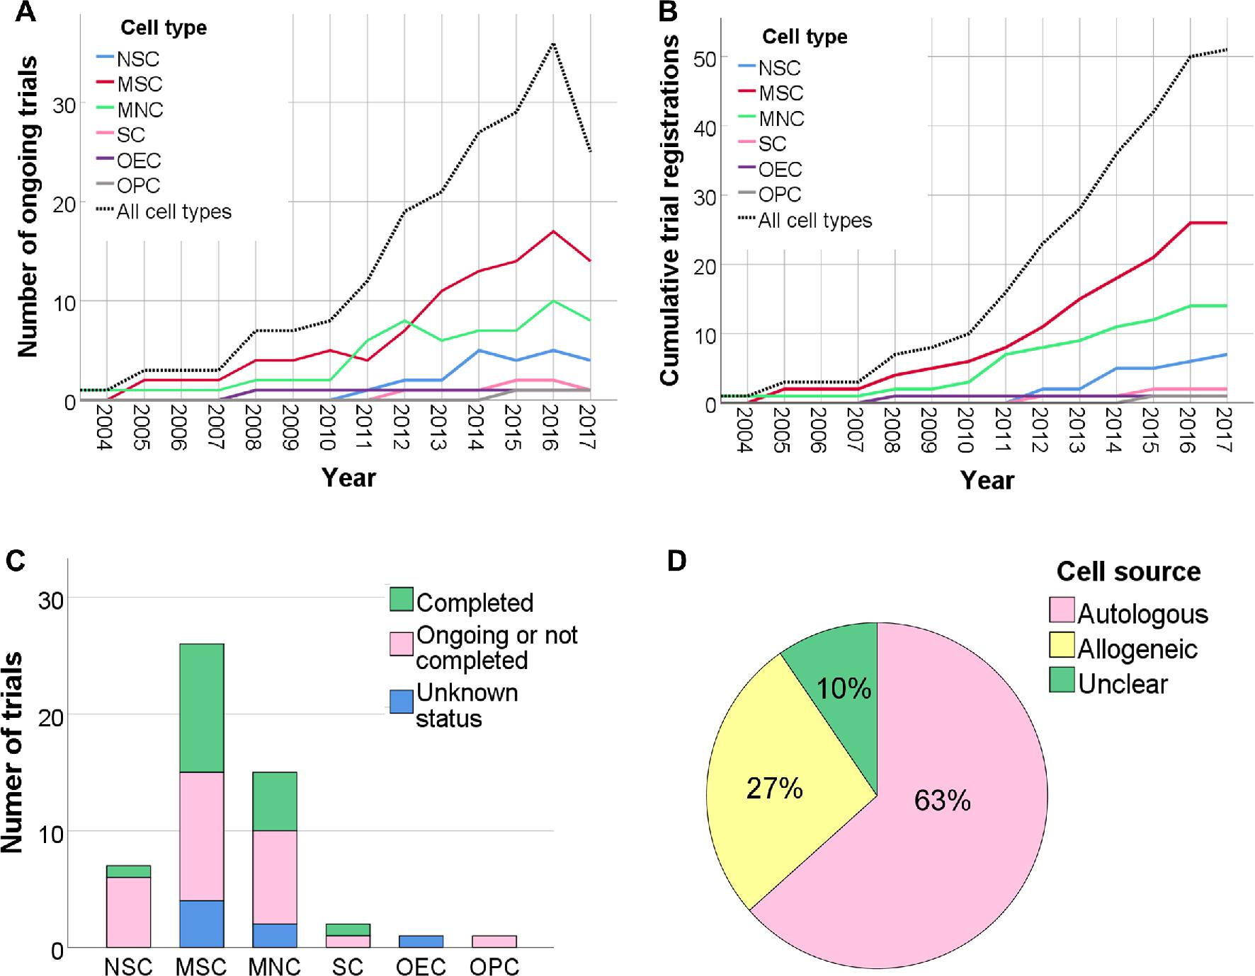

MNC, mononuclear progenitor cell; MSC, mesenchymal stem cell; NSC, neural stem cell; OEC, olfactory ensheathing cell; OPC, oligodendrocyte precursor cell; SC, Schwann cell

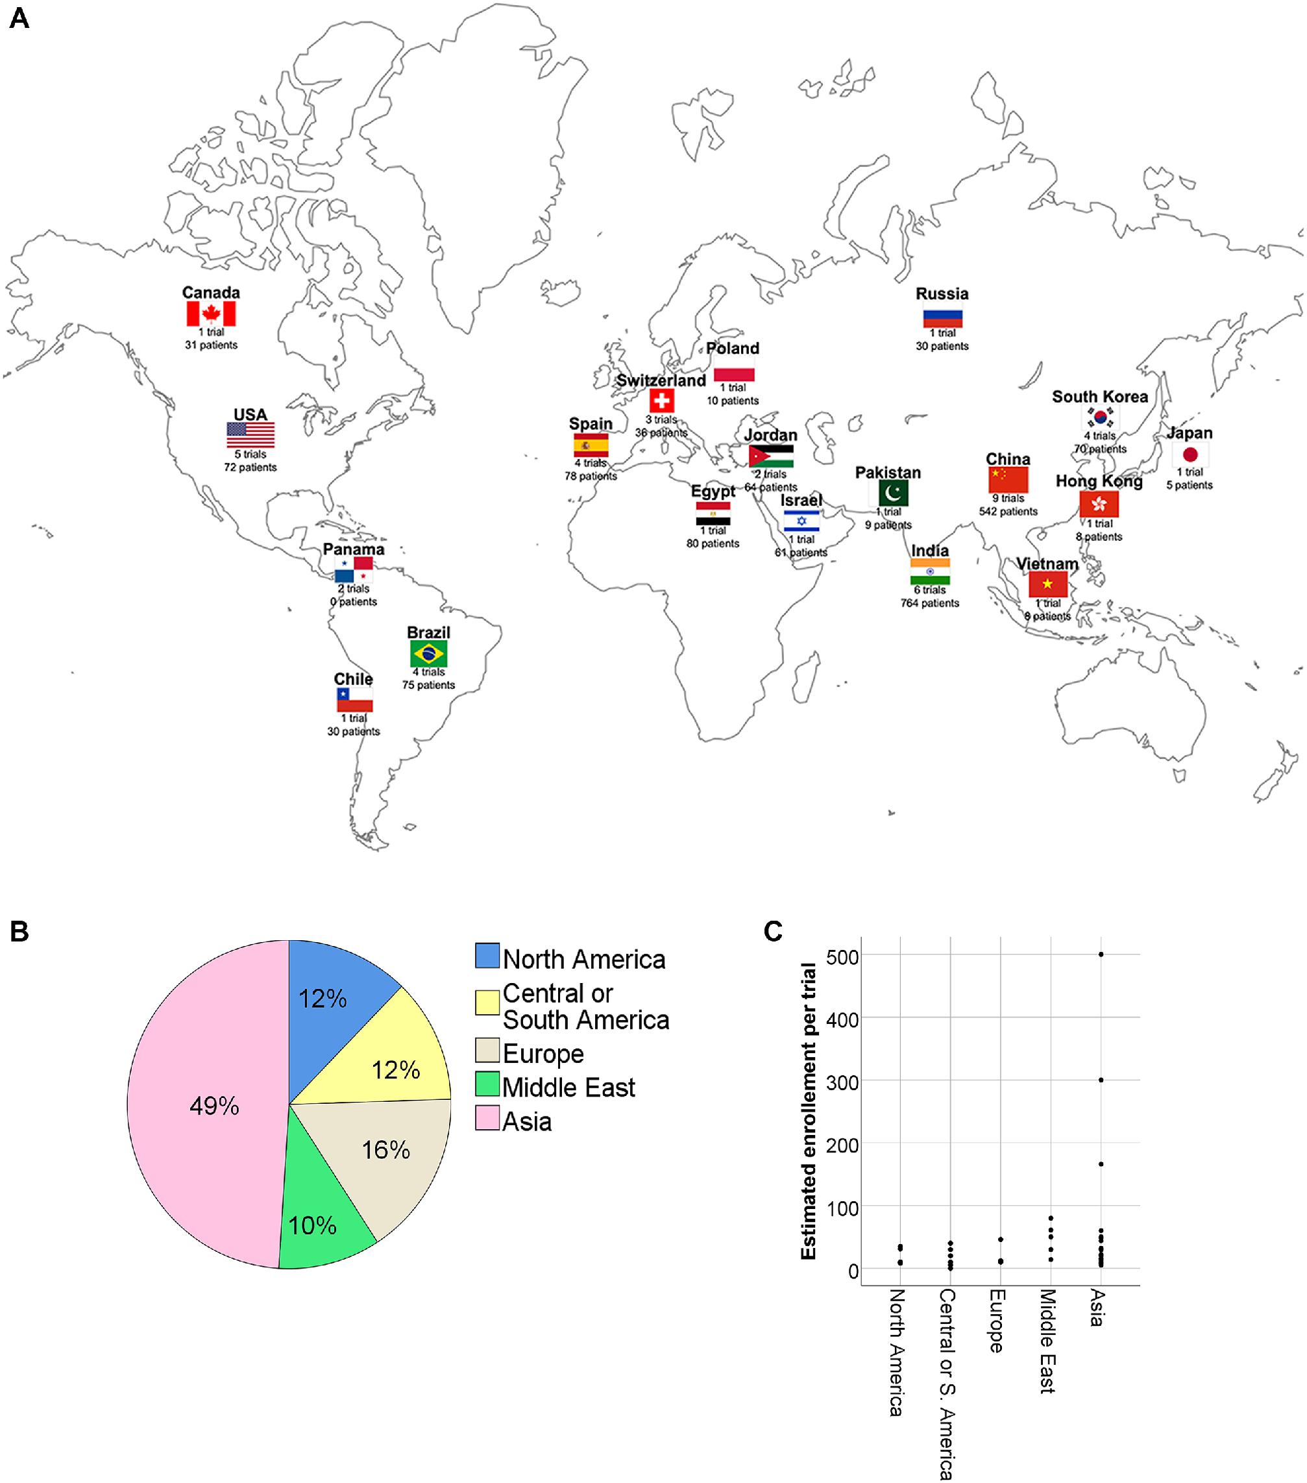

- first trials were registered in the early 2000s.
- majority (63%) have used cells derived from autologous sources, whilst 27% have used allogeneic cells.
- allogeneic cells can be mass produced to a consistent standard, but may require immunosuppression to prevent immune rejection
- timing - most trials are transplanting cells shortly after injury, with 31% delivering cells within 1 mo of SCI.

Clinical Features
History
- Mechanism & forces of injury.
- Site and duration of any pain.
- Transient or persistent numbness, tingling, weakness (or other neurologic problems).
Morbidity of spinal cord injury is so significant that even transient minor symptoms should be investigated!
- Any prior injuries / disorders involving spinal column or spinal cord.

Physical examination
I. Signs of trauma* - provide clues to mechanism of injury:
- abrasions, contusions, swellings.
  - contusions about scapula suggest rotation or flexion-rotation injury of thoracic spine.
  - injury to gluteal region or feet and ankles suggests compression injury.
  - oblique anterior chest or transverse lower abdominal abrasions from automobile belts mandate search for spinal, intrathoracic, and intraabdominal injuries.
- visible / palpable - spinal deformity, gap between spinous processes (= tear in posterior ligament complex = unstable spinal injury).
  - kyphosis ≥ 30° indicates instability.
- local pain & tenderness (may be noted only in subacute phase, can be progressive).
*examiner's hand is gently positioned under supine patient to palpate each spinous process for tenderness → patient is logrolled to lateral position, and whole dorsal spine checked – observed and palpated (in 10-15% cases additional non-contiguous injured levels are found)
II. Various combinations of:
- motor symptoms (respiratory paralysis; hemiplegia sparing face / paraplegia / tetraplegia; areflexia → hyperreflexia).
  - spontaneous muscle fasciculations are seen in muscles innervated by spinal segment just above level of denervation (result from annulment of inhibitory impulses normally exerted by now injured spine segment).
- sensory symptoms (lack of sensation below certain level, burning paresthesias, hemisensory loss sparing face).
  - conscious patient may experience severe pain in sensory dermatome corresponding to level of spinal injury (e.g. burning hands syndrome – see below >>).
- autonomic symptoms (urinary retention, constipation, ileus, gastroparesis, poikilothermia, neurogenic shock*, Horner syndrome, sustained priapism**).
*hypotension with bradycardia and flushed-dry-warm peripheral skin
**loss of sympathetic tone (poor prognosis)

These combinations reflect anatomic spinal syndromes (according to transverse and longitudinal location of SCI): for description → see p. Spin1 >>
    - spinal cord transection – Myelitis traumatica transversa completa (complete SCI; others below are incomplete SCIs)
    - central cord syndrome* – most common incomplete SCI syndrome!; etiology:
      - neck hyperextension (esp. in patients with cervical stenosis) → cord compression between bony bars anteriorly and thickened buckling ligamentum flavum posteriorly → cord hypoperfusion in watershed distribution (mostly central portion of cord – central gray and most central portions of pyramidal & spinothalamic tracts).
N.B. central cord syndrome is ischemic lesion (frequently no radiologically identifiable fractures!!!) - neurologic changes tend to improve with time!
50% initially quadriplegic patients return bowel and bladder control, become ambulatory, and regain some hand function
      - hematomyelia (usually confined to central gray matter).
burning hands syndrome (variation of central cord syndrome first described in extension injuries at C6-C7 level in football players) - severe burning paresthesias in hands; no other neurological dysfunction; > 50% there is underlying spine fracture-dislocation.
    - anterior cord syndrome* (cervical flexion resulting in anterior cord contusion; large disc herniation or burst fracture compressing anterior cord; laceration or thrombosis of anterior spinal artery) – worst prognosis of incomplete SCI syndromes (only 10-20% recover motor function).
    - Brown-Sequard syndrome* (direct penetrating trauma, lateral mass fractures of cervical spine, locked facets) – best prognosis of incomplete SCI syndromes.
    - posterior cord syndrome (hyperextension injuries with fractures of vertebral arch) – rare.
    - conus medullaris syndrome (disc herniation or burst fracture of T12 body).
    - cauda equina syndrome
N.B. abrupt SCI (complete or incomplete) may initially cause spinal shock. see p. Spin1 >>

*three most common syndromes (together constitute 90% incomplete SCI cases)

Define neurologic level - most caudal spinal segment with normal sensation and muscle strength of 3/5 or better.

Carefully document any motor / sensory function below level (incomplete SCI)
  - sacral sparing may be only evidence that paralysis may not be complete – always test perineum sensation, voluntary anal sphincter contraction, and toe flexion!
N.B. absent bulbocavernosus & anal wink reflexes = spinal shock is present (sacral sparing is not testable at this time – wait for return of above reflexes!!!)
  - SCI completeness may be fully evaluated only after spinal shock (return of reflex activity below level, but no sensation or voluntary motor control below level = complete cord transection).
see p. Spin1 >>
- most cervical and thoracolumbar injuries are complete; lumbar injuries produce incomplete lesions.
- absent reflex above returned reflexes indicates LMN injury (e.g. spinal root or cauda equina lesion - often caused by surgically correctable lesion!)

CNS Evidence-Based Guidelines for Thoracolumbar Spine Trauma (2019)
Grade C Recommendation (neurological assessment scales): numerous scales (Functional Independence Measure, Sunnybrook Cord Injury Scale, and Frankel Scale for Spinal Cord Injury) have demonstrated internal reliability and validity. ASIA impairment scale has not been specifically studied.
Grade B Recommendation - the following can be used to predict neurological function and outcome:
- entry ASIA Impairment Scale grade
- sacral sensation - absence of pinprick sensation predicts poor bladder recovery
- ankle spasticity - highly accurate in predicting neurogenic bladder dysfunction
- urethral and rectal sphincter function – reappearance of sphincter function correlates with bladder recovery
- abductor hallucis (AbH) motor function (e.g. on EMG) – may be earliest and most accurate indicator of supraspinal influence and the recovery of neurologic function

Classification (VCT)
Cervical Spine – see p. TrS9 >>
Thoracolumbar Spine – see p. TrS9 >>

Scales (SCI)
ASIA
American Spinal Injury Association (ASIA) system for examination and classification of spinal cord injury:
- recommended by “Clinical Assessment Following Acute Cervical Spinal Cord Injury” guidelines (Level 2 evidence).

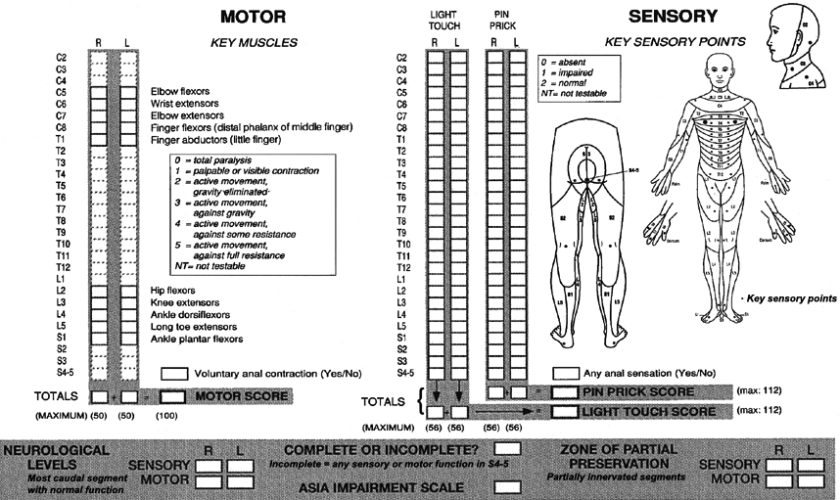

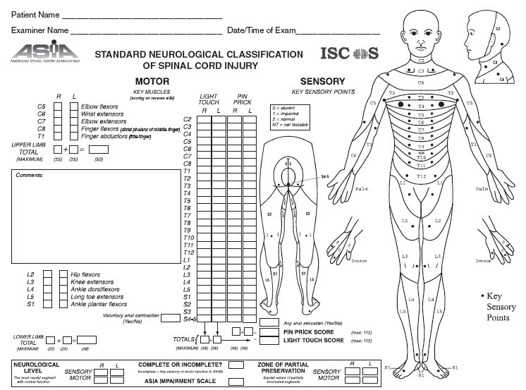

ASIA Impairment Scale:
A = | Complete SCI – loss of motor and sensory function in S4-S5 segments.
B = | Incomplete SCI - sensory but not motor function is preserved.
C = | Incomplete SCI - motor function is preserved (> ½ of key muscles below neurological level have muscle grade < 3 [unable to resist gravity]).
D = | Incomplete SCI - motor function is preserved (> ½ of key muscles below neurological level have muscle grade > 3).
E = | Normal.

Falsely localizing level of neurologic deficit:
- lower cervical dislocation may damage vertebral arteries → decreased flow through anterior spinal artery → neurologic level at C1-C2 level (or even brainstem).
- lumbar fracture or dislocation may compress great radicular artery of Adamkiewicz (sends branches as cephalad as T4 level) → neurologic level at T4.

In unconscious patient (TBI, drugs), only clues to significant SCI may be:
  - lack of facial grimacing to peripherally applied painful stimuli (sensory loss)
  - lack of arm / leg withdrawal to painful stimulation applied to head (motor loss).

Cephalad progression of deficit (esp. hypesthesia) is indicator of deterioration - neurologic examination is repeated at frequent intervals!

  - 40% cervical SCI patients present in ASIA A.
  - use of separate upper- and lower extremity ASIA motor scores rather than a single total ASIA motor score will reduce measurement error when ASIA motor score is used as predictor of outcome.
  - floor effects among paraplegic patients (no measure of motor function between T1 and L1) and ceiling effect among quadriplegic patients (injury above measurable motor units).
  - ASIA is not applicable to pediatric patients.
  - do not announce ASIA A until a month after injury as it may be a spinal shock and some patients recover some function!

International Spinal Cord Injury Basic Pain Data Set
- recommended by “Clinical Assessment Following Acute Cervical Spinal Cord Injury” guidelines (Level 1 evidence) as additional scale to ASIA
- pain can be horribly debilitating, hindering patient.
- prevalence of chronic pain after SCI is 25-80%.
- chronic pain causes functional impairment beyond that expected from neurological injury, plus, causes debilitating depression.

Prehospital management
  - nowhere in spectrum of emergency care can EMT have so great impact on patient’s destiny as in management of head and spine injures; proper management in field can make difference between normal existence or lifetime spent in total paralysis, and there are more than few people walking about today who owe their lives and their ability to move to treatment EMT gave them in field.
quadriplegia is forever!
All VCT patients should be treated as mechanically & neurologically unstable, until proven otherwise.
  - formerly, up to 10% quadriplegia cases were iatrogenic (injudicious manipulation by paramedical personnel, examining physicians, or radiology technicians).

Airway
(suspected) C-spine injury

apneic
spontaneous respirations
child < 8 yrs OR laryngeal injury

severe maxillofacial injury
lateral C-spine X-ray

positive negative
orotracheal intubation
nasotracheal intubation
failed failed
tracheostomy
cricothyrotomy

N.B. in any way maintain in-line immobilization (not traction!) - head and neck held in neutral position.
  - nasotracheal intubation gives least stress on cervical spine but often technically difficult to perform!
  - careful orotracheal intubation (esp. with fiberoptic camera) with in-line spinal immobilization is preferred method of airway management even with evidence of spinal injury!
  - cricothyroidotomy / tracheostomy may be preceded by temporizing needle cricothyroidotomy with jet insufflation. further see p. 3901 >>
  - incising through cervical fascial planes could release previously contained hematoma → life-threatening hemorrhage.

All maneuvers (nasotracheal intubation, orotracheal intubation, cricothyroidotomy) appear to be safe - choice of technique should be determined by physician's experience and expertise with each.

Hypotension correction
- Leg elevation, Trendelenburg position
- Fluids IVI
N.B. severe hypotension itself is potential cause of spinal cord damage!

Spine Immobilization
Collar + board + head packs + tape
Slowly and judiciously.
As soon as practical (often before extrication is complete; in sport injuries, immobilize athlete on field).
Exceptions – immobilization is not recommended:
- awake, alert, not intoxicated patients without neck pain or tenderness, who do not have abnormal motor or sensory examination and who do not have any significant associated injury that might detract from their general evaluation.
- patients with penetrating trauma (immobilization causes increased mortality from delayed resuscitation)
Maintain axial neck traction and do not flex; minimally disturb patient.
Patient is moved as single inflexible object - logrolling technique.
Semirigid cervical spine collar is applied, and patient is placed on back board.

Protect it (spine) until you detect it (unstable spine injury)!

- If victim is wearing helmet – helmet must be cautiously removed because it impedes immobilization (interferes with collar placement; helmet is glassy – if necessary, use adhesive tape), resuscitation, bleeding control, aspiration prevention.
- victim lies supine
- take off protective eyewear
- axial traction (palms on helmet rim, finger grasp under mandible)
- second rescuer unbuckles helmet strap and takes over axial traction (on mandible and occiput)
- first rescuer then removes helmet: widening it at ears, lifting at nose.
- axial traction is taken over again by first rescuer (palms on ears).

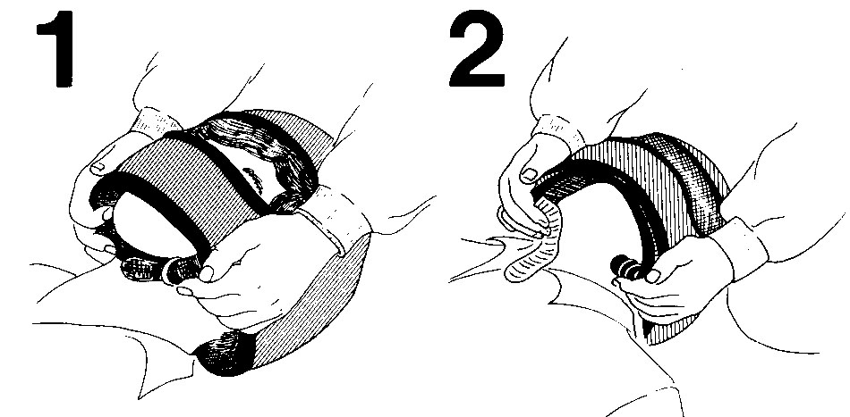
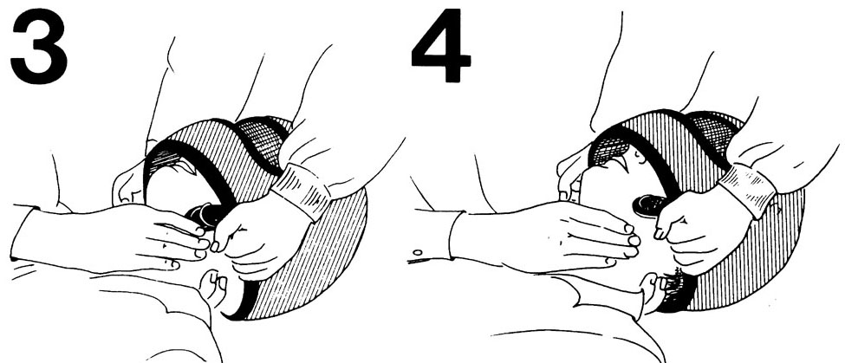
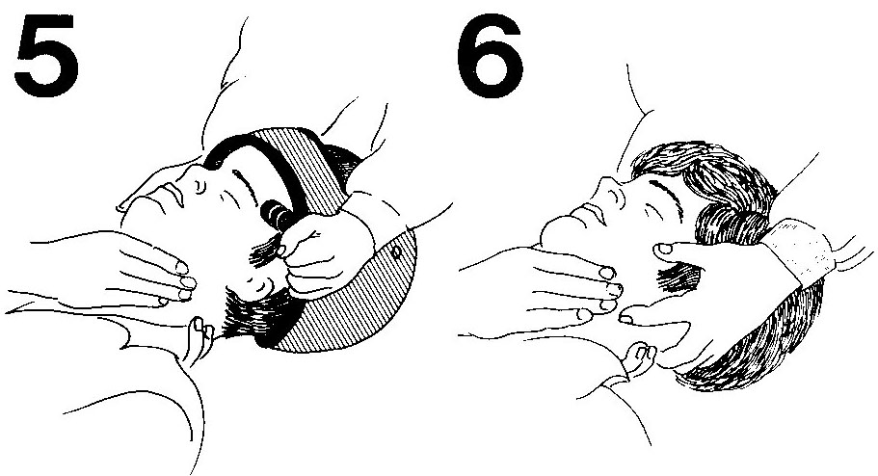
Incorrect helmet removal can do harm!

- One rescuer maintains axial traction (traction should not be applied, i.e. only minimal extension):
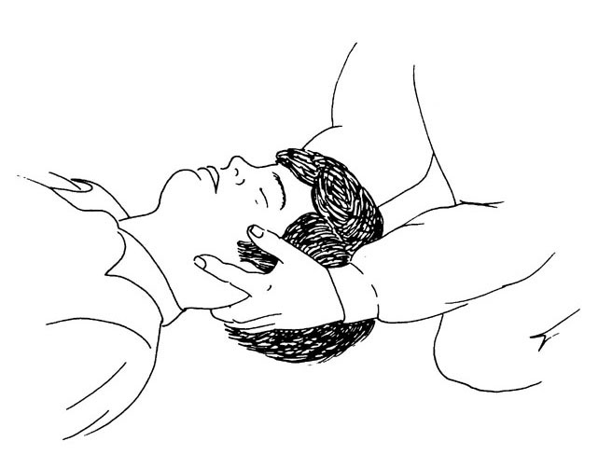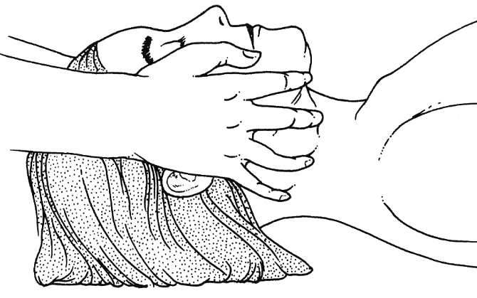

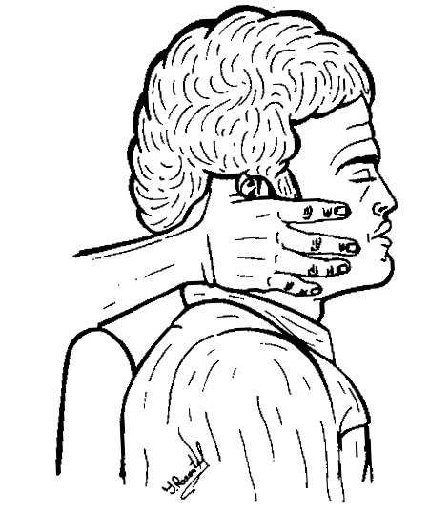

- Other rescuer places semirigid* cervical collar.
*difference from rigid collar – patient can open mouth
- properly placed collar must admit (between it and neck) two fingers.
- variety of effective spinal immobilization orthoses are commercially available (Hare extrication collar, Philadelphia collar, four-poster neck immobilizer, number of adjustable rigid plastic collars) - all appear to be effective, but none have been found to be more effective than traditional backboard with sandbags and tape.
- soft cervical collars (normally prescribed for outpatient therapy of minor cervical disorders) are inadequate for this purpose!

Philadelphia collar – commercially available splint; comes in two halves that are secured by Velcro straps; posterior shell may be flattened and slid under patient’s neck (while assistant applies inline stabilization) → anterior shell is placed over front neck and chin → secure Velcro straps:
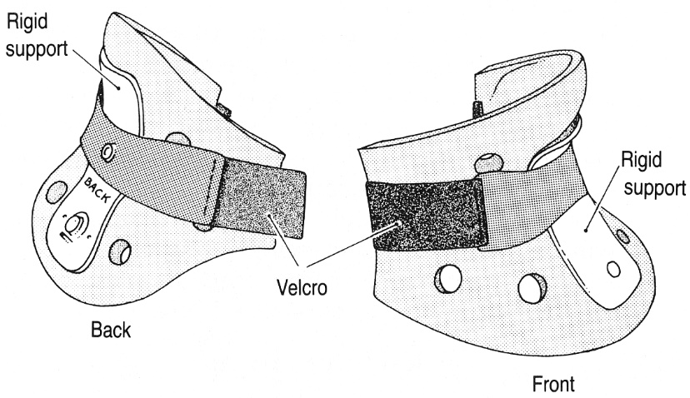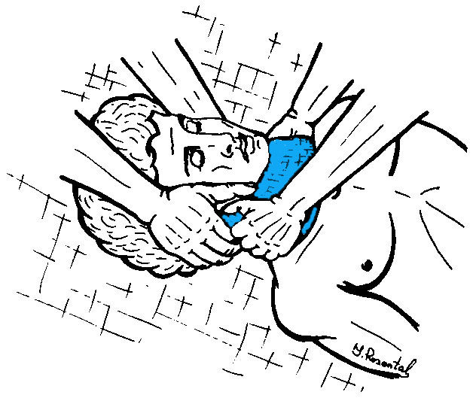
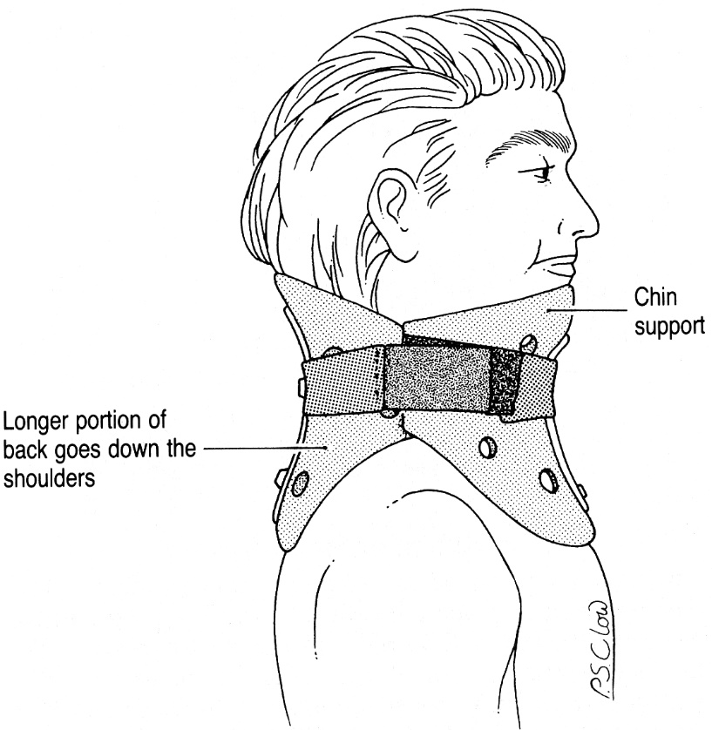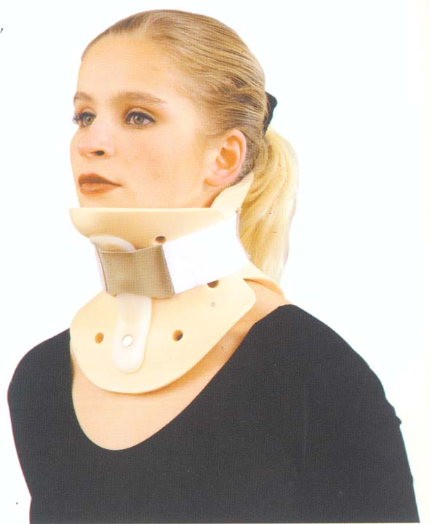

- Victim (maintaining inline immobilization*) is transferred on backboard (rigid & flat) and immobilized. *very minimal traction

Logrolling is only acceptable way to turn patient suspected of spinal injury.
  - body moves as whole - one segment does not precede or drag behind another.
  - requires minimum of three people: one at head (to maintain longitudinal stabilization), one at side (to turn trunk), and one at feet (to turn legs).
  - done in unison under control of one person at head, who directs operation.
  - indications - placement on spinal board, placement of x-ray film, examination of patient's back.
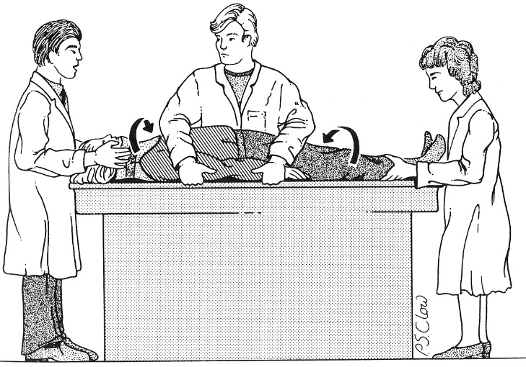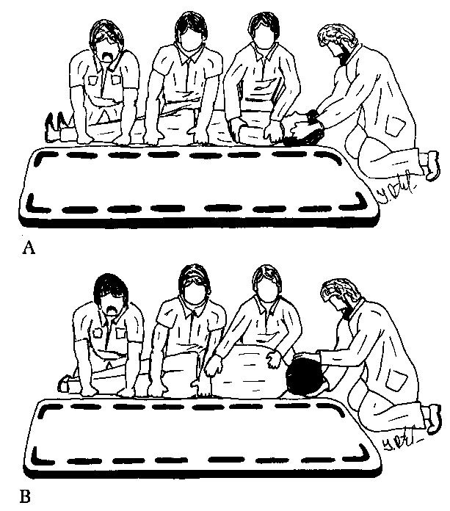

- when on board, head must be extra immobilized* - rolled blankets or sandbags (alternative - head taping to rigid backboard).
Cervical collar prevents flexion / extension, side supports prevent rotation!
*can be the only way to immobilize if collar is not available

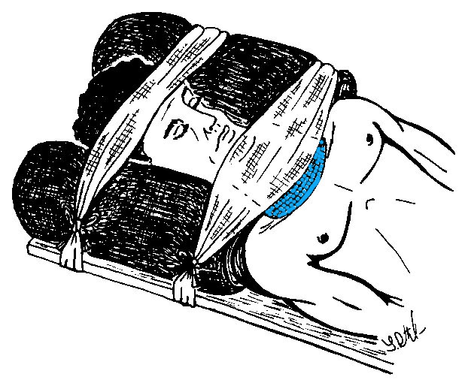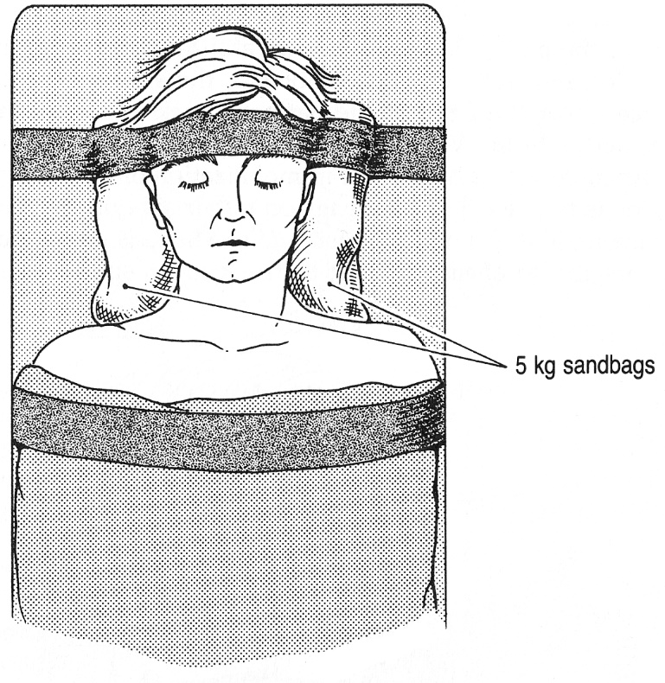

Cervical spine can be immobilized by either "short" or "long" spine board (“short” board is dangerous – no guarantee that patient has no additional spinal injuries below).
Thoracic-lumbar spine is best immobilized on long board with taping patient to backboard above and below major joints.
- rolls are placed under flexures (neck, lumbar, popliteal areas).
- to prevent undue neck flexion, spine board for children ≤ 3 yr must have indentation for occiput.

Spinal immobilization using short board:
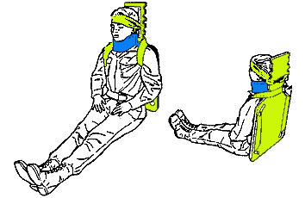

Spinal immobilization using long board:
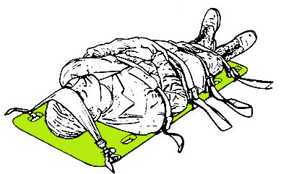

- in general, neck should be placed in neutral position. However, if patient is awake and chooses to hold neck in unusual position, it should not be forced (some patients with cervical spine fractures have been made quadriplegic by ill-advised attempts to straighten neck) - immobilize patient in position in which he is found. Do not attempt to straighten out his back!  - in thoracolumbar dislocations with gibbus deformity and neurologic compromise, patient is placed in lateral decubitus position with knees flexed - this maximizes residual diameter of narrowed spinal canal (vs. supine position narrows spinal canal)  Do not use stable lateral NATO position: | 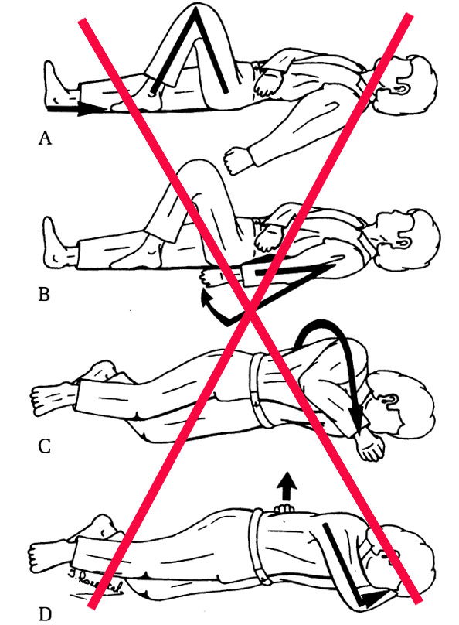
  - adequate suctioning device should be immediately available once patient has been immobilized to prevent possible aspiration of blood or vomitus.
  - Foley catheter, nasogastric tube*, large-bore intravenous lines are always indicated in acute spine-injured patient
*can rupture retropharyngeal hematoma (also gagging – stress on neck).

Transportation
  - it is desirable to tilt backboard onto left side, leaning slightly forward (to prevent aspiration):
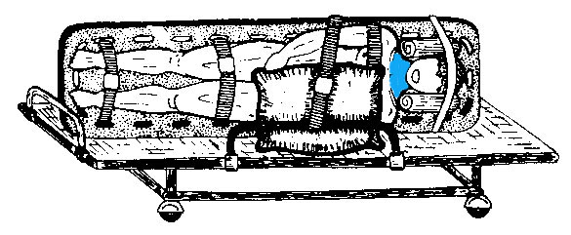
  - transportation must be rapid (10% patients suffer progressive cord / root damage between time of injury and beginning of appropriate treatment in hospital).
  - insensate patients left on hard backboards rapidly develop decubiti!!!
Once in hospital, remove patient from board as soon as practical! (prolonged use is even counterproductive - uncomfortable patients may start moving on board)

Diagnosis & Strategies for Immobilization
Specific categories of patients whose diagnoses are likely to be delayed:
- patients with head injuries (level of consciousness↓)
- patients with multiple injuries (competing pain distracts attention)
- intoxicated patients (level of consciousness↓)
N.B. for these patients maintain spinal immobilization until unstable injury has been ruled out both by radiologic and clinical examination!
  - other significant fractures (such as pelvic fractures, multiple rib fractures, scapular fractures) should heighten index of suspicion for vertebral fractures.
calcaneous injuries - 10% chance of associated lumbar vertebral injury.
  - if one fracture is found, other levels should be carefully checked for additional injury (10-15% incidence of multiple fractures).
  - fracture absence does not ensure spinal column stability!
small bony avulsion or slight malalignment of vertebrae may be only suggestion of gross ligamentous instability!
  - differentiating new fractures from old may be difficult (H: CT, radionuclide bone scan, STIR MRI).

Most of fractures missed on radiographs are: spinous process fractures, transverse processes fractures, fractures in large patients.

Differential diagnosis of vertebral fractures:
- Horizontal residual venous sinus grooves.
- In young children, anterior corners of vertebral body may have small depression (represent epiphyseal margin).
- Ossification centers at ends of transverse processes (may appear as fractures).
- Spina bifida occulta.
- T₁₂ body slightly wedged anteriorly (physiologic wedging).
- Asymmetry of pedicles of lower thoracic spine (7% persons).
- Congenital butterfly vertebral body (appears as compression fracture in lateral projection).

SCI without radiographic abnormalities (SCIWORA)
Causes:
- marked cervical spondylosis and spinal stenosis.
- spontaneously corrected dislocation.
- children < 8 yrs - flexible spinal columns (greater ligamentous laxity - vertebral elements reduce spontaneously).
Diagnostic work-up: MRI; if negative → flexion-extension XR, radiographic screening of entire spinal column.
Treatment: external immobilization of spinal segment of injury for up to 12 weeks (discontinue earlier if becomes asymptomatic and flexion-extension XR is negative).
  - avoid “high-risk” activities for up to 6 months following SCIWORA.

Cervical Spine
Instability must be determined early!!!
There is no imaging gold standard for cervical spinal instability, or for ligamentous injury!!!

When to suspect cervical spine injury
Spinal column and spinal cord injuries are more prevalent in blunt cervical trauma than in penetrating.
- impaired consciousness (incl. even mild alcohol intoxication) and suspected craniofacial trauma
- significant head or facial trauma
- suggestive mechanism of injury* associated with other painful injuries (difficult accurate clinical assessment)
*diving trauma, fall from height, motor vehicle accident, lightning trauma
Patients with osteoporosis, arthritis, metastatic disease can develop spinal injuries as result of even very minor trauma (slips, falls, low-velocity motor vehicle crashes)
- trauma signs above clavicles - NATO rule.
- all trauma cases (and unable to exclude injury) – main rule!
- suggestive clinical features:
  - neck deformation / pain / tenderness / paravertebral muscle spasm
  - unexplained hypotension (esp. with bradycardia, warm dry red skin)
  - focal neurologic deficit (sensory and motor deficits in extremities)
  - diaphragmatic breathing
  - priapism
  - specific extremity position:
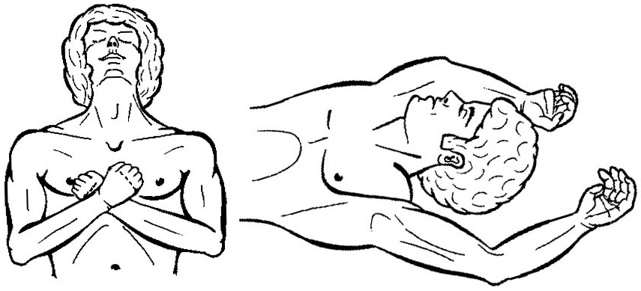
Numerous reports of occult* cervical spine injuries + litigious environment in which medicine is practiced today → widespread practice of obtaining neck CT of all victims of MVC, falls, and sports-related injuries regardless of symptomatology!
*questionable - numerous studies have failed to reveal spine injury, regardless of mechanism of injury, in any alert patient who did not complain of neck pain and who did not have another painful injury

Awake asymptomatic ADULT patients
"Clearing" c-spine without imaging (i.e. low-risk patients – remove C-collar):
Official guidelines (Level 1) – all must be present:
- awake
- asymptomatic (no neck pain or tenderness, normal neurological examination)
- no injury detracting from an accurate evaluation
- able to complete a functional range of motion examination.
N.B. irrespective of the mechanism of potential injury!
Canadian C-Spine Rules (CCR):
    - any high-risk clinical factor (age > 65 years, dangerous mechanism, paresthesias in the extremities) → imaging.
    - any low-risk clinical factor (simple rear-end motor vehicle collision, sitting position in ED, ambulatory at any time after accident, delayed onset of neck pain, absence of midline cervical spine tenderness) → assess for neck range of motion:
    - unable to axially rotate head 45° in either direction → imaging.
    - able to axially rotate head > 45° in both directions - do not require imaging
National Emergency X-Radiography Utilization Group (NEXUS) criteria:
    - no posterior midline cervical spine tenderness.
    - no intoxication.
    - normal level of alertness.
    - no focal neurologic deficit.
    - no painful distracting injury.
CCR is more sensitive than NEXUS (100% vs. 90-99%).

Awake asymptomatic PEDIATRIC patients
"Clearing" c-spine without imaging (i.e. low-risk patients – remove C-collar):
Official guidelines (Level 2) – all must be present:
    - alert (GCS > 13)
    - asymptomatic (no neck pain or midline tenderness, normal neurological examination)
    - no painful distracting injury
    - no unexplained hypotension
    - not intoxicated.
For kids < 3 years add:
    - not motor vehicle collision (MVC)
    - not fall from > 10 feet
    - not non-accidental trauma

Awake patient + neck pain or tenderness
→ CT (3-view* XR only if CT unavailable):
* AP, lateral, and open-mouth odontoid
(open-mouth is not recommended for kids < 9 yo)
Normal imaging:
    - Continue cervical immobilization until asymptomatic
    - Discontinue cervical immobilization following normal and adequate dynamic flexion/extension radiographs
    - Discontinue cervical immobilization following normal MRI obtained within 48 hours of injury
    - Discontinue cervical immobilization at discretion of treating physician

Several studies favor MRI (Level II) over dynamic radiographs (Level III), but may not be feasible or indicated in all situations.

If C-spine injury detected – continue immobilization and image whole spine (10% patients have noncontiguous spine injury)
  - cooperative patient should be cautioned against attempted movement until radiographic studies have been performed.
  - combative patient may require individual assigned to hold patient's head in alignment with longitudinal axis of body; sedation (± paralysis and intubation) may be required for patients who pose danger to themselves because of excessive movement.

Obtunded / unevaluable patient
(cannot be assessed clinically) → cervical spine CT – if reported as normal:

- Continue cervical immobilization until asymptomatic.
- Discontinue cervical immobilization following normal MRI obtained within 48 hours of injury
- Discontinue immobilization at discretion of treating physician.
David M. Panczykowski et al “Comparative effectiveness of using computed tomography alone to exclude cervical spine injuries in obtunded or intubated patients: meta-analysis of 14,327 patients with blunt trauma”
Modern CT alone is sufficient to detect unstable cervical spine injuries in trauma patients. Adjuvant imaging is unnecessary when CT scan is negative for acute injury. Cervical collar may be removed from obtunded or intubated trauma patients if modern CT scan is negative for acute injury.
Negative CT scan misses 1 unstable injury in every 4776 patients not able to be cleared by clinical examination - in typical Level I trauma center in the US, this translates into 1 patient every 14 years!

  - class III medical evidence suggests that dynamic imaging is of marginal benefit and is not recommended at this time.

Diagnostic Modalities
X-ray
For X-ray evaluation principles → see p. D70 >>
Signs of instability → also see p. D70 >>

  - X-ray can miss some fractures (H: CT or MRI; dynamic radiographic views are also diagnostic but contraindicated in immediate setting).

Cervical Spine
    - cross-table supine lateral view* (positive in 85-90% cervical spine injuries) – initial radiologic approach (also performed as part of head CT); may be inadequate as sole view!
- shoulders are depressed actively or passively by pulling patient's hands toward feet using slow steady traction over 1-2 minute period (rather than sudden jerk).
- head is stabilized but not actively distracted (can be disastrous in severe C1-C2 ligamentous injury).
    - AP view*
    - open-mouth (odontoid) view*
*all three views (three-view trauma series) should be obtained before C-spine immobilization is discontinued
    - swimmer’s (transaxillary) view – if above views do not visualize C7-T1 interspace:
  - large, muscular, obese patients.
  - paralysis of shoulder depressing muscles (caused by lesions that are, unfortunately, located in lower cervical region) - unopposed trapezius muscles elevate shoulders.
N.B. if shoulder girdle injury prohibits swimmer’s view → CT.
    - supine oblique-neuroforaminal view – optimal view in confirming subluxations, posterior laminar fractures, unilateral facet dislocations!
    - flexion & extension lateral films - confirming stability vs. subluxations before clearing C-collar in alert patients with persistent neck pain and no signs of instability in other views
Hazardous! – perform only in awake cooperative patient* if above views are negative but ligamentous injury is possibility (MRI is safer!!!):
*if subluxation happens, pain will stop patient from moving, therefore, study may be false negative because of severe muscle spasm prevents enough amplitude – wait 2 weeks and repeat study:
        - if spine is stable, neck pain subsided and patient will show full amplitude
        - if spine is unstable, pain is worse at 2 weeks
differentiate from pseudosubluxation → see p. D70 >>
  - these views will identify > 99% unstable cervical injuries.

Thoracic Spine
- lateral view
- AP view (ribs and transverse processes).
  - lateral flexion & extension studies (standing if possible) - to look for gross instability.
  - fractures of upper thoracic vertebrae → posterior mediastinal hemorrhage → ill-defined mediastinal widening (differentiate from traumatic aorta rupture - CTA or angiography).

CT
- extremely helpful for bone definition + also shows soft tissue changes + permits examination without moving patient from supine position.
Indications:
        - vertebral injuries (fractures, subluxations) on X-ray
        - normal vertebral X-ray, but clinical suspicion remains (e.g. persistent neck pain or neurologic deficit – but MRI is better)
        - difficult to evaluate vertebral X-ray
N.B. unclear fractures / displacements on standard radiographs should be further evaluated by CT.
          - thoracic fractures → CT with contrast (to exclude intrathoracic injuries – pulmonary, vascular).

  - axial CT may fail to depict subtle horizontally oriented injuries, minimal vertebral body compression fractures; H: frontal and sagittal reformation, with very thin sections for primary images.

CTA
Indications - blunt cervical trauma + modified Denver Screening Criteria:
- Fractures involving C1-6 transverse foramina
- C1-3 subluxations
- Facet dislocations
  - MRI is recommended instead of CTA after blunt cervical trauma in patients with complete SCI or vertebral subluxations.

MRI
- direct visualization of cord injury! (MRI findings correlate with neurologic status; virtually all patients who have had serious SCI with permanent sequelae demonstrate abnormalities on MRI).
  - indicated when neurologic deficits are present (esp. if level of deficits does not coincide with skeletal abnormalities).
  - acute fractures - vertebral marrow edema (not seen in chronic compression fractures!).
  - prognostic value:
mild or transient loss of function usually is not accompanied by any signal changes.
cord hemorrhage (type 1 contusion) – poorer prognosis.
cord edema (type 2 contusion) – frequent significant neurologic improvement (but edema extending for > 1 spinal segment predicts poor prognosis).
N.B. the length of cord edema is the only independent predictor of recovery in SCI in multivariate analysis.
  - MRI is incompatible with life-support, monitoring systems, and cervical traction devices (H: MRI-compatible support systems).
  - when MRI is not available, CT myelography is best alternative.

CT myelography
  - best performed by lateral C₁₋₂ puncture (using fluoroscopy with patient supine).
  - often all that is found is complete block near level of injury.
  - cord compression may be shown (but is infrequent).
  - delayed postmyelography CT should demonstrate most cavities in spinal cord.
N.B. abnormal contrast accumulation in cord may be due to myelomalacia (i.e. not cavity).

Bone Scans
  - with Tc^{99m}-hydroxydimethylpyrimidine.
  - may detect occult / minor fractures (area of increased uptake) – scans become positive only > 12-24 hours after injury (or even as long as 72 hours after injury).
  - In¹¹¹–tagged WBCs are more specific in detection of abscess / osteomyelitis.

Somatosensory evoked potentials
  - helpful in distinguishing complete or incomplete lesions (results are less sensitive or specific than MRI, but test can be repeated often).

Importance of completely visualizing all seven cervical vertebrae:
Lateral view (C7 not visualized) Tomography - subluxation of C7 on T1 (arrow):
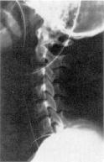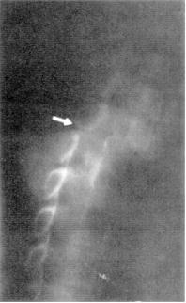

Importance of completely visualizing all seven cervical vertebrae:
A. Inadequate cross-table lateral cervical spine radiograph (C7 not visualized).
B. Repeat lateral film demonstrates burst fracture of C7:
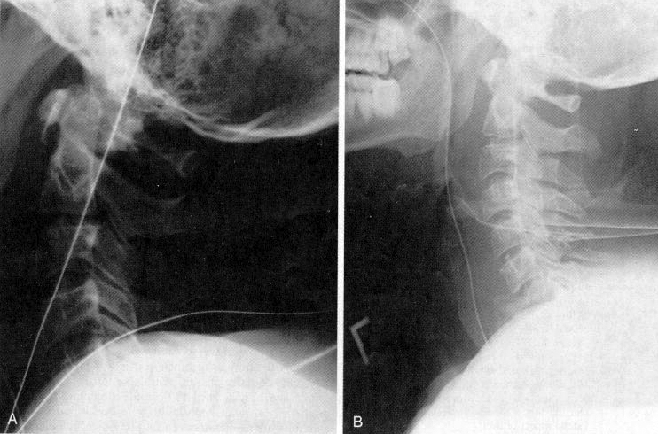

Contusion of spinal cord due to hyperextension injury at C5-6 (sagittal T2-MRI) - swelling and mixed high and low signal in spinal cord from C3 to C7; high signal in ruptured C5–6 intervertebral disc and prevertebral soft-tissue swelling:
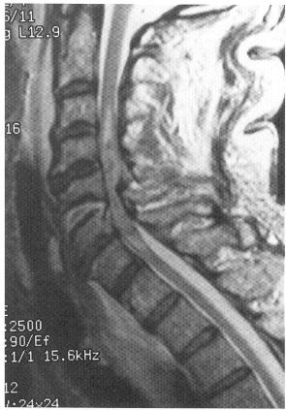

L1 burst fracture and conus contusion (T2-MRI) - wedging and retropulsion of L1 vertebral body fracture; conus is displaced and contains focus of uniformly increased signal that is several centimeters long (i.e. type 2 cord contusion):
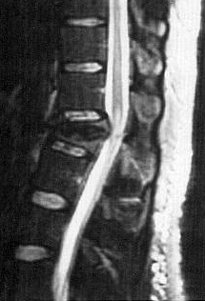

Complications
General Spinal Complications → see p. Spin1 >>
  - 30% SCI patients require hospital admission every year for complications.
  - depression (following initial period of denial) occurs in almost all patients and may be masked by jocularity.

Progressive neurologic dysfunction in previously neurologically stable patient:
- undiagnosed disk or bone* impingement on spinal cord
- myelomalacia
- developing posttraumatic syrinx
- subarachnoid cystic changes, post-traumatic pseudomeningoceles
*e.g. post-traumatic deformity (such as angular kyphosis)
- all are potentially operable conditions (with exception of myelomalacia).

Posttraumatic syrinx (s. traumatic syringomyelia)
- residual intramedullary cysts (e.g. after hematomyelia resorption) become distended → progressive neurologic disorder (after several months ÷ years of neurologic stability).
  - neurologic progression is invariably rostral to original injury - post-traumatic ascending myelopathy (occurs most frequently in cervical region).
  - myelographic appearance similar to other forms of syringomyelia.

Posttraumatic myelomalacia:
A. Sagittal T1-MRI - mottled low signal at C4-C5 level. B. Sagittal T2-MRI - high signal at same level.
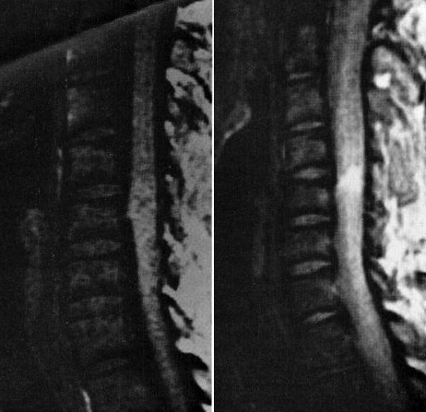

Treatment
  - primary goal is to limit secondary injury!
  - critical factor is time from injury to therapy (complete axonal disruption from secondary phenomena precludes recovery).

Treatment encompasses 6 phases:
- Emergency treatment with ABC, appropriate immobilization, transfer to specialized center.
- Treatment of general medical problems (e.g. hypotension, poikilothermy, ileus, urinary retention).
- Spinal alignment.
- Surgical cord decompression (if indicated) – must be done ASAP if neurodeficits are progressing.
- Spinal stabilization – more elective approach.
- Rehabilitation.

Spinal Cord Perfusion Pressure
SCPP = MAP minus ITP
ITP (intrathecal pressure) is measured via lumbar drain (some experts use it routinely).
SCPP > 60-65 mmHg → significant functional recoveries in ASIA C (or worse) SCI

Neuroprotection
Studied drugs in SCI: GM-1 ganglioside (Sygen), riluzole, minocycline, methylprednisolone, tirilizad mesylate, naloxone, nimodipine, perfluorocarbons, ProCord (activated macrophage cell therapy), BA-210/VX-210/Cethrin (Rho inhibitor - delivered topically during decompression surgery), recombinant human erythropoietin, granulocyte colony-stimulating factor.

CNS Evidence-Based Guidelines for Thoracolumbar Spine Trauma (2019)
N.B. task force selected 167 articles. Of these, all studies were rejected for not meeting inclusion criteria or for being off topic. No studies were selected for systematic review.
Insufficient evidence to make a recommendation for specific pharmacologic agent to improve clinical outcomes in TL fractures + SCI.
- the complication profile should be carefully considered when deciding on the administration of methylprednisolone.

Steroids
2013 guidelines of Congress of Neurological Surgeons (CNS) and American Association of Neurological Surgeons (AANS) recommend against use of steroids early after acute cervical spinal cord injury
  - reduce lipid peroxidation & inflammatory response → improvement in function (but likelihood of clinically significant functional improvement is low).
  - some studies show only improvement by one sensory level.
  - steroids are not FDA approved for SCI.
There is no Class I or II evidence supporting clinical benefit of steroids in treatment of acute SCI.*
Class I, II, and III evidence exists that high-dose steroids are associated with harmful side effects** including death.
*scattered reports of Class III evidence claim inconsistent effects likely related to random chance or selection bias.
**1.5 times higher incidences of GI hemorrhage and pneumonia, 2 times higher incidence of wound infection, 3 times higher incidence of pulmonary embolus in MP-treated patients compared to controls; most compelling is Class I evidence from > 10 000 patients with TBI, indicating that high-dose MP leads to significantly higher mortality independent of injury severity.

Steroids maybe indicated when regaining 1-2 levels makes a big difference (esp. in young healthy patient):
    - cervical SCI – improve mobility, avoid vent dependency.
    - autonomic dysreflexia - risk with SCI at Th6 and above.

NASCIS (National Acute Spinal Cord Injury Study) I-III studies - the largest study investigating the effects of the methylprednisolone in acute SCI.
Outcome evaluated at six weeks, six months or one year.

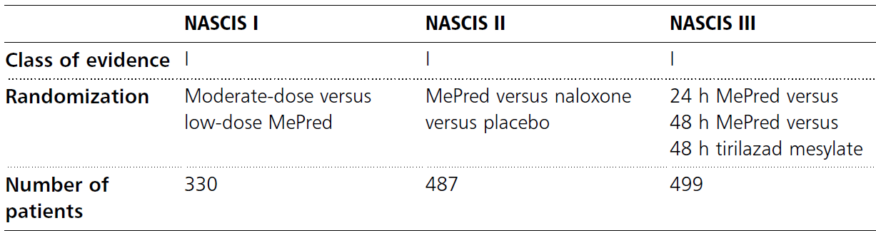

NASCIS I
◆ There was no difference between moderate-dose and low-dose MePred.
◆ There was a trend towards better outcome for moderate-dose MePred if given within 8 h.
◆ There were significantly more complications in the moderate-dose group, including a 3-times higher rate of wound infection.

NASCIS II
◆ Patients who received MePred within 8 h of injury had a statistically significant improvement in motor and sensory function at 6 months after injury, especially those with more severe injury, however, the sensory gains were lost at the 1-year endpoint.
◆ Again, there was also a trend toward higher rates of complications in the MePred group.
◆ There was no effect of naloxone.

NASCIS III
◆ No statistically significant benefit was seen for continuing MePred treatment for 48 h (beyond 24 hrs).
◆ No statistically significant benefit was seen for ultra-early (< 3 hrs) administration of MePred.
◆ Post hoc review noted that patients receiving MePred bolus 3 to 8 hours after injury had short-term neurologic improvement when given MePred for 48 hours, but these gains were lost at 1 year.
◆ Patients undergoing 48-hour MePred infusion also had substantially higher infectious complications and a higher death rate than the 24-hour group.

NASCIS Conclusions
MePred improves outcome of acute SCI if given within 8 h of injury.

NASCIS Critique
The positive results of the NASCIS trials pertain only to post-hoc subgroup analyses. For example, NASCIS II only showed a benefit with MePred for the subgroup of patients who received it within 8 h of injury. It is imperative, therefore, to re-emphasize that the conclusions from this subgroup analysis cannot be extended to all patients within the trial.
The large range of the neurological scores used has meant that it is questionable whether small improvements are clinically relevant (Spencer and Bazarian, 2003).

Steroids for acute spinal cord injury (COCHRANE Review)
Background
Animal experimentation with pharmacologic therapy for acute SCI started in the late 1960s (Ducker 1969), became more common in the 1970s and led, in the USA, to the first National Acute Spinal Cord Injury Study (NASCIS 1) started in 1979 and completed in 1984 (Bracken 1984/85). As far as can be ascertained, this was the first randomized trial of any therapeutic modality for all aspects of spinal cord injury. The second National Acute Spinal Cord Injury Study followed (Bracken 1990/93). A multicenter trial from Japan (Otani 1994) and a single center trial from France (Petitjean 1998) both evaluated one of the treatment arms of NASCIS 2 which represents the first replication of a trial in this area. The third NASCIS trial has been reported (Bracken 1997/98).
Main results
There are few trials in this area. One steroid has been extensively studied, methylprednisolone sodium succinate, which has been shown to improve neurologic outcome up to one year post-injury if administered within eight hours of injury and in a dose regimen of: bolus 30mg/kg over 15 minutes, with maintenance infusion of 5.4 mg/kg per hour infused for 23 hours. The initial North American trial results were replicated in a Japanese trial but not in the one from France. Data was obtained from the latter studies to permit appropriate meta-analysis of all three trials. This indicated significant recovery in motor function after methylprednisolone therapy, when administration commenced within eight hours of injury. A more recent trial indicates that, if methylprednisolone therapy is given for an additional 24 hours (a total of 48 hours), additional improvement in motor neurologic function and functional status are observed. This is particularly observed if treatment cannot be started until between three to eight hours after injury. The same methylprednisolone therapy has been found effective in whiplash injuries. A modified regimen was found to improve recovery after surgery for lumbar disc disease.
Authors’ conclusions
High-dose methylprednisolone steroid therapy is the only pharmacologic therapy shown to have efficacy in a phase 3 randomized trial when administered within eight hours of injury. One trial indicates additional benefit by extending the maintenance dose from 24 to 48 hours, if start of treatment must be delayed to between three and eight hours after injury. There is an urgent need for more randomized trials of pharmacologic therapy for acute spinal cord injury (e.g. drug cocktails, sequential therapies).

Historical standard of care for neurologic deficits (complete or incomplete SCI) after blunt trauma* - Bracken protocol - high doses of methylprednisolone ASAP (no later than 8 hours; preferably start in field):
30 mg/kg IV bolus (over 15 min) → after 45 min, start IVI 5.4 mg/kg/h over 23 h.
Alternative - dexamethasone 10-100 mg IV → 6-10 mg IV q6h.
*i.e. penetrating trauma cases are excluded
Treatment duration:
- if steroid is started within 3 hours of injury, continue it for 24 hours.
- if steroid is initiated 3-8 hours after injury, continue it for 48 hours.
N.B. steroids beyond 24-48 hours are deleterious (late inflammation is necessary for healing processes!)

Adverse effects:
  - gastric bleeding (GI prophylaxis is necessary!!!)
  - wound infection.

Contraindications:
- > 8 hours after SCI (steroids worsen outcome!)
- gunshot SCI
- drug abusers

GM-1 ganglioside (Sygen)
- not recommended!
  - found in cell membranes of mammalian CNS tissue
  - thought to have antiexcitotoxic activity, promote neuritic sprouting, potentiate effects of nerve growth factor, and prevent apoptosis.
  - although patients with ASIA grade C and D SCI treated with Sygen demonstrate statistically significant improvement in modified Benzel grade compared to placebo-treated patients at 4 and 8 weeks after injury, advantage is lost at subsequent follow up visits - no difference between actively treated and placebo-treated patients was noted in any of outcome measures at 1 year.

Naloxone, thyrotropin release hormone, tirilazad
- modest results

Minocycline

Riluzole

Hypothermia
  - attempts at local cooling in human SCI patients began in the 1970s. When using an epidural cooling system during the time of surgical decompression for cervical or thoracic ASIA A patients, 65 percent improved at least one ASIA grade. Of 14 patients in the cervical cohort, 5 patients converted to ASIA B, 3 to ASIA C, and 1 to ASIA D. Of 6 patients in the thoracic cohort, 1 converted to ASIA B, 2 to ASIA C, and 1 to ASIA D.
Hansebout RR, Hansebout CR. Local cooling for traumatic spinal cord injury: outcomes in 20 patients and review of the literature. Journal of Neurosurgery. Spine. 2014;20(5):550-561.
  - systemic modest hypothermia, defined as cooling to 32–34°C via a central venous catheter, has recently been the focus of several clinical studies in SCI: in 35 neurologically complete, cervical ASIA Impairment Scale (AIS) A, adult patients who received 48 hours of cooling starting at mean 5.8 hours after injury, 43 percent improved at least one AIS grade by last follow-up. 23 percent regained some motor function and 11 percent improved to AIS D or better.
Dididze M, Green BA, Dietrich WD, Vanni S, Wang MY, Levi AD. Systemic hypothermia in acute cervical spinal cord injury: a case-controlled study. Spinal cord. 2013;51(5):395-400

Cardiovascular care
Neurogenic shock = hypotension + bradycardia
  - systemic hypotension may exacerbate spinal cord injury (secondary insult).
Goal MAP 85-90 mmHg for 7 days
(class III evidence)
Hawryluk G. et al. Mean Arterial Blood Pressure Correlates with Neurological Recovery after Human Spinal Cord Injury: Analysis of High Frequency Physiologic Data. JOURNAL OF NEUROTRAUMA 32:1958–1967 (December 15, 2015)
Higher average MAP values correlated with improved recovery in the ﬁrst 2–3 days after SCI while the proportion of MAP values below the accepted threshold of 85 mm Hg seemed a stronger correlate, decreasing in strength over the ﬁrst 5–7 days after injury.

          - may not be useful in penetrating spinal cord injuries, plus, causes cardiogenic complications due to vasopressors.
Readdy, William J et al. Failure of Mean Arterial Pressure Goals to Improve Outcomes Following Penetrating Spinal Cord Injury. Neurosurgery: Post Copyedit: May 03, 2016

Alternative SBP goal > 90 mmHg

  - admission to ICU for 7 days is, thus, necessary for close hemodynamic monitoring (e.g. Swan-Ganz catheter) – patients frequently develop cardiovascular instability often despite initial stable cardiac function.
  - rule out hemorrhagic causes.
  - for neurogenic shock → fluids IVI (avoid hypervolemia!; if crystalloids do not restore BP, administer colloids!) + vasopressor-inotrope (agent of choice – dopamine* < norepinephrine; oral: droxidopa, midodrine
*too many c/v complications, esp. for > 55 yo (thus, norepinephrine is preferred)
N.B. problem is hypovolemia + cardiac suppression - fluid resuscitation alone may result in pulmonary edema! H: cardiac support
Avoid α-agonist phenylephrine – exacerbates (reflexly) bradycardia!
Spinal cardiac center is at T1-4; lesions:
- below T6 – OK to use phenylephrine
- above T6 – need inotrope
  - for severe bradycardia - titrate atropine IV or temporary pacing.
  - optimal blood viscosity (to increase cord perfusion) is achieved with hematocrit 33-37%.

CNS Evidence-Based Guidelines for Thoracolumbar Spine Trauma (2019)
- insufficient evidence to recommend for or against the use of active maintenance of arterial blood pressure after thoracolumbar SCI.
- Consensus Statement by the Workgroup: in light of published data from pooled (cervical and thoracolumbar) SCI populations, clinicians may choose to maintain MAP > 85 mmHg in an attempt to improve neurological outcomes.

Respiratory care
- direct relationship exists between level of cord injury and degree of respiratory dysfunction:
- high lesions (ie, C1 or C2), vital capacity is only 5-10% of normal, and cough is absent
- lesions at C3-6, vital capacity is 20% of normal, and cough is weak and ineffective
- high thoracic cord injuries (T2-4), vital capacity is 30-50% of normal, and cough is weak
- lower cord injuries, respiratory function improves
- injuries at T11, respiratory dysfunction is minimal; vital capacity is essentially normal, and cough is strong
N.B. respiratory failure may worsen due to ascending cord edema!

1/3 of patients with cervical spine injuries will require intubation (most in the first 24 h) - decreasing vital capacity and increasing respiratory rate or PCO₂ are all indications for possible emergent or urgent intubation.

Thromboembolia
  - antiembolic measures must be started within 72 hours (preferred – enoxaparin SC)

Thoracolumbar SCI
CNS Evidence-Based Guidelines for Thoracolumbar Spine Trauma (2019)
Insufficient evidence to recommend for or against routine screening for deep venous thrombosis in preventing PE (or venous thromboembolism-associated morbidity and mortality).
Consensus Statement by the Workgroup: based on pooled data (cervical and thoracolumbar) SCI populations, the use of DVT prophylaxis is recommended.
- several studies suggest the highest incidence of VTE events occurs among patients with thoracic segment SCI.
- studies suggest that early initiation of prophylaxis and continuation for a period of approximately 3 mo postinjury (or until transferred to wheelchair) are effective strategies for the prevention of VTE.
- several studies suggest the combination (chemical + mechanical prophylaxis) is better than either alone.
Insufficient evidence to recommend a specific regimen of DVT prophylaxis to prevent PE (or venous thromboembolism-associated morbidity and mortality).
Insufficient evidence to recommend a specific treatment regimen for documented venous thromboembolism that would provide fewer complications than other treatments.

Cervical SCI
Guidelines for the Management of Cervical Spine and Spinal Cord Injuries offers more specific guidance:
Level I recommendation - use prophylaxis in patients with motor deficit caused by SCI.
Level I recommendation - prophylaxis strategies:
- low dose heparin—in combination with pneumatic compression stockings or electrical stimulation
- LMWH, rotating beds, or a combination of modalities.
N.B. low-dose heparin alone or oral anticoagulation is not recommended (level II).
Early initiation (within 72 h) and a 3-month duration for prophylaxis are recommended (level II). The selective use of inferior vena cava filters is recommended for patients who either fail anticoagulation or are not candidates for pharmacologic or other mechanical modalities (level III).

General Measures
- see p. Spin1 >>
  - warm to maintain core temperature of at least 96°F.
  - intermittent bladder catheterization (to prevent permanent bladder atony) → bladder re-training, anterior sacral stimulation, urine acidification, etc.
  - adequate early nutrition!
- nasogastric tube for first 24-48 hours (longer if ileus persists), stress ulcer prophylaxis → bowel re-training.
- early enteral nutrition (initiated within 72 hours) is safe, but has not been shown to affect neurological outcome, length of stay or incidence of complications in acute SCI.
- indirect calorimetry is the best means to determine caloric needs of SCI patients.
  - skin care (pressure sores can develop in < 1 hour in SCI patients!) – use RotoRest bed
  - priapism is not usually treated.

Surgery
decompression → realignment → stabilization
Surgical therapy is limited to:
- restoration of spinal canal anatomy
- removal of foreign bodies
- removal of any bone / disc / hematoma that may be compressing cord.

  - surgical management includes decompression of the injured spinal cord and fixation and fusion of the spine with prevention of secondary injury, but surgery does not directly address the initial insult.

Spinal canal Decompression
Complete SCI - fixed and permanent (little hope for major recovery of distal function - decompressive surgery is unlikely to be of benefit*):
cervical spine - change of single motor level has enormous impact on functional outcome (ventilatory function and upper extremity function) - ensure that level of injury does not ascend (if ascends from edema spread - anticipate impending respiratory failure).
thoracic / lumbar spine - precise level is of less importance.
*problem, only rarely sure that SCI is complete in hyperacute stage – operate early even complete SCI, especially is ongoing cord compression! Plus, subacute stabilization surgery may be performed to expedite rehabilitation

Incomplete SCI (most improve with time) → sequential neurologic examinations:
- stable or improving → monitor further.
- deteriorating → emergency* surgical intervention (spinal cord decompression → stabilization).
N.B. laminectomy to explore sites of cord injury may exaggerate structural instability!
*there are no studies supporting the benefit of early surgery!

Timing of surgical intervention
  - incomplete SCI (esp. with neurological deterioration) in association with ongoing spinal cord compression (from bone / disc fragments, hematoma, or unreduced subluxation) – most common emergency surgery indication! In incomplete SCI, rapid intervention (decompression + stabilization) is most appropriate (therefore, some advocate emergency surgery at night).
  - complete SCI - decompressive surgery has little merit, but early spinal stabilization prevents complications of long-term immobilization and allows for more effective rehabilitation; if complete SCI has perceived possibility for recovering some neurological function and there is ongoing cord compression → operate emergently.
N.B. in cauda equina syndrome, surgical decompression is recommended even with complete deficits - potential for recovery of peripheral nerves is great!

VCT should be fixed as early as practical, once patient is physiologically stable and no longer at risk to suffer neurologic deterioration (as result of cord manipulation)

Aim for decompression within 24 hours (as soon as hemodynamically stable)

Surgical Timing in Acute Spinal Cord Injury Study (STASCIS) - early versus delayed (cutoff 24 hours) decompression for traumatic cervical spinal cord injury
Early versus delayed decompression for traumatic cervical spinal cord injury: results of the Surgical Timing in Acute Spinal Cord Injury Study (STASCIS). Fehlings MG et al. PLoS One. 2012;7(2):e32037
- prospective cohort study of 313 patients with cervical traumatic SCI comparing early and late decompressive surgery using a 24-hour cutoff.
- the study was non-randomized and the patient selection decision in early versus late group was decided by the surgeon based on clinical factors.
- the mean time to surgery in the early and late groups was 14.2 and 48.3 hours, respectively.
- patients demonstrated a 19.8% vs. 8.8% improvement of 2 AIS grades in the early and late groups, corresponding to 2.8 times higher odds in the early group.
- critique: early versus late surgery groups were not comparable - in the early surgery group there were 57.7% of patients with AIS A and B injury versus 38.2% in the late surgery group (p <0.01). This can produce a ceiling effect in the degree of improvement patients with AIS C and D type injuries can achieve.

N.B. convincing preclinical evidence that early decompression in the setting of spinal cord injury (SCI) improves neurological outcomes; however, the effect of early surgical decompression remains uncertain.

Early (< 72 hr) vs. late (> 5 d) surgery for cervical SCI – randomized trial; no difference!
Vaccaro AR , Daugherty RJ , Sheehan J , Sheehan TP , Dante SJ , Cotle JM , Balsderston , RA , Herbison GJ , Northup BE . Neurologic outcome of early versus later surgery for cervical cord injury. S pine 1997; 22 : 2609 – 2613

  - the biggest disadvantage of early surgery – hypotension during anesthesia induction (esp. elderly) and secondary cord insult – important to communicate with anesthesia team BP goals!
  - in animal studies, early decompression makes difference in outcome only if done within 6 hours postinjury.
  - chances of adequate decompression in cervical injuries:
ACDF – only 6%
corpectomy – 75%
360 – 100%

CNS Evidence-Based Guidelines for Thoracolumbar Spine Trauma (2019)
Insufficient and conflicting evidence regarding the effect of timing of surgical intervention on neurological outcomes.
Grade B Recommendation - “early” surgery (< 8-72 h after injury) is an option to reduce length of stay and complications.
  - some studies report higher mortality in early surgery group.

Expansile Duraplasty
- concept borrowed from decompressive craniectomy in TBI
- word of caution (Dr. J. Harrop) – cord (cf. brain) cannot easily expand and needs myelotomy.

Penetrating Wounds
  - if missiles have passed through body cavities prior to penetration of spinal canal, body cavities are explored before considering spinal injury.
- if missiles have passed through large bowel → spinal injury is débrided.
- surgery can be delayed / omitted when missiles have traversed only soft tissues, stomach, or small bowel.
  - penetrating spine wounds are usually stabile.
  - injury exploration is accomplished by laminectomy.
  - if missile has destroyed vertebral body → débride body and implant graft or prosthesis:
in neck – through anterior approach;
in chest – through thoracotomy;
in lumbar area – through flank dissection.

Definitive Spine Reduction & Stabilization
  - goals of stabilization surgery – to prevent:
    - neurological injury
    - deformations
    - pain
  - stable injuries are treated with rest, analgesics, and muscle-relaxing drugs.
- for elderly patients, early mobilization is important.
- NSAIDs are discouraged (may reduce radiographic healing).
  - fractures heal by ≈ 2-3 months; full stabilization may take up to 2 years.
- after initial period of healing of 12-24 weeks, moderate flexion-extension movements are safe (instability and subluxation indicate primary failure of fusion surgery).
- persistent neck pain indicates nonhealing with instability.

Cervical VCT
Malalignment is present (dislocated facets, listhesis) → closed reduction by skeletal traction ASAP see p. TrS9 >>

If closed reduction fails → surgical open reduction & stabilization
  - if choosing posterior approach, MRI is necessary to exclude herniated disk (that would require anterior approach).

tongs application
Gardner-Wells tongs:
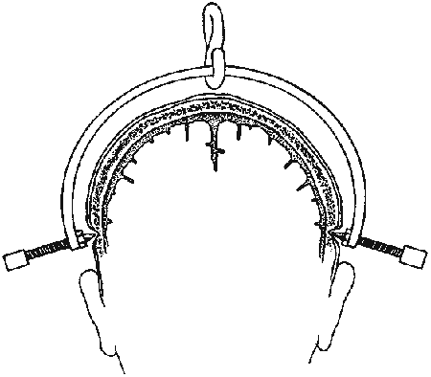

  - shave (if time permits) and prep areas above both ears.
  - local anesthesia, directly through skin (without skin incision); inject also under pericranium!
  - patient's head is stabilized by assistant.
- Gardner-Wells tongs are applied symmetrically just above ears - in vertical line of tragus, 1 fingerbreadth (or 1 cm) above ear lobe, below temporal ridges (areas into which tongs are placed should be below maximal transparietal skull diameter);
- pins that are placed too ventral will be in thinner bone and may cause a painful hematoma in temporalis muscle
- placement too cephalad → risk of tongs sliding off top of scalp.
- placement anterior to external auditory meatus → traction causes spine extension (may be desirable when treating odontoid dislocations).
- placement posterior to external auditory meatus → traction causes spine flexion (may be desirable when trying to "unlock" facets).
  - position tongs with sterile points just touching skin.
  - while assistant holds tongs in place, tighten both screws simultaneously until outer end of point just protrudes beyond flush end screw - indicates that sufficient tension has been applied.
  - attach traction to loop at top of tongs.
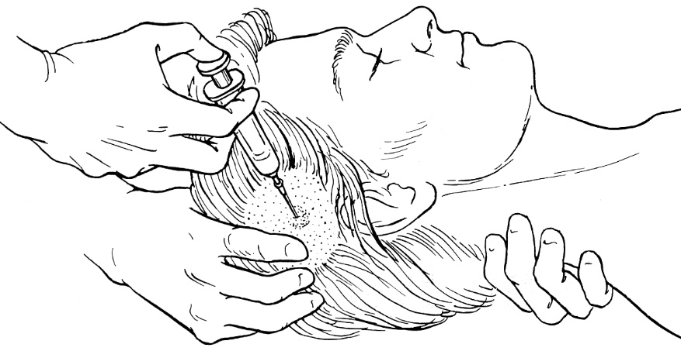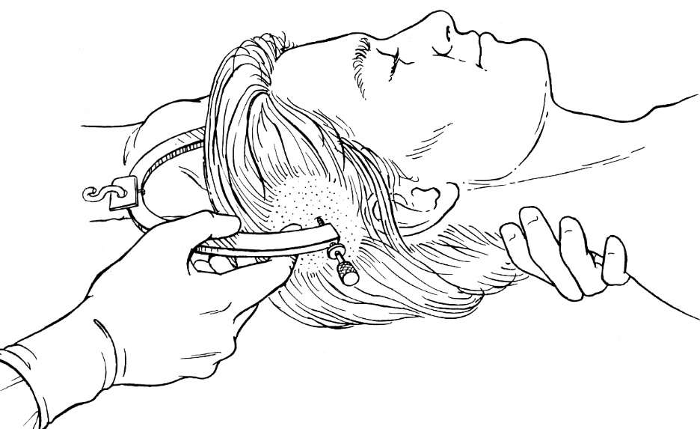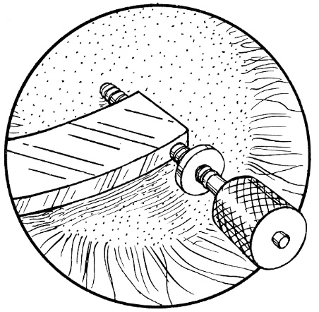

halo application
  - system consist of:
- halo ring/crown
- pins
- plastic vest
- uprights
  - uprights may be adjusted for proper alignment of halo.
  - halo ring is applied:
- for traction
- for stabilization (after period of initial traction with tongs).
  - four sites for pin placement are located:
≈ 1 cm above lateral* segments of eyebrows
*to avoid supraorbital nerves
posterior parietal skull (that ring will be 1 cm above pinnae of ears).
  - patient is lying supine on thin narrow board that holds head.
  - patient keeps eyes closed (if keeps open – may be unable to close due to eyebrow skin pinned to skull)
  - sterilized pins are applied to skull through anesthetized scalp with torque screwdriver; tighten to ≈ 8-10 lb and lock in place with hexagonal nuts.
  - connecting bars are employed in such manner as to hold head in neutral position → control X-ray.
  - pins should be tightened second time in 24 h.
N.B. if pins become loose days* after application – likely due to infection – do not re-tighten as pins may go intracranially!
*vs. within 24 hours – safe to retighten!
  - local pin care - hydrogen peroxide 3 times daily.

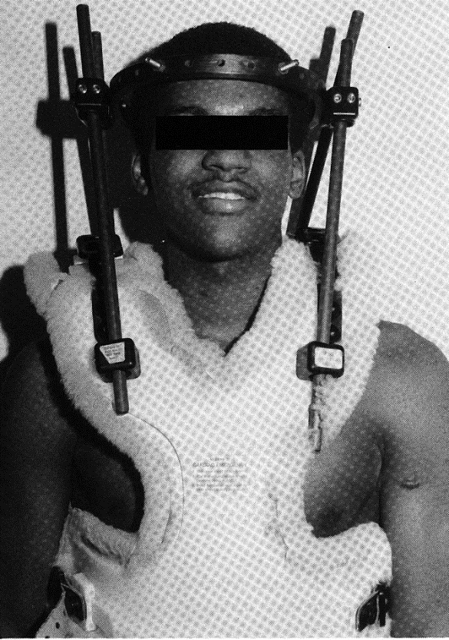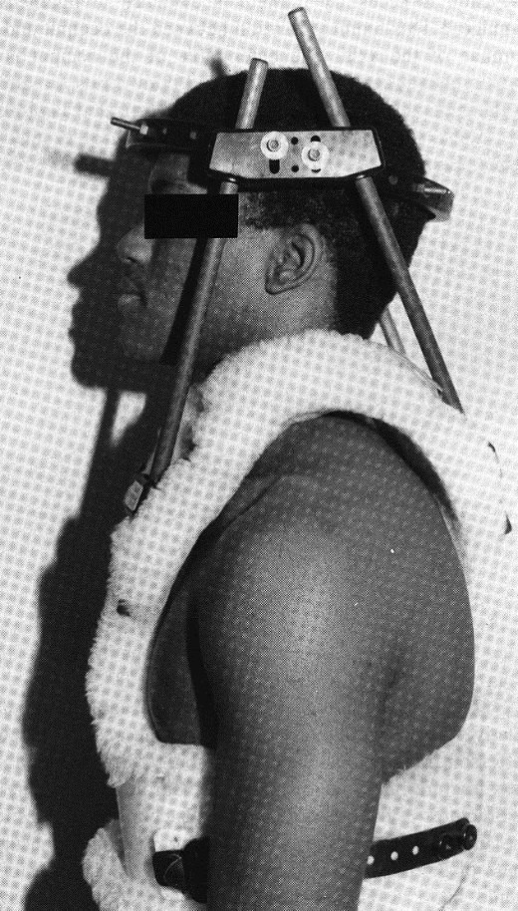

External cervical immobilization devices
- halo vest – preferred in situations of considerable instability:
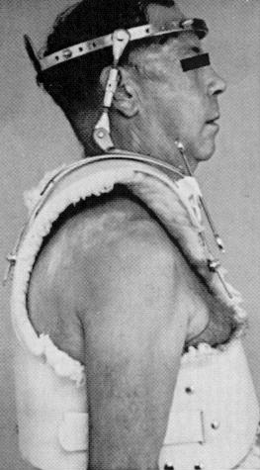

- four-poster (occipital-mandibular) brace: uprights, chin piece, and occiput pad limit flexion and extension; addition of head band restricts rotation at C₁₋₂; earlobe must be opposite shoulder tip:
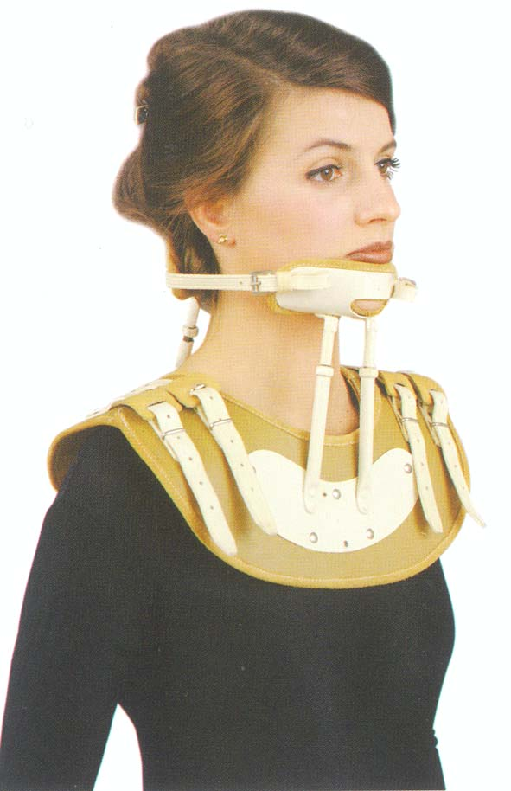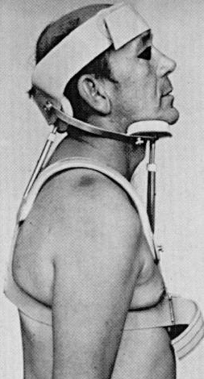

- Lerman Minerva CTO brace:
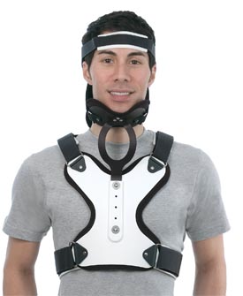

Thoracolumbar VCT
  - patient is kept supine or lateral decubitus on rotating bed until further decision is made.
  - realignment (and reduction maintenance) cannot be accomplished with external traction!

- Stable injuries (or instability in only one column) can be managed with immobilization only – thoracic-lumbar-sacral orthosis (TLSO):
  - orthotic 3-point vest or brace - only partially effective (thoracolumbar junction is especially difficult to immobilize) - primarily serves as reminder to patient to minimize movement.
  - body cast (modified polypropylene jacket) - more effective immobilization; very uncomfortable.
- observe for development of deformity (somewhat unstable fractures may develop progressive deformity despite use of orthotic brace) before allowing ambulation / PT with brace – upright X-rays with patient in brace – check for increasing vertebral body collapse / angulation.

- Unstable injuries → surgical stabilization:
Approach is guided by fracture anatomy and location of spinal canal encroachment.
Posterior approach - does not permit access to vertebral bodies (useful when decompression of spinal canal is not major consideration)
  - fixation of posterior bony elements (with Harrington rods, Cotrel-Dubousset instrumentation or Weiss springs) permits early stabilization → early mobilization.
  - patient in prone position.
Posterolateral (transpedicular) approach - improved access to vertebral bodies (decompression of ventral impingement of canal is still very technically difficult – such reduction may be achieved by placing patient in extended position on Jackson table).
  - may be combined with posterior stabilization procedure.
  - often used for high thoracic fractures (T₁₋₄).
  - patient in prone or modified lateral decubitus position.
Anterior approach - allows access to vertebral bodies at multiple levels - useful for decompression!!!
  - transthoracic exposure is required to access vertebral bodies down to L₂; lower fractures require transabdominal-retroperitoneal exposure.
  - vertebral bodies are often resected and replaced with bone graft (autologous or from bone bank) – N.B. this does not result in early stability (vs. posterior stabilization).
  - patient in supine position.

Decompression
  - historically, simplest approach for decompression has been to "unroof" spinal canal, i.e. laminectomy - relieves pressure on posterior elements, and allows spinal cord to move away from elements anterior to it.
  - laminectomy may not decompress spinal cord compromised by anterior mass (H: check with US, do ligamentotaxy) and laminectomy may have devastating effects on structural integrity of spinal column when anterior and/or middle columns are compromised (H: fusion).

Types of stabilization procedures:
    - posterior interspinous fusion (fixateur interne?) - least-invasive method - use of pedicle screws to obtain stability and promote fusion of 2 segments
    - posterior rods (Harrington, Cotrel-Dubousset rodding systems) - require extensive exposure; effective in stabilizing multiple or unstable fractures; rods are attached with pedicle screws, stainless steel wires, clips, clamps, hooks; rods prevent further deformity and deterioration of 5-7 segments!
    - cage
    - Z-plate anterior thoracolumbar plating (form of anterior arthrodesis) - used for burst fractures.
- three-column injuries often require both anterior and posterior stabilization (360°)
- monitoring during course of spine instrumentation is appropriate:
      - fluoroscopy – monitors anatomical changes.
      - somatosensory evoked potentials or Stagnara “wake-up" test* monitor neural function.
*awaken patient after each step in instrumentation and asking to move those parts that are potentially affected by instrumentation
- implanted instruments are left in place indefinitely → bony elements are often eroded.
N.B. permanent fixation can be assured only if bony fusion is obtained (aligned laminae should routinely be decorticated, and cancellous bone, with or without finely divided cortical bone, is implanted over decorticated laminae or vertebral bodies).
- external orthosis* is applied at time of recovery from anesthesia → ambulation is started in immediate postoperative period (if neurological status permits; if severe paresis - physical therapy is begun immediately); orthosis is worn for ≈ 3 months (12 weeks).
*unnecessary in cases of segmental fixation with Luque rods or pedicle screws and plates

CNS Evidence-Based Guidelines for Thoracolumbar Spine Trauma (2019)
Choice of surgical approach (anterior, posterior, or combined anterior-posterior):
Grade B Recommendation - selection of approach does not appear to impact clinical or neurological outcomes.
Conflicting evidence to recommend surgical approach for radiological outcomes or complications.
Burst Fractures (patients with no neurologic injury and no need for direct decompression)
Grade A Recommendation - the addition of arthrodesis to instrumented stabilization has not been shown to impact clinical or radiological outcomes, and adds to increased blood loss and operative time.
Grade A Recommendation - both open and percutaneous pedicle screws give equivalent clinical outcomes.

  - though regional motion was preserved in the nonfusion group, the nonfusion group also underwent additional surgery more often to remove the spinal implants due to screw loosening.

Prognosis
- see p. Spin1 >>
  - 40% patients with SCI die within 24 hours of accident.
  - 94% patients with SCI survive initial hospitalization (vs. 80% mortality for World War I soldiers).
  - yearly follow-up is necessary.
  - improvements in the medical management of SCI now provide the opportunity for a near-normal life span (historically, life expectancy with SCI was shortened by 15-20 years).

Prediction of recovery according to AIS impairment scale:
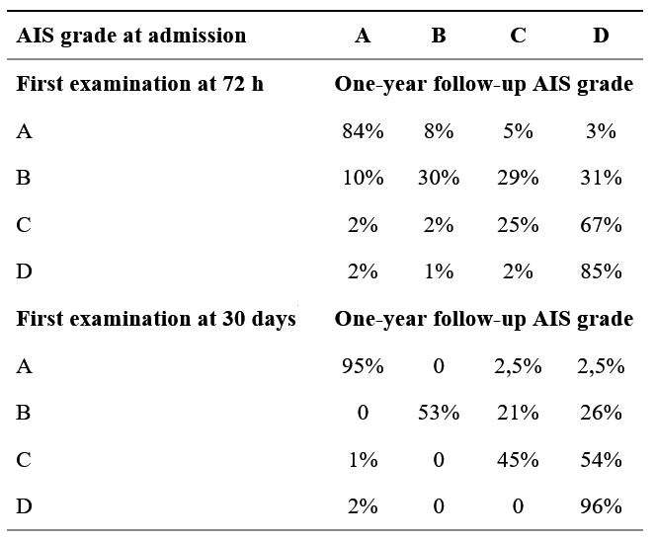
Giorgio Scivoletto et al. Who is going to walk? A review of the factors influencing walking recovery after spinal cord injury. Front Hum Neurosci. 2014; 8: 141.

Prediction of functional walking according to AIS impairment and other features:
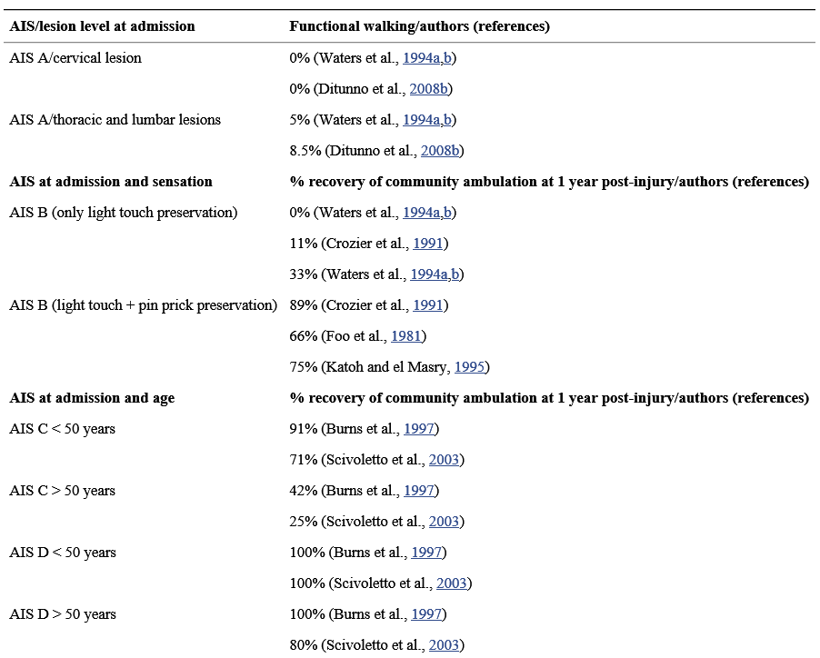
Giorgio Scivoletto et al. Who is going to walk? A review of the factors influencing walking recovery after spinal cord injury. Front Hum Neurosci. 2014; 8: 141.

Rehabilitation
- see p. Spin1 >>

Restorative cell transplantations - see above >>

Associated Injuries
N.B. 75% spinal patients have some other systemic injury; 10-15% have associated head injury.
All multitraumatized patients or any patient with severe head injury have vertebral injury or SCI until proven otherwise!
N.B. cervical trauma is much more strongly associated with brain injury than with facial injury!

  - vertebral fractures are caused by significant forces - associated injuries of almost any organ must be suspected!
  - during acute stage of SCI, both GI tract and bladder become atonic; abdominal examination is unreliable - be quick to obtain abdominal CT / ultrasound / peritoneal lavage.
  - brain, thoracic, abdominal injuries take precedence over spinal injuries.

Pediatric Aspects
Biomechanics of pediatric spine are fundamentally different from that of adult:
- ligamentous laxity; if spine is fractured – it indicates significant force!
- wedge-shaped vertebrae
- horizontally-oriented facets
- predental space up to 5 mm, wider prevertebral soft tissue space
- pseudoluxation of C₂ on C₃ (as well as of C₃ on C₄)
- immature neck muscles and proportionally large head - cervical spine acts like fulcrum (fulcrum starts in upper cervical levels and changes progressively to lower levels as pediatric cervical spine matures, until it reaches adult level at C₅₋₆ - most injuries occur at C₁₋₃ level in children < 8 yrs).

Differences of pediatric injuries from adult injuries:
- Disproportionate involvement of upper cervical spine:
 | Adult | Pediatric
C₁₋₃ | 1-2% | 60-87%
C₄₋₇ | 85% | 30%-40%
Thoracolumbar | 10-15% | 5%
- High frequency of SCIWORA - spinal cord injury without radiographic abnormality (up to 50% pediatric SCI cases) - related to direct spinal cord traction, spinal cord concussion, vascular injury; H: MRI.
- High susceptibility to delayed onset of neurological deficits.
- Higher proportion of complete SCI (potentially poor prognosis).
- More frequent subluxations (vs. fracture-dislocations) due to horizontally-oriented cervical facets.

Neonatal SCI
Soft and lax neonatal spine is susceptible to:
- hyperextension trauma - hyperextension of fetal neck in utero ("flying fetus")
- traction injury during breech delivery
- cord can be transected while soft and pliable spine remains intact.
- distraction injuries following breech deliveries are most common in lower cervical ÷ upper thoracic regions.
N.B. more commonly brachial plexus is stretched during breech delivery.
  - with appropriate care, most infants survive for many years; usual causes of death - recurring pneumonia and progressive loss of renal function.

Bibliography for ch. “Spinal Trauma” → follow this link >>

Viktor’s Notes℠ for the Neurosurgery Resident
Please visit website at www.NeurosurgeryResident.net

