HIV infection – NEUROLOGIC aspects
Last updated: April 12, 2020
Pathogenesis 1
Classification 2
Diagnostic Evaluation 3
Focal CNS lesions 4
Aseptic Meningitis 5
HIV-related Encephalopathies 5
AIDS-dementia complex (ADC) 6
HIV-associated progressive encephalopathy (HPE) 9
CMV ventriculoencephalitis 9
CNS–Immune Reconstitution Inflammatory Syndrome (IRIS) in the setting of HIV infection 10
HIV-related Myelopathies 12
Vacuolar myelopathy 12
Necrotizing CMV myelitis 13
HIV-related Neuropathies 13
Acute inflammatory demyelinating polyneuropathy 14
Chronic inflammatory demyelinating polyneuropathy 14
Mononeuritis multiplex 14
Distal sensory polyneuropathy 15
Progressive polyradiculopathy 16
HIV-related Myopathies 16
HIV wasting syndrome with type II muscle fiber atrophy 16
Cerebrovascular disorders 17

- neuroinvasion occurs in practically every patient (CSF cells↑ & protein↑; intrathecal virus & antibodies are detected in majority of asymptomatic patients).
- 30-70% HIV-infected persons develop symptomatic neurologic disease.
- in 10-20% cases, CNS involvement is first clinical manifestation of HIV.
- at autopsy, neuropathologic abnormalities are found in 80-90% patients dying with AIDS.
- neurologic involvement is more frequent in children and progresses more rapidly (than in adults).
- high frequency of neurologic disorders in HIV infection has led to designation:
HIV - neurotropic virus

Drugs that can penetrate BBB: nevirapine, abacavir, zidovudine, efavirenz, indinavir, lamivudine, stavudine

Pathogenesis
HIV enters CNS at time of primary infection:
  - intracellular transport across BBB within infected macrophages (“Trojan horse”).
  - free virus seeding leptomeninges, or free virus after replication within choroid plexus
  - transcytosis across vascular endothelium.

Pathogenesis:
- direct HIV infection of glial cells
N.B. in nervous system, virus is detected only in microglial cells; virus is not found in neurons or glial cells, even though these cells have CD4 receptors! – nervous dysfunction is not due to cytolytic effect on neurons!
Various hypotheses of neuron dysfunction – soluble factors (cytokines, excitatory neurotoxins) released by infected immune cells, macrophages, or glia; binding of gp120 (or other viral proteins) to neurons → alterations in ion channel conductance (e.g. Ca²⁺) → disturbed neurotransmitter levels.
- immune-mediated injury (e.g. inflammatory demyelinating peripheral neuropathies)
- opportunistic infections
- neoplasms: primary CNS lymphoma (most common), metastatic non-Hodgkin’s lymphomas, metastatic Kaposi’s sarcoma (very rarely).
- vascular complications (sepsis related encephalopathies; stroke due to coagulopathies, nonbacterial thrombotic endocarditis).
- side effects of treatment (e.g. peripheral neuropathy)

Clinical syndromes - neurological disease at any anatomic level:
- cognitive dysfunction → dementia → coma.
- seizures (focal or generalized) - occur at any stage of HIV infection.
- various focal deficits
- aseptic meningitis
most common acute bacterial meningitis - L. monocytogenes
- myelopathy
- peripheral neuropathies
- myopathy

Classification
According to cause
Primary disorders - direct result of HIV-1:
- meningitis
- encephalopathy and AIDS dementia complex
- vacuolar myelopathy
- peripheral neuropathy
- polymyositis

Secondary disorders - result from other identifiable causes:
  - Opportunistic infections:
- toxoplasma encephalitis
- cryptococcal, tbc meningitis
- CMV encephalitis / polyradiculopathy
- progressive multifocal leukoencephalopathy
  - Neoplasms:
- primary (usually primary CNS lymphoma)
- metastatic
  - Drug complications
  - Metabolic-nutritional disorders
  - Cerebrovascular complications

According to stage of HIV infection
Neurologic disorders occur at any stage from first infection and seroconversion to AIDS!
Syndromes during primary HIV infection (indistinguishable from by other viruses):
- disorders precede or accompany seroconversion.
- course is typically self-limited and often with full neurologic recovery.

- aseptic meningitis (most commonly)
- reversible acute encephalopathy
- leukoencephalitis
- seizures
- transverse myelitis
- cranial / peripheral neuropathy (Bell’s palsy, Guillain-Barré syndrome)
- polymyositis
- myoglobinuria

Neurologic complications in AIDS:
- AIDS-dementia complex
- vacuolar myelopathy
- chronic neuropathies
- opportunistic infections and neoplasms:

CD4 count: | > 500 | 200-500 | 100-200 | < 100
Toxoplasma encephalitis |  |  | X | X
Cryptococcal meningitis |  |  | X | X
Syphilitic meningitis | X | X | X | X
Tuberculous meningitis |  | X | X | X
Coccidioidal meningitis |  |  | X | X
CMV encephalitis / polyradiculopathy |  |  |  | X
Progressive multifocal leukoencephalopathy |  |  |  | X

Major neurologic complications of direct HIV infection (height of boxes is relative indicator of frequency of each type of disease):
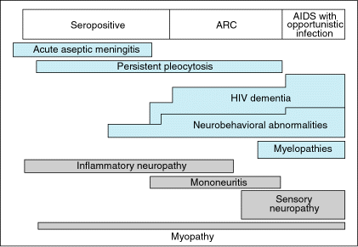

Diagnostic Evaluation
MRI is imaging technique of choice in suspected CNS disease; contrast enhancement (IV gadolinium):
- improves sensitivity, albeit by small amount.
- indicated when lesions are seen on T2-MRI.

CSF – protein↑, mild lymphocytic pleocytosis (up to 50);
- poor correlation with clinical pictures (CSF may be abnormal even in asymptomatic HIV patients!).
CSF analysis serves best to exclude / diagnose secondary cases (opportunistic infections, malignancies).

Focal CNS lesions
Imaging results:
  - Normal / atrophy / focal signal abnormalities but no mass lesion – consider meningitides, AIDS-dementia complex, PML.
  - Focal mass lesions with impending herniation → open biopsy with decompression.
  - Focal mass lesions without impending herniation → additional studies:
- toxoplasma serology:
- > 1 enhancing lesion or positive toxoplasma serology = presumptive diagnosis of toxoplasma encephalitis → start anti-toxoplasma therapy. see Inf5 p.
- 1 enhancing lesion and negative toxoplasma serology → brain biopsy.
- ²⁰¹T SPECT or ¹⁸FDG-PET + CSF PCR for EBV can provide strong evidence that mass lesion represents primary CNS lymphoma (hypermetabolic; vs. toxoplasmosis – hypometabolic).

N.B. rarity of toxoplasmosis in children may warrant brain biopsy without any preceding studies.

Focal parenchymal lesions
+mass +enhancement
- toxoplasmosis - most common cause of intracranial mass lesion in AIDS!!!
- primary CNS lymphoma
- tuberculosis
- Candida
- others (histoplasmosis, aspergillosis, coccidioidomycosis)
+mass −enhancement
Cryptococcomas
−mass +enhancement
- diffuse toxoplasmosis
- viral encephalitides (HSV, CMV)
- infarcts ± HZV arteritis
−mass −enhancement
  - PML (asymmetric lesions)
  - HIV encephalitis (symmetric lesions)

Toxoplasma encephalitis (reactivates within first 2 years after diagnosis of AIDS in ≈ 30% AIDS patients who have antibodies to T. gondii) – eiga greičiausia (over few days): focal + diffuse signs ± fever. see Inf5 p.

Primary CNS lymphoma (5-10% AIDS patients) – extranodal non-Hodgkin’s lymphoma: vyrauja diffuse signs; CT/MRI - one or two lesions (isodense or hypodense, with prominent contrast enhancement), located in deep white matter adjacent to ventricles; diagnostika – biopsy. see Onc36 p.
- EBV genetinė medžiaga aptinkama ≈ 100% atvejų (detection of EBV DNA by PCR in CSF is sensitive and specific for establishing diagnosis).
- primary CNS lymphoma esti smegenų parenchimoje (vs. metastatic systemic lymphoma esti in leptomeninges).

Progressive multifocal leukoencephalopathy (PML) (4-5% AIDS patients) – JC papovavirus reaktyvacija* oligodendrocituose (vs. HIV infekuoja mikrogliocitus) – eiga lėčiausia (over few weeks); although untreatable but may respond to antiretroviral therapy. see 257 (4) p.
*may be activated directly by HIV gene products

Coexistent toxoplasmosis and PML - T2-MRI before (A) and after (B) treatment with anti-toxoplasma therapy - two lesions were present; occipital mass resolved with anti-toxoplasma treatment, whereas left-hemisphere lesion (which showed no mass effect or enhancement) progressed (PML confirmed postmortem):
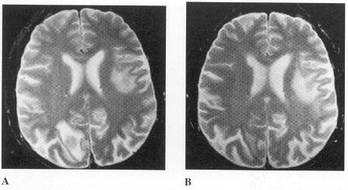

Aseptic Meningitis
- Primary (HIV) meningitis
- acute mild self-limited aseptic meningitis within 1-2 weeks of HIV seroconversion (up to 10% patients).
- clinical & diagnostic features ≈ aseptic meningitis with other viruses (CSF protein↑, normal glucose, lymphocytic pleocytosis, etc).
  - cranial neuropathies may be concomitant finding (most often CN5, 7, 8).
  - persisting CSF pleocytosis sometimes is found in otherwise asymptomatic HIV-positive individuals.
- treatment – supportive.

- Secondary meningitis
- dažniausias sukėlėjas Cryptococcus neoformans.
- other causes: other fungi, toxoplasma, syphilis, tbc, lymphoma.

HIV-related Encephalopathies
- encephalitides caused by direct (primary) HIV infection.

HIV encephalopathy - part of acute HIV syndrome during seroconversion.
HIV-associated progressive encephalopathy (HPE) - syndrome (cognitive, motor, and behavioral features) in children.
AIDS-dementia complex (ADC) - syndrome (cognitive, motor, and behavioral features) in adults.

AIDS-dementia complex (ADC)
- usually develops in advanced AIDS (CD4 counts < 200).
- with advent of HAART:
  - ADC incidence↓ (now ≈ 7% per year after AIDS diagnosis); less severe dysfunction has become more common than ADC - minor cognitive motor disorder (MCMD).
  - ADC prevalence↑ (now ≈ 10% HIV-infected patients; MCMD ≈ 30% HIV-infected patients) - patients with AIDS live longer.

Clinical Features
Focal neurological signs are suggestive of another CNS process
- subacute progressive cognitive dysfunction → global dementia → akinetic mutism, vegetative state → death.
- neuropsychological examination reveals subcortical dementia* (as in Parkinson disease); later dementia becomes global.
*i.e. “cortical” features (aphasia, apraxia, agnosia) are uncommon
- most pronounced neurocognitive deficits (esp. initially): forgetfulness (esp. retrieval of newly learned information), impaired concentration (e.g. difficulty in reading), impaired manipulation of known material, slowed psychomotor speed (e.g. decreased response to verbal and visual stimuli).
- skiriamasis bruožas nuo kitų encefalopatijų - relative preservation of alertness in relation to cognitive loss.
N.B. numerous other disease processes may present with similar neurocognitive picture (e.g. CNS tumors, opportunistic CNS infections, alcohol/drug abuse, depression, learning disabilities, head injury).
- motor dysfunction → paraplegia with urinary and fecal incontinence → decorticate posturing.
- difficulty with rapid, fine movements of eye and hands (clumsiness).
- frontal lobe release signs (e.g. snout response).
- lower extremity hyperreflexia, spastic weakness.
- gait unsteadiness (imbalance).
- tremors of upper extremities
- seizures are rare!!!
- behavioral dysfunction: insidious onset of reduced work productivity, decreased libido, apathy, social withdrawal, sleep disturbances → psychotic features.

MCMD - only mildly impaired activities of daily living; may progress to more severe dementia!

Diagnosis
Diagnosis requires exclusion of opportunistic infections & neoplasms.
Imaging (may be normal in MCMD!):
- diffuse cerebral atrophy with widened sulci and ex vacuo ventricular enlargement (typically in frontotemporal distribution), but normal cortical thickness.
- T2-MRI – poorly defined often symmetrical hyperintense regions (patchy → diffuse) in periventricular white matter and centrum semiovale;
- changes spread gradually slowly over time throughout white matter (rarely, may disappear with antiretroviral therapy).
- no enhancement, no mass effect.
- T1-MRI – little changes.
- CT – attenuation of white matter.
- basal ganglia calcifications (more common in children).

Early HIV encephalopathy (T2-MRI) - earliest white-matter changes are frequently seen as patchy or confluent high signal in peritrigonal white matter:  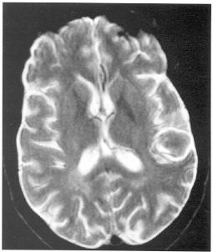 |  | Advanced HIV encephalopathy (T2-MRI) - generalized atrophy + diffuse confluent and symmetrical abnormal high signal of white matter of cerebral hemispheres (A) which is also extending into brain stem to involve cerebral peduncles (B):  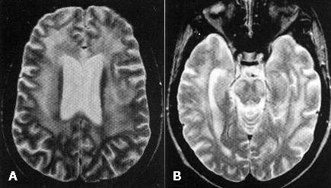
T2-MRI in HIV dementia - bilaterally symmetrical, confluent, hyperintense signal abnormalities in white matter; sulcal widening and central atrophy:  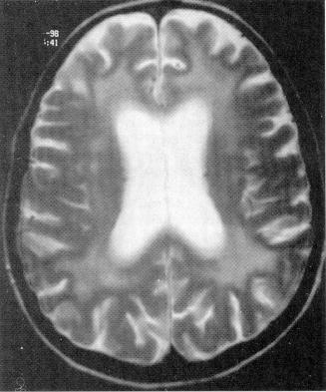 | T2-MRI - ventricular dilatation, cortical atrophy, and periventricular frontal lobe white matter hyperintensity:  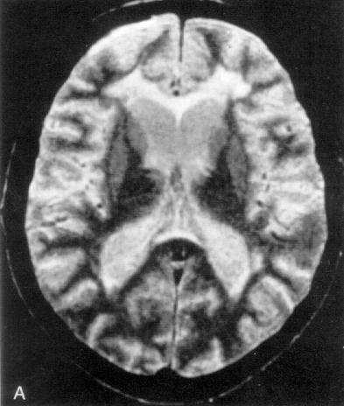 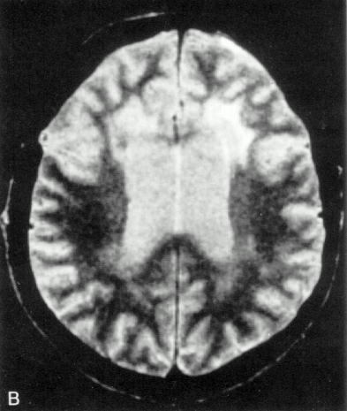

EEG – diffuse slowing in later stages of ADC.
CSF - protein↑ (60%), IgG↑ (intrathecal anti-HIV synthesis) (80%), markers↑ of immune activation (β₂-microglobulin, neopterin, quinolinic acid)
- usually acellular (mononuclear pleocytosis < 50 is found in 20-25% patients).
- HIV antibodies are present.
- PCR may be best correlate of ADC.
Neuropsychological testing – sensitive (but low specificity) diagnosis, management, and monitoring.
- may be normal in MCMD.
- progressive deterioration (on serial testing) in at least two areas, including frontal lobe functions, motor speed, and nonverbal memory.
Brain biopsy (not recommended) may confirm diagnosis – chronic encephalitis in subcortical white matter, diencephalon, brain stem:
- cortical neuronal loss (18-50%), subcortical neuronal loss (basal ganglia) in 25% - diffuse poliodystrophy.
N.B. relative sparing of cerebral cortex!
- reduced synaptic density and dendritic arborization.
- neurons and astrocytes appear to die by apoptosis.
- widely distributed perivascular infiltration by activated microglia (microglial nodules), macrophages, lymphocytes, and multinucleated giant cells (formed by fusion of these cell types) - these cells contain bulk of HIV antigen and genome and support productive infection in CNS!
  - predominance in basal ganglia and subcortical white matter; lesser degree cortical gray matter.
- diffuse myelin pallor (due to changes in BBB rather than to demyelination) - HIV leukoencephalopathy.
- vacuolation and necrosis (→intense reactive gliosis) may be observed.
- calcific vasculopathy - small vessel mineralization in basal ganglia, frontal white matter (children > adults).
N.B. often no correlation between pathologic severity and dementia severity!

HIV-1 encephalitis - microglial nodule and multinucleated giant cells:
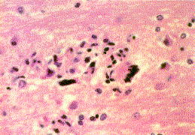

Giant cell encephalitis in AIDS - giant cells (arrows) in cerebral cortex are derived from macrophages (infected with HIV and express viral proteins on cell surface):
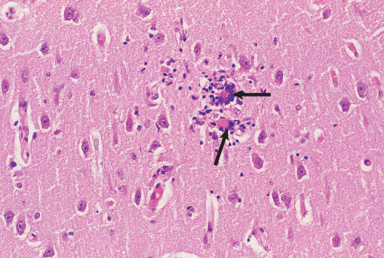

Treatment
- responds to antiretroviral therapy (HAART)!!!
- antiretrovirals with good CSF penetration are treatment of choice. see above
- mean survival time from onset of severe dementia rarely exceeds 6 months (complete clinical reversal is exceptional).

HIV-associated progressive encephalopathy (HPE)
- similar to adult counterpart ADC, but HPE may occur before immunologic dysfunction is severe.

Prevalence:
- untreated children ≈ 50%
- HAART treated children: 1.6% active HPE, 10% arrested HPE.
N.B. now HPE may be thought of as infrequent and reversible complication of HIV!

Diagnostiniai kriterijai vaikams (reikalingas bent vienas progresuojantis kriterijus, trunkantis ≥ 2 mėnesius; būtina sąlyga - nėra kitos būklės, išskyrus HIV infekciją, galinčios visa tai paaiškinti):
- Failure to attain or loss of developmental milestones or loss of intellectual ability - verified by standard developmental scale or neuropsychological tests.
- Impaired brain growth or acquired microcephaly - demonstrated by head circumference measurements ("crossing percentiles") or brain atrophy demonstrated by CT / MRI (serial imaging is required for children < 2 yr).
- Acquired symmetric motor deficit manifested by minimum two of following:
- paresis
- pathologic reflexes
- ataxia
- gait disturbance.

  - age of onset is usually in first year of life (3 to 8 months of age).
  - clinical course is variable.
  - children develop characteristic masklike facial appearance - appear alert and wide eyed but have paucity of spontaneous facial expression.
  - in end stages, child is apathetic, withdrawn, quadriparetic with markedly impaired higher cortical function.

Diagnosis
Neuroimaging - cerebral atrophy, calcification of basal ganglia, ± mineralization of frontal white matter.

Treatment
- responds to antiretroviral therapy (HAART)!!!

CMV ventriculoencephalitis
- most frequent and problematic differential diagnosis of HIV encephalopathy
- rapidly developing (over weeks) diffuse encephalopathy.
- tendency to localize in (sub)ependymal regions - severe hemorrhagic necrotizing ventriculoencephalitis and choroid plexitis are characteristically present (associated with cranial neuropathies, progressive ventricular enlargement).
- imaging is usually normal (even in widespread parenchymal disease); occasionally, necrotizing ventriculitis (periventricular signal abnormalities with enhancement).
- some patients respond well to ganciclovir + foscarnet.
CMV encephalitis has developed in presence of maintenance ganciclovir therapy for CMV retinitis!
- prognosis worse than for HIV encephalopathy.

CNS–Immune Reconstitution Inflammatory Syndrome (IRIS) in the setting of HIV infection
- CNS-IRIS develops after the initiation of HAART (within weeks, months, or, rarely, years) in the setting of HIV-related severe immunosuppression (anergic state).
- intense inflammatory reaction to dead or latent organisms or to self-antigens due to a heightened but dysregulated immune response - CD8 cell infiltration in the leptomeninges, perivascular spaces, blood vessels, and even parenchyma.
- most common infectious organisms associated with CNS-IRIS are JC virus and Cryptococcus
- can range from mild (self-limiting mild symptoms and eventual immune restoration) to fulminating death.
- diagnosis of exclusion:
- onset of new or progressive clinical symptoms, despite medical therapy and despite improved laboratory data
- appearance on neuroimaging studies of contrast enhancement, interstitial edema, mass effect, and restricted diffusion in infections not typically characterized by these findings in the untreated HIV-infected patient.
- changes in medical management may be necessary to prevent neurologic decline and even death; usually responds to steroids.
N.B. IRIS might be averted if steps are taken to prevent CD4 counts from dropping below 50 at the beginning of HAART
- once contained this inflammatory response can be associated with improved patient outcome as immune function is restored.

Progressive Multifocal Leukoencephalopathy–Immune Reconstitution Inflammatory Syndrome (PML-IRIS)
Patient with AIDS and PML:
Initial scan: FLAIR (A) and contrast T1 (B) shows subcortical and deep white matter lesions due to PML - high FLAIR signal without any enhancement.
One month after HAART initiation: marked increase in FLAIR signal (C) compatible with interstitial edema, mass effect, and parenchymal and perivascular enhancement (D).
Long-term follow-up FLAIR (E): resolution of most of the high-signal abnormalities and atrophy with cortical sulcal and ventricular dilation and no enhancement (not shown).
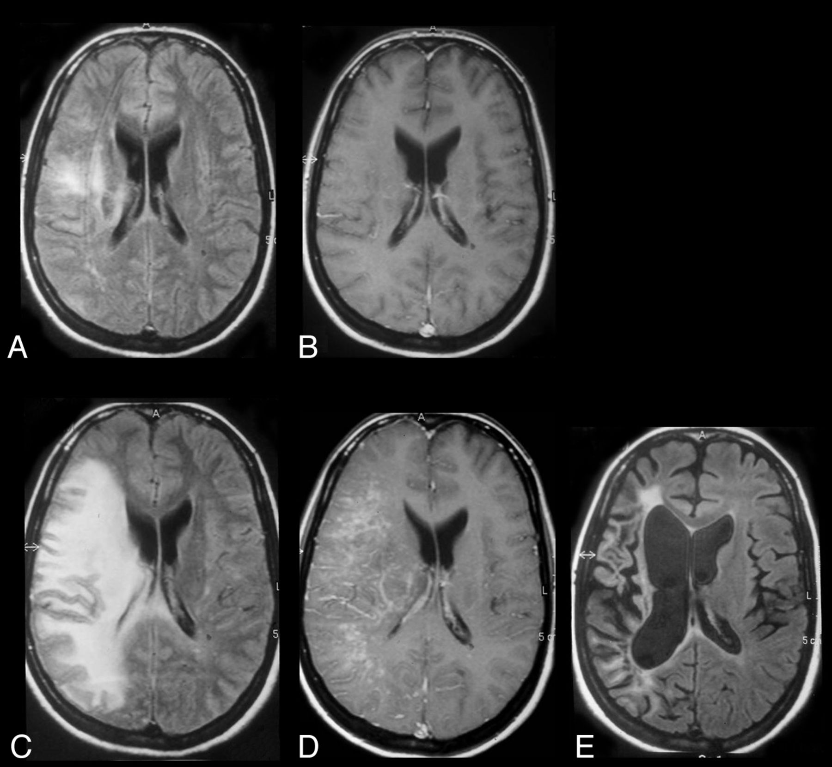

Cryptococcal–Immune Reconstitution Inflammatory Syndrome
Late cryptococcal meningitis–IRIS: FLAIR (A) and T1 postcontrast (B) show distention of the Virchow-Robin spaces in the basal ganglia with hyperintense signal and enhancement; inflammatory process has spread into basal ganglia (FLAIR signal and patchy enhancement):
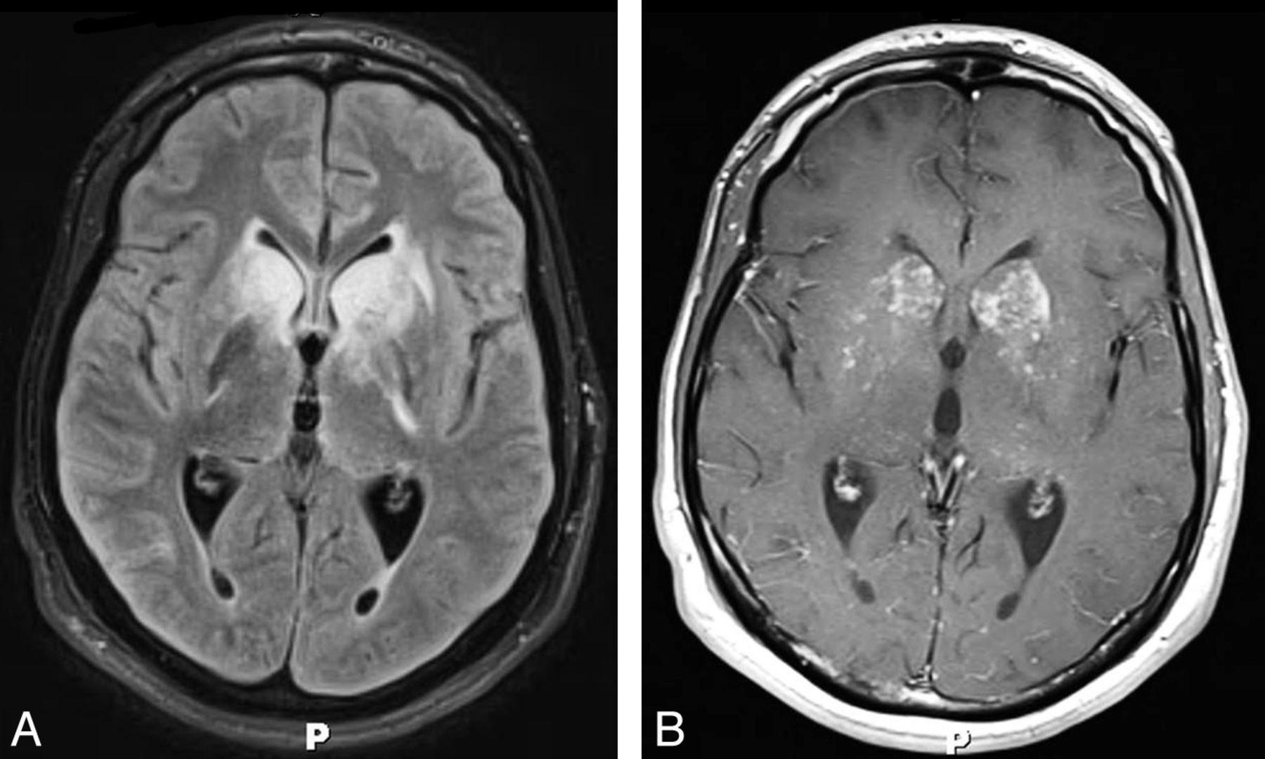

HIV-related Myelopathies
Vacuolar myelopathy
- occurs during late stages of HIV infection (very low CD4 counts) – found in 40-55% AIDS autopsy cases.
- often in conjunction with AIDS dementia complex, peripheral neuropathies, and opportunistic infections or malignancies.
- pathophysiologic hypothesis - infiltration by HIV-infected mononuclear cells that secrete neurotoxic factors in conjunction with neurotoxic astrocyte factors.
- since introduction of HAART, < 10% AIDS patients develop HIV myelopathy.
- pathology (resembles subacute combined degeneration from vitamin B₁₂ deficiency*):
*always check serum vitamin B₁₂ levels
- multifocal vacuolation (intramyelinic or periaxonal severe edema with lipid-laden macrophages) and myelin pallor accompanied by astrogliosis.
N.B. relative preservation of axons.
- dorsal and lateral tracts (esp. gracile tract) > anterolateral tracts.
- thoracic > cervical > lumbar segments.
Extensive spongiform changes in white matter:
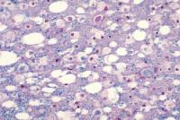

Clinical Features
– subacute painless gait disturbance characterized by spastic paraparesis with ascending sensory ataxia, increased deep tendon reflexes and Babinski signs.
- absent sensory-motor "level" (as in transverse myelopathies).
- latter bladder and bowel incontinence follows.
- arm function suffers only in advanced cases.
- most patients die within 6 months after onset of myelopathy.

Diagnosis
- diagnosis of exclusion.
Imaging - normal or spinal cord atrophy (thoracic ± cervical cord).
- T2-MRI - symmetric nonenhancing high-signal areas (extensive vacuolation) confined to posterior columns (esp. gracile tracts) or diffuse.
T2-MRI - high-intensity lesion in C2-C5 posterior spinal cord:
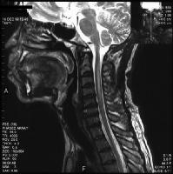
CSF - usually normal.
Tibial somatosensory evoked responses - abnormal in virtually all patients.

Treatment

Although no specific treatment is approved / effective, viral control is important.

Necrotizing CMV myelitis
(most commonly in association with polyradiculitis).
  - acute progressive paraplegia, urinary and rectal sphincter dysfunctions.
  - demonstrable sensory level.

HIV-related Neuropathies
- depending on stage of illness:
Demyelination tends to occur early, axon loss - later
- by time patients develop AIDS, clinical and electrophysiological evidence of neuropathy is present in 2/3 patients.

Neuropathy | CD4
 | > 500 | 200-500 | < 200 | < 50
Acute inflammatory demyelinating polyneuropathy | +
Chronic inflammatory demyelinating polyneuropathy | + | +
Mononeuritis multiplex |  | + | + | +¹
Distal sensory polyneuropathy |  |  | +
Autonomic neuropathy |  |  | +
Progressive polyradiculopathy |  |  |  | +¹
¹cause is CMV

Acute inflammatory demyelinating polyneuropathy
- occurs early in course of HIV infection (e.g. at time of seroconversion).
- autoimmune demyelination - very resembles Guillain-Barré syndrome (progressive symmetric weakness, areflexia, minor sensory complaints, etc.), but ¹⁾more frequent involvement of cranial nerves and ²⁾CSF also includes lymphocytic pleocytosis (up to 50 cells/mm³).
- monophasic illness - responds well to treatment but can also remit without therapy.
- plasmapheresis is treatment of choice.

Chronic inflammatory demyelinating polyneuropathy
- occurs usually before evidence of AIDS.
N.B. CIDP may be presenting feature of HIV, preceding seroconversion for up to 6 months (repeat HIV testing 6 months after onset of CIDP-like disorder!).
- autoimmune demyelination - clinically indistinguishable from idiopathic chronic inflammatory demyelinating polyneuropathy, but CSF also includes lymphocytic pleocytosis!!!
- effective treatments - steroids, plasmapheresis, IVIG.

Mononeuritis multiplex
- occurs at any stage of HIV infection.

early mononeuritis multiplex
- autoimmune mechanism (autoimmune vasculitis of vasa nervorum).
- acute onset - multifocal asymmetric peripheral and cranial* nerves (one or few)
*esp. laryngeal nerves
- nerve conduction studies - asymmetric multifocal involvement with axonal degeneration.
- CSF - protein↑, pleocytosis.
- usually self-limited (even without treatment).
- treatment – IVIG, plasmapheresis; steroids are second choice.

late mononeuritis multiplex
- occurs when CD4 count < 50.
- cause is CMV.
- focal necrotizing vasculitis of epineural arteries → axonal degeneration & demyelination.
- more severe involvement; can progress rapidly to quadriparesis.
- treatment – prompt ganciclovir may be life-saving.

Distal sensory polyneuropathy
- occurs in advanced AIDS (most common type of HIV-1 associated peripheral neuropathy! - found at autopsy in almost 100% of patients with AIDS).
- more common in males > 50 yrs.
- pathophysiologic mechanisms:
    - direct HIV infection of dorsal root ganglion neurons (direct relationship between HIV-RNA load and severity of neuropathic pain).
    - locally infiltrating activated macrophages in peripheral nerves that secrete neurotoxic cytokines.
    - patients who use narcotics have CNS component, which contributes to severity of neuropathic pain.
    - aggravating factors - nutritional deficiencies (e.g. vit. B₁₂) and toxins (e.g. dapsone, vincristine, isoniazid, alcohol, anti-HIV drugs).
N.B. identišką polineuropatiją gali sukelti nucleoside reverse transcriptase inhibitors!
- pathology:
      - distal axonal degeneration with some secondary demyelination.
      - perivascular infiltration by mononuclears (T lymphocytes and macrophages).
      - mild loss of dorsal root ganglion neurons.
N.B. distal axonal degeneration is noted in both central and peripheral projections of dorsal root ganglion cells (e.g. gracile tract degeneration may be seen).
      - intraepidermal nerve fiber density correlates inversely with likelihood of neuropathic symptoms.

Clinical Features
- severity ranges asymptomatic increase in sensory thresholds ÷ severe neuropathic pain (burning numb toes or soles → may ascend subacutely to ankles or beyond) with symmetric panmodal distal sensory loss (“stocking-glove”).
This painful neuropathy is often most functionally disabling manifestation of AIDS!
- lower extremities > upper extremities.
- contact hypersensitivity may cause difficulty with walking.
- typically, CNS complication coexist - reflexes are lost at ankle but exaggerated at knees.
- in more advanced stage: mild motor impairment (distal weakness of intrinsic foot muscles), autonomic symptoms (urogenital and intestinal).
- progressive disease.

Diagnosis of exclusion.

Treatment
- directed at pain relief:
        - tricyclic antidepressants (amitriptyline, nortriptyline, desipramine)
        - anticonvulsants (gabapentin, carbamazepine, lamotrigine)
        - narcotics
        - topical capsaicin
- antiretroviral therapy does not reverse condition! (vs. HIV encephalopathy).
- avoid neurotoxic medications.
- correct vitamin B₁₂ and folate deficiency; consider thiamine replacement if malnourished.

Progressive polyradiculopathy
– occurs in AIDS (CD4 count < 200).
- cause is CMV (co-infection of retina and other sites is common).
N.B. differentiate from other causes - herpes zoster, Treponema pallidum, Mycobacterium tuberculosis, toxoplasmosis of conus medullaris, meningeal lymphoma
- pathology:
          - necrosis of nerve roots and endoneurial and epineurial blood vessels;
          - marked inflammation;
          - cytoplasmic and nuclear CMV inclusions in Schwann cells and fibroblasts.
- (sub)acute cauda equina syndrome - severe, destructive, asymmetric:
          - abrupt pain in perineum & legs.
          - rapidly progressing flaccid paraparesis, paresthesias & sensory loss, areflexia.
          - urinary retention and rectal incontinence.
- may ascend to upper extremities (or even cranial nerves).
- CFS – PMN-preponderant (!) pleocytosis + protein↑↑↑ + glucose↓ + CMV inclusions + CMV PCR (92% sensitivity and 94% specificity) or CMV culture (only 50% sensitivity).
- neuroimaging - root enhancement (arachnoiditis) + thickened nerve roots.
- rapidly fatal without treatment → prompt ganciclovir / foscarnet.
Dramatic and potentially treatable disorder

HIV-related Myopathies
25% AIDS patients suffer from myopathic disease:
- Polymyositis and dermatomyositis; H: steroids (pulsed IV methylprednisolone is preferable to long-term oral prednisone)
- Nemaline (rod) myopathy
- Zidovudine myopathy and rhabdomyolysis - ragged-red fibers in biopsy.
- Myopathy caused by local process:
- neoplasm (lymphoma and Kaposi sarcoma) - cutaneous and subcutaneous involvement in MRI.
- infection (incl. pyomyositis): Toxoplasma gondii, CMV, Microsporidia, Cryptococcus neoformans, Mycobacterium avium-intracellulare, Staphylococcus aureus.
- HIV wasting syndrome with type II muscle fiber atrophy.

HIV wasting syndrome with type II muscle fiber atrophy
  - may develop in all stages of HIV-1 infection (i.e. does not associated with degree of immunosuppression).
  - myofibers are not directly infected (autoimmune mechanisms are proposed).
  - resembles polymyositis - slowly progressive symmetrical painless proximal weakness and atrophy of upper and lower limbs in setting of significant weight loss, diarrhea, and fever.
  - myalgia is present in 25-50%.
  - diagnosis:
    - myopathic EMG features
    - serum creatine kinase moderately ↑.
    - muscle biopsy - scattered myofiber degeneration / necrosis, type II fiber atrophy with occasional associated inflammatory infiltrates.
  - treatment: withdraw zidovudine; if symptoms persist > 1 month after withdrawal → muscle biopsy - if signs of inflammation → trial of steroids.

Cerebrovascular disorders
AIDS is additional risk factor for stroke (ischemic and hemorrhagic) independent of other stroke-related risk factors.
- HIV-positive patients suffer from strokes at much younger ages.
- autopsies often reveal clinically silent cerebrovascular disease.
- most strokes are occlusive (only ≈ 1% are hemorrhagic).

HIV specific etiologies:
  - hypertension from HIV nephropathy.
  - hypotension from cachexia / dehydration.
  - coagulopathies - antiphospholipid antibodies, HIV-associated thrombocytopenia, DIC, hyperviscosity (secondary to dehydration), hepatitis.
  - mycotic aneurysms.
  - cerebral vasculitis (e.g. herpes zoster, CMV)
  - cardiogenic emboli from marantic endocarditis.
  - hemorrhage into tumors.

Bibliography: see p. 268

