Electromagnetic radiation is indirectly ionizing (through short-lived hydroxyl radicals).
- hypoxic tumor cells are significantly less radiosensitive than aerated cells; H: hypoxic cell sensitizers (metronidazole, misonidazole - mimic oxygen and increase cell kill), thymidine analogues (iododeoxyuridine, bromodeoxyuridine - incorporated into DNA and render cells more susceptible to radiation damage; however, they are associated with considerable acute toxicity.)
- DNA damage is also dependent on phase of cell cycle; most radiation-sensitive phases are G₂ and M; H: delivery of radiation in divided doses (fractionation) - allows surviving G₁ and S phase cells to progress to more sensitive phases (reassortment).

Particles are directly ionizing (directly damage DNA) - independent of cellular oxygen levels!
- less dependent on the cell-cycle phase

Palliative radiotherapy
- in certain patients with metastatic disease:
- symptomatic bony metastases.
- spinal cord compression due to vertebral metastases.

Adjuvant radiotherapy
- to decrease local-regional recurrence rates.

Preoperative radiation
Advantages:
- minimize tumor seeding during surgery
- allows for smaller treatment fields (vs. operative bed contaminated with tumor cells).
- may achieve adequate reduction to make tumor operable.

Disadvantages:
- postoperative wound healing problems
- difficulty in planning subsequent radiation therapy in patients who have positive surgical margins.

Postoperative radiation
- given 3-4 weeks after surgery to allow for wound healing.
- postlaparotomy adhesions decrease mobility of small bowel loops - risk for radiation injury in abdominal or pelvic irradiation.

Complications
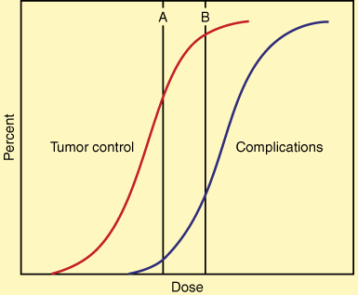

Organ | Acute Changes | Chronic Changes
Nervous system | Cerebral edema | Necrosis, myelitis
Eye | Conjunctivitis | Cataract, keratitis, optic nerve atrophy
Lung | Pneumonitis | Pulmonary fibrosis
Heart | — | Pericarditis, vascular damage
Upper aerodigestive tract | Mucositis, xerostomia, anosmia | Xerostomia, dental caries
GI tract | Nausea, diarrhea, edema, ulceration, hepatitis | Stricture, ulceration, perforation, hematochezia
Kidney | — | Nephropathy, renal insufficiency
Bladder | Dysuria | Hematuria, ulceration, perforation
Gonads | Sterility | Atrophy, ovarian failure
Hematopoietic tissue | Lymphopenia, neutropenia, thrombocytopenia | Pancytopenia
Bone | Epiphyseal growth arrest | Necrosis
Skin | Erythema, wet or dry desquamation, epilation | Telangiectasia, subcutaneous fibrosis, ulceration

Effect of radiation on cervical carcinoma:
Before irradiation:  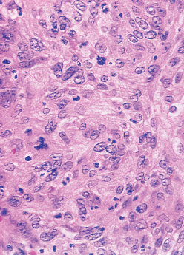 | One week after high-dose irradiation - injury to tumour cells (note bloating of arrowed nuclei) and induced inflammatory reaction:  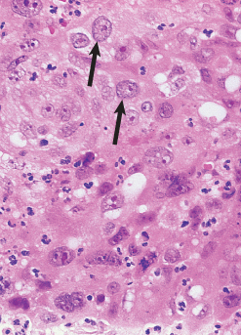

Skin erythema (immediate reaction) due to therapeutic radiation:
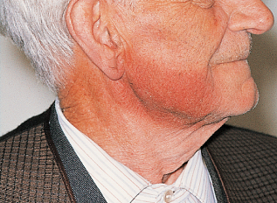

Lung fibrosis due to therapeutic radiation - abrupt demarcation between solid scarred lung (left) and adjacent normally aerated lung (right) - due to sharp cut-off at edge of irradiated field:
