Surgical Needles 1
Needle anatomy 1
Needle types 3
Needle handling tips 5
Surgical Tubes 5
Drainage Tubes 5
Gastrointestinal Tubes 7
Catheters, Hemodialysis Tubes 8

Surgical Needles
Needles are necessary for suture placement in tissue.
- sharp enough to penetrate tissue with minimal resistance (the sharper the needle, the less scarring will result).
- carry suture material through tissue with minimal trauma.
- rigid enough to resist bending, yet flexible enough to bend before breaking.
- sterile and corrosion-resistant.
- needle dimensions must be compatible with suture sizes.
- "surgical yield" point - amount of angular deformation the needle can withstand before becoming permanently deformed; usually 10-30°; any angle beyond renders needle useless (reshaping bent needle may cause it to lose strength).
- ductility - needle's resistance to breaking under given amount of bending (ductile needle will bend before breaking).
- needles must be passed through tissue in direction of needle body.
N.B. needles are not designed to be used as retractors to lift tissue!
- most ETHICON needles have micro-thin coating (silicone or similar lubricants) - significantly and improves ease of needle penetration.  - needle stability in needleholder - most curved needles are flattened (± ribbed) in grasping area to enhance control. | 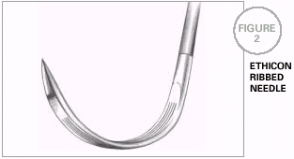

Needle anatomy

Needle size  CHORD LENGTH - straight line distance from point to swage.  NEEDLE LENGTH - distance measured along needle itself from point to end.  RADIUS - distance from center of circle to needle body.  DIAMETER - thickness of needle wire. | 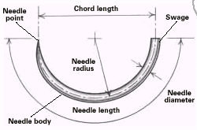

Three basic components:  - Eye  - Body  - Point | 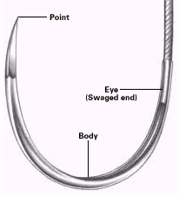

1. Needle eye
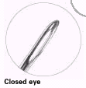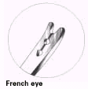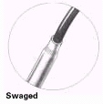

- closed eye - similar to household sewing needle
- French (s. split, spring) eye - have slit from eye inside to needle end with ridges that catch and hold suture in place.
- swaged (eyeless) - virtually all needles used today! minimally traumatic!
  - avoid placing needleholder on or near swaged area which is weakest part of needle.

Disadvantages of eyed needles:
- must be threaded - time-consuming procedure for scrub person.
- pull double strand of suture material through tissue → larger hole.
- suture may become unthreaded.
- repeated use → needle becomes dull.

Swaged needle release:  Holding needle securely in needleholder, suture is grasped securely and pulled straight and taut; needle is released with straight tug of needleholder. | 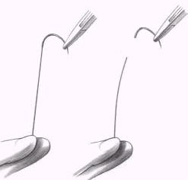

2. Needle body
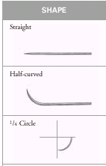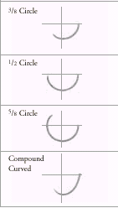

- needle body diameter should be as close as possible to suture diameter.

STRAIGHT NEEDLE
- suturing easily accessible tissue:
  - skin closure
  - arthroscopic suturing of meniscus.
  - tendon repair (Bunnell needles).
  - suturing gastrointestinal tract (taper point needle).
  - nerve and vessel repair.
  - placement of intraocular lenses (straight trans-chamber needle).

HALF-CURVED NEEDLE “SKI”
- primarily in laparoscopy (low profile allows easy passage down laparoscopic trocars).

CURVED NEEDLE
- requires less space for maneuvering.
- curvature may be:
1/4 circle – eye, microsurgery.
3/8 circle - skin closure.
1/2 circle - use in confined space.
5/8 circle - use in confined space (esp. anal, urogenital, intraoral, cardiovascular procedures).

COMPOUND CURVED NEEDLE
- originally developed for anterior segment ophthalmic surgery.
- also for laparoscopy.

3. NEEDLE POINT
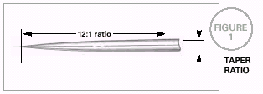

Needle types
- taper point needles are most often used in tissues that are easy to penetrate; cutting needles are more often used in tough, hard-to-penetrate tissues.
N.B. when in doubt, choose taper point for everything except skin sutures!

CUTTING NEEDLES
- have at least two opposing cutting edges.
- sharpened to cut through tough, difficult-to-penetrate tissue (ideal for skin sutures).

a) CONVENTIONAL CUTTING NEEDLES - have third cutting edge on inside concave curvature.  - may be prone to cutout of tissue because inside cutting edge cuts toward wound edges. | 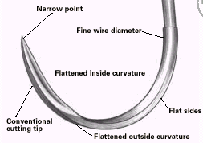

b) REVERSE CUTTING NEEDLES - third cutting edge is located on outer convex needle curvature:  - more strength than similar-sized conventional cutting needles.  - greatly reduced danger of tissue cutout (hole left by needle leaves wide wall of tissue against which suture is to be tied). | 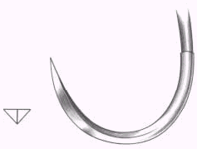

c) SIDE CUTTING NEEDLES (s. SPATULA NEEDLES) - flat on both top and bottom, eliminating undesirable tissue cutout of other cutting needles.  - designed for ophthalmic procedures. | 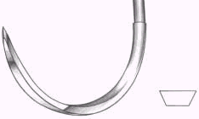

TAPER POINT NEEDLES (s. ROUND NEEDLES) - needle point tapers to sharp tip.
- pierce and spread tissue without cutting it.
- used in easily penetrated tissue.
- preferred when smallest possible hole in tissue are desired (e.g. internal anastomoses to prevent leakage).

TAPERCUT NEEDLES - combine features of reverse cutting edge tip and taper point needles (3 cutting edges extend approximately 1/32", then blend into round taper body).

point (s. “trocar point”) readily penetrates dense, tough tissue.

taper body portion provides smooth passage through tissue without cutting.

initially designed for use in cardiovascular surgery on sclerotic or calcified tissue.

BLUNT POINT NEEDLES
- rounded, blunt point - dissect friable tissue rather than cutting it.
- suturing liver and kidney.

Needle handling tips
- apply force in the same direction as needle curve.
- do not take excessively large bites of tissue with small needle.
- do not force dull needle through tissue - take new needle.
- do not force / twist needle in effort to bring point out through tissue - withdraw needle completely and then replace it in tissue, or use larger needle.
- avoid using needle to bridge or approximate tissues for suturing.
- do not damage taper points & cutting edges with needleholder (grasp as far back on body as possible).
- if tissue is tougher than anticipated - use heavier gauge needle.
- in deep, confined area, ideal needle positioning may not be possible - heavier gauge needle or different curvature may help and second needleholder should be used to locate needle in confined body cavity.
- if glove is punctured by needle, needle must be discarded immediately.
- surgeon receives needleholder with needle point toward thumb (to prevent unnecessary wrist motion); scrub person controls free suture end to prevent dragging it across sterile field, and to keep suture from entering surgeon’s hand along with needleholder. | 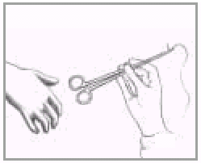
- pass needles on exchange basis - one is passed to surgeon for one returned.
- use nontransfer technique (to avoid inadvertent needlesticks) - surgeon places needle & needleholder down in neutral area of sterile field; scrub person then picks up needleholder.
- secure each needle as soon as it is used; do not allow needles to lie loose on sterile field or Mayo stand; keep them away from sponges and tapes so they will not inadvertently be dragged into wound.

Surgical Tubes
Drainage Tubes
Indications
- used to drain:
- normal fluids that cannot be handled by body
- abnormal fluids (e.g. pus).

Tubing shapes
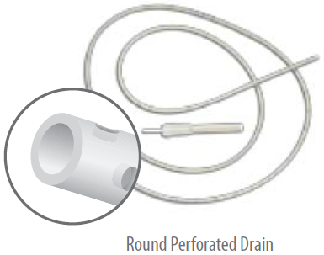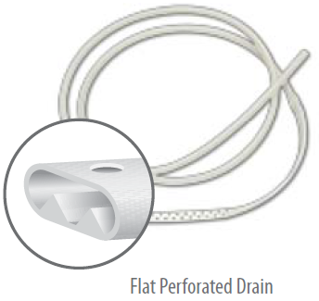

Connection types

1. Open (penrose) drains - not sealed at either end (allow m/o and other materials access to drained area → secondary infection!!!).
- proposed by Penrose in 1890.
- soft, flexible latex rubber wick 0.25-1 inch in diameter.
- use capillary action - drain purulent material, blood, or serum from body cavity.
- intra-abdominal drains are brought out through stab wound in flank (N.B. not through abdominal incision itself - risk of infection → ventral hernia).
- use of two drains is advantageous (allow fluid egress along planes between drains).
- drains should be anchored to skin with nonabsorbable suture; placement of sterile safety pin prevents drain retraction into wound.
- removal:
- complete
- gradual withdrawal (several centimeters a day) - to prevent development of fluid collection or abscess cavity deep to drains.

2. Sump drains - large and bulky double-lumen catheters: air / irrigation fluid continuously enters* through one lumen while suction is applied to other lumen:
- particulate matter evacuation (e.g. debris from abscess, nasogastric tube)
- continuous irrigation.
*risk of secondary infection

3. Closed Drains - connect body cavity to sealed reservoir.
- lower infection rates but clog and cease function early in wound drainage process.
- firm, multiholed catheters made of polyvinyl chloride or silicone (softer, less irritating, less likely to cause infection).
- Gravity drainage – fluid drains into reservoir at lower level (e.g. Foley bladder catheter).
- Underwater-seal drainage systems - drainage tube end is under water in sealed drainage bottle at floor level (water prevents air from re-entering tube and fluid from siphoning back) (e.g. chest tube).
- Suction drainage - suction to drainage tube:
  - can drain large volumes of fluid (such as can collect in Gl tract).
  - promotes “dead space” closure → better approximation of large tissue surfaces (e.g. Jackson-Pratt drain, for large skin flaps).

4. Closed-Suction Penrose Drains - combination of closed-suction drain and open Penrose drain - two tubes are included: while tails of outer tube function by capillary action, inner standard perforated tube sucks through closed system (bacterial contamination↓) – almost ideal drainage system.

5. percutaneous Catheter Drains
- drain localized fluid accumulations in different body areas (e.g. abdominal abscesses).
- inserted percutaneously by radiologists guided by CT or, less reliably, ultrasonography.
- antibiotics are essential for success.
N.B. surgical treatment should not be delayed even with very ill patient if there is any question as to adequacy of percutaneous abscess drainage!

Caveats & complications
"When in doubt, drain" and "It is better to have it and not need it than to need it and not have it" – this is not necessarily correct!
It has been clearly documented that placing drain in routine splenectomy increases morbidity!
Researchers have demonstrated that children in whom Penrose drains were placed at operation for perforated appendicitis averaged nearly 4 more hospital days than those without drains!
- drain presence is not guarantee that fluid collection will not form - foreign body reaction can isolate drain from adjacent tissues;
prophylactic abdominal drains (for peritoneal contamination) are quickly surrounded by omentum and bowel, which isolate drains as ineffective sinus tracts.
N.B. free peritoneal space cannot be drained (tubes are quickly "walled off") - diffuse peritonitis cannot be drained! Localized collections can be drained.
N.B. the only prophylactic drainage is closed-wound suction drainage!
- drain is not substitute for hemostasis - if hemostasis is not adequate, hematoma will likely develop despite drainage.
- drains can become colonized by exogenous m/o (esp. open drains) - risk of secondary infection.
- rigid drains may erode blood vessel or hollow intestinal structure; H: soft drains or removing drains early.
- excessive suction on tube can cause necrosis of nearby structures; H: intermittent / low-level suction or sump tube.
- drain in direct contact with fistula may perpetuate fistula - drain must be withdrawn from fistula if healing is to occur!
- drains can retract into body;
H: always firmly attach to skin + mark with radiopaque marker ± safety pin (to keep small drains outside body).

Drains are removed
A. When no substantial drainage of postoperative fluid collections (blood, lymph) occurs.
Decreased / absent drainage indicates that drain may be withdrawn!
B. When risk of leakage has passed; examples:
- after liver resection, if leak from bile duct is present, it should be evident in 1-2 days; therefore, drains are removed by 3rd day.
- after urinary bladder procedures, urine leak would not be noticeable until bladder catheter is removed; therefore, drains are removed day after catheter is removed.
C. When reconstructive repair is safe; examples:
- after common duct exploration, T tube is removed when spasm of sphincter of Oddi has resolved (cholangiogram documents free bile flow into duodenum).
- after Billroth II reconstruction, tube duodenostomy (prevention of duodenal stump disruption) can be removed once no signs of duodenal leakage have developed (usually 2-4 weeks after surgery).

Gastrointestinal Tubes
Enteral feeding → see p. 2768 >>

    - Gastroesophageal balloon tamponade tubes (Sengstaken-Blakemore or Minnesota tubes) - used to compress & tamponade bleeding esophageal varices.

    - Nasogastric tubes – have two lumens;
        - prolonged gastric decompression – large bore (e.g. Salem sump, 16-18 F).
        - feeding – smaller bore (e.g. Dobhoff tube, 8-12 F):
- advantages: more comfortable, less erosive to nasopharynx, less gastroesophageal reflux by holding lower esophageal sphincter tighter
- disadvantages: thend to clog (flush freequently and regularly; replace with new tube every 4 weeks), collapse easily (difficult to monitor gastric residuals).

Dobhoff tube insertion: original instruction >>
- place patient in high Fowler’s or sitting position. Do not lean patient forward!
- activate HYDROMER coating on weighted tip of tube by submerging weight assembly in water for at least 5 seconds (not necessary for unweighted tubes).
- passage through nasal passage into stomach can be facilitated by using stylet (for stylet placement, using syringe, inject approximately 10 cc of water into tube to activate HYDROMER coating)
N.B. presence of endotracheal tube tends to guide feeding tube into trachea!!! (misplacement of tube into lungs resulting in pneumothorax has been reported in neurologically impaired patients and those with tracheal tubes in place!)
- choose the most patent nare and insert tube with stylet; once in place, DO NOT manipulate or pull stylet back and forth within tube.
- when tube has reached oropharynx encourage patient to swallow; giving sips of cool or room temperature water may assist tube passage.
- insertion depth: measure distance from tip of nose to earlobe and from earlobe to xiphod process for gastric placement; add 25 cm for intestinal placement.
- placement confirmation must be determined by X-ray; supportive confirmation includes auscultation of upper left quadrant during injection of air using syringe and aspiration of gastric contents.
N.B. placement confirmation should be confirmed with stylet secured within tube (never reinsert stylet into indwelling tube)
- once tube position has been confirmed, reactivate HYDROMER with another 10 cc of water before attempting stylet removal (stylet is then removed by gentle traction).
- spontaneous transpyloric passage of weighted tip (if used) often occurs within 24-48 hours; placing patient in semi-Fowler’s position with rotation to right side may expedite transpyloric passage.

    - Long intestinal tubes (double-lumen Miller-Abbott tube, single-lumen Cantor tube) - introduced through nose and allowed to pass into small intestine.
  - weight / bag is at leading tip, allowing peristalsis to carry tube distally.
  - useful for relieving small bowel obstruction (esp. recurrent partial obstructions).

    - Gastrostomy tubes
- feeding
- prolonged gastric decompression.
- once tube is removed, tract will close in 6-24 hours.

    - Baker jejunostomy tubes - inserted directly into proximal jejunum (at time of laparotomy) and passed distally to cecum – used:
- to splint bowel in situations where adhesions will recur.
- to decompress greatly distended bowel encountered at surgery.

    - Jejunostomy tubes - surgically inserted into jejunum and exit on abdominal wall - used for feeding.

    - Cecostomy tubes - large-caliber tube surgically inserted into distended cecum in treating colonic ileus (N.B. colonic obstruction is better treated with proximal diverting colostomy).

    - Rectal tubes - large-caliber tube inserted transanally into rectum - treatment of choice for sigmoid volvulus (tube is passed through torsion area under sigmoidoscopic visualization).
N.B. rectal tubes are best removed after several days (thin-walled colon is prone to pressure necrosis!).

Catheters, Hemodialysis Tubes
1. Central venous catheter (slang = “central line”) - thin single or triple lumen tube placed via internal jugular or subclavian vein into superior vena cava - administration of fluids, parenteral nutrition, pressors.
- femoral vein can be used when necessary.
- larger double lumen catheter can be placed for brief (< 2 weeks) hemodialysis access.

2. Peripherally inserted central catheter (PICC, slang = “pick line”) - placed via antecubital vein and threaded proximally into intrathoracic vein - used as central catheter.

3. Port is equivalent to central venous catheter or PICC, except there is no external extension - catheter is attached to device with septum (port) through which to access lumen; port is buried subcutaneously.
- port is intended for longer term use.
- port is usually used less often than daily (e.g. for periodic chemotherapy).

4. Cuffed central venous catheter (Hickman-type catheter) - maintains access to veins for prolonged time periods.
- catheter has Dacron felt cuff glued to catheter - cuff provokes granulation tissue ingrowth (functions to secure catheter's position and as mechanical barrier to m/o).
- can function for years.
- typical uses: chemotherapy, hemodialysis, long-term hyperalimentation.

5. Tenckhoff peritoneal dialysis catheter - inserted into peritoneal cavity for:
- long-term dialysis therapy
- management of malignant ascites.
- can function for years.
- two Dacron cuffs are glued to catheter: one adjacent to peritoneum (barrier against leakage), one adjacent to skin (barrier against infection).

Panaudota literatūra: ETHICON Educational material, NMS Surgery, Sabiston 1997

