Pressure Sores
(Bedsores; Decubitus Ulcers; Trophic Ulcers)
- ischemic necrosis & ulceration over bony prominences due to prolonged pressure against external object (e.g. bed, wheelchair, cast, splint).
- most common localization: sacrum, ischia, greater trochanters, external malleoli, heels, knees, anterior-superior iliac spines.

Etiology
Intrinsic factors
  - diminished / absent sensation (of pain and pressure) – no signaling to shift position and relieve pressure.
  - debilitated, emaciated, paralyzed patients → immobility, minimal fat & muscle padding.
      - spasticity (esp. in spinal cord injuries) places shearing force on blood vessels.
  - incontinence of bowel or bladder → moisture. see below
  - compromised circulation due to hypotension, dehydration, vascular disease, paralysis (vascular tone↓ → lowered circulatory rate).

Extrinsic factors
- infrequent patient's position shifting → pressure injury
      - in immobilized patient, severe pressure can impair local circulation in < 3 h.
- skin friction, irritation, pulling (ill-adjusted supports, wrinkled bedding or clothing; patient in sloped position or is rubbing constantly against underlying surfaces) → shear injury: local blood vessels are stretched and separated from underlying perforating vessels.
- complicating feature of all pressure ulcers - moisture (perspiration, incontinence) → maceration (skin softening), sticking to underlying surfaces, easy access for infection.

Stages
- pressure sores should be photographed to establish baseline

Stage | Characteristics
1 | intact skin with nonblanchable erythema.
2 | partial-thickness epidermal or dermal loss (as abrasion, blister, shallow crater).
3 | full-thickness necrosis down to underlying fascia (as deep crater ± adjacent tissue undermining).
4 | damage to muscle, bone, supporting structures (undermining, sinus tracts, osteomyelitis, septic arthritis, etc.).

Ulcer is analogous to iceberg - small visible surface with extensive unknown base.
There is no good method to determine tissue damage extent.

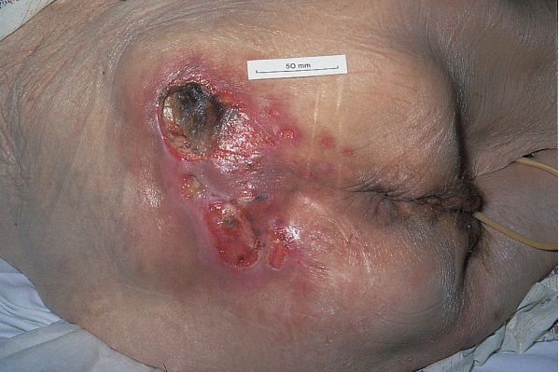

Prophylaxis
- position must be changed at least q 2 h (until tolerance for longer periods can be demonstrated - by redness absence);
  - Stryker frame facilitates turning spinal cord injury patients.
  - wheelchair-bound patients must shift position q 10-15 min (even if pressure-relieving pillow is used).
N.B. special mattresses (air-filled alternating-pressure mattresses, sponge-rubber eggcrate mattresses, silicone gel or water mattresses) do not negate need for position changes q 2 h.!
- pressure relief on sensitive areas (spaudimas turi būti < 30-35 mmHg – t.y. mažesnis už kapiliarinį);
  - standard mattress can generate pressures as high as 150 mmHg.
  - air flotation mattresses provide pressure maximal relief;
  - protective padding (e.g. sheepskin or synthetic equivalent) at bony prominences, esp. under braces or plaster casts;
  - window in cast should be cut at potential pressure sites.
  - avoid ring supports (“donuts”) (restrict circulation and even promote pressure sores!!!).
- inspection & palpation (at least once/day) under adequate light – erythema, trauma?
- cleanliness & dryness to prevent maceration and secondary infection.
  - bedding & clothing should be changed frequently;
  - sheets should be soft, clean, free from wrinkles and particulate matter;
  - lying on sheepskin helps keep skin in good condition.
  - protective padding, pillows, or sheepskin can be used to separate body surfaces.
  - most areas may be powdered with plain talc.
  - skin sponging in hot weather, thorough drying after baths.
  - diversion of urine and absorption of fluids from other sources (such as perspiration or spillage).
- encourage activity - avoid oversedation.
- physiotherapy (passive and active exercises, hydrotherapy).
- well-balanced diet (supplemental vitamin C and zinc help healing).

Treatment
- patient must be in optimal general condition (adequate nutrition, not anemic, muscle spasms prevented, infections [esp. UTI] treated).
Incipient sores (stages 1-2):
- all prophylactic measures (to prevent necrosis) - keep area exposed, dry, free from pressure.
- gentle massage (galima su spiritu, po to sutepti briliantine žaluma) to stimulate circulation.

Stage 3 ulcers - may heal spontaneously (within 6 months) if pressure is removed and area is small.
- debridement. see below
- wet dressings (hydrophilic gels, hydrocolloid) or allogenic skin substitutes (e.g. Apligraf).
Ensure that wound stays clean and moist!!!
- many dressings and topical agents (e.g. levomekolio tepalas) are available - no one is universally superior.
- synthetic dressings are more expensive than saline but are more effective - require fewer changes (less disruption of reepithelialization) and protect against contamination.
- bacterial colonization is universal & polymicrobial - swab cultures should not be performed and topical treatment only if ulcers have not healed after 2 weeks of therapy.

Stage 4 ulcers require debridement with forceps & scissors (or more extensive surgery) to healthy tissue.
- other forms of débridement (may débride without surgery):
- physical débridement: dextranomer beads, whirlpool baths.
- chemical-physical débridement: 1.5% hydrogen peroxide.
- if, at debridement end, bone is exposed → plastic surgical closure:
- radical debridement - removal of every exposed contaminated part and any necrotic tissue.
- remove bony prominence with osteotome to reduce recurrence risk.
- flap is closure of choice (esp. over large bony prominences; if linear closure is attempted, it will place closure under tension immediately over bony prominence; skin grafts are not durable and do no heal on denuded bone); in sacral ulcers use:
  - V-to-Y advancement skin flaps.
  - large fasciocutaneous rotation flap (usually based inferiorly).
  - other flaps (musculofasciocutaneous, etc.) may be used.
- at least two large suction drains.
- for cellulitis, osteomyelitis, sepsis → systemic penicillinase-resistant penicillin or cephalosporin (after cultures of blood and wound border - by needle aspiration or biopsy).

Panaudota literatūra:
Merck Manual 1999
Sabiston Textbook of Surgery 2001

