Cerebral Venous Thrombosis (CVT)
Last updated: April 20, 2019
Epidemiology 1
Etiology 1
Pathophysiology 1
Clinical Features 2
Superior sagittal sinus thrombosis 2
Lateral sinus thrombosis 2
Cavernous sinus thrombosis 3
Diagnosis 3
Imaging 3
MRI 3
MRV 3
CT 4
CTV 5
Arteriography 5
Other Studies 5
EEG 5
Lumbar puncture 5
Funduscopy 5
Blood 5
Urine 6
Differential 6
Treatment 6
Medical 6
Surgical 7
Prognosis 7
Follow up 7

CVT - thrombosis of venous sinuses, superficial or deep cerebral veins.

Epidemiology
- 0.5-1% of all strokes.
- female-to-male ratio 1.29-3 : 1
- any age (newborn to elderly patients); 80% patients are < 50 yrs; age distribution:
men - uniform age distribution;
women - 61% aged 20-35 yrs (may be related to pregnancy or oral contraceptives)
- mean age at presentation is nearly 1 decade younger in women compared to men (34 years vs. 42 years).

Age and sex distribution of cerebral venous and sinus thrombosis (CVT) in adults:
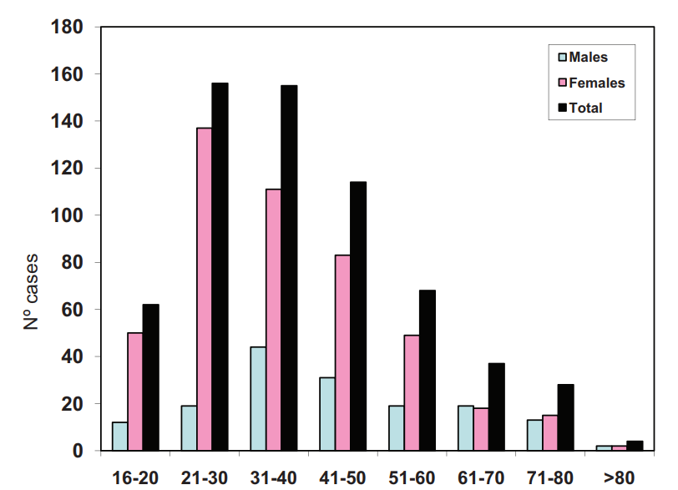
Dr Jose Ferro from the International Study on Cerebral Venous and Dural Sinuses Thrombosis

Etiology
- Infection extension from paranasal sinuses, middle ear (via emissary veins), face, oropharynx → suppurative intracranial thrombophlebitis.
N.B. orbital veins (drain from middle third of face, including paranasal sinuses) have no valves - allow infection passage both anterograde and retrograde!
- may be associated with epidural abscess, subdural empyema, meningitis, cranial osteomyelitis.
- frontal sinuses are most common source.
- most commonly - lateral and cavernous sinuses.
- Staphylococcus aureus is most common.

- Trauma:
  - mild closed injury ÷ depressed skull fracture (occludes dural sinus)
  - iatrogenic - dural taps, infusions into internal jugular vein.

- Tumors – local compression, hypercoagulable state, antineoplastic drugs (e.g. tamoxifen, L-asparaginase).

- Hypercoagulable states (present in 21% cases)
    - antiphospholipid and anticardiolipin antibodies, protein S and C deficiencies, antithrombin III deficiency, lupus anticoagulant, Leiden factor V mutation, hyperhomocysteinemia
    - paroxysmal nocturnal hemoglobinuria, thrombotic thrombocytopenic purpura, sickle cell disease, polycythemia.
    - pregnancy and puerperium!!!
    - disseminated malignancies (paraneoplastic hypercoagulation)
    - sarcoidosis, inflammatory bowel diseases (Crohn), collagenoses (incl. corticosteroids used in treatment).
    - vasculitis (such as Behcet syndrome).
    - nephrotic syndrome, hepatic cirrhosis.
    - dehydration, cachexia (“marantic” thrombosis in infancy) - superior sagittal sinus is most common.

- Medications: oral contraceptives (incl. 3rd-generation), corticosteroids; ε-aminocaproic acid, L-asparaginase, heparin (thrombotic thrombocytopenia with venous sinus thrombosis).

Pathophysiology
Cerebral venous thrombosis is uncommon cause of cerebral infarction (relative to arterial disease).

venous strokes : arterial strokes ≈ 1 : 62.5

- venous occlusion → tissue congestion → early severe vasogenic brain edema → venous infarction → cytotoxic edema:
venous sinus thrombosis - infarction in cortex and adjacent white matter;
deep cerebral vein thrombosis - infarction in basal ganglia, thalamus.
- venous sinus system itself lacks valves, permitting retrograde propagation of clots - thrombosis from dural sinuses may progress (esp. in septic thrombosis) to cortical veins.
  - obstruction of cortical veins (e.g. vein of Labbé) can produce significant damage.
  - although unusual, cortical vein thrombosis may be seen in absence of dural sinus involvement.
- back-transmission of high pressure into capillary bed usually results in significant hemorrhagic component.
- SAH also may be presenting feature (due to venous hypertension).
  - CVT should be considered in workup of SAH, esp. when basilar cisterns are not involved!
- if sinus occlusion occurs gradually (as by neoplastic invasion), collateral drainage routes (incl. scalp veins) are recruited, thus avoiding cerebral edema and ICP↑.
- venous thrombi are rich in RBCs and fibrin but poor in platelets ("red thrombus") → replaced by fibrous tissue with time.

Venous infarcts do not conform to arterial territories, are often hemorrhagic and multifocal.

Frequency:
- superior sagittal sinus (70%, but less common site of infective thrombosis) – bilateral parasagittal more or less symmetric infarcts – most severe damage!
- transverse (lateral) sinuses
- cavernous sinus
- inferior sagittal sinus, straight sinus, petrosal sinuses, vein of Galen - usually involved by secondary extension.

MRV showing the most frequent (%) location of cerebral venous and sinus thrombosis, as reported in the International Study on Cerebral Venous and Dural Sinuses Thrombosis (n=624):
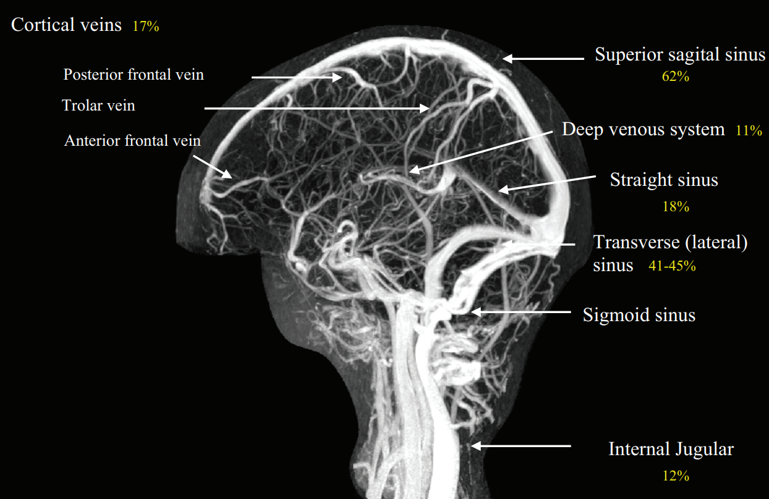

Clinical Features
- course is more severe in septic thrombosis.
- course is mildest in isolated cortical vein thrombosis.

- Signs of ICP↑ (impaired venous outflow)
- headache - most common symptom! (90%); diffuse, increases over several days; thunderclap headache indicates associated SAH!!!
- nausea & vomiting
- normal ÷ decreased level of consciousness (may progress to coma)
- papilledema
- distention of the scalp veins may be noted.

- Focal neurological deficit (focal brain injury from venous ischemia/infarction or hemorrhage; 75% patients) - depending on area involved as thrombus extends to cortical veins (CN syndromes, hemiparesis, facial weakness, aphasia, ataxia, hemianopia, deafness, etc).
N.B. focal neurologic signs may be entirely absent with ICP↑ pressure as only presenting sign!
- seizures are more common (40%) than in arterial strokes!; can be recurrent.
- bilateral brain involvement is not infrequent.

Clinical patterns:
  - isolated intracranial hypertension (mimicking pseudotumor cerebri)
  - focal neurological signs (simulating arterial strokes or seizures)
  - cavernous sinus syndrome.

Symptoms related to area of thrombosis:
Superior sagittal sinus thrombosis
- weakness in lower extremity (unilateral or paraparesis) → hemiparesis (secondary to clot extension into cerebral veins).
- in infants - forehead edema, vein engorgement in area of anterior or posterior fontanels (caput medusae).
- bilateral involvement can produce stupor early in course.
- seizures in > ½ patients.
- course is frequently fulminant and prognosis guarded, although complete recovery may occur.

Lateral sinus thrombosis
- usually secondary to pediatric otitis media and mastoiditis (most patients are febrile with earache).
- swelling over mastoid region with distention of superficial veins.
- Griesinger sign - mastoid emissary vein thrombosis due to thrombus extension from sigmoid sinus.
- pseudotumor cerebri–like picture (ICP↑) – more common with right sinus occlusion (in most individuals, right sinus drains greater portion of brain).
- may produce otitic hydrocephalus.
- most common focal sign – CN6 palsy.
- extension into jugular bulb → tenderness over jugular vein in neck, jugular foramen syndrome (Vernet): CN 9-11

Cavernous sinus thrombosis
- septic thrombosis (S. aureus 66%) is associated with bacterial sinusitis (sphenoidal or ethmoidal) or orbital cellulitis; nonseptic thrombosis is rare!
- involves only one sinus at onset but rapidly spreads (via circular sinus) to opposite side.
- onset is usually sudden and dramatic - patient appears acutely ill with fever; > ½ patients have change in mental status.
- cranial nerve palsies (compressive phenomenon) → variable ophthalmoplegia (esp. early CN6 palsy), ptosis, decreased sensation in CN5₁₋₂ divisions.
- obstruction of ophthalmic veins → periorbital edema (!), proptosis, chemosis, papilledema with hemorrhages around disc; orbits are painful to pressure.
- septic thrombosis has high mortality.

Diagnosis
Imaging
MRI
    - acutely sinus walls appear convex
    - intensity follows blood intensity in ICH
- absence of flow void in venous channels.
N.B. acute thrombus can appear hypointense on spinT2 (mimics flow void!!!); slow flowing blood may appear bright (mimics thrombus); H: MRV
- edema and infarct (unilateral or bilateral or single or multifocal) that does not follow distribution of expected arterial occlusion.
- hemorrhagic infarction is commonly found (because of increased pressure in draining veins).
- chronic organizing thrombus develops significant neovascularity - enhances strongly demonstrating "frayed" or "shaggy" appearance.

Transverse sinus thrombosis:
A. Unenhanced coronal T1-MRI - high signal in right cerebellar hemisphere due to hemorrhage; absence of flow void and high signal in right transverse sinus (arrow).
B. Enhanced coronal T1-MRI - hemorrhagic infarct better defined and thrombus in right transverse sinus (arrow) is demarcated by enhancing walls of sinus.
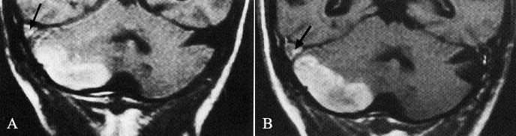

MRV
- excellent method of visualizing dural venous sinuses and larger cerebral veins.
- single-slice phase-contrast angiography (SSPCA) takes < 30 seconds and provides rapid and reliable information (depicts only flow and not thrombus) - procedure of choice in diagnosing CVT (specificity and sensitivity 100%).
N.B. transverse sinus flow gaps (in nondominant or codominant transverse sinus) should not be mistaken for thrombosis.

"empty delta" sign; note prominent sulcal enhancement caused by collateral venous drainage (mimics meningitis):
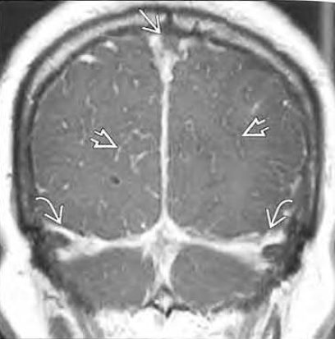

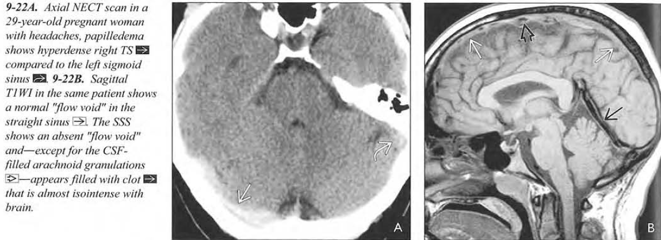
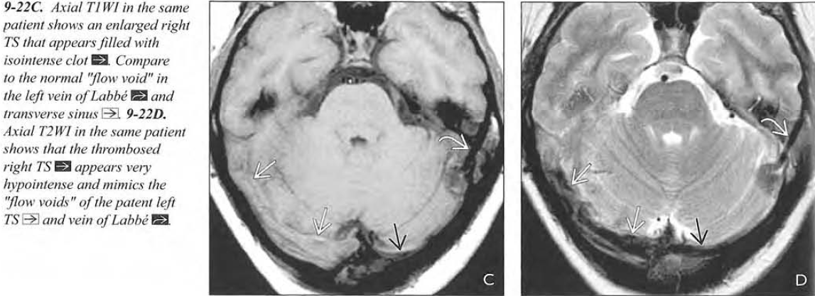

Late acute DST:
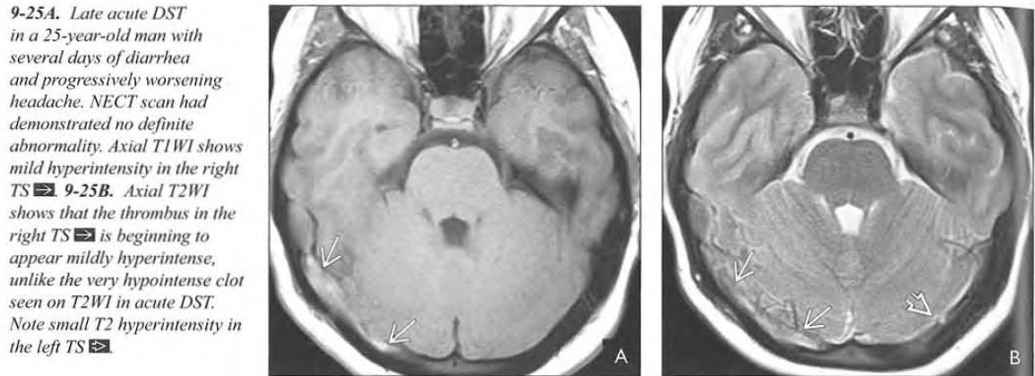
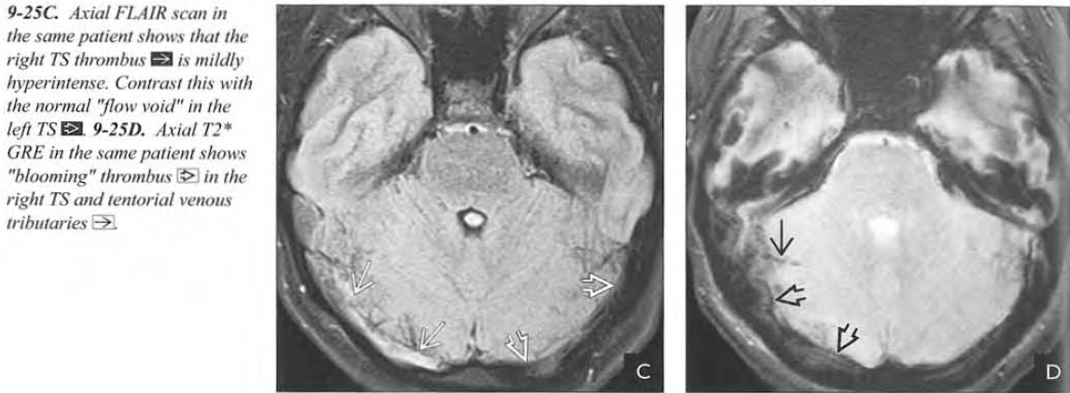
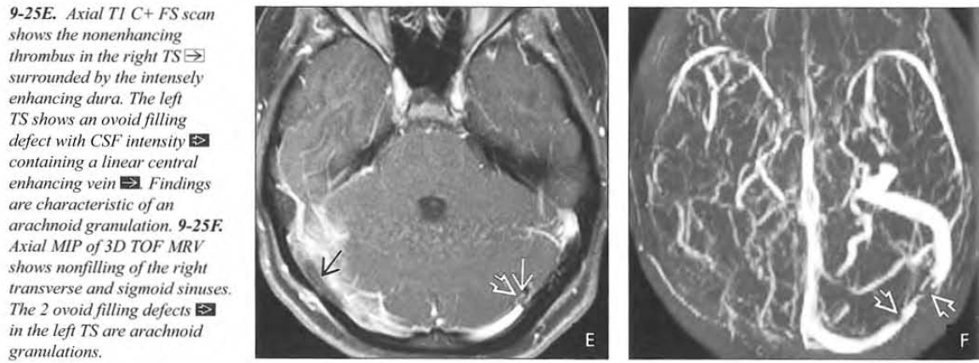

CT
May be normal!
- may show evidence of infarction (edema) that does not correspond to arterial distribution.
- useful in ruling out other conditions – neoplasm, subdural empyema, sinusitis.
- demonstration of infarct may be delayed up to 48-72 hours.
- hemorrhagic infarction:
parasagittally located - superior sagittal sinus;
centrally located - straight sinus;
temporal located - transverse and sigmoid sinuses.
- empty δ sign on contrast CT (most specific CT finding) - nonenhanced thrombus in superior sagittal sinus surrounded by enhancement of engorged collateral veins around sinus and in sinus walls.
- dense triangle sign - fresh coagulated blood in superior sagittal sinus.
- cord sign - thrombosed cortical vein.

Axial CT - cavernous sinus (CS) is distended, with abscess (arrowheads); stenosis of intracavernous ICA is response to abscess:
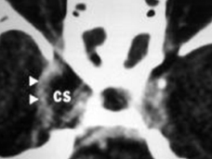

- normal dura and circulating blood are mildly hyperdense compared to brain on CT scans, so subtle increased attenuation of venous thrombi can be difficult to detect.
- venous sinuses lie directly adjacent to skull, so clots can also be obscured by attenuation artifacts.

"empty delta" sign - enhancing dura surrounding nonenhancing thrombus:
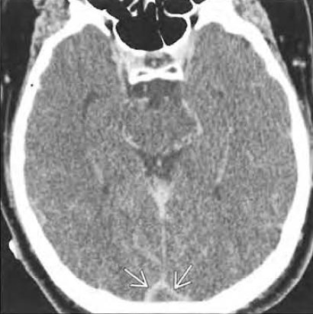
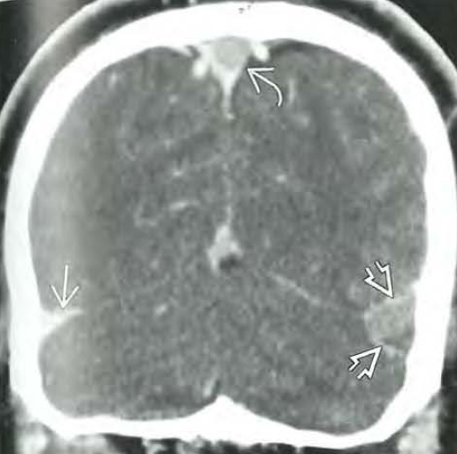

Hyperdensity of right transverse sinus:
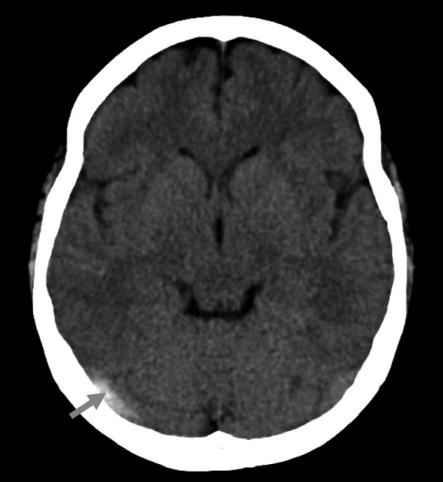

CTV
- equivalent to (or better than) MRV in identification of dural sinus thrombosis.

Arteriography
- with delayed filming technique (to visualize venous system) - was procedure of choice prior to advent of MRV.
- indicated only if MR studies are not diagnostic.
- intraluminal filling defects, flow absence within dural sinus.
- delayed emptying of cortical veins appear as if they are "hanging in space”.
- narrowing of intracavernous ICA in cavernous sinus thrombosis.
- direct venography - passing catheter from jugular vein into transverse sinus.
- orbital venography is most definitive method for cavernous sinus thrombosis.

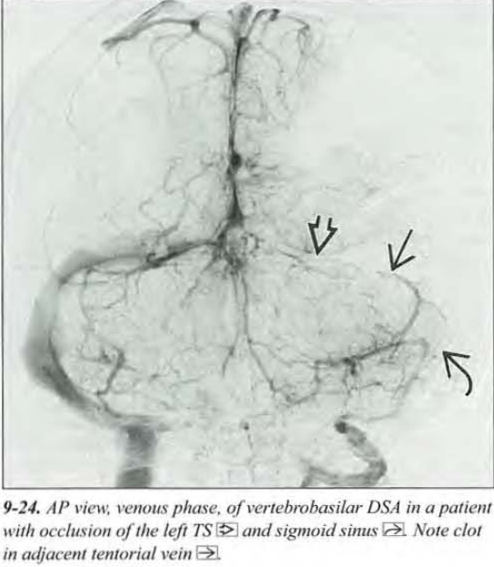

Other Studies
EEG
- normal ÷ mild generalized slowing or focal abnormalities.

Lumbar puncture
- evaluation for meningitis
- compression of jugular vein unilaterally with pressure measurement (now rarely used) → pressure↑ if contralateral transverse sinus is thrombosed (collateral circulation or incomplete compression of jugular vein may yield false-negative result); elevation of intracranial venous pressure may precipitate herniation!

- CSF may be bloody or xanthochromic with parameningeal inflammatory profile and pressure↑.

Funduscopy
- papilledema.

Blood
CBC - leukocytosis (sepsis), polycythemia, platelet count↓ (thrombotic thrombocytopenic purpura).
D-dimer > 500 ng/mL may be beneficial in screening headache patients in ED.
  - D-dimers are positively correlated with thrombosis extent and negatively correlated with symptom duration.
  - sensitivity ≈ 97.1%, negative predictive value ≈ 99.6%, specificity ≈ 91.2%, positive predictive value ≈ 55.7%.

Hypercoagulable workup:
- antithrombin
- protein C, protein S
- factor V Leiden
- prothrombin gene G20210A mutation
- lupus anticoag
- anticardiolipin antibodies
- anti beta2 glycoprotein-1 antibodies
- sickle cell preparation / Hb electrophoresis (individuals of African decent), ESR & antinuclear antibody, liver function tests (cirrhosis).
- tests for hypercoagulable states should not be made while patient is on anticoagulants.

Urine
- nephrotic syndrome.

Differential
Anatomic variants of normal venous anatomy may mimic sinus thrombosis:
    - sinus atresia/hypoplasia
    - asymmetrical sinus drainage (20% of population has partial or complete absence of 1 lateral sinus)
    - prominent arachnoid granulations
    - intrasinus septa.

Treatment

AHA/ASA Scientific Statement on Cerebral Venous Thrombosis (2011):
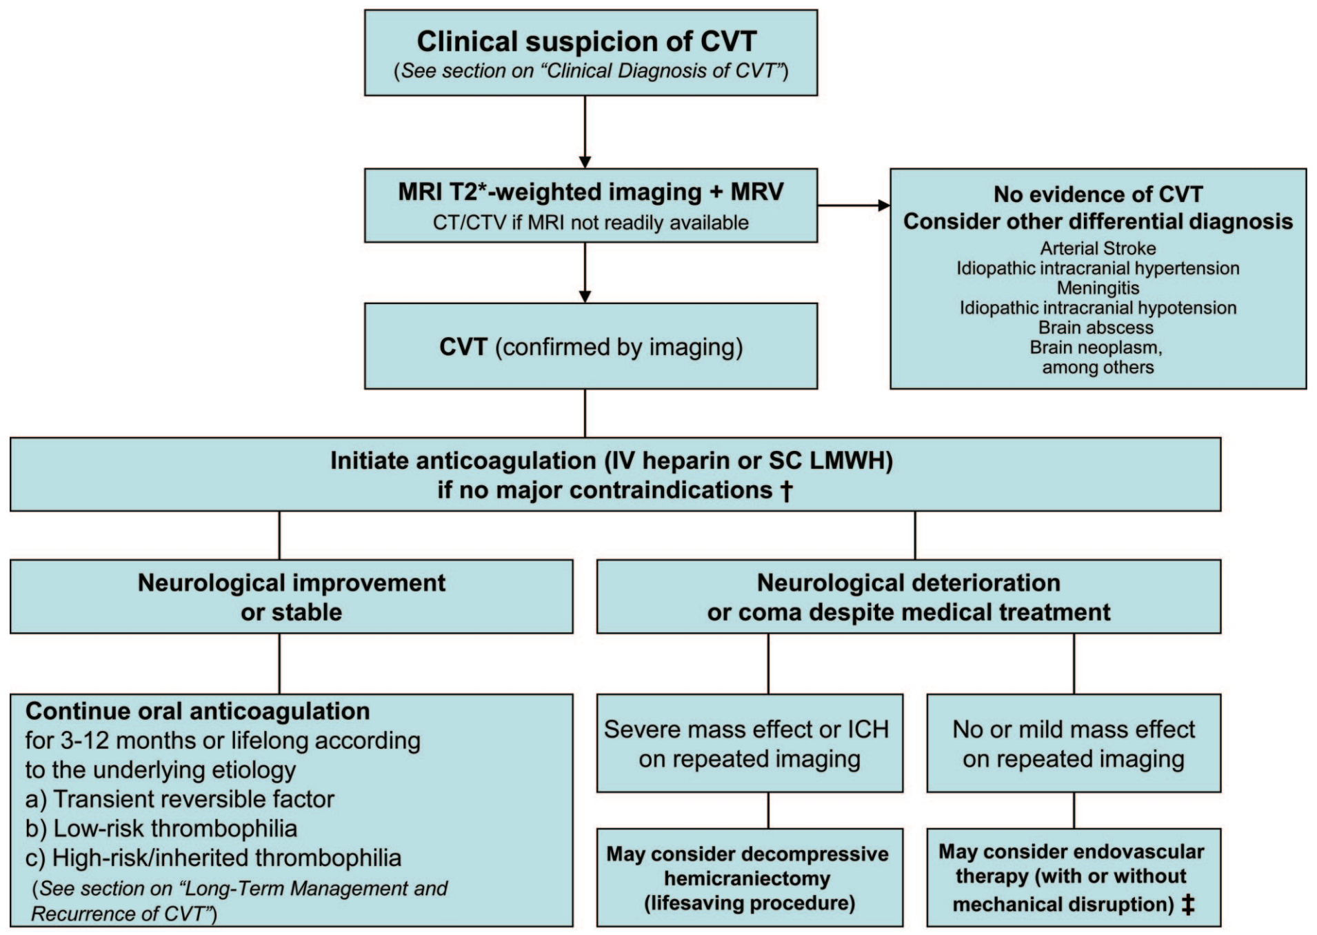
†Intracranial hemorrhage that occurred as the consequence of CVST is not a contraindication for anticoagulation. ‡Endovascular therapy may be considered in patients with absolute contraindications for anticoagulation therapy or failure of initial therapeutic doses of anticoagulant therapy.

Medical
- Hydration!
- Anticoagulation in therapeutic doses ASAP (heparin → warfarin INR goal of 2-3) even if hemorrhagic infarction is present!!!!!!
  - LMWH may be preferable to unfractionated heparin.
  - duration: for unprovoked thromboses - 6-12 months → reimage and decide for continued anticoagulation; if patient is prothrombotic, duration is indefinite.
  - may be followed with aspirin (role unclear).

AHA/ASA Scientific Statement on Cerebral Venous Thrombosis (2011):
- initial anticoagulation with adjusted-dose UFH or weight-based LMWH in full anticoagulant doses is reasonable, followed by vitamin K antagonists, regardless of the presence of ICH (Class IIa; Level of Evidence B).
- in patients with provoked CVT (associated with a transient risk factor), vitamin K antagonists may be continued for 3-6 months, with a target INR of 2.0-3.0 (Class IIb; Level of Evidence C).
- in patients with unprovoked CVT, vitamin K antagonists may be continued for 6-12 months, with a target INR of 2.0-3.0 (Class IIb; Level of Evidence C).
- for patients with recurrent CVT, VTE after CVT, or first CVT with severe thrombophilia indefinite anticoagulation may be considered, with a target INR of 2.0-3.0 (Class IIb; Level of Evidence C).

CVT during pregnancy
AHA/ASA Scientific Statement on Cerebral Venous Thrombosis (2011):
- treat with full-dose LMWH rather than UFH (Class IIa; Level of Evidence C).
- LMWH in full anticoagulant doses should be continued throughout pregnancy, and LMWH or vitamin K antagonist with a target INR of 2.0-3.0 should be continued for at least 6 weeks postpartum (for a total minimum duration of therapy of 6 months) (Class I; Level of Evidence C).
- future pregnancy is not contraindicated (Class IIa; Level of Evidence B); prophylaxis with LMWH during future pregnancies and the postpartum period is probably recommended (Class IIa; Level of Evidence C).

- Antibiotics for septic thrombosis (empirically start with antistaphylococcal a/b).
for cavernous sinus thrombosis - nafcillin or vancomycin + metronidazole + 3rd-generation cephalosporin.

- Supportive treatment similar to arterial stroke (esp. reducing ICP, anticonvulsants*).
*routine seizure prophylaxis is not recommended (Class III; Level of Evidence C)

AHA/ASA Scientific Statement on Cerebral Venous Thrombosis (2011):
- In patients with increased ICP, it is reasonable to initiate acetazolamide. Other therapies (lumbar puncture, optic nerve decompression, or shunts) can be effective if there is progressive visual loss. (Class IIa; Level of Evidence C).
- given the frequency of epileptic seizures in children with an acute CVT, continuous EEG may be considered for individuals who are unconscious or mechanically ventilated (Class IIb; Level of Evidence C).

Thrombolysis at present is limited to specialized centers but should be considered for patients with significant deteriorating deficits.
  - all studies concerning use of thrombolytics in CVT involve intrasinus administration - either direct instillation into sinus (at time of surgery) or use of microcatheters to reach venous sinus; i.e. no data about systemic IV effects for CVT.

- recent report describes use of rheolytic catheter device - delivers 6 high-velocity saline jets through halo device at catheter tip → Bernoulli effect breaks up thrombus; particulate debris is directed into effluent lumen for collection into disposable bag.

AHA/ASA Scientific Statement on Cerebral Venous Thrombosis (2011):
steroids are not recommended, even in the presence of parenchymal brain lesions on CT/MRI, unless needed for another underlying disease (Class III; Level of Evidence B)
- steroids (may have a role in CVT by decreasing vasogenic edema, but steroids may enhance hypercoagulability) cause 4.8-fold increased odds of death or dependence (95% CI 1.2 to 19.8).

Surgical
AHA/ASA Scientific Statement on Cerebral Venous Thrombosis (2011):
- endovascular intervention may be considered if deterioration occurs despite intensive anticoagulation treatment (Class IIb; Level of Evidence C).
- in patients with neurological deterioration due to severe mass effect or intracranial hemorrhage causing intractable intracranial hypertension, decompressive hemicraniectomy may be considered (Class IIb; Level of Evidence C).

open thrombectomy and local thrombolytic therapy – salvage therapy only for severe neurological deterioration* (despite adequate anticoagulation).
*e.g. comatose with papilledema
- surgery is indicated for septic thrombosis if no response to antibiotics in 24 h – remove infected bone (e.g. mastoidectomy), expose and drain sinus; ligate jugular vein (for lateral sinus thrombosis).

Prognosis
Mortality:
untreated cases – 13.8-48%;
treated cases – 12.5% (7% in acute phase, 1% during one year follow-up).
Full recovery:
untreated cases – 29%;
treated cases – 62.5%.
Morbidity:
episodic headaches 11-30%
seizures 8.8-10%
pyramidal signs 11.7%
visual deficits 5.9%
aphasia 9%
memory deficit and depression 17.6%.

- some spontaneously recanalize.
- some form dural AVF.
- 59% (esp. males, polycythemia) developed recurrent thrombotic events.
- prognosis is worse in septic thrombosis.

Follow up
AHA/ASA Scientific Statement on Cerebral Venous Thrombosis (2011):
follow-up CTV or MRV at 3 to 6 months after diagnosis is reasonable to assess for recanalization in stable patients (Class IIa; Level of Evidence C).

Bibliography for ch. “Neurovascular Disorders” → follow this link >>

Viktor’s Notes℠ for the Neurosurgery Resident
Please visit website at www.NeurosurgeryResident.net

