Cerebral Vasculopathies

Last updated: April 20, 2019

Reversible cerebral vasoconstriction syndromes (RCVS), s. Call Fleming syndrome 1

Clinical Features 1

Diagnosis 1

Treatment 1

Fibromuscular dysplasia (FMD) 2

Classification 2

Clinical Features 2

Diagnosis 2

Treatment 3

Moyamoya disease (Basal Occlusive Disease with Telangiectasia) 3

Epidemiology 3

Etiology 3

Pathophysiology 4

Clinical Features 4

Diagnosis 4

Treatment 7

Medical Therapy 7

Surgery 7

Follow up 8

Prognosis 8

Cerebral Autosomal Dominant Arteriopathy with Subcortical Infarcts and Leukoencephalopathy (CADASIL) 8

Clinical Features 8

Diagnosis 9

Treatment 9

Cerebral Vasculitis 10

Systemic Arteritides 10

Granulomatous angiitis of nervous system (GANS) 10

Reversible cerebral vasoconstriction syndromes (RCVS), s. Call Fleming syndrome

- multifocal segmental vasoconstrictions

Clinical Features

* recurrent acute severe headaches (thunderclap headaches).
* > 50% report prior use of vasoconstrictive substances (cocaine, marijuana, nasal decongestants, ergot derivatives, SSRls, interferon, nicotine patches) sometimes combined with binge drinking.
* may also occur postpartum.
* complications (24% patients):

1. during 1st week: SAH, ICH, seizures, reversible posterior leukoencephalopathy syndrome
2. during 2nd week: ischemic events (TIA, CVA)

Diagnosis

* string of beads appearance on angiography of cerebral vessels that usually clears in 1-3 months.

Algorithm of Diagnosis and Treatment of Thunderclap Headache.

*CCB: Calcium-channel blockers; CSF: Cerebrospinal fluid; CT: Computed tomography; ia.: Intra-arterial; iv.: Intravenous; MRA: Magnetic resonance angiography; MRV: Magnetic resonance venography; RCVS: Reversible cerebral vasoconstriction syndromes; SAH: Subarachnoid hemorrhage; TCCS: Transcranial color-coded sonography; TCH: Thunderclap headache.*

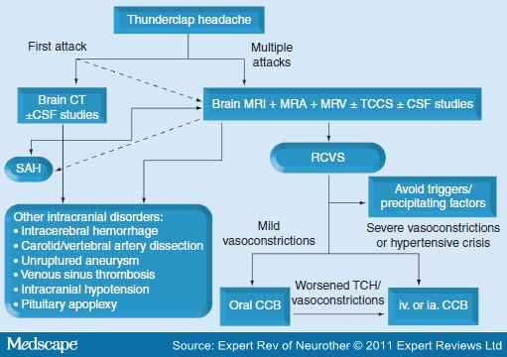

(A) Multi-focal segmental vasoconstrictions and (B) their normalization in a patient with reversible cerebral vasoconstriction syndrome (vasoconstrictions are indicated by black arrows):

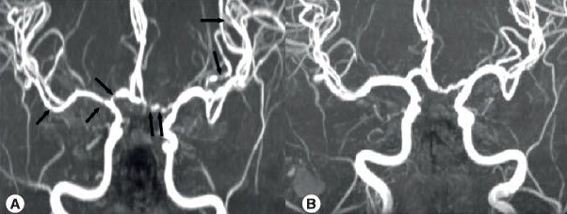

Treatment

**Calcium-channel blockers**:

nimodipine - effective in aborting headaches in 64–83% of patients; oral (30–60 mg every 4 h) or intravenous (0.5–2 mg/h).

nicardipine, verapmil - effective in case reports.

* uncertain how long the therapy should be maintained - the risks of ischemic stroke or PRES outlast headache resolution - maintenance therapy beyond headache resolution is warranted.

Harmful medications:

1. **glucocorticoids** - independent predictors of a poor outcome - use is not recommended.
2. **indomethacin** might cause reversible cerebral vasoconstriction phenomena

Fibromuscular dysplasia (FMD)

Fibrous dysplastic tissue (fibroplasia) + smooth muscle proliferation* → areas of segmental arterial narrowing (nonatherosclerotic, noninflammatory).

*alternates with rings of medial thinning

* rare condition.
* females : males = 9 : 1
* affects *one ÷ all three layers in arterial walls* (most commonly – media).
* both extracranial and intracranial large arteries (esp. bilateral ICAs at level of C2 vertebra rarely extending above skull base; vs. origin of vessels in atherosclerotic narrowing).
* produces ischemia (both by hemodynamic effects and by thromboembolism).
* frequent (20-50%) association with intracranial ***aneurysms*** (FMD is often found during SAH evaluation).
* may cause ***arterial dissections*** (risky angiography!!!)

Classification

FMD is classified histologically into three categories according to which arterial wall layer is affected (media, intima, or adventitia)

* + 1. 85% of FMD cases - **type 1** - medial fibroplasia; media has alternating thin and very thick areas formed by concentric rings of fibrous proliferations and smooth muscle hyperplasia; inflammatory cells are absent.
    2. 10% of FMD cases - **type 2** - intimal fibroplasia → focal band-like and smooth long-segment narrowings; the intima is markedly thickened by circumferential or eccentric collagen deposition; the internal elastic lamina is fragmented.
    3. 5% of FMD cases - **type 3** - adventitial (periarterial) fibroplasia → dense collagen replaces the delicate fibrous tissue of the adventitia and may infiltrate the adjacent periarterial tissues; lipid and inflammatory components arc absent.

Type 1 – alternating areas of constriction and dilatation.

Type 2 – tubular stenosis.

Type 3 – focal corrugations ± diverticulum.

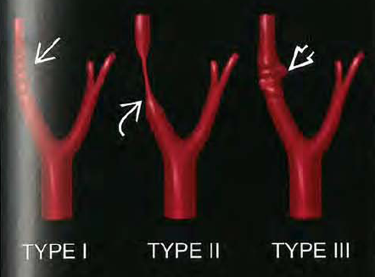

Clinical Features

* commonly found in middle-aged women.
* most often ***asymptomatic*** carotid bruit.
* may present as **TIA** / **stroke** without any evident compromise of vascular lumen (possibly due to *functional constriction*).
* common (75%) involvement of renal arteries → **renovascular hypertension**! (renal artery bruit).
* FMD may remain stable (good long-term prognosis), but form seen in renal arteries can progress in 35% patients.

Diagnosis

|  |  |
| --- | --- |
| * **arteriography** - multiple rings of *constricting fibromuscular bands* alternating with dilatation (“string-of-beads” appearance). | D:\Viktoro\Neuroscience\Vas. Vascular\00. Pictures\FMD (angiography).jpg |
| **Image renal arteries!!!** |  |

Treatment

* stroke recurrence is quite low, even with no therapy.
* antiplatelets / anticoagulants, bypass surgery / surgical dilatation.

Moyamoya disease (Basal Occlusive Disease with Telangiectasia)

(“something hazy, like puff of smoke”)

- **chronic progressive noninflammatory nonatherosclerotic stenosis (up to occlusion)** of intracranial terminal ICAs, proximal ACAs and MCAs* → simultaneous development of compensatory ***collateral network*** through basal ***perforating*** (lenticulostriate) branches (**“moyamoya” vessels**) + ***meningeal*** (transdural) anastomoses between cortical MCA branches and scalp ECA arteries (**“rete mirabile” aka “vault moyamoya” vessels**).

*rarely, in advanced cases, can involve posterior circulation

* first reported by Takeuchi and Shimizu in 1957

Epidemiology

* identified in patients worldwide.
* all ethnic backgrounds (historically considered more prevalent in Asian population)
* most common pediatric cerebrovascular disease in Japan.
* bimodal age distribution (may not be same disease) - **pediatric** (1st decade, mean 3 years) and **young adults** (4th decade)
* females : males = 1.8-2:1
* relative incidences in USA:

whites – 1

Asian Americans – 4

African Americans – 2

Hispanic Americans – 0.5

Etiology

- complex interplay between genetic predisposition and external stimuli**.**

* ***autosomal dominant with incomplete penetrance*** (depends on age and genomic imprinting) - suspected gene locus - 17q25.3
* familial cases in Japan 7-12%, in USA 6%

**moyamoya disease** (66%) - idiopathic cases with no known risk factors.

**moyamoya syndrome (“quasi-moyamoya disease”)** - cases with well-recognized associated condition.

* to have moyamoya disease, patients must have bilateral stenosis (patients with only unilateral findings have moyamoya syndrome).

Associated Conditions

1. **Radiotherapy** of head or neck (especially for optic gliomas, craniopharyngiomas, and pituitary tumors)
2. **Neurofibromatosis** type 1
3. **Sickle cell** anemia!!!
4. Down syndrome
5. Asian race
6. Meningitis (esp. tbc, leptospirosis)
7. Medulloblastoma with Gorlin's syndrome
8. Hematologic: ALL (intrathecal chemotherapy), spherocytosis, ITP
9. Congenital cardiac anomaly, previously operated
10. Renal artery stenosis
11. Giant cervicofacial hemangiomas
12. Shunted hydrocephalus
13. Idiopathic hypertension requiring medication
14. Hyperthyroidism (with Graves’ syndrome)
15. Retinitis pigmentosa

Classification

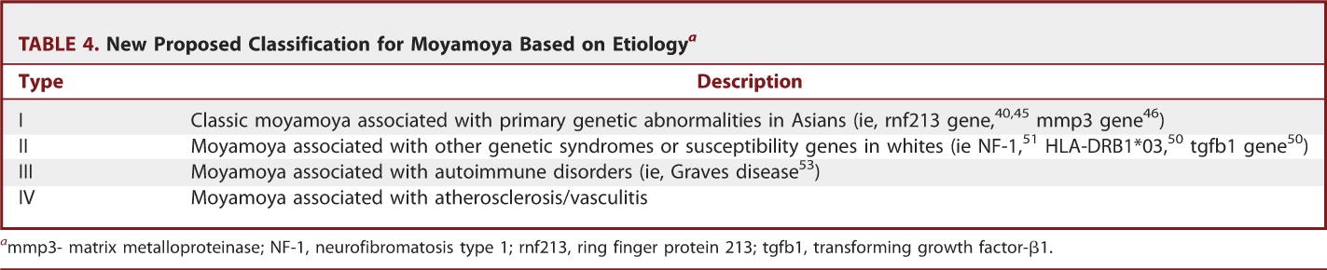

Pathophysiology

- different mechanisms underlying final common carotid arteriopathy and collateral development.

* intimal thickening + smooth muscle hyperplasia + luminal thrombosis → vessel occlusion

*Affected vessels do not exhibit arteriosclerotic or inflammatory changes!*

* some studies show elevated **basic fibroblast growth factor** in dura and scalp arteries
* associated **aneurysms** are common*:

*frequency of aneurysms in vertebrobasilar system is 62% (much higher than in general population)

**type 1** - in usual sites of aneurysms in circle of Willis

**type 2** - in peripheral portions of cerebral arteries (e.g. posterior/anterior choroidal, Heubner's)

**type 3** - within moyamoya vessels.

* may also involve heart, kidneys (systemic vascular disorder?)

A. Gross pathology - narrowing of junction of ICA and MCA (*arrowhead*).

B. Hyperproliferation (*asterisk*) of vessel wall components + abundant intraluminal thrombus (>).



[Source of picture: H. Richard Winn “Youmans Neurological Surgery”, 6th ed. (2011); Saunders; ISBN-13: 978-1416053163 >>](http://www.amazon.com/gp/product/1416053166)

Clinical Features

Symptoms at Initial Evaluation:

1. Stroke (67.8%)
2. Transient ischemic attacks (43.4%)
3. Seizures (6.3%)
4. Headache (6.3%)
5. Choreiform movements (4.2%)
6. Incidental 6 (4.2%)
7. Intraventricular or intracerebral bleeding (2.8%)

Cerebral Ischemia

- typical presentation of **pediatric** cases (81% of children present with ischemia – 41% with TIAs, 40% with actual stroke)

* TIAs may alternate sides (***alternating hemiplegia*** is suggestive clinical finding)
* 6% of all strokes in children (50% of patients are < 10 years)
* less developed verbal skills in children → delayed recognition of underlying moyamoya
* cognitive impairment particularly problematic in younger patients - not able to articulate their experiences - mistaken for psychiatric illness or developmental delay
* precipitating factors:

1. **hyperventilation** in children with crying or exertion or blowing wind instruments → cerebral vessels, already maximally dilated in setting of chronic ischemia, constrict in response to pCO2 decrease
2. **dehydration** in children after colds or fevers.

Hemorrhage

- hallmark of **adult** moyamoya (60% of adults present with hemorrhage)

* rupture of **fragile perforating “moyamoya” vessels** (unable to contain increased flow shunted from progressive ICA stenosis) → intraventricular, intraparenchymal (thalamus, basal ganglia, deep white matter) bleeds
* rupture of **fragile meningeal “rete mirabile” vessels** → SAH
* **aneurysms** in circle of Willis → SAH.

Seizures

Headache

- result of dural irritation from dilated leptomeningeal collaterals

* very common in kids
* typically, headache is migraine-like and refractory to medical therapies.
* often persists years after other symptoms remit postoperatively.

Choreiform movements

- form collateral vessels in basal ganglia

Diagnosis

Any child with new cerebral ischemia has moyamoya until proved otherwise!

CT

* ***hemorrhage*** or small areas of ***stroke***
* ischemia (multiple hypodense areas) involve cortical watershed zones, deep white matter, periventricular regions (but not basal ganglia!!!)

MRI

* acute infarction - best seen with DWI
* chronic infarction - better demonstrated on T1 and T2
* diminished cortical blood flow - linear high signal following sulcal pattern (“ivy” sign) on FLAIR sequences.
* reduced flow voids in ICA, MCA, and ACA + prominent flow voids in basal ganglia - diagnostic of moyamoya!

T1 (A) and T2 (B) - cortical atrophy, old infarcts, and flow void signals resulting from basal collaterals (*arrowheads*).

C. FLAIR - “ivy sign” (*arrowhead*) consistent with bilateral ischemia.



[Source of picture: H. Richard Winn “Youmans Neurological Surgery”, 6th ed. (2011); Saunders; ISBN-13: 978-1416053163 >>](http://www.amazon.com/gp/product/1416053166)

Angiography

- crucial surgical planning data - should be performed in all patients

* all four vessels and ECA injections.
* patient well hydrated!!!

Stages by Suzuki and Takaku:

**Stage 1**: Narrowing of carotid fork (stenosis of suprasellar ICA).

**Stage 2**: Initiation of "moyamoya vessels"; dilatation of intracerebral main arteries.

**Stage 3**: Intensification of "moyamoya vessels"; non-filling of anterior and middle cerebral arteries ↑ most common stage at time of diagnosis

3a: partial non-filling of anterior and middle cerebral arteries.

3b: partial preservation of anterior and middle cerebral arteries.

3c: complete lack of anterior and middle cerebral arteries.

**Stage 4**: Minimization of "moyamoya vessels"; disappearance of PCA; meningeal collaterals start to appear.

**Stage 5**: Reduction of "moyamoya vessels"; main arteries arising from ICA disappear.

**Stage 6**: Disappearance of "moyamoya vessels"; original moyamoya vessels at brain base completely missing, and only collateral circulation from ECA is seen.

Notes:

* in stages 1 and 6, there is no moyamoya vessels on angiography, which are not moyamoya disease by definition.
* doubt there is really vascular dilatation in stage 2.
* progression of stages is commonly observed in children, but in adults many patients often remain in same stages.

Stenosis of distal ICA (*arrowhead*), diminished filling of middle and anterior cerebral artery branches, and proliferation of collateral vessels, “puff of (cigarette) smoke”:



[Source of picture: H. Richard Winn “Youmans Neurological Surgery”, 6th ed. (2011); Saunders; ISBN-13: 978-1416053163 >>](http://www.amazon.com/gp/product/1416053166)

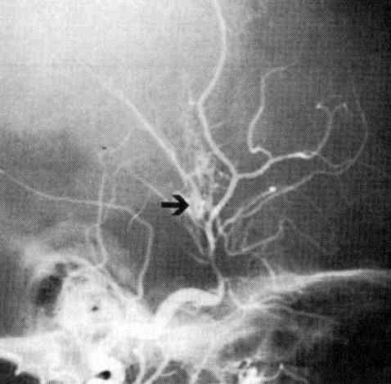

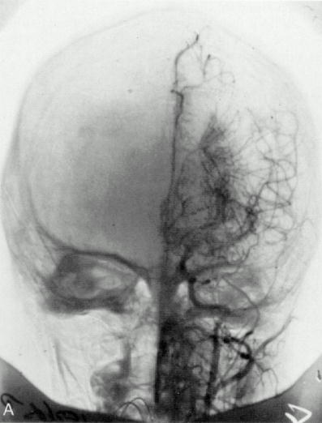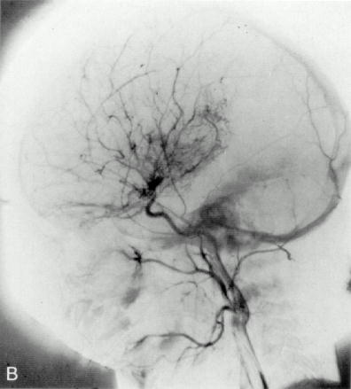

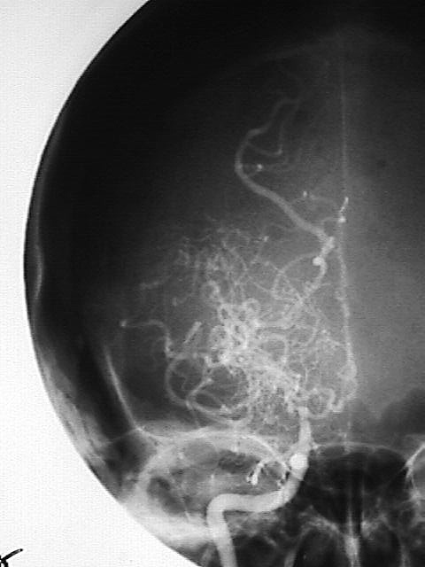

EEG

- specific findings only in *pediatric* patients:

1. posterior or centrotemporal slowing
2. **hyperventilation** (maneuver not recommended in moyamoya patient) produces normal diffuse buildup of monophasic slow waves (delta-bursts) that return to normal within 20-60 seconds after hyperventilation; in > 50% of cases, after or sometimes continuous with buildup is second phase of slow waves (characteristic finding is called "rebuildup") which are more irregular and slower than the earlier waves, and usually normalize in ≤ 10 minutes

Cerebral blood flow studies

(TCD, perfusion CT, Xe-133 CT, positron emission tomography, MR perfusion, SPECT with acetazolamide*) - some clinicians incorporate into treatment algorithms for children.

*causes ***vasodilatation*** - evaluates CBF reserve - can identify areas of "steal" (blood flow gets diverted from already maximally dilated vessels - CBF drops with difference > 30%) which are at high risk of future infarction

* CBF is decreased in children, but relatively normal in adults.
* there is shift of CBF from frontal to occipital lobes (reflecting increasing dependency of CBF on posterior circulation)

Treatment

- to prevent strokes (cannot reverse primary disease process, cannot decrease risk of hemorrhage).

Medical Therapy

* **antiplatelet agents** – to prevent emboli from sites of arterial stenosis; anticoagulants are rarely used.
* **calcium channel blockers** – help with intractable headache, reduce both frequency and severity of refractory TIA; caution to avoid hypotension.
* 38% moyamoya patients who were initially treated medically subsequently required surgery as result of progressive symptoms.
* patient with TIA

1. intravenous **hydration** (usually at 1 to 1.5 times maintenance),
2. supplemental **oxygen** (avoid hyperventilation)
3. emergency imaging; no hemorrhage → **antiplatelet agents** (aspirin 325 mg for adults and ≤ 81 mg for preteen children).

Surgery

- to prevent ischemia (benefit on reducing rate of hemorrhage is unproven)

*Arteriopathy of moyamoya involves ICA while sparing ECA!!!*

All patients with documented moyamoya should be considered operative candidates**!**

* prerequisites:

1. ≥ 2 months after most recent attack (elective surgery!)
2. good neurologic condition
3. infarction < 2 cm on CT, all previous hemorrhages completely resolved
4. angiographic stage is II-IV

Anesthetic Management

* ***avoid hyperventilation*** (!!!) and crying in children; end-tidal CO2 is maintained 36-42 mmHg.
* intraoperative EEG monitoring on all patients (if any significant changes on EEG occur as initial side is operated on, surgery on contralateral hemisphere is postponed).
* anesthesia is maintained with low-dose isoflurane (cerebral vasodilator) and balanced nitrous oxide/oxygen mixture with fentanyl.
* **mannitol** and **furosemide** are unnecessary and risky!!! (dehydration → hypotension).

No mannitol for craniotomy!

Direct revascularization

- branch of ECA (usually superficial temporal artery) is divided and anastomosed to cortical artery (usually distal branch of MCA) - **STA-MCA bypass**.

* immediate restoration of blood supply – better results
* traditionally, have been used in adults (technically difficult in children < 15 years - ***cut off vessel size ≈ 1 mm***)
* cerebral hyperperfusion is potential complication – SBP must be strictly controlled < 130 mmHg; IV minocycline (200 mg/day) might be preventive.

Indirect revascularization

- mobilizing **vascularized tissue supplied by ECA** (dura, muscle, omentum, pedicles of STA) and placing it in contact with brain to facilitate ingrowth of new vessels to cortex.

* numerous variations exist for MCA territory:

1. encephaloduroarteriosynangiosis (EDAS) – ***treatment of choice*** – suturing STA with galeal cuff to linear defect created in dura.
2. encephalomyoarteriosynangiosis (EMAS) – laying temporalis muscle on brain surface (drawback: muscle contractions during talking / chewing → neural impulses to cortex – may cause seizures)
3. pial synangiosis
4. omental transposition (either as pedicle graft or as vascularized free flap) - higher potential to revascularize ischemic tissue than above procedures, but there is greater risk of mass effect

* options for non-MCA territories:

1. simply drilling bur holes with opening of underlying dura and arachnoid
2. "ribbon EDAS" - pedicle of galea is inserted into interhemispheric fissure on both sides
3. stellate ganglionectomy and perivascular sympathectomy (unproven that this increases CBF permanently)

* protection from ischemia is delayed for several weeks.
* may be combined with STA-MCA bypass.
* successful in children and adults:

4% risk for stroke within 30 days of surgery per hemisphere

96% probability of remaining stroke free over 5-year follow-up

Pial synangiosis

1. Course of superficial temporal artery (STA) is mapped with Doppler ultrasound.
2. STA is dissected free from surrounding tissue, with pedicle of areolar tissue and galea left on its undersurface.
3. Craniotomy is performed with stellate dural opening.
4. Arachnoid is opened widely and STA is affixed to cortex with interrupted 10-0 nylon suture.



[Source of picture: H. Richard Winn “Youmans Neurological Surgery”, 6th ed. (2011); Saunders; ISBN-13: 978-1416053163 >>](http://www.amazon.com/gp/product/1416053166)

Combined

- both direct and indirect revascularization each play an important role in postsurgical revascularization:

* early after surgery, direct bypass plays a dominant role because indirect revascularization can take up to 3 months for neovascularization to mature between the extracranial and intracranial vasculature.
* over long term, collaterals secondary to indirect processes could play a more dominant role and improve perfusion to areas of the brain that blood flow could not reach via direct bypass.
* incidences of symptomatic hemorrhage and infarction in operated hemispheres are 0.4% and 0.2% annually.

Postoperative Care

Avoid hypotension*, hypertension**, hypovolemia, hyperthermia, hypocapnia!

*may lead to graft occlusion

**may cause bleeding

* crying and hyperventilation can lower PaCO2 → ischemia (H: painless wound-dressing techniques, closure of wound with absorbable suture)
* **intravenous fluids** at 1.25-1.5 times normal maintenance rate for 48-72 hours.
* start aspirin on POD # 1

Follow up

* **angiography** 2-6 months postop → annual **MRI** for several years

Postoperative angiograms (1 year) after treatment of moyamoya disease by pial synangiosis; internal (A) and external (B) carotid injections. Note abundant filling of MCA territory resulting from surgical treatment (*white shaded area*), in contrast to small region of cortex perfused by internal carotid artery (red shaded area).



[Source of picture: H. Richard Winn “Youmans Neurological Surgery”, 6th ed. (2011); Saunders; ISBN-13: 978-1416053163 >>](http://www.amazon.com/gp/product/1416053166)

Prognosis

* patients can have isolated problems with lengthy periods of relative health or can exhibit fulminant deterioration in very short time.

Untreated cases:

* inevitably progresses in 20-66% of untreated patients (vs. only 2.6% after surgical treatment); progression is more likely to occur rapidly and more frequently in younger patients, females.
* untreated cases → 73% develop major deficit or death within 2 years of diagnosis.

H: early diagnosis → prompt treatment of even asymptomatic cases (58% patients will have good prognosis)

Cerebral Autosomal Dominant Arteriopathy with Subcortical Infarcts and Leukoencephalopathy (CADASIL)

* mapped to chromosome 19q12 (large gene *Notch3*, that belongs to family of genes involved in specification of cell fate during development).
* pathology - media (of leptomeningeal and perforating arteries) is thickened by ***eosinophilic granular material*** (of unknown origin) within smooth muscle cells.
* no hypertension or other cerebrovascular risk factors!

Clinical Features

Begins in middle adult life (mean – 45 yrs):

* **vascular presentation** - ***recurrent subcortical ischemic events*** (lacunar TIAs < lacunar strokes).
* **other symptoms** - progressive or stepwise ***subcortical*** ***dementia*** with pseudobulbar palsy, ***migraine*** with aura (30%), ***depression***.

Diagnosis

**MRI** (even before clinical onset): multiple deep white matter infarctions + extensive areas of diffuse increased T2 signals in subcortical white matter and basal ganglia.

Treatment

- no specific treatment is currently available.

Cerebral Vasculitis

Systemic Arteritides

- heterogeneous group of inflammatory diseases:

* + 1. Polyarteritis nodosa
    2. Sjögren disease
    3. SLE
    4. Giant cell arteritis

Other causes of cerebral vasculitis – infection (e.g. septic emboli, meningovascular neurosyphilis), malignancy, radiotherapy, cocaine ingestion.

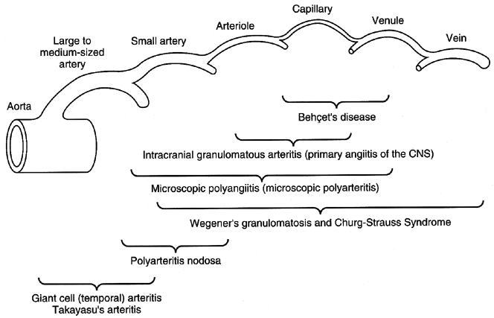

* all involve some **deposition** of humoral and cellular *immune complexes* and **infiltration** of *polymorphonuclear* and *mononuclear* cells in blood vessel walls (segmental inflammation).

Clinical Features

* cerebral arteritis becomes symptomatic after systemic (peripheral) manifestations have been present - (multi)focal cerebral ischemia:
  + - 1. **acute** - platelet aggregation and/or clot formation
      2. **chronic** - through fibrinoid necrosis.
* **cognitive disturbances**, **headache**, **seizures** (encephalopathy) - occur more frequently than *focal neurologic dysfunction*.
* frequently produce *polyneuropathies*.

Diagnosis

Definitive diagnosis - **biopsy**

* mainly smaller parenchymal and leptomeningeal vessels - ***high-resolution angiography*** is far superior to MRA / CTA (but even angiograms may appear normal in 20-30% cases)

Features on angiography (nonspecific) - stenoses, occlusion, thromboses, beaded appearance

* brain / meningeal ***biopsy*** is necessary to make definitive and specific diagnosis! (segmental pathology – risk of sampling error)

**Arteritis caused by septic cardiac emboli:**

A. Carotid arteriogram - filling defect (*arrow*), many vessels are irregular and underfilled, MCA bears mycotic aneurysm (*double arrows*).

B. Beaded appearance of cortical arteries (*arrows*).

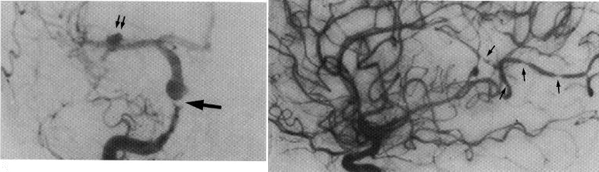

Granulomatous angiitis of nervous system (GANS)

number of synonyms: Primary CNS vasculitis, Primary Angiitis of CNS, Intracranial Granulomatous Arteritis, Noninfectious Granulomatous Angiitis with Predilection for CNS

- rare inflammatory arteriopathy confined to brain, spinal cord, and leptomeninges.

Etiopathology

* absence of systemic disease!
* ***small leptomeningeal arteries*** are preferentially affected.
* no predilection for branching points of arteries (vs. polyarteritis nodosa).
* arterial wall **inflammatory infiltration** with mononuclears (monocytes/histiocytes, lymphocytes, and plasma cells); frequently (85%), granulomatous changes with multinucleated giant cells are seen; destruction of vessel wall.
* numerous small infarctions ± large areas of ischemia, sometimes with superimposed hemorrhage.
* etiology is unknown (viral cause?); no evidence of immune complexes; no identifiable preexisting conditions; postpartum cases described.

Clinical Features

* mean age 33-45 yrs. (range 3-74 yrs).
* no systemic symptoms! - clinical manifestations are restricted to brain!
* subacute or insidious; progressive; may fluctuate with periods of apparent remission.
* prognosis is guarded (better in postpartum cases; poor and devastating if untreated).

Multifocal brain disease with obtundation, severe headaches, and no discernible systemic cause

1. **Diffuse cerebral dysfunction**:
   1. ***headache*** of gradual onset (most common presenting symptom!; often associated with nausea and vomiting)
   2. ***progressive encephalopathy*** *- mental obtundation* (may be preceded by *dementia*).
2. Later, **focal cerebral signs** develop (e.g. cranial neuropathies, seizures, cerebellar dysfunction, cauda equina syndrome); strokes are found in 15% cases.

* *isolated cord involvement* has been noted in few patients.

Differential Diagnosis

- lesions with frequency significantly higher than CNS vasculitis:

1. **Intracranial atherosclerosis** - involvement of proximal, medium to large-sized vessels with sparing of cortical vessels
2. **Amyloid angiopathy**
3. **Reversible cerebral vasoconstriction syndrome (RCVS)** – sudden onset, diffuse areas of vasospasm (improvement with intra-arterial calcium channel blockers)
4. **Wegener's granulomatosis** - pulmonary lesions.
5. **Giant cell (temporal) arteritis** - occurs in older population.
6. **Infections** (mycobacteria, fungi, meningovascular syphilis, hepatitis B, herpes ophthalmicus!).
7. **Drugs** (esp. stimulants)
8. **Noninflammatory vasculopathies** (fibromuscular dysplasia, moyamoya)
9. **Neoplastic** meningitis, intravascular lymphoma
10. **Neurosarcoidosis**
11. **Multiple sclerosis**

Diagnosis

**ESR**↑ (66%) ≈ 44 mm/hr (up to 116 mm/hr) but may be normal!

**CSF** (81%) - ***chronic meningitis***: mixed or lymphocytic pleocytosis (up to 500), protein↑ (> 100 mg/dl in 45-75% cases, up to 825 mg/dl), normal glucose.

* serial LPs may show spontaneous fluctuations in pleocytosis and protein.

**EEG** (81%) - *diffuse slowing*; occasionally, focal slowing or sharp wave discharges.

**CT** – normal, low-density lesions, infarcts, gyriform enhancement, hematoma.

**MRI** - focal *infarctions in multiple vascular territories* (normal MRI is rare, but have been seen in some biopsy-proven cases).

**Angiography** (with high-resolution film magnification - changes in *small-caliber vessels*):

1. "classic arteritis" (65%) - *alternating areas of stenosis and ectasia* ("sausaging" or "beading") *in multiple small vessels*.*

N.B. not completely specific (also seen in other vasculopathies)

*where angiography is not sensitive enough to make diagnosis!

1. less specific abnormalities (19%)
2. normal (13%)

**Leptomeningeal & cortical** **biopsy**

* indication:
  1. normal or atypical angiogram
  2. before highly toxic therapy
* focal nature - significant risk for *sampling error* (diagnostic sensitivity 74.4%).

Treatment

High dose (60-80 mg/day) prednisone + **calcium channel blocker**.

* *good clinical response* → prolonged tapering in few months.
* monitoring - angiography (± repeated biopsies).
* *lack of response* or *recurrence* → add oral cyclophosphamide (1-2 mg/kg/d) for 6-12 months until all signs of disease have disappeared.

Bibliography for ch. “Neurovascular Disorders” → follow this [link >>](http://www.neurosurgeryresident.net/Vas.%20Vascular\Vas.%20Bibliography.pdf)

[Viktor’s Notes℠ for the Neurosurgery Resident](http://www.neurosurgeryresident.net/)

[Please visit website at www.NeurosurgeryResident.net](http://www.neurosurgeryresident.net)