Spinal Hemorrhages, Spinal Vascular Malformations
Last updated: April 20, 2019
Hematomyelia (Spinal Cord Hematoma) 1
Etiology 1
Pathology 1
Clinical Features 1
Diagnosis 1
Treatment 1
Spinal SAH 1
Etiology 1
Clinical Features 2
Diagnosis 2
Treatment 2
Spinal epidural hemorrhage (EDH), Spinal subdural hemorrhage (SDH) 2
Etiology 2
Clinical Features 2
Diagnosis 2
Treatment 3
Spinal Vascular Malformations 3
Dural pathology 3
Intradural pathology 4
Telangiectasias, cavernous malformations 4
Aneurysms 4
Spinal AVMs 4
Etiology 4
Presentations 4
Imaging 4
Surgical treatment 5

Hematomyelia (Spinal Cord Hematoma)
- infrequently encountered condition.

Etiology
Traumatic hematomyelia:
- spinal cord injury (closed or penetrating) – most common cause!
- spinal surgery
- lumbar or C₁₋₂ puncture

Spontaneous (nontraumatic) hematomyelia:
- vascular malformations (most common) - true AVM or angioma.
- coagulopathies
- inflammatory myelitis / vasculitis
- intramedullary tumor
- abscess
- syringomyelia (bleeding into syrinx)
- idiopathic

Pathology
- spinal cord is swollen.
- blood dissects longitudinally (above and below hemorrhage), disrupting gray matter more than white matter.
- with large lesions, extension into subarachnoid space may occur.
- with time, syrinx-like cavity is left.

Clinical Features
Acute painful transverse myelopathy

  - Universal initial symptom - sudden excruciating back / neck pain
- location directly relates to location of underlying pathology and hematoma.

  - Myelopathic deficit directly correlates with hemorrhage region - Brown-Sequard syndrome, central cord syndrome, transection syndrome, conus medullaris syndrome, etc.
- in vascular malformations - deficit occurs suddenly, along with pain, and does not usually increase substantially over time.
- in other etiologies - deficits may lag initial onset of pain by several hours; deficit also may evolve over period of hours (or even days).

Diagnosis
MRI (± gadolinium) – diagnostic procedure of choice for early diagnosis - demonstrates both hematoma and additional underlying pathology.

Spinal angiography – only for suspected vascular malformation.

Treatment
Timing of surgical hematoma drainage:
- urgent need to remove mass effect – aggressive, immediate surgical clot evacuation.
- early exploration damages otherwise viable spinal neurons – wait for plateau of neurologic deficit.

- vascular malformations must undergo surgical extirpation! – to prevent recurrence of hemorrhage.
- medical treatment for cord edema (mannitol, corticosteroids) is unproved.
- correct treatable coagulopathies!

Spinal SAH
< 1% of all SAHs.

Etiology
- Spinal AVM – most common cause!
- Tumor
- Spinal artery aneurysm
- Intracranial aneurysm
- Bleeding diatheses
- Polyarteritis nodosa
- Trauma
- Lumbar puncture

- blood may dissect into spinal cord or along nerve root sheaths.

Clinical Features
  - Sudden, severe, localized* back pain ± radicular pain (e.g. sciatica) ± headache (blood migration into intracranial subarachnoid space)
*spreads rapidly to rest of back and, with cervical lesions, to head
  - Meningismus
  - Compression by blood clot → myelopathy (e.g. Brown-Sequard syndrome, transection syndrome, conus medullaris syndrome, cauda equina syndrome) ± radiculopathy
  - Cranial neuropathies
  - Papilledema

Diagnosis
Principal conditions simulating spinal SAH are herniated disk and aortic dissection.
CT confirms presence of blood in subarachnoid space.
MRI - study of choice for nontraumatic paraplegia or quadriplegia.
Lumbar puncture confirms hemorrhage.
Myelography delineates AVM or tumor while excluding herniated disk.

Treatment
- bed rest.
- surgical resection of vascular malformation, removal of compressive clot.

Spinal epidural hemorrhage (EDH), Spinal subdural hemorrhage (SDH)
- SDH is 2 times more common in women.
- SDH predominates in 6th decade.

- EDH is 4 times more common than SDH.
- EDH is most common (peridural venous plexus > arterial sources):
in cervical region in children;
in dorsal thoracolumbar regions in adults.
- EDH expansion is limited to few vertebral levels.

Etiology
- spontaneous!!!
- trauma (even without bone fracture), spinal surgery, lumbar puncture, epidural anesthesia
- bleeding diatheses
- liver disease with portal hypertension
- epidural vascular malformation

Clinical Features
- compressive symptoms:
- Sudden, severe, localized back pain ± radicular pain
- Compressive myelopathy progressing over hours (e.g. Brown-Sequard syndrome, transection syndrome, conus medullaris syndrome, cauda equina syndrome) ± radiculopathy:
  - hemiparesis / paraparesis / quadriparesis
  - sensory loss below lesion
  - loss of sphincter control

N.B. clinical distinction between EDH and SDH may be impossible.

Diagnosis
- MRI / CT: high-density lesion compressing spinal cord.
- CT is fairly sensitive in lumbar spine (enough epidural fat to provide contrast), but hematomas may be missed in tighter confines of cervical or thoracic spine.

Myelography - extradural mass (in EDH).

Spontaneous upper thoracic epidural hematoma on T2-MRI (white arrowhead) - mixed signal mass (arrow) in posterior epidural space at T₅₋₆ levels displacing forward and compressing spinal cord, which shows increased signal (black arrow):
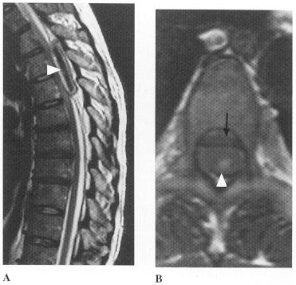

Treatment
- reversal of any underlying clotting disorder → urgent evacuation.
Extrinsic cord compression from any cause is medical emergency and speed matters!
- high-dose methylprednisolone when spinal cord compression is involved.

Spinal Vascular Malformations
- rare, but potentially curable causes of progressive myelopathy!

Dural pathology
Spinal dural AV fistula (s. radiculomeningeal fistula, long dorsal AVM) (type 1 spinal vascular malformation) - most common type! - 80% of spinal vascular malformations) - at dural nerve root sleeve, single spinal radicular artery* develops fistula to single medullary vein** → venous congestion and hypertension*** → spinal cord hypoperfusion (!), hemorrhages (uncommon).
*usually separate from radicular vessels supplying spinal cord
**continues intradurally as single arterialized serpentine vein on dorsal surface of spinal cord; blood flow within this vein is routinely quite slow.
***Batson plexus is valveless - allows arterial fistula to create congestion through entire venous plexus (distribution of abnormally enlarged veins is poor guide to location of fistula)
    - often located below midthoracic level.

Etiology - traumatic (arise in elderly population > 40 yrs).

Symptoms - progressive myelopathy (worsens over extended period of months ÷ years) - progressive leg weakness (gait disturbance), saddle sensory disturbance, bowel / bladder difficulties, pain in distal posterior thoracic region over spine (± painful radiculopathy);
    - activity / change in position may exacerbate symptoms (can be mistaken for spinal stenosis and neurogenic claudication).
    - may have periods of apparent remission with superimposed worsening resembling MS.

Diagnosis – high-resolution MRI with contrast administration, ± CT myelography: enlarged vessels along cord surface.
    - historical approach – angiography.

Dural AV fistula in 54-year-old man with 4-year history of progressive paraparesis (sagittal MRI of thoracic cord):  Left (T2 fast spin-echo): abnormally high signal in central cord (arrowheads); numerous punctate flow voids indent dorsal and ventral spinal cord (arrow) - represent abnormally dilated venous plexus supplied by AV fistula.  Right (T1 post-contrast): multiple, serpentine, enhancing veins (arrows) on ventral and dorsal aspect of thoracic spinal cord - diagnostic of AV fistula. | 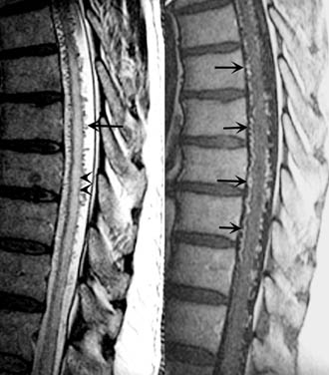
Dural AV fistula (myelography, frontal projection):  1 = intercostal artery;  2 = site of malformation, close to intervertebral foramen, i.e. lateral to spinal cord;  3 = draining veins on spinal cord. | 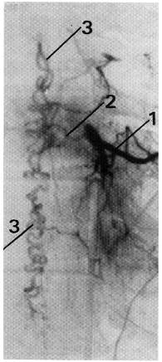

Treatment – surgical resection or angiographic embolization.
    - surgery has excellent results but difficult to find during surgery (H: leave one coil during angiography → use fluoro to localize during open surgery).

Rare extreme form - Foix-Alajouanine syndrome (s. subacute necrotizing myelitis, angiodysgenetic necrotizing myelopathy): spinal venous stasis with abnormally thick, tortuous, hyalinized veins → extensive venous thrombosis with hemorrhagic infarction of cord → rapidly (over weeks) progressive myelopathy (stuttering course – declines and plateaus).
    - anticoagulants or corticosteroids are not effective.

Intradural pathology
Telangiectasias, cavernous malformations
- uncommon and asymptomatic (occasional hemorrhage).
    - surgery has same outcomes as conservative management although surgery eliminates subsequent hemorrhage risk (3.9%/year).

Aneurysms
of spinal arteries - extremely rare.

Spinal AVMs
      - intramedullary (s. glomus, nidus) AVM (type 2 spinal vascular malformation) – tightly compacted group of arterial and venous vessels (nidus) inside short segment of spinal cord; abnormal vessels are intramedullary; at least in many instances, proved to be cavernous angiomas.
      - “juvenile” malformation (type 3 spinal vascular malformation) – resemble classical intracranial AVMs - extensive diffuse AV abnormality of spinal cord parenchyma fed by multiple vessels (can be both intramedullary and extramedullary).
      - intradural extramedullary AVM (type 4 spinal vascular malformation) – on cord surface.

Etiology
- congenital (arise in younger population < 30 yrs) with even distribution throughout spinal cord - upper or lower extremity may be affected (dural AV fistulae - lower limb involvement only).

Presentations
- hemorrhage (!) - intraparenchymal or SAH
- vascular steal phenomenon (rarely) - myeloradiculopathy
- mass effect (rarely)
    - spinal bruit (at rest or after exercise) is suggesting, but its absence does not exclude diagnosis.
    - skin overlying spine may reveal midline cutaneous clues (angioma, lipoma, area of altered pigmentation).

Imaging
CT / MRI - dilated vessels in thecal sac with vasogenic edema in spinal cord (more typically, findings are normal).
Myelography (very sensitive!) - dilated serpiginous vessels in intradural space or just widening of spinal cord; use large volume of contrast, and screen in prone and supine positions.
Arteriography (criterion standard for visualizing AVMs, but not indicated when myelography fails to suggest AVM) - fistula location can be visualized!
- should not be regarded as negative unless: (1) all spinal arteries from foramen magnum to coccyx have been opacified adequately, or (2) veins thought to be abnormal have been opacified and shown to drain normally.
- if lesion is found, adjacent levels also should be injected (advisable to identify major radiculomedullary arteries in same spinal region).
- flush aortography does not result in adequate opacification of relevant vessels, and often will not show these fistulas.

Intradural extramedullary AVM (low thoracic myelogram) - impression of serpiginous vein:  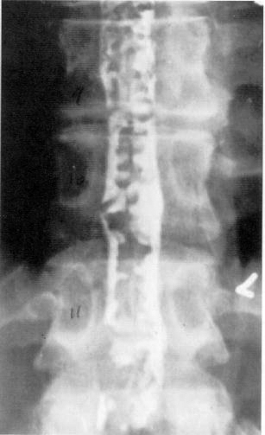 | Intramedullary AVM (myelography - AP (A) and lateral (B) projections): 1 = intercostal artery; 2 = dilated arteria radicularis magna; 3 = enlarged sulcocommissural arteries feeding malformation (4).  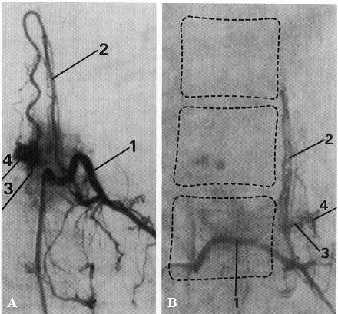

Spinal AVM (T1-weighted (A) and T2-weighted (B) MRI): numerous tubular & saccular low-signal-intensity structures within spinal canal, which demonstrate "flow void" appearance of dilated vessels in subarachnoid and epidural spaces - typical draining veins of AVM nidus:
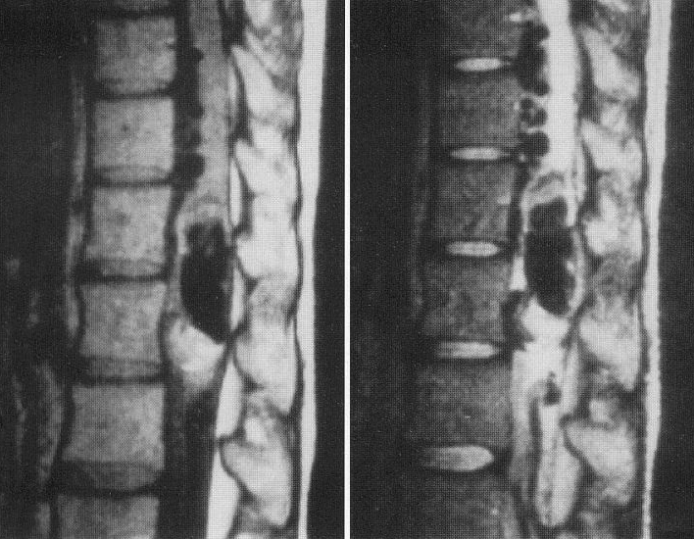

Cobb syndrome (s. cutaneomeningospinal angiomatosis) – spinal cord AVM associated with cutaneous capillary malformation (in same dermatomal distribution on trunk).

Surgical treatment
- early treatment is important if patients are to achieve optimal neurologic outcome.
- glucocorticoids decrease vasogenic edema - may improve neurologic function for short period.

- open surgical ligation (clipping) / resection; in past, practice has been to remove serpentine vein from dorsum of spinal cord, but it is now recognized that this vessel will thrombose if all or even most of radicular fistulous connections have been interrupted.
- endovascular occlusion (embolization or coiling) – preferable for intradural AVMs (esp. if anterior to or within spinal cord and fed by anterior spinal artery).
- stereotactic spinal radiosurgery – investigated.

- general anesthesia with neurophysiological monitoring.
- intraoperative arteriography is mandatory – to locate arterial feeders and draining veins, to confirm closure of AV fistula and nidus excision.

Postoperative neurologic improvement may take several weeks.

Bibliography for ch. “Neurovascular Disorders” → follow this link >>

Viktor’s Notes℠ for the Neurosurgery Resident
Please visit website at www.NeurosurgeryResident.net

