Ischemic Stroke – Treatment, Prevention
Last updated: April 12, 2020
Prehospital Care 1
Hospital Care 2
Supportive Management 2
Initial ED protocol 2
Further Care in Stroke Unit 3
Blood pressure 3
Pathogenetic Treatment 4
Treatments that have not been proven beneficial 4
Systemic Hemodynamics 4
Thrombolysis 4
Inclusion criteria 4
Exclusion criteria 5
Types 6
Procedure 6
Complications 6
Mechanical thrombolysis / thrombectomy / thrombobliteration 7
Indications 7
Contraindications 8
FDA approved embolectomy devices 8
Other 8
Antiaggregants 9
Anticoagulation 9
Heparin 9
Warfarin 10
Steroids 10
Neuroprotective agents 10
Prevention of early ischemic injury 10
Prevention of reperfusion injury 10
Surgical Care 11
Carotid stenosis / occlusion 11
Hemorrhagic transformation 11
Hemispheric stroke (“Malignant MCA stroke”) 11
Clinical features 11
Diagnosis 11
Surgical treatment 12
Conservative treatment 13
Cerebellar infarctions 13
Rehabilitation 14
Prophylaxis 14
Risk factor reduction 14
Prophylactic Surgery 14
Antiplatelet agents 15
Long-term anticoagulation 15
Atherosclerotic intracranial arterial stenosis (s. intracranial stenoocclusive disease) 16
Aggressive medical management 16
Percutaneous transluminal angioplasty and stenting (PTAS) 17
Atherosclerotic extracranial arterial stenosis:
Carotid – see p. Vas7 >>
Vertebral – see p. Vas9 >>

reperfusion + neuroprotection
- to salvage still perfused penumbra neurons (other neurons, after blood flow cessation are dead within 2-3minutes); penumbra will likely die soon from surrounding tissue edema

Prehospital Care
- ABC ± supplemental oxygen.
  - ischemic stroke patient usually maintains airway unless brain stem is affected or significant edema is compressing opposite hemisphere.
- Prehospital stroke assessment tools (e.g. Cincinnati Prehospital Stroke Scale, Los Angeles Prehospital Stroke Scale).
- Establish time of onset (time zero) – when patient was last seen normal (at neurological baseline).
- Transportation to stroke center (unless deficit has existed for several days and is stable) with prearrival notification of stroke teams (allows early mobilization of necessary resources).
N.B. more time in field – less time for definite therapy!
  - if possible, bring witness to help with in hospital history taking.
- Establish IV lines.
- Measure serum [glucose] → administer glucose in hypoglycemic patients; otherwise, glucose containing fluids should be avoided.
- Monitor status.

N.B. no drugs prehospital! (vs. coronary syndromes – aspirin, nitroglycerin, morphine)

N.B. patients at risk for stroke must be educated:
If you experience main warnings of acute ischemic stroke (sudden weakness or numbness on one body side, sudden loss / change of vision, sudden speech difficulty / language comprehension difficulty, sudden dizziness / gait difficulty) that last for 10 minutes → call 911 immediately!

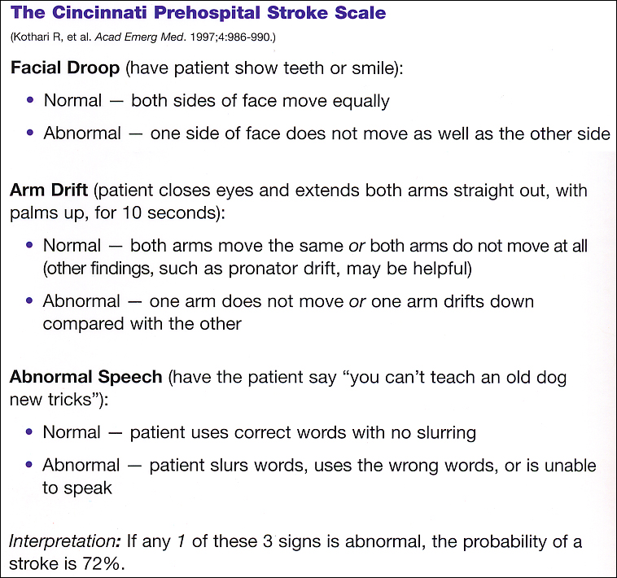

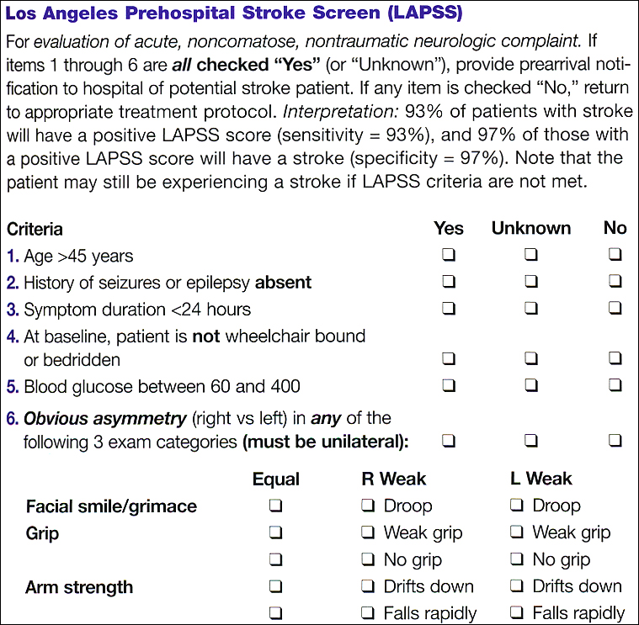

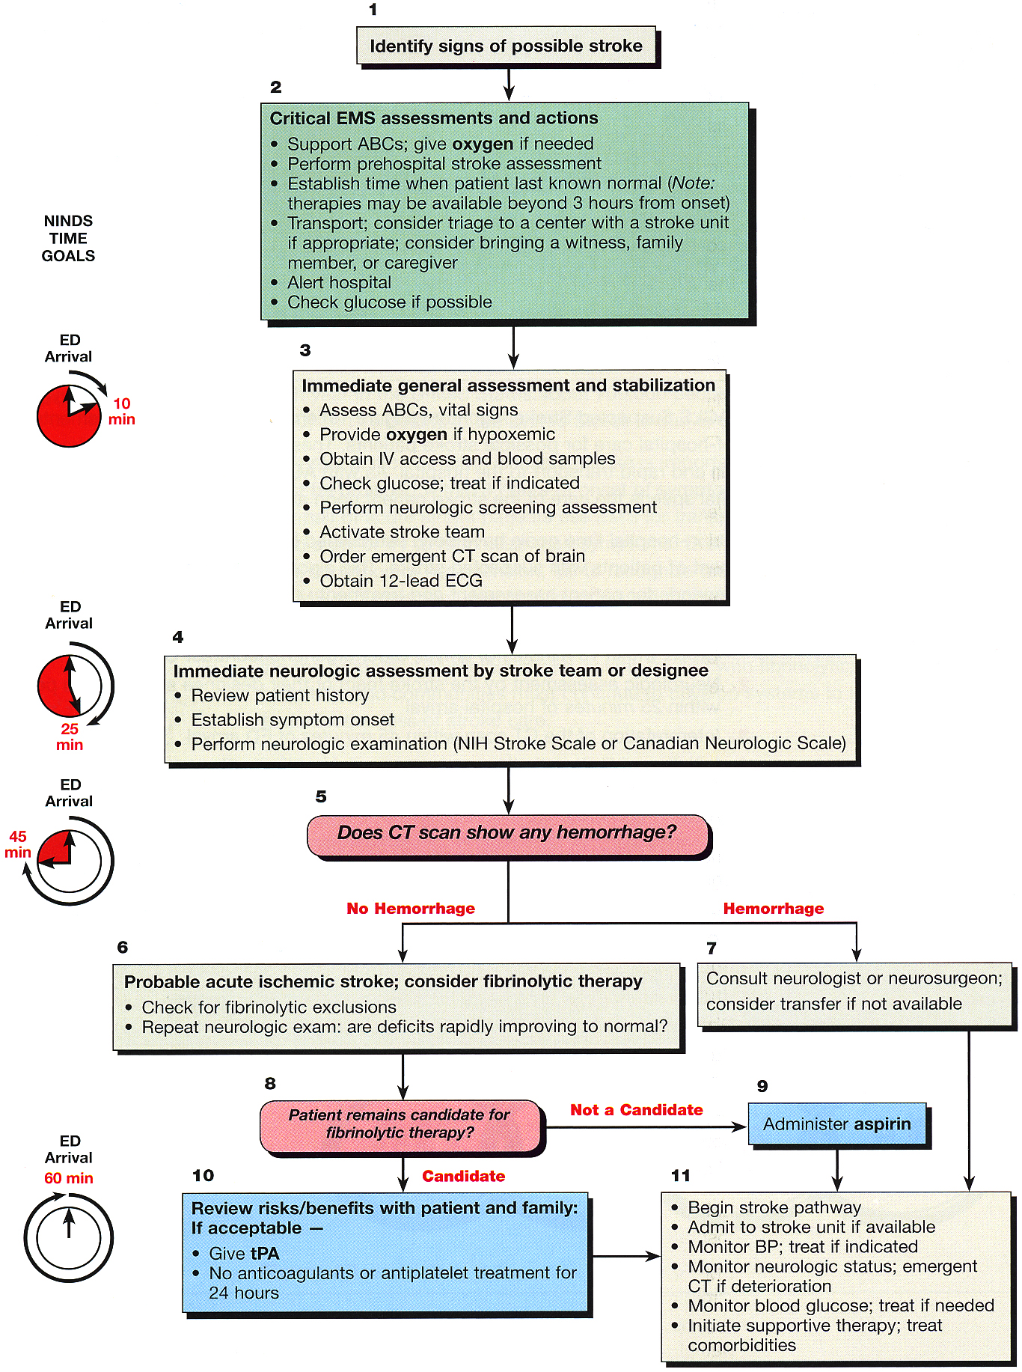

Hospital Care

NINDS Recommended Stroke Evaluation Targets for Potential Thrombolysis Candidates:
Time Interval | Time Target
Door to doctor  Access to neurologic expertise  Door to CT scan completion  Door to CT scan interpretation  Door to treatment  Admission to monitored bed | 10 min  15 min  25 min  45 min  60 min (< 3 hrs from onset)  3 h

- 25% of patients worsen in first 24-48 hours after admission!
- immediately after initial assessment and stabilization, perform noncontrast CT

Supportive Management
Initial ED protocol
- ABC

- Supplemental oxygen – only if indicated (SaO₂ < 92%, hypotensive, etc.)
  - evidence exists that supplemental oxygenation does not affect outcome!

- Establish IV access → obtain blood samples:
- CBC
- Coagulation parameters
- Blood glucose - determine and treat early (both hypoglycemia and hyperglycemia can ^{a)}cause symptoms that closely mimic ischemic stroke or can ^{b)}aggravate ongoing neuronal ischemia!):
hypoglycemia → D50
hyperglycemia (> 185* mg/dL) → insulin
*threshold for treating according to American Heart Association guidelines (formerly it was > 300 mg/dL)

- General Exam + Neurologic Screening Assessment: NIHSS (National Institutes of Health Stroke Scale), CNS (Canadian Neurological Scale).

- Activate stroke team

- Order noncontrast CT – have it read promptly by qualified physician:
- hemorrhage → consult neurologist / neurosurgeon
- no hemorrhage → evaluate for thrombolysis >>
  - if not candidate for thrombolysis, give aspirin in ED (after swallowing screen; if unable to swallow – give rectal suppository)

- 12-lead ECG – look for stroke cause or accompanying arrhythmias (if hemodynamically stable – no need to treat)

- Admit to stroke unit

Further Care in Stroke Unit
  - any time patient deteriorates → order new CT.

- Start pathogenetic treatment ASAP >>

- Control BP >>

- Intravenous fluids (all stroke victims are dehydrated) - IV NS at 50-125 mL/h (unless otherwise indicated) – keep normovolemia (↑ → brain edema; ↓ → reduced perfusion to penumbra)
N.B. avoid D5W* and excessive fluid administration! (esp. in large strokes)
*animal studies demonstrate that dextrose causes increase in cerebral infarction size
Goal hematocrit ≈ 33%
- Temperature - avoid hyperthermia > 100.4°F – increases morbidity (H: oral or rectal acetaminophen 325-1000 mg q4-6h; not to exceed 4 g/24 h).

- Continuous cardiac monitoring - for ischemic changes or atrial fibrillation.

- ICP control see p. S50 >>
    - risk factors (for dangerous ICP↑) – large infarctions, cerebellar infarctions.
N.B. brain edema peaks on 2nd or 3rd day (causes mass effect for 10 days).
    - prophylactic measures - head of bed elevated to 30°*, free water restriction, IV mannitol.
*for strokes not at risk for brain edema, head elevation has no influence on outcome
    - corticosteroids are not recommended.
    - ICP↑ decreases cerebral blood flow.
    - massive MCA stroke → life-saving decompressive craniectomy.

- Seizure control
    - prophylactic anticonvulsants to recent stroke without seizures are not recommended.
    - benzodiazepines (diazepam*, lorazepam**) are first-line drugs for ongoing seizures; for recurrent seizures, use prolonged duration parenteral alternatives - fosphenytoin, phenobarbital, sodium valproate.
*5 mg IV q5-10min; maximum total dose - 20 mg
**1-4 mg IV over 2-10 min; may repeat q10-15min

- Oral intake - NPO initially (aspiration risk is great - avoid oral intake until swallowing assessed! - evaluation by speech-language pathologist ± videofluorographic swallowing study)
    - stool softeners to everybody.
    - dysphagia / impaired mastication → temporary enteral feeding tube.
N.B. NG feeding is preferred to PEG until 2-3 weeks post-stroke
    - if patient remains at significant aspiration risk for foreseeable future → percutaneous endoscopic gastrostomy (PEG) feeding tube.
If oral feedings are restricted for prolonged periods, IV thiamine supplementation becomes important to prevent Wernicke's disease.
    - dietitian consultation - to prevent poststroke malnutrition.

- Foley catheters increase UTI risk - should be used only when absolutely necessary.

- Complex of bedridden patients:
- deep vein thrombosis (esp. in paretic limbs): sequential compression stockings, SC heparin / low-molecular-weight heparin (enoxaparin is generally preferable to heparin, except heparin causes less extracranial hemorrhages than enoxaparin).
- pulmonary toilet: chest physical therapy, frequent turning (supine ↔ unaffected side), volumetrics (deep breaths – to prevent atelectasis).
- pressure sores: frequent skin inspection, routine skin cleansing, frequent turning, special mattresses and protective dressings, improve patient's mobility.
- limb position must be physiologic and reverse of Wernicke–Mann position.

- Activity is tailored to stroke severity.
    - head of bed elevated to 30° - aspiration and ICP↑ precaution; if these are not of concern → lay patient flat for 24-48 hours (to maximize cerebral perfusion pressure).
    - bed rest for at least 24 hours - to avoid postural hypotension (autoregulation is ineffective in areas of ischemic brain!).
    - physical therapist (consultation within first 24 hours of hospitalization) will suggest level of activity.
    - mobilize patient as early as possible! (start with passive range-of-motion exercises to affected limbs → out of bed after 24 hours)
    - at discharge - encourage to increase activity as tolerated (falls are one of most common causes of injury).
    - patients often benefit from brief, intensive rehabilitation in specialized hospitals before being sent home.

- Start occupational, physical, speech therapy.

- Depression treatment

Blood pressure
- should be monitored frequently (or even continuously) for first 48-72 hours; take baseline BP into account!

hypertension Caution in lowering BP acutely! (autoregulation is impaired → reduced perfusion to penumbra)
Generally, do not treat BP < 220/120 mmHg for 72 hrs (permissive hypertension*); then do not reduce below 160-170/90-100 for 1 wk
*may be needed to maintain CBF in face of elevated ICP, and it usually resolves spontaneously

Non-candidate for thrombolysis → permissive hypertension.
Blood Pressure | Treatment
DBP < 120 or SBP < 220 or MAP < 130 mmHg | therapy indicated only if other end-organ damage (AMI, aortic dissection, severe CHF, hypertensive encephalopathy, retinal hemorrhages, acute renal failure)
DBP 120-140 or SBP > 220 or MAP > 130 mmHg | a) labetalol 10-20 mg IV → repeat and double q10min up to total dose of 150-300 mg  b) nicardipine 5 mg/h IVI; titrate q5min until max 15 mg/h
DBP > 140 mmHg | sodium nitroprusside IVI 0.5 mcg/kg/min titrate up to 10 mcg/kg/min

Candidate for thrombolysis – hypertension is treated more aggressively:
Blood Pressure | Treatment
SBP > 185 or DBP > 110 mmHg | a) labetalol 10-20 mg IV 1-2 doses → nitropaste 1-2 inches  b) enalapril 1.25 mg IV
Post-thrombolysis:
DBP 105-120 or SBP 180-230 mmHg (on 2 readings 5-10 min apart) | labetalol 10-20 mg IV → repeat and double q10min up to total dose of 150-300 mg
DBP 121-140 or SBP > 230 mmHg (on single reading) | labetalol 10-20 mg IV → titrated infusion:  a) labetalol 1-2 mg/min (up to 8 mg/min)  b) nicardipine 5 mg/h (up to 15 mg/h)
DBP > 140 mmHg | sodium nitroprusside IVI 0.5 mcg/kg/min titrate up to 10 mcg/kg/min

hypotension
- in small proportion of hypotensive patients, pharmacologically increasing BP may improve flow through critical stenoses.

Pathogenetic Treatment

Currently, tPA and aspirin and thrombectomy are only generally accepted therapies for acute ischemic stroke

Primary Stroke Centers - administration of IV tPA is standard of care.
Comprehensive Stroke Centers - additional treatment modalities are also offered

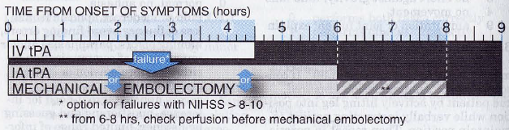

Treatments that have not been proven beneficial
- Vasodilators (CO₂, papaverine, pentoxifylline) – cause paradoxic blood steal from ischemic tissue.
- Viscosity reduction (to improve microcirculation) – may be beneficial only under certain circumstances: low-molecular-weight dextran, mannitol IV drip.
- Perfusion increase (albumin)
High-dose albumin treatment for acute ischaemic stroke (ALIAS) part 2: a randomised, double-blind, phase 3, placebo-controlled trial. Lancet Neurol. 2013; 12(11):1049-58
- Decreasing metabolic demands (hypothermia, barbiturates).
- Hyperoxygenation (except in air embolization)
- Steroids (may be effective in fat embolism, vasculitis)
- Neuroprotectants see below >>

Systemic Hemodynamics
- permissive hypertension for first 24 hrs (some experts keep patient flat to increase perfusion)
- telemetry x 24 hrs (literature quotes 5-10% prevalence of EKG changes, and 2-3% acute MIs in patients with stroke)
- aggressive efforts to restore cardiovascular circulation is the only treatment after watershed infarction (e.g. after cardiac arrest).

Thrombolysis
Thrombolytic agents → see p. 1597 (1-4) >>

Aim for "door-to-needle time" (interval from patient arrival at ED to start of thrombolysis) of 60 min.

Initial testing:
- Noncontrast CT
- Blood work - glucose, prothrombin time, aPTT, platelet count.
- Pregnancy test.
N.B. pregnancy is not contraindication (tPA does not cross placenta) – discuss risk of fetal loss and proceed!

Inclusion criteria
- More than minimal neurologic deficit (greater than minimal weakness, isolated ataxia, isolated sensory deficits, or isolated dysarthria)
- No CT evidence of intracranial hemorrhage
- Time of onset ≤ 4.5 hrs

Modern paradigm: patient presenting with stroke alert (even beyond 4.5-hour window) → negative hCT → patient stays in the scanner → perfusion CT with CTA (while getting ready to get tPA) regardless of NIHSS* to detect penumbra and blockage in angiographically accessible vessel (ICA or M1 or BA) → thrombectomy
*e.g. acute carotid dissections with mild NIHSS pose great risk of deterioration but can be opened in OR
Historic paradigm: patient presenting beyond 3-hour window → MRI to detect DWI/PWI mismatch; if ischemic penumbra is present → thrombolysis (beyond 3-hour treatment window)
DWI-positive + FLAIR-negative means stroke very fresh = in tPA window.

N.B. reasons for treating (risk/benefit analysis) or not treating patient must be documented clearly!

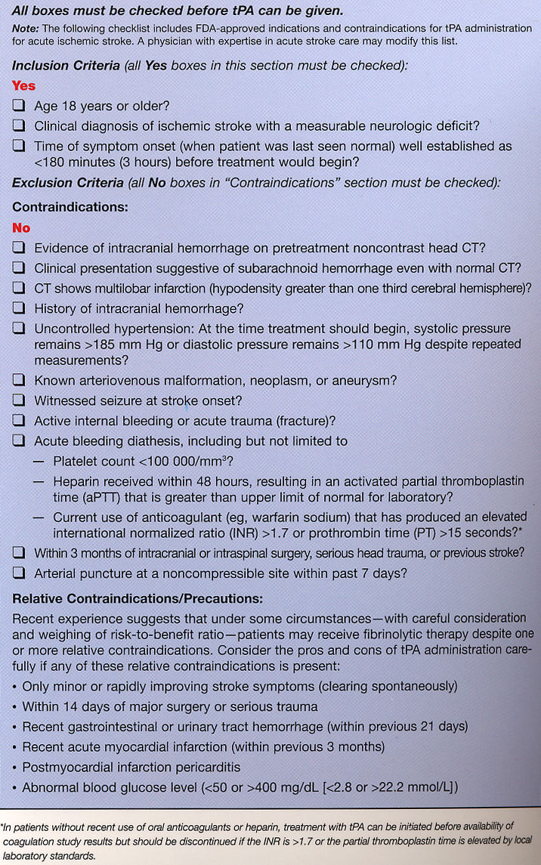

Exclusion criteria
Reasons for not administering IV tPA (if any) should be documented!!!
I. History:
- stroke or serious head trauma or intracranial surgery within 3 months
- prior ich
- intracranial neoplasm?
meningiomas are OK to treat
pituitary adenomas without signs of bleeding on CT are OK to treat except in pregnancy
- symptoms suggestive of SAH (even if CT is negative)
- known AVM or aneurysm
incidental small unruptured aneurysms – OK to treat
Sheth K, Shah N, Morovati T, et al “Intravenous rt-PA is not Associated with Increased Risk of Hemorrhage in Patients with Intracranial Aneurysms”
- concomitant oral anticoagulant
N.B. do not treat patients taking [one of the] new oral anticoagulants with IV tPA unless you are sure that their clotting studies are normal or you are certain that they have not taken any of these oral anticoagulants for the past 2 days
- heparin within 48 hrs (aPTT > 40 sec)

N.B. no age limits (also for children?)
European licensing label for alteplase, which excludes patients > 80 is obsolete! New studies show that patients > 80 yrs also benefit but it is off-label use of tPA.
N.B. pregnancy is not contraindication (tPA does not cross placenta) – discuss risk of fetal loss and proceed!

II. Physical examination:
- minimal neurological deficit (NIHSS score < 4) (e.g. minimal weakness, isolated ataxia, isolated sensory deficit, isolated dysarthria).
- blood pressure (despite nicardipine IVI or labetalol IV):
  - systolic BP > 185 mmHg
  - diastolic BP > 110 mmHg

N.B. patients with severe neurologic deficit (NIHSS score > 22) are at increased risk of symptomatic hemorrhagic transformation, but still tend to benefit from thrombolysis!

III. Laboratory:
- platelet count < 100×10⁹/L
- INR > 1.7 (PT > 15)
- aPTT elevated beyond reference range
- positive pregnancy test (in woman of childbearing age)
    - blood should be sent for type and screen (in case transfusions are required).
    - ECG is not required before thrombolysis.

IV. Neuroimaging:
Immediate noncontrast CT* is imperative - any intracerebral hemorrhage is absolute contraindication to thrombolysis!!!
    - early CT signs of major infarction (edema, mass effect, hypodensity involving > 1/3 of MCA territory**) are reason for caution - increased risk of hemorrhage!
*immediate MRI may be obtained in lieu of CT (MRI should include susceptibility-weighted sequence to detect acute ICH).
**CT is normal in 8-69% of MCA strokes in first 24 hours.

N.B. in general, CT must be ≈ normal for thrombolysis to perform!
If patient is going to have intra-arterial Tx, CTA is also needed* (immediately after screening noncontrast CT)
*also if time of unset unclear (e.g. woke up in morning with deficit)

Cautions
- seizure at stroke onset
- major surgery or serious bodily trauma within 2 weeks
- arterial puncture at noncompressible site or lumbar puncture within 1 week
- rapidly improving neurological signs.
- glucose < 50 mg/dL (< 2.78 mmol/L) or > 400 mg/dL (> 22.2 mmol/L)
- post MI pericarditis
- GI or urinary tract hemorrhage within 21 days

Types
Intravenous - only when treatment can be initiated within 4.5 hours from stroke onset - for every 100 patients given tPA, 32 will benefit and 3 will be harmed
ECASS-3 study extended window from 3 hours to 4.5 hours
AHA/ASA approved (May 29, 2009) use of tPA between 3 and 4.5 hours after symptom onset but with additional exclusion criteria (age > 80 yrs, use of oral anticoagulants regardless of INR, baseline NIHSS score > 25, history of both stroke and diabetes)

Time window of treatment:
first 90 minutes → odds of favorable outcome increased by 2.8-fold;
91-180 minutes → 1.6-fold; in NINDS study* patients were 30% more likely to have minimal or no disability at 3, 6, and 12 months
*ECASS II study failed to show tPA benefit
181-270 minutes → 1.4 fold;
271-360 minutes → did not improve outcome in statistically significant manner.
> 4.5 hours - tPA increases mortality.
Preparations:
- streptokinase – increases morbidity & mortality rates!
- tissue plasminogen activator (tPA) s. alteplase (Activase®) – only drug FDA approved (in 1996) for acute ischemic stroke;
maximum total dose - 90 mg
  - 0.09 mg/kg IV push over 1 min
  - 0.81 mg/kg IVI over 60 minutes

Intra-arterial (s. thrmbolysis in situ)
- not approved by FDA, but commonly administered as off-label therapy at tertiary centers (esp. if beyond IV tPA window):
within 6 hours of onset - in anterior circulation;
up to 12 hours after onset - in posterior circulation.
    - same inclusion and exclusion criteria apply as for IV tPA.
    - angiographically directed: 3 mg of tPA, recombinant prourokinase.
    - substantially increases recanalization rates and good-excellent clinical outcomes (increased hemorrhage frequencies are not associated with any increase in mortality).

Procedure
    - ICU
    - nothing by mouth.
    - patient should be confined to bed rest; no invasive procedures for 24 hours!
    - close BP regulation is critical in first 24 h (keep < 185/110 mmHg – use labetalol or nitroprusside as necessary):
at least q 15 min (for first 2 h after start of therapy);
at least q 30 min for next 6 h and at least hourly for next 16 h.
    - antiplatelets and anticoagulants should be avoided for 24 h after thrombolysis.
- repeat head CT (24 hours after tPA - to rule out asymptomatic hemorrhagic transformation) prior to initiating antithrombotic therapy.
- studies show that aspirin started < 24 hours does not prevent reocclusion but increase risk of bleeding!

Complications
  - Intracerebral hemorrhage (s. hemorrhagic transformation) (in NINDS study: 6.4%; vs. 0.6% with placebo; in ECASS II study: 8.8% vs. 3.4% with placebo; in GWTG-Stroke study 4.8%) - typically occurs within first 12-36 hours - neurological deterioration, acute hypertension, headache, nausea / vomiting → prompt repeat CT; H: cryoprecipitate, platelets, fresh frozen plasma.

N.B. mortality is unchanged* and neurologic outcome is significantly improved at 3 months in patients treated with TPA!
*NINDS study found that mortality in tPA group was similar to controls at 3 mos (17% vs. 21%).

Risk factors for ICH:
- severity of NIHSS
- brain edema or mass effect
- size of infarction
- elevated blood sugar
- HTN
- Asian males
N.B. outcomes are still better for these patients if treated with tPA

Treatment of ICH:
- stop tPA
- 6-8 units of cryoprecipitate containing Factor VIII
- 6-8 units of platelets
- if emergent EVD or other interventional procedure is needed, give Factor VIla (40-80 mg/kg) immediately beforehand (NB: this is only temporizing measure and cryoprecipitate needs to still be given)

  - Other bleedings - GI tract, genitourinary tract (associated with Foley catheters).

  - Oozing from vessel puncture sites (30%) - noncompressible arterial punctures, internal jugular or subclavian venous punctures must be avoided.

  - Angioedema (rare)

  - Reperfusion injury (progressive destruction of reversibly damaged cells) - inflammatory response as leukocytes reenter previously hypoperfused region:
- leukocyte-endothelial adhesion → direct microcirculation obstruction (”no-reflow” phenomenon)
- leukocyte infiltration → release of toxic products - free radicals, cytokines (important component of CNS ischemic injury!)
  - main pro-inflammatory cytokines: IL-1, TNF-α (some studies suggest that it may also have protective role), IL-6.
  - inhibition of IL-1 has been shown to produce therapeutic benefit.

N.B. use of tPA does not affect stroke recurrence rate!

Mechanical thrombolysis / thrombectomy / thrombobliteration
Give tPA, even if considering intra-arterial management!
    - angiographically-guided.
    - used in cerebral vessels 2-5 mm.
≈1/3 of anterior-circulation strokes are attributed to proximal major intracranial vessels!
    - may be particularly useful if thrombus is ≥ 8 mm (IV tPA doesn't open up those clots).
    - removes clot in matter of minutes (even intra-arterial thrombolysis takes as long as 2 hours to dissolve thrombus) - potentially extended treatment window!
Historically, time window was ≤ 6-8 hours from onset! (i.e. revascularization beyond 6 hours results in outcomes similar to those of no revascularization)
DAWN trial – patients benefit up to 24 hours from onset
Alternatively (more and more widely adapted strategy, esp. for “wake up” strokes when time is unclear) – image guidance: if DWI / pCT shows favorable penumbra pattern → revascularize!
      - perform CTA and pCT while tPA is dripping!
    - document penumbra preop (esp. if operating at > 6-8 hour time window) with pCT (or PWI) / DWI because reperfusing stroked area (vs. penumbra) increases morbidity and mortality (due to risk of hemorrhagic transformation – rate 10% and usually catastrophic) without clinical benefit.
N.B. DWI is more sensitive than pCT!!! (but no standard method yet)
- stroke can be seen on CT with 30 brightness/30 contrast regimen.
- if penumbra makes ≥ 2/3 and stroke ≤ 1/3 (it is only about cortex; basal ganglia do not count – good chance of recovery), then risk of bleeding is less than benefit of revascularization! Alternatively, stroke volume < 70-90 mL
DWI identifies infarcted tissue, whereas PWI represents hypoperfused tissue (at risk for infarct)

Thrombolysis in Cerebral Infarction (TICI) scale - recanalization is measured angiographically:
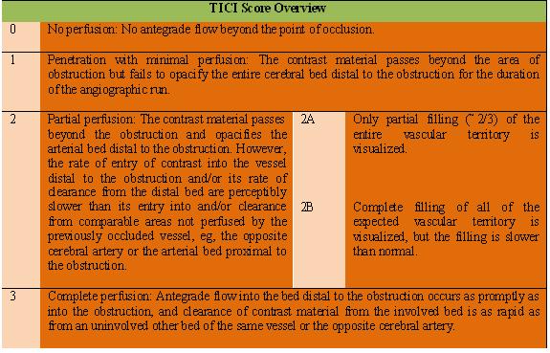

Mechanical Retrieval and Recanalization of Stroke Clots Using Embolectomy (MR RESCUE) trial - favorable penumbral pattern on neuroimaging did not identify patients who would differentially benefit from endovascular therapy, nor was embolectomy shown to be superior to standard care.
N.B. trial used the older device - MERCI

Multicenter Randomized Clinical Trial of Endovascular Treatment for Acute Ischemic Stroke in the Netherlands (MR CLEAN)
- patients randomized to either intra-arterial endovascular treatment (intra-arterial thrombolysis, mechanical treatment, or both) plus usual care or usual care alone (intravenous alteplase when possible).
- eligible patients had a proximal arterial occlusion in the anterior cerebral circulation (confirmed on vessel imaging) and that could be treated intra-arterially within 6 hours of symptom onset.
- patients receiving endovascular therapy were 1.67 times more likely to have a favorable functional outcome (i.e. significantly higher incidence of functionally independent patients treated with intra-arterial therapies (32.6%) compared with conventional therapy alone (19.1%))
- general anesthesia was used in only 37.8% of patients.
- no significant differences in mortality or incidence of symptomatic ICH.

At 2 year F/U:
- Of the 500 patients who underwent randomization in the original MR CLEAN trial, 2-year data for this extended follow-up trial were available for 391 patients (78.2%) and information on death was available for 459 patients (91.8%).
- functional independence is still apparent at 2 years. The odds ratio for better scores on the modified Rankin Scale (mRS) in the endovascular group than in the conventional treatment group was 1.67 at 90 days, as compared with an odds ratio of 1.68 at 2 years.
- The percentage of patients in the intervention group who were functionally independent (mRS score of 0 to 2) at 2 years (37.1%) was also similar to the results at 90 days (32.6%).
- trend toward a reduction in mortality at 2 years in the endovascular group, whereas this was not seen at the 3-month mark.
- cumulative 2-year mortality rates were 26.0% in the intervention group and 31.0% in the control group (adjusted hazard ratio, 0.9; 95% confidence interval [CI], 0.6 - 1.2; P = .46).
- quality of life showed an improvement in the endovascular group. The mean quality-of-life score was 0.48 among those given endovascular therapy compared with 0.38 for the control group (mean difference, 0.10; 95% CI, 0.03 - 0.16; P = .006). The difference in the treatment effect between the two groups was attributable mainly to the EQ-5D-3L dimensions of "mobility," "self-care," and "usual activities."

Indications
NIHSS ≥ 8
Anterior circulation (distal ICA, M1*) < 8 hrs
Posterior circulation (BA) < 24 hrs
*M2 stroke morbidity is almost like M1, so thrombectomy is done also for M2 (esp. dominant hemisphere)
Most modern indications are based on CTA and pCT findings. see p. Vas3 >>

Contraindications
Brainstem stroke
Stroke of > 1/3 of anterior circulation (risk of ICH with reperfusion) or penumbra < 20%

No technical contraindications; if carotid is very tortuous (difficult access), may consider direct carotid access but closure is very risky (big hole in carotid, if Angioseal breaks off → big stroke)

FDA approved embolectomy devices
Stent retrievers (Solitaire FR and Trevo) are preferred to coil retrievers (Merci)
Stent retrievers (Solitaire FR and Trevo) are equal* to direct (contact) aspiration (Penumbra)
*recanalization and adverse event rates; the only exception is a higher risk of vasospasm with stent retrievers; direct aspiration is faster and cheaper (if fails → rescue use of stent retriever)
“Solumbra” technique (stent retriever + Penumbra) - used both as salvage and
as a primary treatment strategy:
      - first-line strategy - achieves higher mTICI 2b/3 and mTICI 3 recanalization rates compared to aspiration alone, although with a higher risk of SAH.
      - rescue treatment (after the failure of the aspiration technique) - 4-fold increase in ICH rates.

Always use proximal occlusion device!
For tortuous anatomy (difficulties reaching target) – may use direct carotid approach (closure is difficult due to large hole in carotid – use "boomerang").

Mechanical embolus removal in cerebral ischemia (MERCI) system (Concentric Medical, Mountain View, CA) - nitinol corkscrew-like apparatus (concentric MERCI retriever) for persistent vessel occlusion after IV tPA.
- FDA approved (2004) within 8 hours of stroke onset in patients ineligible for IV tPA.
MERCI retriever embedded in clot:  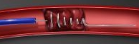 | Clot from basilar artery:  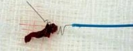
    - corkscrew itself resides in catheter tip, which shields it from wall of vessel until it is ready to be burrowed into clot.
    - once lodged in clot, device and clot are withdrawn from vessel.

Multi-MERCI trial: 69.5% vessel recanalization rate with adjuvant intra-arterial tPA.
- 3 month outcomes not different from IV thrombolysis.

MERCI trial (use of MERCI within 8 hours of stroke onset in patients ineligible for IV tPA
- recanalization in 48%
- procedural complications occurred in 7.1%, symptomatic ICH in 7.8%
- good neurological outcomes (modified Rankin score 2) at 90 days 46% (vs. 10% in patients with unsuccessful recanalization).
- mortality 32% (vs. 54% in patients with unsuccessful recanalization).

N.B. MERCI system is no longer used due to lower efficiency – typically needs 3 passes to recanalize (vs. 1 pass for newer systems) – waste of time; plus, throws distal emboli.

Penumbra Thromboaspiration Catheter (Penumbra, Inc., Alameda, CA) – aspiration catheter to remove thrombus with separator wire used to macerate clot and maintain catheter patency.
    - FDA cleared* (Jan 17, 2008) for acute stroke due to large vessel occlusion within 8 hours of symptom onset (i.e. for those presenting too late for thrombolysis);
*i.e. cleared it to be on shelf but not approved for treatment in stroke patients

Penumbra Pivotal Stroke Trial:
- 81.6% rate of revascularization (TIMI 2 or 3 flow) vs. 48.2% historical controls.
- 3.2% procedural serious adverse events (vs. 7.1% historical controls)
- 28% develop ICH within 24 h after vessel reopening: symptomatic ICH in 11.2%; asymptomatic ICH in 16.8%
- improvement ≥ 4 point in NIHSS at discharge in 57.8%
- modified Rankin Score (mRS) < 2 at 90 days achieved by 25% of patients

Balloon angioplasty and stenting – Thromb Obliteration (stent retrievers) - stent is navigated through embolic occlusion, and expanded to obliterate thromboembolus (i.e. occlusive clot is displaced to intimal layer and, eventually, is thought to dissipate through intrinsic hemodynamic and thrombolytic processes)
    - high efficacy reported in failure of other options (i.e. as rescue).
    - FDA approved:
Solitaire (FDA cleared in March 2012).
- recanalization in 69%
Trevo
- recanalization in 86%

EKOS ultrasound thrombolytic infusion catheter - combines distal ultrasound transducer with infusion of thrombolytic agent through microcatheter.
    - ultrasound changes structure of clot (clot softening) to temporarily increase its permeability while providing acoustic pressure gradient to move drug into clot to speed its dissolution.

Other
AngioJet system (discontinued study) - uses saline jets that are directed back into catheter to create low-pressure zone around catheter tip, inducing suction:
- clot is pulled into exhaust lumen and removed from vessel.  - although FDA has approved this device for AV dialysis grafts and fistulae, coronary arteries, saphenous vein grafts, peripheral vessels, clinical trials for acute stroke are no longer in progress:  - in one study (thrombi in ICA), despite angiographic successes, clinical outcomes were poor (authors postulated poor collateral flow)  - in other study (thrombi in MCA), vessel perforations occurred → SAH. | 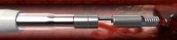  AngioJet catheter, shown with its saline jets activated:  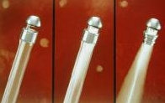

Latis laser device (discontinued study) - uses laser energy to ablate clots.
    - preliminary account of first 5 patients enrolled in trial reported that device could not be delivered to clot (although catheter design was changed, efficacy trial was not pursued).

Endovascular photo acoustic recanalization (EPAR) laser (discontinued study) - laser energy is delivered by fiberoptics to catheter tip at treatment site.
    - laser light absorption by darkly pigmented materials (i.e. clot) occurs inside 1-mm catheter tip → absorption converts photo energy to acoustic energy, which then emulsifies clot inside catheter tip.
    - acceptable safety, causing no complications during active lasering (1 vessel ruptured during manual injection with 1-mL syringe [instead of recommended 3-mL syringe] → distal catheter balloon → fatal vascular rupture).
    - loss of funding stopped further clinical testing.

Devices not evaluated in acute-stroke trials:
- Snare-like devices - simple in design and do not require clot to be amenable to emulsification.
- X-Sizer device - small, moving blades at catheter tip - thrombus excision and aspiration.
- Suction thrombectomy - one of simplest methods of mechanical thrombolysis - suction is applied with syringe to remove thrombus.

Antiaggregants
- aspirin (81-1300 mg/d; start within 24-48 hours; but delay for 24 hours after tPA) - only therapeutic agent (besides thrombolytics) shown to improve outcome in acute stroke (although effect is modest); it is only antiplatelet approved for acute stroke!
N.B. aspirin is not alternative to thrombolysis!
- ticlopidine (250 mg × 2/d)
- clopidogrel (75 mg/d)
Indications: (start within 24-48 hours of onset, but delay for 24 h after thrombolytic therapy)
- stable stroke; if stroke is unstable (progressing) – use IV heparin see below
- new-onset TIA.
- all lacunar TIAs / strokes are treated with antiaggregants.

IV glycoprotein IIb/IIIa receptor inhibitors are not recommended!
    - studies with abciximab were stopped - dramatically higher rate of intracerebral hemorrhage!!!

Anticoagulation
Heparin
Proven indications for immediate* full-dose IV heparin** (after stroke or TIA):
*delay for at least 24 hours after IV fibrinolysis
**vs. low-dose SC heparin
    - High risk of cardiogenic re-embolization (unless source is bacterial endocarditis – high risk of hemorrhagic complications):
- AF with proven intracardial thrombus on echocardiography*
*AF without thrombus → aspirin (160 mg/d) in acute phase → anticoagulation.
- artificial valves
- left atrial or ventricular thrombi
- MI during last 4 weeks.
    - Venous sinus thrombosis (even if associated with cerebral hemorrhage!); continue as oral anticoagulation for at least 6 months (INR 2-3).

Unproven but generally accepted indication:
- symptomatic dissection of arteries supplying brain (after CT exclusion of SAH).

Unproven indications:
  - symptomatic stenosis of extracranial ICA prior to short-term operation (otherwise, aspirin should be given).
  - basilar artery thrombosis - IV heparin is started before intra-arterial fibrinolysis (alternatively, anticoagulation could be started afterwards if thrombolysis or angioplasty can be performed quickly after admission).
  - hypercoagulability (e.g. protein C and S deficiencies, activated protein C resistance, antithrombin deficiency*, relevant titer of antiphospholipid antibodies).
*may use antithrombin III concentrates

Shown ineffective - extracranial / intracranial stenosis (large arteries) with unstable (recent-onset or crescendo) TIAs or early unstable (progressive) stroke; aspirin after acute period.
N.B. it is difficult to predict or monitor stroke progression; thus many physicians heparinize all patients with recent mild ischemic stroke in order to prevent worsening that will occur in at least 20% patients.

Dosage:
Patient | Loading IV | Maintenance IVI*
Normal | 80 U/kg (e.g. 5000 U) | 18 U/kg/h (e.g. 1000 U/h)
Elderly | 70 U/kg | 15 U/kg/h
Pediatric | 50 U/kg | 25 U/kg/h
*20,000-25,000 U in 250-500 mL D5W
    - start together with warfarin; continue warfarin for 6 months.
Bleeding complication rate for 7 days of heparin is ≈ 10%

Monitoring - aPTT q6h until reaches therapeutic 1.5-2 times control value (avoid INR > 2)
aPTT ≤ 1.2 times control: 80 U/kg bolus + increase of 4 U/kg/h
aPTT = 1.2-1.5 times control: 40 U/kg bolus + increase of 2 U/kg/h
aPTT = 1.5-2.3 times control: no change
aPTT = 2.3-3 times control: decrease by 2 U/kg/h
aPTT > 3 times control: hold infusion for 1 h → decrease by 3 U/kg/h

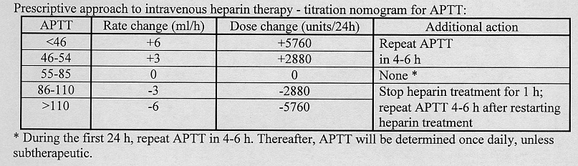

Contraindications to IV heparin - risk of cerebral hemorrhage:
- large (> 5 cm) brain infarctions (delay anticoagulation for 5-7 days)
- pronounced microangiopathic changes in brain
- uncontrolled hypertension (HTN correlates with risk of hemorrhagic transformation)
- bacterial endocarditis (→ intensive antibiotic therapy)
- hemorrhagic infarctions (delay anticoagulation for 2-6 weeks)
N.B. anticoagulation is used ASAP in hemorrhagic venous infarcts!
see p. Vas13 >>
in case of hemorrhagic conversion:
      - urgent need of anticoagulation (e.g. artificial heart valves) → continue full-dose IV heparin (only after normalization of INR values by prothrombin complex and/or other warfarin antagonists if received prior oral anticoagulation)
      - other patients → switch to SC heparin in body-weight–adapted dose.
    - several randomized controlled trials failed to show significant overall benefit of SC heparin, IV heparinoids, SC low-molecular-weight heparin (LMWH).
N.B. LMWH should not be used routinely in stroke management!; indication for LMWH - indicated early anticoagulation but contraindicated heparin.

Warfarin
    - high-intensity warfarin therapy is proven helpful for antiphospholipid antibody syndrome (APLAS).

Steroids
Indications:
    - Steroid responsive vasculitis, e.g. giant cell arteritis (temporal arteritis)
    - Cerebellar infarct/ bleed with mass effect??? – likely no

Neuroprotective agents
At present, no agent with putative neuroprotective effects can be recommended for treatment of acute ischemic stroke in humans!!!
More than 1,000 drugs have been investigated for use in neuroprotection; however, only around 100 of these agents have reached clinical trials, and none has proved successful in humans.
    - attempt to save ischemic neurons from irreversible injury.
    - main target – neurons in ischemic penumbra.
    - mechanisms of action:
- prevent release of excitatory neurotransmitters - prevent early ischemic injury.
- prevent detrimental events associated with return of blood flow - prevent reperfusion injury.

Ischemic cascade appears to be so complex that targeting single pathway may be ineffective - optimal therapy may be achieved by “stroke cocktail”.

Prevention of early ischemic injury
  - ischemia leads to excessive activation of excitatory amino acid receptors, accumulation of intracellular calcium.

N-methyl-D-aspartate (NMDA) Receptor Antagonists
- most commonly studied neuroprotective agents for acute stroke.

Direct NMDA antagonists - adverse effects (hallucinations and agitation) mimic those seen with phencyclidine, which binds at similar site.
Dextromethorphan (noncompetitive NMDA antagonist).
Selfotel (competitive NMDA antagonist) – increases mortality.
Aptiganel – concerns regarding benefit-to risk-ratios.

Indirect NMDA antagonists - prevent glycine from binding, which in turn prevents glutamate from activating receptor.
Agent GV150526 - safe and well tolerated, but offers no improvement.

Magnesium - may reduce ischemic injury by increasing regional blood flow, antagonizing voltage-sensitive Ca²⁺ channels, and blocking NMDA receptor.

Modulation of Non-NMDA Receptors
Nalmefene (Cervene) - narcotic receptor antagonist that reduces levels of excitatory neurotransmitters; minimal side effects; no clinical benefit was found in phase III clinical trial.
Lubeluzole - exact mechanism of action is unclear (may block sodium channels, may reduce release of nitric oxide, neurotransmitter generated by activation of NMDA receptor); trial was unable to confirm efficacy.
Clomethiazole (GABA agonist) - anticonvulsant and sedative; stroke studies negative.

Calcium channel blockers (nimodipine) - did not show efficacy.

Antioxidants (free-radical scavengers)
Tirilazad did not show benefit.
Albumin (antioxidant properties + ability to increase blood flow to penumbra) – no benefit see above
NXY-059 (free-radical trapping agent) - first neuroprotectant to show efficacy in acute stroke treatment trial; also shows vasoprotective properties (hemorrhagic transformations↓ after tPA).

Prevention of reperfusion injury
Despite good outcome associated with reopening blood vessel, additional brain injury may result!

Antiadhesion antibodies - block intercellular adhesion molecule (ICAM) on endothelium to prevent WBC adhesion to vessel wall.
Enlimomab - murine monoclonal anti-ICAM antibody; increased mortality rates.
Hu23F2G - human antileukocytic antibody; no clinical benefit.

Antiplatelet antibodies
Abciximab – disappointing (increased rate of intracranial hemorrhages).

Membrane stabilization
Citicoline (exogenous form of cytidine-5'-diphosphocholine used in membrane biosynthesis) - may reduce ischemic injury by stabilizing membranes and decreasing free radical formation; modest clinical benefit in trials.

Neuronal healing
Fiblast (basic fibroblast growth factor) - poor risk-to-benefit ratios.

Surgical Care
Carotid stenosis / occlusion
– see p. Vas7 >>
N.B. emergency carotid endarterectomy for high grade carotid stenosis/occlusion ipsilateral to fluctuating neuro deficit has no well-established efficacy! Although some studies show good results.

Hemorrhagic transformation
(e.g. after reperfusion due to thrombolytic therapy); usually within first 24-48 hrs; if symptomatic → hematoma evacuation / decompressive craniectomy.
  - pathophysiology is incompletely understood but involves matrix metalloproteinases (MMPs; eg, MMP-9), inflammatory mediators, reactive oxygen species.

Hemispheric stroke (“Malignant MCA stroke”)
References:
Mark S. Greenberg “Handbook of Neurosurgery” 8th ed. (2016), p. 1303

≥ 50% MCA territory with stroke volume ≥ 145 cm² (on DWI-MRI within 14 hrs after stroke) – mortality ≈ 80% without surgery due to herniation (vs. zero mortality if < 145 cm²).
Stroke volume ≥ 80-89 cm² (on DWI-MRI within 6 hrs after stroke) – predictor of fulminant course
  - edema is cytotoxic ± vasogenic.

Clinical features
  - occurs in ≈ 2-10% of all hospitalized ischemic strokes (esp. in large-territory, hemispheric strokes)
  - present with signs of severe hemispheric stroke (dense hemiplegia, forced eye and head deviation, aphasia, severe dysarthria, neglect, visual field defect); initial NIHSS score is often > 20 with dominant hemispheric infarction and > 15 with nondominant hemispheric infarction
↓
decline in level of consciousness (first sign of brain edema and midline shift) shortly after admission
N.B. complete infarction of either hemisphere itself is rarely associated with diminished arousal (although right hemisphere infarction may result in a flattened affect).
Cerebral ptosis (apraxia of eyelid opening) may be present and falsely suggest decreased level of consciousness.
↓
progressive deterioration during first 3-4 days* → transtentorial herniation with pupillary abnormalities (usually within 2-4 days of stroke).
*researchers believe that swelling starts 8 to 14 hours after stroke
  - clinical course (no methods are available to predict course of brain swelling reliably):
- rapid and fulminant course (within 24–36 hours)
- gradually progressive course (over several days)
- initially worsening course followed by a plateau and resolution (about a week).
N.B. some patients may experience deterioration at 4 to 10 days, when previously at-risk penumbra progresses to infarction, followed by delayed swelling and in some cases hemorrhagic transformation
  - complications – ventricle entrapment, PCA, ACA infarctions, (worsening of preexisting) cardiac arrhythmias (particularly in infarcts involving insular region), hemorrhagic transformation.
- hypertension is common; lack of data from randomized, controlled trials - specific blood pressure recommendations cannot be made (BP >220/105 mmHg increases risk of hemorrhagic transformation).
  - may be life-threatening!
Edema and herniation are most common causes of early death after stroke!

Diagnosis
Imaging
- progressive cerebral edema and mass effect, with ipsilateral sulcal effacement, compression of ipsilateral ventricular system, and then shift of midline structures.
- brainstem displacement → widening of ipsilateral ambient cistern → cisterns become effaced when swollen tissue eventually fills cisterns.
- foramen of Monro or third ventricle might be blocked, leading to entrapment and dilatation of contralateral lateral ventricle and obstructive hydrocephalus, which might contribute to increased intracranial pressure (ICP).
- compression PCA or ACA may be seen → infarctions in corresponding territories.

Signs predictive of neurological deterioration and early mortality:
- frank hypodensity in ≥ 1/3 MCA territory within first 6 hours
- dense MCA sign
- midline shift ≥ 5 mm within first 2 days
- angiographic signs: “T occlusion” of distal ICA, incomplete circle of Willis → involvement of multiple vascular territories)

Alberta stroke programme early CT score (ASPECTS)
- 10-point quantitative topographic CT scan score used in MCA stroke; segmental assessment of the MCA vascular territory is made and 1 point is deducted from the initial score of 10 for every region involved:
•caudate
•putamen
•any portion of the internal capsule
•insular cortex
•M1: "anterior MCA cortex," corresponding to frontal operculum
•M2: "MCA cortex lateral to insular ribbon" corresponding to anterior temporal lobe
•M3: "posterior MCA cortex" corresponding to posterior temporal lobe
M1 - M3 are at the level of the basal ganglia
•M4: "anterior MCA territory immediately superior to M1"
•M5: "lateral MCA territory immediately superior to M2"
•M6: "posterior MCA territory immediately superior to M3"
M4 - M6 are at the level of the ventricles immediately above the basal ganglia

ASPECTS ≤ 7 = thrombolysis did not have a good clinical outcome; worse functional outcome at 3 months as well as symptomatic hemorrhage.

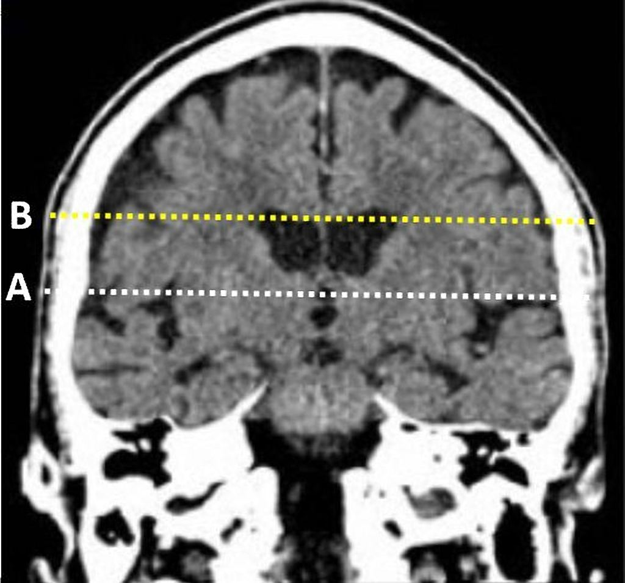
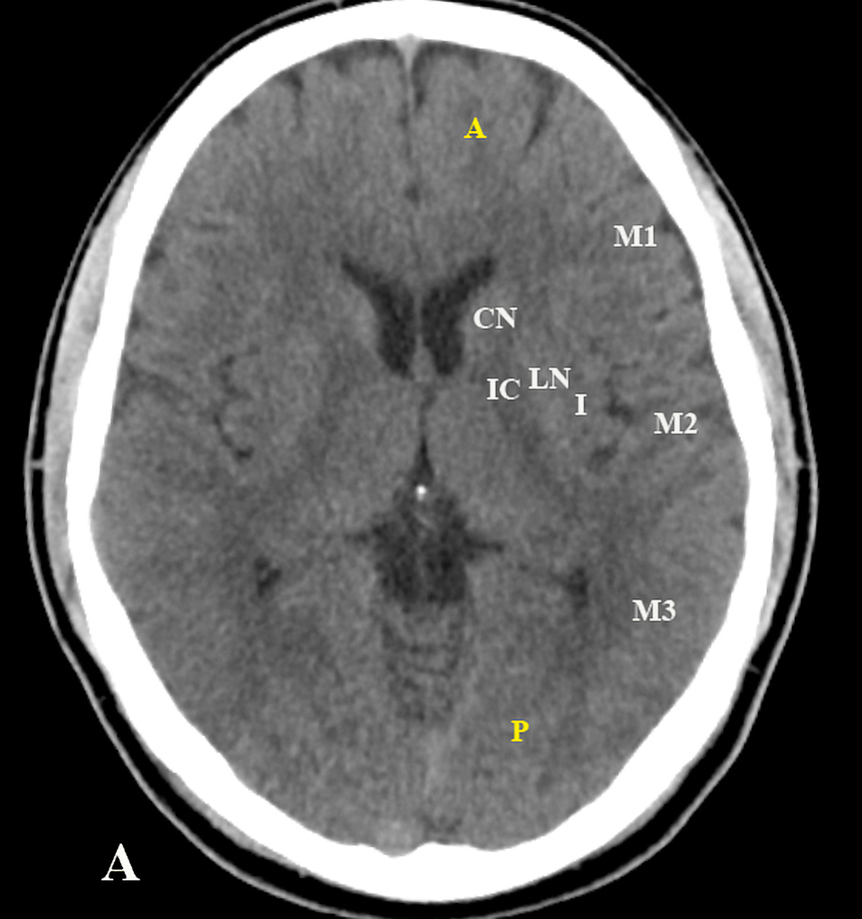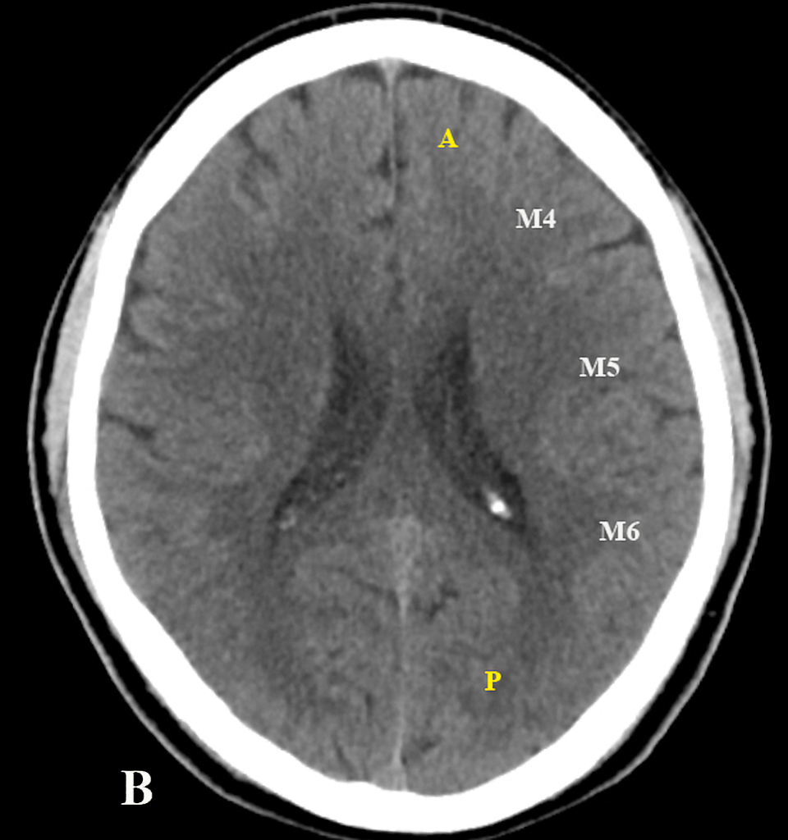
Case courtesy of Dr Subash Thapa, Radiopaedia.org, rID: 40018

EEG - single study suggested that diffuse slowing and increased delta activity in first 24 hours may document early global dysfunction in patients who are likely to swell.
Burghaus L, Hilker R, Dohmen C, Bosche B, Winhuisen L, Galldiks N, Szelies B, Heiss WD. Early electroencephalography in acute ischemic stroke: prediction of a malignant course? Clin Neurol Neurosurg. 2007;109:45–49.

TCD - noninvasive method of monitoring elevated ICP; increase in pulsatility indexes has been shown to correlate with midline shift and outcome.
Asil T, Uzunca I, Utku U, Berberoglu U. Monitoring of increased intracranial pressure resulting from cerebral edema with transcranial Doppler sonography in patients with middle cerebral artery infarction. J Ultrasound Med. 2003;22:1049–1053.
Horstmann S, Koziol JA, Martinez-Torres F, Nagel S, Gardner H, Wagner S. Sonographic monitoring of mass effect in stroke patients treated with hypothermia: correlation with intracranial pressure and matrix metalloproteinase 2 and 9 expression. J Neurol Sci. 2009;276:75–78.

Surgical treatment
N.B. no firm indications; only guidelines!
  - population-based study estimated that 0.3% of all ischemic stroke patients may be eligible for decompressive craniectomy.
  - thrombolysis, hyperventilation, mannitol, or barbiturate coma do not affect outcome.
  - large (> 12 cm) decompressive hemicraniectomy with dural expansion is the only treatment – reduces mortality to 32-37% (esp. in nondominant hemisphere). see p. Op320 >>
N.B. it is lifesaving but nonrestorative surgery - decompressive hemicraniectomy does not treat stroke!
Just EVD is not indicated
  - additional supporting indications: age < 70 years, nondominant hemisphere.
  - achieved ICP reduction:
    - promotes retrograde MCA perfusion via leptomeningeal collaterals.
    - prevents brain herniation.
  - better results occur with early surgery, especially if surgery is performed before any changes associated with herniation occur (usually within first 48 hours).
  - young patients with very large infarcts (> 400 cm³) may benefit from temporal lobectomy; i.e. after DC, ﻿postoperative ICP monitoring and secondary necrosectomy (anterior temporal lobectomy) may have a role in MCA/MCA+ patients (malignant ischemic infarctions extending beyond the middle cerebral artery territory)
Curry WT et al. Factors associated with outcome after hemicraniectomy for large middle cerebral artery territory infarction. Neurosurgery. 2005;56:681–692.

3 trials with class I evidence (DESTINY in Germany, DECIMAL in France, HAMLET in Netherlands): early decompressive surgery (within 48 hours of large MCA infarcts in patients < 60 yrs) clearly reduces mortality but at the cost of producing unacceptable levels of disability in
the survivors (75% of survivors receiving medical care had a ‘favorable’ outcome (mRS < 4) versus 55 % of survivors who received surgery):
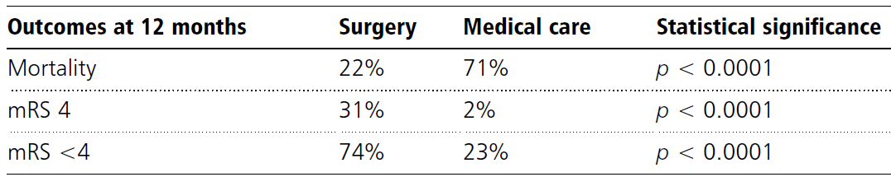

DESTINY II trial showed equal benefit for patients > 60 yrs: compared with ICU therapy only, early (within first 48 hours) decompressive surgery is associated with significant decrease in number of patients surviving with mRS > 5 by 25%, mostly driven by significantly reduced mortality by 40%
Proportion of patients who survived without severe disability was 38% in surgery group compared with 18% in control group (P = 0.04) - trial was stopped after difference in 2 groups became obvious:
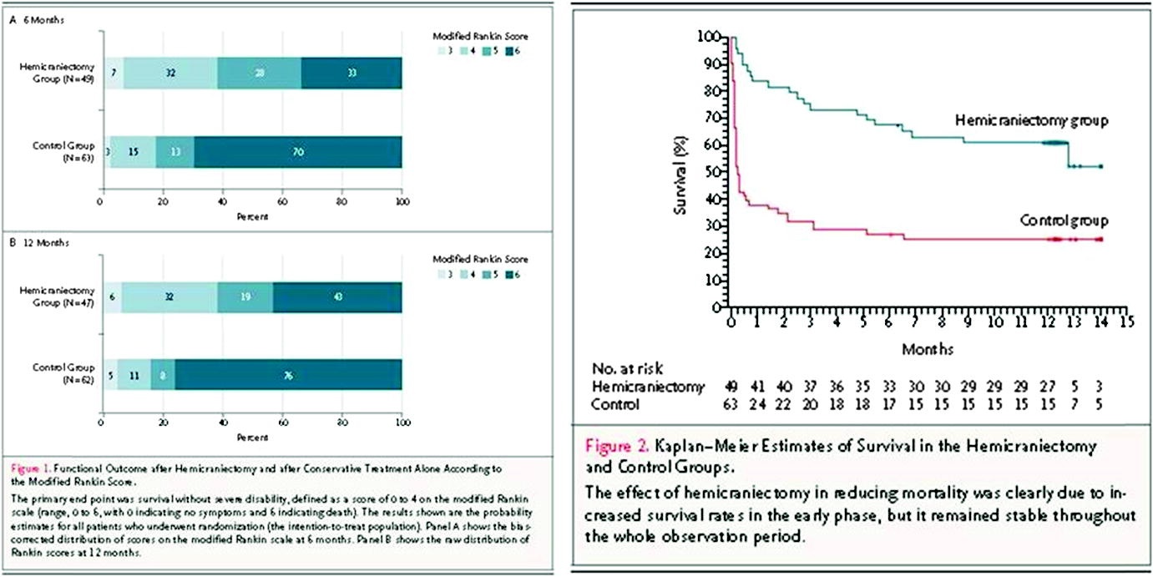

  - requirements to maximally affect outcome:
- surgery performed before any changes associated with herniation (usually < 48 hrs after onset)
- removing bone flap > 12 cm in diameter
- opening wall of middle cranial fossa
  - factors that do not affect outcome:
- age (although younger patients have less room to accommodate swelling)
N.B. older patients may be less likely to suffer consequences of cerebral edema because of increased intracranial compliance secondary to relative atrophy
- final infarct volume
- preoperative Glasgow Coma Scale score
- target osmolarity achieved
- size of herniation.
  - family discussion: half of surviving patients with massive hemispheric infarctions, even after decompressive craniectomy, are severely disabled and a third are fully dependent on care.
  - timing of cranioplasty after decompressive craniectomy remains unknown, but complication rate (hydrocephalus, infection) was slightly higher in early cranioplasty (within 10 weeks of craniectomy); but if bone flap replacement is delayed, communicating hydrocephalus may develop.

Conservative treatment
  - glyburide IVI at 3 mg/d (very low dose) has antiswelling effect and affects outcomes in study.
Glycemia goal 1401-180 mg/dL
- European Stroke Initiative suggests avoiding hyperglycemia > 180 mg/dL
- INSULINFARCT trial - increase in infarct size with aggressive control (aiming at glucose <126 mg/dL).
Rosso C et al. Intensive versus subcutaneous insulin in patients with hyperacute stroke: results from the randomized INSULINFARCT trial. Stroke. 2012;43:2343–2349.
  - European Stroke Initiative has recommended treating temperatures >37.5°C (early fever – think of infectious or drug-induced cause first as stress-induced fever is uncommon).
- there is insufficient research to recommend early hypothermia.
  - by current ASA/AHA guidelines:
- combination of aspirin and clopidogrel is typically discontinued (risk of hemorrhagic transformation) but aspirin may be continued;
- avoid IV heparin but SC is necessary to prevent deep venous thrombosis, even if there is some hemorrhagic conversion or early edema on CT scan.
  - by current ASA/AHA guidelines seizure prophylaxis (in patients without seizures at presentation) is not indicated.

Osmotherapy
  - early (preemptive) osmotherapy: insufficient data to recommend mannitol or hypertonic saline as a preemptive measure in patients with early CT swelling, but practices could vary.
- some practices may switch to mildly hypertonic solutions as maintenance fluids (e.g. 1.5% saline).
- other practices may use an incidental bolus of mannitol or hypertonic saline as bridge to decompressive craniectomy (hyperosmolar or hypernatremic targets are not established in current literature).
N.B. routine ICP monitoring is not recommended (by current ASA/AHA guidelines although cited study talks about early ICP monitoring) – deterioration is result of displacement
of midline structures such as thalamus and brainstem than of mechanism of globally increased ICP. Even in patients with deterioration from cerebral edema, ICP values may remain < 20 mmHg, suggesting that displacement from mass effect is likely mechanism.
  - osmotherapy in deteriorated patient: only small limited studies have studied effect of different osmotic agents in randomized fashion.
  - steroids have been administered to reduce brain swelling, but Cochrane review concluded after review of 8 clinical trials that there was no benefit on mortality or functional outcome.

Cerebellar infarctions
Pontine compression and/or acute hydrocephalus
Surgical indications - any of brainstem (pons) compression* signs (findings proceed in approximate following sequence if there is no intervention):
EOM, mental status, motor
- CN6 palsy
- Loss of ipsilateral gaze (compression of CN6 nucleus and lateral gaze center)
- Peripheral CN7 paresis (compression of facial colliculus)
- Confusion and somnolence (may be partly due to developing hydrocephalus)
- Babinski sign
- Hemiparesis
- Lethargy
- Small but reactive pupils
- Coma
- Posturing
- Flaccidity
- Ataxic respirations

*it is important to recognize a lateral medullary syndrome - signs are present from the onset and are not accompanied by change in sensorium (dysphagia, dysarthria, Horner's syndrome, ipsilateral facial numbness, crossed sensory loss) - it represents primary brainstem ischemia and not compression (no place for surgical decompression).

Treatment – decompressive unilateral or bilateral suboccipital craniectomy ± evacuation of infarcted tissues + dural expansion + EVD
Avoid EVD alone - may cause upward cerebellar herniation and does not relieve direct brainstem compression!!!
  - operation includes enlargement of foramen magnum.
  - dura is opened → infarcted cerebellar tissue usually exudes "like toothpaste" and is easily aspirated.
  - surgery after cerebellar infarct leads to acceptable functional outcome in most patients (unlike supratentorial masses causing herniation, there are several reports of patients in deep coma from direct brainstem compression who were operated upon quickly who made useful recovery; unless brainstem infarction happens!).
N.B. time interval to surgery does not seem to affect outcome (vs. in malignant MCA strokes) – value of preemptive surgery (radiological worsening in stable patient) is unknown!

Rehabilitation
    - rehabilitation planning begins within first day of acute stroke.
    - patients can safely begin sitting up once they are fully conscious and neurologic deficits are no longer progressing, usually ≤ 48 h after stroke.
AVERT (A Very Early Rehabilitation Trial) results show that intensive exercise therapy out of bed within 24 hours of symptom onset is safe method of rehabilitation (even among individuals treated with tPA)
    - resistive exercise for hemiplegic extremities may increase spasticity!
    - comprehensive rehabilitation may improve functional abilities of stroke survivor (despite age and neurologic deficit) → decreased long-term patient care costs.
    - 10% patients receive no benefit from any treatment.
    - transdisciplinary, holistic approach that addresses medical, functional, and psychosocial issues.
    - patients should be seen by physiatrist (rehabilitation specialist) 1 month after discharge and periodically thereafter.
    - emphasize using affected limbs!
    - most important priority is ambulation.
- as long as hemiplegic patients can walk safely and comfortably, gait correction should not be tried (attempts to correct gait often increase spasticity, result in muscle fatigue, and increase already high risk of falls → hip fractures).
- falls are most common in right-hemisphere lesions (left-sided neglect, anosognosia, impulsivity).
    - second most important priority is activities of daily living - more difficult because affected upper limb is less functional than affected lower limb.
    - patients should be toileted after meals to take advantage of gastrocolic reflex.
    - mood changes (due to infarct and patient's frustration at his condition) should be expected.

Techniques of Stroke Rehabilitation:
Author (Type) | Theory
Conventional | Range of motion/strengthening
 | Compensatory strategies
 | Mobility/activity of daily living training
Bobath (neurodevelopmental therapy) | Suppress synergistic movement
 | Facilitate normal movement
Knott, Voss (proprioceptive neuromuscular facilitation) | Suppress normal movement
 | Facilitate defined mass movement
Brunnstrom | Facilitate synergistic movement
Rood | Modify movement with cutaneous sensory stimulation
Biofeedback | Modifies function using volitional control and auditory, visual, sensory cues
Forced-use paradigm | Immobilization of unaffected extremity forcing use of affected extremity
Electrical stimulation | Random or coordinated contraction of muscles

    - functional imaging (fMRI, SPECT, PET) demonstrates that neurons not usually utilized during normal movement (i.e. areas surrounding infarcts, in ipsilateral homologous sites, and in supplementary motor areas) are activated when rehabilitation strategies are applied.
    - dextroamphetamine, methylphenidate, bromocriptine modify noradrenergic or dopaminergic systems, thus facilitating recovery.

Prophylaxis
After TIA or minor stroke, risk for recurrent stroke within 90 days is ≈ 10%. see p. Vas3 >>

Risk factor reduction
      - control hypertension - most beneficial preventive measure!
- all BP↑ should be treated.
- avoid overtreatment in older patients (may have focal vascular stenoses and impaired vasomotor reactivity) - achieve normotension gradually! (recommended target for elderly – 140/90 mmHg)
      - treat cardiac arrhythmias or diseases
      - blood cholesterol reduction (treat if LDL > 70).
statins show benefit in both primary and secondary prophylaxis!
      - manage diabetes mellitus
      - smoking cessation, limited alcohol intake
      - avoid estrogen preparations (e.g. postmenopausal hormone therapy)
      - leisure-time physical activity

Ischemia prevention strategies in pregnancy → see p. Vas1 >>

Prophylactic Surgery
External carotid artery-MCA anastomosis – no benefit in multi-institutional, randomized trials!!! → procedure has been largely abandoned. see p. Vas7 >>
Remaining indications for carotid bypass surgery:
    - Moyamoya disease – main indication!
    - giant carotid aneurysms that cannot be resected

Carotid endarterectomy see p. Vas7 >>

Angioplasty - for extracranial (vs. intracranial) arterial stenoses. see p. Vas7 >>

Antiplatelet agents
- routine secondary prophylaxis after TIA / stroke (unless contraindicated) - well known to decrease risk of stroke and MI; must be started within 48 hours of stroke onset.
- traditional & cheapest first-choice - aspirin (30-1300 mg/d)
- modern first-choice - clopidogrel (Plavix®) 75 mg/d – modestly more effective than aspirin.
- modern first-choice - aspirin 25 mg + extended-release dipyridamole 200 mg (Persantine®, Aggrenox®) × 2/d – modestly more effective than aspirin.
- cilostazol – more effective than aspirin for Asian people! (plus, lower risk of hemorrhagic stroke)
- ticlopidine 250 mg × 2/d – effective, but risk of neutropenia.

Antiplatelet agents cannot be recommended for primary stroke prophylaxis in healthy individuals! (their risk of stroke is so low that "benefit" is meaningless).
However, low-dose aspirin has been shown to markedly reduce risk of ischemic stroke among healthy women ≥ 65 years.

Long-term anticoagulation
    - contraindicated in large infarcts.
    - when to start? - balance risk of recurrent emboli (12% of patients with cardioembolic stroke will have second embolic stroke within 2 weeks) against that of hemorrhagic transformation; delay for at least 48 hours after stroke and then do CT to exclude bleed (no study has shown clear benefit of early anticoagulation!)
For cardiogenic stroke use 1-3-6-12 rule to start anticoagulation:
TIA – start 1 days after onset
NIHSS < 8 – start after 3 days
NIHSS 8-15 – start after 6 days
NIHSS > 15 – start after 12 days
    - optimal duration of anticoagulation - as long as condition persists and no contraindications emerge.
    - aspirin is occasionally used simultaneously with warfarin in certain high-risk patients.
    - until warfarin starts to work, use heparin or LMWH (“bridging”) – but this may increase risk of bleeding (hemorrhagic stroke transformation).
    - newest FDA approval for nonvalvular AF - dabigatran etexilate (Pradaxa) see p. 1596 (4) >>
[keep INR 2-3 unless other indicated]

Indications (for primary & secondary stroke prophylaxis) - risk of cardioembolic stroke:
  - atrial fibrillation: [anticoagulation decreases stroke risk ≈ 70%]
    - asymptomatic patient < 65 yrs → do not treat or aspirin (81-325 mg)
    - asymptomatic patient 65-74 yrs → warfarin (INR 2-3) or aspirin.
    - additional risk factors (age > 75 yrs, previous stroke or TIA, systemic embolism, hypertension, diabetes, congestive heart failure with left ventricular ejection fraction < 25%) → warfarin.
N.B. elderly has increased risk of hemorrhage; some (but not all) experts advise:
      - if only age > 75 yrs (and no other risk factors), decrease INR to 1.6-2.5
      - if only age > 80 yrs (and no other risk factors), use aspirin.
        - FDA approved alternatives to warfarin – dabigatran, rivaroxaban, apixaban.
        - alternative to long-term anticoagulation - sinus rhythm restoration and maintenance (oral anticoagulation 3 wks prior to conversion and at least 4 weeks thereafter; but if AF duration < 48 hrs or intracardial thrombus excluded on echocardiography, conversion can be performed immediately after placing on IV heparin).

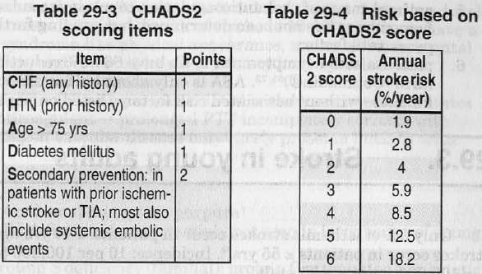

For patients with CHADS2 score ≥ 2, warfarin is significantly protective; for others aspirin may be enough.

ARISTOTLE trial - apixaban is better vs. warfarin in nonvalvular AFib
Goto S “Efficacy and Safety of Apixaban Compared with Warfarin for Stroke Prevention in Patients with Atrial Fibrillation from East Asia: A Subanalysis of the Apixaban for Reduction in Stroke and Other Thromboembolic Events in Atrial Fibrillation (ARISTOTLE) Trial” Am Heart J. 2014 Sep;168(3):303-9.
Compared with warfarin, apixaban resulted in a consistent reduction in stroke or systemic embolism in East Asian (hazard ratio [HR] 0.74, 95% CI 0.50-1.10) and non-East Asian (HR 0.81, 95% CI 0.66-0.99) patients (interaction P = .70). Consistent benefits of apixaban over warfarin were also seen for major bleeding in East Asian (HR 0.53, 95% CI 0.35-0.80) and non-East Asian (HR 0.72, 95% CI 0.62-0.83) patients (interaction P = .17). There was a greater reduction in major or clinically relevant nonmajor bleeding with apixaban compared with warfarin in East Asian (HR 0.49, 95% CI 0.35-0.67) than in non-East Asian (HR 0.71, 95% CI 0.63-0.79) patients (interaction P = .03). Numerically higher rates of intracranial bleeding were seen in East Asian patients with warfarin but not with apixaban.
Apixaban resulted in similar reductions in stroke or systemic embolism and major bleeding and greater reductions in major or clinically relevant nonmajor bleeding in patients from East Asia. Warfarin is associated with more intracranial bleeding, particularly in patients from East Asia.

  - acute MI – anticoagulation (for at least 2-3 months) is indicated only if following exists:
    - persistent AF
    - left ventricular thrombus / aneurysm
    - extensive wall motion abnormalities (left ventricular ejection fraction < 25%).
  - mechanical prosthetic valves (target INR 3-4.5, depending on valve type).
  - mitral stenosis with any prior embolic event.
  - dilated cardiomyopathy
  - other conditions - left atrial myxoma, intraventricular thrombus, ventricular aneurysm with thrombus, mobile thrombus in ascending aorta.

Indications for secondary stroke prophylaxis:
A) after stroke confirmed as cardiogenic:
- large* patent foramen ovale with spontaneous right-to-left shunting
*if small → aspirin is sufficient.
- mitral valve prolapse with myxomatous leaflets
- mitral ring calcifications
- rupture of chordae tendineae
- dyskinetic ventricular wall segment

B) thrombophilias:
- antithrombin III deficiency
- protein C deficiency (INR 3-3.5)
- protein S deficiency
- high titers of anticardiolipin antibodies (INR 2.5-3.5).
- APC resistance
- plasminogen deficiency/inhibition
- dysfibrinogenemia
  - alternative (except for antithrombin III deficiency, anticardiolipin antibodies) - fixed, low-dose SC heparin or LMWH.
  - after single event of thrombosis → anticoagulation for at least 6 months.
  - after recurrent or life-threatening thrombosis or in case of combination of different thrombophilias → lifelong anticoagulation.

No randomized studies* support oral anticoagulation after ischemic stroke of arterial origin (i.e. stenoses of extracranial / intracranial arteries)
  - risk of bleeding.
  - aspirin is preferred (or ICA endarterectomy).
  - warfarin can be stopped after clot organizes and adheres to vessel wall - usually after 3-4 weeks.
*WASID (Warfarin and Aspirin for Symptomatic Intracranial Arterial Stenosis) trial: warfarin has significantly higher rates of adverse events and no benefit over aspirin in intracranial arterial stenosis.

Contraindications - increased risk of bleeding:
- poor compliance
- uncontrollable hypertension
- aortic dissection
- bacterial endocarditis
- liver disease, alcohol dependency
- bleeding lesions, malignant tumor
- retinopathy with bleeding risk
- advanced microvascular changes in brain
- aneurysm of cerebral artery
- previous spontaneous cerebral hemorrhage
- coagulopathies, thrombocytopenia.
In these cases, use aspirin as long-term treatment.

Atherosclerotic intracranial arterial stenosis (s. intracranial stenoocclusive disease)
– causes 8-10% of all strokes in USA
– vasculitis and stenosis appear virtually identical on angiography. Remember: most common cause of vasculitis- like pattern in older patient isn't vasculitis, it's intracranial atherosclerotic stenosis!
– used to be treated by stenting; SAMMPRIS and Vitesse studies show that it increases stroke risk – business now halted!
N.B. intracranial (not intradural) – includes petrous portion of ICA!

70-99% stenosis of major intracranial artery + recent TIA / stroke – high risk of recurrent stroke! (23% at 1 year)

Management strategies:
- percutaneous transluminal angioplasty & stenting (PTAS) – almost impossible to reach beyond basilar tip ar beyond M1
- aggressive medical management

SAMMPRIS trial
Marc I. Chimowitz et al. “Stenting versus Aggressive Medical Therapy for Intracranial Arterial Stenosis” N Engl J Med 2011;365:993-1003
“Aggressive medical treatment with or without stenting in high-risk patients with intracranial artery stenosis (SAMMPRIS): the final results of a randomized trial” The Lancet, Early Online Publication, 26 October 2013 >> or >>
Stent used: Wingspan stent system (Stryker, formerly Boston Scientific Neurovascular)
Medical treatment used: aspirin 325 mg/d + clopidogrel 75 mg/d (for 90 days) → asprin alone

Cumulative rate of stroke or death (of major hemorrhage):
Treatment | 30-day rate | 1-year rate | 3-year rate
PTAS + medical | 14.7% | 20.0% | 23.9% (13%)
Medical | 5.8% | 12.2% | 14.9% (4%)
no treatment |  | 23%

Vitesse Intracranial Stent Study for Ischemic Stroke Therapy trial
- randomized patients with symptomatic intracranial stenosis (≥ 70%) to treatment with balloon-expandable* stent plus medical therapy vs. medical therapy alone at 27 sites.
*stent is mounted on balloon – does not need microcatheter exchange (vs. Wingspan system)
- trial also was stopped early after 112 of the projected 250 patients were enrolled due to higher incidence of ischemic and hemorrhagic complications in stent arm.

Cumulative incidence of TIA, stroke, intracranial hemorrhage, or death (of intracranial hemorrhage alone):
Treatment | 30-day rate
Stent + medical | 24.1% (8.6%)
Medical | 9.4% (0%)

Aggressive medical management
- Combination antiplatelet therapy: aspirin 325 mg/d + clopidogrel 75 mg/d (for 90 days)
- warfarin – not recommended – WASID trial see above >>
- Intensive management of risk factors:
- systolic BP < 140 mmHg (< 130 mmHg if diabetic); Dr. S. Simon prefers ACEI.
- LDL cholesterol < 70 mg/dL (< 1.81 mmol/L)
- smoking cessation

Percutaneous transluminal angioplasty and stenting (PTAS)
Self-expanding Wingspan stent (Boston Scientific)
- originally FDA approved in 2005 under a Humanitarian Use Device (HDE).
- the only device approved by FDA for atherosclerotic 50-99% intracranial arterial stenosis for patients who have had at least one TIA or stroke while receiving antithrombotic therapy (esp. if symptoms indicate hemodynamic problem).
- restenosis occurs in 25-30% within 6 months after stenting.
- new 2012 FDA indications - patients 22-80 years old AND who meet ALL of the following criteria:
- ≥ 2 strokes (not TIAs!) despite aggressive medical management;
- most recent stroke occurred > 7 days (prior to planned treatment with Wingspan);
- 70-99% stenosis due to atherosclerosis of intracranial artery related to recurrent strokes
- good recovery from previous stroke (modified Rankin score ≤ 3).
N.B. approval under HDE means that patient may be treated with Wingspan only if treating physician's IRB has approved its use in advance!

Bibliography for ch. “Neurovascular Disorders” → follow this link >>

Viktor’s Notes℠ for the Neurosurgery Resident
Please visit website at www.NeurosurgeryResident.net

