Carotid Atherosclerotic Stenosis
Last updated: April 20, 2019
Epidemiology 1
Pathophysiology 1
Atherosclerosis in proximal ICA (CCA bifurcation) 2
Clinical Features 2
TIAs 2
Amaurosis Fugax 2
Ischemic Stroke 3
Infarction in ICA distribution 3
Screening 3
Diagnosis 3
Carotid Evaluation 3
Duplex Doppler ultrasound 3
MRA, CTA 4
Arteriography 5
Plain radiographs 6
Oculopneumoplethysmography (OPG) 6
Other Tests 6
Ischemia Prevention (Medical) 6
Ischemia Prevention (Surgery) 6
Indications for intervention 7
CEA vs. Stent 7
Concurrent Carotid and Heart disease 7
Carotid Endarterectomy (CEA) 7
Trials 7
Indications & Contraindications 8
Preoperative evaluation 8
Procedure 9
Complications 9
Eversion Carotid Endarterectomy 10
Carotid Angioplasty & Stenting (CAS) 11
Indication 11
Procedure 11
Physiology 11
Complications 11
Extracranial-Intracranial Bypass 11
Follow up 12
Restenosis after treatment 12

Etiologies for all kinds of extracranial carotid lesions:
- Atherosclerosis (90%)
- Aneurysms
- Arteritis
- Carotid dissection
- Coils and kinks
- Fibromuscular dysplasia
- Radiation
- Vasospasm

Famous trials:
SAPPHIRE
CREST
ICSS
SPACE2

Epidemiology
Prevalence (carotid stenosis > 50%):
0.5% persons 50-60 yrs;
10% persons > 80 years

N.B. atherosclerosis of extracranial ICA causes 60% ischemic brain infarcts!

Pathophysiology
Commonest sites of carotid atherosclerosis (areas of turbulent flow):  - proximal CCA (e.g. in Takayasu's arteritis, aortic arch syndrome)  - proximal ICA (CCA bifurcation)!!!  - carotid siphon  - stenosis tends to be eccentric. | 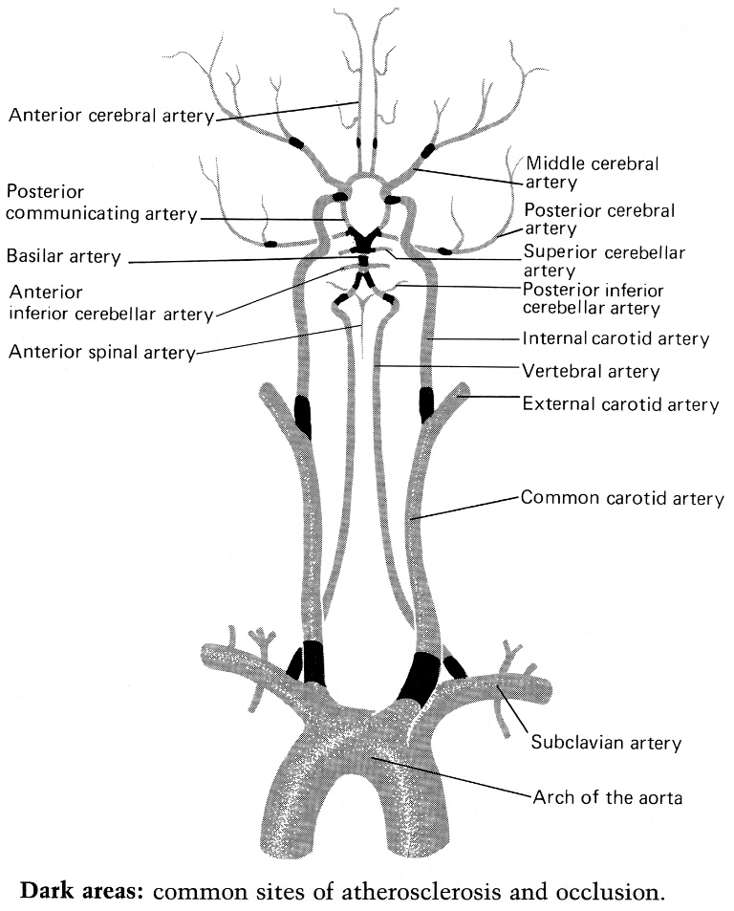

Steps (each step can cause ischemia up to infarction):
Atherosclerotic stenosis
↓
Plaque ulceration → Embolization with necrotic material (e.g. cholesterol crystals)
↓
Thrombosis in situ → Embolization with detached thrombus*

*most common mechanism causing ischemic strokes

N.B. plaque ulceration may cause stroke even with mild stenosis.

Atherosclerosis in proximal ICA (CCA bifurcation)
  - due to unusual geometry of carotid bifurcation.
N.B. atherosclerosis develops largely in regions of relatively low wall shear stress, flow separation, and departure from axially aligned, unidirectional flow (these lead to cumulative vessel wall metabolic disturbances, prolonged exposure to plasma lipids, circulating white cells and platelets, activated coagulation factors, and other mitogenic stimuli).
  - most severe in first 2 cm and arises from posterior wall, often extending downward into CCA.
  - in some patients, ulcerated plaque may be only lesion, but more often there is accompanying stenosis ≥ 50%.

A. Flow patterns at carotid bifurcation - flow reversal along posterior wall of carotid sinus (most vulnerable region to plaque development).
B. Established plaque at carotid bifurcation.
C. Soft, central necrotic core with overlying thin fibrous cap - prone to plaque rupture.
D. Disruption of fibrous cap → necrotic cellular debris and lipid material from central core enter lumen (atherogenic emboli).
E. Empty necrotic core becomes deep ulcer in plaque; ulcer walls are highly thrombogenic and reactive with platelets → thromboembolism.
Ulcerated plaque at carotid bifurcation is most common source of artery-borne emboli!
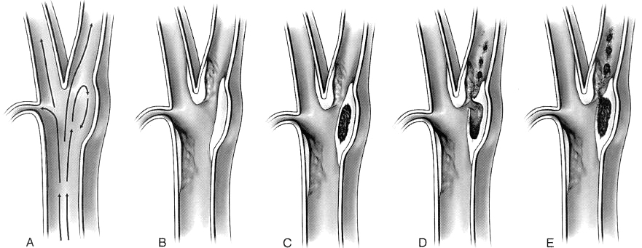

Clinical Features
- usually affects white men and is strongly associated with coronary and peripheral vascular occlusive disease, systolic hypertension, and hyperlipidemia.
N.B. carotid stenosis is indicator of generalized atherosclerosis – more predictive of MI than of ipsilateral stroke!
- ICA stenosis is usually well compensated (ICA occlusion may be clinically silent!):
- Circle of Willis!!! (often congenitally incomplete)
- Retrograde flow through ophthalmic a. parasitizing blood from ECAs via facial a., maxillary a., superficial temporal a.
- Proximal maxillary a. → anterior tympanic a. → caroticotympanic branches of ICA
- Cortical-cortical anastomoses
- Dural-leptomeningeal anastomoses

High-pitched carotid bruit fading into diastole (common finding that is indication for carotid duplex sonography)
- bruit intensity is proportional to reduction in cross-sectional area, increasing until area is reduced by 66%; as stenosis grows tighter (reduced flow distal to stenosis), bruit diminishes and may disappear when occlusion is imminent.
N.B. lack of bruit does not exclude significant carotid stenosis!
- bruit pitch increases steadily as lumen decreases.
- arterial murmurs begin in systole; in stenosis > 80% they extend into diastole.
- differential diagnosis: cardiac murmur transmitted to neck (heard bilaterally and more intense in lower neck), stiff calcified or torturous vessels without stenosis.
- carotid bruit may be coincidental (e.g. auscultation may detect vertebral or subclavian bruits as well).

Carotid pulse is decreased / absent ipsilaterally.
- patients with hypertension may have less hypertensive change in fundus on side of ICA stenosis.
- increased ipsilateral external carotid pulses in face (superficial temporal, brow, angular) - collateral circulation around occluded ICA - check for symmetry of these pulses between sides of face.

There may be bruit without stenosis and stenosis without bruit.
There may be occlusion with palpable pulse or decreased pulse in patent vessel.

TIAs
- TIA warnings are especially common:
- embolisms (more common)
- low-flow (presumably inadequate collateral flow through circle of Willis)
- predictable regularity in distribution of paths taken by emboli owing to laminar nature of blood flow (repetition of similar TIA symptoms in individual patient).
- ophthalmic artery (amaurosis fugax) > proximal MCA > ACA. see p. Vas3 >>
vs. cardiogenic emboli can produce TIAs anywhere in brain (equally distributed throughout brain).
- in severe stenosis, orthostatic BP changes (that would otherwise be considered normal) can cause ischemia.
e.g. act of standing may precipitate attack of tremor or limb shaking (may be mistaken for focal seizure).
- TIAs increase risk of stroke (as compared to asymptomatic carotid stenosis).

Amaurosis Fugax
– sudden painless transient monocular blindness (TMB) from transient ischemia of ipsilateral ophthalmic artery.
N.B. ischemia is most common mechanism of sudden visual loss!
- symptoms last only few minutes (seconds ÷ hours), i.e. shorter in duration than cortical TIAs.
- patients typically describe gray-black curtain shade that gradually sweeps down or up across field of vision:
superior retinal artery - curtain ascending to horizontal mid-visual field and then descending.
inferior retinal artery - curtain descending to horizontal mid-visual field and then ascending.
central retinal artery - almost complete loss of vision in eye.
- because fovea centralis has separate blood supply, patients often retain this small portion of visual field (telescoped or tunnel vision).
- other complaints: vision blurring, fogging, dimming, disappeared upper or lower half of vision.

Ischemic Stroke
- carotid stenosis > 75% (i.e. hemodynamically significant) → annual stroke risk 3.3%.
- abrupt hypotension in severe ICA stenosis can cause ipsilateral “watershed” infarction.
- acute ICA occlusion → 26-49% risk of stroke (not all of these strokes are severe).

Factors that increase risk of stroke for given level of stenosis:
- Symptomatic stenosis – i.e. previous stroke, TIAs (esp. hemispheric TIAs as opposed to retinal TIAs)
- Contralateral carotid occlusion
- Angiographic findings of ulceration
- Male sex

Infarction in ICA distribution
ACA + MCA + ophthalmic or central retinal artery (infarction → permanent vision loss)
- in unusual fetal PCA configuration, PCA is also affected.
Cortex supplied by MCA is affected most often!
  - weakness and numbness are greatest in face.
  - even if circle of Willis is functional, monocular blindness may occur (because ophthalmic artery branches off before communication with circle of Willis).
  - infarction is massive - patients tend to be stuporous or semicomatose; cerebral edema may be life-threatening concern!
  - ipsilateral Horner's syndrome may be present (oculosympathetic involvement along carotid artery).

Screening
US Preventive Services Task Force (USPSTF) - final recommendation advising against screening general adult population to detect asymptomatic carotid artery stenosis.
Very high false positives with US!

Diagnosis
Carotid Evaluation
Noninvasive techniques are increasingly used to evaluate asymptomatic patients found to have carotid bruit in neck on routine physical examination.

N.B. vascular occlusion may be long-standing and clinically asymptomatic!

 | Duplex | CTA | MRA | Angiography
ICA stenosis morphology | good | excellent | good | excellent
Risk | none | minimal | minimal | significant
Cost | + | ++ | +++ | ++++

Duplex Doppler ultrasound
- screening test of choice! (many surgeons will operate on results of carotid duplex alone if laboratory has credentials and is validated!!!; others would proceed to CTA preop)
- can visualize plaque morphology directly:
- small flat fibrofatty plaque - hypoechoic.
- ulcerated plaque - surface variability (thrombi attached to endothelium).
- intraplaque hemorrhage - heterogenous pattern of low and medium echoes.
- calcified plaque - echogenic lesion that produces acoustic shadows.
- can measure carotid stenosis and intraluminal area reduction.
  - can accurately identify carotid stenosis > 60% (hemodynamically significant); for stenosis ≤ 50%, Doppler is not reliable.
  - angiogram is required to distinguish > 95% stenosis (“string sign”) from complete occlusion; because in stenosis > 95%, velocities decrease to normal (and then subnormal) values but waveform is abnormal (distorted - harsh sound!)
  - not valid in setting of contralateral ICA disease (occlusion or severe stenosis) or poor cardiac output.

Stenosis | Peak Systolic Velocity (cm/s) | Peak End Diastolic Velocity (cm/s) | Peak Systolic Velocity Ratio
< 50 | < 150 | < 50 | < 2.0
50-59 | 150-200 | 50-70 | 2.0-2.5
60-69 | 200-250 | 50-70 | 2.5-3.0
70-79 | 250-325 | 70-90 | 3.0-3.5
80-89 | 325-400 | 70-100 | 3.5-4.0
90-99 | > 400 | > 100 | > 4.0
Occlusion | Not applicable | Not applicable | Not applicable
N.B. Peak End Diastolic Velocity starts to increase only when stenosis is > 70-75%

RESUME: Doppler is valid only in unilateral ICA stenosis 50-95% with normal cardiac output - seen as peak velocity↑ + spectral broadening

How to differentiate ICA from ECA? ECA has triphasic waveform (indicative of high resistance):
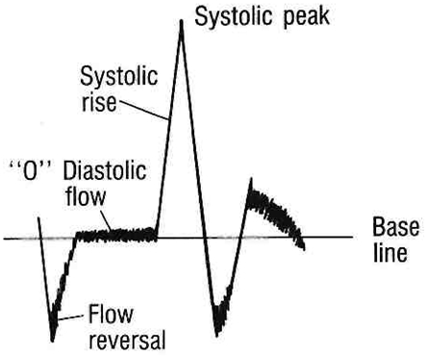

Spectral Doppler: Spectral Doppler is useful for estimating the degree of stenosis from velocity parameters.
Peak systolic velocity (PSV) is the most common, recommended measurement, Other useful measurements include the systolic velocity ratio (SVR), which is ICA stenosis/normal CCA, and end diastolic velocity (EDV), PSV and EDV rise with increasing stenosis.
High-grade, near-occlusive stenoses demonstrate variable velocity. High flow resistance may actually decrease the PSV, so diagnosis is based on color Doppler appearance and damped waveforms distal to the stenosis.
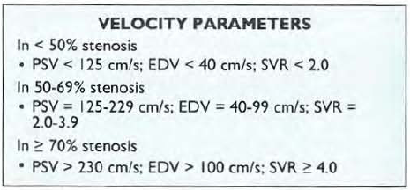

MRA, CTA
- extremely accurate in detecting atherosclerotic narrowing of cervical carotid arteries.
see p. D64 >>
- tendency to overstate significance of stenosis.
MRA is best noninvasive technique for carotid stenosis!
- gadolinium enhancement of carotid plaque is related to inflammatory process and is associated with vulnerable plaque phenotypes.

MRA - high-grade stenosis in right proximal ICA - focal signal loss in proximal ICA (arrowheads):  N.B. distal signal is present - indicates flow through high-grade stenosis  Left (2D TOF MRA). Right (different projection).  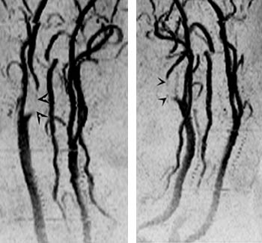 |  | 3D TOF MRA - high-grade stenosis at carotid bifurcation causes turbulent flow resulting in signal loss in proximal internal and external carotid arteries (‘flow gap’):  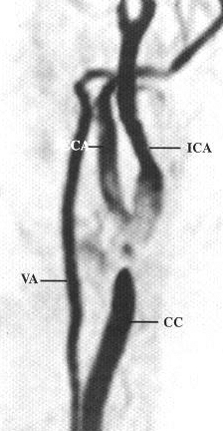
CTA of bilateral carotid artery occlusions (yellow arrows):  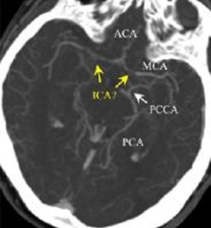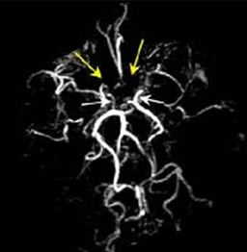 | 3D surface-shaded CTA reconstruction - occluded proximal left ICA (long arrow); ECA (arrowhead) and jugular vein (double arrow) are patent:  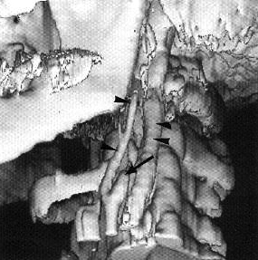

Arteriography
- remains standard definitive method for visualizing carotid anatomy (incl. kinks and coils that may affect conduct of operation).
- procedure associated with 1-2% risk of stroke.
- images of carotid bifurcation must be obtained in at least two projections (usually AP and lateral), but additional oblique projections are often necessary to show plaque in profile and to determine area of maximum stenosis.
- images of carotid bifurcation should be supplemented by images of ipsilateral intracranial circulation (to exclude tandem stenosis or incidental lesion such as aneurysm).

"Tandem lesions" - stenoses distal to a more proximal lesion and arc seen in approximately 2% of patients with hemodynamically significant cervical ICA stenosis. The most common site for a "tandem lesion" is the cavernous ICA.

String sign
High-grade stenosis causes very slow antegrade flow with delayed contrast washout. A "string" sign is present when only a "trickle" ("string") of antegrade now is detected at DSA or color Doppler (10- 15). The string sign-also called carotid pseudoocclusion or preocciusion-repreSCllls > 95% stenosis. Such patients are at especially high short-term risk for stroke. Examining the late venous phase of the DSA is critical to document subtle arterial patency, as this will determine if emergent endarterectomy or stenting is a treatment option.

- diameter of stenosis can be measured directly (use enlarged image for accuracy);
Normal internal diameter of ICA is highly variable - absolute internal diameter is less significant - use percentage.

“N” (NASCET*) method:  diameter (a) of narrowest portion divided by normal diameter (b) distal to lesion:  [1-(a/b)] × 100  disadvantage - may underestimate stenosis when distal lumen narrows as result of severe proximal stenosis that limits volume flow. | 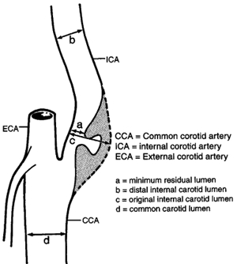
“E” (ECST**) method - residual lumen as percentage of diameter of ICA bulb (i.e. estimated "true" lumen diameter at point of stenosis):

[1-(a/c)] × 100

disadvantage - observer must extrapolate what is thought to be “true” lumen.

Common carotid method: [1-(a/d)] × 100
*North American Symptomatic Carotid Endarterectomy Trial
**European Carotid Surgery Trial

Aortic arch angiography - normal variant of aortic arch (AA) - both innominate artery (IA) and left CCA share common origin, right CCA (RCA) and right ICA are irregular and narrowed - long, multisegment stenosis (result from radiation therapy) | 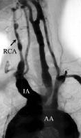 | Only proximal few centimeters of internal carotid artery are patent (arrow) | 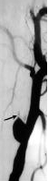
Kink - focal narrowing of proximal ICA (arrow). | 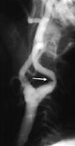 | Kink - horizontal line (arrow) in proximal ICA, which represents focal folding (bruit results from turbulent blood flow) | 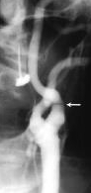
Small filling defect in common carotid bulb (arrow); small blood clot was found at surgery, with intimal ulceration at base of clot | 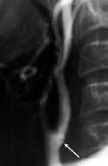 | Irregular lumen (arrows) consistent with recanalization of thrombosis | 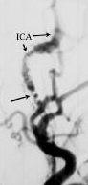
Dilatation (black double arrow) of ICA beyond high-grade stenosis (white arrow) - poststenotic dilatation is associated with hemodynamically significant stenosis. | 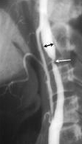 | Multiple areas of deep ulceration in proximal ICA and carotid bulb (arrows). | 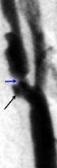
CCA is narrowed, but it has smooth outline; occlusion of supraclinoid ICA (ICA); enlarged ophthalmic artery (Opthal. A.) functions as major collateral. | 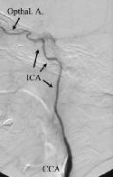 | AP intracranial carotid angiogram - incomplete occlusion of suprasellar ICA near origin of M1 segment → absence of MCA branches. | 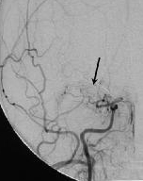
Angiogram near skull base in patient with significant fracture of skull base: ICA compression and focal spasm due to hemorrhage from pseudoaneurysm (arrow) of upper cervical ICA. | 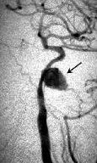 | Lateral carotid angiography - collateral vessels in long-standing complete ICA occlusion. | 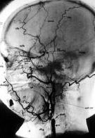
Lateral carotid angiogram - high-grade stenosis of proximal ICA; photograph of plaque after endarterectomy: | 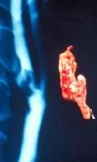 | ICA occlusion at classical site (just beyond its origin); stump is irregular; ascending pharyngeal artery (arrow) should not be confused with very narrow ICA: | 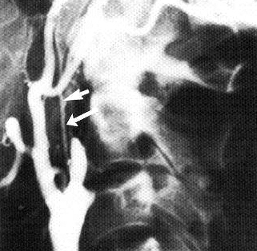
Irregular high-grade atheromatous stenosis at ICA origin (large arrow); shallow atheromatous plaques are seen on ICA (black arrow) and ECA (white arrow): | 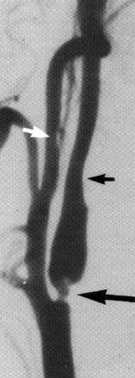

A. No filling of extracranial ICA and prominent meningeal collaterals from ascending pharyngeal and internal maxillary branches of ECA reconstituting petrous and cavernous segments of ICA.
B. Additional collateral flow from ophthalmic artery augmenting intracranial ICA flow with reconstitution of MCA:
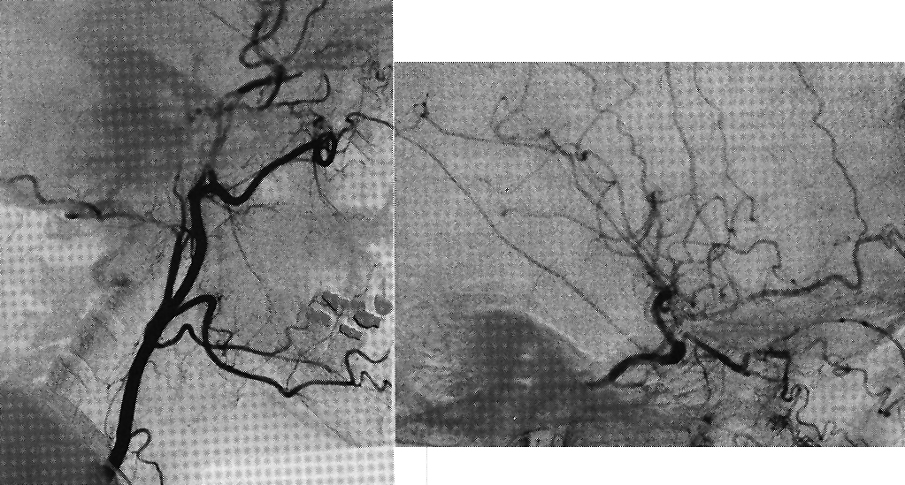

Plain radiographs
- may demonstrate large calcified plaques in carotid vessels in neck.

Oculopneumoplethysmography (OPG)
- detects severe stenosis (≥ 75% cross-sectional area) from level of aortic arch to carotid siphon.
- measuring ophthalmic systolic pressure and brachial systolic pressure → plotting this ratio against standard regression line of normal values (i.e. detecting ocular hypotension)
- now used less frequently.

Other Tests
Funduscopy - cholesterol emboli (shiny refractile bodies or Hollenhorst plaques) in retinal arteries.

ECG - high incidence of concomitant coronary artery disease.
Carotid disease is marker for cardiovascular disease - 50-66% deaths are due to heart disease!!! (stroke* causes only 5% deaths in asymptomatic patients and 20% in symptomatic patients).
*not necessarily in territory of involved carotid artery

Ischemia Prevention (Medical)
Symptomatic patients with mild stenoses (< 50%) and most asymptomatic patients (esp. with stenoses < 60%) are best treated medically!

- Atherosclerosis prophylaxis (esp. statin therapy* and BP control)
*adding extended-release niacin to statin therapy results in significant regression of atherosclerosis as measured by carotid intima-media thickness (IMT)
- Aspirin (325 mg/d) can prevent platelet-fibrin emboli in minor ÷ moderate stenosis.
  - if symptoms recur:
    - increase aspirin dose
    - ticlopidine
    - clopidogrel
N.B. role of dual antiplatelet therapy is unclear (vs. proven for vertebral stenosis)
  - warfarin is not recommended.
  - aspirin is also continued post-endarterectomy.

Ischemia Prevention (Surgery)
After any carotid intervention, BP control is of paramount importance!

Indications for intervention
Symptomatic* stenosis ≥ 50%
Asymptomatic stenosis ≥ 60-70%
*if massive stroke – no salvageable tissue – do not treat (risk of hemorrhagic conversion)

CEA vs. Stent
When CEA is better (vs. stent):
- Males with symptomatic 50-70% stenosis do better with CEA; in all other cases CEA might be better but all studies did not reach statistical significance!
- After stent patient has to be on aspirin + Plavix (vs. after CEA – only aspirin)

When stent is better (vs. CEA):
- High stenosis (would need mandibular splitting for CEA)
- Poor health for surgery
- Previous radiotherapy to neck (carotid stenosis may be not due to atherosclerosis but due to vessel wall sclerosis; some experts monitor all patients with carotid Doppler after neck radiotherapy)
- Prior CEA

Stenting has slightly higher periprocedural (up to 30 days) stroke risk but surgery has a higher rate of cranial nerve palsy or myocardial infarction.

Carotid Revascularization Endarterectomy versus Stenting Trial (CREST)
- no difference in composite primary endpoint of stroke, MI, or death during or after CAS and CAE.

International Carotid Stenting Study (ICSS)
- long-term outcomes after stenting vs CEA for symptomatic carotid stenosis:
- long-term functional outcome and risk of fatal / disabling stroke are similar.
- non disabling strokes are more common in stenting group.

Stent-Protected Angioplasty versus Carotid Endarterectomy (SPACE)
Eckstein HH et al. Results of the Stent-Protected Angioplasty versus Carotid Endarterectomy (SPACE) study to treat symptomatic stenoses at 2 years: a multinational, prospective, randomised trial. Lancet Neurol 2008; 7 : 893 – 902
- class I evidence; equivalent of NASCET except that the two conditions are surgery and stenting (rather than surgery and conservative treatment).
- 2-year outcomes - no significant differences but the trend was for fewer complications in the surgery group + degree of re-stenosis higher in the stent group (10.7% vs. 4.6% p = 0.0009).
- periprocedural risk:
< 68 yrs – lower in stenting group
> 68 yrs – lower in CEA group

Concurrent Carotid and Heart disease
- when patients are undergoing open-heart surgery, whether it's CABG or valve surgery, they are screened for carotid artery disease, given heightened risk of stroke when undergoing heart surgery.
- what is the best timing - staged approach: carotid artery stenting (CAS) → open heart surgery (OHS).
Shishehbor MH, Venkatachalam S, Sun Z, et al. A direct comparison of early and late outcomes with three approaches to carotid revascularization and open heart surgery. J Am Coll Cardiol 2013; http://content.onlinejacc.org
Mahmud E, Reeves R. Carotid revascularization prior to open heart surgery: The data driven treatment strategy. J Am Coll Cardiol 2013; http://content.onlinejacc.org
- combined approach (concurrent CEA + open-heart surgery) is equivalent in terms of short-term outcomes with staged CAS-OHS procedure. Beyond one year, however, staged CAS-OHS approach resulted in lowest risk of all-cause mortality / stroke / MI when compared with combined CEA-OHS and staged CEA-OHS.
- "for patients presenting with an acute coronary syndrome requiring urgent coronary revascularization in whom waiting 3-4 weeks is not safe, combined CEA-OHS is optimum revascularization strategy, though associated with higher neurological ischemic events,"
- “for patients with stable or accelerating anginal syndrome who can wait 3-4 weeks to complete dual antiplatelet therapy [DAPT] after carotid stenting, staged CAS followed by OHS leads to superior early and long-term outcomes."

Carotid Endarterectomy (CEA)
- first successful carotid endarterectomy was performed by DeBakey on August 7, 1953.

Trials
Randomized trials comparing carotid endarterectomy (cross-hatched bars) to medical therapy (open bars):
- principal endpoints include ipsilateral stroke and death with operation or initiation of medical treatment.
- percentage relative risk reduction from carotid endarterectomy is indicated by downward-pointing arrows.
- length of follow-up for each trial is indicated below bars.
ACAS, Asymptomatic Carotid Atherosclerosis Study;
CASANOVA, Carotid Artery Stenosis with Asymptomatic Narrowing: Operation Versus Aspirin;
ECST, European Carotid Surgery Trial;
NASCET, North American Symptomatic Carotid Endarterectomy Trial;
VA, Veterans Administration Trial.
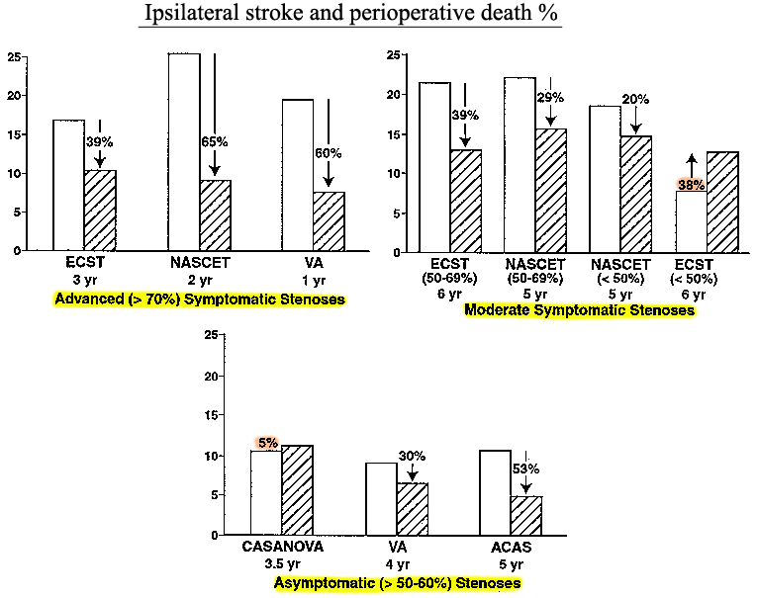

- risk of stroke and death is much greater in symptomatic patients.
- almost all trials in symptomatic patients demonstrated important benefit of carotid endarterectomy (most apparent in advanced, high-grade stenoses).
- for stenoses < 50-60% medical treatment produces equivalent results to endarterectomy.
- many of strokes in surgery groups were caused by preoperative angiograms (if it could be replaced by ultrasonography and MRA, morbidity and mortality will be obviated).

Benefit of Carotid Endarterectomy in different patient categories over 2 years of follow-up:
Stenosis (%) | Relative Risk Reduction (%) | Absolute Risk Reduction (%) | When perioperative morbidity and mortality
SYMPTOMATIC DISEASE
70-99 | 65 | 17 (26→9) | < 5-10%
70-99 + multiple risk factors | 77 | 30
70-99 + contralateral occlusion | 64 | 35
90-99 | 88 | 26
80-89 | 80 | 18
70-79 | 65 | 12
50-69 | 29 | 6.5 | < 6%
<50 | 20 | 4
ASYMPTOMATIC DISEASE
60-99 | 53 | 6 | < 3%

Indications & Contraindications
I. Symptomatic patients (ipsilateral TIAs [incl. amaurosis fugax] or small stroke within 3 months):
- carotid stenosis ≥ 50% (benefits are greatest for stenosis > 70%; modest for 50%–69% stenosis, and no benefit for stenosis < 50%); men, patients > 75 yrs, and those presenting with stroke rather than transient ischemic attack benefit most.
- stenosis < 50% + failed medical therapy (ongoing symptoms), esp. with lesion ulceration or contralateral carotid occlusion.
  - neurologic contraindications:
    - complete carotid occlusion (surgical attempts to reopen often fail clinically); stumpectomy – carotid ligation above occlusion to prevent thromboembolism (modern approach – antiplatelets)
    - severe neurologic deficits (esp. altered consciousness)
    - vertebrobasilar distribution TIAs
    - multi-infarct dementia
    - intracranial hemorrhage
    - large infarcts
  - medical contraindications (limit patient's life expectancy to < 5 yrs*): uncontrolled CHF, recent MI, unstable angina, advanced malignancy, uncertain diagnosis.
*CEA is exceptionally safe and effective even in medically high-risk patients
  - timing of operation after stroke:
early operation – risk of conversion bland infarct → hemorrhagic;
delayed operation – risk of recurrent stroke;
in general, within 4 weeks but 7 days after stroke
- severe neurologic deficits (incl. altered consciousness) - not candidate for endarterectomy, unless considerable clinical recovery (i.e. brain tissue that can be preserved).
- stable, nondisabling acute stroke (incl. normal level of consciousness) + normal CT → endarterectomy shortly after diagnosis is made.
- stable neurologic deficit (incl. normal level of consciousness) + small stroke without significant midline shift on CT:
advanced (> 70%) stenosis → early operation.
moderate (50-69%) stenosis → delay operation for 4-6 weeks.
- large stroke with midline shift on CT (esp. with depressed level of consciousness) → delay operation until patients improves & plateaus in recovery.

II. Asymptomatic patients
  - because benefit-to-risk ratio in asymptomatic patients is much less than that of symptomatic patients, reserve endarterectomy only for good-risk* patients with stenosis > 60-70%
*perioperative morbidity or mortality risk < 3%
N.B. surgical morbidity and mortality achieved by particular surgeon in particular hospital must be considered before endarterectomy is recommended in asymptomatic carotid artery stenosis.
  - again, plaque ulceration or contralateral occlusion may lower threshold for recommending operation.

Preoperative evaluation
  - CBC, aPTT.
  - ECG (most common cause of mortality following carotid endarterectomy is MI).
      - nondiabetics < 70 yrs with no cardiac symptoms and normal ECG may undergo carotid endarterectomy without further cardiac workup.
  - all symptomatic patients should have CT / MRI to rule out other intracranial lesions and identify presence of new and old cerebral infarcts.
  - duplex ultrasound ± MRA ± arteriography see above
Indications for preoperative arteriography:
- Stenosis in 40-59% (moderate) range - duplex ultrasonography frequently underestimates / overestimates levels of stenosis in this range.
- Equivocal or poor quality duplex scans.
- Discrepancy among history, physical examination, duplex, and CT.
- Vertebrobasilar symptoms (often have proximal brachiocephalic disease).
- Suspected proximal disease involving branches of aortic arch.
- Duplex suggestive of distal ICA disease.
- Duplex evidence of total carotid occlusion in presence of ongoing ipsilateral hemispheric symptoms (patients may have near-total occlusion or "string sign").
- Contralateral carotid occlusion / severe / stenosis (ipsilateral increased flow velocities → overestimated duplex results).
- Nonatherosclerotic disease (e.g. fibromuscular dysplasia).
- Recurrent carotid stenosis (plaque morphology and disease extent may be unusual).

Procedure
See p. Op350 >>

Complications
  - complication rate in symptomatic patients is higher than in asymptomatic patients.
  - perioperative mortality 0.5-1.8%.
Guidelines (if results exceed these values, operation is not beneficial):
- combined perioperative morbidity and mortality should not exceed 3% for asymptomatic patients and 6% for symptomatic patients (5% for TIAs, and 7% for ischemic stroke).
- 30-day mortality from all causes related to endarterectomy should not exceed 2%.
- 10-12 carotid endarterectomies per year are necessary to maintain surgical expertise.

  - sympathetic fibers to pupil travel with internal carotid plexus – damaged during carotid endarterectomy / dissection.
  - sympathetic fibers to (lower) face skin travel with branches of external carotid artery – spared in carotid violations.

- Perioperative stroke (1-5%)
  - neurologic deficits within first 12 hours are result of thromboembolic phenomena → immediate heparinization & exploration (without need for confirmatory arteriography or noninvasive tests).
  - neurologic deficits that begin beyond 12-24 hours are usually due to thromboembolic phenomena, but may also be due to postoperative hyperperfusion syndrome or intracerebral hematoma → prompt CT & arteriography.
At wound reopening:
    - excellent ICA pulse and flow is present on Doppler → on-the-table arteriogram; if arteriogram reveals intimal flap or irregular mural thrombus at endarterectomy site → vessel reopening → thrombus is removed, and backbleeding is allowed; mechanical cause of thrombosis is usually defined as intimal flap, and this is repaired.
    - no ICA pulse (vessel is obviously thrombosed) - preliminary arteriogram is not necessary → thrombectomy.
  - prior to flow restoration, ICA arteriogram is done; if embolus exists in intracranial ICA or MCA → local infusion of lytic agent.

- Hyperperfusion syndrome, intracerebral hematoma (0.3-4.0%)
  - pathophysiology - paralysis of autoregulation from chronic ischemia; carotid flow restoration → hyperperfusion in cerebrovascular bed:
      - mild cerebral edema
      - intracerebral hemorrhages - petechial ÷ fatal (≈ 20% perioperative strokes!).
  - risk greatest: after CEA – within 24 hrs; after angioplasty & stenting – within 7 days.
  - risk greater after angioplasties than CEA (angioplasty damages baroreceptors more than CEA)
  - clinical features: ipsilateral frontal headache, followed by focal motor seizures (often difficult to control); postictal Todd's paralysis can mimic postendarterectomy stroke.
  - diagnosis - angiography, CT / MRI.
  - treatment: carefully control hypertension, avoid aspirin & anticoagulants.

- Hypertension / hypotension (30-50%) - carotid sinus malfunction (after endarterectomy, carotid bulb can again distend → carotid sinus reflex overresponse).
N.B. maintain systolic BP < 150 mmHg
  - nitroprusside / nitroglycerin for hypertension.
  - dopamine is preferred pressor.
  - BP usually normalizes within 12-24 hrs.

- Cardiac ischemia (0.8-2.2% risk of MI within 30 days)

- Cranial nerve injury (2-7%)
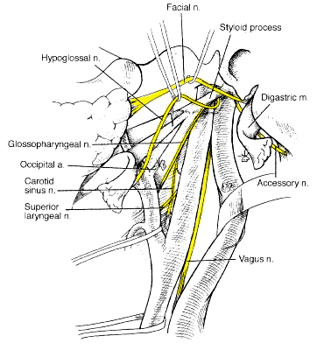
- hypoglossal nerve, descending branch (4-6%) - runs anterior and medial to jugular vein and anterior to ICA; hypoglossal nerve is invariably crossed superiorly by branch of occipital artery to sternocleidomastoid muscle.
  - section of descendens hypoglossi above cervical branch, which forms ansa cervicalis, produces no clinical syndrome (motor supply of deep strap muscles of neck).

- recurrent laryngeal nerve (5-7%) - ascends in neck behind CCA in groove between trachea and esophagus - rarely, if ever, exposed during endarterectomy - usually damaged by traction or cautery.
  - bilateral injury can severely compromise airway; H: indirect laryngoscopy before second (contralateral) endarterectomy.
  - rarely, right RLN arises at level of bifurcation and crosses anteriorly (nonrecurrent recurrent laryngeal nerve) - almost always associated with aberrant origin of right subclavian artery from distal aortic arch (check preoperative arteriography!).
  - rarely, anterior vagus nerve is present - at jeopardy when mobilizing CCA (H: policy of beginning dissection medially and maintaining circumferential dissection within periadventitial plane).

- superior laryngeal nerve (1-3%) – branches from vagus nerve at lower margin of 1st cervical vertebra → runs posteriorly and medially to ICA and ECA (can best be seen just medial and deep to carotid bifurcation).
  - usually damaged when complete mobilization of bifurcation is required.

- facial nerve – injury occurs only when high exposure (> C₂) of ICA is required - some surgeons extend incision anterior to tragus and reflect superficial lobe of parotid superiorly and anteriorly → traction on main facial nerve → complete facial nerve paralysis.
H: safer alternative methods (e.g. mandibular subluxation).
  - more common (1-3%) injury is to marginal mandibular branch - occurs with anterior and superior retraction along angle of mandible where marginal mandibular nerve is vulnerable → paralysis of depressor muscle of lip → asymmetry of mouth, annoying in speech; when eating patient may bite lower lip; deficit often clears within 3 months.

- glossopharyngeal nerve (exits via jugular foramen → passes between ICA and ECA just below stylopharyngeus muscle near its insertion into styloid process) - injured during high exposure of ICA.

- spinal accessory nerve (0.5-1%) (exits via jugular foramen → lies superficial to internal jugular vein → courses into sternocleidomastoid) - injured by misdirected exposure of carotid artery into posterior triangle of neck, by traction, or by cautery in high exposures.

- Spinal nerve injury
  - sensory branches of cervical plexus (transverse cervical nerve and greater auricular nerve) are frequently injured → permanent hypesthesia of upper face, lower neck, and lower ear.
  - generally well tolerated.

- Hematoma ± airway compromise (1.4-3.0%)
  - symptom suggesting significant hematoma - inability to swallow.
  - H: emergency drainage (up to wound opening in bed); in operating room, open and drain wound with local anesthesia (major difficulty in placing endotracheal tube without prior hematoma evacuation).

- Saphenous vein patch rupture (0.5%) - occurs 1 to 7 days after operation → major stroke and death rate is ≈ 48%.
  - linear correlation between diameter of intact veins and rupture pressure (veins < 4-5 mm in diameter should not be used for vein patch reconstruction).

- Recurrent stenosis - continuum of atherosclerotic changes (10% in first year → 3% in second year → 2% in third year → 1% per year).
  - symptomatic recurrence occurs in 0.6-3.0% patients (reoperation is necessary in 1-3% cases!).
  - asymptomatic lesions occur with much greater frequency (7-49%).
  - antiplatelet therapy has no influence on development of clinical manifestations of recurrent carotid stenosis.
  - risk factors for recurrent disease:
- local factors - degree of residual plaque left at time of original endarterectomy.
- systemic factors - female gender!!! (related to smaller vessel size), continued smoking, hypercholesterolemia, diabetes mellitus, hypertension, young age at original endarterectomy, severe atherosclerotic disease.
  - increased risk of cranial nerve injury at reoperation.

Eversion Carotid Endarterectomy
  - introduced in late 1950s.
  - technique involves division of CCA below bifurcation and eversion endarterectomy of both ECA and ICA.
  - recent modifications of technique involve ICA transection at level of bifurcation and reimplantation of ICA after endarterectomy into CCA.
  - advantages - include simplicity, faster operating times, ease of correction of elongated and tortuous ICAs, and possibly, lower rate of carotid restenosis.
  - disadvantages - difficulty in shunting, possibility of incomplete removal of distal intimal flaps, difficulties in obtaining complete endarterectomy of external and common carotid arteries when these are extensively involved with disease, and frequent need for extensive distal ICA mobilization with higher rate of cranial nerve injury.
  - studies demonstrate no differences in major outcomes of stroke-death and recurrent stenosis.

Carotid Angioplasty & Stenting (CAS)
  - not inferior to CEA in preventing recurrent ischemic stroke in patients with severe, symptomatic carotid stenosis.

N.B. post CAS patient will need to take Plavix at least for 6 months (until stent epithelization) and Aspirin for life.

Indication
- high-grade stenosis in high-risk patients*:
- synchronous carotid and coronary artery disease
- postsurgical restenosis
- high lesions not amenable to surgical access
- history of prior irradiation to neck.
*but CEA is exceptionally safe and effective even in medically high-risk patients
  - there are studies* of CAS in acute carotid occlusion and hyperacute stroke (< 6 hrs) showing good results; although most experts wait for > 7 days after stroke to proceed with CAS.
*Yoon, Woong “Outcomes and Prognostic Factors After Emergent Carotid Artery Stenting for Hyperacute Stroke Within 6 Hours of Symptom Onset” Neurosurgery: March 2015 - Volume 76 - Issue 3 - p 321–329

Procedure
  - operating room with C-arm capabilities or angiographic suite.
  - local anesthesia with limited sedation (neurologic status can constantly be monitored).
  - femoral artery access → arch arteriogram → selective carotid arteriogram.
  - long sheath is placed over wire into common carotid artery.
  - 0.014 inch embolic protection filter wire is placed distal to lesion.
  - after appropriate sizing, lesion is quickly pre-dilated with small balloon.
  - stent is placed and post-dilated with larger balloon (intrastent angioplasty).
  - completion arteriogram.
  - access site in femoral artery is closed with closure device.
  - patient is monitored overnight with heparin IVI until morning → discharged next day.

Physiology
  - poststenting ICA flow improves 43% on average; conversely, MCA flow is not significantly compromised at baseline nor altered after stenting, suggesting compensatory intracranial collateral supply prestenting that redistributes following ICA revascularization.

Complications
Hyperperfusion syndrome → hemorrhage - 6-7 times more common than after CEA (4.4% vs 0.8% if presentation was symptomatic; 0.5% vs 0.06% in asymptomatic presentations) see above >>

30-day stroke or mortality rate is 3.1-3.8%

Complication (stroke and death) risk stratification tool
Carotid Stenting Risk Factors | Points
Age, y
50 | 0
50–59 | 2
60–69 | 4
70–79 | 6
80–89 | 8
>90 | 10
Major surgery pending | 4
Atrial fibrillation | 2
Previous stroke | 3
Symptomatic target lesion in previous 6 months | 2
Absence of contralateral occlusion | -2

Score Predicted risk (%)
-2 0.2
0 0.4
1 0.54
2 0.7
3 0.91
4 1.18
5 1.53
6 1.98
7 2.56
8 3.31
9 4.27
10 5.49
11 7.03
12 8.96
>12 >10

Extracranial-Intracranial Bypass
- only relatively rare indications – currently two:
  - Moyamoya
  - Giant uncoilable carotid aneurysms (now Pipeline can take care of it)

- introduced in 1967 to reestablish perfusion of brain regions with diminished flow due to proximal arterial obstruction when obstruction was not directly accessible.
- superficial temporal to middle cerebral artery anastomosis (STA-MCA) became popular bypass procedure; in 1985, international cooperative study concluded that strokes are not prevented by STA-MCA bypass surgery!
- newest data:
Powers WJ et al “Extracranial-Intracranial Bypass Surgery for Stroke Prevention in Hemodynamic Cerebral Ischemia: The Carotid Occlusion Surgery Study (COSS) Randomized Trial” JAMA. 2011;306:1983-1992
Despite excellent graft patency rates that were greater than 95%, bringing a new blood supply to the cerebral circulation did not prevent ipsilateral stroke:
- at 30 days, 14.4% of surgical group and 2.0% of nonsurgical group had ipsilateral stroke.
- at 2 years, 21% of surgical group and 22.7% of nonsurgical group had ipsilateral stroke.
- trial was terminated early for futility.

- conventional STA-MCA bypass delivers flows of 25-50 ml/min (compared to ≥ 100 ml/min by larger vein interposition graft bypass); anastomosis within sylvian fissure along proximal MCA (close to trifurcation) allows for greater flow rates.
- bypass may have role in limiting extent of acute stroke (e.g. carotid occlusion with inadequate collateral flow).
  - risks - aggravating edema and precipitating hemorrhage by increasing flow to infarcted tissue no longer protected by intact BBB and autoregulation ("luxury perfusion syndrome"); low flow rates of STA-MCA may be advantage.
- drawbacks of interposition vein graft bypass - technically demanding, subject to occlusion (size discrepancy between vein and recipient artery, kinking or compression along course of graft, endothelial reaction within vein graft).

Follow up
Post CEA: 2-4 wk postop (for surgical complication) → 6 mos US → yearly US.

Restenosis after treatment
Carotid Revascularization Endarterectomy versus Stenting Trial (CREST):
- rates of restenosis and occlusion after coronary artery stenting (CAS) and carotid endarterectomy (CAE) are similar.
- CAS and CAE are associated with similar frequencies of restenosis in symptomatic or asymptomatic carotid stenosis
- restenosis is associated with ipsilateral stroke after both CAS and CAE
- female sex, diabetes, and dyslipidemia are independent predictors of restenosis after CAS and CAE
- smoking is associated with restenosis after CAE

Bibliography for ch. “Neurovascular Disorders” → follow this link >>

Viktor’s Notes℠ for the Neurosurgery Resident
Please visit website at www.NeurosurgeryResident.net

