Autonomic NS Disorders (GENERAL)
Last updated: April 20, 2019
Etiological Classification 1
Clinical Features 2
Diagnosis 2

Etiological Classification
N.B. most frequent autonomic dysfunction encountered in medical practice is pharmacological (esp. antihypertensives and psychotropic drugs).

Diffuse Autonomic Failure (Pandysautonomia)
I. Preganglionic autonomic failure (central neurodegenerative diseases)
- Multiple system atrophy (Shy-Drager syndrome) – degeneration of central autonomic control nuclei – autonomic failure is severe!
- Parkinson's disease
II. Ganglionic and postganglionic disorders (peripheral neurodegenerative disorders)
Pure autonomic failure (s. chronic postganglionic autonomic insufficiency) see p. Veg3 >>

Acute pandysautonomia:
- Guillain-Barré syndrome
- acute paraneoplastic neuropathies
- acute intermittent porphyria
- drugs (vincristine, Taxol, cisplatinum)
- toxins (thallium, acrylamide, Vacor [rat poison])
- tetanus – up to 40% patients in ICU may suffer arrhythmias → cardiac arrest.
Chronic small-fiber (postganglionic) neuropathies:
- diabetes - most common cause of autonomic neuropathy in developed world!
- amyloidosis
- alcoholic neuropathy
Hereditary:
HSAN, esp. familial dysautonomia (Riley-Day syndrome) see p. PN3 >>
Fabry disease
Subacute or chronic sensory and autonomic ganglionopathies:
Paraneoplastic
Sjögren syndrome
Other peripheral neuropathies:
Infections (HIV)
Connective tissue disease (SLE)
Metabolic-nutritional (alcohol, uremia, vitamin B₂ deficiency)

Cholinergic Dysautonomias

I. Neuromuscular transmission defect
- Botulism (acute)
- Lambert-Eaton myasthenic syndrome (chronic)

II. No neuromuscular transmission defect
- Acute cholinergic dysautonomia (poisoning with organophosphate insecticides?)
- Chronic idiopathic anhidrosis
- Adie's syndrome
- Ross' syndrome (combination of Adie's pupils and segmental anhidrosis)
- Chagas' disease (Trypanosoma cruzi affects neurons of parasympathetic ganglia → megaesophagus, megacolon, cardiomyopathy)

Adrenergic Dysautonomias
- Pure adrenergic neuropathy
- Dopamine-β-hydroxylase deficiency see p. Veg3 >>
- Idiopathic orthostatic hypotension see p. Veg3 >>

Autonomic Dysfunction Secondary to Focal CNS Disease
Telencephalon:
- Stroke (e.g. ischemic damage to insula, cingulate and paracentral cortices)
- Temporal seizures
Diencephalon (esp. hypothalamus):
- Wernicke encephalopathy
- Episodic hyperhidrosis with hypothermia – idiopathic or as manifestation of corpus callosum agenesis.
- Paroxysmal autonomic hyperactivity (s. diencephalic seizures – misnomer! – EEG shows no ictal activity) - majority of cases due to severe closed head injuries marked by episodic increases in ICP and acute hydrocephalus following SAH.
- Fatal familial insomnia
- Iatrogenic
- Neuroleptic malignant syndrome
- Serotonin syndrome
Brain stem:
- Vertebrobasilar disease! (e.g. TIA in basilar artery territory, lateral medullary infarction s. Wallenberg syndrome)
- Tumors
- Syringobulbia
- Arnold-Chiari type I malformation
- Inflammation (multiple sclerosis, poliomyelitis)
Spinal cord:
- Trauma (spinal cord transection above T₅₋₆, i.e. above major splanchnic sympathetic outflow) - autonomic dysreflexia (s. paroxysmal autonomic hyperreflexia) – massive reflex activation of sympathetic outflow below lesion level. see p. Spin1 >>
- Syringomyelia
- Tetanus
- Stiff-person syndrome

N.B. multiple sclerosis may affect autonomic pathways at spinal cord, brain stem, or diencephalon!

Topographic / Organ-Specific Disorders
- Pupils see p. Eye64 >>
- Vasomotor and sudomotor disorders of face:
- gustatory sweating and flushing – in:
    - idiopathic hemifacial hyperhidrosis (associated with hypertrophy of sweat glands);
    - bilateral cervicothoracic sympathectomy (reinnervation of superior sympathetic ganglion by preganglionic sympathetic fibers destined for sweat glands);
    - local damage to autonomic fibers traveling with CN5 (e.g. parotid or submaxillary gland surgery, V3 zoster) → reinnervation of sweat glands and blood vessels by parasympathetic vasodilator fibers destined for salivary glands;
    - peripheral neuropathies (most frequently diabetes mellitus).
- Pourfour du Petit syndrome (reverse of Horner's syndrome) – dilated pupil + flushing + hyperhidrosis – due to sympathetic hyperactivity (frequently following injuries of neck that damage sympathetic plexus around carotid artery).
- harlequin syndrome - sudden flushing and sweating on one side of face (due to lesions in contralateral central or peripheral sympathetic nervous system pathways).
- cluster headache - accompanied by ipsilateral parasympathetic hyperactivity (lacrimation and nasal discharge), sympathetic overactivity (forehead sweating), and ocular sympathetic paralysis (miosis and ptosis).
- Vasomotor disorders of limbs see p. 1474-1476 >>
- Raynaud's phenomenon
- acrocyanosis
- livedo reticularis
- erythromelalgia
- vasomotor paralysis – in lesions of sympathetic pathways
- Sudomotor disorders of limbs:
N.B. sweat glands are innervated by noradrenergic sympathetic fibers (mediating emotional responses) and cholinergic sympathetic fibers (thermal sweating).
axillary eccrine sweat glands are activated by thermal stimuli, whereas palmar & plantar glands - by emotional stimuli.
Localized hyperhidrosis – due to injury to:
  - spinal cord (e.g. syringomyelia)
  - peripheral nerves (e.g. partial median or sciatic nerve injury)
  - eccrine sweat glands.
Essential hyperhidrosis (may be familial) affects axillary, palmar, and plantar regions.
Generalized hyperhidrosis – secondary to infections, malignancies, neuroendocrine disorders (pheochromocytoma, thyrotoxicosis, acromegaly, carcinoid, anxiety, hypotension, hypoglycemia, cholinergic agents).
Congenital insensitivity to pain and anhidrosis – presents in early infancy (affects boys much more frequently than girls) - do not perspire → episodes of high fever related to warm environmental temperatures; lack of pain perception → frequent burns and traumatic injuries; normal intelligence; nerve biopsy - almost total absence of unmyelinated nerve fibers (for pain, temperature, and autonomic functions).
- Regional pain syndromes (causalgia, reflex sympathetic dystrophy, etc). see p. S20 >>
- Neurogenic bladder (spastic bladder with or without detrusor-sphincter dyssynergia, flaccid bladder). see p. 2590a >>
- Sexual dysfunction (erectile dysfunction, ejaculation dysfunction).
- Gastrointestinal dysmotility, pseudo-obstruction.

Clinical Features
Physical Examination → see p. D1 >>
- symptoms are extremely varied!
Pure autonomic failure with no other neurological deficits is rare!

- Eyes – decreased lacrimation.

- Cardiovascular system – baroreflex dysfunction:
  - orthostatic hypotension ± syncope - most severely disabling feature!
N.B. no compensatory tachycardia!
  - supine hypertension
  - fixed heart rate regardless of posture
  - postprandial hypotension
  - acral vasomotor changes - acrocyanosis, pallor, mottling, livedo reticularis, erythema.

- Gastrointestinal system:
  - abnormal motility – constipation (typical symptom!), diarrhea, nausea, postprandial vomiting, bloating, belching, appetite loss, early satiety.
  - glandular secretion↓ - decreased salivation.

- Urinary bladder – hesitancy, poor stream production, increased intervals between micturition, inadequate bladder emptying sense, urinary retention, overflow incontinence.

- Sexual function – male impotence (often earliest symptom of generalized autonomic failure!); sympathetically mediated ejaculatory failure may precede erectile failure.

- Thermoregulation – altered sweating: hyperhidrosis or hypohidrosis (→ heat intolerance, flushing, heat-stroke symptoms).

Major clinical manifestations in generalized autonomic failure syndromes:
Disorder | Postural Hypotension | GU dysfunction | GI dysfunction | Sweating Deficit | Other Manifestations
Aging | ++ | + | + | ± | Postprandial hypotension
Alcoholism | + | + |  |  | Tachycardia
Amyloidosis | +++ | + | ++ | ++ | Dissociated sensory loss
Diabetes mellitus | +++ | ++ | ++++ | + | Distal neuropathy
Familial dysautonomia | ++ | + | +++ | + | Abdominal crises, fevers, sensitivity to pain↓
Holmes-Adie syndrome | ++ |  | ++ | + | Tonic pupils, areflexia, supine hypertension
Multiple system atrophy | ++++ | +++ | +++ | +++ | Parkinsonian and/or cerebellar dysfunction
Parkinson's disease | ++ | + | ++ | ± | Sweating may be increased
Progressive supranuclear palsy | + | ++ | +++ | + | Rigidity, gaze palsies
Pure autonomic failure | ++++ | + | +++ | +++

Diagnosis
MRI – for focal or organ-specific autonomic syndromes.

EMG – denervation in lesions of conus / cauda equina and in multiple system atrophy.

Nerve conduction velocities (NCVs) – useful in peripheral neuropathy.

Pharmacological tests evaluate response of effector organs:
- decreased
- increased – due to denervation supersensitivity (manifestation of postganglionic failure, vs. preganglionic).

Pupil
4% cocaine, 1% hydroxyamphetamine tests. see p. Eye64 >>

Cardiovascular system
Evaluation of cardiac vagal innervation:
- Heart rate response to deep breathing (best noninvasive test for assessment of cardiac vagal innervation) - heart rate increases during inspiration and decreases during expiration;
- laboratory measures of heart rate variability include peak-to-trough amplitude during single breath, standard deviation of ECG RR intervals during 1 minute, statistical measures such as mean square successive difference, expiratory-inspiratory ratio (E/I ratio), mean circular resultant.
- respiratory sinus arrhythmia is abolished by atropine.

- Heart rate response to Valsalva maneuver – assesses baroreceptor reflex - performed by blowing through mouthpiece connected to mercury manometer (column of manometer maintained at 40 mmHg) for 15-20 seconds with subject sitting or supine; normal response has four phases:
Phase 1 (onset of straining) – transient rise in arterial pressure (due to aortic compression) + decrease in heart rate.
Phase 2 – gradual fall in blood pressure (due to decreased venous return) followed by recovery (due to total peripheral vascular resistance↑ - due to increased sympathetic discharge); increase in heart rate.
Phase 3 (cessation of straining) – sudden brief fall in blood pressure (due to increased capacitance of pulmonary bed) + heart rate increases further.
Phase 4 (recovery - requires efferent sympathetic response) – increase in blood pressure above resting value ("overshoot" – due to persistent vasoconstriction and increased cardiac output) + compensatory bradycardia.
- phases 1 & 3 reflect mechanical factors (changes in intrathoracic and intraabdominal pressure).
- phases 2 & 4 are consequence of sympathetic, vagal, baroreflex interactions.
- Valsalva ratio (maximum phase II tachycardia / minimum phase IV bradycardia) - reflects integrity of entire baroreceptor reflex arc.
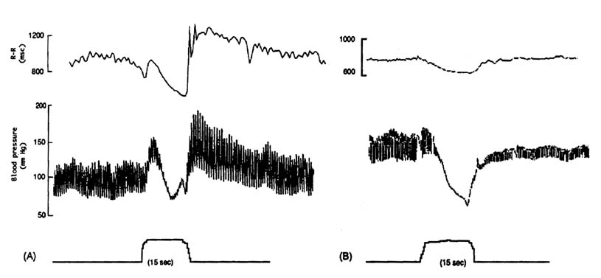
(A) normal subject (B) autonomic failure
- Heart rate response to postural change ("30:15 ratio") – heart rate changes that occur during first 30 seconds of standing result mostly from modification of cardiovagal activity and are blocked by atropine:
Heart rate increases sharply on standing, peaking at ≈ 12 seconds (≈ 15th beat) → progressively slows* until ≈ 20 seconds after standing (30th RR interval is longest) → gradually rises again.
*due to reflex activation of efferent cardiac vagal fibers; bradycardia is reduced in abnormal cardiovagal function.
30:15 ratio = longest RR interval around 30th beat / shortest RR interval around 15th beat (RRmax 30 /RRmin 15 ratio).
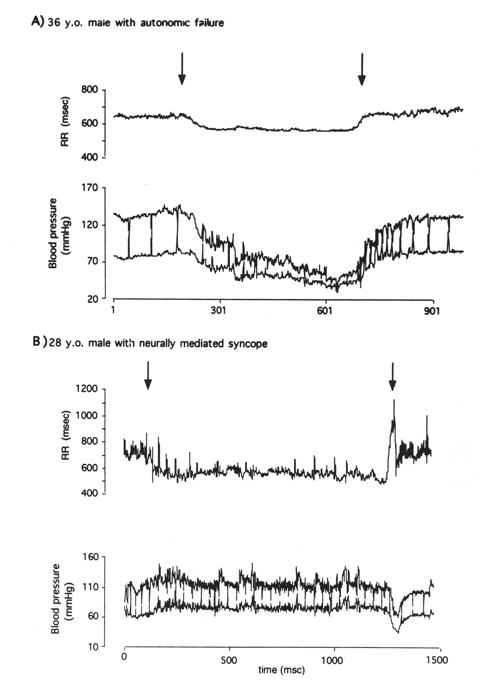
initial arrow denotes when head is tilted up; latter arrow denotes when head is tilted down (syncope).
Evaluation of cardiovascular sympathetic innervation
- Cardiovascular response to postural change – changes in blood pressure and heart rate induced by passive tilt or active standing - most useful test of sympathetic function!
  - upright tilt ≥ 60° → transient reduction in systolic, diastolic, mean blood pressures, heart rate increases by 10-20 beats per minute → recovery within 1 minute.
  - adrenergic failure → marked reduction in systolic, diastolic, and pulse pressure with no recovery + inadequate compensatory tachycardia.

- Blood pressure response to Valsalva maneuver see above >>
  - adrenergic failure → profound decrease of blood pressure in phase 2, absence of blood pressure "overshoot" in phase 4.

- Hemodynamic response to physical / emotional perturbations:
    - immersion of hand in cold water for 1 minute (cold pressor test) – afferent pathway is spinothalamic (distinct from afferent limb of baroreceptor reflex arc!); efferent pathway is sympathetic.
    - isometric exercise (e.g. sustained handgrip maneuver)
    - emotional stress (e.g. mental arithmetic).
  - normal subjects → increases in diastolic pressure > 15 mmHg and in heart rate > 10 beats per minute.

- Venoarteriolar reflex – axon reflex mediated by sympathetic C fibers: distention of veins of dependent limb → local arteriolar constriction (detected by decrease in skin blood flow.

- Plasma norepinephrine (NE) in supine and standing positions (for orthostatic hypotension).
  - in postganglionic failure, resting levels of NE are subnormal (vs. preganglionic failure – [NE] normal).
  - in normal subjects, plasma [NE] doubles with assumption of upright posture (vs. pre- or post-ganglionic sympathetic failure - absent response).
  - infusion of edrophonium (cholinomimetic agent) or tyramine (indirect sympathomimetic agent) → release of NE stores.

- Changes in response to pressor or depressor drugs.
  - pressor response to infusion of α-adrenergic agonists; postganglionic autonomic failure – decreased threshold for pressor effects, diastolic blood pressure increases≥ 20 mmHg (denervation supersensitivity).

Skin
- Thermoregulatory sweat test – by raising body temperature with external heating source → change in color of indicator powder (e.g. iodine with starch, quinizarin, alizarin-red) in response to rise in core body temperature - evaluates distribution of sweating; test abnormal in both pre- and post-ganglionic failure.
- Postganglionic sudomotor function – measuring sweat output after:
  - iontophoresis of cholinergic agonist - quantitative sudomotor axon reflex test (QSART).
  - intradermal injection of cholinergic agonists (pilocarpine, nicotine, methacholine).
- Intradermal injection of histamine → "triple response" (erythema, flare, wheal) through axon reflex (via nociceptive C-afferent fibers); loss of histamine flare = loss of nociceptive C axons:
  - familial dysautonomia
  - peripheral neuropathies affecting sympathetic nerves.
- Sympathetic skin potential (s. peripheral autonomic surface potential) – electrodermal activity (slow change in electrical potential of skin) generated by sweat production – occurs spontaneously and can be evoked (by unexpected noise, deep inspiration, electrical stimuli); autonomic failure → absence of sympathetic skin response (limited specificity + no localizing value).
- Sweat imprint – formed by secretion of active sweat glands into plastic or silicone mold in response to iontophoresis of cholinergic agonist (to determine sweat gland density, sweat droplet size, sweat volume per unit of area).

preganglionic cause of anhidrosis → abnormal thermoregulatory sweat test + normal postganglionic function.
postganglionic cause of anhidrosis → abnormal thermoregulatory sweat test + abnormal postganglionic function.

Urinary bladder
Postvoid residual volume (measurements of bladder volume):
large bladder volumes – lower motor neuron bladder or sensory denervation;
small bladder volumes – upper motor neuron or spastic bladder.

Differentiation of preganglionic versus postganglionic pandysautonomia
 | Preganglionic  (e.g. multiple system atrophy) | Postganglionic  (e.g. small fiber neuropathy)
Plasma norepinephrine | normal | ↓
NE response to standing | abolished
NE response to edrophonium | normal | impaired
Blood pressure response to tyramine | increases | no increase
Blood pressure response to NE | increases, normal threshold | very increased, decreased threshold (denervation supersensitivity)
Vasopressin response to standing | impaired | normal or exaggerated
Thermoregulatory sweat responses | impaired
Cholinergic sweat response | normal | impaired
Horner's syndrome:
Response to phenylephrine | dilated pupil | no response
Response to diluted α-agonist | no response | dilated pupil (supersensitivity)
Adie's pupil:  Response to diluted muscarinic agonist |  | pupil constricts (denervation supersensitivity)

Bibliography for ch. “Autonomic NS disorders” → follow this link >>

Viktor’s Notes℠ for the Neurosurgery Resident
Please visit website at www.NeurosurgeryResident.net

